Name: V.Jon
NIM: 27XXXXXXX
DevOps is a combination of Development (Dev) and Operations (Ops) practices, tools, and cultural philosophies that aim to improve collaboration between software development and IT operations teams. The goal of DevOps is to deliver software faster, more reliably, and with higher quality through automation, continuous integration, continuous delivery (CI/CD), monitoring, and shared responsibility across teams.
Key Benefits of DevOps:
- Faster software delivery
- Improved collaboration and communication
- Higher deployment success rates
- Faster issue detection and recovery
- Increased automation and efficiency
- Better customer satisfaction
Example:
In a traditional environment, developers write code and then hand it off to operations for deployment. In DevOps, both teams work together throughout the software lifecycle, using automated tools and processes to build, test, deploy, and monitor applications continuously.
DevOps LifeCycle:
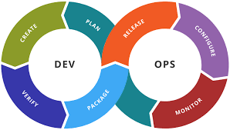
Common Devops Tools:


