The Commons: A Toolkit for the Quantitative Analysis of Trust and Cooperation in Online Environments

Joshua Berman, Steven M. Drucker Peter Kollock
Microsoft Research, Redmond, WA. 98052 Department of Sociology, UCLA, 90095
berman@cc.gatech.edu , sdrucker@microsoft.com kollock@ucla.edu

ABSTRACT
A toolkit for performing social dilemma tests has been built which allows for the measurement of the development of trust and cooperation within an online group. This is especially important for online environments since many of the cues that we rely on in face to face communication are missing from online interaction.

Keywords
Social Interfaces, Social Computing, Computer-Mediated Communication, Community Computing, Social Dilemmas

INTRODUCTION
Across a variety of disciplines in the social sciences, a key way of conceptualizing and measuring the success of a relationship or group is to look at the level of trust and cooperation that exists. In fact, a well-defined set of models and methods has been developed to test the existence and dynamics of cooperation in social relations [1,2,3].
We have created a system that capitalizes on these methods to create a rich and extensible toolkit that can be used to better understand and develop successful communication techniques for online environments.

PREVIOUS AND RELATED WORK
Social dilemmas are situations in which an individually reasonable decision leads to collective disaster; that is, a situation in which everyone is worse off than they might have been otherwise. Models of social dilemmas capture this tension between individual and collective outcomes, and can therefore be used as a very powerful and broadly applicable probe to assess the level of cooperation and trust in a group. Since the 1950s, a large research literature has developed in this area (for reviews, see [1,2,3]).
However, there has been little current work that has applied social dilemma models to online interaction and electronic societies. A recent exception is Rocca's work that examined the difference between electronic and face-to-face communication [4]. In Rocca's research, a specialized system was built, and a specific experiment was run to show the difference between online and face-to-face communities. In contrast, we have completed a generalizable toolkit and methodology capable of capturing not only these differences, but differences created by interface or social factors within electronic societies themselves.

THE COMMONS
The Commons toolkit was created using the V-Worlds Platform, a robust and extensible framework for distributed persistent objects [5]. The V-Worlds system, specifically designed to facilitate the development of shared virtual environments, offer many advantages; namely, automatic communication between multiple clients, easy programming via scripting, convenient interface prototyping via Dynamic HTML, and integration with the World Wide Web.
Because of the modular nature of the platform, and the ability to modify objects even at run time, different behaviors can be easily prototyped. This creates the ability to quickly and easily modify an existing environment to include The Commons, and to change experimental conditions with little change to the rest of the interface and user experience.
Since V-Worlds allows creation and modification in Active Scripting languages, members of the sociology, psychology and design community can design experiments without the need for dedicated developers.
Finally, the V-Worlds architecture, integrated in design and practice with Microsoft Internet Explorer, allows us to create tools which can be run on the World Wide Web, allowing The Commons to run experiments that were previously not possible efficiently and inexpensively. Examples of such experiments are those done over a great geographical distance, an extended period of time, or that use the large user population of the World Wide Web.

Experiment
Once the general toolkit was created and tested, scripts were created to test the validity of this approach by running a simple but important experiment. Using the Commons toolkit, we designed and implemented an experiment to study the effects of communication on levels of cooperation in online interactions.
For our initial studies, we chose to focus on an iterated, continuous Prisoner's Dilemma Game. The game is iterated in that partners play it repeatedly with each other. This allows relationships to build over the course of the experiment, and effects to be recognizable which might only occur over time. For our first study, we focussed on the dyadic (2-person) version of the game, although future studies will examine the multiple person (termed N-Person) versions of the game as well. The rules were that about 100 rounds would be played, and at each round a person had up to 10 points that they could give to the other person playing the game. The amount of points given are doubled and given to the other person. Thus, the situation has the structure of a Prisoner's Dilemma: The greatest possible return comes from keeping all of one's points while one's partner contributes all 10 points (a return of 30 points -- the 10 original points plus the 20 points from the partner's doubled contribution). However, if both actors follow this strategy each will end up with only 10 points (having contributed none to each other) rather than the 20 points each could receive if each contributed all their points.
In this study, 20 adult subjects played this iterated dyadic continuous prisoner's dilemma for seventy rounds. They did not meet each other face-to-face before, during, or after the game. Approximately half of the subjects who played were allowed to send text messages to each other (chat) during the game. The other half had no communication beyond what the game itself provided. Data was gathered on the contribution made by each player at each round, as well as data about chat message counts and contents.
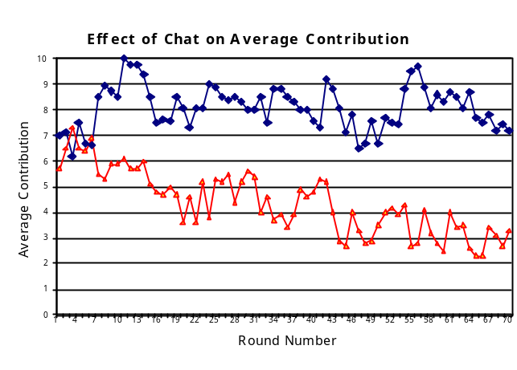
The subjects were randomly assigned to two groups. All factors were held constant between the two groups with the exception that one group (the chat condition) was given instructions and affordances for sending and receiving text messages with their partner during the experiment. Each participant, isolated from all other participants throughout the experiment, was given a preliminary briefing that their performance in the game would affect their reward upon leaving. In addition, they were given a post-experimental questionnaire in order to determine how motivated they were in their performance. Informed consent was gathered at the beginning of the experiment.
Analysis of the post-experimental questionnaire provides evidence that the subjects were motivated to earn as much as possible (mean = 5.50; seven point scale).
At the conclusion of the experiment, the data was analyzed for both group differences and trends with time. Descriptive statistics showed clear differences between the groups, henceforth labeled as chat and no-chat. The means were 8.10 for chat and 4.38 for no-chat. Medians were 10 and 3.25 respectively. It was also noted that the variance was much higher for the condition without chat, 17.14 as opposed to 8.84.
The data suggested that cooperation decreased over time in the no-chat condition, while remaining stable in the chat condition. To test this, repeated measures anova tests were performed to test for the main effect of blocks of rounds across time. For these tests, rounds were considered in fourteen blocks of five. For the no chat condition, round block had an effect of significance, F(13,52) = 3.06, p<.01. For the chat condition, there was no significant effect of round, F(13,52) = 1.06, p≈.41. Combining these results with the graphs of figures 4 and 5 showed these hypotheses to be true.

CONCLUSIONS
While there is some debate on the merit of using a game to measure cooperation and trust on a real collaborative task absent other factors such as working relationships, this technique can be used as a comparison for communication techniques when other factors are held constant.
Further experiments need to be done about the sensitivity of the technique for comparing different communication modalities, but the toolkit can already be used by sociologists to run experiments that were not possible before. These include the following: research on large groups, increased sample size, reduced selection bias, and removal of experimental effects by allowing subjects to work under their own conditions rather than at sociologist’s lab.

REFERENCES
- Axelrod, R. The Evolution of Cooperation. Basic Books, New York, 1984
- Hardin, G., The Tragedy of The Commons. Science. 162:1243-48, 1968
- Kollock, P. Social Dilemmas: The Anatomy of Cooperation. Annual Review of Sociology 1998. 24:183-214
- Rocco, E. Trust Breaks Down in Electronic Contexts but Can Be Repaired by Some Initial Face-to-Face Contact, in Proceedings of CHI '98 (Los Angeles CA, April 1998), ACM Press, 496-502.
- Vellon, M., Marple. K., Mitchell, D., and Drucker, S. The Architecture of a Distributed Virtual Worlds System. Proceedings of the 4th Conference on Object-Oriented Technologies and Systems (COOTS). April, 1998.

