**CMSC 628 Mobile Networks**

**Assignment #1**

**Steven M. Hernandez**

For this assignment, I use the ns-3 simulator to identify the effects of different mobility patterns on a selection of routing protocols in a Mobile ad hoc network (MANET). As a starting point, I employed the pre-existing example file (manet-routing-compare.cc) released along with the ns-3 simulator which is used as documentation for working with the simulator directly. This base simulation script by default allows for simple use of the following routing protocols: AODV, OLSR, DSDV and DSR. Further, the simulation defaults to using a random waypoint mobility model. To extend this, I’ve added both Random-walk and GaussMarkov mobility models, however further analysis will look at the Gauss-Markov and random waypoint mobility models specifically.

We begin by looking at how the AODV (Ad hoc On-Demand Distance Vector) and DSR (Dynamic Souce Routing) protocols when using the RandomWalk and GaussMarkov mobility models effect throughput. We know that AODV and DSR take different principle approaches to routing. For example, AODV requires intermediate nodes to determine and remember the best path to a given destination [1], while DSR as the name suggests requires the source node to determine the optimal path, using route maintenance steps to determine if and when paths to specific destinations have broken [2]. Thus, these two protocols provide an interesting contrast in procedures with which to evaluate through simulation.

The simulation begins with a 1500x300 unit space where nodes can move. Each node has a transmission power of 7.5 units which limits the range of their transmission. Additionally, a warm-up period of 100 seconds is given to the mobility of the nodes to allow evaluation to begin at a sufficiently random state. Examples of the two mobility models within a smaller 20x20 unit space are given in fig. 1. We can see that RandomWaypoint contains long stretches of absolutely linear trajectory while Gauss-Markov shows similar long stretches in a given direction, yet with minor variations in angle throughout the path. In general, GaussMarkov considers its previous direction for determining future trajectories.

Figure 2 presents the four combinations of routing protocols and mobility models. We can see that in general, each protocol succeeds at a similar rate for each simulation. The mobility models are given a modest range of movement speed in randomly in the range of (0.0,20.0). We do see halfway through (around 160s) DSR begins improving while AODV slightly decreases in performance. This might hint towards an issue discussed previously in the course regarding a random min speed of 0.0 resulting in the network as a whole approaching average speed of 0.0 [3], but this is not explored further.

DSR (Dynamic Source Routing) requires the source to determine the route a message should take. In highly dynamic networks, this is an issue in that by the time a node is aware of a possible full path, the path would have broken up, thus resulting in failed transmissions. We explore this idea in finding a best-case and worst-case situation for DSR routing using GaussMarkov Modelling seen in fig. 3. For best-case, we limit mobility speed between (0.0,0.0), meaning no movement occurs. In this case, obviously, known routes are never broken, thus messages are able to successfully transmit without issue. Figure 3 also presents the case for a bad-case which we simulate by giving high possible speeds (100.0,100.0) and then an even worst-case with speeds of (1000.0,1000.0).

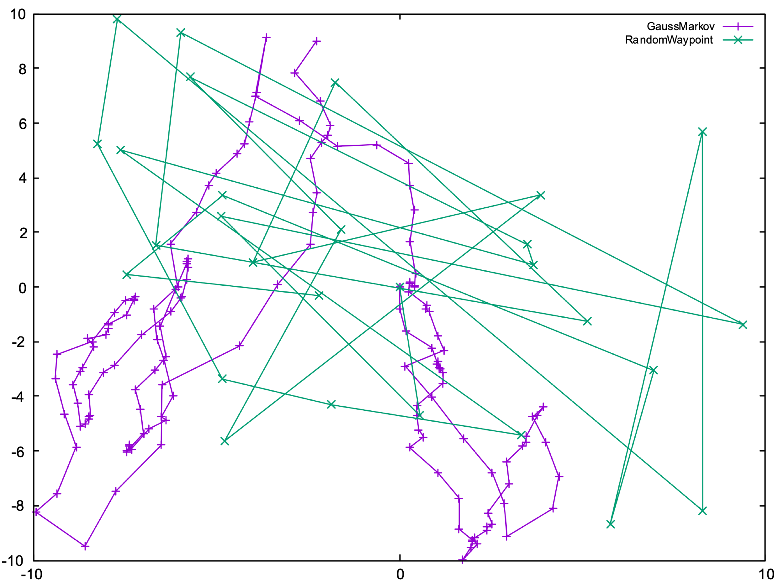

**Figure 1.** Example mobility model paths for both GaussMarkov and RandomWaypoints used in the simulation. Notice, the size of the bounding box is smaller than the final simulations.

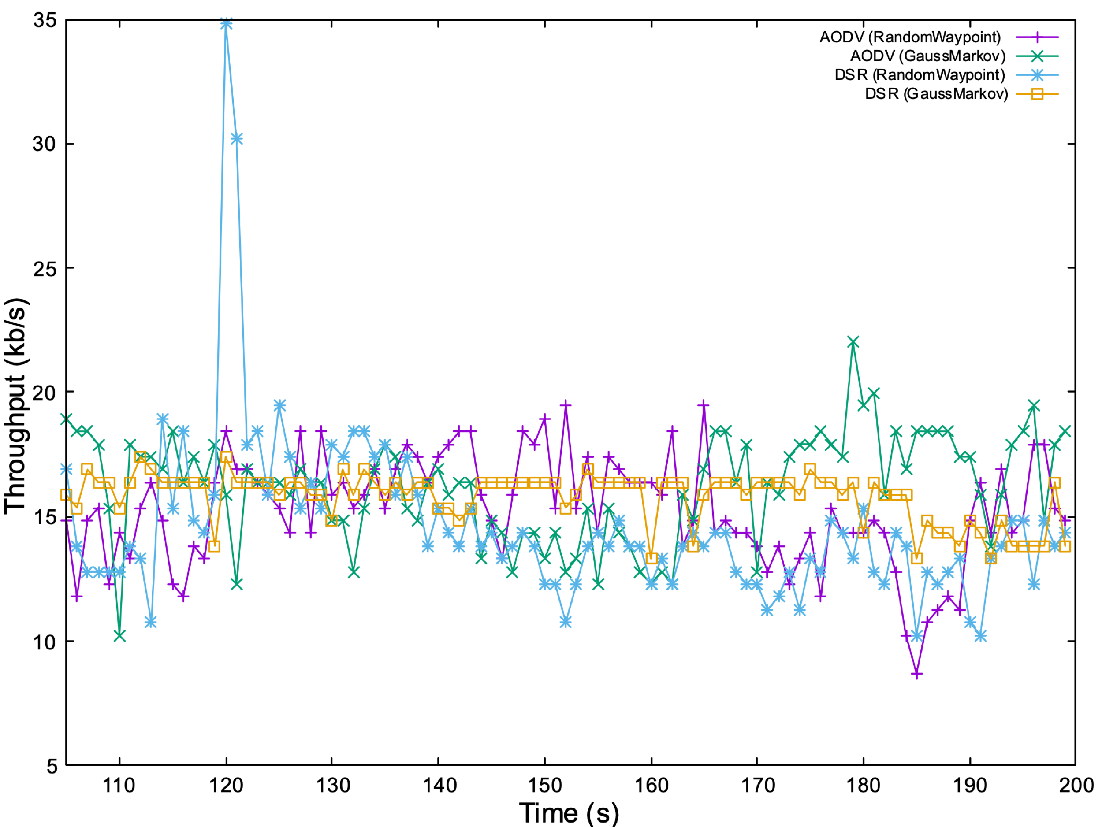

**Figure 2.** Plot of throughput throughout the network using default parameters for mobility model and routing protocol for mobility models AODV, DSR and mobility models RandomWaypoint, GaussMarkov.

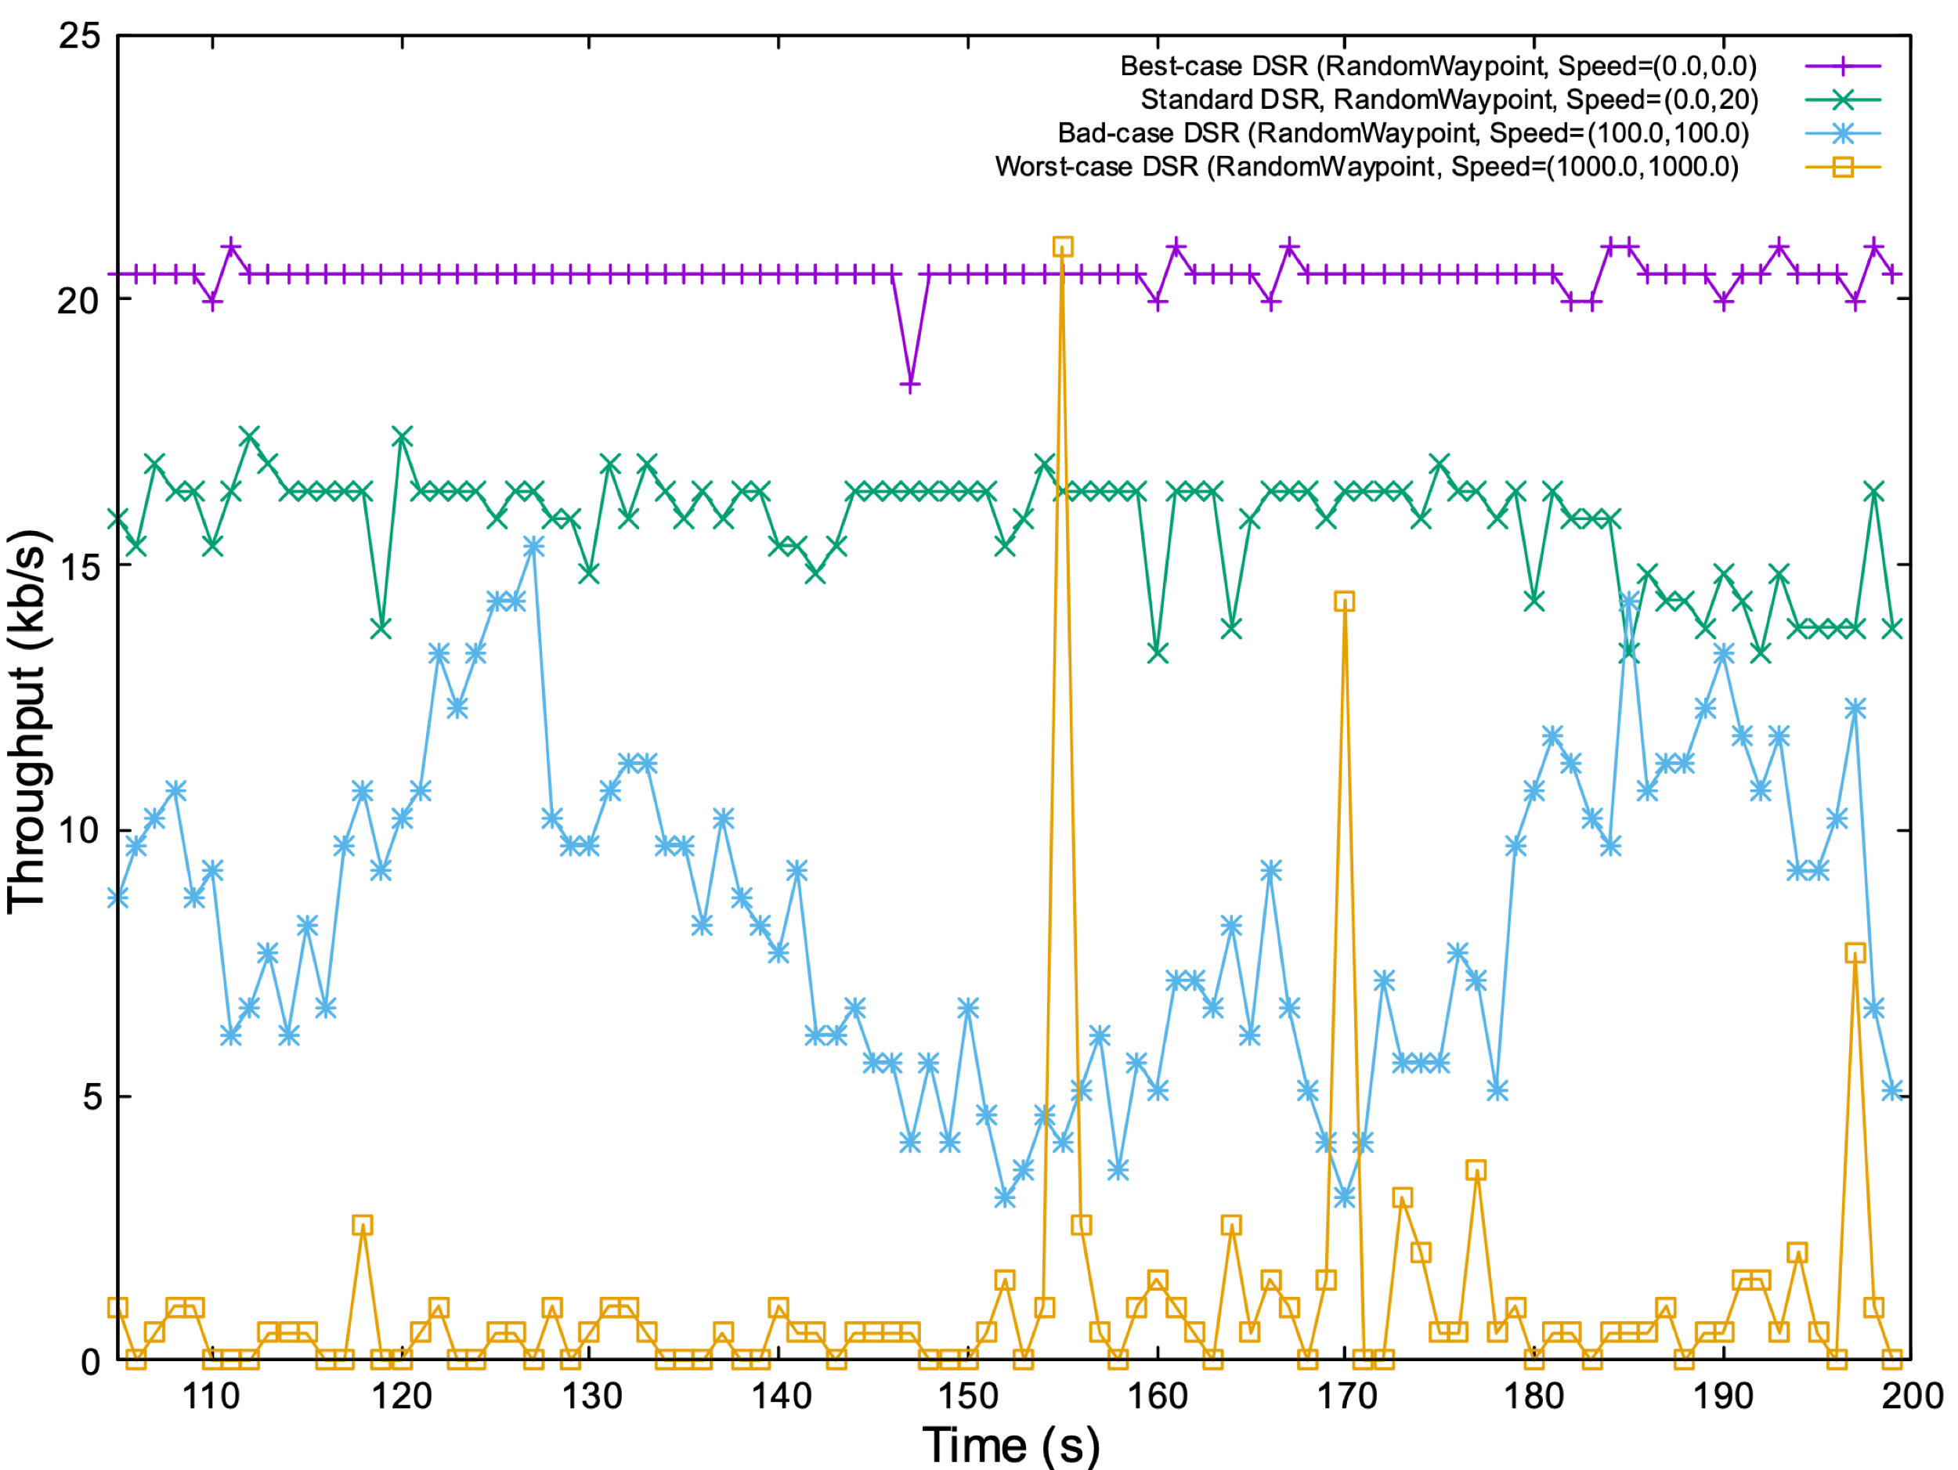**Figure 3.** Plot for throughput in the best-case, normal-case, bad-case and worst-case. Each case accomplished through changing the possible range of random speeds per node in the network with the understanding that higher-speeds result in worse routing decisions from a source-routing protocol such as DSR.

**References:**

[1] C. E. Perkins, E. M. Belding-Royer, and S. R. Das, Ad hoc On-Demand Distance Vector (AODV) Routing, IETF Internet Draft, draft-ietfmanet-aodv-13.txt, Feb. 17, 2003 (work in progress).

[2] D. Johnson, Y. Hu, and D. Maltz, The Dynamic Source Routing Protocol (DSR) for Mobile Ad Hoc Networks for IPv4, IETF Internet Draft, July 19, 2004

[3] Yoon, J., Liu, M. and Noble, B., 2003, March. Random waypoint considered harmful. In IEEE INFOCOM 2003. Twenty-second Annual Joint Conference of the IEEE Computer and Communications Societies (IEEE Cat. No. 03CH37428) (Vol. 2, pp. 1312-1321). IEEE.