Assignment 4: Fuzzy Logic

CMSC 678: Statistical Learning and Fuzzy Logic Algorithms

Steven M. Hernandez

Department of Computer Science

Virginia Commonwealth University

Richmond, VA USA

hernandezsm@vcu.edu

The following use the Matlab file: `hernandezsm_without_F.m`.

**Broad MFs:**

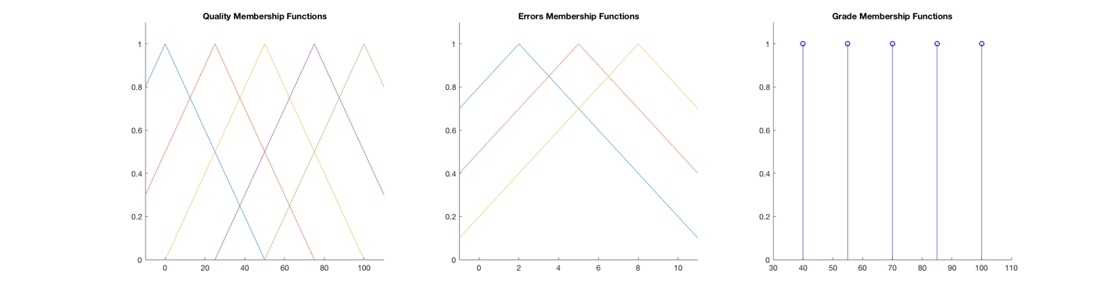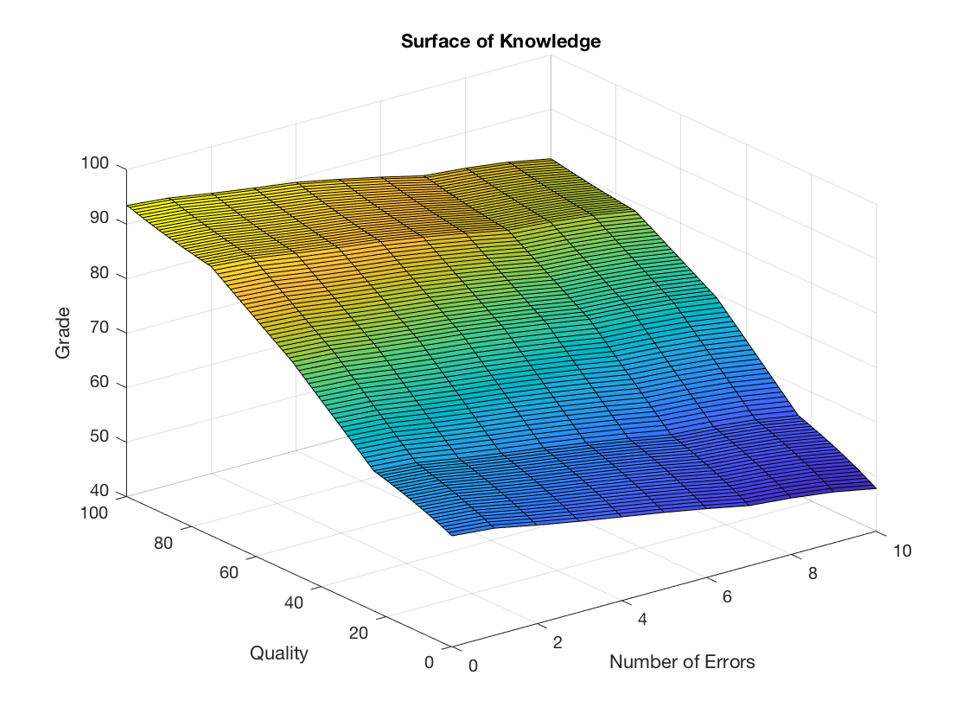

**Medium MFs:**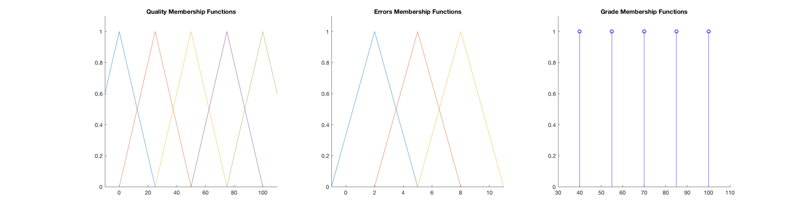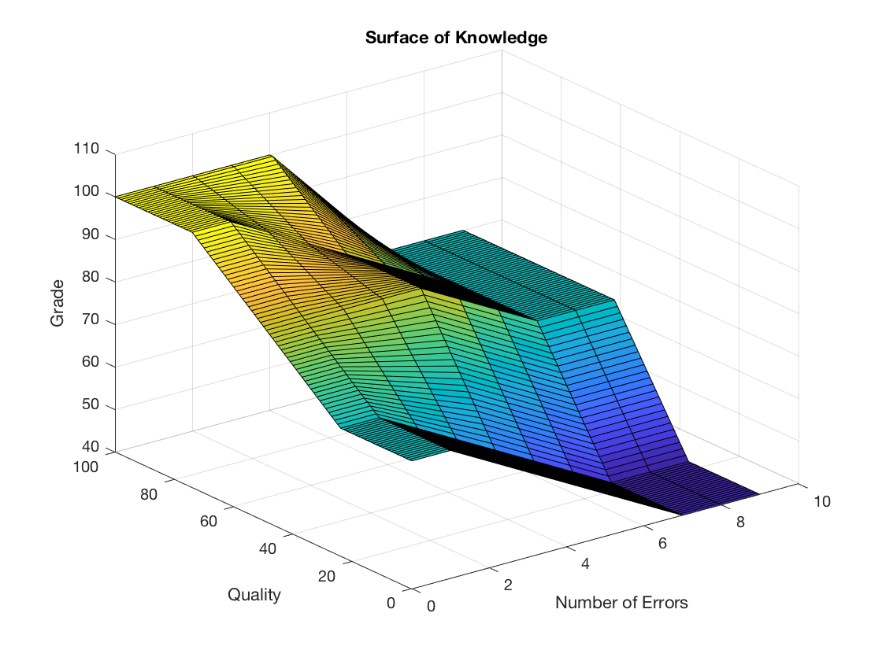

**Narrow MFs:**

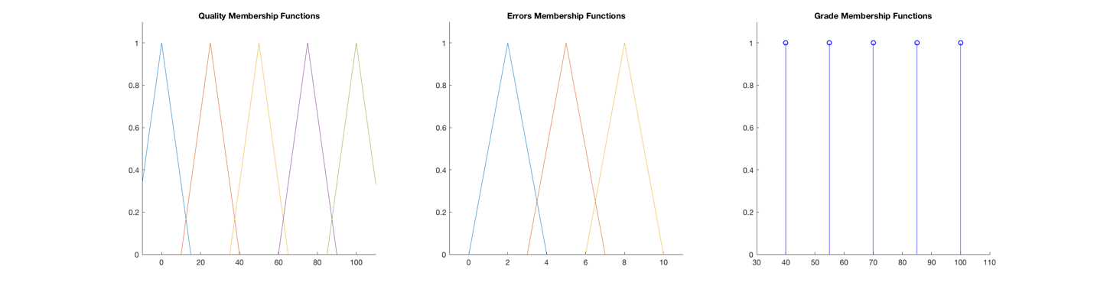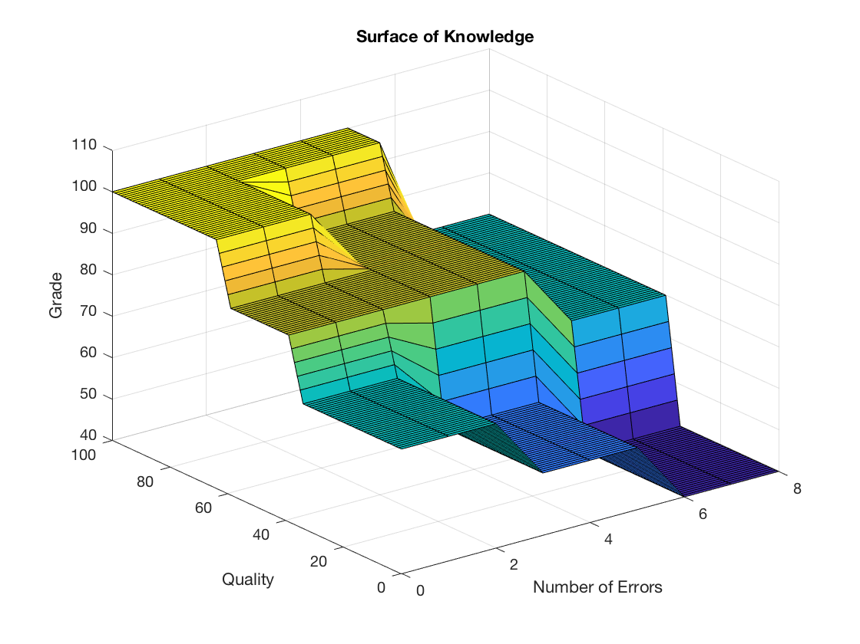

**With Power of Figures:**

Note: the below is for part two which uses the Matlab file: `hernandezsm_with_F.m`.

