# 431 Lab 01

Due **2021-09-06** at 9 PM | Last Edited 2021-08-12 12:53:16

## Deadline

Lab 01 has 4 questions, all of which you need to complete by the deadline posted on the [Course Calendar](https://thomaselove.github.io/431/calendar.html). We don’t give extensions on Labs. Instead, we use the [Late Work policy](https://github.com/THOMASELOVE/431-2021/tree/main/labs#late-work) to deal with Late work on Labs.

## Getting Help

You are welcome to discuss Lab 01 with Professor Love, the teaching assistants or your colleagues, but your answer must be prepared by you alone. Don’t be afraid to ask questions, using any of the methods described on our [Contact Us](https://thomaselove.github.io/431/contact.html) page.

## Loading Packages

library(patchwork); library(tidyverse)

## Learning Objectives

1. Be comfortable interacting with R to gain additional information about an embedded data set.
2. Describe a provided visualization, including commenting on its shape and the relationship observed.
3. Contextualize the information presented in the figure, by using additional information about the data and building upon your description.
4. Critically consider, and apply, the PPDAC approach as laid out by David Spiegelhalter in the Introduction of *The Art of Statistics: Learning from Data*.

# Question 1.

## Make a 30-second video to help us pronounce your name and learn something interesting about you

In this question, you will create and submit a short (30 seconds or less, please) video of yourself (recording yourself using Zoom is a solid approach.) In this film, we should be able to see your face clearly and also hear you clearly, so make sure that is the case. The resulting video should ideally be sent to us as an **.mp4** file.

## You will be doing two things in the video:

1. First, say hello, and then state your name, loudly and clearly, so that the viewer can learn to pronounce it correctly. Please use both your given name and your family name. If you prefer to be called by a nickname, please specify that, too.
2. Then, tell us something about you that we don’t know, and might be interested to learn. It can be anything at all. We’re hoping to get to know you a little better, and this can be something about your professional or private life, or whatever you feel you would like to share with us. We’re hoping to facilitate connections here.

### Some tips for the video…

* Expect that your fellow students (as well as the Teaching Assistants and Dr. Love) will see your video before the semester is over, so keep that in mind as you decide what to tell us.
* Do not worry about the quality of the video, or adding elaborate theatricality, props or scenery. If you’d like to do so, that’s fine, but just make sure that we can see you and hear what you are saying clearly.
* We’re not kidding about the 30-second time limit. Please don’t let your video exceed 30 seconds.

# Question 2.

## Interpret Visualizations Built using R

We used R and the tidyverse (specifically the ggplot2 part of the tidyverse) to build two plots using the DNase data set from the datasets package automatically loaded by R. Below, you’ll find the two plots we built (labeled Plot A and Plot B) and the code we used to build the plots and then display them in a single Figure with an appropriate title (for which we used the patchwork package.)

Use the Help window in R to learn about the DNase data set, and in particular, about the two variables displayed in the plots below, and their scientific context.

Then write a paragraph (100-150 words is the appropriate length) which explains what the Figure’s two plots indicate about the relationship between the two variables, and (more generally) what you have learned about the data (or science) from the Figure. Be sure to discuss how the two plots work together specifically addressing the question of what you can learn things from Plot A that you can’t learn from Plot B and vice versa.

Your response to this question should be written using clear and complete English sentences and minimizing jargon, as is the case with all “essays” you will write for this course.

## Code for Plot A

plotA <- ggplot(DNase, aes(x = conc, y = density)) +  
 geom_point() +  
 geom_smooth(method = "loess", formula = y ~ x) +  
 theme_bw() +  
 labs(title = "Plot A")

## Code for Plot B

plotB <- ggplot(DNase, aes(x = factor(conc), y = density)) +  
 geom_boxplot() +  
 theme_bw() +  
 labs(title = "Plot B")

## Code to combine Plots A and B into one Figure and display the result

plotA / plotB +   
 plot_annotation(  
 title = "Question 2. Association of `density` and `conc` in the `DNase` data")

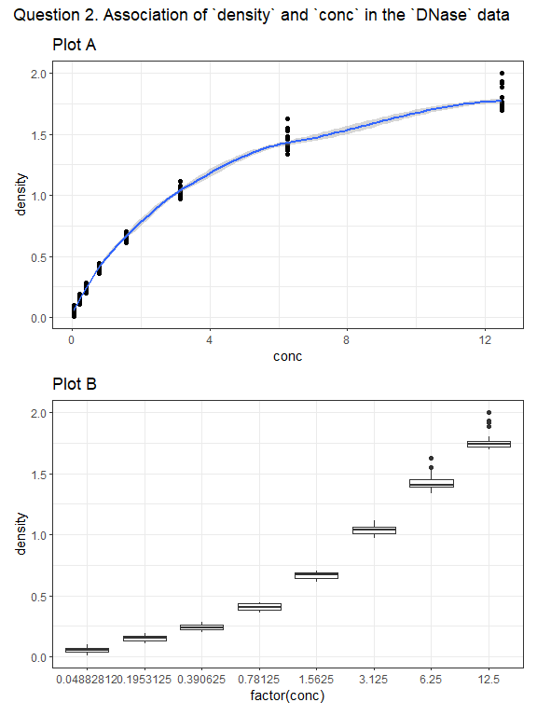

# Question 3.

## React to the Introduction of *The Art of Statistics*

Read the introduction to David Spiegelhalter’s book *The Art of Statistics*. Then write a short essay (of 100-150 words, please) describing how the PPDAC problem solving cycle might be helpful to you in the context of some “problem” you are interested in solving. Please feel free to draw on your own experience solving problems in a systematic way, and don’t feel obliged to write about a “problem” that is related to biology or medicine or health or science. Anything you can explain briefly and that you are interested in could work well here.

Again, your response to this question (and to the other Questions) should be written using clear and complete English sentences and minimizing jargon.

# Question 4.

## Connecting Spiegelhalter to Question 2

In Question 2 above, you’ve been given data (D) and a very rough analysis (A), and from your own write-up have drawn some conclusions (C). The PPDAC approach is notably a cycle, and so after we create a conclusion we return to another problem. Given what you’ve learned about the data, what you’ve seen in the analysis, and the conclusions you’ve drawn in Question 2, briefly (again, in 100-150 words) describe your thoughts as to what the next cycle of the PPDAC approach for a study of these data could be.

In your response, clearly specify what you see as the Problem, Plan, Data, Analysis, and Conclusion while also highlighting how this builds upon the results already presented.

# Submitting the Lab

Eventually, you will:

* create an .mp4 video file for Question 1
* build a single Word or PDF or HTML document containing your responses to Questions 2-4 (please include your full name in the body of the document and clearly indicate which part of your response refers to each Question, ideally with headers like “Question 2.”)

The essays and the video should be submitted (the system will let you upload each file individually) to the Lab 01 section in the [Assignments folder in Canvas](http://canvas.case.edu) before the deadline on the [Course Calendar](https://thomaselove.github.io/431/calendar.html).

# Grading

We will summarize some of the more interesting responses to Questions 2-4 after the Lab has been graded.

* This Lab will be graded on a scale from 0-100, and students will receive 25 points for successful completion of each of the four questions.
* Note that the teaching assistants will review your responses to Questions 2-4 carefully to assess clarity of writing, attention to detail, and adherence to grammatical and syntax requirements, but we will not grade Lab 01 with those elements in mind. (Spelling, grammar, syntax and the rest will matter for grading purposes in all other assignments this term.)

A detailed answer sketch and grading rubric for this Lab will be provided on the day after the deadline.