Forecasting & Cryptocurrency
Steven Munich
Eastern Florida State College
MAN 4504: Operational Decision Making
Dr. F. D. Christopian
01/28/2023

Computer Industry & Form Factors

I am really taken aback by this class and how much it relates to my major feild of study, computer programming. The definition of a forecast is a statement about the future value of a variable. Now in programming a variable is one of the most basic things, and it holds a value that can change. In my Object Oriented Programming classes I am learning about how an object can hold many variables. A door knob can have an X, Y, Z cordinates, different angles, handles, anything physical on the outside. On the inside are the parts that serve a purpose, to lock. Each of those components have properties themselves and also serve a purpose.

The beginning of this chapter gave me an epiphany on how I see the outside world. Its not like the matrix where everything is a 1 or a 0, but rather seeing the object, all its variables or attributes, and its function/purpose. I think the most interesting things about forecast is that they are not perfect. You may expect 400 people to show up at your restaurant during lunch hour and get 450. No matter how well you predict or take every variable into account, the number of customers is either going to be a up or down by some amount. This is called random variation.

Now things that are cyclical last for one or more year. It makes me think of a bitcoin chart because you can tell when the bull and bear markets are. Below is a linear chart that shows the entire lifetime of bitcoin and is a perfect depiction of the bear and bull markets. It is not only a perfect example of a cycle, but also a trend. What I like to look at are previous highs and previous lows. In its first bull market it goes to approx. $20,000 then after that its low is around $3,000
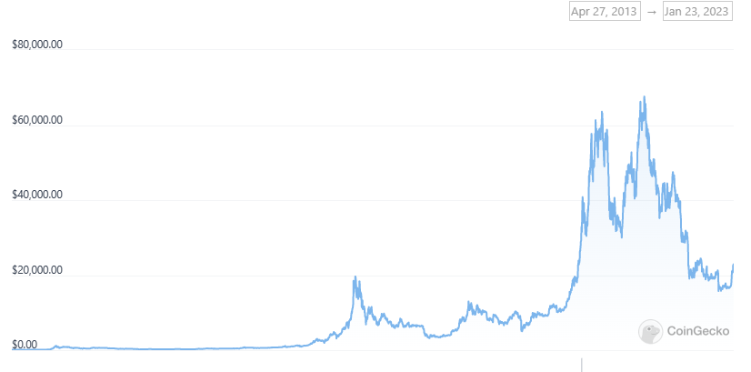
(CoinGecko, Bitcoin Price Chart(BTC))

Another thing I like to look at with Bitcoin charts is trend reversals or continuations. The current price for bitcoin right now is around $23,000. What I have to ask myself is “is that above or below the previous high?”. If it is below the previous high we may still be in a downtrend, above and it may reverse to an uptrend. The key word here is “may” and Im not very good at predicting the price of bitcoin myself so I just hold onto it long-term. If I was a trader, I would be looking at quantitative, which is hard data. However, I can not predict human factors, which would be Qualitative. I can not control what the government does. An example of this is the legal actions SEC(Security & Exchanges Commission) took against Ripple/XRP.

The result of this lawsuit could have serious consequences for the value of XRP and the cryptocurrency environment as a whole. Below is a statement about how the final verdict could effect other cryptocurrencies.
“Notably, if the regulator is successful in this case, it might have very negative repercussions for XRP, its investors, and the cryptocurrency sector as a whole. In particular, the regulatory body has the authority to levy a fine on Ripple Labs and demand that the business register XRP as a security.
As a consequence, a judgment of this kind would certainly result in XRP being treated in the same manner as conventional securities, which may restrict both its adoption and usage. “
(Jordan Major)
If the government can do this to XRP what is stopping them from doing it to any other cryptocurrency? A short term qualitative forecast would be if I just had a hunch or a gut-feeling that tells me that prices will go up or down. The only positive I can see from qualitative forecasting is that it is “on the fly”.
“ If management must have a forecast quickly, there may not be enough time to gather and analyze quantitative data. At other times, especially when political and economic conditions are changing, available data may be obsolete, and more up-to-date information might not yet be available” (Stevenson, 2020, P. 81).

My long term strategy is Quantitative because I am making predictions based on historical data(I remember when bitcoin was $300. However, I never saw its worth in dollars). Quantitative forecast gives me something I always find valuable when making calculations, NUMBERS. It also gives me historical data which can be used to show a pattern. There are many patterns with charts, the ones I am most familiar with are the head & shoulders / upsidedown head & shoulders. These are usually indicative of a trend reversal and before the latest crash I ignored this signal and suffered as a result.

References

© 2023 CoinGecko. All Rights Reserved. Bitcoin Price: BTC Live Price & News. Retrieved 01/23/2023 from https://www.coingecko.com/en/coins/bitcoin

Jordan Major. What happens to XRP if Ripple wins case against the SEC?
Retrieved 01/23/2023 from https://finbold.com/what-happens-to-xrp-if-ripple-wins-case-against-the-sec/

Stevenson, W. J. (2020). Operations Management (14th ed.). McGraw-Hill Higher Education (US). https://reader2.yuzu.com/books/9781260718447

