Capacity & Utilization
Steven Munich
Eastern Florida State College
MAN 4504: Operational Decision Making
Dr. F. D. Christopian
01/20/2023

Capacity & Utilization

Once again, I see parallels with operations and computers. Capacity is the upper limit or ceiling when it comes to production. Big-O notation (for programming) is also an upper limit when it comes to software and resources. Although the concepts are the same there are a few differences, capacity planning in operations requires some forecasting (What do I want to make? How much?). In programming, Big-O is for worst case scenario, how long will it take to process X amount of data. There is also something in computer science known as a “bottleneck”, which is exactly the same in operations. The slowest part can slow down the whole system.

So, what can cause a bottleneck? Well, capacity requires 3 things: Equipment, Space or Real Estate, and employees with the proper skills. If an employee is sick how is that going to affect production for that period? What if the equipment breaks? If multiple people need to use that piece of equipment it’s going to create a bottleneck. A good example would be internet in an office building. If the internet goes down no one can send emails, do research, and in some cases phone calls. In a perfect world the maximum output, or design capacity, could always be achieved. But that’s not realistic, machines may need parts replaced because of rust and people need rest from their labor.

We can deduce the design capacity by how much production is done by the system operating at 100%. It is the theoretical capacity, where as effective capacity is the reality, the actual output. I like to think in terms of equipment and people, but there are many factors to be considered for effective capacity.
Table 5.2
Factors that determine effective capacity
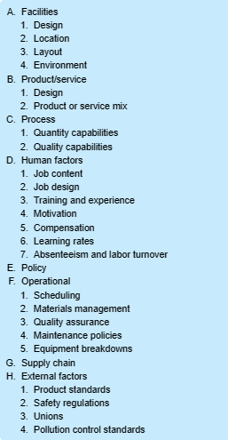
As you can see there are many variables that can affect the actual output, effective capacity. When I’m dealing with variables in real life(not as a programmer), I like to put things into an equation. One equation is: Utilization = actual output / design capacity. Understanding this concept can help an organization get the most out of their resources.
“Capacity utilization can also be defined as the metric used to calculate the rate at which the prospective levels of output are being met or used. The rate is displayed as a percentage and provides an insight into the total utilization of resources and how a company can increase its output without increasing the costs associated with production. The capacity utilization rate is also called the operating rate.” ( CFI Education Inc.)
One thing I really like about this quote are the words “without increasing the cost”. It sounds like a good thing at first, but I’m reminded of chapter 4 and over production. So I ask myself, “is it worth it?” The answer lies with demand. If demand is growing it’s a very obvious win. If demand goes lower it can also be a win, by doing nothing. With less demand and same production I can have a capacity cushion and won’t have to worry about lost sales.

To fully utilize we need to plan the capacity, there are 3 different plans:
1. Leading is anticipation of demand, expecting demand to grow.
2. Following is when demand exceeds capacity.
-An example of this would be if I pitched / advertised a product on a T.V show such as “Shark Tank” and as a result demand skyrockets from the free press. Yet instead of anticipation, I did not increase capacity/production. Now I have to chase demand before it goes away.
3. Tracking which increments to keep pace with increase demand.
Personally, Tracking is my favorite because it seems to be the more conservative and wise choice. One thing I found with tracking is that you can use software to monitor resources and even use the data to create a performance report:
“When preparing reports/charts for stakeholders, utilization can be a crucial metric to include as it gives a more rounded picture of performance. With resource utilization charts, you can automatically inform your boss about how hard your team’s working. It’s also useful to forecast what is to come, where new resources are needed, and where new projects can be taken on if the utilization is low.” (Ganttic)
References
CFI Education Inc. Capacity Utilization. corporatefinanceinstitute.com Retrieved 02/07/2023 https://corporatefinanceinstitute.com/resources/economics/capacity-utilization/

Ganttic. Resource Utilization Tracking in Ganttic. Ganttic.com Retrieved 02/07/2023
https://help.ganttic.com/hc/en-us/articles/11462924196625#:~:text=Simply%20put%2C%20utilization%20tracking%20is%20monitoring%20the%20usage,each%20resource.%20This%20is%20displayed%20as%20a%20percentage.

Stevenson, W. J. (2020). Operations Management (14th ed.). McGraw-Hill Higher Education (US). https://reader2.yuzu.com/books/9781260718447

