Application Opened
Main content
Module
2

Using the System Utilities
- Chapter Introduction
- 2-1Settings Overview
- 2-2Administrative Tools
  - 2-2aMicrosoft Management Console
  - 2-2bComputer Management
  - 2-2cServices
- 2-3Command-Line Administration Tools
  - 2-3aCommand Prompt
  - 2-3bWindows PowerShell
- 2-4Display
  - 2-4aDisplay Settings
  - 2-4bVisual Effects
  - 2-4cDesktop Backgrounds
  - 2-4dScreen Savers
  - 2-4eMultiple Monitors
- 2-5Managing Optional Features
- 2-6Hardware Management
  - 2-6aDevice Drivers
  - 2-6bDevice Driver Compatibility
  - 2-6cDevice Manager
  - 2-6dDevice Driver Signing
  - 2-6eHardware Component Installation
- 2-7Power Management
  - 2-7aACPI States
  - 2-7bModern Standby
  - 2-7cLegacy Power Management
  - 2-7dPower Plans
  - 2-7eFast Startup
  - 2-7fPower Button Options
  - 2-7gTroubleshooting Power Management
- 2-8Task Scheduler
- 2-9Chapter Review
  - 2-9aSummary
  - 2-9bKey Terms
  - 2-9cReview Questions
  - 2-9dCase Projects
Go to pg.
help
Application Opened
Main content

Chapter Introduction
After reading this module and completing the exercises, you will be able to:
- 1Understand and use Settings to configure Windows 10
- 2Understand the Administrative Tools
- 3Use command-line administration tools
- 4Configure displays
- 5Manage Windows 10 optional features
- 6Manage hardware components
- 7Understand and configure power management
- 8Use Task Scheduler
Windows 10 includes a wide range of system utilities in Settings and in Administrative Tools. A thorough knowledge of these utilities can help you manage, tune, and improve your system. Some of the more advanced tools are Microsoft Management Console (MMC) snap-ins. A snap-in is the standardized format for creating system management utilities in Windows.
This module provides an overview of Settings and Administrative Tools, along with a description of the MMC. In-depth coverage also is provided of how to manage hardware components, configure power management, configure the display, and use Task Scheduler.
Go to pg.
help
Application Opened
Main content

2-1Settings Overview
Most of the configuration options for Windows 10 can be accessed through Settings, shown in Figure 2-1. The settings are organized into categories to make it easier to find the specific settings you are looking for. To access Settings, click the Start button and then click Settings on the Start menu.
Figure 2-1Windows 10 Settings Window
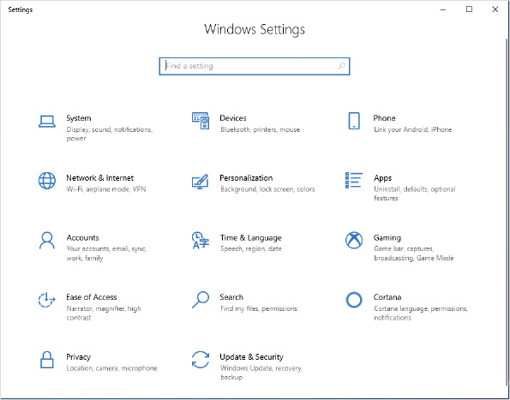
The categories within Settings are:
- System—These are general settings for configuring Windows 10 functions. This category includes settings for display, sound, notifications, power, storage, tablet mode, multitasking, clipboard, and Remote Desktop.
- Devices—This category includes settings for Bluetooth, printers, scanners, mouse, typing, Windows Ink, AutoPlay, and USB.
- Phone—These are settings for the My Phone feature that lets you link an iPhone or Android device to your computer. You can use My Phone to access photos and text messages on your phone. You can also use your computer to send text messages and make phone calls through your phone.
- Network & Internet—This category includes settings for connectivity, which includes network status, network connections, virtual private networks (VPNs), data usage, and proxy configuration.
- Personalization—This category has settings to configure the look and feel of Windows 10. These settings include desktop background, colors, the lock screen, themes, fonts, the Start menu, and taskbar.
- Apps—This category includes settings for managing applications. You can add or remove applications and Windows 10 optional features. You can also configure default applications for content types and which applications run at startup.
- Accounts—This category allows you to configure authentication to Windows 10. This includes creating and managing local user accounts.
- Time & Language—This category has settings for the date and time, regional formats, language, and speech recognition.
- Gaming—This category has settings for the game bar, capturing gameplay, broadcasting gameplay, Game Mode, and Xbox Networking with Xbox Live services.
- Ease of Access—The category contains settings that can make it easier for people with visual or physical challenges to use Windows 10. You can configure options such as high contrast display colors and enable Narrator to read text on the screen.
- Search—This category contains settings that let you customize Windows search results from the Internet and your local computer. This includes settings to customize which local files are indexed and included in search results.
- Cortana—This category contains settings to customize when Cortana can be used and to which of your data Cortana has access.
- Privacy—This category has settings that control which data Windows 10 can capture on your computer and submit to web services. For example, you can disable diagnostic and usage data from being submitted to Microsoft. This category also includes settings to control which applications can access data and devices on your computer, such as location, camera, microphone, documents, and calendar.
- Update & Security—This category has a wide range of settings for Windows Update, backup, troubleshooting, recovery, activation, find my device, and the Windows Insider program.
Caution
Many of the configuration options in Settings are controlled by toggle switches. Changing a toggle switch between Off and On takes effect immediately; no option to cancel or undo is available.
If you don’t know which category a setting is in, then search for it instead of browsing. Searching for a setting is much faster than browsing through multiple categories. After you search for it, you’ll be able to see which category it’s in.
Note 1
Options in Settings can vary depending on the hardware present in a computer running Windows 10. You might see some inconsistency among the computers you use.
In Windows 7 and earlier versions of Windows, Control Panel was used to access configuration settings. Control Panel, shown in Figure 2-2, is still available in Windows 10. Most configuration options can be accessed through Settings, but some are still accessible only through Control Panel. In some cases, a configuration option can be accessed through both Settings and Control Panel. Newer configuration options are available only in Settings.
Figure 2-2Control Panel Window
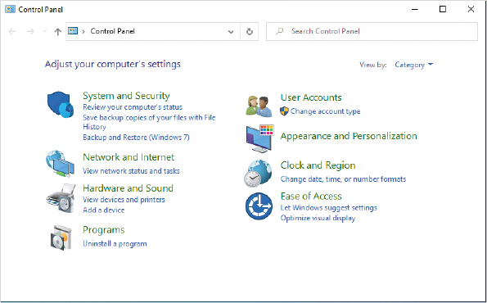
Activity 2-1

Exploring Settings
Time Required: 10 minutes
Objective: Review the available settings
Description: In Windows 10, Settings is where most of the user-level configuration options are accessed. You should be familiar with these settings so that you understand what options are available. In this activity, you browse through Settings to identify the available options.
- 1
If necessary, start your computer and sign in.
- 2
Click the Start button and then click Settings.
- 3
If necessary, expand the Settings windows so that all categories are visible and then click System.
- 4
Read the settings on the Display screen. If necessary, scroll down to view them all.
- 5
Click Focus assist in the left pane and read the default settings.
- 6
Click Multitasking in the left pane and read the default settings.
- 7
Scroll down in the left pane and then click About. Read the information that is displayed about your computer. Information about your computer is located here, such as processor type and speed, memory, and computer name.
- 8
Click Home in the left pane and then click Devices.
- 9
Click AutoPlay in the left pane and review the default settings.
- 10
Click Home in the left pane and then click Apps.
- 11
In Apps & features, read the list of installed apps.
- 12
Click Default apps in the left pane and read the default settings.
- 13
Click Home in the left pane and then click Time & Language.
- 14
In the Date & time screen, read the default settings.
- 15
Click Region in the left pane and read the default settings.
- 16
Click Language in the left pane and review the option to install an additional language.
- 17
Click Home in the left pane and then click Privacy.
- 18
In the General screen, review the default settings.
- 19
Click Diagnostics & feedback in the left pane and read the default settings.
- 20
Scroll down in the left pane, click Microphone, and read the default settings.
- 21
Take time to review any other categories that interest you and then close the Settings window.
Activity 2-2

Using Ease of Access Features
Time Required: 10 minutes
Objective: Explore the Ease of Access features in Windows 10
Description: Your organization has several people with visual and hearing challenges. You need to explore the Ease of Access features in Windows 10 to ensure that you understand how best to support them.
- 1
If necessary, start your computer and sign in.
- 2
Click the Start button and then click Settings.
- 3
In Settings, click Ease of Access and read the Display settings.
- 4
Click Cursor & pointer in the left pane and read the available settings.
- 5
Click Magnifier in the left pane and then click the Turn on Magnifier toggle to change the setting to On.
- 6
Move the pointer to the edges of the screen to change the portion of the screen that is visible.
- 7
In the Magnifier window, click Views on the toolbar and then click Lens.
- 8
Move the pointer around to change the area that is magnified.
- 9
Close the Magnifier window.
- 10
Click Color filters in the left pane and then click the Turn on color filters toggle to change the setting to On. This feature is useful if the user is color-blind.
- 11
Scroll down until you can see the color wheel, and then click Red-green (green weak, deuteranopia).
- 12
Click Blue-yellow (tritanopia) and notice that the color wheel changes.
- 13
Scroll up and then click the Turn on color filters toggle to change the setting to Off.
- 14
Click High contrast in the left pane, and then click the Turn on high contrast toggle to change the setting to On.
- 15
In the Choose a theme box in the right pane, select High Contrast #1.
- 16
Click the Turn on high contrast toggle to change the setting to Off.
- 17
Scroll down in the left pane, click Keyboard, and read the available settings.
- 18
Click the Use the On-Screen Keyboard toggle to change the setting to On. This can be useful for someone with limited hand movement who is unable to use a regular keyboard.
- 19
Close the On-Screen Keyboard window.
- 20
Close the Settings window.
Go to pg.
help
Application Opened
Main content

2-2Administrative Tools
Windows 10 includes a collection of system configuration utilities that are grouped in a category called Administrative Tools and found in System and Security in Control Panel. Most of the tools in this category use the Microsoft Management Console (MMC). The MMC is a framework that simplifies the development of administrative tools. The Administrative Tools are shown in Figure 2-3. Brief descriptions of these tools follow; later modules offer more detailed coverage.
Figure 2-3Administrative Tools Window
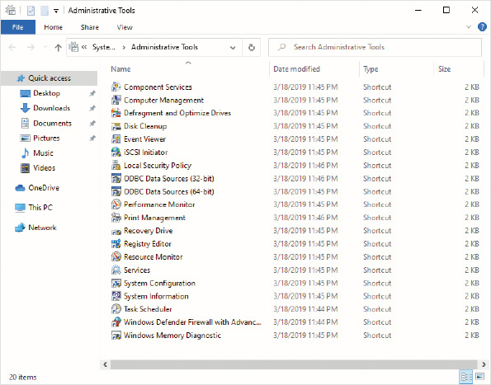
Component Services is used to configure settings for some apps. It includes settings for COM, DCOM, and Distributed Transaction Coordinator. Typically, these settings are modified only if you receive instructions from an application developer or as part of a troubleshooting document.
Computer Management is a tool that allows you to manage multiple parts of Windows 10, such as local users and disks. You can use this tool instead of opening multiple other tools.
The Administrative Tools in Windows 10 include disk management tools. The Defragment and Optimize Drives tool moves file blocks around on the disk to make individual files contiguous and faster to access. It is seldom required to perform this task manually because defragmentation is performed once per week automatically. The Disk Cleanup tool helps you identify unneeded files that can be removed.
Event Viewer is used to view messages from apps or Windows 10. These messages are useful for troubleshooting errors. When you find an error, you can search the Internet for a solution if the fix is not obvious.
The iSCSI protocol allows computers to communicate with external storage over standard Ethernet networks. External storage devices that support iSCSI are known as iSCSI targets. The computers that access iSCSI targets are iSCSI initiators. The iSCSI Initiator tool lets you configure Windows 10 to communicate with iSCSI targets and use the iSCSI targets as external disks over the network. The iSCSI protocol is used only in corporate environments and mostly on servers rather than workstations.
The Local Security Policy tool allows you to edit a wide variety of security settings on the local computer. Some of the settings include password policies, account lockout policies, auditing policies, user rights assignment, and software restriction policies. When Group Policies are used in a corporate environment, the Group Policy settings configured centrally by the administrator override the settings configured locally with this tool.
Open Database Connectivity (ODBC) is a standard mechanism for allowing applications to access databases. Applications written to use ODBC can communicate with any supported database, such as Microsoft SQL Server, Microsoft Access, or Oracle databases. A network administrator must then configure an ODBC data source to communicate with the proper database. This isolates the application from the database, makes application development easier, and provides greater flexibility when choosing a database. Windows 10 includes separate tools for configuring ODBC connections for 32-bit apps and 64-bit apps.
Performance Monitor is used to monitor and troubleshoot performance issues in Windows 10. It includes the capability to monitor many system resources, including the processor, disk, memory, and the network. Performance Monitor can log resource status over time and generate reports.
Print Management is a tool for monitoring and managing printers. In a single view, you can monitor and manage local and network printers.
Recovery Drive is a tool that you can use to create media for installing Windows 10. Because most computers do not ship with a Windows 10 installation DVD, this is important if you want to reinstall Windows 10.
Registry Editor allows you to edit data in the Windows 10 registry. The registry is a centralized database of settings for Windows 10 and for applications. This tool is used for advanced troubleshooting and when instructed by help documentation.
Resource Monitor is a tool that provides detailed information about the processes running on your computer. You can use it to view the processor utilization, memory utilization, network utilization, and disk activity of individual processes. It is like a more advanced version of Task Manager.
Services allows you to configure Windows 10 services. You can also start and stop services if required for troubleshooting. This functionality is also available in Computer Management.
System Configuration gives you access to boot configuration, service startup, startup applications, and system tools. The General tab, shown in Figure 2-4, lets you select the type of startup you want to perform. The Boot tab lets you configure boot options, such as Safe Mode. The Services tab lets you enable or disable services. The Startup tab provides a link to Task Manager where you can disable any of the applications that Windows 10 is starting automatically. The Tools tab gives you easy access to a variety of system tools, such as the Registry Editor.
Figure 2-4General Tab in System Configuration Dialog Box
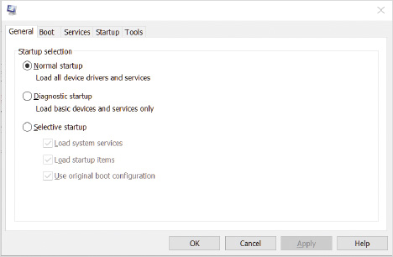
System Information provides detailed information about Windows 10 configuration for hardware and software. You can view information such as hardware resources, device configuration, device drivers, services, and running tasks.
Task Scheduler lets you create system maintenance tasks that are performed on a regular schedule or when system events occur. Windows 10 uses Task Scheduler to perform many background maintenance tasks. You can also create your own tasks.
Windows Defender Firewall with Advanced Security is an advanced editor for configuring Windows Firewall. It allows you to configure advanced settings for Windows Firewall that are not available through the Windows Firewall applet in Control Panel or Settings. In addition, Windows Defender Firewall with Advanced Security can configure IPSec settings. IPSec is a protocol used to encrypt data communication over the network.
The Windows Memory Diagnostics Tool is used to perform tests on the physical memory of a computer running Windows 10. The physical memory of a computer cannot be tested when Windows 10 is running because the memory diagnostics tool needs access to test all the memory, including the memory used by Windows 10. So, when you choose to use the Windows Memory Diagnostics Tool, your computer reboots to run the tool without Windows 10 in memory.
Go to pg.
help
Application Opened
Main content

2-2aMicrosoft Management Console
The MMC is a graphical interface shell that provides a structured environment to build management utilities. The MMC provides basic functionality, such as menus, so that management utility developers do not have to create it themselves. This also provides a consistent user interface for all management utilities, which makes network administrators more productive.
Network administrators use MMC consoles with MMC snap-ins to perform management tasks. Each MMC console can host one or more snap-ins. A snap-in is a component that adds control mechanisms to the MMC console for a specific service or object. For example, the Disk Management snap-in is used to manage hard disks. Snap-ins typically are capable of multiple functions. For example, the Disk Management snap-in can partition and format hard disks.
An MMC console, shown in Figure 2-5, is composed of a console menu bar, console tree, details pane, and an Actions pane. The contents of the Action and View menus in the console menu bar change based on the snap-in that is active in the console. The console menu bar also contains a mini-icon toolbar of shortcuts to common tasks in the Action and View menus. The console tree is the left pane of the console and displays the snap-ins that are loaded into the console. The details pane is the middle pane of the console and displays the details of the item selected in the console tree. The Actions pane on the right is used to provide easy access to the options in the Action menu. For example, in Figure 2-5, Event Viewer is selected, and the Actions pane shows the options available at that node.
Figure 2-5Computer Management MMC Console
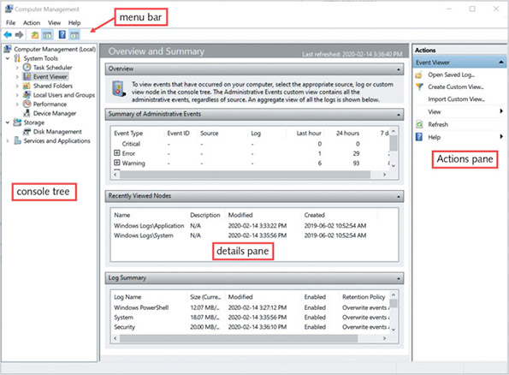
Figure 2-5 shows the pre-built Computer Management administrative tool that includes several snap-ins. You also can create a customized MMC console by adding the snap-ins you want to a single console and then saving the console as an .msc file. Because you can share .msc files among users and computers, administrators can be more productive.
Go to pg.
help
Application Opened
Main content

2-2bComputer Management
Computer Management is an MMC console that serves as a common troubleshooting and administrative interface for several snap-ins. The Computer Management console is divided into three sections: System Tools, Storage, and Services and Applications.
The System Tools section contains:
- Task Scheduler—This provides a way to schedule programs to run at a specified time or when an event occurs.
- Event Viewer—This is another way to access the same information as is found in the Event Viewer administrative tool.
- Shared Folders—This is a way to view the shared folders on the local system. The Shares folder lets you see all shares, including hidden shares, the path of each share, and the number of clients connected to each share. The Sessions folder lets you view which users are connected to the local system over the network, how many files they have open, and the computer they are using. The Open Files folder lets you see which files are open and which user has them open.
- Local Users and Groups—This is a way to access similar information as Accounts in Settings; however, this option is more advanced and provides additional options.
- Performance—This is another way to access the same information as is available in the Performance Monitor administrative tool.
- Device Manager—This provides a way to view and modify the configuration of hardware devices in your computer.
The Storage section contains:
- Disk Management—This is used to manage hard disks. You can partition and format hard disks.
The Services and Applications section contains:
- Services—This is used to enable, configure, and disable Windows 10 services.
- WMI Control—This provides a way to back up and restore, control security, and specify a default namespace for Windows Management Instrumentation (WMI). WMI is used to perform remote monitoring and management of Windows.
Tip
You can also open Computer Management by pressing Win+X and selecting Computer Management.
Activity 2-3

Using Computer Management
Time Required: 5 minutes
Objective: Use the Computer Management MMC Console
Description: The Computer Management MMC console is one of the most commonly used administrative tools. It has several useful snap-ins, such as Event Viewer, Disk Management, and Services. In this activity, you open Computer Management using two different methods.
- 1
If necessary, start your computer and sign in.
- 2
Click the Start button, type Control Panel in the Search box, and then click Control Panel.
- 3
Click System and Security and then click Administrative Tools in the right pane.
- 4
Double-click Computer Management in the left pane. Notice that a number of options to manage Windows 10 using this single MMC console are listed.
- 5
In the left pane, expand Services and Applications and click Services. This is the same information you can see in the Services tool that is available in Administrative Tools.
- 6
Close Computer Management.
- 7
Close the Administrative Tools window and close the System and Security window.
- 8
Right-click the Start button and then click Computer Management. This is another way to start Computer Management.
- 9
Close Computer Management.
Go to pg.
help
Application Opened
Main content

2-2cServices
A service is a program that runs in the background without user interaction. Services typically perform tasks for other software applications or perform housekeeping tasks for Windows 10. For example, the DHCP Client service is responsible for communicating on the network to get a network address that allows Windows 10 to access servers and the Internet. Windows Defender Firewall also runs as a service.
The Services administrative tool is used to manage Windows 10 services. The details pane of Services has a standard view and an extended view that can be selected from tabs at the bottom of the console. The extended view, shown in Figure 2-6, displays the description of the selected service at the left side of the details pane and includes shortcuts for starting, stopping, and restarting the selected service.
Figure 2-6Services Window
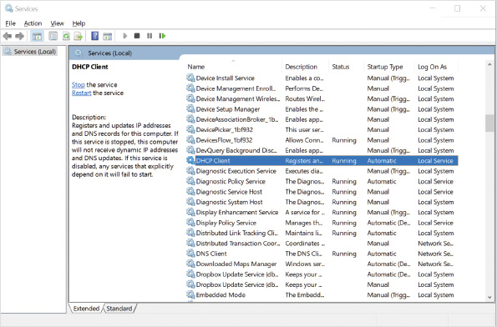
Both views show the following service information:
- Name—Each service is given a name to identify it. You can modify the name of a service, but it is not recommended. If you call a vendor for support, the vendor will expect services to be using standard names.
- Description—The description of a service provides information about what tasks the service performs. Descriptions for Windows services are provided by Microsoft, while descriptions for other services are provided by the vendor.
- Status—The status of a service indicates whether it is started or stopped. In rare cases, a service may have a status of starting or stopping if the service is experiencing problems during startup or shutdown.
- Startup Type—Services with an Automatic startup type are started when Windows 10 boots. Services with an Automatic (Delayed Start) startup type are started several minutes after Windows 10 boots. Services with a Manual startup type must be started manually by a user or by another application. Services with a Disabled startup type cannot be started.
- Log On As—Each service logs on to (or signs in to) Windows to determine its permissions to perform tasks such as file manipulation. Services can log on as the Local System account, which has full access to Windows 10, or a specific user account. Most Windows 10 services log on as Local System. However, logging on as a specific user account is more secure. Some Windows 10 services log on as Network Service or Local Service. Both of these accounts are more limited than Local System.
When you view the properties of a service, you can see additional information about it. You can also modify characteristics of the service. The Properties dialog box of a service, shown in Figure 2-7, includes the following tabs:
- General—Displays the service name, description, path to executable, and start parameters. In addition, it includes buttons to start, stop, pause, and resume the service. Stopping and starting a service is often performed when the service has experienced an error. Pausing and restarting a service is typically done when testing service functionality.
- Log On—Allows you to specify the account name used by a service to log on to perform its tasks.
- Recovery—Allows you to specify which action is taken after first, second, and subsequent failures. The actions include taking no action, restarting the services, running a program, and restarting the computer.
- Dependencies—Shows you which other services require this service to be running before they can start. In addition, this tab shows you the other services that must be running for this service to start.
Figure 2-7Properties of a Service Dialog Box
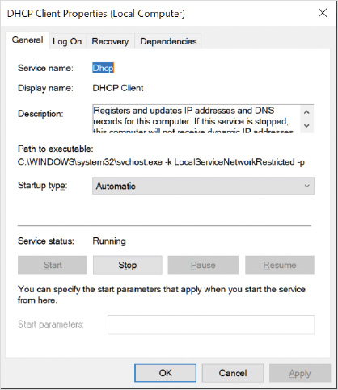
Activity 2-4

Managing Services
Time Required: 10 minutes
Objective: Manage Windows 10 services by using the Services tool
Description: Windows 10 has a number of services that run in the background performing system tasks. As part of a troubleshooting process, you often need to verify the status of services and occasionally stop or start services. In this activity, you manage services by using the Services MMC snap-in.
- 1
If necessary, start your computer and sign in.
- 2
Click the Start button, type Services, and then click Services.
- 3
If necessary, scroll to and then click Bluetooth Support Service. The extended view in the Services snap-in shows a description of the service at the left side of the window. This description can also be viewed when you are looking at the properties of a service.
- 4
Click the Standard tab at the bottom of the window. This view removes the service description and makes it easier to see information about the services.
- 5
Scroll down, right-click Network Connection Broker, and then click Restart on the shortcut menu. When you restart a service, you are given a list of other services that depend on it and are notified that the dependent services will also be restarted.
- 6
In the Restart Other Services window, click Yes. This stops and starts the service and the dependent services. It is occasionally necessary to stop and start a service if it is not functioning properly.
- 7
Double-click Network Connection Broker. The General tab in the Properties dialog box shows most of the same information that was visible in the summary of services you have already been viewing. Notice that this tab shows the executable file that runs as a service.
- 8
Click the Log On tab. If a service is configured to run as a particular user account to limit its permissions, then the credentials are entered here.
- 9
Click the Recovery tab. This tab contains settings for the actions to be taken if this service fails one or more times. Notice that this service is automatically restarted after each failure.
- 10
Click the Dependencies tab. Notice that this service requires several services to run properly, and one service depends on it.
- 11
Click Cancel and then close the Services window.
Caution
When you restart a service with dependencies, sometimes the process fails due to delays stopping or starting any one of the services. When this happens, you need to manually verify that all services were restarted.
Go to pg.
help
Application Opened
Main content

2-3Command-Line Administration Tools
A command-line interface (CLI) is a text-based interface that requires you to type in all the commands. Older operating systems such as MS-DOS had only a command line interface, and all the utilities and management was done with a keyboard. Even though Windows 10 has a graphical interface, you still have the option to do much management from a command-line.
Go to pg.
help
Application Opened
Main content

2-3aCommand Prompt
The first Windows operating systems included a command prompt for command-line administration. Windows 10 still includes a command prompt, shown in Figure 2-8, for you to run command-line tools and applications. You’re unlikely to find command-line applications anymore, but plenty of useful command-line tools are included in Windows 10.
Figure 2-8Command Prompt Window
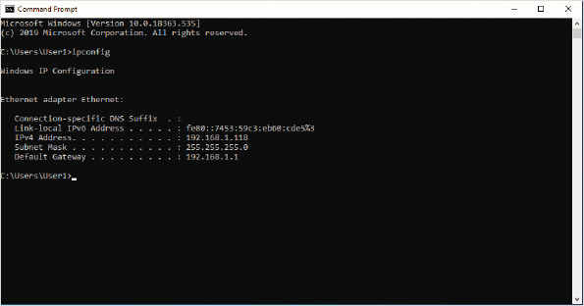
You’ll see many command-line tools throughout this book, but here are a few examples:
- Ping.exe for testing network connectivity
- Ipconfig.exe to view network configuration settings
- Netsh.exe to modify network configuration settings
- Dism.exe to configure features and packages in Windows 10
In addition to running executable files designed for command-line use, you might also see batch files. A batch file is a text file with the .bat extension. Inside the text file, each line is one command. Batch files are not commonly used in Windows 10 anymore, but you might see them in some environments for logon scripts or other automated tasks.
When you are learning to use command-line utilities, one difficulty is identifying the available options. Fortunately, most command-line utilities are self-documenting and include help information. To get help information for most command line utilities, use the /? switch.
Activity 2-5

Using a Command Prompt
Time Required: 10 minutes
Objective: Use a command prompt to run utilities
Description: Windows 10 includes a command prompt for administration. In this activity, you learn how to open a command prompt and run command-line utilities.
- 1
If necessary, start your computer and sign in.
- 2
Click the Start button and then type cmd. Notice that you have the option to run the command prompt as administrator. This is required to perform some administrative actions.
- 3
Click Command Prompt in the left pane.
- 4
At the command prompt, type ipconfig.exe and then press Enter. This command displays network configuration information.
- 5
Type ipconfig and then press Enter. Notice that you can run the command without specifying .exe. However, it is running the same file both times.
- 6
Type ipconfig /? and then press Enter.
- 7
Scroll through the help information for ipconfig and read it.
- 8
Type dir and then press Enter. This shows the folders and files in the current directory. Notice that ipconfig.exe is not in the current directory.
- 9
Type echo %path% and press Enter. This displays the value of the path environment variable. All these locations are searched for executable files when you attempt to run them.
- 10
Type dir.exe and then press Enter. This fails because the dir command is built into the command prompt and not an executable file.
- 11
Type dir /? and then press Enter. This displays the help information for the dir command.
- 12
Close the command prompt window.
Go to pg.
help
Application Opened
Main content

2-3bWindows PowerShell
Windows PowerShell is a newer command-line interface, shown in Figure 2-9, for performing system configuration in Windows 10. First introduced in Windows Vista, Windows PowerShell has become an essential administrative tool. You can perform many configuration tasks by using Windows PowerShell, but the real usefulness for Windows PowerShell is scripting. Windows PowerShell scripts are an effective replacement for batch scripts and Visual Basic scripts. Most people find it significantly easier to work with Windows PowerShell than batch scripts or Visual Basic scripts.
Figure 2-9Windows PowerShell Prompt
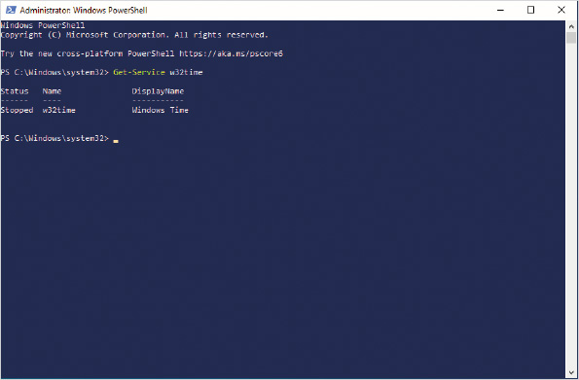
Each version of Windows PowerShell adds additional capabilities for managing Windows. Some of the actions you can perform with Windows PowerShell are:
- Manage services
- Manage processes
- Manage networking
- Edit the registry
- Manipulate files and folders
- Retrieve event log events
The individual commands in Windows PowerShell are cmdlets (pronounced command-lets). Each cmdlet is a verb-noun format. The verb describes what you want to do, and the noun describes what you want to do it to. For example, Start-Service is used to start a service. Some of the common verbs are: Get, Set, Remove, Start, and Stop.
Caution
Microsoft has released PowerShell Core as a cross-platform solution for command-line administration; however, it does not support some of the cmdlets that are available in Windows PowerShell.
Most cmdlets have parameters that are used to provide instructions to the cmdlet. The parameters of a cmdlet are similar to using switches to modify the actions of an executable. A dash is used at the beginning of all parameter names, for example, “Start-Service -Name W32Time”.
You can learn to use cmdlets in several ways, such as:
- Do a search for examples—If you are trying to accomplish a specific task, search for that task plus the word PowerShell. Many people have well-written blog postings and sample scripts.
- Do an Internet search for the cmdlet—If you execute an Internet search for a specific cmdlet, the Microsoft help information for that cmdlet is usually at the top of the results list. That help information includes a description of all the available parameters and examples.
- Use the Get-Help cmdlet—The Get-Help cmdlet provides a description of parameters and examples for a cmdlet. Use the -Full parameter to get all of the available information. For example, “Get-Help Get-Service -Full” shows all of the available help for the Get-Service cmdlet.
Tip
Use tab completion when you are typing in cmdlets and parameters. When you are typing, press Tab and the name of the cmdlet or parameter will be autocompleted for you. If multiple matches for what you have typed are listed, pressing Tab multiple times cycles through them. Using autocomplete makes entering commands faster and increases accuracy.

Objects and Properties
When you use a Get-* cmdlet to retrieve a list of items such as services or processes, the items retrieved are objects that you can examine and manipulate. Objects have properties that can be examined and modified. For example, when you use Get-Service to retrieve a list of services that are running, each service returned is an object that has properties. Properties for a service include elements such as Status, Name, and StartType.
When you query a list of objects, you can pipe those objects to another cmdlet for further processing. To pipe objects between cmdlets, you use the pipe symbol ( | ), which is a vertical line. The following example queries a list of services and then pipes the objects to the Sort-Object cmdlet to sort based on the value in the status property:
- Get-Service | Sort-Object Status
To view all information about an object type, you use the Get-Member cmdlet. This cmdlet accepts an object as input and then displays all of the properties in that object type. Get-Member also displays methods that can be used to manipulate that object type. The following example shows all of the properties and methods available for services:
- Get-Service | Get-Member

Formatting Output
Each cmdlet has a default output format that identifies which properties are displayed in list format or table format. Typically, a cmdlet displays only a subset of properties on the screen. If you need to see the value of other properties, you can modify the output to display specific properties. The two common display formats are:
- List—Displays each property as a separate line and each object is listed consecutively. This format allows you to see more detail about objects. Pipe output to Format-List to display output in a list format.
- Table—Displays object properties in a table format in which each object is a row and each property is a column. This makes object information easily readable if you want to display a limited amount of information on the screen. Pipe output to Format-Table to display output in a table format.

Windows PowerShell Scripts
Windows PowerShell scripts are text files saved with the .ps1 file extension. Although it is possible to create PowerShell scripts by using a simple text editor, such as Notepad, you should use a more advanced editor, such as the Windows PowerShell Integrated Scripting Environment (ISE). Windows PowerShell ISE, shown in Figure 2-10, provides color coding of the script as you type it to help you identify when syntax errors are entered. It also includes debugging functionality. Windows PowerShell ISE is included in Windows 10.
Figure 2-10Windows PowerShell ISE Window
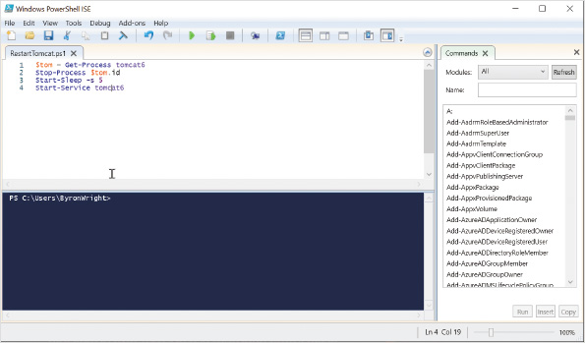
Tip
Windows PowerShell ISE is no longer in active development. Consider using the free Visual Studio Code editor from Microsoft instead. To create and edit Windows PowerShell scripts with Visual Studio Code, you need to download and install the PowerShell extension for Visual Studio Code. For more information see https://docs.microsoft.com/en-us/powershell/scripting/components/vscode/using-vscode.
Windows 10 includes an execution policy setting that controls which Windows PowerShell scripts can be run. The valid settings are:
- AllSigned—All scripts must be digitally signed by a trusted publisher.
- RemoteSigned—All scripts downloaded from the Internet must be signed by a trusted publisher.
- Restricted—No scripts can be run. This is the default for Windows 10.
- Unrestricted—Any script can be run.
- Bypass—All scripts can be run and no warnings will be issued.

Windows PowerShell vs. Command Prompt
You can use Windows PowerShell as a unified solution for command-line administration. Almost all utilities that you can run at a command prompt also work properly at a Windows PowerShell prompt. This means that you can choose the utilities and commands that you are most comfortable with when working at a Windows PowerShell prompt. For example, you can use cmdlets for most tasks, but continue using ipconfig.exe to view network configuration.
Tip
Most problems running command-line utilities in a Windows PowerShell prompt are caused by characters that are valid at a command prompt but are reserved in Windows PowerShell. For example, the - character used by some utilities to specify options is reserved in Windows PowerShell to indicate a parameter. The { } characters used with bcdedit.exe are also reserved characters in Windows PowerShell.
Activity 2-6

Using Windows PowerShell
Time Required: 10 minutes
Objective: Use Windows PowerShell to display information about Windows 10
Description: Windows 10 includes many PowerShell cmdlets for viewing information and configuring Windows 10. In this activity, you query information and format it.
- 1
If necessary, start your computer and sign in.
- 2
Right-click the Start button and then click Windows PowerShell (Admin) on the shortcut menu.
- 3
In the User Account Control window, click Yes.
- 4
At the Windows PowerShell prompt, type Get-Service and then press Enter. This displays all services with the default view showing Status, Name, and DisplayName.
- 5
Type Get-Service | Sort-Object Status and then press Enter. This command sends the list of services to the Sort-Object cmdlet which sorts the services based on the value of the Status property.
- 6
Type Get-Service -Name w32time and then press Enter. This gets information for just one service.
- 7
Type Get-Service w32time | Format-List and then press Enter. This displays the information for the service in a list format.
- 8
Type Get-Service w32time | Format-List * and then press Enter. This displays all properties in a list format.
- 9
Type Get-Service w32time | Format-Table Name,DisplayName,Status,StartType and then press Enter. This displays specific properties in a table format.
- 10
Type Get-Process | Out-GridView and then press Enter. This displays information in a sortable grid view similar to a spreadsheet. The information in grid view is a snapshot and does not update. You can sort the data by clicking the column names.
- 11
Close the Get-Process | Out-GridView window.
- 12
At the Windows PowerShell Prompt, type Get-Command *-Service and then press Enter. This displays all the cmdlets you can use to manage services.
- 13
Type Get-Help Restart-Service and then press Enter.
- 14
Type y and then press Enter to update the help content from the Internet. Wait for a few minutes while the help updates.
- 15
Read the help information that is displayed for Restart-Service. This is only the summary information.
- 16
Type Get-Help Restart-Service -Full and then press Enter.
- 17
Scroll up and down to read the full help for the Restart-Service cmdlet. This information now includes detailed information about the parameters and examples.
- 18
Type Get-ExecutionPolicy and then press Enter. By default, running Windows PowerShell scripts is not allowed.
- 19
Type Set-ExecutionPolicy RemoteSigned and then press Enter. This allows you to run any Windows PowerShell scripts that you create but not unsigned scripts from the Internet.
- 20
Type y and then press Enter to confirm making the change.
- 21
Close the Windows PowerShell prompt window.
Tip
When you want to repeat a command in a Windows PowerShell prompt, you can press the up arrow on the keyboard to display the previous command.
Go to pg.
help
Application Opened
Main content

2-4Display
As a system administrator, your main concern for displays is the display drivers that are required for Windows 10. Windows 10 requires a display driver that supports the Windows Display Driver Model (WDDM) and DirectX 9. This is approximately the same video requirements that were in place for Windows 7 and should be met by all more recent video cards. With the correct driver installed, you can ensure that the display is configured to match the needs of your users.
Go to pg.
help
Application Opened
Main content

2-4aDisplay Settings
The Display settings, shown in Figure 2-11, allow you to modify commonly configured display settings. You can change the size of text and applications if you have a very high-resolution screen and want to make items appear larger. You can change the orientation of monitors to be landscape or portrait to match the physical orientation of the monitor. The night light option allows you to change the screen colors away from the blue spectrum at night.
Figure 2-11Display Settings
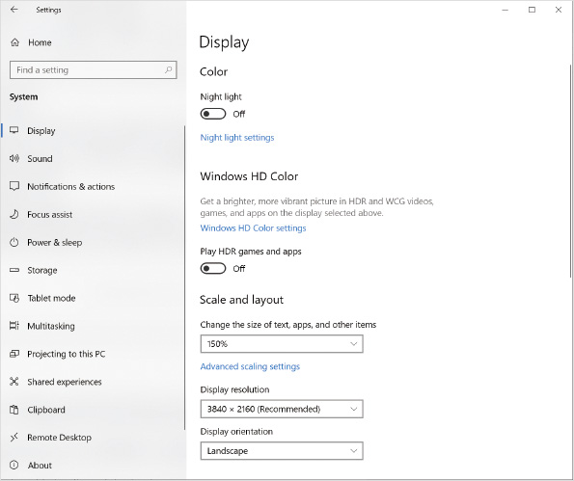
The display resolution is the number of pixels that your display can show. A pixel is a single dot on the screen. The resolution is expressed as the number of horizontal pixels by the number of vertical pixels. For example, a resolution of 1366 × 768 means that there are 1366 pixels across the screen and 768 pixels up and down the screen. The common high definition (HD) resolution is 1920 × 1080. If you get a 4K monitor, the resolution is 3840 × 2160.
The optimal display resolution varies depending on the display you are using and your video card. In general, monitors should be used at their native resolution. If you set your screen resolution at less than the native resolution, the display appears fuzzy.
Modern monitors are Plug and Play, and Windows 10 queries the optimal display resolution for the monitor. The optimal display resolution is selected by default and marked as recommended.
The display settings vary depending on your computer hardware. For example, the Play HDR games and apps option appears only when supported by the video card and the display.
The Advanced display settings option allows you to view detailed configuration options for each display, including the resolution, refresh rate, and color configuration. You can also open the display adapter properties shown in Figure 2-12. On the Adapter tab, you can configure the screen resolution and color depth being used by selecting a mode. The Monitor tab allows you to set the refresh rate for the monitor. You can set a color profile on the Color Management tab to optimize colors for a particular display or purpose.
Figure 2-12Display Adapter Properties
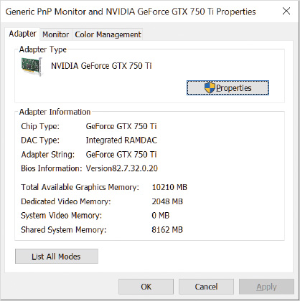
Activity 2-7

Configuring Display Settings
Time Required: 10 minutes
Objective: Configure the screen resolution and color depth for your computer
Description: Windows 10 automatically selects display settings based on the display device that is connected to your computer during installation. You might want to modify the display settings, however, to suit your own preferences. In this activity, you change the display settings and view the results.
- 1
If necessary, start your computer and sign in.
- 2
Right-click the desktop and then click Display settings on the shortcut menu.
- 3
In the Settings window, in the Scale and layout area, take note of the existing setting in the Change the size of text, apps, and other items box. On most computers this value will be 100%, but high resolution displays might be using a larger value, such as 300%.
- 4
In the Change the size of text, apps, and other items list, select 125%. Notice that all text on the screen changed size. This is useful on high resolution displays or small screens.
- 5
In the Change the size of text, apps, and other items list, select the original value you took note of in Step 3.
- 6
Click Advanced scaling settings in the right pane.
- 7
Read the advanced scaling settings and then click the back arrow.
- 8
Read the value in the Display resolution box and take note of it.
- 9
Click the Display resolution box, select 800 × 600, and click Keep changes. If you are using a physical computer, everything appears larger when the screen resolution gets smaller. If you are using a virtual machine, the virtual machine viewing window might become smaller instead of the graphics becoming larger.
- 10
Click Advanced display settings. Notice that the screen resolution listed is what you configured.
- 11
Click Display adapter properties for Display 1. If you do not see the adapter Properties window, it might be located behind the Settings window.
- 12
In the adapter Properties window, click the List All Modes button. This displays all of the screen resolution, color depth, and refresh rate combinations that your display and video card are capable of providing.
- 13
Select the mode with a display resolution that matches what you noted in Step 8 and then click OK.
- 14
Click the Monitor tab. This tab shows you what type of monitor is installed and allows you to configure the screen refresh rate.
- 15
Click OK and then click Keep changes to keep the new settings.
- 16
Close the Settings window.
Go to pg.
help
Application Opened
Main content

2-4bVisual Effects
The performance options for Windows 10 includes visual effects that can be enabled or disabled, as shown in Figure 2-13. In most cases, you should use the Let Windows choose what’s best for my computer option. When this option is selected, Windows enables and disables specific options based on the performance capabilities of your computer.
Figure 2-13Visual Effects Settings
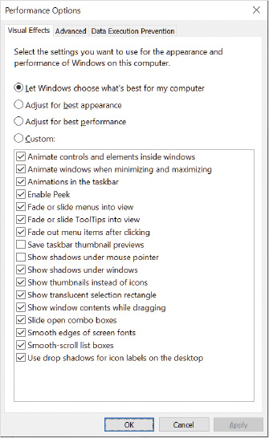
Because the visual effects seldom need to be configured, they are not directly accessible in Settings. To access the visual effects:
- 1
Click the Start button, type control, and then click Control Panel.
- 2
In Control Panel, click System and Security and then click System in the right pane.
- 3
In the System window, click Advanced system settings in the left pane.
- 4
In the System Properties dialog box, on the Advanced tab, in the Performance area, click Settings.
Go to pg.
help
Application Opened
Main content

2-4cDesktop Backgrounds
Personalizing the desktop background is one of the most common actions users want to perform when receiving a new computer. Some corporate environments dictate that a standard desktop background must be used. Standardizing the desktop background has no effect on the performance of a computer; however, a standardized background can be used to display information, such as contact information for the help desk.
Windows 10 comes with a number of desktop backgrounds from which you can choose. Most people, however, want to use their own pictures for a desktop background. This is the computer equivalent of putting a picture on your desk. When you use your own image for a desktop background, it can be in any common picture format such as bitmap (.bmp), Joint Picture Experts Group (.jpeg, .jpg), Graphics Interchange Format (.gif), or Portable Network Graphics (.png) format.
When you select a desktop background, you must also select how the graphic is laid out on the page. You can choose to stretch the picture to the size of the screen, center the picture on the screen, or tile the picture. Stretching the picture distorts the image if the original graphic is not the same proportion as the screen. Centering the picture ensures that the image is not distorted but may leave blank spaces around the picture. Tiling the picture repeats the image if the size of the picture is less than the screen resolution.
You have the option to configure a slideshow for your background. You can define how often the pictures are changed and use the Shuffle option to randomize how they are displayed.
Go to pg.
help
Application Opened
Main content

2-4dScreen Savers
At one point in time, screen savers were used to prevent screen burn-in, sometimes called ghosting or etching. Screen burn-in occurred in monitors that displayed the exact same image for an extended period of time. After screen burn-in occurs, a ghosted image appears on the screen. Screen savers were meant to combat screen burn-in by constantly changing the information displayed on the screen.
Screen savers are no longer required to prevent screen burn-in. Modern displays are much less susceptible to screen burn-in than older devices. In addition, power-saving features in modern computers turn off displays quite quickly, often in the same time frame you would configure a screen saver to turn on.
Screen savers are now a security mechanism for locking a computer. By default, no screen saver is configured in Windows 10 and the screen does not lock. To increase security, you should enable the On resume, display logon screen option, shown in Figure 2-14. After you enable this option, you can define how many minutes of inactivity are required before the screen saver starts. If no screen saver is selected, the screen is blanked instead. When you resume using the computer, you are forced to sign in again. This ensures that if you leave your computer unattended, no one can access your work.
Figure 2-14Screen Saver Settings
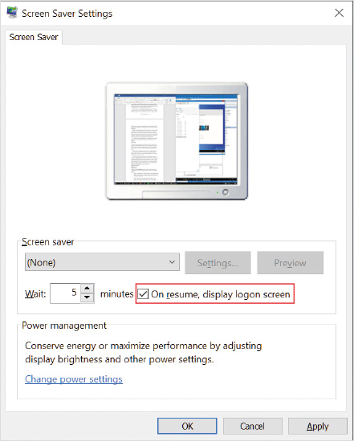
Tip
To ensure consistent application, many organizations use Group Policy to configure screen lock settings on all computers.
Go to pg.
help
Application Opened
Main content

2-4eMultiple Monitors
Windows 10 supports multiple monitors attached to a single computer. When you use multiple monitors, there are three configuration options; each option is useful in different scenarios:
- PC only—On a laptop computer with an external display connected, this option allows you to display only on the laptop display and leave the external display blank. This is useful when a laptop is connected to a projector for a presentation, but you want to do some work before the presentation that is not displayed on the projector.
- Duplicate—The default option for multiple monitors is to mirror the desktop on both displays. This is most useful when one display is a projector and you are performing a presentation or demonstration.
- Extended—When the desktop is extended onto the second display, you have additional screen space to perform your work. You can move windows back and forth between the two displays and even stretch windows across both monitors. This makes it easier to use multiple applications at the same time. For example, a system administrator can perform remote desktop operations on one display while reading documentation on the other display. Microsoft PowerPoint automatically uses this option when available to display presentation notes on the local display and slides on the external display.
- Second screen only—When you are running a laptop on batteries, it is useful to turn off the LCD panel display and use only an external projector during presentations and demonstrations. This can also be useful when connecting a laptop or tablet to a larger monitor.
Tip
You can connect more than two displays to a computer if you have a need and purchase the necessary hardware.
The hardware requirements for multiple monitors vary depending on whether your computer is a laptop computer or a desktop computer. Some desktop computers include multiple connectors for displays or support the installation of multiple video cards. Laptop computers may include a connector for external displays, but it is more common to require an external adapter. You can purchase external video adapters that will work with desktop computers and laptop computers.
Caution
When purchasing an external video adapter, make sure that you purchase an adapter that works with your system and meets your requirements for display resolution and refresh rate. External adapters can connect by using USB 2.0, USB 3.0, USB-C, or DisplayPort connectors.
Tip
Instead of purchasing multiple displays for a desktop computer, consider using a 4K television with HDMI connectivity. This produces the screen resolution of four HD (1920 × 1080) monitors with a single connection, which provides ample screen space to use multiple applications at the same time.
When you have multiple displays, you can configure which display is primary. The primary display is the one that displays the taskbar and Start button. Both displays are shown in Display settings. You can configure whether the taskbar is displayed on additional monitors and which apps are listed on the taskbar of the secondary monitor.
Go to pg.
help
Application Opened
Main content

2-5Managing Optional Features
Windows 10 has optional features that provide additional functionality, which is not always required. Because these features are not part of the Windows 10 core functionality, they can be added or removed. Some of the features are:
- Language-based handwriting and speech recognition
- Internet Explorer 11
- Windows Media Player
- Language specific fonts
- Remote Server Administration Tools (tools to manage server features)
- Hyper-V
- Internet Information Services (IIS)
Some optional features can be viewed in Settings in Apps & features, as shown in Figure 2-15. These optional features are primarily applications for users and user interface features.
Figure 2-15Optional Features
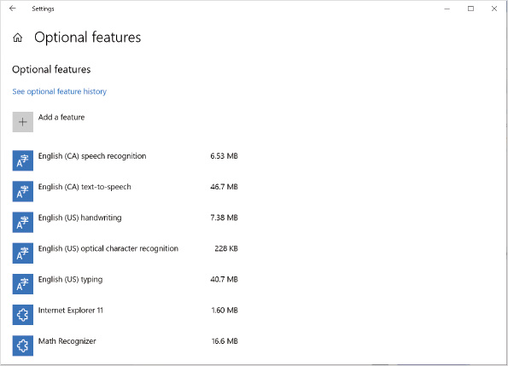
A different set of optional features is accessible by using the Turn Windows features on or off option in Control Panel, dism.exe, or the Enable-WindowsOptionalFeature and Disable-WindowsOptionalFeature cmdlets. This set of features tends to be more technical and is likely to be used only by system administrators.
Activity 2-8

Managing Windows Optional Features
Time Required: 10 minutes
Objective: Manage Windows optional features
Description: Optional features in Windows 10 can be enabled or disabled depending on your requirements. For example, if you need to use server management tools from your computer running Windows 10, you can enable Remote Server Administration Tools. In this activity, you will manage optional features in Windows 10.
- 1
If necessary, start your computer and sign in.
- 2
Click the Start button and then click Settings.
- 3
In the Settings window, click Apps and then click Optional features in the Apps & Features area on the Apps and features screen.
- 4
Review the list of optional features that are already installed and then click Add a feature.
- 5
Scroll down and read the list of optional features available for installation and then close the Settings window.
- 6
Click the Start button, type control, and then click Control Panel.
- 7
In Control Panel, click Programs and then click Turn Windows features on or off in the Programs & Features area in the right pane.
- 8
In the Windows Features dialog box, scroll up and down to read the list of available features, and then click Cancel.
- 9
Close Control Panel.
- 10
Right-click the Start button and then click Windows PowerShell (Admin) on the shortcut menu.
- 11
At the User Account Control prompt, click Yes.
- 12
At the Windows PowerShell prompt, type Get-WindowsOptionalFeature -Online and then press Enter. This queries the status of all optional features.
- 13
Scroll through the list of optional features and read them. This list includes many optional features not available in Settings.
- 14
Type Get-WindowsOptionalFeature -Online | Where-Object State -eq Enabled and then press Enter. This generates a list of optional features that are enabled.
- 15
Type Get-WindowsOptionalFeature -Online -FeatureName TelnetClient and then press Enter.
- 16
Type telnet.exe and then press Enter. This fails because the telnet client is not enabled.
- 17
Type Enable-WindowsOptionalFeature -Online -FeatureName TelnetClient and then press Enter.
- 18
Type telnet.exe and then press Enter. This telnet client starts because it has been enabled.
- 19
Type quit and then press Enter. This exits the telnet client.
- 20
Type dism.exe /online /get-features and then press Enter. This provides the same information as the Get-WindowsOptionsFeature cmdlet.
- 21
Type dism.exe /online /get-featureinfo:telnetclient and then press Enter.
- 22
Type dism.exe /online /disable-feature:telnetclient and then press Enter. This removes the TelnetClient feature.
Go to pg.
help
Application Opened
Main content

2-6Hardware Management
Managing and maintaining computer hardware is a task performed regularly by network administrators. Windows 10 supports a wide variety of internal and external hardware components with which you should be familiar. Internal hardware components include network cards, video cards, and hard disk drives. External components are typically peripheral devices, such as a mouse, printer, or USB drive.
Windows 10 requires device drivers to manage and communicate with hardware components. Device drivers are written specifically for a particular type and model of component. For example, a GeForce GTX 1650 video card driver is different than a Radeon RX 570 video card driver.
Microsoft does not provide a list of hardware that is compatible with Windows 10. In most cases, hardware that functioned properly in Windows 7 or newer works with Windows 10. If your computer is running Windows 7 SP1 or Windows 8.1, you can use the Windows 10 Update Assistant to verify compatibility.
Note 2
The Windows 10 Update Assistant can be downloaded from https://www.microsoft.com/en-us/software-download/windows10.
To manage hardware in Windows 10, you should understand:
- Device drivers
- Device driver compatibility
- Device Manager
- Device driver signing
- Procedures for adding new hardware components
Go to pg.
help
Application Opened
Main content

2-6aDevice Drivers
Hardware devices, such as modems, network adapter cards, and video cards, are manufactured by a wide variety of vendors. The capabilities and functions of these devices vary depending on the model and manufacturer.
Device drivers act as intermediaries between a hardware component and an operating system, such as Windows 10. A device driver contains the instructions on how to use the full capabilities of a device properly. After they are installed, device drivers load automatically as part of the boot process each time Windows 10 is started.
In some cases, a device driver not specifically designed for a hardware component may allow that component to function. For example, the Microsoft Basic Display Adapter driver works with almost all video cards. If an incorrect device driver works, it is because the basic functionality of a class of hardware devices, such as video cards, is similar. Installing the wrong device driver for a hardware component, however, results in poor performance and does not let you use the advanced features of a device. Using the incorrect device driver for a hardware component may also make Windows 10 unstable.
Vendors regularly release updated device drivers to improve performance, add features, or fix flaws. It is a best practice to use the latest device drivers that are available from the manufacturer’s website. When a device is not working properly, installing the latest device driver should be one of the first troubleshooting steps.
Tip
Some device drivers are distributed by Windows Update as optional updates.
Go to pg.
help
Application Opened
Main content

2-6bDevice Driver Compatibility
Some device drivers designed for previous versions of Windows do not work properly with Windows 10. The driver incompatibility is due to changes that make Windows 10 more stable and secure. If a driver does not function properly in Windows 10, you must get an updated driver from the device manufacturer.
Some potential device driver compatibility issues are:
- A 32-bit version of Windows 10 requires 32-bit drivers, and a 64-bit version of Windows 10 requires 64-bit drivers.
- All driver files referenced in an .inf file must be part of the driver installation package. The .inf file for a driver describes the files that need to be installed. In some previous versions of Windows, including all files in the driver package was preferred, but not enforced. This might cause the installation of some drivers to fail.
- Installers cannot display a user interface during installation. Some older device drivers display a user interface during installation to request configuration information. You must obtain an updated device driver from the manufacturer that does not present a user interface during installation.
- All 64-bit drivers that run in kernel mode must be digitally signed by Microsoft. This means that manufacturers must submit kernel mode drivers to Microsoft for testing and approval. Previous versions of Windows allowed kernel mode drivers to be digitally signed by the manufacturer. Kernel mode drivers have unrestricted access to the computer.
- Windows 10 uses the NDIS 6.x interface for network devices. Old network cards with an NDIS 5.x driver that was compatible with Windows XP are not supported.
- Kernel mode printer drivers cannot be used in Windows 10. Replace kernel-mode printer drivers with newer, user-mode drivers from the printer manufacturer. This affects a very small number of printer drivers. Affected printer drivers are typically specialized devices used in manufacturing environments, such as bar code printers.
Go to pg.
help
Application Opened
Main content

2-6cDevice Manager
Device Manager is the primary tool for managing device drivers. The main purpose of Device Manager is to allow you to view and modify hardware device properties. Some of the tasks that can be performed with Device Manager are:
- Determining whether installed hardware is functioning correctly
- Viewing and changing hardware resource settings
- Determining and changing the drivers used by a device
- Enabling, disabling, and uninstalling devices
- Configuring advanced settings for devices
- Viewing and printing summary information about installed devices
After installing Windows 10, you should use Device Manager to confirm that all devices are working properly. You should also use Device Manager to confirm that a new component is working after installation. A hardware component that is not functioning correctly is displayed with a yellow exclamation mark. A hardware component that has been manually disabled is displayed with a down arrow, as shown in Figure 2-16.
Figure 2-16Device Manager Window
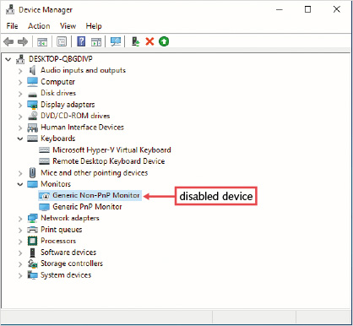
If a hardware component is not functioning properly, you should install an updated driver for it. You can install an updated device driver from the Driver tab in the Device Properties dialog box, shown in Figure 2-17. To access the properties for a device, right-click the device and click Properties. You can also install an updated device driver by using the Hardware Update Wizard that is accessible by right-clicking the device.
Figure 2-17Properties of a Device, Driver Tab
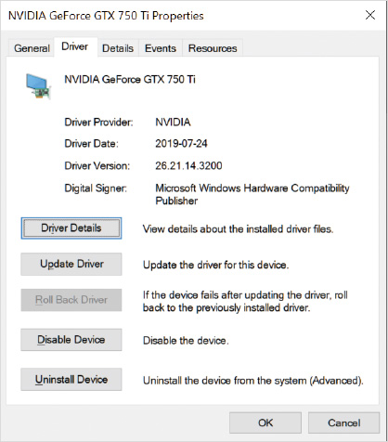
Although vendors perform extensive testing, occasionally an updated device driver causes problems. You can roll back a device driver to the previous version when an updated device driver causes problems.
Tip
Device Manager is a stand-alone tool and also is included in Computer Management.
Activity 2-9

Using Device Manager
Time Required: 10 minutes
Objective: Use Device Manager to configure hardware components and device drivers
Description: Device Manager is an administrative tool that can configure hardware components and device drivers. You can use it to install updated drivers and disable devices that are not functioning properly. In this activity, you view the status of the network card in your computer.
- 1
If necessary, start your computer and sign in.
- 2
Right-click the Start button and then click Device Manager on the shortcut menu. If some devices are listed with a yellow question mark, it means that no device driver is loaded for those devices.
- 3
Expand Network adapters and then double-click your network card to display the Properties dialog box (the name of the network card will vary depending on your hardware). The General tab gives general information about your network card, including its status.
- 4
Click the Advanced tab. The contents of the Advanced tab vary depending on the model of network card. The properties are defined by the device driver.
- 5
Click the Driver tab. This shows information about the device driver, including date, version number, and publisher. You can also update drivers here.
- 6
Click Driver Details. This displays the files that are used as part of the device driver.
- 7
Click OK in the Driver File Details dialog box and then click the Details tab. You can select and view the value of all the device driver properties on this tab.
- 8
Click the Property arrow and browse through the list of properties that you can view.
- 9
Click the Events tab. This tab displays information about actions taken by the device, such as loading or starting the device driver.
- 10
If present, click the Resources tab. You can view and modify the resources used by a device on this tab. This tab might not be available if your Windows 10 installation is virtualized.
- 11
If present, click the Power Management tab. You can use this tab to control how the network adapter interacts with power management. This tab might not be available if your Windows 10 installation is virtualized.
- 12
Click Cancel.
- 13
Close the Device Manager window.
Go to pg.
help
Application Opened
Main content

2-6dDevice Driver Signing
Windows 10 uses file signatures on system files to ensure system stability. Device drivers can also be signed. Device driver signing ensures that a driver for a specific hardware component has been verified by Microsoft to be from a known software publisher (meaning it is authentic). Device driver signing also ensures that the device driver has not been modified in any way since it was signed (meaning it has integrity). Viruses are unable to spread by using device drivers because digital signing shows an infected device driver as corrupted.
If you attempt to install an unsigned device driver in Windows 10, one of the following messages will appear:
- Windows can’t verify the publisher of this driver software—This message appears when no digital signature is present, or the digital signature cannot be verified as valid. You should install an unsigned driver only if you are confident it is from a legitimate source.
- This driver software has been altered—This message appears if the device driver has been altered since the developer added the digital signature. In most cases, this message indicates that the original device driver has been infected by a malicious program and it should not be installed.
- Windows cannot install this driver software—This message appears only on the 64-bit versions of Windows 10. The 64-bit versions of Windows 10 do not allow unsigned device drivers to be installed by default. For testing purposes, however, you can disable the check for driver signing by using bcdedit.exe or in the Windows 10 advanced startup settings.
You can verify that existing drivers and system files are signed by running the File Signature Verification utility (sigverif.exe). The file name, location, modification date, and version number are returned for each unsigned file. You can then investigate whether signed versions of these files are available. It is best practice to use only signed device drivers.
Caution
A signed device driver does not indicate that Microsoft has performed stability or quality testing.
Go to pg.
help
Application Opened
Main content

2-6eHardware Component Installation
When hardware components are installed in a computer, they are assigned resource settings that allow them to access the system processor and memory in different ways. Devices for modern computers and operating systems, such as Windows 10, support Plug and Play, which automatically assigns resources to devices. Universal Serial Bus (USB) devices are also Plug and Play. Only settings for legacy ports, such as parallel ports and serial ports might require manual configuration of resources in Windows 10.
To install a Plug and Play device:
- 1
Install or attach the new hardware component.
- 2
Windows 10 automatically detects the new device.
- 3
A device driver is loaded automatically if Windows 10 contains an appropriate device driver.
- 4
If Windows 10 does not contain an appropriate device driver, you are prompted to provide one.
Some USB devices require you to install the driver before attaching the USB device the first time. This is required to ensure that Windows 10 does not attempt to load an incompatible driver before the correct driver is available. Read the instructions that come with the device to be sure.
Tip
Windows 10 might not contain the latest device driver for your hardware component. You can update the device driver after installation.
To simplify the location of device drivers, you can make them available to computers by staging the drivers in the driver store or by providing a location to search. Windows 10 contains a driver store with a large set of device drivers included on the Windows 10 installation media. You can add new drivers to the driver store by using the pnputil.exe command. By adding a device driver to the driver store, you ensure that Windows 10 is able to find and install the driver when the matching hardware is attached. For example, you could stage the driver for a new USB printer on all Windows 10 computers. Then, when that printer is attached to any Windows 10 computer in the office, the appropriate driver is automatically loaded without asking the user to locate the appropriate driver.
You can also store drivers in a centralized network location. If you store drivers in a network location, you need to modify a registry key on the Windows 10 computers to configure the computers to search in that location when looking for drivers. Edit the following registry key: HKLM\Software\Microsoft\Windows\CurrentVersion\DevicePath.
Tip
You should use an automated tool to update this registry key on all of the computers to simplify deployment.
Go to pg.
help
Application Opened
Main content

2-7Power Management
Power management is becoming a major concern for corporate and personal computer owners alike. Hardware manufacturers have started to address this concern by focusing on reduced power consumption in their new products. Minimizing power usage is driven by both cost and environmental factors.
The basic settings for power management are shown in Figure 2-18. These settings let you control when the display is turned off and when your computer goes into sleep mode. If you have a device with a battery, such as a laptop computer, you can set the display and sleep timing independently for when on battery power and when plugged in. If the device does not have a battery, then the when on battery power options are not displayed.
Figure 2-18Power & Sleep Settings
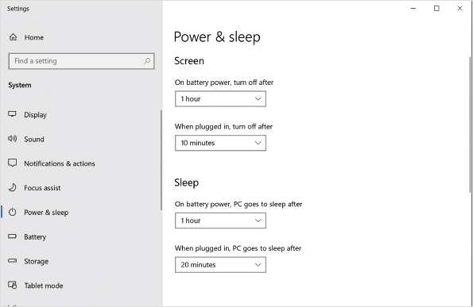
Windows 10 relies on power management capabilities in computer hardware to perform power management. Computers must meet the specifications of the Advanced Configuration and Power Interface (ACPI) standard to be managed by Windows 10. All current computers meet this standard but can implement varying options.
The ACPI standard defines power states for global power management and individual devices. Power states define which devices are drawing power in the system. Depending on the power plan you have configured, power states can be implemented at different times.
Tip
Organizations using Active Directory can centrally control power management by using Group Policy.
Go to pg.
help
Application Opened
Main content

2-7aACPI States
The ACPI standard defines several global power management states; however, not all states are used by Windows 10. Table 2-1 lists the ACPI power states used by Windows 10.
Table 2-1

ACPI Power States Used by Windows 10
Power state | Description
S0 (or G0) Working | The S0 state is the fully functioning computer. While in this state, individual devices, such as the processor and hard disks, can be in varying power states. For example, the spinning of a hard disk can be stopped after a few minutes of inactivity to reduce power usage.  For faster recovery from sleep mode, some hardware manufacturers support Modern Standby in the S0 state. Modern Standby maximizes power savings while still providing an instant on experience. Systems capable of using Modern Standby do not use the typical S3 state for sleep.
S3 Sleep | The S3 state is also known as suspend to RAM. In this state, all system devices are powered down except the RAM. The RAM retains the state of all running applications. Returning from S3 to S0 requires only that the hardware be reinitialized.  If power is lost while the computer is in the S3 state, all data from memory is lost. This is equivalent to losing power while the computer is running.  ACPI also defines sleep states S1 and S2, but they are less commonly implemented by hardware manufacturers. They also stop processing data but provide slightly less power saving.
S4 Hibernate | The S4 state is also known as suspend to disk. In this state, the contents of RAM are saved to disk and all devices including RAM are powered off. During restart, the contents of RAM are loaded from disk rather than booting the operating system. When a computer system has a large amount of RAM, restarting from the S4 state can take a long period of time. For example, a computer with 2 GB of RAM needs to load 2 GB of data from disk during startup from the S4 state. This state is commonly known as hibernate.  If power is lost while the computer is in the S4 state, all data is unaffected. Because the contents of memory are stored on disk, a power failure does not affect the S4 state.
S5 (or G2) Soft Off | In this state, the operating system is not running. This is the power state triggered when the operating system is shut down. Minimal hardware functionality is maintained, such as the ability to start booting the computer by using Wake-on-LAN. To start a computer from this state, the operating system must go through a complete boot up.
G3 Mechanical Off | In this state, the operating system is not running and no power is supplied to any devices in the computer. This is the only state in which hardware can be serviced. A computer that is in the G3 state can be unplugged and not be affected. The only power consumption for a computer in the G3 state is from a small battery that maintains BIOS settings and the clock.
Go to pg.
help
Application Opened
Main content

2-7bModern Standby
Modern Standby is the power saving option that provides the best experience for users. It is a variation of the S0 power state that minimizes power usage by putting hardware devices into their lowest possible power state, but leaving processes running. For users, Modern Standby provides an “instant-on” feeling, like a smartphone, when waking up.
This allows applications, such as an email client, to retrieve data in the background while Windows 10 is in Modern Standby. Also, other applications, such as media players, can continue to function while the system is in Modern Standby. Finally, Windows 10 can also complete scheduled maintenance tasks while in Modern Standby, such as installing updates.
Most newer computer hardware supports using the Modern Standby feature in Windows 10. The hardware support for Modern Standby varies, but if your computer supports Modern Standby it is usually enabled by default. If you want to enable legacy power management, the firmware might contain an option to do so, but the name of that option will vary depending on the computer manufacturer.
Using Modern Standby is automatically configured during installation of Windows 10 if the hardware supports it. If you want to switch back to legacy power management, you’ll need to reinstall Windows 10 after configuring the appropriate firmware setting.
On battery-backed systems such as a laptop or tablet, the risk of data loss in Modern Standby is minimal because hibernation will be triggered when the battery gets low. For desktop computers using Modern Standby, there is a risk of data loss if a power interruption occurs while the computer is sleeping. Modern Standby does not save the system state or data. To mitigate the risk of data loss, you should connect computers to an uninterruptible power supply (UPS) or enable hibernation after a specified period of time. By default, hibernation is disabled when using Modern Authentication.
Go to pg.
help
Application Opened
Main content

2-7cLegacy Power Management
For computer systems that do not support Modern Sleep, the S3 power state is used. In this power state, all processing is stopped. Applications cannot obtain data and Windows does not perform updates; however, the system can be woken up by events such as the use of Wake-on-LAN functionality where a special data packet is sent on the network to trigger a wake up.
Windows 10 also implements a hybrid sleep mode. Hybrid sleep saves the contents of memory to disk when entering the S3 state. This effectively means the computer is in the S3 state but prepared for the S4 state. Hybrid sleep is available depending on the hardware capabilities of the computer. When available, it is enabled by default.
Hybrid sleep provides the following advantages:
- If power is lost in the S3 state, the computer can recover from the S4 state on reboot. No data is lost when a power outage occurs in the S3 state.
- Hybrid sleep eliminates the requirement to leave sleep mode to enter hibernation.
Away Mode can be used to maximize power savings on computers running Windows 10 that need to maintain background processes, such as media sharing. Away Mode provides functionality similar to Modern Standby. Away Mode is implemented entirely in software and does not require hardware support. Computers in Away Mode are still in the S0 state. However, the computer looks and sounds like it is off. Away Mode maximizes device-level power savings while continuing to work in the background if required.
After Away Mode is enabled, it replaces Standby requests. For example, if shutdown normally puts the computer in the S3 state, it now puts the computer in Away Mode instead. You configure Away Mode in the Multimedia settings of a power plan. Configure the When sharing media option to Allow the computer to enter Away Mode.
Go to pg.
help
Application Opened
Main content

2-7dPower Plans
Windows 10 uses power plans to control how your computer implements power management. As many as four default power plans are provided, as shown in Figure 2-19. The plans available by default vary depending on the hardware capabilities of your computer. A computer that supports Modern Hybrid shows only the Balanced power plan by default. Some hardware manufacturers, such as Dell, include their own additional power management plan as part of the default operating system configuration.
Figure 2-19Power Plans
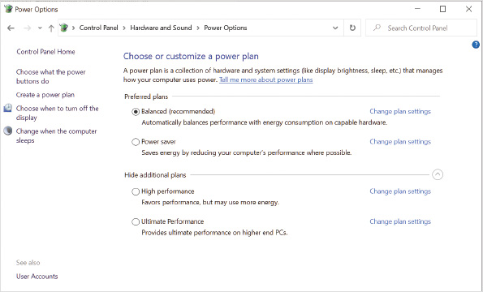
The basic settings for a power plan are the same display blanking (i.e., going blank) and sleep timing that you can configure in Settings, but you can configure more advanced granular settings. Some of the advanced settings you can configure are:
- How long the hard disk is idle before turning it off
- Power saving mode for wireless network adapters
- Minimum processor state (as percentage of clock rate)
- Maximum processor state (as percentage of clock rate)
Tip
When you edit the display blanking and sleep timing in Settings, you are editing the values for the currently selected power plan.
Activity 2-10

Configuring a Power Plan
Time Required: 5 minutes
Objective: Configure a power plan to reduce power consumption
Description: Windows 10 includes default power plans to maximize performance, maximize power savings, and provide balanced power savings and performance. In most environments, the Balanced plan is the most appropriate because maximum performance is not required. In this activity, you configure a power plan.
- 1
If necessary, start your computer and sign in.
- 2
Click the Start button and then click Settings.
- 3
Click System and then click Power & sleep in the left pane. The options available here are very limited. If your system is virtualized, you might see only the option to control when the screen will be turned off.
- 4
Click Additional power settings in the Related Settings area in the right pane.
- 5
If available, click Change settings that are currently unavailable. This is required to allow you to select a power plan.
- 6
In the Power Options window, under Preferred plans, click Power saver. This changes the current power plan.
- 7
Next to the Power saver plan, click Change plan settings. Notice that when using the Power saver plan, the display turns off after 5 minutes. The content displayed here will vary depending on whether your computer is ACPI compliant. An ACPI-compliant computer will also have a setting for when the computer goes to sleep.
- 8
Click Change advanced power settings. This allows you to see more detailed information about the power plans.
- 9
Read the setting for turning off a hard disk. This setting is relevant for only spinning (magnetic) disks and not for SSD drives.
- 10
Expand Processor power management and expand Minimum Processor State. The minimum processor state is 5%. A virtualized version of Windows 10 might not have this setting.
- 11
Expand System cooling policy. This controls whether the system will use fans to cool the processor. When set to Passive instead of Active, the processor speed is slowed to prevent heat buildup instead of using fans. This can result in a significant performance decrease.
- 12
Expand Maximum processor state. The maximum processor state is 100%. You could reduce the maximum processor state to reduce battery utilization, but it will also decrease system performance.
- 13
Close all open windows and dialog boxes.
Tip
If you forget what changes you have made when editing a power plan, you can click the Restore plan defaults button.
Go to pg.
help
Application Opened
Main content

2-7eFast Startup
Windows 10 makes shutting down and restarting your computer faster with Fast Startup. When you shut down a Windows 10 computer with Fast Startup enabled, it signs out all the user accounts, closes all applications, and hibernates Windows 10. When you turn your computer back on again, it resumes from hibernation rather than performing a complete startup. Fast Startup is enabled by default.
The benefit of Fast Startup is faster startup times after performing a shutdown. This means, however, that your computer never completely shuts down the operating system, and if any part of the operating system becomes unstable, a shutdown and start won’t fix it. Instead, you need to do a restart. A restart always completely unloads Windows 10 and starts it again.
When Windows 10 is in hibernation mode, the contents of memory are stored in C:\hiberfil.sys. This file can be several GB in size. This can be a concern on computers with small hard disks and little free space.
Go to pg.
help
Application Opened
Main content

2-7fPower Button Options
On a computer running Windows 10, you can define what happens when the power button is pressed, when the sleep button is pressed, or when the lid on a laptop computer is closed. Also, if a device has a battery, you can define different settings for On battery and Plugged in, as shown in Figure 2-20. The options for each action vary depending on your system capabilities, but can include Do nothing, Sleep, Hibernate, Shut down, and Turn off the display.
Figure 2-20Power Button Options
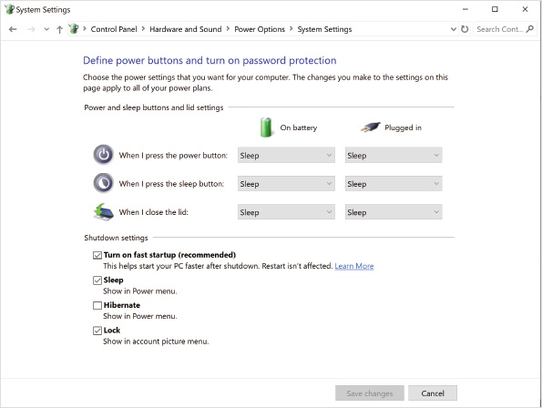
The default settings for the power button, sleep button, and lid closing vary depending on whether Modern Sleep is supported. When Modern Sleep is supported, all options are configured to trigger sleep mode. When Modern Sleep is not supported, the power button triggers a shut down.
You also have these options to configure Windows 10 shutdown settings:
- Turn on fast startup (recommended)—Fast startup is enabled by default and should be left enabled for best startup performance.
- Sleep—Leave this option on to display Sleep as an option for users in the Power menu.
- Hibernate—Turn this option on to display Hibernate as an option for users in the Power menu.
- Lock—Leave this option enabled to allow users to lock their screen from the account picture menu.
Go to pg.
help
Application Opened
Main content

2-7gTroubleshooting Power Management
When you get a new batch of computers for your organization, one problem you might run into is expected power management settings not being available. For example, you might have only the Balanced power management plan available by default. Or, you might not have the ability to enable hybrid sleep. Both issues occur when Windows 10 is configured to use Modern Sleep. You need to understand whether your new computers support Modern Sleep and the ramifications of that for power management.
To identify whether a computer is using Modern Sleep you can use powercfg.exe. When you run powercfg.exe /a, as shown in Figure 2-21, if Modern Sleep is supported then Standby (S0 Low Power Idle) Network Disconnected will be listed as available. The state Standby (S0 Low Power Idle) Network Connected might also be listed as available depending on the capabilities of your hardware.
Figure 2-21Powercfg.exe Showing Available Sleep States
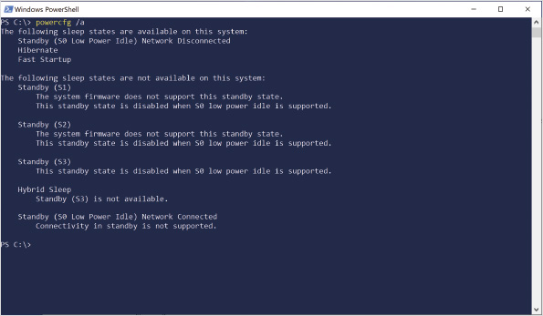
If Windows 10 is not turning off the display, going into sleep mode, or hibernating when expected, the first thing you should do is verify the power management settings. For example, if you expect the display to turn off after 10 minutes of idle time, make sure that setting is in the power plan.
Sometimes applications running in the background prevent Windows 10 power management from behaving as expected. You can run powercfg.exe /requests to identify applications that are making power management requests. If you identify the application, the best option is to either reconfigure or remove that application. If that’s not possible, you can use the /requestsoverride option of powercfg.exe to block that process from making power management requests.
It is also possible that a hardware device is waking up Windows 10. You can run powercfg.exe /lastwake to identify the source of the last wake event. You can verify which hardware devices in your computer are allowed to wake the system by running powercfg.exe /devicequery -wake_armed.
If your computer supports Modern Sleep, but you find the battery is draining too quickly while sleeping, then you should configure the power plan to initiate hibernation after a period of time. For example, you could initiate hibernation after 4 hours of sleep. This would provide you with the advantages of Modern Sleep during the workday but extend battery life by hibernating overnight.
You can also configure hibernation in a power plan if you are concerned about data loss for non-battery powered computers running Windows 10. When hibernation is initiated, all contents in memory are written to disk, including unsaved application data. If a power loss event occurs after hibernation, then no data is lost.
Powercfg.exe can also be used to manage power plans and generate reports. Table 2-2 shows some useful options not mentioned above.
Table 2-2

Powercfg.exe Options
Option | Description
/List | Lists all power plans.
/Query | Displays the settings in a power plan.
/DuplicateScheme | Copies the settings from an existing power plan to a new one.
/SetActive | Sets the power plan that is active.
/Energy | Analyzes the computer for common energy usage and battery problems. Results are stored in a report named energy-report.html in the current directory.
/BatteryReport | Creates a report named battery-report.html, which shows battery usage and charging information.
/SleepStudy | Creates a report named sleepstudy-report.html, which shows time spent in the various power states and the transitions between them. The /SystemPowerReport options generates the same report.
/SystemSleepDiagnostics | Creates a report named system-sleep-diagnostics.html, which shows user not present intervals and analysis of when the computer did not go to sleep when you might have expected it to go to sleep.
Tip
Windows 10 does not include Windows PowerShell cmdlets for managing power plans or settings. Powercfg.exe is the command-line tool for managing power settings.
Activity 2-11

Using the Powercfg.exe Command
Time Required: 15 minutes
Objective: View the options available when using powercfg.exe
Description: When you are troubleshooting issues with power management, the powercfg.exe utility can be very useful. This tool allows you to generate reports and perform configuration that is not easily available in any other way. In this activity, you will use the powercfg.exe command to generate reports and view configuration information.
- 1
If necessary, start your computer and sign in.
- 2
Right-click the Start button and then click Windows PowerShell (Admin) on the shortcut menu. Starting the Windows PowerShell prompt with administrative permissions is necessary for some powercfg.exe functionality.
- 3
In the User Account Control window, click Yes.
- 4
At the Windows PowerShell prompt, type powercfg.exe /? and then press Enter.
- 5
Scroll through the list of powercfg.exe options and read the descriptions.
- 6
Type powercfg.exe /AvailableSleepStates and then press Enter.
- 7
Read the sleep states supported by your computer. If your computer is virtualized, it is expected that no sleep states are available.
- 8
Type powercfg.exe /List and then press Enter. This output refers to each power plan as a power scheme. An asterisk is used to indicate that the Power saver power plan is the currently selected plan.
- 9
Type powercfg.exe /Query 381b4222-f694-41f0-9685-ff5bb260df2e and then press Enter. This displays the settings for the Balanced power plan. The default power plans have a known and consistent GUID for all Windows 10 installations.
- 10
Scroll through the list of settings for the Balanced power plan and read them.
- 11
Type powercfg.exe /SetActive 381b4222-f694-41f0-9685-ff5bb260df2e and then press Enter.
- 12
Type powercfg.exe /List and then press Enter. Verify that the Balanced power plan is now the active power plan.
- 13
Type powercfg.exe /Energy and then press Enter.
- 14
When the report is generated (this might take a few moments), type energy-report.html and then press Enter. This opens the file in Microsoft Edge.
- 15
Review the content in the Power Efficiency Diagnostics Report and then close Microsoft Edge. If your computer is virtualized, it will contain only limited information.
- 16
Type powercfg.exe /SleepStudy and then press Enter.
- 17
Type sleepstudy-report.html and then press Enter. This opens the file in Microsoft Edge.
- 18
Review the content in the System Power Report and then close Microsoft Edge. If your computer is virtualized, it will contain only limited information.
- 19
Close the Windows PowerShell prompt window.
Go to pg.
help
Application Opened
Main content

2-8Task Scheduler
Network administrators seldom have enough time to visit workstations and perform preventive maintenance. In most cases, the only time a network administrator sees a workstation is after it is already having problems.
Task Scheduler, shown in Figure 2-22, allows you to be proactive about computer maintenance. You can schedule a task to run at a particular time or after a particular event. For example, you could trigger disk maintenance to be performed each day at noon, when the network users are typically having lunch. If the computer is in standby, it wakes up, performs the scheduled task, and then goes back into standby. Many Windows maintenance tasks are now performed automatically by the Task Scheduler instead of relying on services to remain running.
Figure 2-22Task Scheduler
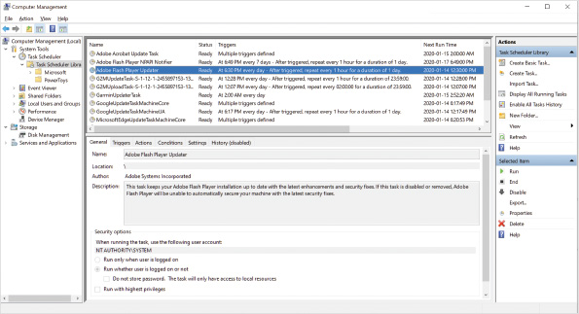
Tasks can be configured to run interactively or in the background. When a task runs interactively, it creates a window that users can interact with and see. For users to interact with a task, the task needs to run within the user’s own security context. When you create an interactive task for your own computer as a single user, you can specify your account. If you are creating a task for all users on a computer, then use a generic credential such as NT Authority\Interactive. To create an interactive task, select the Run only when user is logged on option.
Most scheduled tasks run as background processes that do not require a user to be signed in. This option is preferred because it prevents users from closing a window that is performing maintenance. For a task that runs in the background, however, you need to specify a user account to define the permissions used when the task is run. To configure a task that runs as a background process, select the Run whether user is logged on or not option.
You can provide a local user account or a domain user account with the necessary permissions to run a background task. When you provide a user account, you are prompted to provide a password for the user account, and those credentials are stored locally on the computer in Credential Manager. A domain user account is required when the scheduled task needs to access network resources.
When you select the Do not store password option, the local permissions of the account are used, but the task does not have access to any network resources. Selecting this option triggers the use of Service for User (S4U), which is a specific authentication feature for domain-based networks. This feature is not available for local accounts. If you choose to store the password, the password is secured in Credential Manager.
You can also specify built-in accounts that do not use passwords:
- NT AUTHORITY\SYSTEM—This account provides full access to the local computer. Any scheduled task using this account can perform any action on the local computer.
- NT AUTHORITY\LOCAL SERVICE—This account has user access equivalent to the local Users group. This account only has access to the local computer.
- NT AUTHORITY\NETWORK SERVICE—In a domain environment, this account has permissions equal to the computer account in the domain. This account can access resources over the network.
Some features of Task Scheduler are:
- The Task Scheduler in Windows 10 allows all users to create scheduled tasks. Security is not compromised because users cannot schedule a task to run using permissions higher than their own.
- The Task Scheduler Summary shows the status of previously run and currently active tasks. In addition, each task has a History tab that allows you to view detailed information about that particular task. By default, however, history for tasks is disabled. To enable history for all tasks, click Enable All Tasks History.
- You can schedule a task to run at a specific scheduled time; however, many additional triggers exist, including at sign-in, at startup, on idle, on an event, on registration, on Terminal Server session connect, on Terminal Server session disconnect, on workstation lock, and on workstation unlock. If multiple triggers are specified, all triggers must be activated to run the task.
- You can include multiple actions in a single task. When multiple actions are specified, they are completed in order. This allows you to complete an entire process that has multiple actions that must be performed in a specific order. Each action can run a program, send an email, or send a message via pop-up window. The options to send an email or display a pop-up message have been deprecated and you should avoid using them. Instead, run a program or script to accomplish the same task.
- Conditions include power states and network conditions. Power states let you specify that certain tasks are run only when the computer is or is not in a sleep state. Network conditions let you specify that the task should be run only if certain network connections are available.
- Other settings are available to control how tasks behave when they start or fail. For example, you can configure a task to restart every few minutes if it fails. You can also control whether the task can be run manually regardless of the triggers and conditions that are in place.
Activity 2-12

Using Task Scheduler
Time Required: 5 minutes
Objective: Use Task Scheduler to view a task
Description: The Task Scheduler is used extensively by Windows 10 to run background processes. In this activity, you view a scheduled task that defragments your computer hard disk.
- 1
If necessary, start your computer and sign in.
- 2
Right-click the Start button and then click Computer Management on the shortcut menu.
- 3
In the left pane, click Task Scheduler. This displays the Task Scheduler Summary in the middle pane, which shows the status of currently running tasks and previously run tasks. As well, all tasks scheduled to run in the future are listed under active tasks.
- 4
In the Actions pane, click Enable All Tasks History. The history is useful information to have when you are troubleshooting whether a task has been running properly.
- 5
In the left pane, expand Task Scheduler, expand Task Scheduler Library, expand Microsoft, expand Windows, and then click Defrag. You can see in the left pane that many categories of tasks have been created for system maintenance. ScheduledDefrag is one task.
- 6
In the middle pane, click the Triggers tab. You can see that the ScheduledDefrag task does not have a schedule. This is because the task is triggered by automatic maintenance.
- 7
Click the Actions tab. You can see that this task runs the defrag.exe program.
- 8
Click the Conditions tab. You can see that this task runs only if the computer is on AC power. If the computer switches to battery power, the task stops.
- 9
Click the Settings tab. You can see that if the computer is turned off when the task is configured to run, the task starts as soon as possible after the computer is turned on.
- 10
Click the History tab. This shows you all the event log entries for this task, including when it started, when it completed, and if any errors occurred.
- 11
Close the Computer Management window.
Activity 2-13

Creating a Scheduled Task
Time Required: 10 minutes
Objective: Use Task Scheduler to create a task
Description: As a system administrator, you might want to add your own scheduled tasks to Windows 10 to perform maintenance. In this activity, you create a scheduled task that runs a Windows PowerShell script to delete temporary files that are no longer needed for an application.
- 1
If necessary, start your computer and sign in.
- 2
Right-click the Start button and then click Windows PowerShell on the shortcut menu.
- 3
At the Windows PowerShell prompt, type md C:\Scripts and then press Enter. This creates a new folder that you will use to hold scripts.
- 4
Type md C:\AppTemp and then press Enter. This is the folder that will hold the application temporary files that need to be deleted.
- 5
Type “unneeded log file” | Set-Content C:\AppTemp\LogFile.txt and then press Enter. This creates LogFile.txt that will be deleted by the script.
- 6
Type Get-ChildItem C:\AppTemp and press then Enter. Get-ChildItem is the Windows PowerShell equivalent of the dir command. Verify that LogFile.txt is present as expected.
- 7
Type “Get-ChildItem C:\AppTemp | Remove-Item” | Set-Content C:\Scripts\CleanTemp.ps1 and then press Enter. This creates the script that will delete the temporary files.
- 8
Type Get-Content C:\Scripts\CleanTemp.ps1 and then press Enter. Verify the contents of the script were typed correctly. If the script contents are incorrect, repeat Step 7.
- 9
Right-click the Start button and then click Computer Management on the shortcut menu.
- 10
In Computer Management, expand Task Scheduler and then click Task Scheduler Library.
- 11
In the Actions pane, click Create Basic Task.
- 12
In the Create Basic Task Wizard window, in the Name box, type Clean Application Temp Files and then click Next.
- 13
On the Task Trigger screen, select Weekly and then click Next.
- 14
On the Weekly screen, in the Start box, enter a time of 11:00:00 PM.
- 15
Select Sunday and then click Next.
- 16
On the Action screen, if necessary, click select Start a program and then click Next.
- 17
On the Start a Program screen, in the Program/script box, type powershell.exe.
- 18
In the Add arguments box, type -File C:\Scripts\CleanTemp.ps1 and then click Next.
- 19
Click Finish.
- 20
Read the security options for your new task. It will run only when you are signed in.
- 21
Double-click Clean Application Temp Files.
- 22
In the Clean Application Temp Files Properties (Local Computer) dialog box, click Change User or Group.
- 23
In the Select User or Group dialog box, in the Enter the object name to select box, type System, click Check Names, and then click OK.
- 24
In the Clean Application Temp Files Properties (Local Computer) dialog box, click OK.
- 25
Right-click Clean Application Temp Files and then click Run.
- 26
Click the History tab and verify that the task ran successfully. Note that successful execution of the task does not mean that it performed the action we wanted it to. In this context, it means only that powershell.exe was successfully started.
- 27
At the Windows PowerShell prompt, type Get-ChildItem C:\AppTemp and then press Enter. This command generates no output, because running the task removed the file in this folder.
- 28
Close all open windows.
Note 3
To successfully run the task in this activity, execution of Windows PowerShell scripts needs to be enabled. Enabling Windows PowerShell script execution was done in Activity 2-6 Using Windows PowerShell.
Go to pg.
help
Application Opened
Main content

Chapter Review

2-9aSummary
- Settings provides access to change the more commonly manipulated settings in Windows 10. For more advanced settings, Control Panel is still used.
- Administrative Tools is a collection of system maintenance utilities. All of the administrative tools are MMC consoles. Two of the more commonly used administrative tools are Computer Management and Services.
- You can use either a command prompt or Windows PowerShell to perform command-line administration of Windows 10. Windows PowerShell provides a much better scripting environment. To allow scripts to run, you need to set the execution policy.
- Windows 10 uses device drivers to properly communicate with various hardware components in a computer. Most device drivers designed for Windows 7 and newer versions of Windows are compatible with Windows 10.
- Device Manager is the MMC snap-in that is used to manage device drivers and hardware components. You can use Device Manager to update drivers, roll back to previous driver versions, or view the resources a hardware component is using.
- Power Management in Windows 10 reduces power utilization by allowing the computer to go to sleep or hibernate when not in use. Fast Startup uses hibernation to speed up the boot process. Power plans are used to define how power management is implemented for various devices.
- The display on a Windows 10 computer can be customized by controlling the display resolution, color depth, and refresh rate. The optimal configuration for display settings varies depending on the display device. Desktop backgrounds let you display a picture on your desktop. Screen savers are used to implement security. You can implement multiple displays to enhance productivity.
- Task Scheduler has been enhanced with security improvements for credentials, improved logging, and expanded triggers for starting tasks. Multiple actions are allowed per task, and additional conditions can be required for a task to run.
- Windows PowerShell is a command-line interface for managing Windows 10. Many cmdlets are included, and Get-Help can be used to find out more information about a cmdlet. Use the Windows PowerShell ISE for creating and editing PowerShell scripts.
Go to pg.
help
Application Opened
Main content

Chapter Review

2-9bKey Terms
- Administrative Tools
- Advanced Configuration and Power Interface (ACPI)
- Away Mode
- cmdlet
- Computer Management
- Control Panel
- device driver signing
- device drivers
- Device Manager
- display resolution
- driver store
- Event Viewer
- Fast Startup
- File Signature Verification utility
- hibernate
- hybrid sleep
- Microsoft Management Console (MMC)
- MMC snap-ins
- Modern Standby
- multiple monitors
- Open Database Connectivity (ODBC)
- Performance Monitor
- pixel
- power plans
- powercfg.exe
- S0 state
- S3 state
- S4 state
- service
- Services
- Settings
- System Configuration
- System Information
- Task Scheduler
- Windows Memory Diagnostics Tool
- Windows PowerShell
- Windows PowerShell ISE
Go to pg.
help
Application Opened
Main content

Chapter Review

2-9cReview Questions
- Which of the following accurately describe the administrative tools available in Control Panel? (Choose all that apply.)
  - Most are MMCs.
  - You can schedule tasks.
  - You can change the screen resolution.
  - You can change power options.
  - You can manage device drivers.
- Which Settings category allows you to control whether apps can access your location?
  - System
  - Devices
  - Network & Internet
  - Accounts
  - Privacy
- A(n) is a type of Windows application that runs in the background without user intervention.
- Which of the following is used by apps to connect to databases?
  - DB sources
  - ODBC
  - SQL
  - RPC
  - local ports
- Which of the following are found in Administrative Tools? (Choose all that apply.)
  - Event Viewer
  - Windows Memory Diagnostic
  - Computer Management
  - Installed Programs
  - Task Scheduler
- You can build a customized MMC console by adding to the console.
- Which snap-ins are available in Computer Management? (Choose all that apply.)
  - Task Scheduler
  - Folder Options
  - Services
  - Security Configuration Management
  - Device Manager
- Which tasks can you accomplish using the Services administrative tool? (Choose all that apply.)
  - Stop a service.
  - Configure a service to start automatically.
  - Configure the credentials for a service.
  - Schedule the time when a service will start.
  - Configure the dependencies for a service.
- A(n) is software used to manage communication between hardware components and Windows 10.
- To find a list of hardware components certified to run on Windows 10, you should consult the Hardware Compatibility List. True or False?
True
False
- Which tasks can you perform in Device Manager? (Choose all that apply.)
  - Determine which devices do not have a driver loaded.
  - Disable devices.
  - Install new hardware.
  - View hardware resource configuration.
  - Roll back a device driver.
- You can use the Get-Member cmdlet to view the properties available for an object. True or False?
True
False
- With a signed device driver, which of the following can Windows 10 do? (Choose all that apply.)
  - Determine if a driver has been modified.
  - Determine if a driver has been adequately tested.
  - Determine if the publisher is valid.
  - Determine if the driver is 32-bit or 64-bit.
  - Automatically download updates.
- Hybrid sleep is a combination of which ACPI power states? (Choose two.)
  - S0
  - S3
  - S4
  - S5
  - G3
- Modern Standby puts the computer in which ACPI power state?
  - S0
  - S3
  - S4
  - S5
  - G3
- Which requirements must be met for display adapters in Windows 10? (Choose all that apply.)
  - minimum 256 MB of RAM on the video card
  - support for WDDM
  - support for DirectX 9
  - do not use Windows 10 Starter Edition
  - computer is certified as “Designed for Windows 10”
- The primary purpose of a screen saver is to prevent screen burn-in. True or False?
True
False
- Which multiple monitor display mode should you select when you are using each monitor for different tasks?
  - PC only
  - Office workspace
  - Duplicate
  - Extended
  - Second screen only
- Which tool can you use to create reports about power management?
  - Device Manager
  - Powerrpt.exe
  - Create-PowerReport
  - System Information
  - Powercfg.exe
- When you view optional features in Settings, dism, and Get-WindowsOptionalFeature, they all show the same list of optional features. True or False?
True
False
Go to pg.
help

