Application Opened
Main content
Module
7

User Productivity Tools
- Chapter Introduction
- 7-1File Explorer
  - 7-1aRibbon Tabs
  - 7-1bLibraries
  - 7-1cSearch
- 7-2OneDrive
  - 7-2aOneDrive Client
  - 7-2bOneDrive Web Interface
  - 7-2cManaging Files
  - 7-2dSharing Files and Folders
  - 7-2eManaging Synchronization
  - 7-2fControlling Network Utilization
  - 7-2gPersonal Vault
  - 7-2hOneDrive for Business
- 7-3Printing
  - 7-3aPrinting Scenarios
  - 7-3bPrinter Drivers
  - 7-3cPrinter Management Tools
  - 7-3dPrinter Configuration
- 7-4Browsers
  - 7-4aMicrosoft Edge
  - 7-4bSecurity Zones
  - 7-4cGroup Policy Settings for Microsoft Edge
  - 7-4dIE Mode
- 7-5Accessories and Shortcuts
  - 7-5aText Editing
  - 7-5bGraphics Editing
- 7-6Chapter Review
  - 7-6aSummary
  - 7-6bKey Terms
  - 7-6cReview Questions
  - 7-6dCase Projects
Go to pg.
help
Application Opened
Main content

Chapter Introduction
After reading this module and completing the exercises, you will be able to:
- 1Describe features for file management in File Explorer
- 2Use OneDrive to store documents
- 3Explain and configure Windows 10 printing
- 4Describe the features in Microsoft Edge and Internet Explorer
- 5Identify useful Windows 10 applications and keyboard shortcuts
Windows 10 includes a variety of tools that are required in a modern operating system in order to be productive. You certainly need specialized apps like Microsoft Office to create and consume content, but the operating system also needs to provide some core tools for tasks such as managing files and accessing the Internet.
In this module, you learn how to use File Explorer for file management, including how to configure libraries. You also learn about how cloud-based storage provided by OneDrive can be used to make your files portable. OneDrive also serves as a backup solution if your computer’s hard drive fails. Despite the promise of a paperless office, printing is still important functionality in Windows 10, so you will learn how to configure printing. To help support using web-based applications, you will identify the features available in the Microsoft Edge browser, including Enterprise Mode, which supports backward compatibility with Internet Explorer. Finally, you will identify useful application and shortcut keys in Windows 10.
Go to pg.
help
Application Opened
Main content

7-1File Explorer
File Explorer, shown in Figure 7-1, is the interface used to view the file system in Windows 10. The left navigation pane provides a way to move quickly to various locations where files might be stored. The right pane displays the files and folders in the location that is selected in the navigation pane.
Figure 7-1File Explorer
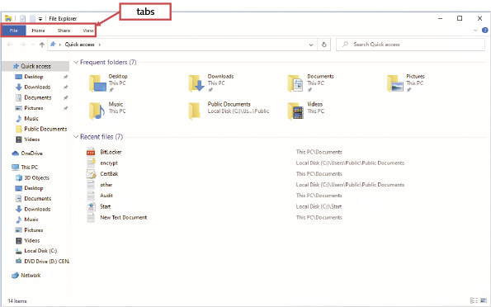
In the navigation pane, several file storage locations are available by default:
- Quick access—When you select this node, a list of recently accessed files and folders are displayed. You also have the option to pin folders in Quick access. For example, if you are working on several projects, you can pin the folder that stores files for each project in Quick access.
- OneDrive—This node provides access to OneDrive cloud storage that is associated with a Microsoft account.
- This PC—This node displays the files and folder for locally attached storage. This includes hard drives, USB drives, and DVDs.
- Network—Use this node to display computers on the local area network (LAN). If the computers have shared resources, you can browse file shares and shared printers.
Tip
Some third-party products, such as Dropbox, also integrate into the navigation pane. Dropbox is cloud storage similar to OneDrive.
If you are double-clicking folders in the right pane to drill down into the folder structure, the navigation pane is not updated. You can configure the navigation pane to keep in sync with the folders to which you browse. Some people prefer this because it simplifies moving between folders in the navigation pane.
Go to pg.
help
Application Opened
Main content

7-1aRibbon Tabs
Above the navigation pane and the right pane are tabs on the ribbon for various functions. The tabs available on the ribbon vary depending on the content that you have selected.
When you are viewing the file system, the following tabs are available:
- File—This tab provides options to open a new File Explorer window or to display a Windows PowerShell prompt that is focused on the current folder. The Windows PowerShell prompt option can be significantly faster than opening a prompt and then changing to the directory that you want. This tab also allows access to folder and search options.
- Home—This tab has buttons for manipulating files and folders. For example, it contains buttons to copy, paste, and delete, along with options to view file and folder properties and select items. Many of the options here are similar to the shortcut menu that is displayed when you right-click a file or folder.
- Share—This tab provides options to configure folder sharing and file permissions. It also has options to share files via email or with an app that you specify. Options to send files to a zipped folder, burn to disc, print, or fax also are offered.
- View—This tab has options that control how files and folders are displayed. For example, you can select whether file details are displayed, you can display only file names, or you can specify various sizes of icons. You can enable display of a Details pane or a Preview pane with additional information when files are selected. You can also choose to view hidden items and hide items.
One common user complaint is the inability to distinguish between files of different types that have the same name. For example, you may have a Word document and an Excel spreadsheet that are both named Project1. Both documents have different icons, but it can be difficult to interpret the icons when files are displayed in List view. To make it easier for users to distinguish between files of different types, you can configure Windows 10 to display the file name extensions. This is done on the View tab by selecting the File name extensions check box. This is not selected by default.
Activity 7-1

Configuring File Explorer
Time Required: 5 minutes
Objective: Customize the display in File Explorer
Description: For many users, the default display in File Explorer is acceptable. You have the option, however, to customize it in many ways to better suit your preferences. In this activity, you perform some of the commonly implemented modifications to the default view in File Explorer.
- 1
If necessary, start your computer and sign in.
- 2
On the taskbar, click File Explorer.
- 3
In the File Explorer window, click the View tab, click the Navigation pane button, and then, if necessary, click Expand to open folder to enable it.
- 4
In the navigation pane, click This PC.
- 5
In the right pane, double-click Local Disk (C:) and then double-click Windows. Notice that the navigation pane reflects the content of the location you are browsing.
- 6
Scroll down in the right pane, and notice that most of the file extensions are hidden.
- 7
Click the View tab and, if necessary, select the File name extensions check box.
- 8
Scroll down in the right pane, and notice that most of the file extensions are now visible, which makes it easier to identify the type of file.
- 9
Click the View tab and then click List in the Layout group. Notice that you can now see more files and folders at one time.
- 10
Click the View tab and then click the Options button.
- 11
In the Folder Options dialog box, click the View tab, click Restore Defaults, and then click OK. This disables viewing of file extensions.
- 12
Close the File Explorer window.
Go to pg.
help
Application Opened
Main content

7-1bLibraries
Libraries were introduced in Windows 7 to simplify access to files in multiple locations. Each library contains multiple file system locations and the content from all locations is placed together into a single view. A library can contain local folders or file shares.
You can modify the locations included in a library, but the location must be indexed by Windows Search. This means that if you add a file share, it must be indexed by Windows Search on the computer that is hosting the file share. This requirement ensures that content can be categorized and displayed quickly.
Some file management issues to consider for libraries are:
- When you browse down into a folder from the root of a library, you are viewing a specific location, and any files created are in that specific location.
- When you are viewing the root of a library and create a new file or folder, the new item is created in the location specified as the default save location in the properties of the library.
Activity 7-2

Using Libraries
Time Required: 5 minutes
Objective: Use libraries to organize files in File Explorer
Description: In Windows 10, libraries are not visible by default. Some users who upgrade from Windows 7 or Windows 8.1 may prefer to continue using this feature. In this activity, you enable libraries in File Explorer and verify their functionality.
- 1
If necessary, start your computer and sign in.
- 2
On the taskbar, click File Explorer.
- 3
In the File Explorer window, click the View tab, click the Navigation pane button, and then click Show libraries to place a check mark before that item.
- 4
In the navigation pane, expand Libraries and then click Documents.
- 5
Right-click Documents and then click Properties.
- 6
In the Documents Properties window, click Add.
- 7
In the Include Folder in Documents window, in the address bar, type C:\Users\Public and then press Enter.
- 8
Click Public Documents and then click Include folder.
- 9
In the Document Properties dialog box, the single green check mark identifies the Documents folder as your default save location. The green check mark with the users identifies the Public Documents folder as the public save location.
- 10
Right-click Public Documents, click Set as default save location, and then click OK. Notice that the view now includes both locations.
- 11
Click the Home tab, click New item, click Text Document, type NewPublicFile as the file name, and then press Enter. Notice that the file was created in the Public Documents folder because that is the default save location for the Documents library.
- 12
Click the View tab, click Navigation pane, and then click Show libraries to remove the check mark from that item.
- 13
Close the File Explorer window.
Go to pg.
help
Application Opened
Main content

7-1cSearch
Windows 10 includes search functionality that can be used to find files and folders. Search is made faster by an indexing function included in Windows 10. It is context sensitive, so you do not need to choose whether the search occurs inside or outside the index. If you are searching content that is indexed, the index is used. If you are searching content that is not indexed, the index is not used.
Indexing is automatically enabled so that all users can immediately get the benefit of index-based searches. Each time a file is updated, the index is also updated. When a user performs a search, the search results include only files to which the user has access.
By default, only the most common file system locations are indexed. This is the Classic search option selected in Figure 7-2. Classic search prevents the index from incorporating less relevant files, such as operating system files, for which users are unlikely to search. Search speed is improved, and indexing time is decreased by indexing only specified files.
Figure 7-2Search Settings
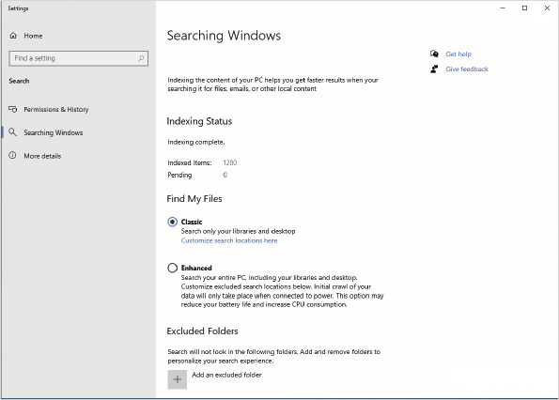
The Enhanced search option indexes all files on your computer unless they are in excluded folders. If you store files outside of your user profile that you want to be indexed, this can be a fast way to ensure that they are indexed. When you enable the Enhanced search option, some user profile folders for application data are excluded. Content in C:\Program Files, C:\ProgramData, and C:\Windows also is excluded.
The file locations indexed by Classic search are the Start menu and C:\Users (except the AppData subfolder in each profile). Other locations are indexed for specific applications if the application is in use. For example, if you are using Microsoft Outlook in cached mode, the cached mailbox is indexed. You can specify additional search locations depending on your needs, as shown in Figure 7-3.
Figure 7-3Indexing Options Dialog Box
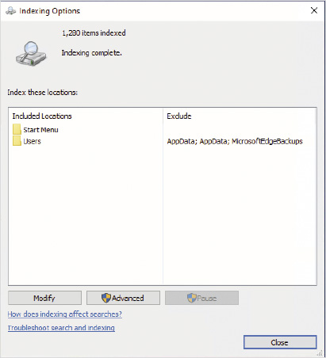
The Advanced Options in Indexing Options apply to both Classic search and Enhanced search. You can define which file types are indexed and how those files are indexed. For each file type (defined by file extension), you specify whether the contents of the files or only the files’ metadata is indexed. For some file types, such as pictures, the content of the files is meaningless from a search perspective and should not be indexed. Other file types, such as Word documents, can have their content indexed so that you can search for documents based on the content. The filter for each file type is responsible for understanding how to properly index that content type. Figure 7-4 shows the configuration of file types in Advanced Options.
Figure 7-4Indexing Advanced Options Dialog Box
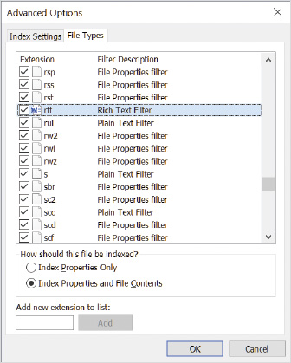
The Index Settings tab in Advanced Options contains additional settings that you can configure, including the following:
- File Settings—You can select whether encrypted files are indexed. You can also select whether words with different accents are treated the same, for example, whether resume and resumé are indexed as the same word.
- Troubleshooting—You can rebuild the index if you believe it has become corrupted. You can also run a troubleshooter that guides you through the troubleshooting process.
- Index location—You can move the index from the default location of C:\ProgramData\Microsoft to another location. This can be useful if the C: drive is becoming full and free space is available on a different partition.
The most basic file metadata are characteristics such as file name, creation date, and modified date. Depending on the type of file, additional metadata may be included. For example, pictures taken with a digital camera have additional metadata that is appropriate only for pictures, such as the shutter speed and lighting conditions.
Activity 7-3

Configuring Windows Search
Time Required: 10 minutes
Objective: Configure Windows Search to index a new location
Description: Indexing files makes it much faster to find specific files you are seeking. If you store files outside of your User file, they are not indexed by default. In this activity, you specify an additional indexing location for Windows Search and then verify that it is searchable.
- 1
If necessary, start your computer and sign in.
- 2
On the taskbar, click File Explorer.
- 3
If necessary, expand This PC and then click Local Disk (C:).
- 4
Click the Home tab, click New folder, type NewData as the folder name, and then press Enter.
- 5
Double-click the NewData folder, click the Home tab, click New item, click Text Document, type SearchFile as the file name, and then press Enter.
- 6
Double-click SearchFile to open the file in Notepad.
- 7
In the Notepad window, type Kangaroo, click File on the menu bar, and then click Save.
- 8
Exit Notepad.
- 9
On the taskbar, click the Type here to search button and then type Kangaroo. This displays web searches for Kangaroo.
- 10
At the top of the search box, click Documents and then click Kangaroo. The search should not find any matches.
- 11
Close all open windows.
- 12
Click the Start button and then click Settings.
- 13
In the Settings window, in the Find a setting box, type index and then click Windows Search settings.
- 14
On the Searching Windows screen, below the Classic option, click Customize Search locations here.
- 15
In the Indexing Options window, click Modify.
- 16
In the Indexed Locations window, expand Local Disk (C:), select the NewData check box, and then click OK.
- 17
In the Indexing Options dialog box, click Close.
- 18
On the taskbar, click the Type here to search button, type Kangaroo, and then click Documents. This time, the search found the file because it has been indexed.
- 19
Close all open windows.
Go to pg.
help
Application Opened
Main content

7-2OneDrive
OneDrive is cloud-based storage that is automatically included free of charge when you create a Microsoft account. Each Microsoft account is allocated 5 GB of storage space that can be used for file storage in OneDrive. Additional storage can be purchased if required.
Files stored in OneDrive can be accessed directly from the OneDrive website or by using the OneDrive client. The OneDrive client is included with Windows 10 and integrates into File Explorer as a separate node for accessing files.
Using OneDrive has several benefits, including the following:
- Access files from anywhere
- Back up automatically to the cloud
- Recover deleted or modified files
- Edit files from a browser
- Edit files on mobile devices
- Share files with others
Go to pg.
help
Application Opened
Main content

7-2aOneDrive Client
If you sign in to Windows 10 using a Microsoft account, the OneDrive client automatically uses that account to sign in to OneDrive also. Then, any files you save on the OneDrive node in File Explorer are automatically synchronized to OneDrive where they can be accessed from another computer, a mobile phone, or tablet. Because OneDrive files are accessible by browser, they can be accessed from almost any device.
Tip
If you don’t sign in to Windows 10 using your Microsoft account, you need to configure the OneDrive client with the credentials for your OneDrive account.
The OneDrive node in File Explorer contains Documents and Pictures folders by default, but you can create additional folders to organize your files. Local files and folders that are synchronized with OneDrive have a green check mark to indicate that they are successfully synchronized. When you make changes to a file, the icon changes to two arrows in a circle to indicate that the file is synchronizing. While you have a file open for editing, it is typical for the synchronizing icon to appear for the file. If the icon is a cloud, then the file is available in OneDrive but not synchronized locally. If a small icon with the outline of a person appears as part of the status, then the file or folder is shared. Figure 7-5 shows the status icons.
Figure 7-5Sync Status Icons
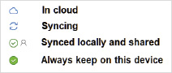
The default location for files synchronized by the OneDrive client is C:\Users\%username%\OneDrive in the user’s profile. If you have a folder with preexisting data, you can change synchronization to use that folder instead. When you select a folder with preexisting data, that data is merged with the data already stored in OneDrive.
In the properties for the OneDrive client, you can also configure the following settings:
- Start OneDrive automatically when I sign in to Windows—This option is on by default and should be left on. If you turn off this option, files stop synchronizing with OneDrive because the client is not enabled the next time you sign in.
- Let me use OneDrive to fetch any of my files on this PC—This option is disabled by default. Enable this option if you want to be able to browse the file system on the computer and access files through the OneDrive website.
- Use Office to work on files with other people at the same time—This option is on by default and should be left on. When this option is on, you can collaborate with other users on a shared Microsoft Office document at the same time. Two or more users can perform simultaneous editing.
The OneDrive client also has a backup option. For your local computer, you can back up the Desktop, Documents, and Pictures folder to OneDrive. When you configure backup, those folders become part of OneDrive, and you don’t need to manage your OneDrive documents separately. You also have the option to automatically store pictures and videos from cameras and phones in OneDrive when you retrieve them using your computer. Finally, you can configure screenshots to be saved in OneDrive automatically.
Tip
During profile creation for a Microsoft account, you are asked whether you want to back up your files with OneDrive. The backup feature is enabled if you click Next. If you select the Only save files to this PC option, then backup is not enabled.
Go to pg.
help
Application Opened
Main content

7-2bOneDrive Web Interface
The web interface for OneDrive, shown in Figure 7-6, provides access to all the features of OneDrive. In the web interface, you have access to all the files that have been synchronized to OneDrive, but in addition you can do the following:
- Recover deleted files from the Recycle Bin
- Access previous versions of files
- View a list of all files that you have shared
- View the amount of storage space you have remaining in OneDrive
- Access files on computers with the OneDrive client installed and configured
Figure 7-6OneDrive Web Interface
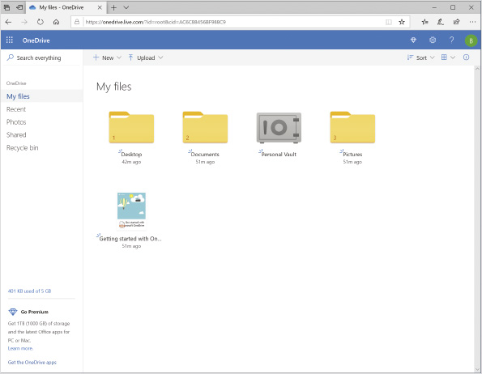
Tip
You can access OneDrive at https://onedrive.live.com.
The web interface for OneDrive is not merely a way to download your files on different computers. You can also use the web versions of Microsoft Office applications, such as Word and Excel, to view and edit the files online. When you open a file on the OneDrive website, it automatically opens in the appropriate online Office application in read-only mode. If you choose to edit the file, you are prompted as to whether to edit in the online Office application or use a locally installed Office application.
If you choose to use the online Office application to edit a file, you get a functional, but not full-featured, version of the application. The online Office applications work with a variety of browsers across platforms, such as Microsoft Edge, Internet Explorer, Firefox, Chrome, and Safari.
Tip
Files in online Office applications are automatically saved as you edit them. It is initially disconcerting that you don’t have the option to save files manually, but you can verify that the file has been saved by checking the title bar.
If you choose to use a locally installed Office application to edit a file, the file is opened directly from OneDrive. Office applications are capable of opening files over the Internet by using the HTTP protocol. When you save the file, it is saved directly back in OneDrive.
Tip
When you store files on OneDrive, you can use the AutoSave feature in Microsoft Office desktop apps that saves file changes in near real-time.
Mobile versions of Office applications are also available for tablets and phones running Android and iOS. These apps are free from each operating system’s app store. This means that you can install a mobile version of Word on your iPad or Android device and edit a document stored in OneDrive.
Go to pg.
help
Application Opened
Main content

7-2cManaging Files
You can perform basic file management tasks by using both the OneDrive website and the OneDrive client in File Explorer. Both these tools can delete, copy, move, and rename files; however, the following two functions can be performed only on the OneDrive website:
- Recover deleted files—Files deleted from OneDrive are placed in the Recycle Bin and then deleted after approximately 90 days. If a file has not been deleted from the Recycle Bin, you can restore it and regain access to it.
- Previous file versions—As you modify files, OneDrive keeps multiple versions of the file, not just the most recently saved version. You can access and recover previous versions if an incorrect modification has been made.
If you upgrade to a paid version of OneDrive in Office 365, you also have the option to restore your entire OneDrive to a point in time up to 30 days ago. Microsoft will also notify you if it appears that ransomware is affecting your OneDrive files. After you eliminate the ransomware, you can restore your files in OneDrive back to the point before the ransomware infected your computer.
Note 1
You can find more information about various OneDrive plans on Compare OneDrive Plans at https://products.office.com/en-us/onedrive/compare-onedrive-plans.
Go to pg.
help
Application Opened
Main content

7-2dSharing Files and Folders
When you store files in OneDrive, you also have the option to share files and folders with other users. You can share files anonymously with users so that they can access files in your OneDrive without authenticating. You send other users a URL for the specific file or folder that you shared. When they follow the URL, they can either view or edit the files, depending on the level of permissions that you specified.
Caution
If you share files anonymously, you control to whom you send the URL, but you can’t control to whom they send it. Because of this, you shouldn’t use anonymous sharing for important files.
Instead of sharing with anonymous users, most of the time you should share with specific users. When you share with specific users, you specify an email address. The email address you specify must be associated with a Microsoft account or an Azure AD account. That user then is required to authenticate before accessing the file.
Go to pg.
help
Application Opened
Main content

7-2eManaging Synchronization
The Files On-Demand feature in OneDrive controls which files are synchronized to the local computer. By default, the Save space and download files as you use them option is enabled. With this configuration, files are synchronized to the local device only when you open them. Until that point, they remain only in the cloud.
You can force files or folders to synchronize locally if you right-click and select Always keep on this device. Forcing local synchronization is useful when you want to ensure that you always have the latest version of a file for offline use. For example, you can edit the latest version when you are on an airplane as long as you allowed it to sync before you take off.
If you need to free up disk space on a device, you can right-click and then select Free up space. This removes the local copy of the file. You can do this for files that were synced dynamically by Files On-Demand or files that you forced to sync locally.
Go to pg.
help
Application Opened
Main content

7-2fControlling Network Utilization
On a mobile device with a metered network, you might be concerned about using too much data for OneDrive synchronization. For example, if you tether your laptop through the mobile phone you probably wouldn’t want to download 1 GB of file changes that exist in OneDrive. To prevent network utilization on a metered network you can enable the Automatically pause sync when this device is on a metered network option.
Tip
Remember that Windows 10 does not designate Wi-Fi networks as metered by default. When tethering to a mobile device, you need to manually identify the network as a metered network.
On some networks, the total volume of data is not a concern, but the speed of data synchronization is. For example, an office with a slow Internet connection with multiple computers attempting to synchronize as quickly as possible might slow down other important services, such as email. By default, upload and download rates are not limited, but you can specify a limited rate, such as 125 KB/s for either.
Caution
If you have a slow Internet connection, consider an appropriate value for limiting upload and download rates. The rate of 125 KB/s is equivalent to 1 Mbps.
Go to pg.
help
Application Opened
Main content

7-2gPersonal Vault
To help store highly secure personal information, Microsoft has created Personal Vault for personal and home plans of OneDrive. To access the files you store in the Personal Vault, you need to provide additional authentication information beyond your user name and password. You need to be further authenticated by a strong authentication method, such as fingerprint, face recognition, PIN, or a code sent by text message.
When you unlock your personal vault, it relocks after a period of inactivity to ensure that your data remains safe. On a mobile device, the personal vault locks again after 3 minutes. On a computer running Windows 10, the personal vault locks again after 20 minutes by default, but you can set longer values up to 4 hours.
Caution
If you disable Personal Vault, all files inside Personal Vault are removed and can’t be recovered. Copy files out of Personal Vault before you disable it.
Go to pg.
help
Application Opened
Main content

7-2hOneDrive for Business
Business plans of Office 365 or Microsoft 365 include OneDrive for Business, which is similar to the consumer version of OneDrive but with different features. Some differences with OneDrive for Business include:
- OneDrive for Business does not allow remote access to files on computers with the OneDrive client.
- OneDrive for Business does not include Personal Vault.
- OneDrive for Business requires an Azure AD account rather than a Microsoft account.
- OneDrive for Business has a starting size of 1 TB that can be unlimited in size, depending on the specific plan.
- OneDrive for Business can be centrally managed by the administrator of your Office 365 or Microsoft 365 tenant.
Activity 7-4

Using OneDrive
Time Required: 10 minutes
Objective: Use OneDrive to manage files
Description: OneDrive is a cloud-based service that you can use to back up and share files. In this activity, you save files in OneDrive and explore the recovery options.
- 1
If necessary, start your computer and sign in by using your Microsoft account.
- 2
On the taskbar, click File Explorer.
- 3
In File Explorer, in the navigation pane, click OneDrive and read the list of files. Notice that the status for Getting started with OneDrive is a cloud icon. This .pdf file should be in the root of OneDrive unless you previously deleted it.
- 4
Double-click Getting started with OneDrive to open it, quickly scan through the document, and then exit Microsoft Edge.
- 5
In the File Explorer window, read the status of Getting started with OneDrive. The status icon is now a green check mark to indicate that the file is stored locally because you opened it.
- 6
In the navigation pane, expand OneDrive and then click Documents.
- 7
In the right pane, right-click an open area, point to New, click Text Document, type OnlineFile, and then press Enter.
- 8
Double-click OnlineFile.
- 9
In the Notepad window, type First edit, exit Notepad, and then save the changes. When the file icon has a green check mark, it has finished synchronizing to OneDrive.
- 10
In the File Explorer window, right-click OnlineFile and then click Delete.
- 11
On the taskbar, click Microsoft Edge.
- 12
In the Microsoft Edge window, in the address bar, type https://onedrive.live.com and then press Enter. Notice that you do not need to provide authentication credentials if you signed in to Windows 10 by using a Microsoft account.
- 13
If necessary, on the Welcome to OneDrive screen, click FINISH LATER.
- 14
If necessary, on the Get the premium experience screen, close the screen.
- 15
On the My files screen, read the list of files and folders. Notice that these match those in OneDrive on your computer except for the Personal Vault.
- 16
In OneDrive, click Recycle bin. Notice that OnlineFile.txt is listed here.
- 17
Click OnlineFile.txt and then click Restore.
- 18
Click My files and then click Documents. Notice that the file is restored to the Documents folder.
- 19
Click OnlineFile.txt and wait for the file contents to be displayed. A simple online text editor is used because this is a text file rather than a Word document.
- 20
Click Open on the menu bar and then click Open in Text Editor.
- 21
Add the text Second edit as a new line in the file and then click Save.
- 22
In File Explorer, right-click OnlineFile and then click Always keep on this device.
- 23
Verify that a green check mark appears next to OnlineFile and then double-click OnlineFile.
- 24
In Notepad, verify that the text Second edit appears and then exit Notepad.
- 25
In OneDrive, in the top ribbon menu, click OneDrive and then click Documents.
- 26
In OneDrive, click New and then click Word document. This creates a new Word document named Document1.
- 27
In Word Online, if a Welcome to Word on the web dialog box appears, close it.
- 28
In Document1, type Version 1, wait for the document to finish saving, and then close the Document1.docx tab in Microsoft Edge.
- 29
In OneDrive, click Document1.docx.
- 30
In Word Online, click Edit Document and then click Edit in Word Online.
- 31
Add a new line with the text Version 2, wait for the document to finish saving, and then close the Document1.docx tab in Microsoft Edge.
- 32
In OneDrive, right-click Document1.docx and then click Version history. The current version is automatically selected, and you will see a preview.
- 33
Select the most recent previous version. Notice that this document has only the Version 1 text. You have the option to restore this version or download it.
- 34
Exit Microsoft Edge.
- 35
In the File Explorer window, if necessary, expand This PC, right-click Desktop, and then click Properties.
- 36
In the Desktop Properties dialog box, click the Location tab. Notice that the location of the Desktop folder has been redirected inside the OneDrive folder because backup has been configured.
- 37
Click Cancel and then close the File Explorer window.
Go to pg.
help
Application Opened
Main content

7-3Printing
Despite the promise of the paperless office, most organizations still do quite a bit of printing. Maintaining printers and troubleshooting their functionality can be a significant portion of your job when doing desktop support. To support printers and troubleshoot them, you need to understand the following:
- Printing scenarios
- Printer drivers
- Printer management tools
Go to pg.
help
Application Opened
Main content

7-3aPrinting Scenarios
As a network administrator, you need to be able to troubleshoot the printing process. One of the keys to troubleshooting is understanding how printers can be connected to Windows 10. Figure 7-7 shows the physical layout of local printing, network printing directly to a printer, and network printing to a shared printer.
Figure 7-7Printing Scenarios
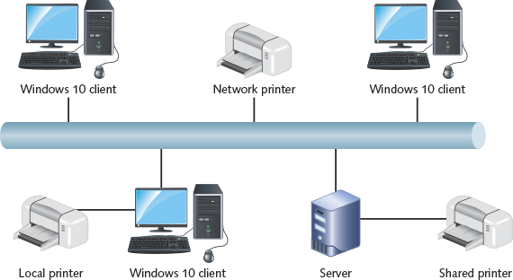

Local Printing
Local printing requires that a printer be connected directly to a Windows 10 computer by using a cable. The type of cable you select depends on which connection type is physically available on the printer. Most newer printers connect to a computer by using a USB cable. Some older printers and specialty printers are connected by using parallel or serial cables.
USB printers are automatically installed in Windows 10 when they are connected because they are Plug and Play. Before you connect a USB printer for the first time, however, read the documentation included with the printer. Some USB printers (particularly multifunction printers) require you to install the driver before attaching the printer for the first time. If you connect the printer before the proper driver is installed, Windows 10 attempts to load a compatible driver, which might not have full functionality for the printer. The installation process for serial and parallel printers must be triggered manually.
The most common reasons to use local printing are simplicity and security. The entire printing process occurs within the local computer, so troubleshooting is easier. Having a local printer makes printing secure because users are able to print sensitive documents in their office from the local printer rather than in an open area on a shared network printer where other users might see the documents’ contents.
To install a local printer, you need administrator permissions if the driver is not already installed. After a local printer is installed, it is available to all users on that computer.

Printing Directly to a Network Printer
A high percentage of printers can be configured to communicate directly on a wired or wireless network. This functionality is available even in many lower-end printers for home users. When a printer is connected directly to the network, computers can send it print jobs over the network. Many computers can be connected to the network printer at the same time, but only one computer can be printing at a time.
Sharing a printer on the network saves money in the long run. Typically, it costs less to purchase a single high-capacity printer rather than many low-capacity printers for many computers. The per-page consumables cost for the high-capacity printer is typically much lower than for low-capacity printers.
In this scenario, print jobs are queued at the local computer and sent to the printer when the printer is not busy. This is a contention-based system, and jobs are not serviced in any specific order. No central queue controls the order or priority of print jobs; however, a key benefit is the lack of any single computer as a single point of failure.
When you print directly to a network printer, it behaves similarly to a local printer except that connectivity is through a network port or wireless network adapter instead of a USB port. To install this type of printer in Windows 10, you need administrator permissions if the driver is not already installed on the computer. After this type of printer is installed, it is available to all users on the computer.

Printing to a Shared Printer
Both Windows servers and Windows clients are capable of sharing printers on the network. When a printer is shared, multiple computers on the network can use it. Windows 10 attempts to find printers shared on the local network and install them automatically; however, if the shared printers are not on the local subnet, you need to install the printer manually.
In this scenario, all print jobs are queued on the computer that is sharing the printer. This allows all jobs to be controlled in a central location, which can make troubleshooting relatively simple. If jobs are not printing, you start by looking at the computer that is sharing the printer; however, the computer sharing the printer also becomes a central point of failure. If the computer sharing the printer is disabled or turned off, it is not possible to print documents on the shared printer.
Tip
Shared printers can be connected directly to the sharing computer or be network printers.
Standard users can install a shared printer, even if the printer driver is not already installed. For older version 3 printer drivers (Windows 7), the printer driver is copied from the computer sharing the printer. For newer version 4 printer drivers (Windows 8, 8.1, or 10), the print job can be rendered completely on the server side, and no driver installation is required. If the client can identify the correct version 4 printer driver through Plug and Play, however, the driver can be installed from local files or Windows Update to allow client-side rendering with full functionality.
Note 2
For detailed information about print driver versions, see Printer Sharing Technical Details at https://docs.microsoft.com/en-us/previous-versions/windows/it-pro/windows-server-2012-R2-and-2012/jj590748(v=ws.11).
After installation, a shared printer is installed only for the user who installed it. Other users on the same computer also need to install the printer to be able to use it.
Go to pg.
help
Application Opened
Main content

7-3bPrinter Drivers
A basic printer driver is software that Windows 10 uses to understand and use the features of a printer. A key part of driver functionality is formatting print jobs so that they print properly. When an incorrect printer driver is used, print jobs might have small formatting errors, like misalignment, or you might get what appear to be random characters printing.
Windows 10 supports printer driver packages that include the basic printer driver but can also include additional software. For example, a printer driver package could include additional software that shows printer status, such as remaining toner, in the notification area. Generally, printer packages are still referred to as printer drivers.

Page Description Languages
Many printers have support for multiple page description languages, and different printer drivers are available for each of the languages. A page description language defines the layout of content for a print job. It is not uncommon to find that some applications work properly with a printer driver using one page description language but have small formatting errors when using the printer driver for another page description language. You might need to experiment with different versions of printer drivers to find one that works best with your applications.
Some commonly available page description languages are:
- PostScript—PostScript is the oldest and best supported page description language. If you are having issues with printer driver versions, try using the PostScript driver, because printer manufacturers often put the most effort in ensuring that the PostScript drivers work properly.
- Printer Command Language—Printer Command Language (PCL) is the most common page description language besides PostScript. In general, PCL offers faster printing than PostScript but is also more prone to odd formatting errors because many printer manufacturers put less time into developing PCL drivers. Because PCL 5 and PCL 6 drivers can provide varying results, you should try both when troubleshooting if your printer supports both.
- Portable Document Format—Portable Document Format (PDF) is most often thought of as a document format, but it is also supported by some printers as a page description language. This allows .pdf documents to be sent directly to a printer without any processing.
- XML Paper Specification—Microsoft designed XML Paper Specification (XPS) as both a document format and page description language. Microsoft uses XPS internally as part of the printing process, but most printers do not include native support for XPS.
To support using XPS as a document format, Windows 10 includes a virtual printer named Microsoft XPS Document Writer. New in Windows 10 is a virtual printer for PDF documents named Microsoft Print to PDF. Both these printers let you print from any application and save the output as a file in either XPS or PDF format. XPS and PDF documents can both be viewed by using Microsoft Edge.
Caution
Beginning with Windows 10 version 1803, the XPS Viewer is no longer installed by default. You can still install XPS Viewer as a feature.

Printer Driver Store
Windows 10 has a printer driver store where installed printer drivers are added. Printer drivers can be added to the store before the printer is attached. This can be useful in corporate environments by preconfiguring computers with all printer drivers that may be required.
Adding a driver to the store is known as staging a driver. If a printer driver is added during the printer installation process, the driver is automatically staged as part of the process. Drivers can also be staged manually by a user with administrative rights using the pnputil.exe utility. Drivers can also be added to the store by users who have been granted device installation rights by a group policy. Table 7-1 has examples of using the pnputil.exe utility.
Table 7-1

Pnputil.exe Examples
Example | Description
pnputil.exe /add-driver driverINFfile | Add a printer driver to the store
pnputil.exe /enum-drivers | Enumerate (list) all third-party drivers in the store
pnputil.exe /delete-driver driverINFfile | Delete a printer driver from the store
pnputil.exe /? | Display the help information for pnputil.exe
When drivers are added to the store, they are stored side by side. This means that multiple versions of the same driver can be contained in the store, which is useful when testing new printer drivers. Occasionally, new printer drivers result in print quality problems for specific reports or documents. When this occurs, you can change the printer driver back to a previous version.
After a printer driver is in the printer driver store, standard users can install local and network printers that use that driver. By default, standard users cannot install new printer drivers unless it is a shared printer and the driver is downloaded from the computer sharing the printer.
Caution
You should remove old printer driver versions from the driver store to ensure that users don’t accidentally install obsolete versions.
Activity 7-5

Staging a Driver
Time Required: 10 minutes
Objective: Stage a printer driver in the driver store
Description: Standard users are not able to download and install their own printer drivers from a manufacturer’s website. If a driver is staged in the driver store before the printer is installed, however, Windows 10 uses the driver automatically when the printer is installed. In this activity, you download and stage a printer driver.
- 1
If necessary, start your computer and sign in.
- 2
On the taskbar, click Microsoft Edge.
- 3
In the Search or enter web address box, type support.hp.com and then press Enter.
- 4
Click Software and Drivers and then click Printer.
- 5
On the Identify your printer screen, in the Enter your product name box, type hp universal print driver and then click HP Universal Print Driver Series for Windows.
- 6
In the search area, click Search all support and then select Software, Drivers, and Updates.
- 7
Expand Driver – Universal Print Driver (3), and for HP Universal Print Driver for Windows PCL6 (64-bit), click Download and then click Save.
- 8
When the download is complete, close the Microsoft Edge window.
- 9
On the taskbar, click File Explorer and then click Downloads.
- 10
Double-click the file you just downloaded.
- 11
In the WinZip Self-Extractor window, in the Unzip to file box, type C:\HPDriver, deselect the When done unzipping open: .\install.exe check box, and then click Unzip.
- 12
Click OK and then close all open windows.
- 13
Right-click the Start button, click Windows PowerShell (Admin), and then click Yes.
- 14
Type pnputil /? and then press Enter. This command displays the list of available options for pnputil.exe.
- 15
Type pnputil /enum-drivers and then press Enter. This command displays the list of third-party driver packages that have been installed. The HP Universal Print Driver package is not listed.
- 16
Type dir C:\HPDriver\*.inf and then press Enter. This command displays all INF files in the HPDriver directory.
- 17
Type pnputil /add-driver C:\HPDriver\hpcu240u.inf and then press Enter. This command installs the printer driver package into the printer driver store. If the command prompt is not running as an administrator, this command fails. This file might not be available in your downloaded version of the driver. If this file is not available, select an alternative .inf file.
- 18
After the package is added, type pnputil /enum-drivers and then press Enter. Notice that the driver is now listed and named oemx.inf, where x is a number. The .inf file for each driver is renamed when it is added to the driver store. This guarantees that all .inf files have a unique name.
- 19
Close all open windows.
Go to pg.
help
Application Opened
Main content

7-3cPrinter Management Tools
Windows 10 has several tools for managing printers. You can choose the method based on your scenario and tool preference. The Print Management snap-in and Devices and Printers were introduced in Windows 7. The option to manage printers in Settings is new for Windows 10.

Printers and Scanners
The Printers & scanners screen, accessed from Devices in the Settings window and shown in Figure 7-8, is a new interface for managing printers in Windows 10. You can add or remove printers here. You can also set the default printer. When the Let Windows manage my default printer check box is selected, the default printer is always the last printer you used at a location, rather than a printer specifically defined as the default printer.
Figure 7-8Printers & Scanners Screen
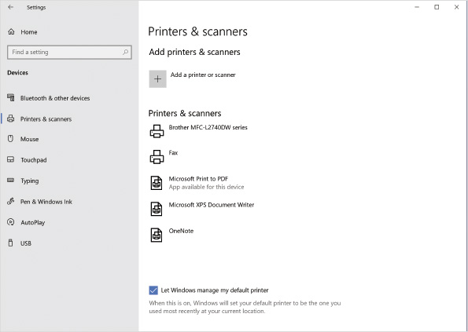
When you click Add a printer or scanner, Windows 10 scans the network looking for printers and displays a list of available printers. If the printer you want to install is found, you select the printer name from the list and click Add device to install it. If Windows 10 does not find the printer on the network, you can click The printer that I want wasn’t listed, which starts the Add Printer Wizard that provides more advanced option for installing a printer.
After adding a printer, if you click the printer name, an Open queue option allows you to manage print jobs. A Manage option also is provided where you can perform the following tasks:
- Print a test page
- Run the troubleshooter
- View printer properties
- View printing preferences
- View hardware properties
Activity 7-6

Adding a Printer
Time Required: 10 minutes
Objective: Add a new printer from Settings
Description: In Windows 10, a USB printer will be detected automatically, but you need to manually install network printers. In this activity, you install a new network printer from Settings.
- 1
If necessary, start your computer and sign in.
- 2
Click the Start button and then click Settings.
- 3
In the Settings window, click Devices and then click Printers & scanners.
- 4
Click Add a printer or scanner. Windows takes a few minutes to scan the network to attempt to find printers and display any printers that are found.
- 5
Click The printer that I want isn’t listed.
- 6
In the Add Printer dialog box, click Add a printer using a TCP/IP address or hostname and then click Next.
- 7
In the Device type list, select TCP/IP Device.
- 8
In the Hostname or IP address text box, type 172.16.99.99. No printer resides at this IP address; it is chosen for the purposes of this activity only to see the interface.
- 9
Deselect the Query the printer and automatically select the driver to use check box and then click Next. In most cases, you want to leave this option on. You are deselecting it because this activity simulates the process.
- 10
After the TCP/IP port is detected (which might take a few minutes), on the Additional port information required screen, click Standard and then click Next.
- 11
In the Manufacturer area, click HP.
- 12
In the Printers box, select HP Universal Printing PCL 6 and then click Next.
- 13
In the Printer name box, type HP Printer PCL6 and then click Next.
- 14
On the Printer Sharing screen, click Do not share this printer and then click Next.
- 15
Click Finish.

Devices and Printers
Devices and Printers in Control Panel, shown in Figure 7-9, allows you to manage printers installed on the local computer. The functionality of Devices and Printers is the same as Printers & scanners in the Settings window. The major tasks that you can perform in Devices and Printers include:
- Add a printer—This option adds a new printer to the local computer. This printer can be physically attached or a network printer. This option scans the network just as when you add a printer through Printers & scanners.
- See what’s printing—This option allows you to see jobs in the print queue for the selected printer. Within the queue, you can pause or delete individual print jobs.
- Set as default printer—This option allows you to configure a printer as the default printer for apps. In an app, such as Microsoft Word, when you click the Print button on the toolbar, the default printer is used.
- Select printing preferences—This option allows you to configure basic printer settings and paper configuration.
- Configure printer properties—This option allows you to edit all printer properties, including those for printing preferences, sharing, and security.
- Configure print server properties—This option allows you to edit print server properties for the local computer. This includes setting available forms (page sizes), configuring ports, and managing drivers.
- Remove device—This option removes the printer from your computer.
Figure 7-9Devices and Printers in Control Panel
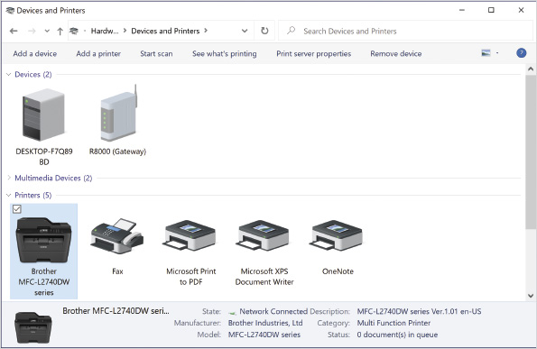
Tip
When you right-click a printer name, most of the commonly used configuration options are accessed by selecting the Printer Properties option. The Properties option allows you to view some summary information.

Print Management Snap-In
The Print Management snap-in, shown in Figure 7-10, allows you to manage printers for your entire network from a single computer. This is a big benefit for any organization with multiple print servers. Typically, you use the Print Management snap-in to manage print servers rather than individual computers.
Figure 7-10Print Management Snap-In
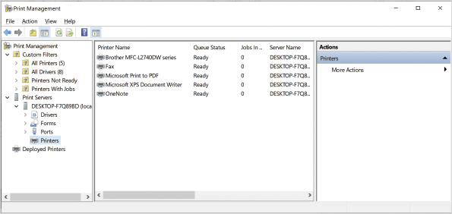
Some features of the Print Management snap-in are:
- Manage multiple print servers—You can manage and configure not only printers, but also print server configuration, such as adding standard TCP/IP ports or printer drivers.
- Filter views—You can filter views to display only the printers in which you are interested. This can include showing only printers in an error state or in one physical location. Four filters exist by default: All Printers, All Drivers, Printers Not Ready, and Printers With Jobs.
- Automatic installation of printers on a print server—You can trigger an automatic printer installation process that scans the local subnet for network printers. If the appropriate drivers are located on the print server, all printers will be installed automatically. This can make configuring a new print server much faster.
- Bulk printer management—You can perform management operations on multiple printers at one time. For example, you can pause all the printers on a print server before you take it down for maintenance.
- Use Group Policy to deploy printers—You can add printer deployment information to Group Policy objects to automatically install printers on workstations.
- Notification—You can configure notifications to generate an email message when the conditions of a filter are met. For example, you can create a filter that shows only those printers in an error condition and set a notification on that filter. Then, when any printer experiences an error condition, you will be notified by email.
Caution
The Use Group Policy to deploy printers option in the Print Management snap-in is outdated and should not be used. The updated method for deploying printers by using Group Policy is by configuring Group Policy Preferences.
Activity 7-7

Using the Print Management Snap-In
Time Required: 10 minutes
Objective: Use the Print Management snap-in to install a new printer on the local computer
Description: The Print Management snap-in is capable of managing local and remote printers and print servers. In this activity, you use the Print Management snap-in to install a local printer.
- 1
If necessary, start your computer and sign in.
- 2
Click the Start button, type print, and then click Print Management.
- 3
If necessary, in the left pane, expand Custom Filters and then click All Printers. This filter displays all the printers installed on every print server that is being monitored. In this case, only the local printers are displayed because only the local computer is being monitored.
- 4
In the left pane, click All Drivers. This filter displays all the printer drivers that are installed on every print server that is being monitored. This allows you to see if different printer driver versions are installed on various print servers.
- 5
In the left pane, if necessary, expand Print Servers, expand your computer, and then click Drivers. This node displays only the printer drivers that are installed on your computer.
- 6
In the left pane, click Forms. This node displays the forms that are configured on your computer. Forms are the paper sizes the printer is configured to use. You can add, edit, or delete forms by right-clicking the Forms node and then clicking Manage Forms.
- 7
In the left pane, click Ports. This node displays all the ports configured on your computer that can be used for printing. You can add additional ports or manage existing ports from here.
- 8
In the left pane, click Printers. This node displays all of the printers that are installed on your computer. You can manage the printers from here and install new printers.
- 9
In the left pane, right-click Printers and then click Add Printer.
- 10
Click Add a new printer using an existing port, if necessary, select LPT1: (Printer Port), and then click Next. After printer installation, this printer will generate an error message when you attempt to print because no printer is physically attached to your computer on LPT1.
- 11
Click Use an existing printer driver on the computer, if necessary, click HP Universal Printing PCL6, and then click Next.
- 12
In the Printer Name box, type Local.
- 13
Leave the option Share this printer checked, type Local in the Share Name box, and then click Next.
- 14
On the Printer Found screen, click Next.
- 15
When the printer installation is finished, click Finish.
- 16
In the left pane, click Printers. The new printer named Local is installed here now.
- 17
Right-click Local and then click Pause Printing.
- 18
Right-click Local and then click Print Test Page.
- 19
In the Local dialog box, click Close.
- 20
In the left pane, click Printers With Jobs. Notice that this screen now displays the printer Local because a job is in the queue.
- 21
Close all open windows.
Go to pg.
help
Application Opened
Main content

7-3dPrinter Configuration
In many cases, after installing a printer, no further configuration is required. If you install a local USB printer, all the available options might already be configured for you. When you install more complex printers with multiple paper trays and finishing options like duplexing, however, you often need to configure the printer. You might also need to manage print jobs, configure location-aware printing, or configure branch office printing.

Configuration Options
Each printer you install in Windows 10 can be configured independently. Most of the options available for configuration are standardized by Windows 10; however, the Device Settings tab, shown in Figure 7-11, has device-specific settings. These settings typically indicate whether specific hardware options, such as duplexers and paper trays, have been installed. The Device Settings tab might not be included for all printers.
Figure 7-11Device Settings Tab of a Printer
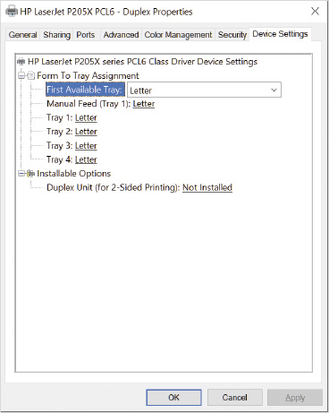
The Advanced tab, shown in Figure 7-12, has a number of options that are typically only implemented for server-based printing; however, these settings are also available for Windows 10. The options on this tab are the same regardless of the printer driver that is installed.
Figure 7-12Advanced Tab of a Printer
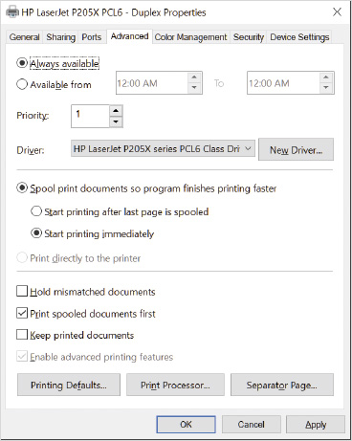
Options on the Advanced tab are:
- Availability—You can schedule the time of day that the printer is available. This is typically used for large print jobs that are deferred until after regular work hours to prevent the printer from being busy for an extended period of time during the workday.
- Priority—This option is used when multiple printers are configured to use the same port. The printer with the highest priority will print first. Printers with lower priority are able to print through the port only when printers with higher priority have completed all of their jobs. This is used on busy print servers to give a few users faster access to the printer.
- Driver—You can update or change the printer driver here.
- Spooling configuration—Spooling allows you to begin using an application faster after printing by storing the print job as a file and sending the print job to the printer as a background process. If you print directly to the printer, you cannot begin using your application again until the print job is complete. When spooling is enabled, you can prevent printing from starting until the last page is spooled as a troubleshooting mechanism when print jobs are being corrupted.
- Hold mismatched documents—This option holds print jobs in the queue if the paper type of the print job is not correctly matched to the paper in the printer.
- Print spooled documents first—This option gives priority to print jobs that have completed spooling over those that are still spooling.
- Keep printed documents—This option keeps a copy of each print job in the queue even after the job is complete. This allows print jobs to be resubmitted later if additional copies are required.
- Enable advanced printing features—This option enables various advanced printing options depending on the application that you are using and the printer driver that is installed.
- Printing Defaults—This option includes the default configuration options for print jobs, such as duplexing, paper orientation, and print quality. These options vary based on the printer driver that is installed.
- Print Processor—This option allows you to choose the format of the print jobs. This is typically used when troubleshooting print job corruption issues.
- Separator Page—This option allows you to specify a separator page that is included at the beginning of each document. Large organizations sometimes include these on busy printers where the separator page includes the user name of the person who printed the job.
Other standard tabs in a printer’s Properties window are:
- General—Used to view information about the printer, configure printing preferences, and print a test page.
- Sharing—Used to configure printer sharing.
- Ports—Used to select and configure ports that are used by this printer.
- Color Management—Used to configure color profiles that are used to control how screen colors are translated to colors for printers. In some cases, color profiles for specific printers are available for download.
- Security—Used to configure user and group permissions for printing.

Printer Sharing and Security
Just as you can create file shares to share files with other users and computers over the network, you can also create shared printers. This is useful in a small office when you want to share the printer attached to a workstation. Sharing is enabled and controlled on the Sharing tab, shown in Figure 7-13.
Figure 7-13Sharing Tab of a Printer
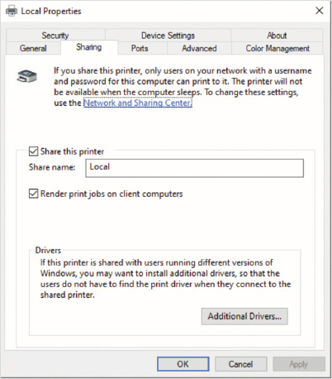
The Sharing tab allows you to:
- Enable sharing for the printer.
- Define the share name for the printer.
- Specify whether print jobs are rendered on the client computer or print server.
- Add drivers for other operating systems to download.
Whether a printer is shared or local, you can also configure security on that printer to control who is allowed to use and manage the printer. The Security tab is shown in Figure 7-14. You can allow or deny user and group permissions to print, manage printers, and manage documents.
Figure 7-14Security Tab of a Printer’s Properties Dialog Box
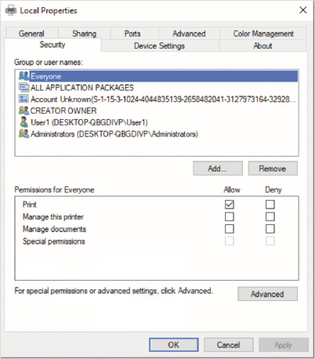
The default permissions for printing are:
- Everyone—Allowed to print.
- All Application Packages—Allowed to print and manage documents. This allows Windows Store apps to print and manage print jobs.
- Creator Owner—Allowed to manage documents. This allows all users to manage their own print jobs.
- User who installed printer (Userx)—Allowed to print, manage printers, and manage documents.
- Administrators—Allowed to print, manage printers, and manage documents.

Branch Office Direct Printing
In Windows Server 2012 and Windows 8, Microsoft introduced Branch Office Direct Printing as a way to improve print performance for users in remote offices. Branch Office Direct Printing is designed for use when the client doing the printing and the printer are in the same physical location, but the print server that shares the printer is in a different location. Print configuration information from the print server is cached on the client computer, and the client prints directly to the printer instead of sending print jobs to the print server.
Consider the following for Branch Office Direct Printing:
- You can centralize the administration of printers for remote offices but still keep WAN link utilization low because the print jobs stay local within the branch office.
- Intermittent WAN outages are not a problem because the printer configuration is cached on the client.
- The client computer is responsible for rendering the print job and must have the correct printer driver installed locally.
- Branch Office Direct Printing is enabled on a shared printer by using the Print Management snap-in.

Managing Print Jobs
In addition to controlling printers, you can also manage the individual jobs in a print queue. For each print job, you can perform the following tasks:
- Pause—Prevents the job from printing. If a job is partially finished printing, it stops at the end of a page.
- Resume—Allows a paused print job to continue printing.
- Restart—Restarts printing a job from the first page.
- Cancel—Stops a print job and removes it from the queue. The print job might not stop immediately, as it might take a few moments for the printer to remove the job from memory and complete printing the final page.
- Edit job properties—Allows you to change the priority of a print job or schedule the job.
Some of the situations where you might want to manage print jobs include:
- Restarting a print job when a paper jam has occurred and some pages have been destroyed
- Pausing a large print job to let several other smaller print jobs be completed
- Raising the priority of a print job to ensure that it prints next
- Changing the schedule of a large print job to prevent it from printing during main office hours
- Canceling a corrupted print job that is blocking other jobs in the queue
Print jobs are managed in Windows 10 by the spooler service. When printing has inexplicably stopped for a printer on a Windows computer, a reboot usually fixes the problem, unless a corrupted print job is blocking the queue. Instead of rebooting the computer, stop and start the print spooler service to accomplish the same result faster. This can be done by using the Services snap-in or opening a command prompt as Administrator and using the net stop spooler and net start spooler commands. You can also use the Windows PowerShell commands Stop-Service Spooler and Start-Service Spooler or Restart-Service Spooler.
If a corrupted print job occurs, it is possible that you will not be able to cancel the job. In such a case, stop the spooler service and delete the job manually in the file system. Print jobs are stored in C:\Windows\System32\spool\PRINTERS. Each print job is composed of two numbered files (.spl and .shd). Delete both files for the corrupted print job and then start the spooler service.
Tip
Sometimes corrupted print jobs cause the Spooler Service to hang and stop processing print jobs. If you can’t stop the spooler service, you can kill the spoolsv.exe process by using Task Manager.
Activity 7-8

Managing Print Jobs
Time Required: 5 minutes
Objective: Manage print jobs
Description: Managing individual print jobs is seldom required; however, it can be useful for troubleshooting. In this activity, you manage a print job in the queue.
- 1
If necessary, start your computer and sign in.
- 2
Click the Start button and then click Settings.
- 3
Click Devices, click Printers & scanners, and then click Local. Note that the Printer local is paused.
- 4
Click Open queue. Notice that a Test Page job exists from Activity 7-7.
- 5
Right-click Test Page and then click Pause. Notice that the status of the job changes to Paused.
- 6
Right-click Test Page and then click Resume.
- 7
Right-click Test Page and then click Properties.
- 8
Click the General tab. You can modify the priority and schedule of the job here.
- 9
Click OK to close the Test Page Document Properties dialog box.
- 10
Right-click Test Page and then click Cancel.
- 11
When prompted, click Yes to confirm canceling the job.
- 12
Close all open windows.
Go to pg.
help
Application Opened
Main content

7-4Browsers
Microsoft includes the Edge browser in Windows 10. This is the default browser and is designed to be used for everyday browsing. Some organizations, however, have older intranet applications or access websites with ActiveX controls that are not supported in Microsoft Edge. To support those older applications, Internet Explorer 11 is also included in Windows 10.
Go to pg.
help
Application Opened
Main content

7-4aMicrosoft Edge
Over the years, Internet Explorer gained a reputation as an unsecure browser. Despite huge security improvements in Internet Explorer during later years, the reputation was hard to shake, and Microsoft determined that it would be best to create a completely new browser that is not limited by the requirement to support legacy technologies. Microsoft Edge in Windows 10 is that browser.
Microsoft Edge works well for browsing on the Internet and is focused on supporting Internet standards, such as HTML5. This browser is not designed to support older web applications designed for specific versions of Internet Explorer. Any web-based application that requires an older version of Internet Explorer to be rendered properly on the screen will not work properly in Microsoft Edge.
The other major feature not in Microsoft Edge is ActiveX controls. ActiveX controls were a method to allow code to be downloaded from a website and executed in the browser. Due to their design, however, ActiveX controls were a large security risk. Many older web-based applications used ActiveX controls.
Finally, Java applets are not supported in Microsoft Edge. No compatible plug-in or extension allows you to run Java applets. Because Java applets were an ongoing security concern, this is a positive development. Other major browsers, such as Chrome and Firefox, have also ended support for Java applets.

Chromium-Based Microsoft Edge
In January of 2020, Microsoft released a new version of Microsoft Edge based on the open source Chromium browser. The Google Chrome browser is also based on Chromium. This should result in better website compatibility with Microsoft Edge, because the functionality in Chromium is more widely supported than the previous page-rendering technology in the older version of Microsoft Edge.
Microsoft documentation refers to the Chromium-based version of Microsoft Edge as version 77 or later. The older version of Microsoft Edge is referred to as version 45 or earlier. To identify which version of Microsoft Edge is installed, you can look at the icon. Figure 7-15 shows the icon for the versions of Microsoft Edge.
Figure 7-15Microsoft Edge Versions
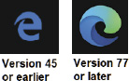
The Chromium-based version of Microsoft Edge is not included in Windows 10 version 1909, but an automatic update upgrades Microsoft Edge to the Chromium-based version. Windows 10 version 2004 and later include the Chromium-based version of Microsoft Edge.
Note 3
If your installation of Windows 10 is not using the new Chromium-based version of Microsoft Edge, you can download it free of charge from https://www.microsoft.com/en-us/edge.

Configuration Settings
Most of the settings available in Microsoft Edge are common across almost all browsers. You can view the history of websites you have visited or save commonly visited websites to your list of favorites.
Collections is a new feature in the Chromium-based version of Microsoft Edge. You can create collections to store a list of websites that share a theme. This is similar to using folders in Favorites to organize webpages. Within a collection, you can also add notes, which is not possible within Favorites. This might be useful when researching, because you can create notes to identify what you still need to research or indicate what useful content a website contained.
Microsoft Edge can also save user names and passwords for websites. This password manager functionality makes it easier for you to maintain a unique user name and password combination for each website that you visit because you don’t need to remember it.
If you use multiple devices, you should consider configuring profile synchronization in Microsoft Edge. If you sign in to Microsoft Edge with a Microsoft account or an Azure AD account, you can enable synchronization among devices that includes information such as favorites, settings, and saved passwords. This makes it easier to work seamlessly across multiple devices.
Activity 7-9

Configure Microsoft Edge
Time Required: 10 minutes
Objective: Configure settings and features in Microsoft Edge
Description: The Chromium-based version of Microsoft Edge is an updated browser for Windows 10. You should be aware of a number of configuration settings to support users. In this activity, you review and configure settings in Microsoft Edge. If necessary, you update your browser to the Chromium-based version of Microsoft Edge.
- 1
If necessary, start your computer and sign in.
- 2
Look at the Microsoft Edge icon on the taskbar and compare it to the icons in Figure 7-15. If you are using version 77 or later, skip to Step 13.
- 3
On the taskbar, click Microsoft Edge.
- 4
In the Search or enter web address box, type https://www.microsoft.com/en-us/edge and then press Enter.
- 5
Click DOWNLOAD for Windows 10.
- 6
In the Download the new Microsoft Edge dialog box, click Accept and download and then click Close.
- 7
In the What do you want to do with MicrosoftEdgeSetup.exe dialog box, click Run.
- 8
In the User Account Control dialog box, click Yes and then wait for the download to complete.
- 9
In the Close Microsoft Edge to install the new version dialog box, click Close and continue.
- 10
If necessary, on the Someone else is signed in to this PC screen, click Install anyway.
- 11
On the Welcome to the new Microsoft Edge screen, click Get started and then click Done.
- 12
Close the Microsoft Edge window.
- 13
On the taskbar, click Microsoft Edge. Notice that the default page that opens is content from Microsoft.
- 14
In the upper-right corner, click Settings and more and then click Settings.
- 15
Read the information on the Your profile screen. You can sign in by using a Microsoft account or an Azure AD account to synchronize Microsoft Edge settings such as favorites and saved credentials between devices.
- 16
In the navigation pane, click Privacy and services and read through the available options. Notice, at the bottom of the screen, that Microsoft Defender SmartScreen is enabled by default.
- 17
In the navigation pane, click Appearance and read the available options.
- 18
In the navigation pane, click On startup and read the available options. Notice that the Open a new tab option is selected by default.
- 19
In the navigation pane, click New tab page and then click Customize.
- 20
In the Page layout dialog box, click Inspirational and identify how the layout has changed.
- 21
Click Focused and close the Page layout dialog box.
- 22
In the Search or enter web address box, type edge://settings and then press Enter.
- 23
In the navigation pane, click Site permissions and read the list of permissions.
- 24
In the Search or enter web address box, type edge://edge-urls and then press Enter. This is a list of URLs that you can use to get additional information about Microsoft Edge configuration.
- 25
Scroll down and click edge://system and read the system information.
- 26
Close the Microsoft Edge window.
Go to pg.
help
Application Opened
Main content

7-4bSecurity Zones
Windows 10 uses security zones to apply different levels of security to websites. The interface for managing the websites assigned to zones was originally designed for Internet Explorer but are also effective for Microsoft Edge; however, not all options, such as Protected Mode, apply to Microsoft Edge. The settings for zones and the sites in each zone are configured by using the Security tab in the Internet Options dialog box, shown in Figure 7-16.
Figure 7-16Security Zones
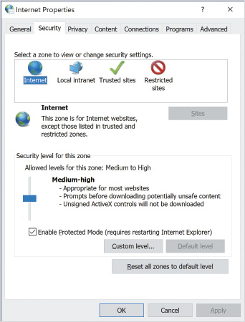
The security zones are:
- Internet—The Internet zone includes all Internet websites that are not specifically assigned to another zone. The default security level is Medium-high.
- Local intranet—The Local intranet zone is meant to be all computers on the internal corporate network. The internal corporate network is defined by default as all sites in the local domain; however, this is relevant only if the workstation is joined to a domain. For workstations that are not part of a domain, the Intranet zone is treated the same as the Internet zone. The default security level is Medium-low.
- Trusted sites—The Trusted sites zone contains no sites by default; you must add sites that you consider trusted. This is useful when the Internet zone settings block functionality, such as pop-up windows, that are required for a site you know and trust. Adding the site to the Trusted sites zone allows that site to function properly. The default security level is Medium.
- Restricted sites—The Restricted sites zone is a specific list of sites that you do not trust. No sites are in this list by default. The default security level is High and cannot be changed except through custom settings.
The Local intranet zone is used primarily to support older web-based applications that require lowered security to function properly. By default, any website accessed by using a server name without dots (periods) is part of the Local intranet zone. For example, http://webserver/app is part of the Local intranet zone, but http://webserver.mydomain.com/app is not part of the Local intranet zone. You can also manually add websites to the Local intranet zone.
When a website is part of the Local intranet zone, Microsoft Edge can pass sign-in credentials from the local workstation to the web server for authentication. Some companies use this as a method for automatically authenticating users to web-based applications. Users are prompted for sign-in credentials if the website is not part of the Local intranet zone.
Tip
The Seamless Single Sign-On feature in Azure AD that allows automatic sign-in to Office 365 services requires a website to be placed in the Intranet zone.
Go to pg.
help
Application Opened
Main content

7-4cGroup Policy Settings for Microsoft Edge
In larger organizations, it’s not reasonable to visit each computer to configure Microsoft Edge to meet organizational standards. Instead, on domain-joined computers Group Policy is used to apply settings. The necessary policy files, however, are not included with Windows 10. Instead, you need to download the policy files that define the Group Policy settings. After you download the policy files, you can configure Microsoft Edge settings by using Group Policy.
The three groups of Microsoft Edge settings that you can configure after installing the policy files include:
- Microsoft Edge—Settings for Microsoft Edge where the setting from Group Policy is authoritative and can’t be changed by users. Some of these are security related and should not be adjusted by users.
- Microsoft Edge-Default Settings (users can override)—This is a smaller group of settings that users are more likely to want to customize. For example, the settings for the Startup page and new tabs are included here.
- Microsoft Edge Update—These settings control how automatic updates for Microsoft Edge are performed, including configuration of a proxy server.
Go to pg.
help
Application Opened
Main content

7-4dIE Mode
To support legacy web-based applications that still require the use of Internet Explorer, you can use IE Mode in Microsoft Edge. IE Mode allows you to create a list of websites that require Internet Explorer and have those websites automatically open in IE Mode for your users. This avoids the user frustration of needing to remember which browser to use for which websites.
Caution
IE Mode uses the components of Internet Explorer 11, which is included as part of Windows 10. If you uninstall the Internet Explorer 11 optional feature, then IE will not work.
You can specify which websites to open in IE Mode by using an XML file to list specific websites or enable the Send all intranet sites to Internet Explorer setting for Microsoft Edge in Group Policy. It is recommended to create the XML instead, because not all intranet sites are likely to require IE Mode.
Although you can manually create the XML file for Enterprise Mode, it is faster and easier to use Enterprise Mode Site List Manager, shown in Figure 7-17, to create the XML file. When you specify the websites, you can also select the mode of Internet Explorer. For example, to support an older web-based application, you can specify that the site be opened in IE 7 Enterprise Mode, which emulates Internet Explorer 7.
Figure 7-17Enterprise Mode Site List Manager for v.2 Schema
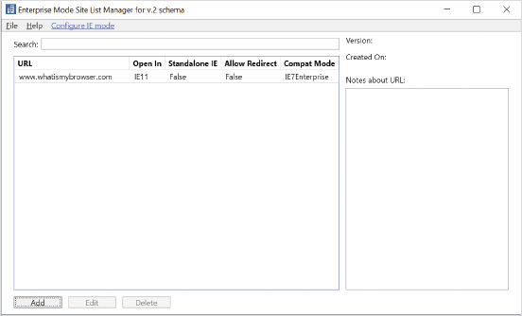
Note 4
Enterprise Mode Site List Manager for Windows 10 can be downloaded from http://go.microsoft.com/fwlink/p/?LinkId=716853.
The final step in configuring Enterprise Mode is configuring the clients to use the XML file. This is done by enabling the Configure the Enterprise Mode Site List Group Policy setting in \Administrative Templates\Windows Components\Microsoft Edge, shown in Figure 7-18. This setting is available for users and computers. When you enable this setting, you provide the location of the XML files. The location can be a website, network share, or local file.
Figure 7-18Group Policy Setting for Site List
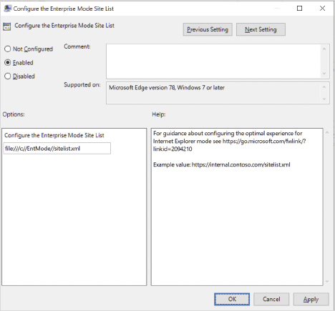
You also need to configure how Internet Explorer is integrated with Microsoft Edge. You configure this in Group Policy with the Configure Internet Explorer integration setting. The three options for this setting include the following:
- Internet Explorer 11—A new Internet Explorer 11 window is opened.
- Internet Explorer mode—The Internet Explorer components run from inside the Microsoft Edge window.
- None—Websites are opened only in normal Microsoft Edge rendering.
Note 5
For detailed information about configuring IE mode in Microsoft Edge, see Use Microsoft Edge with IE mode at https://go.microsoft.com/fwlink/?linkid=2094210.
Activity 7-10

Using IE Mode for Compatibility
Time Required: 20 minutes
Objective: Implement Enterprise Mode to provide backward compatibility for web-based applications
Description: Many organizations have web-based applications that are not compatible with Microsoft Edge. You can use IE Mode to configure a list of websites that will open by using Internet Explorer components. In this activity, you implement IE Mode to support legacy web-based applications.
- 1
If necessary, start your computer and sign in.
- 2
On the taskbar, click Microsoft Edge.
- 3
In the Search or enter web address box, type http://go.microsoft.com/fwlink/p/?LinkId=716853 and then press Enter.
- 4
On the Enterprise Mode Site List Manager (schema v.2) page, click Download.
- 5
When the download is complete, click Open file.
- 6
In Enterprise Mode Site List Manager Setup dialog box, click Next.
- 7
Select the I accept the terms in the License Agreement check box and then click Next.
- 8
On the Destination Folder screen, click Next.
- 9
Click Install and then click Yes in the User Account Control dialog box.
- 10
Click Finish.
- 11
Click the Start button, type enterprise, and then click Enterprise Mode Site List Manager.
- 12
In Enterprise Mode Site List Manager for v.2 schema window, click Add.
- 13
In the Add new website window, in the URL box, type www.whatismybrowser.com.
- 14
In the Open In box, select IE11.
- 15
In the Compat Mode box, select IE7 Enterprise Mode and then click Save.
- 16
In Enterprise Mode Site List Manager for v.2 schema window, click File on the menu bar and then click Save to XML.
- 17
In the Save as dialog box, click Local Disk (C:), click New Folder, type EntMode, and then press Enter.
- 18
Double-click EntMode.
- 19
In the File name box, type sitelist.xml and then click Save.
- 20
Close the Enterprise Mode Site List Manager for v.2 schema window.
- 21
In Microsoft Edge, in the Search or enter web address box, type https://www.microsoft.com/en-us/edge/business/download and then press Enter.
- 22
On the Download and deploy the new Microsoft Edge for business page, in the Select channel/build box, select the newest Stable option.
- 23
Click GET POLICY FILES and then click Accept and download.
- 24
When the file download is complete, click Open file.
- 25
In the File Explorer window, right-click MicrosoftEdgePolicyTemplates and then click Extract.
- 26
In the Select A Destination dialog box, in the navigation pane, below This PC access, click Local Disk (C:), click New folder, type PolicyFiles, and then press Enter.
- 27
Double-click PolicyFiles and then click Extract.
- 28
In the File Explorer window, navigate to C:\PolicyFiles\MicrosoftEdgePolicyTemplates\windows\admx.
- 29
Use Ctrl+click to select msedge.admx, msedgeupdate.admx, and the en-US folder.
- 30
Click the Home tab and then click Copy.
- 31
Navigate to C:\Windows\PolicyDefinitions, click the Home tab, and then click Paste.
- 32
In the Destination Folder Access Denied dialog box, select the Do this for all current items check box and then click Continue.
- 33
Close the File Explorer window.
- 34
In Microsoft Edge, in the Search or enter web address box, type www.whatismybrowser.com and then press Enter. Notice that your browser is identified as Microsoft Edge.
- 35
Close the Microsoft Edge window.
- 36
Click the Start button, type group, and then click Edit group policy.
- 37
In the Local Group Policy Editor window, navigate to \Local Computer Policy\Computer Configuration\Administrative Templates\Microsoft Edge and then double-click Configure Internet Explorer integration.
- 38
In the Configure Internet Explorer integration dialog box, click Enabled.
- 39
In the Configure Internet Explorer integration box, select Internet Explorer mode and then click OK.
- 40
Double-click Configure the Enterprise Mode Site List.
- 41
In the Configure the Enterprise Mode Site List window, click Enabled.
- 42
In the Type the location (URL) of your Enterprise Mode IE website list box, type file:///c://EntMode//sitelist.xml and then click OK.
- 43
On the taskbar, click Microsoft Edge.
- 44
In the Search or enter web address box, type edge://compat and then press Enter. Notice that the site list is being used.
- 45
In the Search or enter web address box, type www.whatismybrowser.com and then press Enter. Notice that the browser version is reported as an old version.
- 46
Close all open windows.
Go to pg.
help
Application Opened
Main content

7-5Accessories and Shortcuts
Windows client operating systems have always included some programs for performing simple editing of graphics and text. Some of these programs can be found in a Windows Accessories folder on the Start menu. These programs have limited utility but ensure that you don’t need to install expensive software, such as Microsoft Office, to perform simple tasks. To aid productivity, Windows 10 also includes a wide variety of shortcuts that you can use to quickly perform tasks instead of clicking in several places. Table 7-2 lists some shortcuts for Windows.
Table 7-2

Windows Shortcuts
Shortcut | Description
Win+D | Minimize all windows
Win+L | Lock the screen
Win+I | Open Settings
Win+Ctrl+Shift+B | Attempt to fix display issues, such as a blank screen
Win++ | Turn on Magnifier for a quick closeup during presentations
Note 6
A comprehensive list of shortcuts in Windows 10 can be found on the Keyboard shortcuts on the Windows page at https://support.microsoft.com/en-us/help/12445/windows-keyboard-shortcuts.
Go to pg.
help
Application Opened
Main content

7-5aText Editing
Notepad is a basic text editor included in Windows 10. This program can edit text files but does not include any text formatting, which means you cannot have multiple fonts, bold type, or italics. It also means that while Notepad is a poor choice for writing a report, it can be an excellent choice for editing text-based configuration files.
Tip
Many support professionals use Notepad++ as an alternative to Notepad. Notepad++ includes many advanced features for searching and editing text. It can be downloaded for free from https://notepad-plus-plus.org.
WordPad is a more advanced text editor that can be used to create simple documents that include text formatting. In addition to text formatting, you can also insert graphics. It does not have many of the advanced features found in a word processor like Microsoft Word, but you can create simple reports. You should avoid using WordPad when editing text-based configuration files because it might add unnecessary formatting information and corrupt the data file.
Windows 10 allows you to use many text-editing shortcuts, which are listed in Table 7-3.
Table 7-3

Text Editing Shortcuts
Shortcut | Description
Ctrl+C | Copy selected text or item to clipboard
Ctrl+X | Cut selected text or item and place on clipboard
Ctrl+V | Paste clipboard contents
Win+V | Open clipboard history and select item to paste
Ctrl+Z | Undo previous action (for many applications)
Ctrl+Y | Redo previous action (for many applications)
Ctrl+Home | Move to top of document (for many applications)
Ctrl+End | Move to end of document (for many applications)
Double-click text | Select whole word (for many applications)
Triple-click text | Select whole paragraph or line (for many applications)
Shift+arrow key | Move cursor one character at a time and select text
Win+. | Displays emoji keyboard
Most of these shortcuts have not changed from previous versions of Windows, but one new option is Win+V for clipboard history. The default clipboard in Windows 10 retains only a single item. When you enable clipboard history, you can copy multiple items and then paste them later. Clipboard history can be enabled in Settings, as shown in Figure 7-19. You can also enable syncing of clipboard data across multiple devices.
Figure 7-19Clipboard Settings
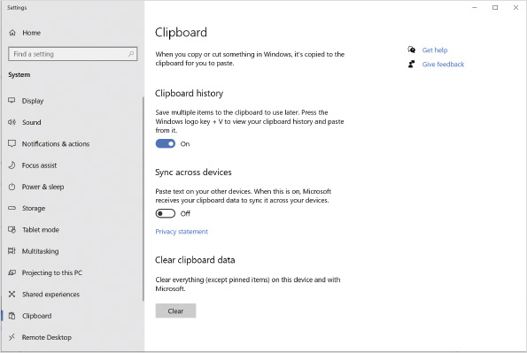
Go to pg.
help
Application Opened
Main content

7-5bGraphics Editing
The Paint application in Windows 10 is a quick and easy want to do some very basic picture editing. If you capture a screenshot and want to crop or annotate it before you paste it into a document, the Paint application works well. Paint, however, does not have more advanced tools for editing pictures, such as adjusting brightness or coloring.
Paint 3D is a newer application that can accomplish the same simple editing as Paint but also apply color filtering and add stickers. You also can add a variety of 3D shapes. When you add a 3D shape, you can rotate it to the position you prefer.
When you double-click a picture, such as a JPG file, it opens in the Photos application. Photos is suitable for simple picture editing. In addition to cropping and rotating, you can also apply filters and light and color adjustments, as well as fix red eye. You can also combine multiple photos with music to create a video.
As a technical support professional, it’s a common requirement to create documentation. The best documentation provides sufficient screenshots to make a process easier to understand. Table 7-4 describes the options included in Windows 10 for taking screenshots.
Table 7-4

Screenshot Shortcuts
Shortcut | Description
Print Screen | Take a screenshot of the entire screen
Win+Print Screen | Take a screenshot of the entire screen and automatically save it to Pictures\Screenshots
Shift+Print Screen | Take a screenshot of the in-focus window
Win+Shift+S | Open the snipping tool to capture a region of the screen, a window, or the entire screen
Win+G | Open the Xbox Game Bar to capture video
Go to pg.
help
Application Opened
Main content

Chapter Review

7-6aSummary
- File Explorer is used to manage and access files in Windows 10. You can enable libraries to provide additional functionality. You can also index additional file system locations to make searching more effective.
- OneDrive is cloud-based storage for files that provides a backup location for your files and portability. You can access files in OneDrive through File Explorer or by using a browser. You can also share files stored in OneDrive with other people.
- In the web interface for OneDrive, you can view file versions and recover deleted files from the Recycle Bin. You can also edit files by using online Microsoft Office applications.
- Printing can be implemented with local or network printers. You can also share printers from a computer running Windows 10 or Windows Server.
- Printer drivers allow Windows 10 to use the full capabilities of a printer. The drivers are often available for PostScript and PCL. After installation, printer drivers are stored in the printer driver store.
- Printers can be installed and managed by using Printers & scanners in Settings, Devices and Printers in Control Panel, and the Print Management snap-in. Some of the configuration settings for printers are standardized, while others are specific to the capabilities of each printer.
- The Microsoft Edge browser is the primary browser in Windows 10. To maintain backward compatibility for older web-based applications, you can configure IE Mode in Microsoft Edge. IE Mode can be used to identify websites that should automatically be opened using compatibility with Internet Explorer.
- Windows 10 includes many useful programs for text editing and graphics editing. Many keyboard shortcuts also can be used to accomplish tasks quickly.
Go to pg.
help
Application Opened
Main content

Chapter Review

7-6bKey Terms
- Branch Office Direct Printing
- Clipboard history
- IE Mode
- libraries
- metadata
- Microsoft Edge
- OneDrive
- OneDrive for Business
- page description language
- Personal Vault
- Portable Document Format (PDF)
- PostScript
- Print Management snap-in
- Printer Command Language (PCL)
- printer driver
- printer driver packages
- printer driver store
- XML Paper Specification (XPS)
Go to pg.
help
Application Opened
Main content

Chapter Review

7-6cReview Questions
- Which document format is similar to XPS?
  - PDF
  - TXT
  - DOC
  - RTF
- Which of the following are languages used by printers? (Choose all that apply.)
  - WPF
  - XPS
  - PCL
  - PostScript
- Which utility is used to add printer drivers to the printer driver store?
  - pdriver.exe
  - pnputil.exe
  - PushPrinterConnections.exe
  - Print Management snap-in
- Which utilities can be used to manage printers? (Choose all that apply.)
  - Devices and Printers in Control Panel
  - Computer Management
  - Device Manager
  - Print Management snap-in
  - Printers & scanners in Settings
- Which of the following are features available only in the Print Management snap-in? (Choose all that apply.)
  - Manage remote printers
  - Manage local printers
  - Configure notifications
  - Bulk printer management
  - Update printer drivers
- When a printer is configured with a lower priority value, the print jobs for that printer are printed first. True or False?
- By default, all users are able to manage their own print jobs because the group has the manage documents permission.
- When you create a new document in the root of a library, where is the document created?
  - in the highest priority location with free space
  - in the first location listed in the library properties
  - in a location you specify when prompted
  - in the default save location of the library
- Which file locations are indexed by default? (Choose all that apply.)
  - the Temp folder
  - the Windows folder
  - the Start menu
  - the Users folder
- For each type of file, you can specify whether the contents of the file are indexed. True or False?
- Which security zone is relevant only if the computer is joined to a domain?
  - Internet
  - Local intranet
  - Trusted sites
  - Restricted sites
- What is the default folder synchronized with OneDrive?
  - C:\OneDrive
  - C:\Users\%username%\SkyDrive
  - C:\Users\%username%\OneDrive
  - C:\Users\%username%\Cloud
- Which actions for OneDrive can be performed only when accessing files through the web interface? (Choose all that apply.)
  - Recover deleted files from the Recycle Bin.
  - Share files with other people.
  - Edit files by using web-based applications.
  - Simultaneously edit files at the same time as other people.
  - Access previous versions of files.
- Access to shared files in OneDrive can be restricted to specific people. True or False?
- Which of the following are characteristics of Branch Office Direct Printing? (Choose all that apply.)
  - WAN utilization is reduced.
  - The print server is responsible for rendering the print job.
  - WAN outages prevent jobs from starting because the print server cannot be contacted.
  - You can centrally manage printers for multiple locations from a single print server.
  - The Print Management snap-in is used to enable Branch Office Direct Printing on a printer.
- Which steps are required to configure IE Mode with Microsoft Edge? (Choose all that apply.)
  - Create a text file with a list of websites requiring Internet Explorer 11.
  - Create an XML file with a list of websites requiring Internet Explorer 11.
  - Enable IE Mode in Group Policy.
  - Enable IE Mode in Microsoft Edge settings.
- The service is responsible for processing print jobs.
- Which application included in Windows 10 is the best to use for editing text-based configuration files?
  - Notepad
  - Word
  - Edit.exe
  - WordPad.exe
  - Notepad++
- Which keyboard shortcut takes a screenshot of the in-focus window?
  - Print Screen
  - Ctrl+P
  - Shift+Print Screen
  - Win+P
  - Win+Print Screen
- What is the version number for the new version of Microsoft Edge that is Chromium-based?
  - 25 and higher
  - 42 and higher
  - 55 and higher
  - 77 and higher
  - 86 and higher
Go to pg.
help

