Application Opened
Main content
Chapter
1

Taking a Computer Apart and Putting It Back Together
- Chapter Introduction
- 1-1Exploring a Desktop Computer
  - 1-1aStep 1: Planning and Organizing Your Work and Gathering Your Tools
  - 1-1bStep 2: Opening the Case
  - 1-1cStep 3: Removing Expansion Cards
  - 1-1dStep 4: Removing the Motherboard
  - 1-1eStep 5: Removing the Power Supply
  - 1-1fStep 6: Removing the Drives
  - 1-1gSteps to Put a Computer Back Together
- 1-2First Look at Laptop Components
  - 1-2aSpecial Keys, Buttons, and Input Devices on a Laptop
  - 1-2bDocking Stations and Port Replicators
  - 1-2cSpecial Considerations When Supporting Laptops
  - 1-2dWorking Inside a Laptop Computer
  - 1-2eExploring Laptop Internal Components
  - 1-2fExploring Inside an All-in-One Computer
  - 1-2gMaintaining Laptops
- 1-3Chapter Review
  - 1-3aChapter Summary
  - 1-3bKey Terms
  - 1-3cThinking Critically
  - 1-3dHands-On Projects
  - 1-3eReal Problems, Real Solutions
  - 1-3fExam Tips
Go to pg.
help
Application Opened
Main content

Chapter Introduction
After completing this chapter, you will be able to:
- Disassemble and reassemble a desktop computer safely while being able to identify various external ports and major components inside a desktop and describe how they connect together and are compatible. You’ll be able to identify various tools you will need as a computer hardware technician.
- Disassemble and reassemble a laptop computer safely while being able to identify various external ports and slots and major internal components of a laptop. You will know what special concerns need to be considered when supporting and maintaining laptops.
Like many other computer users, you have probably used your personal computer to play games, update your Facebook profile, write papers, or build Excel worksheets. This text takes you from being an end user of your computer to becoming an information technology (IT) support technician able to support all types of personal computers. The only assumption made here is that you are a computer user—that is, you can turn on your machine, load a software package, and use that software to accomplish a task. No experience in electronics is assumed.
As an IT support technician, you’ll want to become A+ certified, which is the industry standard certification for IT support technicians. This text prepares you to pass the A+ 220-1001 Core 1 and 220-1002 Core 2 exams by CompTIA (comptia.org). The exams are required by CompTIA for A+ certification.
In this chapter, you take apart and reassemble a desktop computer and laptop while discovering the various hardware components inside the cases. You’ll also learn about the tools you’ll need to work inside the case.
A+ Exam Tip
As you work your way through a chapter, notice the green and blue A+ mapping icons underneath headings. These page elements help you know to which objectives on which exam the content applies. After studying each chapter, take a look at the grid at the beginning of this text and make sure you understand each objective listed in the grid for the chapter just completed.
Taking apart and servicing a computer are tasks that every A+ certified technician needs to know how to do. As part of your preparation to become A+ certified, try to find old desktop and laptop computers you can take apart. If you can locate the service manual for a laptop, you should be able to take it apart, repair it (assuming the parts are still available and don’t cost more than the computer is worth), and get it up and running again. Have fun with this chapter and enjoy tinkering with these computers!
Go to pg.
help
Application Opened
Main content

1-1Exploring a Desktop Computer
A+ Core 1
- 2.8
Given a scenario, use appropriate networking tools.
- 3.2
Identify common connector types.
- 3.3
Given a scenario, install RAM types.
- 3.4
Given a scenario, select, install and configure storage devices.
- 3.5
Given a scenario, install and configure motherboards, CPUs, and add-on cards.
- 3.7
Summarize power supply types and features.
- 5.5
Given a scenario, troubleshoot common mobile device issues while adhering to the appropriate procedures.
In this part of the chapter, you learn how to take apart a desktop computer and put it back together. This skill is needed in this chapter and others as you learn to add or replace computer parts inside the case and perhaps even build a system from scratch. As you read the following steps, you might want to refer to the Hands-On Projects at the end of the chapter, which allow you to follow along by taking a computer apart. As you do so, be sure to follow all the safety precautions found in Appendix A. In the steps that follow, each major computer component is identified and described. You learn much more about each component later in the text. Take your time—don’t rush—as you take apart a computer for the first time. It can be a great learning experience or an expensive disaster! As you work, pay attention to the details and work with care.
Go to pg.
help
Application Opened
Main content

1-1aStep 1: Planning and Organizing Your Work and Gathering Your Tools
A+ Core 1
- 5.5
Given a scenario, troubleshoot common mobile device issues while adhering to the appropriate procedures.
When you first begin to learn how to work inside a computer case, make it a point to practice good organization skills. If you keep your notes, tools, screws, and computer parts well organized, your work goes more smoothly and is more fun. Here are some tips to keep in mind:
- As you work, make notes using pencil and paper and perhaps take photos with your cell phone so that you can backtrack later if necessary. (When you’re first learning to take a computer apart, it’s easy to forget where everything fits when it’s time to put the computer back together. Also, in troubleshooting, you want to avoid repeating or overlooking things to try.)
- Remove loose jewelry that might get caught in cables and components as you work.
- To stay organized and not lose small parts, keep screws and spacers orderly and in one place, such as a cup or tray.
- Don’t stack boards on top of each other: You could accidentally dislodge a chip this way. When you remove a circuit board or drive from a computer, carefully lay it on an antistatic mat or in an antistatic bag in a place where it won’t get bumped.
- When handling motherboards, cards, or drives, don’t touch the chips on the device. Hold expansion cards by the edges. Don’t touch any soldered components on a card, and don’t touch the edge connectors unless it’s absolutely necessary. All this helps prevent damage from static electricity. Also, your fingerprints on the edge connectors can cause later corrosion.
- To protect a microchip, don’t touch it with a magnetized screwdriver.
- Never, ever touch the inside of a computer that is turned on. The one exception to this rule is when you’re using a multimeter to measure voltage output.
- Consider the monitor and the power supply to be “black boxes.” Never remove the cover or put your hands inside this equipment unless you know about the hazards of charged capacitors and have been trained to deal with them. The power supply and monitor contain enough power to kill you, even when they are unplugged.
- As you work, remember to watch out for sharp edges on computer cases that can cut you.
- In a classroom environment, after you have reassembled everything, have your instructor check your work before you put the cover back on and power up.

Tools Used by a Computer Hardware Technician
Every IT support technician who plans to repair desktop or laptop computers or mobile devices needs a handy toolbox with a few essential tools. Several hardware and software tools can help you maintain a computer and diagnose and repair computer problems. The tools you choose depend on the amount of money you can spend and the level of hardware support you expect to provide.
Essential tools for computer hardware troubleshooting are listed here, and several of them are shown in Figure 1-1. You can purchase some of these tools in a computer toolkit, although most toolkits contain items you really can do without.
Figure 1-1
Tools used by IT support technicians when maintaining, repairing, or upgrading computers
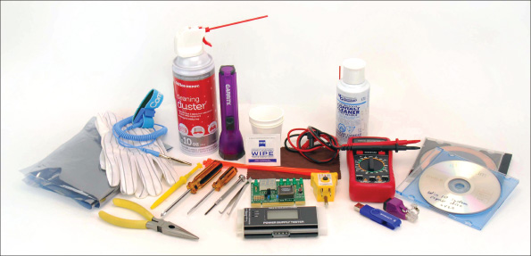
One of the more important tools is an ESD strap (also called a ground bracelet), which protects against ESD when working inside the computer case. Electrostatic discharge (ESD) is another name for static electricity, which can damage chips and destroy motherboards, even though it might not be felt or seen with the naked eye. Use the strap to connect or ground your hand to the case, as shown in Figure 1-2, and any static electricity between you and the case is dissipated.
Figure 1-2
An ESD strap, which protects computer components from ESD, can clip to the side of the computer case and eliminate ESD between you and the case
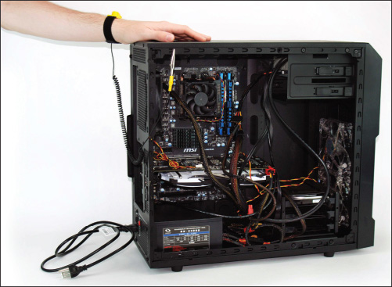
Here is a list of essential tools:
- An ESD strap (also called a ground bracelet)
- Flathead screwdriver
- Phillips-head or crosshead screwdriver
- Torx screwdriver set, particularly size T15
- Tweezers, preferably insulated ones, for picking pieces of paper out of printers or dropped screws out of tight places
- Software, including recovery CD or DVD for any operating system (OS) you might work on (you might need several, depending on the OSs you support), antivirus software on bootable CDs or USB flash drives, and diagnostic software
The following tools might not be essential, but they are very convenient:
- Cans of compressed air (see Figure 1-3), small portable compressor, or antistatic vacuum cleaner to clean dust from inside a computer case
Figure 1-3
A can of compressed air is handy to blow dust from a computer case

- Cleaning solutions and pads such as contact cleaner, monitor wipes, and cleaning solutions for CDs and DVDs
- Multimeter to check cables and the power supply output
- Power supply tester
- Needle-nose pliers for removing jumpers and for holding objects in place while you screw them in (especially handy for those pesky nuts on cable connectors)
- Cable ties to tie cables up and out of the way inside a computer case
- Flashlight to see inside the computer case
- AC outlet ground tester
- Network cable tester
- Loopback plugs to test ports
- Small cups or bags to help keep screws organized as you work
- Antistatic bags (a type of Faraday cage) to store unused parts
- Pen and paper for taking notes
- POST diagnostic cards
Notes
It’s important to know how to stay safe when working inside computers. Before opening a computer case and using the tools described in this section, be sure to read Appendix A. As you work inside a computer, follow all the safety guidelines discussed in this appendix.
Keep your tools in a toolbox designated for hardware troubleshooting. If you put discs and hardware tools in the same box, be sure to keep the discs inside a hard plastic case to protect them from scratches and dents. In addition, make sure the diagnostic and utility software you use is recommended for the hardware and software you are troubleshooting.
As you turn your attention to the disassembly of a desktop computer, you’ll also learn about several IT support technician tools, including loopback plugs, diagnostic cards, power supply testers, and multimeters. Now that you’ve prepared your work area and tools, put on your ESD strap and let’s get started with opening the computer case.
Go to pg.
Application Opened
Main content

1-1eStep 5: Removing the Power Supply
A+ Core 1
- 2.8
Given a scenario, use appropriate networking tools.
- 3.7
Summarize power supply types and features.
To remove the power supply from the case, look for screws that attach the power supply to the computer case, as shown in Figure 1-36. Be careful not to remove any screws that hold the power supply housing together. You do not want to take the housing apart. After you have removed the screws, the power supply still might not be free. Sometimes, it is attached to the underside of the case by recessed slots. Turn the case over and look on the bottom for these slots. If they are present, determine in which direction you need to slide the power supply to free it from the case.
Figure 1-36
Remove the power supply mounting screws
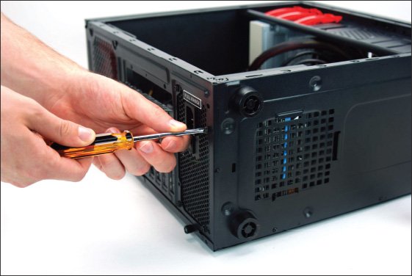

Power Supply Tester
A power supply tester is used to measure the output of each connector coming from the power supply. You can test the power supply when it is outside or inside the case. As you saw earlier in Figure 1-18, the power supply provides several cables and connectors that power various components inside the computer case. A power supply tester has plugs for each type of cable. Connect a power cable to the tester, plug up the power supply, and turn on the tester. An LCD panel reports the output of each lead (see Figure 1-37).
Figure 1-37
Use a power supply tester to test the output of each power connector on a power supply
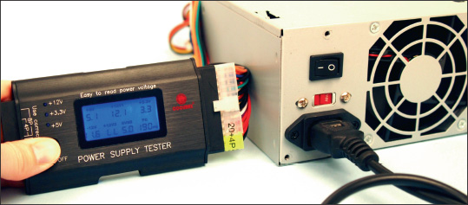

Multimeter
A multimeter (see Figure 1-38) is a more general-purpose tool that can measure several characteristics of electricity in a variety of devices. Some multimeters can measure voltage, current, resistance, and continuity. (Continuity determines that two ends of a cable or fuse are connected without interruption.) When set to measure voltage, you can use it to measure output of each pin on a power supply connector. When set to measure continuity, a multimeter is useful to test fuses, to determine if a cable is good, or to match pins on one end of a cable to pins on the other end.
Figure 1-38
This digital multimeter can be set to measure voltage, resistance, or continuity
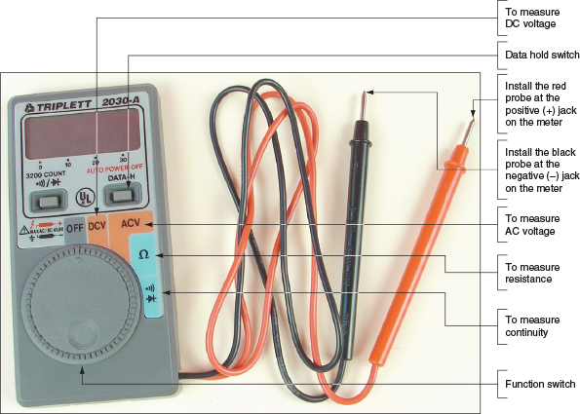
Go to pg.
help
Application Opened
Main content

1-1fStep 6: Removing the Drives
A+ Core 1
- 3.4
Given a scenario, select, install and configure storage devices.
- 3.5
Given a scenario, install and configure motherboards, CPUs, and add-on cards.
A computer might have one or more hard drives, an optical drive (CD, DVD, or Blu-ray), or some other type of drive. A drive receives power by a power cable from the power supply, and communicates instructions and data through a cable attached to the motherboard. Most hard drives and optical drives today use the serial ATA (SATA) standard.
Figure 1-39 shows a SATA cable connecting a hard drive and motherboard. SATA cables can only connect to a SATA connector on the motherboard in one direction (see Figure 1-40). SATA drives get their power from a power cable that connects to the drive using a SATA power connector (refer back to the photo in Table 1-2).
Figure 1-39
A hard drive subsystem using the SATA data cable
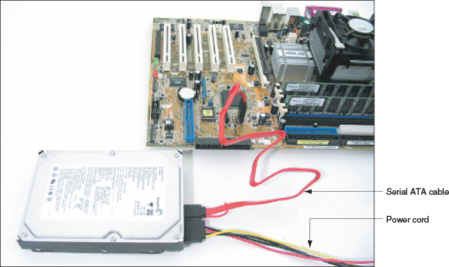
Figure 1-40
A SATA cable connects to a SATA connector in only one direction; for this system, use red connectors on the motherboard first
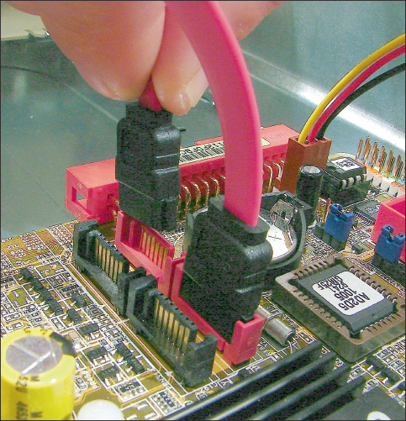
Remove each drive next, handling them with care. Here are some tips:
- Some drives have one or two screws on each side of the drive that attach the drive to the drive bay. After you remove the screws, the drive slides to the front or to the rear and then out of the case.
- Sometimes, there is a catch underneath the drive that you must lift up as you slide the drive forward.
- Some drive bays have a clipping mechanism to hold the drive in the bay. First, release the clip and then pull the drive forward and out of the bay (see Figure 1-41). Handle the drives with care. Some drives have an exposed circuit board on the bottom of the drive. Don’t touch this board.
Figure 1-41
To remove this optical drive, first release the clip to release the drive from the bay
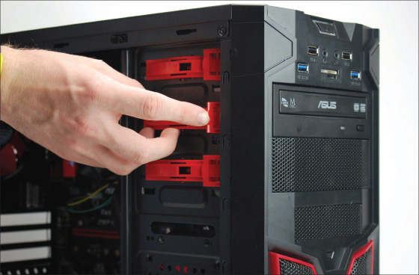
- Some drives must be removed through the front of the case, especially optical drives. After removing all screws or releasing the clipping mechanism, you might need to remove the front panel of the case to remove the drive. See Figure 1-42.
Figure 1-42
Some cases require you to remove the front panel before removing the optical drive
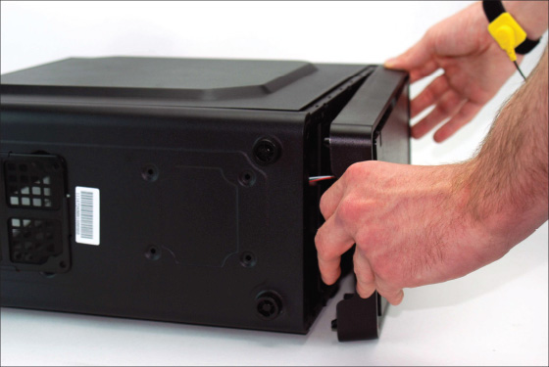
- Some cases have a removable bay for smaller hard drives (see Figure 1-43). The bay is removed first and then the drives are removed from the bay. To remove the bay, first remove the screws or release the clip holding the bay in place, and then slide the bay out of the case. The drives are usually installed in the bay with two screws on each side of each drive. Remove the screws and then the drives (see Figure 1-44).
Figure 1-43
Push down on the clip and then slide the removable bay forward and out of the case
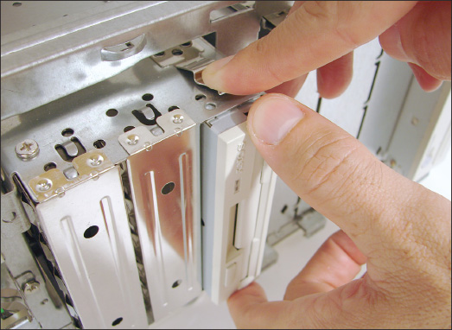
Figure 1-44
Drives in this removable bay are held in place with screws on each side of the bay and drive
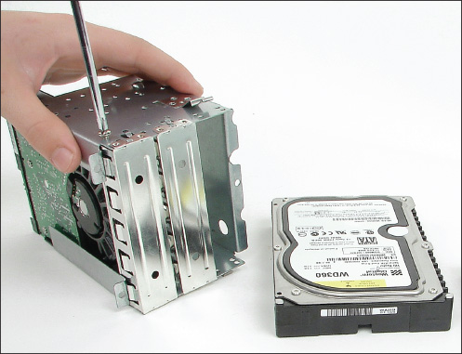
Go to pg.
help
Application Opened
Main content

1-1gSteps to Put a Computer Back Together
A+ Core 1
- 3.5
Given a scenario, install and configure motherboards, CPUs, and add-on cards.
- 5.5
Given a scenario, troubleshoot common mobile device issues while adhering to the appropriate procedures.
To reassemble a computer, reverse the process of disassembling. Here is where your diagrams will be very useful; having the screws and cables organized will also help. In the directions that follow, we’re also considering the possibility that you are installing a replacement part as you reassemble the system. Do the following:
- Install components in the case in this order: power supply, drives, motherboard, and cards. When installing drives, know that for some systems, it’s easier to connect data cables to the drives and then slide the drives into the bay. If the drive is anchored to the bay with screws or latches, be careful to align the front of the drive flush with the front of the case before installing screws or pushing in the latches (see Figure 1-45).
Figure 1-45
Align the front of the drive flush with the case front and then anchor with a screw
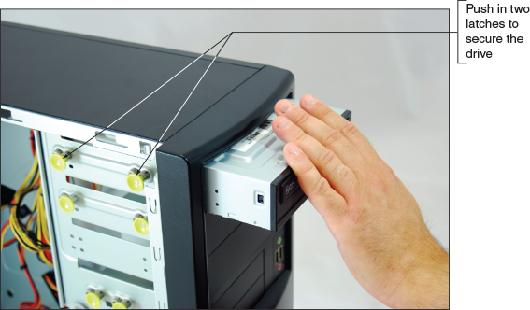
- Place the motherboard inside the case. Make sure the ports stick out of the I/O shield at the rear of the case and the screw holes line up with screw holes on the bottom of the case. Figure 1-46 shows how you must align the screw holes on the motherboard with those in the case. There should be at least six screw sets, and there might be as many as nine. Use as many screws as there are holes in the motherboard.
Figure 1-46
Align screw holes in the case with those on the motherboard
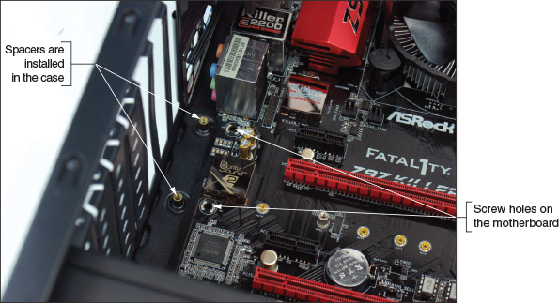
- Connect the power cords from the power supply to the motherboard. A system will always need the main P1 power connector and most likely will need the 4-pin auxiliary connector for the processor. Other power connectors might be needed depending on the devices you later install in the system. Here are the details:
  - Connect the P1 power connector from the power supply to the motherboard (refer back to Figure 1-23).
  - Connect the 4-pin or 8-pin auxiliary power cord coming from the power supply to the motherboard, as shown in Figure 1-47. This cord supplies the supplemental power required for the processor.
Figure 1-47
The auxiliary 4-pin power cord provides power to the processor
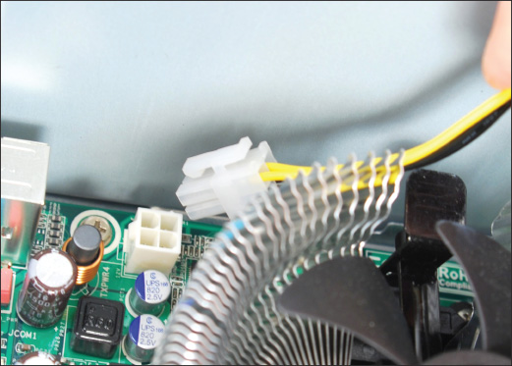
  - To power the case fan, connect the power cord from the fan to pins on the motherboard labeled Fan Header. Alternately, some case fans use a 4-pin Molex connector that connects to a power cable coming directly from the power supply.
  - If a CPU and cooler are already installed on the motherboard, connect the power cord from the CPU fan to the pins on the motherboard labeled CPU Fan Header.
- Connect the wire leads from the front panel of the case to the front panel header on the motherboard. These are the wires for the switches, lights, and ports on the front or top of the computer. Because your case and your motherboard might not have been made by the same manufacturer, you need to pay close attention to the source of the wires to determine where they connect on the motherboard. For example, Figure 1-48 shows a computer case that has seven connectors from the front panel that connect to the motherboard. Figure 1-49 shows the front panel header on the motherboard for these lights and switches. If you look closely at the board in Figure 1-49, you can see labels identifying the pins.
Figure 1-48
Seven connectors from the front panel connect to the motherboard
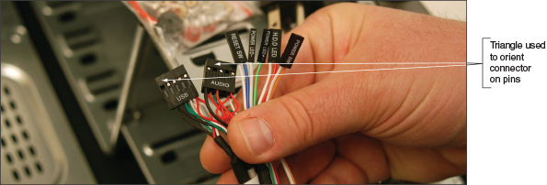
Figure 1-49
The front panel header uses color-coded pins and labels
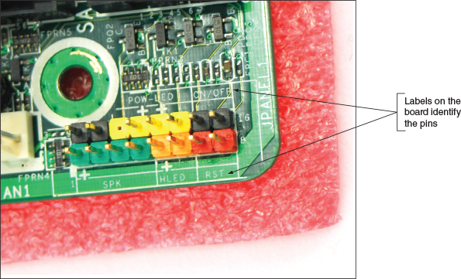
The five smaller connectors on the right side of Figure 1-48 are labeled from right to left as follows:
  - Power SW. Controls power to the motherboard; must be connected for the PC to power up
  - HDD LED. Controls the drive activity light on the front panel that lights up when any SATA or IDE device is in use (HDD stands for hard disk drive and LED stands for light-emitting diode; an LED is a light on the front panel.)
  - Power LED+. Positive LED controls the power light and indicates that power is on
  - Power LED−. Negative LED controls the power light; the two positive and negative leads indicate that power is on
  - Reset SW. Switch used to reboot the computer
Notes
Positive wires connecting the front panel to the motherboard are usually a solid color, and negative wires are usually white or striped.
To help orient the larger connectors on the motherboard pins, look for a small triangle embedded on the connector that marks one of the outside wires as pin 1 (see Figure 1-48). Look for pin 1 to be labeled on the motherboard as a small 1 embedded to either the right or left of the group of pins. If the labels on the board are not clear, turn to the motherboard user guide for help. The diagram in Figure 1-50 shows what you can expect from one motherboard user guide. Notice pin 1 is identified as a square pin in the diagram, rather than round like the other pins.
Figure 1-50
Documentation for front panel header connections
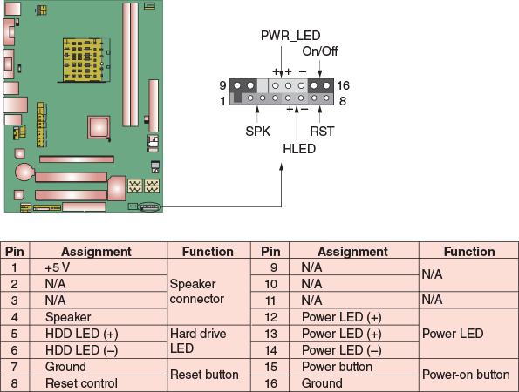
Notes
If the user guide is not handy, you can download it from the motherboard manufacturer’s website. Search on the brand and model number of the board, which is imprinted somewhere on the board.
Sometimes the motherboard documentation is not clear, but guessing is okay when connecting a wire to a front panel header connection. If it doesn’t work, no harm is done. Figure 1-51 shows all front panel wires in place and the little speaker also connected to the front panel header pins.
Figure 1-51
A front panel header with all connectors in place
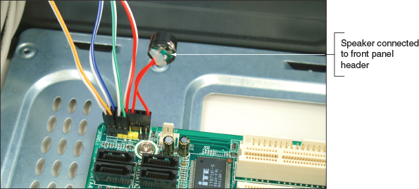
- Connect wires to ports on the front panel of the case. Depending on your motherboard and case, there might be cables to connect audio ports or USB ports on the front of the case to headers on the motherboard. Audio and USB connectors are the two left connectors shown in Figure 1-48. You can see these ports for audio and USB on the front of the case in Figure 1-52. Look in the motherboard documentation for the location of these connectors. The audio and USB connectors are labeled for one board in Figures 1-53(A) and (B).
Figure 1-52
Ports on the front of the computer case
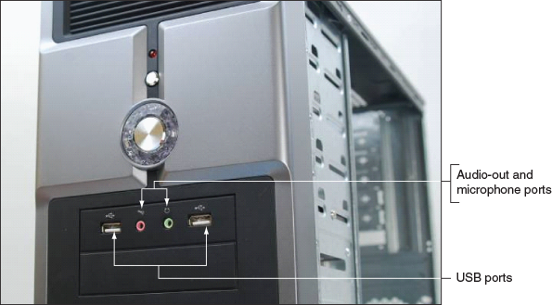
Figure 1-53
Connectors for front panel ports
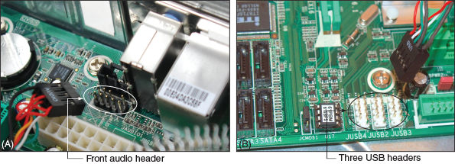
- Install the video card and any other expansion cards. Push the card straight down into the slot, being careful not to rock it side to side, and install the screw to secure the card to the case.
- Take a few minutes to double-check each connection and make sure it is correct and snug. Verify that all required power cords are connected correctly and the video card is seated solidly in its slot. Also verify that no wires or cables are obstructing fans. You can use cable ties to tie wires up and out of the way.
- Plug in the keyboard, monitor, and mouse.
- In a classroom environment, have the instructor check your work before you close the case and power up.
- Turn on the power and check that the PC is working properly. If the PC does not work, most likely the problem is a loose connection. Just turn off the power and recheck each cable connection and each expansion card. You probably have not solidly seated a card in the slot. After you have double-checked, try again.
Now step back and congratulate yourself on a job well done! By taking a computer apart and putting it back together, you’ve learned how computer parts interconnect and work.
Now let’s turn our attention to how to disassemble and reassemble a laptop.
Go to pg.
Application Opened
Main content

1-2First Look at Laptop Components
A+ Core 1
- 1.1
Given a scenario, install and configure laptop hardware and components.
- 1.3
Given a scenario, use appropriate laptop features.
- 3.3
Given a scenario, install RAM types.
- 3.9
Given a scenario, install and configure common devices.
- 5.5
Given a scenario, troubleshoot common mobile device issues while adhering to the appropriate procedures.
A laptop, also called a notebook, is designed for portability (see Figure 1-54A and 1-54B) and can be just as powerful as a desktop computer. More than half of personal computers purchased today are laptops, and almost 30 percent of personal computers currently in use are laptops. Laptops use the same technology as desktops, but with modifications to use less power, take up less space, and operate on the move.
Figure 1-54
A laptop, netbook, and all-in-one computer
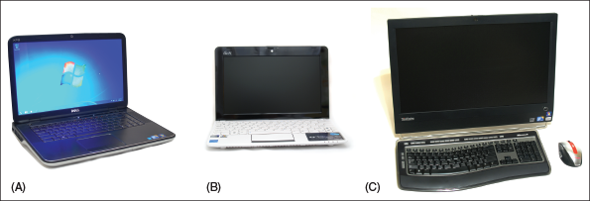
Laptops come in several varieties, including some with a touch screen that allows you to handwrite on it with a stylus and some with a rotating or removable screen that allows you to use the laptop as a tablet (see Figure 1-55). Another variation of a laptop is a netbook (Figure 1-54B), which is smaller and less expensive than a laptop and has fewer features. An all-in-one computer (Figure 1-54C) has the monitor and computer case built together and uses components that are common to both a laptop and desktop. Because all-in-one computers use many laptop components and are serviced in similar ways, we include them in this part of the chapter.
Figure 1-55
A laptop with a rotating display can do double-duty as a tablet computer
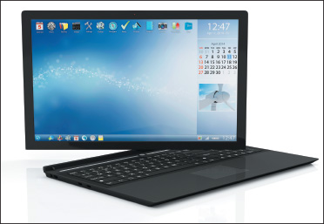
Source: iStockphoto.com/Rasslava
A laptop provides ports on its sides, back, or front for connecting peripherals (see Figure 1-56). Ports common to laptops as well as desktop systems include USB, network, and audio ports (for a microphone, headset, or external speakers). Video ports might include one or more VGA, DisplayPort, Thunderbolt (on Apple laptops), or HDMI ports to connect to a projector, second monitor, or television. On the side or back of the laptop, you’ll see a lock connector that’s used to physically secure the laptop with a cable lock (see Figure 1-57) and a DC jack to receive power from the AC adapter. Also, a laptop may have an optical drive, but netbooks usually don’t have them.
Figure 1-56
Ports and slots on a laptop computer
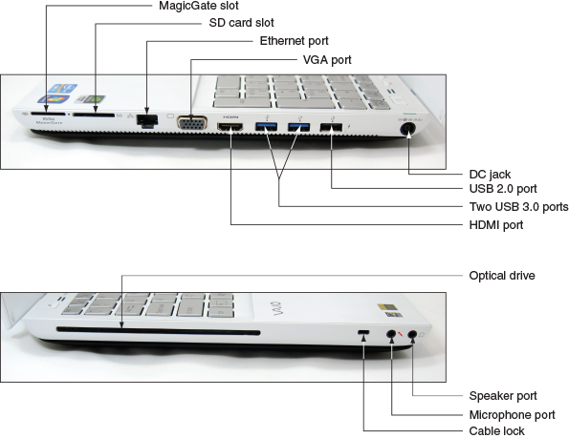
Figure 1-57
Use a cable lock system to secure a notebook computer to a desk to help prevent it from being stolen
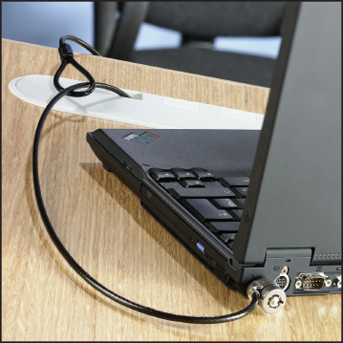
Source: Kensington Technology Group
Notice the two slots in Figure 1-56 used for flash memory cards: a MagicGate slot and an SD card slot. Each can support several types of flash memory cards that you learn about later in the text.
When a laptop is missing a port or slot you need, you can usually find a USB dongle to provide the port or slot. Here are some possible solutions for a missing or failed port:
- Connect to a local wired network. Figure 1-58 shows a USB to RJ-45 dongle. Plug the dongle into a USB port and plug a network cable into the RJ-45 port the dongle provides to connect the laptop to a wired network.
Figure 1-58
A USB to RJ-45 dongle provides a network port to connect to a wired network
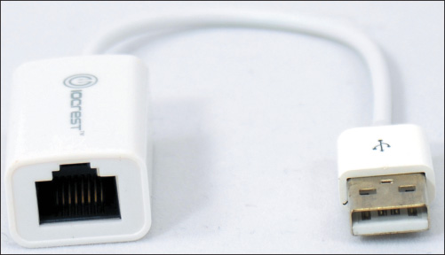
- Connect to a local wireless network. Figure 1-59 shows a USB to Wi-Fi dongle, which allows you to connect a laptop to a wireless network that doesn’t have wireless capability or the laptop’s wireless component has failed. Wi-Fi (Wireless Fidelity) is the common name for standards for a local wireless network.
Figure 1-59
This USB to Wi-Fi adapter plugs into a USB port to connect to a local wireless network
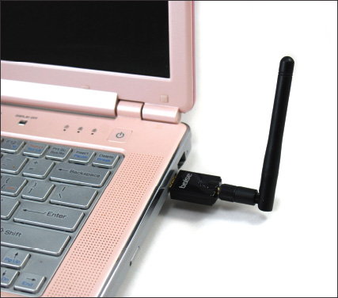
- Connect to a cellular network. Some laptops have embedded capability to connect to a cellular network. Figure 1-60 shows a USB cellular modem that can be used for a laptop that doesn’t have the embedded technology. A cellular network consists of geographic areas of coverage called cells, each controlled by a tower called a base station. Cell phones are so named because they use a cellular network.
Figure 1-60
This USB device by Sierra Wireless provides a wireless connection to a cellular network
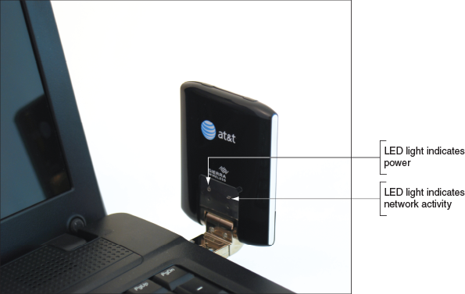
- Connect to a Bluetooth device. When a laptop doesn’t have Bluetooth capability, you can use a USB to Bluetooth adapter to connect to a Bluetooth wireless device such as a Bluetooth printer or smartphone. Bluetooth is a short-range wireless technology to connect two devices in a small personal network.
- Use an external optical drive. When a laptop or netbook doesn’t have an optical drive, you can use a USB optical drive. Plug the USB optical drive into a USB port so that you can use CDs and DVDs with the laptop or netbook.
Notes
When troubleshooting or installing an operating system on a laptop or netbook, you might need to boot from a USB optical drive containing the Windows setup DVD. In this situation, you need to first access BIOS/UEFI setup and change the boot priority order to boot first from an external USB device. This process is covered in Chapter 2.
Go to pg.
Application Opened
Main content

1-2aSpecial Keys, Buttons, and Input Devices on a Laptop
A+ Core 1
- 1.1
Given a scenario, install and configure laptop hardware and components.
- 1.3
Given a scenario, use appropriate laptop features.
Buttons or switches might be found above the keyboard, and the top row of keys contains the function keys. To use a function key, hold down the Fn key as you press the function key. Here are the purposes of a few keys and buttons. Some of them change Windows settings. Know that these same settings can also be changed using Windows tools:
- Volume setting. You can set the volume using the volume icon in the Windows taskbar. In addition, some laptops offer buttons or function keys to control the volume (see Figure 1-61).
Figure 1-61
On this laptop, use the Fn and the F2, F3, or F4 key to control volume; use the Fn key and the F5 or F6 key to control screen brightness; and use the Fn key and the F7 key to manage dual displays
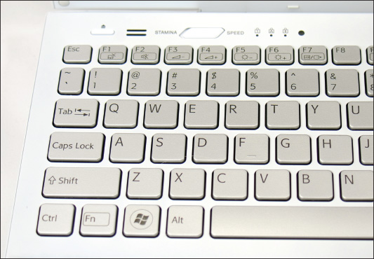
- Keyboard backlight. Function keys can be used to control the keyboard backlight and light up the keyboard.
- Touch pad on or off. Other function keys can activate or deactivate the touch pad, which is the most common pointing device on a laptop (see Figure 1-62). Some people prefer to use a USB wired or wireless mouse instead of a touch pad.
Figure 1-62
The touch pad is the most common pointing device on a notebook
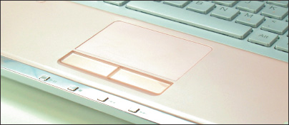
- Screen brightness and screen orientation. Function keys can control the screen brightness on many laptops. Screen brightness can also be controlled in Windows display settings. Some laptops allow you to use a function key to change the screen orientation to landscape or portrait so you can use the laptop turned on its end.
- Dual displays. Most laptops use a function key to control dual displays. For example, for one laptop, the combination of the Fn key and the F7 key (refer back to Figure 1-61) displays the box shown in Figure 1-63. Use arrow keys to select only the LCD panel, duplicate or extend output to the external monitor, or use only the external monitor. Dual displays can also be managed using Windows display settings.
Figure 1-63
Control dual monitors on a Windows 10 laptop
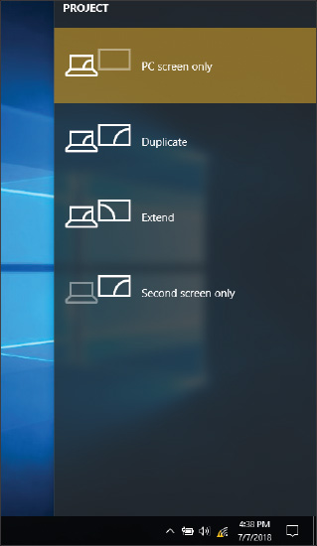
- Bluetooth, Wi-Fi, or cellular on or off. Some laptops use function keys such as Fn with F5 or F6 to toggle Bluetooth, Wi-Fi, or cellular on or off, or a laptop might have a switch for this purpose. You can also control these wireless technologies using Windows settings or software utilities provided by the manufacturer. When you turn off all wireless technologies, the computer is said to be in airplane mode.
- Media options. Some laptops provide buttons or allow you to use function keys to fast forward, stop, pause, or rewind audio or video media playing in an optical drive.
- GPS on or off. If a laptop has a GPS (Global Positioning System) receiver to calculate its position on Earth, the laptop might provide a button or function key to turn the GPS on or off. GPS is a system of 24 or more satellites orbiting Earth; a GPS receiver can locate three or more of these satellites at any time and then calculate its own position from these three locations, a process called trilateration.
Notes
If the keyboard fails and you’re not able to immediately exchange it, know that you can plug in an external keyboard to a USB port for use in the meantime.
Go to pg.
help
Application Opened
Main content

1-2bDocking Stations and Port Replicators
A+ Core 1
- 1.3
Given a scenario, use appropriate laptop features.
The bottom or sides of some laptops have a proprietary connector, called a docking port, (see Figure 1-64) that connects to a docking station. A docking station provides ports to allow a laptop to easily connect to a full-sized monitor, keyboard, AC power adapter, and other peripheral devices. See Figure 1-65. Laptop manufacturers usually offer a docking station as an additional option on most business laptops and a few consumer laptops as well. A disadvantage of a docking station is that when you upgrade your laptop, you typically must purchase a new compatible docking station.
Figure 1-64
The docking port and sheet battery connector on the bottom of a laptop
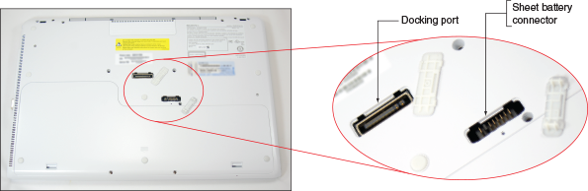
Figure 1-65
A docking station for a Lenovo ThinkPad
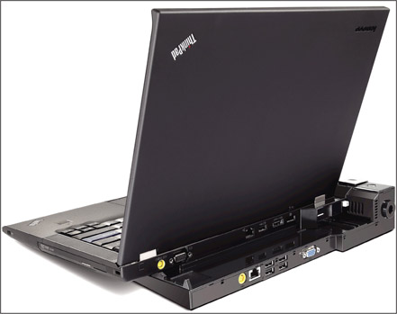
Source: Courtesy of Lenovo
A port replicator, sometimes called a universal docking station, is a device that provides ports to allow a laptop to easily connect to peripheral devices, such as an external monitor, network, printer, keyboard and mouse, or speakers. See Figure 1-66. Some port replicators also supply power to the laptop to charge the battery. The difference between a port replicator and a docking station is that a port replicator isn’t proprietary to a single brand or model of laptop because it typically connects to a laptop using a single USB port.
Figure 1-66
This port replicator provides USB 3.0, USB 2.0, HDMI, DVI, and network ports
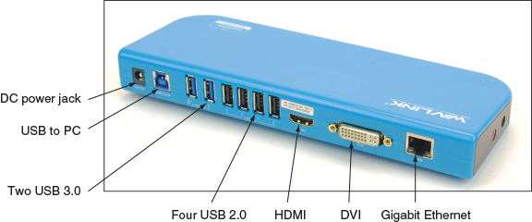
To use a docking station or port replicator, plug all the peripherals into the docking station or port replicator. Then, connect your laptop to the station. No software needs to be installed. When you need to travel with your laptop, you don’t have to unplug all the peripherals; all you have to do is disconnect the laptop from the docking station or port replicator.
Go to pg.
help
Application Opened
Main content

1-2cSpecial Considerations When Supporting Laptops
A+ Core 1
- 5.5
Given a scenario, troubleshoot common mobile device issues while adhering to the appropriate procedures.
Laptops and their replacement parts cost more than desktop computers with similar features because their components are designed to be more compact and stand up to travel. Laptops use compact hard drives, small memory modules, and CPUs that require less power than regular components. Whereas a desktop computer is often assembled from parts made by a variety of manufacturers, laptop computers are almost always sold by a vendor that either manufactured the laptop or had it manufactured as a consolidated system. Notable factors that generally apply more to laptop than desktop computers are the original equipment manufacturer’s warranty, the service manuals and diagnostic software provided by the manufacturer, the customized installation of the OS that is unique to laptops, and the need to order replacement parts directly from the laptop manufacturer or other source authorized by the manufacturer.
In many situations, the tasks of maintaining, upgrading, and troubleshooting a laptop require the same skills, knowledge, and procedures as when servicing a desktop computer. However, you should take some special considerations into account when caring for, supporting, upgrading, and troubleshooting laptops. These same concerns apply to netbooks and all-in-one computers. Let’s begin with warranty concerns.

Warranty Concerns
Most manufacturers or retailers of laptops offer at least a one-year warranty and the option to purchase an extended warranty. Therefore, when problems arise while the laptop is under warranty, you are dealing with a single manufacturer or retailer to get support or parts. After the laptop is out of warranty, this manufacturer or retailer can still be your one-stop shop for support and parts.
Caution
The warranty often applies to all components in the system, but it can be voided if someone other than an authorized service center representative services the laptop. Therefore, you as a service technician must be very careful not to void a warranty that the customer has purchased. Warranties can be voided by opening the case, removing part labels, installing other-vendor parts, upgrading the OS, or disassembling the system unless directly instructed to do so by authorized service center personnel.
Before you begin servicing a laptop, avoid potential problems with a warranty by always asking the customer, “Is the laptop under warranty?” If the laptop is under warranty, look at the documentation to find out how to get technical support. Options are chat sessions on the web, phone numbers, and email. Use the most appropriate option. Before you contact technical support, have the laptop model and serial number ready (see Figure 1-67). You’ll also need the name, phone number, and address of the person or company that made the purchase. Consider asking the customer for a copy of the receipt and warranty so you’ll have the information you need to talk with support personnel.
Figure 1-67
The model and serial number stamped on the bottom of a laptop are used to identify the laptop to service desk personnel
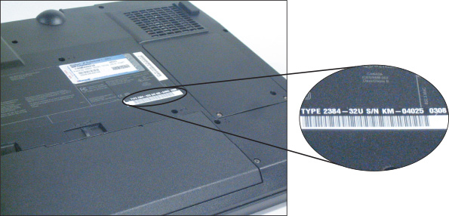
Based on the type of warranty purchased by the laptop’s owner, the manufacturer might send an on-site service technician, ask you to ship or take the laptop to an authorized service center, or help you solve the problem by an online chat session or over the phone. Table 1-3 lists some popular manufacturers of laptops, netbooks, and all-in-ones. Manufacturers of laptops typically also produce all-in-ones because of the features they have in common.
Table 1-3

Laptop, Netbook, and All-in-One Manufacturers
Manufacturer | Website
Acer | us.acer.com and us.acer.com/support
Apple Computer | apple.com and apple.com/support
ASUS | usa.asus.com and asus.com/us/support/
Dell Computer | dell.com and support.dell.com
Hewlett Packard (HP) | hp.com and support.hp.com
Lenovo | lenovo.com and support.lenovo.com
Microsoft | microsoft.com
Razer | razer.com and support.razer.com
Samsung | samsung.com and samsung.com/support
Sony (VAIO) | store.sony.com and esupport.sony.com
Toshiba America | toshiba.com and support.toshiba.com

Service Manuals and Other Sources of Information
Desktop computer cases tend to be similar to one another, and components in desktop systems are usually interchangeable among manufacturers. Not so with laptops. Laptop manufacturers typically take great liberty in creating their own unique computer cases, buses, cables, connectors, drives, circuit boards, fans, and even screws, all of which are likely to be proprietary in design.
Every laptop model has a unique case. Components are installed in unique ways and opening the case for each laptop model is done differently. Because of these differences, servicing laptops can be very complicated, tedious, and time consuming. For example, a hard drive on one laptop is accessed by popping open a side panel and sliding the drive out of its bay. However, to access the hard drive on another model of laptop, you must remove the keyboard. If you are not familiar with a particular laptop model, you can damage the case frame or plastics as you pry and push trying to open it. Trial and error is likely to damage a case. Even though you might successfully replace a broken component, the damaged case will result in an unhappy customer.
Fortunately, a laptop service manual can save you considerable time and effort—if you can locate one (see Figure 1-68). Most laptop manufacturers closely guard these service manuals and release them only to authorized service centers. Two laptop manufacturers, Lenovo and Dell, provide their service manuals online free of charge. HP also does an excellent job of offering online support. For example, Figure 1-69 displays a video that shows the steps to replace the top cover on an HP laptop. I applaud Lenovo, Dell, and HP for the generous documentation about how their laptops are disassembled and the options to purchase proprietary parts without first being an authorized service center.
Figure 1-68
A laptop service manual tells you how to use diagnostic tools, troubleshoot a laptop, and replace components
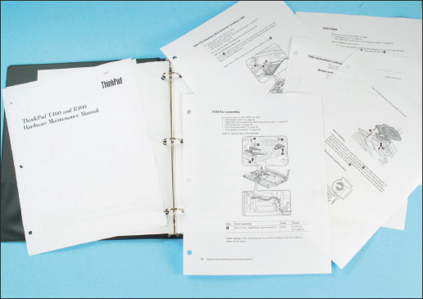
Figure 1-69
The HP website (support.hp.com) provides detailed instructions and videos for troubleshooting and replacing components
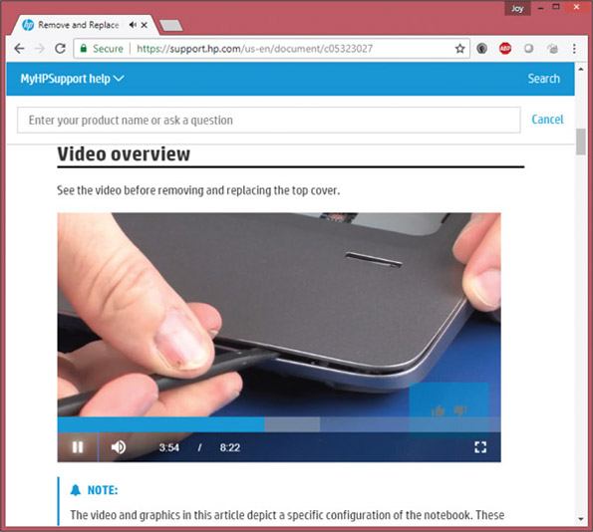
Source: hp.com
Notes
The wiki-type website ifixit.com does an excellent job of providing its own teardown and reassembly instructions for many brands and models of laptops. You can also buy parts and tools on the site.
Videos at youtube.com can also help teach you how to disassemble a specific model of laptop. However, beware that not all videos posted on YouTube follow recommended best practices.
For all laptop manufacturers, check the Support or FAQ pages of their websites for help with tasks such as opening a case without damaging it and locating and replacing a component. Be aware that some manufacturers offer almost no help at all. Sometimes, you can find service manuals on the web. To find your manual, search on the laptop model—for example, search on “Lenovo ideapad 310-15ABR laptop service manual.”
Don’t forget about the user manuals. They might contain directions for upgrading and replacing components that do not require disassembling the case, such as how to upgrade memory or install a new hard drive. User manuals also include troubleshooting tips and procedures and possibly descriptions of BIOS/UEFI settings. In addition, you can use a web search engine to search on the computer model, component, or error message, which might give you information about the problem and solution.

Diagnostic Tools Provided by Manufacturers
Most laptop manufacturers provide diagnostic software that can help you test components to determine which component needs replacing. As one of the first steps when servicing a laptop, check the user manual, service manual, or manufacturer’s website to determine if diagnostic software exists and how to use it. Use the software to pinpoint the problem component, which can then be replaced.
Notes
When you purchase a replacement part for a laptop from the laptop’s manufacturer, most often the manufacturer also sends detailed instructions for exchanging the part and/or phone support to talk you through the process.
Check the manufacturer’s website for diagnostics software that can be downloaded for a specific model of laptop or stored on the hard drive or on CDs bundled with the laptop. Figure 1-70 shows a window provided by the diagnostics program installed on the hard drive of one laptop.
Figure 1-70
Use diagnostics software provided by a laptop manufacturer to troubleshoot hardware problems
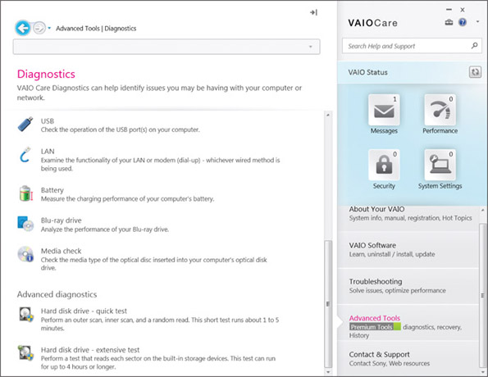
Source: Sony
One example of diagnostic software is PC-Doctor (pc-doctor.com), which is recommended by several manufacturers, including Lenovo, Fujitsu, and HP. The diagnostic software is stored on the hard drive or on CD. If stored on CD, you can boot from the CD to run the tests. If the software is stored on the hard drive, you can run it from the Windows Start menu or by pressing a function key at startup before Windows loads. Either way, PC-Doctor can run tests on the keyboard, video, speakers, touch pad, optical drive, wireless LAN, motherboard, processor, ports, hard drive, and memory. To learn how to use the software, see the laptop’s service manual or user manual. You can find a stand-alone version of PC-Doctor for DOS and PC-Doctor for Windows at pc-doctor.com. You can purchase it at this site; it’s expensive but might be worth it if you plan to service many laptops.
Go to pg.
help
Application Opened
Main content

1-2dWorking Inside a Laptop Computer
A+ Core 1
- 5.5
Given a scenario, troubleshoot common mobile device issues while adhering to the appropriate procedures.
Sometimes it is necessary to open a laptop case so you can upgrade memory, exchange a hard drive, or replace a failed component such as the LCD panel, video inverter, keyboard, touch pad, processor, optical drive, DC jack, fan, motherboard, CMOS battery, Mini PCIe card, wireless card, or speaker. Most laptops sold today are designed so that you can easily purchase and exchange memory modules or hard drives. However, replacing a failing processor or motherboard can be a complex process, taking several hours. Most likely, you will choose to replace the entire laptop rather than doing these labor-intensive and costly repairs.
Screws and nuts on a laptop are smaller than those on a desktop system and therefore require smaller tools. Figure 1-71 shows several tools used to disassemble a laptop, although you can get by without several of them. Here’s the list:
Figure 1-71
Tools for disassembling a laptop
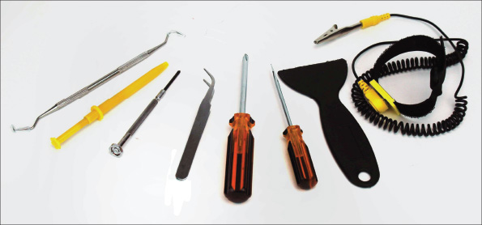
- ESD strap
- Small flathead screwdriver
- Number 1 Phillips-head screwdriver
- Metal and plastic spudgers (useful for prying open casings without damaging plastic connectors and cases, such as the one in Figure 1-69)
- Dental picks and tweezers (useful for prying without damaging plastic cases, connectors, and screw covers, such as the one in Figure 1-72)
Figure 1-72
Use a small screwdriver or dental pick to pry up the plastic cover hiding a screw
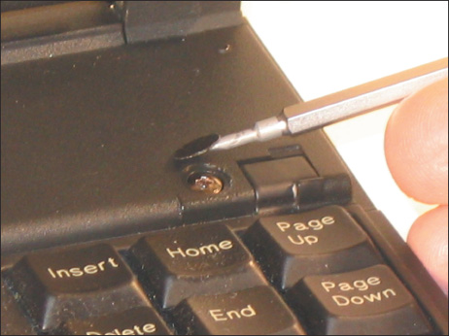
- Torx screwdriver set, particularly size T5
- Something such as a pillbox to keep screws and small parts organized
- Notepad for note-taking or digital camera (optional)
- Flashlight (optional)
Working on laptops requires extra patience. As with desktop systems, before opening the case of a laptop or touching sensitive components, you should always wear an ESD strap to protect the system against ESD. You can attach the alligator clip end of the strap to an unpainted metallic surface on the laptop. This surface could be, for instance, a port on the back of the laptop (see Figure 1-73). If a ground strap is not available, first dissipate any ESD between you and the laptop by touching a metallic, unpainted part of it, such as a port on the back, before you touch a component inside the case.
Figure 1-73
To protect the system against ESD, attach the alligator clip of a ground strap to an I/O port on the back of the laptop
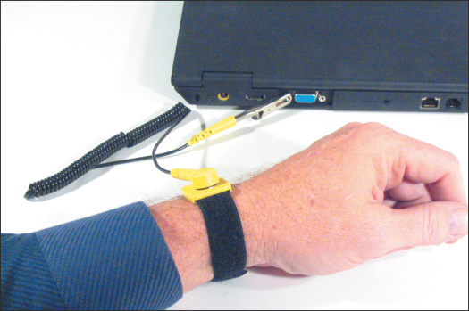
Laptops contain many small screws of various sizes and lengths. When reassembling the system, put screws back where they came from so you won’t use screws that are too long and that can protrude into a sensitive component and damage it. As you remove a screw, store or label it so you know where it goes when reassembling. One method is to place screws in a pillbox with each compartment labeled. Another way is to place screws on a soft, padded work surface and use white labeling tape to label each set of screws. A third way to organize screws is to put them on notebook paper and write beside them where the screw belongs (see Figure 1-74). My favorite method of keeping up with all these screws is to tape each one beside the manufacturer documentation I’m following to disassemble the laptop (see Figure 1-75). Whatever method you use, work methodically to keep screws and components organized so you know what goes where when reassembling.
Figure 1-74
Using a notepad can help you organize screws so you know which screw goes where when reassembling
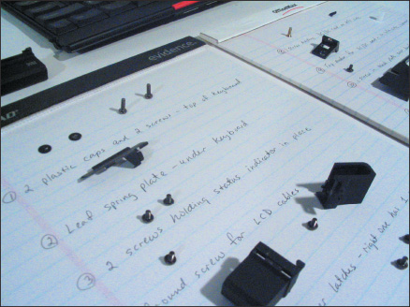
Figure 1-75
Tape screws beside the step in the manufacturer documentation that told you to remove the screw
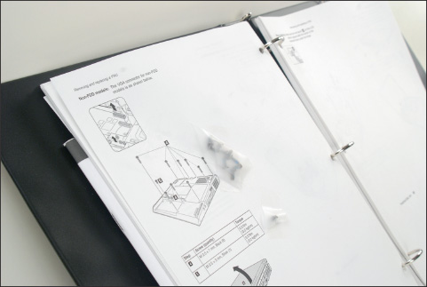
A+ Exam Tip
The A+ Core 1 exam expects you to know the importance of keeping parts organized when disassembling a laptop as well as the importance of having manufacturer documentation to know the steps for disassembly. Given a scenario, you should be able to adhere to appropriate procedures.
If you disassemble a computer and are not following directions from a service manual, keep notes as you work to help you reassemble later. Draw diagrams and label things carefully. Include cable orientations and screw locations in your drawings. You might consider using a digital camera. Photos that you take at each step in the disassembly process will be a great help when it’s time to put the laptop back together.
When disassembling a laptop, consider the following tips:
- Make your best effort to find the hardware service manual for the particular laptop model you are servicing. The manual should include all the detailed steps to disassemble the laptop and a parts list of components that can be ordered from the laptop manufacturer. If you don’t have this manual, your chances of successfully replacing an internal component are greatly reduced! Another helpful resource is searching the Internet for video tutorials for the teardown of the model you are using. If you don’t have much experience disassembling a laptop, it is not wise to attempt to do so without the service manual.
- Consider the warranty that might still apply to the laptop. Remember that opening the case of a laptop under warranty most likely will void the warranty. Make certain that any component you have purchased to replace an internal component will work in the model of laptop you are servicing.
- Take your time. Patience is needed to keep from scratching or marring plastic screw covers, hinges, and the case.
- As you work, don’t force anything. If you do, you’re likely to break it.
- Always wear an ESD strap or use other protection against ESD.
- When removing cables, know that some ribbon cable connectors are ZIF connectors. To disconnect a cable from a ZIF connector, first pull up on the connector and then remove the cable, as shown in Figure 1-76. Figure 1-77 shows a laptop that uses three ZIF connectors to hold the three keyboard cables in place. For some ribbon cables, you simply pull the cable out of the connector. For these cables, it’s best to use two tweezers, one on each side of the connector, to remove the cable.
Figure 1-76
To disconnect a ZIF connector, first lift up on the locking flap to release the latch, and then remove the cable using the pull tab, which is blue on this laptop
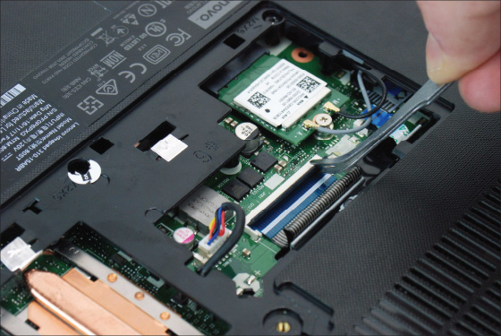
Figure 1-77
Three ZIF connectors hold the three keyboard cables in place
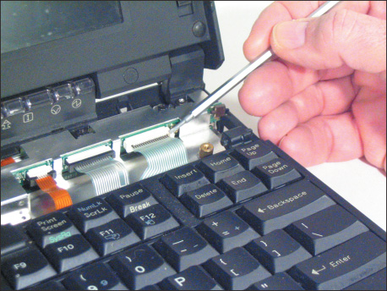
- Again, use a spudger, dental pick, or very small screwdriver to pry up the plastic cover hiding a screw.
- Some laptops use plastic screws that are intended to be used only once. The service manual will tell you to be careful not to overtighten these screws and to always use new screws when reassembling a laptop.
- Disassemble the laptop by removing each field replaceable unit (FRU) in the order given by the laptop’s service manual. For example, one manufacturer says that to replace the fan assembly and heat sink assembly for a laptop, you must remove components in this order: HDD compartment cover, keyboard bezel, HDD, mini PCIe slot compartment cover and RAM, wireless card, optical drive, and then system board. After all these components are removed, you can then remove the fan assembly and heat sink assembly. Follow the steps to remove each component in the correct order.
- At some point in the disassembly process after all appropriate covers and screws have been removed, you must crack the case, which means you separate the top and bottom parts of the case. The parts might be tightly sealed together. To separate them, use a plastic or metal spudger to slide along the seal and pry open the case, as shown earlier in Figure 1-69.
When reassembling a laptop, consider these general tips:
- Reassemble the laptop in the reverse order you disassembled it. Follow each step carefully.
- Be sure to tighten, but not overtighten, all screws. Loose screws or metal fragments in a laptop can be dangerous; they might cause a short as they shift about inside the laptop.
- Before you install the battery or AC adapter, verify that there are no loose parts inside the laptop. Pick it up and gently shake it. If you hear anything loose, open the case, find the loose component, screw, spring, or metal flake, and fix the problem.
Go to pg.
Application Opened
Main content

1-2eExploring Laptop Internal Components
A+ Core 1
- 1.1
Given a scenario, install and configure laptop hardware and components.
- 3.3
Given a scenario, install RAM types.
- 3.9
Given a scenario, install and configure common devices.
- 5.5
Given a scenario, troubleshoot common mobile device issues while adhering to the appropriate procedures.
Here is a list of important components you are likely to be instructed to remove when disassembling a laptop and the typical order you remove them. However, know that the components and the order of disassembly vary from one laptop to another:
- Remove or disable the battery pack. To start the disassembly, disconnect all peripherals, remove discs from the optical drive, and shut down the system. Then, disconnect the AC adapter and remove the battery. Removing the battery (see Figure 1-78) assures you that no power is getting to the system, which keeps the laptop and you safe as you work. Some laptops and netbooks have built-in batteries. For these devices, follow the manufacturer instructions to disable the battery (often called Ship Mode), which prevents it from providing power to any component.
Figure 1-78
Remove the battery pack before opening a laptop case
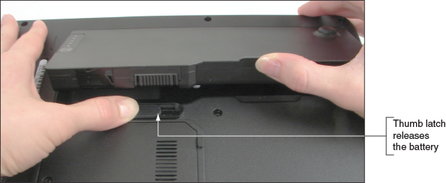
- Remove the hard drive. For some laptops, the hard drive is accessed by removing the hard drive compartment cover from the bottom of the laptop. For example, Figure 1-79 shows the hard drive is secured in its bay with three screws. When you remove the screws and disconnect the ribbon cable, you can lift the drive from its bay. For other hard drives, rather than disconnecting a ribbon cable from the drive, you unplug the drive from its drive socket.
Figure 1-79
Remove all screws that secure the hard drive in its bay
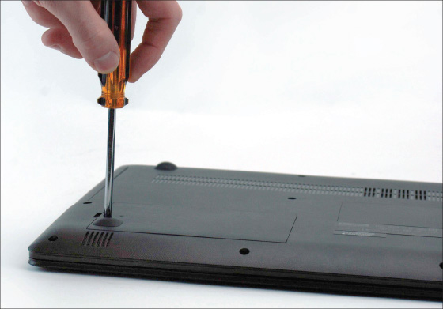
- Remove memory. Laptops use smaller memory modules than the DIMMs used in desktop computers. Figure 1-80 shows a DIMM and a SO-DIMM (small outline DIMM) for size comparison. For one laptop, you first remove the memory/Mini PCI Express Card compartment cover to access the memory modules. Release two latches on both edges of the socket at the same time to remove the memory modules, as shown in Figure 1-81.
Figure 1-80
A DIMM used in desktops compared with a SO-DIMM used in laptop computers
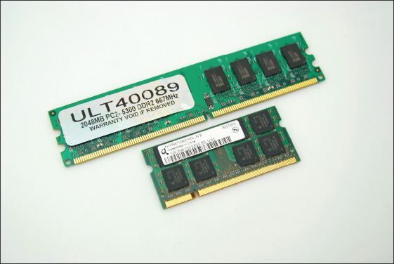
Figure 1-81
Release the latches on both edges of the socket to remove the memory modules
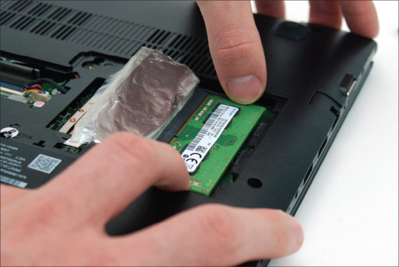
- Remove the wireless card. For the laptop in Figure 1-81, the Mini PCI Express wireless card is installed in the same compartment as the memory modules. Disconnect the two wires leading to the wireless antennas, which are installed in the laptop lid. Next, remove the screw securing the wireless card, then pull the card directly away from the socket, as shown in Figure 1-82.
Figure 1-82
Pull the wireless card directly away from the socket to prevent damage to the card and socket
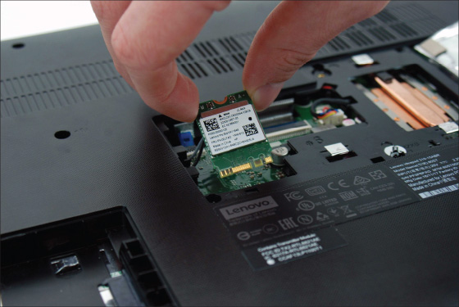
- Remove the optical drive. The optical drive is secured by a single screw on the bottom of the laptop. Figure 1-83 shows the removal of the single screw holding the drive in place. Next, slide the drive out of the case.
Figure 1-83
Slide the optical drive out of the case after removing the screw securing the optical drive to the laptop
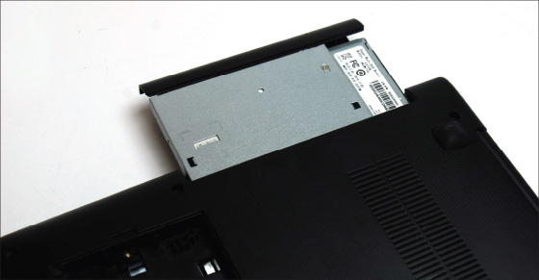
- Crack the case. After removing compartment covers and the components accessible inside these compartments (for example, memory, optical drive, and hard drive), you are ready to remove any other screws as directed in the service manual, and then you can crack the case. Use a spudger to slide along the seal between the case top and bottom, and pry open the plastic casing on the side, as shown in Figure 1-84.
Figure 1-84
Using a spudger helps prevent harming the casing when prying it open
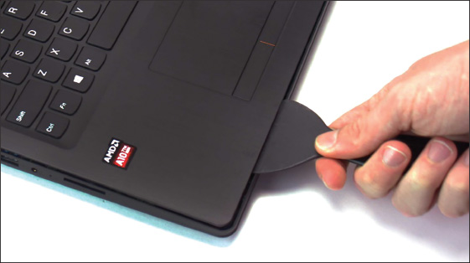
- Remove the keyboard bezel. The keyboard bezel is the keyboard casing surrounding the keyboard of a laptop. For some laptops, such as the one shown in Figure 1-85, the keyboard bezel is the top of the case. For other laptops, you remove the case top and then remove the keyboard. Once you remove screws and disconnect the cables from the motherboard, the keyboard bezel should easily lift away from the laptop, as shown in Figure 1-85. You might need a spudger to help.
Figure 1-85
Disconnect both the touch pad board cable and the keyboard cable to remove the keyboard
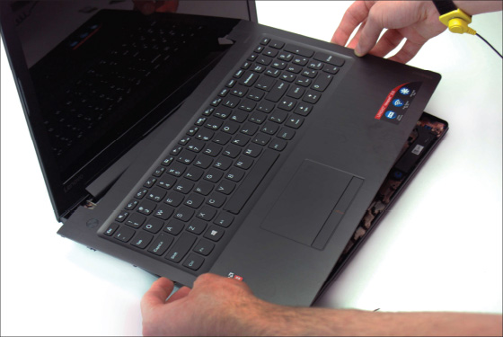
- Remove the system board. Figure 1-86 shows a system board (in laptop documentation, the motherboard is usually called the system board) with heat sink, fan, and processor connected to it. A system board in a laptop also has ports on one side that are easily accessed externally on the laptop. To remove the system board, you must remove all screws and disconnect all cables for all the components in the laptop, which can be time consuming and difficult. You’ll learn how to replace the system board in Chapter 2.
Figure 1-86
The system board, heat sink, and fan are replaceable units in this laptop
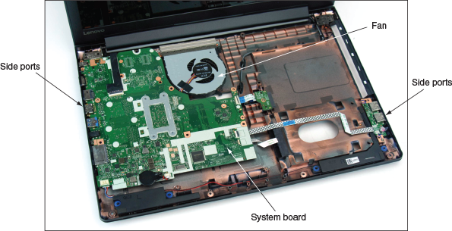
- Remove the CPU, heat sink, and fan. The CPU is embedded on the system board in many laptops, which means if the CPU fails, the system board must be replaced to repair the laptop. The heat sink draws heat from the CPU and pipes it to the fan, as labeled in Figure 1-86. The fan blows the heat out of the laptop case. The fan and heat sink assembly is considered a field replaceable component in many laptops.
Other hardware components you are likely to find in a laptop case include the LCD panel and components in the laptop lid. Later in the text, you’ll learn how to replace the components in a laptop lid.
Go to pg.
Application Opened
Main content

1-2fExploring Inside an All-in-One Computer
A+ Core 1
- 1.1
Given a scenario, install and configure laptop hardware and components.
An all-in-one computer uses a mix of components sized for a desktop computer and a laptop. Let’s get the general idea of what’s inside the case of an all-in-one by looking inside the Lenovo ThinkCentre all-in-one, which was shown earlier in Figure 1-54. Figure 1-87 shows the computer with the case cover removed. Notice in the figure that the hard drive is a 3.5-inch drive appropriate for a desktop system, and the memory modules are SO-DIMMs appropriate for a laptop. So goes the hybrid nature of an all-in-one. The fan and heat sink look more like that of a laptop computer, but the processor socket on the motherboard is a desktop processor socket, another hybrid design.
Figure 1-87
Components inside an all-in-one computer
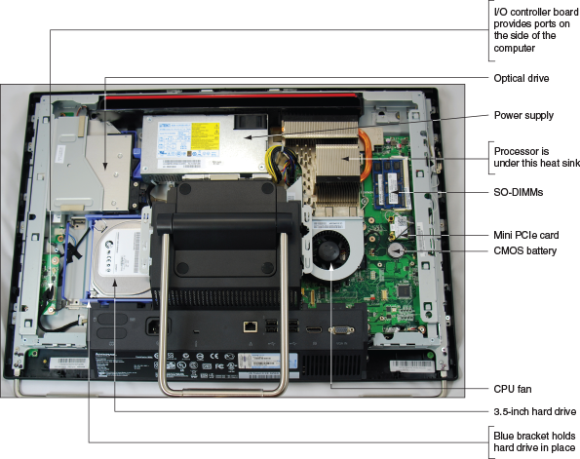
Several components are easy to exchange in this all-in-one without further disassembly. For example, the Mini PCIe card for wireless connectivity is easy to get to, as are the SO-DIMMs you can partly see on the right side of Figure 1-88.
Figure 1-88
A CMOS battery and Mini PCIe wireless card
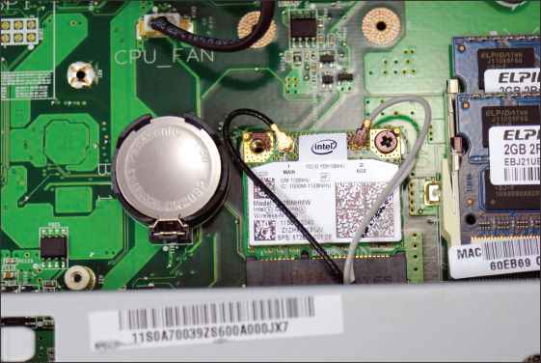
To work inside an all-in-one, you’ll need the service manual to know how to open the case and replace internal components. Replacements for some components, such as the motherboard and power supply, must be purchased from the all-in-one manufacturer because they are likely to be proprietary, as with many laptop components. For specific directions about replacing parts in an all-in-one, see the service manual.
Now that you are familiar with some major components of a laptop, let’s learn some special considerations when maintaining laptops.
Go to pg.
help
Application Opened
Main content

1-2gMaintaining Laptops
A+ Core 1
- 1.3
Given a scenario, use appropriate laptop features.
- 3.3
Given a scenario, install RAM types.
- 3.9
Given a scenario, install and configure common devices.
- 5.5
Given a scenario, troubleshoot common mobile device issues while adhering to the appropriate procedures.
Laptops and mobile devices tend not to last as long as desktop computers because they are portable and therefore subject to more wear and tear. A device’s user manual gives specific instructions on how to care for the device. Those instructions follow these general guidelines:
- LCD panels on devices are fragile and can be damaged fairly easily. Take precautions against damaging a laptop or other device’s LCD panel. Don’t touch it with sharp objects like ballpoint pens.
- Don’t pick up or hold a laptop by the lid. Pick it up and hold it by the bottom. Keep the lid closed when the laptop is not in use.
- Only use battery packs and AC adapters recommended by the laptop manufacturer. Keep the battery pack away from moisture or heat, and don’t attempt to take the pack apart. When it no longer works, dispose of it correctly. For laptops, you might consider buying an extra battery pack to use when the first one discharges. You can also buy battery chargers so that you can charge one while the other is in use.
- Don’t tightly pack a laptop or tablet in a suitcase because the LCD panel might get damaged. Use a good-quality carrying case and make a habit of always transporting the laptop in the carrying case. Don’t place heavy objects on top of the laptop case.
- Don’t move the laptop while the hard drive is being accessed (when the drive indicator light is on). Wait until the light goes off.
- Don’t put the laptop close to an appliance such as a TV, large audio speakers, or refrigerator that generates a strong magnetic field, and don’t place your cell phone on a laptop while the phone is in use.
- Always use passwords to protect access to your laptop so you are better protected when connected to a public network or if the device is stolen or used by an unauthorized person.
- Keep your laptop or device at room temperature. For example, never leave it in a car overnight during cold weather, and don’t leave it in a car during the day in hot weather. Don’t expose your laptop or device to direct sunlight for an extended time.
- Don’t leave the laptop or device in a dusty or smoke-filled area. Don’t use it in a wet area such as near a swimming pool or in the bathtub. Don’t use it at the beach where sand can get in it.
- Don’t power it up and down unnecessarily.
- Protect the laptop from overheating by not running it when it’s still inside the case, not resting it on a pillow, and not partially covering it with a blanket or anything else that would prevent proper air circulation around it.
- If a laptop has just been brought indoors from the cold, don’t turn it on until it reaches room temperature. In some cases, condensation can cause problems. Some manufacturers recommend that when you receive a new laptop shipped to you during the winter, you should leave it in its shipping carton for several hours before you open the carton to prevent subjecting the laptop to a temperature shock.
- Protect a laptop against static electricity. If you have just come in from the cold on a low-humidity day when there is the possibility that you are carrying static electricity, don’t touch the laptop until you have grounded yourself.
- Before placing a laptop in a carrying case for travel, remove any CDs, DVDs, or USB flash drives, and put them in protective covers. Verify that the system is powered down and not in sleep mode, which will drain the battery.
- If a laptop gets wet, you can partially disassemble it to allow internal components to dry. Give the laptop several days to dry before attempting to turn it on. Don’t use heat to speed up the drying time.
- Keep current backups of important data on a laptop or device in case it fails or is stolen.
A well-used laptop, especially one that is used in dusty or dirty areas, needs cleaning occasionally. Here are some cleaning tips:
- Clean the LCD panel with a soft, dry cloth. If the panel is very dirty, you can use monitor wipes to clean it or dampen the cloth with water. Some manufacturers recommend using a mixture of isopropyl alcohol and water to clean an LCD panel. Be sure the LCD panel is dry before you close the lid.
- Use a can of compressed air meant for use on computer equipment to blow dust and small particles out of the keyboard, trackball, and touch pad. Turn the laptop at an angle and direct the air into the sides of the keyboard. Then, use a soft, damp cloth to clean the key caps and touch pad.
- Use compressed air to blow out all air vents on the laptop to make sure they are clean and unobstructed.
- If a laptop is overheating, the CPU fan might be clogged with dust. The overheating problem might be solved by disassembling the laptop and blowing out the fan with compressed air.
- If keys are sticking, remove the keyboard so you can better spray under the keys with compressed air. If you can remove the key cap, remove it and clean the key contact area with contact cleaner. One example of a contact cleaner you can use for this purpose is Stabilant 22 (stabilant.com). Reinstall the keyboard and test it. If the key still sticks, replace the keyboard.
- Remove the battery and clean the battery connections with a contact cleaner.
A+ Exam Tip
The A+ Core 1 exam expects you to know how to solve the problem of sticking keys on a laptop, given a scenario.
Go to pg.
help
Application Opened
Main content

Chapter Review

1-3aChapter Summary

Exploring a Desktop Computer
- When hardware support technicians disassemble or reassemble a computer, it is important for them to stay organized, keep careful notes, and follow all the safety procedures to protect the computer equipment and themselves.
- Before opening a computer case, shut down the system, unplug it, disconnect all cables, and press the power button to drain residual power.
- Common tools for a computer hardware technician include an ESD strap, screwdrivers, tweezers, flashlight, compressed air, and cleaning solutions and pads.
- Special tools a hardware technician might need include a POST diagnostic card, power supply tester, multimeter, and loopback plugs.
- A computer’s video ports might include the VGA, DVI, DisplayPort, and HDMI ports. Other ports include RJ-45, audio, SPDIF, USB, eSATA, PS/2, serial, and RJ-11 ports. A Thunderbolt port can transmit video, data, and power.
- Internal computer components include the motherboard, processor, expansion cards, DIMM memory modules, hard drive, optical drive, tape drive, and power supply.
- Cases, power supplies, and motherboards use ATX and microATX form factors. The form factor determines how the case, power supply, and motherboard fit together and the cable connectors and other standards used by each.
- Power connectors used by the ATX and microATX form factors include the older 20-pin P1, current 24-pin P1, 4-pin and 8-pin CPU auxiliary motherboard, 4-pin Molex, 15-pin SATA, and 6/8-pin PCIe connectors.
- An expansion card fits in a slot on the motherboard and is anchored to the case by a single screw or clip.
- Firmware consists of the older BIOS (basic input/output system) firmware and the newer UEFI (Unified Extensible Firmware Interface) firmware. This BIOS/UEFI firmware is responsible for managing essential devices (for example, keyboard, mouse, hard drive, and monitor) before the OS is launched, starting the computer, and managing motherboard settings.
- Most hard drives and optical drives today use the serial ATA (SATA) standards for the drive to interface with the motherboard and power supply.

First Look at Laptop Components
- Laptop computers are designed for travel. They use the same technology as desktop computers, with modifications for space, portability, and power conservation. A laptop generally costs more than a desktop with comparable power and features.
- Laptop computers use function keys to control the display, volume, touch pad, media options, GPS, airplane mode, and other features of the laptop. A laptop docking station or port replicator can make it easy to disconnect peripheral devices.
- You can use the USB ports for expansion—for example, you can add a USB to RJ-45 dongle, a USB to Wi-Fi dongle, Bluetooth capability, or a USB optical drive.
- The laptop manufacturer documentation, including the service manual, diagnostic software, and recovery media, is useful when disassembling, troubleshooting, and repairing a laptop.
- Field replaceable units (FRUs) in a laptop can include the memory modules, hard drive, LCD panel, video inverter, keyboard, touch pad, processor, optical drive, DC jack, fan, motherboard, CMOS battery, Mini PCIe card, wireless card, and speakers.
- When an internal component needs replacing, consider the possibility of disabling the component and using an external peripheral device in its place. Don’t jeopardize the warranty on a laptop by opening the case or using components not authorized by the manufacturer.
- Replacing the laptop might be more cost effective than performing labor-intensive repairs, such as replacing the motherboard.
- When disassembling a laptop, the manufacturer’s service manual is essential.
- When upgrading components on a laptop, including memory, use components that are the same brand as the laptop, or use only components recommended by the laptop’s manufacturer.
- Follow the directions in a service manual to disassemble a laptop. Keep small screws organized as you disassemble a laptop because they come in a variety of sizes and lengths. Some manufacturers use plastic screws and recommend you use new screws rather than reuse the old ones.
- Special concerns when supporting a laptop also apply to supporting a netbook or all-in-one computer.
- Internal laptop components you might need to remove when replacing a FRU include the keyboard, hard drive, memory, smart card reader, optical drive, wireless card, screen, DC jack, battery pack, touch pad, speaker, system board, CPU, heat sink, and fan.
- An all-in-one computer uses a combination of components designed for desktop computers and laptops.
Go to pg.
help
Application Opened
Main content

Chapter Review

1-3bKey Terms
For explanations of key terms, see the Glossary for this text.
- 4-pin 12-V connector
- 8-pin 12-V connector
- 20-pin P1 connector
- 24-pin P1 connector
- airplane mode
- all-in-one computer
- analog
- ATX (Advanced Technology Extended)
- ATX12V power supply
- audio ports
- base station
- BIOS (basic input/output system)
- Bluetooth
- cellular network
- central processing unit (CPU)
- chassis
- DB9 port
- DB15 port
- DE15 port
- desktop case
- digital
- DIMM (dual inline memory module)
- DisplayPort
- docking port
- docking station
- dual-voltage selector switch
- DVI (Digital Video Interface) port
- electrostatic discharge (ESD)
- Ethernet port
- expansion card
- external SATA (eSATA) port
- firmware
- form factors
- front panel connectors
- front panel header
- GPS (Global Positioning System)
- hard disk drive (HDD)
- hard drive
- HD15 port
- HDMI (High-Definition Multimedia Interface) port
- heat sink
- internal components
- keyboard backlight
- laptop
- loopback plug
- main board
- microATX (mATX)
- microprocessor
- modem port
- Molex connector
- motherboard
- multimeter
- netbook
- network port
- notebook
- optical connector
- PCI Express (PCIe)
- PCIe 6/8-pin connector
- port replicator
- POST card
- POST diagnostic card
- POST (power-on self test)
- power supply
- power supply tester
- power supply unit (PSU)
- processor
- PS/2 port
- RAM (random access memory)
- RJ-11 port
- RJ-45 port
- SATA power connector
- screen orientation
- serial ATA (SATA)
- serial port
- SO-DIMM (small outline DIMM)
- spacers
- SPDIF (Sony-Philips Digital Interface) sound port
- spudgers
- standoffs
- system board
- Thunderbolt 3 port
- touch pad
- tower case
- UEFI (Unified Extensible Firmware Interface)
- USB (Universal Serial Bus) port
- USB optical drive
- USB to Bluetooth adapter
- USB to RJ-45 dongle
- USB to Wi-Fi dongle
- VGA (Video Graphics Array) port
- video memory
- Wi-Fi (Wireless Fidelity)
- ZIF connectors
Go to pg.
help
Application Opened
Main content

Chapter Review

1-3cThinking Critically
These questions are designed to prepare you for the critical thinking required for the A+ exams and may use content from other chapters and the web.
- You purchase a new desktop computer that does not have wireless capability, and then you decide that you want to use a wireless connection to the Internet. What are the two least expensive ways (choose two) to upgrade your system to wireless?
  - Trade in the computer for another computer that has wireless installed.
  - Purchase a second computer that has wireless capability.
  - Purchase a wireless expansion card and install it in your system.
  - Purchase a USB wireless adapter and connect it to the computer by way of a USB port.
- What type of computer is likely to use SO-DIMMs, have an internal power supply, and use a desktop processor socket?
- When troubleshooting a computer hardware problem, which tool might help with each of the following problems?
  - You suspect the network port on a computer is not functioning.
  - The system fails at the beginning of the boot and nothing appears on the screen.
  - A hard drive is not working and you suspect the Molex power connector from the power supply might be the source of the problem.
- You disassemble and reassemble a desktop computer. When you first turn it on, you see no lights and hear no sounds. Nothing appears on the monitor screen. What is the most likely cause of the problem? Explain your answer.
  - A memory module is not seated properly in a memory slot.
  - You forgot to plug in the monitor’s external power cord.
  - A wire in the case is obstructing a fan.
  - Power cords to the motherboard are not connected.
- You are looking to buy a laptop on a budget that requires you to service and repair the laptop yourself, and you want to save money by not purchasing an extended service agreement beyond the first year. To limit your search, what should you consider when choosing manufacturers? Which manufacturers would you choose and why?
- A four-year-old laptop will not boot and presents error messages on screen. You have verified with the laptop technical support that these error messages indicate the motherboard has failed and needs replacing. What is the order of steps you should take to prepare for the repair?
  - Ask yourself if replacing the motherboard will cost more than purchasing a new laptop.
  - Find a replacement motherboard.
  - Find the service manual to show you how to replace the motherboard.
  - Ask yourself if the laptop is still under warranty.
- Why are laptops usually more expensive than desktop computers with comparable power and features?
- When a laptop internal device fails, what three options can you use to deal with the problem?
- A friend was just promoted to a new job that requires part-time travel, and he has also been promised a new laptop after his first month with the company. He needs an easy way to disconnect and reconnect all his peripheral devices to his old laptop. Devices include two external monitors (one HDMI, one DVI), a USB wireless mouse, USB wireless keyboard, Ethernet network, USB printer, headphones, and microphone. He has a budget of $100. What kind of device would best suit his needs? Why? Research online to find a recommendation for a device that will work best for him. What is your recommendation and why?
- Your laptop LCD panel is blank when you boot up. You can hear the laptop turn on, and the keyboard backlight is on. You have checked the brightness using the function keys, and that is not the problem. What is an easy next step to determine if the LCD panel has failed? Describe how that next step can also help if the LCD panel has failed, but the replacement components won’t arrive for a week and you still need to use your laptop.
- A foreign exchange student brought his desktop computer from his home in Europe to the United States. He brought a power adapter so that the power cord would plug into the power outlet. He tried turning on his computer, but it wouldn’t power on. What is likely the problem? What should you warn him about when he returns home at the end of the year?
- You’re building a new desktop computer from parts you picked out and purchased. You invested a good deal of money in this computer and want to be sure to protect your investment while you assemble it. What precautions should you take to protect your computer from damage and electrostatic discharge?
- Your friend asks for your help because her laptop screen is too dim to read anything. What is the first step you should take to fix the problem?
- Your boss asks you to give a presentation and you need to use a projector to show a slideshow. What are the steps to display the slideshow on both your laptop and the projector simultaneously?
- After troubleshooting a problem, you decide that the wireless card has failed in a laptop. What do you do first before you disassemble the laptop?
Go to pg.
help
Application Opened
Main content

1-1bStep 2: Opening the Case
A+ Core 1
- 2.8
Given a scenario, use appropriate networking tools.
- 3.2
Identify common connector types.
- 3.3
Given a scenario, install RAM types.
- 3.4
Given a scenario, select, install and configure storage devices.
- 3.5
Given a scenario, install and configure motherboards, CPUs, and add-on cards.
- 3.7
Summarize power supply types and features.
- 5.5
Given a scenario, troubleshoot common mobile device issues while adhering to the appropriate procedures.
Before we discuss the parts inside a desktop case, let’s take a quick look at the outside of the case and the ports and switches on it.

What’s on the Outside of a Desktop Case
A computer case for any type of computer is sometimes called the chassis, and it houses the power supply, motherboard, processor, memory modules, expansion cards, hard drive, optical drive, and other drives. A computer case can be a tower case, a desktop case that lies flat on a desk, an all-in-one case used with an all-in-one computer, or a mobile case used with laptops and tablets. A tower case (see Figure 1-4) sits upright; it can be as high as two feet and has room for several drives. Often used for servers, this type of case is also good for desktop computer users who anticipate upgrading because tower cases provide maximum space for working inside a computer and moving components around. A desktop case lies flat and sometimes serves double-duty as a monitor stand. Later in this chapter, you learn how to work inside a tower case, desktop case, laptop case, and all-in-one case.
Figure 1-4
This slimline tower case supports a microATX motherboard
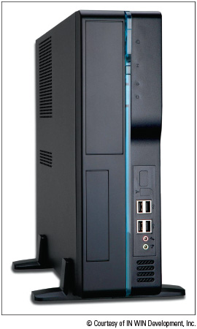
© Courtesy of IN WIN Development, Inc.
Notes
Don’t lay a tower case on its side when the computer is in use because the CD or DVD drive might not work properly. For the same reason, if a desktop case is designed to lie flat, don’t set it on its end when the computer is in use.
Table 1-1 lists ports you might find on a desktop or mobile computer. Consider this table your introduction to these ports so that you can recognize them when you see them. Later in the text, you learn more about the details of each port.
A+ Exam Tip
The A+ Core 1 exam expects you to know how to identify the ports shown in Table 1-1.
Table 1-1

Ports Used with Desktop and Laptop Computers
Port | Description
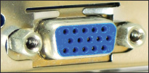 | A VGA (Video Graphics Array) port, also called a DB-15 port, DB15 port, HD15 port, or DE15 port, is a 15-pin, D-shaped, female port that transmits analog video. (Analog means a continuous signal with infinite variations as compared with digital, which is a series of binary values—1s and 0s.) All older monitors use VGA ports. (By the way, the HD15 [high-definition 15-pin] name for the port is an older name that distinguishes it from the early 9-pin VGA ports.)
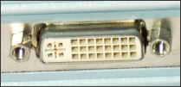 | A DVI (Digital Video Interface) port transmits digital or analog video. Three types of DVI ports exist, which you learn about in Chapter 6.
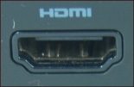 | An HDMI (High-Definition Multimedia Interface) port transmits digital video and audio (not analog transmissions) and is often used to connect to home theater equipment.
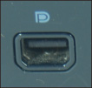 | A DisplayPort transmits digital video and audio (not analog transmissions) and is slowly replacing VGA and DVI ports on personal computers.
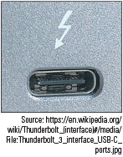  Source: https://en.wikipedia.org/wiki/Thunderbolt_(interface)#/media/File:Thunderbolt_3_interface_USB-C_ports.jpg | A Thunderbolt 3 port transmits video, data, and power on the same port and cable and is popular with Apple computers. The port is shaped the same as the USB-C port and is compatible with USB-C devices. Up to six peripherals (for example, monitors and external hard drives daisy-chained together) can use the same Thunderbolt port.
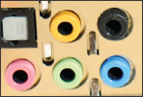 | A system usually has three or more round audio ports, also called sound ports, for a microphone, audio in, audio out, and stereo audio out. These types of audio ports can transmit analog or digital data. If you have one audio cable to connect to a speaker or earbuds, plug it into the lime-green sound port in the middle of the three ports. The microphone uses the pink port.
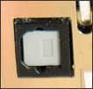 | An SPDIF (Sony-Philips Digital Interface) sound port connects to an external home theater audio system, providing digital audio output and the best signal quality. SPDIF ports always carry digital audio and can work with electrical or optical cable. When connected to a fiber-optic cable, the port is called an optical connector.
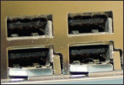 | A USB (Universal Serial Bus) port is a multipurpose I/O port that comes in several sizes and is used by many different devices, including printers, mice, keyboards, scanners, external hard drives, and flash drives. Some USB ports are faster than others. Hi-Speed USB 2.0 is faster than regular USB, and Super-Speed USB 3.0 is faster than USB 2.0.
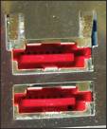 | An external SATA (eSATA) port is used by an external hard drive or other device using the eSATA interface.
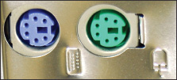 | A PS/2 port, also called a mini-DIN port, is a round 6-pin port used by a keyboard or mouse. The ports look alike but are not interchangeable. On a desktop, the purple port is for the keyboard and the green port is for the mouse. Many newer computers use USB ports for the keyboard and mouse rather than the older PS/2 ports.
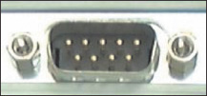 | An older serial port, sometimes called a DB9 port, is a 9-pin male port used on older computers. It has been mostly replaced by USB ports. Occasionally, you see a serial port on a router, where the port is used to connect the router to a device a technician can use to monitor and manage the router.
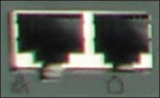 | A modem port, also called an RJ-11 port, is used to connect dial-up phone lines to computers. A modem port looks like a network port, but is not as wide. In the photo, the right port is a modem port and the left port is a network port shown for comparison.
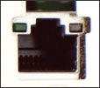 | A network port, also called an Ethernet port or an RJ-45 port, is used by a network cable to connect to the wired network. Fast Ethernet ports run at 100 Mbps (megabits per second), and Gigabit Ethernet runs at 1000 Mbps or 1 Gbps (gigabits per second). A megabit is one million bits and a gigabit is one billion bits. A bit is a binary value of 1 or 0.

Loopback Plugs
A loopback plug is used to test a network port in a computer or other device to make sure the port is working. It might also test the throughput or speed of the port. Figure 1-5 shows a loopback plug testing a network port on a laptop. You know both the port and the network cable are good because the lights on either side of the port are lit. You can also buy a USB loopback plug to test USB ports.
Figure 1-5
A loopback plug testing a network port and network cable
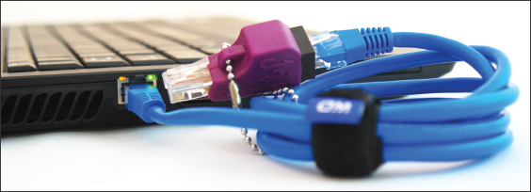

What’s Inside a Desktop Case
Now that you’re familiar with the outside of the case, let’s open the case to see what is inside. Here are the steps to open a computer case:
- Back up important data. If you are starting with a working computer, make sure important data is backed up first. Copy the data to an external storage device such as a flash drive or external hard drive. If something goes wrong while you’re working inside the computer, at least your data will be safe.
- Power down the system and unplug it. Remove discs from the optical drive. Then, power down the system and unplug the power, monitor, mouse, and keyboard cables, and any other peripherals or cables attached. Then, move these cables out of your way.
Caution
When you power down a computer and even turn off the power switch on the rear of the computer case, know that residual power is still on. Some motherboards even have a small light inside the case to remind you of this fact and to warn you that power is still getting to the system. Therefore, be sure to always unplug the power cord before opening a case.
- Press and hold down the power button for a moment. After you unplug the computer, press the power button for about three seconds to completely drain the power supply (see Figure 1-6). Sometimes when you do so, you’ll hear the fans quickly start and go off as residual power is drained. Only then is it safe to work inside the case.
Figure 1-6
Press the power button after the computer is unplugged
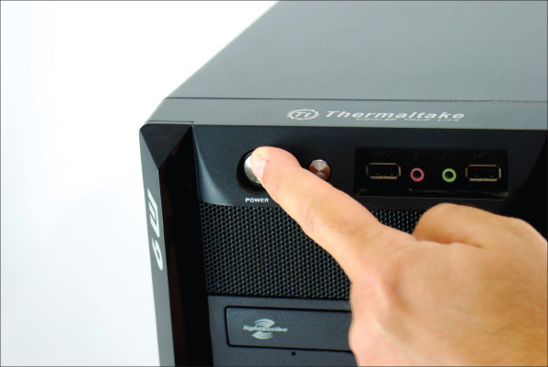
- Have a plastic bag or cup handy to hold screws. When you reassemble the computer, you will need to insert the same screws in the same holes. This is especially important with the hard drive because screws that are too long can puncture the hard drive housing, so be careful to label those screws clearly.
- Open the case cover. Sometimes I think figuring out how to open a computer case is the most difficult part of disassembling. If you need help figuring it out, check the user manual or website of the case manufacturer. To remove the computer case cover, do the following:
  - Some cases require you to start by laying the case on its side and removing the faceplate on the front of the case first. Other cases require you to remove a side panel first, and much older cases require you to first remove all the sides and top as a single unit. Study your case for the correct approach.
  - Most cases have panels on each side that can be removed. It is usually necessary to remove only one panel to expose the top of the motherboard. To know which panel to remove, look at the port locations on the rear of the case. For example, in Figure 1-7, the ports on the motherboard are on the left side of the case, indicating the bottom of the motherboard is on the left. Therefore, you will want to remove the right panel to expose the top of the motherboard. Lay the case down to its left so that the ports and the motherboard are on the bottom. Later, depending on how drives are installed, it might become necessary to remove the other side panel in order to remove the screws that hold the drives in place.
Figure 1-7
Decide which side panel to remove
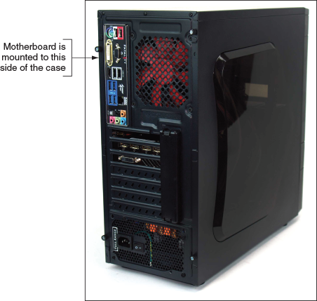
  - Locate the screws or clips that hold the side panel in place. Be careful not to unscrew any screws besides these. The other screws probably are holding the power supply, fan, and other components in place (see Figure 1-8). Place the screws in the cup or bag used for that purpose. Some cases use clips on a side panel in addition to or instead of screws (see Figure 1-9).
Figure 1-8
Locate the screws that hold the side panel in place
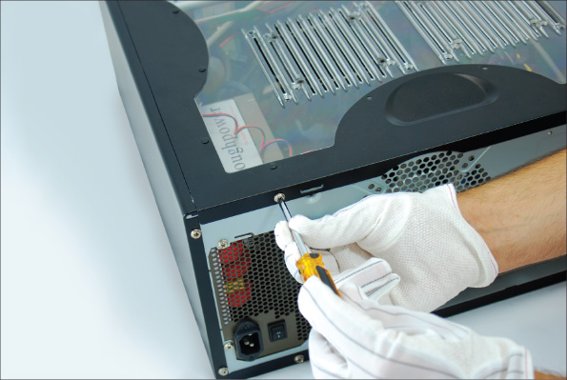
Figure 1-9
On this system, clips hold the side panel in place
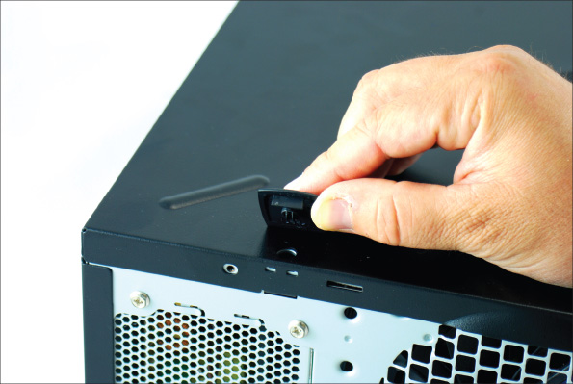
  - After the screws are removed, slide the panel toward the rear and then lift it off the case (see Figure 1-10).
Figure 1-10
Slide the panel to the rear of the case
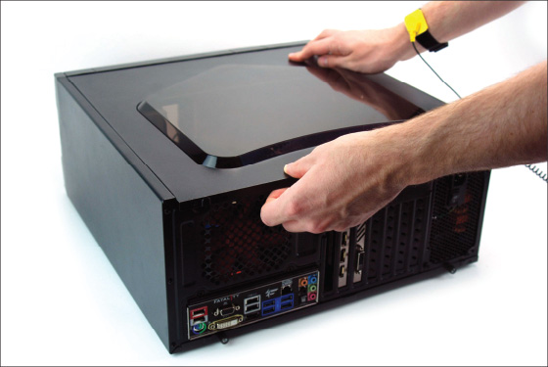
- Clip your ESD strap to the side of the computer case. To dissipate any charge between you and the computer, put on your ESD strap if you have not already done so. Then, clip the alligator clip on the strap cable to the side of the computer case (see Figure 1-11).
Figure 1-11
Attach the alligator clip of your ground bracelet to the side of the computer case
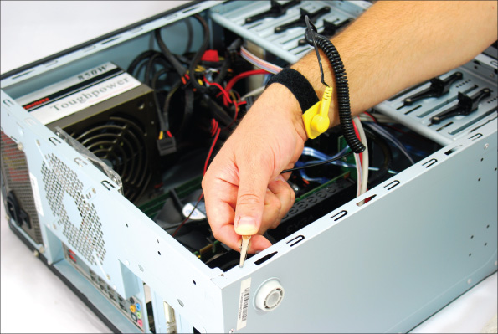
After you open a computer case, as shown in Figure 1-12, the main components you see inside are the power supply, motherboard, expansion card, and drives installed in drive bays. You also see a lot of cables and wires connecting various components. These cables are power cables from the power supply to various components, or cables carrying data and instructions between components. The best way to know the purpose of a cable is to follow it from its source to its destination.
Figure 1-12
Inside the computer case
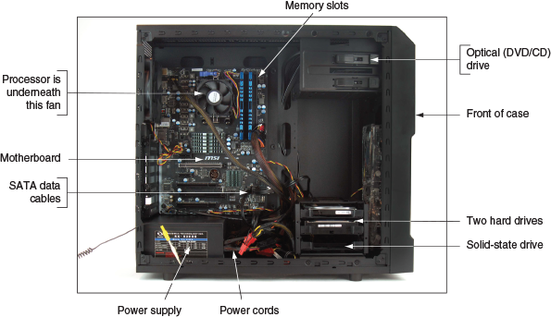
Here is a quick explanation of the main components installed in the case, which are called internal components:
- The motherboard, processor, and cooler. The motherboard, also called the main board, the system board, or the techie jargon term, the mobo, is the largest and most important circuit board in the computer. The motherboard contains a socket to hold the processor or CPU. The central processing unit (CPU), also called the processor or microprocessor, does most of the processing of data and instructions for the entire system. Because the CPU generates heat, a fan and heat sink might be installed on top to keep it cool. A heat sink consists of metal fins that draw heat away from a component. The fan and heat sink together are called the processor cooler. Figure 1-13 shows the top view of a motherboard, and Figure 1-14 shows the ports on the side of a motherboard.
Figure 1-13
All hardware components are either located on the motherboard or directly or indirectly connected to it because they must all communicate with the CPU
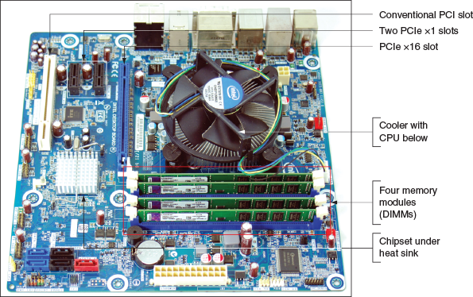
Figure 1-14
Ports provided by a motherboard
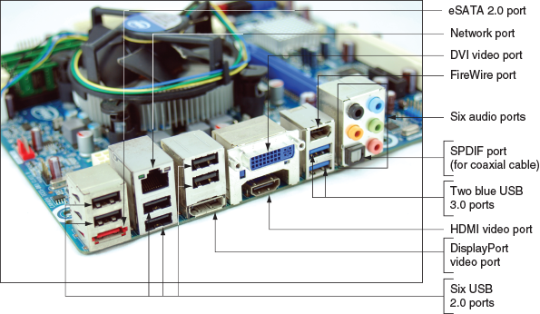
- Expansion cards. A motherboard has expansion slots to be used by expansion cards. An expansion card, also called an adapter card, is a circuit board that provides more ports than those provided by the motherboard. Figure 1-15 shows a video card that provides three video ports. Notice the cooling fan and heat sink on the card, which help to keep the card from overheating. The trend today is for most ports in a system to be provided by the motherboard (called onboard ports) and less use of expansion cards.
Figure 1-15
The easiest way to identify this video card is to look at the ports on the end of the card
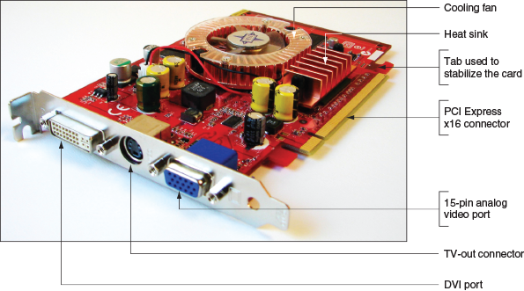
- Memory modules. A desktop motherboard has memory slots, called DIMM (dual inline memory module) slots, to hold memory modules. Figure 1-16 shows a memory module installed in one DIMM slot and three empty DIMM slots. Memory, also called RAM (random access memory), is temporary storage for data and instructions as they are being processed by the CPU. The memory module shown in Figure 1-16 contains several RAM chips. Video cards also contain some embedded RAM chips for video memory.
Figure 1-16
A DIMM holds RAM and is mounted directly on a motherboard
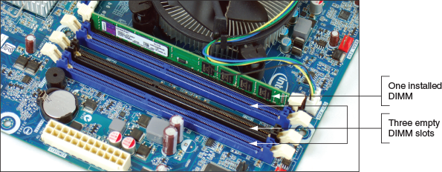
- Hard drives and other drives. A system might have one or more hard drives and an optical drive. A hard drive, also called a hard disk drive (HDD), is permanent storage used to hold data and programs. For example, the Windows 10 operating system and applications are installed on the hard drive. All drives in a system are installed in a stack of drive bays at the front of the case. The system shown in Figure 1-12 has two hard drives and one optical drive installed. These three drives are also shown in Figure 1-17. The larger hard drive is a magnetic drive, and the smaller hard drive is a solid-state drive (SSD). Each drive has two connections for cables: The power cable connects to the power supply, and another cable, used for data and instructions, connects to the motherboard.
Figure 1-17
Two types of hard drives (larger magnetic drive and smaller solid-state drive) and a DVD drive
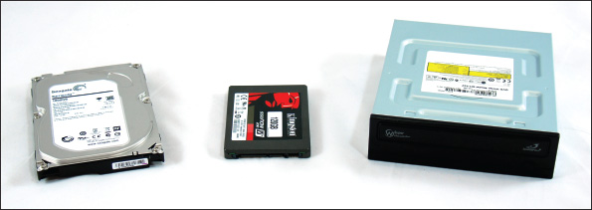
- The power supply. A computer power supply, also known as a power supply unit (PSU), is a box installed in a corner of the computer case (see Figure 1-18) that receives and converts the house current so that components inside the case can use it. Most power supplies have a dual-voltage selector switch on the back of the computer case where you can switch the input voltage to the power supply if necessary—115 V is used in the United States and 220 V is used in other countries. See Figure 1-19. The power cables can connect to and supply power to the motherboard, expansion cards, and drives.
Figure 1-18
A power supply with attached power cables
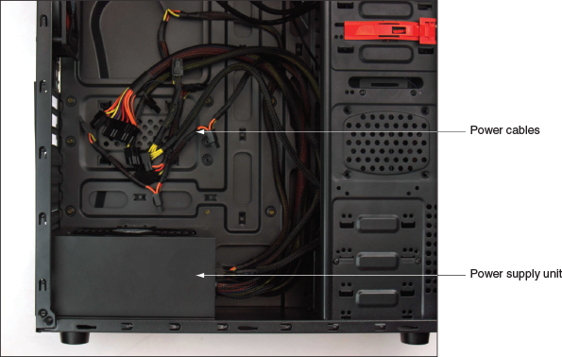
Figure 1-19
The dual-voltage selector switch sets the input voltage to the power supply
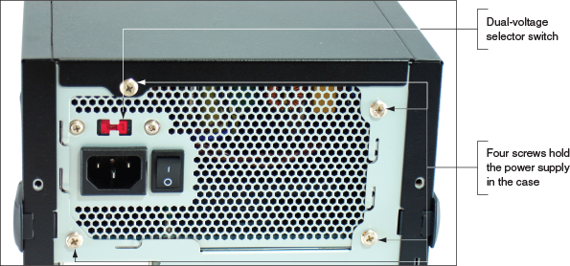
Notes
If you ever need to change the dual-voltage selector switch, be sure you first turn off the computer and unplug the power supply.

Form Factors Used by Desktop Cases, Power Supplies, and Motherboards
The desktop computer case, power supply, and motherboard must all be compatible and fit together as an interconnecting system. The standards that describe the size, shape, screw hole positions, and major features of these interconnected components are called form factors. Using a matching form factor for the motherboard, power supply, and case assures you that:
- The motherboard fits in the case.
- The power supply cords to the motherboard provide the correct voltage, and the connectors match the connections on the board.
- The holes in the motherboard align with the holes in the case so you can anchor the board to the case.
- The holes in the case align with ports coming off the motherboard.
- For some form factors, wires for switches and lights on the front of the case match up with connections on the motherboard.
- The holes in the power supply align with holes in the case for anchoring the power supply to the case.
The two form factors used by most desktop and tower computer cases and power supplies are the ATX and microATX form factors. Motherboards use these and other form factors that are compatible with ATX or microATX power supplies and cases. You learn about other motherboard form factors in Chapter 2. Following are important details about ATX and microATX:
- ATX (Advanced Technology Extended) is the most commonly used form factor today. It is an open, nonproprietary industry specification originally developed by Intel. An ATX power supply has a variety of power connectors (see Figure 1-20). The power connectors are listed in Table 1-2 and several of them are described next.
Figure 1-20
An ATX power supply with connectors
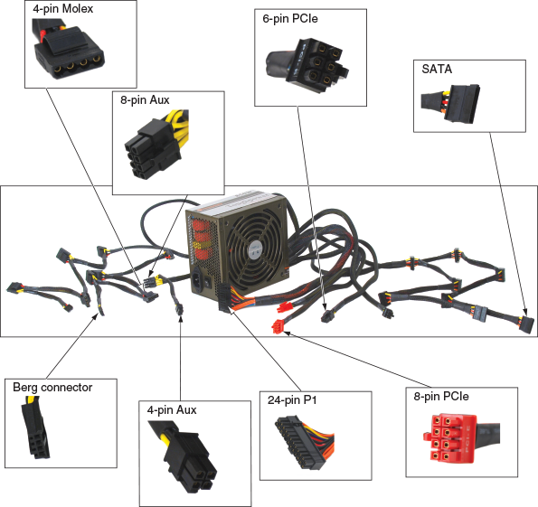
Table 1-2

Power Supply Connectors
Connector | Description
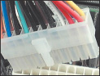 | The 20-pin P1 connector is the main motherboard power connector used in the early ATX systems.
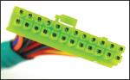 | The 24-pin P1 connector, also called the 20+4-pin connector, is the main motherboard power connector used today.
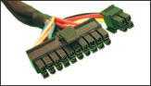 | The 20+4-pin P1 connector has four pins removed so the connector can fit into a 20-pin P1 motherboard connector.
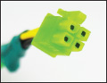 | The 4-pin 12-V connector is an auxiliary motherboard connector, which is used for extra 12-V power to the processor.
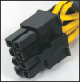 | The 8-pin 12-V connector is an auxiliary motherboard connector, which is used for extra 12-V power to the processor, providing more power than the older 4-pin auxiliary connector.
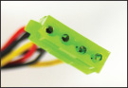 | The 4-pin Molex connector is used for older IDE drives, some newer SATA drives, and to provide extra power to video cards. It can provide +5 V and +12 V to the device.
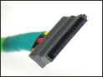 | The 15-pin SATA power connector is used for SATA (Serial ATA) drives. It can provide +3.3 V, +5 V, and +12 V, although +3.3 V is seldom used.
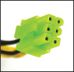 | The PCIe 6-pin connector provides an extra +12 V for high-end video cards using PCI Express.
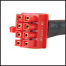 | The PCIe 8-pin connector provides an extra +12 V for high-end video cards using PCI Express.
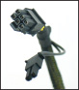 | The PCIe 6/8-pin connector is used by high-end video cards using PCIe ×16 slots to provide extra voltage to the card; it can accommodate a 6-hole or 8-hole port. To get the 8-pin connector, combine both the 6-pin and 2-pin connectors.
A+ Exam Tip
The A+ Core 1 exam expects you to know about each connector listed in Table 1-2 and to know how to choose a connector given a scenario.
Power connectors have evolved because components that use new technologies require more power. As you read about the following types of power connectors and why each came to be, you’ll also learn about the evolving expansion slots and expansion cards that drove the need for more power:
  - 4-pin and 8-pin auxiliary connectors. When processors began to require more power, the ATX Version 2.1 specifications added a 4-pin auxiliary connector near the processor socket to provide an additional 12 V of power (see Figure 1-21). A power supply that provides this 4-pin 12-volt power cord is called an ATX12V power supply. Later boards replaced the 4-pin 12-volt power connector with an 8-pin motherboard auxiliary connector that provided more amps for the processor. See Figure 1-22.
Figure 1-21
The 4-pin 12-volt auxiliary power connector on a motherboard with a power cord connected
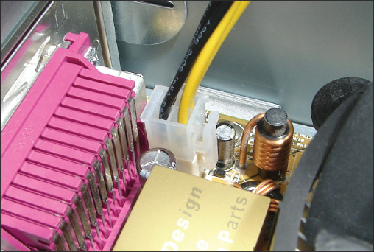
Figure 1-22
An 8-pin, 12-volt auxiliary power connector for extra power to the processor
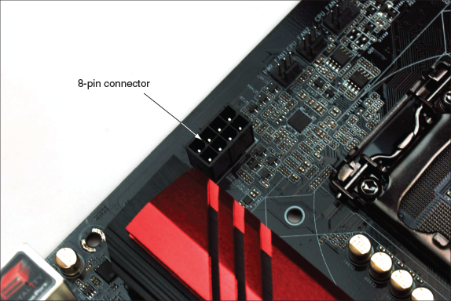
  - 24-pin or 20+4-pin P1 connector. The original P1 connector had 20 pins. Later, when faster PCI Express (PCIe) slots were added to motherboards, more power was required and a new ATX specification (ATX Version 2.2) allowed for a 24-pin P1 connector, also called the 20+4 power connector.
All motherboards today use a 24-pin P1 connector. The extra 4 pins on the 24-pin P1 connector provide +12 volts, +5 volts, and +3.3 volts. Figure 1-23 shows a 24-pin P1 power cord from the power supply and a 24-pin P1 connector on a motherboard. Figure 1-24 shows the pinouts for the 24-pin power cord connector, which is color-coded to wires from the power supply.
Figure 1-23
A 24-pin power cord ready to be plugged into a 24-pin P1 connector on an ATX motherboard
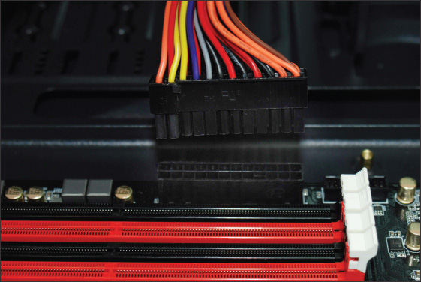
Figure 1-24
A P1 24-pin power connector follows ATX Version 2.2 and higher standards
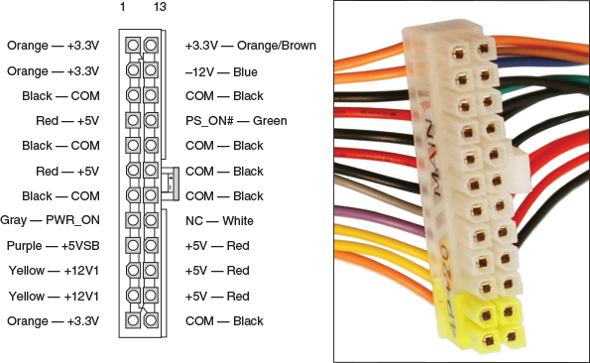
Figure 1-25 shows a PCIe ×16 video card. The edge connector has a break that fits the break in the slot. The tab at the end of the edge connector fits into a retention mechanism at the end of the slot, which helps to stabilize a heavy video card.
Figure 1-25
This PCIe ×16 video card has a 6-pin PCIe power connector to receive extra power from the power supply
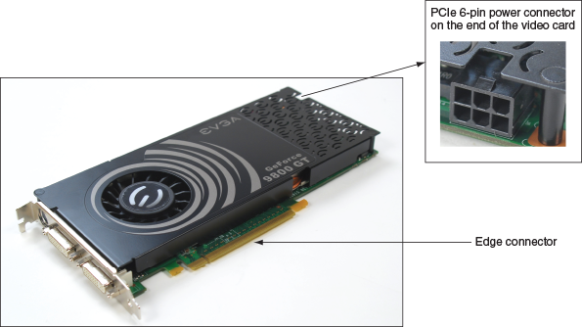
  - 6-pin and 8-pin PCIe connectors. Video cards draw the most power in a system, and ATX Version 2.2 provides for power cables to connect directly to a video card and provide it additional power than what comes through the PCIe slot on the motherboard. The PCIe power connector might have 6 or 8 pins. The video card shown in Figure 1-25 has a 6-pin connector on the end of the card. A PCIe 6-pin power cord from the power supply plugs into the connector. The power supply connector is shown earlier in Table 1-2.
Notes
For more information about all the form factors discussed in this chapter, check out the form factor website sponsored by Intel at formfactors.org.
- The microATX (mATX) form factor is a major variation of ATX and addresses some technologies that have emerged since the original development of ATX. MicroATX reduces the total cost of a system by reducing the number of expansion slots on the motherboard, which in turn reduces the power supplied to the board and allows for a smaller case size. A microATX motherboard (see Figure 1-26) will fit into a case that follows the ATX 2.1 or higher standard. A microATX power supply uses a 24-pin P1 connector and is not likely to have as many extra wires and connectors as those on an ATX power supply.
A+ Exam Tip
The A+ Core 1 exam expects you to recognize and know the more important features of the ATX and microATX form factors used by power supplies. Given a scenario, you should be able to identify and choose the appropriate form factor.
Figure 1-26
This microATX motherboard by Biostar is designed to support an AMD processor
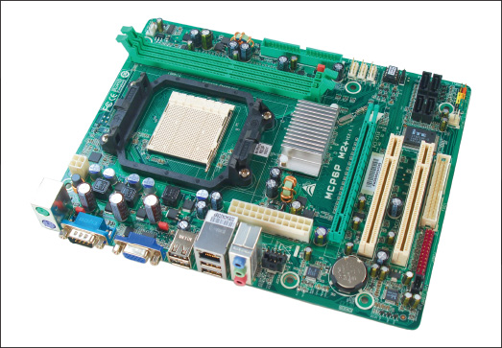
Now let’s learn about the expansion cards you might find installed inside a system.
Go to pg.
help

