Application Opened
Main content
Chapter
10

Virtualization, Cloud Computing, and Printers
- Chapter Introduction
- 10-1Client-Side Virtualization
  - 10-1aType 1 And Type 2 Hypervisors
  - 10-1bSetting Up Client-Side Virtualization
  - 10-1cSecuring a Virtual Machine
- 10-2Cloud Computing
  - 10-2aDeployment Models for Cloud Computing
  - 10-2bElements of Cloud Computing
  - 10-2cCloud Computing Service Models
  - 10-2dApplication Virtualization
  - 10-2eSetting Up Client Computers to Use Cloud Resources
- 10-3Printer Types and Features
  - 10-3aLaser Printers
  - 10-3bInkjet Printers
  - 10-3cImpact Printers
  - 10-3dThermal Printers
  - 10-3e3D Printers
- 10-4Using Windows to Install, Share, and Manage Printers
  - 10-4aLocal or Network Printer
  - 10-4bWired or Wireless Printer Connections
  - 10-4cInstalling a Local or Network Printer
  - 10-4dSharing a Printer on a Network
  - 10-4eVirtual Printing
  - 10-4fCloud Printing
  - 10-4gConfiguring Printer Features and Add-on Devices
- 10-5Printer Maintenance
  - 10-5aOnline Support for Printers
  - 10-5bCleaning a Printer
  - 10-5cCalibrating a Printer
  - 10-5dPrinter Maintenance Kits
- 10-6Troubleshooting Printers
  - 10-6aPrinter Does Not Print
  - 10-6bPoor Print Quality
- 10-7Chapter Review
  - 10-7aChapter Summary
  - 10-7bKey Terms
  - 10-7cThinking Critically
  - 10-7dHands-On Projects
  - 10-7eReal Problems, Real Solutions
  - 10-7fExam Tips
Go to pg.
help
Application Opened
Main content

Chapter Introduction
After completing this chapter, you will be able to:
- Implement and configure virtual machines and hypervisors
- Support cloud computing services on a network
- Discuss printer types and features
- Install and share printers and manage printer features, add-on devices, and the printer queue
- Perform routine maintenance tasks necessary to support printers
- Troubleshoot printer problems
Continuing our exploration of network infrastructure and its resources, this chapter begins with coverage of virtualization and cloud computing. Infrastructure and resources on a network can be virtualized on a single machine, reducing hardware costs. Other resources can be outsourced to third-party providers over the Internet, reducing costs even further. The chapter then explores in depth the most popular types of network printers and how to support them. As you work through the chapter, you learn about printer types and features, how to install a local or network printer, and how to share a printer with others on a network. You learn how to manage printer features, add-on devices, shared printers, and print jobs. Finally, you learn about maintaining and troubleshooting printers.
Go to pg.
help
Application Opened
Main content

10-1Client-Side Virtualization
A+ Core 1
- 3.8
Given a scenario, select and configure appropriate components for a custom PC configuration to meet customer specifications or needs.
- 4.1
Compare and contrast cloud computing concepts.
- 4.2
Given a scenario, set up and configure client-side virtualization.
Virtualization in computing is when one physical machine hosts multiple activities that are normally done on multiple machines. Two types of virtualization are:
- Application virtualization. One computer can serve up multiple applications such as web servers, email servers, file servers, and desktop applications such as Microsoft Office and Adobe Acrobat. Later in the chapter you learn more about application virtualization.
- Desktop virtualization. Desktop virtualization, also called client-side virtualization, client virtualization, and client-side desktop virtualization, is when one computer provides multiple desktops for users. Each virtual desktop is contained in its own virtual machine.
With desktop virtualization, software called a hypervisor creates and manages virtual machines (VMs). Each VM managed by a hypervisor has its own virtual hardware (virtual motherboard, processor, RAM, hard drive, NIC, and so forth) and acts like a physical computer. After an OS is installed in a VM, applications can be installed.
Figure 10-1 shows a Windows 10 Professional desktop with two virtual machines running that were created by Oracle VirtualBox, which is hypervisor software. One VM is running Windows 10 and the other VM is running Ubuntu Desktop, which is a Linux OS. You’ll learn about Linux in Chapter 18.
Figure 10-1
Two virtual machines running on a Windows 10 host, each with its own virtual hardware and OS (Windows 10 and Ubuntu Linux)
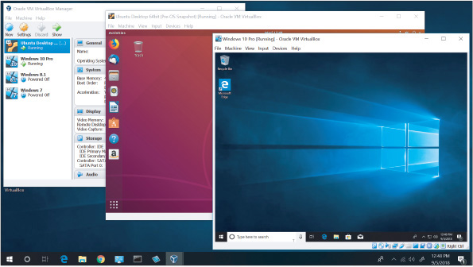
Source: Oracle Corporation and Canonical Group Limited
Go to pg.
help
Application Opened
Main content

10-1aType 1 And Type 2 Hypervisors
A+ Core 1
- 4.2
Given a scenario, set up and configure client-side virtualization.
Hypervisor software can be a Type 1 or Type 2 hypervisor, the main difference being whether the host computer has its own OS. The differences are diagrammed in Figure 10-2.
Figure 10-2
Type 1 and Type 2 hypervisors
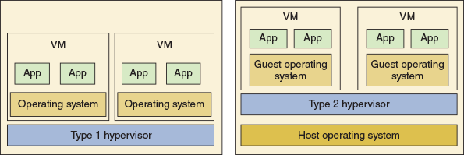
Here is an explanation of the two types of hypervisors:
- A Type 1 hypervisor installs on a computer before any operating system, and is therefore called a bare-metal hypervisor. After it installs, it partitions the hardware computing power into multiple VMs. A different OS can be installed in each VM. Examples of Type 1 hypervisors are the open-source XenServer by Citrix (xenserver.org), KVM by Red Hat (redhat.com), the free ESXi by VMware (vmware.com), and Microsoft’s Hyper-V (microsoft.com), which is embedded in Windows Server. When a server provides virtual desktops or VMs to multiple users over the local network or the cloud, this is called remote or server-hosted desktop virtualization. For server-hosted desktops, most likely the hypervisor used is a Type 1 hypervisor.
- A Type 2 hypervisor installs in a host operating system as an application and is sometimes called a hosted hypervisor. Examples of Type 2 hypervisors include VMware Workstation or Player (vmware.com), Windows Client Hyper-V by Microsoft (microsoft.com), and Oracle VirtualBox (virtualbox.org). A Type 2 hypervisor is not as powerful as a Type 1 hypervisor because it is dependent on the host OS to allot its computing power. A VM in a Type 2 hypervisor is not as secure or as fast as a VM in a Type 1 hypervisor. When a workstation is used to host a hypervisor with its VMs, this is called local or client-hosted desktop virtualization. For the most part, client-hosted desktops are provided by a Type 2 hypervisor.
Here are some ways that client-hosted VMs created by Type 2 hypervisors might be used:
- Developers often use VMs to test applications. If you save a copy of a virtual hard drive (VHD) that has a fresh installation of Windows, you can easily build a new VM to test an application.
- Help-desk technicians use VMs so they can easily switch from one OS to another when a user asks for help with a particular OS.
- Honeypots are single computers or a network of computers that lure hackers to protect the real network. Virtual machines can give the impression to a hacker that he has found a computer or an entire network of computers. Administrators can monitor the honeypot for unauthorized activity.
- Students use VMs to install and practice using and supporting different operating systems.
Go to pg.
help
Application Opened
Main content

10-1bSetting Up Client-Side Virtualization
A+ Core 1
- 3.8
Given a scenario, select and configure appropriate components for a custom PC configuration to meet customer specifications or needs.
- 4.2
Given a scenario, set up and configure client-side virtualization.
As an IT support technician, you might be called on to set up client-side virtualization on a workstation to host multiple VMs. The first step is to make sure the workstation can support the hypervisor and VMs.

Customize a Virtualization Workstation
Here are the requirements for a workstation that will host multiple virtual machines:
- Maximum CPU cores. Each VM has its own virtual processor, so it’s important that the host’s processor is a multicore processor. All dual-core or higher processors sold today support hardware-assisted virtualization (HAV), which is a technology that enhances the processor support for virtual machines. For Intel processors, this feature is called Intel VT. For AMD processors, the technology is called AMD-V.
- The motherboard BIOS/UEFI. Most of today’s motherboards support HAV, and it must be enabled in BIOS/UEFI setup. Figure 10-3 shows the UEFI setup screen for one motherboard where the HAV feature is called Intel Virtualization Technology. When you enable the feature, also verify that all subcategories are enabled under the main category for hardware virtualization.
Figure 10-3
A UEFI setup screen to enable hardware virtualization
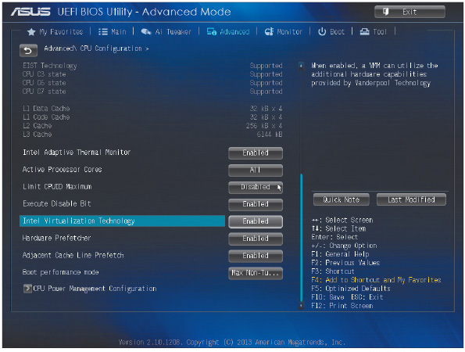
Source: American Megatrends, Inc.
- Maximum RAM. Some hypervisors are designed so that each VM that is running ties up all the RAM assigned to it. Therefore, you need extra amounts of RAM when a computer is running several VMs. Other hypervisors allow a VM to tie up only the RAM it is using, which is called dynamic allocation of memory.
- Lots of storage space. Each VM has its own virtual hard drive (VHD), which is a file stored on the physical hard drive that acts like an independent hard drive, complete with its own boot sectors and file systems. You can configure this VHD to be a fixed size or dynamically expanding. The fixed size takes up hard drive space whether the VM uses the space or not. A dynamically allocated VHD increases in capacity as the VM uses the space. Each VM must have an operating system installed, which takes about 20 GB for a Windows 10/8/7 installation. In addition, each application installed in a VM requires storage space. Make sure you have adequate storage space for all the VMs the customer plans to create. See the requirements provided by the hypervisor manufacturer for additional recommendations.
- Network requirements. If multiple VMs on the workstation will be running at the same time, you’ll need a fast network connection; make sure the NIC supports Gigabit Ethernet. Later, when you set up the workstation, it might require a static IP address so that others on the network can reach the VMs. Also consider using two NICs in the workstation: The hypervisor can run all the VMs through one NIC that has the static IP address assignment and the other NIC is used for other network activity on the workstation. Some network administrators may also choose to set up the VMs in their own VLAN.
- Emulator requirements. Some hypervisors can emulate hardware devices and present this virtual hardware to each VM. For example, in Chapter 9, you learned how to use the hypervisor included in Android Studio to run an Android device emulator (see Figure 10-4). The emulator not only includes the Android OS and applications, it also emulates the hardware of a smartphone, tablet, or other mobile devices. Emulators might include a virtual processor, memory, motherboard, hard drive, optical drive, keyboard, mouse, monitor, network adapter, SD card, USB device, smartphone, printer, hardware buttons, and other components and peripherals. Research the hypervisor software to find out the system requirements for emulators the hypervisor can create and make sure the workstation can support the emulator system requirements.
Figure 10-4
Android Studio emulates a Google Pixel XL phone running Android Oreo
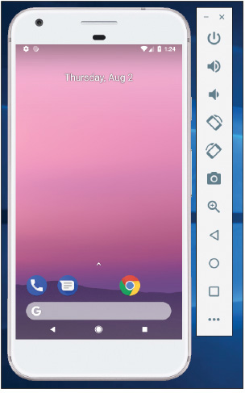
Source: Android
When deciding how to use the overall budget for a virtualization workstation, prioritize the number of CPU cores and the amount of installed RAM.

Install and Configure a Type 2 Hypervisor
A hypervisor offers a way to configure each VM, including which virtual hardware is installed. For example, when you launch Oracle VirtualBox, the VirtualBox Manager window shown on the left side of Figure 10-5 appears. To create a new VM, click New in the upper-left corner and follow the directions on screen. To change the configuration of a VM, select the VM in the left pane and click Settings. The Settings box appears. Click the Storage menu, shown on the right side of Figure 10-5, to install and uninstall virtual hard drives and optical drives in the VM.
Figure 10-5
Emulated (virtual) hard drives and an optical drive are installed in a VM on VirtualBox
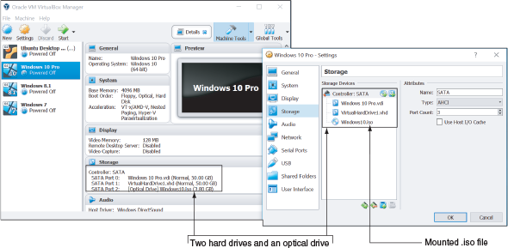
Source: Oracle VirtualBox
Notice in the Settings box in Figure 10-5 that this VM, which does not yet have an OS installed, has two hard drives and an optical drive. The virtual hard drive named Windows 10 Pro.vdi is connected to SATA port 0 and will contain the Windows 10 installation. VirtualHardDrive1.vhd, a backup hard drive for this VM, is the same size (50 GB) and is connected through SATA port 1. The virtual optical drive is connected to SATA port 2 and holds the Windows 10 ISO file, ready for installation on the VM. An ISO file holds the image of a CD or DVD and can be used to provide Windows installation files. When you mount this file to the VM, you can install Windows in the VM from this virtual DVD; many hypervisor programs will perform this step for you during setup of a new VM.
Click the System menu (see Figure 10-6) to configure motherboard settings, such as boot order and memory. Also consider network requirements for the VM. A VM can have one or more virtual network adapters, called a virtual NIC. Click Network (see Figure 10-7) to change adapter settings. A VM can connect to a local network in the same way as other computers using the host computer’s network interface, and it can share and use shared resources on the network. Alternatively, you can keep the VM isolated from the physical network while connected to other VMs on the host computer, or you can keep it completely isolated from all physical and virtual networks. On the right side of the Settings box, you can control the number and type of installed network adapters—up to four adapters for this hypervisor.
Figure 10-6
Configure motherboard settings in the VM to change the boot order
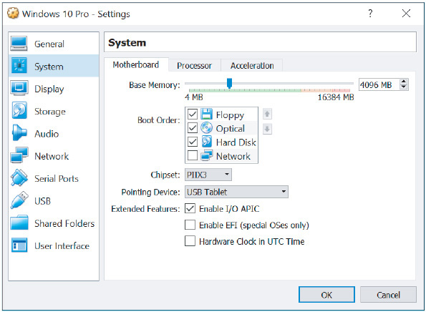
Source: Oracle VirtualBox
Figure 10-7
Configure up to four network adapters for a VM in Oracle VirtualBox
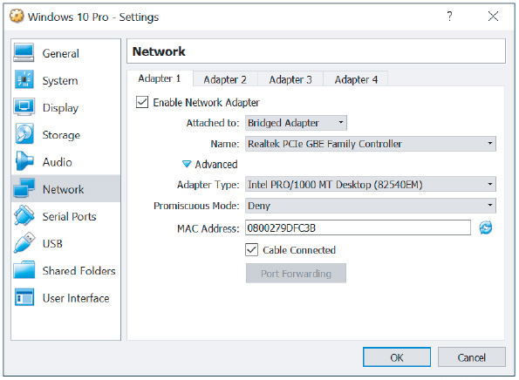
Source: Oracle VirtualBox
To boot up a VM, select it in the left pane and click Start in the menu. The VM boots up and works the same way as a physical computer.
Go to pg.
help
Application Opened
Main content

10-1cSecuring a Virtual Machine
A+ Core 1
- 4.2
Given a scenario, set up and configure client-side virtualization.
A virtual machine is susceptible to hackers and malware just like a physical machine. When supporting a VM that holds sensitive data and has network and Internet connectivity or is located in a public area, keep these points in mind for securing VM resources:
- Secure the VM within the VM. Using the OS installed in the VM, follow all the security measures you are learning throughout this text. For example, be sure to configure the OS firewall in the VM, keep updates current, install and run anti-malware software, require passwords for all user accounts in the VM, and encrypt data folders.
- VMs should be isolated for best security. One major advantage of using VMs on a workstation is that a VM on one workstation is better isolated from a VM on another because the workstations provide an extra layer of protection. Also, the host workstation for VMs should not be used for web surfing or other activities that might compromise its VMs. If a workstation has more than one NIC, a VM that should be kept especially secure can be isolated by dedicating a NIC solely to this VM and putting this NIC on its own subnet.
- Secure the files that hold a VM. You can move a VM from one computer to another by moving the files that contain the VM. Be sure these files that hold the VM are secured with permissions that allow access only to specific local or network users and apply file encryption to the files.
- Secure the host computer. Protect your VMs by applying security measures to protect the host computer that holds the VMs. For example, run anti-malware, keep Windows updated, require password authentication to sign in to the host computer, harden the host computer’s firewall, and isolate it on the network in a protected subnet.
A+ Exam Tip
The A+ Core 1 exam might give you a scenario that requires you to secure a virtual machine installed on a host computer.
Go to pg.
help
Application Opened
Main content

10-2Cloud Computing
A+ Core 1
- 2.2
Compare and contrast common networking hardware devices.
- 3.8
Given a scenario, select and configure appropriate components for a custom PC configuration to meet customer specifications or needs.
- 3.9
Given a scenario, install and configure common devices.
- 4.1
Compare and contrast cloud computing concepts.
In Chapter 8, you learned about server resources available on a network, and in this chapter, you’ve learned some ways to virtualize network resources. Not all of a network’s resources reside on the local network. Cloud computing is when a vendor or corporation makes computing resources available over the Internet. In Chapter 9 you learned about Google Drive, iCloud Drive, Dropbox, and OneDrive, which are examples of cloud file storage services where you can store your files in the cloud. These services work with synchronization apps on mobile devices and computers to sync data and settings to cloud storage accounts such as Google Cloud and iCloud and between devices. Cloud computing can also provide many other types of services and resources, including applications, network services, websites, database servers, specialized developer applications, and virtual desktops in VMs.
The current trend for both small and large businesses is to use cloud computing rather than local computing resources to expand current and future computing needs. As an IT technician, you need to understand how cloud computing works and how to support it.
Go to pg.
help
Application Opened
Main content

10-2aDeployment Models for Cloud Computing
A+ Core 1
- 4.1
Compare and contrast cloud computing concepts.
Cloud computing services are delivered by a variety of deployment models, depending on who manages the cloud and who has access to it. The main deployment models you are likely to encounter are:
- Public cloud. In a public cloud, services are provided over the Internet to the general public. Google or Yahoo! email services are examples of public cloud deployment.
- Private cloud. In a private cloud, services are established on an organization’s own servers or established virtually for a single organization’s private use. For example, an insurance company might have a centralized data center that provides private cloud services to its branch offices throughout the United States. A corporation might provide access to its email servers for employees working remotely using a browser or an off-site email application such as Outlook.
- Community cloud. In a community cloud, services are shared between multiple organizations with a common interest, but the services are not available publicly. For example, a medical database might be shared among all hospitals in a geographic area or government agencies might share regulatory requirements. In these cases, the community cloud could be hosted internally by one or more of the organizations involved, or hosted externally by a third-party provider.
- Hybrid cloud. A hybrid cloud is a combination of public, private, and community clouds used by the same organization. For example, a company might store inventory databases in a private cloud but use a public cloud email service.
Go to pg.
help
Application Opened
Main content

10-2bElements of Cloud Computing
A+ Core 1
- 4.1
Compare and contrast cloud computing concepts.
Regardless of the service provided, all cloud computing service models incorporate the following elements:
- Service at any time. On-demand service is available to users at any time. Cloud computing vendors often advertise uptime of their services, which is the percentage of time in any given year when their services are available online without disruption. Downtimes are minimized to a number of hours or even minutes per year.
- Elastic services and storage. Rapid elasticity refers to the service’s ability to be scaled up or down as the need level changes for a particular customer without requiring hardware changes that could be costly for the customer. Layers of services, such as applications, storage space, or number of users, can be added or removed when requested. Services can also be adjusted automatically, depending on the options made available by the service vendor.
- Support for multiple client platforms. Platform refers to the operating system, the runtime libraries or modules the OS provides to applications, and the hardware on which the OS runs. Cloud resources are made available to clients through standardized access methods that can be used with a variety of platforms, such as Windows, Linux, or macOS, on any number of devices, such as desktops, laptops, tablets, and smartphones from various manufacturers.
- Resource pooling and consolidation. With resource pooling, services to multiple customers are hosted on shared physical resources, which are dynamically allocated to meet customer demand. Customers generally don’t know the geographical location of the physical devices providing cloud services, which is called location independence.
- Measured service. Resources offered by a cloud computing vendor, such as storage, applications, bandwidth, and other services, are measured, or metered, for billing purposes and/or for the purpose of limiting any particular customer’s use of that resource according to the service agreement. These measured services have reporting policies in place to ensure transparency between vendors and customers.
Go to pg.
help
Application Opened
Main content

10-2cCloud Computing Service Models
A+ Core 1
- 2.2
Compare and contrast common networking hardware devices.
- 4.1
Compare and contrast cloud computing concepts.
Cloud computing service models are categorized by the types of services they provide. The National Institute of Standards and Technology (NIST) has developed a standard definition for each category, which varies by the division of labor implemented. For example, as shown on the left side of Figure 10-8, an organization is traditionally responsible for its entire network, top to bottom. In this arrangement, the organization has its own network infrastructure devices, manages its own network services and data storage, and purchases licenses for its own operating systems and applications. The three cloud computing service models illustrated on the right side of Figure 10-8 incrementally increase the amount of management responsibilities outsourced to cloud computing vendors.
Figure 10-8
At each progressive level, the vendor takes over more computing responsibility for the customer
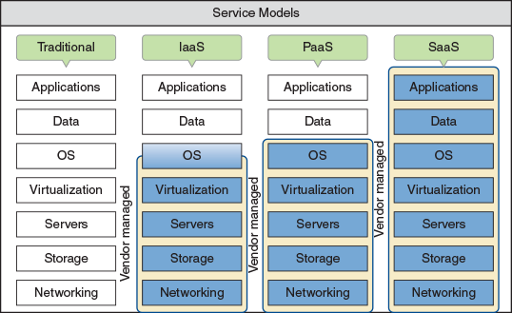
The following list describes these service models:
- IaaS. With IaaS (Infrastructure as a Service), the customer rents hardware, including servers, storage, and networking, and can use these hardware services virtually. Customers are responsible for their own application installations, data management, and backup. In most situations, customers are also responsible for their own operating systems. For example, customers might rent several VMs and use them for servers by installing an OS in each VM and hosting applications such as web servers, email servers, DNS servers, or DHCP services, or by hosting productivity software such as Microsoft Office for employees. IaaS is ideal for fast-changing applications, to test software, or for startup businesses looking to save money by not having to invest in hardware. Examples of IaaS providers are Amazon Web Services (aws.amazon.com), Windows Azure (azure.microsoft.com), and Google Compute Engine (cloud.google.com).
Notes
A good example of an IaaS product is a cloud-based network controller, which provides remote management of network resources over a WAN connection. These network resources might include Wi-Fi access points, network servers, network routers, switches, and firewalls, and these resources might be located on-site or in the cloud at a third-party service provider’s data center. All of these resources can be controlled through a browser interface from anywhere with an Internet connection. For example, while traveling for a conference, a network admin using a product such as CloudTrax (cloudtrax.com) can manage wireless mesh network configuration issues back at the office simply by signing into his network controller dashboard through a browser.
- PaaS. With PaaS (Platform as a Service), a customer rents hardware, operating systems, and some applications that might support other applications the customer may install. PaaS is popular with software developers who require access to multiple platforms during the development process. A developer can build and test an application on a PaaS virtual machine made available over the web, and then throw out the machine and start over with a new one with a few clicks in his browser window. Applications that a PaaS vendor might provide to a developer are tailored to the specific needs of the project, such as an application to manage a database of test data. Examples of PaaS services include Google Cloud Platform and Microsoft Azure.
- SaaS. With SaaS (Software as a Service), customers use applications hosted on the service provider’s hardware and operating systems, and typically access the applications through a web browser. Applications are provided through an online user interface and are compatible with a multitude of devices and operating systems. Online email services, such as Gmail and Yahoo!, are good examples of SaaS. Google offers an entire suite of virtual software applications through Google Cloud and their other embedded products. Except for the interface itself (the device and whatever browser software is required to access the website), the vendor provides every level of support from network infrastructure through data storage and application implementation.
- XaaS (Anything as a Service or Everything as a Service). In the XaaS model, the “X” represents an unknown, just as it does in algebra. Here, the cloud can provide any combination of functions depending on a customer’s exact needs. The XaaS model is not shown in Figure 10-8.
Go to pg.
help
Application Opened
Main content

10-2dApplication Virtualization
A+ Core 1
- 4.1
Compare and contrast cloud computing concepts.
Using application virtualization, an application is made available to users by a virtualization server and does not need to be installed on the user’s computer. For laptops and desktops, especially in an enterprise environment, this means ready access to many more applications than can reasonably be installed on a computer, freeing up more of its storage space, and personalizing apps to the needs of many users without having to manage tedious customizations.
Here are two options for application virtualization:
- Cloud-based applications. With cloud-based applications, which is a form of SaaS, the software resides on a server in the cloud and the user accesses the software through a browser. For example, many companies are moving toward rentable software or software by subscription, such as with Adobe and Microsoft. When you buy an annual subscription to Office 365, you might access the software through a browser, and you might install the software on your own computer. This particular service also includes built-in data storage, if desired by the user, by connecting the licensed account with OneDrive, a virtual data storage service.
- Application streaming. Application streaming is a cross between cloud-based applications, where the application is never installed on the local computer and runs only in the cloud, and installed applications, which is the traditional method of installing an app for use on the local device. With application streaming, parts of the application are downloaded, at least temporarily, on the local device only when needed; other parts of the application might continue to run in the cloud from a distant server. The application is never fully installed on the local device—only the pieces of the application that the user currently needs, and those pieces stay on the device only while they’re being used.
A good example of application streaming is Android’s Instant Apps, which allows a user to tap an app in Google Play and try the app without first having to install it (see Figure 10-9). If you turn on the Instant Apps feature in Android and then open your browser, you can search for and run an instant app right in your browser. This works great for an app you want to use temporarily but don’t want to install.
Figure 10-9
Give an app a test drive without having to install it

Source: Android and BuzzFeed, Inc.
Go to pg.
help
Application Opened
Main content

10-2eSetting Up Client Computers to Use Cloud Resources
A+ Core 1
- 3.8
Given a scenario, select and configure appropriate components for a custom PC configuration to meet customer specifications or needs.
- 3.9
Given a scenario, install and configure common devices.
With the trend of providing more virtual desktops and applications in the cloud, fewer resources need to be devoted to high-end workstations required to support installed applications. When a hypervisor on a server in the cloud presents a virtual desktop to a client computer, the technology is called Virtual Desktop Infrastructure (VDI). See Figure 10-10. In this part of the chapter, you learn how to configure a client computer to use a virtual desktop.
Figure 10-10
Using VDI, a hypervisor serves up virtual desktops
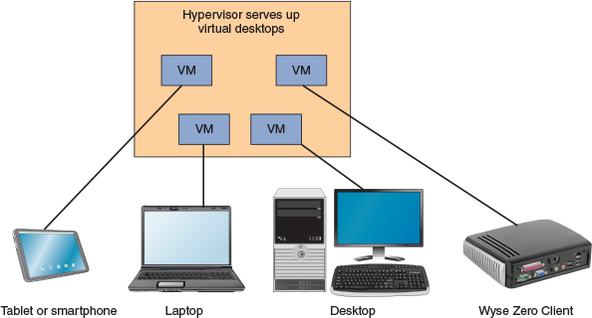
© Sergiy Zavgorodny/Shutterstock.com

Thick Client and Thin Client
The VDI virtual desktop is presented to the user on a thick client, thin client, or zero client:
- A thick client, also called a fat client, is a regular desktop computer or laptop that is sometimes used as a client by a hypervisor server. It can be a low-end to high-end desktop or laptop. It should meet the recommended requirements to run its OS and any desktop applications the user might require when it is being used as a stand-alone computer rather than a VDI client.
- A thin client is a computer, such as a Chromebook, that has an operating system but little computing power of its own and might only need to support a browser used to communicate with the server. The server does most of the processing while the user interacts directly with the thin client. To reduce the cost of the computer, configure it to:
  - Meet only the minimum requirements for a basic OS.
  - Support basic applications required for interaction with the server.
  - Support high-speed network connectivity.
- A zero client, also called a dumb terminal, such as the Wyse Zero Client by Dell, does not have an OS and is little more than an interface to the network with a keyboard, monitor, and mouse.

VDI Virtual Desktop Accounts
Setting up a zero client requires special software provided by the VDI vendor. Setting up a thick client or thin client to receive a VDI virtual desktop is simple. First, know there are two approaches to VDI: The virtual desktop presented to the user is persistent or nonpersistent. The user’s account determines which type of desktop the user receives:
- Persistent VDI. With persistent VDI, the user owns the virtual desktop, which can be customized for the user and saved for future use. Each time the user signs on, he picks up the desktop where it left off the last time he signed off.
- Nonpersistent VDI. With nonpersistent VDI, a user receives a desktop from a pool of desktops; each time the user signs on, she gets a desktop that reverts to its original state.
To access the virtual desktop, open a browser, go to the virtual desktop provider’s website, and sign in with a user account and password.
Go to pg.
help
Application Opened
Main content

10-3Printer Types and Features
A+ Core 1
- 3.6
Explain the purposes and uses of various peripheral types.
- 3.11
Given a scenario, install and maintain various print technologies.
So far in this chapter, you’ve explored the basics of virtualization and cloud computing. These skills and concepts give you ways to customize and expand your network. When supporting a network, you’ll also likely be expected to support printers on the network. So let’s take a look at what that entails.
As an output device, a printer converts digital data to hard copy on paper. Some printers are also a multifunction input device that can work as a scanner to scan printed paper and print additional hard copies of that information or create a digital file from it. The file can then be saved on a computer or sent out over a phone or network connection. A scanner can also be a dedicated device with no printing, copying, or faxing capability. Scanners, whether dedicated devices or integrated in a printer, come in two primary types:
- Flatbed scanners must be fed one page at a time, with each page being lined up on a glass surface.
- ADF (automatic document feeder) scanners can automatically process a stack of papers, cards, or envelopes, pulling each page individually into a roller system for scanning and then spitting it out into a separate tray.
Notes
For heavy business use, sometimes it’s best to purchase a dedicated machine for each purpose instead of bundling many functions into a single machine. For example, if you need a scanner and a printer, purchase a good printer and a good scanner rather than a combo machine. Routine maintenance and troubleshooting are easier and less expensive on single-purpose machines, although the initial cost is higher. On the other hand, for home or small office use, a combo device can save money and counter space.
As for the output side of this process, the major categories of printer types include laser, inkjet (ink dispersion), impact, thermal, and 3D printers. In the following sections, we look at the different types of printers for desktop computing. Table 10-1 lists some popular printer manufacturers.
Table 10-1
Printer manufacturers
Printer Manufacturer | Website
Brother | brother-usa.com
Canon | usa.canon.com
Epson | epson.com
Hewlett-Packard | hp.com
Konica Minolta | kmbs.konicaminolta.us
Lexmark | lexmark.com
Oki Data | okidata.com
Xerox | xerox.com
Zebra Technologies | zebra.com
A+ Exam Tip
The A+ Core 1 exam might give you a scenario that requires you to perform installation or maintenance steps on these types of printers: laser, inkjet, thermal, impact, and 3D printers. You also need to know about virtual printers.
Go to pg.
help
Application Opened
Main content

10-3aLaser Printers
A+ Core 1
- 3.11
Given a scenario, install and maintain various print technologies.
A laser printer is a type of electro-photographic printer that can range from a small, personal desktop model to a large network printer capable of handling and printing large volumes continuously. Figure 10-11 shows an example of a typical laser printer for a small office.
Figure 10-11
A Samsung Xpress color multifunction laser printer
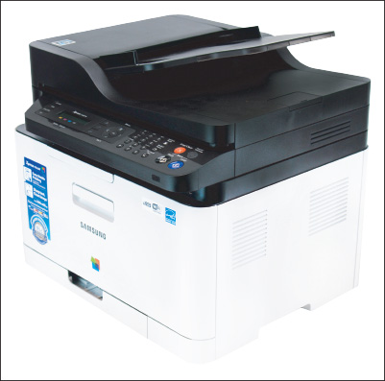
Laser printers require the interaction of mechanical, electrical, and optical technologies. They work by placing toner on an electrically charged rotating drum called the imaging drum, transferring the toner onto paper as the paper moves through the system, and then fusing the toner to the paper. Figure 10-12 shows the seven steps of laser printing.
Figure 10-12
The seven progressive steps of laser printing
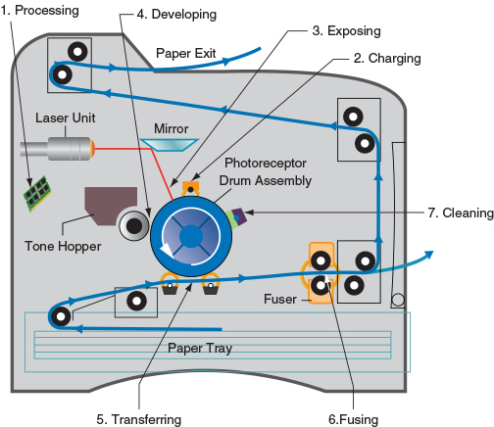
Note that Figure 10-12 shows only a cross-section of the drum, mechanisms, and paper. Remember that the drum is as wide as a sheet of paper. The mirror, blades, and rollers in the drawing are also as wide as paper. Also know that toner responds to a charge and moves from one surface to another if the second surface has a more positive charge than the first.
A+ Exam Tip
The A+ Core 1 exam might give you a scenario that requires you to solve a problem using your knowledge of the seven steps of laser printing. Be sure you know the order of steps.

Laser Printing Steps
The seven steps of laser printing are described next:
- Processing the image. A laser printer processes and prints an entire page at one time. The page comes to the printer encoded in a language the printer understands, and the firmware inside the printer processes the incoming data to produce a bitmap (a bunch of bits in rows and columns) of the final page, which is stored in the printer’s memory. One bitmap image is produced for monochrome images. For color images, one bitmap is produced for each of four colors. (The colors are blue, red, yellow, and black, better known as cyan, magenta, yellow, and black, and sometimes written as CMYK.)
- Charging or conditioning. During charging, the drum is conditioned by a roller that places a high uniform electrical charge of -600 V to -1000 V on the surface of the drum. The roller is called the primary charging roller or primary corona, which is charged by a high-voltage power supply assembly. For some printers, a corona wire is used instead of the charging roller to charge the drum.
- Exposing or writing. A laser beam controlled by motors and a mirror scans across the drum until it completes the correct number of passes. The laser beam is turned on and off continually as it makes a single pass down the length of the drum, once for each raster line, so that dots are exposed only where toner should go to print the image. For example, for a 1200 dots per inch (dpi) printer, the beam makes 1200 passes for every inch of the drum circumference. This means that 1200 dots are exposed or not exposed along the drum for every inch of linear pass. The 1200 dots per inch down this single pass, combined with 1200 passes per inch of drum circumference, accomplish the resolution of 1200 × 1200 dots per square inch of many laser printers. For each exposed dot, the laser beam applies a charge of -100 V, which is significantly more positive than for the unexposed dots on the drum. The charge on this image area will be used in the developing stage to transmit toner to the drum surface.
- Developing. The developing cylinder applies toner to the surface of the drum. The toner is charged between -200 V and -500 V, and sticks to the developing cylinder because of a magnet inside it. A control blade prevents too much toner from sticking to the cylinder surface. As the cylinder rotates very close to the drum, the toner is attracted to the parts of the drum surface that have a -100 V charge and is repelled from the more negatively charged parts of the drum surface. The result is that toner sticks to the drum where the laser beam has hit and is repelled from the areas where the laser beam has not hit.
- Transferring. During transfer, a strong electrical charge draws the toner off the drum onto the paper. This is the first step that takes place outside the cartridge and the first step that involves the paper. The soft, black transfer roller puts a positive charge on the paper to pull the toner from the drum onto the paper. Then the static charge eliminator weakens the charges on both the paper and the drum so that the paper does not stick to the drum. The stiffness of the paper and the small radius of the drum also help the paper move away from the drum and toward the fusing assembly. Very thin paper can wrap around the drum, which is why printer manuals usually instruct you to use only paper designated for laser printers.
- Fusing. The fuser assembly uses heat and pressure to fuse the toner to the paper. Up to this point, the toner is merely sitting on the paper. The fusing rollers apply heat to the paper, which causes the toner to melt, and the rollers apply pressure to bond the melted toner into the paper. The temperature of the rollers is monitored by the printer. If the temperature exceeds an allowed maximum value (for example, 410 degrees F), the printer shuts down.
- Cleaning. A sweeping blade cleans the drum of any residual toner. The charge left on the drum is then neutralized. Some printers use erase lamps in the top cover of the printer for this purpose. The lamps use red light so they won’t damage the photosensitive drum.
For color laser printers, the writing process repeats four times, one for each toner color of cyan, magenta, yellow, and black. Each color might require a separate image drum, although many color printers can use the same drum for all four colors. Then, the paper passes to the fusing stage, where the fuser bonds all toner to the paper and aids in blending the four tones to form specific colors.
A+ Exam Tip
The A+ Core 1 exam expects you to know these laser printer terms: imaging drum, fuser assembly, transfer belt, transfer roller, pickup roller, separate pads, and duplexing assembly.

Cartridges and Other Replaceable Parts
The charging, exposing, developing, and cleaning steps use the printer components that undergo the most wear. To make the printer last longer, some or all of these steps are done inside a removable cartridge that can be replaced as a single unit. For older printers, all four steps are done inside one cartridge. For newer printers, the cleaning, charging, and exposing steps are done inside the image drum cartridge. The developing cylinder is located inside the toner cartridge. The transferring is done using a transfer belt that can be replaced on some printers, and the fusing is done inside a fuser cartridge, which also might be replaceable.
By using these multiple cartridges inside laser printers, the cost of maintaining a printer is reduced. You can replace one cartridge without having to replace them all. The toner cartridge needs replacing the most often, followed by the image drum, the fuser cartridge, and the transfer assembly, in that order.
Other printer parts that might need replacing include the pickup roller that pushes a sheet of paper forward from the paper tray and the separation pad (also called a separate pad) that keeps more than one sheet of paper from moving forward. If the pickup roller is worn, paper misfeeds into the printer. If the separation pad is worn, multiple sheets of paper will be drawn into the printer. Sometimes you can clean a pickup roller or separation pad to prolong its life before it needs replacing.
Notes
Before replacing expensive parts in a printer, consider whether a new printer might be more cost effective than repairing the old one.

Duplexing Assembly
A printer that is able to print on both sides of the paper is called a duplex printer or a double-sided printer. Many laser printers and a few inkjet printers offer this feature. After the front of the paper is printed, a duplexing assembly, which contains several rollers, turns the paper around and draws it back through the print process to print on the back of the paper. Alternately, some high-end printers have two print engines so that both sides of the paper are printed at the same time.
Go to pg.
help
Application Opened
Main content

10-3bInkjet Printers
A+ Core 1
- 3.11
Given a scenario, install and maintain various print technologies.
An inkjet printer (see Figure 10-13) uses a type of ink-dispersion printing and doesn’t normally provide the high-quality resolution of laser printers. Inkjet printers are popular because they are small and can print color inexpensively. Most inkjet printers today can print high-quality photos, especially when used with photo-quality paper.
Figure 10-13
An example of an inkjet printer with feeder trays open
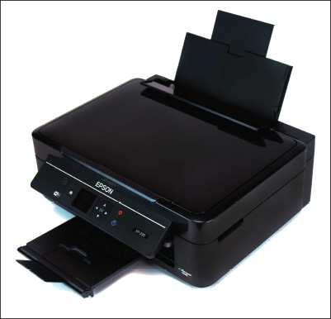
An inkjet printer uses a print head that moves across the paper, creating one line of the image with each pass. The printer puts ink on the paper using a matrix of small dots. Different types of inkjet printers form their droplets of ink in different ways. Printer manufacturers use several technologies, one of which is the bubble-jet. Bubble-jet printers use tubes of ink that have tiny resistors near the end of each tube. These resistors heat up and cause the ink to boil. Then a tiny air bubble of ionized ink (ink with an electrical charge) is ejected onto the paper. A typical bubble-jet print head has 64 or 128 tiny nozzles, all of which can fire a droplet simultaneously. (High-end printers can have as many as 3000 nozzles.) Plates carrying a magnetic charge direct the path of ink onto the paper to form shapes.
Inkjet printers include one or more ink cartridges to hold the different colors of ink for the printer. Figure 10-14 shows four ink cartridges. A black cartridge is on the left and the three color cartridges are cyan, yellow, and magenta. For this printer, a print head is built into each ink cartridge.
Figure 10-14
The ink cartridges of an inkjet printer
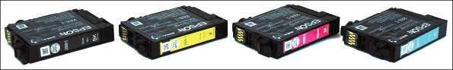
A stepper motor moves the print head and ink cartridges across the paper using a carriage and belt to move the assembly and stabilizing bars to control the movement (see Figure 10-15). A paper tray can hold a stack of paper, or a paper feeder on the back of the printer can hold a few sheets of paper. The sheets stand up in the feeder and are dispensed one at a time. Rollers pull a single sheet into the printer from the paper tray or paper feeder. A motor powers these rollers and times the sheet going through the printer in the increments needed to print the image. When the printer is not in use, the assemblage sits in the far-right position, which is called the home position or parked position. This position helps protect the ink in the cartridges from drying out. Figure 10-15 shows the assemblage positioned so that the ink cartridges are accessible for replacement.
Figure 10-15
The belt and stabilizing bars used to move the print head across the page
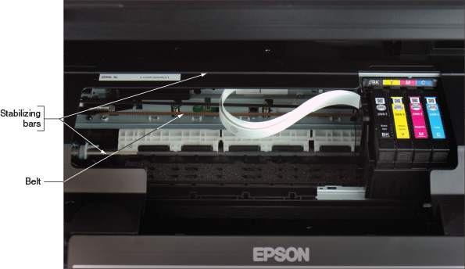
Some inkjet printers offer duplex printing. These printers are larger than normal inkjet printers because of the added space required for the duplexing assembly. For duplex printing, be sure to use heavy paper (rated at 24-pound paper or higher) so the ink doesn’t bleed through.
Even with single-sided printing, inkjet printers tend to smudge on inexpensive paper, and they are slower than laser printers. If a printed page later becomes damp, the ink can run and get quite messy. The quality of the paper used with inkjet printers significantly affects the quality of printed output. You should use only paper that is designed for an inkjet printer, and you should use a high-grade paper to get the best results.
Notes
Weight and brightness are the two primary ways of measuring paper quality. The rated weight of paper (for example, 20 pounds to 32 pounds) determines the thickness of the paper. Brightness is measured on a scale of 92 to 100.
Notes
Photos printed on an inkjet printer tend to fade over time, more so than photos produced professionally. To make your photos last longer, use high-quality photo paper (rated at high gloss or studio gloss) and use fade-resistant ink (such as Vivera ink by HP). Then protect these photos from exposure to light, heat, humidity, and polluted air. To best protect photos made by an inkjet printer, keep them in a photo album rather than displayed and exposed to light.
When purchasing an inkjet printer, look for the kind that uses two or four separate cartridges. One cartridge is used for black ink. Three cartridges, one for each color, give better-quality color than one cartridge that holds all three colors. Some low-end inkjet printers use a single three-color cartridge and don’t have a black ink cartridge. These printers must combine all colors of ink to produce a dull black. Having a separate cartridge for black ink means that it prints true black and, more important, does not use the more expensive colored ink for black print. To save money, you should be able to replace an empty cartridge without having to replace all cartridges.
Notes
It’s possible to refill an ink cartridge, and many companies will sell you the tools and ink you need as well as show you how to do it. You can also purchase refilled cartridges at reduced prices. When you purchase ink cartridges, make sure you know if they are new or refilled. Also, for best results, don’t refill a cartridge more than three times. Many manufacturers and retail shops will accept empty cartridges for recycling.
Go to pg.
help
Application Opened
Main content

10-3cImpact Printers
A+ Core 1
- 3.11
Given a scenario, install and maintain various print technologies.
An impact printer creates a printed page by using some mechanism that touches or hits the paper. The best-known impact printer is a dot matrix printer, which prints only text that it receives as raw data. It has a print head that moves across the width of the paper, using pins to print a matrix of dots on the page. The pins shoot against a cloth ribbon, which hits the paper, depositing the ink. The ribbon provides both the ink for printing and the lubrication for the pinheads. The quality of the print is poor compared with other printer types. However, you still see impact printers in use for three reasons:
- They use continuous tractor feeds and fanfold paper (also called computer paper) rather than individual sheets of paper, making them useful for logging ongoing events or data.
- They can use carbon paper to print multiple copies at the same time.
- They are extremely durable, give little trouble, and seem to last forever.
A+ Exam Tip
The A+ Core 1 exam might give you a scenario that requires you to install or maintain an impact printer’s print head, ribbon, and tractor feed, or to work with the impact paper used in the printer.
Maintaining a dot matrix impact printer is easy. The impact paper used by these printers comes as a box of fanfold paper or in rolls (used with receipt printers). When the paper is nearing the end of the stack or roll, a color on the edge alerts you to replace the paper. Occasionally, you should replace the ribbon of a dot matrix printer. If the print head fails, check on the cost of replacing the head versus the cost of buying a new printer. Sometimes, the cost of the head is so high that it’s best to just buy a new printer. Overheating can damage a print head (see Figure 10-16), so keep it as cool as possible to make it last longer. Keep the printer in a cool, well-ventilated area, and don’t use it to print more than 50 to 75 pages without allowing the head to cool down.
Figure 10-16
Keep the print head of a dot matrix printer as cool as possible so that it will last longer
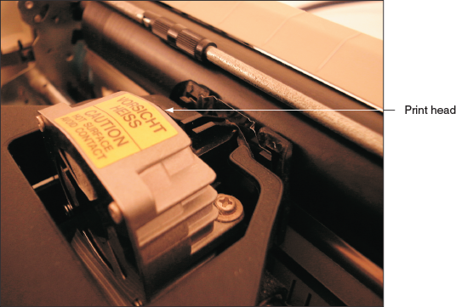
Go to pg.
help
Application Opened
Main content

10-3dThermal Printers
A+ Core 1
- 3.11
Given a scenario, install and maintain various print technologies.
Thermal printers use heat to create an image. Two types of thermal printers are a direct thermal printer and a thermal transfer printer. The older direct thermal printer burns dots onto specially coated paper called thermal paper; this process was used by older fax machines. The process requires no ink and does not use a ribbon. Direct thermal printers are often used as receipt printers that use rolls of thermal paper (see Figure 10-17). The printed image can fade over time or if it interacts with another heat source or ultraviolet light.
Figure 10-17
The TM-T88V direct thermal printer by EPSON
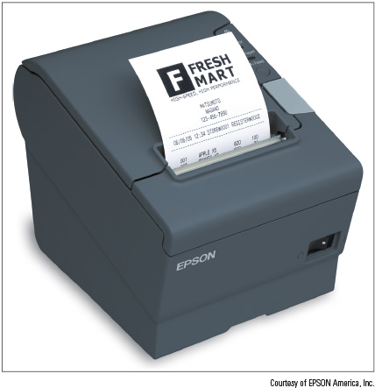
Courtesy of EPSON America, Inc.
A thermal transfer printer uses a ribbon that contains wax-based ink. The heating element melts the ribbon (also called foil) onto special thermal paper so that it stays glued to the paper as the feed assembly moves it through the printer. Thermal transfer printers are used to print receipts, barcode labels, clothing labels, or container labels. Figure 10-18 shows a thermal transfer printer used to make barcodes and other labels.
Figure 10-18
The GC420 printer by Zebra is both a thermal transfer printer and a direct thermal printer
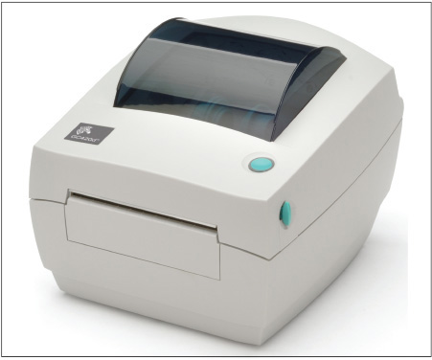
Courtesy of Zebra Technologies
Thermal printers are reliable and easy to maintain. When you are responsible for a thermal printer, you know it’s time to replace the paper roll when it shows a color strip down one edge. It’s important to regularly clean the print head because buildup can harden over time and permanently damage the head. Follow the printer manufacturer’s directions to clean the print head. Some thermal printer ribbons have a print head cleaning stripe at the end, and it’s a good idea to clean the head each time you replace the ribbon. Additionally, some manufacturers suggest cleaning the head with isopropyl alcohol wipes.
When cleaning, remove any dust and debris that get down in the print head assembly. As you work, ground yourself to protect the sensitive heating element against static electricity. Don’t touch the heating element with your fingers. You might need to clean it with a lint-free cotton swab dabbed in isopropyl alcohol. Also, to prolong the life of the print head, use the lowest heat setting for the heating element that still gives good printing results.
A+ Exam Tip
The A+ Core 1 exam might give you a scenario that requires you to install or maintain the feed assembly or heating element used in thermal printers, or you might need to work with the special thermal paper used in the older direct thermal printers.
Go to pg.
help
Application Opened
Main content

10-3e3D Printers
A+ Core 1
- 3.11
Given a scenario, install and maintain various print technologies.
While impact printers and thermal printers have been around for a very long time, a new type of printer is the 3D printer. 3D printers use a plastic filament to build a 3D model of a digital image. In Figure 10-19, notice the coil of plastic filament on the left that is fed into the 3D printer, which heats the plastic and deposits thin layer upon layer to build three-dimensional objects.
Figure 10-19
A 3D printer heats a plastic filament and layers the plastic to build three-dimensional objects
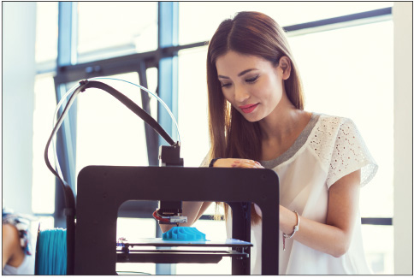
Source: iStock.com/izusek
When setting up a 3D printer, make sure the printer is level. When you’re ready to print, you can buy premade images online. If you want to design your own images, you’ll need a 3D modeling program. Some of these are free and simple to learn, such as Sketchup (sketchup.com) and Tinkercad (tinkercad.com). Others require a much steeper learning curve and a higher price in exchange for more features. As discussed in Chapter 6, any computer used for 3D imaging and design will perform more quickly and gracefully with more RAM and CPU power. Before you start printing, do some research online for tips on getting a cleaner finished product. YouTube has several informative videos by 3D Printing Nerd (the3dprintingnerd.com), Matter Hackers (matterhackers.com), and others.
Now let’s turn our attention to using Windows to install, share, and manage printers.
Go to pg.
help
Application Opened
Main content

10-4Using Windows to Install, Share, and Manage Printers
A+ Core 1
- 3.10
Given a scenario, configure SOHO multifunction devices/printers and settings.
- 3.11
Given a scenario, install and maintain various print technologies.
In this part of the chapter, you learn to install local and network printers, share an installed printer, and remotely use a shared printer. You also learn about virtual printing and cloud printing, and how to configure printer add-ons and features. We begin with local and network printers.
Go to pg.
help
Application Opened
Main content

10-4aLocal or Network Printer
A+ Core 1
- 3.10
Given a scenario, configure SOHO multifunction devices/printers and settings.
A printer connects to a single computer or to the network:
- A local printer connects directly to a computer by way of a USB port, serial port, or wireless connection (Bluetooth or Wi-Fi). Most printers these days support more than one method.
- A network printer has an Ethernet port to connect directly to the network or uses Wi-Fi to connect to a wireless access point.
Some printers have both an Ethernet port and a USB-B port (see Figure 10-20), as well as multiple wireless connection options. These printers can be installed as either a network printer (connecting directly to the network) or a local printer (connecting directly to a computer).
Figure 10-20
This printer has an Ethernet port and USB-B port
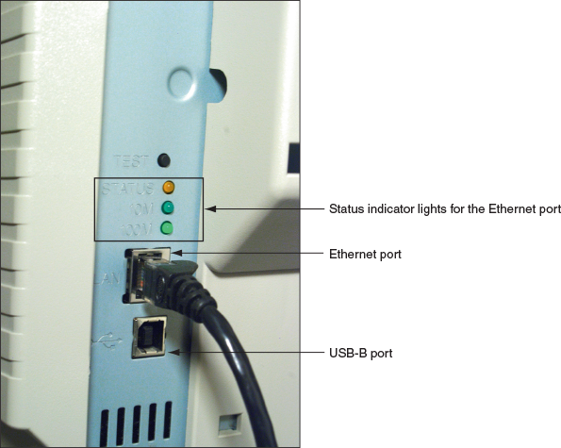
The two ways to install a printer and make it available on a network are:
- Shared local printer. Connect a local printer to a computer on the network, and then share the printer through the computer’s network connection. See Computer A in Figure 10-21. Two requirements to keep in mind include:
  - For a shared local printer to be available to other computers on the network, the host computer must be turned on and not in sleep or standby mode.
  - For another computer on the network to use the shared printer, the appropriate printer drivers for the computer’s OS must be installed on the remote computer.
Figure 10-21
A shared local printer and a network printer
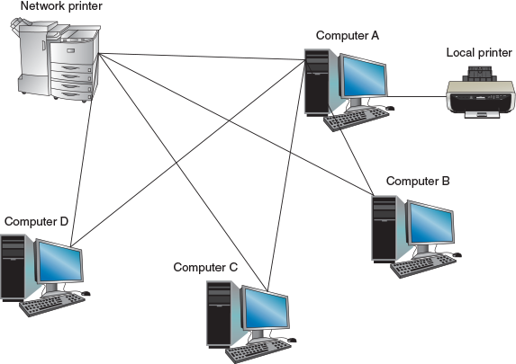
- Network printer. A network printer can connect directly to a network with its own NIC (see the network printer in Figure 10-21), and is identified on the network by its IP address or host name. To use the printer, any computer on the network can install this printer and print to it, which is called remote printing.
Notes
A computer can have several printers installed. Of these, Windows designates one printer to be the default printer, which is the one Windows prints to unless another is selected.
Go to pg.
help
Application Opened
Main content

10-4bWired or Wireless Printer Connections
A+ Core 1
- 3.10
Given a scenario, configure SOHO multifunction devices/printers and settings.
Connecting a wired printer (USB or Ethernet) is easy:
- USB. Plug the USB cable into the printer and computer, and Windows installs the printer automatically.
- Serial. For a printer with a serial port, plug the serial cable into the printer and computer and install the printer as a local printer.
- Ethernet. Plug the Ethernet cable into the printer and network wall jack, switch, or router and install the printer as a network printer on any computer on the network.
Connecting a wireless printer is a little more complex:
- Bluetooth. For a Bluetooth printer installed as a local printer, turn on Bluetooth in Windows, move the printer within range of the computer, and watch as the two Bluetooth devices pair up. While you might need to navigate some of the Bluetooth settings on the printer’s display to enable pairing, the process works like most other Bluetooth connections.
- Wi-Fi infrastructure mode. In infrastructure mode, Wi-Fi devices connect to a Wi-Fi access point, such as a SOHO router. Put the Wi-Fi printer within range of the access point and use controls on the printer to select the Wi-Fi network using the highest IEEE standard (802.11 a, b, g, n, or ac) supported by both the access point and the printer. Enter the security key to the network if one is required. All Wi-Fi printers support infrastructure connections and some Wi-Fi printers can handle ad hoc connections, which are discussed next.
- Wi-Fi ad hoc mode. Some Wi-Fi printers can connect directly to a nearby computer in a Wi-Fi ad hoc mode network to be installed as a local printer. This is accomplished in different ways depending on the technology available in the printer and the computer:
  - Many modern Wi-Fi printers include the ability to host a Wi-Fi hotspot to which nearby computers can connect. The main disadvantage here is that most computers can connect to only one Wi-Fi network at a time, so if a computer is connected to the printer’s Wi-Fi network, it can’t communicate with the Internet or other network resources.
  - The reverse arrangement might work better: Set up a mobile hotspot on the computer and connect the printer to the computer’s hotspot. In Windows 10, you click the computer’s network icon in the taskbar and click the Mobile hotspot tile to turn it on. Right-click the tile and click Go to Settings, where you’ll find the hotspot’s network name and network password. On the printer, use that information to connect to the computer’s hotspot. (Windows 8 supports mobile hotspots, but it requires using several netsh commands not covered in this text.)
  - Windows 7 computers can create a device-to-device Wi-Fi connection called an ad hoc network. Open the Network and Sharing Center, click Set up a new connection or network, click Set up a wireless ad hoc (computer-to-computer) network, and follow the directions on screen.
Notes
Apple computers and mobile devices can use an AirPrint printer without you having to install it. For a Mac or iOS device to use an AirPrint printer, simply open the Print menu in any app. If an AirPrint printer is on the network, it will appear in the list of printers. All AirPrint-enabled printers are capable of Wi-Fi connections to a wireless network and some have a USB or Ethernet port for wired connections. AirPrint printers are also capable of cloud printing, as discussed later in this chapter.
Go to pg.
help
Application Opened
Main content

10-4cInstalling a Local or Network Printer
A+ Core 1
- 3.10
Given a scenario, configure SOHO multifunction devices/printers and settings.
When you install a printer, printer drivers are required that are compatible with the installed operating system. Be sure to use 32-bit drivers for a 32-bit OS and 64-bit drivers for a 64-bit OS. Windows has many printer drivers built in. The drivers might also come on a CD bundled with the printer or you can download them from the printer manufacturer’s website.
With some printers, you launch the installation program that came bundled on the setup CD or was downloaded from the printer manufacturer’s website. With others, use the Windows 10 Settings app or the Windows 10/8/7 Devices and Printers window in Control Panel to install a printer. These windows are also used to manage and uninstall printers, as you’ll see throughout the rest of this chapter.
Applying Concepts

Installing a Printer
A+ Core 1
- 3.10
Given a scenario, configure SOHO multifunction devices/printers and settings.
Installing a network printer is sometimes called mapping a printer. Windows 10 has many preinstalled printer drivers that make printer installation particularly easy and straightforward. However, some manufacturers recommend that you install their drivers before connecting the printer to your computer or the network. This provides additional printer configuration and management tools that are not included in the Windows drivers. Follow these steps to install a wired or Wi-Fi network printer, serial-port printer, or Bluetooth printer using the Windows drivers, or follow more specific instructions from the printer’s manufacturer:
- Make sure the printer is connected to the network or the computer. In Windows 10, open the Settings app and click Devices, then click Printers & scanners. Click Add a printer or scanner. Windows searches for available printers and lists them (see Figure 10-22).
Figure 10-22
Use the Printers & scanners window to install a printer
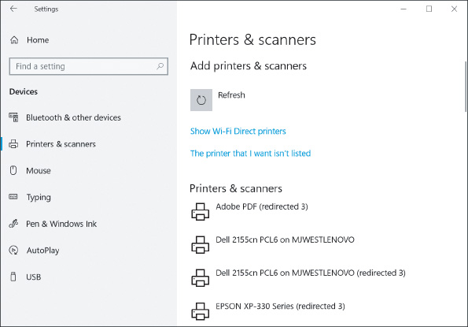
- Select the printer and click Manage to change printer settings.
- If your printer isn’t listed, click The printer that I want isn’t listed. Choose one of the following options:
  - My printer is a little older searches for older printer drivers.
  - Select a shared printer by name allows you to enter a network location for the printer.
  - Add a printer using a TCP/IP address or hostname allows you to address the printer by IP address or host name.
  - Add a Bluetooth, wireless or network discoverable printer searches again for printers connected through Bluetooth or the network.
  - Add a local printer or network printer with manual settings gives you the option to make more granular changes to the printer’s installation, use a setup CD provided by the manufacturer, or select an appropriate driver from a list of available Windows printer drivers. In the next box, choose the port where the printer is connected and click Next. Then you can select the brand and printer model to use drivers provided by Windows (see the left side of Figure 10-23), or you can use drivers stored on CD or previously downloaded from the web by clicking Have Disk. The Install From Disk box appears (see the right side of Figure 10-23). Click Browse to locate the drivers; Windows is looking for an .inf file. Be sure to select 32-bit or 64-bit drivers, depending on which type of OS you are using, then click OK.
Figure 10-23
Locate printer drivers on CD or downloaded from the web
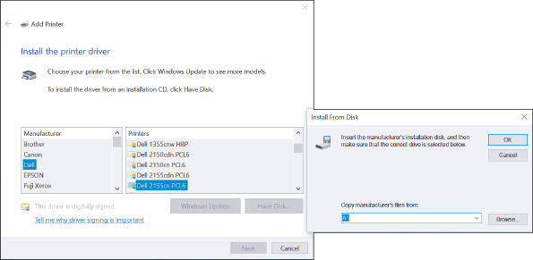
Notes
Use the System window to find out if a 32-bit or 64-bit OS is installed. To open the System window in Windows 10/8, press Win+X and click System. In Windows 7, click Start, right-click Computer, and select Properties.
OS Differences
To use Control Panel to add a printer in Windows 10/8/7, open Control Panel in Classic view and click Devices and Printers. In the Devices and Printers window, click Add a printer. Select the printer and click Next. If your printer isn’t listed, click The printer that I want isn’t listed and select one from a list of printers for which Windows has drivers. In the next box, select the brand and printer model to use the drivers provided by Windows. To use drivers stored on CD or previously downloaded from the web, click Have Disk. The Install From Disk box appears. Click Browse to locate the drivers; Windows is looking for an .inf file. Be sure to select 32-bit or 64-bit drivers, depending on which type of OS you are using.
- Continue to follow the wizard to install the printer. Dialog boxes give you the opportunity to change the name of the printer and designate it as the default printer. You can also test the printer. It’s always a good idea to print a test page when you install a printer to verify that the installation works.
You can send a test page to the printer at any time. Click the printer in the Printers & scanners window, click Manage, and then click Print a test page (see Figure 10-24).
Figure 10-24
Send a test page to the printer to test connectivity to the printer, the printer, and the printer installation
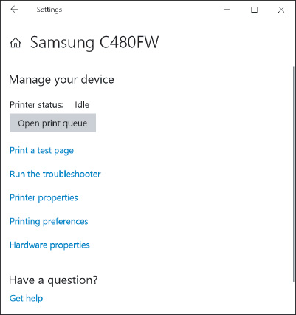
OS Differences
To use Control Panel to print a test page in Windows 10/8/7, right-click the printer in the Devices and Printers window and select Printer properties. On the General tab of the Properties box, click Print Test Page.
Rather than using Windows tools to start a printer installation, you can also start the installation using the setup program on the CD that came bundled with the printer or using the setup program downloaded from the printer manufacturer’s website. Figure 10-25 shows one such window in the setup process for a Samsung printer. This method might provide more customized installation options.
Figure 10-25
A menu provided by a setup program that came bundled with a printer
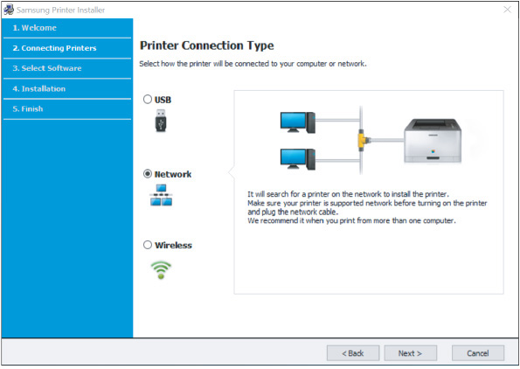
Source: Samsung
A+ Exam Tip
The A+ Core 1 exam might give you a scenario that requires you to install a local or network printer.
Go to pg.
help
Application Opened
Main content

10-4dSharing a Printer on a Network
A+ Core 1
- 3.10
Given a scenario, configure SOHO multifunction devices/printers and settings.
Recall from Chapter 8 that a print server manages network printers and makes them available to computers and other devices on the network. Any time a computer sends a print job to a printer through the network, whether that printer is a shared local printer or a network printer, print server functions play a role. However, the device that provides the print server can vary depending on how the printer is set up. Let’s look at the available options:
- Integrated print server. Most printers today include network capability—you can connect them directly to a router or switch, and devices on the network can find and access the printer. In this case, the printer is providing its own integrated print server embedded in the firmware on the printer’s hardware. Some integrated printers allow you to manage print protocols, start or stop jobs in the print queue, reorder jobs in the queue, cancel specific jobs coming from a particular computer on the network, monitor printer maintenance tasks, and set up your email address so the printer alerts you by email when it has a problem.
- Computer as a print server. When a computer shares its local printer with other computers on the network, the computer is considered to be a print server. If a network has several print servers, you might find it convenient as an IT support technician to use the Print Management console on your workstation to manage these print servers. Using Print Management, you can stop, start, and clear print jobs on any print server on the network and troubleshoot other printer problems from your workstation. You learn to use Print Management in Chapter 14.
- Other network hardware. Print server software might be embedded in other network devices, such as a router or firewall. Connect the printer to the network device and use its configuration interface to manage the printer.
Applying Concepts

Configuring and Using a Shared Printer
A+ Core 1
- 3.10
Given a scenario, configure SOHO multifunction devices/printers and settings.
To share an installed local or network printer with others on the network, follow these steps:
- In the printer Properties dialog box, which you access through the Settings app or Control Panel, click the Sharing tab. Check Share this printer (see the middle box in Figure 10-26).
Figure 10-26
Share the printer and decide how printer sharing is handled
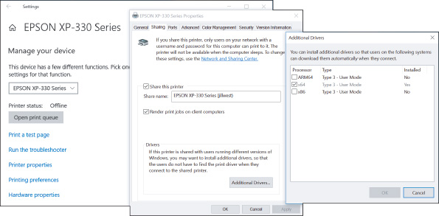
- You can then change the share name of the printer. Notice in Figure 10-26 the option to control where print jobs are rendered. A print job can be prepared (rendered) on the remote computer (client computer) or this computer (print server). Your choice depends on which computer you think can best handle the computing burden. You can test several print jobs on remote computers with rendering at either location and see which method best uses computing resources on the network.
- If you want to make drivers for the printer available to remote users who are using an operating system other than the OS on this computer, click Additional Drivers.
- The Additional Drivers box opens (see the right side of Figure 10-26). For 32-bit operating systems, select x86. For 64-bit operating systems, select x64. Click OK to close the box. You might be asked for the Windows setup DVD or other access to the installation files.
- Click OK to close the Properties box. A shared printer shows a two-friends icon under it or in the status bar in the Devices and Printers window. The printer is listed in the Network group in File Explorer or Windows Explorer on other network computers.
For the printer share to be successful, the following requirements must be met:
- The computer sharing the printer and the computer using the shared printer must both be connected to the same network.
- The shared printer and the computer sharing it must be turned on.
- Both computers must allow file and printer sharing.

Secure a Shared Printer
Consider the security of your shared printer and the privacy of data embedded in documents to be printed:
- Secure the printer. On the printer’s Properties box (refer back to Figure 10-26), click the Security tab to manage who has access to the printer and permissions allowed. Notice in Figure 10-27 that the Everyone group can print but is not allowed to manage the printer or documents sent to it. Just as with shared files and folders, you can share the printer with specific users and/or set up a customized user group that is allowed to use a printer. In this way, user authentication is required before giving a user access to the printer.
Figure 10-27
Security settings for a printer
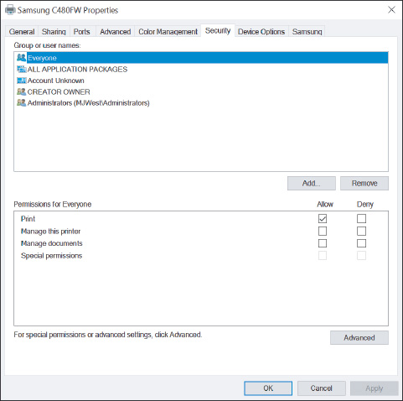
- Secure the data. By default, documents sent to the printer are cached (spooled) to the hard drive of the print server and cached on a hard drive that might be installed in a high-end printer. To prevent these print jobs from being hacked, don’t allow caching to either hard drive. To change the Windows default setting for spooling, click the Advanced tab of the printer’s Properties box (see Figure 10-28). Select Print directly to the printer. Not spooling to the hard drive slows down the printing process in exchange for better security.
Figure 10-28
For best security, bypass caching print jobs to the hard drive
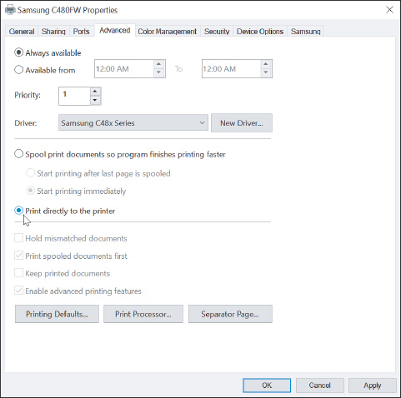
Notes
When print jobs are spooled and the printer is not working or is turned off, the documents can back up in the print queue. To manage the print queue from the Settings app in Windows 10, click Devices, click the printer in the list, and click Open queue (see Figure 10-29). Use the menu bar in the queue window to manage the printer’s queue. In Windows 10/8/7, double-click the printer in the Devices and Printers window from Control Panel. Click the queue link to open the queue window.
Figure 10-29
Use the print queue to pause printing or cancel a print job
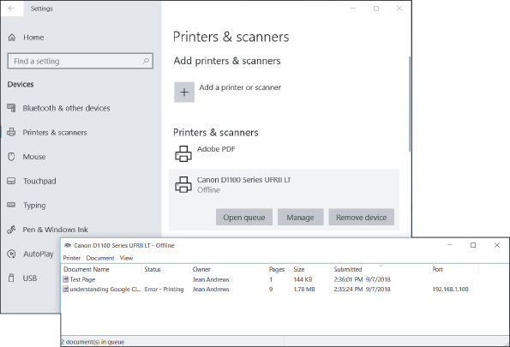

Use a Shared Printer
To install a shared printer on a remote computer, you can (1) use the Settings app in Windows 10, (2) use the Devices and Printers window in Windows 10/8/7, or (3) use File Explorer in Windows 10/8 or Windows Explorer in Windows 7. Here are the general steps for all three methods:
- Settings app. On a remote computer, open the Printers & scanners window and click Add a printer or scanner. Click The printer that I want isn’t listed to tell the computer where to find the printer. Choose Select a shared printer by name to locate the printer by name, such as \\MJWEST\EPSON XP-330 Series (jillwest), or click Browse to find the printer on the network. You’ll need to enter sign-in credentials for the computer sharing the printer. For the user name to work, the printer must be shared with this specific user or user group and the password must match the password of this user on the remote computer. Then select the printer and click Select (see Figure 10-30). Click Next. Once the printer is selected, Windows attempts to use printer drivers found on the host computer. If it doesn’t find the drivers, you will be given the opportunity to provide them on CD or other media.
Figure 10-30
Locate a shared printer on the network
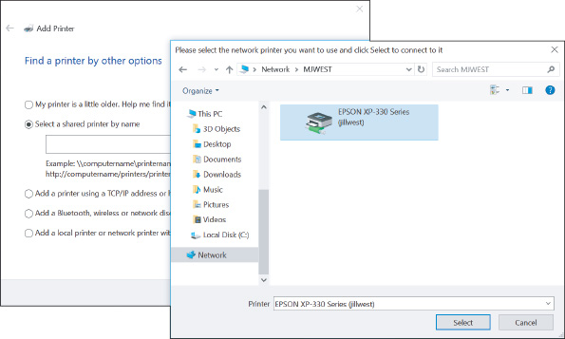
If you don’t see a shared printer in the list of printers to add, the user account might not be authorized to access resources on the remote computer. In this situation, use the File Explorer method discussed later in this list, which allows the user to authenticate to the remote computer.
Notes
If you don’t see a shared printer in the list of printers, consider that the printer might be shared by a Mac computer on the network and Bonjour is not yet running on your Windows computer. Bonjour is an Apple program that is used to interface between computers and devices and share content and services between them; it is used by Windows to discover a printer shared by a Mac computer. If you suspect a Mac is sharing a printer, open the Services tab of Task Manager in Windows and verify that Bonjour Service is running. You can download Bonjour Print Services for Windows from the Apple website at support.apple.com/downloads/bonjour-for-windows. Also make sure that UDP ports 1900, 5350, 5351, and 5353 are open for Bonjour, and that TCP port 631 is open for the Internet Printing Protocol (IPP), which is used by macOS printer sharing services.
- Devices and Printers window. On a remote computer, open the Devices and Printers window, click Add a printer, and follow the directions on screen to add a network printer. Select the shared printer, which shows the sharing computer’s host name and the printer name in the printer address column, or click The printer I want isn’t listed and browse the network to find the printer. Windows attempts to use printer drivers found on the host computer. If it doesn’t find the drivers, you will be given the opportunity to provide them on CD or other media.
- File Explorer or Windows Explorer. In the Explorer window, drill down into the computer that is sharing the printer. If required, authenticate to the remote computer with a valid user account and password on the remote computer. For the user name to work, the printer must be shared with this specific user or user group and the password must match the password of this user on the remote computer. After authentication, you can see the shared printer. Right-click the printer and select Connect (see Figure 10-31). In the warning box that appears, click Install driver and follow the directions on screen.
Figure 10-31
Use File Explorer to connect to a shared printer
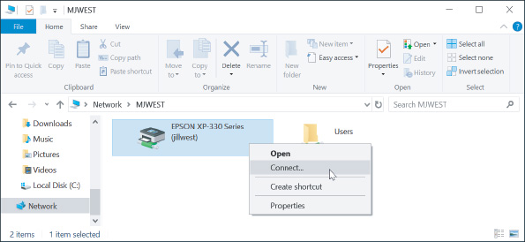
After the printer is installed, be sure to send a test page to the printer to verify that the installation is successful.
Go to pg.
help
Application Opened
Main content

10-4eVirtual Printing
A+ Core 1
- 3.11
Given a scenario, install and maintain various print technologies.
Printing to a file instead of producing a hard copy at a printer is called virtual printing. The types of files you can virtually print depend on the software installed on your system. To see your options for virtual printing, open the Print menu or dialog box for an application. For example, Figure 10-32 shows the results on one system using Word 2016.
Figure 10-32
The file types available for virtual printing depend on software installed in the system
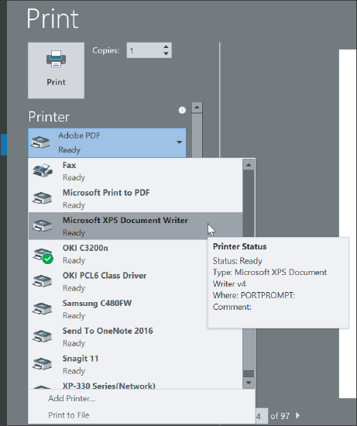
The items of interest listed in the figure are the following types of files:
- PDF (Portable Document Format) file. Windows 10 includes the Microsoft Print to PDF tool, which sends a print job to a PDF file. Notice in Figure 10-32 that Adobe Acrobat is installed on this system, which provides the option to use the Acrobat application to virtually print to a PDF file.
- Image file, also called a bitmap file. Snagit is imaging software normally used to take screenshots. When you print to Snagit, you create an image that appears in the Snagit window. Then, you can use Snagit to save the image as a PNG, GIF, JPG, BMP, TIF, or other image file format.
- XPS (XML Paper Specification) file. Windows includes the Microsoft XPS Document Writer, which creates an XPS file. The file is similar to a PDF and can be viewed, edited, printed, faxed, emailed, or posted on websites. In Windows, the file is viewed in a browser window.
- Print to file. When you check Print to file on a Print menu, the print job is created for the currently selected printer and saved to a PRN file. The file contains the information a printer needs to print the document. Saving a print job to a PRN file and later printing it worked with older printers, but doesn’t work with modern printers. Today, it’s better to create a PDF or XPS document.
A+ Exam Tip
The A+ Core 1 exam might give you a scenario that requires you to perform virtual printing to PDF, XPS, or image files, or to use the option to Print to file.
Go to pg.
help
Application Opened
Main content

10-4fCloud Printing
A+ Core 1
- 3.10
Given a scenario, configure SOHO multifunction devices/printers and settings.
With cloud printing, you can print to a printer anywhere on the Internet from a personal computer or mobile device connected to the Internet. Cloud printing is a type of client/server application. Client software on a computer or mobile device sends a document (which might be encrypted) or a print job to server software on a network that funnels the print jobs to a printer on its network. The printer might be a privately owned printer, a shared network printer, or a public printer run by a business. The computer or mobile device with the client software installed can be anywhere on the Internet. Examples of cloud printing services include Google Cloud Print (google.com/cloudprint), which you can set up on any cloud-ready printer, and enterprise-grade UniPrint Infinity (uniprint.net). For best security, make sure your software can encrypt a document or print job sent over the Internet. You learn to print using Google Cloud Print in a project at the end of this chapter.
Go to pg.
help
Application Opened
Main content

10-4gConfiguring Printer Features and Add-on Devices
A+ Core 1
- 3.10
Given a scenario, configure SOHO multifunction devices/printers and settings.
After the printer is installed, use the printer Properties box to manage printer features and hardware devices installed on the printer. To access settings for the EPSON printer shown in Figure 10-33, click the General tab and then click Preferences, which shows the available options on the right side of the figure. Other printers might show a Device Settings tab. The options depend on the installed printer. As you can see in the figure, the Main tab lets you control the size of the paper, page orientation (landscape or portrait), quality of printing (for example, draft, standard, or high quality), color options (color or black/grayscale), 1-sided or 2-sided (called duplex printing), collated or uncollated, and various add-on devices depending on the printer, such as a printer hard drive, stapler, or stacker unit.
Figure 10-33
The Printing Preferences dialog box for an EPSON printer
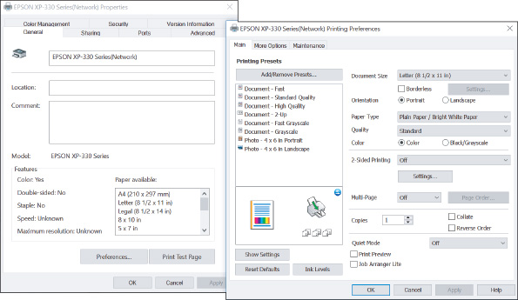
You can also manage many printer settings and features through the printer’s own utility, which might be installed as an application on your computer or might be a firmware utility in the printer that is accessed through your browser. For example, for one Oki Data printer, enter the IP address of the printer in a browser and then enter the administrative password to the printer firmware. The firmware utility (see Figure 10-34) allows you to manage printer settings and features.
Figure 10-34
The user interface for a network printer accessed through a network computer’s browser
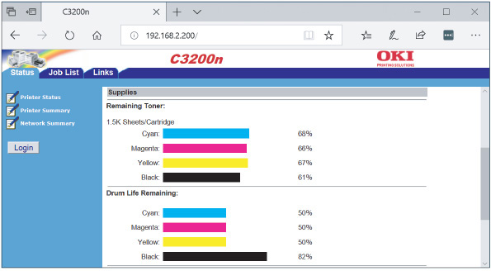
Source: Oki Data
Now let’s turn our attention to tasks you might be called on to do when maintaining and upgrading a printer.
Go to pg.
help
Application Opened
Main content

10-5Printer Maintenance
A+ Core 1
- 3.11
Given a scenario, install and maintain various print technologies.
Printers generally last for years if they are properly used and maintained. To get the most out of a printer, it’s important to follow the manufacturer’s directions when using the device and to perform the necessary routine maintenance. For example, the life of a printer can be shortened if you allow the printer to overheat, don’t use approved paper, or don’t perform maintenance when required.
Go to pg.
help
Application Opened
Main content

10-5aOnline Support for Printers
A+ Core 1
- 3.11
Given a scenario, install and maintain various print technologies.
The printer manufacturer’s website is an important resource when supporting printers. Often, you can find online documentation, warranty information, a knowledge base of common problems and solutions, updated device drivers, replacement parts available for order, and printer maintenance kits.
When working on printers, always keep a few safety tips in mind:
- Dangerous electricity. A printer might still keep power even when it is turned off. To ensure that the printer has no power, unplug it. Even when a laser printer is unplugged, internal components might still hold a dangerous electrical charge for some time.
- Hot to touch. Some laser printer parts can get hot enough to burn you while in operation. Before you work inside a laser printer, turn it off, unplug it, and wait about 30 minutes for it to cool down.
- Laser beam. For your protection, the laser beam in a laser printer is always enclosed inside a protective case. Therefore, when servicing a laser printer, you should never have to look at the laser beam, which can damage your eyes.
- Static electricity. To protect sensitive memory modules and hard drives inside printers, be sure to use an ESD strap when installing them. You don’t need to wear an ESD strap when exchanging consumables such as toner cartridges, fuser assembles, or image drums.
- When no one is around. Here’s one more tip to stay safe, but I don’t want it to frighten you: When you work inside high-voltage equipment such as a laser printer, don’t do it when no one else is around. If you have an emergency, someone needs to be close by to help you.
Notes
If you’re working with laser printer toner cartridges and you get toner dust on your clothes or hands while exchanging the cartridge, don’t use hot water to clean it up. Remember that heat sets the toner. Go outdoors and use a can of compressed air to blow off the toner. Then use cold water to clean your hands and clothes. It’s a good idea to wear a smock or apron when working on printers.
Figure 10-35 shows an ink cartridge being installed in an inkjet printer. To replace an inkjet cartridge, turn on the printer and open the front cover. The printer releases the cartridges from their parked positions. You can then open the latch on top of the cartridge and remove it. Install the new cartridge as shown in the figure.
Figure 10-35
Installing an ink cartridge in an inkjet printer
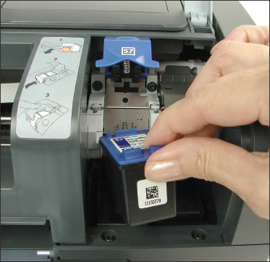
Go to pg.
help
Application Opened
Main content

10-5bCleaning a Printer
A+ Core 1
- 3.11
Given a scenario, install and maintain various print technologies.
A printer gets dirty inside and outside as stray toner, ink, dust, and bits of paper accumulate. As part of routine printer maintenance, you need to regularly clean the printer. How often depends on how much the printer is used and the work environment. Some manufacturers suggest that a heavily used printer be cleaned weekly, and others suggest you clean it whenever you exchange the toner, ink cartridges, or ribbon.
Clean the outside of the printer with a damp cloth. Don’t use ammonia-based cleaners. Clean the inside of the printer with a dry cloth and remove dust, bits of paper, and stray toner. Picking up stray toner can be a problem. Don’t try to blow it out with compressed air because you don’t want the toner in the air. Also, don’t use an antistatic vacuum cleaner. You can, however, use a vacuum cleaner designed to pick up toner, called a toner vacuum. This type of vacuum does not allow the toner that it picks up to touch any conductive surface.
Some printer manufacturers also suggest you use an extension magnet brush. The long-handled brush is made of nylon fibers that are charged with static electricity and easily attract the toner like a magnet. For a laser printer, wipe the rollers from side to side with a dry cloth to remove loose dirt and toner. Don’t touch the soft, black roller (the transfer roller), or you might affect the print quality. You can find specific instructions for cleaning a printer on the printer manufacturer’s website.
Go to pg.
help
Application Opened
Main content

10-5cCalibrating a Printer
A+ Core 1
- 3.11
Given a scenario, install and maintain various print technologies.
An inkjet printer might require calibration to align and/or clean the inkjet nozzles, which can solve a problem when colors appear streaked or out of alignment. To calibrate the printer, you might use the menu on the printer’s control panel or use software that came bundled with the printer. How to access these tools differs from one printer to another. See the printer manual to learn how to perform the calibration. For some printers, a Services tab is added to the printer Properties window. Other printer installations might put utility programs in the Start menu. The first time you turn on a printer after installing ink cartridges, it’s a good idea to calibrate the printer.
If an inkjet printer still does not print after calibrating it, you can try to manually clean the cartridge nozzles. Check the printer manufacturer’s website for directions. For most inkjet printers, you are directed to use clean, distilled water and cotton swabs to clean the face of the ink cartridge, being careful not to touch the nozzle plate. To prevent the inkjet nozzles from drying out, don’t leave the ink cartridges out of their cradle for longer than 30 minutes. Here are some general directions:
- Following the manufacturer’s directions, remove the inkjet cartridges from the printer and lay them on their sides on a paper towel.
- Dip a cotton swab in distilled water (not tap water) and squeeze out any excess water.
- Hold an ink cartridge so that the nozzle plate faces up and use the swab to clean the area around the nozzle plate, as shown in Figure 10-36. Do not clean the plate itself.
Figure 10-36
Clean the area around the nozzle plate with a damp cotton swab
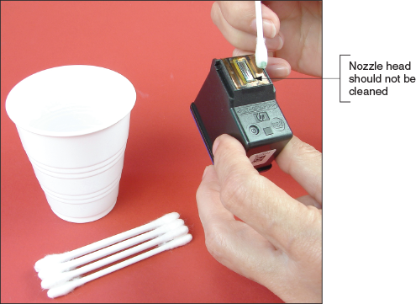
- Hold the cartridge up to the light and make sure that no dust, dirt, ink, or cotton fibers are left around the face of the nozzle plate. Make sure the area is clean.
- Clean all the ink cartridges the same way and replace the cartridges in the printer.
- Print a test page. If print quality is still poor, try calibrating the printer again.
- If you still have problems, you need to replace the ink cartridges.
Laser printers automatically calibrate themselves periodically. You can instruct a laser printer to calibrate at any time by using the controls on the front of the printer or the browser-based utility program that is included in the firmware of a network printer. To access the utility, enter the IP address of the printer in the browser address box and sign in.
Go to pg.
help
Application Opened
Main content

10-5dPrinter Maintenance Kits
A+ Core 1
- 3.11
Given a scenario, install and maintain various print technologies.
Manufacturers of high-end printers provide printer maintenance kits, which include specific printer components, step-by-step instructions for performing maintenance, tips for how often maintenance should be done, and information on any special tools or equipment you need to do maintenance. For example, the maintenance plan for the HP Color LaserJet 4600 printer says to replace the transfer roller assembly after printing 120,000 pages and to replace the fusing assembly after 150,000 pages. The plan also says the black ink cartridge should last for about 9,000 pages and the color ink cartridge should last about 8,000 pages. HP sells the image transfer kit, the image fuser kit, and the ink cartridges designed for this printer.
To find out how many pages a printer has printed so you’ll know if you need to do the maintenance, have the printer give you the page count since the last maintenance. You can tell the printer to display the information or print a status report by using buttons on the front of the printer (see Figure 10-37), or you can use utility software using a computer connected to the printer. See the printer documentation to know how to get this report. For network printers that offer a browser-based utility, enter the IP address of the printer in your browser and use the utility to find the counters. (Figure 10-38 shows such a utility for an Oki Data network printer.)
Figure 10-37
Use buttons on the front of the printer to display information, including the page count
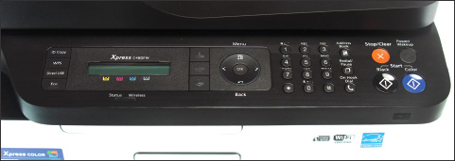
Figure 10-38
Use the web-based printer utility to read the printer counters
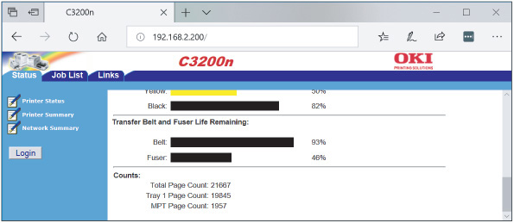
Source: Oki Data
After you have performed the maintenance, be sure to reset the page count so it will be accurate when you need to do the next routine maintenance. Keep a written record of the maintenance and other service done.
As examples of replacing printer consumables, let’s look at how to replace a toner cartridge, image drum, and fuser for an Oki Data color laser printer.
A+ Exam Tip
The A+ Core 1 exam might give you a scenario that requires you to replace a toner cartridge or apply a maintenance kit for a laser printer.
A toner cartridge for this printer generally lasts for about 1,500 pages. Here are the steps to replace a color toner cartridge:
- Turn off and unplug the printer. Press the cover release button on the upper-left corner of the printer and open the printer cover (see Figure 10-39).
Figure 10-39
Open the printer cover
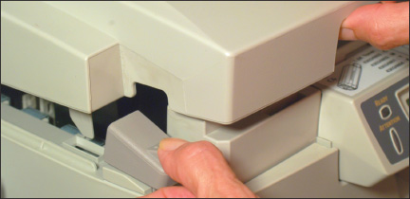
- Figure 10-40 shows the cover up. Notice the four erase lamps on the inside of the cover. Look inside the printer for the four toner cartridges and the fuser assembly labeled in Figure 10-41. Push or pull the blue toner cartridge release button forward to disconnect and release the cartridge from the image drum below it (see Figure 10-42).
Figure 10-40
The cover is lifted
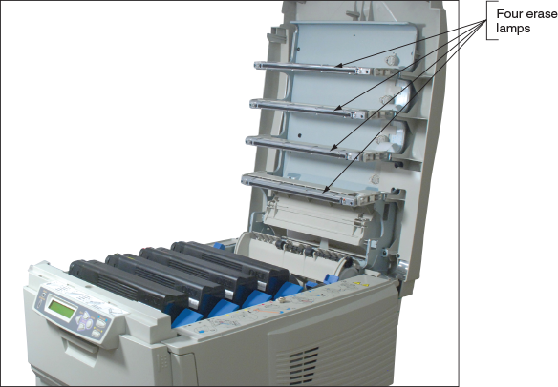
Figure 10-41
Inside the Oki Data printer
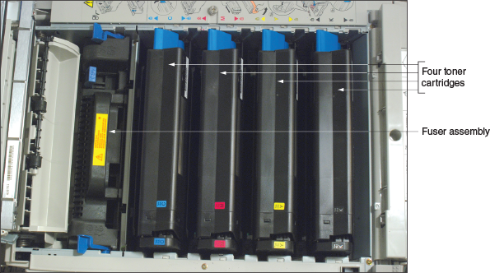
Figure 10-42
Push the blue lever forward to release the toner cartridge
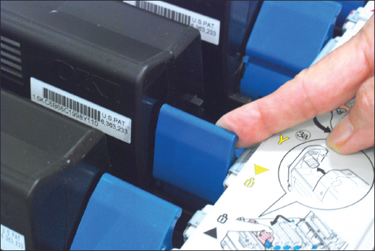
- Lift the cartridge out of the printer, lifting up on the right side first and then removing the left side (see Figure 10-43). Be careful not to spill loose toner.
- Unpack the new cartridge. Gently shake it from side to side to loosen the toner. Remove the tape from underneath the cartridge, and place the cartridge in the printer by inserting the left side first and then the right side. Push the cartridge lever back into position to lock the cartridge in place. Close the printer cover.
Figure 10-43
Remove the toner cartridge
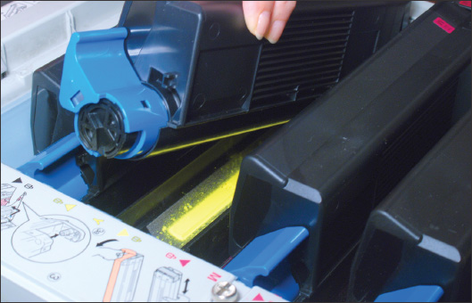
This printer has four image drums, one for each color. The drums are expected to last for about 15,000 pages. When you purchase a new drum, the kit comes with a new color toner cartridge. Follow these steps to replace the cartridge and image drum. In these steps, we are using the yellow drum and cartridge:
- Turn off and unplug the printer. Wait about 30 minutes for it to cool down, then open the printer cover. The toner cartridge is connected to the image drum. Lift the drum together with the toner cartridge out of the printer (see Figure 10-44). Be sure to dispose of the drum and cartridge according to local regulations.
Figure 10-44
Remove the image drum and toner cartridge as one unit
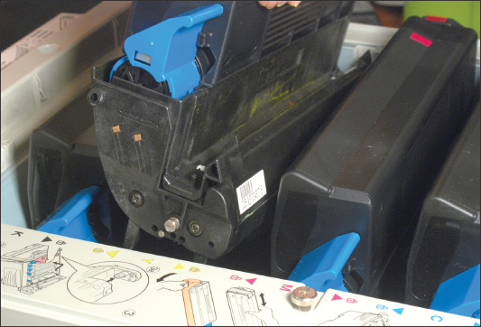
- Unpack the new image drum. Peel the tape off the drum and remove the plastic film around it. As you work, be careful to keep the drum upright so as not to spill the toner. Because the drum is sensitive to light, don’t allow it to be exposed to bright light or direct sunlight. Don’t expose it to normal room lighting for longer than five minutes.
- Place the drum in the printer. Install the new toner cartridge in the printer. Close the printer cover.
The fuser should last for about 45,000 pages. To replace the fuser, follow these steps:
- Turn off and unplug the printer. Allow the printer to cool and open the cover.
- Pull the two blue fuser levers forward to unlock the fuser (see Figure 10-45).
Figure 10-45
Pull the two fuser levers forward to release the fuser
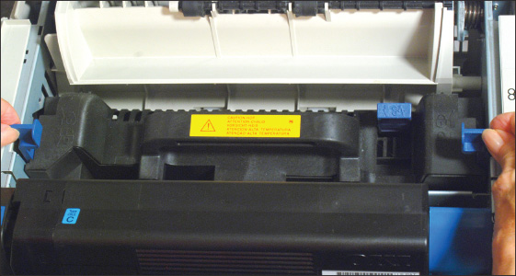
- Lift the fuser out of the printer using the handle on the fuser, as shown in Figure 10-46.
Figure 10-46
Remove the fuser
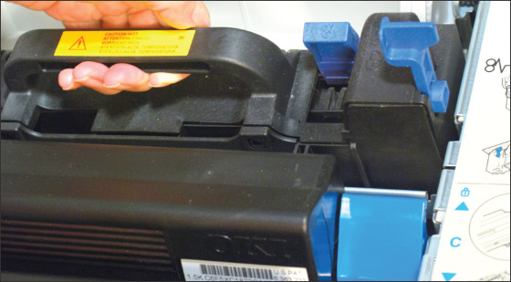
- Unpack the new fuser and place it in the printer. Push the two blue levers toward the back of the printer to lock the fuser in place.
As a last step whenever you service the inside of this printer, always carefully clean the LED erase lamps on the inside of the top cover (see Figure 10-47). The printer maintenance kits you’ve just learned to use all include a wipe to clean these strips.
Figure 10-47
Clean the LED strips on the inside top cover
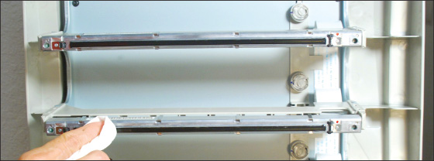
Go to pg.
help
Application Opened
Main content

10-6Troubleshooting Printers
A+ Core 1
- 3.11
Given a scenario, install and maintain various print technologies.
- 5.6
Given a scenario, troubleshoot printers.
In this part of the chapter, you learn some general and specific printer troubleshooting tips. As with all computer problems, begin troubleshooting by interviewing the user, finding out what works and doesn’t work, and making an initial determination of the problem. When you think the problem is solved, ask the user to check things out to make sure he is satisfied with your work. After the problem is solved, be sure to document the symptoms of the problem and what you did to solve it.
Go to pg.
help
Application Opened
Main content

10-6aPrinter Does Not Print
A+ Core 1
- 3.11
Given a scenario, install and maintain various print technologies.
- 5.6
Given a scenario, troubleshoot printers.
When a printer does not print, the problem can be caused by any number of things. As you can see in Figure 10-48, the problem can be isolated to one of the following areas:
Figure 10-48
How to isolate a printer problem
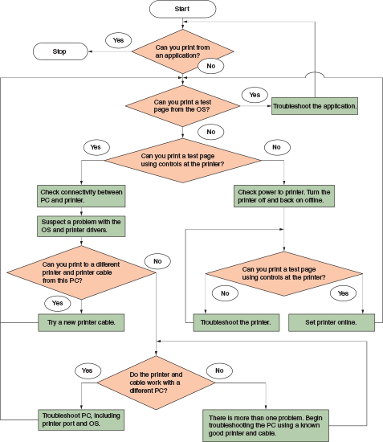
- The application attempting to use the printer
- Windows, Windows settings, or printer drivers
- The printer itself
- Connectivity between the computer and its local printer or a network printer
In addition, if this is the first time you have tried to use the printer after installing it, the printer drivers or the printer installation might be the problem. The following sections address printer problems caused by all of these categories, starting with the application trying to use the printer.

Problems Printing from an Application
If you have trouble printing from an application on a client computer, try these steps:
- On the client computer, try to print a Windows test page. If the Windows test page prints, you have proven the problem is with the application or the file it is attempting to print.
- Make sure the correct printer is selected in the application print menu.
- Try using the application to print a different file.
- Try to print to a different file type, then print that file from a different application. For example, you can print to an XPS document by selecting Microsoft XPS Document Writer in the list of installed printers. Then you can double-click the .xps file, which opens in the XPS Viewer window, and you can print from this window.
- Verify that enough hard drive space is available for the OS to create temporary print files.
- Try repairing or reinstalling the application.
A+ Exam Tip
The A+ Core 1 exam might give you a scenario that expects you to determine if connectivity between the printer and the computer is the problem when troubleshooting printer issues.

Problems Printing from Windows
If the Windows test page does not print from the client computer, do the following:
- The print spool might be stalled. Open the printer’s queue and try deleting all print jobs in the queue. To cancel one document, right-click it and click Cancel in the shortcut menu (see Figure 10-49). To cancel all documents, click Printer and click Cancel All Documents. Try printing a Windows test page again.
Figure 10-49
Cancel a print job in the printer queue
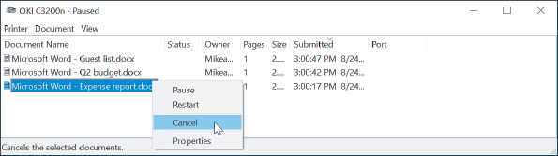
A+ Exam Tip
The A+ Core 1 exam might give you a scenario that requires you to solve problems with the print queue.
- If the Windows test page also stalls in the queue, go to the printer and check the simple things at the printer:
  - Is the printer on? Is it getting power?
  - Is there paper in the printer?
  - Does the control panel on the printer show an error code?
  - Can you print a printer self-test page by using controls at the printer? For directions to print a self-test page, see the printer’s user guide. For example, you might need to hold down a button or combination of buttons on the printer’s front panel. If this test page prints correctly, then the printer is working. If the test page does not print, solve the problem with the printer itself.
- If the printer is working, do a quick check to be sure you have communication with the printer before you continue troubleshooting. Do the following:
  - Try pinging the printer. Open a command prompt window, enter ping, and then enter the IP address of your printer. In Figure 10-50, the address is 192.168.2.200. If the printer replies (see Figure 10-50), the problem is not network connectivity.
Figure 10-50
Use the ping command to determine if you have network connectivity with the printer
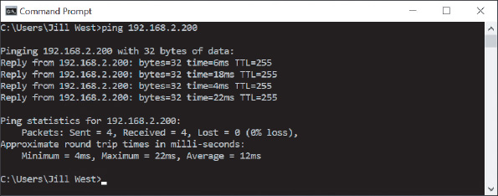
  - If the ping does not work, move on to the section, “Problems with Connectivity for a Network Printer or Shared Printer.”
  - For a USB printer, check the cable connection between the computer and local printer.
- If you have concluded you have connectivity with the printer, stop and restart the Windows Print Spooler service. Windows uses the Services console to stop, start, and manage background services used by Windows and applications. Do the following:
  - Enter services.msc in the Windows 10/8 Run box or the Windows 7 Search box. In the Services console, select Print Spooler (see Figure 10-51). Click Stop to stop the service.
Figure 10-51
Use the Services console to stop and start the print spooler
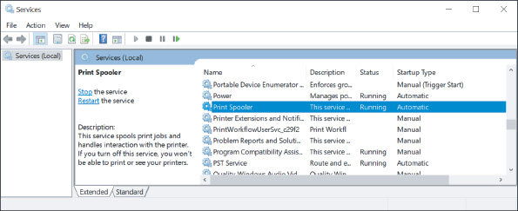
  - To delete any print jobs left in the queue, open File Explorer or Windows Explorer and delete all files in the C:\Windows\System32\spool\PRINTERS folder.
  - Restart the print spooler. Return to the Services console, make sure Print Spooler is selected, and click Start. Close the Services console window.
- If you still cannot print, reboot the computer. Try deleting the printer and then reinstalling it.
- Check the printer manufacturer’s website for an updated printer driver. Download and install the correct driver.
- Try disabling printer caching, which you learned to do earlier in the chapter, so that print jobs are not cached but are sent directly to the printer.

Problems with the Printer Itself
To eliminate the printer as the problem, check these things:
- Is the printer on? Is it getting power? If there’s no image on the printer’s control panel display, the printer is not getting power or it is turned off.
- Does the printer have paper?
- Look for an error message or error code in the control panel on the front of the printer. If the control panel reports “Ready” or “Online,” then you can assume a network printer is communicating with the network.
Notes
If you see an error code you don’t understand, search the printer documentation or website to find out its meaning. Follow the directions on the printer manufacturer’s website to address the error code.
- Can you print a printer self-test page, as described earlier? If this test page prints correctly, then the printer is working.
Notes
A printer self-test page might tell you the printer resolution and how much memory is installed. If this information is not correct, try upgrading firmware on the printer.
- Try resetting the printer. (For some printers, press the Reset button on the printer.) Try powering down or unplugging the printer and starting it again. As it starts up, look for any new error messages that appear.
- Is the paper installed correctly? Are the printer cover and rear access doors properly closed and locked? Is there a paper jam?
- If paper is jammed inside the printer, follow the directions in the printer documentation to remove the paper. Don’t jerk the paper from the printer mechanism, but pull evenly on the paper, with care. You don’t want to leave pieces of paper behind. Check for jammed paper from both the input tray and the output bin. Check both sides. Laser and inkjet printers likely have a door in the back that you can open to gently clear the jammed paper, as shown in Figure 10-52.
Figure 10-52
Open the door on the back of an inkjet printer to remove jammed paper
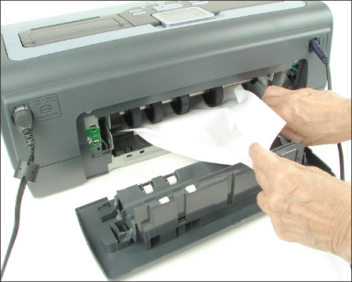
- Is the paper not feeding? Remove the paper tray and check the metal plate at the bottom of the tray. Can it move up and down freely? If not, replace the tray. When you insert the tray in the printer, does the printer lift the plate as the tray is inserted? If not, the lift mechanism might need repair.
- Damp paper can cause paper jams, creases, and wrinkles. Is the paper in the printer dry? Paper that is too thin can also crease or wrinkle in the printer.
- For an inkjet printer, check if nozzles are clogged. Sometimes, leaving the printer on for a while will heat up the ink nozzles and unclog them.
- If the print head of an impact printer moves back and forth but nothing prints, check the ribbon. Is it installed correctly between the plate and print head? Is it jammed? If the ribbon is dried out, it needs to be replaced.
- Check the service documentation and printer page count to find out if routine maintenance is due or if the printer has a history of similar problems. Check the user guide for the printer and the printer manufacturer’s website for other troubleshooting suggestions.
If you still cannot get a printer to work, you might need to take the printer to a certified repair shop. Before you do, though, try contacting the manufacturer. You might also be able to open a chat session on the printer manufacturer’s website.

Problems with Connectivity for a Network Printer or Shared Printer
If the printer’s self-test page prints correctly (the printer is working) but you cannot ping the printer from the computer where the print job was issued, the next step is to suspect no connectivity between the printer and computer. We call this computer the client computer in the following steps for a network printer:
- Consider that the entire network might be down or the client computer is offline. Can the client computer communicate with other devices or computers on the network? Can another computer on the network communicate with the printer?
- Consider that the IP address of the printer might have changed, which can happen if the printer is receiving a dynamic IP address. Using Windows, delete the printer, and then install the printer again. If this solves the problem, assign a static IP address to the printer to keep the problem from reoccurring.
- Can you print to another network printer? If so, there might be a problem with the first printer’s configuration. Try uninstalling and installing the printer at the client computer.
- Check the network port on the printer and the switch or router to which the printer connects. Do the network status indicator lights indicate connectivity and network activity? If not, try replacing the network cable to the printer.
- Use the printer’s browser-based utility and check for status reports and error messages. Run diagnostic software that might be available on the utility menu. Try flashing the printer’s firmware if updates are recommended by the manufacturer.
- Is the printer installed directly on the client computer or on another host computer that is acting as a print server?
Even though you are using a network printer, it might have been installed as a printer that is shared on the network by the host computer. Let’s look at an example of this situation. Figure 10-53 shows a Devices and Printers window with several installed printers. Notice the two installations of the EPSON XP-330 Series printer. The first installation was done by using a printer that was shared by another computer on the network. The second installation was done by installing the Epson printer as a network printer addressed by its IP address. When you print using the second installation of the Epson printer, you print directly over the network to the printer. When you print to the first installation of the Epson printer, you print by way of the other computer on the network. If this computer is offline, the print jobs back up in the print queue until the computer is available.
Figure 10-53
A network printer installed using two methods
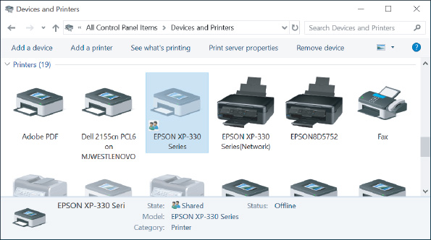
When a computer has shared a local or network printer with others on the network, follow these steps to solve problems with these shared printers:
- Is enough hard drive space available on the client or host computer?
- Did you get an “Access denied” message when you tried to print from the client computer? If so, you might not have access to the host computer. On the client computer, go to File Explorer or Windows Explorer and attempt to drill down into resources on the printer’s computer. Perhaps you have not entered a correct user account and password to access this computer; if so, you will be unable to use the computer’s resources. Make sure you have a matching Windows user account and password on each computer.
- On the host computer, open the printer’s Properties box and click the Security tab. Select Everyone and make sure Permissions for Everyone includes permission to print (refer back to Figure 10-27).
- Using Windows on the client computer, delete the printer, and then install the printer again. For best results, install the printer directly over the network and not through another computer. Watch for and address any error messages that might appear.
Go to pg.
help
Application Opened
Main content

10-6bPoor Print Quality
A+ Core 1
- 3.11
Given a scenario, install and maintain various print technologies.
- 5.6
Given a scenario, troubleshoot printers.
Poor print quality can be caused by the printer drivers, the application, Windows, or the printer. Let’s start by looking at what can cause poor print quality with laser printers and then move on to other problems that affect printouts.
A+ Exam Tip
The A+ Core 1 exam might give you a scenario that requires you to resolve problems with streaks, faded prints, ghost images, garbled characters on a page, vertical lines, low memory errors, wrong print colors, and printing blank pages. All these problems are covered in this part of the chapter.

Poor Print Quality for Laser Printers
For laser printers, poor print quality can include printing blank pages or faded, smeared, wavy, speckled, or streaked printouts with vertical lines down the page. These problems often indicate that the toner is low. All major mechanical printer components that normally create problems are conveniently contained within the replaceable toner cartridge. In most cases, the solution to poor-quality printing is to replace this cartridge.
Follow these general guidelines to fix poor print quality with laser printers:
- If you suspect the printer is overheated, unplug it and allow it to cool for 30 minutes.
- The toner cartridge might be low on toner or might not be installed correctly. Remove the toner cartridge and gently rock it from side to side to redistribute the toner. Replace the cartridge. To avoid flying toner, don’t shake the cartridge too hard.
- If this doesn’t solve the problem, try replacing the toner cartridge immediately.
- Econo Mode (a mode that uses less toner) might be on; turn it off.
- The paper quality might not be good enough. Try a different brand of paper. Only use paper recommended for use with a laser printer. Also, some types of paper can receive print only on one side.
- The printer might need cleaning. Clean the inside of the printer with a dry, lint-free cloth. Don’t touch the transfer roller, which is the soft, spongy black roller.
- If the transfer roller is dirty, the problem will probably correct itself after several sheets print. If not, take the printer to an authorized service center.
- Does the printer require routine maintenance? Check the website of the printer’s manufacturer to see how often to perform maintenance and to purchase the required printer maintenance kit.
Notes
Extreme humidity can cause the toner to clump in the cartridge and give a Toner Low message. If this is a consistent problem in your location, you might want to invest in a dehumidifier for the room where your printer is located.
- Streaking is usually caused by a dirty developer unit or corona wire. The developer unit is contained in the toner cartridge. Replace the cartridge or check the printer documentation for directions on how to remove and clean the developer unit. Allow the corona wire to cool and clean it with a lint-free swab.
- Speckled printouts can be caused by the laser drum. If cleaning the printer and replacing the toner cartridge don’t solve the problem, replace the laser drum.
Notes
If loose toner comes out with your printout, the fuser is not reaching the proper temperature and toner is not being fused to the paper. Professional service is required.
- Distorted images can be caused by foreign material inside the printer that might be interfering with the mechanical components. Check for debris that might be interfering with the printer operation.
- If the page has a gray background or gray print, the image drum is worn out and needs to be replaced.
- If a ghost image appears a few inches below the actual darker image on the page, the problem is usually with the image drum or toner cartridge. The drum is not fully cleaned in the cleaning stage, and toner left on it causes the ghost image. If the printer utility installed with the printer offers the option to clean the drum, try that first. The next solution is to replace the toner cartridge. If the problem is still not solved, replace the image drum.

Poor Print Quality for Inkjet Printers
To troubleshoot blank pages or poor print quality for an inkjet printer, check the following:
- Is the correct paper for inkjet printers being used? The quality of paper determines the final print quality, especially with inkjet printers. In general, the better the quality of the paper you use with an inkjet printer, the better the print quality. Don’t use less than 20-pound paper in any type of printer unless the printer documentation specifically states that a lower weight is satisfactory.
- Is the ink supply low, or is there a partially clogged nozzle?
- Remove and reinstall the cartridge(s).
- Follow the printer’s documentation to clean each nozzle. Is the print head too close to or too far from the paper?
- There is a little sponge in some printers near the carriage rest that can become clogged with ink. It should be removed and cleaned.
- If you are printing transparencies, try changing the fill pattern in your application.
- Missing lines or dots on the printed page can be caused by the ink nozzles drying out, especially when the printer sits unused for a long time. Follow the directions given earlier in the chapter for cleaning inkjet nozzles.
- Streaks or lines down the page can be caused by dust or dirt in the print head assemblage. Follow the manufacturer’s directions to clean the inkjet nozzles.

Garbled Characters on Paper
If scrambled or garbled characters print on all or part of a page, the problem can be caused by the document being printed, the application, connectivity between the computer and the printer, or the printer. Follow these steps to zero in on the problem:
- First, cancel all print jobs in the print queue. Then try printing a different document from the same application. If the second document prints correctly, the problem is with the original document.
- Try printing using a different application. If the problem is resolved, try repairing or reinstalling the application.
- For a USB printer, the problem might be with a USB hub, port, or cable. Is the USB cable securely connected at both ends? If you are using a USB hub, remove the hub, connecting the printer directly to the computer. Try a different USB cable or USB port.
- Recycle the printer by powering it down and back up or by pressing a Reset button.
- Update the printer drivers. Go to the website of the printer manufacturer to find the latest drivers and follow the directions to install them.
- If the problem is still not solved, the printer might need servicing. Does the printer need maintenance? Search the website of the printer manufacturer for other solutions.

Low Memory Errors
For some printers, an error occurs if the printer does not have enough memory to hold the entire page. For other printers, only a part of the page prints. Some might signal this problem by flashing a light or displaying an error message on their display panels, such as “20 Mem Overflow,” “Out of memory,” or “Low Memory.” The solution is to install more memory or to print only simple pages with few graphics. Print a self-test page to verify how much memory is installed. Some printers give you the option to install a hard drive in the printer to provide additional printer storage space.

Wrong Print Colors
For a printer that is printing the wrong colors, do the following:
- Some paper is designed to print on only one side. You might need to flip the paper in the printer.
- Try adjusting the print quality. These adjustments vary by printer. For one color laser printer, open the Printing Preferences box and click the Quality tab (see the left side of Figure 10-54). You can try different selections in this box. To manually adjust the color, check Manual Color Settings and then click Color Settings. The box on the right side of Figure 10-54 appears.
Figure 10-54
Adjust printing quality and color
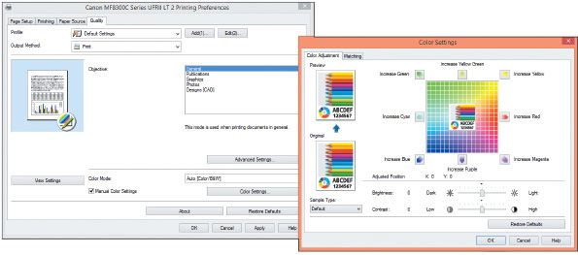
Source: Canon
- For an inkjet printer, try cleaning the ink cartridges and calibrating the printer. One step in this process prints a self-test page. If the self-test page shows missing or wrong colors, the problem is with the ink cartridges. Try cleaning the ink nozzles. If that doesn’t work, replace the ink cartridges.
- For a laser printer, try calibrating the printer.
Applying Concepts

Solving Problems with Printer Installations
A+ Core 1
- 3.11
Given a scenario, install and maintain various print technologies.
- 5.6
Given a scenario, troubleshoot printers.
Here are some steps you can take if the printer installation fails or installs with errors:
- If you have problems, consider that Windows might be using the wrong or corrupted printer drivers. Try removing the printer and then installing it again. To remove a printer in the Windows 10 Settings app, click a printer and click Remove device. To use Control Panel, right-click the printer in the Devices and Printers window and click Remove device. Try to install the printer again.
- If the problem is still not solved, completely remove the printer drivers by using the printui command. The Printer User Interface command, printui, is used by administrators to manage printers and printer drivers on remote computers. You can also use it to delete drivers on the local computer. Follow these steps:
  - If the printer is listed in the Settings app or the Devices and Printers window, remove it. (Sometimes Windows automatically puts a printer there when it finds printer drivers are installed.)
  - Before you can delete printer drivers, you must stop the print spooler service. Open the Services console and use it to stop the Print Spooler (refer to Figure 10-51). To delete any print jobs left in the queue, open Explorer and delete all files in the C:\Windows\System32\spool\PRINTERS folder.
  - You can now start the print spooler back up. Because the printer is no longer listed in the Settings app or the Devices and Printers window, starting the spooler will not tie up these drivers.
  - Open an elevated command prompt window, which is a window used to enter commands that have administrator privileges. To open this window in Windows 10, click Start, click the Windows System folder, right-click Command Prompt, point to More, and click Run as administrator. Respond to the UAC box.
OS Differences
To open the elevated command prompt in Windows 8, press Win+X and click Command Prompt (Admin). In Windows 7, click Start, All Programs, and Accessories. Right-click Command Prompt and click Run as administrator. Respond to the UAC box.
  - At the command prompt (see the left side of Figure 10-55), enter the command printui /s /t2. In the command line, the /s causes the Print Server Properties box to open and the /t2 causes the Drivers tab to be the selected tab.
Figure 10-55
Use the printui command to delete printer drivers and possibly delete the driver package (driver store)
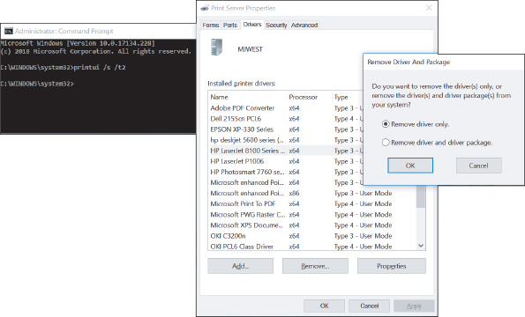
  - The Print Server Properties box opens, as shown in the middle of Figure 10-55. Select the printer and click Remove. In the Remove Driver And Package dialog box (see the right side of Figure 10-55), select Remove driver only and click OK. It is not necessary to remove the driver package. (This driver package, also called the driver store, can be installed on this computer or a remote computer; it holds a backup of the printer drivers.)
  - When a warning box appears, click Yes. Close all windows.
- Try to install the printer again. Start the installation from the CD that came bundled with the printer or by using the printer setup program downloaded from the printer manufacturer’s website.
Go to pg.
help
Application Opened
Main content

Chapter Review

10-7aChapter Summary

Client-Side Virtualization
- Client-side virtualization is done by creating multiple virtual machines, each with its own virtual desktop, on a physical machine using a hypervisor.
- A Type 1 hypervisor installs before an OS is installed and is called a bare-metal hypervisor. A Type 2 hypervisor is an application that installs in an OS. A Type 1 hypervisor is faster and more secure than a Type 2 hypervisor.
- When customizing a virtualization workstation, maximize the available budget for CPU cores and the amount of installed RAM. Make sure the NIC supports Gigabit Ethernet, consider adding a second NIC to the workstation, and account for system requirements needed to support the hypervisor software and its hardware emulator.

Cloud Computing
- Cloud computing is providing computing resources over the Internet to customers.
- A public cloud service is available to the public, and a private cloud service is kept on an organization’s own servers or made available by a vendor only for a single organization’s private use. A community cloud is shared between multiple organizations, and a hybrid cloud is any combination of these deployment models.
- All cloud computing service models incorporate on-demand service, rapid elasticity, multiplatform compatibility, resource pooling, and measured service.
- Cloud computing service models, including IaaS, PaaS, SaaS, and XaaS, are categorized by the types of services they provide and the degree that a third-party service or vendor is responsible for the resources.
- Application virtualization makes an application available to remote users from a virtualization server and does not install the application on the user’s system.
- A thick client needs to meet recommended requirements for its OS and applications, and a thin client is a low-end computer that only needs to meet the minimum requirements for a lightweight OS.

Printer Types and Features
- The two most popular types of printers are laser and inkjet. Other types of printers are thermal printers, impact printers (dot matrix), and 3D printers. Laser printers produce the highest quality, followed by inkjet printers. Dot matrix printers have the advantage of being able to print multicopy documents. 3D printers use a plastic filament to build a 3D model of a digital image.
- The seven steps that a laser printer performs to print are processing, charging, exposing, developing, transferring, fusing, and cleaning. The charging, exposing, developing, and cleaning steps take place inside removable cartridges, which makes the printer easier to maintain.
- Inkjet printers print by shooting ionized ink at a sheet of paper. The quality of the printout largely depends on the quality of paper used with the printer.
- Dot matrix printers are a type of impact printer. They print by projecting pins from the print head against an inked ribbon that deposits ink on the paper.
- Direct thermal printers use heat to burn dots into special paper, and thermal transfer printers melt the ribbon or foil during printing.
- If you want to design your own images for three-dimensional printing, you’ll need a 3D modeling program.

Using Windows to Install, Share, and Manage Printers
- A printer is installed as a local printer connected directly to a computer or as a network printer that works as a device on the network. Local printers can connect to a computer via a USB, serial, Bluetooth, or Wi-Fi connection. Network printers can connect to the network via an Ethernet or Wi-Fi connection. USB printers are installed automatically in Windows.
- Windows 10 installs, manages, and removes a printer using the Printers & scanners window in the Settings app. Windows 10/8/7 uses the Devices and Printers window in Control Panel. You can also install a printer using a setup program provided by the printer manufacturer. Always print a test page after installing a printer.
- A print server can be a computer on the network, firmware embedded in a network printer, or other network hardware such as a router or firewall.
- A printer can be shared in Windows so that others on the network can use it. To use a shared printer, the printer drivers must be installed on the remote computer.
- Network printers are identified on the network by their IP address.
- The Windows print queue is managed from the Printers & scanners window or from the Devices and Printers window.
- Virtual printing prints to a file, and cloud printing prints to a printer via the Internet.
- Printer features, such as duplexing, collating, and page orientation, are managed in a printer Properties box.

Printer Maintenance
- An inkjet or laser printer can be calibrated to align the color on the page. The nozzles of an inkjet printer tend to clog or dry out, especially when the printer remains unused. The nozzles can be cleaned automatically by means of printer software or buttons on the front panel of the printer.
- Check the page count of the printer to know when service is due and you need to order a printer maintenance kit. The page count can be reported on the printer panel or through a web-based utility in the printer firmware.
- Memory and a hard drive can be added to a printer to improve performance and prevent errors.

Troubleshooting Printers
- When troubleshooting printers, first isolate the problem. Narrow the source to the printer, connectivity between the computer and its local printer, the network, Windows, printer drivers, the application using the printer, or the printer installation. Test pages printed directly to the printer or within Windows can help narrow the source of the problem.
- Poor print quality can be caused by the printer drivers, the application, Windows, or the printer. For a laser printer, consider that low toner can be the problem. For an inkjet printer, consider that the ink cartridges need cleaning or replacing. The quality of paper can also be a problem.
Go to pg.
help
Application Opened
Main content

Chapter Review

10-7bKey Terms
For explanations of key terms, see the Glossary for this text.
- 3D printer
- ADF (automatic document feeder) scanner
- ad hoc mode
- AirPrint
- application streaming
- application virtualization
- Bonjour
- calibration
- charging
- client-hosted desktop virtualization
- client-side virtualization
- cloud-based application
- cloud-based network controller
- cloud computing
- cloud file storage service
- cloud printing
- community cloud
- default printer
- direct thermal printer
- duplex printer
- duplexing assembly
- elevated command prompt window
- extension magnet brush
- flatbed scanner
- fuser assembly
- HAV (hardware-assisted virtualization)
- hybrid cloud
- hypervisor
- IaaS (Infrastructure as a Service)
- imaging drum
- impact paper
- impact printer
- infrastructure mode
- ink cartridge
- inkjet printer
- integrated print server
- laser printer
- local printer
- measured service
- network printer
- on-demand
- PaaS (Platform as a Service)
- pickup roller
- platform
- print head
- printer maintenance kit
- printer self-test page
- printui
- private cloud
- public cloud
- rapid elasticity
- remote printing
- resource pooling
- SaaS (Software as a Service)
- separate pad
- separation pad
- Services console
- synchronization app
- thermal paper
- thermal printer
- thermal transfer printer
- thick client
- thin client
- toner vacuum
- tractor feed
- transfer belt
- transfer roller
- Type 1 hypervisor
- Type 2 hypervisor
- VDI (Virtual Desktop Infrastructure)
- virtual desktop
- virtualization
- virtualization server
- virtual NIC
- virtual printing
- VM (virtual machine)
- zero client
Go to pg.
help
Application Opened
Main content

Chapter Review

10-7cThinking Critically
These questions are designed to prepare you for the critical thinking required for the A+ exams and may use content from other chapters and the web.
- You’re setting up some VMs to test an application you’re considering making available to employees of the small company you work for. You need to test the app in a variety of OSs, and you don’t expect to need these VMs after testing is complete. You’d like setup to be as simple and straightforward as possible without needing to make any changes to the servers on your network. Which of these hypervisors will best serve your needs?
  - XenServer
  - Client Hyper-V
  - Hyper-V
  - ESXi
- You have three VMs running on a Windows 10 computer. Two of the VMs, machines A and B, are able to communicate with the Internet and other network resources, as is the host Windows 10 machine. However, one VM, machine C, cannot access websites on the Internet. What is the first component you check? The second component?
  - The host machine’s network adapter
  - The switch connected to the host machine
  - VM C’s virtual NIC
  - The host machine’s hypervisor
- You’re installing VirtualBox on a Windows 10 Home computer and you get the following error message:
VT-x is disabled in the BIOS for all CPU modes
What is the problem? How do you fix it?
- Which component in a thin client might need a higher rating than other components?
  - The CPU because most of the processing is done on the thin client
  - RAM because the system must have enough to hold a virtual desktop
  - The hard drive because a VM takes up a large amount of hard drive space
  - The NIC because most of the processing is done on the server
- Your boss has instructed you to set up a virtualization workstation that will provide help-desk users with access to Windows 10 Pro and Home, Windows 7 Pro and Home Basic, Ubuntu Desktop, Linux Mint, and Android Oreo and Pie. She also wants you to use Client Hyper-V as the hypervisor. In what order should you install the operating systems and hypervisor?
  - Ubuntu Desktop, Client Hyper-V, remaining OSs in VMs
  - Client Hyper-V, Windows 10 Pro, remaining OSs in VMs
  - Client Hyper-V, OSs in VMs
  - Windows 10 Pro, Client Hyper-V, remaining OSs in VMs
- You work for a small startup company that just hired five new employees, doubling its number of team members. In preparation for the new employees’ first day in the office, you add five new user accounts to your CRM (customer relationship management) software subscription, a service that is hosted in the cloud. What aspect of cloud computing has worked to your advantage?
  - On-demand
  - Rapid elasticity
  - Measured service
  - Resource pooling
- Doctors at a regional hospital access an online database of patient records that is being developed and tested by a conglomerate of health insurance agencies. The database contains records of hundreds of thousands of patients and is regulated by HIPAA restrictions on protected health information (PHI). What kind of cloud deployment is this database?
- You’re responding to a troubleshooting ticket about a laser printer in HR that isn’t working. According to reports, the printer runs the print job and successfully sends the paper through. The paper shows the text prints correctly. However, the toner smudges easily and sticks to other papers, equipment, and clothes. Which part in the printer probably needs replacing?
  - Fuser assembly
  - Imaging drum
  - Transfer roller
  - Toner cartridge
- You are not able to print a Word document on a Windows computer to a printer on the network. The network printer is connected directly to the network, but when you look at the Devices and Printers window, you see the name of the printer as \\BRYANT\HP LaserJet Pro MFP. In the following list, select the possible sources of the problem. Select all that apply.
  - The BRYANT computer is not turned on.
  - The HP LaserJet printer is not online.
  - The BRYANT computer does not have file and printer sharing enabled.
  - The Windows computer has a stalled print spool.
- Gmail is an example of what type of cloud computing service model?
  - IaaS
  - Application streaming
  - PaaS
  - SaaS
- You are not able to print a test page from your Windows 10 computer to your local, USB-connected Canon Pixma printer. Which of the following are possible causes of the problem? Select all that apply.
  - The network is down.
  - The printer cable is not connected properly.
  - The Windows print spool is stalled.
  - File and printer sharing is not enabled.
- Which of the following resources are shared between the host computer and a VM? Select all that apply.
  - NIC
  - Operating system
  - Hard drive
  - Applications
- What should you do if an inkjet printer prints with missing dots or lines on the page?
  - Change the ink cartridge.
  - Clean the heating element.
  - Replace the image drum.
  - Clean the inkjet nozzles.
- Your boss, an avid user of Apple devices, has asked you to print some contracts to her shared printer. You send the documents from your Windows 10 workstation, but the print job doesn’t go through. What is the first thing you need to do? Second?
  - Verify that the Bonjour service is running on your computer.
  - Verify that your boss can print a test page from her printer.
  - Verify that you can view the boss’s computer in File Explorer.
  - Restart your computer.
- Why might you assign a static IP address to a printer?
Go to pg.
help

