Application Opened
Main content
Chapter
11

Windows Versions and Customer Service
- Chapter Introduction
- 11-1Windows Interfaces
  - 11-1aWindows 10 Interface
  - 11-1bChoosing a Windows Edition
- 11-2Windows Tools for Users and Technicians
  - 11-2aWindows 10/8 File Explorer and Windows 7 Windows Explorer
  - 11-2bControl Panel
  - 11-2cWindows 10 File Explorer Options or Windows 8/7 Folder Options
  - 11-2dPower Options
  - 11-2eSystem Window
  - 11-2fSystem Information Window
  - 11-2gWindows 10 Settings App
- 11-3How Windows Controls Access to Network Resources
  - 11-3aWindows Workgroup and Homegroup
  - 11-3bWindows Domain
  - 11-3cDomain Setup
  - 11-3dPublic and Private Networks
- 11-4What Customers Want: Beyond Technical Know-How
  - 11-4aBecoming a Competent and Helpful Support Technician
  - 11-4bPlanning for Good Service
- 11-5Chapter Review
  - 11-5aChapter Summary
  - 11-5bKey Terms
  - 11-5cThinking Critically
  - 11-5dHands-On Projects
  - 11-5eReal Problems, Real Solutions
  - 11-5fExam Tips
Go to pg.
help
Application Opened
Main content

Chapter Introduction
After completing this chapter, you will be able to:
- Use Windows to interface with users, files and folders, applications, and hardware
- Use Windows tools to explore, examine, and support the system
- Explain the various ways Windows secures resources on the network and secures a network connection
- Support customers with professionalism and respect, in addition to your technical skills
In this chapter, you learn about the versions of Microsoft Windows and how this operating system provides an interface between users and applications and between applications and hardware devices. You learn to use several Windows tools and utilities that are useful to view and manage storage devices, examine a system, and troubleshoot simple problems with hardware and applications. Finally, you learn about interpersonal skills (people skills, sometimes called soft skills) needed by an IT support technician.
A+ Exam Tip
In this text, you learn about Windows 10, Windows 8.1, Windows 8.0, and Windows 7. All these operating systems are covered on the A+ Core 2 exam. In the text, we use Windows 8 to refer to Windows 8.0 and Windows 8.1.
Go to pg.
help
Application Opened
Main content

11-1Windows Interfaces
A+ Core 2
- 1.2
Compare and contrast features of Microsoft Windows versions.
An operating system (OS) is software that controls a computer. In general, you can think of an operating system as the middleman between applications and hardware, between the user and hardware, and between the user and applications (see Figure 11-1).
Figure 11-1
Users and applications depend on the OS to relate to all applications and hardware components
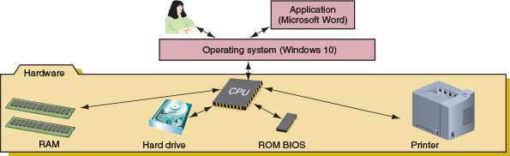
Several applications might be installed on a computer to meet various user needs, but a computer really needs only one operating system. Although there are important differences among them, all operating systems share the following four main functions:
- Function 1: Provide a user interface
  - Performing storage and housekeeping procedures requested by the user, such as reorganizing a hard drive, deleting files, copying files, and changing the system date
  - Providing a way for the user to manage the desktop, hardware, applications, and data
- Function 2: Manage files
  - Managing files on hard drives, DVD drives, CD drives, USB flash drives, and other drives
  - Creating, storing, retrieving, deleting, and moving files
- Function 3: Manage hardware
  - Managing the BIOS/UEFI (programs permanently stored on hardware devices)
  - Managing memory, which is a temporary place to store data and instructions as they are being processed
  - Diagnosing problems with software and hardware
  - Interfacing between hardware and software (that is, interpreting application software needs to the hardware and vice versa)
- Function 4: Manage applications
  - Installing and uninstalling applications
  - Running applications and managing the interface to the hardware on behalf of an application
Windows 10 is the latest Microsoft operating system and is an upgrade to Windows 8, which was preceded by Windows 7. Windows 8.1 is a free update or release of the original Windows 8. Every IT support technician needs to be a power user of Windows 10 and familiar with Windows 8/7.
Notes
This chapter assumes Windows 10 is already installed on your computer, and it would be helpful if you have access to the Windows 8 and Windows 7 operating systems as you work your way through this chapter. If Windows is not yet installed, read Chapter 12 and install Windows 10, 8, or 7. Then you can return to this chapter to learn how to use the OS.
Every Windows OS offers a graphical user interface (GUI; pronounced “GOO-ee”) that uses graphics instead of a command-driven interface. Windows 10 offers two graphical user interfaces—the desktop and Tablet mode via a feature called Continuum. Windows 8 has two graphical user interfaces—the modern interface and the desktop. Windows 7 offers one graphical user interface, the desktop. We next examine these interfaces.
Notes
The figures and steps in this text use Windows 10 Professional, Windows 8.1 Professional, and Windows 7 Professional. If you are using a different edition of Windows 10, 8, or 7, your screens and steps may differ slightly from those presented here.
Go to pg.
help
Application Opened
Main content

11-1aWindows 10 Interface
A+ Core 2
- 1.2
Compare and contrast features of Microsoft Windows versions.
Let’s take a quick look at the Windows 10 desktop and Start menu, as well as other features you’ll find useful when supporting Windows 10.

Windows 10 Desktop
The application and utility hub in Windows 10 is the Start menu on the desktop (see Figure 11-2). Tools used by technicians to support, secure, and troubleshoot Windows, as well as productivity software such as Microsoft Office, QuickBooks, and Dreamweaver, can be accessed from the Start menu, desktop, and taskbar. The taskbar is normally located at the bottom of the Windows desktop, displaying information about open programs and providing quick access to others. By default, Windows 10 pins the Task View, Microsoft Edge, File Explorer, and Store icons in the Quick Launch toolbar on the left side of the taskbar. Click an icon to open the program. An open application displays a program icon in the taskbar to the right of the toolbar; if a pinned application is open, it is underlined.
Figure 11-2
Windows 10 uses a Start menu with live tiles
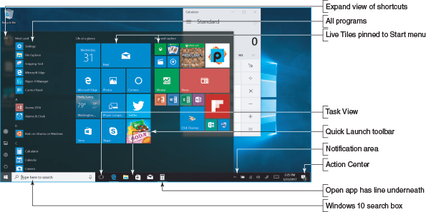
The Windows 10 Start menu has live tiles on the right side of the menu that offer continuous real-time updates. Click a tile or program name to open its app. The left side of the Start menu includes lists of:
- recently added apps, if there are any,
- apps used most often,
- suggested apps for downloading from the Windows Store, and
- an alphabetical list of all apps available on the computer.
To expand the view of the links on the left side of the Start menu, click the three horizontal bars (sometimes called a hamburger button) at the top-left corner of the menu, as shown in Figure 11-2.
The bottom-left corner of the Start menu has a few icons that you can use to access important functions. Click the Account icon to change account settings, lock Windows, or sign out of Windows. Other icons allow you to access File Explorer, the Settings app, and the Power menu. Click the Power icon to put the computer in sleep mode, shut it down, or restart.
Notes
To customize the Start menu, open the Start menu and click the Settings app icon. In the Settings app, open the Personalization group and select Start. If you prefer to use the Windows 8 Start screen in Windows 10, apply the full-screen Start menu option in the Personalization group of the Settings app.
The notification area, also called the system tray or systray, is located on the right side of the taskbar by default and displays open services. A service is a program that runs in the background to support or serve Windows or an application. The services in the notification area include the volume or sound control and network connectivity.
To launch a program from the desktop, use one of these methods:
- Start menu. Click the Start button and find the program in the list of all programs on the left, or find the pinned app or a live tile on the right. To pin an app to the Start menu, find the app in the alphabetical apps list, right-click the app tile, and click Pin to Start. To unpin an app from the Start menu, right-click the pinned app tile and click Unpin from Start.
- Windows 10 search box with Cortana. Cortana is the new voice-enabled search feature of Windows 10 and is accessed using the search box on the taskbar (shown earlier in Figure 11-2). If you know the name of the program file, you can type that name in the search box and press Enter, or click the microphone button to the right of the search box and then say the command to Cortana. For example, the program name of the Notepad text editor is notepad.exe. When you type notepad in the search box and press Enter, the Notepad window opens. (Windows assumes the file extension for a program is .exe, so it’s not necessary to type the extension.) Alternatively, you can click the microphone button and then say, “Open Notepad.” The Notepad window opens.
- Quick Launch menu. To launch most Windows support tools, right-click the Start button to display the Quick Launch menu (see Figure 11-3) and then click an item to open it. You can also press Win+X to launch the menu from anywhere in Windows 10.
Figure 11-3
Use the Quick Launch menu from anywhere in Windows to access useful Windows utilities and screens
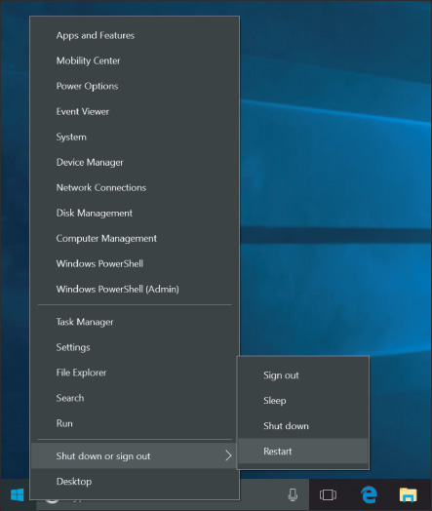
Here are some important items on the Quick Launch menu. You’ll learn to use these and other items on the menu in this chapter and later chapters:
  - Use the Settings app to change Windows settings. To change more advanced settings, you’ll need to use the Control Panel. You’ll have a chance to explore the Settings app and Control Panel later in this chapter.
  - To repair, update, and uninstall installed apps, use the Apps & Features window, which can also be found in the Settings app. The window also has a link to the Programs and Features window, which you can use to turn Windows features on or off.
  - The System link opens the About page in the Settings app to display information about the system and gives links to many more tools to manage settings (see Figure 11-4). The About page replaces the System window of earlier versions of Windows, although you can still find the System window in Control Panel.
Figure 11-4
The About page in the Settings app displays the same information found in the System window
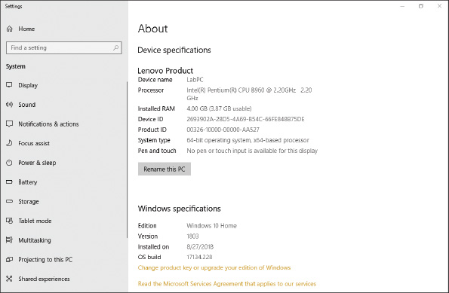
  - Windows PowerShell and Windows PowerShell (Admin) provide a command-line interface where you can process small PowerShell programs called cmdlets. Earlier versions of Windows provided Command Prompt and Command Prompt (Admin) options on the Start menu, which open a command-line interface to enter Windows commands. You learn to use PowerShell and Command Prompt windows in Chapter 13.
  - Notice the Shut down or sign out item near the bottom of the Quick Launch menu in Figure 11-3. When you point to it, you see submenu items that always include Shut down, Sign out, and Restart. Depending on your system configuration, you might also see Sleep or Hibernate.
- Pin to taskbar. For a program you use often, you can add its icon to the taskbar on the desktop, which is called pinning to the taskbar. Right-click an app on the Start menu to see the app’s shortcut menu (see Figure 11-5). If necessary, click More, then click Pin to taskbar. You can also open a program, right-click the program’s icon in the taskbar, and then click Pin to taskbar (see Figure 11-6).
Figure 11-5
Right-click an app to pin it to the taskbar from the Start menu
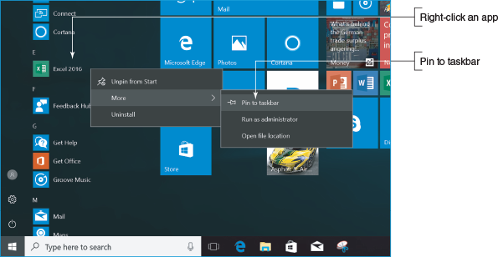
Figure 11-6
Right-click an icon for an open app and then pin it to the taskbar
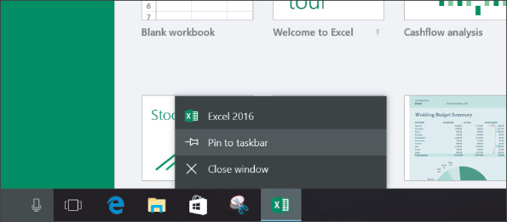
- Double-click the program file name in File Explorer. File Explorer allows you to view and manage files and folders on your computer or the network. To open File Explorer, click the File Explorer icon in the taskbar or the Quick Launch menu. You can launch a program by double-clicking the program file name in File Explorer.
- Shortcut on the desktop. You can place a shortcut to a program on the desktop and then double-click the shortcut to launch the program. You learn to create shortcuts later in this chapter.
- Run box or search box. If you know the name of the program file, you can open the Quick Launch menu and click Run. The Run box appears, as shown in Figure 11-7. Type the name of the program file and press Enter. For example, the program file name of the Notepad text editor is notepad.exe. When you type notepad in the Run box and press Enter, the Notepad window appears. (Windows assumes the file extension for a program is .exe, so it’s not necessary to type the extension.) You can also enter notepad in the Windows 10 search box to launch the program.
Figure 11-7
Use the Run box to launch a program
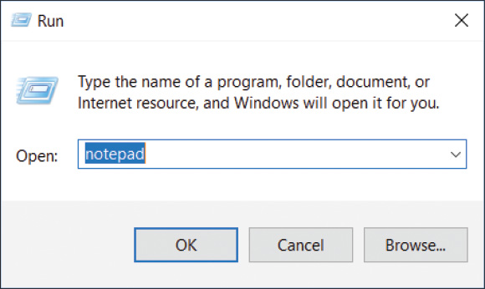
Here are a few tips about managing windows on the desktop:
- Drag the title bar of a window to move the window. Use the buttons in the upper-right corner to resize, maximize, minimize, and close a window.
- Drag a window to the top of the screen to maximize it. Drag the window downward on the screen to return it to its original size. Drag a window to the right or left of the screen so that it snaps to the side of the screen and fills that half of it. Drag a window to a corner of the screen so that it snaps to a quarter-size of the screen in that corner.
- Press and shake (drag back and forth quickly) the title bar of a window to minimize all other windows except the one you shake. Shake again to restore the size of the other windows.

Windows 10 Features
Here’s a brief list of Windows 10 features that apply mainly to the end user:
- Action Center. The new Action Center in Windows 10 is used to toggle several Windows features on and off, access the Settings app, and view notifications. In Windows 10, you open the Action Center by clicking the Action Center icon next to the date and time in the taskbar (see Figure 11-8). Windows 8 has an Action Center that is much more powerful than the Windows 10 Action Center. The Windows 10 version of the Windows 8 Action Center is called Security and Maintenance and can be found in the Windows 10 Control Panel.
Figure 11-8
The Action Center is used for accessing Security and Maintenance and other Windows features
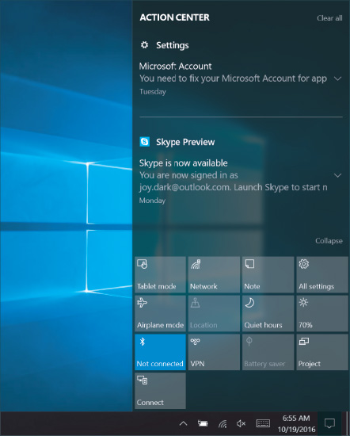
- Cortana. Windows 10’s digital assistant, Cortana, can learn your speech, handwriting patterns, and typing history to assist with user input. Access Cortana using the search box on the taskbar (see Figure 11-9). Cortana speaks using a woman’s voice, so she is often referred to using a female pronoun. Cortana can, for example, help you search your computer for a file, compose an email, search the Internet, or even check the weather.
Figure 11-9
Access Cortana by typing or speaking to her
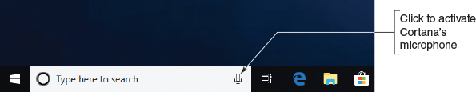
- Snap Assist. Windows 8 introduced Snap Assist, which makes it easy to snap windows to the left or right side of the screen, but this was a problem for Windows 8 modern apps that needed the entire screen. To allow for more flexibility, Snap Assist in Windows 10 allows for half and quadrant snapping, so a window can take up all of the screen, half of it, or only a quarter. Windows 10 apps are now contained in windows that float on the desktop and can be snapped to an edge or corner.
- Task View. To help organize applications opened on the desktop, Windows 10 uses Task View to create multiple virtual desktops so you can flip through to the desired desktop as needed (see Figure 11-10). For example, if you are paying bills, writing a paper, and surfing the Internet, you can put those three tasks on separate desktops. On desktop 1, you can open relevant web browsers and budgeting software. On desktop 2, open Microsoft Word, OneNote, and web browsers for research. On desktop 3, open web browsers to keep up with social media and news. To open a new desktop, click the Task View icon on the taskbar (refer back to Figure 11-2), and then click New desktop. The keyboard shortcut to toggle your open desktops is Ctrl+Win+arrow left or arrow right. To close a desktop, click the Task View icon and close its Desktop thumbnail in the pane just above the taskbar.
Figure 11-10
Use Task View to organize your open apps
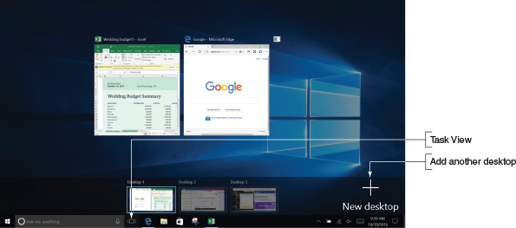
Applying Concepts

Signing In To Windows 10 And Using The Windows 10 Interface
Windows 10 is designed to flow between touch screen and desktop interfaces. Follow these steps to learn how to sign in to Windows 10 and manage apps:
- When you start up a Windows 10 computer, you see the lock screen. Click anywhere on the screen and the sign-in screen appears (see Figure 11-11). To sign in, select a user account and enter the account password. The desktop appears.
Figure 11-11
The Windows sign-in screen
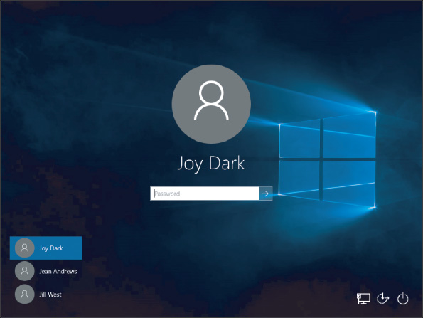
Notes
These instructions assume you are using a mouse and keyboard. If you’re using a touch screen, simply tap instead of clicking, press and hold instead of right-clicking, double-tap instead of double-clicking, and swipe to scroll the screen to the right, left, up, or down.
- To open an app, click the Start icon, and then click the app tile on the Start menu.
- Using the Start menu, open a second app.
Notes
In Windows, there are multiple ways to do the same thing. For example, to open the Start menu,
  - click the Start button or
  - press the Windows key on the keyboard.
- Use Snap Assist to snap a window to the left or right side or a corner of the screen so a second window can share it. To snap a window, press and drag the title bar of the window to the left or right side of the screen. When you release the window, it snaps to the side, and then you can snap a second app to the other side of the screen. You can press and drag the vertical bar between the two windows to adjust the window sizes (see Figure 11-12).
Figure 11-12
Two app pages on the screen
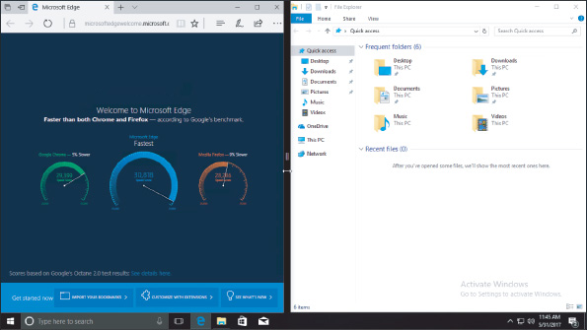
Notes
To snap windows, your screen resolution must be at least 1024 × 768.
- Open and close three other apps using these two methods:
  - Open the Start menu and click a tile in the alphabetical list of programs on the left.
  - In the Search bar, type the name of the app you want to open. As you type, search results appear above the Search bar. For example, when no is typed in the Search bar in Figure 11-13, Notepad appears as the best match. Other possible search results are also listed. You can click any app in the search results to open it. By default, the Search feature searches for apps, Windows settings, files, web images, and web videos. If you click an item under the Web heading, Edge opens to search online.
Figure 11-13
Use the Search bar to find and open apps and utilities
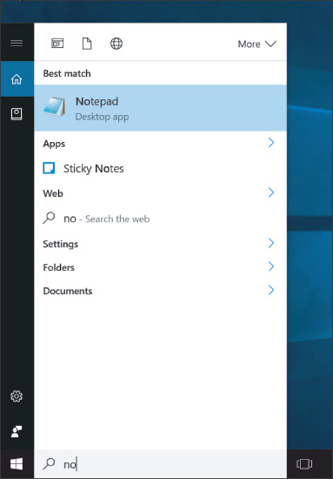
- To see thumbnails of open apps that are not visible on the screen, click Task View in the taskbar (refer to Figure 11-10).
- To close a selected app, move your pointer to the top of the screen. A menu bar appears if it was hidden. Click the red X on the far right of the menu bar.
- Close all open apps.
Windows 8

Modern Interface
A+ Core 2
- 1.2
Compare and contrast features of Microsoft Windows versions.
The Windows 8 modern interface, also called the Windows 8 interface and formerly called the Metro User Interface or Metro UI, presents the Start screen to the user. The Start screen contains tiles that represent lean apps, which use few system resources and are designed for social media, social networking, and the novice end user (see Figure 11-14). Click a tile to open its app. Some apps use live tiles. For example, the People app has a live tile to make it easy to keep up with updates on Facebook, LinkedIn, and Twitter.
Figure 11-14
The Windows 8 Start screen is used to view app tiles and to open apps
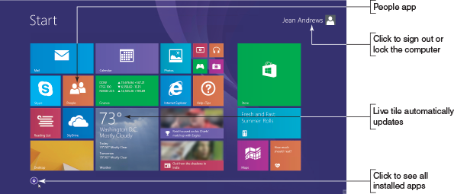
Notes
Remember that in this text, we use Windows 8 as an umbrella term to cover Windows 8.0 (the first release of Windows 8) and Windows 8.1 (the free update to Windows 8.0).
The modern interface uses pages in comparison to the windows used on the desktop. The interface is specifically designed for touch screens.
Notes
To conserve system resources, you can turn off a Windows 10/8 live tile. Right-click the tile on the Start screen and then click Turn live tile off in the shortcut menu that appears. You can also use Task Manager to find out how the app is affecting overall system performance. You learn to use Task Manager in Chapter 14.

The Charms Bar and the Settings Charm
The charms bar appears on the right side of any Windows 8 screen when you move your pointer to a right corner (see Figure 11-15A). It gives handy access to common tasks such as returning to the Start screen, searching for content, connecting to a wireless network, personalizing the Start screen, and changing other Windows settings. In the charms bar, click a charm to select it. The Settings charm can be particularly useful, and items at the top of the Settings pane can change depending on the situation. Figure 11-15B shows the Settings pane on the Start screen, and Figure 11-15C shows the Settings pane on the desktop.
Figure 11-15
(A) The charms bar, (B) the Settings pane on the Start screen, and (C) the Settings pane on the desktop
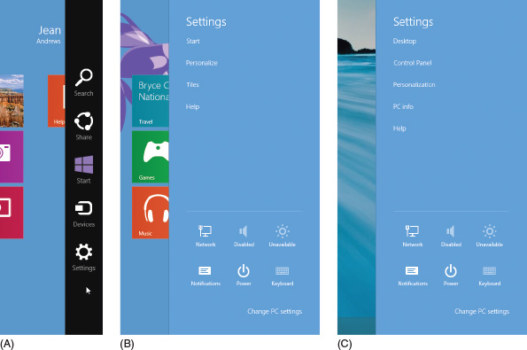
Notes
With the first release of Windows 8, many users complained that important items like the charms bar were difficult to find and not intuitive to use. As a result, beginning with Windows 8.1, Microsoft added tips that randomly appear on screen to help users learn how to use the new interface.

The Power Icon
Use the Power icon in the upper-right corner of the Start screen to shut down or restart the computer. Click the Power icon, and then click an item in the menu that appears (see Figure 11-16). The items on this menu always include Shut down and Restart, and, depending on the configuration, might also include Sleep and Hibernate.
Figure 11-16
Use the Power icon at the top of the Start screen to shut down or restart the system
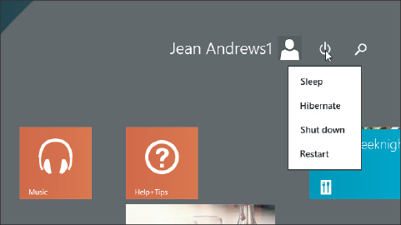

Windows 8 Desktop
To access the Windows 8 desktop, click the Desktop tile on the Start screen. When you move your pointer to a right corner of the desktop screen, the charms bar appears, as shown in Figure 11-17. Click the Start charm in the charms bar to return to the Start screen. Alternately, you can click the Start button in the taskbar to return to the Start screen.
Figure 11-17
The Windows 8 desktop with the charms bar in view
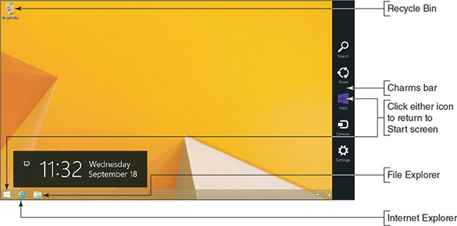
Notes
According to Microsoft terminology, you sign in to Windows 10/8 and log on to Windows 7.
OS Differences
The Windows 7 desktop provides a 3D user interface called the Aero user interface that gives a glassy appearance (see Figure 11-18). The Windows 7 desktop can have gadgets, which are mini-apps that provide information such as the time, date, news headlines, or weather. You can open programs by using the Start menu, shortcuts on the desktop, or icons in the taskbar. For example, to open Windows 7 Windows Explorer, click its icon in the taskbar. File Explorer in Windows 10/8 is called Windows Explorer in Windows 7.
Figure 11-18
The Windows 7 desktop using the Aero interface has a glassy, transparent look
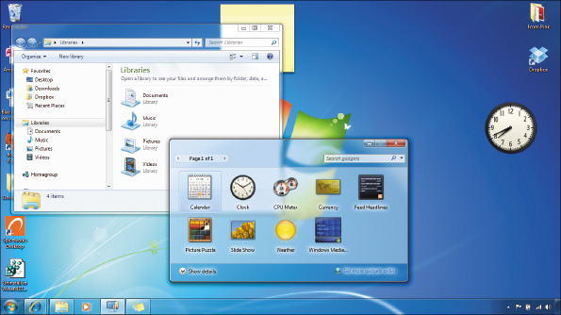
Go to pg.
help
Application Opened
Main content

11-1bChoosing a Windows Edition
A+ Core 2
- 1.2
Compare and contrast features of Microsoft Windows versions.
Microsoft offers several editions of each version of Windows. Here are the most important ones:
- Important Windows 10 editions for personal computers include Windows 10 Home, Windows 10 Pro, Windows 10 Enterprise, and Windows 10 Education. Home editions for Windows are intended for laptops and desktop computers in a home or small office. Pro, Enterprise, and Education editions are designed to work in large organizations and enterprises. Enterprise editions allow for volume licensing. Education editions are less expensive editions for those who can prove they qualify for the educational discounts.
- Windows 8 options are Windows 8.1 Core (the Home version), Windows 8.1 Pro, and Windows 8.1 Enterprise.
- Windows 7 options are Windows 7 Home Basic and Premium, Windows 7 Professional, and Windows 7 Enterprise.
A+ Exam Tip
The A+ Core 2 exam expects you to be able to compare and contrast which version and edition of Windows is best in a given scenario, including Windows 10, Windows 8.1, Windows 8.0, and Windows 7 personal and corporate editions.
When deciding among Windows 10, Windows 8, or Windows 7 for a new installation, select Windows 10 if possible because Microsoft support for its latest OS will last longer, and Windows 10 improves in many ways on Windows 8 and Windows 7.
When faced with choosing an edition of Windows 10/8/7, consider the purposes for using Windows. Is the computer intended for corporate or personal use? Different editions offer different features. The professional editions have more features that are more useful in a corporate setting, which is why these editions are more expensive. Consider the following features that the user or organization might require; they are all available on the Windows 10/8/7 Pro, Education, Business, and Ultimate editions, but are not available in the Home editions:
- Domain access. If the computer connects to a corporate or educational network to access network resources, it requires access to a Windows domain, which manages resources on the network. How to join a domain is covered later in this chapter.
- BitLocker. BitLocker encrypts an entire volume on a drive to protect the data and can provide full hard drive encryption. This level of security is often required by corporations to secure a computer and its data and settings before the computer is allowed to connect to and access resources on a corporate network.
- Encryption File System (EFS). EFS encrypts files and folders to protect the data. Although not as secure as full drive encryption, EFS is sometimes required by individuals and corporations to protect the data on a computer’s hard drive.
- Branchcache. Branchcache optimizes content access over a wide area network (WAN) by retrieving content from remote servers and caching it on local servers for better access. The feature is sometimes required to optimize accessing resources on remote corporate networks.
- Media Center. Media Center is a digital video recorder and media player originally offered as part of earlier editions of Windows, including Windows 7 Professional. It was also available as a paid add-on in Windows 8 Pro. However, it is deprecated (no longer available) starting with Windows 10.
Now that you’re familiar with the Windows interfaces and editions, let’s learn to use several tools that are helpful to both users and technicians.
Go to pg.
help
Application Opened
Main content

11-2Windows Tools for Users and Technicians
A+ Core 2
- 1.2
Compare and contrast features of Microsoft Windows versions.
- 1.3
Summarize general OS installation considerations and upgrade methods.
- 1.5
Given a scenario, use Microsoft operating system features and tools.
- 1.6
Given a scenario, use Microsoft Windows Control Panel utilities.
- 1.8
Given a scenario, configure Microsoft Windows networking on a client/desktop.
All users need to know how to use File Explorer or Windows Explorer. In addition, a technician needs to know how to use the Control Panel, Power Options, System window, System Information window, and for Windows 8/7, the Action Center. All these tools are covered in this part of the chapter.
Go to pg.
help
Application Opened
Main content

11-2aWindows 10/8 File Explorer and Windows 7 Windows Explorer
A+ Core 2
- 1.6
Given a scenario, use Microsoft Windows Control Panel utilities.
You open Windows 10/8 File Explorer or Windows 7 Windows Explorer in these ways:
- Click the yellow File Explorer or Windows Explorer icon in the taskbar. If an Explorer window is already open, it becomes the active window. To open an additional instance of Explorer, right-click the File Explorer icon and click File Explorer. Having two instances of Explorer open makes it easy to drag and drop files and folders from one location to another.
- For Windows 10, press Win+X or right-click the Start button to open the Quick Launch menu, and then click File Explorer. From the Windows 8 desktop, open the Quick Launch menu (press Win+X) and click File Explorer in the menu. For Windows 7, right-click Start and select Open Windows Explorer from the menu that appears. If an Explorer instance is already open, a new instance of Explorer is created.
- For Windows 10, enter explorer in the search box. For Windows 8, open the Quick Launch menu, click Run, and enter explorer in the Run box. For Windows 7, click Start and enter explorer in the search box. You can use this method to open multiple instances of Explorer.
- In Windows 10, click the microphone button in the search box on the taskbar. Tell Cortana to “Open File Explorer.” If an Explorer window is already open, it becomes the active window.
The Windows 10/8 File Explorer window has tabs near the top that open ribbons (see Figure 11-19). These tabs can change depending on the situation. You click a tab to see its ribbon or a drop-down menu that appears with more tools. The Home ribbon is shown in the figure. The left pane in Windows 10 is called the Quick access area; pin often-used folders in this area to quickly access them. In Windows 8/7, this area is called Favorites. The Windows 7 Windows Explorer window doesn’t use ribbons (see Figure 11-20).
Figure 11-19
The Windows 10 File Explorer window with the Home ribbon shown
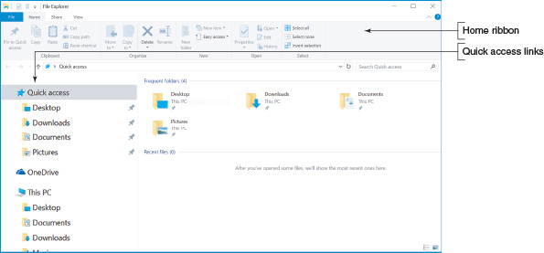
Figure 11-20
The Windows 7 Windows Explorer window with the Computer item selected in the left pane
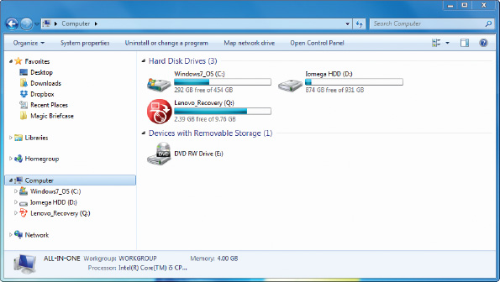
Applying Concepts

Using Quick Access In File Explorer
In Windows 10 File Explorer, shortcuts to Desktop, Downloads, Documents, and Pictures are pinned to the Quick access list by default. Pinned shortcuts remain in the list until you remove them. Shortcuts to recently used items appear in the list, and then disappear in time if they are no longer being used. If you want an item to remain in the Quick access list, you can pin it.
Follow these steps to pin a folder to the Quick access list:
- Create a new folder on the desktop, and change the folder name to Projects. To create the folder, right-click the desktop, select New in the shortcut menu, and click Folder. You can then rename the folder.
- Open File Explorer. Click Quick access in the left pane to view Quick access items in the main folder window. The top section lists frequently used folders (Frequent folders) and the bottom section lists recently used files (Recent files). Notice Frequent folders are also listed in the left pane of the File Explorer window.
- Drag and drop the Projects folder into the Quick access Frequent folders section. Notice that a shortcut to the Projects folder now appears under Quick access in the left pane, with a pin icon next to its name.
- Right-click the Projects folder under Quick access in the left pane or in the Quick access view and select Unpin from Quick access.
Let’s see how to use the Explorer windows to manage files and folders and other system resources.

Files and Directories
Every OS manages a hard drive, optical drive, USB drive, or other type of drive by using directories (also called folders), subdirectories, and files. The drive is organized with a single root directory at the top of the hierarchical structure of subdirectories, as shown in Figure 11-21. The exception to this rule is a hard drive because it can be divided into partitions that can have more than one volume, such as drive C: and drive D:, on the same physical hard drive (see Figure 11-22). For a volume, such as drive C:, the root directory is written as C:. Each volume has its own root directory and hierarchical structure of subdirectories. You can think of volumes as logical drives within the one physical drive.
Figure 11-21
Storage devices such as a USB drive, DVD, or hard drive are organized into directories and subdirectories that contain files
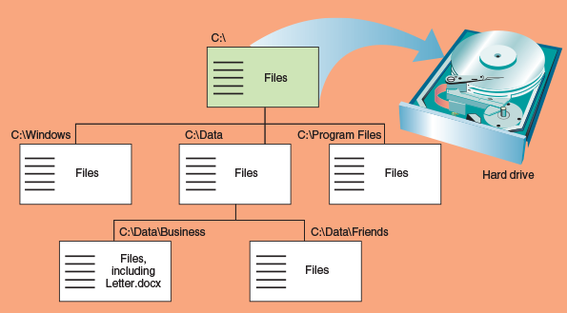
Figure 11-22
A hard drive can be divided into one or more partitions that can each contain a volume such as drive C: or drive D:
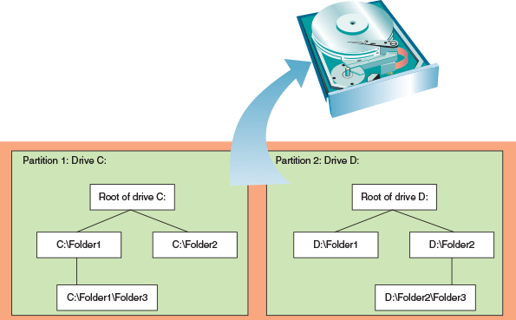
As shown in Figure 11-21, the root directory can hold files or other directories, which can have names such as C:\Data. These directories, called subdirectories, child directories, folders, or subfolders can have other directories listed in them in turn. Any directory can have files and other subdirectories listed in it; for example, Figure 11-21 shows that one file on drive C: is C:\Data\Business\Letter.docx. In this path to the file, the C: identifies the volume and is called the drive letter. Drive letters used for a hard drive, CD, USB drive, or DVD are C:, D:, E:, and so forth.
Notes
Technicians tend to call a directory a folder when working in File Explorer or Windows Explorer, but when working with a command-line interface, they call a directory a directory.
When you refer to a drive and directories that are pointing to the location of a file, as in C:\Data\Business\Letter.docx, the drive and directories are called the path to the file (see Figure 11-23). The first part of the name before the period is called the file name (Letter), and the part after the period is called the file extension (.docx). A file extension indicates how the file is organized or formatted, the type of content in the file, and what program uses the file. For example, the .docx file extension identifies the file type as a Microsoft Word document file. By default, Windows does not display file extensions in Explorer. How to display these extensions is coming up.
Figure 11-23
The complete path to a file includes the volume letter, directories, file name, and file extension; the colon, backslashes, and period are required to separate items in the path
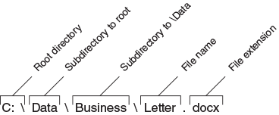

Navigate the Folder Structure
When working with the File Explorer or Windows Explorer window, these tips can make your work easier:
- Click or double-click items in the left pane, called the navigation pane, to drill down into these items. The folders or subfolders appear in the right pane. You can also double-click folders in the right pane to drill down. When you click the arrow on the left side of a folder in the navigation pane, its subfolders are listed underneath it in the pane.
- To control how files and subfolders appear in the right pane of Windows 10/8, click one of the icons in the lower-right corner to select Thumbnail view or Details view (see Figure 11-24A). For Windows 7, click the View icon in the menu bar and select your view (see Figure 11-24B).
Figure 11-24
Click the View icon to change how files and folders display in the right pane of (A) Windows 10/8 File Explorer or (B) Windows 7 Windows Explorer
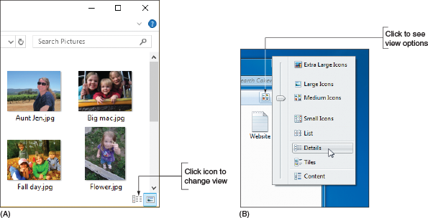
- To control the column headings that appear in Details view, right-click a column heading and select the headings that you want to appear (see Figure 11-25). To control which column is used to sort items in Details view, click a column heading.
Figure 11-25
Right-click a column heading to select columns to display in Details view
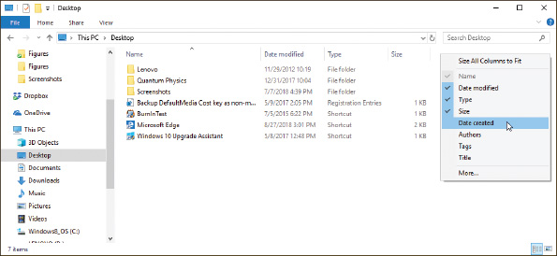
- To search for a folder or file, use the search box in the upper-right corner of the window.
- Use the forward and back arrows in the upper-left corner to move forward and backward to previous views.
- Click a right arrow in the path displayed in the address bar at the top of the Explorer window to see a drop-down list of subfolders (see Figure 11-26). Click one to move to the subfolder.
Figure 11-26
Click a right arrow in the address bar to move up the folder tree and down to a new folder
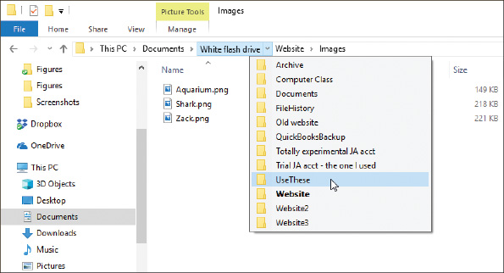

Create a Folder
To create a folder, first select the folder you want to use as the parent folder. (Remember that a parent folder contains the child folder.) Next, use one of these methods to create the new folder:
- In Windows 10/8, select the Home ribbon and click New folder. In Windows 7, click New folder on the menu bar.
- Right-click in the white area of the right pane and point to New in the shortcut menu. The menu in Figure 11-27 appears. Click Folder to create a regular folder or click Compressed (zipped) Folder to create a compressed folder.
Figure 11-27
Create a new file, folder, or compressed folder
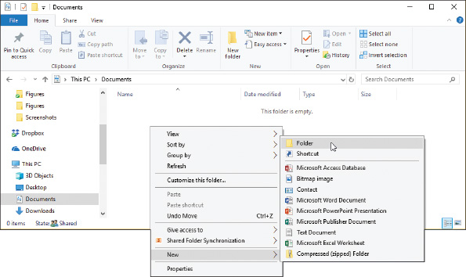
Notes
A compressed (zipped) folder has a .zip extension. Any file or folder that you put in this folder will be compressed to a smaller size than normal. A compressed folder is often used to make files smaller so they can more easily be sent by email. When you remove a file or folder from a compressed folder, the file or folder is uncompressed back to its original size. In general, Windows treats a compressed folder more like a file than a folder.
After Windows creates the folder, the folder name is highlighted so that you can rename it (see Figure 11-28).
Figure 11-28
Edit the new folder’s name
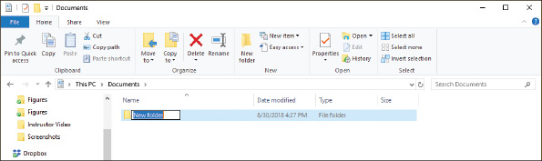
Notes
The Windows desktop is itself a folder and is located at C:\Users\username\Desktop. For example, if the user, Anne, creates a folder named Downloads on her desktop, the folder is located at C:\Users\Anne\Desktop\Downloads.

Create a File
You can create a file using a particular application or using File Explorer or Windows Explorer. In Explorer, right-click the unused white area in the right pane of the window and point to New in the shortcut menu. The menu lists applications you can use to create a file in the current folder (see Figure 11-27). Click the application and the file is created. You can then rename the file. However, to keep the proper file association, don’t change the file extension.

Copy, Move, Rename, or Delete Files or Folders
Use these handy tips to copy, move, rename, and delete files or folders using File Explorer or Windows Explorer:
- To copy a file or folder, right-click it and select Copy from the shortcut menu. Then right-click in the white area of the folder where the copied item will go and select Paste from the shortcut menu. You can also use the Cut and Paste commands to move an item to a new location.
- Drag and drop an item to move or copy it to a new location. If the location is on the same drive as the original location, the file or folder will be automatically deleted from its original location as you move it to the new one. If you don’t want it deleted, hold down the Ctrl key while you drag and drop the item to copy the file or folder to the new location.
- To rename a file or folder, right-click it and select Rename from the shortcut menu. Change the name and click off the file or folder to deselect it. You cannot rename a data file when an application has the file open, and you can’t rename a program file when the program is running; first close the data file or program and then rename it.
- To delete a file or folder, select the item and press the Delete key, or right-click the item and select Delete from the shortcut menu. The deleted file or folder and all its contents, including subfolders, is sent to the Recycle Bin.
- To select multiple items to delete, copy, or move at the same time, hold down the Shift or Ctrl key as you click. To select several adjacent items in a list, click the first item and Shift-click the last item. To select nonadjacent items in a list, hold down the Ctrl key as you click each item.
Files deleted from the hard drive are stored in the Recycle Bin on the desktop. Emptying the Recycle Bin will free up your disk space by permanently deleting the files. To empty the Recycle Bin, right-click the bin and select Empty Recycle Bin from the shortcut menu.
Notes
In this chapter, you use File Explorer or Windows Explorer to create, copy, move, delete, and rename files and folders. In Chapter 13, you will learn that you can do the same tasks using commands from a command prompt.

Create a Shortcut
To create a shortcut on the Windows desktop to a data file or program, use File Explorer or Windows Explorer to locate the data file or program file, right-click it, and click Create shortcut in the menu that appears. For example, in Figure 11-29, you can see that a shortcut to the C:\Windows\System32\notepad.exe program is about to be placed on the Windows desktop.
Figure 11-29
Place a shortcut to a program file on the Windows desktop
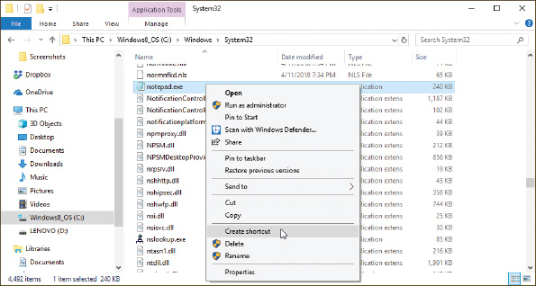
Go to pg.
help
Application Opened
Main content

11-2bControl Panel
A+ Core 2
- 1.2
Compare and contrast features of Microsoft Windows versions.
- 1.6
Given a scenario, use Microsoft Windows Control Panel utilities.
Control Panel is a window containing several small utility programs called applets that are used to manage hardware, software, users, and the system. (In general, a utility program is used to maintain a system or fix a computer problem.) To access Control Panel in Windows 10, type Control Panel in the search box on the taskbar. In Windows 8, right-click Start and click Control Panel. In Windows 7, click Start and click Control Panel.
By default, Control Panel appears in Category view where utilities are grouped by category. To switch to Classic view, click Category and select either Large icons or Small icons. Figure 11-30 shows the Windows 10 Control Panel in Small icons view. Use the search box in the title bar to help find information and utilities in Control Panel.
Figure 11-30
Many technicians prefer to use Control Panel in Classic view to more easily access utilities
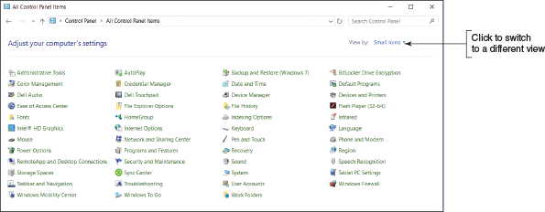
Here is a short list of some of the applets in Control Panel. Later in the text, you learn about other Control Panel applets:
- The Sound applet is used to select a default speaker and microphone and adjust how Windows handles sounds. To control volume, recall you can use the volume icon in the taskbar.
- The Network and Sharing Center is a tool for viewing basic network information and setting up connections.
- HomeGroup is in the Windows 8/7 Control Panel but is not supported by Windows 10. A homegroup allows Windows 8/7 computers on a small network to share resources.
- The Power Options applet is used to select or customize a power plan for your computer.
- The Windows 10 File Explorer Options applet or Windows 8/7 Folder Options applet lets you change how files and folders are displayed in File Explorer or Windows Explorer.
A+ Exam Tip
The A+ Core 2 exam expects you to be able to use Control Panel utilities such as Folder Options, System, Power Options, HomeGroup, and the Network and Sharing Center when given a scenario.
Go to pg.
help
Application Opened
Main content

11-2cWindows 10 File Explorer Options or Windows 8/7 Folder Options
A+ Core 2
- 1.6
Given a scenario, use Microsoft Windows Control Panel utilities.
The Windows 10 File Explorer Options applet or the Windows 8/7 Folder Options applet in Control Panel can be used to view and change options assigned to folders. These options control how users view the files in the folder and what they can do with these files. In File Explorer or Windows Explorer, Windows has an annoying habit of hiding file extensions if it knows which application is associated with a file extension. For example, just after installation, it hides .exe, .com, .sys, and .txt file extensions, but does not hide .docx, .pptx, or .xlsx file extensions until the software to open these files has been installed. Also, Windows really doesn’t want you to see its own system files, and it hides these files from view until you force it to show them.
Applying Concepts

Changing File Explorer Options
A technician is responsible for solving problems with system files (files that belong to the Windows operating system) and file extensions. To fix problems with these files and extensions, you need to see them first. To change File Explorer options so you can view system files and file extensions in Windows 10/8/7, do the following:
- Open Control Panel and, if necessary, change the view to Small icons view. For Windows 10, click File Explorer Options. For Windows 8/7, click Folder Options. The File Explorer Options or Folder Options dialog box appears. Even though the name is different, the dialog box works the same in Windows 10 and Windows 8/7. Figure 11-31A shows the box for Windows 10 with the General tab selected. On the General tab, you can change settings for how Explorer navigates folders and handles the navigation pane.
Figure 11-31
Use the File Explorer Options or Folder Options box to control how Explorer works and displays files and folders
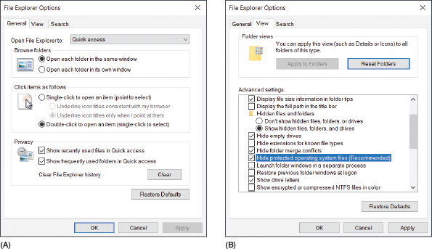
Notes
In Windows, the difference between a window and a dialog box is that a window can be resized, but a dialog box cannot.
- Click the View tab. Scroll down in the Advanced settings group and make these selections to show hidden information about files, folders, and drives, as shown in Figure 11-31B:
  - Select Show hidden files, folders, and drives.
  - Uncheck Hide extensions for known file types.
  - Uncheck Hide protected operating system files (Recommended) and respond to the Warning box.
- To save your changes and close the File Explorer Options or Folder Options box, click OK.
A+ Exam Tip
The A+ Core 2 exam expects you to know how to view hidden files and file extensions in File Explorer and Windows Explorer.
Go to pg.
help
Application Opened
Main content

11-2dPower Options
A+ Core 2
- 1.6
Given a scenario, use Microsoft Windows Control Panel utilities.
The Power Options applet of Control Panel can help you conserve power and increase the amount of time before a battery pack on a laptop needs recharging. Power is managed by putting the computer into varying degrees of suspend or sleep modes.
A+ Exam Tip
The A+ Core 2 exam might give you a scenario and expect you to know which power options to change to solve a problem, including using power plans and sleep (suspend), hibernate, and standby modes.
Here are the different power-saving states:
- Sleep mode. Using Windows 10/8/7, you can put the computer into sleep mode, also called standby mode or suspend mode, to save power when you’re not using the computer. If applications are open or other work is in progress, Windows first saves the current state, including open files, to memory and saves some of the work to the hard drive. Then everything is shut down except memory and enough of the system to respond to a wake-up. In sleep mode, the power light on the laptop might blink from time to time. (A laptop generally uses about 1 to 2 percent of battery power for each hour in sleep mode.) To wake up the computer, press the power button; for some computers, you press a key or touch the touch pad. Windows wakes up in about two seconds. When Windows is in sleep mode, it can still perform Windows updates and scheduled tasks. Windows can be configured to go to sleep after a period of inactivity, or you can manually put it to sleep.
To put the system to sleep manually in Windows 10, click Start, then click the power icon and select Sleep. In Windows 10/8, you can open the Quick Launch menu, point to Shut down or sign out, and click Sleep (see Figure 11-32a). In Windows 8, you can use the charms bar, as you learned earlier in the chapter. For Windows 7, click Start, click the arrow to the right of Shut down, and then click Sleep (see Figure 11-32b). A laptop might also be configured to go to sleep when you close the lid.
Figure 11-32
Put Windows to sleep using the (A) Windows 10/8 Quick Launch menu or (B) Windows 7 Start menu
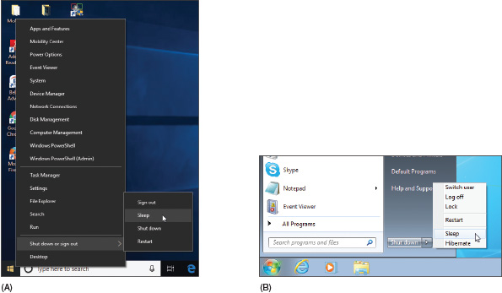
- Hibernation. Hibernation saves all work to the hard drive and powers down the system. When you press the power button, Windows reloads its state, including all open applications and documents. When Windows is in sleep mode on a laptop and senses the battery is critically low, it will put the system into hibernation.
Notes
Recall that hard drives are permanent or nonvolatile storage and memory is temporary or volatile storage. A hard drive does not require power to hold its contents, but memory, on the other hand, is volatile and loses its contents when it has no power. In hibernation, the computer has no power and everything must therefore be stored on the hard drive.
Applying Concepts

Configuring Windows Power Plans
Follow these steps to configure power plans in Windows 10:
- Open Control Panel in Classic view and click Power Options. The Power Options window opens. Figure 11-33 shows the window for one laptop. The plans might be different for other laptops.
Figure 11-33
Power plans in Windows 10
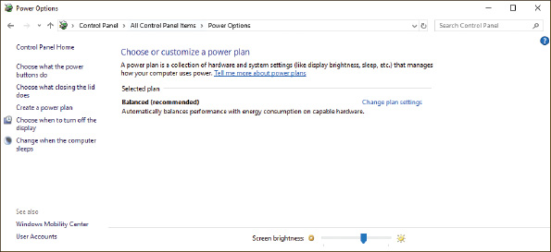
- You can customize each plan. For example, under Balanced (recommended), click Change plan settings. The Edit Plan Settings window appears (see the left side of Figure 11-34). Notice in the figure the various times of inactivity required before the computer goes into sleep mode; these are called sleep timers.
Figure 11-34
Customize a power plan
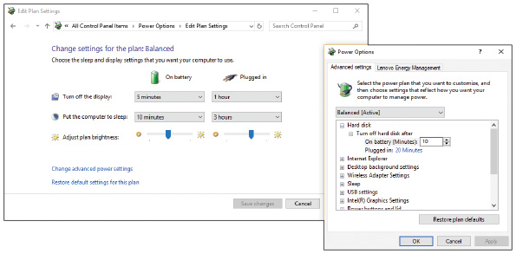
- To see other changes you can make, click Change advanced power settings. Using the Power Options window (see the right side of Figure 11-34), you can control the number of minutes before the hard drive turns off; control what happens when you close the lid, press the sleep button, or press the power button; and set the brightness level of the LCD panel to conserve power. You can also use this box to set what happens when the battery gets low or critically low. Make your changes and click OK to close the box.
- If you made changes, click Save changes in the Edit Plan Settings window. Close the Power Options window.
As an IT support technician, you need to be able to sit down at a working computer and within 5 or 10 minutes find the details about what software and hardware are installed on the system and its general health. Within 20 minutes, you should be able to solve any minor problems the computer might have, such as a broken network connection. Some quick and easy support tools that can help you are the System window, System Information window, and Windows 10 Settings app. All these tools are discussed next.
A+ Exam Tip
The A+ Core 2 exam expects you to know how to use File Explorer, Windows Explorer, the System window, and the System Information window. If the utility can be accessed by more than one method, you are expected to know all of the methods.
Go to pg.
help
Application Opened
Main content

11-2eSystem Window
A+ Core 2
- 1.6
Given a scenario, use Microsoft Windows Control Panel utilities.
The System window is your friend. It can give you a quick look at what hardware and software are installed and can get you to other useful Windows tools. To open the System window in Windows 10, open Control Panel and click System. In Windows 8, open the Quick Launch menu (press Win+X) and click System. In Windows 7, click Start, right-click Computer, and select Properties from the shortcut menu. (Alternately, you can open Control Panel and click System.) Figure 11-35 shows the resulting System window for one Windows 10 laptop.
Figure 11-35
The System window reports Windows 10 Pro is installed
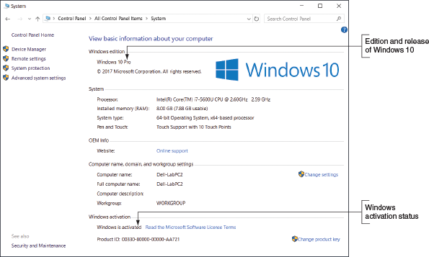
So what technical information are you looking at? Here is the rundown:
- Windows 10/8/7 comes in several editions; you can see this system has the Windows 10 Pro edition installed.
- The type of OS installed is a 64-bit OS. A 32-bit operating system processes 32 bits at a time, and a 64-bit operating system processes 64 bits at a time. Most editions of Windows 10/8/7 come in either 32-bit or 64-bit versions. A 64-bit OS performs better than a 32-bit OS, but requires more memory. A 32-bit OS can support up to 4 GB of memory, and a 64-bit OS can support much more. The details of how much memory each edition of Windows can support are covered in Chapter 12.
- The processor installed is the Intel Core i7-5600U, and 8 GB of RAM is installed.
- You can also see that Windows 10 is activated. (If it is not, refer to Chapter 12 to learn how to activate Windows.)
Notes
Windows 8/7 relies on the Control Panel applets to manage most settings. Windows 10 introduced the Settings app for settings a user might need to change, but settings a technician might change are still done with Control Panel applets. In Windows 10, you often find the same setting in both locations. For example, the About page (refer back to Figure 11-4) in the Settings app gives information similar to that shown in the System window in Control Panel.
That’s a lot of useful information for a first look at a computer.
Go to pg.
help
Application Opened
Main content

11-2fSystem Information Window
A+ Core 2
- 1.5
Given a scenario, use Microsoft operating system features and tools.
Turn to the System Information window (msinfo32.exe) for more details about a system, including installed hardware and software, the current system configuration, and currently running programs. For example, you can use the window to find out what BIOS/UEFI version is installed on the motherboard, how much RAM is installed, the directory where the OS is installed, the size of the hard drive, the names of currently running drivers, a list of startup programs, print jobs in progress, currently running tasks, and much more. Because the System Information window gives so much useful information, help-desk technicians often ask a user on the phone to open it and report information about the computer.
When strange error messages appear during startup, use the System Information window to get a report of drivers that loaded successfully. Device drivers are small programs stored on the hard drive that tell the computer how to communicate with a specific hardware device such as a printer, network card, or scanner. If you have saved the System Information report when the system was starting successfully, comparing the two reports can help identify the problem device.
To run System Information in Windows 10, enter msinfo32 in the search box. For Windows 8, open the Quick Launch menu, click Run, and enter msinfo32.exe in the Run box. In Windows 7, click Start and enter msinfo32.exe in the search box. The System Information window for one computer is shown in Figure 11-36. To drill down to more information in the window, click items in the left pane.
Figure 11-36
Use the System Information utility to examine details about a system
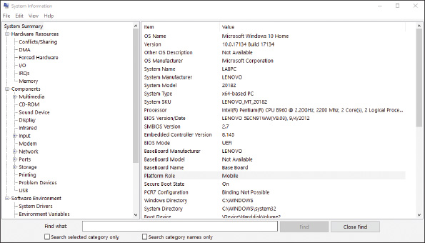
Go to pg.
help
Application Opened
Main content

11-2gWindows 10 Settings App
A+ Core 2
- 1.5
Given a scenario, use Microsoft operating system features and tools.
The Windows 10 Settings app is a user-friendly interface to access numerous Windows settings. You can open the Settings app from the Start menu, the Quick Launch menu, or by pressing the hotkeys Win+I. On the Start menu, click Start and then click the Settings icon on the far-left side of the menu (see Figure 11-37).
Figure 11-37
Access the Settings app from the Start menu
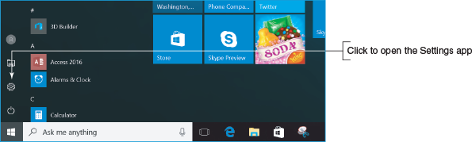
The Settings app includes links to Control Panel and has a search box near the top that makes it easy to jump straight to a setting you want to adjust (see Figure 11-38). For example, suppose you want to configure Windows to use a different language. When you type language in the search box, several actions appear in the drop-down list, including Add a language to this device. The primary menu includes settings for the following:
- System. The catchall for information and settings that affect the function of your computer is the System group. Go here to adjust display, notification, power, sleep, storage, and tablet-mode settings.
- Devices. The Devices group includes settings for printers and scanners, connected devices, Bluetooth, mouse and touch pad devices, typing, AutoPlay, and USB.
- Network & Internet. The Network & Internet group provides network status, data usage information, and settings for different connections, including Wi-Fi, Ethernet, dial-up, VPN, and mobile hotspots. Go here to set up new connections. Airplane mode and proxy settings are also available for mobile devices. The link to the Network and Sharing Center takes you to more connection settings.
- Personalization. The Personalization group is where you find settings for the background, colors, lock screen, themes, Start menu, and taskbar. For example, to adjust your screen for working in low-light conditions, click Personalization, click Colors in the left pane, scroll down to Choose your app mode, and then click Dark (see Figure 11-39).
- Apps. To uninstall applications, set default applications, and check other application settings, use the Apps group. For example, to make Outlook the default app for email, click Apps, click Default apps, and then change the setting from Mail to Outlook.
- Accounts. To find your Windows account information or link your account to a Microsoft account, use the Accounts group. The Accounts group also includes email and app accounts, sign-in options, Microsoft account sync settings, options to sign in to work or school networks, and options to add new user accounts to the computer. You will learn more about accounts later in this text.
- Time & language. The Time & language group provides settings for date and time, region and language, and speech.
- Gaming. The Gaming group contains settings for the Game bar, Game DVR, broadcasting, and Game Mode. When you turn on Game Mode, Windows improves the gaming experience by prioritizing system resources for the game being played on the computer.
- Ease of Access. This group provides all the standard access settings, such as narrator, magnifier, closed captions, and more.
- Privacy. Find the settings to restrict or allow app access to your information in the Privacy group. You can limit app access and use of your location, camera, microphone, notifications, speech, inking, typing, account information, contacts, calendar, call history, email, messaging, radios, and other devices. The Privacy group is also where you adjust settings for feedback, diagnostic, and usage data that is sent to Microsoft. You can also choose which apps are allowed to run in the background.
- Update & security. The Windows update status and settings, as well as the Windows Defender settings, are found in the Update & security group. Here you also find settings for backups, recovery, and activation, and links to Find My Device if you lose your connected devices, such as a phone. Finally, you find settings for developers, such as device discovery, remote desktop, and PowerShell.
Figure 11-38
The new Windows 10 Settings app
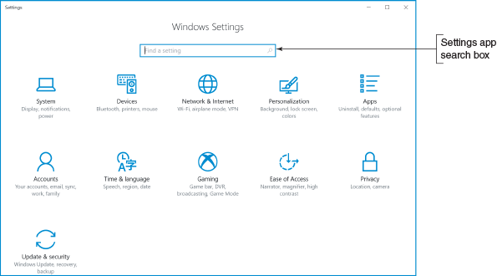
Notes
Some items in the Settings app may be unavailable if you are logged in with a Standard account. Use an account with administrative privileges to view all available settings.
Figure 11-39
Dark app mode is ideal for low-light conditions
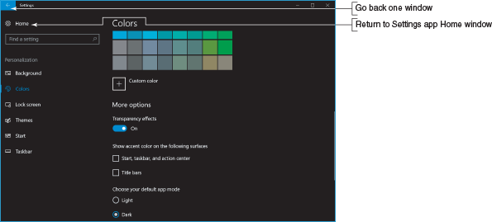
Notes
To go back one window in the Settings app, click the left arrow in the upper-left corner of the Settings window. To return to the Settings app Home window, click Home, as shown in Figure 11-39.
Windows 8

Action Center
A+ Core 2
- 1.6
Given a scenario, use Microsoft Windows Control Panel utilities.
The Windows 8/7 Action Center is the tool to use when you want to make a quick jab at solving a computer problem. If a hardware or application problem is easy to solve, the Action Center can probably do it in a matter of minutes because it lists errors and issues that need attention and proposed solutions. The Action Center flag appears in the notification area of the taskbar. If the flag has a red X beside it, as shown in Figure 11-40, Windows considers the system to have an important issue that needs resolving immediately. When you click the flag, you can see a brief report of issues, as shown in the figure.
Figure 11-40
A red X on the Windows 8 Action Center flag in the taskbar indicates a critical issue needs resolving
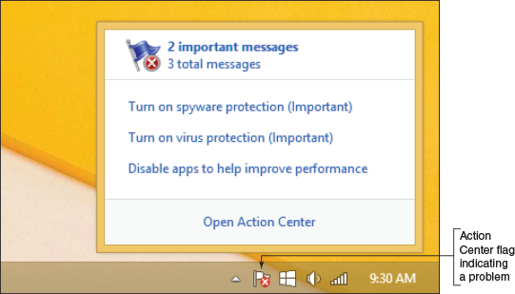
To open the Action Center, you can click the red flag in the taskbar and then click Open Action Center. Alternately, you can open Control Panel and click Action Center. The Action Center window for one Windows 8 computer is shown in Figure 11-41. (The Windows 7 Action Center is similar.) Notice the colored bar to the left of a problem. A red bar indicates a critical problem that needs immediate attention. In this example, antivirus software is not running on the system. An orange bar indicates a less critical problem, such as apps running in the background that might be slowing down the system or no backups scheduled. Click the button to the right of a problem to find a recommended solution.
Figure 11-41
The Action Center shows a critical problem that needs a resolution
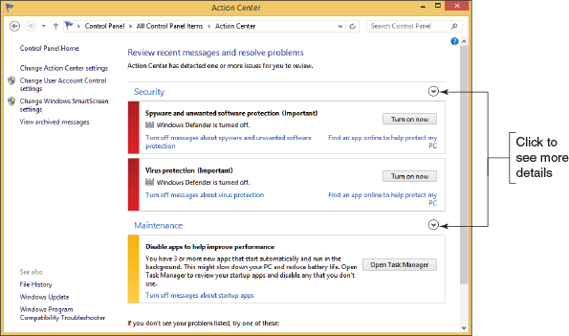
To see other information available under the Security or Maintenance group, click the down arrow to the right of a group. For example, when you click the arrow to the right of Security, detailed information appears for Windows Firewall, Windows Update, and other security settings.
To see a complete list of past and current problems on a computer, click View archived messages in the left pane of the Action Center. This report helps you understand the history of problems on a computer that you are troubleshooting. The problems in this list might or might not have a solution.
Go to pg.
help
Application Opened
Main content

11-3How Windows Controls Access to Network Resources
A+ Core 2
- 1.8
Given a scenario, configure Microsoft Windows networking on a client/desktop.
An essential task of IT technicians is to connect computers to a wired or wireless network and support these connections, as you learned in Chapter 7. Once a computer is connected to a network, you need to look at the ways Windows accesses resources on the network. If a network is public, such as a public hotspot at a local coffee shop or airport, resources on the network aren’t shared. However, private networks often share their data files, printers, and other resources. In this part of the chapter, you learn how Windows can access resources on a network using a Windows workgroup, homegroup, or domain, and you learn about options that Windows uses to secure a network connection.
Go to pg.
help
Application Opened
Main content

11-3aWindows Workgroup and Homegroup
A+ Core 2
- 1.8
Given a scenario, configure Microsoft Windows networking on a client/desktop.
A network that doesn’t have centralized control, such as one in a small office or home office (SOHO), is called a peer-to-peer (P2P) network. Windows can access resources on a P2P network by using file shares and/or a workgroup; Windows 8/7 can use a homegroup. (Windows 10 does not support homegroups.) Workgroups and homegroups can form a logical group of computers and users that share resources (see Figure 11-42), where administration, resources, and security on a workstation are controlled by that workstation.
Figure 11-42
A Windows workgroup is a type of peer-to-peer network where no single computer controls the network and each computer controls its own resources
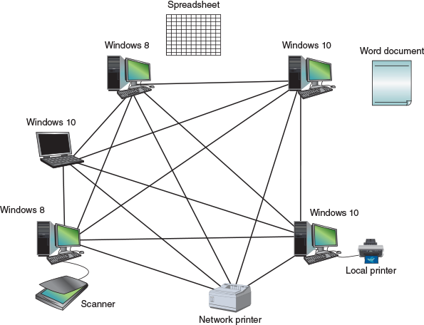
Notes
When looking at the diagrams in Figure 11-42 and later in Figure 11-43, know that the connecting lines describe the logical connections between computers and not the physical connections. Both networks might be physically connected the same way, but logically, resources are controlled by each computer on the network or by using a centralized database. In network terminology, the arrangement of physical connections between computers is called the physical topology. The logical way the computers connect on a network is called the logical topology.
Figure 11-43
A Windows domain is a type of client/server network where security on each computer or other device is controlled by a centralized database on a domain controller
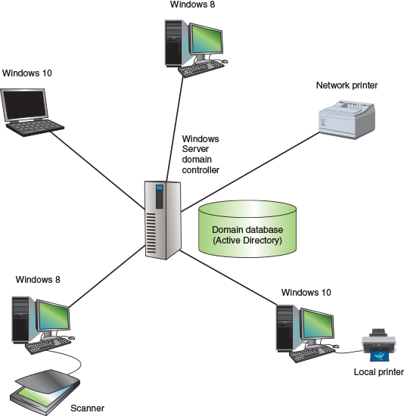
In a Windows workgroup, each computer maintains a list of users and their rights on that particular computer. The computer allows a user on the network to access local resources based on the rights she has been given. In a homegroup, each computer shares files, folders, libraries, and printers with other computers in the homegroup. (In Windows 10/8/7, a library is a collection of folders.) A homegroup provides less security than a workgroup because any user of any computer in the homegroup can access homegroup resources. For this reason and others, the homegroup feature was removed from Windows 10 in the March 2018 update.
A+ Exam Tip
The A+ Core 2 exam expects you to be able to contrast a workgroup, homegroup, and domain and know which to use in a given scenario. You also need to know that homegroups only apply to Windows 8/7, and no longer to Windows 10.
Go to pg.
help
Application Opened
Main content

11-3bWindows Domain
A+ Core 2
- 1.8
Given a scenario, configure Microsoft Windows networking on a client/desktop.
A Windows domain is implemented on a larger, private network, such as a corporate or college network. The domain forms a logical group of networked computers that share a centralized directory database of user account information and security (see Figure 11-43). A Windows domain is a type of client/server network, which is a network where resources are managed by centralized computers. A computer making a request from another is called the client, and the computer answering the request is called the server. Using the client/server model, the directory database is controlled by a network operating system (NOS). Examples of network operating systems are Windows Server and various forms of Linux such as Ubuntu Server and Red Hat Enterprise Linux (RHEL).
Notes
Windows Home editions do not support joining a domain. If you plan to join a domain on your network, install Windows 10 Professional, Enterprise, or Education edition; Windows 8.1 Professional or Enterprise edition; or Windows 7 Professional, Enterprise, or Ultimate edition.
Windows 10/8 allows three types of accounts to sign in to Windows: a local account, which applies only to the local computer and is also called an offline account; a Microsoft account (always an email address); and a network ID. Windows 7 uses local accounts and network IDs but does not use Microsoft accounts. A Microsoft account signs you in to the local computer and to Microsoft resources in the cloud, such as OneDrive. A network ID signs you in to a Windows domain to which the local computer belongs.
Microsoft offers two options for managing a domain—Active Directory and Azure Active Directory (see Figure 11-44):
- Active Directory. Windows Server controls a network using the directory database called Active Directory (AD). Each user on the network must have his own domain-level account, the most common of which is called a domain user account or network ID. These accounts are kept in AD and assigned by the network or system administrator. If you are connecting a computer to a domain, the administrator will tell you the network ID and password to the domain that you can use to sign in to the network. Active Directory normally manages a domain for users on company premises. Remote users can join the domain using a VPN or DirectAccess connection. Recall that a VPN is a security technique that encrypts data transmitted between a private network and a computer somewhere on the Internet. Windows DirectAccess was designed to eliminate the need for a VPN.
- Azure Active Directory. Azure Active Directory (Azure AD) manages users in the cloud and creates a virtual network of users connected through the Internet. Whereas AD is managed by Windows Server installed on private computers on company premises, Azure AD runs in the cloud from 28 Microsoft data centers around the world that offer Azure AD as a public service. Windows 10 professional and business editions allow work-owned devices and personal devices to join Azure AD. Windows 10 home editions and all editions of Windows 8/7 do not support Azure AD.
Figure 11-44
Active Directory and Azure AD are two Microsoft options for managing a domain
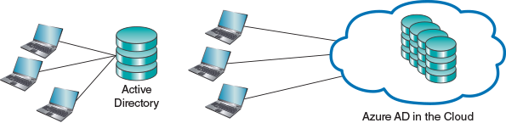
Windows 10 offers three ways to authenticate a user so that the computer can join a domain:
- Domain join. This method is used in Windows 10/8/7 to join an Active Directory domain maintained by a corporation or school. This is the traditional way employees on company premises access resources on the corporate network.
- Azure AD join. This method is primarily intended as a way for work-owned devices to access cloud resources, such as Office 365, from anywhere on the Internet. For example, a company might provide company-owned laptops to its sales force that work from many remote locations to access company resources in the cloud. Azure AD uses email addresses as account names.
- Bring your own device (BYOD) experience. Microsoft calls joining a personal device to Azure AD the BYOD experience. When a personal device joins Azure AD, you can access corporate resources, such as corporate databases, while still accessing personal resources, such as your personal OneDrive. The process works by using a personal account to sign in to Windows, followed by a secondary sign-in to authenticate to Azure AD. A school might use the BYOD experience to allow students to access school resources using their personal devices via the Internet.
Here is how to join a domain using each of the three methods:
- Sign in to Windows using an administrator account. Open the Settings app. Click the Accounts group, and then click Access work or school.
- Under Connect to work or school, click Connect. See Figure 11-45.
Figure 11-45
Three ways to join a domain
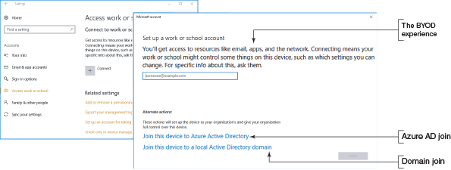
- Do one of the following:
  - For a domain join, click Join this device to a local Active Directory domain. Enter the domain name and click Next. Follow the on-screen directions. The next time you sign in to Windows, use your network ID on the domain.
  - For an Azure AD join, click Join this device to Azure Active Directory. Enter the email address for the work or school account you are accessing and click Next. Follow the on-screen directions. The next time you sign in to Windows, use the same email address.
  - For the BYOD experience, enter your Azure AD email address and click Next. Follow the on-screen directions. You will then have access to organizational resources using SSO (Single Sign On) as well as access to your personal resources, such as your personal OneDrive. The next time you sign in to Windows, use your personal account. You will automatically be signed in to Azure AD.
Notes
If your computer is part of a domain, press Ctrl+Alt+Del when Windows starts to display a sign-in screen, and then enter your network ID and password.
Go to pg.
help
Application Opened
Main content

11-3cDomain Setup
A+ Core 2
- 1.8
Given a scenario, configure Microsoft Windows networking on a client/desktop.
If a computer is already connected to a physical network, you have signed in to Windows with a local user account, and you want to access resources controlled by a Windows domain on the network, you’ll need to change the way Windows connects to the network. To make the change, you’ll need the network ID and password to the domain provided by the network administrator. Open the System window (see Figure 11-46). Under Computer name, domain, and workgroup settings, click Change settings. In the System Properties box that appears, click Network ID and follow the directions on screen. The next time you restart the computer, you can sign in with your network ID and password to authenticate to the domain.
Figure 11-46
Set up Windows to join a domain
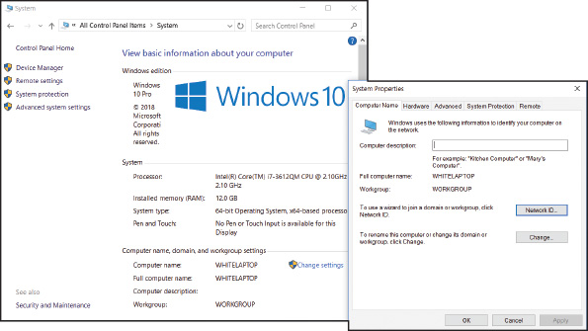
Now let’s look at the different ways that Windows handles public and private network connections.
Go to pg.
help
Application Opened
Main content

11-3dPublic and Private Networks
A+ Core 2
- 1.8
Given a scenario, configure Microsoft Windows networking on a client/desktop.
When you connect a Windows computer to a network the first time, Windows asks how you want to secure the network connection. When connecting to a public network, such as when you connect your laptop to a public wireless network at a local airport, you always want to ensure that your computer is protected from outside hackers and malware. Windows 10/8 offers three ways to secure a network connection:
- Public network. When using Public network security, Windows configures strong firewall settings, the computer is hidden from other devices on the network, and you can’t share files or printers. This option is the most secure.
- Private network. When using Private network security, the computer is discoverable and you can share files and printers. In Windows 8/7, you can join a homegroup. Windows 10/8/7 computers can join a workgroup.
- Domain network. When the computer is set up to join a Windows domain, it yields control for authenticating users and sharing files, folders, and printers to settings in Active Directory or Azure Activity Directory managing the domain.
Windows 7 offers four network security options, which have different names and slightly different default settings:
- Public network. Network Discovery is turned off and you cannot join a homegroup or workgroup. This option is the most secure.
- Home network. Network Discovery is turned on and you can join a homegroup or workgroup.
- Work network. Network Discovery is turned on and you can join a workgroup, but you cannot join a homegroup.
- Domain network. When the computer is set up to join a Windows domain, it yields control for authenticating users and sharing its resources to Active Directory managing the domain.
If you want to change the setting that controls how Windows secures a network connection, open the Network and Sharing Center and click Change advanced sharing settings. In the Advanced sharing settings window (see Figure 11-47), you can change the public, private, home, or work status of a network connection, and you can turn network discovery and file and printer sharing on or off. You learn how to manage all these settings in Chapter 16.
Figure 11-47
Change the security setting for a Windows network connection
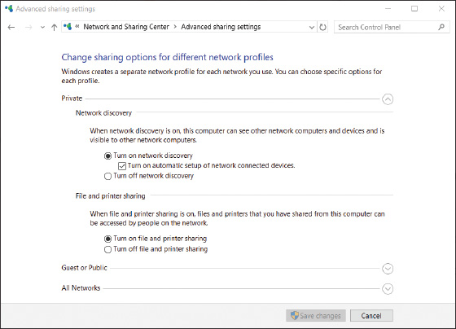
Go to pg.
help
Application Opened
Main content

11-4What Customers Want: Beyond Technical Know-How
A+ Core 2
- 4.7
Given a scenario, use proper communication techniques and professionalism.
Probably the most significant indication that an IT technician is doing a good job is that customers are consistently satisfied. In your career as an IT support technician, commit to providing excellent service and to treating customers as you would want to be treated in a similar situation. One of the most important ways to achieve customer satisfaction is to do your best by being prepared, both technically and personally. Being prepared includes knowing what customers want, what they don’t like, and what they expect from an IT technician.
Equally important to being prepared technically is knowing how to work effectively with people in a technical world, which is one of the most sought-after skills in today’s service-oriented work environments. An employer once told me, “It’s not hard to find technically proficient people these days. But it’s next to impossible to find people who know how to get along with others and can be counted on when managers are not looking over their shoulders.” I could sense his frustration, but I also felt encouraged to know that good social skills and good work ethics can take you far in today’s world. My advice to you is to take this part of the chapter seriously. It’s important to be technically proficient, but the skills learned in this part of the chapter just might be the ones that make you stand out above the crowd to land that new job or promotion.
Notes
People respond in kind to the position of your facial muscles. Try smiling when you greet someone and see what happens.
Go to pg.
help
Application Opened
Main content

11-4aBecoming a Competent and Helpful Support Technician
A+ Core 2
- 4.7
Given a scenario, use proper communication techniques and professionalism.
The following traits distinguish a competent and helpful technician from a technician who is incompetent or unhelpful in the eyes of the customer:
- Be dependable and reliable. Customers appreciate and respect those who keep their word. If you promise to be back at 10:00 the next morning, be there on time. If you cannot keep your appointment, never ignore your promise. Call, apologize, let the customer know what happened, and reschedule your appointment. Also, do your best to return phone calls the same day and return email within two days.
Notes
Quote from R.C., an employer: “When I choose a person to work for me, in a lot of cases, I choose based on his or her past dependability or attendance. I am less concerned about a person’s ability because I can train anyone to do a specific job. I cannot, however, train anyone to do anything if he or she is not present for me to train. Being dependable and reliable has a profound impact on customer relationships as well.”
- Keep a positive and helpful attitude. This helps establish good customer relationships. You communicate your attitude in your tone of voice, the words you choose, how you use eye contact, your facial expressions, how you dress, and in many other subjective and subtle ways. Generally, your attitudes toward your customers stem from how you see people, how you see yourself, and how you see your job. Your attitude is a heart issue, not a head issue. To improve your attitude, you must do it from your heart. That’s pretty subjective and cannot be defined with a set of rules, but it always begins with a decision to change. As you work with customers or users, make it a habit not to patronize or talk down to them. Don’t make customers or users feel inferior. People appreciate it when they feel your respect for them, even when they have made a mistake or are not knowledgeable. If a problem is simple to solve, don’t make other people feel they have wasted your time. Your customer or user should always be made to feel that the problem is important to you.
Applying Concepts

Customer Service
Josie walked into a computer parts store and wandered over to the cleaning supplies looking for Ace monitor wipes. She saw another brand of wipes, but not the ones she wanted. Looking around for help, she noticed Mary stocking software on the shelves in the next aisle. She walked over to Mary and asked for help finding Ace monitor wipes. Mary put down her box, walked over to the cleaning supply aisle without speaking, picked up a can of wipes, and handed them to Josie, still without speaking a word. Josie explained she was looking for Ace wipes. Mary yelled over three aisles to a coworker in the back room, “Hey, Billy! This lady says she wants Ace monitor wipes. We got any?” Billy came from the back room and said, “No, we only carry those,” pointing to the wipes in Mary’s hand, and returned to the back room. Mary turned to Josie and said, “We only carry these,” and then put the wipes back on the shelf. She turned to walk back to her aisle when Josie said to Mary, “Well, those Ace wipes are great wipes. You might want to consider carrying them.” Mary said, “I’m only responsible for software.” Josie left the store.
Discuss this situation in a small group of students and answer the following questions:
  - If you were Josie, how would you feel about the service in this store?
  - What would you have expected to happen that did not happen?
  - If you were Mary, how could you have provided better service?
  - If you were Billy, is there anything more you could have done to help?
  - If you were the store manager, what principles of good customer service would you want Billy and Mary to know that would have helped them in this situation?
- Listen without interrupting your customer. When you’re working with or talking to a customer, focus on him or her. Don’t assume you know what your customer is about to say. Let her say it, listen carefully, and don’t interrupt (see Figure 11-48). Make it your job to satisfy this person, not just your organization, your boss, your bank account, or the customer’s boss.
Figure 11-48
Learn to listen before you decide what a user needs or wants

© iStockphoto.com/Sportstock
- Use proper and polite language. Speak politely and use language that won’t confuse your customer. Avoid using slang or jargon, which is technical language that only technical people understand. Avoid acronyms (initial letters that stand for words). For example, don’t say to a nontechnical customer, “I need to ditch your KVM switch,” when you could explain yourself better by saying, “I need to replace that small switch box on your desk that controls your keyboard, monitor, and mouse.”
- Show sensitivity to cultural differences. Cultural differences happen because we are from different countries and societies. Culture can cause us to differ in how we define or judge good service. For example, culture can affect our degree of tolerance for uncertainty. Some cultures are willing to embrace uncertainty, and others strive to avoid it. Those who tend to avoid uncertainty can easily get upset when the unexpected happens. For these people, you need to make special efforts to communicate early and often when things are not going as expected.
- Express patience and honor to those with physical disabilities. For the physically disabled, especially the hearing- or sight-impaired, communication can be more difficult. It’s your responsibility in these situations to do whatever is necessary to find a way to communicate. It’s especially important to have an attitude that expresses honor and patience, which you will unconsciously express in your tone of voice, your choice of words, and your actions.
Notes
Employers look for technicians with good social skills and work ethics because they realize that technicians with these skills are good for business.
- Take ownership of the problem. Taking ownership of the customer’s problem means to accept the problem as your own. Doing that builds trust and loyalty because the customer knows you can be counted on. Taking ownership of a problem also increases your value in the eyes of your coworkers and boss. People who don’t take ownership of the problem at hand are likely to be viewed as lazy, uncommitted, and uncaring. One way to take ownership of a problem is not to engage your boss in unproductive discussions about a situation he expects you to handle on your own.
Applying Concepts

Self-Control
Jack had a bad day on the phones at the networking help desk in Atlanta. An electrical outage coupled with a generator failure had caused servers in San Francisco to be down most of the day. The entire help-desk team had been fielding calls all day explaining to customers why they did not have service and giving expected recovery times. The servers were finally online, but it was taking hours to get everything reset and functioning. No one had taken a break all afternoon, but the call queue was still running about 20 minutes behind. Todd, the boss, had asked the team to work late until the queue was empty. It was Jack’s son’s birthday and his family was expecting Jack home on time. Jack moaned as he realized he might be late for Tyler’s party. Everyone pushed hard to empty the queue. As Jack watched the last call leave the queue, he logged off, stood up, and reached for his coat.
And then another call comes. Jack is tempted to ignore it, but decides it has to be answered. It’s Lacy, the executive assistant to the CEO (chief executive officer over the entire company). When Lacy calls, all priorities yield to her, and Lacy knows it. The CEO is having problems printing to the laser printer in his office. Would Jack please walk down to his office and fix the problem? Jack asks Lacy to check the simple things: “Is the printer turned on? Is it plugged in?” Lacy gets huffy and says, “Of course, I’ve checked that. Now come right now. I need to go.” Jack walks down to the CEO’s office, takes one look at the printer, and turns it on.
He turns to Lacy and says, “I suppose the on/off button was just too technical for you.” Lacy glares at him in disbelief. Jack says, “I’ll be leaving now.” As he walks out, he begins to form a plan as to how he’ll defend himself to his boss in the morning, knowing the inevitable call to Todd’s office will come.
In a group of two or four students, one student should play the role of Jack and another the role of Todd. Discuss these questions:
  - Todd is informed the next morning of Jack’s behavior, and calls Jack into his office. He likes Jack and wants him to be successful in the company. Jack is resistant and feels justified in what he did. As Todd, what do you think is important that Jack understand? How can you explain this to Jack so he can accept it? What would you advise Jack to do?
  - Switch roles or switch team members and replay the roles.
  - What are three principles of relating to people that would be helpful for Jack to keep in mind?
- Portray credibility. Convey confidence to your customers. Don’t allow yourself to appear confused, afraid, or befuddled. Troubleshoot the problem in a systematic way that portrays confidence and credibility. Get the job done and do it with excellence. Credible technicians also know when the job is beyond their expertise and when to ask for help.
- Work with integrity and honesty. Don’t try to hide your mistakes from your customer or your boss. Everyone makes mistakes, but don’t compound them by a lack of integrity. Accept responsibility and do what you can to correct the error.
- Know the law with respect to your work. For instance, observe the laws concerning the use of software. Don’t use or install pirated software.
- Dress and behave professionally. A professional at work knows not to allow his emotions to interfere with business relationships. If a customer is angry, allow the customer to vent, keeping your own professional distance. (You do, however, have the right to expect a customer not to talk to you in an abusive way.) Dress appropriately for the environment. Take a shower each day and brush your teeth after each meal. Use mouthwash. Iron your shirt. If you’re not in good health, try as best you can to take care of the problem. Your appearance matters. And finally—don’t use rough language; it is never appropriate.
Notes
Your customers might never remember what you said or did, but they will always remember how you made them feel.
Go to pg.
help
Application Opened
Main content

11-4bPlanning for Good Service
A+ Core 2
- 4.7
Given a scenario, use proper communication techniques and professionalism.
Your customers can be “internal,” meaning you work for the same company and might consider the customers colleagues, or they can be “external” (they come to you or your company for service). Customers can be highly technical or technically naive, represent a large company or simply own a home computer, be prompt or slow at paying their bills, want only the best (and be willing to pay for it) or be searching for bargain service, be friendly and easy to work with or demanding and condescending. In each situation, the key to success is always the same: Don’t allow circumstances or personalities to affect your commitment to excellence, and treat the customer as you would want to be treated.
A+ Exam Tip
The A+ Core 2 exam expects you to know that when serving a customer, you should be on time, avoid distractions, set and meet expectations and timelines, communicate the status of the solution with the customer, and deal appropriately with customers’ confidential materials.
Most good service for customers of IT support begins with entries in call tracking software, so let’s start there.

Call Tracking Software
Your organization is likely to use call tracking software to track support calls and give technicians a place to keep their call notes. Figure 11-49 shows a window in everything HelpDesk software, which is a popular call tracking application.
Figure 11-49
Call tracking software allows you to create, edit, and close tickets used by technicians
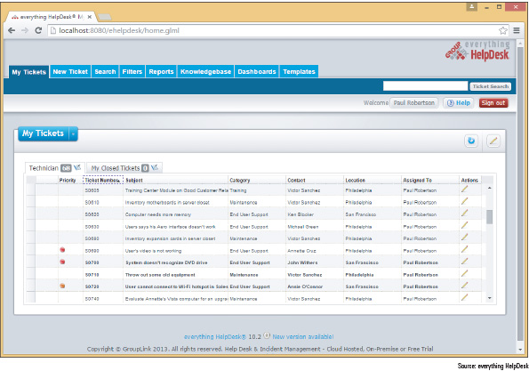
Source: everything HelpDesk
When someone initiates a call for help, whoever receives the call starts the process by creating a ticket (sometimes called an incident), which is a record of the request and what is happening to resolve it. The call tracking software might track:
- the date, time, and length of help-desk or on-site calls,
- causes of and solutions to problems already addressed,
- who is currently assigned to the ticket and who has already worked on it,
- who did what and when, and
- how each call was officially resolved.
The ticket is entered into the call tracking system and stays open until the issue is resolved. Support staff assigned to the ticket document their progress under this ticket in the call tracking system. As an open ticket ages, more attention and resources are assigned to it, and the ticket might be escalated (passed on to someone more experienced or who has more resources available) until the problem is finally resolved and the ticket closed. Help-desk personnel and managers acknowledge and sometimes even celebrate those who consistently close the most tickets!
As you support customers and solve computer problems, it’s very important to include detailed information in your call notes so that you have the information as you solve the problem or when faced with a similar problem later. Sometimes another person must pick up your open ticket, and she should not have to waste time finding out information you already knew. Also, tracking-system notes are sometimes audited.

Initial Contact with a Customer
Your initial contact with a customer might be when the customer comes to you, such as in a retail setting, when you go to the customer’s site, when the customer calls you on the phone, when the customer reaches you by chat or email, or when you are assigned a ticket already entered in a call tracking system. In each situation, always follow the specific guidelines of your employer. Let’s look at some general guidelines for handling first contact with customers.
When you answer the phone, identify yourself and your organization. (Follow the guidelines of your employer on what to say.) Follow company policies to obtain specific information when answering an initial call, such as name (get the right spelling), phone number, and business name. For example, your company might require that you obtain a licensing or warranty number to determine whether the customer is entitled to receive your support. After you have obtained the information you need and confirmed you are authorized to help the customer, open up the conversation for the caller to describe the problem.
Prepare for on-site visits by reviewing information given to you by the person who took the call. Know the problem you are going to address, the urgency of the situation, and what computer, software, and hardware need servicing. Arrive with a complete set of equipment appropriate to the visit, which might include a toolkit, flashlight, multimeter, ESD strap and mat, and bootable media.
When you arrive at the customer’s site, greet the customer in a friendly manner and shake his or her hand (see Figure 11-50). Use terms such as Mr. or Ms. and Sir or Ma’am when addressing the customer, unless you are certain the customer expects you to use his or her first name. If the site is a residence, you should not remain there when only a minor is present. If a minor child answers the door, ask to speak with an adult and don’t allow the adult to leave the house with only you and the child present.
Figure 11-50
If a customer permits it, begin each new relationship with a handshake

© iStockphoto.com/killerb10
After initial greetings, the first thing you should do is listen and ask questions. As you listen, it’s fine to take notes, but don’t start the visit by filling out your paperwork. Save the paperwork for later, or have the essentials already filled out before you reach the site.

Interview the Customer
Troubleshooting begins by interviewing the user. As you ask the user questions, take notes and keep asking questions until you thoroughly understand the problem. Have the customer reproduce the problem, and carefully note each step taken and its results. This process gives you clues about the problem and the customer’s technical proficiency, which helps you know how to communicate with the customer.
A+ Exam Tip
The A+ Core 2 exam expects you to be able to clarify customer statements by asking open-ended questions to narrow the scope of the problem and by restating the issue or question.
Use diplomacy and good manners when you work with a user to solve a problem. For example, if you suspect that the user dropped the computer, don’t ask, “Did you drop the laptop?” Put the question in a less accusatory manner: “Could the laptop have been dropped?”

Set and Meet Customer Expectations
A professional technician knows that it is her responsibility to set and meet expectations with a customer. It’s important to create an expectation of certainty with customers so that they are not left hanging and don’t know what will happen next.
Part of setting expectations is to establish a timeline with your customer for the completion of a project. If you cannot solve the problem immediately, explain to the customer what needs to happen and the timeline that he should expect for a solution. Then keep the customer informed about the progress of the solution. For example, you can say to a customer, “I need to return to the office and research the cost of parts that need replacing. I’ll call you tomorrow before 10:00 a.m. with an estimate.” If you later find out you need more time, call the customer before 10:00 a.m., explain your problem, and give him a new time to expect your call. This kind of service is very much appreciated by customers and, if you are consistent, you will quickly gain their confidence.
Another way to set expectations is to give customers an opportunity to make decisions about repairs to their equipment. When explaining to the customer what needs to be done to fix a problem, offer repair or replacement options if they apply (see Figure 11-51). Don’t make decisions for your customer. Explain the problem and what you must do to fix it, giving as many details as the customer wants. When a customer must make a choice, state the options in a way that does not unfairly favor the most lucrative solution for you as the technician or for your company. For example, if you must replace a motherboard (a costly repair in parts and labor), explain to the customer the total cost of repairs and then help him decide if it’s better to purchase a new system or repair the existing one.
Figure 11-51
Advise and then allow a customer to make repair or purchasing decisions

© iStockphoto.com/Dean Mitchell

Work with a Customer on Site
As you work with a customer on site, avoid distractions. Don’t accept personal calls or texts on your cell phone, and definitely don’t check social media sites when you’re on the job. Most organizations require that you answer calls from work, but keep them to a minimum. Be aware that the customer might be listening, so be careful not to discuss problems with coworkers, the boss, or other situations that might put the company, its employees, or products in a bad light with the customer. If you absolutely must excuse yourself from the on-site visit for personal reasons, explain the situation to the customer and return as soon as possible.
When working at a user’s desk, follow these general guidelines:
- As you work, be as unobtrusive as possible. Consider yourself a guest in the customer’s office or residence. Don’t make a big mess. Keep your tools and papers out of the customer’s way. Don’t pile your belongings and tools on top of the user’s papers, books, and so forth.
- Protect the customer’s confidential and private materials. For example, if you are working on the printer and discover a budget report in the out tray, quickly turn it over so you can’t read it, and hand it to the customer. If you notice a financial spreadsheet is displayed on the customer’s computer screen, step away and ask the user if she wants to first close the spreadsheet before you work with the computer. If sensitive documents are on the customer’s desk, you might let him know and ask if he would like to put them out of your view or in a safe place.
- Don’t take over the mouse or keyboard from the user without permission.
- Ask permission again before you use the printer or other equipment.
- Don’t use the phone without permission.
- Accept personal inconvenience to accommodate the user’s urgent business needs. For example, if the user gets an important call while you are working, don’t allow your work to interfere. You might need to stop work and perhaps leave the room.
- Also, if the user is present, ask permission before you make a software or hardware change, even if the user has just given you permission to interact with the computer.
- Don’t disclose information about a customer on social media sites, and don’t use those public outlets to complain about difficulties with a customer.
In some IT support situations, it is appropriate to consider yourself a support to the user as well as to the computer. Your goals can include educating the user as well as repairing the computer. If you want users to learn something from a problem they caused, explain how to fix the problem and walk them through the process if necessary. Don’t fix the problem yourself unless they ask you to do so. It takes a little longer to train the user, but it is more productive in the end because the user learns more and is less likely to repeat the mistake (see Figure 11-52).
Figure 11-52
Teaching a user how to fix her problem can prevent it from reoccurring

© iStockphoto.com/Sportstock

Work with a Customer on the Phone
Phone support requires more interaction with customers than any other type of IT support. To understand the problem and give clear instructions, you must be able to visualize what the customer sees at his or her computer. Patience is required if the customer must be told each key to press or command button to click. Help-desk support requires excellent communication skills, good phone manners, and lots of patience (see Figure 11-53). As your help-desk skills improve, you will learn to think through the process as though you were sitting in front of the computer yourself. Drawing diagrams and taking notes as you talk can be very helpful. In some cases, help-desk support personnel might have software that enables the remote control of customers’ computers. Examples of this type of software are GoToAssist by Citrix at netviewer.com and LogMeIn Rescue by LogMeIn at secure.logmeinrescue.com. Always communicate clearly with customers when using this type of software, so that they understand what type of access they are allowing you to have on their computers.
Figure 11-53
Learn to be patient and friendly when helping users

© iStockphoto.com/mediaphotos
If your call is accidentally disconnected, call back immediately. Don’t eat or drink while on the phone. If you must put callers on hold, tell them how long it will be before you get back to them. Speak clearly and don’t talk too fast. Don’t complain about your job, your boss, coworkers, your company, or other companies or products to your customers. A little small talk is okay and is sometimes beneficial in easing a tense situation, but keep it upbeat and positive.

Deal with Difficult Customers
Most customers are polite and appreciate your help. If you make it a habit to treat others as you want to be treated, you’ll find that most of your customers will tend to treat you well, too. However, occasionally you’ll have to deal with a difficult customer. In this part of the chapter, you learn how to work with customers who are not knowledgeable, who are overly confident, and who complain.

When the Customer Is Not Knowledgeable
When on site, you can put a computer in good repair without depending on a customer to help you. But when you are trying to solve a problem over the phone, with a customer as your only eyes, ears, and hands, a computer-illiterate user can present a challenge. Here are some tips for handling this situation:
- Be specific with your instructions. For example, instead of saying, “Open File Explorer,” say, “Using your mouse, right-click the Start button, and click File Explorer from the menu.”
- Don’t ask the customer to do something that might destroy settings or files without first having the customer back them up carefully. If you think the customer can’t handle your request, ask for some on-site help.
- Frequently ask the customer what is displayed on the screen to help you track the keystrokes and action.
- Follow along at your own computer. It’s easier to direct the customer keystroke by keystroke if you are doing the same things.
- Give the customer plenty of opportunity to ask questions.
- Genuinely compliment the customer whenever you can to help the customer gain confidence.
- If you determine that the customer cannot help you solve the problem without a lot of coaching, you might need to tactfully request that the caller have someone with more experience call you. The customer will most likely breathe a sigh of relief and have someone take over the problem.
Notes
When solving computer problems in an organization other than your own, check with technical support within that organization instead of working only with the user. The user might not be aware of policies that have been set on his computer to prevent changes to the OS, hardware, or applications.

When the Customer Is Overly Confident
Sometimes customers might want to give advice, take charge of a call, withhold information they think you don’t need to know, or execute commands at the computer without letting you know, so that you don’t have enough information to follow along. A situation like this must be handled with tact and respect for the customer. Here are a few tips:
- When you can, compliment the customer’s knowledge, experience, or insight.
- Slow the conversation down. You can say, “Please slow down. You’re moving too fast for me to follow. Help me catch up.”
- Don’t back off from using problem-solving skills. You must still have the customer check the simple things, but direct the conversation with tact. For example, you can say, “I know you’ve probably gone over these simple things already, but could we just do them again together?”
- Be careful not to accuse the customer of making a mistake.
- Even though the customer might be using technical jargon, keep to your policy of not using jargon back to the customer unless you’re convinced he truly understands you.
A+ Exam Tip
The A+ Core 2 exam expects you to know that it is important not to minimize a customer’s problem and not to be judgmental toward a customer.

When the Customer Complains
When you are on site or on the phone, a customer might complain to you about your organization, products, or service or the service and product of another company. Consider the complaint to be helpful feedback that can lead to a better product or service and better customer relationships. Here are a few suggestions that can help you handle complaints and defuse customer anger:
- Be an active listener, and let customers know they are not being ignored. Look for the underlying problem. Don’t take complaints or anger personally.
- Give the customer a little time to vent and apologize when you can. Then start the conversation by asking questions, taking notes, and solving problems. Unless you must have the information for problem solving, don’t spend a lot of time finding out exactly who the customer dealt with and what happened to upset the customer.
- Don’t be defensive. It’s better to leave the customer with the impression that you and your company are listening and willing to admit mistakes. No matter how much anger is expressed, resist the temptation to argue or become defensive.
- Know how your employer wants you to handle a situation where you are verbally abused. For example, you might say something like this in a calm voice: “I’m sorry, but my employer does not require me to accept this kind of talk.”
- If the customer is complaining about a product or service that is not from your company, don’t start by saying, “That’s not our problem.” Instead, listen to the customer complain. Don’t appear as though you don’t care.
- If the complaint is against you or your product, identify the underlying problem if you can. Ask questions and take notes. Then pass these notes on to people in your organization who need to know.
- Sometimes simply making progress or reducing the problem to a manageable state reduces the customer’s anxiety. As you are talking to a customer, summarize what you have both agreed on or observed so far in the conversation (see Figure 11-54).
Figure 11-54
When a customer is upset, try to find a place of agreement

© iStockphoto.com/Kameleon007
- Point out ways that you think communication could be improved. For example, you might say, “I’m sorry, but I’m having trouble understanding what you want. Could you please slow down, and let’s take this one step at a time?”
Applying Concepts

Culture of Honor
Andy is one of the most intelligent and knowledgeable support technicians in his group at CloudPool, Inc. He is about to be promoted to software engineer and today is his last day on the help desk. Sarah, a potential customer with little computer experience, calls asking for help in accessing the company website. Andy says, “The URL is www dot cloud pool dot com.” Sarah responds, “What’s a URL?” Andy’s patience grows thin. He’s thinking to himself, “Oh, help! Just two more hours and I’m off these darn phones.” He answers Sarah in a tone of voice that says, hey, I really think you’re an idiot! He says to her, “You know, lady! That address box at the top of your browser. Now enter www dot cloud pool dot com!” Sarah gets flustered and intimidated and doesn’t know what to say next. She really wants to know what a browser is, but instead she says, “Wait. I’ll just ask someone in the office to help me,” and hangs up the phone.
Discuss the situation with others in a small group and answer these questions:
- If you were Andy’s manager and overheard this call, how would you handle the situation?
- What principles of working with customers does Andy need to keep in mind?
Two students sit back-to-back, one playing the role of Andy and the other playing the role of Sarah. Play out the entire conversation. Others in the group can offer suggestions and constructive criticism.

The Customer Decides When the Work Is Done
When you think you’ve solved the problem, allow the customer to decide if the service is finished to his or her satisfaction. For remote support, the customer generally ends the call or chat session, not the technician. If you end the call too soon and the problem is not completely resolved, the customer can be frustrated, especially if it is difficult to contact you again.
For on-site work, after you have solved the problem, complete these tasks before you close the call:
- If you changed anything on the computer after you booted it, reboot one more time to make sure you have not caused a problem with the boot.
- Allow the customer enough time to be fully satisfied that all is working. Does the printer work? Print a test page. Does the network connection work? Can the customer sign in to the network and access data on it?
- If you backed up data before working on the problem and then restored the data from backups, ask the user to verify that the data is fully restored.
- Review the service call with the customer. Summarize the instructions and explanations you have given during the call. This is an appropriate time to fill out your paperwork and explain to the customer what you have written. Then ask if she has any questions.
- Explain preventive maintenance to the customer, such as deleting temporary files from the hard drive or cleaning the mouse. Most customers don’t have preventive maintenance contracts for their computers and appreciate the time you take to show them how to take better care of their equipment. One technician keeps a pack of monitor wipes in his toolkit and ends each call by cleaning the customer’s monitor screen.
To demonstrate a sincere concern for your customer’s business and that you have owned the problem, it’s extremely important to follow up later with the customer, ask if he is still satisfied with your work, and ask if he has any more questions. For example, you can say to the customer, “I’ll call you on Monday to make sure everything is working and you’re still satisfied with the work.” On Monday, make that call. As you do, you’re building customer loyalty.
A+ Exam Tip
The A+ Core 2 exam expects you to know to follow up with the customer at a later date to verify his or her satisfaction.

Sometimes You Must Escalate a Problem
You are not going to solve every computer problem you encounter. Knowing how to escalate a problem properly so it is assigned to people higher in the support chain is one of the first things you should learn on a new job. Know your company’s policy for escalation. What documents or entries in the call tracking software do you use? Who do you contact? How do you pass the problem on—do you use email, a phone call, or an online entry in a database? Do you remain the responsible “support” party, or does the person now addressing the problem become the new contact? Are you expected to keep in touch with the customer and the problem, or are you totally out of the picture?
When you escalate, let the customer know. Tell the customer you are passing the problem on to someone who is more experienced or has access to more extensive resources. If you check back with the customer only to find out that the other support person has not called or followed through to the customer’s satisfaction, don’t lay blame or point fingers. Just do whatever you can to help within your company guidelines. Your call to the customer will go a long way toward helping the situation.

Work with Coworkers
Learn to be a professional when working with coworkers. A professional at work is someone who puts business matters above personal matters (see Figure 11-55). In big bold letters, I can say the key to being professional is to learn not to be personally offended when someone lets you down or does not please you. Remember, most people do the best they can considering the business and personal constraints they’re up against. Getting offended leads to becoming bitter about others and about your job. Learn to keep negative opinions to yourself, and to expect the best of others. When a coworker starts to gossip, try to politely change the subject.
Figure 11-55
Coworkers who act professionally are fun to work with

© iStockphoto.com/Chris Schmidt
Know your limitations and be willing to admit when you can’t do something. For example, Larry’s boss stops by his desk and asks him to accept one more project. Larry already is working many hours overtime just to keep up. He needs to politely say to his boss, “I can accept this new project only if you relieve me of some of these tasks.”
Applying Concepts

Active Learning
Ray was new at a corporate help desk that supported hospitals across the nation. He had only had a couple of weeks of training before he was turned loose on the phones. He was a little nervous the first day he took calls without a mentor sitting beside him. His first call came from Fernanda, a radiology technician who was trying to sign in to the network to start the day. When Fernanda entered her network ID and passcode, an error message stated her user account was not valid. She told Ray she had tried signing in several times on two different computers. Ray checked his database and found her account, which appeared to be in good order. He asked her to try again. She did and got the same results. In his two weeks of training, this problem had never occurred. He told her, “I’m sorry, I don’t know how to solve this problem.” She said, “Okay, well, thank you anyway,” and hung up. She immediately called the help-desk number back and the call was answered by Jackie, who sits across the room from Ray. Fernanda said, “The other guy couldn’t fix my problem. Can you help me?”
“What other guy?” Jackie asked.
“I think his name was Ray.”
“Oh, him! He’s new and he doesn’t know much, and besides that, he should have asked for help. Tell me the problem.” Jackie reset the account and the problem was solved.
In a group of three or more students, discuss and answer the following questions:
- What mistake did Ray make? What should he have done or said?
- What mistake did Jackie make? What should she have done or said?
- What three principles of relating to customers and coworkers would be helpful for Ray and Jackie to keep in mind?
Go to pg.
help
Application Opened
Main content

Chapter Review

11-5aChapter Summary

Windows Interfaces
- An operating system manages hardware, runs applications, provides an interface for users, and stores, retrieves, and manipulates files.
- Windows 10 offers two graphical user interfaces: the desktop and Tablet mode. Windows 8 offers two GUIs: the modern interface and the Windows 8 desktop. The Windows 7 desktop offers the Aero user interface.
- Ways to launch a program from the Windows 10 desktop include using the Start menu, the search box, the Quick Launch menu, an icon pinned to the taskbar, File Explorer, a shortcut on the desktop, and the Run option on the Quick Launch menu.
- Ways to launch a program from the Windows 8 desktop include using the Start screen, the Quick Launch menu, an icon pinned to the taskbar, File Explorer, a shortcut on the desktop, and the Run option on the Quick Launch menu.
- Ways to launch a program from the Windows 7 desktop include using the Start menu, the search box, an icon pinned to the taskbar, Windows Explorer, or a shortcut on the desktop.

Windows Tools for Users and Technicians
- Windows 10/8 File Explorer and Windows 7 Windows Explorer are used to manage files and folders on storage devices. Folders are organized in a top-down hierarchical structure of subfolders.
- The file extension indicates how file contents are organized and formatted and what program uses the file.
- Control Panel gives access to a group of utility programs used to manage the system. Technicians generally prefer the Classic view for Control Panel.
- The Windows 10 File Explorer Options and Windows 8/7 Folder Options applets in Control Panel change the way files and folders are displayed in Explorer.
- The Sound applet in Control Panel controls audio, including default speakers and microphones.
- The Power Options applet in Control Panel manages power settings on a computer.
- The System window gives a quick overview of the system, including which edition and version of Windows is installed and the amount of installed memory.
- The System Information window gives much more information about the computer than the System window, including information on hardware, device drivers, the OS, and applications.
- The Settings app is a centralized location for users to access common Windows 10 settings.

How Windows Controls Access to Network Resources
- Windows 10/8/7 supports workgroups and domains to manage resources on a private network. In addition, Windows 8/7 supports homegroups to manage resources on a private network. Workgroups are more secure than homegroups.
- Windows 10/8 supports public and private settings to secure a network connection, and Windows 7 supports public, home, and work settings to secure a network connection.
- Join a Windows computer to a domain using one of these methods:
  - use a network ID when you sign in to Windows to authenticate the user to Active Directory on the local network or through some type of VPN;
  - use an email address and password when you sign in to Windows to authenticate the user to Azure AD in the cloud; or
  - use an email address and password to authenticate to Azure AD in the cloud as a secondary login after you have already signed in to Windows with your personal user account.
- Use the Settings app to set up a computer to connect to a workgroup or to authenticate a user so that the computer can join a domain.
- Use the Network and Sharing Center to change the security settings for a Windows network connection.

What Customers Want: Beyond Technical Know-How
- Customers want more than just technical know-how. They want a positive and helpful attitude, respect, good communication, sensitivity to their needs, ownership of their problem, dependability, credibility, integrity, honesty, and professionalism.
- Customers expect their first contact with you to be professional and friendly, and expect that listening to their problem or request will be your first priority.
- Know how to ask penetrating questions when interviewing a customer about a problem or request.
- Set and meet customer expectations by using good communication about what you are doing or intending to do and allowing the customer to make decisions where appropriate.
- Deal confidently and gracefully with customers who are difficult, including those who are not knowledgeable, are overly confident, or complain.
- When you first start a new job, find out how to escalate a problem you cannot solve.
Go to pg.
help
Application Opened
Main content

Chapter Review

11-5bKey Terms
For explanations of key terms, see the Glossary for this text.
- 32-bit operating system
- 64-bit operating system
- Action Center
- Active Directory (AD)
- Aero user interface
- Azure Active Directory (Azure AD)
- Branchcache
- BYOD experience
- call tracking software
- Category view
- charm
- charms bar
- child directories
- Classic view
- client/server
- compressed (zipped) folder
- Control Panel
- Cortana
- device drivers
- domain
- domain user account
- escalate
- File Explorer
- File Explorer Options applet
- file extension
- file name
- Folder Options applet
- folders
- gadgets
- graphical user interface (GUI)
- hibernation
- homegroup
- library
- live tiles
- logical topology
- Media Center
- Metro UI
- Metro User Interface
- modern interface
- navigation pane
- Network and Sharing Center
- Notepad
- notification area
- operating system (OS)
- path
- peer-to-peer (P2P)
- physical topology
- pinning
- Power Options applet
- Recycle Bin
- root directory
- service
- Settings app
- sleep mode
- sleep timers
- Sound applet
- standby mode
- Start screen
- subdirectories
- suspend mode
- System Information
- system tray
- System window
- systray
- taskbar
- Task View
- ticket
- volume
- Windows 8.1
- Windows 10
- Windows Explorer
- workgroup
Go to pg.
help
Application Opened
Main content

Chapter Review

11-5cThinking Critically
These questions are designed to prepare you for the critical thinking required for the A+ exams and may use content from other chapters and the web.
- When Kristy recently started a photography business, she downloaded Photoshop to her computer to edit her photos. She notices her computer freezes when she is using Photoshop, so she asks you to help her fix the problem. Your research discovers that Photoshop requires a lot of RAM to run smoothly, and you need to know how much RAM Kristy’s computer has to see if that is the problem. Which Windows tools from the following list can you use to know how much RAM is installed on a system? Select all that apply.
  - System window
  - Power Options applet
  - System Information window
  - Network and Sharing Center
- John is traveling for work and is spending a week at a new branch. He needs to print an email, but he isn’t able to add the network printer to his computer. He is using a Windows 10 Pro laptop, is connected to the network, and can access the Internet. What is a likely and easy fix to John’s problem?
  - The computer is not set to find resources shared on the network; use the Settings app to fix the problem.
  - The computer is not set to find resources shared on the network; use the Network and Sharing Center to fix the problem.
  - John did not correctly authenticate to the Windows domain; use the Settings app to fix the problem.
  - The drivers for the network printer need to be updated. Use Device Manager to fix the problem.
- Mary wants her 32-bit installation of Windows 7 Professional to run faster. She has 4 GB of memory installed on the motherboard. She decides more memory will help. She installs an additional 2 GB of memory for a total of 6 GB, but does not see any performance improvement. What is the problem and what should you tell Mary?
  - She should use Control Panel to install the memory in Windows 7. After it is installed, performance should improve. Tell Mary how to open Control Panel.
  - A 32-bit OS cannot use more than 4 GB of memory. Tell Mary she has wasted her money.
  - A 32-bit OS cannot use more than 4 GB of memory. Tell Mary to upgrade her system to the 64-bit version of Windows 7 Professional.
  - A 32-bit OS cannot use more than 4 GB of memory. Explain the problem to Mary and discuss the possible solutions with her.
- Jack needs to email two documents to a friend, but the files are so large his email server bounced them back as undeliverable. What is your advice?
  - Tell Jack to open the documents, break each of them into two documents, and then email the four documents separately.
  - Tell Jack to put the two documents in a compressed folder and email the folder.
  - Tell Jack to put each document in a different compressed folder and email each folder separately.
  - Tell Jack to put the documents on a USB drive and snail mail the drive to his friend.
- Jawana has been working on a paper for her Anatomy class for weeks. One day her little brother was on her computer and accidentally deleted her paper from the Documents folder. How can Jawana recover her deleted paper?
- A technician needs to be prepared to launch programs even when utility windows or the Windows desktop cannot load. What is the program name for the System Information utility? What is the program name for the Remote Desktop utility?
- Suppose you are a customer who wants to have a computer repaired. List five main characteristics that you would want to see in your computer repair person.
- When you receive a phone call requesting on-site support, what is one thing you should do before you make an appointment?
- You make an appointment to do an on-site repair, but you are detained and find out that you will be late. What is the best thing to do?
- When making an on-site service call, what should you do before making any changes to software or before taking the case cover off a computer?
- What should you do after finishing your computer repair?
- What is a good strategy to follow if a conflict arises between you and your customer?
- You have exhausted your knowledge of a problem and it still is not solved. Before you escalate it, what else can you do?
- If you need to make a phone call while on a customer’s site and your cell phone is not working, what do you do?
- What is one thing you can do to help a caller who needs phone support and is not a competent computer user?
- Describe what you should do when a customer complains to you about a product or service that your company provides.
- Robert works in a call center and receives a call from Kathy. Kathy says she can no longer access the online reporting application for her weekly reports through her web browser. You ask your boss, and he tells you that the server team changed the application’s URL during an upgrade over the weekend. He asks you to make sure all the other technicians are aware of this change. What is the best way to share this information?
  - Print a flyer with the new URL and post it on the wall in the call center.
  - Send out a mass email with the new URL to all the technicians.
  - Update the knowledge base article that contains the application’s URL in the call tracking application.
  - Yell the new URL to all technicians sitting in the call center.
Go to pg.
help
Application Opened
Main content

Chapter Review

11-5dHands-On Projects
Hands-On Project 11-1

Practicing Using the Quick Launch Menu
Do the following to practice using the Quick Launch menu:
- Click the Power icon on the Start menu. What are the options on the Power icon menu?
- Open the Quick Launch menu, and practice using several options on the menu. What are the submenu items that appear when you point to Shut down or sign out?
- Click Power Options on the Quick Launch menu. The Settings app opens to the Power & sleep page. Sometimes you need to use links in the Settings app to navigate to the control panel applets and find more options. Find the settings in the Power Options window that allow you to change the options available in the Shut down or sign out menu.
- Go to the Start menu. Click your account icon on the left side of the Start menu. What options appear in the drop-down menu? Try the Lock and Sign out options, and describe what each option does.
Hands-On Project 11-2

Creating Shortcuts
Do the following to practice creating shortcuts on the Windows desktop:
- Open Windows 10/8 File Explorer or Windows 7 Windows Explorer and create a folder called Temp under the root directory of the hard drive. List the steps you took.
- Add a subfolder to Temp called MyFiles. List the steps you took.
- Create a text file named Text1.txt in the MyFiles folder. List the steps you took.
- Create a shortcut to the Text1.txt file on the Windows desktop. List the steps you took.
- In the MyFiles folder, rename the file Text2.txt.
- Double-click the shortcut on the desktop. Did that cause an error? Did the shortcut name change when you changed the name of the original file? Did it open the correct file?
- The program file for Microsoft Paint is mspaint.exe. Use Windows Explorer to locate the program file and launch the Microsoft Paint program.
- Create a shortcut to Microsoft Paint on the Windows desktop. Launch Microsoft Paint using the shortcut.
- To clean up after yourself, delete the Temp folder and the shortcuts. Close the two Paint windows.
Hands-On Project 11-3

Using the System Information Utility
Do the following to run the System Information utility and gather information about your system:
- Use the msinfo32.exe command to launch the System Information window.
- Browse through the different levels of information in this window and answer the following questions:
  - What OS and OS version are you using?
  - What is your CPU speed?
  - What is your BIOS manufacturer and version?
  - How much video RAM is available to your video adapter card? Explain how you got this information.
  - What is the name of the driver file that manages your network adapter? Your optical drive?
Hands-On Project 11-4

Installing and Uninstalling Windows 10/8 Apps
Windows 10/8 apps are installed from the Windows Store. Follow these steps to install an app and then uninstall it:
- Open the Start menu.
OS Differences
In Windows 8, you must have a Microsoft account to get apps from the Windows Store. If you don’t already have an account, you can get one free at live.com.
- To install an app, click the Microsoft Store tile. Next, scroll through the apps in the Store or use its search box to find an app (see Figure 11-56). Click a free one, such as Windows Help+Tips, and follow the directions on screen to install it. If you did not sign in to Windows using a Microsoft account, you are asked to sign in so that you can apply this app to all your devices using this Microsoft account; in Windows 10, you can decline and install this app only on the local machine.
Figure 11-56
Search the Windows Store for apps to install
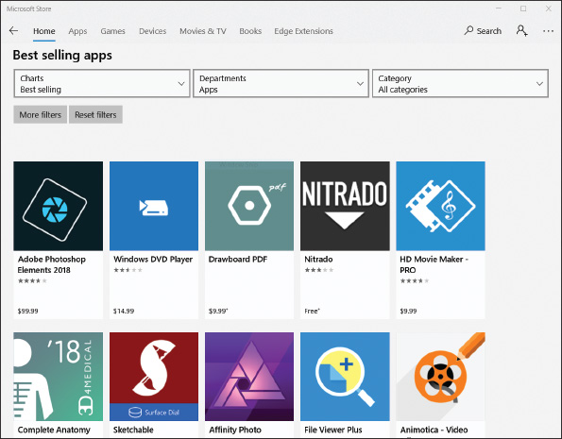
- Launch the app and practice using it to make sure it works.
- To uninstall the app, right-click the app tile on the Start menu. Click Uninstall and follow the directions on screen.
Go to pg.
help
Application Opened
Main content

Chapter Review

11-5eReal Problems, Real Solutions
Real Problem 11-1

Using Windows Help and Support
The best IT support technicians are the ones who continually teach themselves new skills. You can teach yourself to use and support Windows by using the web, a couple of apps in Windows 10 called Get Help and Tips, or the Windows Help and Support utility in Windows 8/7. To start the apps in Windows 10, type get help in the search box or type tips in the search box. In Windows 8, type Help and Support on the Start screen. In Windows 7, click Start and then click Help and Support. If you are connected to the Internet, clicking links can take you to the Microsoft website, where you can find information and watch videos about Windows.
Do the following to research a topic so you can become an independent learner about Windows:
- The Windows 10/8/7 Snipping Tool can help you take screenshots of the Windows desktop. These screenshots are useful when documenting computer problems and solutions. Use Get Help or Windows Help and Support to find out how to use the Snipping Tool. Use it to take a screenshot of your Windows desktop. Save the screenshot into a file on a USB flash drive or on the hard drive. Print the file contents.
- Access the support.microsoft.com website for Windows support. Save or print one article from the Knowledge Base that addresses a problem when installing Windows 10/8/7.
- Search the web to learn the purpose of the pagefile.sys file. What website did you use to find your answer? Why is the Microsoft website considered the best source for information about the pagefile.sys file?
Real Problem 11-2

Documenting How to Use Windows
This problem requires a microphone, and a webcam would also be useful. Make a screen recording with a voiceover to teach end users how to use Windows. Do the following:
- Screencast-O-Matic offers free software to make a screen recording with voice and video. Go to screencast-o-matic.com and launch the online video recording software. You might be required to download and install the software.
- Select a Windows feature to explain. For example, you can explain how to open and close an app, install or uninstall an app, create a shortcut, empty the Recycle Bin, or use the Start menu. You or your instructor might have other ideas.
- Use the Screencast-O-Matic software to make a screen recording that explains how to use the Windows feature you selected. The recording should be no longer than three minutes. Explain the steps as you go. The software records your screen movements, your voice if a microphone is detected, and video if a webcam is detected.
- View the video. If you see a problem, record it again. When you’re satisfied with your video, save it as an MP4 file.
Real Problem 11-3

Learning a New App Available in Windows 10
Sometimes you might encounter an application that you are not familiar with, yet you might be asked to help a user answer questions about the app. In that case, you can search for the information you need in the application’s Help system. In this Real Problem, you use the Help system and online tutorials for Sway, a new app available for free in Windows 10. Perform the following steps, looking up Help information as necessary to learn how to proceed. If you are already familiar with Sway, pretend you are not and rely on Help information instead. To practice using Sway, complete the following tasks:
- Create a new Sway story.
- Choose a design and layout.
- Add a title, photographs, and text.
- Add focus points on photographs.
- Share the URL to your Sway story with another person and have her watch what you created using a web browser.
Real Problem 11-4

Installing and Using the Mouse Without Borders App
This Real Problem requires two computers on the same network, both with Internet access. Install the free Microsoft app Mouse Without Borders on both computers. This app allows one computer’s mouse and keyboard to control up to four computers. The app is very useful when you frequently switch between two different computers, even when you are using both Windows 10 and Windows 8. Complete the following tasks:
- Open Edge and search for the Mouse Without Borders download. Make sure your system meets the minimum system requirements.
- Download and install the app from the Microsoft Download Center webpage.
- Use Mouse Without Borders to connect two computers on the same network.
- On the first computer, use the mouse and keyboard to control the second computer by opening an app on it without touching its mouse or keyboard.
Go to pg.
help

