Application Opened
Main content
Chapter
12

Installing Windows
- Chapter Introduction
- 12-1How to Plan a Windows Installation
  - 12-1aChoosing the Edition, License, and Version of Windows
  - 12-1bVerifying That Your System Qualifies for Windows
  - 12-1cChoosing the Type of Installation: In-Place Upgrade, Clean Install, or Dual Boot
  - 12-1dUnderstanding the Choices You’ll Make During the Installation
  - 12-1eFinal Checklist Before Beginning the Installation
- 12-2Installing Windows 10, Windows 8.1, and Windows 7
  - 12-2aWindows 10 In-Place Upgrade
  - 12-2bWindows 10 Clean Install
  - 12-2cMultiboot Installations
  - 12-2dSolving Problems with Installations
- 12-3What to Do After a Windows Installation
  - 12-3aVerifying Network Access
  - 12-3bActivating Windows
  - 12-3cInstalling Windows Updates
  - 12-3dInstalling Hardware
  - 12-3eSetting Up User Accounts
  - 12-3fInstalling Applications
  - 12-3gTurning Windows Features On or Off
  - 12-3hInstallations in a Virtual Machine
- 12-4Special Concerns When Working in a Large Enterprise
  - 12-4aMethods to Deploy a Standard Image
  - 12-4bUsing USMT Software
- 12-5Chapter Review
  - 12-5aChapter Summary
  - 12-5bKey Terms
  - 12-5cThinking Critically
  - 12-5dHands-On Projects
  - 12-5eReal Problems, Real Solutions
  - 12-5fExam Tips
Go to pg.
help
Application Opened
Main content

Chapter Introduction
After completing this chapter, you will be able to:
- Plan a Windows installation
- Install Windows 10, Windows 8.1, and Windows 7
- Configure Windows settings after the installation
- Describe special concerns when installing Windows in a large enterprise
Windows 10, 8, and 7 all share the same basic Windows architecture, and all have similar characteristics. Windows 10 includes free upgrades called builds. Windows 8 includes a free upgrade to Windows 8.1 via the Windows Store. Windows 10 is available for purchase directly from Microsoft, but you can no longer purchase Windows 8 or 7. (However, Windows 8.1 and 7 can be purchased from other vendors.)
This chapter discusses how to plan a Windows installation and the steps to perform a Windows 10, Windows 8.1, or Windows 7 installation in various scenarios, including what to do after the OS is installed. You also learn what to expect when installing Windows on computers in a large enterprise.
Notes
In the text, we use the term “Windows 8” to refer to Windows 8.0 and Windows 8.1.
Go to pg.
help
Application Opened
Main content

12-1How to Plan a Windows Installation
A+ Core 2
- 1.1
Compare and contrast common operating system types and their purposes.
- 1.3
Summarize general OS installation considerations and upgrade methods.
As an IT support technician, you can expect to be called on to install Windows in a variety of situations. You might need to install Windows on a new hard drive, after an existing Windows installation has become corrupted, or to upgrade from one OS to another. Many decisions need to be made before the installation, and most of these decisions apply to any Windows operating system.
Go to pg.
help
Application Opened
Main content

12-1aChoosing the Edition, License, and Version of Windows
A+ Core 2
- 1.1
Compare and contrast common operating system types and their purposes.
- 1.3
Summarize general OS installation considerations and upgrade methods.
When buying a Windows operating system, know that the price is affected by the Windows edition and type of license you purchase. You learned about the different editions in Chapter 11. You also need to decide between 32-bit and 64-bit architecture. In this part of the chapter, you learn about your options when purchasing Windows and how to make sure your computer qualifies for the version and edition you’ve selected.

OEM or Retail License
When buying Windows, you can purchase a retail license or an Original Equipment Manufacturer (OEM) license. Options for both types of licenses include 32-bit and 64-bit. Here are the key differences between an OEM license and a retail license:
- The OEM license is for builders and manufacturers of computers and can be installed only on a new computer. You can purchase and download a Windows 10 OEM license from a third party such as Amazon at amazon.com or Newegg at newegg.com.
- An OEM license allows all hardware upgrades except for an upgrade to a different model of motherboard.
- An OEM license costs less than a retail license. Microsoft generally refers technical support for an OEM license to the computer manufacturer or builder.
- Retail licenses can be purchased from the Microsoft online store at microsoftstore.com. Microsoft sells Windows 10 as either a download or on a boxed USB flash drive (sometimes called an Install Stick) that’s shipped to you with the installation files. Whether you’re doing a clean install of Windows 10 or an upgrade from Windows 8/7 to Windows 10, the retail license costs the same.
- The benefit of a retail license over an OEM license is that it can be transferred to a different computer, and you get Microsoft direct support from Microsoft support personnel.
When you download the Windows 10 setup files from Microsoft, you start by downloading the Media Creation Tool. After you install and launch the tool, you use it to download Windows setup files; you also have the option to create a bootable DVD or USB flash drive. You learn how to use the Media Creation Tool later in this chapter.
Notes
The Media Creation Tool and Windows setup files can be downloaded for free from Microsoft. Therefore, when you purchase Windows 10, you are really only purchasing a product key, which is required to activate a license to use Windows 10. The product key is emailed to your Microsoft account email address.

32-Bit or 64-Bit Architecture
Recall that an operating system can process 32 bits or 64 bits at a time. A 64-bit installation of Windows generally performs better than a 32-bit installation if you have enough RAM. (Table 12-1 shows how much RAM is supported by popular editions of Windows.) Also, 64-bit installations of Windows can support 64-bit applications, which run faster than 32-bit applications. Even though you can install 32-bit applications in a 64-bit OS, always choose 64-bit applications for best performance. Keep in mind that 64-bit installations of Windows require 64-bit device drivers.
Table 12-1

Maximum Memory Supported by Windows 10, 8.1, and 7 Editions and Versions
Operating System | 32-Bit Architecture | 64-Bit Architecture
Windows 10 Home  Windows 8.1 | 4 GB | 128 GB
Windows 10 Pro  Windows 10 Enterprise  Windows 8.1 Pro  Windows 8.1 Enterprise | 4 GB | 512 GB
Windows 7 Home Premium | 4 GB | 16 GB
Windows 7 Professional  Windows 7 Enterprise  Windows 7 Ultimate | 4 GB | 192 GB
Notes
All processors (CPUs) used in personal computers today are hybrid processors and can handle a 32-bit or 64-bit OS. However, the Intel Itanium and Xeon processors used in high-end workstations and servers are true 64-bit processors and require a 64-bit OS.
Notes
How much memory or RAM you can install in a computer depends not only on the OS installed, but also on how much memory the motherboard can hold. To know how much RAM a motherboard can support, see the motherboard documentation.
Go to pg.
help
Application Opened
Main content

12-1bVerifying That Your System Qualifies for Windows
A+ Core 2
- 1.1
Compare and contrast common operating system types and their purposes.
- 1.3
Summarize general OS installation considerations and upgrade methods.
The minimum hardware requirements for Windows 10/8/7 are listed in Table 12-2. (These minimum requirements are also the Microsoft recommended requirements.) Beginning with Windows 8, in addition to the requirements listed, Microsoft requires three technologies used by the processor (NX, PAE, and SSE2). All processors built in the last 10 years use these technologies, so the move was intended to prevent a new edition of Windows from being installed on a system that was more than 10 years old. Know, however, that Microsoft occasionally changes the minimum and recommended requirements for its OSs.
Table 12-2

Minimum and Recommended Hardware Requirements for Windows 10/8/7
Hardware | For 32-Bit Windows | For 64-Bit Windows
Processor | 1 GHz or faster; for Windows 10/8, must support NX, PAE, and SSE2
Memory (RAM) | 1 GB | 2 GB
Free hard drive space | 16 GB | 20 GB
Video device and driver | DirectX 9 device with WDDM 1.0 or higher driver
Notes
The three processor technologies are NX (Never Execute or No Execute), which prevents malware from hiding in the data storage area of another program; PAE (Physical Address Extension), which was originally intended to allow 32-bit processors to use more than 4 GB of RAM but is no longer used for that purpose because it gave device drivers a big headache; and SSE2 (Streaming SIMD Extensions 2), which allows a processor to execute a single instruction multiple times.
A+ Exam Tip
The A+ Core 2 exam may give you a scenario and ask you to demonstrate hardware compatibility requirements for a Windows installation.

MBR or GPT Partitioning System
You need to be aware of the partitioning method you will use on the hard drive. A hard drive is divided into one or more partitions. Windows can use one of two methods to partition a hard drive: The Master Boot Record (MBR) method is older, allows for four partitions, and is limited to 2.2-TB drives. The GUID Partition Table (GPT) method is newer, allows for any size of hard drive, and for Windows can have up to 128 partitions on the drive. GPT is required for drives larger than 2.2 TB.
When an MBR or GPT partition is formatted with a file system and assigned a drive letter (such as drive C:), it is called a volume. A file system is the overall structure an OS uses to name, store, and organize files on a volume; Windows is always installed on a volume that uses the NTFS file system. For most installations, you install Windows on the only hard drive in the computer and allocate all the space on the drive to one partition that Windows setup calls drive C:. Windows is installed in the C:\Windows folder. You learn more about partitions and file systems in Chapter 13.

BIOS/UEFI Firmware on the Motherboard
To understand if your system qualifies for Windows 10/8/7, it helps to understand how Windows relates to hardware by using device drivers and firmware on the motherboard, as shown in Figure 12-1. (In the figure, the kernel is the part of Windows responsible for relating to hardware.)
Figure 12-1
Windows relates to hardware by way of device drivers and system BIOS/UEFI
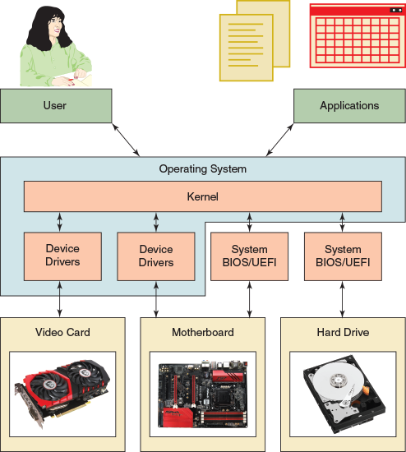
When a computer is first turned on, it uses some devices such as the keyboard, monitor, and hard drive before the OS starts up. The motherboard BIOS/UEFI is contained on a chip on the motherboard (see Figure 12-2) and manages these essential devices. This chip is called a firmware chip because it holds programs.
Figure 12-2
A chip on a motherboard contains BIOS/UEFI used to start the computer, hold motherboard settings, and run essential devices. The chip retains power from a nearby coin battery when the computer is turned off.
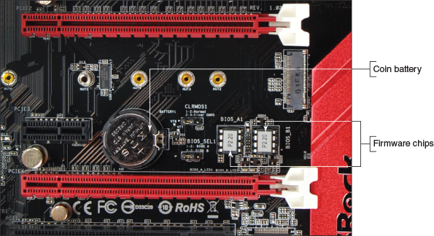
All modern motherboards use firmware called UEFI (Unified Extensible Firmware Interface). UEFI is a much improved replacement for BIOS (basic input/output system) and offers legacy support for BIOS compatibility. BIOS stores its setup information on the motherboard, while UEFI stores its setup information and some drivers on the motherboard and the hard drive. The motherboard BIOS/UEFI provides three main functions:
- The system BIOS/UEFI contains instructions for running essential hardware devices before an operating system is started. After the OS is started, it might continue to use system BIOS/UEFI or use device drivers to communicate with these devices.
- The startup BIOS/UEFI starts the computer and finds a boot device that contains an operating system. Boot devices that a system might support include an internal or external hard drive, CD or DVD drive, bootable USB flash drive, and the network. After it finds a boot device, the firmware turns the startup process over to the OS.
Notes
When choosing a boot device, consider that solid-state drives are faster than magnetic hard drives because they have no moving parts. USB flash drives are also solid-state devices. Some hard drives might be hot-swappable, which means they are inserted into an easily accessible hot-swap bay and can be exchanged without powering down the system.
- The setup BIOS/UEFI is used to change motherboard settings. You can use it to enable or disable a device on the motherboard (for example, the network port, video port, or USB ports), change the date and time that is later passed to the OS, and select the order of boot devices for startup BIOS/UEFI to search when looking for an operating system to load. This order of boot devices is called the boot priority order.
Most computers today give you the option of booting the system in UEFI mode or the legacy BIOS mode, which is called UEFI CSM (Compatibility Support Module) mode. You must select which firmware mode you will use before you install Windows. Here are points to help you decide:
- UEFI mode is required if the hard drive is larger than 2.2 TB or is using the GPT partitioning system. (However, a hard drive manufacturer might provide device drivers to allow a drive larger than 2.2 TB to use the MBR partitioning system and legacy BIOS.)
Notes
Seagate offers its DiscWizard device drivers that you can install on Seagate’s 3-TB hard drive so you can install the hard drive in a system that only has legacy BIOS. DiscWizard creates two MBR virtual hard drives and presents them to BIOS; they appear to BIOS to be two physical MBR hard drives.
- UEFI and the GPT partitioning system for the hard drive work only with 64-bit versions of Windows 10/8/7. A 32-bit version of Windows 10/8/7 can read and write to a GPT disk but not boot from it.
- UEFI has a security system called Secure boot, which helps to prevent malware from hijacking a system during or before the operating system load. UEFI mode and Windows work together to ensure that no unsecured device driver, application, or OS component is loaded during startup. If you want to enable Secure boot, you must use UEFI, GPT, and a 64-bit edition of Windows.
- Ultimately, the only times you might select the CSM mode are when you use a legacy MBR hard drive or install a 32-bit version of Windows 10/8/7.
Applying Concepts

Selecting the Firmware Mode and Boot Priority Order
You can use BIOS/UEFI setup to change the firmware mode and boot priority order. See the motherboard documentation to find out how to access and use BIOS/UEFI setup. Here are steps for one system:
- To access BIOS/UEFI setup, press a key such as Del or F2 early in the boot process before Windows starts to load. When the BIOS/UEFI setup screen appears, look for a screen to manage the boot. For example, the Boot screen for one motherboard’s firmware is shown in Figure 12-3.
Figure 12-3
The Boot screen for BIOS/UEFI setup
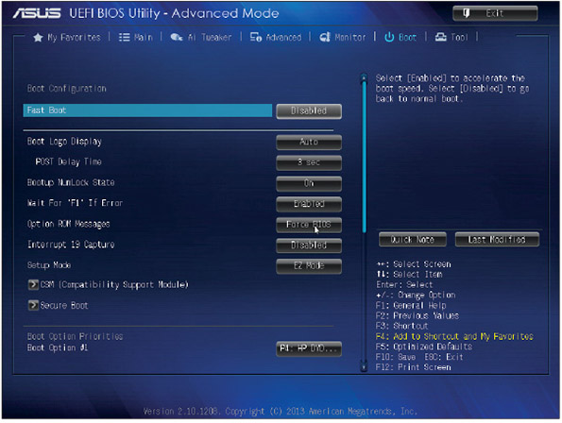
Source: American Megatrends, Inc.
- To use CSM mode, which requires the MBR partitioning system:
  - Click CSM (Compatibility Support Module) and make sure that CSM is enabled (see Figure 12-4).
Figure 12-4
Enable or disable CSM mode
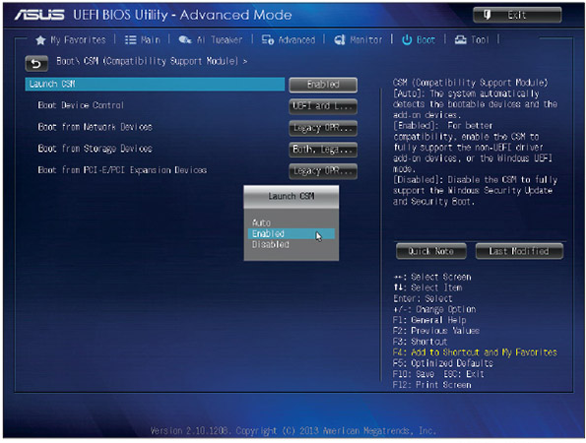
Source: American Megatrends, Inc.
  - On the Boot screen (see Figure 12-3), click Secure Boot. In the Secure Boot menu, select Other OS for the OS Type (see Figure 12-5).
Figure 12-5
Select Other OS to allow Windows to install on an MBR hard drive
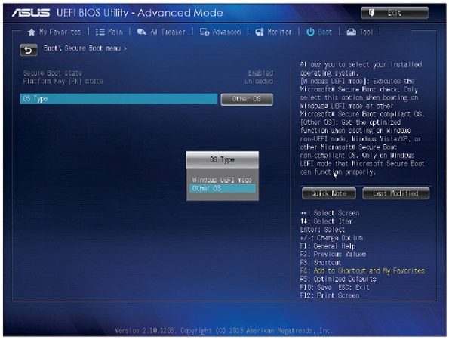
Source: American Megatrends, Inc.
- To use UEFI mode and the GPT partitioning system, use the same screens from the previous step to disable CSM (see Figure 12-4) and set the OS Type to Windows UEFI mode (see Figure 12-5).
- Normally, BIOS/UEFI is set to boot first from the internal hard drive. If you plan to install Windows by booting from a DVD, USB flash drive, or external hard drive connected to a USB port, you need to change the boot priority order. To make the change, look for a Boot screen or menu. For the system shown in Figure 12-6, boot options are the DVD drive, hard drive, and network port. Also, know that sometimes the DVD drive is labeled CD-ROM in BIOS/UEFI setup.
Figure 12-6
Set the boot order in BIOS/UEFI setup
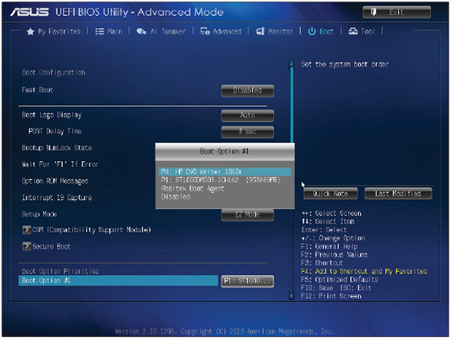
Source: American Megatrends, Inc.
In a corporate or enterprise environment, automated methods might be in place to install a fresh copy of Windows on a workstation from deployment servers on the network. To use this method, you configure BIOS/UEFI setup to boot from the network and locate a deployment server to install Windows. How to do that is covered later in this chapter.

Application and Hardware Compatibility
Verify that the applications you already have installed will work in a new OS you are about to install. You can go to the application manufacturer’s website to check for compatibility with the new OS.
Device drivers are small programs stored on the hard drive that tell the computer how to communicate with a specific hardware device such as a printer, network card, or scanner. These drivers are installed on the hard drive when the OS is first installed or when new hardware is added to the system. A device driver is written to work for a specific OS, such as Windows 10, 8.1, or 7. In addition, a 32-bit OS requires 32-bit drivers and a 64-bit OS requires 64-bit drivers.
Windows provides some device drivers and the manufacturer of the hardware device provides others. When you purchase a printer, video card, digital camera, scanner, or other hardware device, a CD that contains the device drivers is usually bundled with the device along with a user manual (see Figure 12-7). You can also download the drivers for a device from the manufacturer’s website. Be sure you have the correct Windows device drivers for all your critical devices, such as your network card or motherboard.
Figure 12-7
A device such as this video card comes packaged with its device drivers stored on a CD
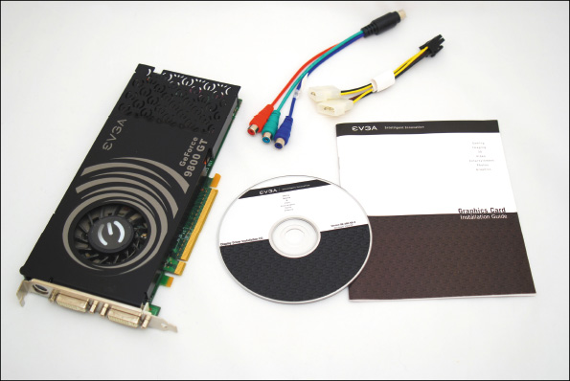
If you are not sure your devices will work with Windows 10/8/7, one solution is to set up a dual boot. A dual boot, also called a multiboot, allows you to install the new OS without disturbing the old one so you can boot to either OS. After the installation, you can test your software or hardware. If they work under the new OS, you can delete the old one. If they don’t work, you can still boot to the old OS and use it. How to set up a dual boot is covered later in this chapter.
Go to pg.
help
Application Opened
Main content

12-1cChoosing the Type of Installation: In-Place Upgrade, Clean Install, or Dual Boot
A+ Core 2
- 1.3
Summarize general OS installation considerations and upgrade methods.
If you are installing Windows on a new hard drive, you must perform a clean install. If an OS is already installed on the hard drive, you have three choices:
- Clean install. You can perform a clean install, overwriting the existing operating system and applications. In the Windows setup program, a clean install is called a custom installation. The main advantage of a clean install is that problems with the old OS are not carried forward and you get a fresh start. During the installation, you will have the option to reformat the hard drive, erasing everything on it. If you don’t format the drive, data will still be on it. The previous operating system settings and user profiles are collectively stored in the Windows.old folder that setup creates on the hard drive. After Windows is installed, you will need to install the applications. After you’re sure the new installation is working as expected, you can delete the Windows.old folder to save space on the drive. Windows 10 automatically deletes most of the content of this folder 28 days after the installation.
- In-place upgrade. If the upgrade path allows it, you can perform an in-place upgrade installation. An in-place upgrade is a Windows installation that is launched from the Windows desktop and carries forward user settings and installed applications from the old OS to the new one. A Windows OS is already in place before you begin the new installation. An in-place upgrade is faster than a clean install and is appropriate if the system is generally healthy and does not have problems. To perform an in-place upgrade, Microsoft requires that certain editions and versions of Windows be installed already and running the latest version of either Windows 8.1 or Windows 7 with Service Pack 1 installed. These qualifying OSs are called upgrade paths. Table 12-3 outlines the acceptable upgrade paths for Windows 10 compatibility.
Table 12-3

In-Place Upgrade Paths to Windows 10
Windows 8 |  | Windows 7
From OS | To OS | From OS | To OS
Windows 8.1 | Windows 10 Home | Windows 7 Starter | Windows 10 Home
 |  | Windows 7 Home Basic
 |  | Windows 7 Home Premium
Windows 8.1 Pro | Windows 10 Pro | Windows 7 Professional | Windows 10 Pro
Windows 8.1 Pro for Students |  | Windows 7 Ultimate
Notes
You can upgrade from Windows 10 Home to Windows 10 Pro by using the Settings app within Windows. If you have already purchased a Windows 10 Pro product key, simply change the product key on the Activation page in the Settings app and then follow the on-screen instructions. Alternately, you can go to the Microsoft Store app, purchase Windows 10 Pro, then follow the on-screen instructions. The upgrade is easy and does not require going through the entire upgrade process.
- Multiboot. You can install Windows in a second partition on the hard drive and create a dual-boot situation with the other OS, or even install three OSs, each in its own partition in a multiboot environment. Don’t create a dual boot unless you need two operating systems, such as when you need to verify that applications and hardware work under Windows 10 before you delete the old OS. Windows 10/8/7 all require that they be the only operating system installed on a partition, so to set up a dual boot, you’ll need at least two partitions on the hard drive or a second hard drive.
In addition to the information in Table 12-3, keep these tips in mind:
- A 64-bit version of Windows can only be upgraded to a 64-bit OS. A 32-bit OS can only be upgraded to a 32-bit OS.
- If you want to install a 64-bit version of Windows on a computer that already has a 32-bit OS installed, you must perform a clean install.
Notes
If your current installation of Windows is corrupted, you might be able to repair the installation rather than reinstalling Windows. Chapter 15 covers how to fix a corrupted Windows installation.
Go to pg.
help
Application Opened
Main content

12-1dUnderstanding the Choices You’ll Make During the Installation
A+ Core 2
- 1.3
Summarize general OS installation considerations and upgrade methods.
While Windows is installing, you must choose which drive and partition to install Windows in, the size of a new partition, and how Windows will connect to the network. Next, you’ll learn how to decide on the size of the Windows partition and how Windows will connect to the network.

The Size of the Windows Partition
For a clean install or dual boot, you can decide not to use all the available space on the drive for the Windows partition. Here are reasons not to use all the available space:
- You plan to install more than one OS on the hard drive, creating a dual-boot system. For example, you might want to install Windows 8 on one partition and leave room for another partition where you intend to install Windows 10, so you can test software under both operating systems. (When setting up a dual boot, always install the older OS first.)
- Some people prefer to use more than one partition or volume to organize data on their hard drives. For example, you might want to install Windows and all your applications on one partition and your data on another. Having your data on a separate partition makes backing up easier. In another situation, you might want to set up a volume on the drive that is used exclusively to hold data backups on another computer on the network. The size of the partition that will hold Windows 10/8/7 and its applications should be at least 16 GB for a 32-bit install and 20 GB for the 64-bit install, but a larger volume is nearly always preferred.
Caution
It’s convenient to back up one volume to another volume on a different hard drive. However, don’t back up one volume to another volume on the same hard drive; if the drive fails, all volumes on the drive might be damaged and you could lose both your data and your backup.
In Chapter 13, you learn to use the Disk Management utility after Windows is installed to create partitions from unallocated space and to resize, delete, and split existing partitions.

Network Configuration
Recall from Chapter 11 that all editions of Windows 10/8/7 can join a workgroup, Windows 8/7 computers can join a homegroup, and professional editions of Windows 10/8/7 can join a Windows domain. (Windows 10 does not support homegroups.) To join a domain, you’ll need the name of the domain and the network ID and password assigned to you by the private network’s administrator. To join a homegroup, you’ll need its password. To use a workgroup, you configure each computer to share its folders and files to specific people on the local network. You can connect to a homegroup or domain during the installation, or you can wait and make the connection after the installation is complete. How to share folders and files on a local network is covered in Chapter 16.
You also need to know that the Windows installation process usually has no problems connecting to the network and the Internet without your help. However, you might need to know how the IP address is assigned. An IP address uniquely identifies a computer on the network, and it might be assigned dynamically (by a server each time the workstation connects to the network) or statically (permanently assigned to the workstation). If the network is using static IP addressing, you need the IP address for the workstation. How to change IP address assignments is covered in Chapter 7.
Go to pg.
help
Application Opened
Main content

12-1eFinal Checklist Before Beginning the Installation
A+ Core 2
- 1.1
Compare and contrast common operating system types and their purposes.
- 1.3
Summarize general OS installation considerations and upgrade methods.
Before you begin the installation, complete the final checklist shown in Table 12-4 to verify that you are ready.
Table 12-4

Checklist to Complete Before Installing Windows
Questions to Answer | Further Information
Does the computer meet the minimum or recommended hardware requirement? | CPU:  RAM:  Hard drive partition size:  Free space on the partition:
Do you have the Windows device drivers for your hardware devices and application setup CDs? | List hardware and software that need to be upgraded:
Do you have the product key available? (It might not be required if you are reinstalling Windows 10.) | Product key:
How will users be recognized on the network? | Homegroup password (for Windows 8/7):  Domain name:  Computer name:  Network ID:  Network password:
How will the computer be recognized on the network? | Static or dynamic IP addressing:  IP address (for static addressing):
Will you do an upgrade or a clean install? | Current operating system:  Does the old OS qualify for an upgrade?
For a clean install, will you set up a dual boot? | List reasons for a dual boot:  Size of the second partition:  Free space on the second partition:
Have you backed up important data on your hard drive? | Location of backup:
Before getting into the step-by-step instructions for installing an OS, here are some general tips for installing Windows:
- Verify that you have all application software CDs or DVDs available and all device drivers.
- Back up all important data on the drive. How to perform backups is covered in Chapter 13.
- For upgrade installations and clean installs in which you do not plan to reformat the hard drive, run antivirus/anti-malware software to make sure the drive is free from malware. If Windows will not start or you suspect malware is present, perform a clean installation of Windows. If you suspect the hard drive is damaged, you can use the format command to scan the drive for bad sectors before you begin the installation. This process is discussed later in the chapter and in Chapter 13.
- If you want to begin the installation by booting from the Windows USB flash drive or DVD, use BIOS/UEFI setup to verify that the boot sequence is first USB or the optical drive, and then the hard drive.
- In BIOS/UEFI setup, disable any virus protection setting that prevents the boot area of the hard drive from being altered.
- Set BIOS/UEFI to use UEFI mode (which uses GPT and possibly Secure boot) or UEFI CSM mode (which uses MBR partitions on the hard drive). Know that Windows will install on a GPT drive only when CSM mode is disabled and will install on an MBR drive only when CSM mode is enabled.
- For a laptop computer, connect the AC adapter and use this power source for the complete OS installation, updates, and installation of hardware and applications. You don’t want the battery to fail in the middle of the installation.
Notes
In general, it’s best not to upgrade an OS on a laptop unless you want to use some feature the new OS offers. For laptops, follow the general rule, “If it ain’t broke, don’t fix it.” Many hardware components in a laptop are proprietary, and the laptop manufacturer is the only source for these drivers. If you are considering upgrading a laptop to Windows 10, check the laptop manufacturer’s website for advice and to download Windows 10 drivers, which are called third-party drivers because they are not included in BIOS/UEFI or Windows. It’s very important to have a Windows 10 driver for your network port without having to depend on the network or Internet to get one after Windows 10 is installed. Also know that many Windows 8/7 drivers work with Windows 10.

Verify That You Have the Windows 10 Product Key
Typically, you’ll purchase Windows 10 online, with the product key emailed to the Microsoft account used to make the purchase. If you purchased Windows 10 on a USB flash drive, look for the product key printed on the cover of the flash drive case, on a card inside the case, or affixed to the back of the Windows documentation booklet.
However, keep in mind that the product key might not be required to reinstall Windows. After Windows 10 is activated the first time with a valid product key, Windows assigns a digital license to the machine and stores it along with information about the computer’s physical hardware (called the hardware signature) on Microsoft activation servers. If Windows is installed later, it can retrieve this information from Microsoft servers rather than requesting that you re-enter the product key.
In addition, for a laptop, all-in-one, or other brand-name computer, the computer manufacturer might have stored the Windows product key on motherboard firmware. When reinstalling Windows, setup can retrieve this product key from firmware. Either way, the new Windows installation is assigned a digital license and you don’t have to enter the product key during the installation.
Notes
To determine if Windows was activated using a product key or digital license, open the Settings app, click Update & security, and click Activation (see Figure 12-8).
Figure 12-8
This installation of Windows was activated using a digital license stored on Microsoft activation servers
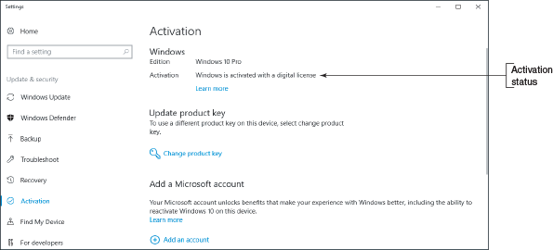
Applying Concepts

Using the Media Creation Tool to Create a Bootable Windows Setup DVD or Flash Drive
To create the installation media, you’ll need a blank DVD, 4-GB or larger USB flash drive, or at least 4 GB of free space on your hard drive. Use a blank flash drive because any data on it will be lost. To use the Media Creation Tool to download Windows setup files and create a bootable DVD or USB flash drive, follow these steps:
- To download and install the Media Creation Tool, use a working computer, go to the website microsoft.com/en-us/software-download/windows10, and click Download tool now. Save the file and then run MediaCreationTool1803.exe.
- Accept the license terms. On the next window shown in Figure 12-9, select Create installation media (USB flash drive, DVD, or ISO file) for another PC and click Next.
Figure 12-9
The Media Creation Tool can be used to upgrade a computer or to create installation media
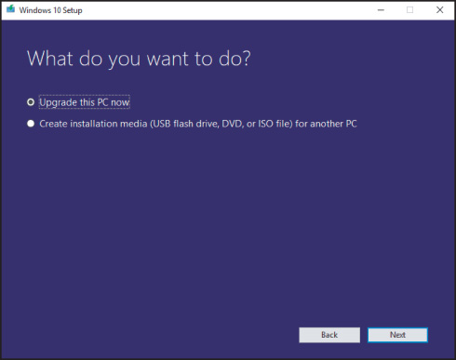
- Select a language and architecture (64-bit or 32-bit), as shown in Figure 12-10. (The only edition available to select is Windows 10.) Alternatively, if you’re creating installation media as a troubleshooting tool for the computer you’re using, check Use the recommended options for this PC. Click Next.
Figure 12-10
The installation medium is bit specific: Choose 32-bit for a 32-bit computer and 64-bit for a 64-bit computer
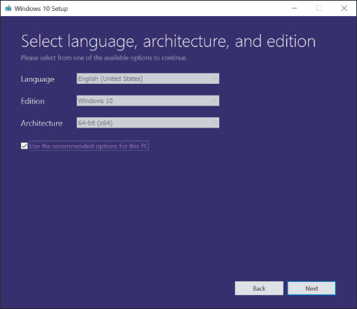
Notes
The best practice is to save the Windows setup files to a USB flash drive or ISO image. You never know when you’ll need the files later to repair a corrupted Windows installation.
- On the next screen, select USB flash drive or ISO file, which you can later burn to a DVD. If you choose USB flash drive, the tool searches for the drive. If you choose ISO file, the tool asks for the location to save the file (see Figure 12-11). Navigate to the location, click Save, and follow the on-screen instructions. After the download completes, if you chose to save an ISO file, you will be given the opportunity to insert a DVD in the disk drive, right-click the ISO file, and click Burn disc image.
Figure 12-11
Select a location to save the ISO file
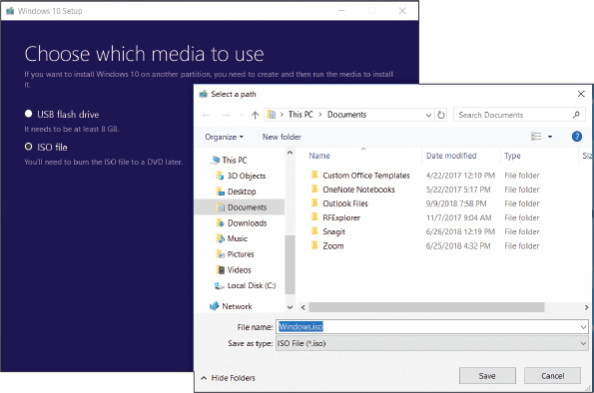
Here’s some useful information about an ISO file:
- An ISO file, also called an ISO image or disc image, is an image of an optical disc, including its file system and all its files and folders. An ISO (International Organization for Standardization) file has an .iso file extension.
- To see the contents of an ISO file, open File Explorer or Windows Explorer, right-click the file, and click Mount. The ISO file is assigned a drive letter and you can drill down into its contents.
- If you have an optical drive that can write to DVDs and you want to burn a DVD from an ISO file, insert a blank DVD in your optical drive and double-click the ISO file. Follow the on-screen directions and Windows does the rest.
- Later in the chapter, you learn how to mount an ISO file to a virtual DVD drive in a virtual machine and use it to install Windows in the VM, as you would with a physical DVD installed in a physical computer.
Go to pg.
help
Application Opened
Main content

12-2Installing Windows 10, Windows 8.1, and Windows 7
A+ Core 2
- 1.3
Summarize general OS installation considerations and upgrade methods.
In this part of the chapter, you learn the steps to install Windows as an in-place upgrade, clean install, and dual boot. You also learn how to handle the special situation of using a Windows upgrade product key to install Windows on a new hard drive. Later in the chapter, you learn to install Windows 10 on a virtual machine. As you install and configure software, be sure to document what you do. This documentation will be helpful for future maintenance and troubleshooting. In a project at the end of this chapter, you will develop a documentation template.
Let’s begin with how to perform an in-place upgrade of Windows 10.
Go to pg.
help
Application Opened
Main content

12-2aWindows 10 In-Place Upgrade
A+ Core 2
- 1.3
Summarize general OS installation considerations and upgrade methods.
The Windows 10 upgrade retail package comes with 32-bit and 64-bit options. The product key is found in a slip pocket inside the box or is included in the emailed receipt. Here are the steps to perform an in-place upgrade from Windows 8.1 to Windows 10 when you’re working with a Windows 10 setup DVD or USB flash drive:
- Sign in to Windows using an administrator account, which is a user account that has the right to install system software.
- As with any upgrade installation, do the following before you start the upgrade:
  - Scan the system for malware using an updated version of anti-malware software. When you’re done, be sure to close the anti-malware application so it’s not running in the background.
  - Uninstall any applications or device drivers you don’t intend to use in the new installation.
  - Make sure your backups of important data are up to date and then close any backup software running in the background.
- Insert the Windows 10 setup DVD or flash drive or mount the setup ISO file. Recall that to mount an ISO file, you right-click it and click Mount. Windows assigns a drive letter to the file and you can access its contents.
- Open File Explorer and double-click the setup.exe program in the root of the device or mounted ISO file. (For a DVD, the setup program might start automatically.) When the User Account Control box appears, click Yes. The setup program loads files, examines the system, and reports any problems it finds. If it finds the system meets minimum hardware requirements, setup asks permission to go online for updates (see Figure 12-12). Make your selection and click Next.
Figure 12-12
Decide how you will handle updates during the setup process
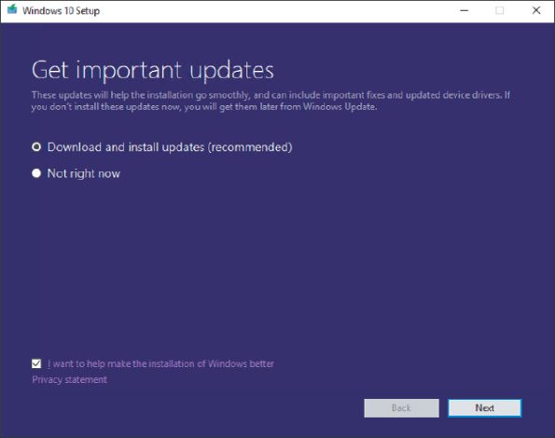
- The next window requests the product key (see Figure 12-13). Enter the product key; Windows verifies that the key is valid. If the computer is connected to the Internet, setup will automatically activate Windows during the installation. Click Next.
Figure 12-13
The product key is verified as valid during the setup process
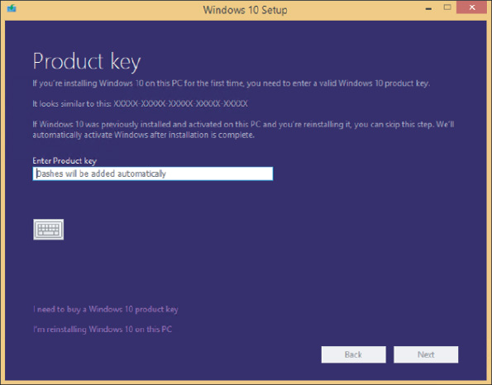
Notes
If you prefer to activate Windows 10 after the installation, you can click I’m reinstalling Windows 10 on this PC, which allows you to proceed without a product key and install Windows 10 although it’s not yet activated. This is a good way to practice Windows installations.
- The License terms window appears. Click Accept.
- Wait for updates to download. Then, in the Ready to install window, verify that Keep personal files and apps is selected. To specify what you want to retain from the previous installation, click Change what to keep (see Figure 12-14).
Figure 12-14
Windows is ready to install as an upgrade, but you can still change what to keep
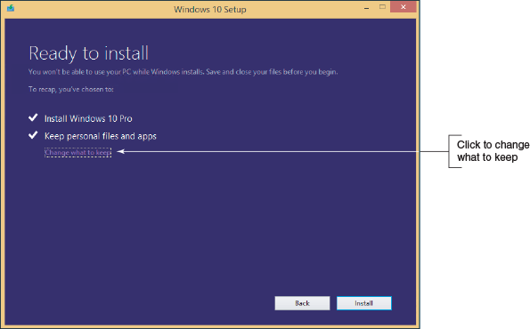
- In the Choose what to keep window (see Figure 12-15), decide what you want to do with Windows settings, personal files, and apps:
  - The first two options perform upgrades to Windows 10.
  - The Nothing option performs a clean install of Windows 10.
Figure 12-15
Decide what to keep of the old installation
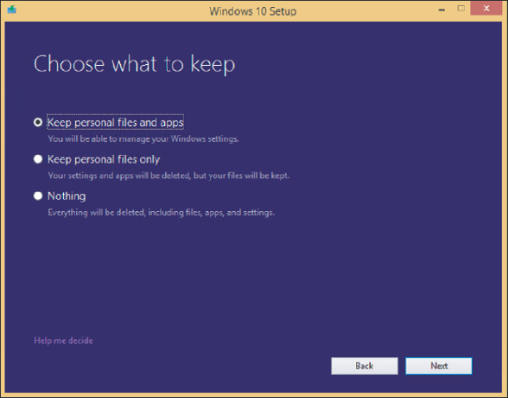
In this example, you are doing an in-place upgrade installation, so select Keep personal files and apps, and then click Next. The Ready to install window appears again.
- On the Ready to install window, verify the choices listed and click Install to begin the installation.
- During the installation, setup might restart the system several times. When the Welcome to Windows 10! screen appears showing your user name, click Next.
- On the Choose privacy settings for your device screen, select the privacy settings for location, speech recognition, diagnostics, tailored experiences with diagnostic data, and relevant ads, and then click Accept.
Notes
You might need to scroll down to view all the privacy settings on this screen.
- On the Meet Cortana screen, you can decide to give Microsoft permission to use your information to personalize your experience with Cortana. To read more about the type of information Microsoft collects for Cortana, click Learn more. Click Not now or Use Cortana to move to the next screen.
- The New apps for the new Windows screen appears. Review the new apps built into Windows 10. Click Next.
- Settings are applied and the Windows 10 sign-on screen appears. You can now use the new upgrade to Windows 10.
Go to pg.
help
Application Opened
Main content

12-2bWindows 10 Clean Install
A+ Core 2
- 1.3
Summarize general OS installation considerations and upgrade methods.
Recall that a clean install is the best option to use if the current installation is sluggish or causing problems, the currently installed OS does not allow for an in-place upgrade, or you’re installing Windows 10 on a new hard drive or new desktop computer you’re building.
If you have a Windows 8/7 installation that qualifies for a Windows 10 upgrade and you need to do a clean install, follow these steps:
- Begin by starting the installation from the Windows desktop as you would for an upgrade.
- Follow the previous steps for an in-place upgrade to enter the product key, accept license terms, and download updates.
- When you get to the Ready to install window (refer back to Figure 12-14), click Change what to keep.
- On the Choose what to keep window (refer back to Figure 12-15), click Nothing and click Next. Then continue with the installation. The contents of the volume holding the previous version of Windows is deleted. If the hard drive has other volumes, they are left unchanged.
Use the following steps to perform a clean install on a newly installed hard drive, on a new computer you’re building, or on a computer that has a corrupted Windows installation that refuses to start:
- Boot from the Windows setup DVD or USB flash drive. Recall that you first might need to change the boot priority order in BIOS/UEFI. In the Windows Setup screen (see Figure 12-16), select the language and regional preferences and click Next. On the next screen, click Install now.
Figure 12-16
Decide on language and keyboard preferences
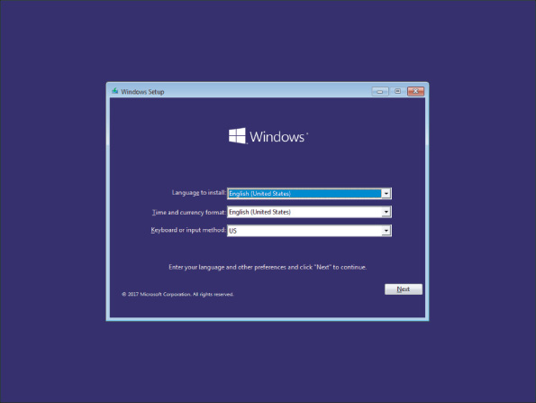
- Enter your product key on the next screen (see Figure 12-17). Click Next. Setup verifies that the key is a valid product key, which then determines the version of Windows to install.
Figure 12-17
Enter a valid product key
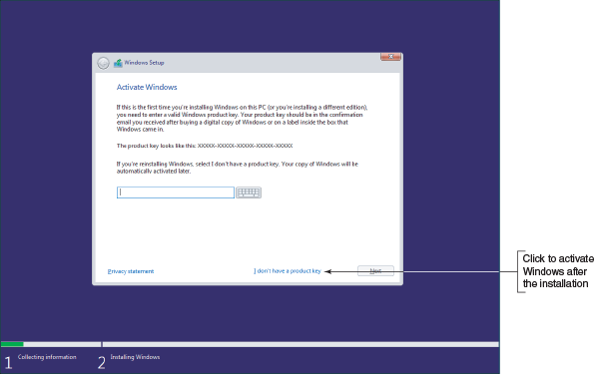
Notes
If you prefer to enter the product key after you have installed Windows, click I don’t have a product key. On the next screen, select the version of Windows you want to install.
- Accept the license agreement on the next screen and click Next. On the next screen (see Figure 12-18), click Custom: Install Windows only (advanced).
Figure 12-18
Decide between an upgrade and a clean installation
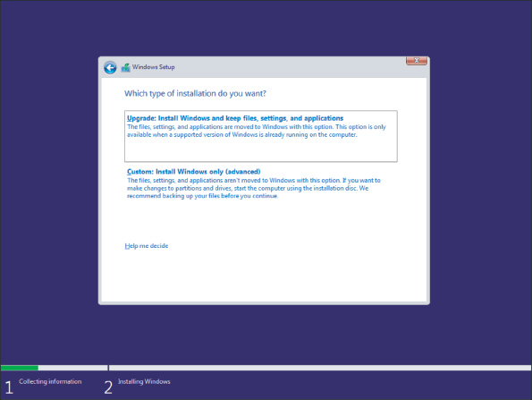
- The Where do you want to install Windows? screen appears. Select the drive and volume where you want to install Windows. By default, setup will use the entire unallocated space for the Windows volume. If you want to use only a portion of the space, click New and enter the size of the volume. (Setup will also create a small system partition that it later uses for system files and the startup process.) Click Next to continue.
- The installation begins. Note that the system might restart several times. When the next screen appears, choose your region and then click Yes.
- On the next screen, choose the right keyboard layout and click Yes. On the next screen, which gives you the option of adding a second keyboard layout, click Skip.
- The setup program detects if your computer is connected to the Internet, checks for updates, and then moves on to the next screen. If your computer has no connection, the Let’s connect you to a network screen appears. The next few steps assume you have an Internet connection; if you don’t, your experience might be different. Click Ethernet to make the connection.
- On the How would you like to set up? screen, you can choose to set up the computer on a school or business network and have limited control, or you can choose to set up the computer for personal use and have full control of it. Select Set up for personal use and click Next.
Notes
If you do not have a network connection set up, Windows has you use an offline, local account by default.
- On the Sign in with Microsoft screen, you can choose to use an existing Microsoft account, create a new Microsoft account, or create an offline account (see Figure 12-19). To create a local, offline account, click Offline account.
Figure 12-19
Choose the type of account to set up
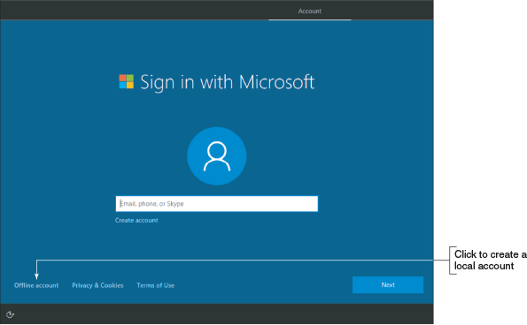
- On the Sign in with Microsoft Instead? screen, Microsoft again encourages you to use a Microsoft account instead of an offline account (see Figure 12-20). To continue creating an offline account, click No.
Figure 12-20
During setup, Microsoft strongly encourages the use of a Microsoft account and not a local account
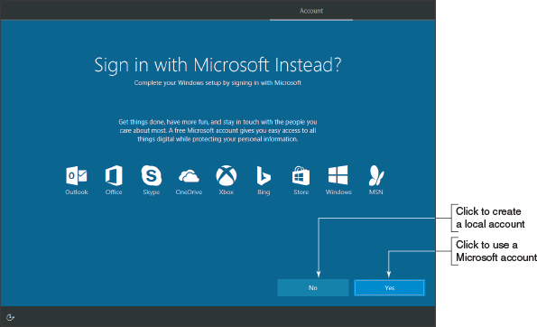
- On the next screen, enter the name for the user of the local account. (Again you see at the bottom of the screen that Microsoft is still encouraging you to use a Microsoft account.) Click Next, enter a password for the offline account, click Next, confirm the password, click Next, create a password hint, and then click Next.
- On the Make Cortana your personal assistant? screen, you can give Microsoft permission to use your information to personalize your experience with Cortana. To read more about the type of information Microsoft collects for Cortana, click Learn more. To accept Cortana, click Yes.
- On the next screen, select the device’s privacy settings for location, speech recognition, diagnostics, tailored experiences with diagnostic data, and relevant ads, and then click Accept.
- The installation continues, settings are applied, and the Windows desktop appears. You can now use the new installation of Windows 10.
Windows 8

Steps to Perform a Windows 8.1 Clean Install
A+ Core 2
- 1.3
Summarize general OS installation considerations and upgrade methods.
Recall that a clean install is the best option to use if the current installation is sluggish or giving problems, the currently installed OS does not allow for an in-place upgrade, or you’re installing Windows 8.1 on a new hard drive.
If you have a Windows 7 installation that qualifies for a Windows 8.1 upgrade and you need to do a clean install, begin by starting the installation from the Windows desktop as you would for an upgrade. When you get to the window shown earlier in Figure 12-15, click Nothing and continue with the installation. The volume holding the old Windows installation is formatted and everything on the volume is lost. If the hard drive has other volumes, they are left unchanged.
OS Differences
The steps and screenshots for a clean install in this section are for Windows 8.1. The steps for Windows 8.0 work about the same way.
To perform a clean install of Windows 8.1, you can begin the installation from the Windows 8.1 DVD or USB flash drive:
- If no operating system is installed on the PC, begin the installation by booting from the Windows 8.1 setup DVD or USB flash drive. Using this method, you will not be using the upgrade option, but will be required to do a Custom installation, also called a clean install.
- If an operating system is already installed on the PC, you can begin the installation from the Windows desktop or by booting from the Windows 8.1 setup DVD or USB flash drive. Either way, you can perform a Custom installation.
Follow these steps to begin the installation by booting from the Windows 8.1 setup DVD or USB flash drive:
- Boot from the Windows setup DVD or USB flash drive. In the Windows Setup screen, select the language and regional preferences and click Next. On the next screen, click Install now.
- Enter your product key on the next screen. Setup verifies that the key is a valid product key. Click Next.
- Accept the license agreement on the next screen and click Next. On the next screen, click Custom: Install Windows only (advanced).
- On the next screen, select the drive and volume where you want to install Windows. By default, setup will use the entire unallocated space for the Windows volume. If you want to use only a portion of the space, click New and enter the size of the volume. (Setup will also create a small reserved partition that it later uses for system files and the startup process.) Click Next to continue.
Notes
If you don’t see the New link on the Where do you want to install Windows? screen, click Drive options (advanced) to see it and other links you can use to manage the space on the hard drive.
- The installation begins, and the system might restart several times. You can select a screen color and enter the PC name. Next, the Settings screen appears.
- After you have made your choices on the Settings screen, the Sign in to your Microsoft account screen appears. (Microsoft really encourages you to use a Microsoft account.) As with an in-place upgrade, you can sign in using an existing Microsoft account or create a new Microsoft account. In addition, you can create a new local account.
If you want to create a new local account, click Create a new account. On the next screen, click Sign in without a Microsoft account. On the Your account screen, enter the local account name, password, and password hint, and then click Finish.
- The installation continues, settings are applied, and the Start screen appears. You can now use the new installation of Windows 8.1.
OS Differences
A clean install of Windows 7 works about the same as a Windows 8.1 installation. Boot from the Windows 7 setup DVD and follow the on-screen instructions.
Go to pg.
help
Application Opened
Main content

12-2cMultiboot Installations
A+ Core 2
- 1.3
Summarize general OS installation considerations and upgrade methods.
You can install two or more operating systems on the same computer in a multiboot situation—for example, Windows 10 and Ubuntu Desktop. Each OS must have its own hard drive partition and each partition must have enough free space to hold the OS, with room for applications, data, and OS working space. Recall that Windows 10/8/7 needs at least 16 GB (32-bit) or 20 GB (64-bit) of free space for the OS. Also know you cannot boot more than one OS at a time. To create a multiboot environment, always install Windows operating systems in order from older to newer.
Notes
If an OS is already installed, you might need to shrink a partition to make room for a second partition to hold the next OS. For Windows, use Disk Management to shrink a partition, create a new partition, or format a partition. Windows requires the NTFS file system. How to use Disk Management is covered in Chapter 13.
Here are the steps to set up a dual-boot system with two operating systems (using Windows 8.1 and 10 as examples):
- Install Windows 8.1. If you plan to install Windows 10 on the same hard drive as Windows 8.1, leave some unallocated space for the Windows 10 partition. (See the setup screen in Figure 12-21, which works the same in Windows 8.1 as in Windows 10.) On this screen, click New. You can then specify how much of the total unallocated space you want to use for the Windows 8.1 installation.
Figure 12-21
This hard drive has not yet been partitioned
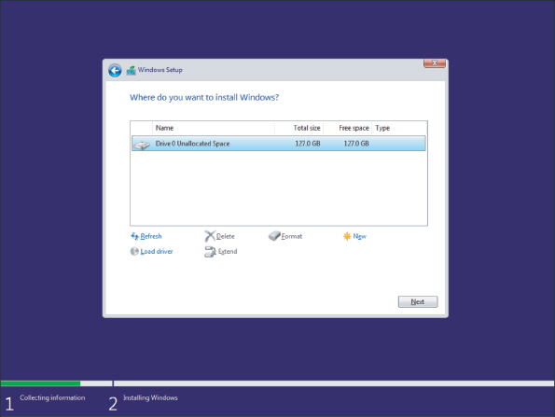
- To install Windows 10, first make sure you have (a) a second partition with enough free space to hold the Windows 10 installation, (b) enough unallocated space on the drive to create a new partition while installing Windows 10, or (c) a second hard drive to hold the Windows 10 installation.
- Start the Windows 10 installation by booting from the Windows 10 setup DVD or USB flash drive. The Windows Setup screen appears. Follow the steps given earlier in this chapter to perform a clean install.
- When you’re asked where to install Windows, select the partition or unallocated space to hold the installation. For example, select Unallocated Space to hold the Windows 10 installation, as shown in Figure 12-22. Don’t select the partition where the older operating system is already installed; doing so causes the setup program to install Windows 10 in place of the older OS. Continue on to complete the clean install.
Figure 12-22
Select unallocated space or a partition other than the one used by the first OS installation
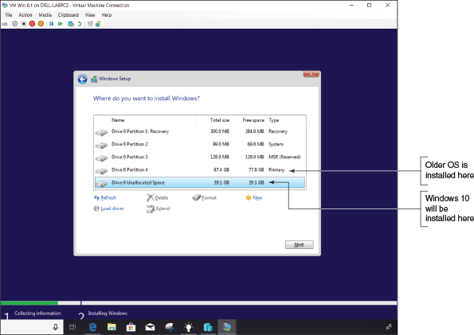
After the installation, when you boot with a dual boot, the boot loader menu automatically appears and asks you to select an operating system, as shown in Figure 12-23.
Figure 12-23
The boot loader menu in a dual-boot environment
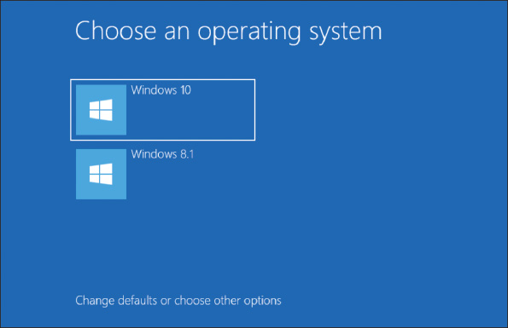
When using a dual boot, you can execute an application while one OS is loaded even if the application is installed under the other OS, as long as each OS is using the same architecture (32-bit or 64-bit). If the application is not listed on the Windows 10 Start menu or the Windows 8.1 Start screen, locate the program file in File Explorer. Double-click the application to run it.
Go to pg.
help
Application Opened
Main content

12-2dSolving Problems with Installations
A+ Core 2
- 1.3
Summarize general OS installation considerations and upgrade methods.
In this part of the chapter, we look at a few special situations you might encounter when installing Windows and what to do about them, including how to use an upgrade product key with a new hard drive and problems that require preparing a hard drive before the installation.

Use an Upgrade Product Key on a New Hard Drive
Suppose a Windows upgrade license has been used to install Windows on a computer and later the hard drive fails. You replace the hard drive with a new one, and now you need to reinstall and activate Windows. Microsoft doesn’t sell a Windows 10 upgrade product key, but it did offer a free upgrade to Windows 10 from Windows 8.1 or 7 for a short time. These first free releases of Windows 10 can be activated using Windows 8.1, 8, or 7 product keys. Starting with the 1607 release of Windows 10, Windows began to use digital licenses that are linked to a Microsoft account. If you do not have a valid product key or did not link your Windows activation to a Microsoft account, you must buy a new Windows license with a product key. If you used a Microsoft account and Version 1607 or later, you can reinstall Windows 10 by simply logging in with your Microsoft account and activating Windows using the Activation troubleshooter in the Settings app. When you launch the Activation troubleshooter, click I changed hardware on this device recently. You will be required to use a Microsoft account to proceed.
In a situation where a Windows 7 system was upgraded to Windows 8.0 and then updated to Windows 8.1:
- Reinstall Windows 7. You don’t need to enter the product key during the installation or to activate Windows 7.
- Reinstall Windows 8.0 using the upgrade product key and make sure Windows 8 is activated after the installation.
- Download and install the free Windows 8.1 upgrade from the Windows Store.
Applying Concepts

Converting an MBR Drive to GPT
Suppose you want to use a 64-bit version of Windows and UEFI firmware mode, thus requiring you to use the GPT partitioning system. However, your hard drive has already been partitioned with the MBR system. The error won’t show up until you get to the step in the installation where you select the partition or unallocated space on the hard drive to hold the Windows installation (see Figure 12-24).
Figure 12-24
An error appears when Windows is in UEFI mode and requires the GPT partitioning system
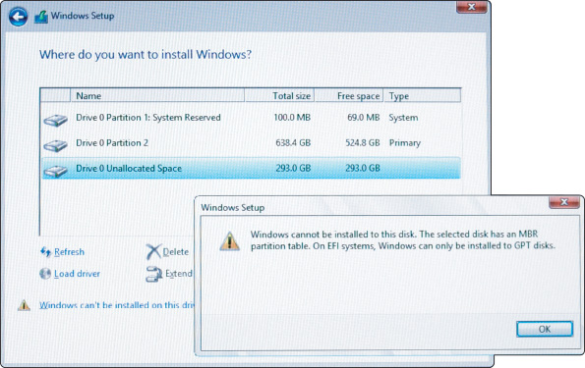
Follow these steps to use the diskpart command to wipe the partition system off the hard drive. All data on the drive will be destroyed and then you can convert the drive to GPT:
- Restart the computer from the Windows setup DVD and select your language and regional preferences. Click Next. On the next screen, select Repair your computer (see Figure 12-25).
Figure 12-25
Use the Windows setup DVD to launch a command prompt
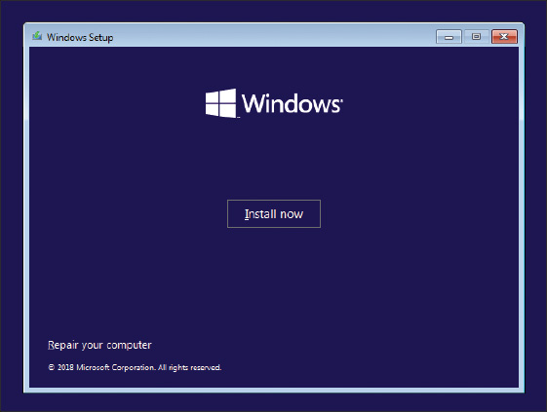
- On the next screen, click Troubleshoot. On the Advanced options screen, click Command Prompt. A command prompt window appears. Type diskpart and press Enter. The DISKPART> prompt appears, as shown in Figure 12-26.
Figure 12-26
The command prompt window with diskpart running
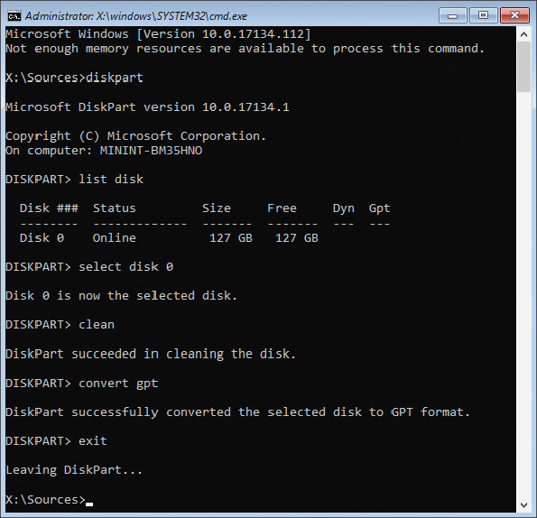
- At the DISKPART> prompt, use the commands shown in Table 12-5 and Figure 12-26 to select the hard drive, clean it, and convert it to a GPT drive:
Table 12-5

Diskpart Commands to Convert an MBR Drive to GPT
Command | Description
list disk | List the hard drives installed. If you have more than one hard drive, use the size of the drive to determine which one you want to clean. Most likely, you will have one hard drive identified as Disk 0.
select disk 0 | Make Disk 0 the selected hard drive.
clean | Clean the partition table and all partitions from the drive.
convert gpt | Convert the partitioning system to GPT.
exit | Exit the diskpart utility.
- Enter one more exit command to close the command prompt window. On the setup screen that appears, click Turn off your PC.
- You can now restart the system and install Windows in UEFI mode, which uses the GPT partitioning system.

Repair a Damaged Hard Drive
Besides diskpart, you can also use the format command in the command prompt window available from Windows setup media. Two types of formats are:
- Quick format, which creates an empty root directory for a volume, effectively resulting in all data being deleted from the volume. When Windows installs and formats the hard drive, it uses a quick format to save time.
- Full format, which creates an empty root directory, checks each sector on the volume for errors, and marks bad sectors so they will not be used by the file system.
If you suspect the hard drive is damaged and Windows will not start, launch the command prompt window from the Windows setup media and perform a full format. How to use the format command is covered in Chapter 13. In addition, the diskpart commands include the format command, with options for a quick or full format.
Caution
If sensitive data is on the hard drive, know that a quick or full format will not actually erase this data from the drive; hackers have been known to be able to read such data even after the volume is formatted. To actually erase the data, you can use a zero-fill utility available from hard drive manufacturers. This software overwrites everything on the drive with zeroes. You learn more about zero-fill utilities in Chapter 17.
Go to pg.
help
Application Opened
Main content

12-3What to Do After a Windows Installation
A+ Core 2
- 1.3
Summarize general OS installation considerations and upgrade methods.
- 1.5
Given a scenario, use Microsoft operating system features and tools.
- 1.6
Given a scenario, use Microsoft Windows Control Panel utilities.
- 1.7
Summarize application installation and configuration concepts.
- 2.6
Compare and contrast the differences of basic Microsoft Windows OS security settings.
- 2.7
Given a scenario, implement security best practices to secure a workstation.
After you have installed Windows, you need to do the following:
- Verify that you have network access.
- Activate Windows.
- Install updates for Windows and verify update settings and anti-malware settings.
- Install hardware.
- Set up user accounts and transfer or restore user data and preferences from backups to the new system.
- Install applications.
- Turn Windows features on or off.
- For laptops, use Control Panel to configure power-management settings. Power management was covered in Chapter 11.
Caution
To protect your computer from malware, don’t surf the web for drivers or applications until you have updated Windows and verified that anti-malware software is providing real-time protection from malware.
Go to pg.
help
Application Opened
Main content

12-3aVerifying Network Access
A+ Core 2
- 1.5
Given a scenario, use Microsoft operating system features and tools.
Do the following to verify network and Internet access:
- To make a wired connection to a network when using Windows, simply plug in the network cable and let Windows do the rest. To create a wireless connection, click the network icon in the taskbar and select the wireless network. You might need to enter a password to the Wi-Fi network.
- To verify access to the local network, open File Explorer or Windows Explorer and verify that you can see other computers on the network (see Figure 12-27). Try to drill down to see shared resources on these computers.
Figure 12-27
Use File Explorer to access resources on your network
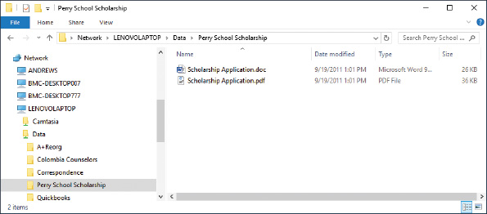
- To verify Internet access, open Internet Explorer and try to navigate to a couple of websites.
If a problem arises, the problem might be that you need to install the drivers for the motherboard, including the drivers for the onboard network port. Also, the IP address, wireless network, or network security settings might be wrong. How to configure network settings and troubleshoot network connections is covered in Chapter 7.
Go to pg.
help
Application Opened
Main content

12-3bActivating Windows
A+ Core 2
- 1.3
Summarize general OS installation considerations and upgrade methods.
To make sure a valid Windows license has been purchased for each installation of Windows, Microsoft requires product activation. If you entered a product key during the installation, Windows is already activated.
To view the activation status, open the Settings app, select the Update & security group, and then select Activation. Figure 12-28 shows the Activation window for a system that is not activated. To activate, you have a couple of options. First, make sure you’re connected to the Internet. If you need to purchase Windows 10, click Go to Store. If you already have a product key, click Change product key.
Figure 12-28
View the activation status using the Settings app
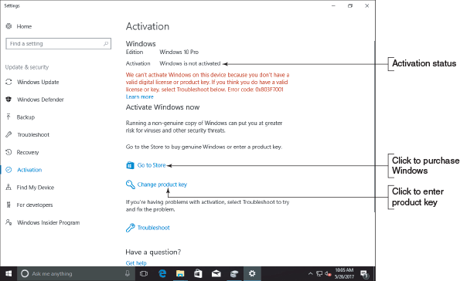

Problems with Activation
As explained earlier in this chapter, if the system already has a digital license or the product key is stored on the motherboard firmware, an upgrade or clean install will activate itself; you don’t need to enter a product key. Here are some situations that might cause trouble when activating Windows:
- Replacing a failed hard drive. If you replace a failed hard drive with a new drive, you should still be able to perform a clean install of Windows 10 on the new hard drive and rely on the digital license, with no need to enter the product key. During setup, don’t enter a product key. After Windows is installed, open the Settings app, select the Activation group, and verify that Windows is activated. If it is not, click Troubleshoot in the Activation window. Windows troubleshoots the problem and offers solutions. For example, when you click I changed hardware on this device recently in Figure 12-29, the troubleshooter gives you the opportunity to communicate with Microsoft and verify that the computer has a license to use Windows.
Figure 12-29
The activation troubleshooter resolves activation problems and might lead you to a chat window with Microsoft support
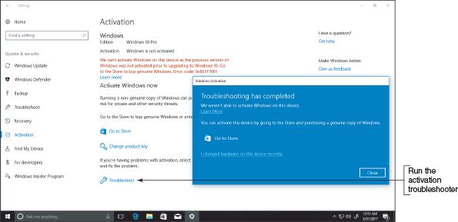
- Upgrading the motherboard. If the system is working, be sure to associate your Microsoft account with the Windows installation before you upgrade the motherboard. To do so, add the account and sign in to Windows using it. This will associate the digital license and hardware signature stored on Microsoft activation servers with your Microsoft account.
Later, after you upgrade the motherboard, start Windows and sign in using your Microsoft account. The system should be activated when Microsoft servers recognize your Microsoft account and the machine. If the installation is not activated, open the Settings app, select the Activation group, and then click Troubleshoot.
- Replacing a failed motherboard. Suppose the motherboard fails and you replace it, but you have never signed in to Windows using the Microsoft account that purchased the product key. In that case, Windows might not activate automatically and the Activation troubleshooter might not be able to resolve the problem. In this situation, you most likely will need to talk with Microsoft support staff and explain the problem.
- Upgrading from Windows 8 Home to Windows 10 Pro. When upgrading from Windows 8 Home to Windows 10 Pro, the installation may automatically upgrade to Windows 10 Home without giving you the option to choose Pro. If this happens, go to the Activation window after the installation is complete and enter your new product key for Windows 10 Pro. The system should reactivate with Windows 10 Pro.
- Reinstalling Windows 10 Pro. Suppose Windows 10 Pro is activated on a system and then gets corrupted. You perform a clean install to fix the problem, but setup automatically installs and activates Windows 10 Home without asking for a product key. You can fix the problem by going to the Activation window and changing the product key to the default product key for Pro: VK7JG-NPHTM-C97JM-9MPGT-3V66T. The system should reactivate with Windows 10 Pro.
Windows 8

Activate Windows
To view the activation status for Windows 8/7, go to the System window. Figure 12-30 shows the window for a system that is not activated. To activate, make sure you’re connected to the Internet and click Activate Windows. On the next screen, if necessary, you can enter a new product key and then activate Windows.
Figure 12-30
Use the System window to activate Windows
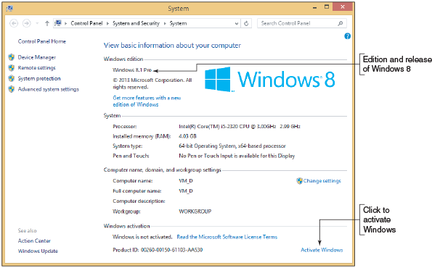
Go to pg.
help
Application Opened
Main content

12-3cInstalling Windows Updates
A+ Core 2
- 1.3
Summarize general OS installation considerations and upgrade methods.
- 1.5
Given a scenario, use Microsoft operating system features and tools.
- 2.7
Given a scenario, implement security best practices to secure a workstation.
The Microsoft websites offer patches, fixes, and updates for known problems and have an extensive knowledge base that documents problems and their solutions. It’s important to keep these updates current on your system to fix known problems and plug up security holes that might allow malware. Be sure to install updates before you attempt to install software or hardware.
Windows 10 updates automatically by default on a regular basis. To apply any pending Windows 10 updates, open the Settings app and click the Update & security group. In the Windows Update window (see Figure 12-31), you can view the update status and install any available updates. Depending on the situation, you might click Restart now to finish installing updates, click Install now to install available updates, or click Check for updates if no updates are available. Keep installing important updates and checking for more updates until no more are available. You might need to restart the system after certain updates are installed.
Figure 12-31
View and manage Windows 10 updates
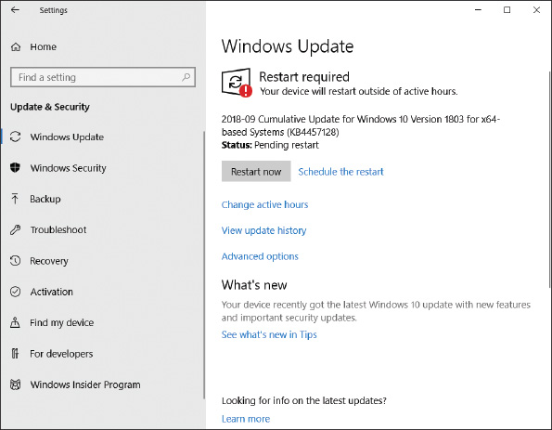
Tools you can use to manage update settings include the Settings app, Group Policy, and the Registry Editor. Here’s a brief list of your options for managing updates from the Settings app:
- View or uninstall an update. In the Settings app, click Update & security and then click Windows Update in the left pane. Click View update history to review recent updates and to uninstall updates that are available for uninstallation (see Figure 12-32).
Figure 12-32
Use the Settings app to manage Windows 10 updates
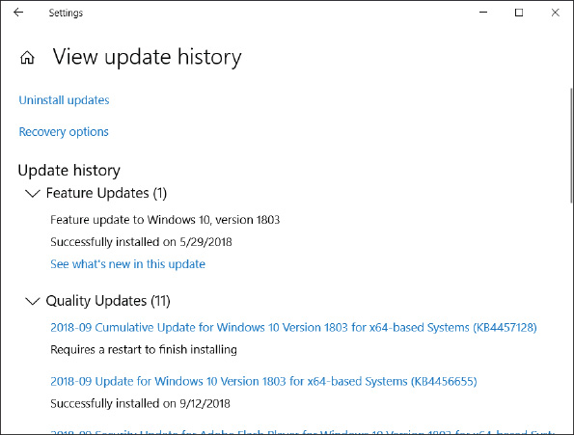
- Schedule restarts and active hours. In the Windows Update window, use the Update settings section to schedule a pending restart or to set active hours, during which time the computer will avoid automatic restarts. Note that if a scheduled restart occurs outside of active hours but when the computer is in use, you will have an opportunity to delay the restart.
- Update other Microsoft products and Windows features. In the Windows Update window, click Advanced options. On the Advanced options window (see Figure 12-33), you can choose to receive updates to other Microsoft products along with Windows updates. You can also allow Windows to automatically sign you in and finish installing updates after a Windows restart.
Figure 12-33
Control how updates to Windows and Microsoft apps are installed
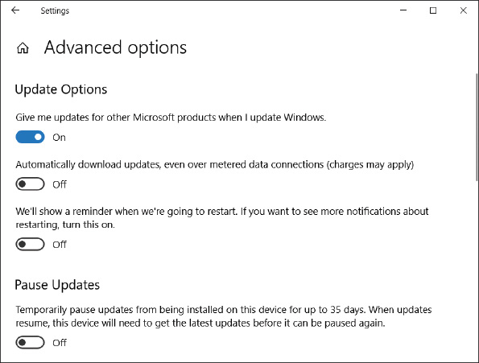
- Defer or pause updates. For business and professional editions of Windows 10, you can open the Advanced options window and then choose when updates are installed or pause updates. Notice in Figure 12-33 that updates can be deferred for up to 35 days. You cannot defer or pause security updates in this window.
Windows 8

Update Windows 8
To view and manage Windows 8/7 update settings, open the System window and click Windows Update in the left pane. In the Windows Update window (see Figure 12-34), click Check for updates in the left pane. Don’t forget to keep checking for and installing updates until there are no more to install. To change Windows Update settings, click Change settings in the Windows Update window and use the Change settings window.
Figure 12-34
View and manage Windows 8 updates
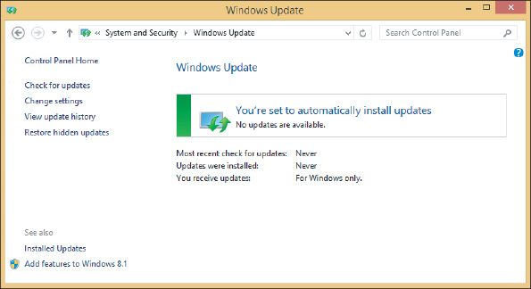
If Windows 8.0 is installed, you can update it to Windows 8.1 for free. Open the Windows Store app on the Start screen, select the Windows 8.1 update, and follow the on-screen directions to download and install it.
OS Differences
Recall that Windows 7 releases major updates as a service pack. On a Windows 7 system, if you see a service pack listed in the updates, install all the updates listed above it. Then install the service pack as the only update to install. It takes about 30 minutes and a reboot to download and install a service pack. Only the latest OS service pack will install because it includes all the content from previous service packs.

Malware Protection
Windows includes its own preinstalled, anti-malware software called Windows Defender Antivirus in Windows 10 and Windows Defender in Windows 8/7. To verify that the utility is running in Windows 10, open Control Panel, click Security and Maintenance, and expand the Security group (see Figure 12-35).
Figure 12-35
Verify that Windows Defender Antivirus is running
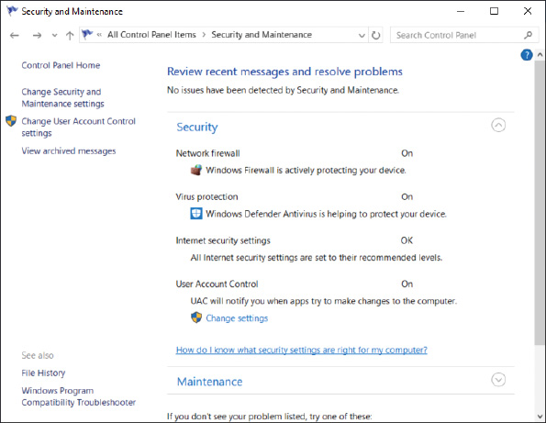
To verify protection in Windows 8, launch Windows Defender from the Start screen or menu. On the Settings tab, verify that Real-time protection is turned on.
OS Differences
In Windows 7, Windows Defender is not considered adequate protection against malware. For Windows 7, it’s best to install third-party anti-malware software.
Go to pg.
help
Application Opened
Main content

12-3dInstalling Hardware
A+ Core 2
- 1.3
Summarize general OS installation considerations and upgrade methods.
- 1.5
Given a scenario, use Microsoft operating system features and tools.
- 1.6
Given a scenario, use Microsoft Windows Control Panel utilities.
You’re now ready to install the hardware devices that were not automatically installed during the Windows installation. Be sure to install 32-bit drivers for a 32-bit OS and 64-bit drivers for a 64-bit OS. Also, as much as possible, install drivers designed for the specific OS: Windows 10, Windows 8.1, or Windows 7. Sometimes drivers designed for an older OS will still work in the newer one. As you install each device, reboot and verify that the software or device is working before you move on to the next item. Most likely, you will need to do the following:
- Install the drivers for the motherboard. Motherboard drivers might come on a CD or DVD bundled with the motherboard, or you can download them from the motherboard manufacturer’s website. To start the installation, double-click a setup program on the disc or that you downloaded and follow the on-screen directions.
- Even though Windows has embedded video drivers, install the drivers that came with the video card so you can use all the features the card offers. These drivers are on disc or are downloaded from the video card manufacturer’s website.
- Install printers. To install a local USB printer, all you have to do is plug it in and Windows will install it automatically. For a network printer, you can run the setup program that came with the printer and the program will find and install the printer. Alternately, open Control Panel in Classic view and open the Devices and Printers window. Then click Add a printer and follow the on-screen directions.
- For other hardware devices, always read and follow the manufacturer’s directions for the installation. Sometimes you are directed to install the drivers before you connect the device, and sometimes you will first need to connect the device.
If a problem arises while installing hardware in Windows 10, open Control Panel and click Troubleshooting. In the Troubleshooting app (see Figure 12-36), click Hardware and Sound. Windows will search for hardware installation problems and suggest solutions. If the problem persists, turn to Device Manager.
Figure 12-36
Use the Troubleshooting app in Control Panel to resolve hardware installation problems
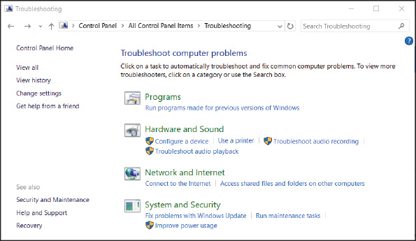
OS Differences
If a problem occurs while Windows 8/7 is installing a device, it automatically launches the Action Center to help find a solution. Follow the on-screen directions to allow Windows to help you resolve the problem.

Use Device Manager
Device Manager is your primary Windows tool for managing hardware. (Its program file is named devmgmt.msc.) It lists all installed hardware devices and the drivers they use. Using Device Manager, you can disable or enable a device, update its drivers, uninstall a device, and undo a driver update (called a driver rollback).
A+ Exam Tip
The A+ Core 2 exam expects you to know which scenarios are appropriate for using Device Manager. You also need to know how to use the utility and how to evaluate its results.
To access Device Manager, use one of these methods:
- For Windows 10/8, right-click Start and select Device Manager.
- Open the System window and click Device Manager.
- Enter the devmgmt.msc command in the Windows 10/7 search box or the Windows 8 Run box.
A Device Manager window is shown in Figure 12-37.
Figure 12-37
Use Device Manager to uninstall, disable, or enable a device
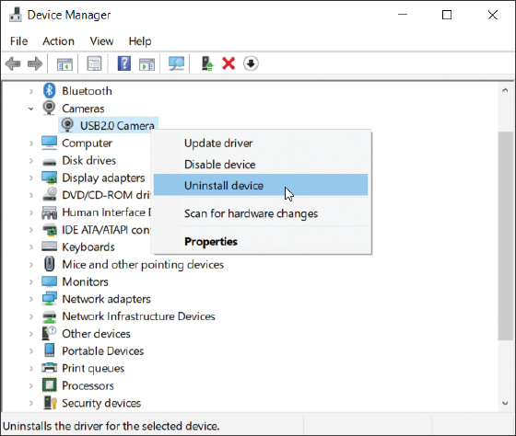
Click an arrow to expand the view of an item or to collapse the view. Here are ways to use Device Manager to solve problems with a device:
- Uninstall and reinstall the device. To uninstall the device, right-click it and click Uninstall device on the shortcut menu, as shown in Figure 12-37. (Alternately, you can click Properties in the shortcut menu to open the Properties box and then click Uninstall Device on the Driver tab, as shown in Figure 12-38A.) Then reboot the system. Windows will recognize that the device is not installed and attempt to install the appropriate driver. Look for issues during the installation that point to the source of the problem. Sometimes, though, reinstalling a device is all you need to do. Notice in Figure 12-38B that the selected Device type is Cameras, and that the camera is connected through a USB interface. Sometimes USB devices are listed in Device Manager and sometimes they are not.
Figure 12-38
(A) Use the device’s Properties box to uninstall a device and (B) solve problems with device drivers
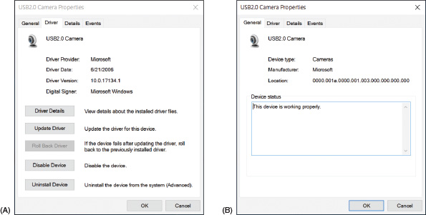
- Look for error messages offered by Device Manager. To get more information about a device, look for error messages that show up on the General tab of the Properties box (see Figure 12-38B). Some messages might suggest a solution.
- Update or roll back the drivers. Click the Driver tab (see Figure 12-38A) to update the drivers and roll back (undo) a driver update.
Applying Concepts

Updating Device Drivers
Follow these steps to use Device Manager to update device drivers:
- For best results, locate and download the latest driver files from the manufacturer’s website to your hard drive. Be sure to use 64-bit drivers for a 64-bit OS and 32-bit drivers for a 32-bit OS. If possible, use drivers specifically designed for Windows 10, Windows 8.1, or Windows 7.
- Using Device Manager, right-click the device and select Properties from the shortcut menu. The Properties box for that device appears. Select the Driver tab and click Update Driver. The Update Driver Software box opens.
- To search the Internet for drivers, click Search automatically for updated driver software. If you have already downloaded drivers to your computer, click Browse my computer for driver software and point to the downloaded files. Note that Windows is looking for an .inf file to identify the drivers. Continue to follow the on-screen directions to complete the installation.
Notes
By default, Device Manager hides legacy devices that are not Plug and Play. To view installed legacy devices, click the View menu of Device Manager and check Show hidden devices.
Go to pg.
help
Application Opened
Main content

12-3eSetting Up User Accounts
A+ Core 2
- 1.7
Summarize application installation and configuration concepts.
- 2.6
Compare and contrast the differences of basic Microsoft Windows OS security settings.
As you know, a user must sign in to Windows with a valid user account to gain access to the OS. When you install Windows as a clean installation, you create a user account and you can create others later. Here’s a brief overview of the types of user accounts and the privileges associated with them:
- The scope of the account. Windows offers three types of user accounts, each with a different scope:
  - Local account. A local account is created on the local computer and is recognized only on the local computer.
  - Network ID. Professional and business editions of Windows allow a user to sign in to Windows with a network ID and password that are created and maintained on a Windows domain in Active Directory or Azure Active Directory. When you sign in to Windows using this type of account, you are authenticated to the local computer and to the Windows domain on a corporate network or in the cloud.
  - Microsoft account. For Windows 10/8, a Microsoft account is an email address initially set up at the Microsoft website, live.com. The account gives you access to several types of online accounts, including Microsoft OneDrive, Facebook, LinkedIn, Twitter, Skype, and Outlook.com. On a Windows computer, you can associate or link a Microsoft account to a local account or a network ID. As you learned earlier in the chapter, Microsoft makes every effort to encourage you to use a Microsoft account in Windows.
Notes
A Microsoft account is an example of a single sign-on (SSO) account, which accesses multiple, independent resources, systems, or applications after you sign in one time to one account.
- Privileges for the account. In Windows, there are two types of privileges assigned to a user account: those for an administrator account and for a standard account. An administrator account has more privileges than a standard account and is used by people responsible for maintaining and securing the system.
Applying Concepts

Creating a Local Account
To create a new account, you can use the Windows 10 Settings app, the Windows 8 Settings charm, the Windows 7 User Accounts applet in Control Panel, or, for all editions of Windows, the Computer Management console in Control Panel. You have more control over creating and setting up an account when you use the Computer Management console, as you learn in Chapter 16. For now, let’s use one of the other methods; follow these steps to create a local account:
- Sign in to Windows with an administrator account.
- Do one of the following to create an account:
  - Windows 10. Open the Settings app. Click Accounts. Click Family & other people and click Add someone else to this PC. See Figure 12-39. Click I don’t have this person’s sign-in information and click Add a user without a Microsoft account (see the right side of Figure 12-39). Enter a user name, enter the password twice, and click Next.
Figure 12-39
Bypass the Microsoft account and create a local account
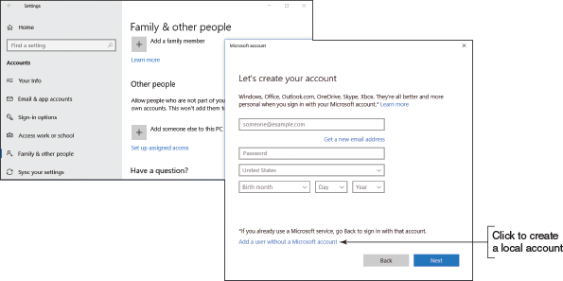
  - Windows 8. Open the Settings charm and click Change PC settings. On the PC settings screen, click Accounts. On the Accounts screen, click Other accounts (see Figure 12-40). Click Sign in without a Microsoft account (not recommended), and click Next. Follow the on-screen directions to set up the account.
Figure 12-40
Set up a new user account
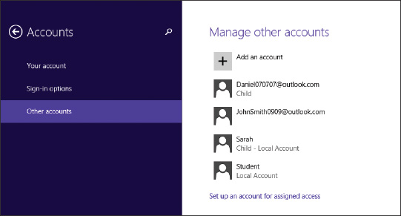
- In Windows 10/8, the account created is a standard account. To change the account type to administrator, click the account and click Change account type. Then select Administrator and click OK. To remove the account, select it and click Remove.
The first time a user signs in to Windows with the account, user files and folders (called the user profile) are created in the C:\Users folder.
OS Differences
You create an account in Windows 7 by signing in to it using an administrator account. Open Control Panel in Classic view and click User Accounts. Click Manage another account. Click Create a new account. Enter the user name and select Standard user or Administrator. Click Create Account.
After you have created user accounts in a new installation of Windows, you might want to transfer user data files from the C:\Users folder or other folders on the hard drive to the new computer. How to share files and folders on a network is covered in Chapter 16.
Notes
After moving user data from one computer to another, the best practice is to leave the user data on the original computer untouched for at least two months. This practice gives the user plenty of time to make sure everything has been moved over.

Use a Microsoft Account with Windows 10/8
You might want to associate your local account with your Microsoft account, or set up Windows to sign in with your Microsoft account so that you can get easy access to Microsoft resources in the cloud, such as OneDrive. However, know that anyone with administrative rights to the computer can access your Microsoft private settings, apps, online accounts, and OneDrive stored on the local computer. Therefore, you would only want to set up your Microsoft account on a computer where you trust people with administrative access to the computer. Here are the details of making the switch:
- For Windows 10. To connect an existing local account or network ID to a Microsoft account, open the Settings app, click Users, and then click Sign in with a Microsoft account instead. See Figure 12-41. Follow the on-screen directions, which include entering your current Windows password.
Figure 12-41
Associate a local account with a Microsoft account
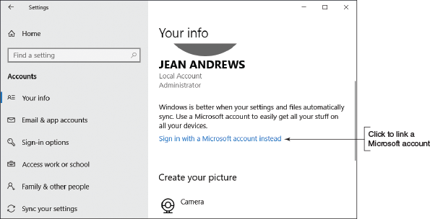
- For Windows 8. Open the charms bar, select the Settings charm, select Change PC settings, and click Accounts. Select Your account and then click Connect to a Microsoft account. Follow the on-screen directions.
Notes
To connect a network ID on a domain to a Microsoft account, the Group Policies controlling the Windows domain must allow it. After the connection, the Microsoft account is used to authenticate to the domain.
If you want to switch the user account back to the local account, go back to your account settings, click Your info, and click Sign in with a local account instead. On a Windows 8 computer, go back to your account settings and click Disconnect.
Recall that you can sign in to Windows using a local account, network ID, or Microsoft account. As you ponder the differences among these accounts, consider where the account is authenticated:
- A local account is authenticated on the local computer and gives access to the local computer. An administrator local account has more access than a standard local account.
- A network ID is authenticated by a computer on the network, which gives you access to the local computer and other resources on the Windows domain.
- A Microsoft account is authenticated on the live.com website, which gives access to the local computer and online resources, such as OneDrive and Facebook.com. A Microsoft account can be a standard account or an administrator account. It can also be associated with a network ID so that you can sign in with the Microsoft account and be authenticated to the Windows network as well as to live.com.

User Account Control Dialog Box
At some point while you are working with a computer to maintain or troubleshoot it, the User Account Control (UAC) dialog box will pop up (see Figure 12-42). If the UAC box appears and you are signed in as an administrator, all you have to do is click Yes to close the box and move on, as shown in Figure 12-42A. If the user account does not have administrative privileges, you’ll have to enter the password of an administrative account to continue, as shown in Figure 12-42B.
Figure 12-42
(A) The User Account Control box of an administrator does not require an administrative password; (B) the UAC box of a standard user requires an administrative password
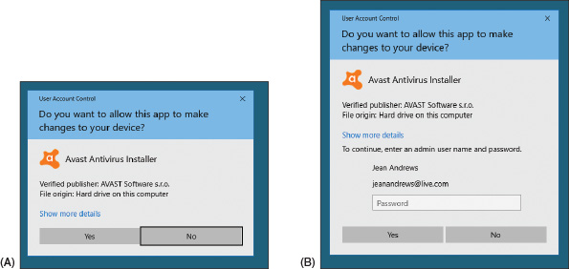
The purposes of the UAC box are:
- to prevent malicious background tasks from gaining administrative privileges when the administrator is signed in, and
- to make it easier for an administrator to sign in using a less powerful user account for normal desktop activities, but still be able to perform administrative tasks while signed in as a regular user.
The UAC box stands as a gatekeeper to malware installing behind your back because someone has to click the UAC box before the installation can proceed.
You can control how the UAC box works. In Control Panel, click User Accounts and click Change User Account Control settings. The User Account Control Settings window appears (see Figure 12-43). In the figure, the recommended setting is selected.
Figure 12-43
Windows provides options to control the UAC box
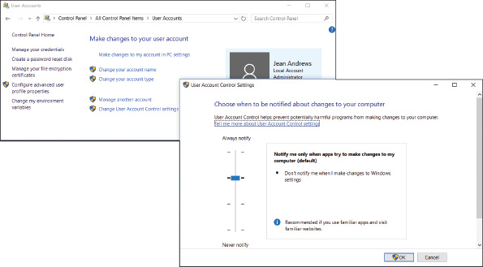
Go to pg.
help
Application Opened
Main content

12-3fInstalling Applications
A+ Core 2
- 1.6
Given a scenario, use Microsoft Windows Control Panel utilities.
- 1.7
Summarize application installation and configuration concepts.
Before installing an application, consider:
- System requirements. How much free space on the hard drive does the app need for the installation and how much RAM will the app use when running?
- Compatibility with the OS. If at all possible, install applications designed for the specific OS: Windows 10, Windows 8.1, or Windows 7. For best performance, install 64-bit apps in a 64-bit OS. It’s possible to install 32-bit apps in a 64-bit OS, but you cannot install 64-bit apps in a 32-bit OS.
- Impact to network performance. Before installing software, research how much network activity the software produces. You might want to set its priority as high or low on the network to control its performance or to keep it from hogging network resources. How to prioritize applications on the network is covered in Chapter 7.
- Impact to device security. For an application that uses the Internet, consider if it will make the computer vulnerable to attack. Read manufacturer documentation and reviews about how to secure the application and the system, such as making changes to Windows Firewall or installing each app in its own secured virtual machine on the host computer.
- Local user permissions. Here are the situations you need to know when dealing with local user permissions:
  - A user account with administrator privileges has permission to install software for all users; this software is normally installed in the C:\Program Files folder or the C:\Program Files (x86) folder. Both folders require administrator permissions to edit the folder’s contents. For these installations, expect a UAC box to appear to verify the installation (refer back to Figure 12-42A).
  - A user with standard privileges can install software that is designed to install in his C:/Users profile folder and does not make changes to protected areas of the Windows registry. (The registry is a database of Windows settings.) The software can only be used by this one user account.
  - If a user signed in with a standard account attempts to install software, such as anti-malware software, that is designed to run under all user accounts, a UAC box appears (see Figure 12-42B). To continue with the installation, the user must enter the password for an administrator user account.
Applications can be installed in Windows 10/8/7 from CD, DVD, or USB flash drive, from a downloaded application file, directly from the web, from the Windows 10/8 Windows Store, or from a folder shared by another computer on the network.
To install applications from a disc, USB flash drive, or software downloaded from the Internet, open File Explorer or Windows Explorer, locate and double-click the setup program file, and follow the on-screen directions to launch the installation routine.
When installing a program directly from the web, click the link on the website to install the software and follow the on-screen directions. To install apps in the Windows Store, use the Store app on the Windows 10 taskbar or the Windows 8 Start screen. After an application is installed, you might also need to install any updates available for the application on the manufacturer’s website.
Notes
In Chapter 16, you learn that you can map a network drive to a folder that is shared by another computer on the network. For example, this shared folder can appear as drive Z: in your File Explorer window. It’s common for administrators to put application setup programs in a shared folder for users on the network to install on their local computers. However, the setup program might give errors when you attempt to run it from the mapped network drive. The solution is to copy the setup program and other setup files to your computer and run it locally. In Chapter 14, you learn about other tasks you can try when an application fails to install.

Uninstall Applications
If you need to uninstall an application, do one of the following:
- For Windows 10/8/7, open Control Panel and click Programs and Features.
- For Windows 10, right-click Start or press Win+X, and click Apps and Features.
- For Windows 8, right-click Start or press Win+X, and click Programs and Features.
Figure 12-44 shows the Programs and Features window. Using either the Programs and Features window or the Apps and Features window, select an app and click Uninstall. When you select an app in the Programs and Features window, the buttons at the top of the list will change based on the software. For example, in Figure 12-44, the Bonjour software offers the options to Uninstall and Repair the software. (Bonjour by Apple allows Windows to find resources on a network offered by Apple devices.)
Figure 12-44
Select a program from the list to view your options to manage the software
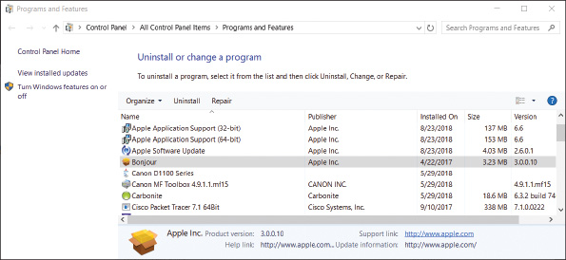
Notes
The new Windows Store apps can be uninstalled only in the Apps and Features window and not in the Programs and Features window. In Chapter 13, you learn how to use PowerShell to uninstall apps.
Recall that you can also uninstall a Windows 10/8 app that provides a tile on the Start menu or Start screen. Right-click the app tile and then click Uninstall.
Go to pg.
help
Application Opened
Main content

12-3gTurning Windows Features On or Off
A+ Core 2
- 1.5
Given a scenario, use Microsoft operating system features and tools.
- 1.6
Given a scenario, use Microsoft Windows Control Panel utilities.
You can save on system resources by turning off Windows features you will not use, and you might need to turn on some features that are turned off by default. To control Windows features, open the Programs and Features window and click Turn Windows features on or off in the left pane (refer to Figure 12-44). The Windows Features box opens (see Figure 12-45). Check or uncheck the features you want or don’t want and then click OK. Sometimes a restart is necessary for the changes to take effect.
Figure 12-45
Turn Windows features on or off
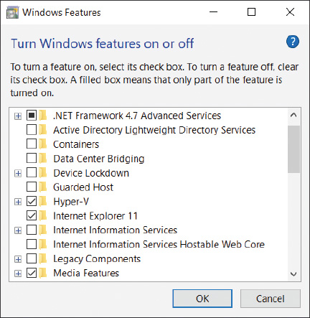
The Windows installation, devices, user accounts, and applications should now be good to go. Restart the computer and make one last check that all is well. Now would be a good time to document what you did after the installation. A project at the end of this chapter will help you organize your documentation for each computer you support. Also consider making a backup of the entire Windows volume in the event of a hard drive failure or corrupted installation. How to make backups is covered in Chapter 13.
Go to pg.
help
Application Opened
Main content

12-3hInstallations in a Virtual Machine
A+ Core 2
- 1.3
Summarize general OS installation considerations and upgrade methods.
Another type of Windows installation is when you install Windows in a virtual computer. A virtual computer or virtual machine (VM) is software that simulates the hardware of a physical computer. Using this software, you can install and run multiple operating systems at the same time on a single computer, which is called the host machine. These multiple instances of operating systems can be used to train users, run legacy software, and support multiple operating systems. For example, help-desk technicians can run a virtual machine for each OS they support on a single computer and quickly switch from one OS to another by clicking a window. Another reason to use a virtual machine is that you can capture screenshots of the boot process in a virtual machine, which is how some screenshots were made for this text.
Software used to manage VMs installed on a workstation is called a hypervisor. Some popular hypervisors for Windows are Client Hyper-V and Virtual PC by Microsoft (microsoft.com), VirtualBox by Oracle (virtualbox.org), and VMware Player by VMware, Inc. (vmware.com). Client Hyper-V is embedded in Windows 10/8 Pro or Enterprise, but is not available for other Windows releases. Virtual PC is free for download in all other editions of Windows 10/8/7 except Windows 7 Starter. VirtualBox and VMware Player are freeware. Be aware that virtual machine programs require a lot of memory and might slow down your system. Figure 12-46 shows two virtual machines running under VirtualBox.
Figure 12-46
Two virtual machines running under VirtualBox
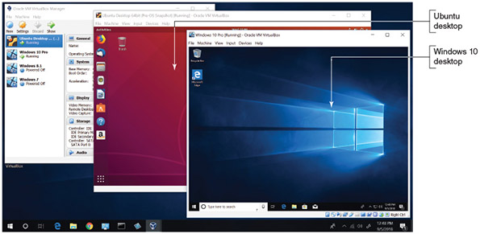
Source: VirtualBox (Oracle)

Install Windows in a Client Hyper-V VM
Client Hyper-V is the virtual machine (VM) manager that is part of 64-bit Windows 10 Pro. If your processor and motherboard support hardware-assisted virtualization (HAV), you can use Client Hyper-V to install and manage virtual machines on the desktop. Generation 1 VMs allow either a 32-bit or 64-bit installation of an OS in a VM. Generation 2 VMs require a 64-bit guest operating system. Hyper-V can connect a VM to the local network. Client Hyper-V supports dynamically expanding virtual hard drives and dynamically allocated memory. When using dynamically expanding virtual hard drives, the VM ties up only the portion of the host’s hard drive that the VM’s hard drive is actually using. When using dynamic memory, the VM ties up only the portion of allocated memory that it is actually using.
Applying Concepts

Setting Up a VM
Here are the steps to set up a VM using Windows 10 Pro:
- Go into BIOS/UEFI setup on your computer and make sure virtualization is enabled.
- Hyper-V is disabled in Windows 10 Pro by default. To turn it on, open the Settings app, select the Apps group, select Apps and features, and click Programs and Features. In the Programs and Features window, click Turn Windows features on or off. Place a check mark by Hyper-V and click OK. You’ll need to restart the system for the change to take effect.
- To launch the Hyper-V Manager, open the search box, type Hyper-V, and then click Hyper-V Manager. The Hyper-V Manager window appears on the desktop. In the Hyper-V Manager pane on the left, select the host computer (see Figure 12-47).
Figure 12-47
Select the host computer for managing Hyper-V virtual machines
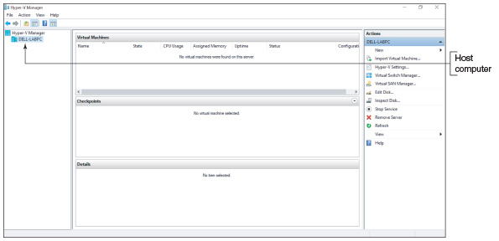
- To give your VMs access to the network or the Internet, you first need to install a virtual switch. To create a virtual switch, click Virtual Switch Manager in the Actions pane on the right side of the Hyper-V Manager window.
- The Virtual Switch Manager window appears (see Figure 12-48). In the left pane, make sure New virtual network switch is selected. To bind the virtual switch to the physical network adapter so the VMs can access the physical network, click External in the right pane. Click Create Virtual Switch.
Figure 12-48
Create a virtual switch
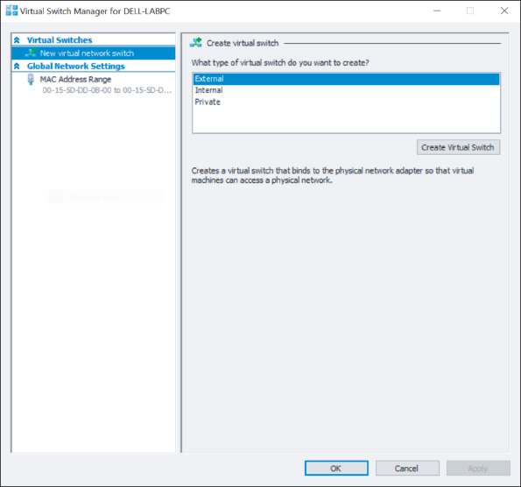
- The Virtual Switch Properties box appears; the new switch is shown in the right pane. In this pane, you can name the virtual switch or leave the default name. You can also select the network adapter to use for the switch. For most situations, that would be the wired Ethernet adapter. Make sure Allow management operating system to share this network adapter is checked, and then click Apply. Click Yes to create the virtual switch. Click OK to close the window.
- You’re now ready to create a VM. In the Actions pane, click New, and then click Virtual Machine. This opens the New Virtual Machine Wizard, where you can set the name and location of the VM files and configure memory and the virtual hard drive. Click Next. (Notice you can click Finish to accept default settings for the VM.)
- Assign a name to the VM. If you want the VM files to be stored in a different location than the default, check Store the virtual machine in a different location, and browse to that location (see Figure 12-49). After you’ve selected the location, click Next.
Figure 12-49
Name the VM and decide where the VM files will be stored
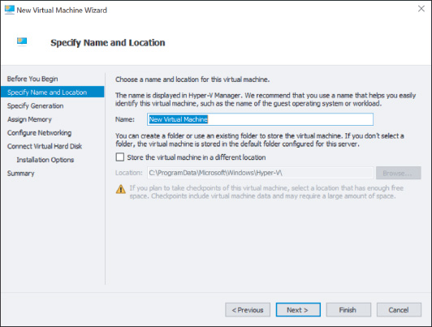
- In the next box, select Generation 1 and click Next to continue.
- Set the desired amount of RAM for the VM. Be sure to allow for at least the minimum requirement of RAM needed to install the OS. Check Use Dynamic Memory for this virtual machine (see Figure 12-50). Click Next to continue.
Figure 12-50
Use dynamic memory to conserve memory on the host computer
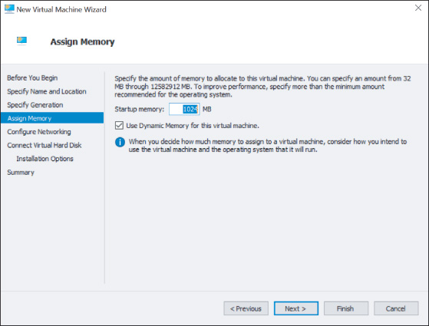
- In the Configure Networking dialog box, select the virtual switch you created earlier and click Next.
- In the Connect Virtual Hard Disk dialog box, select Create a virtual hard disk and click Next.
- The Installation Options dialog box appears (see Figure 12-51). To install Windows from the ISO file you downloaded earlier using the Media Creation Tool, select Install an operating system from a bootable CD/DVD-ROM. Select Image file (.iso). Click Browse and select the ISO file for the Windows installation. Click Next to continue. The last dialog box in the New Virtual Machine Wizard shows a summary of your selections. Click Finish to create the VM. The new VM is listed in the Virtual Machines pane in the Hyper-V Manager window.
Figure 12-51
Decide how an OS will be installed in the VM
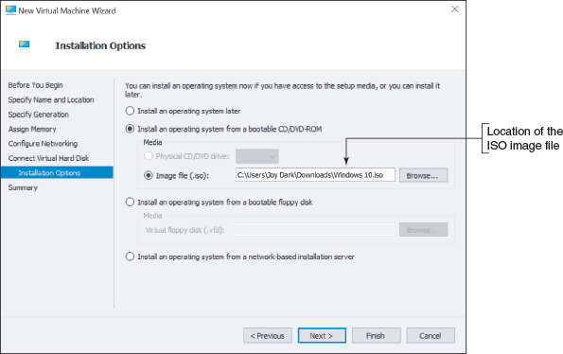
- To manage the VM’s virtual hardware, select the VM in Hyper-V Manager and click Settings near the bottom of the Actions pane. The Settings dialog box for the VM appears. Select the hardware in the left pane and apply your settings in the right pane.
- To install Windows, you need to boot from the virtual DVD drive. Click BIOS in the left pane and select Boot from CD in the right pane.
- Close the Settings box. To start the VM, select it and click Start in the Actions pane. The VM boots up and Windows setup starts. A thumbnail of the VM appears in the bottom-middle pane of the Hyper-V Manager window. To see the VM in a separate window, double-click the thumbnail. Figure 12-52 shows the VM window at the beginning of the OS installation. Notice in the figure that several VMs have been created, and three of them are currently running.
Figure 12-52
Windows 10 is running in the VM
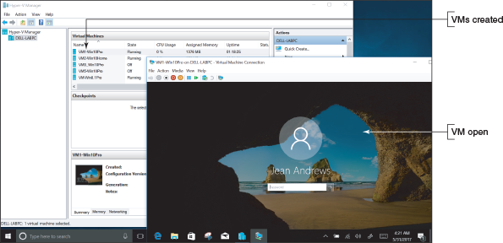
Notes
If you are trying to install an OS in a new VM and you get an error after the Product Key screen, try shutting down and restarting the VM. Then start the install again.
Go to pg.
help
Application Opened
Main content

12-4Special Concerns When Working in a Large Enterprise
A+ Core 2
- 1.3
Summarize general OS installation considerations and upgrade methods.
- 1.4
Given a scenario, use appropriate Microsoft command line tools.
Working as an IT support technician in a large corporate environment is different from working as an IT support technician for a small company or with individuals. In this part of the chapter, you learn how Windows is installed on computers in an enterprise.
Earlier in the chapter, you learned how to install Windows using a setup DVD, USB flash drive, or files downloaded from the Microsoft website, and you had to respond to each question asked during setup. These types of installations are called attended installations.
If, however, you were responsible for installing Windows on several hundred computers in a large corporation, you might want a less time-consuming method. These methods are called deployment strategies. As an IT support technician in a large corporation, most likely you would not be involved in choosing or setting up the deployment strategy. However, you need to be aware of the different strategies so you have a general idea of what will be expected when you are asked to provide desk-side or help-desk support as Windows is being deployed in your organization or a desktop OS that has failed needs to be refreshed.
Beginning with Windows 10, Microsoft expanded the methods it offers to deploy Windows in an enterprise. These methods are listed in Table 12-6. Some methods were designed to work with on-premises domains controlled by Active Directory (AD) and others work with Azure Active Directory (AAD) in the cloud.
Table 12-6

Deployment Strategies for Windows 10 (continues)
Category | Method | Description
Modern deployments: Use these methods with AD or AAD domains.
 | Windows Autopilot | Streamlines the OOBE (out-of-box experiences) for devices preregistered with the enterprise. When a user receives a new device, turns it on, connects to the Internet, and enters his user name and password, the device is automatically joined to AAD and configured with settings and content specific for the organization without further user input.
 | In-place upgrade | Automates an in-place upgrade from Windows 8/7 to Windows 10 using a setup created by a system administrator with tools in the Microsoft Deployment Toolkit (MDT).
Dynamic deployments: Use these methods with AAD domains.
 | Subscription activation | Used to upgrade Windows 10 Pro to Windows 10 Enterprise. When a user signs in to AAD, the Windows upgrade happens automatically without user input or a restart. Product keys and Windows licensing information are kept in AAD, not on the local computer. This method creates a Windows subscription.
 | Azure Active Directory join with MDM | MDM (Mobile Device Management) is software that forces devices to comply with corporate policies when they join an AAD domain.
 | Provisioning packages | When a device joins AAD and MDM is not implemented, a provisioning package containing settings, apps, and data specific for the enterprise is downloaded to the device and applied with minimal input from the user. This package is easier to set up than an image, which is used in traditional deployments.
Traditional image deployments: Use these methods for on-premises AD domains when older deployment strategies are already established in the enterprise.
 | Bare metal | Also called wipe and load deployment, a standard image is created that contains the OS, drivers, applications, settings, and data specific for the enterprise. The image can be deployed on a new, empty hard drive or the drive can first be wiped clean.
 | Refresh | Also called wipe and load deployment, user settings and data are saved and the hard drive is wiped clean before the standard image is applied. Then the image is applied and the user state is reinstalled.
 | Replace | Used to replace an old device with a new one. After the standard image is applied to the new computer, the user state is copied from the old computer and applied to the new one.
Go to pg.
help
Application Opened
Main content

12-4aMethods to Deploy a Standard Image
A+ Core 2
- 1.3
Summarize general OS installation considerations and upgrade methods.
A standard image contains the entire Windows volume in a single Windows Imaging (WIM) file, which has a .wim file extension. Installing Windows on a computer via a standard image is called image deployment. Here are a few details about image deployments:
- A standard image is hardware independent, meaning it can be installed on any computer. (In Chapter 13, you learn to create other types of images that can only be used on the computer that created them.)
- A standard image is created in a process called drive imaging. Microsoft provides several tools you can use to image a drive; many are included in the MDT.
- Deploying a standard image always results in a clean install rather than an upgrade.
Image deployment can be started using one of these methods:
- Local installation. Your company might provide you with a bootable flash drive or DVD that contains the image. When you boot from the device, Windows Preinstallation Environment (Windows PE) is launched; this is a minimum operating system used to start the installation. Follow the on-screen instructions.
- Network installation. To boot to the network and deploy the image from a server, first go to BIOS/UEFI setup and configure it to boot from a network device. You might need to search the motherboard documentation for help; in general, you’ll need to change the following or similar settings, which are likely to be on an Advanced screen or Boot screen:
  - Enable the Network Stack (see Figure 12-53). For the LAN controller, enable the PXE option.
Figure 12-53
Configure BIOS/UEFI setup to boot to the network
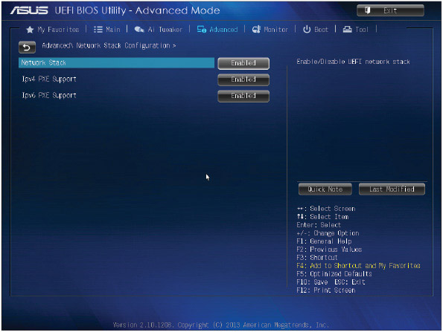
Source: American Megatrends, Inc.
  - Disable Secure boot, Fast boot, and Quiet mode.
  - Enable CSM support. In the CSM group, enable Boot from network devices.
  - Change the boot priority so that an IPv4 Network boot is listed first. If you don’t see it as an option, reboot after making the changes in the previous three bullets. The Network boot option should then be available.
  - Select the Network boot option to have the computer launch the Preboot eXecution Environment or Pre-Execution Environment (PXE). The identification for the Network boot option might include IPv4 and the name of the network adapter, as shown in Figure 12-54. PXE searches for a server on the network to provide a bootable operating system (Windows PE on the deployment server).
Figure 12-54
When you click IPV4 Realtek PCIe GBE Family Controller, this system reboots to the network
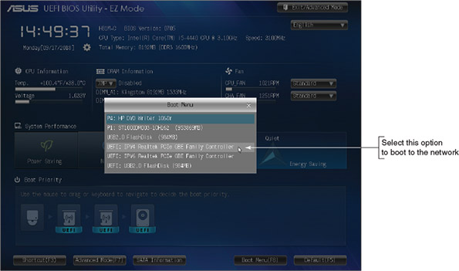
Source: American Megatrends, Inc.
- Push automation. A technician does not start the image deployment; rather, the installation uses push automation when a user is not likely to be sitting at the computer. The entire remote network installation is automated and no user intervention is required. The process can turn on a computer that is turned off and even works when no OS is installed on the computer or the current OS is corrupted.
Depending on how the system administrator has set up the deployment, you might be required to respond to questions as the installation progresses. An unattended installation does not require any responses, such as the administrator password or domain name, because these responses are stored in an answer file. After the installation completes, the User State Migration Tool might be used to transfer user settings, user data files, and application settings to the new installation.
The degree of work required by a technician to deploy an image is called high-touch, lite-touch, or zero-touch. The less involved the technician or user is, the more work is required by the system administrator to set up the deployment. For this reason, lite-touch or zero-touch deployments are only used in very large organizations.
Notes
IT support technicians find that large enterprises appreciate quick and easy solutions to desktop or laptop computer problems. Technicians quickly learn that their marching orders are almost always “replace or reimage.” Little time is spent trying to solve the underlying problem when hardware can quickly be replaced or a Windows installation can quickly be reimaged.
Go to pg.
help
Application Opened
Main content

12-4bUsing USMT Software
A+ Core 2
- 1.3
Summarize general OS installation considerations and upgrade methods.
- 1.4
Given a scenario, use appropriate Microsoft command line tools.
The User State Migration Tool (USMT) can be used when deploying Windows in a Windows domain to copy user files and settings from one computer to another. Let’s look briefly at what to expect when using the following three commands, which are part of the USMT software:
- scanstate copies user settings and files from the source computer to a safe location.
- loadstate applies these settings and files to the destination computer.
- usmtutils provides encryption options and hard drive management.
The scanstate, loadstate, and usmtutils command lines can be lengthy and include references to .xml files along with other parameters. The details of these command lines are not covered in this text. Most likely, the commands are stored in batch files provided by the system administrator. A batch file has a .bat file extension and contains a list or batch of OS commands that are executed as a group. These batch files might be automatically executed as part of a zero-touch installation or manually executed in a lite-touch or high-touch installation. To manually execute a batch file, you type the name of the file at a command prompt.
Notes
A system administrator uses the DISM (Deployment Image Servicing and Management) commands to initially capture (create) and manage a standard image. The DISM command also comes with Windows 10; you can use it to repair a corrupted Windows installation. You learn to use some DISM commands in Chapter 14.
Go to pg.
help
Application Opened
Main content

Chapter Review

12-5aChapter Summary

How to Plan a Windows Installation
- Windows can be purchased as a less expensive OEM version or a more expensive retail version. The OEM version can only be installed on a new computer.
- Each edition of Windows 10, Windows 8, and Windows 7 (except Windows 7 Starter) is available in either 32- or 64-bit versions. A 32-bit OS cannot address as much memory as a 64-bit OS. A 64-bit OS performs better and requires more memory than a 32-bit OS.
- Before purchasing Windows, make sure your system meets the minimum hardware requirements and that all the hardware and applications will work under the OS. A 64-bit OS requires 64-bit drivers.
- A hard drive contains one or more partitions or volumes and can use the MBR or GPT partitioning system. To use UEFI Secure boot, the partitioning system must be GPT and the Windows installation must be 64-bit.
- Normally, Windows is installed on the C: volume in the C:\Windows folder. The volume in which Windows is installed must use the NTFS file system.
- A computer might have legacy BIOS installed on the motherboard or have the newer UEFI firmware installed. Most UEFI firmware offers the option to support legacy BIOS when in UEFI CSM mode.
- Windows can be installed as an in-place upgrade, a clean installation, or in a multiboot environment with another OS.
- Windows can be installed from the setup DVD, a USB flash drive, files downloaded from the Internet via the Media Creation Tool, or in a virtual machine.

Installing Windows 10, Windows 8.1, and Windows 7
- A technician needs to know how to perform an in-place upgrade, a clean install, or a multiboot with Windows.
- The steps for installing or upgrading Windows 8.1 are about the same as those for Windows 10.
- A clean install is the best option to use if the current installation is sluggish or giving problems, or if you’re installing Windows on a new desktop computer that you’re building.
- In a multiboot, each OS must be installed on its own partition. Make sure you have enough free space on a partition before installing Windows on it, and make sure it doesn’t currently hold an OS.

What to Do After a Windows Installation
- After a Windows installation, verify network access, activate Windows, install any Windows updates or Windows 7 service packs, verify that automatic updates are configured correctly, install hardware and applications, create user accounts and transfer or restore user data and preferences from backups, and turn Windows features on or off.
- Virtual machine software can provide multiple instances of operating systems for training users, running legacy software, and supporting multiple operating systems.

Special Concerns When Working in a Large Enterprise
- Three types of deployments for installing Windows in a large enterprise are modern deployments, dynamic deployments, and traditional image deployments. Modern deployments are done using Active Directory or Azure Active Directory, dynamic deployments use AAD, and traditional deployments use AD.
- Zero-touch deployments require the most time to set up, but do not require a technician to be at the computer when the installation happens.
Go to pg.
help
Application Opened
Main content

Chapter Review

12-5bKey Terms
For explanations of key terms, see the Glossary for this text.
- active hours
- administrator account
- answer file
- batch file
- BIOS (basic input/output system)
- boot loader menu
- boot priority order
- clean install
- custom installation
- default product key
- device drivers
- Device Manager
- digital license
- diskpart
- DISM (Deployment Image Servicing and Management)
- drive imaging
- driver rollback
- dual boot
- file system
- full format
- GUID Partition Table (GPT)
- hardware signature
- hot-swappable
- hypervisor
- image deployment
- in-place upgrade
- ISO file
- ISO image
- loadstate
- local account
- Master Boot Record (MBR)
- Media Creation Tool
- Microsoft account
- Microsoft Deployment Toolkit (MDT)
- multiboot
- Original Equipment Manufacturer (OEM) license
- Preboot eXecution Environment
- Pre-Execution Environment (PXE)
- product activation
- product key
- Programs and Features
- provisioning package
- push automation
- quick format
- remote network installation
- scanstate
- Secure boot
- service pack
- setup BIOS/UEFI
- single sign-on (SSO)
- solid-state drive
- standard account
- standard image
- startup BIOS/UEFI
- system BIOS/UEFI
- third-party drivers
- UEFI (Unified Extensible Firmware Interface)
- UEFI CSM (Compatibility Support Module) mode
- unattended installation
- upgrade paths
- User Account Control (UAC) dialog box
- User State Migration Tool (USMT)
- usmtutils
- virtual machine (VM)
- volume
- Windows Defender Antivirus
- Windows.old folder
- Windows Preinstallation Environment (Windows PE)
Go to pg.
help
Application Opened
Main content

Chapter Review

12-5cThinking Critically
These questions are designed to prepare you for the critical thinking required for the A+ exams and may use content from other chapters and the web.
- You are planning an upgrade from Windows 8.1 to Windows 10. Your system uses a network card that you don’t find on the Microsoft Windows 10 list of compatible devices. What do you do next?
  - Abandon the upgrade and continue to use Windows 8.1.
  - Check the website of the network card manufacturer for a Windows 10 driver.
  - Buy a new network card.
  - Install a dual boot for Windows 8.1 and Windows 10 and only use the network when you have Windows 8.1 loaded.
- You have just installed Windows 10 and now want to install your favorite game that worked fine under Windows 8.1. When you attempt the installation, you get an error. What is your best next step?
  - Purchase a new version of your game—one that is compatible with Windows 10.
  - Download any updates to Windows 10.
  - Reinstall Windows 8.1.
  - Install a VM running Windows 8.1.
- You have 32-bit Windows 8.1 installed on your computer, and you purchase a license for Windows 10 Pro. You want to install Windows 10 using the 64-bit architecture. In which way(s) can you install Windows 10?
  - You can perform an upgrade, but not a clean install.
  - You can perform an upgrade or a clean install.
  - You can perform a clean install, but not an upgrade.
  - None of the above
- A laptop reports that it has made a wireless network connection but cannot access the network or the Internet. Arrange the following steps in the best order to troubleshoot the problem:
  - Use Device Manager to uninstall the wireless adapter and install it again.
  - Disable and enable the wireless network adapter.
  - Disconnect the connection and connect again to the wireless network.
  - Use Device Manager to update the wireless adapter drivers.
- Which installation of Windows 10 requires you to enter a product key during the install process?
  - You are replacing a failed hard drive that already had Windows 10 installed.
  - You are replacing a failed motherboard on a system with Windows 10 installed and a Microsoft account was not used to sign in to Windows.
  - You are replacing a failed motherboard on a system with Windows 10 installed and a Microsoft account had been used to sign in to Windows.
  - Windows 10 has become corrupted and you decide to perform a clean install to recover the OS.
- Which of the following methods can you use to install Windows 10 in a VM? Select all that apply.
  - Clean install from an ISO image
  - Clean install from a USB flash drive
  - Upgrade from Windows 8 using an ISO image
  - Clean install from a setup DVD
- Suppose you want to boot a VM from its virtual DVD drive, but it boots to the VM’s hard drive. Which of the following could be the source of this problem? Select all that apply.
  - There is no DVD or ISO file mounted to the virtual DVD drive.
  - The virtual DVD drive is not enabled.
  - The boot sequence is not correct in the VM’s BIOS/UEFI settings.
  - The hard drive does not have an OS installed.
- You are setting up a Windows 10 desktop computer that requires 4 TB of storage. Which options work (select all that apply)? Which option is the recommended best practice?
  - Install one 3-TB hard drive with the MBR partitioning system and 64-bit Windows 10.
  - Install two 1.5-TB hard drives with the GPT partitioning systems and 32-bit Windows 10.
  - Install two 1.5-TB hard drives with the MBR partitioning systems and 64-bit Windows 10.
  - Install two 1.5-TB hard drives with the GPT partitioning systems and 64-bit Windows 10.
- If you suspect a computer is infected with a virus and you are ready to upgrade from Windows 8 to Windows 10, what is your best practice?
  - Perform a clean install of Windows 10 rather than an upgrade.
  - Scan the system for malware before you perform the Windows 10 upgrade.
  - Install Windows 8 as an in-place upgrade to remediate the system and then upgrade to Windows 10.
  - Completely erase the hard drive with a full format and then install Windows 10.
- After setting up a dual-boot installation with Windows 8 and Windows 10, how do you boot the system into Windows 8?
  - Start the system as normal; the oldest OS automatically loads.
  - Start the system as normal; the newest OS automatically loads.
  - Start the system and select the OS in the boot loader menu.
  - Go into BIOS/UEFI setup and set the boot priority order to start with Windows 8.
- After a Windows installation, what is the easiest way to determine that you have Internet access?
  - Open the Network and Sharing Center and verify that Wi-Fi is turned on and shows no errors.
  - Open Internet Explorer and browse to a website.
  - Open Device Manager and check the network adapter for errors.
  - Verify that the local router has lights blinking to indicate connectivity.
- After installing the device drivers for a video adapter, you still are not able to use the special features of the adapter. What is your next step?
  - Open Device Manager and check for errors.
  - Uninstall the adapter and try the installation again.
  - Update Windows.
  - Check the website of the video adapter’s manufacturer for guidance.
- The PXE programming code is used to boot a computer when it is searching for an OS on the network. Where is this code stored?
  - On the deployment server
  - On the motherboard
  - On the Windows volume of the local hard drive
  - In the cloud in Azure Active Directory
- What is an advantage of using a dynamic hard drive in a VM?
- Ming is building an inexpensive computer to use for her online classes, and needs to purchase Windows. What is the most cost-effective way Ming can purchase and activate a selected version of Windows?
Go to pg.
help
Application Opened
Main content

Chapter Review

12-5dHands-On Projects
Hands-On Project 12-1

Installing 64-Bit Windows 10 Pro
Use the Media Creation Tool to download Windows 10 setup files, and then install 64-bit Windows 10 Pro on your lab computer. If you need help with the installation, see the directions in the chapter. Set up Windows to use a local account to sign in to Windows. Write down each decision you have to make as you perform the installation. If you get any error messages during the installation, write them down and list the steps you took to recover from them. How long did the installation take?
Hands-On Project 12-2

Using the Internet for Problem Solving
Access the support.microsoft.com website for Windows 10 support. Print one article from the Knowledge Base that addresses a problem when installing Windows 10. In your own words, write a paragraph describing the problem and a paragraph explaining the solution. If you don’t understand the problem or the solution from this article, do a search online for additional information so that you can give a well-rounded description of both the problem and the solution.
Hands-On Project 12-3

Installing Windows 8.1 in a VM
This project assumes you already have 64-bit Windows 10 Pro installed on a computer. Do the following:
- Enable Client Hyper-V and set up a VM in it.
- Using the Media Creation Tool, create an ISO file to install Windows 8.1 in the VM.
- Verify that you can use Internet Explorer in the VM to surf the web.
Hands-On Project 12-4

Installing Windows 10 in a VM as a Dual Boot
This project assumes you already have 64-bit Windows 10 Pro installed and a VM with Windows 8.1 installed on a computer. Do the following:
- Using the Media Creation Tool, create an ISO file to install Windows 10 in the VM.
- Open the VM you already created with Windows 8.1 installed and create a second partition with at least 16 GB.
- Mount the Windows 10 ISO file to the VM. In the Settings app for the Windows 8.1 VM, change the firmware settings to boot from a file. Restart the Windows 8.1 VM and install Windows 10 as a dual boot on the partition you just created.
- Verify that you can use Microsoft Edge in the VM to surf the web.
Hands-On Project 12-5

Recommended Updates
On a Windows 10 system connected to the Internet, open the Settings app and click the Update & security group. Under Looking for info on the latest updates?, click Learn more. Windows Update opens the Microsoft website and recommends Windows updates. Print the webpage showing a list of recommended updates. Then, on a Windows 8.1 system connected to the Internet, open the System window and click Windows Update. Windows Update searches the Microsoft website and recommends Windows updates. Print the webpage showing a list of recommended updates. For a lab computer, don’t perform the updates unless you have your instructor’s permission.
Hands-On Project 12-6

Creating a Documentation Form
Support technicians are expected to maintain documentation for each computer for which they are responsible. Create a document that a technician can use when installing Windows and performing all the chores mentioned in the chapter that are needed before and after the installation. The document needs a checklist of what to do before the installation and a checklist of what to do after the installation. It also needs a place to record decisions made during the installation, the applications and hardware devices installed, user accounts created, and any other important information that might be useful for future maintenance or troubleshooting. Don’t forget to include a way to identify the computer, the name of the technician doing the work, and when the work was done.
Go to pg.
help
Application Opened
Main content

Chapter Review

12-5eReal Problems, Real Solutions
Real Problem 12-1

Recovering Data from a Corrupted Windows Installation
As an IT support technician for a small organization, it’s your job to support the computers, the small network, and the users. One of your coworkers, Jason, comes to you in a panic. His Windows 10 system won’t boot, and he has lots of important data files in several locations on the drive. He has no idea which folders hold the files. Besides the application data he’s currently working on, he’s especially concerned about losing email addresses, email, and his Internet Explorer Favorites links.
After trying everything you know about recovering Windows 10, you conclude the OS is corrupted beyond repair. You decide there might be a way to remove the hard drive from Jason’s computer and connect it to another computer so that you can recover the data. Search the Internet and find a device that you can use to connect Jason’s hard drive to another computer through one of its USB ports. The hard drive uses a SATA hard drive interface. Print the webpage showing the device and its price.
Real Problem 12-2

Troubleshooting an Upgrade
Your friend, Thomas, has upgraded his Windows 8.1 desktop to Windows 10. After the installation, he discovers his media card reader does not work. He calls you on the phone and asks you what to do. Do the following to plan your troubleshooting approach:
- List the questions you should ask Thomas to help diagnose the problem.
- List the steps you would take if you were sitting at the computer solving the problem.
- What do you think is the source of the problem? Explain your answer.
Go to pg.
help

