Application Opened
Main content
Chapter
13

Maintaining Windows
- Chapter Introduction
- 13-1Scheduling Preventive Maintenance
  - 13-1aVerifying Critical Windows Settings
  - 13-1bPatch Management
- 13-2Backup Procedures
  - 13-2aPlanning for Disaster Recovery
  - 13-2bBacking Up User Data and the System Image
  - 13-2cBacking Up Windows System Files with System Protection
- 13-3Managing Files, Folders, and Storage Devices
  - 13-3aHow Partitions and File Systems Work
  - 13-3bUsing Disk Management to Manage Hard Drives
  - 13-3cImproving Hard Drive Performance
- 13-4Using a Command-Line Interface (CLI)
  - 13-4aCommands to Manage Files and Folders
  - 13-4bCommands to Manage Hard Drives
  - 13-4cWindows 10 PowerShell and Ubuntu Bash Interfaces
- 13-5Remote Connections
  - 13-5aRemote Desktop Connection (RDC)
  - 13-5bRemote Assistance
  - 13-5cThird-Party Remote Access
- 13-6Chapter Review
  - 13-6aChapter Summary
  - 13-6bKey Terms
  - 13-6cThinking Critically
  - 13-6dHands-On Projects
  - 13-6eReal Problems, Real Solutions
  - 13-6fExam Tips
Go to pg.
help
Application Opened
Main content

Chapter Introduction
After completing this chapter, you will be able to:
- Set up and perform scheduled preventive maintenance tasks to keep Windows healthy
- Prepare for disaster by keeping good backups of user data, the Windows volume, and Windows system files
- Use Windows tools, including Disk Management, to manage hard drives
- Use commands to manage files, folders, and hard drives
- Connect to remote computers for screen and file sharing
Earlier in the text, you learned how to install Windows. This chapter takes you to the next step in learning how to support a Windows operating system: maintaining the OS after it is installed. Most Windows problems stem from poor maintenance. If you are an IT support technician responsible for the ongoing support of several computers, you can make your work easier and your users happier by setting up and executing a good maintenance plan for each computer you support. A well-maintained computer gives fewer problems and performs better than one that is not maintained. In this chapter, you learn how to schedule regular maintenance tasks, prepare for disaster by setting up backup routines for user data and system files, use Windows tools and commands to manage files, folders, and hard drives, and remotely access computers so that you can share screens and files.
This text covers Windows 10, 8.1, 8.0, and 7. As you read, you might consider following the steps in the chapter using a Windows 10 system, and then going through the steps again using a Windows 8 or Windows 7 system.
Go to pg.
help
Application Opened
Main content

13-1Scheduling Preventive Maintenance
A+ Core 2
- 1.1
Compare and contrast common operating system types and their purposes.
- 2.7
Given a scenario, implement security best practices to secure a workstation.
Regular preventive maintenance can keep a Windows computer performing well for years. At least once a month, you need to verify critical Windows settings and clean up the hard drive. These skills are covered in this part of the chapter. If you notice the system is slow as you do this maintenance, you need to dig deeper to improve Windows performance, which is covered in Chapter 14.
Notes
When you’re responsible for a computer, be sure to keep good records of all that you do to maintain, upgrade, or fix it. When performing preventive maintenance, take notes and include them in your documentation. The Computer Inventory and Maintenance document available at cengage.com can help you organize your notes.
Go to pg.
help
Application Opened
Main content

13-1aVerifying Critical Windows Settings
A+ Core 2
- 1.1
Compare and contrast common operating system types and their purposes.
- 2.7
Given a scenario, implement security best practices to secure a workstation.
The Windows settings discussed here are critical for keeping the system protected from malware and hackers. Users sometimes change these settings without realizing their importance. Check the following settings; if you find they are incorrect, take time to explain to the computer’s primary user how important they are. Here are the critical Windows settings you need to verify:
- Windows updates. Install any important Windows updates or Windows 7 service packs that are waiting to be installed and verify that Windows Update is configured to automatically allow updating. These updates may include updates to Windows, applications, device drivers, and firmware. You learned how to configure Windows Update in Chapter 12.
- Antivirus/anti-malware software. To protect a system against a malicious attack, you need to verify that anti-malware software is configured to scan the system regularly and that it is up to date. If you discover it is not scanning regularly, take the time to do a thorough scan for viruses. For Windows 10/8, Windows Defender is running in the background. To verify this, follow the directions in Chapter 12.
- Network security setting. To secure the computer against attack from the network, use the Network and Sharing Center to check that the network security type is set correctly for the optimum firewall settings. The network types are public and private in Windows 10/8, and public, work, and home in Windows 7. How to verify the network type was covered in Chapter 11. Further details of configuring network security in Windows are discussed in Chapter 16.
- Backups of user data, the Windows volume, and system files. Following directions given later in the chapter, verify that backup routines are running as expected to protect data and software from loss or corruption.
To keep Windows performing well, do the following:
- Uninstall software you no longer need. This helps overall performance by reducing the number of startup processes running in the background. To uninstall software, use the Windows 10/8 Apps & Features window or the Windows 10/8/7 Programs and Features window. Also, for Windows 10/8, turn off live tiles you don’t watch.
- Clean up the hard drive. A hard drive needs at least 15 percent free space on drive C:, where Windows is installed. Later in the chapter, you learn how to use Disk Cleanup to erase unnecessary files on drive C:. You can also move data on the drive to other media.
Notes
Don’t forget that what you learn about maintaining Windows also applies to Windows in a VM. When maintaining a VM, make sure Windows in a VM is updated, anti-malware software is installed and running, and network settings are secure.
Go to pg.
help
Application Opened
Main content

13-1bPatch Management
A+ Core 2
- 1.1
Compare and contrast common operating system types and their purposes.
- 2.7
Given a scenario, implement security best practices to secure a workstation.
When researching a problem, suppose you discover that Microsoft or a manufacturer’s website offers a fix or patch for Windows, a device driver, or an application. To download and apply compatible software, you need to make sure you get a 32-bit patch for a 32-bit installation of Windows, a device driver, or an application. For a 64-bit installation of Windows, make sure you get a 64-bit device driver. An application installed in a 64-bit OS might be a 32-bit application or a 64-bit application.
The documentation on the Microsoft website or other sites might be cryptic about the type of patch. Follow these guidelines when reading error messages or documentation:
- The term x86 refers to 32-bit CPUs or processors and to 32-bit operating systems. For example, the Microsoft website might say a patch to fix a problem with a USB device applies to a Windows 10, x86-based version. This means the patch is for a 32-bit version of Windows 10.
- The term x64 refers to 64-bit operating systems. For example, Microsoft offers two versions of Windows 10: the x86 version and the x64 version.
- All CPUs installed in personal computers today are hybrid processors that can process either 32 bits or 64 bits. The term x86-64 refers to these processors, such as the Intel Core i5 or an AMD Ryzen processor. (AMD64 refers specifically to these hybrid AMD processors.) The term x86-64 can also refer to a 64-bit OS. For example, a Windows message might read, “You are attempting to load an x86-64 operating system.” Take that to mean you are attempting to load a 64-bit OS on a computer that has a hybrid 32-bit/64-bit processor installed, such as the Ryzen 5 1500x or Intel Core i5-7500.
- The term IA64 refers specifically to 64-bit Intel processors such as the Xeon or Itanium, which is used in servers or high-end workstations.
A+ Exam Tip
The A+ Core 2 exam expects you to know the difference between 32-bit and 64-bit operating systems and, when given a scenario, to select compatible software for patch management.
Now let’s look at how to perform on-demand backups and how to schedule routine backups.
Go to pg.
help
Application Opened
Main content

13-2Backup Procedures
A+ Core 2
- 4.3
Given a scenario, implement basic disaster prevention and recovery methods.
A backup is an extra copy of a data file or software file that you can use if the original file is damaged or destroyed. Losing data due to system failure, a virus, file corruption, or some other problem really makes you appreciate the importance of having backups.
Notes
With data and software, here’s a good rule of thumb: If you can’t get along without it, back it up.
Applying Concepts

Backups Pay Off
Dave was well on his way to building a successful career as an IT support technician. His IT tech support shop was doing well, and he was excited about his future. But one bad decision changed everything. He was called to repair a server at a small accounting firm. The call was on the weekend when he was normally off, so he was in a hurry to get the job done. He arrived at the accounting firm and saw that the problem was an easy one to fix, so he decided not to do a backup before working on the system. During his repairs, the hard drive crashed and all data on the drive was lost—four million dollars’ worth! The firm sued, Dave’s business license was stripped, and he was ordered to pay the money the company lost. A little extra time to back up the system would have saved his whole future. True story!
Because most of us routinely write data to the hard drive, this section focuses on backing up from the hard drive to other media. However, when you store important data on any medium—such as a flash drive, external hard drive, CD, or in the cloud—always keep a copy of the data on another device or in the cloud. Never trust important data to only one location.
In this part of the chapter, you learn how to make a disaster recovery plan and then learn how to use Windows to back up user data, entire volumes, and critical Windows system files.
Go to pg.
help
Application Opened
Main content

13-2aPlanning for Disaster Recovery
A+ Core 2
- 4.3
Given a scenario, implement basic disaster prevention and recovery methods.
The time to prepare for disaster is before it occurs. If you have not prepared, the damage from a disaster will most likely be greater than if you had made and followed disaster recovery plans. Suppose the hard drive on your computer stopped working and you lost all its data. What would be the impact? Are you prepared for this to happen? Here are decisions you need to make for your backup and recovery plans:
- Decide on the type of backup. Different backup types include different kinds of data:
  - You might back up single files or folders, in which case you might also have access to previous versions of a file; this is called a file-level backup and allows granular control over which content is included in the backup and which content can be recovered on a file-by-file basis. File-level backups are appropriate for backing up user data, but generally are not considered good options for backing up applications and Windows.
  - You might back up an entire volume of a drive, called an image-level backup. Restoring from an image-level backup would also restore your OS installation, applications, user account settings, and user data. However, the process restores the entire backup image and does not allow selecting portions of the backup separately.
  - You might need a separate backup plan for critical applications, which are any applications required to keep a business functioning while other backup solutions are being used to recover from any data loss. Consider cloud solutions or virtualization options as backups for critical applications such as email, databases, or office productivity software.
- Decide on the backup destination. For example, for a personal computer or small network, options include backup to a cloud, network drive, CD, DVD, Blu-ray, SD card, USB flash drive, external hard drive, or other media. Here are points to keep in mind:
  - A cloud storage backup service such as Carbonite (carbonite.com), Backblaze (backblaze.com), Amazon Drive (amazon.com/amazondrive), Google Drive (drive.google.com), or iCloud Drive (icloud.com) is the easiest, most reliable, and most expensive solution. You pay a yearly subscription for the service, and it guarantees your backups, which are automatically done when your computer is connected to the Internet. If you decide to use one of these services, be sure to restore files from backup occasionally to make sure your backups are happening as you expect and that you can recover a lost file.
  - Local storage backups are relatively inexpensive and convenient, in that data is easily accessible at your location. This method might present a problem, however, if a catastrophic event, such as a fire or flood, destroys the building where your original data and backups are all located. For this reason, always keep backups at an off-site location.
  - Even though it’s easy to do, don’t make the mistake of backing up your data to another volume or folder on the same hard drive. When a hard drive crashes, most likely all volumes go down together and you will lose your data and your backup. Back up to another device and, for extra safety, store it at an off-site location.
Notes
For individuals or small networks, backups to the cloud are generally more expensive than backing up to a local server or external hard drive. For large networks, storing data in the cloud, such as Google Cloud or Amazon Web Services, can save money over buying and maintaining backup storage solutions on location.
- Decide on the backup software. Windows offers one or more backup utilities. However, you can purchase third-party backup software that might offer more features. Read reviews about the software and consider:
  - Hard drive manufacturers often bundle backup software with a new hard drive or you can download the software from the manufacturer’s website.
  - What does the software back up? Files or the entire image of a volume?
  - Does the software provide a way to boot from backup media so you can easily access the backups when the hard drive crashes?
  - Can you schedule when backups occur?
  - Does the software support backing up to a remote location, such as a different branch office where you can easily access the backups?
- Decide how simple or complex your backup strategy needs to be. A backup and recovery plan for individuals or small organizations might be very simple. However, large organizations might require that backups be documented each day and scheduled at certain times of the day or night, and recovery plans might have to be tested on a regular basis. Know the requirements of your organization when creating a backup and recovery plan. As a general rule of thumb, back up data for at least every 4 to 6 hours of data entry. This might mean a backup needs to occur twice a day, daily, weekly, or monthly. Find out the data entry habits of workers before making your backup schedule and deciding on the folders or volumes to back up.
- Consider ways of ensuring business continuity. Not all disasters are directly related to data loss. A loss of power or Internet connection can also interfere with business productivity, and physical or electrical damage to computer or network hardware is another significant concern. Plugging a computer’s power cord into a surge protector can protect against voltage spikes by blocking or grounding excessive voltage. An uninterruptible power supply (UPS) can be strategically placed on the network to supply power when voltage drops during brownouts or short-term blackouts and ensure that routers, switches, and servers keep running during a power outage. See Figure 13-1. Also consider physical security to protect against theft or vandalism. You can learn more about surge protectors and UPS devices in Appendix A, and you’ll learn more about physical security in Chapter 17.
Figure 13-1
A UPS protects a desktop computer, server, or network devices from low voltages and blackouts
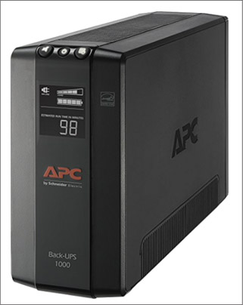
Source: amazon.com
After you have a backup plan working, test the recovery plan. In addition, you need to occasionally retest the recovery plan to make sure all is still working as you expect. Do the following:
- Test the recovery process. Erase a file on the hard drive, and use the recovery procedures to verify that you can re-create the file from the backup. This test also verifies that the backup medium works, that the recovery software is effective, and that you know how to use it. After you are convinced that the recovery works, document how to perform it.
- Keep backups in a safe place and routinely test them. Don’t leave a backup DVD or other media lying around for someone to steal. Backups of important and sensitive data should be kept under lock and key at an off-site location. In case of fire, keep enough backups off-site so that you can recover data even if the entire building is destroyed. Routinely verify that your backups are good by performing a test recovery of a backed-up file or folder. Backups are useless if the data on the backup is corrupted.
Notes
One reason that organizations use cloud solutions, such as Microsoft Azure, Google Cloud, and Amazon Web Services, is that work can be done from any location by signing in to the online service where applications and data are kept in the cloud. Cloud computing greatly eliminates the need for an organization to maintain its own backups and still be protected against local catastrophic events.
Now let’s see how to back up user data, the entire Windows volume, and important Windows system files.
Go to pg.
help
Application Opened
Main content

13-2bBacking Up User Data and the System Image
A+ Core 2
- 4.3
Given a scenario, implement basic disaster prevention and recovery methods.
Here are the tools offered by Windows 10/8/7 for backups:
- Windows 10 offers File History or Backup and Restore to back up user data and create a system image.
- Windows 8 uses File History but not Backup and Restore. In addition, Windows 8 offers the recimg command to create a custom refresh image, which is a type of system image.
- Windows 7 offers Backup and Restore to back up user data and to create a system image.
A system image is a backup of the entire Windows volume, including the Windows installation, applications, user settings, and data. The best time to create the image is right after you’ve installed Windows, hardware, applications, and user accounts and customized Windows settings. The image is stored in a single file with a .wim file extension. The WIM file uses the Windows Imaging File (WIM) format and is a compressed file that contains many related files.
Next, let’s see how these backup tools work.

Windows 10/8 File History
Windows 10/8 File History backs up user data stored in the Documents, Music, Pictures, Videos, and Desktop folders, as well as offline OneDrive files (for Microsoft accounts) and other folders as determined by the user. When the backup is enabled, it first makes a full backup to another medium. By default, it scans for file and folder changes every hour and keeps as many generations of backups as free space allows on the storage device.
Follow these steps to use File History on a Windows 10 computer:
- First connect your backup device. In the Settings app, click Update & Security, then click Backup. When you click Add a drive, Windows searches for a usable drive. Select the drive or click Show all network locations to find and select a drive on the network. File History connects to the drive and turns on.
- To manage these backups, click More options. On the Backup options window shown in Figure 13-2, you can set how often backups are made (every 10 minutes up to daily), how long old backups should be kept (forever, until space is needed, 1 month, 1 year, and so forth), and which folders to back up.
Figure 13-2
Backup options for File History
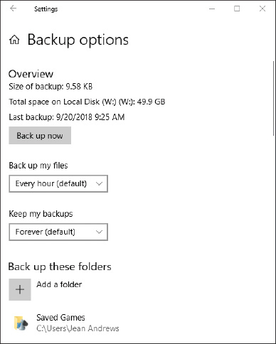
File History can also be accessed through Control Panel (see Figure 13-3). Click items in the left pane to turn File History on or off, change File History settings, and restore files from backup. Using the File History window in Control Panel, you can click System Image Backup (see Figure 13-3) to start the process of creating a system image.
Figure 13-3
Control File History settings and restore files from backup
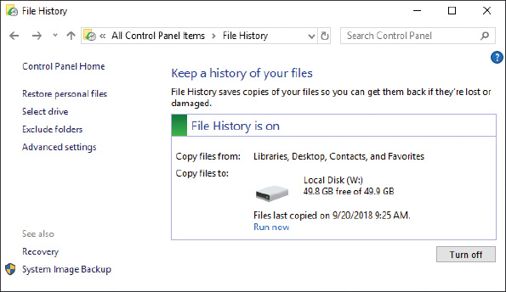
A+ Exam Tip
The A+ Core 2 exam might give you a scenario that expects you to create, use, and test backups.

Restore Files and Folders in File History
To restore a file or folder from backup, open the File History window from Control Panel and click Restore personal files. You can view and recover items from the backups (see Figure 13-4). Use the left and right arrow keys on either side of the green Restore button at the bottom of the window to select a backup, and then drill down into the backup to find the file or folder you need. Select an item to see a preview, and then click the Restore button to restore the item. If you prefer to save the previous version in a different location so as not to overwrite the newest version of the file, right-click the Restore button and click Restore to. Navigate to the location where you want to save the previous version and then click Select Folder.
Figure 13-4
Drill down into backups to find what you want to restore
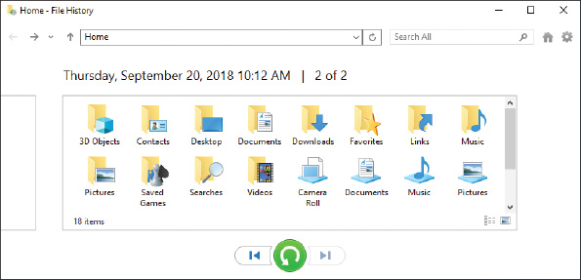
Another way to restore a file or folder from backup is to use File Explorer or Windows Explorer. Follow these steps:
- When you restore a file or folder to a previous version, the current file or folder can be overwritten by the previous version. To keep the original, first copy—not move—the folder or file to a new location so that you can revert to the copy if necessary.
- Right-click the file or folder and select Restore previous versions from the shortcut menu. The Properties box for the file or folder appears with the Previous Versions tab selected. Windows displays a list of all previous versions of the file or folder it has kept (see Figure 13-5); these versions were created by File History or Backup and Restore.
Figure 13-5
Restore a file or folder from a previous version
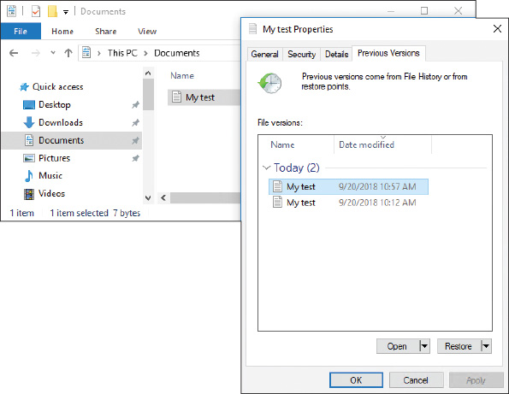
- Select the version you want and click Restore. A message box asks if you are sure you want to continue. Click Restore and then click OK.
- Open the restored file or folder and verify that it is the version you want. If you decide you need another version, delete the file or folder, and copy the file or folder you saved in Step 1 back into the original location. Then return to Step 2 and try again, this time selecting a different previous version.

Windows 10/7 Backup and Restore
Windows 10 and Windows 7 offer Backup and Restore to back up any folder on the hard drive and create a system image. Generally, File History is designed to be an easy tool for users to manage their own backups, and Backup and Restore is designed for technicians who prefer more granular control of backups.
The folders and volume are first backed up entirely; this is called a full backup. Then, on the schedule you set, any file or folder is backed up if it has changed or been created since the last backup. This is called an incremental backup. Occasionally, Windows does another full backup. If you’ve established a backup schedule in File History on a Windows 10 machine, those settings will appear in the Backup and Restore window.
Follow these steps to save a backup and set up an ongoing backup schedule using Backup and Restore in Windows 10:
- Open Control Panel in Classic view, and click Backup and Restore. If no backup has ever been scheduled on the system, the window will look like the one shown in Figure 13-6. Click Set up backup.
Figure 13-6
Use the Backup and Restore window to schedule backups
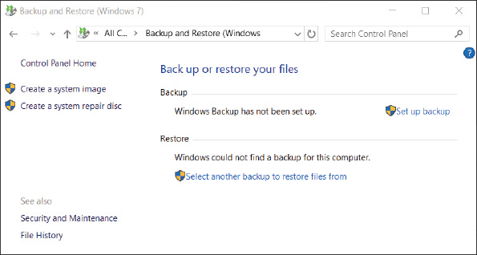
- In the next dialog box, select the device or location to hold the backup. All Windows 10 editions and Windows 7 Professional, Ultimate, and Enterprise editions allow you to save the backup to a network location. To use a shared folder on the network for the backup destination, click Save on a network. In the resulting box, click Browse and point to the folder. See Figure 13-7. Also enter the user name and password on the remote computer that the backup utility will use to authenticate to that computer when it makes the backup. You cannot save to a network location when using Windows 7 Home editions. For these editions, the Save on a network button is missing in the window where you select the backup destination.
Figure 13-7
Point to a shared folder on the network to hold the backups
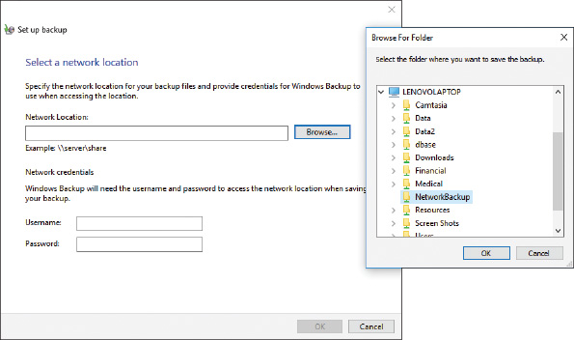
- In the next box, you can allow Windows to decide what to back up or choose for yourself. Select Let me choose so that you can select the folders to back up. Click Next.
- In the next box, make your selections. If the backup medium can hold the system image, the option to include the image is selected by default. If you don’t want to include the image, uncheck the option. Click Next to continue. Here are folders that might contain important user data:
  - Application data is usually found in C:\Users\username\AppData.
  - Internet Explorer favorites are in C:\Users\username\Favorites.
  - Better still, back up the entire user profile at C:\Users\username.
  - Even better, back up all user profiles at C:\Users.
- In the next box, you can verify that the correct items are selected. To change the default schedule, click Change schedule. In the next box, you can choose to run the backup daily, weekly, or monthly and select the time of day. Make your selections and click OK.
- Review your backup settings, and click Save settings and run backup. The backup proceeds. A shadow copy is made of any open files so that they are included in the backup.
Later, you can return to the Backup and Restore window to change the backup settings or to turn off the backup.
Notes
One limitation of Windows File History and Backup and Restore is that you can have only one scheduled backup routine.
Notes
After Windows does a full backup, it only backs up files that have changed since the last full backup. Occasionally, it does another full backup. Each full backup is called a backup period. Windows keeps as many backup periods as it has space on the backup device. As free space fills, it deletes the oldest backup periods. To see how space is used on your backup media, click Manage space in the Backup and Restore window. In the Manage Windows Backup disk space, you can click View backups to delete a backup period, but be sure to keep the most recent backup periods.
To recover backed-up items, open the Backup and Restore window, scroll down to the bottom of the window, and click Restore my files. Locate and select multiple files or folders to restore. Then follow the on-screen directions to restore all the selected items.

Maintain a System Image
As you’ve already learned, the backup of a Windows volume is called a system image. Here are points to keep in mind when creating a system image and using it to recover a failed Windows volume:
- Creating a system image takes some time. Before creating a system image on a laptop, plug the laptop into an AC outlet so that a failed battery will not interrupt the process.
- A system image includes the entire drive C: or other drive on which Windows is installed. When you restore a hard drive using the system image, everything on the volume is deleted and replaced with the system image.
- Don’t depend just on the system image as your backup. You should back up individual folders that contain user data separately from the system image. If only individual data files or folders need to be recovered, you would not want to use the system image for the recovery because it would totally replace the entire Windows volume.
- You can create a system image any time after Windows is installed, and then you can use this image to recover from a failed hard drive. Using the system image to recover a failed hard drive is called reimaging the drive. The details of how to reimage a drive are covered in Chapter 15.
Notes
The system image you create can be installed only on the computer that was used to create it. A hardware-independent image is called a standard image, as you learned in Chapter 12.
Windows 8

Custom Refresh Image
A custom refresh image was intended to replace the Windows 7 system image. However, it was not as popular, so the recimg command used to create a custom refresh image is not included in Windows 10.
Here are the steps to create a Windows 8 custom refresh image:
- Open an elevated command prompt window. One way to do so is to press Win+X and click Command Prompt (Admin). Respond to the UAC box. The Administrator: Command Prompt window opens.
- Enter the following command, substituting a drive and folder for the sample path shown:
Creating the image takes some time, and then the image and its location are registered as the active recovery image. The image is stored in a large .wim file that you can view using File Explorer. You can create as many refresh images as you like, but only one is designated as the active recovery image, and it’s the one that will be used when you refresh the Windows 8 installation. How to perform a Windows 8 refresh is covered in Chapter 15.
The recimg command can also be used to manage refresh images. The parameters for the command are listed in Table 13-1.
Table 13-1

The Recimg Command and Parameters
Command | Result
recimg /createimage <path> | Creates the refresh image and registers its location as the active refresh image
recimg /showcurrent | Displays the location of the active refresh image
recimg /deregister | Deregisters the active recovery image; during the refresh process, Windows will not find an image and will revert to a hidden recovery partition on the hard drive or the Windows 8 setup files for the refresh
recimg /setcurrent <path> | Registers a refresh image in the path given; the image at this location is now the active refresh image
Suppose you’ve created multiple refresh images and you want to select a particular image for a refresh. Figure 13-8 shows the commands you can use to change the active refresh image from the one stored in the D:\MyImage folder to one stored in the D:\MyImage2 folder.
Figure 13-8
Use the recimg command with parameters to manage refresh images
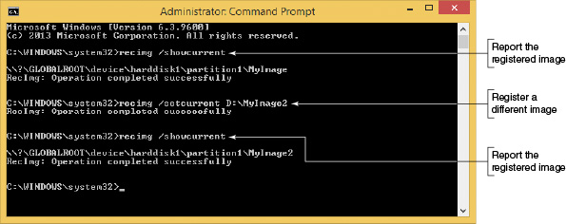
Notes
Because a refresh image must be named CustomRefresh.wim, you must store each image in a separate folder.
Go to pg.
help
Application Opened
Main content

13-2cBacking Up Windows System Files with System Protection
A+ Core 2
- 4.3
Given a scenario, implement basic disaster prevention and recovery methods.
When the System Protection utility is turned on, it automatically backs up system files and stores them on the hard drive at regular intervals and just before you install software or hardware. These snapshots of the system are called restore points and include Windows system files that have changed since the last restore point was made. A restore point does not contain all user data, and you can manually create a restore point at any time. System Restore (rstrui.exe) restores the system to its condition at the time a restore point was made. If you restore the system to a previous restore point, user data on the hard drive will not be altered, but you can affect installed software and hardware, user settings and passwords, and OS configuration settings. You’ll learn how to use System Restore in Chapter 14.

Enable System Protection
System Protection is turned off by default in Windows 10. To enable System Protection, open Control Panel and open the System window. In the System window, click System protection. The System Protection tab of the System Properties box appears (see the left side of Figure 13-9). Make sure protection is turned on for the drive containing Windows, which indicates that restore points are created automatically. In Figure 13-9, protection for drive C: is on and other drives are not being protected. To make a change, click Configure. The System Protection box appears, as shown on the right side of the figure. If you make a change to this box, click Apply and then click OK.
Figure 13-9
Make sure System Protection is turned on for the volume on which Windows is installed
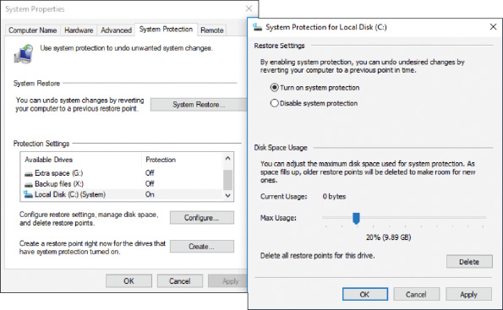
Restore points are normally kept in a folder named C:\System Volume Information, which is not accessible to the user. Restore points are taken at least every 24 hours, and they can use up to 15 percent of disk space. If disk space gets very low, restore points are no longer made, which is one more good reason to keep at least 15 percent or more of the hard drive free.

Manually Create a Restore Point
To manually create a restore point, use the System Protection tab of the System Properties box, as shown on the left side of Figure 13-9. Click Create. In the System Protection box, enter a name for the restore point, such as “Before I tested software,” and click Create. The restore point is created.
Go to pg.
help
Application Opened
Main content

13-3Managing Files, Folders, and Storage Devices
A+ Core 2
- 1.3
Summarize general OS installation considerations and upgrade methods.
- 1.4
Given a scenario, use appropriate Microsoft command line tools.
- 1.5
Given a scenario, use Microsoft operating system features and tools.
- 3.1
Given a scenario, troubleshoot Microsoft Windows OS problems.
In this part of the chapter, you learn how files, folders, and volumes on a hard drive are organized, how to manage hard drive partitions and volumes using the Disk Management utility, and how to improve hard drive performance. Let’s begin the discussion with how partitions and file systems work in Windows.
Go to pg.
help
Application Opened
Main content

13-3aHow Partitions and File Systems Work
A+ Core 2
- 1.3
Summarize general OS installation considerations and upgrade methods.
- 1.4
Given a scenario, use appropriate Microsoft command line tools.
- 1.5
Given a scenario, use Microsoft operating system features and tools.
Recall that a hard drive is organized into partitions, volumes, and file systems. Total capacities for today’s drives are measured in GB (gigabytes, roughly one billion bytes) or TB (terabytes, roughly one trillion bytes). Before a hard drive leaves the factory, a process called low-level formatting organizes the space in a long series of logical blocks; this is called Logical Block Addressing (LBA). When you first prepare a new hard drive for use, the drive is further organized into one or more partitions using one of two partitioning systems:
- MBR partitions. The Master Boot Record (MBR) partitioning system keeps a map of partitions in a partition table stored at the beginning of the hard drive called the MBR. Recall that the MBR system is required when a computer is using a 32-bit operating system or legacy BIOS. The MBR partition table can track up to four partitions on a drive. A drive can have one, two, or three primary partitions, also called volumes. The fourth partition is called an extended partition and can hold one or more volumes called logical drives, which are tracked in their own partition table separately from the primary partitions. Figure 13-10 shows how an MBR hard drive is divided into three primary partitions and one extended partition.
Figure 13-10
A hard drive with four partitions; the fourth partition is an extended partition
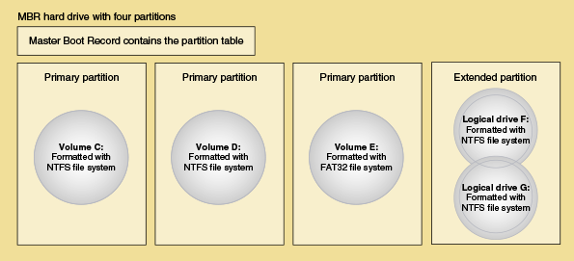
A+ Exam Tip
The A+ Core 2 exam expects you to know the difference between a primary and extended partition and between a volume and logical drive on an MBR hard drive.
- GPT partitions. The Globally Unique Identifier Partition Table (GUID or GPT) system can support up to 128 partitions and is required for drives larger than 2.2 TB. Recall that GPT requires a 64-bit operating system and UEFI firmware and is needed to use Secure boot, a feature of UEFI and the OS. Most new computers sold today use the GPT system.
The first sector in a GPT system contains the protective MBR, which provides information to legacy software that doesn’t recognize GPT systems so that the legacy software will not attempt to repair or install an MBR system on the drive. GPT tracks all partitions in a single partition table, which it stores in the GPT header immediately following the protective MBR. GPT systems also back up the partition table at the end of the disk (see Figure 13-11).
Figure 13-11
A hard drive using GPT partitioning
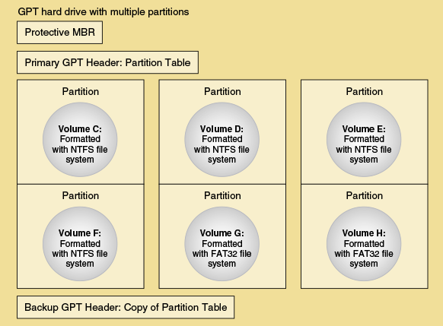

Windows File Systems
Before a partition or drive can be accessed, it must be assigned a drive letter such as C: or D: and formatted using a file system. Recall that the file system is the overall structure an OS uses to name, store, and organize files and folders on a drive. Installing a drive letter, file system, and root directory on a volume is called formatting the drive or high-level formatting. This formatting can happen during the Windows installation.
Notes
In most Microsoft documentation, a partition is called a partition until it is formatted with a file system and assigned a drive letter. Then it is called a volume.
Here is a list of file systems supported by Windows:
- NTFS. For most editions of Windows, NTFS (New Technology file system) is required for the volume on which Windows is installed. NTFS was designed to replace the older FAT32 file system; it is more reliable, efficient, and secure than FAT32. NTFS supports encryption, disk quotas (limiting the hard drive space available to a user), and file and folder compression. If you boot the system from another boot medium such as a DVD, you can access a volume using a FAT file system. If the volume uses NTFS, an administrator password is required to gain access.
- ReFS. The latest file system by Microsoft is the Resilient File System (ReFS), which is designed to improve on the NTFS file system by offering better performance. ReFS also offers fault tolerance , which protects data when sectors on the hard drive fail, eliminating the need for repairs using chkdsk, and it offers compatibility with virtualization and data redundancy in a RAID system. (RAID joins multiple hard drives into one virtual hard drive space.) ReFS is included in Windows 10 Pro for Workstations, but not with Windows 10 Pro or other editions of Windows 10.
- NFS. The NFS (Network File System) is a client/server file system that supports file sharing over a network across platforms. For example, a Linux-hosted NFS server can serve up file shares to Windows workstations on the network. Windows 10 supports NFS client connections.
- exFAT. Choose the exFAT file system for large external storage devices that you want to use with other operating systems. For example, you can use a smart card formatted with exFAT in a Mac or Linux computer or in a digital camcorder, camera, or smartphone. exFAT uses the same structure as the older FAT32 file system, but with a 64-bit-wide file allocation table (FAT). exFAT does not use as much overhead as the NTFS file system and is designed to handle very large files, such as those used for multimedia storage.
- FAT32. Use FAT32 for small hard drives or USB flash drives because it does not have as much overhead as NTFS and is supported by Linux and other OSs.
- CDFS and UDF. CDFS (Compact Disc File System) is an older file system used by optical discs (CDs, DVDs, and BDs), and is being replaced by the newer UDF (Universal Disk Format) file system.
A+ Exam Tip
The A+ Core 2 exam expects you to know about the FAT32, exFAT, NTFS, CDFS, and NFS file systems, including which is appropriate to use in a given scenario.
Notes
Windows installs on an NTFS volume, but if a second volume on the drive is formatted using the FAT32 file system, you can convert that volume to NTFS. For large drives, NTFS is more efficient, and converting might improve performance.

How Partitions Are Used During the Boot
With MBR hard drives, one of the primary partitions is designated the active partition, which is the bootable partition that startup BIOS/UEFI turns to when searching for an operating system to load. In GPT systems, this bootable partition is called the EFI System Partition (ESP); UEFI turns to it to find and start the operating system. The OS program it looks for in this partition is called the boot loader or boot manager.
In Windows, the MBR active partition or the GPT EFI System Partition is called the system partition. For Windows 10/8/7, the boot manager program is named BootMgr (with no file extension). The boot manager turns to the volume that is designated the boot partition, where the Windows operating system is stored, and continues the process of starting Windows.
Notes
Don’t be confused by the terminology here. It is really true that, according to Windows terminology, the Windows OS is on the boot partition and the boot manager is on the system partition, although that might seem backward. The computer starts or boots from the system partition and loads the Windows operating system from the boot partition. Typically, the boot partition and folder where Windows is stored is C:\Windows.
Go to pg.
help
Application Opened
Main content

13-3bUsing Disk Management to Manage Hard Drives
A+ Core 2
- 1.3
Summarize general OS installation considerations and upgrade methods.
- 1.5
Given a scenario, use Microsoft operating system features and tools.
The primary tool for managing hard drives is Disk Management. In Chapter 12, you learned how to install Windows on a new hard drive. This installation process initializes, partitions, and formats the drive. After Windows is installed, you can use Disk Management to install and manage drives. In this part of the chapter, you learn to use Disk Management to manage partitions on a drive, prepare a new drive for first use, mount a drive, use Windows dynamic disks, and troubleshoot problems with the hard drive.
Applying Concepts

Examining Hard Drives Using Disk Management
Let’s use Disk Management (diskmgmt.msc) to view the hard drives in two systems:
- 1
To open the Disk Management window, use one of these methods:
  - For Windows 10/8, right-click Start and click Disk Management. You can find Disk Management in the Windows 7 Start menu.
  - Press Win+R and enter diskmgmt.msc in the Windows 10/7 search box or the Windows 8 Run box.
In Figure 13-12, you can see an example of the Disk Management window showing three MBR hard drives in a system. In this computer, Windows is installed on Disk 0; Disk 1 is an unformatted drive, and Disk 2 is formatted using the NTFS file system. On Disk 0, the first partition is the System Reserved partition, which is designated the active partition and the Windows system partition. The boot partition is drive C:, where Windows is stored.
Figure 13-12
Three MBR disks with Windows 10 installed on Disk 0
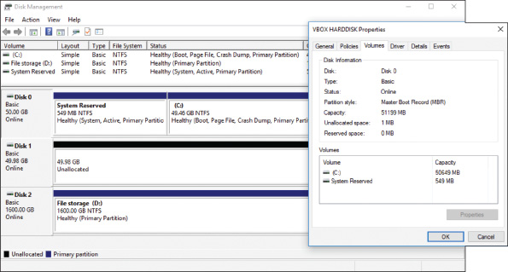
- 2
To see the Disk 0 Properties box, right-click Disk 0 on the left side of the Disk Management window and click Properties. The Properties box appears, as shown in Figure 13-12. Select the Volumes tab to find out the partitioning system for the disk.
Figure 13-13 shows another computer that has a single GPT hard drive installed. Among other partitions, it contains an OEM recovery partition, the EFI System Partition, and drive C:, which is designated the boot partition and holds the Windows 10 installation.
Figure 13-13
A GPT disk with Windows 10 installed
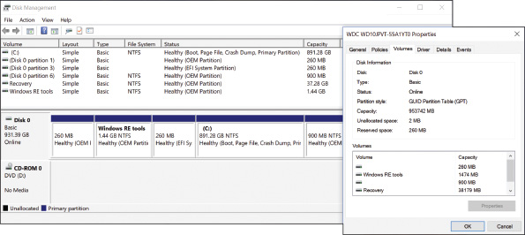

Resize, Create, and Delete Partitions
Suppose you have installed Windows 10 on a hard drive and used all available space on the drive for the one partition. Now you want to split the partition into two partitions so that you can use the second one to hold the backups for another computer on the network. You can use Disk Management to shrink the original partition, which frees up some space for a new Ubuntu partition. Let’s see how it’s done:
- Open the Disk Management window (see Figure 13-14).
Figure 13-14
Shrink a volume to make room for a new partition
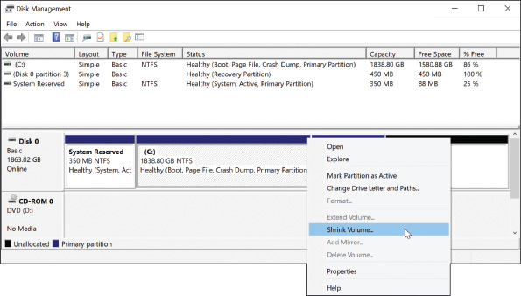
- To shrink the existing partition, right-click in the partition space and select Shrink Volume from the shortcut menu (see Figure 13-14). The Shrink dialog box appears and shows the amount of free space on the partition. Enter the amount in MB to shrink the partition; this amount cannot be more than the available amount of free space so that no data on the partition will be lost. (For best performance, be sure to leave at least 20 percent free space on the existing partition.) Click Shrink. The disk now shows unallocated space.
- To create a new partition in the unallocated space, right-click in that space and select New Simple Volume from the shortcut menu (see Figure 13-15). The New Simple Volume Wizard opens.
Figure 13-15
Use unallocated space to create a new partition
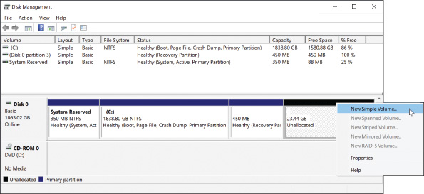
- Follow the on-screen directions to enter the size of the volume in MB, select a drive letter for the volume, and select a file system. Leave the Allocation unit size at Default. You can also enter a Volume label and decide to do a quick format. (A quick format does not check the volume for bad sectors.) The partition is then created and formatted with the file system you chose. When you open Explorer, you should see the new volume listed.
Notice in Figure 13-14 the options on the shortcut menu for this MBR system, where you can make the partition the active partition (the one BIOS/UEFI looks to for an OS), change the drive letter for a volume, format the volume (which erases all data on it), extend the volume (increase its size), and shrink or delete the volume. An option that is not available for the particular volume and situation is grayed out.
A+ Exam Tip
The A+ Core 2 exam expects you to know how to use Disk Management to extend, split, and shrink partitions and configure a new hard drive in a system.

Prepare a Drive for First Use
When you install a new, second hard drive in a computer, use Disk Management to prepare the drive for use. This happens in a two-step process:
- 1.
Initialize the disk. When the disk is initialized, Windows identifies it as a basic disk. A basic disk is a single hard drive that works independently of other hard drives. When you first open Disk Management after you have installed a new hard drive, the Initialize Disk box automatically appears (see Figure 13-16). Select the partitioning system (MBR or GPT) and click OK. Disk Management now reports the hard drive as a Basic disk.
Figure 13-16
Use the Initialize Disk box to set up a partitioning system on new hard drives
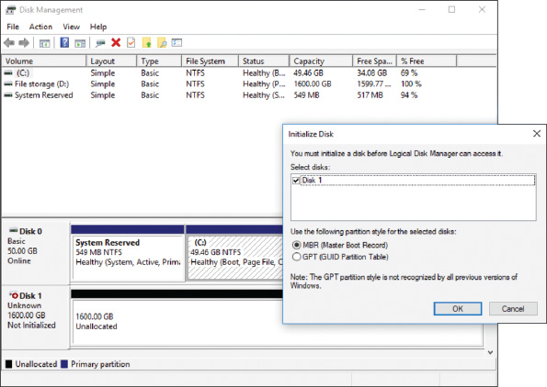
Notes
After installing a new hard drive, if you don’t see the Initialize Disk box when you first open Disk Management, right-click in the Disk area and select Initialize Disk from the shortcut menu. The Initialize Disk box will appear.
- 2.
Create a volume and format it with a file system. As you learned to do earlier, you can now create a New Simple Volume in unallocated space on the disk.

How to Mount a Drive
A mounted drive is a volume that can be accessed by way of a folder on another volume so that the folder has more available space. A mounted drive is useful when a folder is on a volume that is too small to hold all the data you want in the folder. In Figure 13-17, the mounted drive gives the C:\Projects folder a capacity of 20 GB. The C:\Projects folder is called the mount point for the mounted drive.
Figure 13-17
The C:\Projects folder is the mount point for the mounted drive
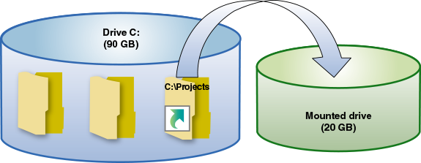
Follow these steps to mount a drive:
- Make sure the volume that will host the mounted drive uses the NTFS file system. The folder on this volume, called the mount point, must be empty. You can also create the folder during the mount process. In this example, we are mounting a drive to the C:\Projects folder.
- Using Disk Management, right-click in the unallocated space of a disk. In our example, we’re using Disk 3 (the fourth hard drive). Select New Simple Volume from the shortcut menu. The New Simple Volume Wizard launches. Using the wizard, specify the amount of unallocated space you want to devote to the volume. Our example uses 20 GB, although the resulting size of the C:\Projects folder will only show about 19 GB because of overhead.
- As you follow the wizard, the box shown on the left side of Figure 13-18 appears. Select Mount in the following empty NTFS folder, and then click Browse. In the Browse for Drive Path box that appears (see the right side of Figure 13-18), you can drill down to an existing folder or click New Folder to create a new folder on drive C:.
Figure 13-18
Select the folder that will be the mount point for the new volume
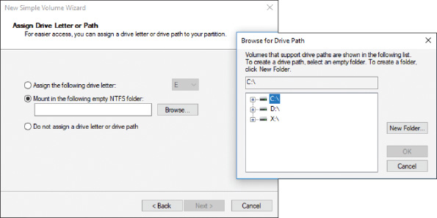
- Complete the wizard by selecting a file system for the new volume; you can also name the volume. The volume is created and formatted.
- To verify that the drive is mounted, open Explorer and then open the Properties box for the folder. In our example, the Properties box for the C:\Projects folder is shown in the middle of Figure 13-19. Notice the Properties box reports the folder type as a Mounted Volume. When you click Properties in the Properties box, the volume Properties box appears (see the right side of Figure 13-19). In this box, you can see the size of the mounted volume minus overhead.
Figure 13-19
The mounted drive in Explorer appears as a very large folder
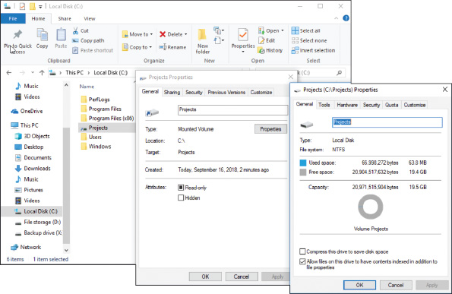
You can think of a mount point, such as C:\Projects, as a shortcut to a volume on a second hard drive. If you look closely at the left window in Figure 13-19, you can see the shortcut icon beside the Projects folder.

Windows Dynamic Disks
A basic disk works independently of other hard drives, but a dynamic disk can work with other hard drives to hold data. Volumes stored on dynamic disks are called dynamic volumes. Several dynamic disks can work together to collectively present a single dynamic volume to the system.
When dynamic disks work together, data to configure each hard drive is stored in a disk management database that resides in the last 1 MB of storage space on each hard drive. Note that Home editions of Windows do not support dynamic disks.
Here are three uses of dynamic disks:
- For better reliability, you can configure a hard drive as a dynamic disk and allocate the space as a simple volume. This is the best reason to use dynamic disks and is a recommended best practice. Because of the way a dynamic disk works, the simple volume is considered more reliable than when it is stored on a basic disk. A volume that is stored on only one hard drive is called a simple volume.
- You can implement dynamic disks on multiple hard drives to extend a volume across these drives (called spanning). This volume is called a spanned volume.
- Dynamic disks can be used to piece data across multiple hard drives to improve performance and/or provide fault tolerance (protecting data against loss). The technology to configure two or more hard drives to work together as an array of drives is called RAID (redundant array of inexpensive disks or redundant array of independent disks).
  - Joining hard drives together to improve performance is called striping or RAID 0. The volume is called a striped volume (see Figure 13-20). RAID 0 can improve performance because the work is shared between two hard drives. However, RAID 0 does not provide fault tolerance (if one drive fails, the data is lost).
Figure 13-20
A simple volume is stored on a single disk, but a striped volume or a mirrored volume is stored on an array of dynamic disks
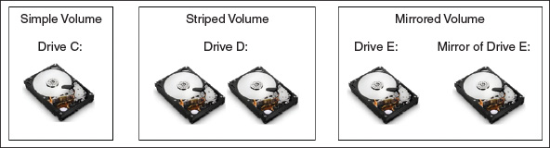
  - Copying one hard drive to another as a backup is called mirroring or RAID 1. The volume is called a mirrored volume. RAID 1 improves fault tolerance because if one drive fails, you have another copy of the data. RAID 1 can reduce performance because the drives operate at the speed of the slowest drive.
When RAID is implemented in this way using Disk Management, it is called software RAID. A more reliable way of configuring RAID is to use BIOS/UEFI setup on a motherboard that supports RAID, which is called hardware RAID.
A+ Exam Tip
The A+ Core 2 exam expects you to select which RAID type is appropriate to use in a given scenario.
You can use Disk Management to convert two or more basic disks to dynamic disks. Then you can use unallocated space on these disks to create a simple volume or a Windows array of disks using a spanned, striped, or mirrored volume. To convert a basic disk to dynamic, right-click the Disk area and select Convert to Dynamic Disk from the shortcut menu (see Figure 13-21). Then right-click free space on the disk and select New Simple Volume, New Spanned Volume, New Striped Volume, or New Mirrored Volume from the shortcut menu. If you were to select spanning or striping in Figure 13-21, you could make Disk 1 and Disk 2 dynamic disks that hold a single volume. The size of the volume would be the sum of the space on both hard drives. If you were instead using mirroring in Figure 13-21, you could make Disk 2 mirror the volume on Disk 1 as a backup copy. The size of the volume would be the space both hard drives have in common—which means it would be the size of the smaller of the two disks.
Figure 13-21
Convert a basic disk to a dynamic disk
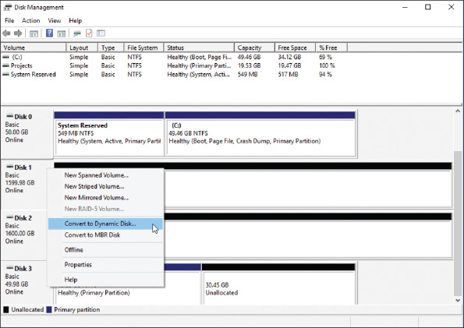
Notes
When Windows implements RAID, know that you cannot install an OS on a spanned or striped volume that uses software RAID. You can, however, install Windows on a hardware RAID drive.
Also, after you have converted a basic disk to a dynamic disk, you cannot revert it to a basic disk without losing all data on the drive.
Now for some serious cautions about software RAID where you use Windows for spanning, striping, and mirroring: Microsoft warns that when Windows is used for software RAID, the risk of catastrophic failure increases and can lead to data loss. Microsoft suggests you only use Windows spanning, striping, or mirroring when you have no other option. In other words, spanning, striping, and mirroring in Windows aren’t very safe. Instead, use a mounted drive or use hardware RAID to expand the size of a volume or to copy a volume to another drive.

Windows Storage Spaces
Storage Spaces in Windows 10/8 is a potential replacement for traditional Windows software RAID. With Storage Spaces, you can create a storage pool using any number of internal or external backup drives that use interfaces such as SATA (Serial ATA), SAS (Serial Attached SCSI), or even USB. Then you create one or more virtual drives, called spaces, from this pool, which appear as normal drives in File Explorer. Drives used for Storage Spaces can be formatted with the NTFS or ReFS file system.
Storage Spaces is designed for resiliency, which resists data loss in the event of drive failure. The following storage options offer varying degrees of resiliency in Storage Spaces:
- Simple. A simple storage space combines multiple physical drives into a single logical drive with no built-in data backup. This option offers no resiliency.
- Two-way mirroring. A logical drive can be mirrored, which means the data is duplicated across multiple physical drives used to create the space.
- Three-way mirroring. In three-way mirroring, data is stored in triplicate to provide additional resiliency against data loss, although this feature requires that at least five physical drives be used to create the storage pool.
- Parity. To provide even greater resiliency, parity spaces maintain multiple copies of data (depending on the configuration) plus parity checking, which is a way to check backed-up data for any loss and re-create compromised data through parity calculations.
A single storage pool can be divided into multiple spaces, and each space can be configured with different resiliency settings. As pool capacity is depleted, more drives can be added to increase the available space without reconfiguring the space. In fact, the space can be configured as if it has more virtual storage than the physical drives actually offer by using a feature called thin provisioning. For example, in Figure 13-22, you can see the total of storage spaces presented to users is 12 TB; however, the physical hard drive capacities add up to only 8 TB. As the space actually used approaches 8 TB, the administrator is prompted to add more physical storage to the pool, which can eventually meet the 12-TB maximum capacity.
Figure 13-22
Thin provisioning allows for additional physical devices as needed without reconfiguring space available to users
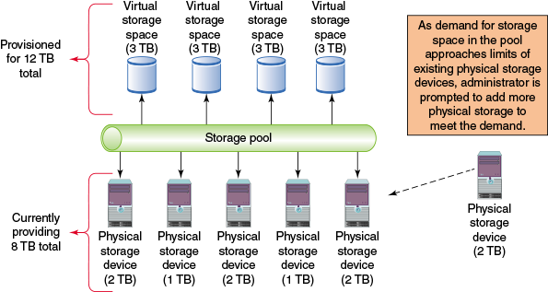
To set up a system to use Storage Spaces, do the following:
- Attach any drives to the computer that you intend to use for your storage pool. These can include SATA, SAS, or certain USB devices, and they do not have to match in capacity. Make sure the drives are identified as basic disks. All data on the storage drives will be lost during formatting, so be sure to back up anything important first.
- In Classic view of Control Panel, click Storage Spaces. Click Create a new pool and storage space. Respond to the UAC box.
- Any drives that are compatible with Storage Spaces will be listed. Select the drives to format. All data on the selected drives will be lost. Click Create pool to prepare the drives.
- After the drives are ready, use the Create a storage space window (see Figure 13-23) to assign a name and drive letter for the storage space and select a file system. File system options include NTFS; for Windows 10 Pro Workstation, ReFS is an option.
Figure 13-23
Define the resiliency type for the new storage space
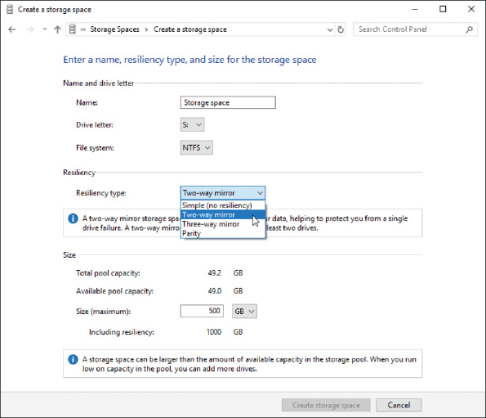
- Select a resiliency type. Options include simple (no resiliency), two-way mirror, three-way mirror, and parity. Then, if you plan to use thin provisioning, adjust the maximum size of the storage pool. Sizes can be set in GB or TB. Notice that you can set a maximum size well beyond the actual sizes of the disks in the pool, and you’ll be notified when you need to add more drives to provide that space. Click Create storage space. The storage space is created and formatted.
- After the storage space is created, you can return to the Storage Spaces window to change the name, drive letter, and size of an existing storage space.

Use Disk Management to Troubleshoot Hard Drive Problems
Notice in Figure 13-21 that the system has four hard drives (Disk 0, Disk 1, Disk 2, and Disk 3), and information about the disks and volumes is shown in the Disk Management window. When you are having a problem with a hard drive, it helps to know what the information in the window means. Here are the disk and volume statuses you might see in this window:
- Healthy. The healthy volume status shown in Figure 13-21 indicates that the volume is formatted with a file system and that the file system is working without errors.
- Failed. A failed volume status indicates a problem with the hard drive or that the file system has become corrupted. To try to fix the problem, make sure the hard drive data cable and power cable are secure. Data on a failed volume is likely to be lost. For dynamic disks, if the disk status is Offline, try bringing the disk back online. (Details are covered later in this list.)
- Online. An online disk status indicates the disk has been sensed by Windows and can be accessed by either reading or writing to the disk.
- Active. One volume on an MBR system will be marked as Active. This is the volume that startup BIOS/UEFI looks to for an OS boot manager to load.
- EFI System Partition. In GPT systems, one volume will be marked as the EFI System Partition. BIOS/UEFI looks to this volume to find an OS boot manager to load an OS.
- Unallocated. Space on the disk is marked as unallocated if it has not yet been partitioned.
- Formatting. This volume status appears while a volume is being formatted.
- Basic. When a hard drive is first sensed by Windows, it is assigned the Basic disk status. A basic disk can be partitioned and formatted as a stand-alone hard drive.
- Dynamic. The following status indicators apply only to dynamic disks:
  - Offline. An offline disk status indicates a dynamic disk has become corrupted or is unavailable. The problem can be caused by a corrupted file system, loose drive cables, a failed hard drive, or another hardware problem. If you believe the problem is corrected, right-click the disk and select Reactivate Disk from the shortcut menu to bring the disk back online.
  - Foreign drive. If you move a hard drive that has been configured as a dynamic disk on one computer to another computer, it will report the disk as a foreign drive. To fix the problem, you need to import the foreign drive. Right-click the disk and select Import Foreign Disks from the shortcut menu. You should then be able to see the volumes on the disk.
  - Healthy (At Risk). The dynamic disk can be accessed, but I/O errors have occurred. Try returning the disk to online status. If the volume status does not return to healthy, back up all data and replace the drive.
If you are still having problems with a hard drive, volume, or mounted drive, check Event Viewer for events about the drive that might have been recorded there. These events might help you understand the nature of the problem and what to do about it. How to use Event Viewer is covered in Chapter 14.
Go to pg.
help
Application Opened
Main content

13-3cImproving Hard Drive Performance
A+ Core 2
- 1.5
Given a scenario, use Microsoft operating system features and tools.
- 3.1
Given a scenario, troubleshoot Microsoft Windows OS problems.
For best performance, Windows needs at least 15 percent free space on the hard drive that it uses as working space, so it’s important to uninstall software you no longer need and delete unneeded files occasionally. Disk Management includes a Disk Cleanup (cleanmgr.exe) utility that deletes temporary files on the drive. In addition, a hard drive can be optimized to improve performance; how that’s done depends on the type of hard drive.
Two types of hard drives are magnetic hard disk drives (HDDs), which contain spinning platters, and solid-state drives (SSDs), which contain flash memory. For magnetic hard drives, Windows automatically defragments the drive once a week, and for SSDs, Windows automatically trims the drive weekly. Let’s look at what each of these operations accomplishes:
- Magnetic hard drives. To defragment is to rearrange fragments or parts of files on the drive so each file is stored on the drive in contiguous clusters. Each platter on a magnetic hard drive is divided into tracks, which are divided into sectors (see Figure 13-24). In a file system, a cluster, also called a file allocation unit, is a group of whole sectors. The number of sectors in a cluster is fixed and is determined when the file system is first installed. A file is stored in whole clusters, and the unused space at the end of the last cluster, called slack, is wasted free space. As files are written and deleted from an HDD, clusters are used, released, and used again. New files written on the drive can be put in available clusters spread over the drive. Over time, drive performance is affected when the moving read/write arm of a magnetic drive must move over many areas of the drive to collect all the fragments of a file. Defragmenting a drive rewrites files in contiguous clusters and improves drive performance.
Figure 13-24
A magnetic hard drive is divided into concentric circles called tracks, and tracks are divided into sectors
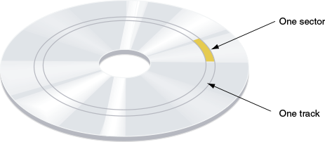
- Solid-state drives. Defragmenting an SSD can reduce the life of the drive and is not recommended—Windows disables defragmenting for solid-state drives. However, data on an SSD still needs trimming. To trim an SSD is to erase a block on the drive that is filled with unused data. Recall that SSDs are organized in blocks, and each block contains many pages. A file can spread over several pages in various blocks. Each time a new page is written to the drive, the entire block to which it belongs must be read into a buffer, erased, and then rewritten with the new page included. When a file is deleted, information about the file is deleted, but the actual data in the file is not erased. This can slow down SSD performance because the unused data must still be read and rewritten in its block. To improve performance, Windows sends the trim command to an SSD drive to erase a block that no longer contains useful data so that a write operation does not have to manage the data.
OS Differences
Windows 7 does not support optimizing an SSD.
Applying Concepts

Cleaning and Optimizing Hard Drives
To delete unneeded files on a drive and verify that the drive is being automatically defragged or trimmed, use the Disk Cleanup utility (cleanmgr.exe) and the Defragment and Optimize Drives (dfrgui.exe) utility. Do the following when starting the utilities from Explorer:
- 1.
To delete unneeded files, open Explorer, right-click drive C:, and click Properties. On the General tab of the drive Properties box, click Disk Cleanup to calculate how much space can be cleaned up. Select the file types to delete (see Figure 13-25) and click OK.
Figure 13-25
Delete unneeded files on a hard drive to free up space
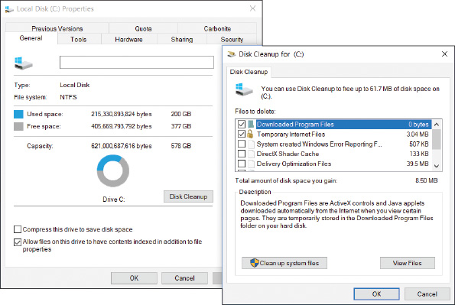
Notes
When Windows installs, it stores the old installation in the Windows.old folder. Windows 10 deletes the folder 28 days after the installation. If you see the Windows.old folder in Windows 8/7 systems, include it in the list to be deleted to free up disk space.
- 2.
To optimize the hard drive, select the Tools tab in the drive Properties box and click Optimize. The Optimize Drives box appears (see Figure 13-26). This system has two hard drives installed. Drive C: is an SSD and drive F: is a magnetic HDD.
Figure 13-26
Windows is set to automatically defragment a magnetic hard drive once a week
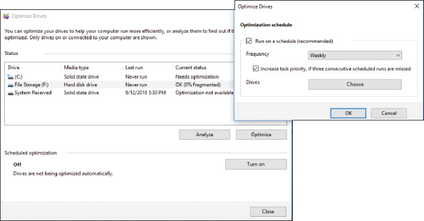
- 3.
Here are tasks you can do:
  - For a magnetic drive, click Analyze for Windows to tell you if a drive needs defragmenting. To defrag the drive, click Optimize. The process can take a few minutes to several hours. If errors occur while the drive is defragmenting, check the hard drive for errors and try to defragment again.
  - For a solid-state drive, click Optimize to trim the SSD.
  - Near the bottom of Figure 13-26, you can see optimization is turned off. To turn it on, click Turn on. In the box that appears (see the right side of the figure), check Run on a schedule (recommended) and select Weekly for the Frequency. Click OK.
Throughout this chapter, you’ve learned a lot about Windows maintenance tasks, backup procedures, and how to manage hard drives. The next part of this chapter discusses ways to perform many related tasks from a command-line interface.
Go to pg.
help
Application Opened
Main content

13-4Using a Command-Line Interface (CLI)
A+ Core 2
- 1.3
Summarize general OS installation considerations and upgrade methods.
- 1.4
Given a scenario, use appropriate Microsoft command line tools.
IT support technicians find it is much faster to manipulate files and folders and perform other tasks by using commands in a command prompt window than by using Explorer and other graphical tools. In some troubleshooting situations, you have no other option but to use a command prompt window.
Windows has two levels of command prompt windows: a standard window and an elevated window. In a standard window, the default directory is the currently signed-in user’s folder and commands have the same permissions as that user. Commands issued in an elevated command prompt window have administrative privileges and the default directory is C:\Windows\System32.
To open a standard command prompt window (see Figure 13-27), enter command or cmd in the Windows 10/7 search box or the Windows 8 Run box, and then click Command Prompt.
Figure 13-27
A command prompt window
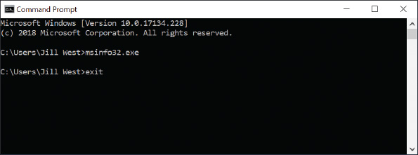
OS Differences
For Windows 8, Command Prompt is listed in the Quick Launch menu. Press Win+X and click Command Prompt.
To open an elevated command prompt window, type cmd or command in the Windows 10/7 search box or the Windows 8 Run box, right-click Command Prompt, and click Run as administrator. Then respond to the UAC box. The Administrator: Command Prompt window is shown in Figure 13-28. Notice the word Administrator in the title bar, which indicates the elevated window, and the default directory, which is the C:\WINDOWS\system32 folder.
Figure 13-28
An elevated command prompt window has administrative privileges
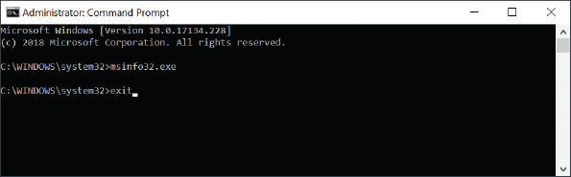
OS Differences
To get an elevated command prompt window in Windows 8, press Win+X, click Command Prompt (Admin), and respond to the UAC box. In Windows 7, click Start, All Programs, Accessories, and right-click Command Prompt. Then select Run as administrator from the shortcut window and respond to the UAC box.
Here are some tips for working in a command prompt window:
- Type cls and press Enter to clear the window.
- To retrieve the last command you entered, press the up arrow. To retrieve the last command line one character at a time, press the right arrow.
- To terminate a command before it is finished, press Ctrl+C, Ctrl+Break, or Ctrl+Pause.
- To access settings for the command prompt window, right-click the title bar and click Properties. You can change the background color, font, font color, and font size so you can better read the text in the window, adjust opacity so you can see what’s behind the window as you work, and access Ctrl key shortcuts.
- To close the window, type exit (see Figure 13-28) and press Enter.
Notes
Many of the commands you learn about in this section can also be used in the Windows Recovery Environment (Windows RE), which can be loaded from within Windows during troubleshooting. When Windows refuses to start, you can load Windows RE from Windows setup media or a USB or DVD recovery drive. How to use the Recovery Environment is covered in Chapters 14 and 15.
Go to pg.
help
Application Opened
Main content

13-4aCommands to Manage Files and Folders
A+ Core 2
- 1.3
Summarize general OS installation considerations and upgrade methods.
- 1.4
Given a scenario, use appropriate Microsoft command line tools.
If the command you are using applies to files or folders, the path to these files or folders is assumed to be the default drive and directory. The default drive and directory, also called the current drive and directory, shows in the command prompt. For example, in Figure 13-27, the default drive is C: and the default path is C:\Users\Jill West. If you use a different path in the command line, the path you use overrides the default path. Also know that Windows makes no distinction between uppercase and lowercase in command lines (however, Linux does).
Now let’s look at the file-naming conventions you will need to follow when creating files, wildcard characters you can use in command lines, and several commands useful for managing files and folders.

File-naming Conventions
When using the command prompt window to create a file, keep in mind that file name and file extension characters can be the letters a through z, the numbers 0 through 9, and the following characters:
_ ^ $ ~ ! # % & – { } ( ) @ ' `
In a command prompt window, if a path or file name has spaces in it, it is sometimes necessary to enclose the path or file name in double quotation marks.

Wildcard Characters in Command Lines
As you work at the command prompt, you can use wildcard characters in a file name to apply the command to a group of files or to abbreviate a file name if you do not know the entire name. The question mark (?) is a wildcard for one character, and the asterisk (*) is a wildcard for one or more characters. For example, if you want to find all file names in a directory that start with A and have a three-letter file extension, you would use the following command:
A+ Exam Tip
The A+ Core 2 exam expects you to know how to use the dir, cd, copy, xcopy, robocopy, chkdsk, format, /?, and shutdown commands, which are all covered in this chapter. Other commands also required for the A+ Core 2 exam are covered in other chapters.
Notes
Many commands can use parameters in the command line to affect how the command will work. Parameters (also called options, arguments, or switches) often begin with a slash or a hyphen followed by a single character. In this chapter, you learn about the basic parameters used by a command for the most common tasks. For a full listing of the parameters available for a command, use the help command. Another way to learn about commands is to follow this link on the Microsoft website: docs.microsoft.com/en-us/windows-server/administration/windows-commands/windows-commands.

Help or <command name> /?
Use the help command to get help about any command. You can enter help followed by the command name or enter the command name followed by /?. Table 13-2 lists some sample applications of this command.
Table 13-2

Sample Help Commands
Command | Result
help xcopy  xcopy /? | Gets help information about the xcopy command
help | Lists all commands
help xcopy | more | Lists information about the xcopy command one screen at a time; press Space to see the next screen, or Enter to advance one line at a time
Notes
Windows commands are not case sensitive. You can type help, Help, or HELP and you’ll get the same result.
A+ Exam Tip
The A+ Core 2 exam does not give you access to /? or the help command and expects you to know how to structure each command and its parameters covered in this and other chapters.

dir [<filename>] [/p] [/s] [/w]
Use the dir command to list files and directories. In Microsoft documentation about a command (also called the command syntax), the brackets [ ] in a command line indicate the parameter is optional. In addition, the parameter included in < >, such as <filename>, indicates that you can substitute any file name in the command. This file name can include a path or file extension. Table 13-3 lists some examples of the dir command.
Table 13-3

Sample dir Commands
Command | Result
dir /p | Lists one screen at a time
dir /w | Presents information using wide format, where details are omitted and files and folders are listed in columns on the screen
dir *.txt | Lists all files with a .txt file extension in the default path
dir d:\data\*.txt | Lists all files with a .txt file extension in the D:\data\ folder
dir myfile.txt | Checks that a single file, such as myfile.txt, is present
dir /s | Includes subdirectory entries

cd [<drive>:\[<path>]] or cd..
The cd (change directory) command changes the current default directory. You enter cd followed by the drive (a volume letter, such as C:) and the entire path that you want to be current, like so:
The command prompt now looks like this:
To move up from a child directory to its parent directory, use the .. (dot, dot) variation of the command:
The command prompt now looks like this:
Remember that .. (dot, dot) always indicates the parent directory. You can move from a parent directory to one of its child directories simply by stating the name of the child directory:
The command prompt now looks like this:
Remember not to put a backslash in front of the child directory name; doing so tells the OS to go to a directory named chess that is directly under the root directory.
Notes
Two commands closely related to cd are md (make directory), which creates a subdirectory under a directory, and rd (remove directory), which removes an empty directory.

copy [/v] [/y] <source> [<destination>]
The copy command copies a single file or group of files. The original files are not altered. To copy a file from one drive to another, use a command similar to this one:
The drive, path, and file name of the source file follow the copy command. The drive, path, and file name of the destination file follow the source file name. If you don’t specify the file name of the destination file, the OS assigns the file’s original name to this copy. If you omit the drive or path of the source or the destination, then the OS uses the current default drive and path.
To copy the file myfile.txt from the root directory of drive C: to drive E:, use the following command:
Because the command does not include a drive or path before the file name myfile.txt, the OS assumes that the file is in the default drive and path. Also, because there is no destination file name specified, the file written to drive E: will be named myfile.txt.
To copy all files in the C:\Docs directory to the USB flash drive designated drive E:, use the following command:
To make a backup file named system.bak of the SYSTEM registry hive file in the \Windows\System32\config directory of the hard drive, use the following command:
If you use the copy command to duplicate multiple files, the files are assigned the names of the original files. When you duplicate multiple files, the destination portion of the command line cannot include a file name.
Here are two parameters that are useful with the copy command:
- /v. When the /v switch is used, the size of each new file is compared with the size of the original file. This slows down the copying but verifies that the copy is done without errors.
- /y. When the /y switch is used, a confirmation message does not ask you to confirm before overwriting a file.
Notes
When trying to recover a corrupted file, you can sometimes use the copy command to copy the file to new media, such as from the hard drive to a USB drive. If the copy command reports a bad or missing sector during the copying process, choose the option to ignore that sector. The copying process then continues to the next sector. The corrupted sector will be lost, but others can likely be recovered. The recover command can be used to accomplish the same thing.

xcopy <source> [<destination>] [/s] [/e] [/c] [/y] [/d:[date]]
The xcopy command is more powerful than the copy command. It follows the same general command-source-destination format as the copy command, but it offers several more options. Table 13-4 shows some of these options.
Table 13-4

Sample Xcopy Commands
Command | Result
xcopy C:\docs\*.* E: /s | Uses the /s parameter to include subdirectories in the copy; this command copies all files in the directory C:\docs, as well as all subdirectories under \docs and their files, to drive E:, unless the subdirectory is empty
xcopy C:\docs\*.* E: /e | Works the same as /s but empty subdirectories are included in the copy
xcopy C:\docs\*.* E: /d: 03-14-19 | Uses the /d switch to examine the date; this command copies all files from the directory C:\docs created or modified on or after March 14, 2019
xcopy C:\docs\*.* E: /y | Uses the /y switch to overwrite existing files without prompting
xcopy C:\docs\*.* E: /c | Uses the /c switch to keep copying even when an error occurs

Robocopy <source> <destination> [/s] [/e] [/log:<logfile>] [/log+:<logfile>] [/move] [/purge]
The robocopy (robust file copy) command is similar to the xcopy command. It offers more options than xcopy and is intended to replace xcopy. A few options for robocopy are listed in Table 13-5.
Table 13-5

Sample Robocopy Commands
Command | Result
robocopy C:\docs\*.* E: /s | Uses the /s switch to include subdirectories in the copy but does not include empty directories
robocopy C:\docs\*.* E: /e | Uses the /e switch to include subdirectories, even the empty ones
robocopy C:\docs\*.* E: /log:Mylog.txt | Records activity to a log file and overwrites the current log file
robocopy C:\docs\*.* E: /log+:Mylog.txt | Appends a record of all activity to an existing log file
robocopy C:\docs\*.* E: /move | Moves files and directories, deleting them from the source
robocopy C:\docs\*.* E: /purge | Deletes files and directories at the destination that no longer exist at the source
Go to pg.
help
Application Opened
Main content

13-4bCommands to Manage Hard Drives
A+ Core 2
- 1.3
Summarize general OS installation considerations and upgrade methods.
- 1.4
Given a scenario, use appropriate Microsoft command line tools.
Several commands can be used to manage hard drives either when setting up a new hard drive, refreshing a hard drive, or during troubleshooting. Sometimes these commands are easier than digging through menus for a needed utility. If you’re restricted to the Windows Recovery Environment during troubleshooting, these commands might be your only means of accessing some of these tools.

chkdsk [<volume>:] [/f] [/r]
The chkdsk (check disk) command fixes file system errors and recovers data from bad sectors. Recall that a file is stored on the hard drive as a group of clusters. The FAT32 and exFAT file systems use a FAT (file allocation table) to keep a record of each cluster that belongs to a file. In Figure 13-29, you can see that each cell in the FAT represents one cluster and contains a pointer to the next cluster in a file. The NTFS file system uses a database called the master file table (MFT) to hold similar information.
Figure 13-29
Lost and cross-linked clusters
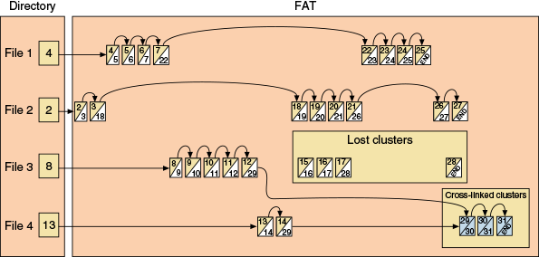
Notes
For an interesting discussion of how the FAT works, see the document FAT Details.pdf on the companion website for this text at cengage.com. See the Preface for more information.
Used with the /f parameter, chkdsk searches for and fixes two types of file system errors made by the FAT or MFT:
- Lost clusters (also called lost allocation units). Lost clusters are clusters that are marked as used in the FAT or MFT, but they do not belong to any file. In effect, the data in these clusters is lost.
- Cross-linked clusters. Cross-linked clusters are marked in the FAT or MFT as belonging to more than one file.
Used with the /r parameter, chkdsk checks for lost clusters, cross-linked clusters, and bad sectors on the drive. The FAT and MFT keep a table of bad sectors that they normally do not use. However, over time, a sector might become unreliable. If chkdsk determines that a sector is unreliable, it attempts to recover the data from the sector and marks the sector as bad so that the FAT or MFT will not use it again.
Used without any parameters, the chkdsk command only reports information about a drive and does not make any repairs.
An elevated command prompt is required to use the chkdsk command. In the following sample commands, the command prompt is not shown because the default drive and directory are not important. To check the hard drive for file system errors and repair them, use this command:
To redirect a report of the findings of the chkdsk command to a file that you can later print, use this command:
Use the /r parameter of the chkdsk command to fix file system errors and examine each sector of the drive for bad sectors, like so:
If chkdsk finds data that it can recover, it asks you for permission to do so. If you give permission, it saves the recovered data in files that it stores in the root directory of the drive.
Notes
Use either the /f or /r parameter with chkdsk, but not both. Using both parameters is redundant. For the most thorough check of a drive, use /r.
The chkdsk command will not fix anything unless the drive is locked, which means the drive has no open files. If you attempt to use chkdsk with the /f or /r parameter when files are open, chkdsk tells you of the problem and asks permission to schedule the run the next time Windows is restarted. Know that the process will take plenty of time.
Notes
The chkdsk command is also available from the Windows Recovery Environment.

defrag [<volume>:] [/C]
The Disk Defragmenter defrag command examines a magnetic hard drive for fragmented files and rewrites these files to the drive in contiguous clusters. Use this command to optimize a magnetic hard drive’s performance. Table 13-6 shows two examples of the command. Recall that it’s not a good idea to defrag solid-state storage devices such as an SSD, flash drive, or smart card. Doing so can shorten the life of the drive.
Table 13-6

Sample Defrag Commands
Command | Result
defrag C: | Defrags volume C:
defrag /C | Defrags all volumes on the computer, including volume C:
The defrag command requires an elevated command prompt window in Windows. It is not available under the Windows Recovery Environment.

format <volume:>[/q] [fs:<filesystem>]
You can format a hard drive or other storage device using Disk Management. In addition, you can use the format command from a command prompt window and from the Windows Recovery Environment. This high-level format installs a file system on the device and erases all data on the volume. Table 13-7 lists various sample uses of the format command.
Table 13-7

Sample Format Commands
Command | Result
format D: | Performs a full format of volume D: using the default file system for the volume type
format D: /q | Performs a quick format of volume D: by re-creating an empty root directory; use it to quickly format a previously formatted disk that is in good condition; /q does not read or write to any other part of the disk
format D: /fs:NTFS | Formats volume D: using the NTFS file system
format D: /fs:FAT32 | Formats volume D: using the FAT32 file system
format D: /fs:EXFAT | Formats volume D: using the extended FAT file system

shutdown [/i] [/r] [/s] [/m \\<computername>] [/t xx]
Use the shutdown command to shut down the local computer or a remote computer. You must be signed in with an administrator account to use this command. By default, the command gives users a 30-second warning before shutdown. To shut down a remote computer on the network, you must have an administrator account on that computer and be signed on the local computer with that same account and password. Table 13-8 lists some shutdown commands.
Table 13-8

Sample Shutdown Commands
Command | Result
shutdown /r | Restarts the local computer
shutdown /s /m \\bluelight | Shuts down the remote computer named \\bluelight
shutdown /s /m \\bluelight /t 60 | Shuts down the \\bluelight computer after a 60-second delay
shutdown /i | Displays the Remote Shutdown dialog box so you can choose computers on the network to shut down
Go to pg.
help
Application Opened
Main content

13-4cWindows 10 PowerShell and Ubuntu Bash Interfaces
A+ Core 2
- 1.3
Summarize general OS installation considerations and upgrade methods.
- 1.4
Given a scenario, use appropriate Microsoft command line tools.
- 4.8
Identify the basics of scripting.
As you become more comfortable with command-line interfaces, you’ll find they can be more flexible and convenient than a graphical interface, especially for commands you use frequently. Microsoft continues to make significant improvements to command-line options in Windows, including increased emphasis on PowerShell and the addition of a Linux shell. The three command-line interfaces (CLI) offered by Windows 10 are the Command Prompt, PowerShell, and Linux shell interfaces. First, let’s explore PowerShell cmdlets, and then we’ll see how the Linux shell works in Windows 10.

PowerShell
Windows PowerShell is designed to replace the command prompt utility for providing a command-line interface. Windows PowerShell processes objects called cmdlets (pronounced “command-lets”) that essentially run prebuilt programs, similar to batch files. Windows PowerShell contains thousands of cmdlets so that users don’t have to build their own. Technicians or programmers who program their own cmdlets can build customized objects using existing cmdlets as building blocks.
PowerShell skills are becoming increasingly important for all IT technicians. In this part of the chapter, we look at some basic PowerShell cmdlets as a starting point to help you warm up to PowerShell.

PowerShell Cmdlet Syntax
Native PowerShell cmdlet syntax almost always starts with a verb followed by a noun and connected with a hyphen, as in verb-noun. For example, consider the cmdlet Get-ChildItem. The Get verb defines the action and the ChildItem noun defines the object of that action. “Get” simply means to retrieve something; an item is a file or folder, and “ChildItem” is any item within another item. So, the cmdlet Get-ChildItem retrieves items in one or more specified locations, similar to how dir works at the command prompt.
Some cmdlets have parameters, such as the -Depth parameter in the Get-ChildItem cmdlet. This parameter allows you to specify how many layers to search in the targeted location to retrieve child items. To use this parameter, you must also use the -Recurse parameter, which instructs PowerShell to retrieve items within child items (such as files within folders) at the targeted location. For example, Get-ChildItem -Recurse -Depth 2 delivers a list of items in the current folder, that folder’s child folders, and folders within those child folders, but the list goes no deeper than two child layers of folders. In a project at the end of this chapter, you get some practice using the Get-ChildItem cmdlet with parameters.
Set, Copy, and Remove are other verb options for cmdlets. Other noun options include Help, Location, Content, Process, and Service. With this information, you can deduce the names of several helpful cmdlets, as shown in Table 13-9.
Table 13-9

Common PowerShell cmdlets
Cmdlet | Description
Get-Item | Retrieves files and folders
Get-Process | Retrieves the processes running on a computer
Set-Location | Changes the current working location to a specified location
Copy-Item | Copies an item to a specified location
Remove-Item | Deletes an item
Get-Verb | Shows a list of all cmdlet verbs
Get-Verb *-Location | Shows a list of all cmdlet verbs available for a specific noun, where the asterisk is a wildcard in place of any verb attached to the noun Location
Get-Command | Shows a list of all available cmdlets
Notes
PowerShell cmdlets are not case sensitive. You can type Get-Item or get-item and you’ll get the same result.
Applying Concepts

Using PowerShell
Let’s learn to use PowerShell by looking at an example of how helpful and powerful it can be. Even a clean copy of Windows comes with several apps that you might not want and that cannot be removed through the Apps & features window or the Programs and Features window. For example, you might not want Xbox installed on a computer you use for work. You can use PowerShell to uninstall unwanted apps.
Complete the following steps to install an app from the Windows Store and then remove it using PowerShell:
- Open the Windows Store and find a simple app to install, such as Dropbox. Click Get to download and install the app. Close the Windows Store.
- Open the Settings app and click Apps.
- Scroll down to the app you just installed. In most cases, you can use this window to remove the app, but some apps can’t be uninstalled from here. For example, as shown in Figure 13-30, the Uninstall button is grayed out for the Maps app.
Figure 13-30
Some apps cannot be uninstalled through the Apps & features window
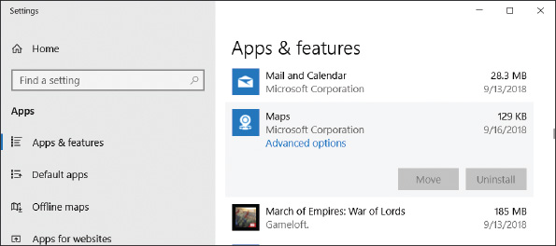
- Let’s use PowerShell to uninstall an app. PowerShell offers a standard PowerShell window and an elevated PowerShell window. Use one of these methods to open an elevated PowerShell window:
  - For Windows 10, press Win+X and click Windows PowerShell (Admin).
  - For Windows 8, open the Start screen and type powershell. Right-click Windows PowerShell and click Run as administrator.
  - For Windows 7, click Start, All Programs, Accessories, and Windows PowerShell. In the folder, right-click Windows PowerShell and click Run as administrator.
- If needed, click Yes in the UAC dialog box.
- Enter Get-AppxPackage to see a list of all apps installed for the current user. Wade through and find the entry for the app you just installed. (It’s most likely at the bottom of the list because you just installed it.) For example, Figure 13-31 shows Dropbox installed on the system.
Figure 13-31
Find the app you just installed
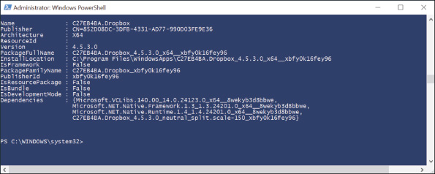
- Select and copy the text for the PackageFullName field of the app to be removed. Enter the command Remove-AppxPackage <PackageFullName>, as shown in Figure 13-32.
Figure 13-32
The text for the PackageFullName field must be typed exactly; therefore, it’s easiest to copy and paste
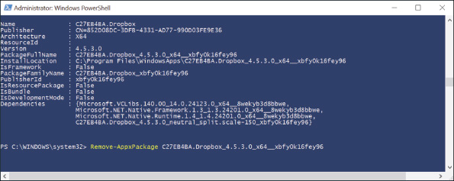
- Enter the command Get-AppxPackage to confirm the app was removed. Also check the Settings app to make sure the app is no longer listed there.
- Enter exit to close the PowerShell session.
Notes
By default, Windows 10 lists Windows PowerShell in the Quick Launch menu. You can change this setting so Command Prompt is listed. Open the Settings app, click Personalization, and click Taskbar. Scroll down and turn the slider button to Off under Replace Command Prompt with Windows PowerShell in the menu when I right-click the start button or press Windows key+X.
Here are some other basic cmdlet features you should know:
- Aliases for command prompt commands. An alias is a nickname or shortcut for a cmdlet. For convenience, many of the commands you’re accustomed to using in a command prompt window also work in PowerShell. These commands are defined as aliases for native PowerShell cmdlets. For example, one default alias for Get-ChildItem is dir. Therefore, you can enter dir in PowerShell to execute the Get-ChildItem cmdlet. Note that an alias applies only to the referenced command and does not include parameters or values (such as a file name) that might be used by the command.
Notes
You can create your own aliases using the Set-Alias and New-Alias cmdlets. For example, Set-Alias show Get-ChildItem assigns the alias show to the cmdlet Get-ChildItem.
- List of aliases. The cmdlet Get-Alias shows all the available aliases in the current session, including the default aliases and other aliases you created during the session.
- Help. To find the cmdlet assigned to a specific alias, use the Help cmdlet (also called Get-Help). For example, enter help dir to see the output shown in Figure 13-33. Here you can see that dir is an alias for Get-ChildItem.
Figure 13-33
dir, gci, and ls are all aliases for Get-ChildItem
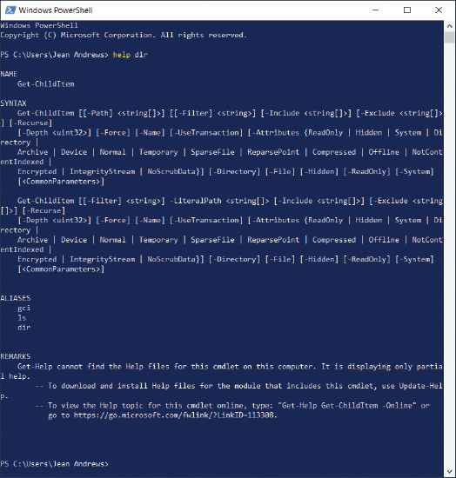
Notes
At the bottom of Figure 13-33, a message informs the user that the Help files for the cmdlet are not available on the computer. You must install the PowerShell help files to access them; open an elevated PowerShell window, type Update-Help, and press Enter. The process will take a few minutes. When you return to the PowerShell prompt, enter help dir again to see how much additional information you can access.

Ubuntu Bash on Windows
In response to customer feedback, Microsoft built a Linux shell into Windows 10 that provides a shell prompt to enter Linux commands. Note that this shell is not a VM, and it’s not a fully separate operating system; rather, it’s a shell that allows users to interact with underlying Windows functions and system files. The new shell requires a Windows component, Windows Subsystem for Linux (WSL), to support it. WSL installs a subset of the Ubuntu distribution of Linux, which is one of the most popular distributions. By default, Ubuntu provides Bash, which is its most popular shell. This shell is called Bash on Ubuntu on Windows, Bash on Windows, or Ubuntu Bash. (It’s possible to install other Ubuntu shells by using switcher software in PowerShell.) Many Linux commands work in WSL running Ubuntu Bash.
WSL runs on any 64-bit Windows 10 system with the Anniversary Update build 14393 or later. You must first turn on Developer Mode and then enable the Windows Subsystem for Linux (Beta) feature. As its name suggests, this feature is still in beta as Microsoft continues to resolve many bugs and gaps in compatibility.
Applying Concepts

Enabling Windows Subsystem for Linux (WSL) and Installing Ubuntu Bash
Complete the following steps to enable Windows Subsystem for Linux and install Ubuntu Bash on a Windows 10 system:
- First, turn on Developer Mode.
  - Open the Settings app and click Update & Security. In the left pane, scroll down and click For developers.
  - Select Developer mode, as shown in Figure 13-34. Click Yes to turn on Developer Mode and close the Settings app.
Figure 13-34
Turn on Developer Mode from the Settings app
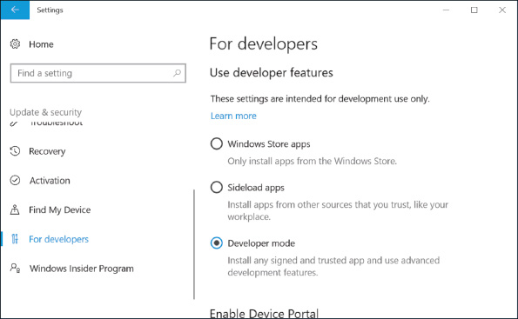
- Enable Windows Subsystem for Linux.
  - Open Control Panel and click Programs and Features. In the left pane, click Turn Windows features on or off.
  - Scroll down and click Windows Subsystem for Linux (Beta), as shown in Figure 13-35. Click OK.
Figure 13-35
Turn on the Windows Subsystem for Linux (Beta) feature
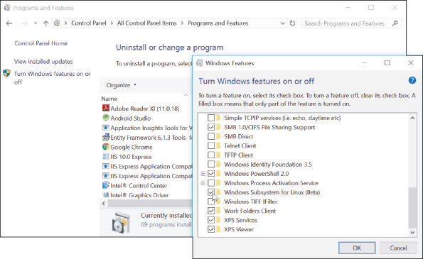
  - Restart the computer when the changes are complete to finish enabling Windows Subsystem for Linux.
- Install and run Bash on Ubuntu on Windows from the command prompt.
  - Open a command prompt window and enter bash (see Figure 13-36). Note that the first time you enter the bash command, Windows downloads and installs Ubuntu on Windows.
Figure 13-36
The first time you enter the bash command, Windows will download and install Ubuntu on Windows
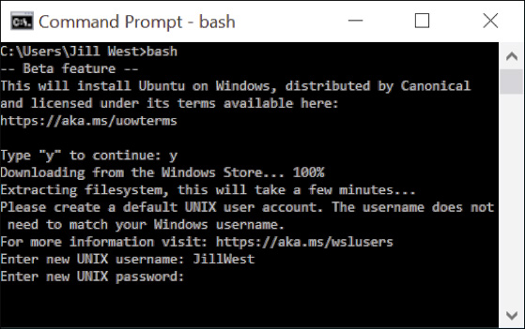
  - Enter y to accept the installation terms. Bash on Ubuntu on Windows downloads from the Windows Store, and then is extracted and installed. This might take several minutes.
  - Enter a new UNIX user name at the prompt. This user name can be different from your Windows user name.
  - Enter a password at the next prompt. The cursor will not move as you type the password. Re-enter the password at the next prompt.
  - After the installation is complete, Windows switches to the Bash on Ubuntu environment with its shell prompt within the command prompt window.
- You can continue to interact with Ubuntu Bash from the command prompt window, or you can open Bash on Ubuntu on Windows in a separate window. To do this, click Start and then click Bash on Ubuntu on Windows in the Start menu. You can also open Bash from within PowerShell. See Figure 13-37 to compare the three windows.
Figure 13-37
Bash on Ubuntu can be accessed from the command prompt, PowerShell, or its own app, Bash on Ubuntu on Windows
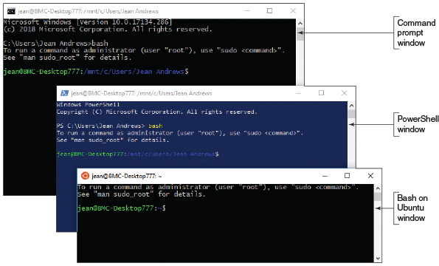
At this point, most commonly used Linux commands will work as usual at the Ubuntu shell prompt. The commands interact with the underlying Windows system files, and changes to those files can be monitored through other Windows tools. You’ll learn more about Linux commands in Chapter 18.
Notes
Linux commands are case sensitive. If you enter Ifconfig, you’ll get an error message.
It might seem like you’re learning three different languages when you try switching among Command Prompt, PowerShell, and Linux. Table 13-10 provides a quick look at some of the most familiar commands in Command Prompt, allowing you to compare them to similar commands in PowerShell and Linux. Keep in mind that each command will function differently in its respective environment and will also offer various options and limitations. What’s really interesting is to explore the extent of these differences and learn how a command in one environment might offer options that another environment does not. What other commands would you add to this list?
Table 13-10

Common Commands in Three CLIs
Command Prompt | PowerShell | Ubuntu Bash
dir | Get-ChildItem | ls
ipconfig | Get-NetIPConfiguration  Get-NetIPAddress | ifconfig  iwconfig
ping | Test-NetConnection | ping
cd | Set-Location | cd
tasklist | Get-Process | ps
help command command /? | Get-Help command | command -help
exit | Exit | exit
Go to pg.
help
Application Opened
Main content

13-5Remote Connections
A+ Core 2
- 1.5
Given a scenario, use Microsoft operating system features and tools.
- 1.6
Given a scenario, use Microsoft Windows Control Panel utilities.
- 1.8
Given a scenario, configure Microsoft Windows networking on a client/desktop.
- 4.9
Given a scenario, use remote access technologies.
You might find it handy to access your Windows desktop from a remote location, and technicians are sometimes called upon to assist users remotely. Windows 10/8/7 offers Remote Desktop Connection (RDC) for screen and file sharing and Remote Assistance to assist users by screen sharing. In Windows 10, you have a new option to remotely assist a user: Quick Assist. Finally, if using a Windows feature isn’t your preferred method, you can also use third-party software for a remote connection.
Go to pg.
help
Application Opened
Main content

13-5aRemote Desktop Connection (RDC)
A+ Core 2
- 1.5
Given a scenario, use Microsoft operating system features and tools.
- 1.6
Given a scenario, use Microsoft Windows Control Panel utilities.
- 1.8
Given a scenario, configure Microsoft Windows networking on a client/desktop.
- 4.9
Given a scenario, use remote access technologies.
Remote Desktop Connection (RDC), commonly called Remote Desktop, gives a user access to a Windows desktop from anywhere on the Internet. As a software developer, I find Remote Desktop extremely useful when I work from a remote location (my home office) and need to access a corporate network to support software on that network. Using the Internet, I can access a file server on these secured networks to make my software changes. Remote Desktop is easy to use and relatively safe for the corporate network. To use Remote Desktop, the computer you want to remotely access (the server) must be running business or professional editions of Windows 10/8/7, but the computer you’re using to access it (the client) can be running any version of Windows.
Notes
In Chapter 8, you learned that Remote Desktop Protocol (RDP) is used by the Windows Remote Desktop and Remote Assistance services and that these services listen at port 3389.
A+ Exam Tip
The A+ Core 2 exam expects you to know how to use Remote Desktop and Remote Assistance and to know which is appropriate in a given scenario.
Applying Concepts

Configuring Remote Desktop on Two Computers
A+ Core 2
- 1.5
Given a scenario, use Microsoft operating system features and tools.
- 1.6
Given a scenario, use Microsoft Windows Control Panel utilities.
- 1.8
Given a scenario, configure Microsoft Windows networking on a client/desktop.
- 4.9
Given a scenario, use remote access technologies.
In this section, you see how to set up Remote Desktop for first use, and then you learn how to use it.

How to Set Up Remote Desktop for First Use
The host or server computer is the computer that serves up Remote Desktop to client computers that can “remote in to” (remotely access) the server. To prepare your host computer, you need to configure it for static IP addressing and configure the Remote Desktop service. Here are the steps needed:
- 1.
Configure the computer for static IP addressing. How to assign a static IP address is covered in Chapter 7.
- 2.
If your computer is behind a firewall, configure the router for port forwarding and allow incoming traffic on port 3389. Forward that traffic to the IP address of your desktop computer. You learned how to set up port forwarding in Chapter 7.
- 3.
To turn on the Remote Desktop service, open the System window in Control Panel and click Remote settings in the left pane. The System Properties box appears with the Remote tab selected (see Figure 13-38). In this window, you can control settings for Remote Assistance and Remote Desktop. In the Remote Desktop area, check Allow remote connections to this computer. Leave the box checked for Allow connections only from computers running Remote Desktop with Network Level Authentication (recommended).
Figure 13-38
Configure a computer to run the Remote Desktop service
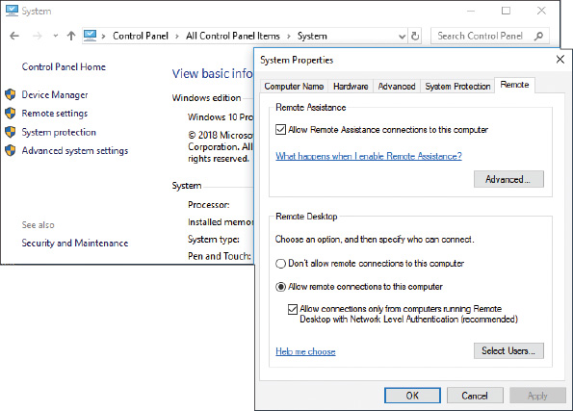
OS Differences
To enable Remote Desktop on a Windows 7 computer, go to the Remote Desktop area on the Remote tab in the System Properties box, and check Allow connections from computers running any version of Remote Desktop (less secure).
Notes
Server applications such as Remote Desktop listen for network activity from clients. If you want these server applications to be available at all times, you can set your network adapter properties to Wake-on-LAN, which you learned about in Chapter 7.
- 4.
Users who have administrative privileges are allowed to use Remote Desktop by default, but other users need to be added. If you need to add a user, click Select Users and follow the on-screen directions. Then close all windows.
- 5.
To verify that Windows Firewall is set to allow Remote Desktop activity on this computer, open Control Panel and click Windows Defender Firewall. (Click Windows Firewall in Windows 8.) The Windows Defender Firewall window appears (see Figure 13-39). In the left pane, click Allow an app or feature through Windows Defender Firewall.
Figure 13-39
Windows Defender Firewall can block or allow activity on the network to your computer
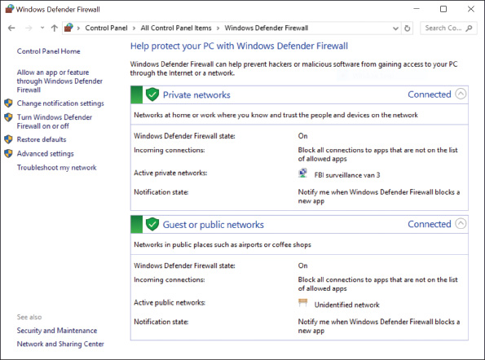
OS Differences
To allow Remote Desktop activity on a Windows 7 computer, open the Windows Firewall window and click Allow a program or feature through Windows Firewall.
- 6.
The Allowed apps window appears. Scroll down to Remote Desktop and adjust the settings as needed (see Figure 13-40). Click OK to apply any changes.
Figure 13-40
Allow Remote Desktop communication through Windows Defender Firewall on your local computer
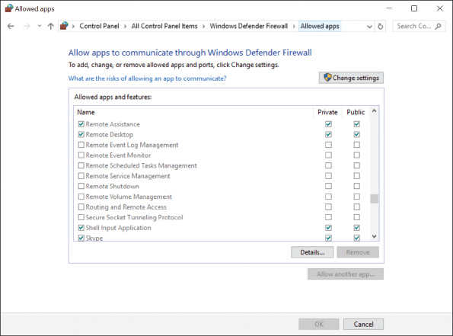
You are now ready to test Remote Desktop.

How to Use Remote Desktop
Try to use Remote Desktop from another computer somewhere on your local network and make sure it works before testing the Remote Desktop connection from the Internet. On the client computer, you can start Remote Desktop to remote in to your host computer by using the mstsc.exe application (which stands for Microsoft Terminal Services Client). Follow these steps to use Remote Desktop:
- 1.
Enter mstsc in the Windows 10/7 search box or the Windows 8 Run box. The Remote Desktop Connection box opens (see Figure 13-41).
Figure 13-41
The IP address of the remote computer can be used to connect to it
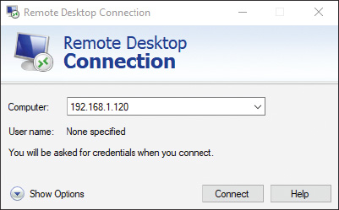
- 2.
Enter the IP address or the host name of the computer to which you want to connect. If you decide to use a host name, begin the name with two backslashes, as in \\CompanyFileServer.
Notes
If you have trouble using the host name to make a Remote Desktop connection on a local network, try entering the host name and IP address of the remote computer in the hosts file in the C:\Windows\System32\drivers\etc folder of the client computer.
- 3.
If you plan to transfer files from one computer to the other, click Show Options for Windows 10/8 or Options for Windows 7, and then click the Local Resources tab, as shown on the left side of Figure 13-42. Click More to see the box on the right side of the figure. Check Drives and click OK. Click Connect to make the connection. If a warning box appears, click Connect again. If another warning box appears, click Yes.
Figure 13-42
Allow drives and other devices to be shared using the Remote Desktop Connection
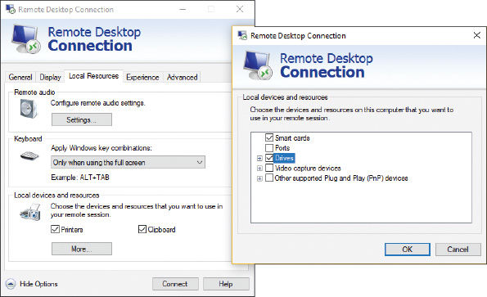
- 4.
A Windows security box is displayed by the remote computer (see Figure 13-43). Sign in with a user name and password for the remote computer. If a warning box reports that the remote computer might not be secure, click Yes to continue the connection.
Figure 13-43
Enter your user name and password on the remote computer
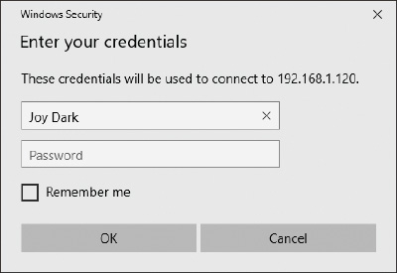
- 5.
The desktop of the remote computer appears with a toolbar at the top of the screen, as shown in Figure 13-44. Click Restore Down to show both the remote desktop and the local desktop on the same screen, as shown in Figure 13-45.
Figure 13-44
The RDC connection toolbar is pinned to the top of the window showing the remote computer’s screen
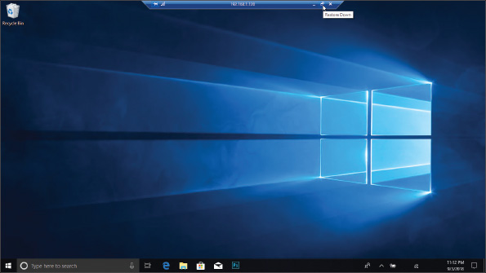
Figure 13-45
The desktop of the remote computer is available on your local computer
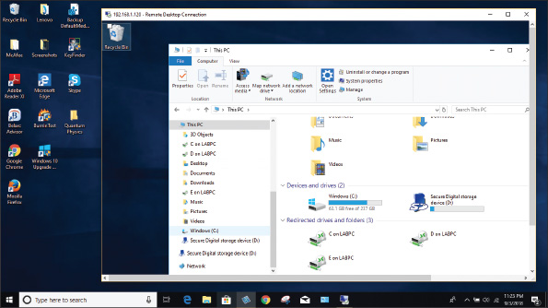
Notes
When a remote desktop connection is made, the user sitting at the remote computer will see it return to the sign-on screen.
- 6.
When you click in the remote desktop’s window, you can work with the remote computer just as if you were sitting in front of it, except response time is slower. To move files back and forth between computers, use File Explorer or Windows Explorer on the remote computer. Files on your local computer and on the remote computer will appear in the Explorer window on the remote computer. Specifically, the files will appear in the This PC group in Windows 10/8 or the Windows 7 Computer group. For example, you can see drive C: on each computer labeled in Figure 13-45. To close the connection to the remote computer, sign out from the remote computer or close the desktop window.
Notes
Even though Windows normally allows more than one user to be signed in at the same time, this is not the case with Remote Desktop. When a Remote Desktop session is opened, all local users on the remote computer must sign out after receiving a warning, as shown in Figure 13-46.
Figure 13-46
Local users must sign out before a Remote Desktop Connection can happen
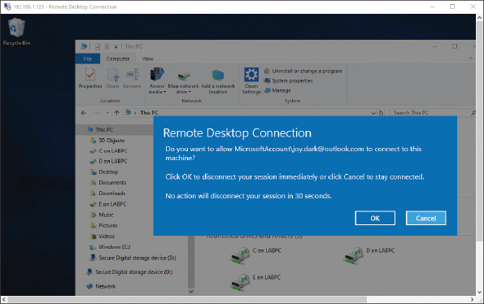
Is your host computer as safe as it was before you set it to serve up Remote Desktop and enabled port forwarding to it? Actually, no, because a port has been opened, so take this into account when you decide to use Remote Desktop.
Go to pg.
help
Application Opened
Main content

13-5bRemote Assistance
A+ Core 2
- 1.5
Given a scenario, use Microsoft operating system features and tools.
- 1.6
Given a scenario, use Microsoft Windows Control Panel utilities.
Remote Assistance differs from Remote Desktop in that a user on the server computer can remain signed in during the remote session, retains control of the session, and can see the screen. This is helpful when troubleshooting problems on a computer. The user who needs your help sends you an invitation by email or chat to connect to her computer using Remote Assistance. When you respond to the invitation, you can see the user’s desktop just as she sees it; if the user gives you permission, you can take control of her computer to change settings or do whatever else is needed to fix her problem or show her how to perform a task. Think of Remote Assistance as a way to provide virtual desk-side support.
There are several ways to initiate a Remote Assistance session. The first method listed is the most reliable:
- The user saves an invitation file and then sends that file to the technician. The file can be sent by any method, including email, chat, or posting to a shared folder on the network.
- The user can send an automated email through the Remote Assistance app. This option only works if the system is configured with a compatible email program.
- The user can use Easy Connect, which is the easiest method to start a Remote Assistance connection but only works if both computers used for the connection are using Windows. Also know that some routers don’t support the Peer Name Resolution Protocol (PNRP), which is the protocol Easy Connect uses to establish a Remote Assistance connection.
- The technician can initiate a session. This method is the most difficult to use; it requires that Group Policies be applied on the technician’s computer. You learn more about Group Policy later in the text.
Notes
Easy Connect is the easiest method for the user when initiating a Remote Assistance connection but it can be the most difficult for the technician to set up. If Easy Connect is grayed out when starting a session, chances are that the PNRP service might be down. To start the service, enter the services.msc command to open the Services console (see Figure 13-47). Select Peer Name Resolution Protocol and click Start. You learn more about services and the Services console in Chapter 14.
Figure 13-47
Use the Services console to start a service
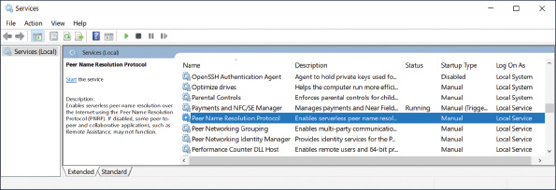
To initiate a Remote Assistance connection when the user sends an invitation to the technician, follow these steps:
- To allow Remote Assistance sessions on the user’s computer, called the host computer, open the System window in Control Panel and click Remote settings in the left pane. If the user does not have administrative permissions, he must respond to the UAC box by entering an administrator password. The System Properties box appears with the Remote tab selected (refer back to Figure 13-38).
- In the Remote Assistance area, check Allow Remote Assistance connections to this computer, and then click OK.
- In the search box, type remote assistance, then click Invite someone to connect to your PC and help you, or offer to help someone else. The Windows Remote Assistance box appears, as shown in Figure 13-48.
Figure 13-48
Create or respond to an invitation to connect
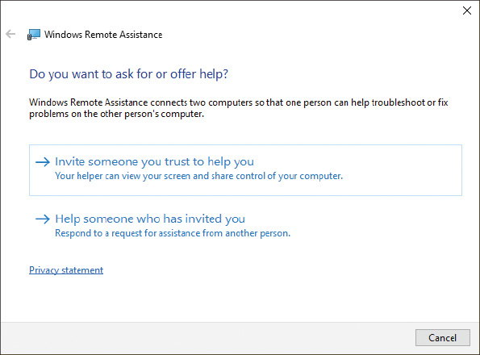
OS Differences
To launch Remote Assistance in Windows 8, open Control Panel in Category view. Click System and Security. Under System, click Launch remote assistance. (Alternately, you can press Win+S to open the search box and type Invite, then click Invite someone to connect to your PC and help you.)
To launch Remote Assistance in Windows 7, click Start, type Remote Assistance in the search box, and then click Windows Remote Assistance.
- Click Invite someone you trust to help you, then click Save this invitation as a file. Point to a location to save the file and click Save. Remote Assistance provides a password for the user to give the technician in order to create the connection (see the left side of Figure 13-49). The user can send the invitation file to the technician as an email attachment or by other means.
Figure 13-49
The user’s computer shows a password the technician must enter to connect Remote Assistance
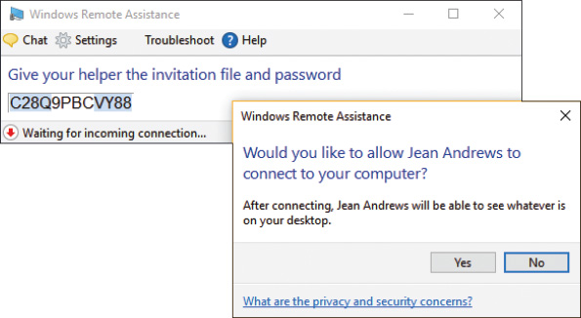
The technician can respond to the invitation into Remote Assistance as follows:
- On the technician’s computer, the technician double-clicks the invitation file she has received from the user. In the box that appears (see Figure 13-50), the technician enters the password that appeared on the user’s screen and clicks OK. (Most often, the user reads the password to the technician over the phone.)
Figure 13-50
The technician enters the password to start a Remote Assistance session
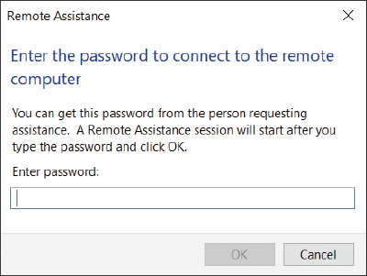
- The user’s computer generates a warning box requesting permission for the technician’s computer to connect (see the right side of Figure 13-49). The user clicks Yes to allow the connection. The user’s desktop turns black and the Remote Assistance management window appears. The technician’s computer opens the Windows Remote Assistance window, as shown in Figure 13-51, with a live feed from the user’s computer.
Figure 13-51
Control the shared screen using the toolbar options at the top
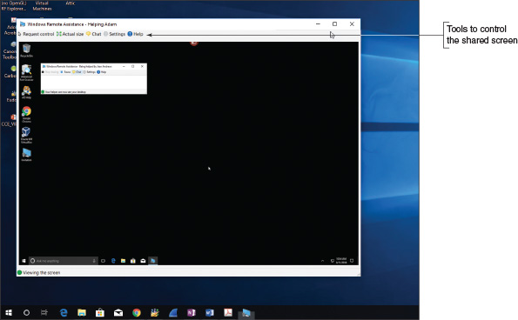
Using Remote Desktop, you can share files between computers, but Remote Assistance does not allow for file sharing. Here are some things you can do during a Remote Assistance session:
- To open a chat session with the user, click the Chat icon. A chat pane appears in the Remote Assistance window on both desktops.
- To ask the user if you can take control of his desktop, click Request control in the Remote Assistance control window. When the user accepts the request, you can control his computer. The user can stop sharing control by clicking Stop sharing.
- The user can hide his desktop from you at any time by clicking Pause in the control window.
- Either of you can disconnect the session by closing the control window.
- A log file is kept of every Remote Assistance session in the C:\Users\username\Documents\Remote Assistance Logs folder. The file includes the chat session. If you type instructions during the chat session that will later help the user, he can use the log file to remind him of what was said and done.
- If an invitation created by a user is not used within six hours, the invitation expires. This time frame can be changed by clicking Advanced in the Remote Assistance section on the Remote tab of the System Properties dialog box.
If you have problems making the connection, do the following:
- Windows Firewall on the user’s computer might be blocking Remote Assistance. Verify that Remote Assistance is checked as an exception to blocked apps in the Windows Firewall window.
- If you are outside the user’s local network, the hardware firewall protecting his network might be blocking Remote Assistance. Verify that port forwarding on that hardware firewall is enabled for Remote Assistance. Remote Assistance uses port 3389, the same RDP port used by Remote Desktop.
Notes
Because Remote Assistance can be difficult to set up, Windows 10 offers Quick Assist, which is more universally compatible with existing network hardware configurations. For Quick Assist to work, both computers must be running Windows 10, the technician providing assistance must have a Microsoft account, and the person receiving the connection must agree to it by entering a code generated by the technician’s client computer.
Go to pg.
help
Application Opened
Main content

13-5cThird-Party Remote Access
A+ Core 2
- 4.9
Given a scenario, use remote access technologies.
Remote Desktop and Remote Assistance require you to open a port to your network, which is a security risk. Third-party remote access software executed from a browser window is more secure because the browser initiates communication outside the protected network and open listening ports are not required. Examples of this type of software, some of which are free, are TeamViewer (teamviewer.com), GoToMyPC by Citrix (gotomypc.com), LogMeIn (logmein.com), and Zoom (zoom.us). When evaluating third-party remote access applications, consider the following:
- Where is software installed? On the host, on the client, or on both computers?
- How secure is the connection? Are you required to open incoming ports?
- How are live screens shared? For example, is a live screen shared only by the host computer or can it be shifted to another computer in the same screen sharing session?
- Can files be shared in one or both directions during the same screen sharing session?
Go to pg.
help
Application Opened
Main content

Chapter Review

13-6aChapter Summary

Scheduling Preventive Maintenance
- Regular preventive maintenance includes verifying Windows Update, anti-malware, and network security settings, uninstalling software you no longer need, and cleaning up and optimizing the hard drive.
- Apply 32-bit patches to 32-bit applications and OSs. Apply 64-bit patches to 64-bit applications and OSs.

Backup Procedures
- You need a plan for disaster recovery in the event the hard drive fails. This plan needs to include routine backups of data files, the entire Windows volume, critical applications, and system files.
- You can back up to local storage or to the cloud. Test your backups to make sure you can restore from them.
- Windows 10/8 File History and Windows 10/7 Backup and Restore can be used to schedule routine backups of user data files. Both tools can back up a system image.
- The best time to create a system image is right after you’ve installed Windows, hardware, applications, and user accounts and customized Windows settings.
- A Windows 8 custom refresh image backs up the entire Windows volume.
- System Protection creates restore points, which include Windows system files that have changed since the last restore point was made.

Managing Files, Folders, and Storage Devices
- The MBR partitioning system can support only three primary partitions and one extended partition.
- The GPT partitioning system can support up to 128 partitions and hard drives larger than 2.2 TB. A GPT hard drive contains a protective MBR for compatibility with legacy software.
- Windows file systems include NTFS, ReFS, NFS, exFAT, FAT32, CDFS, and UDF.
- An MBR hard drive has a designated active partition and GPT drives have a designated EFI System Partition that contains the Windows boot manager program that starts Windows. In Windows, this partition is called the system partition.
- Use Disk Management to manage hard drives and partitions. Use it to create, delete, and resize partitions, mount a drive, manage dynamic disks, and solve problems with hard drives.
- Windows Storage Spaces is expected to replace the Windows solution for software RAID and can support thin provisioning, which allows for physical hard drives to be added to the storage pool as need demands.
- To improve hard drive performance, use the Disk Cleanup tool and the Defragment and Optimize Drives tool to clean and optimize the drive.

Using a Command-Line Interface (CLI)
- Commands used to manage files, folders, and storage media include help, dir, cd, copy, xcopy, robocopy, chkdsk, defrag, format, and shutdown.
- The PowerShell command-line interface uses cmdlets with parameters and is intended to ultimately replace the command prompt window.
- Using the Ubuntu Bash interface, you can enter Linux commands in a Windows shell and interact with the Windows system.

Remote Connections
- Remote Desktop gives you access to your Windows desktop and file sharing from anywhere on the Internet. Remote Assistance lets you provide remote support to users but does not allow file sharing.
- When using Remote Assistance, the user on the host computer can remain signed in during the remote session, retains control of the session, and can see the screen.
- When evaluating third-party remote access applications, consider how screens and files are shared and the security of the connection.
Go to pg.
help
Application Opened
Main content

Chapter Review

13-6bKey Terms
For explanations of key terms, see the Glossary for this text.
- active partition
- active recovery image
- alias
- array
- Backup and Restore
- Bash on Ubuntu on Windows
- basic disk
- BootMgr
- boot partition
- cd (change directory)
- CDFS (Compact Disc File System)
- chkdsk (check disk)
- cluster
- cmdlets
- copy
- critical applications
- custom refresh image
- defrag
- defragment
- Defragment and Optimize Drives
- dir
- Disk Cleanup
- dynamic disk
- dynamic volume
- EFI System Partition (ESP)
- elevated command prompt window
- exFAT
- extended partition
- FAT (file allocation table)
- FAT32
- fault tolerance
- file allocation unit
- File History
- file-level backup
- formatting
- Globally Unique Identifier Partition Table (GUID or GPT)
- hardware RAID
- help
- high-level formatting
- image-level backup
- logical drives
- low-level formatting
- Master Boot Record (MBR)
- master file table (MFT)
- Microsoft Terminal Services Client
- mirroring
- mount point
- mounted drive
- mstsc.exe
- NFS (Network File System)
- NTFS (New Technology file system)
- partition table
- PowerShell
- primary partitions
- quick format
- RAID (redundant array of inexpensive disks or redundant array of independent disks)
- RAID 0
- RAID 1
- Remote Assistance
- Remote Desktop Connection (RDC)
- resiliency
- Resilient File System (ReFS)
- restore points
- robocopy (robust file copy)
- shutdown
- simple volume
- slack
- software RAID
- Storage Spaces
- striping
- surge protector
- system image
- system partition
- System Protection
- System Restore
- thin provisioning
- trim
- UDF (Universal Disk Format)
- uninterruptible power supply (UPS)
- wildcard
- Windows Subsystem for Linux (WSL)
- xcopy
Go to pg.
help
Application Opened
Main content

Chapter Review

13-6cThinking Critically
These questions are designed to prepare you for the critical thinking required for the A+ exams and may use content from other chapters and the web.
- Order the following routine maintenance tasks from most to least important when securing a computer.
  - Verify anti-malware settings.
  - Verify file sharing settings.
  - Verify Windows Update settings.
  - Verify that hard drives are being optimized weekly.
- While verifying Windows settings, you discover defragmenting is turned off for the hard drive. What do you do next?
  - Immediately defrag the drive.
  - Turn on defragmenting.
  - Analyze the drive for errors.
  - Check the type of hard drive installed.
- What are reasons to uninstall software you no longer use? Select all that apply.
  - To prevent Windows errors
  - To speed up Windows performance
  - To free up hard drive space
  - To clean the system of malware
- What type of storage media must be used to create a Windows system image? Select all that apply.
  - DVDs
  - Internal hard drive
  - External hard drive
  - Network drive
- Which Windows utilities are used to create previous versions of files that can be recovered from the file properties dialog box? Select all that apply.
  - Windows 10/8 File History
  - Windows 10/7 Backup and Restore
  - Disk Management
  - Windows 8 Custom Refresh Image
- Sarah is setting up Backup and Restore and wants to create a system image. She has discovered that drive E: in the system has plenty of free space for the image. What is the next thing she should check before she creates the image?
  - Does the Windows volume have enough free space to perform the procedure?
  - Is there a drive on the network she can use? Network drive images are faster to create.
  - Is drive E: on the same hard drive as drive C:?
  - Ask the user which folders on drive C: are the most important and need backing up.
- Linda works from home occasionally and needs to set up her computer at work so she can remote in from her home office. Which tools should she use?
  - System Protection
  - Remote Assistance
  - Ubuntu Bash
  - Remote Desktop
- You suspect malware might have infected restore points saved on the computer and you want to delete them all. What is your next step?
  - Turn off System Protection.
  - Run anti-malware software to scan the system for malware.
  - Harden the Windows Firewall, closing all open ports.
  - Update Windows.
- You suspect the hard drive is corrupted. Which window do you open to repair the drive?
  - Command prompt window to use chkdsk
  - Elevated command prompt window to use chkdsk
  - Disk Management
  - File Explorer
- You are planning to install Windows 10 on a computer in a dual-boot configuration. The computer already has Windows 8 installed. You open Disk Management and discover there is one hard drive with an EFI System Partition, a primary partition with plenty of free space, and no unallocated space. In Disk Management, how can you prepare the drive to hold the Windows 10 installation?
  - There’s nothing more to do in Disk Management. Close the windows and begin the installation.
  - Shrink the EFI System Partition and create a new partition for Windows 10.
  - Shrink the primary partition and create a simple volume for Windows 10.
  - Shrink the primary partition and create a new basic disk for Windows 10.
- Your friend is setting up a computer and plans to use Windows RAID striping. He asks you how many hard drives he should install in the system. What do you tell him?
  - At least three drives: one to hold the Windows installation and two for the array
  - At least two drives: the striped array can install on two drives and it can also hold the Windows installation
  - Only one drive is necessary. He can create extra partitions on the drive; the first can hold Windows and the other two can hold the array.
  - Suggest to your friend that he use hardware RAID, which is more stable.
- A family member calls and wants to copy the Notepad text editor to a folder she has just created in the root of drive C:. She asks you to help her construct the command line. Which is the correct command?
  - Copy C:\notepad.exe C:\Windows
  - Copy C:\Windows\Notepad.exe C:\
  - Copy C:\Windows\System32\Notepad.exe C:\
  - Copy notepad.exe C:\
- Without changing the default folder, what is the command to list all files in the C:\Linda\test2 folder that have file extensions of only two characters?
  - Dir C:\Linda\test2\*.??
  - Dir *.*
  - Dir C:\Linda\test2\********.**
  - Dir C:\*.*
- You are trying to clean up a slow Windows 8 system that was recently upgraded from Windows 7, and you discover that the 75-GB hard drive has only 5 GB of free space. The entire hard drive is taken up by the Windows volume. What is the best way to free up some space?
  - Compress the entire hard drive.
  - Move the /Program Files folder to an external hard drive.
  - Delete the Windows.old folder.
  - Uninstall several applications.
- Which is the best first step to protect important data on your hard drive?
  - Use dynamic disks to set up a striped volume so that the data has redundancy.
  - Back up the data to another device.
  - Compress the folder that holds the data.
  - Put password protection on the data folder.
- Adam frequently calls your help desk asking for instructions on how to use Windows 10. What is the best way to help Adam?
  - Open a chat session with Adam over Facebook and talk with him about Windows 10.
  - Use Remote Assistance to show Adam how to use Windows 10 and point him to the log file created.
  - Explain to Adam that a help desk is not the place to go to learn to use new software, and he needs to look elsewhere for help.
  - Email Adam some links to online video tutorials about Windows 10.
- Remote Desktop and Remote Assistance require a technician to change port settings and firewall settings, but third-party apps such as GoToMyPC do not. Why is this?
  - Microsoft makes its apps more secure than third-party apps.
  - GoToMyPC and other third-party apps use ports already left open for web browsing and don’t require incoming connections.
  - Remote Desktop and Remote Assistance allow incoming connections at the same port 80 that is already left open for web browsing.
  - GoToMyPC and other third-party apps are not concerned about security because they depend on Windows to secure a network connection.
- Christos is traveling on vacation. On his server at home, he has several movies that he bought and downloaded. He wants to remotely connect with his server at home and watch the movies on his laptop in the hotel. Which remote connection would be best for this purpose and why?
  - Remote Assistance
  - Remote Desktop Connection
  - TeamViewer
  - Quick Assist
- Carrie works on a help desk and is assigned a ticket that was automatically generated by a server because of an error. The error message states that the server has run out of storage space because logs were not set to delete at a certain age. Rather than going to the data center to physically access that server on the rack, what Windows tool might Carrie use to troubleshoot the server?
Go to pg.
help

