Application Opened
Main content
Chapter
14

Troubleshooting Windows After Startup
- Chapter Introduction
- 14-1Concepts and Windows Tools for Solving Problems with Windows, Applications, and Hardware
  - 14-1aWhat Are the Shell and the Kernel?
  - 14-1bDirectory Structures
  - 14-1cHow Windows Manages Applications
  - 14-1dSurvey of Windows Tools and Techniques
- 14-2Best Practices to Troubleshoot Windows-Related Problems
  - 14-2aStep 1: Interview the User and Back up Data
  - 14-2bStep 2: Error Messages, the Web, Coworkers, and Logs Might Help
  - 14-2cStep 3: Consider That the Data or the Application Might Be Corrupted
  - 14-2dStep 4: Consider Outside Interference
  - 14-2eStep 5: Consider That Windows Might Be the Problem
- 14-3Slow Startup and Slow Performance
  - 14-3aStep 1: Observe Startup
  - 14-3bStep 2: Back Up User Data
  - 14-3cStep 3: Perform Routine Maintenance
  - 14-3dStep 4: Investigate and Eliminate Startup Programs
  - 14-3eStep 5: Check for Unwanted Scheduled Tasks
  - 14-3fStep 6: Check for Low System Resources
- 14-4Application Errors and Crashes
  - 14-4aApplication Hangs
  - 14-4bSlow-Performing Application
  - 14-4cService Fails to Start
  - 14-4dFile Fails to Open
  - 14-4eMissing DLL or Component Not Registered
  - 14-4fApplication Has Never Worked
- 14-5An Application Fails to Uninstall
  - 14-5aRegistry Editor
  - 14-5bBefore You Edit the Registry, Back It Up!
  - 14-5cManually Removing Software
- 14-6Troubleshooting Hardware Problems in Windows
  - 14-6aDisplay Settings and Graphics Software
  - 14-6bPrint Management
  - 14-6cLimited Connectivity
- 14-7Chapter Review
  - 14-7aChapter Summary
  - 14-7bKey Terms
  - 14-7cThinking Critically
  - 14-7dHands-On Projects
  - 14-7eReal Problems, Real Solutions
  - 14-7fExam Tips
Go to pg.
help
Application Opened
Main content

Chapter Introduction
After completing this chapter, you will be able to:
- Explain the concepts and describe Windows tools used to solve problems with Windows, applications, and hardware
- Apply recommended best practices to troubleshoot Windows-related problems
- Troubleshoot problems with slow startup and slow performance
- Troubleshoot application errors and crashes
- Manually remove software when an application fails to uninstall
- Troubleshoot hardware problems in Windows
In previous chapters, you learned about the tools and strategies to install and maintain Windows and about the importance of keeping good backups. This chapter takes you one step further as an IT support technician so that you can solve problems with Windows, applications, and hardware using Windows tools and methods. This chapter is about problems that occur after startup. Troubleshooting Windows startup is covered in Chapter 15. We begin the chapter by learning about the Windows concepts and tools you’ll need to optimize and troubleshoot Windows. Then we turn our attention to general steps you can follow when solving Windows, applications, and hardware problems, and finally move on to specific problems you might encounter and how to solve them. As you read the chapter, you might consider following along using a Windows 10/8/7 system.
Notes
Windows installed in a virtual machine is an excellent environment to use when practicing the skills in this chapter.
Go to pg.
help
Application Opened
Main content

14-1Concepts and Windows Tools for Solving Problems with Windows, Applications, and Hardware
A+ Core 2
- 1.4
Given a scenario, use appropriate Microsoft command line tools.
- 1.5
Given a scenario, use Microsoft operating system features and tools.
- 1.6
Given a scenario, use Microsoft Windows Control Panel utilities.
Knowledge is power when it comes to supporting Windows. In this part of the chapter, you learn more about how Windows works and how it is structured. We also survey several Windows tools that are useful when solving a problem with Windows, applications, Windows users, networks, and hardware. In later parts of the chapter, you learn to use these tools to solve typical problems you might encounter as an IT technician supporting Windows.
Go to pg.
help
Application Opened
Main content

14-1aWhat Are the Shell and the Kernel?
A+ Core 2
- 1.4
Given a scenario, use appropriate Microsoft command line tools.
- 1.5
Given a scenario, use Microsoft operating system features and tools.
- 1.6
Given a scenario, use Microsoft Windows Control Panel utilities.
It might sound like we’re talking about a grain of wheat, but Windows has a shell and a kernel, and you need to understand what they are and how they work so you can solve problems with each. A shell is the portion of an OS that relates to the user and to applications. The kernel is responsible for interacting with hardware. Figure 14-1 shows how the shell and kernel relate to users, applications, and hardware. In addition, the figure shows a third component of an OS, the configuration data. For Windows, this data is primarily contained in the registry.
Figure 14-1
Inside an operating system, different components perform various functions
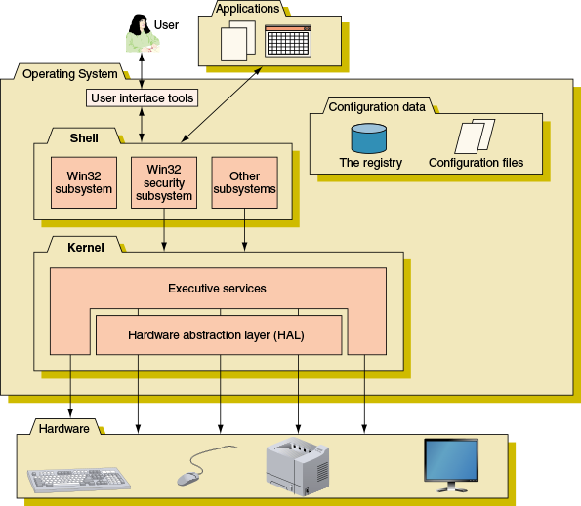

The Windows Shell
The shell provides tools such as File Explorer or the Windows desktop as a way for the user to do such things as select music to burn to a CD or launch an application. For applications, the shell provides commands and procedures that applications can call on to do such things as print a document, read from a storage device, or display a photograph on the screen.
The shell is made up of several subsystems that all operate in user mode, which means these subsystems have only limited access to system information and can access hardware only through other OS services. One of these subsystems, the Win32 security subsystem, provides sign-in to the system and other security functions, including privileges for file access. All applications relate to Windows by way of the Win32 subsystem.

The Windows Kernel
The kernel, or core, of the OS is responsible for interacting with hardware. Because the kernel operates in kernel mode, it has more power to communicate with hardware devices than the shell has. Applications operating under the OS cannot get to hardware devices without the shell passing those requests to the kernel. This separation of tasks provides for a more stable system and helps to prevent a wayward application from destabilizing the system.
The kernel has two main components: (1) the HAL (hardware abstraction layer), which is the layer closest to the hardware, and (2) the executive services interface, which is a group of services that operate in kernel mode between the user mode subsystems and the HAL. Executive services contained in the ntoskrnl.exe program file manage memory, I/O devices, file systems, some security, and other key components directly or by way of device drivers.
Notes
In Task Manager, the Windows processes group on the Processes tab shows that the Windows kernel process ntoskrnl.exe appears as System.
When Windows is first installed, it builds the HAL based on the type of CPU installed. The HAL cannot be moved from one computer to another, which is one reason you cannot copy a Windows installation from one computer to another.
Go to pg.
help
Application Opened
Main content

14-1bDirectory Structures
A+ Core 2
- 1.4
Given a scenario, use appropriate Microsoft command line tools.
- 1.5
Given a scenario, use Microsoft operating system features and tools.
- 1.6
Given a scenario, use Microsoft Windows Control Panel utilities.
Folder or directory locations you need to be aware of include those for user files, program files, and Windows data. In the folder locations given in this discussion, we assume Windows is installed on drive C:.

User Profile Namespace
When a user first signs in to Windows, a user profile is created. This collection of user data and settings consists of two general items:
- A user folder together with its subfolders. These items are created under the C:\Users folder—for example, C:\Users\Jean Andrews. This folder contains a group of subfolders collectively called the user profile namespace. (In general, a namespace is a container to hold data—for example, a folder.)
- NTUSER.DAT. NTUSER.DAT is a hidden file stored in the C:\Users\username folder that contains user settings. Each time the user signs in, the contents of this file are copied to a location in the registry.

Program Files
Here is where Windows stores program files unless you select a different location when a program is installed:
- Program files are stored in C:\Program Files for 32-bit versions of Windows. Only 32-bit applications can be installed in a 32-bit installation of Windows.
- In 64-bit versions of Windows, 64-bit programs are stored in the C:\Program Files folder, and 32-bit programs are stored in the C:\Program Files (x86) folder. (For best performance, when you have the option, install 64-bit applications in a 64-bit installation of Windows.)
Here are folders that applications and some utilities use to launch programs at startup:
- A program file or shortcut to a program file stored in the C:\Users\username\AppData\Roaming\Microsoft\Windows\Start Menu\Programs\Startup folder launches at startup for an individual user.
- A program file or shortcut to a program file stored in the C:\ProgramData\Microsoft\Windows\Start Menu\Programs\Startup folder launches at startup for all users.

Folders for Windows Data
An operating system needs a place to keep hardware and software configuration information, user preferences, and application settings. This information is used when the OS is first loaded and when needed by hardware, applications, and users. Windows uses a database called the registry for most of this information. In addition, Windows keeps some data in text files called initialization files, which often have an .ini or .inf file extension.
Here are some important folder locations used for the registry and other Windows data:
- Registry location. The Windows registry is stored in the C:\Windows\System32\config folder.
- Backup of the registry. A backup of the registry is stored in the C:\Windows\System32\config\RegBack folder.
- Fonts. Fonts are stored in the C:\Windows\Fonts folder.
- Temporary files. These files, which are used by Windows when it is installing software and performing other maintenance tasks, are stored in the C:\Windows\Temp folder.
- Offline files. Offline files are stored in the CSC (client-side caching) folder, which is C:\Windows\CSC. The folder is managed by Sync Center, an applet in Control Panel, which syncs files in a shared folder on the network with the \CSC folder on the local computer. Users can work with the \CSC folder when the computer is offline; later, when the computer is connected to the network, Sync Center can sync up the files with those on the network share. How to use Sync Center is covered in Chapter 16.
Notes
Most often, Windows is installed on drive C:, although in a dual-boot environment, one OS might be installed on C: and another on a different drive. For example, Windows 8 can be installed on C: and Windows 10 installed on E:. Also, drive C: for one OS in a dual-boot system is likely to have a different drive letter in the other OS.
If the drive letter of the Windows volume is not known, it is written in Microsoft documentation as %SystemDrive%. For example, the location of the Program Files folder is written as %SystemDrive%\Program Files.
Go to pg.
help
Application Opened
Main content

14-1cHow Windows Manages Applications
A+ Core 2
- 1.4
Given a scenario, use appropriate Microsoft command line tools.
- 1.5
Given a scenario, use Microsoft operating system features and tools.
- 1.6
Given a scenario, use Microsoft Windows Control Panel utilities.
When an application is first installed, its program files are normally stored on the hard drive. When the application is launched, the program is copied from the hard drive into memory and there it is called a process. A process is a program that is running under the authority of the shell, together with the system resources assigned to it. System resources might include other programs the process has started and memory addresses to hold its data. When the process makes a request for resources, this request is made to the Win32 subsystem and is called a thread. A thread is a single task, such as the task of printing a file that the process requests from the kernel. Figure 14-2 shows two threads in action, which is possible because the process and Windows support multithreading. Sometimes a process is called an instance, such as when you say to a user, “Open two instances of Internet Explorer.” Technically, you are saying to open two Internet Explorer processes.
Figure 14-2
A process with more than one thread is called multithreading
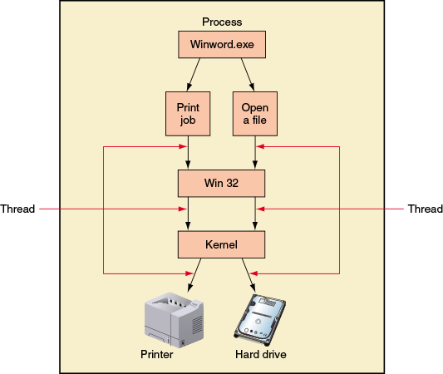
Go to pg.
help
Application Opened
Main content

14-1dSurvey of Windows Tools and Techniques
A+ Core 2
- 1.4
Given a scenario, use appropriate Microsoft command line tools.
- 1.5
Given a scenario, use Microsoft operating system features and tools.
- 1.6
Given a scenario, use Microsoft Windows Control Panel utilities.
With an understanding of how Windows is structured, let’s turn our attention to useful tools and techniques for managing and troubleshooting Windows, applications, users, hardware, and networks. Table 14-1 lists many of these tools. As you read through the list, try to form a context for how you might use a tool to help you solve a Windows-related problem. To get started, launch each tool and take a look at how its window is organized, the basic functions available, and what is on each tab in a window. Later in the chapter, you learn how to apply each tool as you address many typical Windows problems.
A+ Exam Tip
The A+ Core 2 exam gives you a scenario with possible alternatives toward a solution. It expects you to know which Windows tool to use and how to use it to resolve a problem. These Windows tools include Computer Management, Performance Monitor, the Services console, System Configuration, Data Sources, Print Management, Event Viewer, Task Manager, the Registry Editor, MMC, and DxDiag. All of these tools are discussed in this chapter.
A+ Exam Tip
In performance-based questions on the A+ Core 2 exam, you are expected to know how to access a Windows tool using more than one method. It’s a good idea to know the command that launches a given tool.
Table 14-1
Tools and techniques to solve Windows-related problems (continues)
Tool | Description
Use these tools to conveniently access and manage other Windows tools:
Control Panel | Control Panel is a collection of small programs, called applets, that are used to manage many Windows settings. To open Control Panel in Windows 10/7, enter Control Panel in the search box. For Windows 8, right-click Start and click Control Panel.
Administrative Tools | This applet in Control Panel contains several tools used by IT technicians. You need to be signed in to Windows with administrator privileges to use many of these tools.
Computer Management (compmgmt.msc) | This console in the Administrative Tools group is where you can find several Windows tools and add your own tools to manage the local computer or other computers on the network.
Microsoft Management Console (MMC, mmc.exe) | Use this console to build your own customized console windows.
Use these tools to observe Windows, Windows user, network, application, and hardware activities as tracked and logged by Windows:
Event Viewer (eventvwr.msc) | Just about anything that happens in Windows is logged by Windows, and these logs can be viewed using Event Viewer in the Administrative Tools group.
Performance Monitor (perfmon.msc) | Performance Monitor in the Administrative Tools group can track activity by hardware and software to measure performance.
Reliability Monitor | Reliability Monitor, also known as reliability history, can be accessed from Control Panel or Task Manager to find out what changes were made to the system around the time a problem started and what other problems occurred about that same time.
Resource Monitor (resmon.exe) | Resource Monitor monitors the CPU, hard drive, network, and memory in real time. If you suspect CPU, memory, hard drive, or network resources are being used excessively by an application or malware, you can use Resource Monitor to identify the process. You can access the tool on the Performance tab of Task Manager or in the Administrative Tools group.
Solve Windows, application, networking, and Windows user problems with these tools:
Task Manager (taskmgr.exe) | Task Manager lets you view the applications and processes running on your computer as well as information about process and memory performance, network activity, and user activity. Use Task Manager to end a process causing trouble and to enable or disable programs that launch at Windows startup. One way to access Task Manager is to press Ctrl+Alt+Del and click Task Manager.
System Configuration (msconfig.exe) | Use the System Configuration utility (commonly called “M-S-config”) in the Administrative Tools group to temporarily disable programs from launching at startup in order to troubleshoot a startup problem.
Services console (services.msc) | Use the Services console in the Administrative Tools group to control Windows and third-party services installed on a system.
Troubleshooting | Use the Troubleshooting applet in Control Panel to automatically troubleshoot and fix many common Windows problems involving applications, hardware, sound, networking, Windows updates, and maintenance tasks.
Group Policy (gpedit.msc) | Group Policy is used on a Windows domain to secure and manage the domain; it can control what users can do and how Windows clients in the domain can be used.
Local Group Policy (gpedit.msc) | Local Group Policy is a limited version of Group Policy included in business and professional editions of Windows (not home editions) and applies to the local computer. Use it to control a variety of application, user, and Windows settings.
Registry Editor (regedit.exe) | Use the Registry Editor to back up and edit the Windows registry.
Solve Windows problems using these tools:
System File Checker (sfc.exe) | Use System File Checker (SFC) to verify and replace Windows system files. It keeps a cache of current system files in case it needs to refresh a damaged file.
DISM (dism.exe) | Use DISM (Deployment Image Servicing and Management) to repair corrupted Windows system files when SFC cannot do the job or Windows Update is corrupted.
Windows Updates | Use Windows Updates to download and apply the latest Windows updates to solve problems with Windows, applications, and hardware. In Windows 10, open Windows Updates in the Settings app. For Windows 8/7, use the System window to find Windows Updates.
Clean boot | A clean boot disables all third-party software that has been added to the Windows startup process. To clean boot, use System Configuration and Task Manager to disable all but Microsoft services launched at startup. You learn how to do this later in the chapter.
Safe Mode, aka Safe boot | Safe Mode goes beyond a clean boot; it not only eliminates third-party software from Windows startup, it also reduces startup to only the Windows minimum configuration necessary to start the OS. It can create a stable environment when the Windows system or device drivers become corrupted. First try a clean boot. If that doesn’t resolve a problem, try Safe Mode. To do so, use System Configuration to restart the computer in Safe boot.
System Restore (rstrui.exe) | Use System Restore to revert the system back to a previously saved restore point before a problem started.
Solve application errors or crashes with these tools:
Programs and Features (appwiz.cpl) | Use the Programs and Features tool in Control Panel to repair and uninstall applications and enable and disable Windows features.
tasklist | The tasklist command reports the process identifier (PID), which is a number that identifies each running process.
taskkill | The taskkill command uses the process ID to kill the task or process. Use taskkill to end a process when Task Manager is unable to do so.
Component Services | Use Component Services (also called COM+) in the Administrative Tools group to register components in the Windows registry so that an application can access the component. This resolves a problem that happens when a component is not correctly registered to the application when it is first installed or the connection between the two gets broken.
Secondary logon | Use a secondary logon to run an application using administrator privileges that refused to run under the authority of a standard user. Use the Properties dialog box of the application program file to perform a secondary logon.
Compatibility mode | To solve an incompatibility problem with the OS, try running the application in compatibility mode by using the Properties dialog box of the application program file.
Digital signature | A digital signature verifies that the application is not a rogue application and that it is certified as Windows-compatible by Microsoft. Verify a digital signature using the Properties dialog box of the application program file.
Data Sources | Use Data Sources, also called ODBC Data Sources (Open Database Connectivity Data Sources), to create a connection between a local application and a remote database so that the application can manage the database. Data Sources can be accessed in the Administrative Tools group.
Task Scheduler (taskschd.msc) | Use Task Scheduler in the Administrative Tools group to schedule a program to run at a future time, including at startup.
Manage and solve problems with hardware using these tools:
Device Manager (devmgmt.msc) | Recall Device Manager in Control Panel is the go-to tool to make sure Windows has correctly installed a hardware device and to solve problems with a device.
Print Management (printmanagement.msc) | Use Print Management in the Administrative Tools group to monitor and manage printer queues for all printers on the network.
Display applet (desk.cpl) | Use the Display applet to manage display settings. In Windows 10, access Display settings in the Settings app. For Windows 8/7, use Control Panel.
DxDiag (dxdiag.exe) | Use the DxDiag (DirectX Diagnostic Tool) command to diagnose problems with DirectX. DirectX is Microsoft’s interface between video and sound hardware and the applications that use these devices. Some gaming applications or other apps that rely heavily on graphics and sound require the latest version of DirectX. DxDiag can tell you which version of DirectX is installed; you can download the latest version from Microsoft.com.
Memory Diagnostics (mdsched.exe) | Use Memory Diagnostics in Administrative Tools to test memory before or after Windows is launched.
chkdsk | The chkdsk command checks the hard drive for a corrupted file system and bad sectors on the drive. Use this command to check drive C: and recover data: chkdsk c: /r
Disk Defragmenter (defrag.exe) | Defrag a magnetic hard drive to improve drive performance.
Notes
If you have not already used a tool listed in Table 14-1, open the tool’s window and take a good look at its features and menus before you continue with the chapter. If you can, open each tool using more than one method. Try to remember at least one way to open it. Don’t worry if you don’t know how to use the tool—that’s coming up.
A+ Exam Tip
If an often-used Windows utility can be launched from a command prompt, the A+ Core 2 exam expects you to know the program name of that utility.
Applying Concepts

USING Windows Tools to Manage Tools
Windows offers several windows and consoles to help access and organize Windows tools. Take a quick look at each to get familiar with how a window or console works and the tools each one contains:
- Control Panel. Control Panel is a collection of applets used to manage most Windows settings. By default, Control Panel opens in Category view, but applets are easier to find in Classic view, also called icon view. To switch to Classic view, click Category and select either Large icons or Small icons. Also, the search box in the upper-left corner of Control Panel can help you quickly find an applet.
- Administrative Tools. In Classic view of Control Panel, click Administrative Tools to see a group of tools used by technicians and developers to support Windows. Figure 14-3 shows the Administrative Tools window for Windows 10 Pro. The Home editions of Windows don’t include several of these tools.
Figure 14-3
Administrative tools available in Windows 10 Pro
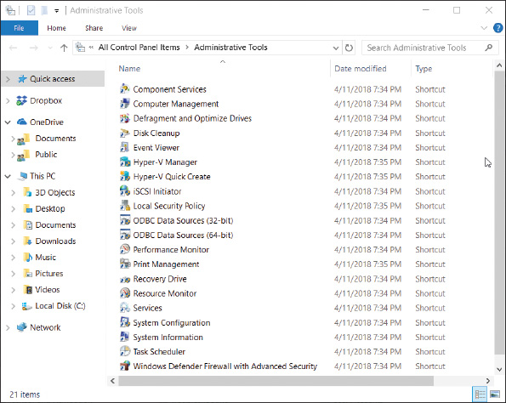
- Computer Management. Computer Management (compmgmt.msc) contains several tools that can be used to manage the local computer or other computers on the network. The window is called a console because it consolidates several Windows administrative tools. To use most of these tools, you must be signed in as an administrator, although you can view certain settings in Computer Management if you are signed in with lesser privileges. The Computer Management window is shown in Figure 14-4.
Figure 14-4
Windows Computer Management combines several administrative tools into a single, easy-to-access window
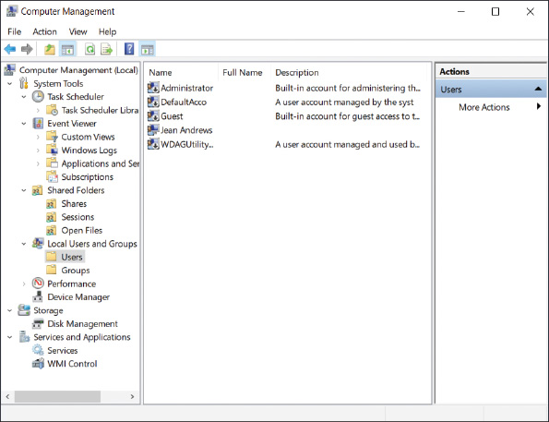
- Microsoft Management Console (MMC). You can build your own console to hold the tools you use often, and you can copy this console to any computer you support. To build a console, first sign in to Windows using an account with administrator privileges and then open the Microsoft Management Console (MMC; the program file is mmc.exe). A new empty console is created, as shown in Figure 14-5. Tools you add to your console are called snap-ins and the console is saved in a file with an .msc file extension. You learn to create your own console in a project at the end of this chapter.
Notes
A program that can work as a snap-in under the MMC has an .msc file extension.
Figure 14-5
An empty console
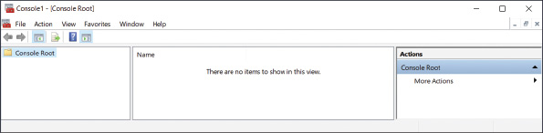
Go to pg.
help
Application Opened
Main content

14-2Best Practices to Troubleshoot Windows-Related Problems
A+ Core 2
- 1.4
Given a scenario, use appropriate Microsoft command line tools.
- 1.5
Given a scenario, use Microsoft operating system features and tools.
- 1.6
Given a scenario, use Microsoft Windows Control Panel utilities.
- 3.1
Given a scenario, troubleshoot Microsoft Windows OS problems.
This section gives you a general strategy to follow when solving any problem with Windows, an application, or hardware. Later in the chapter, you’ll learn about specific problems and how to address them.
Go to pg.
help
Application Opened
Main content

14-2aStep 1: Interview the User and Back up Data
A+ Core 2
- 3.1
Given a scenario, troubleshoot Microsoft Windows OS problems.
When the user is available, always start troubleshooting by interviewing the user:
- Interview the user and back up data. Find out as much information as you can from the user about the problem, when it started, and what happened to the system around the time the problem started. Also ask if valuable data is on the system, and back it up if necessary.
- Ask the user to reproduce the problem while you watch. Many problems with applications are caused by user error. Watch carefully as the user shows you the problem. If you see him making a mistake, be tactful as you explain the problem and its solution.
Notes
A problem might be caused by an underlying intermittent conflict or other issue. If the user is unable to reproduce the problem, don’t dismiss the user’s ability to help you understand the nature of the problem. Continue asking the user questions as you investigate the problem.
- Try a reboot. Reboots solve a lot of application problems and one might be a shortcut to your solution. If it doesn’t work, no harm is done and you’re ready to begin investigating the system. (Before you restart the system, be sure to ask the user if she needs to save her work.)
Go to pg.
help
Application OpenedApplication OpenedApplication Opened
Main content

14-2dStep 4: Consider Outside Interference
A+ Core 2
- 3.1
Given a scenario, troubleshoot Microsoft Windows OS problems.
The problem could be caused by a virus, Windows, applications other than the one that presented the initial symptoms, or hardware.

Malware Is At Work
Scan the system for malware using up-to-date anti-malware software. In Chapter 17, you learn more about symptoms that indicate malware is at work and how to scan for and remove malware.

Faulty Memory
Errors with memory are often difficult to diagnose because they can appear intermittently and might be mistaken as application errors, user errors, or other hardware component errors. Sometimes these errors cause the system to hang, a BSOD (blue screen of death) error might occur, or the system continues to function with applications giving errors or data being corrupted. You can quickly identify a problem with memory or eliminate memory as the source of a problem by using the Windows Memory Diagnostics (mdsched.exe) tool. It works before Windows is loaded to test memory for errors and can be used on computers that don’t have Windows installed. Use one of these two methods to start the utility:
- Use the mdsched.exe command. After Windows has started, enter the mdsched.exe command. A dialog box appears and asks if you want the tool to immediately restart the system and run the test or wait until the next restart.
- Boot from Windows setup media. If Windows is not the installed operating system or you cannot boot from the hard drive, boot the computer from the Windows setup USB drive or DVD to test memory for errors. Follow these steps:
  - If necessary, change the boot priority order in BIOS/UEFI setup to boot first from the optical drive or USB drive. Boot from the Windows setup DVD or USB drive.
  - On the opening screen for Windows 10/8, select your language and click Next. On the next screen (see Figure 14-8), click Repair your computer. Next choose Troubleshoot. For Windows 10, the Advanced options screen appears; for Windows 8, you must click Advanced options to see this screen.
Figure 14-8
The opening menu when you boot from Windows 10 setup media

  - On the Advanced options screen (see Figure 14-9), choose Command Prompt. In the command prompt window, enter the mdsched.exe command.
Figure 14-9
The Windows 10 Advanced options screen launched from Windows 10 setup media

OS Differences
For Windows 7, after booting from the Windows 7 setup DVD, select the Windows installation to repair. On the System Recovery Options screen, click Windows Memory Diagnostic. For Windows 7, it is not necessary to open a command prompt window to test memory.
If the tool reports memory errors, replace all memory modules installed on the motherboard.

Corrupted Hard Drive
To eliminate the hard drive as the source of a Windows or application error, use the chkdsk c: /r command to check the drive. The error-checking utility searches for bad sectors on a volume and recovers the data from them if possible. It then marks the sector as bad so that it will not be reused. Also check Event Viewer for warnings or errors regarding the hard drive.

Low on System Resources
Malware, applications, background services, device drivers, or Windows might be hogging system resources to slow down the system and/or prevent an application from working or cause Windows errors.
Use Task Manager to verify that a process is not using excessive system resources. Several ways to access Task Manager are:
- Press Ctrl+Alt+Del. Depending on your system, the security screen (see Figure 14-10) or Task Manager appears. If the security screen appears, click Task Manager. This method works well when the system has a problem and is frozen.
- Press Ctrl+Shift+Esc.
- For Windows 10/8, press Win+X and click Task Manager in the Quick Launch menu. For Windows 7, click Start, enter taskmgr.exe in the search box, and press Enter.
Figure 14-10
Use the security screen to launch Task Manager

Notes
When working with a virtual machine, you cannot send the Ctrl+Alt+Del keystrokes to the guest operating system in the VM because these keystrokes are always sent to the host operating system. To send the Ctrl+Alt+Del keystrokes to a VM in Windows Client Hyper-V, click the Action menu in the VM window and click Ctrl+Alt+Delete (see Figure 14-11).
Figure 14-11
Send the Ctrl+Alt+Del keystrokes to a VM managed by Windows 10 Pro Client Hyper-V

To send the Ctrl+Alt+Del keystrokes to a VM in Oracle VirtualBox, click Input in the menu bar at the top of the VM window. For the system shown in Figure 14-12A, you can see the keystrokes to press for Ctrl+Alt+Del are Host+Del. By default, the Host key in VirtualBox is the right Ctrl key. To verify the Host key for your installation of VirtualBox, look in the bottom-right corner of the VM window (see Figure 14-12B).
Figure 14-12
For Oracle VirtualBox, (A) send the Ctrl+Alt+Del keystrokes to a VM, and (B) verify the Host key for the VM

The Windows 10 Task Manager window is shown in Figure 14-13. If you see very limited information in the window, click More details to see the details shown in the figure.
Figure 14-13
The Windows 10 Task Manager window with the Processes tab selected

Here are important details about each tab in Task Manager:
- Processes tab and Details tab. The Processes tab shows running processes organized by Apps, Background processes, and Windows processes. Right-click a process and click Go to details (see Figure 14-13) to jump to the Details tab, where you see the name of the program file and other details about the running program. On the Details tab (see Figure 14-14), a hung process is reported as Not Responding. To end the task, select it and click End task. The application will attempt a normal shutdown; if data has not been saved, you are given the opportunity to save it.
Figure 14-14
Use the Details tab to end a task that is not responding

Notes
If your desktop locks up, you can use Task Manager to refresh it. To do so, press Ctrl+Alt+Del and open Task Manager. Click the Processes tab. In the Windows processes group, select Windows Explorer and click Restart. (Yes, Windows 10/8 Task Manager really does call Explorer “Windows Explorer.”)
In Windows 7, click the Processes tab and select and end the explorer.exe process. Then click File in the menu bar and click New Task (Run). Enter explorer.exe in the Create New Task box, and click OK. Your desktop will be refreshed and any running programs will still be open.
If you want to end a process and all related processes, click the Details tab, right-click the process, and select End Process Tree from the shortcut menu. Be careful not to end critical Windows processes; ending these might crash your system.

OS Differences
The Windows 7 Task Manager window has six tabs: Applications, Processes, Services, Performance, Networking, and Users. The Applications tab of Task Manager is used to view a list of running processes. You can end a process that is not responding on this tab or end it on the Processes tab.
A+ Exam Tip
The A+ Core 1 exam expects you to understand the purposes of each tab in Task Manager and know when to use a tab to resolve a problem in a given scenario.
- Performance tab. The Performance tab of Task Manager (see Figure 14-15) allows you to monitor performance of key devices in the system and network connections. For example, Figure 14-15 shows the CPU selected, where you can monitor what percentage of CPU resources are in use. You can also see whether Hardware-assisted Virtualization is enabled. Also notice the link to open the Resource Monitor, which can identify each process using system resources. Check for such a process if you suspect malware might be at work in a denial-of-service (DoS) attack.
Figure 14-15
Use the Performance tab to view system resource usage

OS Differences
In Windows 7, the Performance tab of Task Manager monitors performance of the CPU and memory and gives you access to the Resource Monitor. To monitor the performance of network connections, see the Networking tab of Task Manager. Alternately, you can use the Windows 7 Resource Monitor to monitor the performance of the CPU, memory, hard drive, and network connections.
- App history tab. The App history tab (see Figure 14-16) shows the resources that a program is using. For example, it’s useful when deciding if a live tile or other app is using too much CPU time or network resources.
Figure 14-16
The App history tab can help you decide if a background program is hogging system resources

Notes
To conserve resources, you can disable a live tile on the Windows 10 Start menu or Windows 8 Start screen from updating itself. Go to the Start menu or screen, right-click the tile, and click Turn live tile off in the shortcut menu.
- Startup tab. The Startup tab of Task Manager in Windows 10/8 is used to manage startup items (see Figure 14-17). Click a white arrow to expand the items in a group. To disable a program from launching at startup, select it and click Disable at the bottom of the window or in the shortcut menu. To see the program file location, right-click it and click Open file location, as shown in the figure.
Figure 14-17
Startup processes are managed on the Startup tab of Task Manager

- Users tab. The Users tab (see Figure 14-18) lists currently signed-in users. Expand the list for a user to show processes started by the user that might be affecting overall system performance. Notice that the statuses of some programs on this tab are listed as Suspended. If certain apps remain idle for a short time, they’re suspended so they don’t require the attention of the CPU. When the app is used again, it automatically comes out of suspension, and the CPU once again begins servicing it. To disconnect a remote user or sign out a local user from the system, select the user and click Disconnect or Sign out at the bottom of the screen.
Figure 14-18
The Users tab shows system resources used by each signed-in user

- Services tab. The Services tab (see Figure 14-19) lists the services currently installed along with the status of each service. You can stop, start, or restart a service by right-clicking it and selecting the action in the shortcut menu. Services can also be managed from the Services console, as discussed later in this chapter.
Figure 14-19
The Services tab of Task Manager gives the current status of all installed services

The system might be slow because the OS does not have the hardware resources it needs. Use System Information (msinfo32.exe) to find the model and speed of the installed processor and hard drive and the amount of memory installed. Compare all these values with the minimum and recommended requirements for Windows listed in Chapter 12. If you suspect that the processor, hard drive, or memory is a bottleneck, use Performance Monitor to get more information. If the bottleneck appears to be graphics, the problem might be solved by updating the graphics drivers or video adapter.
Applying Concepts

Observing Hardware Activity Using Performance Monitor
Performance Monitor (perfmon.msc) tracks activity by hardware and software to measure performance. It can monitor in real time and can save collected data in logs for future use. Software developers might use this tool to evaluate how well their software is performing and to identify software and hardware bottlenecks.
To open Performance Monitor, enter the perfmon.msc command or open it from the Administrative Tools group in Control Panel. Performance Monitor offers hundreds of counters used to examine many aspects of the system related to performance. The Windows default setting is to show the % Processor Time counter the first time you open the window (see Figure 14-20). This counter appears as a red line in the graph and tracks activity of the processor.
Figure 14-20
Performance Monitor uses counters to monitor various activities of hardware and software

To keep from unnecessarily using system resources, only use the counters you really need. For example, if you suspect the hard drive is slowing down the entire system, do the following to track hard drive performance:
- Remove the % Processor Time counter. To delete a counter, select it from the list so that it is highlighted and click the red X above the graph.
- Click the green plus sign above the graph to add counters. In the Add Counters dialog box, expand the LogicalDisk group. To track the percentage of time the hard drive is in use, select % Disk Time and click Add. To track the average number of processes waiting to use the drive, select Avg. Disk Queue Length and click Add. Figure 14-21 shows the Add Counters box with two counters added. After all your counters are added, click OK.
Figure 14-21
Add counters to set up what Performance Monitor tracks

Allow Performance Monitor to keep running while the system is in use, and then check the counters. The results for one system are shown in Figure 14-22. Select each counter and note the average, minimum, and maximum values for the counter.
Figure 14-22
Two counters can measure hard drive performance

If the % Disk Time is more than 80 percent and the Avg. Disk Queue Length is above two, you can conclude that the hard drive is working excessively hard and processes are slowed down waiting on the drive. Anytime a process must wait to access the hard drive, you are likely to see degradation in overall system performance.
Notes
To find out which counters to use to measure specific performances, search the Microsoft website or perform a general web search.
If you find that the system is slow because of a hardware component, discuss the situation with the user. You might be able to upgrade the hardware or OS or remove background processes drawing on hardware resources.

OS Differences
The Windows 7 Aero interface might be slowing down the system as it uses computing power. If disabling it improves performance, you can keep it disabled or upgrade memory and/or the video card to support it. To disable the Aero interface, right-click the desktop, select Personalize from the shortcut menu, and click Windows 7 Basic.

Incompatible Applications or Third-Party Services
Sometimes you can’t install or run an application without errors because there is a conflict or compatibility issue with other software. To eliminate these conflicts, run the application causing problems after a clean boot. A clean boot eliminates third-party software from starting during the boot and is done using System Configuration and Task Manager. If a clean boot allows the application to run without errors, you need to methodically zero in on the third-party program until you discover the one in conflict. Try disabling half of these programs. If the problem persists, disable the other half. Continue disabling half of the half until you find the program in conflict.
Caution
Don’t depend on System Configuration or Task Manager to be a permanent fix to disable a startup program or service. Once you’ve decided you want to make the change permanent, use other methods to permanently remove that process from Windows startup. For example, you might uninstall a program, remove it from a startup folder, or use the Services console to disable a service.
Applying Concepts

Performing a Clean Boot
Let’s see how to perform a clean boot to disable all third-party software during Windows startup:
- To open System Configuration, enter the msconfig.exe command. The Windows 10 System Configuration box is shown in Figure 14-23 with the General tab selected.
Figure 14-23
Use the General tab to control how Windows starts

- Click the Services tab and check Hide all Microsoft services. The list now shows only services put there by third-party software (see Figure 14-24). Click Disable all.
Figure 14-24
Use the Services tab of System Configuration to view and control services launched at startup
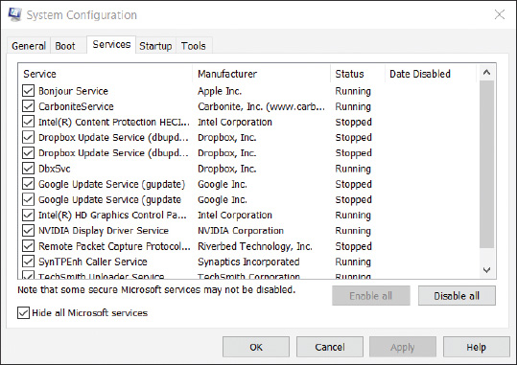
- Click the General tab and notice that Selective startup is now selected. Click Apply and close the System Configuration box.
- Open Task Manager and select the Startup tab (refer back to Figure 14-17). For each startup item, select it and click Disable. Close the Task Manager window and restart Windows.
Verify that the problem is solved in a clean boot environment. If the problem involves an application that will not install, install it now; then you can return the system to a normal startup. If the problem involves an application giving errors, you need to disable half the startup items and continue to disable half until you discover the startup program that is in conflict.
Here’s how to return to a normal Windows startup:
- Open the System Configuration box. On the General tab, click Normal startup. On the Services tab, uncheck Hide all Microsoft services. Verify that all services are now checked.
- Open Task Manager. In the Task Manager window, select each startup item and enable it. Close all windows and restart the system.

OS Differences
In Windows 10/8, the Startup tab in System Configuration is used only to open Task Manager, where startup items can be enabled and disabled. However, in Windows 7, startup items are managed on the Startup tab in System Configuration.
The Tools tab in the System Configuration box gives you quick access to other Windows tools you might need during a troubleshooting session (see Figure 14-25).
Figure 14-25
The Tools tab makes it easy to find troubleshooting tools
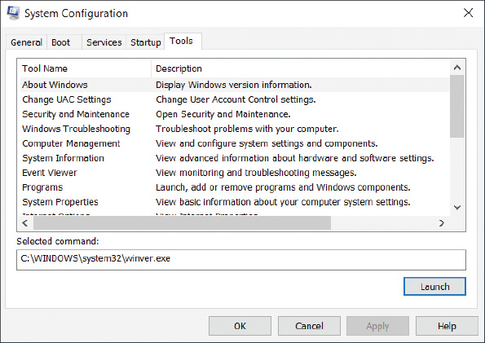
Notes
System Configuration reports only what it is programmed to look for when listing startup programs and services. It looks only in certain registry keys and startup folders, and sometimes does not report a startup process. Therefore, don’t consider its list of startup processes to be complete.
Go to pg.
help

Main content

14-2bStep 2: Error Messages, the Web, Coworkers, and Logs Might Help
A+ Core 2
- 3.1
Given a scenario, troubleshoot Microsoft Windows OS problems.
Windows might display an error message and offer a solution. Logs kept by Windows can offer clues. Following are a few examples of how to get help from Windows, the web, and coworkers.

Use Event Viewer and Reliability Monitor to Look for Clues
The Event Viewer logs might give clues about hardware or network failure, OS error messages, a device or service that has failed to start, or general protection faults, which can cause Windows to lock up or hang. Use Reliability Monitor to look for errors with applications or with key hardware components such as the hard drive.
Here are general steps to use Event Viewer:
- Open Event Viewer in the Administrative Tools group or by using the command eventvwr.msc. To see events, select a log in the left pane and then drill down into subcategories of these logs. For example, Figure 14-6 shows events in the Administrative Events log. Select an event to see more about it. In the figure, the selected event is that the computer was not able to lease an IP address from the DHCP server.
Figure 14-6
Use Event Viewer to see logs about hardware, Windows, security, and application events

- To sort a list of events, click a column heading in the middle pane. After you have selected an event, click the Details tab to show more information about the event.
The types of events are Critical, Error, Warning, Information, and Audit Success. Error events are the most important and indicate something went wrong with the system, such as a scheduled backup failing to work. Warning events indicate failure might occur in the future, and Critical events indicate a problem occurred with a critical Windows process.
Here are the logs that are the most useful:
- Administrative Events log. This filtered log shows only Critical, Error, and Warning events intended for the administrator. This log is in the Custom Views category and is selected in Figure 14-6.
- Application log. In the Windows Logs group, look in the Application log for events recorded by an application. This log might help you identify why an application is causing problems.
- Security log. Events in the Security log are called audits and include successful and unsuccessful sign-ins to a user account and attempts from another computer on the network to access shared resources on this computer.
- Setup log. Look in the Setup log for events recorded at the time applications are installed.
- System log. Look in the System log to find events triggered by Windows components, such as a device driver failing to load or a problem with hardware.
- Forwarded Events log. This log receives events that were recorded on other computers and sent to this computer.
When you first encounter a Windows, hardware, application, or security problem, get in the habit of checking Event Viewer as one of your first steps toward investigating the problem. To save time, first check the Administrative Events log because it filters out all events except Critical, Error, and Warning events.
Applying Concepts

Event Viewer Solves a Mystery
A+ Core 2
- 1.4
Given a scenario, use appropriate Microsoft command line tools.
- 1.5
Given a scenario, use Microsoft operating system features and tools.
- 1.6
Given a scenario, use Microsoft Windows Control Panel utilities.
- 3.1
Given a scenario, troubleshoot Microsoft Windows OS problems.
Event Viewer can be useful in solving intermittent hardware problems. For example, I once worked in an office where several people updated Microsoft Word documents stored on a file server. For weeks, people complained about these Word documents getting corrupted. We downloaded the latest patches for Windows and Microsoft Office and scanned for viruses, thinking that the problem might be with Windows or the application. Then we suspected a corrupted template file for building the Word documents. But nothing we did solved our problem of corrupted Word documents. Then one day someone thought to check Event Viewer on the file server. Event Viewer had faithfully been recording errors when writing to the hard drive. What we had suspected to be a software problem was in fact a failing hard drive, which was full of bad sectors. We replaced the drive and the problem went away. That day I learned the value of checking Event Viewer very early in the troubleshooting process.

Try the Troubleshooting Applet and Device Manager
Another go-to tool to use early in the troubleshooting process is the Troubleshooting applet in Control Panel, as shown in Figure 14-7. Drill down into a category in this window to see what Windows offers to solve a problem. This tool is easy to use and generally does no harm, and is therefore a good tool to show a user how to access and use when problems arise.
Figure 14-7
Use the Troubleshooting applet early in the troubleshooting process to solve simple Windows, application, hardware, network, and security problems

When the problem is hardware-related, check Device Manager. Sometimes using Device Manager to uninstall a device and then reinstalling the device solves the problem.

Find and Ask for Help
For Windows problems, search for the error message or description of the problem on the web. When you perform a Google search, add site:microsoft.com to the end of the search text to target your search to Microsoft websites. For problems with hardware and applications, try searching the website of the manufacturer for support and help. Also, search the web on the error message, application, or description of the problem. Look for forums where others have posted the same problem with the same app or device. Someone else has likely posted a solution. However, be careful and don’t take the advice unless you trust the website. After you’ve made a reasonable effort to find help on your own, ask for help from coworkers who are more experienced.
Notes
Working while a customer looks over your shoulder can be awkward. A customer needs her IT support technician to appear confident and in charge. To maintain your customer’s confidence in your technical abilities, you might want to find privacy when searching the web or talking with coworkers.
Go to pg.
help

14-3aStep 1: Observe Startup
A+ Core 2
- 3.1
Given a scenario, troubleshoot Microsoft Windows OS problems.
To get a benchmark of how fast Windows starts and see what might be causing the problem of a slow startup, do the following:
- Use a stopwatch or a watch with a second hand to time a normal startup from the moment you press the power button until the wait icon on the Windows desktop disappears.
- Follow the steps given earlier in the chapter to set up a clean boot. Time the boot again, this time using a clean boot. Note the differences.
If there is no difference, you can assume startup processes are not the source of the problem. If the difference is significant, follow the steps in this part of the chapter to reduce Windows startup to essentials. If the performance problem still exists after a clean boot, you can assume that the problem is with hardware or Windows settings. You can then look for bottlenecks with hardware and consider that Windows might be corrupted, using the tools presented earlier in the chapter.
Go to pg.
help
Application Opened
Main content

14-3bStep 2: Back Up User Data
A+ Core 2
- 3.1
Given a scenario, troubleshoot Microsoft Windows OS problems.
As always, if valuable data is not backed up, back it up before you apply any of the fixes in this chapter. You don’t want to risk losing the user’s data.
Notes
If you are able to interview the user to find out when slow performance began, use Reliability Monitor (called reliability history in Windows 10) to discover what changes were made to the system around that time and what other problems occurred.
Go to pg.
help
Application Opened
Main content

14-3cStep 3: Perform Routine Maintenance
A+ Core 2
- 1.4
Given a scenario, use appropriate Microsoft command line tools.
- 1.5
Given a scenario, use Microsoft operating system features and tools.
- 1.6
Given a scenario, use Microsoft Windows Control Panel utilities.
- 3.1
Given a scenario, troubleshoot Microsoft Windows OS problems.
It might seem pretty mundane, but the first things you need to do to improve Windows performance are the routine maintenance tasks that you learned in Chapter 13. These tasks are summarized here:
- Verify critical Windows settings. Make sure Windows updates are current. Verify that antivirus software is updated and set to routinely scan for viruses. Make sure the network connection is secured and backups are happening as you expect. If the system is experiencing a marked decrease in performance, suspect a virus and use up-to-date antivirus software to perform a full scan of the system.
- Uninstall software you no longer need and optimize the hard drive. Make sure drive C: has at least 15 percent free space and the hard drive is being defragged or optimized weekly. If you suspect hard drive problems, use chkdsk to check the hard drive for errors and recover data.
Go to pg.
help
Application Opened
Main content

14-3dStep 4: Investigate and Eliminate Startup Programs
A+ Core 2
- 1.4
Given a scenario, use appropriate Microsoft command line tools.
- 1.5
Given a scenario, use Microsoft operating system features and tools.
- 1.6
Given a scenario, use Microsoft Windows Control Panel utilities.
- 3.1
Given a scenario, troubleshoot Microsoft Windows OS problems.
To speed up startup, search for unnecessary startup programs you can eliminate. Tools that can help are System Configuration (msconfig.exe), startup folders, and Task Manager. Follow these steps to investigate startup:
- Open the Startup tab in Windows 10/8 Task Manager or the Startup tab in Windows 7 System Configuration. In the list of startup items, look for a specific startup program you don’t want. If you’re not sure of the purpose of a program, right-click it in Windows 10/8 and click Search online in the shortcut menu. (For Windows 7, scroll to the right in the Command column to see the location and name of the startup program file, and use that information for a web search.) Then search the web for information on this program. Be careful to use only reliable sites for credible information.
Caution
A word of caution is important here: Many websites will tell you a legitimate process is malicious so that you will download and use their software to get rid of the process. However, their software is likely to be adware or spyware that you don’t want. Make sure you can trust a site before you download from it or take its advice.
- If you want to find out whether disabling a startup entry gives problems or improves performance, temporarily disable it using Windows 10/8 Task Manager or Windows 7 System Configuration. To permanently disable a startup item, it’s best to uninstall the software or remove the entry from a startup folder. See Appendix B for a list of startup folders.
Notes
The startup folder for all users is hidden by default. In Chapter 11, you learned how to “unhide” folders that are hidden.
- As you research startup processes, Task Manager can tell you what processes are currently running. Open Task Manager and select the Processes tab. If you see a process and want to know its program file location, right-click the process in Windows 10/8 and click Open file location. File Explorer opens at the program file’s location.

OS Differences
For Windows 7, you can find out the file location by clicking View and clicking Select Columns. In the Select Process Page Columns box, check Image Path Name and click OK. The Image Path Name column is added to the Processes tab.
For extremely slow systems that need a more drastic fix, set Windows for a clean boot. Then restart the system and see what problems you have if a program you really need is disabled. Enable just the services and programs you decide you need.
Regardless of the method you use, be sure to restart the system after each change and note what happens. Do you get an error message? Does a device or application not work? If so, you have probably disabled a service or program you need.
Has performance improved? If performance does not improve by disabling services or startup programs, go back and enable them again. If a non-Microsoft service or startup program didn’t cause the problem, turn your attention to Microsoft services or startup programs. Start disabling them one at a time.
Caution
You might be tempted to disable all Microsoft services. If you do, however, you are disabling Networking, Event Logging, Error Reporting, Windows Firewall, Windows Installer, Windows Backup, Print Spooler, Windows Update, System Protection, and other important services. These services should be disabled only when testing for performance problems and then immediately enabled when the test is finished. Also, know that if you disable the Volume Shadow Copy service, all restore points kept on the system will be lost. If you intend to use System Restore to fix a problem with the system, don’t disable this service. If you are not sure what a service does, read its description in the Services console before you change its status.
Remember that you don’t want to permanently leave System Configuration or Task Manager in control of startup. After you have used these tools to identify the problem, use other tools to permanently remove the problem service or program from startup. Use the Services console to disable a service, use the Programs and Features window to uninstall software, and remove program files from startup folders. After the problem is fixed, return System Configuration and/or Task Manager to a normal startup.
Don’t forget to restart the computer after making a change to verify that all is well.
Go to pg.
help
Application Opened
Main content

14-3eStep 5: Check for Unwanted Scheduled Tasks
A+ Core 2
- 1.5
Given a scenario, use Microsoft operating system features and tools.
- 3.1
Given a scenario, troubleshoot Microsoft Windows OS problems.
When applications install, they often schedule tasks to check for and download their program updates, and malware sometimes hides as a scheduled task. Scheduled tasks might be unnecessary and can slow a system down. The best way to uninstall a scheduled task is to uninstall the software that is responsible for the task. Open the Task Scheduler window and search through tasks to find those you think are unnecessary or causing trouble. Research the software the task works with and then decide if you want to uninstall the software or disable the task.
Applying Concepts

Using Task Scheduler to Manage Startup Programs
To get familiar with Task Scheduler and use it to remove unnecessarily scheduled tasks from Windows startup, do the following:
- Task Scheduler stores tasks in files and subfolders in the C:\Windows\System32\Tasks folder. Open Windows 10/8 File Explorer or Windows 7 Windows Explorer and drill down into this folder to see the list of scheduled task files. One example is shown in Figure 14-29.
Figure 14-29
The Tasks folder contains tasks managed by Task Scheduler
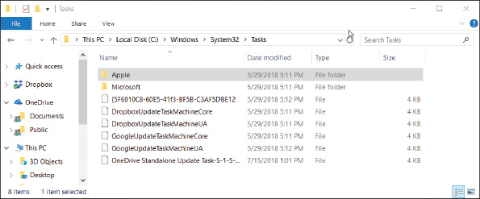
- To open Task Scheduler, enter the taskschd.msc command or double-click Task Scheduler in the Administrative Tools group. The Task Scheduler window is shown in Figure 14-30.
Figure 14-30
View and manage tasks from the Task Scheduler window
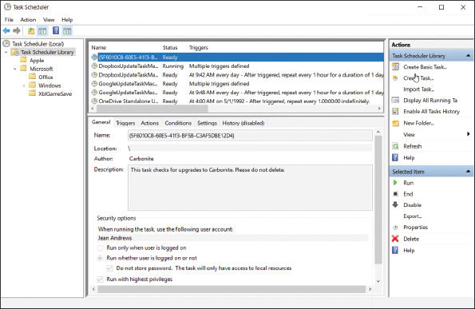
- To explore tasks, drill down into groups and subgroups in the left pane. Notice in the left pane of Figure 14-30 that the groups and subgroups match up with the folder structure in the Tasks folder of Explorer. Tasks in a group are listed in the middle pane.
- To see details about a task, including what triggers it, what actions it performs, the conditions and settings related to the task, and the history of past actions, select the task and then click the tabs in the lower-middle pane. For example, in the list of tasks shown in Figure 14-30, you can see that the Carbonite program task runs under the Jean Andrews account even when the user is not logged on.
- To delete, disable, or run a task, select it, and in the Actions pane, click Delete, Disable, or Run. You can also create your own tasks. To do so, click Create Basic Task in the Actions pane and follow the wizard to create the task.
- When you’re finished, close Task Scheduler. If you made changes in Task Scheduler, don’t forget to restart the system to make sure all is well before you move on.
Notes
Tasks can be hidden in the Task Scheduler window. To be certain you’re viewing all scheduled tasks, unhide them. In the menu bar, click View and make sure Show Hidden Tasks is checked.
Go to pg.
help
Application Opened
Main content

14-3fStep 6: Check for Low System Resources
A+ Core 2
- 1.4
Given a scenario, use appropriate Microsoft command line tools.
- 1.5
Given a scenario, use Microsoft operating system features and tools.
- 1.6
Given a scenario, use Microsoft Windows Control Panel utilities.
- 3.1
Given a scenario, troubleshoot Microsoft Windows OS problems.
Follow directions in the “Low on System Resources” section earlier in this chapter to check a hardware component that might be a bottleneck. Also, you might be able to improve performance by moving the virtual memory file, pagefile.sys; Windows uses this file in the same way it uses memory to enhance the amount of RAM in a system. Normally, pagefile.sys is a hidden file stored in the root directory of drive C:. To save space on drive C:, you can move pagefile.sys to another volume on the same hard drive or to a different hard drive, but don’t move it to a different hard drive unless you know that drive is at least as fast as the current one. If the drive is as fast as the one on which Windows is installed, performance should improve. Also, make sure the new volume has plenty of free space to hold the file—at least three times the amount of installed RAM.
A+ Exam Tip
The A+ Core 2 exam expects you to know how to configure virtual memory for optimal performance.
Applying Concepts

Changing the Location of Pagefile.sys
To change the location of pagefile.sys, follow these steps:
- Open the System window and click Advanced system settings in the left pane. The System Properties box appears with the Advanced tab selected (see Figure 14-31).
Figure 14-31
Manage virtual memory using the System Properties box
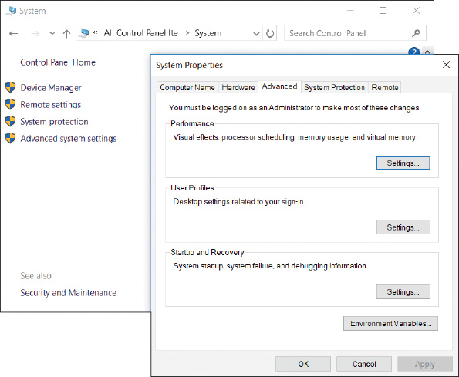
- In the Performance section, click Settings. In the Performance Options box, select the Advanced tab and click Change. The Virtual Memory dialog box appears.
- Uncheck Automatically manage paging file size for all drives (see Figure 14-32). Select the drive where you want to move the paging file. For best performance, allow Windows to manage the size of the paging file. If necessary, select System managed size and click Set.
Figure 14-32
Move pagefile.sys to a different drive
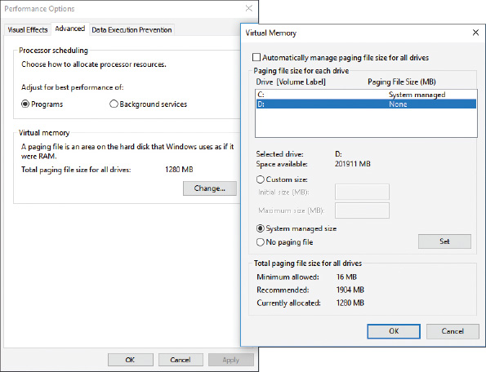
- Click OK. Windows informs you that you must restart the system for the change to take effect. Click OK to close the warning box.
- Click Apply and close all boxes. Then restart the system.
If you still don’t have enough free space on the Windows volume, consider adding a second hard drive to the system. In fact, if you install a second hard drive that is faster than the Windows hard drive, know that reinstalling Windows on the faster hard drive will improve performance. You can then use the slower, older hard drive for data.
Go to pg.
help
Application Opened
Main content

14-4Application Errors and Crashes
A+ Core 2
- 1.4
Given a scenario, use appropriate Microsoft command line tools.
- 1.5
Given a scenario, use Microsoft operating system features and tools.
- 1.6
Given a scenario, use Microsoft Windows Control Panel utilities.
- 3.1
Given a scenario, troubleshoot Microsoft Windows OS problems.
In this part of the chapter, you learn to deal with specific application errors and crashes.
Notes
If you are troubleshooting a problem and make a change to the system, be sure to restart Windows and check to see if the problem is resolved before you move on to the next fix.
Go to pg.
help
Application Opened
Main content

14-4aApplication Hangs
A+ Core 2
- 1.4
Given a scenario, use appropriate Microsoft command line tools.
- 1.5
Given a scenario, use Microsoft operating system features and tools.
- 3.1
Given a scenario, troubleshoot Microsoft Windows OS problems.
If an application is locked up and not responding, use Task Manager to end it. If Task Manager can’t end a process, use the tasklist and taskkill commands. The tasklist command returns the process identifier (PID), which is a number that identifies each running process. The taskkill command uses the process ID to kill the process. Here’s how to use the commands, using Notepad as our sample application:
- Open a command prompt window and start Notepad with the notepad.exe command. Be sure the Notepad window and the command prompt window are positioned so both are visible on your screen.
- Use the tasklist | more command to see a list of processes currently running (press the Spacebar to scroll to the next page). Note the PID of the Notepad process—for example, 7132. (You can also view PIDs on the Details tab of Task Manager.)
- Enter the command taskkill /f /pid:7132, substituting the PID you noted in Step 2. The /f parameter forcefully kills the process. Be careful using this command; it is so powerful that you can end critical system processes that will cause the system to shut down.
Go to pg.
help
Application Opened
Main content

14-4bSlow-Performing Application
A+ Core 2
- 1.4
Given a scenario, use appropriate Microsoft command line tools.
- 1.5
Given a scenario, use Microsoft operating system features and tools.
- 1.6
Given a scenario, use Microsoft Windows Control Panel utilities.
- 3.1
Given a scenario, troubleshoot Microsoft Windows OS problems.
Each application running on your computer is assigned a priority level, which determines its position in the queue for CPU resources. You can use Task Manager to change the priority level for an application that is already open. If an application performs slowly, increase its priority. You should only do this with very important applications because giving an application higher priority than certain background system processes can sometimes interfere with the operating system.
To use Task Manager to change the priority level of an open application, do the following:
- In Task Manager, click the Processes tab, right-click the application, and click Go to details.
- On the Details tab, right-click the selected program and point to Set priority. Set the new priority to Above normal (see Figure 14-33). If that doesn’t give satisfactory performance, try High.
Figure 14-33
Change the priority level of a running application
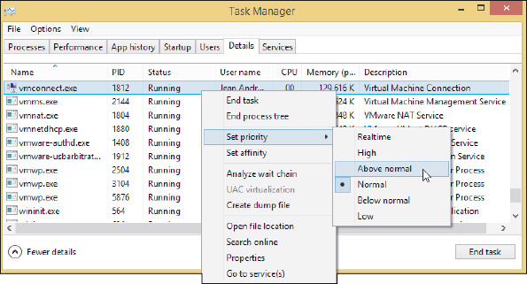
Remember that any changes you make to an application’s priority level affect only the current session.

OS Differences
For Windows 7, you can set the priority for a process in Task Manager by beginning with the Applications tab. Right-click the application and select Go To Process. On the Processes tab, right-click the selected process and point to Set Priority. You can then set the new priority.
Go to pg.
help
Application Opened
Main content

14-4cService Fails to Start
A+ Core 2
- 1.5
Given a scenario, use Microsoft operating system features and tools.
- 3.1
Given a scenario, troubleshoot Microsoft Windows OS problems.
An error results when an application expects a background service to be running but it failed to start. Research the application documentation and find out if the app relies on a service to work. To manage services, enter the services.msc command to open the Services console. If the Extended tab at the bottom of the window is not selected, click it (see Figure 14-34). This tab gives a description of a selected service.
Figure 14-34
The Services console is used to manage Windows services
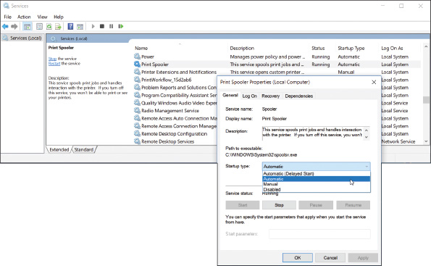
When you click a service to select it and the description is missing, most likely it’s a third-party service put there by an installed application; in fact, it might be malware. To get more information about a service or to stop or start a service, right-click its name and select Properties from the shortcut menu. In the Properties box (see Figure 14-34), the startup types for a service are:
- Automatic (Delayed Start). Starts shortly after startup and after the user signs in, so as not to slow down the startup process
- Automatic. Starts when Windows loads
- Manual. Starts as needed
- Disabled. Cannot be started
Use the Services console to make sure the service an application requires has started. If the service has failed to start, make sure it has an Automatic or Manual setting. If problems with the service or application persist, you might need to reinstall the service or the application that uses the service.
Other problems with a service can sometimes be resolved by stopping and restarting the service. For example, stopping and restarting the Spooler service might solve a problem with print jobs not moving on to the printer. To stop or restart, right-click the service and use the shortcut menu.
Notes
If you suspect a Windows system service is causing a problem, you can use System Configuration to disable the service. If this works, try replacing the service file with a fresh copy from Windows setup media.
Go to pg.
help
Application Opened
Main content

14-4dFile Fails to Open
A+ Core 2
- 3.1
Given a scenario, troubleshoot Microsoft Windows OS problems.
Windows depends on the file extension to associate a data file with an application used to open it; this is called the file association. An application associated with a file extension is called its default program. When you double-click a data file and Windows examines the file extension but doesn’t know which application to call on to open the file, it displays an error message. The solution to this problem is to change the file association for the file extension.
Applying Concepts

Solving File Association Problems
A+ Core 2
- 3.1
Given a scenario, troubleshoot Microsoft Windows OS problems.
In our example, the Transact.dbf file shown in Figure 14-35A is a legacy database file created by dBASE, and the error box in Figure 14-35A appeared when the user double-clicked the file.
Figure 14-35
Windows does not know which application to use to open the data file
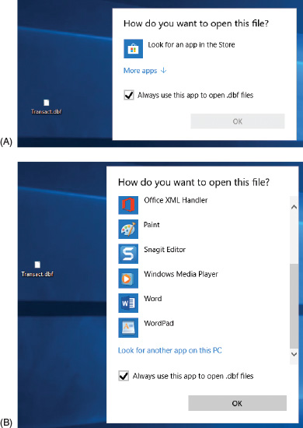
Follow these steps to instruct Windows to use Microsoft Excel to open files with a .dbf file extension:
- When Windows displays an error message asking which application it should use to open a file, click More apps, as shown in Figure 14-35A. (For Windows 8/7, click More Options.) At the bottom of the box (see Figure 14-35B), click Look for another app on this PC. (For Windows 7, click Select a program from a list of installed programs.)
- The Open with window appears. Locate the program file for Microsoft Excel, as shown in Figure 14-36, and click Open. (If you don’t know an application’s program file and location, launch the application and then open Task Manager. On the Processes tab of Task Manager, right-click the application and click Open file location. File Explorer or Windows Explorer opens and highlights the program file. You can see the path to the program file at the top of the Explorer window.)
Figure 14-36
Locate and select the EXCEL.EXE application program file
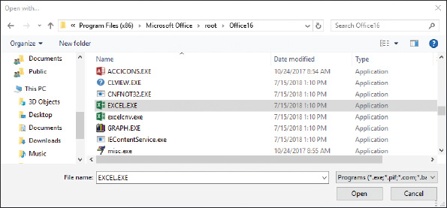
- When you double-click the Transact.dbf file, the file opens in an Excel window. Also, the icon used for the file on the desktop is now the Excel icon.
You might need to change the program associated with a file extension. For example, suppose you tried to associate the Transact.dbf file with Microsoft Access, and when you opened the file, Access gave an error. To change a file association, right-click the file in Explorer and click Open with. Next, for Windows 10, click Choose another app, check Always use this app to open files, and then find and select the new application. (For Windows 8/7, click Choose default program and find the new application to associate with the file extension.)
Go to pg.
help

Application Opened
Main content

14-4eMissing DLL or Component Not Registered
A+ Core 2
- 1.5
Given a scenario, use Microsoft operating system features and tools.
- 1.6
Given a scenario, use Microsoft Windows Control Panel utilities.
- 3.1
Given a scenario, troubleshoot Microsoft Windows OS problems.
Most applications have a main program file that uses a collection of many smaller programs called components or objects that serve the main program. The main program for an application has an .exe file extension and relies on several component services that often have .dll file extensions. (DLL stands for Dynamic Link Library.) Problems with applications can be caused by a missing DLL program or a broken association between the main program and a component.
If you get an error message about a missing DLL, the easiest way to solve the problem might be to reinstall the application. However, if that is not advisable, you can identify the path and name of the missing DLL file and recover it from backup or from the application installation files.
On the other hand, the file might be present and undamaged, but the application cannot find it because the relationship between the two is broken. Relationships between a main program and its components are normally established by entries in the registry when the application is installed. The process is called registering a component. In addition, you can use Component Services (also called COM+) in the Administrative Tools group to register components. The tool is often used by application developers and system administrators when developing and deploying an application. For example, a system administrator might use COM+ when installing an application on servers or client computers where an application on one computer calls an application on another computer on the network.
A+ Exam Tip
The A+ 220-902 exam expects you to know how to handle missing DLL errors and to know when it’s appropriate to use the Component Services tool.
As an IT support technician, you might be asked by a system administrator or software provider to use the COM+ tool to help solve a problem with an application giving errors. Suppose you get this error when installing an application:
When you contact the help desk of the application provider, you might be instructed to use the COM+ tool to solve the problem. To open the tool, open Control Panel and click Administrative Tools, then double-click Component Services. The Component Services window is shown in Figure 14-37. To learn how to use the tool, click Help in the menu bar. The application provider should be able to step you through the process of registering one of their components.
Figure 14-37
Use the Component Services window to register components used by an application
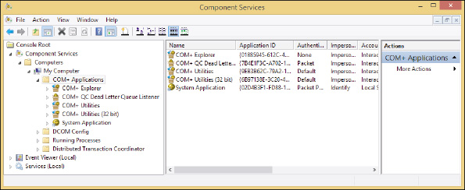
Go to pg.
help
Application Opened
Main content

14-4fApplication Has Never Worked
A+ Core 2
- 1.5
Given a scenario, use Microsoft operating system features and tools.
- 1.6
Given a scenario, use Microsoft Windows Control Panel utilities.
- 3.1
Given a scenario, troubleshoot Microsoft Windows OS problems.
If an application has never worked or stops working after the OS has been upgraded, follow these steps:
- Update Windows and search the web. Installing all important and critical Windows updates can sometimes solve a problem with an application that won’t install. Also check the website of the software manufacturer and the Microsoft support site (support.microsoft.com) for solutions. Search on the application name or the error message you get when you try to run it. Verify that the application is approved by its manufacturer to work in the installed OS.
- Run the installation program or application as an administrator. The program might require that the user have privileges not assigned to the current user account. Try running the application with administrator privileges, which Windows calls a secondary logon. Use Explorer to locate the executable program file in a subfolder of the Program Files or Program Files (x86) folder. Right-click the file and select Run as administrator from the shortcut menu (see Figure 14-38).
Figure 14-38
Execute a program using administrative privileges
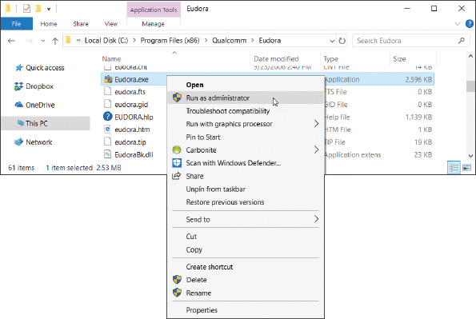
Notes
To run a program from a user account other than administrator, hold down the Shift key and right-click the program file. Then select Run as different user from the shortcut menu. You must then enter the user name and password of another user account in the Windows Security box.
If the program works when you run it with administrative privileges, you can make that setting permanent. To do so, right-click the program and select Properties from the shortcut menu. Then click the Compatibility tab and check Run this program as an administrator (see Figure 14-39). Click Apply and then close the Properties box.
Figure 14-39
Permanently change the privilege level of an application
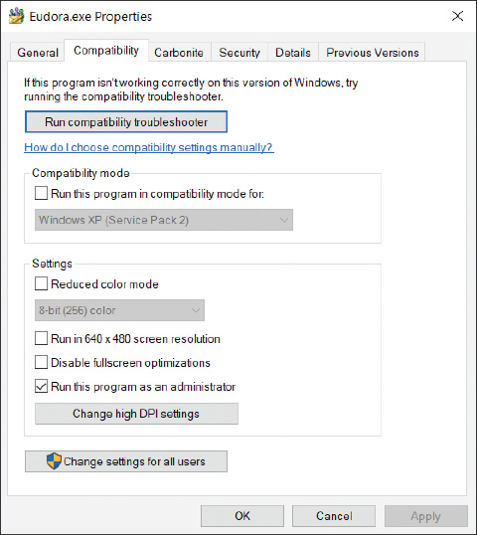
- Consider whether an older application is having compatibility problems with Windows. Some older applications cannot run under Windows 10/8 or they run with errors. In the Properties box shown in Figure 14-39, click Run compatibility troubleshooter. Windows makes its recommendations, such as enabling Compatibility mode for Windows XP programs. Test the program and click OK to make the change permanent.
- Verify that the application is digitally signed. Although applications that are not digitally signed can still run on Windows, a digital signature does verify that the application is not a rogue application and that it is certified as Windows-compatible by Microsoft. To view the digital signature, select the Digital Signatures tab of the program file’s Properties box. Select a signer in the list and click Details (see Figure 14-40). If the Digital Signatures tab is missing, the program is not digitally signed.
Figure 14-40
This program is digitally signed
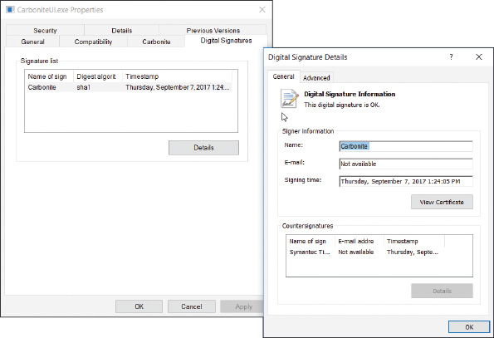

ODBC Data Sources
As an IT technician, you might be called on to help set up a local computer on a corporate network to connect to a remote database stored on a company database server. For example, suppose Microsoft Access is installed on the local computer and you want to configure it to connect to a Microsoft SQL Server database on a server. Open Database Connectivity (ODBC) is the technology used to create the data source, which provides access to the database and includes the drivers required to interface between Access and the data (see Figure 14-41). Drivers for Microsoft SQL Server must be installed on the local computer (Windows has SQL drivers installed by default). Then you can use the ODBC Data Sources tool in the Administrative Tools group of Control Panel to configure the data source.
Figure 14-41
Microsoft Access connects to an ODBC data source on a corporate network
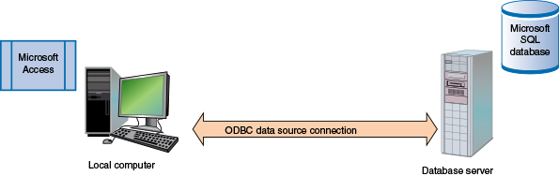
Do the following to create a new data source for Microsoft Access so that it can work with a remote Microsoft SQL Server database:
- For Windows 10/8, you need to know whether Access is installed as a 32-bit or 64-bit application. One easy way to find out is to look on the Processes tab of Task Manager when the application is open. You’ll see “32 bit” or “64 bit” listed in the application name.
- Open the Administrative Tools group. For Windows 10/8, click either ODBC Data Sources (32-bit) or ODBC Data Sources (64-bit), depending on the version of Access that’s installed. For Windows 7, click Data Sources (ODBC). The ODBC Data Source Administrator box opens (see the left side of Figure 14-42).
Figure 14-42
Use the Data Sources tool to create a connection between a foreign data source and an application
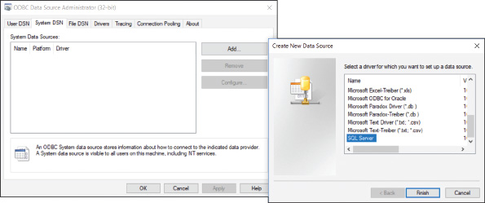
- To make the data source apply to all users of the system, click the System DSN tab. (DSN stands for Data Source Name; the User DSN tab applies only to the current user.) Click Add. The Create New Data Source box appears (see the right side of Figure 14-42). Scroll down, select SQL Server, and click Finish. Follow the on-screen directions to enter the name of the SQL Server computer on the network and the sign-in ID and password to SQL Server. The database administrator in your organization can supply this information.
Notes
If you don’t see the driver you need in the Create New Data Source box, close all windows and use Explorer to locate the C:\Windows\SysWOW64\Odbcad32.exe program file. When you double-click this file, the ODBC Data Source Administrator box appears and you can then access all ODBC drivers installed on the local computer.
Go to pg.
help
Application Opened
Main content

14-5An Application Fails to Uninstall
A+ Core 2
- 1.5
Given a scenario, use Microsoft operating system features and tools.
- 1.6
Given a scenario, use Microsoft Windows Control Panel utilities.
- 3.1
Given a scenario, troubleshoot Microsoft Windows OS problems.
Normally, you use the Programs and Features window to uninstall an application. However, some uninstall routines get corrupted and you need to manually uninstall the application. To do so, you need to know how to use the Windows Registry Editor (regedit.exe). As an IT technician, you will be called on to edit the registry for a variety of purposes, not just to remove software. Let’s first look at how the registry is organized and how to edit it, and then we’ll explore the details of manually removing software.
Go to pg.
help
Application Opened
Main content

14-5aRegistry Editor
A+ Core 2
- 1.5
Given a scenario, use Microsoft operating system features and tools.
- 1.6
Given a scenario, use Microsoft Windows Control Panel utilities.
- 3.1
Given a scenario, troubleshoot Microsoft Windows OS problems.
Many actions, such as installing application software or hardware, can result in changes to items in the registry, called keys, which are assigned values. Changes to the registry can include adding or removing keys and their values or editing the values assigned to existing keys. For a few difficult problems, you might need to edit the values assigned to a key or remove a registry key. This part of the chapter looks at how the registry is organized, which keys might hold entries causing problems, and how to back up and edit the registry using the Registry Editor. Let’s first look at how the registry is organized.

How the Registry Is Organized
The registry is the most important Windows component that holds information for Windows. The registry is a database designed with a treelike structure (called a hierarchical database) that contains configuration information for Windows, users, software applications, and installed hardware devices. During startup, Windows builds the registry in memory and keeps it there until Windows shuts down. During startup, after the registry is built, Windows reads from it to obtain information to complete the startup process. After Windows is loaded, it continually reads from many of the subkeys in the registry.
Windows builds the registry from the current hardware configuration and from information it takes from the following files:
- Five files stored in the C:\Windows\System32\config folder; these files are called hives, and they are named the SAM (Security Accounts Manager), SECURITY, SOFTWARE, SYSTEM, and DEFAULT hives. (Each hive is backed up with a log file and a backup file, which are also stored in the C:\Windows\System32\config folder.)
- C:\Users\username\Ntuser.dat file, which holds the preferences and settings of the currently signed-in user.
After the registry is built in memory, it is organized into five high-level keys (see Figure 14-43). Each key can have subkeys, and subkeys can have more subkeys and can be assigned one or more values. The way data is organized in the hive files is different from the way it is organized in registry keys. Figure 14-44 shows the relationship between registry keys and hives. For example, notice that the HKEY_CLASSES_ROOT key contains data that comes from the SOFTWARE and DEFAULT hives, and some of this data is also stored in the larger HKEY_LOCAL_MACHINE key.
Figure 14-43
The Windows registry is logically organized in five keys with subkeys
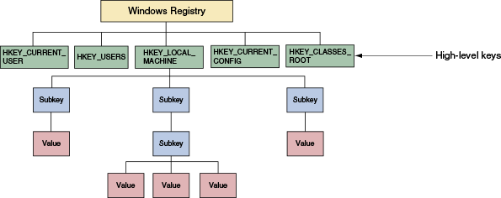
Figure 14-44
The relationship between registry keys and hives
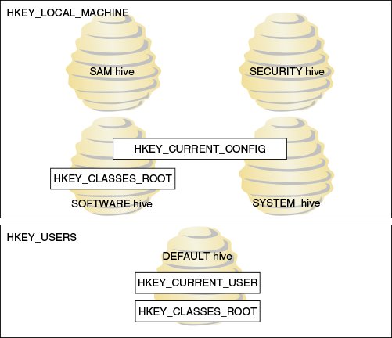
Here are the five keys, including where they get their data and their purposes:
- HKEY_LOCAL_MACHINE (HKLM) is the most important key and contains hardware, software, and security data. The data is taken from four hives: the SAM hive, the SECURITY hive, the SOFTWARE hive, and the SYSTEM hive. In addition, the HARDWARE subkey of HKLM is built when the registry is first loaded, based on data collected about the current hardware configuration.
- HKEY_CURRENT_CONFIG (HKCC) contains information that identifies each hardware device installed on the computer. Some of the data is gathered from the current hardware configuration when the registry is first loaded into memory. Other data is taken from the HKLM key, which got its data primarily from the SYSTEM hive.
- HKEY_CLASSES_ROOT (HKCR) stores information that determines which application to open when the user double-clicks a file. This file association relies on the file’s extension. Data for this key is gathered from the HKLM key and the HKCU key.
- HKEY_USERS (HKU) contains data about all users and is taken from the DEFAULT hive.
- HKEY_CURRENT_USER (HKCU) contains data about the current user. The key is built when a user signs in using data kept in the HKEY_USERS key and in the Ntuser.dat file of the current user.
Notes
Device Manager reads data from the HKLM\HARDWARE key to build the information it displays about hardware configurations. You can consider Device Manager to be an easy-to-view presentation of this HARDWARE key data.
Go to pg.
help
Application Opened
Main content

14-5bBefore You Edit the Registry, Back It Up!
When you think you need to edit the registry, if possible, first try to make the change from the Windows tool that is responsible for the key—for example, by using the Programs and Features applet in Control Panel. If that doesn’t work and you must edit the registry, always back it up first. Changes made to the registry are implemented immediately.
Caution
There is no undo feature in the Registry Editor, and no opportunity to change your mind once the edit is made.
Here are the ways to back up the registry:
- Use System Protection to create a restore point. A restore point keeps information about the registry. You can restore the system to a restore point to undo registry changes, as long as the registry is basically intact and not too corrupted. Also know that, if System Protection is turned on, Windows automatically makes a daily backup of the registry hive files to the C:\Windows\System32\Config\RegBack folder.
- Back up a single registry key just before you edit the key. This method, called exporting a key, should always be used before you edit the registry. How to export a key is explained in the following steps.
- Make an extra copy of the C:\Windows\System32\config folder. This is what I call the old-fashioned shotgun approach to backing up the registry. This backup will help if the registry gets totally trashed. You can boot from Windows setup media and use the Windows Recovery Environment to get a command prompt window that you can use to restore the folder from your extra copy. This method is drastic and not recommended except in severe cases. Still, just to be on the safe side, you can make an extra copy of this folder just before you start any serious digging into the registry.
In some situations, such as when you’re going to make drastic changes to the registry, you’ll want to play it safe and use more than one backup method. Extra registry backups are always a good thing! Now let’s look at how to back up an individual key in the registry, and then you’ll learn how to edit the registry.

Back Up, Edit, and Restore Individual Keys
A less time-consuming method of backing up the registry is to back up a particular key that you plan to edit. However, know that if the registry gets corrupted, having a backup of only a particular key most likely will not help you much when trying a recovery. Also, although you could use this technique to back up the entire registry or an entire tree within the registry, it is not recommended.
To back up a registry key along with its subkeys, follow these steps:
- 1.
To open the Registry Editor, enter the regedit command and respond to the UAC box. Figure 14-45 shows the Registry Editor with the five main keys and several subkeys listed. Click the triangles on the left to see subkeys. When you select a subkey, such as KeyboardClass in the figure, the names of the values in that subkey are displayed in the right pane along with the data assigned to each value.
Figure 14-45
The Registry Editor showing the five main keys, subkeys, values, and data
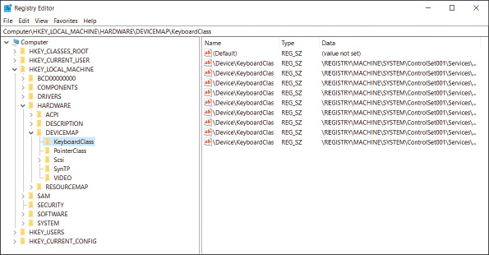
Notes
The full path to a selected key displays in the bar at the top of the Windows 10 editor window and at the bottom of the Windows 8/7 editor window. If the bar is missing, click View in the menu bar. For Windows 10, make sure Address Bar is checked. For Windows 8/7, make sure Status Bar is checked.
- 2.
Suppose we want to back up the registry key that contains a list of installed software, which is HKLM\SOFTWARE\Microsoft\Windows\CurrentVersion\Uninstall. (HKLM stands for HKEY_LOCAL_MACHINE.) First click the appropriate triangles to navigate to the key. Next, right-click the key and select Export from the shortcut menu, as shown in Figure 14-46. The Export Registry File dialog box appears.
Figure 14-46
Using the Registry Editor, you can back up a key and its subkeys with the Export command
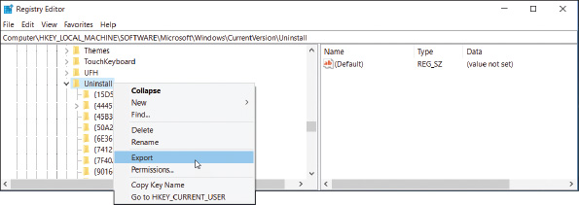
- 3.
Select the location to save the export file and name the file. The desktop is a convenient place to store an export file while you edit the registry. Click Save when done. The saved file will have a .reg file extension.
- 4.
You can now edit a key you have exported or one of its subkeys. To search the registry for keys, values, and data, click Edit in the menu bar and then click Find. Locate and select the key in the left pane of the editor. The values stored in the key display in the right pane.
- 5.
To edit, rename, or delete a value, right-click it and select the appropriate option from the shortcut menu. Changes are immediately applied to the registry and there is no undo feature. (However, Windows or applications might need to read the changed value before it affects their operations.)
- 6.
Later, if you need to undo your changes, exit the Registry Editor and double-click the saved export file. The key and its subkeys saved in the export file will be restored. After you’re done with an export file, delete it so that no one accidentally double-clicks it and reverts the registry to an earlier setting.
Caution
Changes made to the registry take effect immediately. Therefore, take extra care when editing the registry. If you make a mistake and don’t know how to correct a problem you create, double-click the exported key to recover. When you double-click an exported key, the registry is updated with the values stored in the key.
Go to pg.
help
Application Opened
Main content

14-5cManually Removing Software
A+ Core 2
- 1.5
Given a scenario, use Microsoft operating system features and tools.
- 1.6
Given a scenario, use Microsoft Windows Control Panel utilities.
- 3.1
Given a scenario, troubleshoot Microsoft Windows OS problems.
You’re now ready to learn how to get rid of programs that refuse to uninstall or give errors when uninstalling. Doing so often causes problems later, so use the methods discussed in this section only as a last resort after normal uninstall methods have failed.
Here are the high-level steps:
- First try to locate and use an uninstall routine provided by the software. If this works, you are done and can skip the next steps.
- Delete the program folders and files that hold the software.
- Delete the registry entries used by the software.
- Remove the entries in the Start menu and delete any shortcuts on the desktop.
- Remove any entries that launch processes at startup.
Notes
Before uninstalling software, make sure it’s not running in the background. For example, antivirus software cannot be uninstalled if it’s still running. You can use Task Manager to end all processes related to the software, and you can use the Services console to stop services related to the software. Then remove the software.
Now let’s step through the process of manually removing software.

Step 1: First Try the Uninstall Routine
Most programs written for Windows have an uninstall routine that can be accessed from the Programs and Features window or launched from the Windows 10/7 Start menu or Windows 8 Start screen. First, try one of these methods before moving on to Step 2.

Step 2: Delete Program Files
If the uninstall routine is missing or does not work, the next step is to delete the program folders and files that contain the software. In our example, we’ll delete the RegServe software without using its uninstall routine. (RegServe is utility software that can clean the registry of unused keys.) Follow these steps:
- If you have not already done so, close the application.
- Look for the program folder in the C:\Program Files or C:\Program Files (x86) folder. In Figure 14-47, you can see the RegServe folder under the C:\Program Files (x86) folder. Keep in mind, however, the program files might be in another location that was set by the user when the software was installed.
Figure 14-47
Program files are usually found in the Program Files or Program Files (x86) folder
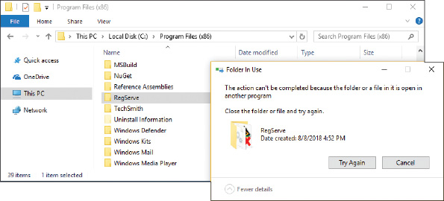
- Delete the RegServe folder and all its contents. As you do, the Folder In Use box shown on the right side of Figure 14-47 might report the program is in use. In this situation, do the following:
  - Look for the program file reported on the Processes tab of Task Manager. If you see it listed, end the process (see Figure 14-48).
Figure 14-48
Task Manager shows a process is running and needs to be stopped before the program files can be deleted
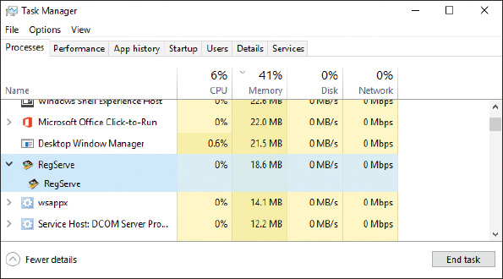
  - If you don’t find the program on the Processes tab, check the Services tab. If you find it there, select it and stop the service.
  - After the program or service is stopped, try to delete the program folder again. If you still cannot delete the folder, look for other running programs or services associated with the software. Look for a program or service that has a program file location in the RegServe folder or its subfolders.
  - Try deleting all the subfolders and files in the RegServe folder until you find a particular file that you cannot delete. This program file is the process you must first stop before you can delete it. In our example, the program file that could not be deleted was RSListener.exe. See Figure 14-49. After it was stopped, the RegServe folder could be deleted.
Figure 14-49
A running process prevents the RegServe folder and its running process from being deleted
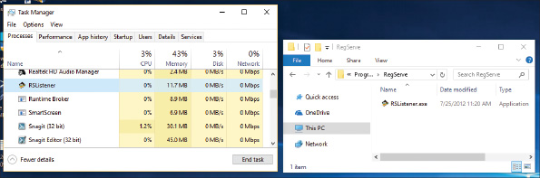

Step 3: Delete Registry Entries
Editing the registry can be dangerous, so do it with caution and be sure to back up first! Do the following to delete registry entries that cause a program to be listed as installed software in the Programs and Features window of Control Panel:
- 1.
To be on the safe side, back up the entire registry using one or more of the methods discussed earlier in the chapter.
- 2.
Open the Registry Editor by entering the regedit command.
- 3.
Locate a key that contains the entries that make up the list of installed software. Use the following criteria to decide which key to locate:
  - For a 32-bit program installed in a 32-bit OS or for a 64-bit program installed in a 64-bit OS, locate this key:
HKEY_LOCAL_MACHINE\Software\Microsoft\Windows\CurrentVersion\Uninstall
  - For a 32-bit program installed in a 64-bit OS, locate this key:
HKEY_LOCAL_MACHINE\SOFTWARE\Wow6432Node\Microsoft\Windows\CurrentVersion\Uninstall
Notes
Recall that 32-bit programs normally install in the \Program Files (x86) folder on a 64-bit system. These 32-bit programs normally use the Wow6432Node subkey in the registry of a 64-bit OS. However, occasionally you’ll see a 32-bit app in the Uninstall key tree for 64-bit apps.
- 4.
Back up the Uninstall key to the Windows desktop so that you can backtrack, if necessary. To do that, right-click the Uninstall key and select Export from the shortcut menu (see Figure 14-46 earlier in the chapter).
- 5.
In the Export Registry File dialog box, select Desktop. Enter the file name as Save Uninstall Key, and click Save. You should see a new file icon named Save Uninstall Key.reg on your desktop.
- 6.
The Uninstall key can be a daunting list of all the programs installed on your computer. When you expand the key, the left pane shows a long list of subkeys, which might have meaningless names that won’t help you find the program you’re looking for. Select the first subkey in the Uninstall key and watch as its values and data are displayed in the right pane. Step down through each key, watching for a meaningful name of a subkey in the left pane or meaningful details in the right pane until you find the program you want to delete. If you don’t find the application in the Uninstall key for 32-bit apps, check the Uninstall key for 64-bit apps. Occasionally you’ll see a 32-bit app in the 64-bit Uninstall key tree.
- 7.
To delete the key, right-click it and select Delete from the shortcut menu. Confirm the deletion, as shown in Figure 14-50. Be sure to search through all the keys in this list because the software might have more than one key. Delete them all and exit the Registry Editor.
Figure 14-50
Select a subkey under the Uninstall key to display its values and data in the right pane and to delete the subkey
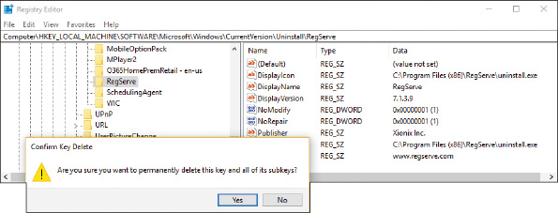
- 8.
Open the Programs and Features window and verify that the list of installed software is correct and the software you are uninstalling is no longer listed.
- 9.
If the list of installed software is not correct, restore the Uninstall registry key by double-clicking the Save Uninstall Key.reg icon on your desktop.
- 10.
As a last step when editing the registry, clean up after yourself by deleting the Save Uninstall Key.reg file on your desktop. Right-click the icon and select Delete from the shortcut menu.

Step 4: Remove Program Shortcuts
For Windows 10, you can remove the app from the Start menu by opening the menu, right-clicking the app, and clicking More. Then click Remove from this list. See Figure 14-51. If the program has shortcuts on the desktop, delete them.
Figure 14-51
Remove an app from the Windows Start menu
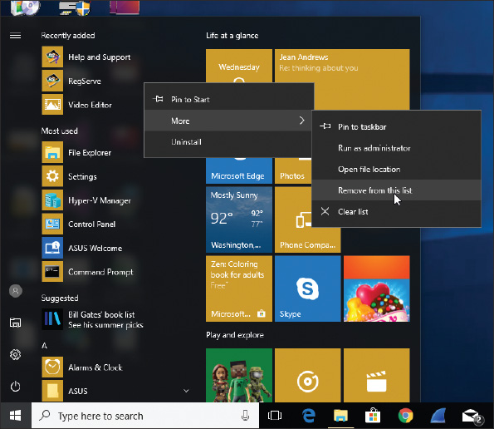

OS Differences
For Windows 8, go to the Start screen and type the name of the program. The Problem with Shortcut box appears. When you click Yes, the program will no longer be listed on the Start screen or Apps screen. For Windows 7, you can remove the program from the All Programs menu by right-clicking the program and selecting Delete from the shortcut menu.

Step 5: Remove Startup Processes
Restart the system and watch for any startup errors about a missing program file. The software might have stored startup entries in the registry, in startup folders, or as a service that is no longer present and causing an error. If you see an error, use System Configuration or Task Manager to find out how the program is set to start. This entry point is called an orphaned entry. You’ll then need to delete this startup entry by editing the registry, deleting a shortcut in a startup folder, or disabling a service using the Services console.
It’s unlikely you will be able to completely remove all keys in the registry that the software put there. A registry cleaner can help you find these orphaned keys, but if no errors appear at startup, you can just leave these keys untouched. Also, an installation might put program files in the C:\Program Files\Common Files folder or the C:\Program Files (x86)\Common Files folder. Most likely you can just leave these untouched as well. Address all error messages you encounter and stop there.
Go to pg.
help
Application Opened
Main content

14-6Troubleshooting Hardware Problems in Windows
A+ Core 2
- 1.4
Given a scenario, use appropriate Microsoft command line tools.
- 1.5
Given a scenario, use Microsoft operating system features and tools.
- 1.6
Given a scenario, use Microsoft Windows Control Panel utilities.
- 3.1
Given a scenario, troubleshoot Microsoft Windows OS problems.
Now we’re ready to discuss dealing with display problems, network printing problems, and limited network connectivity.
Go to pg.
help
Application Opened
Main content

14-6aDisplay Settings and Graphics Software
A+ Core 2
- 1.5
Given a scenario, use Microsoft operating system features and tools.
- 1.6
Given a scenario, use Microsoft Windows Control Panel utilities.
- 3.1
Given a scenario, troubleshoot Microsoft Windows OS problems.
For Windows 10, you can access the display settings by right-clicking the desktop and clicking Display settings. Alternately, you can click Display in the Settings window. The Display window is shown in Figure 14-52. For a dual-monitor setup, select the display you want to adjust, as shown in the figure.
Figure 14-52
Adjust Windows 10 display settings
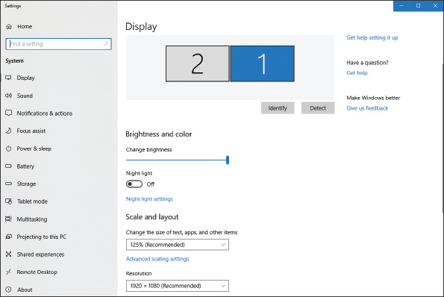
Here are a few basic display settings:
- To adjust resolution (the number of horizontal and vertical pixels used to build one screen), click the Resolution drop-down menu and select the highest or recommended resolution. The recommended resolution is usually the native resolution, which is the optimal resolution the monitor was designed to support.
- The refresh rate is the number of times the monitor refreshes the screen in one second. To set the rate, scroll down and click Advanced display settings. Click Display adapter properties for Display for the display device you want to configure. The video adapter properties box for that display appears. Click the Monitor tab and select the highest value available under Screen refresh rate (see Figure 14-53).
Figure 14-53
Adjust the Windows 10 refresh rate on the monitor properties box
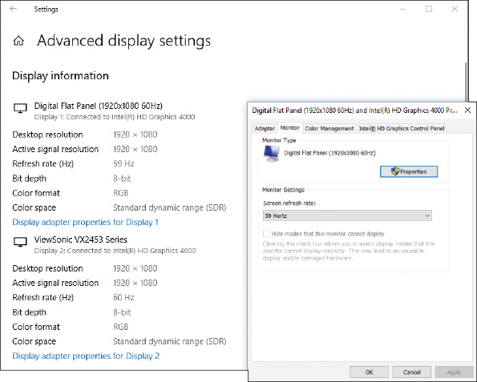
- For a dual-monitor setup, you can configure multiple displays. For a multiple monitor orientation problem, drag the two monitor boxes so that they represent the relative positions of each monitor. (For example, in Figure 14-52, the right monitor is represented by box 1 and the left monitor is represented by box 2.) You can also adjust the boxes so they are horizontal or vertical relative to each other. If you stack the boxes vertically, the pointer moves vertically from monitor to monitor. For either a horizontal or vertical multiple monitor misalignment problem, align the two boxes evenly so that the pointer moves straight across or straight up or down to the second monitor without staggering. For best results, use the same screen resolution for both monitors.

Color Depth
Accurate color representation on a monitor screen is called color depth. The best color depth is important for graphics design and editing photos. To get optimum color depth, you can download and apply a color profile for the monitor from the monitor manufacturer. Do the following for Windows 10:
- Look on the front or rear of the monitor for its brand and model.
- Go to the monitor manufacturer’s website and download the latest drivers for the monitor model (not the video adapter) and the version of Windows installed. The color profile file, which has an .icm file extension, should be in the downloaded package. To find the file, you might need to unzip a downloaded zipped folder or execute a downloaded executable file.
- Open the video adapter properties box shown earlier in Figure 14-53 and select the Color Management tab. Then click Color Management. The Color Management box appears. See Figure 14-54.
Figure 14-54
Use the Color Management box to apply a color profile
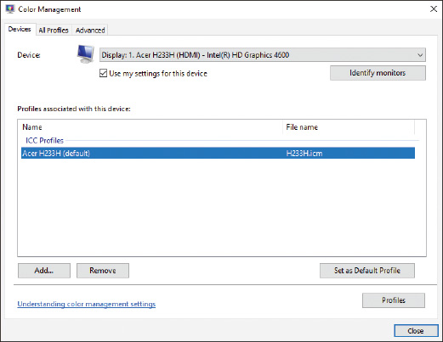
- In the drop-down menu, select the monitor and check Use my settings for this device. To add a new profile, click Add and click Browse. Then point to the .icm file you downloaded. Click Add.
- In the Color Management box, select the added profile and click Set as Default Profile. You should notice colors on the screen change slightly after applying a new color profile.
- There’s one more color adjustment you can make. On the Color Management box, click the Advanced tab, click Calibrate display, and follow the on-screen directions to calibrate brightness and contrast settings.
Windows 8

Display Settings for Windows 8
A+ Core 2
- 1.5
Given a scenario, use Microsoft operating system features and tools.
- 1.6
Given a scenario, use Microsoft Windows Control Panel utilities.
- 3.1
Given a scenario, troubleshoot Microsoft Windows OS problems.
For Windows 8/7, use the Display applet in Control Panel to manage display settings. The Display window for Windows 8 is shown in Figure 14-55.
Figure 14-55
Adjust Windows 8 display settings
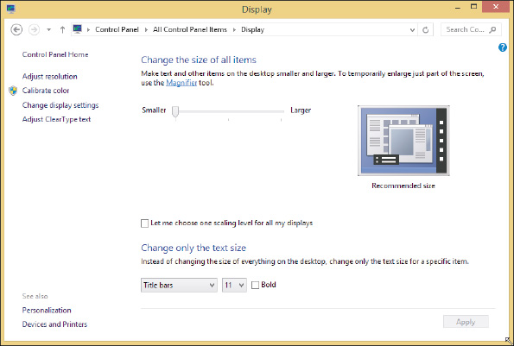
Here are a few basic display settings for Windows 8/7:
- To adjust resolution, click Adjust resolution. The Screen Resolution window shown in Figure 14-56 appears. Select the highest or recommended resolution.
Figure 14-56
Adjust the Windows 8/7 refresh rate on the monitor properties box
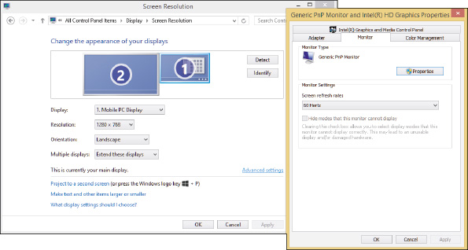
- To set the refresh rate, click Advanced settings on the Screen Resolution window. The video adapter properties box appears. Click the Monitor tab and select the highest value available under Screen refresh rate (see Figure 14-56).
- To adjust color depth by applying a color profile for the monitor, select the Color Management tab on the monitor properties box (see Figure 14-56).
- To calibrate color, click Calibrate color on the Display window (see Figure 14-55) and follow the on-screen directions.

Update DirectX
Recall from Chapter 12 that Windows requires the video adapter and drivers to support DirectX 9. DirectX is a Microsoft software development tool that developers can use to write multimedia applications, such as games, video-editing software, and computer-aided design software. The video firmware on the video card or motherboard chipset can interpret DirectX commands to build 3D graphics.
If an application such as a game or desktop publishing app that relies heavily on graphics is not performing well or giving errors, the problem might be the version of DirectX the system is using. You can use the dxdiag.exe command to display information about hardware and diagnose problems with DirectX. The first time you execute the dxdiag.exe command, a message box appears and asks if you want to check whether your drivers are digitally signed. When you click Yes, the opening window appears, as shown in Figure 14-57. Look for the version of DirectX that’s installed (version 12 in the figure).
Figure 14-57
The DirectX Diagnostic tool reports information about DirectX components
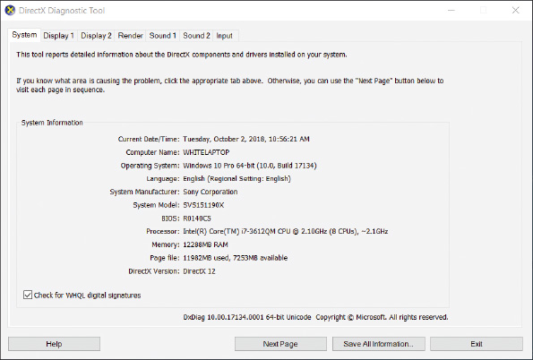
To find out the latest version of DirectX published by Microsoft, go to microsoft.com and search on “DirectX End-User Runtime Web Installer.” You can use a link on the page to download and install a new version of DirectX.
Go to pg.
help
Application Opened
Main content

14-6bPrint Management
A+ Core 2
- 1.5
Given a scenario, use Microsoft operating system features and tools.
- 1.6
Given a scenario, use Microsoft Windows Control Panel utilities.
- 3.1
Given a scenario, troubleshoot Microsoft Windows OS problems.
Windows professional and business editions offer the Print Management (printmanagement.msc) console in the Administrative Tools group of Control Panel. (Home editions don’t provide the Print Management tool.) It comes in handy when you’re responsible for managing several printers and users. Rather than having to walk over to a computer that has an installed printer with a problem, you can manage the computer’s printer queue and other print issues while sitting at your own workstation. In Print Management, each computer on the network that has installed printers is considered a print server.
Applying Concepts

Learning to Use Print Management
A+ Core 2
- 1.5
Given a scenario, use Microsoft operating system features and tools.
- 1.6
Given a scenario, use Microsoft Windows Control Panel utilities.
- 3.1
Given a scenario, troubleshoot Microsoft Windows OS problems.
Follow these steps to learn to use Print Management:
- Open Control Panel and Administrative Tools. Double-click Print Management. The Print Management window appears.
- In the Print Servers group, drill down to your local computer and click Printers. The list of printers installed on your computer appears, as shown in Figure 14-58.
Figure 14-58
Use Print Management to monitor and manage printers on the network
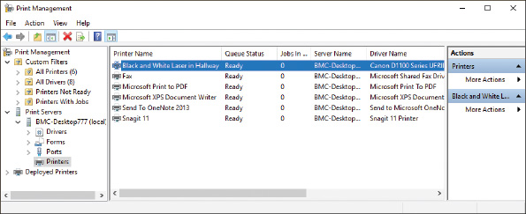
- You can manage printers installed on other computers on the network by adding each computer as a print server. To add other print servers to the list, right-click Print Servers in the left pane and click Add/Remove Servers. In the Add/Remove Servers box (see the left side of Figure 14-59), click Browse. Locate the computer (see the right side of Figure 14-59) and click Select Server. The computer is now listed under Add servers in the Add/Remove Servers box. Click Add to List. The computer is listed in the Print servers area. Click OK to close the Add/Remove Servers box.
Figure 14-59
Select a print server to monitor and manage
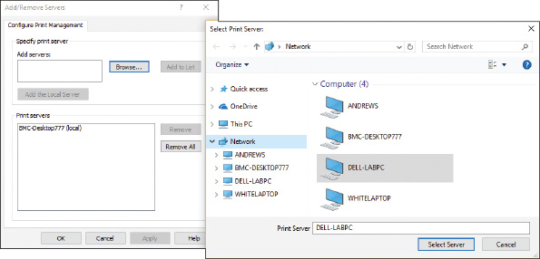
- The computer is now listed as a print server in the left pane of the Print Management window. Notice in Figure 14-60 that you can view a computer on the network that has its printer offline. Right-click this printer to see a menu with options that you can use to manage the printer and its printer queue.
Figure 14-60
Manage print servers, printers, and printer queues on the network
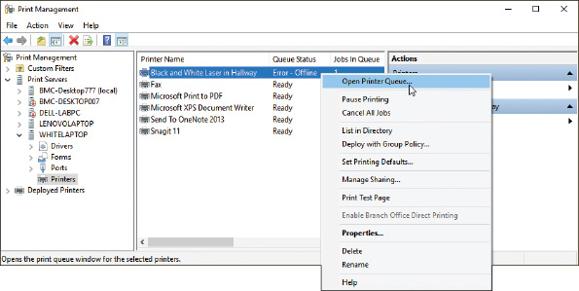
Notes
If printers you know to be installed on a remote computer don’t show up in the console, the problem might be that DNS on the network cannot find the remote computer. For Windows domains, configure DNS for forward lookups by adding a DNS ‘A’ record for the client computer that is running Print Management. For peer-to-peer networks, try adding the remote computer and its IP address to the hosts file of the client that is running Print Management. For this last method to permanently work, the remote computer must have a static IP address. You learned to use the hosts file in Chapter 7. Configuring DNS is beyond the scope of this text.
Go to pg.
help
Application Opened
Main content

14-6cLimited Connectivity
A+ Core 2
- 3.1
Given a scenario, troubleshoot Microsoft Windows OS problems.
IT technicians are often asked to help when the local network has no connectivity or limited connectivity. Here is a brief list of what to do to solve these types of problems:
- Verify that the network cable between the computer and the router or wall jack is not damaged and is securely connected at both ends.
- For SOHO routers, connect the cable to a different port on the router. You know you have connectivity when the port LED lights are blinking. If the power LED light on the router is blinking, the problem is with the router and the router firmware might be corrupted. If LED lights don’t indicate connectivity, consider the problem is hardware-related. You might need to replace the network adapter.
- Go to Device Manager on the computer and disable then enable the network adapter. Update the device drivers.
- As you learned to do in Chapter 7, go to the TCP/IP Properties box and verify the TCP/IP configuration for the connection. Most likely the correct option is Obtain an IP address automatically. Verify that the computer is getting a unique IP address from the router. When two computers on the network have the same IP address, connectivity errors occur. Have two computers been assigned the same static IP address? An administrator needs to check all static IP address assignments for duplicated addresses.
- Update the network settings. Try using the following two commands to release and renew the DHCP assignments for the IP address, subnet mask, default gateway, and DNS server addresses:

- Try resetting the modem and router. Turn off both devices. Then turn on the modem and wait for the lights to settle. Finally, turn on the router and wait for its lights to settle.
- The computer might have malware. Try running anti-malware software and updating Windows.
- For wireless connections, check these things:
  - For a laptop, is the wireless switch turned on?
  - Disconnect and reconnect to the wireless network. Try removing or forgetting the wireless network profile and start fresh by entering the wireless security key.
  - For MAC address filtering, is the computer’s MAC address allowed on the network?
  - Is the wireless device too far from the wireless access point so that the signal is too weak? Try moving the device closer.
- For Internet connectivity, do the following:
  - To eliminate DNS as the problem, try this command:
  - If you are unable to access a particular computer on the Internet, try using the tracert command. For example:
  - If you can access resources on the local network but don’t have Internet connectivity, contact your ISP and ask them to reset the connection at their end.
For more information about troubleshooting network connectivity problems, see Chapters 7 and 8.
Go to pg.
help
Application Opened
Main content

Chapter Review

14-7aChapter Summary

Concepts and Windows Tools for Solving Problems with Windows, Applications, and Hardware
- The Windows OS is made up of two main components: the shell and the kernel. The shell provides an interface for users and applications. The kernel is responsible for interacting with hardware.
- A process is a program running under the shell, together with all the resources assigned to it. A thread is a single task that a process requests from the kernel.
- Windows tools that conveniently access and manage other Windows tools are Control Panel, Administrative Tools, Computer Management, and Microsoft Management Console (MMC).
- Tools to observe, track, and log Windows, user, network, application, and hardware activities are Event Viewer, Performance Monitor, Reliability Monitor, and Resource Monitor.
- Tools for solving Windows, application, networking, and Windows user problems are Task Manager, System Configuration, the Services console, the Troubleshooting applet, Group Policy, Local Group Policy, and the Registry Editor.
- Other tools for solving Windows problems are System File Checker, DISM, Windows Updates, a clean boot, Safe Mode (Safe boot), and System Restore.
- Tools for solving application errors and crashes are Programs and Features, tasklist, taskkill, Component Services, secondary logons, Compatibility mode, digital signatures, Data Sources, and Task Scheduler.
- Tools for solving problems with hardware are Device Manager, Print Management, the Display applet, DxDiag, Memory Diagnostics, chkdsk, and Disk Defragmenter.

Best Practices to Troubleshoot Windows-Related Problems
- General steps to solve Windows-related problems are to (1) interview the user and back up data, (2) get help from error messages, the web, coworkers, and event logs, (3) consider that the data or the application might be corrupted, (4) consider outside interference such as malware, faulty memory, a corrupted hard drive, low system resources, and incompatible applications or third-party services, and (5) consider that Windows might be corrupted.

Slow Startup and Slow Performance
- General steps to solve problems with slow performance or slow startup are to (1) get a benchmark by using a stopwatch or watch to time startup to the point the Windows desktop loads and observe any errors that appear in the startup process, (2) back up user data, (3) perform routine maintenance, (4) investigate and eliminate unwanted startup programs, (5) eliminate unwanted scheduled tasks, and (6) check for low system resources.

Application Errors and Crashes
- The commands taskkill and tasklist can be used to forcefully end an application that is hung.
- Task Manager can change the priority level to improve performance of an application.
- The Services console is used to change the way a background service is started.
- In Explorer, use the shortcut menu for a data file to create a file association so that Windows knows which application is associated with the given data file. This solves the problem of a file that fails to open.
- Use Component Services to solve the problem that causes an error message to appear for an unregistered component or missing DLL. The tool creates the association between the DLL or component and its application in the Windows registry.
- When an application has never worked, update Windows, search the web for help, try running the application in compatibility mode or as an administrator using a secondary logon, and verify that the application is legitimate with a digital signature.
- To solve a problem when connecting a local database application to a database source online, use ODBC Data Sources to connect the application with the database server.

An Application Fails to Uninstall
- When an application fails to uninstall, you might need to manually edit the Windows registry using the Registry Editor.
- Always back up registry keys before editing them.
- To manually remove software, (1) try the uninstall routine, (2) delete program files, (3) delete registry entries, (4) remove program shortcuts, and (5) remove startup processes.

Troubleshooting Hardware Problems in Windows
- Use Display settings to adjust the resolution, refresh rate, multiple monitor orientation, and color depth for monitors.
- Use the dxdiag command to determine which version of DirectX is installed. DirectX is Microsoft software that works with graphics software and graphics adapter video drivers.
- Print Management makes it easy to manage network printers and their connections with workstations on the network.
- Limited network connectivity problems can be solved by verifying network cable connections, network port activity, NIC device drivers, TCP/IP configuration (network settings), cable or DSL modem connectivity to the ISP, wireless connectivity and access, and DNS name resolution.
Go to pg.
help
Application Opened
Main content

Chapter Review

14-7bKey Terms
For explanations of key terms, see the Glossary for this text.
- Administrative Tools
- Aero interface
- chkdsk
- clean boot
- color depth
- compatibility mode
- Component Services (COM+)
- Computer Management
- console
- data source
- Data Sources
- default program
- digital signature
- DirectX
- DISM (Deployment Image Servicing and Management)
- DxDiag (DirectX Diagnostic Tool)
- dxdiag.exe
- Event Viewer
- executive services
- file association
- Group Policy
- HAL (hardware abstraction layer)
- HKEY_CLASSES_ROOT (HKCR)
- HKEY_CURRENT_CONFIG (HKCC)
- HKEY_CURRENT_USER (HKCU)
- HKEY_LOCAL_MACHINE (HKLM)
- HKEY_USERS (HKU)
- initialization files
- kernel
- kernel mode
- Local Group Policy
- Memory Diagnostics
- Microsoft Management Console (MMC)
- multiple monitor misalignment
- multiple monitor orientation
- native resolution
- Open Database Connectivity (ODBC)
- pagefile.sys
- Performance Monitor
- Print Management
- process
- Programs and Features
- refresh rate
- registry
- Registry Editor
- reliability history
- Reliability Monitor
- resolution
- Resource Monitor
- Safe Mode
- secondary logon
- Services console
- shell
- snap-in
- System Configuration
- System File Checker (SFC)
- System Restore
- taskkill
- tasklist
- Task Manager
- Task Scheduler
- thread
- Troubleshooting applet
- user mode
- user profile
- user profile namespace
- virtual memory
Go to pg.
help

Main content

