Application Opened
Main content
Chapter
15

Troubleshooting Windows Startup
- Chapter Introduction
- 15-1Understanding the Boot Process
  - 15-1aDifferent Ways to Boot
  - 15-1bSteps to Boot the Computer and Start Windows
- 15-2What to Do Before a Problem Occurs
  - 15-2aWindows 10/7 System Repair Disc
  - 15-2bWindows 10/8 Recovery Drive
  - 15-2cWindows 10 Media Creation Tool
- 15-3Tools for Least Invasive Solutions
  - 15-3aStartup Repair
  - 15-3bChanging Startup Settings
  - 15-3cSystem Restore
  - 15-3dThe Command Prompt Window in Windows RE
- 15-4Options to Reinstall Windows
  - 15-4aWindows 10 Previous Version
  - 15-4bWindows 10 Repair Upgrade
  - 15-4cWindows 10 Fresh Start
  - 15-4dWindows 10 Reset
  - 15-4eApplying a Windows 10/7 System Image
  - 15-4fOEM Factory Recovery Partition
  - 15-4gInstalling Windows Over the Network
- 15-5Troubleshooting Specific Windows Startup Problems
  - 15-5aImportant Data on the Hard Drive
  - 15-5bError Messages and Problems
- 15-6Chapter Review
  - 15-6aChapter Summary
  - 15-6bKey Terms
  - 15-6cThinking Critically
  - 15-6dHands-On Projects
  - 15-6eReal Problems, Real Solutions
  - 15-6fExam Tips
Go to pg.
help
Application Opened
Main content

Chapter Introduction
After completing this chapter, you will be able to:
- Describe the boot process from the time you press the power button until the Windows desktop or Start screen loads
- Create bootable media and backups to prepare for Windows startup problems
- Implement appropriate Windows tools to solve Windows startup problems
- Implement appropriate Windows tools to reimage or reload Windows
- Troubleshoot Windows startup problems
You’ve already learned how to deal with application and hardware problems, and Windows problems after the OS has started. In this chapter, you take your troubleshooting skills one step further by learning to deal with startup problems caused by Windows. When Windows fails to start, it can be stressful if important data has not been backed up or the user has pressing work to do with the computer. What helps more than anything else is to have a good understanding of Windows startup and a good plan for approaching startup problems.
We begin the chapter with a discussion of what happens when you first turn on a computer and Windows starts. The more you understand about startup, the better your chances of fixing startup problems. Then you learn about Windows tools specifically designed to handle startup problems. Finally, you learn about strategies for solving startup problems.
Go to pg.
help
Application Opened
Main content

15-1Understanding the Boot Process
A+ Core 2
- 3.1
Given a scenario, troubleshoot Microsoft Windows OS problems.
Knowledge is power. The better you understand what happens when you first turn on a computer until Windows is loaded and the Windows desktop or Start screen appears, the more likely you will be able to solve a problem when Windows cannot start. Let’s begin by noting the differences between a hard boot and a soft boot.
Notes
Most techies use the terms boot and startup interchangeably. However, in general, the term boot refers to the hardware phase of starting up a computer. Microsoft consistently uses the term startup to refer to how its operating systems are booted—I mean, started.
Go to pg.
help
Application Opened
Main content

15-1aDifferent Ways to Boot
A+ Core 2
- 3.1
Given a scenario, troubleshoot Microsoft Windows OS problems.
The term booting comes from the phrase “lifting yourself up by your bootstraps” and refers to the computer bringing itself up to a working state without the user having to do anything but press the On button. Two fundamental ways to boot a computer are:
- A hard boot, or cold boot, involves turning on the power with the on/off switch.
- A soft boot, or warm boot, involves using the operating system to reboot. In Windows, a soft boot is called a restart.
A hard boot takes more time than a soft boot because a hard boot requires the initial steps performed by BIOS/UEFI. Most desktop cases have three power buttons, which for one system are shown in Figure 15-1.
Figure 15-1
This computer case has two power buttons on the front and one power switch on the rear
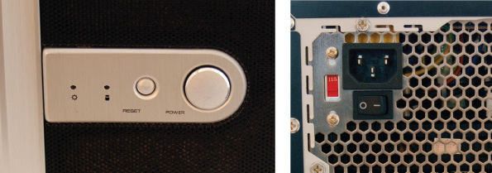
Here’s how the buttons work:
- The power button in front can be configured as a “soft” power button, causing a Windows restart.
- The reset button initializes the CPU so that it restarts at the beginning of the BIOS/UEFI startup program. The computer behaves as though the power were turned off and back on and then goes through the entire boot process.
- The switch on the rear of the case simply turns off the power abruptly and is a “hard” power button. If you use this switch, wait 30 seconds before you press the power button on the front of the case to boot the system. This method gives you the greatest assurance that memory will clear. However, if Windows is abruptly stopped, it might give an error message when you reboot.
How the front two buttons work can be controlled in BIOS/UEFI setup. Know, however, that different cases offer different options.
When Windows hangs, first try a restart. If that doesn’t work, try a shutdown and then power the system back up. Windows shutdown closes all open applications, user sessions, services, devices, and system processes and then powers down the computer. If a shutdown does not work, press the reset button on the front of the case. If that doesn’t work, turn off the power switch on the rear of the case, wait 30 seconds, turn it back on, and then press the power button on the front of the case.
Go to pg.
help

Application Opened
Main content

15-1bSteps to Boot the Computer and Start Windows
A+ Core 2
- 3.1
Given a scenario, troubleshoot Microsoft Windows OS problems.
Recall that BIOS/UEFI is responsible for getting a system up and going and finding an OS to load. Table 15-1 lists the components and files stored on the hard drive that are necessary to start Windows. The table can serve as a guide as you study the steps to see what happens from the time power is turned on until Windows is started. In these steps, we assume the OS is loaded from the hard drive.
Table 15-1

Software Components and Files Needed to Start Windows
Component or File | Partition and Path | Description
BIOS systems using MBR partitioning
MBR | The first sector of the hard drive is called the Master Boot Record (MBR) | BIOS looks to the partition table in the MBR to locate the active partition.
System partition | Also called the active partition or System Reserved partition | The system partition holds the Boot Manager, Boot Configuration Data (BCD) store, and other files and folders needed to begin Windows startup. For Windows, these files are stored in the root and \Boot directory of the hidden system partition.
Boot Manager | In the root of the system partition | Windows Boot Manager, bootmgr (with no file extension), accesses the BCD store and locates the Windows Boot Loader.
BCD store | \Boot directory on the system partition | The Boot Configuration Data (BCD) store is a database file named BCD (no file extension) and is organized the same as a registry hive. It contains boot settings that control the Boot Manager and can be viewed and edited with the bcdedit command.
UEFI systems using GPT partitioning
GPT partition table | At the beginning of the hard drive and a backup copy at the end of the drive | UEFI looks to the GPT partition table to locate the EFI System Partition.
System partition | The EFI System Partition (ESP) is normally 100 MB to 200 MB in size. | The system partition holds the Windows Boot Manager, BCD, and other supporting files. For Windows, the Boot Manager is bootmgfw.efi and is stored in \EFI\Microsoft\Boot. A backup copy of bootmgfw.efi is at \EFI\Boot\bootx64.efi.
Boot Manager | For Windows, \EFI\Microsoft\Boot on the ESP | Bootmgfw.efi loads EFI applications based on variables stored in onboard RAM and reads the BCD store to find out other boot parameters (such as a dual boot).
BCD store | \EFI\Microsoft\Boot on the ESP | Entries in the BCD store point the Windows Boot Manager to the location of the Windows Boot Loader program.
All Windows BIOS and UEFI systems
Windows Boot Loader | C:\Windows\System32 | Windows Boot Manager turns control over to the Windows Boot Loader, which loads and starts essential Windows processes. Two versions of the program file are:  winload.exe (BIOS)  winload.efi (UEFI)
Resume from hibernation | C:\Windows\System32 | This Windows Boot Loader is used when Windows resumes from hibernation:  winresume.exe (BIOS)  winresume.efi (UEFI)
Ntoskrnl.exe | C:\Windows\System32 | Windows kernel
Hal.dll | C:\Windows\System32 | Dynamic Link Library handles low-level hardware details
Smss.exe | C:\Windows\System32 | Sessions Manager program responsible for starting user sessions
Csrss.exe | C:\Windows\System32 | Win32 subsystem manages graphical components and threads
Winlogon.exe | C:\Windows\System32 | Logon process
Services.exe | C:\Windows\System32 | Service Control Manager starts and stops services
Lsass.exe | C:\Windows\System32 | Authenticates users
System registry hive | C:\Windows\System32\Config | Holds data for the HKEY_LOCAL_MACHINE key of the registry
Device drivers | C:\Windows\System32\Drivers | Drivers for required hardware
A successful boot depends on essential hardware devices, BIOS/UEFI, and the operating system all performing without errors. Let’s look at the steps to start a Windows computer. Several of these steps are diagrammed in Figures 15-2 and 15-3 to help you visually understand how the steps work.
Figure 15-2
Steps to booting the computer and loading Windows
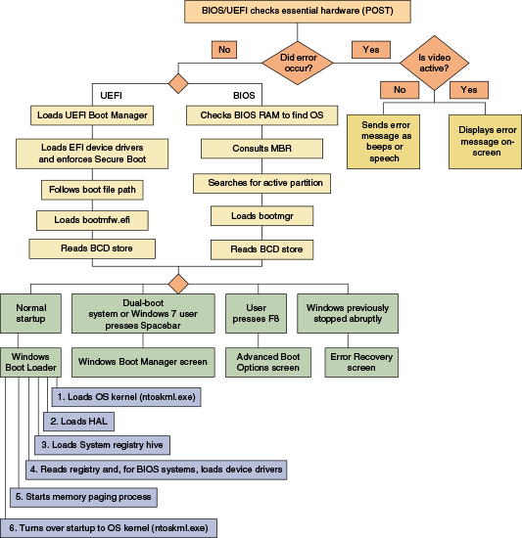
Figure 15-3
Steps to complete loading Windows
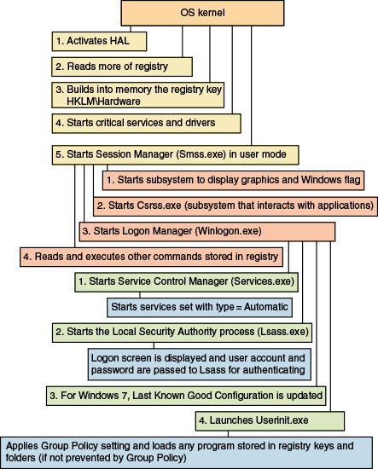
Study these steps carefully because the better you understand startup, the more likely you’ll be able to solve startup problems:
- Startup BIOS/UEFI is responsible for the early steps in the boot process. Onboard RAM accessible to BIOS/UEFI holds an inventory of hardware devices, hardware settings, security passwords, date and time, and startup settings. Startup BIOS/UEFI reads this information and then surveys the hardware devices it finds present, comparing it with the list kept in its RAM.
Notes
Onboard RAM, also called onboard memory, nonvolatile RAM, or NVRAM, is used by BIOS/UEFI to hold configuration data and keeps its data even when power is turned off. Onboard RAM is different from system memory or RAM, which holds programs and data only while the system is turned on.
- Startup BIOS/UEFI runs POST (power-on self test), which is a series of tests to find out if the firmware can communicate correctly with essential hardware components required for a successful boot. Any errors are indicated as a series of beeps, recorded speech, or error messages on the screen (after video is checked). If the key is pressed to request BIOS/UEFI setup, the BIOS/UEFI setup program runs.
- Based on information kept in onboard RAM, startup UEFI loads the UEFI boot manager and device drivers. BIOS/UEFI then turns to the hard drive or other boot device to locate and launch the Windows Boot Manager. If BIOS/UEFI cannot find a Windows Boot Manager or cannot turn over operation to it, one of these error messages appears:
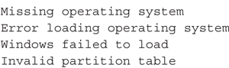
- The Windows Boot Manager does the following:
  - It reads the settings in the BCD.
  - The next step depends on entries in the BCD and these other factors:
    - Option 1. For normal startups that are not dual booting, no menu appears and Boot Manager finds and launches the Windows Boot Loader program.
    - Option 2. If the computer is set up for a dual-boot environment, Boot Manager displays the Choose an operating system screen, as shown in Figure 15-4.
    - Option 3. If Windows was previously stopped abruptly or another error occurs, the Windows Startup Menu appears (see Figure 15-5) to give you the option to troubleshoot the problem.
Figure 15-4
In a dual-boot setup, Windows Boot Manager provides a choice of operating systems
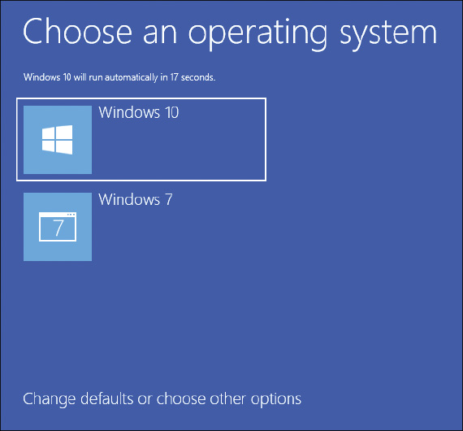
Figure 15-5
The Windows Startup Menu offers the opportunity to troubleshoot a problem with startup
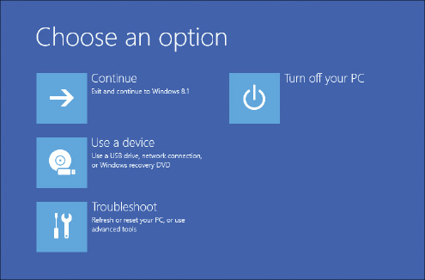
- Windows Boot Loader (winload.exe or winload.efi) is responsible for loading Windows components. It does the following:
  - For normal startups, Boot Loader loads into system memory the OS kernel, Ntoskrnl.exe, but does not yet start it. Boot Loader also loads into memory the hardware abstraction layer (Hal.dll), which will later be used by the kernel.
  - Boot Loader loads into memory the system registry hive (C:\Windows\System32\Config\System).
  - Boot Loader then reads the registry key just created, HKEY_LOCAL_ MACHINE\SYSTEM\Services, looking for and loading into memory the device drivers that must be launched at startup. The drivers are not yet started.
  - Boot Loader starts up the memory paging process and then turns over startup to the OS kernel (Ntoskrnl.exe).
- The kernel (Ntoskrnl.exe) does the following:
  - It activates the HAL, reads more information from the registry, and builds into memory the registry key HKEY_LOCAL_ MACHINE\HARDWARE, using information that has been collected about the hardware.
  - The kernel then starts critical services and drivers that are configured to be started by the kernel during the boot. Recall that drivers interact directly with hardware and run in kernel mode, while services interact with drivers. Most services and drivers are stored in C:\Windows\System32 or C:\Windows\System32\Drivers and have an .exe, .dll, or .sys file extension.
  - After the kernel starts all services and drivers configured to load during the boot, it starts the Session Manager (Smss.exe), which runs in user mode.
- The Session Manager (Smss.exe) loads the graphical interface and starts the client/server run-time subsystem (csrss.exe), which also runs in user mode. Csrss.exe is the Win32 subsystem component that interacts with applications.
- Smss.exe starts the Logon Manager (winlogon.exe) and reads and executes other commands stored in the registry, such as a command to replace system files placed there by Windows Update.
- Winlogon.exe does the following:
  - It starts the Service Control Manager (services.exe). Services.exe starts all services listed with the startup type of Automatic in the Services console.
  - Winlogon.exe starts the Local Security Authority process (lsass.exe). The sign-in screen appears (see Figure 15-6), and the user account and password are passed to the lsass.exe process for authenticating.
  - Winlogon.exe launches userinit.exe. For Windows 10/7, the desktop is launched. For Windows 8, the Start screen is launched.
Figure 15-6
The Windows sign-in screen
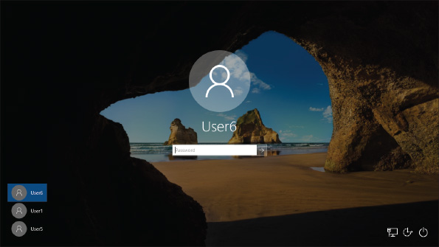
- Userinit.exe applies Group Policy settings and any programs not trumped by Group Policy that are stored in startup folders and startup registry keys. See Appendix B for a list of these folders and registry keys.
The Windows startup is officially completed when the Windows desktop or Start screen appears and the pinwheel wait icon disappears.
OS Differences
For Windows 7, if the OS encounters an error during startup, the Windows 7 Error Recovery screen appears (see Figure 15-7). Also, Windows 7 can be controlled by keystrokes entered during startup: If the user presses the Spacebar near the beginning of startup, the Windows 7 Boot Manager screen appears, which allows the user to run Windows Memory Diagnostics. If the user presses F8 at startup, the Windows 7 Advanced Boot Options screen appears (see Figure 15-8).
Figure 15-7
The Windows Error Recovery screen appears if Windows 7 has been abruptly stopped
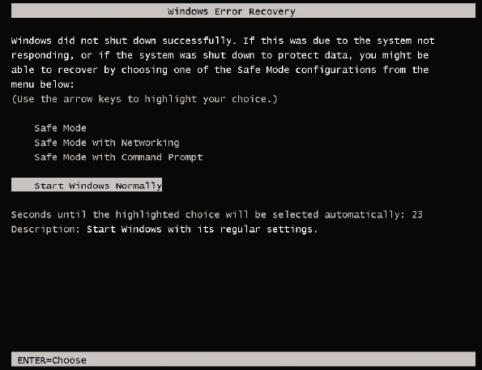
Figure 15-8
Press F8 during the boot to launch the Windows 7 Advanced Boot Options menu
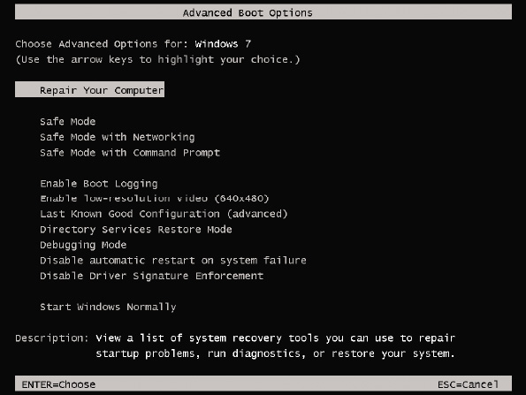
With this basic knowledge of the boot in hand, let’s turn our attention to what you can do to prepare for problems when Windows refuses to load.
Go to pg.
help

Application Opened
Main content

15-2What to Do Before a Problem Occurs
A+ Core 2
- 3.1
Given a scenario, troubleshoot Microsoft Windows OS problems.
When troubleshooting startup, it helps to have a road map, which is the purpose of the diagram in Figure 15-9. It can help you organize in your mind the various ways to boot the system and the menus and procedures available to you depending on how the boot happens.
Figure 15-9
Methods to boot the system, menus that appear, and tools available on menus used to troubleshoot startup problems
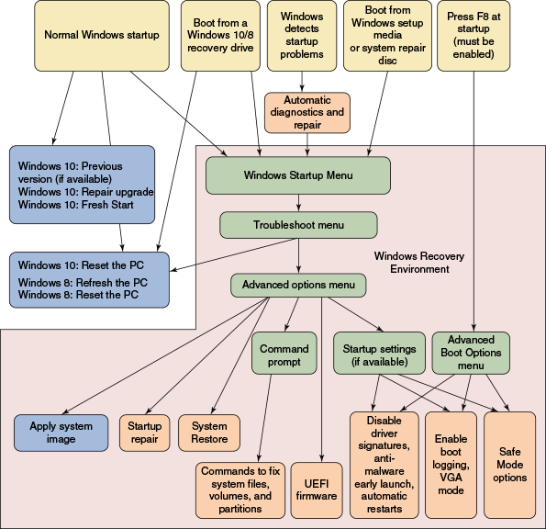
As you learn to use each tool, keep in mind that you want to use the tool that makes as few changes to the system as possible to fix the problem. Good preparation will make troubleshooting startup problems much simpler and more successful. When you are responsible for a computer and while the computer is still healthy, be sure to complete the following tasks:
- Keep good backups. Chapter 13 covers methods to back up data, applications, and user settings.
- Create a system image. Recall that a Windows 10/7 system image or a Windows 8 custom refresh image should be created right after you’ve installed Windows, hardware, applications, and user accounts, and customized Windows settings. The image can be updated periodically. You learned to create a Windows 10/7 system image and Windows 8 custom refresh image in Chapter 13.
- Configure Windows 10/8 to use the F8 key at startup. The F8 key gives you access to the Advanced Boot Options menu in Windows, which you’ll learn about later in this chapter. Windows 10/8 has the feature disabled by default, and Windows 7 has it enabled. To enable the F8 key at startup, open an elevated command prompt window and enter this command:
Figure 15-10 shows the Advanced Boot Options screen that appears when you press F8 during Windows 10 startup.
Figure 15-10
Use the Advanced Boot Options menu to troubleshoot difficult startup problems
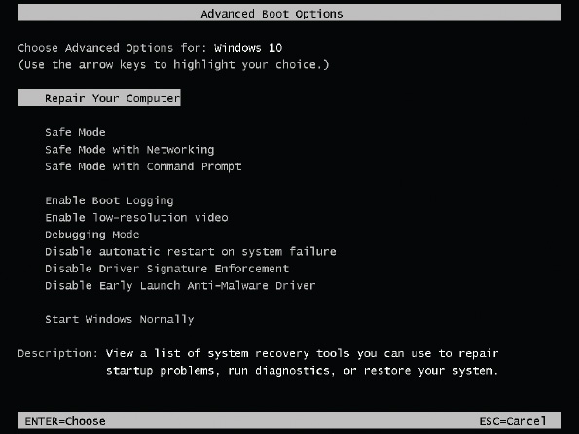
Later, if you want to disable the use of F8 at startup, open an elevated command prompt window and enter this command:
Caution
As you learn to troubleshoot Windows 10/8 startup, don’t depend on the F8 key to work during the boot because you never know when you’ll work on a computer that has it disabled. All the tools available on the Advanced Boot Options screen are also available on the Startup Settings screen, which you can access without using F8. You learn about the Startup Settings screen later in this chapter.
- Create recovery boot media. If Windows can’t boot from the hard drive, you may be able to repair the Windows installation using tools available in the Windows Recovery Environment (Windows RE). Windows RE is normally stored on a hidden partition on the hard drive and is a lean operating system that can be launched to solve Windows startup problems. It provides both a graphical and command-line interface. Figure 15-9 shows Windows RE as a pink background. Menus in Windows RE are in green, tools are in blue and purple, and ways to launch Windows RE are in yellow boxes. Notice in the figure you can launch Windows RE after a normal Windows startup. However, if Windows won’t start, you’ll need other recovery boot media to launch it. Although it’s possible to use recovery media created on a different computer than the one you are troubleshooting, the process is simplified if you already have these tools on hand. Figure 15-9 shows the three types of recovery boot media:
  - Windows 10/7 DVD system repair disc
  - Windows 10/8 USB recovery drive
  - Windows 10 setup media created by the Media Creation Tool
The key to using a system repair disc or recovery drive is to create the disc or drive before it is needed. Let’s look at each of the three recovery boot media.
Notes
All boot media are bit-specific. Use 32-bit media to repair a 32-bit Windows installation and 64-bit media to repair a 64-bit installation. Also, use Windows 10 recovery boot media to repair Windows 10 systems. Use Windows 8 recovery boot media for Windows 8 installations, and Windows 7 recovery boot media to repair Windows 7 installations.
Go to pg.
help
Application Opened
Main content

15-2aWindows 10/7 System Repair Disc
A+ Core 2
- 3.1
Given a scenario, troubleshoot Microsoft Windows OS problems.
A system repair disc is a bootable DVD with Windows repair tools that can start the system and fix problems. Using the DVD requires an optical drive. For Windows 10/7, open Control Panel and go to the Backup and Restore (Windows 7) window (see Figure 15-11). Click Create a system repair disc. A 32-bit Windows installation will create a 32-bit version of the repair disc, and a 64-bit Windows installation will create a 64-bit version of the repair disc. Windows 8 has the option to create a system repair disc, but it is hidden. To use a system repair disc, boot the system from the disc and select your keyboard layout. Then Windows RE is launched.
Figure 15-11
Create a system image or a system repair disc from Control Panel
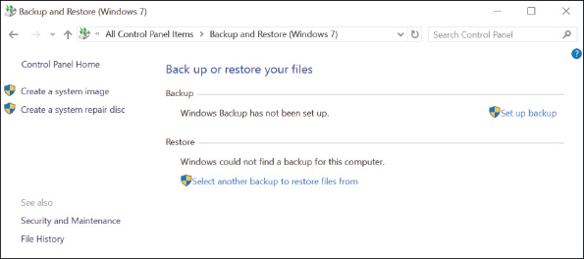
Go to pg.
help
Application Opened
Main content

15-2bWindows 10/8 Recovery Drive
A+ Core 2
- 3.1
Given a scenario, troubleshoot Microsoft Windows OS problems.
Suppose the hard drive in a laptop completely fails. You can purchase a new hard drive for the system, but a problem might arise when you install Windows on the new drive. Most laptops, all-in-one, and other brand-name computers include an OEM recovery partition on the hard drive that contains the drivers specific for the computer. Before a problem occurs, you can back up this OEM recovery partition to a Windows recovery drive. A recovery drive is a bootable USB flash drive that can access Windows 10/8 repair tools; in addition to holding an OEM recovery partition, it is handy when you need to repair a computer that doesn’t have an optical drive.
Notes
A recovery drive is bit-specific: Use a 32-bit recovery drive to repair a 32-bit Windows installation and a 64-bit recovery drive to repair a 64-bit installation.
If you include the system files on the recovery drive, you have the option of reinstalling Windows from the recovery drive. As you can see in Figure 15-9, a recovery drive can be used to perform a Windows 10 reset or a Windows 8 refresh or reset. You learn to use these tools later in the chapter. You can use a recovery drive to repair a computer other than the one on which it was created. However, system files included on a recovery drive may not be compatible with all computers.
Do the following to create a recovery drive:
- Open Control Panel in Classic view and click Recovery. Click Create a recovery drive, and respond to the UAC dialog box.
- Choose whether to include system files (see Figure 15-12), which will copy the OEM recovery partition to the recovery drive. If the computer doesn’t have an OEM recovery partition, the check box on this dialog box is gray and not available. Click Next to continue.
Figure 15-12
Back up system files to the recovery drive so you can reinstall Windows later
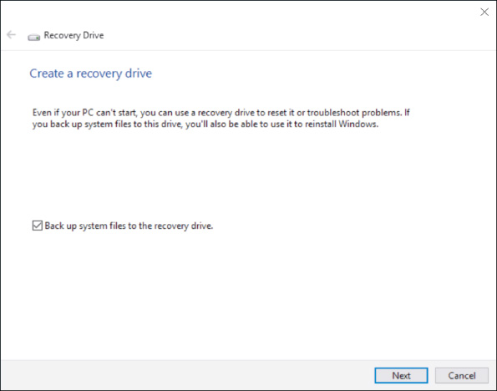
- Windows reports the size of the USB flash drive needed (see Figure 15-13.) Plug in a USB flash drive that is large enough. Know that the entire USB flash drive will be formatted and everything on the drive will be lost.
Figure 15-13
Windows reports the size of the USB flash drive needed to hold the recovery drive
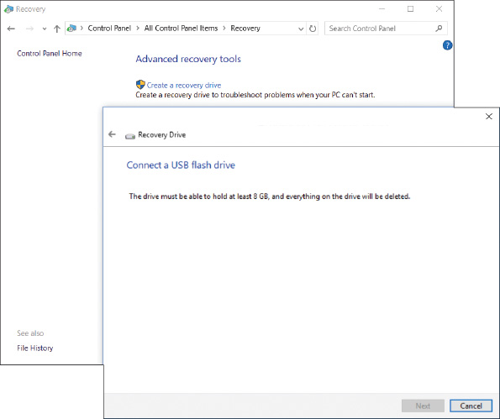
- Windows inspects the size of the drive; if it is large enough, you see it listed among available devices. Be careful to select the USB flash drive because everything on the drive will be lost. Click Next. Click Create to begin the process. It will take a while to complete. Then click Finish.
Be sure to label the flash drive well and put it in a safe place. For example, you can put it in an envelope, label it “Recovery drive for John Hawkins 64-bit Windows 10 Sony laptop,” and store it in the computer’s documentation file.
Notes
If you copied the OEM recovery partition to the USB flash drive and are short on hard drive space on the computer, you can use Disk Management to delete the recovery partition and free up some space, and then expand the Windows volume.
Go to pg.
help
Application Opened
Main content

15-2cWindows 10 Media Creation Tool
A+ Core 2
- 3.1
Given a scenario, troubleshoot Microsoft Windows OS problems.
You can launch Windows RE from a Windows setup DVD or flash drive. For Windows 10, recall you can use the Media Creation Tool on a working computer to create a bootable Windows setup ISO file, DVD, or flash drive. You learned how to use the Media Creation Tool in Chapter 12.
Go to pg.
help
Application Opened
Main content

15-3Tools for Least Invasive Solutions
A+ Core 2
- 3.1
Given a scenario, troubleshoot Microsoft Windows OS problems.
Looking back at the diagram in Figure 15-9, tools to diagnose and repair Windows are shown in purple boxes. In this part of the chapter, we discuss several tools that are easy to use and don’t make major changes to Windows system files or user settings, including several options on the Windows advanced startup screens.
If Windows works well enough to get to the Windows desktop, you can use one of the following methods to launch Windows RE:
- Windows 10 Settings app. Open the Settings app and click Update & security. In the left pane, click Recovery. Under Advanced startup, click Restart now. See Figure 15-14.
Figure 14
The Windows 10 Recovery page in the Settings app
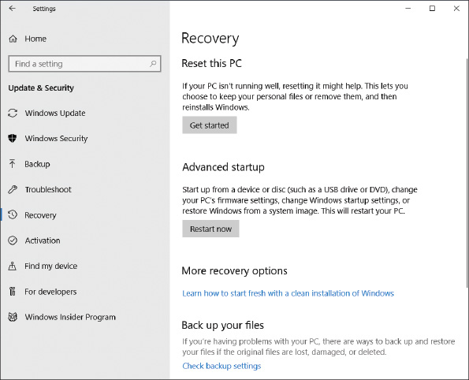
Notes
The Advanced startup option is not available on the Recovery window when you are using a remote connection to the computer or Windows 10 is installed in a VM.
OS Differences
For Windows 8, you can launch Windows RE after a normal startup by opening the charms bar and clicking Settings. In the Settings pane, click Change PC settings. In the left pane of the PC settings window, click Update and recovery. In the Update and recovery pane, click Recovery and click Restart now (see Figure 15-15).
For Windows 7, press F8 at startup and click Repair Your Computer on the Advanced Boot Options screen (refer back to Figure 15-10).
Figure 15-15
Refresh or reset a Windows 8 computer or restart the computer in advanced startup mode
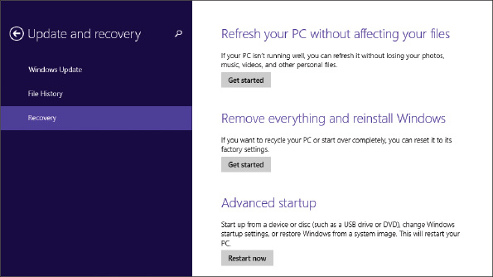
- Shift + Restart. From the Windows 10/8 Start menu, click the Power icon. Press and hold the Shift key and click Restart.
- Command prompt. In a Windows 10/8/7 command prompt window, enter shutdown /r /o. The /r parameter instructs the computer to restart, and the /o parameter opens Windows RE after the restart.
Notes
You can also use the shutdown command to remotely shut down computers over the network.
Here are the methods to launch Windows RE when Windows cannot start normally:
- Windows detects startup problems and launches automatic diagnostics and repairs. If you restart the computer several times within a few minutes or Windows detects errors during startup, it automatically launches diagnostics (see Figure 15-16) and takes you through steps to attempt to repair the system. The process, called Automatic Repair or Startup Repair, includes running both Check Disk and System File Checker.
Figure 15-16
Windows automatically launches diagnostic and repair procedures after several restarts within a few minutes
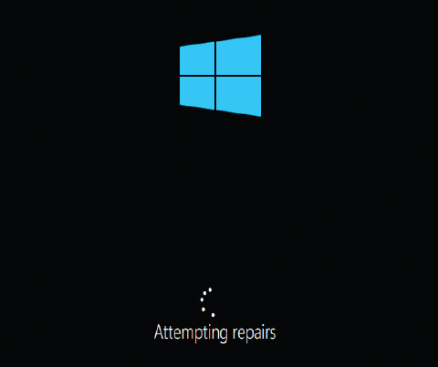
If Automatic Repair fails, you’re given the option to boot into Windows RE, where you have access to other troubleshooting tools. Also know that if you cannot launch Windows RE after a normal Windows startup, which can sometimes happen when working with a Windows 10 installation in a VM, you can restart Windows several times. Each time you see the Windows flag appear, turn off the computer. After two or three attempts to start Windows, it will launch Automatic Repair on the next startup, and then you can access Windows RE.
Notes
When you are trying to restart a computer while troubleshooting it yourself, you might find that Automatic Repair slows down or interferes with your efforts. In this case, you can disable Automatic Repair as follows: Open an elevated command prompt window, enter bcdedit /set recoveryenabled no, and then perform your own repair steps. You can reenable Automatic Repair later with the command bcdedit /set recoveryenabled yes.
- Boot from a USB recovery drive, DVD system repair disc, or Windows setup DVD or USB drive. These boot recovery media give you the option to launch Windows RE. You might have to adjust BIOS/UEFI settings to boot from these alternate media. To launch Windows RE from a Windows setup DVD or flash drive, click Repair your computer when you see the Windows Setup screen.
- Press F8 during startup. Earlier in the chapter, you learned how to configure Windows 10/8 to enable F8 at startup. If it is enabled, press F8 during startup to launch the Advanced Boot Options menu (refer back to Figure 15-10), which is part of Windows RE. You learn to use the tools on this menu later in the chapter.
Applying Concepts

Exploring Windows RE Menus and Options
A+ Core 2
- 3.1
Given a scenario, troubleshoot Microsoft Windows OS problems.
Let’s explore the menu screens in Windows RE, which are shown in green boxes in Figure 15-9. Follow these steps to explore Windows RE menus:
- Start Windows and use one of the methods listed earlier to launch Windows RE. The first screen you see after Windows RE launches is the Windows Startup Menu or the Choose an option screen (see Figure 15-17).
Figure 15-17
The Windows Startup Menu is the first screen you see after launching Windows RE
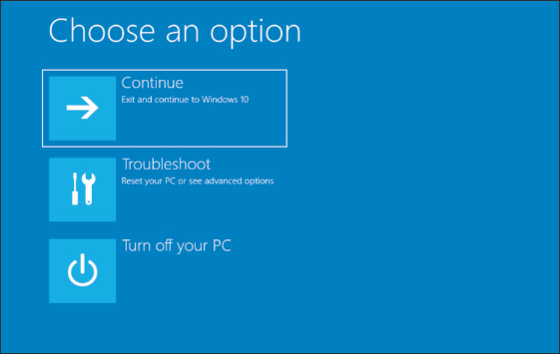
- Click Troubleshoot to see the Troubleshoot menu screen. Figure 15-18A shows the Windows 10 Troubleshoot screen, and Figure 15-18B shows the Windows 8 Troubleshoot screen.
Figure 15-18
(A) Windows 10 reset or (B) Windows 8 refresh and reset are available on the Troubleshoot screen
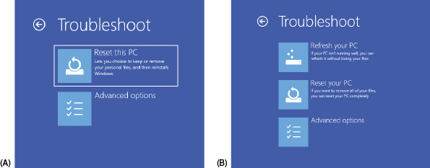
- Click Advanced options to see the Advanced options screen in Figure 15-19.
Figure 15-19
The option to go back to a previous version is available because this computer recently received a major Windows update
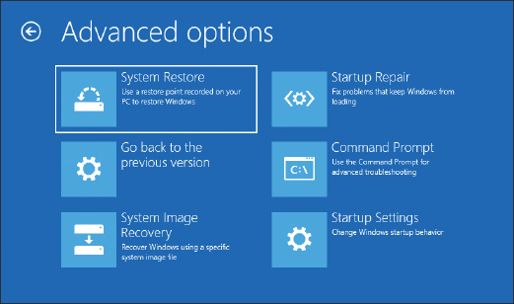
Notes
Depending on the situation, you might see a seventh option on the Advanced options screen, which is UEFI Firmware Settings. Use this option to change settings in a computer’s UEFI firmware.
- To get a command prompt, click Command Prompt. Here you can enter various commands to troubleshoot and solve problems. To exit the command prompt, enter the exit command. You are returned to the Advanced options screen.
- The Startup Settings option is available on the Advanced options screen shown in Figure 15-19 because Windows RE was launched after a normal Windows startup. Click Startup Settings to see the startup options shown in Figure 15-20.
Figure 15-20
The Startup Settings menu gives options for how Windows starts up
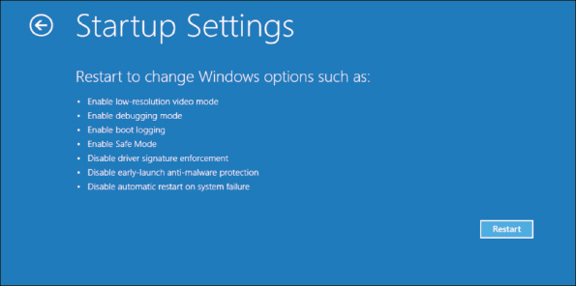
- Click Restart. After the restart, another Startup Settings screen appears (see Figure 15-21), which has more options than the first one. Press numbers or function keys F1 through F9 to launch the tools on this screen. The tools listed on this screen are the same as those listed on the Advanced Boot Options screen (refer back to Figure 15-10) that appears when you press F8 at startup.
Figure 15-21
Press a function key or number to restart the system in a given mode
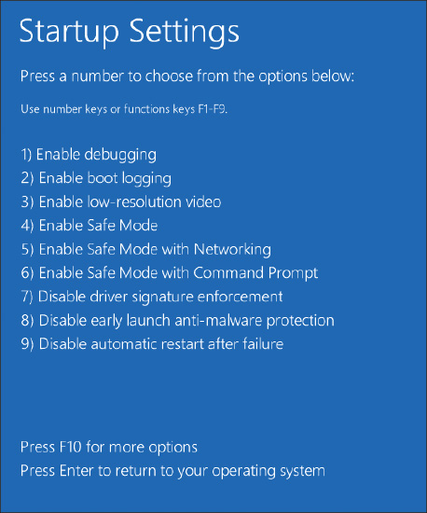
- To return to the Windows Startup Menu shown earlier in Figure 15-17, press F10. On the Choose an option screen, click Continue to reload Windows 10.
Next, we discuss some tools to repair Windows, including Startup Repair, Startup Settings, System Restore, and commands entered in a command prompt window.
Go to pg.
help
Application Opened
Main content

15-3aStartup Repair
A+ Core 2
- 3.1
Given a scenario, troubleshoot Microsoft Windows OS problems.
When addressing startup problems, the first tool to try is startup repair, which is a built-in diagnostic and repair tool. It can fix Windows system files without changing Windows settings, user data, or applications. You can’t cause additional problems with the tool and it’s easy to use.
To run startup repair in Windows RE, drill down to the Advanced options screen (refer back to Figure 15-19) and click Startup Repair. Windows RE examines the system, fixes problems, reports what it did, and might offer suggestions for further fixes. A log file of the process can be found at C:\Windows\System32\LogFiles\SRT\SRTTrail.txt.
OS Differences
For Windows 7, after you launch Windows RE, the Advanced Boot Options screen appears (refer back to Figure 15-8). Click Repair Your Computer and enter an administrator password. The System Recovery Options box appears (see Figure 15-22). Click Startup Repair to launch the startup repair process.
Figure 15-22
Recovery tools in Windows RE for a Windows 7 installation
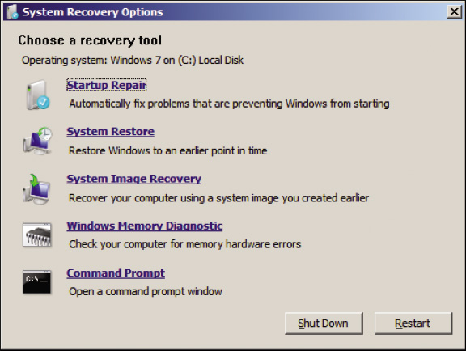
Go to pg.
help
Application Opened
Main content

15-3bChanging Startup Settings
A+ Core 2
- 3.1
Given a scenario, troubleshoot Microsoft Windows OS problems.
The Startup Settings option on the Advanced options screen shown in Figure 15-19 is available only when Windows RE is launched from the hard drive rather than other media. Following directions given earlier, launch Windows RE and drill down to the Startup Settings screen shown earlier in Figure 15-21. Here’s a quick rundown of what these tools can do.

Press 1 or F1: Enable Debugging
This tool moves system boot logs from the failing computer to another computer for evaluation. The computers must be connected by way of a serial port.

Press 2 or F2: Enable Boot Logging
Windows loads normally and all files used during the load process are recorded in a log file, C:\Windows\Ntbtlog.txt (see Figure 15-23). Use this option to see what did and did not load during the boot. For instance, if you have a problem getting a device to work, check Ntbtlog.txt to see what driver files loaded. Boot logging is much more effective if you have a copy of Ntbtlog.txt that was made when everything worked as it should. Then you can compare the good load with the bad load, looking for differences.
Figure 15-23
A sample C:\Windows\Ntbtlog.txt log file
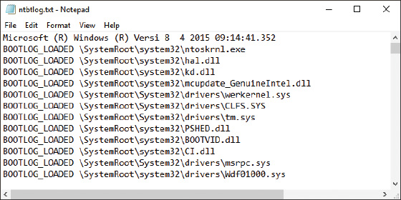
Notes
The Ntbtlog.txt file is also generated when you boot into Safe Mode.
Notes
If Windows hangs during the boot, try booting using the Enable Boot Logging option. Then look at the last entry in the Ntbtlog.txt file. This entry might be the name of a device driver causing the system to hang.

Press 3 or F3: Enable Low-Resolution Video (640 × 480)
Use this option when the video settings don’t allow you to see the screen well enough to fix a bad setting (for example, black fonts on a black background or a corrupted video driver). Booting in this mode gives you a very plain, standard video in VGA mode. You can then go to Display settings, correct the problem, and reboot normally. For problems with video drivers, open Device Manager and update, roll back, or uninstall and reinstall the video drivers.

Press 4 or F4: Enable Safe Mode
With this option, the Safe Mode desktop appears (see Figure 15-24) after the system restarts and you sign in to Windows. Launching Safe Mode and then restarting the system again can sometimes solve a startup problem. You can also go to the Windows desktop in Safe Mode and launch anti-malware software to scan the system for malware. You can open Event Viewer to find events that are helpful in troubleshooting the system, run the System File Checker command (sfc /scannow) to restore system files, use Device Manager to roll back a driver, use Memory Diagnostics (mdsched.exe) to verify memory, use the chkdsk /r command to check for file system errors, configure Windows for a clean boot on the next restart, and perform other troubleshooting tasks. Recall from Chapter 14 that you can also launch Safe Mode from the Boot tab on the System Configuration window, where Safe Mode is called Safe boot.
Figure 15-24
The Windows 10 Safe Mode desktop
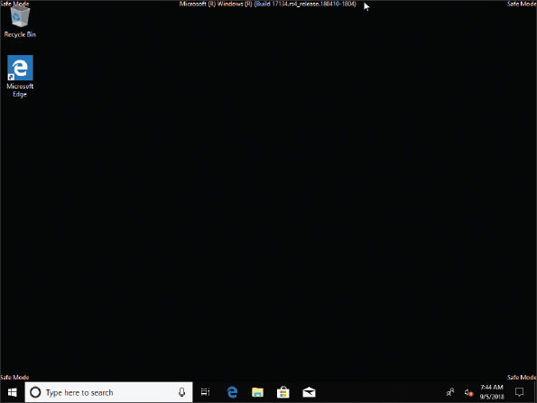
A+ Exam Tip
The A+ Core 2 exam gives you a scenario and expects you to know when and how to use Safe Mode to help resolve a Windows startup problem.

Press 5 or F5: Enable Safe Mode with Networking
Use this option when you need access to the network to solve the problem. For example, you might need to download updates to your anti-malware software. Also use this mode when the Windows installation files are available on the network, rather than Windows setup media, and you need to access those files.

Press 6 or F6: Enable Safe Mode with Command Prompt
If Safe Mode can’t start, try Safe Mode with Command Prompt, which doesn’t attempt to load the graphical interface. At the command prompt, use the sfc /scannow command to verify system files (see Figure 15-25). If the problem is still not solved, you can use the rstrui command to launch System Restore and then follow the on-screen directions to select a restore point. However, as Figure 15-26 shows, if restore points have not been previously made, System Restore cannot help. As you learn later in the chapter, you can also use this command prompt to restore a corrupted Windows registry from backups.
Figure 15-25
SFC finds and attempts to repair corrupted system files
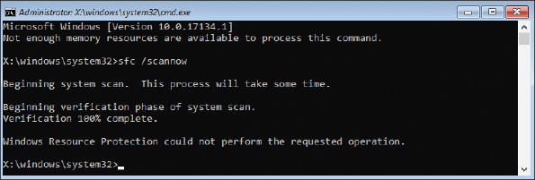
Figure 15-26
Use System Restore after booting to Safe Mode with Command Prompt
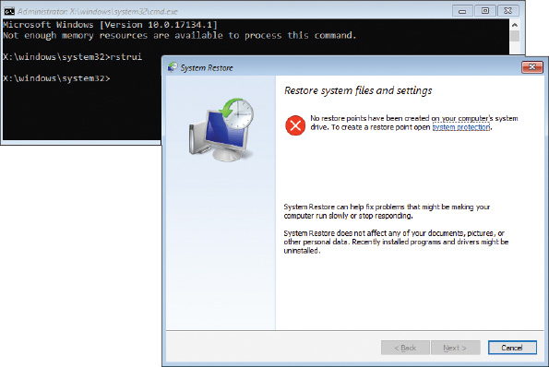

Press 7 or F7: Disable Driver Signature Enforcement
All 64-bit editions of Windows require that kernel-mode drivers be digitally signed. Developers disable driver signature enforcement when they test kernel-mode device drivers that are not yet digitally signed. Don’t use this option for troubleshooting Windows startup because doing so might allow malware drivers to load.

Press 8 or F8: Disable Early Launch Anti-Malware Driver
Windows 10/8 allows anti-malware software to launch a driver before any third-party drivers are launched so it can scan these drivers for malware. Unless you’re sure a driver is the problem, don’t disable this security feature. (Windows 7 doesn’t offer this option on its Advanced Boot Options screen.)

Press 9 or F9: Disable Automatic Restart on System Failure
By default, Windows automatically restarts immediately after a blue screen of death (BSOD) stop error, which is described in more detail later in this chapter. The error can cause the system to continually reboot rather than shut down. Press F9 to disable automatic restarts and stop the rebooting.
Notes
To permanently disable automatic restarts, go to Control Panel, open the System window, and click Advanced system settings. In the Startup and Recovery group of the System Properties box, click Settings. In the Startup and Recovery box, uncheck Automatically restart (see Figure 15-27). Click OK twice and close the System window.
Figure 15-27
Permanently disable automatic restarts
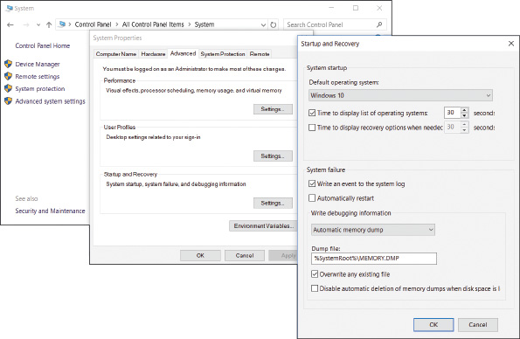

Press F10: Return to the Startup Settings Screen
Press F10 to return to the Windows Startup Menu screen shown previously in Figure 15-17.
Notes
As you use these startup settings tools, be sure to reboot after each attempt to fix the problem to make sure it has not been resolved before you try another tool. To exit Windows RE and relaunch Windows, press Enter on the Startup Settings screen.
OS Differences
Windows 7 offers an option on the Advanced Boot Options menu called the Last Known Good Configuration, which is not available in Windows 10/8. The Windows 7 Last Known Good Configuration settings are saved in the registry each time the user successfully logs on to the system. If your problem is caused by a bad hardware or software installation, using the Last Known Good can, in effect, undo the bad installation. Try the Last Known Good option early in the troubleshooting session before a bad Last Known Good overwrites a good one. (However, know that if you sign in to Safe Mode, the Last Known Good is not saved.)
Go to pg.
help
Application Opened
Main content

15-3cSystem Restore
A+ Core 2
- 3.1
Given a scenario, troubleshoot Microsoft Windows OS problems.
Windows gives you several opportunities during the startup troubleshooting process to use System Restore to restore the system to an earlier point in time when a restore point was made. You can select System Restore from the Windows RE Advanced options screen (refer back to Figure 15-19) or the Windows 7 System Recovery Options screen (refer back to Figure 15-22). You can also perform System Restore in Safe Mode or from a command prompt with the rstrui command.
System Restore can cause problems of its own because Windows updates and updates to anti-malware software can be lost, and hardware devices and applications might need to be reinstalled. System Restore won’t help if the file system is corrupted or the registry is trashed. In these situations, the command prompt might help.
Go to pg.
help
Application Opened
Main content

15-3dThe Command Prompt Window in Windows RE
A+ Core 2
- 3.1
Given a scenario, troubleshoot Microsoft Windows OS problems.
Use the command prompt window in Windows RE when the graphical interface is missing or corrupted or you want to use a specific command to fix a problem when Windows refuses to start. Using this command prompt, you have administrator privileges and full read and write access to all files on all drives. Many commands you learned about in Chapter 13 can be used at this command prompt. To access the Windows RE command prompt, click Command Prompt on the Windows 10/8 Advanced options screen (refer back to Figure 15-19) or the Windows 7 System Recovery Options screen (refer back to Figure 15-22).
Next are some examples of how to use the Windows RE command prompt to repair a system.

Manage Data Files and System Files
As you learned in Chapter 14, you can use the SFC or DISM commands to restore critical Windows system files. Use the cd, copy, rename, and delete commands to manage data files and system files. For example, if key registry files are corrupted or deleted, the system will not start. You can restore registry files using files saved in the C:\Windows\System32\config\RegBack folder. This RegBack folder contains partial backups of the registry files put there after a successful boot. Use the commands in Table 15-2 to restore the registry files. In the table, we assume Windows is installed on drive C:. However, know that Windows RE is likely to assign a different drive letter to the Windows volume.
Table 15-2

Steps to Restore the Registry Files
Command Line | Description
- 1.  c: | Makes drive C: the current drive. The default directory is root.
- 2.  dir | Examines the contents of drive C:. If this is not your Windows volume, try a different drive letter.
- 3.  cd \windows\system32\config | Makes the Windows registry folder the current folder.
- 4.  ren default default.save  - 5.  ren sam sam.save  - 6.  ren security security.save  - 7.  ren software software.save  - 8.  ren system system.save | Renames the five registry files.
- 9.  cd regback | Makes the registry backup folder the current folder.
- 10.  copy system c:\windows\system32\config | For hardware problems, first try copying just the System hive from the backup folder to the registry folder and then reboot.
- 11.  copy software c:\windows\system32\config | For software problems, first try copying just the Software hive to the registry folder and then reboot.
- 12.  copy system c:\windows\system32\config  - 13.  copy software c:\windows\system32\config  - 14.  copy default c:\windows\system32\config  - 15.  copy sam c:\windows\system32\config  - 16.  copy security c:\windows\system32\config | If the problem is still not solved, try copying all five hives to the registry folder and reboot.
After you try each fix, reboot the system to see if the problem is solved before you try the next fix.

Repair the Hard Drive File Systems and Partitions
A corrupted file system or partition can cause a failure to boot. To repair the file system, first try the chkdsk /r command. If you decide the hard drive is so corrupted you must start over with a fresh installation of Windows, you can use the diskpart command to totally wipe the hard drive clean of everything, including the partitioning system, before you install Windows again using Windows setup media. You learned to use diskpart in Chapter 12; a project at the end of this chapter gives you more practice with diskpart. Diskpart and chkdsk can also be used in a normal command prompt window.

Enable Networking
Networking is not normally available from the Windows RE command prompt. Use the wpeinit command to enable networking. The wpeinit command initializes Windows PE. Recall from Chapter 12 that Windows PE is the preinstallation-environment operating system that is launched prior to installing Windows in a clean install and includes networking components.

Use Bootrec and Bcdedit to Repair the File System and Key Boot Files
A failure to boot can be caused by a corrupted BCD. If startup repair does not fix the problem, you can use the bootrec command to repair the BCD and boot sectors. Use the bcdedit command to manually edit the BCD. (Be sure to make a copy of the BCD before you edit it.) Use the bootsect command to repair a dual-boot system. To get helpful information about these commands, enter the command followed by /?, such as bcdedit /?. Some examples of the bootrec and bcdedit commands are listed in Table 15-3.
Table 15-3

Bootrec and bcdedit Commands to Repair System Files and the File System
Command Line | Description
bootrec /scanOS | Scans the hard drive for Windows installations not stored in the BCD
bootrec /rebuildBCD | Scans for Windows installations and rebuilds the BCD
bootrec /fixboot | Repairs the boot sector of the system partition
bootrec /fixmbr | Repairs the MBR for hard drives using the MBR partitioning system
bcdedit /enum | Displays the contents of the BCD
Although a startup repair should solve the problem when you get an error message at startup that “Bootmgr is missing,” rebuilding the BCD store should also be able to resolve the same problem on a legacy BIOS and MBR system.
Go to pg.
help
Application Opened
Main content

15-4Options to Reinstall Windows
A+ Core 2
- 1.3
Summarize general OS installation considerations and upgrade methods.
- 3.1
Given a scenario, troubleshoot Microsoft Windows OS problems.
After you have made reasonable efforts to repair a Windows installation, your next option is to reinstall Windows. The startup troubleshooting tools discussed in this part of the chapter affect the entire Windows installation on a computer rather than a few files or settings. Look back at Figure 15-9 and notice that these tools to reinstall Windows are shown in blue boxes; you can also see how to reach each tool. Some of these options allow you to keep personal data, and other options remove that data; the tools are listed here starting with the least intrusive solution:
- Windows 10/8 previous version. Undo a recent Windows 10/8 update.
- Windows 10 repair upgrade. Install Windows 10 as an upgrade over the existing installation, keeping personal data, apps, and Windows settings.
- Windows 10 Fresh Start. Do a clean installation of the most recent version of Windows 10. User data, some Windows settings, and a few apps can be kept.
- Windows 10 reset. Do a clean Windows 10 installation from recovery media or the recovery partition on the hard drive. User data, some Windows settings, and a few apps can be kept.
- Windows 8 refresh. Restore Windows 8 from a custom refresh image with the option to keep user data and some apps.
- Apply a Windows 10/7 system image. Use a system image to replace everything on the Windows volume. Current user data, Windows settings, and apps are lost.
- Windows 8 reset. The hard drive is reformatted and a clean installation of Windows is done. If an OEM recovery partition is available, it is used for the Windows installation.
- Install Windows 10/8/7 from the OEM recovery partition. Laptops and brand-name computers may have an OEM recovery partition on the hard drive that can be used to restore the system to factory state. Some manufacturer procedures allow user data to be kept.
- Windows 10/8/7 clean install from setup media. This method is covered in Chapter 12 and may allow you to keep user data on the hard drive.
Let’s see how the Windows previous version, repair upgrade, Fresh Start, reset, and refresh work.
Go to pg.
help
Application Opened
Main content

15-4aWindows 10 Previous Version
A+ Core 2
- 3.1
Given a scenario, troubleshoot Microsoft Windows OS problems.
Minor updates to Windows are distributed on the second Tuesday of each month (called “Patch Tuesday”). Major updates, called versions, come along once or twice a year. Recall that you can look up your computer’s current Windows 10 version by opening the Settings app, clicking System, and then clicking About. For Windows 10/8/7, you can also enter the winver command in the Windows search box or Run box. The About Windows box that appears reports the current version and build of Windows. See Figure 15-28.
Figure 15-28
Version and build numbers can identify the major and minor Windows updates installed
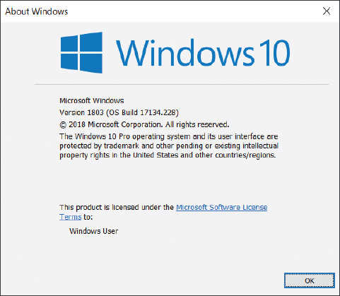
Notes
A Windows 10 version, such as the April 2018 Update, is assigned a version number, which appears as Version 1803 in Figure 15-28. A build number identifies updates to the current version. The major portion of the build number (such as 17134 for build 17134.228, shown in Figure 15-28) appears to be somewhat arbitrary and is notoriously unpredictable for future releases. However, the minor portion of the build number is more specific, in that these decimal places increment with each minor update.
A version includes all previous updates, so even minor updates are reinstalled when you install the next version. If a new version is giving problems, you can revert your system back to the earlier version as long as
- the version was installed within the last 10 days;
- you have not reset your computer during this time; and
- the Windows.old folder has not been deleted.
To roll back Windows updates, including device drivers that come with Windows updates, do one of the following to revert your system to a previous version:
- From the Windows desktop. Open the Settings app, click Update & security, and then click Recovery. Under Go back to the previous version of Windows 10, click Get started. If this button is grayed out, the time limit for reverting to the previous version has already passed or the Windows.old folder is missing.
- From Windows RE. If the option is available, you can see it on the Advanced options screen in Windows RE, shown earlier in Figure 15-19. Use this method when a new version has caused the system to fail to start, such as when a critical driver is corrupted.
Go to pg.
help
Application Opened
Main content

15-4bWindows 10 Repair Upgrade
A+ Core 2
- 3.1
Given a scenario, troubleshoot Microsoft Windows OS problems.
If you’re having problems with Windows updates or basic Windows functionality but you can still boot into Windows, you might consider performing a repair upgrade, also known as a repair install or an in-place upgrade. A repair upgrade is a nondestructive installation of Windows 10 over an existing Windows installation. This is not the same as a full reinstall because the Windows volume will not be reformatted. Just as with an upgrade from Windows 8 to Windows 10, you can keep personal files, apps, and Windows settings. Essentially, you trick the machine into thinking it’s being upgraded while potentially repairing the Windows installation.
Keep these points in mind when doing a repair upgrade:
- Create Windows setup media, either on DVD or USB, or save an ISO file on the local hard drive.
- Make sure that you can fully boot into Windows 10. If you can’t, you’ll have to use a different troubleshooting tool.
- Even though all data, apps, and settings should be protected in a repair upgrade, make a backup just in case.
- Gather all product keys for all installed apps to make reinstallation of these apps easier should it become necessary.
Notes
Belarc Advisor (belarc.com) is a free tool that is quick and easy to use. It will produce a list of all installed apps along with their product keys if that information is available. Print a copy of the report and keep it in a safe place.
Applying Concepts

Performing a Repair Upgrade
A+ Core 2
- 3.1
Given a scenario, troubleshoot Microsoft Windows OS problems.
The easiest way to perform a repair upgrade is to start with an ISO file created by the Media Creation Tool, as described in Chapter 12. Complete the following steps:
- Sign in to Windows using an administrator account. Back up all personal data using one of the methods you learned about in Chapter 13.
- Following steps in Chapter 12, download the correct ISO file for the Windows installation you’re currently using on the computer to be repaired.
- In File Explorer, double-click the ISO file that you created with the Media Creation Tool. This mounts the image and shows the included files.
- Double-click setup.exe, as shown in Figure 15-29. Click Yes in response to the UAC dialog box.
Figure 15-29
To begin the repair upgrade, double-click setup.exe on the virtual DVD in Explorer
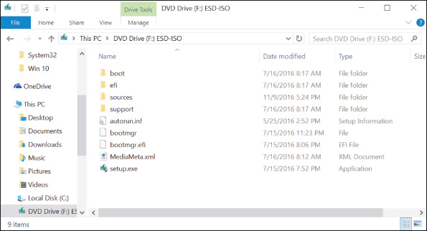
- On the first Windows 10 Setup window, make sure Download and install updates (recommended) is selected, and then click Next. Setup examines the system.
- Click Accept on the Applicable notices and license terms window. Windows 10 Setup checks for and downloads updates.
- If the Choose what to keep window appears, decide whether to keep personal files and apps, personal files only, or nothing. Sometimes setup makes these decisions for you and skips directly to the Ready to install window.
- On the Ready to install window, make sure Keep personal files and apps appears and is checked, as shown in Figure 15-30. If not, click Change what to keep and select Keep personal files and apps, and then click Next to return to the Ready to install window. Click Install to begin the installation process, which will take a while and require several restarts. Enjoy a cup of tea or coffee while you wait.
Figure 15-30
You can keep user data and settings and third-party apps during a repair upgrade
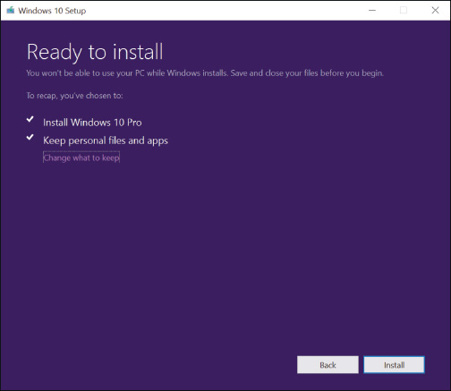
- When the lock screen appears, sign in to Windows. Once you see the desktop, all your files, apps, and settings should still be in place.
Go to pg.
help
Application Opened
Main content

15-4cWindows 10 Fresh Start
A+ Core 2
- 3.1
Given a scenario, troubleshoot Microsoft Windows OS problems.
A Fresh Start performs a clean installation of the most recent version of Windows 10 and is often used to remove manufacturer bloatware. Here’s what is installed, kept, and not kept with a Fresh Start:
- Installed. The latest generic copy of Windows, free from manufacturer bloatware, is downloaded directly from the Microsoft website.
- Kept. User accounts, their settings, and personal data are kept as well as some Windows settings. Microsoft apps that are natively integrated in Windows and Microsoft store apps installed by the computer manufacturer are also kept.
- Not kept. All apps are removed, except as stated above. A list of removed apps is displayed on the desktop after the Fresh Start completes. Be aware that you also lose any manufacturer drivers or OEM system files.
To install a fresh copy of Windows 10, first make sure you’re connected to the Internet and that you have sufficient storage space for the Windows image (about 3 GB). Open the Settings app, click Update & security, and then click Recovery. Under More recovery options (see Figure 15-31), click Learn how to start fresh with a clean installation of Windows. Then click Yes to switch to the Fresh start page, which is shown on the right side of Figure 15-31. Click Get started to begin the process. The tool downloads and performs a clean installation of Windows 10. Sign in to complete setup.
Figure 15-31
Personal files are kept when executing a Fresh Start for Windows 10
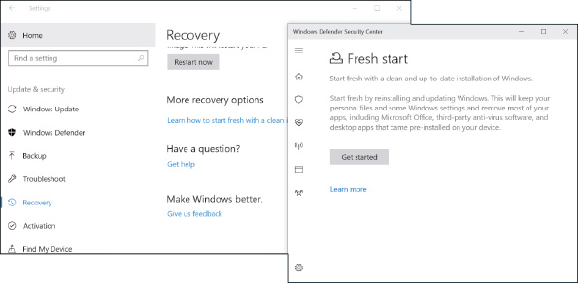
Go to pg.
help
Application Opened
Main content

15-4dWindows 10 Reset
A+ Core 2
- 3.1
Given a scenario, troubleshoot Microsoft Windows OS problems.
A Windows 10 reset reinstalls Windows with the option of keeping user accounts, some Windows settings, and all personal data files. If you decide to remove data files, you can also choose to clean the drive. During a reset, any apps or drivers that were installed from third-party providers will be removed, and some changes made to Windows settings will be lost. Also, if your computer has received a major update within the past 10 days, you will lose the ability to revert to a previous version of Windows. If you’re using a Microsoft account, you can choose to have many Windows settings automatically resynced to the device.
Notes
The basic difference between a Windows 10 reset and Fresh Start is the source of the Windows installation files. A reset uses files taken from recovery media or the recovery partition on the hard drive, whereas a Fresh Start downloads a pristine, up-to-date copy of Windows from the Microsoft website. Fresh Start therefore gives you a cleaner reinstall or fresher start than a reset. On the other hand, a reset installs original manufacturer drivers and OEM system files, which may be needed for a customized system. Both methods are capable of retaining personal files.
Notes
Before performing a reset, you might want to back up any desktop apps that you’ve customized or use frequently. Then you can restore the backed-up versions rather than installing fresh copies. To do this, store a copy of selected apps on a flash drive using a third-party app such as CloneApp (Mirinsoft.com), and then restore the apps along with their customized settings after the Windows reset is complete.
Applying Concepts

Resetting a Windows 10 Computer
A+ Core 2
- 3.1
Given a scenario, troubleshoot Microsoft Windows OS problems.
If you are not able to start Windows, you can use Windows 10 setup media or a recovery drive to launch Windows RE. Drill down to the Troubleshoot screen (refer back to Figure 15-18) and click Reset this PC to start the reset.
Here are the steps in Windows 10 to reset a computer using the Settings app:
- Sign in to Windows using an administrator account. If possible, first back up all personal files.
- If a recovery partition is present, it will be used for the reset. If there’s no recovery partition, insert bootable Windows media such as a recovery drive, system repair disc, or Windows setup media. The reset process will then use the media to install Windows.
- Open the Settings app and click Update & security. In the left pane, click Recovery, as shown earlier in Figure 15-14. Under Reset this PC, click Get started.
- In the Choose an option box, shown in Figure 15-32, decide whether to keep your files or to remove everything.
Figure 15-32
Keep your files or remove everything
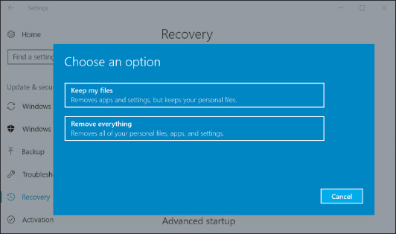
Notes
For a laptop, all-in-one, or other brand-name computer with a recovery partition present, you might see a third option on the Choose an option box: Restore factory settings. This option reinstalls the version of Windows that your computer came with (for example, Windows 8.1) and removes your personal files.
- If you click Keep my files, you’re given a list of all apps that will be removed. If you’ve recently updated your computer, you might see a warning that you will not be able to undo the update. Click Next and then click Reset to begin.
- If you click Remove everything, you’re given the option to clean only the Windows volume or all volumes on the hard drive. Make your selections and click Reset to begin.
Go to pg.
help
Application Opened
Main content

15-4eApplying a Windows 10/7 System Image
A+ Core 2
- 3.1
Given a scenario, troubleshoot Microsoft Windows OS problems.
You learned how to create a system image in Chapter 13. System image recovery tends to be an all-or-nothing recovery option where you replace the entire contents of a hard drive with whatever operating system state and personal data are saved in the system image. It recovers all personal files, system files, and installed apps that were in place at the time the system image was most recently created or updated. If your system image is updated regularly, this option could work very well for you when repairing or replacing hardware, such as a failed hard drive. However, if a software-related problem has been building for a while, a recently updated system image won’t necessarily fix the root of the problem.
To recover Windows 10/8 using a system image file, reboot the computer into Windows RE, drill down to the Advanced options screen (refer back to Figure 15-19), and select System Image Recovery. For Windows 7, select System Image Recovery on the System Recovery Options screen shown earlier in Figure 15-22.
Windows 8

Refreshing and Resetting a Windows 8 Computer
A+ Core 2
- 3.1
Given a scenario, troubleshoot Microsoft Windows OS problems.
Windows 8 offers a refresh process that’s not available in Windows 10 or Windows 7. In addition, a Windows 8 reset works differently than a Windows 10 reset. Let’s see how to perform a Windows 8 refresh and then a reset.

Refresh a Windows 8 Computer
In Chapter 13, you learned that Windows 8 prefers to use a custom refresh image of the Windows volume rather than the traditional system image. To solve a problem with a corrupted Windows 8 installation, you can perform a refresh in Windows 8. The refresh can use a custom refresh image that has been designated as the active recovery image, a hidden OEM recovery partition on the hard drive, or the Windows 8 setup DVD.
When you refresh a computer, the refresh saves installed apps that use the Windows 8 interface and current user settings and data. Unless you’re working with a custom refresh image, Windows settings and desktop applications are lost during a refresh. Here’s how to perform a refresh:
- Because the system will restart a couple of times during the refresh, remove any discs in the optical drive and unplug any bootable external hard drives or USB flash drives. For a laptop, plug in the AC adapter so you don’t lose battery power during the refresh. If the computer doesn’t have a recovery partition and you haven’t made a custom refresh image, insert the Windows setup DVD in the optical drive, which the refresh will use to perform a partial in-place upgrade of Windows 8.
- Do one of the following, depending on the health of the Windows installation:
  - If you can launch Windows, open the charms bar, click Settings, click Change PC settings, click Update and recovery, and click Recovery. Click Get started under Refresh your PC without affecting your files (refer back to Figure 15-15). A warning message appears (see Figure 15-33). Click Next. Click Refresh.
Figure 15-33
Windows lists what to expect from a refresh
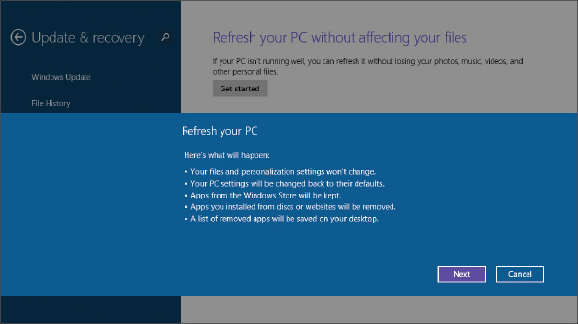
  - If you cannot launch Windows, boot from the Windows 8 setup DVD or a recovery drive to launch Windows RE. Drill down to the Troubleshoot screen (refer back to Figure 15-18B) and click Refresh your PC.
- Windows verifies there’s enough free space on the hard drive to perform the refresh. A lot of space is needed (as much as half the space on the Windows volume) because Windows will store the old Windows installation in a Windows.old folder and will also need space to back up apps and data. If there’s not enough space, an error occurs, and you’ll need to delete files or folders or move them to a different location to free up enough space, and then start the refresh again.
- Another warning message appears. Click Refresh to continue. Next, user settings, user data, and Windows 8 apps are backed up, and Windows searches for media or an image to use to reinstall Windows. It uses this order for the search:
  - It checks for a custom refresh image. If a custom refresh image was previously made and registered with the system, this image is used to refresh the system. (If desktop applications were included in the image, they are included in the refresh. Any desktop applications that were installed after the refresh image was created are lost and must be manually reinstalled.)
  - If no custom refresh image is found, Windows checks for an OEM recovery partition. If it finds an OEM recovery partition, the image on the partition is used to refresh the computer to its factory state.
  - If no image or recovery partition is found, Windows requests the Windows setup DVD if it’s not already available. The refresh process will use the Windows setup DVD to perform a partial in-place upgrade of Windows 8.
- The system restarts and the refresh begins. Progress is reported as a percentage of completion. The Windows volume is formatted, and Windows is reinstalled from an image or from the Windows setup files. User settings, data, and Windows 8 apps are restored from backup, and the system restarts.
- The names of desktop applications lost during the refresh are stored in a file named Removed Apps.html on the Windows desktop (see Figure 15-34). Open the file to see the list of applications. You’ll need to reinstall these applications.
Figure 15-34
View a list of desktop applications lost during the refresh
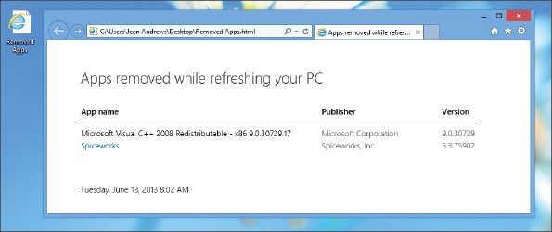
- The refresh created a Windows.old folder containing the old Windows installation. After you’re sure you don’t need anything in it, you can delete the folder to free up the disk space.

Reset a Windows 8 Computer
You might want to perform a Windows 8 reset when you’re about to give away a computer, recycle it, or totally want to start over. The Windows volume is formatted and Windows is reinstalled. If an OEM recovery partition is present, the system is reset to its factory state. If there’s no recovery partition, the process requests the Windows 8 setup DVD, which it uses to reinstall Windows. All user data and settings and installed apps are lost. You can use the recovery methods provided by the manufacturer (for example, press F12 or F10 at startup) or you can use Windows 8 to reset the system.
Here are the steps to reset a computer in Windows 8:
- If a recovery partition is present, it will be used for the reset. If there’s no recovery partition, insert the Windows setup DVD in the optical drive, which the reset process uses to perform a clean install of Windows.
- Do one of the following:
  - If you can launch Windows, go to the Update and recovery screen and click Get started under Remove everything and reinstall Windows (refer back to Figure 15-15). A warning message appears. Click Next.
  - If you cannot launch Windows, boot from the Windows setup DVD or a recovery drive and make your way to the Troubleshoot screen shown earlier in Figure 15-18B. Click Reset your PC.
- If the system contains more than one volume or hard drive, Windows asks if you want to format all drives or just the Windows volume. Click a box to make your selection.
- On the next screen (see Figure 15-35), you’re asked to decide between a quick format and a thorough format. A thorough format makes it less likely someone can recover data on the drive. Make your selection by clicking a box.
Figure 15-35
Decide what type of format the reset will use
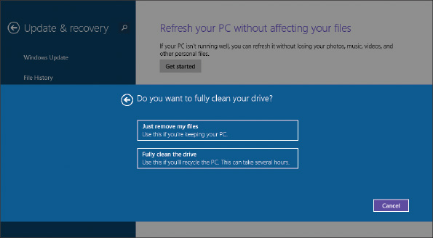
- On the next screen, another warning appears. Click Reset to start the process. The system restarts and resetting begins. After another restart, you can step through the process of preparing Windows for first use.
Go to pg.
help
Application Opened
Main content

15-4fOEM Factory Recovery Partition
A+ Core 2
- 1.3
Summarize general OS installation considerations and upgrade methods.
- 3.1
Given a scenario, troubleshoot Microsoft Windows OS problems.
Laptops, all-in-one computers, and brand-name desktops come with the OS preinstalled at the factory. This OEM (original equipment manufacturer) build of the OS is likely to be customized, and for laptops, the drivers might be specific to proprietary devices installed in the laptops.
The laptop or brand-name computer is likely to have a recovery partition on the hard drive that contains a copy of the OS build, device drivers, diagnostics programs, and preinstalled applications needed to restore the system to its factory state. This partition might or might not be hidden. For example, Figure 15-36 shows the Disk Management information for a hard drive on one laptop that has a 16.38-GB recovery partition.
Figure 15-36
This laptop hard drive has a 16.38-GB recovery partition that can be used to recover the system
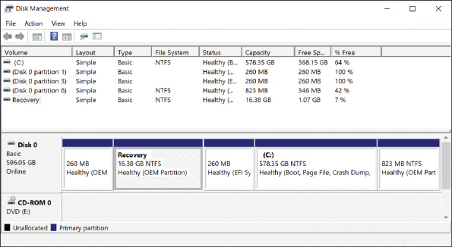
To know how to access the recovery tools stored on a recovery partition, see the manufacturer’s website or look for a message at the beginning of the boot, such as “Press ESC for diagnostics” or “Press F12 to recover the system.” For one Sony laptop, you press the red Assist button during the boot (see Figure 15-37). When you press the key or button, a menu appears with options to diagnose the problem, to repair the current OS installation, or to completely rebuild the entire hard drive to its factory state.
Figure 15-37
For this laptop, press the Assist button during the boot to launch programs on the recovery partition
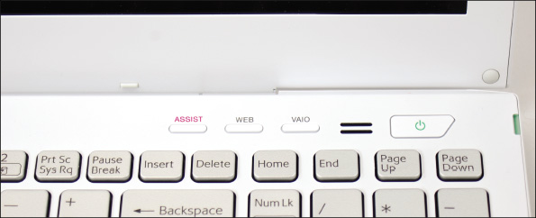
If the laptop doesn’t have a recovery partition or the partition is corrupted, look for the option to download recovery media from the manufacturer’s website and use it to create a bootable USB flash drive or DVD. You can then use the media to install Windows to its factory state.
Notes
When you first become responsible for a laptop, use a USB flash drive to make a Windows 10/8 recovery drive that includes the OEM recovery partition in case you must replace the laptop’s hard drive. Know that if the laptop is more than three years old, the manufacturer might no longer provide the recovery media.
Caution
Before upgrading a laptop to Windows 10, make sure the laptop manufacturer provides Windows 10 drivers for laptop components.
Go to pg.
help
Application Opened
Main content

15-4gInstalling Windows Over the Network
A+ Core 2
- 3.1
Given a scenario, troubleshoot Microsoft Windows OS problems.
Recall from Chapter 12 that in an enterprise environment, you can install Windows from a deployment image on the network. You must boot the computer to the network where it finds and loads Windows PE on the deployment server. Go into BIOS/UEFI setup and look for an advanced setup screen to enable PXE Support. The computer then boots to the Preboot eXecution Environment (PXE) and PXE then searches for a server on the network to provide Windows PE and the deployment image.
A+ Exam Tip
The A+ Core 2 exam expects you to know how to use a preinstallation environment and a recovery image to help resolve a Windows startup problem.
Go to pg.
help
Application Opened
Main content

15-5Troubleshooting Specific Windows Startup Problems
A+ Core 2
- 3.1
Given a scenario, troubleshoot Microsoft Windows OS problems.
- 4.3
Given a scenario, implement basic disaster prevention and recovery methods.
And now the fun begins! With your understanding of the boot process and Windows tools for troubleshooting startup in hand, let’s work through a bunch of errors and problems that can affect Windows startup and see what can be done about them. When troubleshooting a startup problem, follow procedures to interview the user, back up important data or verify that you have current backups, research and identify any error messages, and determine what has just changed that might be the source of the problem.
When you know the source of the problem, decide which tool will be the least invasive to use yet still fix the problem. If that doesn’t work, move on to the next tool. Remember that tools are described earlier in the chapter from least to most invasive.
Go to pg.
help
Application Opened
Main content

15-5aImportant Data on the Hard Drive
A+ Core 2
- 3.1
Given a scenario, troubleshoot Microsoft Windows OS problems.
Troubleshooting a computer problem should always start with the most important question: Is there important data on the hard drive that’s not backed up? Even if data is lost or corrupted, you might be able to recover it using Windows tools, third-party file recovery software, or commercial data recovery services. One good product is GetDataBack by Runtime Software (runtime.org), which can recover data and program files even when Windows cannot recognize the drive.
For less than $30, you can purchase a SATA-to-USB converter kit (see Figure 15-38) that includes a data cable and power adapter. You can use one of these kits to temporarily connect a desktop or laptop hard drive to a USB port on a working computer. Set the drive beside your computer and plug one end of the data cable into the drive and the other into the USB port. The AC adapter supplies power to the drive. While power is getting to the drive, be careful not to touch the circuit board on the drive.
Figure 15-38
Use a SATA-to-USB converter to recover data from a drive using a SATA connector
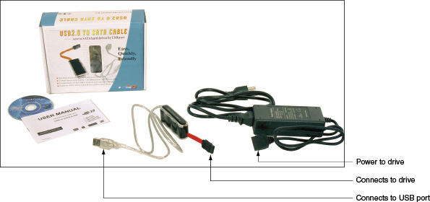
Using File Explorer or Windows Explorer, you can browse the drive and copy data to other media. After you have saved the data, you can use diagnostic software from the hard drive manufacturer to examine the drive and possibly repair it or return the drive to its own computer and start troubleshooting there.
Go to pg.
help
Application Opened
Main content

15-5bError Messages and Problems
A+ Core 2
- 3.1
Given a scenario, troubleshoot Microsoft Windows OS problems.
- 4.3
Given a scenario, implement basic disaster prevention and recovery methods.
Problems that prevent Windows from booting can be caused by hardware, device drivers, services, applications, or Windows. This section covers what to do when error messages appear on a black or blue screen or when Windows gets corrupted.

Startup Error Messages on a Black Screen
Generally, problems that present as white text on a black screen are caused by hardware. Here are some possible error messages:
- No OS found
- A disk read error occurred
- Invalid boot disk
- Hard drive not found
- Disk boot failure
- No boot device found
Here is what’s happening and what to do about it:
- Start with the error message. Research the text shown on the screen so that you understand the problem and get solutions from trusted websites.
- If you see spinning white dots on a black screen, Windows may be installing updates before it launches. Wait. It may take some time for the update installations to complete. If the system hangs indefinitely, the updates might be causing a problem. If a reboot doesn’t solve the problem, boot into Windows RE and return to a previous version of Windows.
- Consider that startup BIOS/UEFI might not be able to communicate with the hard drive. Check BIOS/UEFI setup for the boot sequence. Update the boot order so that you can try booting from another device.
- For Windows 10/8, try going into BIOS/UEFI setup and disabling any quick boot features. This causes BIOS/UEFI to do a more thorough job of POST and reports more information on the screen as it performs POST.
- Windows might halt and show a black screen when it encounters a video problem at startup. Try restarting the system in Safe Mode, as you learned to do earlier in the chapter. Then check Event Viewer for clues, update Windows, and use Device Manager to roll back drivers or disable or uninstall the video adapter. If you cannot boot into Safe Mode, launch Windows RE and use Startup Repair, Memory Diagnostics, and the chkdsk /r command to check Windows, memory, and the hard drive.
- The hard drive might be failing. To recover data from the drive, move it to another computer and install it as a second hard drive.

Problems with User Profiles
If Windows bogs down right after the user signs in, the problem might be with loading the user profile. For a slow profile load, the user might see a black screen with spinning dots for several minutes. To fix the problem, try these tasks listed in the least invasive order:
- Try the Windows Troubleshooting applet that you learned about in Chapter 14. Go to Control Panel and click Troubleshooting. On the Troubleshooting page, click Run maintenance tasks and follow the on-screen directions.
- Make sure Windows updates are applied.
- Run sfc /scannow to fix problems with system files.
- Reduce startup items. Compare the time to load a user profile when starting Windows normally and during a clean boot.
- Apply a restore point that was created before the problem started.
- For Windows 10, try a repair upgrade.
- Create a new user profile. You can copy user data files from the old profile into the new user profile namespace. (Locations of these files are given in Chapter 14.)
If the user profile gets corrupted, it might not load at all and you might see the error message, “The User Profile Service failed the logon.” To rebuild the user profiles, do the following to repair Windows system files that affect the corrupted profiles:
- Do as many of the above steps as you can do when a single user profile is slow to load.
- Following directions given in Chapter 14, use the DISM commands to repair corrupted Windows system files.
- For Windows 10, perform a reset. Be sure to back up data before you do a reset.
Sometimes you can recover a user account by deleting it without deleting its files and then creating a new one with the same name.
To delete the account and keep its files, open Control Panel, click User Accounts, select the account, and click Delete the account. In the Delete Account window (see Figure 15-39), click Keep Files and then click Delete Account. The files are stored in a folder on your desktop and the account and its settings are deleted. Create a new account with the same name. Then you can copy the files saved to your desktop folder to the new user profile namespace.
Figure 15-39
Delete a user account and its settings and keep the files in the user profile
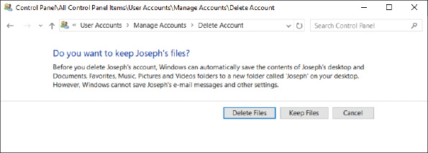
If this doesn’t work, you can edit the registry to delete an old profile or repair a corrupted one:
- Launch the Registry Editor and back up this registry key:
HKEY_LOCAL_MACHINE\SOFTWARE\Microsoft\Windows NT\CurrentVersion\ProfileList
- Drill down into each S-1-5 folder in the above key until you find the correct user profile in the ProfileImagePath subkey (see Figure 15-40).
Figure 15-40
Set the State subkey value to 0
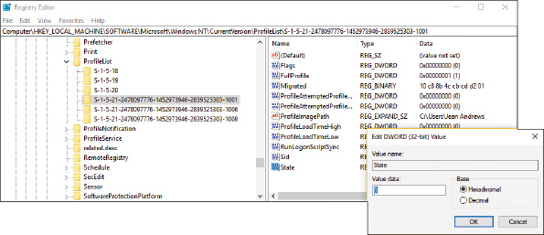
- If the profile has a State subkey, set it to 0, as shown in the figure. If the profile has a RefCount subkey, set it to 0.
- Close the Registry Editor and restart the computer.
Notes
If you’re searching for the correct S-1-5 folder and it has .bak in the name, remove .bak from the folder name. To rename a folder, right-click it and click Rename.
If you see two S-1-5 folders with the same name, except one has .bak at the end, you must switch the names: First rename the folder that does not contain .bak to .hold. Then remove the .bak from the other folder name. Next, rename the .hold folder to .bak. Then edit the S-1-5 folder that does not have .bak in the name.
If you still have problems with a user profile, you can follow these steps to delete the profile:
- Manually copy any important data files in the user profile namespace to a new location. Recall that you can find these files in the C:\Users\username subfolders.
- Go to Control Panel and open the System window. Click Advanced system settings. In the System Properties box, select the Advanced tab and click Settings under User Profiles. See Figure 15-41. In the list of user profiles, select the profile and click Delete.
Figure 15-41
Delete the user profile
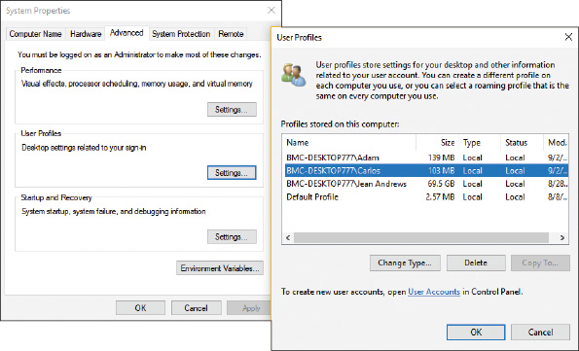
- Launch the Registry Editor, back up the ProfileList key as you learned to do earlier, and locate the S-1-5 folder for the user profile you want to delete. Right-click the Sid key and click Delete.
- Restart the computer and create a new profile.

Error Messages on a Blue Screen
Hardware and software errors can present as error messages on a Windows blue screen of death (BSOD) and are called stop errors. Also, sometimes Windows hangs with the pinwheel spinning, continuously restarts, or does an abrupt and improper shutdown. A BSOD, or stop error, happens when processes running in kernel mode encounter a problem and Windows must stop the system. Figure 15-42 shows an example of a Windows 8 blue screen with the stop error at the top and the specific number of the error near the bottom of the screen. Windows 10 blue screens may be much simpler, such as the one shown in Figure 15-43.
Figure 15-42
A blue screen of death (BSOD) is definitively not a good sign; time to start troubleshooting
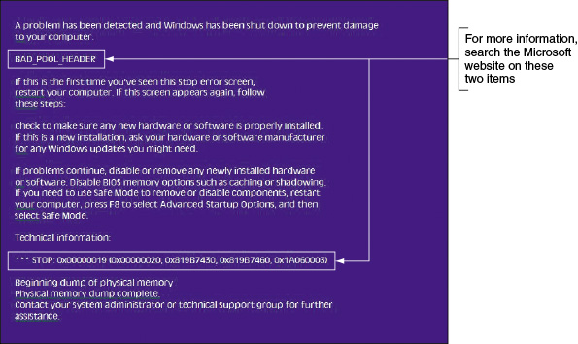
Figure 15-43
The Windows 10 stop error screen
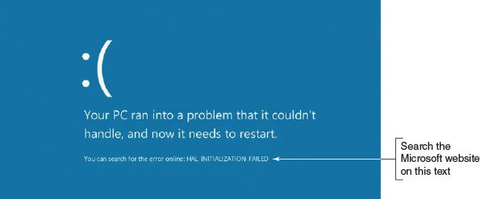
A stop error can be caused by a corrupted Windows update, a corrupted registry, a system file that is missing or damaged, a device driver that is missing or damaged, bad memory, or a corrupted or failing hard drive. Stop errors can occur during or after startup. Here’s what to do when you get a stop error:
- As for the tools that are useful in solving stop errors, put the web at the top of your list! (But don’t forget that some sites are unreliable and others mean you harm.) Search the Microsoft websites on the items labeled in Figure 15-42 or Figure 15-43.
- Disconnect any peripheral devices that might be causing trouble, such as a docking station, USB device, projector, or extra monitor.
- Reboot the system. Immediately after a reboot following a stop error, Windows displays an error message box or bubble with useful information. Follow the links in the box.
- If possible, restart the system and enable boot logging. Check the C:\Windows\Ntbtlog.txt file to see if the correct driver files loaded.
- Restart the computer a couple of times. Sometimes that’s all you need to do to solve a problem. If Windows encounters errors, it will launch an automatic repair. If that doesn’t fix the problem, you can launch Windows RE and restart Windows in Safe Mode with Networking. In Safe Mode, examine the log file created by Automatic Repair at C:\Windows\System32\LogFiles\Srt\SrtTrail.txt. See Figure 15-44. Also, recall that Safe Mode creates its own log file at C:\Windows\Ntbtlog.txt.
Figure 15-44
Examine the log file left by Automatic Repair
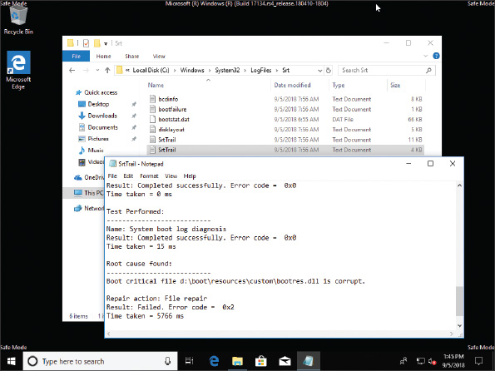
Notes
If the stop error prevents Windows from loading the desktop and F8 has not yet been enabled at startup, you can force automatic repair by turning off the computer a couple of times as Windows launches.

Errors with Hardware and Device Drivers
If the blue screen names a device or device driver that caused the problem, do the following:
- If the driver has been recently updated and the Safe Mode desktop is loaded, open Device Manager and roll back the driver.
- Consider that the device driver might have been updated along with a Windows update. For recent Windows updates, try to return to a previous version of Windows.
- A Windows update might fix the problem. Open the Settings app and update Windows.
- Use Device Manager to uninstall the device. When given the option, select Delete the driver software for this device. Then reboot the system.
- If the stop error does not identify the device but names a program file, open File Explorer or Windows Explorer on a working computer to locate the program file. Driver files are stored in the C:\Windows\System32\drivers folder. Right-click the file and select Properties from the shortcut menu. The Details tab of the Properties box tells you the purpose of the file (see Figure 15-45). You can then reinstall the device or program that caused the problem.
Figure 15-45
Use the Details tab of a driver’s Properties box to identify the purpose of the driver
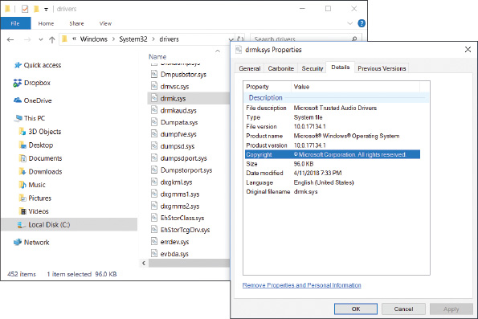
- If you cannot start Windows in Safe Mode, use Windows RE to open a command prompt window. Then back up the registry and open the Registry Editor using the regedit command. Drill down to the service or device key. The key that loads services and drivers can be found in this location:
HKEY_LOCAL_MACHINE\System\CurrentControlSet\Services
Disable the service or driver by changing the Start value to 0x4. Close the Registry Editor and reboot. If the problem goes away, use the copy command to replace the service or driver program file, and restart the service or driver.
Caution
Consider that the device might be physically damaged. If you feel excessive heat coming from the computer case or a peripheral device, immediately unplug the device or power down the system. Don’t turn the device or system back on until the problem is solved; you don’t want to start a fire! Other symptoms that indicate potential danger are strong electrical odors, unusual noises, no noise (such as when the fan is not working to keep the system cool), liquid spills on a device, and visible damage such as a frayed cable, melted plastic, or smoke. In these situations, turn off the equipment immediately.

Errors with Services or Other Programs
Applications don’t generally cause stop errors because they all run in user mode rather than kernel mode. When a blue screen with a stop error identifies a service or other program that failed to start or is causing problems, do the following:
- Check Event Viewer, which might provide events it has logged. Recall that critical errors and warnings are recorded in the Administrative Events log.
- Use Task Manager to stop the service or other program causing the error. If you cannot end the process using Task Manager, use the taskkill command, as you learned to do in Chapter 14. Try restarting the program.
- Use Task Manager or the Services console to disable the service from launching at startup. Chapter 14 covers how to use these tools and search other locations for startup programs.
- Update Windows.
- If you are not sure which service or other program is causing the problem, follow directions given in Chapter 14 to perform a clean boot. If a clean boot still gives errors, try a Safe boot.
- Undo any recent changes to the system. If you are not sure which changes to undo, consider using System Restore to restore the system to the point in time before the problem started.
- Use the Memory Diagnostics tool to check memory and use the chkdsk /r command to check the hard drive for errors. If the problem is still not resolved, you might need to repair Windows system files by using SFC and DISM commands or other Windows startup repair tools discussed in this chapter.

Windows Is Corrupted
Here are some possible problems with Windows system files and what to do about them:
- Missing Boot Configuration Data. If the BCD store is corrupted or missing and Automatic Repair did not fix the problem, try using the bootrec /rebuildBCD command.
- Improper shutdown. The problem can be caused by overheating, a hardware problem, or the Windows kernel. After a restart, check Event Viewer for clues, apply Windows updates, verify memory with Memory Diagnostics, and use chkdsk /r to check the hard drive for errors.
- No graphics appear. Suspect that the monitor is not turned on, not getting power, or not connected to the computer. Try a different monitor or onboard video port. Try launching a command prompt in Windows RE and use it to perform a System Restore.
After you have done your best to back up user data and troubleshoot problems with hardware and applications, you may decide the Windows installation is beyond repair and it’s time to reimage or reload Windows. As you learned in this chapter, the tools to use to reimage or reload Windows, listed in the least intrusive order, are the Windows 10 previous version (if available), a Windows 10 repair upgrade, Windows 10 Fresh Start, a Windows 10 reset, and applying a system image. For Windows 8, your options are a refresh and a reset. For Windows 7, your option is applying a system image. As a last resort, you can perform a clean installation of Windows 10/8/7, as you learned in Chapter 12. After you have Windows up and running again, you can restore the user data from backups.
Go to pg.
help
Application Opened
Main content

Chapter Review

15-6aChapter Summary

Understanding the Boot Process
- When you first turn on a system, startup BIOS/UEFI on the motherboard takes control and performs POST to examine hardware components and then find an operating system to load.
- Windows startup is managed by the Windows Boot Manager. For a BIOS system, the program is bootmgr. For a UEFI system, the program is bootmgfw.efi. The Windows Boot Loader is winload.exe or winload.efi. The Boot Configuration Data (BCD) store contains Windows startup settings.

What to Do Before a Problem Occurs
- Before a startup problem occurs, you can keep good backups, create a system image, configure the F8 key at startup, and create recovery boot media.

Tools for Least Invasive Solutions
- The Windows Recovery Environment (Windows RE) can be started from within Windows, from the Windows setup DVD or flash drive, from a recovery drive, or from a system repair disc. For Windows 7, press F8 at startup to launch Windows RE.
- Tools for startup troubleshooting include startup repair, startup settings, System Restore, Safe Mode, enabling boot logging, SFC, and the chkdsk, diskpart, bootrec, and bootsect commands.

Options to Reinstall Windows
- Tools that can be used to reinstall Windows are the Windows 10 previous version, a repair upgrade, Fresh Start, and a reset. Windows 8 tools are a refresh and a reset. With Windows 10/7, you can apply a system image. Some manufacturers offer a recovery partition on the hard drive to restore a computer to factory state. You can also reinstall Windows from Windows setup media.

Troubleshooting Specific Windows Startup Problems
- If a hard drive contains valuable data but will not boot, you might be able to recover the data by installing the drive in another system as the second, nonbooting hard drive.
- Use the web to research stop errors by the error title and error number listed on a black or blue screen.
- Improper shutdowns are most likely hardware related. Event Viewer might record failures. Use Memory Diagnostics and chkdsk to check memory and the hard drive. Consider overheating as a source of the problem.
- When a device or service causes the system to hang during a normal boot, boot into Safe Mode or perform a clean boot and disable the device or service. System Restore can return the system to a previously saved restore point before the problem occurred.
Go to pg.
help
Application Opened
Main content

Chapter Review

15-6bKey Terms
For explanations of key terms, see the Glossary for this text.
- bcdedit
- blue screen of death (BSOD)
- Boot Configuration Data (BCD) store
- booting
- bootrec
- bootsect
- cold boot
- Fresh Start
- hard boot
- Last Known Good Configuration
- POST (power-on self test)
- recovery drive
- recovery partition
- refresh
- repair upgrade
- soft boot
- startup repair
- system repair disc
- warm boot
- Windows 8 reset
- Windows Boot Loader
- Windows Recovery Environment (Windows RE)
- wpeinit
Go to pg.
help
Application Opened
Main content

Chapter Review

15-6cThinking Critically
These questions are designed to prepare you for the critical thinking required for the A+ exams and may use content from other chapters and the web.
- As a computer starts up, you see an error message about the HAL. At what point in startup does this error occur?
  - When BIOS/UEFI is searching for an OS using devices listed in the boot priority order
  - When Windows attempts to load the user profile
  - When Windows attempts to launch critical device drivers
  - When Windows attempts to launch the Windows kernel
- Which Windows program must be running before a user can sign in to Windows?
  - Kernel.exe
  - Userinit.exe
  - Explorer.exe
  - Lsass.exe
  - All of the above
- As a computer starts up, you see an error message about a missing operating system. At what point in startup does this error occur?
  - When BIOS/UEFI is searching for an OS using devices listed in the boot priority order
  - When Windows attempts to load the user profile
  - When Windows attempts to launch critical device drivers
  - When Windows attempts to launch the Windows kernel
- Your friend sees an error message during Windows startup about a corrupted bootmgr file. He has another computer with a matching configuration and decides to copy the bootmgr file from the working computer to the computer with the problem. Where can he locate the bootmgr file?
  - C:\Boot\bootmgr
  - System Reserved\Boot\bootmgr
  - System Reserved\bootmgr
  - All of the above
- In question 4 above, your friend is having problems finding the bootmgr file and asks for your help. What is your best response?
  - Use diskpart commands to “unhide” and locate the file.
  - Use the File Explorer options applet to unhide the hidden bootmgr file.
  - Explain to your friend that performing a startup repair is a better option.
  - Explain to your friend that he can use the bootrec command to fix the bootmgr file without having to copy another file to the computer.
- You are seeing multiple errors about device drivers failing to launch at startup. Of the following, which is the best option to try first? Second?
  - Restore the SYSTEM hive from backup.
  - Restore the SAM hive from backup.
  - Perform a startup repair.
  - Perform a Windows 10 reset.
- A stop error halts the Windows 10 system while it is booting, and the booting starts over in an endless loop of restarts. How can you solve this problem?
  - Use the Windows Startup Settings screen to disable automatic restarts.
  - Press F8 at startup and then disable automatic restarts.
  - Launch Windows 10 from setup media and perform a Windows 10 reset.
  - Press F9 at startup and then disable automatic restarts.
- If you are having a problem with a driver, which of the following should you try first? Second?
  - Update the driver.
  - Use System Restore to apply a restore point.
  - Update Windows.
  - Perform a clean boot.
- When error messages indicate that the Windows registry is corrupted and you cannot boot from the hard drive, what tool or method is the first best option to fix the problem? The second best option?
  - Use bootable media to launch Windows RE and use System Restore to apply a restore point.
  - Use bootable media to launch Windows RE and perform a startup repair.
  - Use bootable media to launch Windows RE and then use commands to recover the registry from backup.
  - Refresh Windows using a system image or custom refresh image.
- Your Windows system boots to a blue screen stop error and no Start screen or desktop. What do you do first?
  - Reinstall Windows.
  - Use the web to research the stop error messages and numbers.
  - Attempt to boot into Windows RE using the Windows setup DVD or a recovery drive.
  - Verify that the system is getting power.
- You have important data on your hard drive that is not backed up and your Windows installation is so corrupted you know that you must refresh the entire installation. What do you do first?
  - Use System Restore to apply a restore point.
  - Make every attempt to recover the data.
  - Perform an in-place upgrade of Windows.
  - Reformat the hard drive and reinstall Windows.
- Your computer displays the error message “A disk read error occurred.” You try to boot from the Windows setup DVD and you get the same error. What is most likely the problem?
  - The Windows setup DVD is scratched or damaged in some way.
  - The hard drive is so damaged the system cannot read from the DVD.
  - Both the optical drive and the hard drive have failed.
  - The boot device order is set to boot from the hard drive before the optical drive.
- When a driver is giving problems in Windows 10, which tool offers the least intrusive solution?
  - Device Manager
  - Windows Update
  - System Restore
  - Registry Editor
- An error message is displayed during Windows startup about a service that has failed to start, and then the system locks up. You try to boot into Safe Mode, but get the same error message. What do you try next?
  - Use the command prompt to edit the registry.
  - Boot to Windows RE and enable boot logging.
  - Perform an upgrade repair of Windows 10.
  - Boot to Windows RE and perform a startup repair.
- Stop errors happen when which type of processes encounter an error?
  - Processes created by applications
  - Processes created by Windows components running in user mode
  - Processes created by Windows components running in kernel mode
  - Processes created by anti-malware software
- What is the command to use the System File Checker to immediately verify and repair system files?
- What is the path and name of the log file created when you enable boot logging on the Windows 10/8 Startup Settings menu?
- What information is contained in the C:\Windows\System32\LogFiles\SRT\SRTTrail.txt file?
Go to pg.
help

