Application Opened
Main content
Chapter
18

macOS, Linux, and Scripting
- Chapter Introduction
- 18-1macOS for Macintosh Computers
  - 18-1aGetting to Know the macOS Desktop
  - 18-1bMaintaining and Supporting macOS
  - 18-1cTroubleshooting macOS Startup
- 18-2Linux Operating System
  - 18-2aLinux Installs, Updates, and Backups
  - 18-2bInstalling and Exploring Ubuntu Server
  - 18-2cTelnet and SSH for Remote Access
  - 18-2dComparing Windows, macOS, and Linux
- 18-3Scripting Software and Techniques
  - 18-3aScript File Types
  - 18-3bBasics of Scripting
- 18-4Chapter Review
  - 18-4aChapter Summary
  - 18-4bKey Terms
  - 18-4cThinking Critically
  - 18-4dHands-On Projects
  - 18-4eReal Problems, Real Solutions
  - 18-4fExam Tips
Go to pg.
help
Application Opened
Main content

Chapter Introduction
After completing this chapter, you will be able to:
- Use and support macOS for Apple computers
- Use and support Linux distributions with graphical and command-line interfaces
- Identify basic scripting methods and scripting software
In this chapter, you learn about two more operating systems for desktops and laptops other than Windows: macOS and Linux. As you will see, understanding Windows gives you a solid foundation to approach learning and supporting other operating systems. IT technicians are expected to be familiar with a variety of operating systems and operating environments, and this chapter equips you for these skills. In addition, you learn the fundamentals of scripting used in all scripting software and environments. IT technicians customarily use scripts to automate repetitive tasks.
Go to pg.
help
Application Opened
Main content

18-1macOS for Macintosh Computers
A+ Core 2
- 1.1
Compare and contrast common operating system types and their purposes.
- 1.3
Summarize general OS installation considerations and upgrade methods.
- 1.9
Given a scenario, use features and tools of the Mac OS and Linux client/desktop operating systems.
macOS, formally called Mac OS X, is a proprietary operating system that is only available for Macintosh computers by Apple Inc. (apple.com). Like Linux, macOS is built on a UNIX foundation and has been evolving and improving since its original release in 1984. (UNIX is a popular OS used to control networks and to support server applications available on the Internet.) At the time of this writing, macOS Mojave was just released, and some users are converting to it from the last release, macOS High Sierra.
The Mac keyboard has some special keys. See Figure 18-1. However, don’t depend on these special keys because a customer might have a regular keyboard connected via a USB port. The touch pad on a Mac laptop is called the trackpad, and is a touch pad on steroids; you can use multiple fingers and actions called gestures, which you learn about as you read through this part of the chapter.
Figure 18-1
Special keys on a Mac keyboard
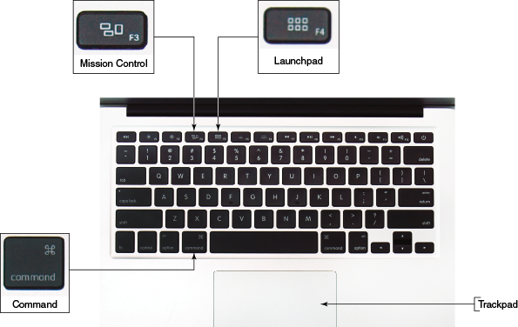
Now let’s get to know the macOS interface, including the desktop with its dock and Apple menu, Finder, Launchpad, System Preferences, Spotlight, Mission Control, multiple desktops, iCloud Drive, Keychain, Screen Sharing, Remote Disc, and Terminal.
Go to pg.
help
Application Opened
Main content

18-1aGetting to Know the macOS Desktop
The macOS desktop, with its major components labeled, is shown in Figure 18-2. The Finder application, which can help you find applications and data files, is open and active. Because Finder is the currently active application, the menu bar for the Finder window is displayed at the top of the screen. The menu bar provides drop-down menus that contain options for working with applications, files, and the interface.
Figure 18-2
The macOS desktop with a Finder window showing the Applications pane
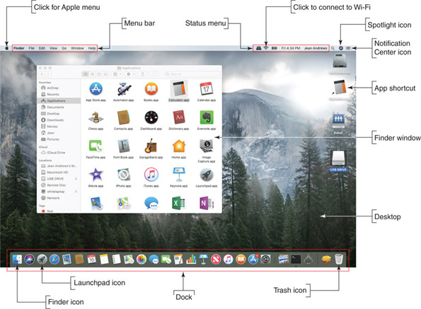
Source: Apple Inc.
By default, the dock appears at the bottom of the desktop. It contains shortcut icons to access frequently used applications. To open an application from its icon in the dock, click it once. The icons in the dock that represent open applications have a small, black dot underneath them. The macOS desktop can also include shortcuts that provide quick access to files, folders, and applications.
When a window is open, three circles in the upper-left corner (see Figure 18-3A) let you manipulate the window. The red circle closes the window, the yellow circle minimizes the window to the dock in the lower-right corner of the screen (see Figure 18-3B), and the green circle maximizes the window to full-screen size. To restore a maximized window to its original size, move your pointer to the top of the screen. When the circle icons appear, click the green circle.
Figure 18-3
(A) Close, minimize, or expand a window; (B) this Finder window has been minimized, but the app is still running and is easily accessible in the dock
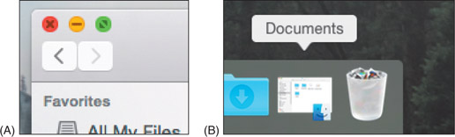
Source: Apple Inc.
Closing an app’s window does not close the app. To quit an app that is active, click the name of the app in the menu bar and click Quit at the bottom of the drop-down menu. See Figure 18-4.
Figure 18-4
To close an app, select Quit in the app’s menu
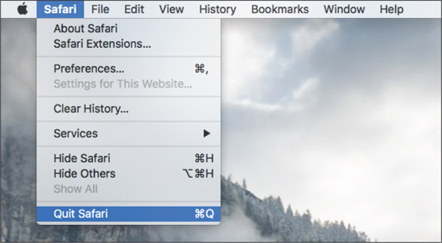
Source: Apple Inc.

Finder
The Finder window, shown earlier in Figure 18-2 and again in Figure 18-5, functions something like File Explorer in Windows; use it to find and access files, applications, and macOS utility programs. To open the Finder window, click it in the dock. Note that the Finder is always running; you can close the Finder window, but you can’t end the Finder utility. Here are useful things you can do with Finder:
- Files and folders. To open files and folders, click Documents or some other storage location, such as iCloud Drive or Downloads. Double-click a folder to drill down into it and double-click a document file to open it. You can drag and drop a file or folder into and out of a folder or location window.
- Applications. To open an app, click Applications in the sidebar, scroll to the app, and click it. You can also open apps from Launchpad.
- macOS utilities. macOS offers several utility programs that are accessed from the Finder window. Click Applications, scroll down to the Utilities folder, and click it. See Figure 18-6. You learn to use several of these utilities later in this chapter.
- Locations. As shown on the left side of Figure 18-6, available locations are the Mac, the internal hard drive (Macintosh HD), a USB drive, Remote Disc, and the network. Drill down into any of these locations to see available resources. When you drill down into Network, you see network devices and their shared resources. When you drill down into Remote Disc, you can see a shared optical drive that has been shared by another computer on the network.
- Finder menu bar. To use the Finder menu bar to list devices and other resources, click Go in the Finder menu bar and click Computer. The Computer window shows all locations and storage devices, and you can drill down into them. To control what appears in the Finder sidebar or on the desktop, click Finder in the menu bar and then click Preferences.
- Tags. Tags are used to assign a tag or color to a file or folder to make it easier to find later. For example, you can secondary-click a file and use the shortcut menu to assign it a blue tag. (A secondary-click is a tap of the trackpad with two fingers.) Later, click the blue tag in the left column of Finder to see all items with blue tags.
Figure 18-5
The Finder window showing the Documents folder contents
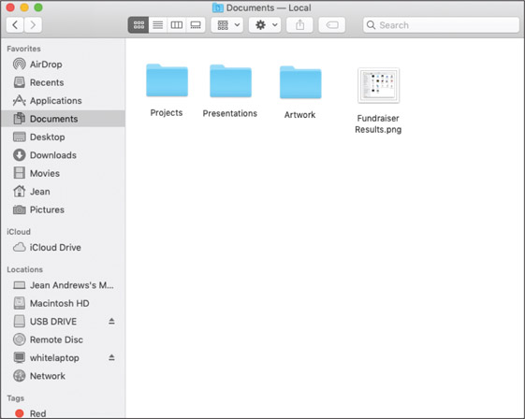
Source: Apple Inc.
Figure 18-6
Utilities to support a Mac are in the Utilities folder under Applications in the Finder window
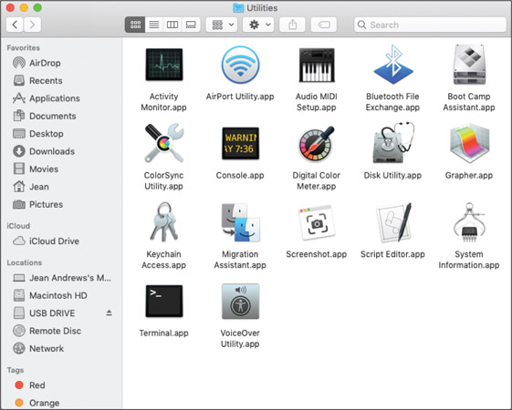
Source: Apple Inc.
Notes
If you use an app frequently, such as GarageBand, you can add it to the dock or desktop. In Finder, click Applications and then click and drag the app’s icon to the dock or desktop. To remove an icon from the dock or desktop, click and drag the icon to the Trash icon.

Launchpad
Launchpad (see Figure 18-7), which is somewhat similar to a combination of the Windows Start menu and Programs and Features window, shows all apps installed on the computer. Use one of these methods to open Launchpad:
- Use the dock. Click the Launchpad icon in the dock.
- Use a gesture. Pinch with three fingers and your thumb on the trackpad.
- Use a key. Press the Launchpad key at the top of the Mac keyboard.
Figure 18-7
View all installed apps in Launchpad; when more apps are installed, Launchpad creates additional screens to the side
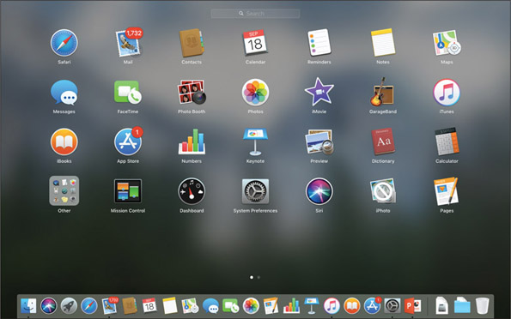
Source: Apple Inc.
In the Launchpad window shown in Figure 18-7, notice the two dots above the dock, which indicate that Launchpad requires two screens to show all installed apps. Swipe left or right with two fingers to move through the screens.
Here are tips on how to use Launchpad:
- Click an app to open it, which also closes Launchpad.
- To uninstall an app, press and hold the option key, which causes the app icons to jiggle. Click an X on an icon to uninstall its app. You can also rearrange jiggling icons, similar to how an iPad and iPhone work. Release the option key when you’re done.
- To close Launchpad and return to the desktop, use a pinch gesture with three fingers and your thumb spread apart.

Apple Menu
The menu at the top of the macOS screen changes with each application that is active except for the Apple icon, which is always shown at the far left of the menu bar. The Apple menu (see Figure 18-8) opens when you click the Apple icon. Use the Apple menu to put the computer to sleep, log out, restart, or shut down the system.
Figure 18-8
The Apple menu is always available no matter which application is active
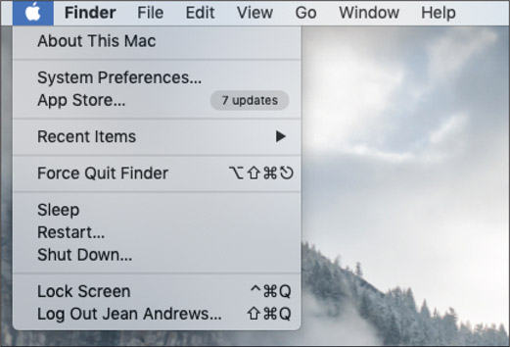
Source: Apple Inc.
The Apple menu also provides access to system information, system preferences, the App Store, recent items, and the Force Quit option. Similar to ending a task from Task Manager in Windows, you can force quit an app by clicking Force Quit. In the Force Quit Applications window (see Figure 18-9), select the app and click Force Quit. The application closes. You can also access the Force Quit Applications window by pressing command ()-option-esc.
Figure 18-9
Force Quit can be used to close an app that is not responding
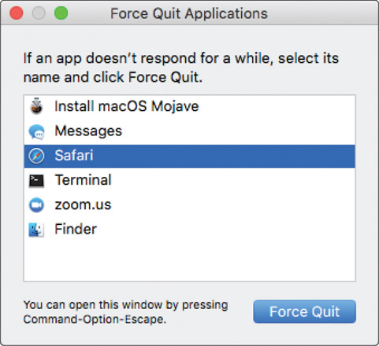
Source: Apple Inc.

System Preferences
The System Preferences window is used to change and customize macOS settings and is similar to the Settings app in Windows 10. It can be opened from the Apple menu (refer back to Figure 18-8) or from the System Preferences icon in the dock (see Figure 18-10). The System Preferences window is shown in Figure 18-11.
Figure 18-10
The System Preferences icon in the dock shows the app is open
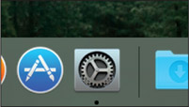
Source: Apple Inc.
Figure 18-11
The System Preferences window is used to customize the macOS interface
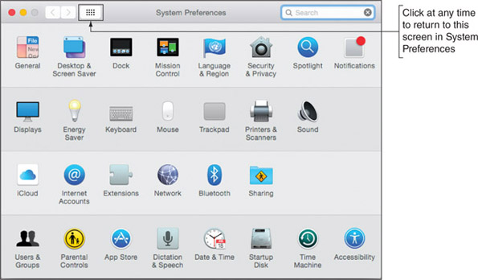
Source: Apple Inc.
Click an icon in System Preferences to change settings for that tool, feature, or app. As an IT technician, here are a few important tools you might use in System Preferences:
- Trackpad. Click Trackpad to adjust trackpad gestures.
- iCloud. Set up an iCloud account on this computer, choose what content to sync to iCloud and iCloud Drive, and adjust account details.
- Time Machine. Use Time Machine to configure backups.
- Users & Groups. Add and remove users and change startup items for a user.
- Sharing. Share the Mac’s screen, files, and printers, and allow remote login and management of the computer.
- Network. Change network settings, including TCP/IP settings for Bluetooth, Wi-Fi, and Ethernet connections. (For Mac laptops, Ethernet connections are often made via the multipurpose Thunderbolt port using a Thunderbolt to Gigabit Ethernet adapter.)
- Spotlight. Change settings for Spotlight, the macOS search utility. You can control where Spotlight searches and its keyboard shortcuts.

Spotlight
If you’re having a problem locating a file or folder, Spotlight can search for it. To open Spotlight, click the search icon on the right side of the menu bar or press command () + spacebar. In the Spotlight search box (see Figure 18-12), type the name of the file, folder, or text you want to find. For example, if you type Projects, Spotlight lists a folder named Projects as the Top Hit (see Figure 18-13).
Figure 18-12
Spotlight searches the local computer and online resources
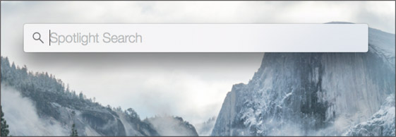
Source: Apple Inc.
Figure 18-13
Use Spotlight to search for files and folders
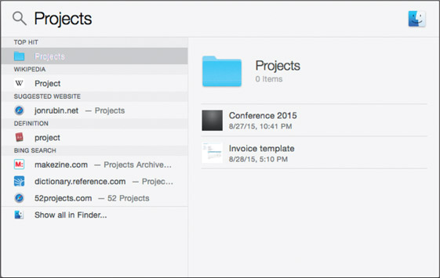
Source: Apple Inc.
Notes
When you no longer need a file or folder, drag its icon to the Trash icon until the Trash is highlighted, and release the icon. When an item is in the Trash, you can recover it: Click Trash to open it and drag an item in the Trash to another location. To empty the trash, click Finder in the menu bar and click Empty Trash.

Mission Control and Multiple Desktops
Mission Control gives you a quick view of all open windows and desktops and lets you switch among them. The macOS includes a feature called multiple desktops, which as its name indicates, is several desktop screens, each with its own collection of open windows. Suppose you’re working with several windows for a school project, and you have a few more windows open for a project at work. You can place the school project windows on one desktop, called a Space, and place the work project windows on a separate desktop or Space.
To accomplish this, first open Mission Control using one of these methods:
- Press the Mission Control key.
- Click Mission Control in the Launchpad window.
- Swipe up with three or four fingers on your trackpad.
A Mission Control window is shown in Figure 18-14. Three desktops have been created on the system, as you can see in the Spaces bar at the top of the window. Also, when an app is in full-screen mode, it acts as a separate Space and shows up in the Spaces bar along with desktops. To create a new desktop, drag an open window into the Spaces bar or click + on the right side of the Spaces bar. To delete a desktop, hover over it in the Spaces bar and click the X. Desktop configurations apply to each user and remain in place even when the computer is rebooted.
Figure 18-14
Mission Control allows you to create multiple desktops to contain windows
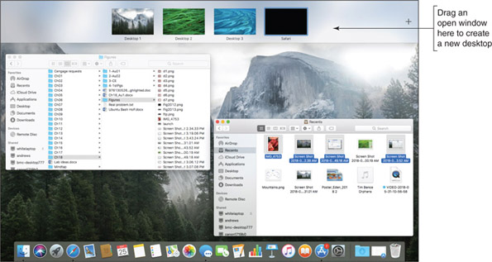
Source: Apple Inc.
Here are a few more tips about multiple desktops:
- Move among desktops. To move among desktops as you work, swipe left or right with three fingers or press control + left arrow or control + right arrow.
- Organize desktops. To help keep your desktops organized, it helps to customize each desktop with a different wallpaper. Go to a desktop and secondary-click. In the menu that appears on the desktop background, click Change Desktop Background (see Figure 18-15A). The Desktop & Screen Saver window opens. (This window is one of the tools in System Preferences.) Select your wallpaper and close the window. Wallpaper settings in other existing desktops won’t be affected.
- Organize apps in desktops. To help keep your apps organized, you can assign an app to a specific desktop. Go to that desktop and secondary-click the app’s icon in the dock (see Figure 18-15B). Select Options and then click This Desktop. Later, when you open the app, the selected desktop will appear with the app’s open window.
Figure 18-15
(A) Set a different background for each desktop, and (B) assign different apps in the dock of each desktop
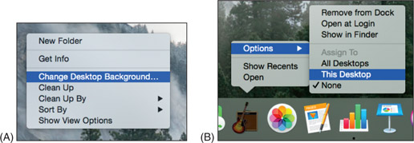
Source: Apple Inc.

iCloud and iCloud Drive
Looking back at the Finder window shown earlier in Figure 18-5, notice that iCloud Drive is listed in the sidebar along with other storage locations such as Desktop, Documents, and Downloads. When a user signs in to macOS for the first time, she is given the opportunity to set up iCloud with her Apple ID, or the setup can be done later in System Preferences. In System Preferences, you can also control which apps store their data in iCloud (see Figure 18-16).
Figure 18-16
Choose what content to sync with iCloud
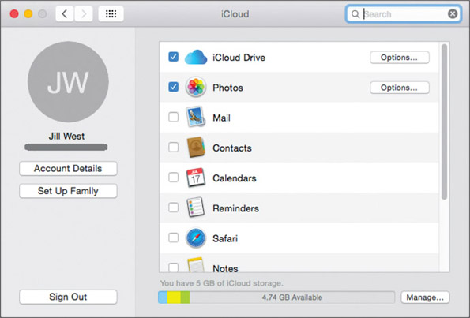
Source: Apple Inc.
To open iCloud Drive, click it in the Finder window or in Launchpad. Drag and drop files in and out of the iCloud Drive window. The contents are synced with any iPhone, iPad, or Windows desktop that has the iCloud Drive app installed, or with another device that is set up with your Apple ID. (On iPhone and iPad, recall that you can manage iCloud Drive using the Files app.) You can also access your iCloud content, including iCloud Drive, from any device with a browser by going to icloud.com and signing in with your Apple ID.

Keychain
Keychain is the macOS built-in password manager. To open Keychain, go to the Finder window, drill down into the Applications list, and then click Utilities (refer back to Figure 18-6). Double-click Keychain Access app. From the Keychains window (see the left side of Figure 18-17), you can view, edit, and remove accounts for applications, websites, and servers. You can also manage personal accounts that you’ve added, such as credit card and bank accounts.
Figure 18-17
The data stored in Keychain is encrypted
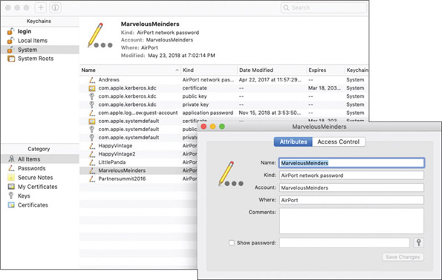
Source: Apple Inc.
If you have problems with Keychain, you can delete all saved passwords and restore from backup. In the Keychain Access menu, click Preferences. In the Preferences box, click Reset My Default Keychains. New, empty Login and Local Items keychains are created. If you have Time Machine backups, try to restore the keychains from backup.

Screen Sharing
In System Preferences, click Sharing to open the Sharing window, where you can set up file and folder sharing on the network, printer sharing, remote access, and screen sharing. Screen Sharing works like Remote Desktop in Windows. In the Sharing window (see Figure 18-18), turn on Screen Sharing and set it up to allow all users or only certain users that you add.
Figure 18-18
Screen Sharing makes it easier to collaborate on projects or to help other users with their computers
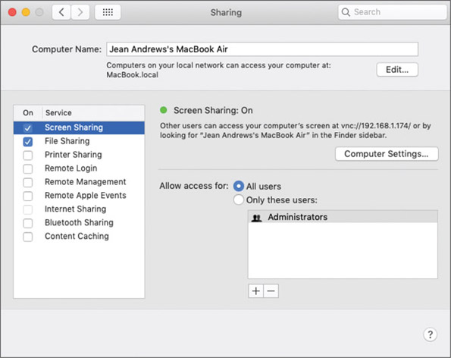
Source: Apple Inc.
To use screen sharing, a user of another Mac on the network should be able to see your shared Mac in his Finder window in the Shared group. He can click your computer and then click Share Screen. He then has the opportunity to sign in to your computer with a user name and password recognized by your computer. Using screen sharing, he can move files and folders between the two computers.
Notes
Screen Sharing uses incoming port 5900. To access a Mac from the Internet, set up port forwarding on your router to allow incoming traffic on port 5900.
How secure is macOS screen sharing? Some of the content moved between computers is encrypted and some is not, and you must open an incoming port on your router. Therefore, macOS screen sharing is not as secure as other types of remote access software. Also, as you’ll recall from Chapter 13, third-party remote access apps that use a browser are considered more secure than OS tools that open ports for incoming traffic initiated from the Internet. Two examples of apps that use browsers and provide encrypted communication are join.me (join.me) and Zoom (zoom.us).

Remote Disc
If your Mac has an optical drive, the Sharing window includes the option DVD or CD Sharing. This feature, called Remote Disc, gives other Mac computers on the network access to the computer’s optical drive. Remote Disc is especially useful when you need to install software or drivers from a disc on a Mac that doesn’t have an optical drive. After you turn on DVD or CD Sharing on a Mac that has an optical drive, go to the Mac that doesn’t have an optical drive and open Finder. In Finder, click Remote Disc in the sidebar under Locations (refer back to Figure 18-5).
Notes
You can enable remote disc sharing on a Windows computer. To share a Windows computer’s optical drive with Macs on your network, download and install DVD or CD Sharing Update 1.0 for Windows, which is available at support.apple.com/kb/DL112?locale=en_US.

Terminal
Terminal in macOS is similar to a command prompt window in Windows, except Terminal uses UNIX commands because macOS is based on UNIX. To open Terminal, open Finder, click Applications, and double-click the Utilities folder. Scroll down and double-click Terminal. The Terminal window opens, as shown in Figure 18-19. Many of the Linux commands you learn about later in this chapter work in the macOS Terminal.
Figure 18-19
Terminal in macOS uses most of the same commands as Linux
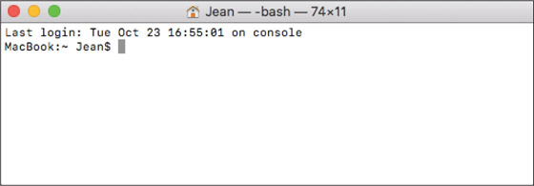
Source: Apple Inc.

Summary of Gestures and Keystrokes
We finish up this part of the chapter with Table 18-1, which lists shortcuts and gestures you might find helpful when supporting a Mac. You’ve already learned to use several of these.
Table 18-1

Useful Keystrokes, Substitute Keys, and Gestures
Keystrokes, Substitute Keys, and Gestures | Description
Keystrokes
command-x | Cut the selected item.
command-c | Copy the selected item.
command-v | Paste the selected item.
command-a | Select all items.
option-command-esc | Force quit an app.
command-spacebar | Open Spotlight.
shift-command-5 | Take a screenshot of the entire screen or part of the screen. By default, screenshots are saved to the desktop.
Substitute keys when using a regular keyboard instead of a Mac keyboard
command key | The Windows logo key or Control key is the substitute.
option key | The Alt key is the substitute.
Gestures (gesture actions can be changed in the trackpad app’s System Preferences)
Secondary-click | Tap the trackpad with two fingers.  Optional actions are:  - Tap the bottom-right corner of the trackpad.  - Tap the bottom-left corner of the trackpad.  - With a mouse, right-click.
Swipe | Swipe left or right with three fingers to move among desktops. On a keyboard, press control + right arrow and control + left arrow.
Scroll | Swipe up or down with two fingers.
Zoom | Pinch in or out with two fingers.
Pinch | Pinch in with three fingers and thumb to show Launchpad. Do a spread-apart pinch with three fingers and thumb to return to the desktop. If you are already on the desktop, a spread-apart pinch pushes all open windows to the edges to clear the desktop.
Go to pg.
help
Application Opened
Main content

18-1bMaintaining and Supporting macOS
A+ Core 2
- 1.3
Summarize general OS installation considerations and upgrade methods.
- 1.9
Given a scenario, use features and tools of the Mac OS and Linux client/desktop operating systems.
In addition to working with files and applications, you also need to know how to support and maintain macOS, including updates, backups, and hard drive maintenance. This section will give you a good foundation for these skills. To dig deeper into how to support a Mac, search the documentation on the Apple website (support.apple.com).
Caution
Many Apple computers are covered by an Apple Care warranty, which provides excellent coverage for Macs. Always be absolutely certain that a Mac is not covered by Apple Care before opening the case or doing anything else that might void the warranty.

macOS Directory Structures
You need to be familiar with the directory structure in macOS so you know where to look for what. Here are some tips:
- To see the directory structure, click Go on the Finder menu bar and then click Computer. In the Finder window, click the hard drive, which is labeled Macintosh HD in most systems. In Figure 18-20, you can see the five folders at the root level. (Other folders in the root are hidden.) User data is in the Users folder.
Figure 18-20
Folders visible in the root of the hard drive
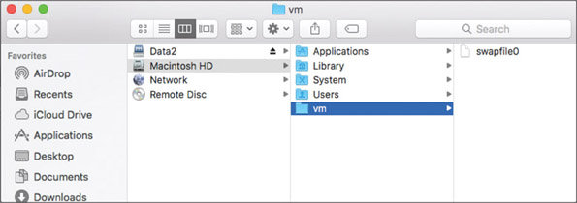
Source: Apple Inc.
- Notice the vm folder is selected, and it contains a single file, swapfile0. This swapfile is used to hold virtual memory, similar to pagefile.sys in Windows.
- You can also browse the directory structure using the Terminal and Linux commands. In Finder, open Applications, open Utilities, and double-click Terminal. Use the cd command to move through the directory structure and the ls command to list files and directories. For example, Figure 18-21 shows the root directory of the Macintosh HD. Compare Figure 18-20 with Figure 18-21 and notice that some folders that appear in the Terminal window are hidden in the Finder window. You learn more about these directories later in this chapter.
Figure 18-21
Contents of the root directory on a Mac hard drive
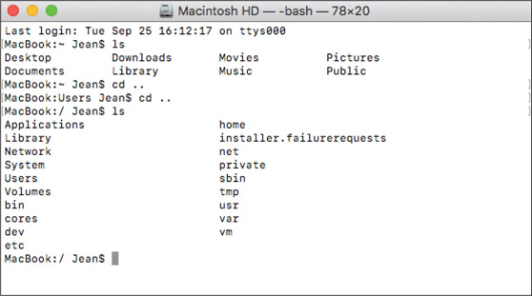
Source: Apple Inc.

Update macOS, Drivers, and Firmware
Just like Windows, macOS needs regular updates. Updates often address zero-day vulnerabilities, which makes these updates important to maintaining a healthy system. However, sometimes the updates themselves introduce bugs, which is why many Mac experts advise against setting macOS updates to install automatically. Instead, wait a few days after a macOS update is released before manually installing the update; this gives you a chance to see if the update introduces any significant issues.
macOS updates come from the App Store. To manually update macOS, click the App Store icon in the dock, then click Updates in the left pane. See Figure 18-22. Any available OS updates will be shown near the top of the screen. Additional updates to apps might also be available in this window.
Figure 18-22
The Updates window shows available updates and recently installed updates
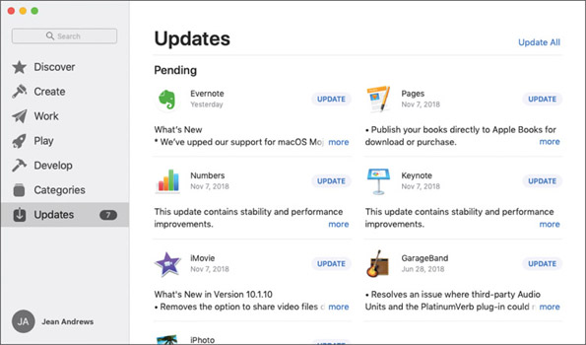
Source: Apple Inc.
Notes
Printer, scanner, and graphics driver updates are usually included in macOS updates. Other devices that require drivers, if not included in macOS, can be downloaded from the manufacturer’s website and installed. These drivers will not be updated through macOS updates. If any problems are encountered with these devices, you’ll need to check the manufacturer’s website for updates.
To change the settings for automatic updates, open System Preferences and click Software Update. The OS checks for and reports available updates. For automatic updates, check Automatically keep my Mac up to date. To change detailed update settings, click Advanced (see Figure 18-23). Here is an explanation of each option:
- Check for updates. Automatically check for updates.
- Download new updates when available. Download updates without installing them.
- Install macOS updates. Install all updates to the operating system without first requiring user approval.
- Install app updates from the App Store. Install all updates to App Store applications without first requiring user approval.
- Install system data files and security updates. Install critical system patches that address known vulnerabilities.
Figure 18-23
Manage how automatic updates are handled
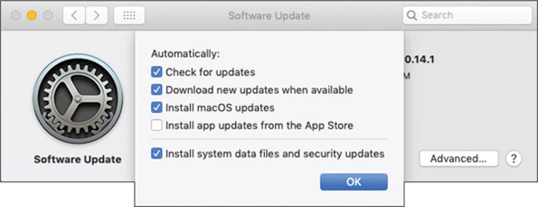
Source: Apple Inc.
Usually any needed firmware updates are included in the macOS update. Occasionally, however, Apple has released a firmware update as a stand-alone installation. You can find a list of available firmware updates in the Apple Knowledge Base Article at support.apple.com/en-us/HT201518.
To determine whether a Mac computer needs a firmware update, first check the current firmware version on the computer. This and a great deal more information is available in the System Information app. Open Finder, navigate to the Utilities folder, and double-click System Information. In the System Information window (see Figure 18-24), select Hardware in the sidebar and look under Hardware Overview for the Model Identifier, Boot ROM Version, and SMC Version (system). Compare the information in the System Information window with the information for the latest firmware update available on the support.apple.com website. Install a firmware update only if the version listed on Apple’s website is newer than what’s installed on the computer.
Figure 18-24
The System Information window gives detailed information about the computer
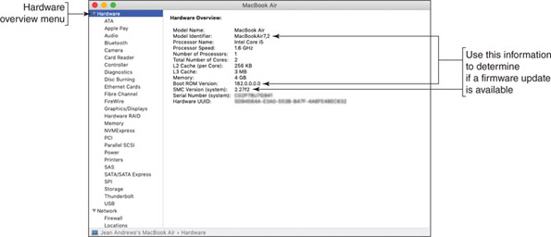
Source: Apple Inc.
Notes
The System Information app can also be opened from the Apple menu. Click the Apple icon, then click About This Mac, which gives an overview of the computer’s system information, as shown in Figure 18-25. Then click System Report to open the System Information window that you saw in Figure 18-24.
Figure 18-25
Click System Report to go to the System Information window for more detailed information
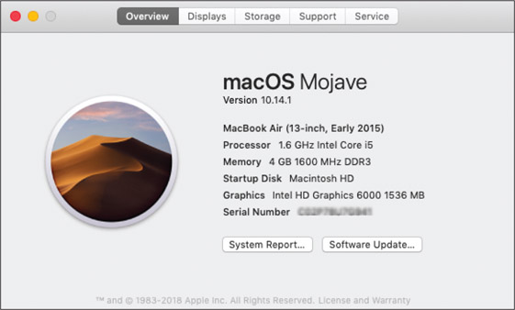
Source: Apple Inc.
Notes
Although Macs are not attacked by malware as often as Windows systems, it’s still important to protect a Mac by installing and maintaining anti-malware software. Products to consider are Avast Free Mac Security (avast.com), Sophos Home Premium for Mac (sophos.com), and Trend Micro Antivirus for Mac (trendmicro.com/mac).

Back Up and Restore with Time Machine
Like iOS mobile devices, Mac computers can use iCloud Drive to store files and folders in the cloud and sync this content across all of your devices. Unlike the mobile devices you learned about in Chapter 9, iCloud is not sufficient for backing up a Mac. For this purpose, macOS includes Time Machine, which is a built-in backup utility that automatically backs up user-created data, applications, and the entire macOS system. You can back up to:
- An external USB or Thunderbolt hard drive or a USB flash drive
- Another Mac on the local network
- Network-attached storage (NAS) devices that support Time Machine
Once Time Machine is set up, backups are updated in the background. Depending on the space available on the backup drive, Time Machine keeps hourly backups for 24 hours, daily backups for a month, and weekly backups until the disk is full. The oldest backups are deleted to make space for new backups. You can also set up multiple backup schedules to more than one backup device.
To set up Time Machine in macOS, open System Preferences and click Time Machine. The Time Machine window appears, as shown in Figure 18-26.
Figure 18-26
Configure Time Machine backups
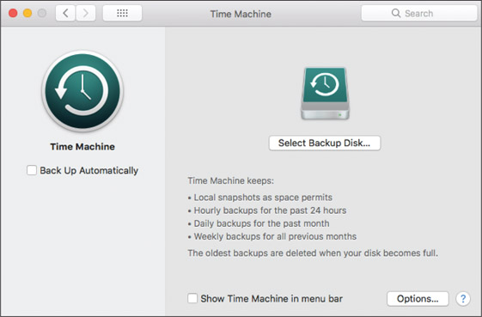
Source: Apple Inc.
Follow the on-screen directions to select a backup disk and configure backup options. Everything on the disk will be erased. The original backup will be at least 20 GB, includes the entire macOS volume, and takes some time to complete.
Notes
When your Mac is not connected to the backup disk, Time Machine stores backup copies, called local snapshots, of created, modified, or deleted files on the hard drive. When you reconnect the computer to the backup disk, the local snapshots are copied to the backup disk. Local snapshots stay on the hard drive as long as they don’t take up too much space, and can be restored from the hard drive if needed. Time Machine saves one snapshot each day and one weekly snapshot for each week the backup disk is disconnected.
You can use the backups to recover files, folders, or the entire macOS volume. To recover a file or folder from Time Machine, open Finder. In the Applications group, double-click Time Machine. The timeline and available backups in Finder appear (see Figure 18-27). Use the Finder window to locate the file or folder. Then go back through time to find the version of the file or folder you want to restore. To move through time, you can use the timeline on the right, the arrow buttons, or click a Finder window in the stack of available windows. Select the item and click Restore.
Figure 18-27
Locate an item and then go back through time to find the version to restore
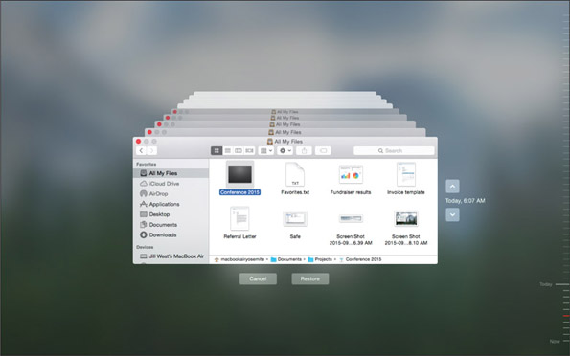
Source: Apple Inc.
Later in this chapter, you learn how to use Time Machine to restore the entire macOS startup disk, which is the volume on which macOS is installed.

Drive Maintenance Tools
Hard drives in Mac computers require very little maintenance. However, performing a few simple tasks on a regular basis can help keep things running smoothly:
- Empty the trash. To empty the Trash, click the Trash icon in the dock. Trash contents appear in a Finder window (see Figure 18-28). Click Empty and then click Empty Trash in the warning box. Items are permanently deleted.
Figure 18-28
Check the contents of the Trash Can before emptying it
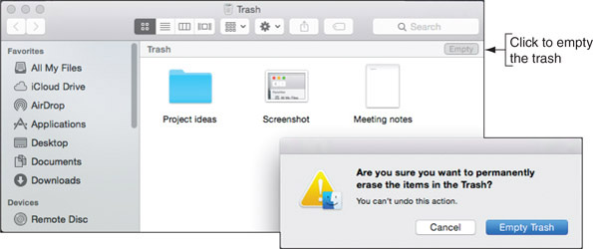
Source: Apple Inc.
- Free up space. Maintain at least 15–20 percent free space on the hard drive for optimal performance. To see how much free space is available on the drive, open the Apple menu, click About This Mac, and then click the Storage tab, as shown in Figure 18-29.
Figure 18-29
Maintain at least 15 percent free space on the hard drive
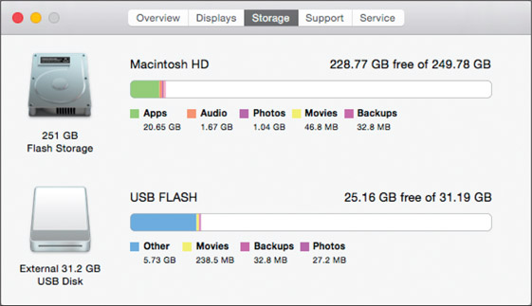
Source: Apple Inc.
- Install updates. Regularly check for and install macOS and app updates, which you learned to do earlier in this chapter.
- Verify no startup items. Programs that automatically launch at startup are called startup items and programs that automatically launch after a user logs in are called login items. Apple discourages the use of startup items because they slow down the startup process and items in the startup folder might be malware. You can verify that the system doesn’t have startup items by looking in two directories that can contain them: /Library/StartupItems and /System/Library/StartupItems (see Figure 18-30).
Figure 18-30
For best performance, the StartupItems folder should remain empty
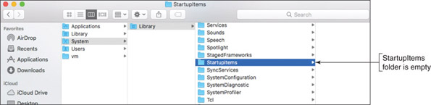
Source: Apple Inc.
- Remove login items. Launching too many programs at login slows down the boot process and uses up valuable RAM. To adjust login items, open System Preferences and click Users & Groups. Select a user account in the sidebar, and then click the Login Items tab (see Figure 18-31). Use the + and − buttons at the bottom of the items list to add or remove login items.
Figure 18-31
A list of login items applies to each user
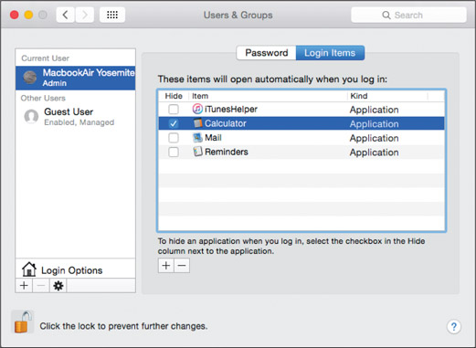
Source: Apple Inc.
- Restart the computer. Power cycle the computer at least once a week. A quick way to do so is to click Restart in the Apple menu (refer back to Figure 18-8).
- Uninstall unneeded apps. Uninstall apps you no longer need. Apps obtained from the App Store are uninstalled from Launchpad. For apps installed from other sources besides the App Store, locate the app in Finder and drag the app to the Trash. Empty the trash to complete the uninstall.

Repairs Using the Disk Utility App
The Disk Utility app can be used to repair file system errors and hard drive corruptions. To open Disk Utility, open Finder and navigate to the Utilities folder. Double-click Disk Utility. In the sidebar, select Macintosh HD (see Figure 18-32) and click Info in the menu bar to view information about the drive.
Figure 18-32
Manage drives from the Disk Utility app
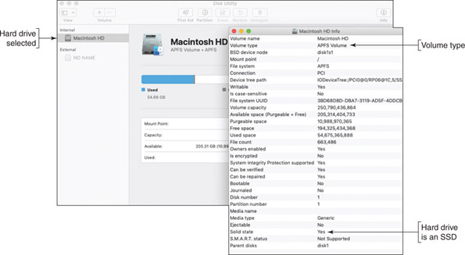
Source: Apple Inc.
In the Info box shown on the right side of Figure 18-32, you can see the drive is using the APFS file system. Here are the file systems macOS supports:
- APFS (Apple File System) is the default file system for SSDs and can also be used for magnetic hard drives. APFS allocates free space as needed for each volume on the drive. APFS uses the GUID (also called GPT) partitioning system.
- Mac OS Extended file system, also called HFS+ (Hierarchical File System Plus), is an older file system in macOS 10.12 and earlier versions that uses a proprietary Apple partitioning system. If the Mac OS Extended file system is installed on an SSD and the system is upgraded to High Sierra, the upgrade converts the file system to APFS because it better manages an SSD. When upgrading to Mojave, the file system is always upgraded to APFS. However, APFS is not compatible with some earlier versions of macOS.
- The FAT32 and exFAT file systems are supported for compatibility with Windows and Linux.
Notes
Windows cannot read from storage devices that are using the APFS or Mac OS Extended file system unless third-party drivers are installed in Windows. For example, HFS Explorer can be installed to allow Windows to read a volume using the Mac OS Extended (also called HFS) file system.
You can use First Aid in Disk Utility to scan the hard drive for file system errors and repair them. In Disk Utility, select the drive in the sidebar, click First Aid, and click Run in the box that appears. A warning box reports that apps will be frozen while the drive is repaired. Click Continue. The process can take some time. Click Done when it completes.
Notes
If you plug in an external hard drive and macOS does not recognize the drive, you can use Disk Utility to fix the problem. In the Disk Utility window, select the drive and click Mount. If the mount does not work, click First Aid and then try to mount the drive again. When you mount a drive, it can be viewed by the OS, the drive is listed in the sidebar of the Finder window, and its icon appears on the desktop.
Go to pg.
help
Application Opened
Main content

18-1cTroubleshooting macOS Startup
A+ Core 2
- 1.9
Given a scenario, use features and tools of the Mac OS and Linux client/desktop operating systems.
When you have problems with macOS startup, use the options discussed in this part of the chapter to diagnose and fix the problems. These options are summarized in Table 18-2. Turn on the Mac and press certain keys at startup to launch tools or boot from other media. Release the keys as soon as you see the Apple logo.
Table 18-2

Keys to Press to Access Mac Startup Options
Keys to Press as a Mac Boots | Tools Launched
Hold down shift key | Boots into Safe Mode
Hold down option key | Displays the Startup Manager so you can choose to boot from different media (for example, the external hard drive, USB flash drive, or network locations)
Hold down d key | Launches Apple Diagnostics to perform tests on hardware
Hold down command+r | Launches macOS Recovery to reinstall macOS from a Time Machine backup or the Internet
Notes
Many of these same steps can also help when troubleshooting kernel panics. A kernel panic is similar to a BSOD in Windows. It might be caused by something simple, such as a crashed app or a network communication issue, or it might result from a corrupted macOS installation. macOS restarts automatically when experiencing a kernel panic. If the kernel panic continues to prompt restarts, macOS will stop trying after five attempts and shut down the computer.

Safe Mode
Starting the computer in Safe Mode can solve problems when the computer won’t start due to file system errors or corrupted startup or login items. Safe Mode in macOS loads essential kernel components, prevents startup items and login items from launching, and loads a minimum of user processes. It also verifies the startup disk and repairs any file system errors it finds.
To boot into Safe Mode, hold down the shift key as a Mac starts up. To verify that the computer booted into Safe Mode, open System Information. In the Software group, look for Boot Mode, which should report Safe (see Figure 18-33).
Figure 18-33
Boot Mode indicates the computer is booted into Safe Mode
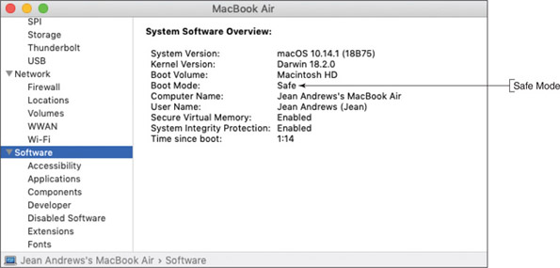
Source: Apple Inc.
Do these things in Safe Mode:
- When Safe Mode starts, it automatically attempts to fix many problems. Restart the computer normally and see whether the problem is solved.
- Delete startup and login items that you suspect are causing a problem.

macOS Recovery
Using the macOS Recovery tools, you can reinstall macOS from a Time Machine backup or from the Internet. You can also erase the hard drive before you perform the image recovery. Turn on the Mac and press and hold command+r until you see the Apple logo. macOS Recovery launches and you see the macOS Utilities menu (see Figure 18-34).
Figure 18-34
Boot into macOS Recovery to reinstall macOS
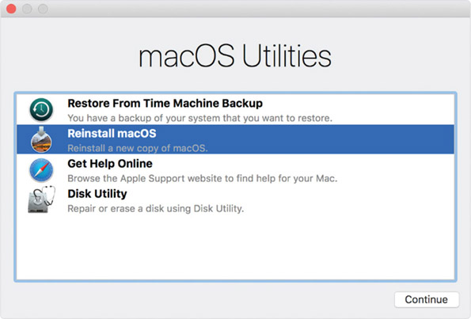
Source: Apple Inc.
After you select an option, click Continue. Here are the options you’ll see:
- Restore From Time Machine Backup. Plug in the external hard drive that holds the Time Machine backup, then select this option and follow the on-screen directions.
- Reinstall macOS. The latest macOS that was installed on the computer is downloaded from the Internet and reinstalled. As you follow the on-screen directions, the computer will reboot several times. If errors occur during the process, try erasing the hard drive and reinstalling again. After the new installation of macOS boots up, any data backed up with Time Machine can be restored.
- Disk Utility. If you need to erase the hard drive (for example, before you give away a Mac), select Disk Utility and follow the on-screen directions.
Suppose you are attempting to reinstall macOS from the Internet and you are not able to get an Internet connection through Wi-Fi or Ethernet. In this situation, you can use another Mac to create a bootable installation device and use it to reinstall macOS. This bootable device is created using commands in the Terminal window and is not covered in this text. The commands and process can be found at support.apple.com/en-us/HT201372.

Startup Manager and NetBoot
When you press the option key at startup, the Startup Manager screen appears and allows you to select your boot device. See Figure 18-35.
Figure 18-35
Startup Manager allows you to select a startup disk or network startup
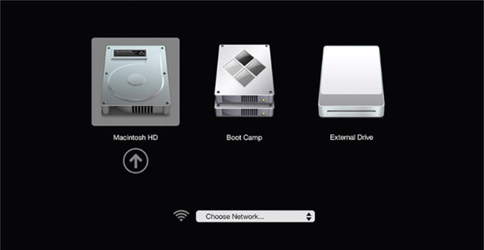
Source: https://support.apple.com/en-us/HT202796
If you want to boot to a deployment server on the network to reinstall macOS from a disk image, you will use the Apple technology called NetBoot. NetBoot searches for a disk image stored in a DMG file on the server. A DMG file is a disk image file for a Mac and is similar to WIM or ISO files in Windows. In addition to storing clones of the macOS, DMG files are often used to hold app installers, as are EXE files in Windows.

Boot Camp
Notice in Figure 18-35 the option to start the computer using Boot Camp, which is an Apple technology that allows you to install and run Windows on a Mac. If the hard drive on a Mac is using a single partition with at least 40 GB of free space, Boot Camp can split the partition and install Windows in the new partition for a dual boot. Access the Boot Camp Assistant through the Utilities folder; Figure 18-36 shows the first screen, which includes a warning to first back up your disk before installing Windows on a Mac. After Windows is installed, you can choose which OS to use as your default for the computer, or you can press and hold the option key when starting the computer to reach the Startup Manager, which lets you choose from the installed operating systems. (Although you can install Windows on a Mac, you cannot install macOS on a non-Apple computer.)
Figure 18-36
Use Boot Camp Assistant to install Windows on a Mac and manage the Windows installation
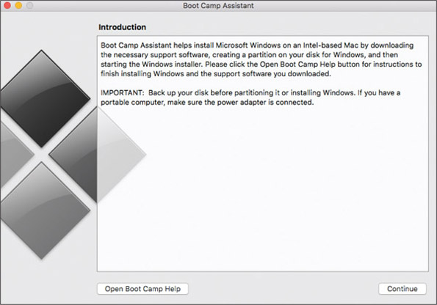
Source: Apple Inc.
Go to pg.
help
Application Opened
Main content

18-2Linux Operating System
A+ Core 2
- 1.3
Summarize general OS installation considerations and upgrade methods.
- 1.9
Given a scenario, use features and tools of the Mac OS and Linux client/desktop operating systems.
- 4.9
Given a scenario, use remote access technologies.
A variation of UNIX is Linux (pronounced “Lih-nucks”), an OS created by Linus Torvalds when he was a student at the University of Helsinki in Finland. Basic versions of this OS are open source, and all the underlying programming instructions (called source code) are freely distributed. Linux is popular because it’s inexpensive and very stable (it seldom crashes). Linux is used as an OS for desktops, servers, mobile devices, and IoT devices. It’s the most popular OS for server applications such as web servers and email servers. In addition, Android and Chrome OS for mobile devices are based on Linux, and bootable CDs and flash drives that contain utility software often use Linux. Versions of Linux are called distributions or flavors; the more popular ones for desktops and servers are listed in Table 18-3. Hardware requirements for Linux vary widely by distribution.
Table 18-3

Popular Linux Distributions for Desktops and Servers
Name | Comments | Website
Arch Linux | Arch Linux must be manually configured. It has excellent online documentation and community support, and Linux professionals appreciate its simplicity. | archlinux.org
Fedora | Fedora has been around for a long time and is backed by a stable company. When updates are released, they tend to work well without errors. It’s a great distribution for just about any OS purpose. | getfedora.org
Linux Mint | Linux Mint is based on Ubuntu with several features added. | linuxmint.com
openSUSE | openSUSE is made for servers, desktops, and mobile devices. Applications install without a hassle; go to software.opensuse.org, select an app, and perform a Direct Install. | opensuse.org
Red Hat Enterprise Linux | Designed for enterprise use on servers and workstations, this commercial distribution is stable and comes with long-term support. The free version of Red Hat Enterprise is CentOS, which comes with no support. | redhat.com
Ubuntu | Ubuntu is one of the most popular distributions of Linux for desktops and servers, and it comes with tons of online tutorials and help. | ubuntu.com
Notes
For more information on Linux, see linux.org as well as the websites of the different Linux distributors.
Linux itself is not a complete operating system but is only the kernel for the OS. You also need a shell for user and application interfaces, and Linux shells vary widely by distributions. Many distributions of Linux include a GUI shell or desktop, which is called a windows manager. For example, Figure 18-37 shows the desktop or windows manager for Ubuntu Desktop. Some distributions of Linux designed for server applications don’t have a windows manager. For example, Ubuntu Server installs with only a command-line interface. In this chapter, we use Ubuntu Desktop and Ubuntu Server as our sample Linux distributions.
Figure 18-37
Ubuntu Desktop with the Mozilla Firefox browser window open
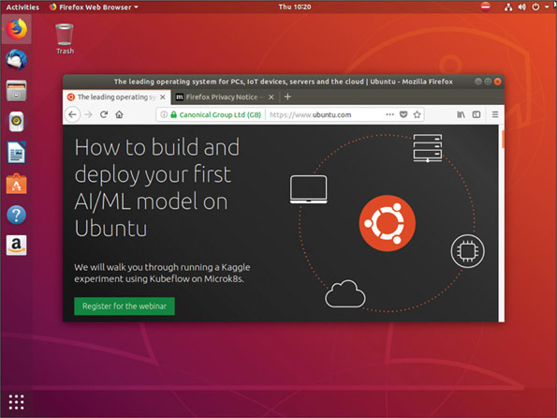
Source: Canonical Ltd.
You can install Ubuntu Desktop or Ubuntu Server in a VM or on a hard drive, CD, or USB flash drive. When you install Ubuntu on a CD or USB flash drive, it is called a Live CD or Live USB. A Live CD or USB can boot up a live version of Linux, complete with Internet access and all the tools you normally have available in a hard drive installation of Linux, but without installing the OS on the hard drive. In Chapter 5, you created a Live USB that can be used to test a computer when it cannot boot from the hard drive where Windows is installed.
Let’s first install and explore Ubuntu Desktop with its graphical interface, and then you’ll learn to install and use Ubuntu Server with its command-line interface.
Applying Concepts

Installing Ubuntu Desktop in a VM
Follow these steps to install Ubuntu Desktop in a VM:
- Recall that you learned how to install a hypervisor and create a VM in Chapter 12. If you don’t already have a hypervisor installed, install one that you can use to manage VMs. For example, in 64-bit Windows 10 Pro, you can use the Programs and Features window to enable Client Hyper-V, which comes embedded in the OS. Alternately, you can download and install one of these free hypervisors:
  - Oracle VirtualBox at virtualbox.org/wiki/Downloads
  - Windows Virtual PC at microsoft.com/en-us/download/details.aspx?id=3702
  - VMware Workstation Player at my.vmware.com/web/vmware/free#desktop_end_user_computing/vmware_workstation_player/12_0
- Go to ubuntu.com/download/desktop and download the free Ubuntu Desktop OS to your hard drive. The file that downloads is an ISO file.
Notes
Ubuntu Desktop is only available as a 64-bit OS. To install a 64-bit guest OS in a VM, the host OS must also be 64-bit.
- Open the Hyper-V Manager, Oracle VM VirtualBox, Virtual PC Manager, or VMware Workstation Player manager. Create a new VM with at least 2 GB of RAM and at least a 25-GB virtual hard drive capacity. Mount the ISO file that contains the Ubuntu Desktop download to a virtual DVD in your VM.
- Start up the VM and install Ubuntu Desktop in the VM, accepting all default settings. Be sure to write down the name of the VM and your Ubuntu host name, Ubuntu user name, and password. When given the option, decline to install any extra software bundled with the OS. If needed, the software can be installed later.
Notes
If you need help learning to use your hypervisor of choice, try searching for some tutorial videos at youtube.com or on the hypervisor manufacturer’s website.
- When asked to restart the VM, first dismount (remove) the ISO file from the optical drive so that the VM boots to the hard drive. After Ubuntu Desktop launches, log in with your user name and password. Figure 18-38 shows the desktop with the Settings window active and the Network setting selected. To open this window, click the Apps button and then click Settings. When a window is active, its menu appears at the top of the screen. Also notice the System menu is displayed. To open the System menu, click the system icons area in the upper-right corner of the screen.
Figure 18-38
Ubuntu Desktop with the Settings window open
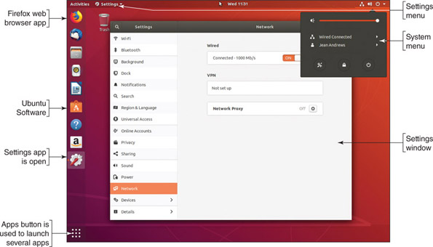
Source: Canonical Ltd.
- Take a few minutes to poke around the desktop. You’ll see how it resembles macOS in many ways. For example, to open a Terminal window where you can enter Linux commands, click Activities and type terminal in the search box. Then click Terminal in the list that appears. Using the Terminal, you can enter Linux commands to manage and support the OS.
- To shut down Ubuntu Desktop, click the system icons area in the upper-right corner of the screen. The System menu opens. Click the Power icon and click Power Off.
To learn more about using Ubuntu Desktop, an excellent source of information is the Ubuntu Desktop Guide at help.ubuntu.com/stable/ubuntu-help/.
Go to pg.
help
Application Opened
Main content

18-2aLinux Installs, Updates, and Backups
A+ Core 2
- 1.3
Summarize general OS installation considerations and upgrade methods.
- 1.9
Given a scenario, use features and tools of the Mac OS and Linux client/desktop operating systems.
- 4.9
Given a scenario, use remote access technologies.
When supporting a Linux system, an IT technician needs to know how to install software, update the OS and apps, and create and maintain scheduled backups. Here are a few details to get you started:
- Install software. To install software, click the Ubuntu Software button. Ubuntu Desktop software appears. Click an item and then click Install to start its installation. You can also install an app by clicking a setup file you have downloaded from the web.
- Update Ubuntu and apps. To update, click Updates in the Ubuntu Software window. Updates for Ubuntu are listed first, followed by app updates. Click Install beside the updates you want to install. Figure 18-39 shows that no updates are available.
Figure 18-39
Ubuntu Desktop is up to date
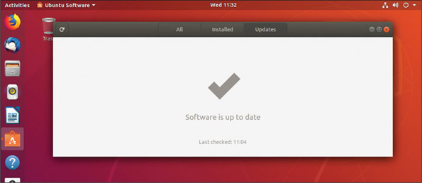
Source: Canonical Ltd.
- Change update settings. To change update settings, open the Software & Updates menu and click Software & Updates in the drop-down list. Then click the Updates tab in the Software & Updates window (see Figure 18-40).
Figure 18-40
Change how Ubuntu Desktop handles updates
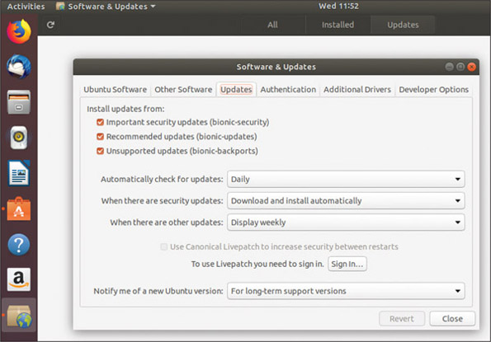
Source: Canonical Ltd.
- Configure backups. Click the Apps button. In the list of apps, scroll down and click Utilities (see Figure 18-41). Click the Backups utility. Using the Backups window (see Figure 18-42), you can schedule backups, decide where the backups are stored, and select which items are included in the backup.
Figure 18-41
Ubuntu Desktop utilities
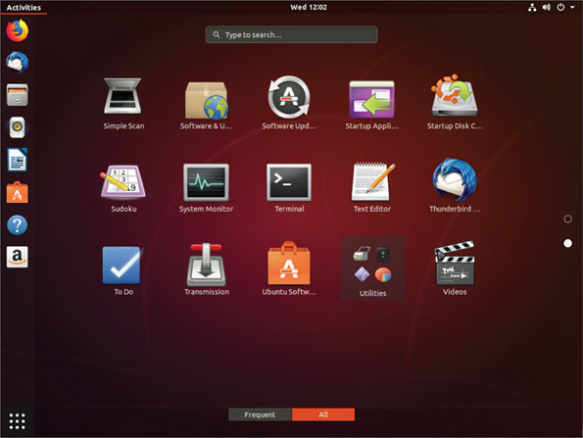
Source: Canonical Ltd.
Figure 18-42
Schedule an Ubuntu Desktop backup
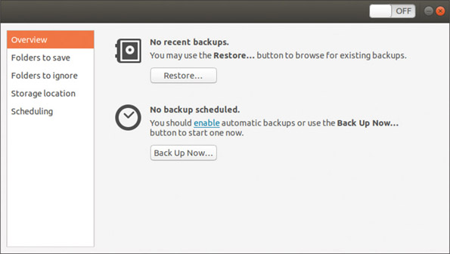
Source: Canonical Ltd.
Now that you know about Ubuntu Desktop, let’s turn our attention to Ubuntu Server.
Go to pg.
help
Application OpenedApplication Opened

18-2bInstalling and Exploring Ubuntu Server
A+ Core 2
- 1.3
Summarize general OS installation considerations and upgrade methods.
- 1.9
Given a scenario, use features and tools of the Mac OS and Linux client/desktop operating systems.
- 4.9
Given a scenario, use remote access technologies.
Ubuntu Server does not include a windows manager but uses a command-line interface called the terminal. The default shell for the terminal is the Bash shell, which stands for “Bourne Again Shell” and takes the best features from two previous shells, the Bourne and Korn shells. In this chapter, we use Ubuntu Server and its default Bash shell. In Linux, a command prompt in the terminal is called a shell prompt.
Notes
To find out what shell is the default shell for the Linux system, enter the echo $SHELL command. To find out which shell you are currently using, enter the echo $0 command.
As an IT support technician, you should know a little about Linux and its command-line interface. In this chapter, you learn about root and user accounts, file structure, some common commands, and how to use the vi text editor. As you work, be aware that the organization of files and directories and the way each command works might be slightly different with the distribution and version of Linux you are using.
Notes
As you learn to use Ubuntu, know that the help.ubuntu.com website contains a wealth of information about Ubuntu and links to even more help.
Applying Concepts

Installing Ubuntu Server in a VM
To practice Linux skills covered in this chapter, you need an installation of Ubuntu Server. Before you continue with this chapter, follow these steps to install Ubuntu Server in a VM on a Windows computer:
- Go to ubuntu.com/download/server and download the Ubuntu Server OS to your hard drive. The file that downloads is an .iso file.
- Open the Hyper-V Manager, Oracle VM VirtualBox, Virtual PC Manager, or VMware Workstation Player manager, and then create a new VM. For Ubuntu Server, you’ll need at least 2 GB of RAM and at least a 25-GB virtual hard drive. Mount the ISO file that contains the Ubuntu Server download to a virtual DVD in your VM.
- Start up the VM and install Ubuntu Server, accepting all default settings until you get to the Filesystem setup screen (see Figure 18-43). To improve Ubuntu performance, you can set up a swap partition, which is used to hold virtual memory. In Linux, a swapfile or swap partition can hold virtual memory, but a swap partition yields better performance. Select Manual, as shown in the figure, so that you can create two partitions on the hard drive.
Figure 18-43
Partition the hard drive to include a swap partition
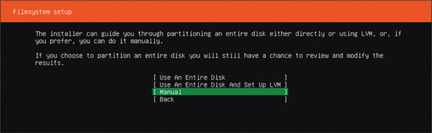
Source: Canonical Ltd.
Notes
When installing Ubuntu, use the arrow keys to navigate menus and press Enter to make a selection. The Esc key takes you back one level in a menu.
- On the next screen, under AVAILABLE DEVICES, point to the local disk and press Enter. In the drop-down menu, select Add Partition, as shown in Figure 18-44.
Figure 18-44
Create a new partition on the drive
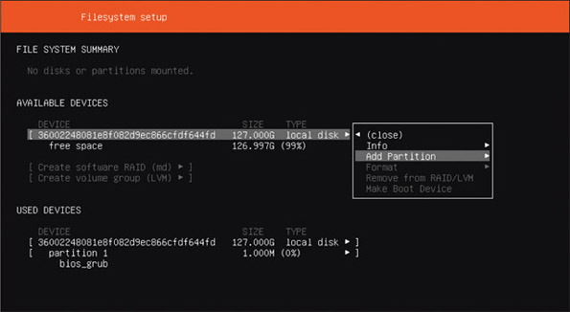
Source: Canonical Ltd.
- In the Adding partition box, enter the size of the boot partition (at least 50 GB) and select the file system type ext4, as shown in Figure 18-45.
Figure 18-45
Select ext4 for the file system of the new Ubuntu partition
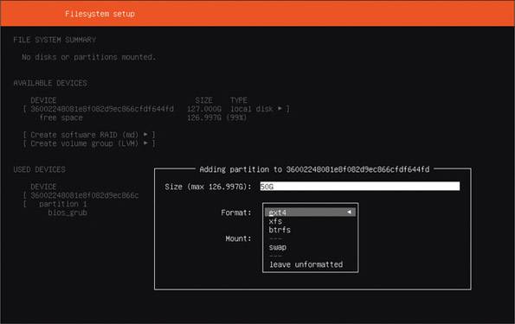
Source: Canonical Ltd.
- Add a second partition and select swap as the file system type. Make the partition size a little larger than the amount of installed memory. Figure 18-46 shows the resulting Filesystem setup screen with three partitions created. Notice that not all of the hard drive is partitioned in our example:
  - Partition 1. The small bios_grub partition is automatically created and is used to boot the system in a dual-boot environment. GRUB (GR and Unified Bootloader) is a boot loader used to manage dual-boot systems.
  - Partition 2. The 50-GB partition that will hold the OS uses the ext4 file system.
  - Partition 3. The 4-GB swap partition is used to hold virtual memory. A swap partition does not have a file system installed.
Figure 18-46
Partitions are created to hold the Ubuntu installation
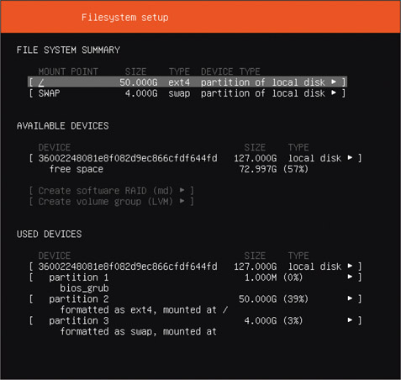
Source: Canonical Ltd.
- Select Done to complete the installation, accepting all defaults. Be sure to write down the name of the VM and your Ubuntu host name, Ubuntu user name, and password. When given the option, decline to install any extra software bundled with the OS. Notice this software includes add-ons to be used when Ubuntu Server is installed in the cloud at Amazon Web Services or Google Cloud. If needed, the software can be installed later.
- After the VM restarts, Ubuntu Server launches, and you should see the terminal shell in the VM. See Figure 18-47.
Figure 18-47
When you log in to Ubuntu Server, available updates are listed
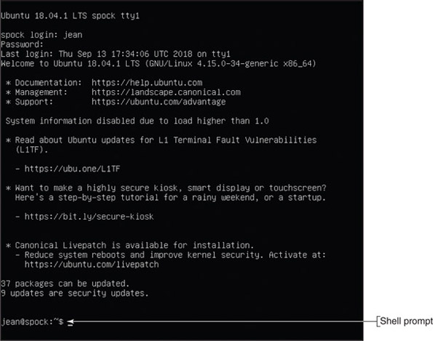
Source: Canonical Ltd.
- You might need to press Enter to see the shell prompt. Then enter your user name and password, and you’re logged in to Ubuntu Server. In the figure, the server is named spock and the logged-in user is jean. Notice Ubuntu reports that 37 packages can be updated. In Ubuntu, a package is the collection of files needed to install software.
- Whenever you’re ready to shut down Ubuntu Server, use the sudo shutdown now command.
Normally, the shell prompt includes the user name, host name, and the current directory, followed by a $. For example, in Figure 18-47, the shell prompt shows the user name is jean, the host name is spock, and the ~ character indicates the user’s home directory, which for the jean account is /home/jean. When you first log in to Linux, the current directory is always the home directory of the logged-in user. (In Linux, directories in a path are separated with forward slashes, in contrast to the backward slashes used by Windows.)
It’s easiest to install a swap partition when you install Ubuntu. If Ubuntu is installed on a single partition on the hard drive and you want to improve performance later, you can shrink the Ubuntu partition and create a swap partition in the free space. How to do that is not covered in this text.
A+ Exam Tip
The A+ Core 2 exam expects you to know that a swap partition improves performance and that you can create one during or after the installation. You also need to know about the ext4 and ext3 file systems.
Recall that each OS has file systems it can support. Linux file systems include:
- ext4. The current Linux file system is ext4 (fourth extended file system).
- ext3. The ext3 file system was the first to support journaling, which is a technique that tracks and stores changes to the hard drive and helps prevent file system corruption.
- FAT32 and NTFS. The FAT32 and NTFS file systems are supported for compatibility with Windows and macOS. Windows can use either FAT32 or NTFS, and macOS can use FAT32. Ubuntu should not be installed on a FAT32 or NTFS volume.
Notes
On a local network or in a dual boot with Windows and Linux, you might want to access files in either volume from either OS. Know that Linux can access the NTFS file system on the Windows volume, but Windows cannot access the ext4 file system on the Linux volume. You can, however, install third-party software, such as Paragon ExtFS for Windows (paragon-software.com), to access the ext4 volume.
As you read along and learn about Linux commands, you can use your Ubuntu VM to practice these commands.

Directory Structures
Table 18-4 lists some important directories that are created in the root during a typical Linux installation. (Some distributions of Linux modify the directory structure.) Not all directories in the root are listed in the table.
Table 18-4

Important Directories in a Typical Linux Root Directory
Directory | Description
/bin | Contains programs and commands necessary to boot the system and perform other system tasks not reserved for the administrator, such as shutdown and reboot
/boot | Consists of components needed for the boot process, such as boot loaders
/dev | Holds device names, which consist of the type of device and a number identifying the device; actual device drivers are located in the /lib/modules /[kernel version]/ directory
/etc | Contains system configuration data, including configuration files and settings and their subdirectories; these files are used for tasks such as configuring a user account, changing system settings, and configuring a domain name resolution service
/home | Contains user data; every user of the system has a directory in the /home directory, such as /home/jean or /home/scott, and when a user logs in, that directory becomes the current working directory
/lib | Stores common libraries used by applications so that more than one application can use the same library at one time; an example is the library of C programming code, without which only the kernel of the Linux system could run
/lost+found | Stores data that is lost when files are truncated or when an attempt to fix system errors is unsuccessful
/opt | Contains installations of third-party applications such as web browsers that do not come with the Linux OS distribution
/root | Serves as the home directory for the root user and contains only files specific to the root user; don’t confuse this directory with the root, which contains all the directories listed in this table
/sbin | Stores commands required for system administration
/tmp | Stores temporary files, such as the ones that applications use during installation and operation
/usr | Contains executable programs, libraries, and shared resources that are not critical to the Ubuntu system
/var | Holds variable data such as logs, email, news, print spools, and administrative files
Applying Concepts

Exploring Directories and Files
Let’s learn a few Linux commands that we can use to explore directories and files. As shown in Figure 18-48, use these commands:
- Use the clear command to clear the screen of all its clutter.
- Use the pwd command (print working directory) to display the full path to the current directory, which is /home/jean in the figure.
- Use the cd .. command to move up one directory to /home. (There’s a space after d.)
- Use the ls command to display the list of files and subdirectories in the /home directory. Notice in the figure that the one subdirectory in the /home directory is jean.
- Use the ls -l command to display the results using the long format. (There’s a space after the s.) As you can see in the figure, the results are:
Here is an explanation of the types of information in the list:
  - Attributes. The first 10 characters (drwxr-xr-x)define the file or directory attributes. The first character identifies the type of item: A d is a directory, a - is a regular file, and a 1 indicates the item is a link to another location. The other nine characters (rwxr-xr-x) define the read, write, and execute permissions assigned to the file or directory; these permissions are explained in detail later in the chapter.
  - Links. The second column lists the number of links the item has, which is 4 in our example. In Linux, a link is similar to a Windows shortcut to a file or directory.
  - Owners. The third column lists the user owner and the fourth column lists the group that owns the file or directory. In Figure 18-48, the owner is jean and the owner group is also jean.
  - Size, date, and name. The last columns list the size of the file or directory in bytes, the date the item was last modified, and the name of the file or directory. The name of directory jean is listed in blue.
- When you use the cd .. command again, you move up to the main directory in Linux, called the root directory, which is indicated with a forward slash. The ls -l command lists the files and subdirectories in the root.
Figure 18-48
Directories in the root
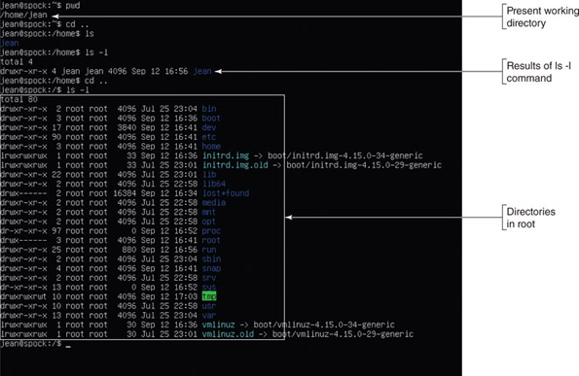
Source: Canonical Ltd.

Root Account and User Accounts
A Linux system administrator is responsible for installing updates to the OS (called patches), managing backups, installing software and hardware, setting up user accounts, resetting passwords, and generally supporting the OS and users. To accomplish this, she requires root privileges or access to all the functions of the OS. Two ways Linux allows for root privileges are:
- Superuser. The principal user account is called the root account. Notice in Figure 18-48 that all the directories and files in the root directory belong to the root account. When logged in to the root account, the user is called the superuser. Because the root account is so powerful, Ubuntu disables login to this account by default. The root account is similar to the Windows Administrator account.
- Regular user account with root privileges. Any user account can be assigned root privileges. If the user has root privileges, she can execute any command that requires root access by adding sudo to the beginning of the command line. An account with root privileges is similar to a Windows account that has been assigned Administrative rights.
The command to switch users is su. For a user to switch to the root account, she uses the command sudo su root, as shown in Figure 18-49. Notice in the figure that the shell prompt changes to root@spock:/#. The Linux command prompt for the root user is different from the command prompt for regular users. The root command prompt is #, and other users have the $ command prompt. To switch back to the jean account, use the command su jean. As a general practice, never log in to Linux as root unless you have no other option; you can do a lot of damage as root.
Figure 18-49
The user account, host name, and current directory appear in the shell prompt along with a # or $ to indicate the root account or other account
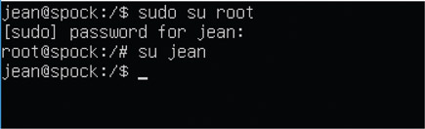
Source: Canonical Ltd.

Linux Commands
Table 18-5 describes some basic Linux commands, together with simple examples of how some are used. As you read along, be aware that all commands entered in Linux are case sensitive, meaning that uppercase and lowercase matter.
Table 18-5

Some Common Linux Commands (Continues)
Command | Description
adduser | Add a user to a system:
apt-get | Install and remove applications and other programs (called packages) in Linux. When you first install Linux, it installs with only a bare-bones set of commands and utilities and includes a library of packages that you can install as needed. For example, to install the SSH (Secure Shell) package so you can remote in to your Linux server, use this command:  The apt-get command requires root access, which means you must precede the command with sudo.
cat | View the contents of a file. Many Linux commands can use the redirection symbol > to redirect the output of the command. For example, use the redirection symbol with the cat command to copy a file:  The content of the shells file is written to newfile.
cd | Change the directory.  To change the directory to /etc: cd /etc  To move up one level in the directory tree: cd ..  To go to the root: cd /
chmod | Change modes (or permissions) for a file or directory. You’ll see several examples of this command later in the chapter.
chown | Change the owner of a file or directory.
clear | Clear the screen. This command is useful when the screen has become cluttered with commands and data that you no longer need to view.
cp | Copy a file:
dd | Copy and convert files, directories, partitions, and even entire DVDs or hard drives. It’s a powerful command with many practical uses and parameters, and only a superuser can use it. The basic format of the command is:  For example, use this command to create an ISO file from the contents of a CD:
deluser | Remove a user from a system:  Remove the user and his home directory:
df | The command stands for disk filesystem and displays the amount of free space on the hard drive.  To see the file system the drive is using: df -T
echo | Display information on the screen. You can also save the information to a file. For example, to create a new file that contains text, enter this command:
exit | Log out; the login shell prompt appears, where you can log in again.
grep | Search for a specific pattern in a file or in multiple files. This command is useful when searching through long log files:
ifconfig | Troubleshoot problems with TCP/IP network connections. This command can disable and enable network adapters and assign a static IP address to an adapter. For example, to show all configuration information:  To enable or disable an adapter, use the up or down parameter. For example, to enable eth0, the first Ethernet interface:  To assign a static IP address to the eth0 interface:
iwconfig | This command works like ifconfig but applies only to wireless networks. Use it to display information about the wireless adapter’s configuration or to change the configuration. To set the wireless NIC to Ad-Hoc mode so that other devices within range can connect directly to it, use this command, where wlan0 identifies the wireless adapter:  To force the NIC to use channel 3:
kill | Kill a process instead of waiting for it to terminate. Use the ps command to list process IDs. To end a process, use the kill command followed by the PID. For example, to kill the process with a PID of 984: kill 984  The command sends a signal to the process to end itself in an orderly way. If the process doesn’t die peacefully, you can get the kernel involved to forcefully end the process; this is called a forced kill: kill -kill 984
1s | Like the Windows dir command, ls displays a list of directories and files.  For example, to list files in the /etc directory, use the long parameter for a complete listing:  To include hidden files in the list: ls -la /etc  (In Linux, hidden files begin with a period.)
man | Display the online help manual, called man pages. For example, to get information about the echo command:  The manual program displays information about the command. To exit the manual program, type q.
mkdir | Make a new directory:
mv | Move a file or rename it, if the source and destination are the same directory:  To move myfile from the jean directory to the home directory:  Because the /home directory is owned by the root account, the sudo command is required.
passwd | Change a password. When a user enters the command, he is asked for the old password and then can change it.  The superuser can change the password for any account and does not need to enter the account’s old password, making it possible to reset a forgotten password.
ping | Test network connections by sending a request packet to a host. If a connection is successful, the host will return a response packet. For example:  The ping results continue until you manually stop the process. Press Ctrl+C to break out of the process.  To specify the number of pings: ping 192.168.1.100 -c 4
ps | The command stands for process status and displays the process table so that you can identify process IDs for currently running processes. (Once you know the process ID, you can use the kill command to terminate a process.)  To list processes of the current user: ps  To list processes owned by all users: ps aux
pwd | Show the name of the current or present working directory.  When you first log in to Linux, the directory is /home/username.
rm | Remove or delete the file or files that are specified:
rmdir | Remove or delete an empty directory:
shutdown | Automatically shut down the system.  To shut down now: sudo shutdown now  To warn users and then shut down: sudo shutdown -h +10 “Everyone log out now. The system will shut down in 10 minutes for maintenance.”  To reboot now: sudo shutdown -r now
su | The command stands for substitute user or switch user and changes to a different user account. When switching to superuser, add sudo to the command.  To switch to the root account: sudo su root  To switch back to the jean account: su jean
sudo | The command stands for substitute user to do the command and is pronounced “sue-doe” or “sue-doo.” When logged in as a normal user with an account that has the right to use root commands, you can start a command with sudo to run the command as the superuser. A user password may be required.  For example: sudo shutdown now
touch | Create a blank file in the current directory. For example:
vi | Launch a full-screen editor that can be used to edit a file:
A+ Exam Tip
The A+ Core 2 exam expects you to be familiar with these Linux commands: ls, grep, cd, shutdown, pwd, passwd, mv, cp, rm, chmod, chown, iwconfig, ifconfig, ps, su, sudo, apt-get, vi, dd, and kill.
Here are a few tips when using commands at a shell prompt:
- Retrieve previous commands. Press the arrow-up key to retrieve previously entered commands and then edit a command that appears.
- Use wildcard characters. Linux can use the * and ? wildcard characters in command lines, similar to Windows. For example, the ls *.??? command lists all files with a file extension of three characters. In addition, Linux provides a third wildcard: Brackets can give a choice of characters. For example, the ls *.[abc]* command lists all files whose file extension begins with a, b, or c.
- Redirect output. Normally, output from a command displays on the screen. To redirect that output to a file, use the redirection symbol >. For example, to redirect the output of the ifconfig command to myfile, use this command: ifconfig > myfile
- Page the output. Append |more to the end of a command line to display the results of the command on the screen one page at a time. For example, to page the ls command: ls -l |more
- Use Ctrl+C. To break out of a command or process, press Ctrl+C. Use it to recover after entering a wrong command or to stop a command that requires a manual halt.

The vi Editor
The vi editor (visual editor) is a text editor that works in command mode (to enter commands) or in insert mode (to edit text). In this section, you learn how to create a text file in the vi editor, edit text, and save your changes. All vi commands are case sensitive.
Let’s create and work with a file called mymemo:
- You can save a file to your home directory because you own that directory. If you are not already in your home directory, use the cd command to go there. For example:
- To open the vi editor and create the new file, enter the command vi mymemo. The vi editor screen appears and the file name is shown at the bottom of the screen.
- When you first open the vi editor, you are in command mode. Type i to switch to insert mode. When you are in insert mode, the word INSERT is shown at the bottom of the screen.
- Type the contents of Step 3 as the text for your memo (see Figure 18-50). Use your arrow keys to move over the text to edit it. You can also use the Insert key to switch between inserting text and overwriting text.
Figure 18-50
The vi text editor in Insert mode
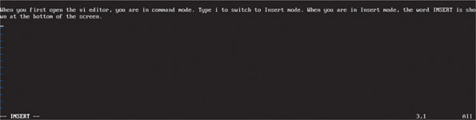
Source: Canonical Ltd.
- To switch back to command mode, first press the Esc key and then type a :. The colon command prompt appears and your pointer goes to the bottom of the screen. Type wq to save (write) the file and exit (quit) the editor.
Here is a list of enough vi commands to get you started with the editor. You can find other commands online:
:w | Save your changes but don’t exit the editor.
:q | Exit the editor after you have just saved your changes with the :w command.
:wq | Save your changes and exit the editor.
:q! | Quit without saving your changes.
Applying Concepts

Installing FTP Server in Ubuntu
In the following steps, you learn to use several Linux commands to install and configure software and examine a log file. Follow these steps to set up an FTP server in Ubuntu:
- Log in to Ubuntu Server with your user name and password.
- To create a short file to test the FTP server, you can use the echo command with redirection. Create mymemo in your /home/username directory using this command:
- To install the FTP program named vsftpd, enter this command:
- Respond to the prompts and then wait for the package to install.
- Now you need to configure the FTP program by editing the /etc/vsftpd.conf text file. Before you edit the file, go to the /etc directory and make a backup copy of the file just in case you need it later. The sudo command is needed because files in the /etc directory belong to root:
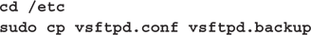
- Use the vi editor to edit the FTP configuration file:
- Verify and/or change three lines in the file to create the settings listed below. Part of the file, including the three lines, is shown in Figure 18-51.
anonymous_enable=NO | Disable anonymous logins.
local_enable=YES | If necessary, remove the # to uncomment the line and allow local users to log in.
write_enable=YES | If necessary, remove the # to uncomment the line and allow users to write to a directory.
- Figure 18-51
- Part of the vsftpd.conf text file
- 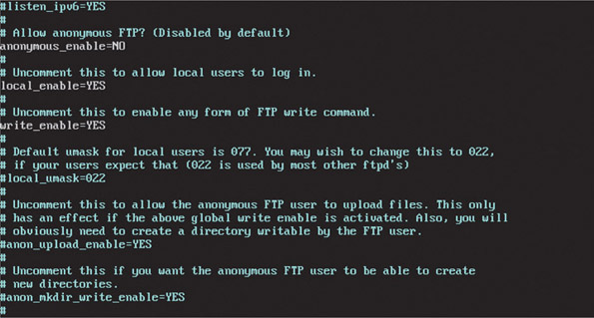
- Source: Canonical Ltd.
- Exit the vi editor, saving your changes. Restart the FTP service using this command:
- To find out the IP address of the server, type ifconfig.
- On your host Windows computer, open a command prompt window and go to a directory on your Windows computer where you have a file stored. To test your FTP server, open an FTP session using the IP address of the server—for example, ftp 192.168.1.110 (your IP address may be different). Then enter your user name and password. The ftp> prompt appears. See Figure 18-52.
Figure 18-52
Use FTP to transfer files between a Windows and Ubuntu system
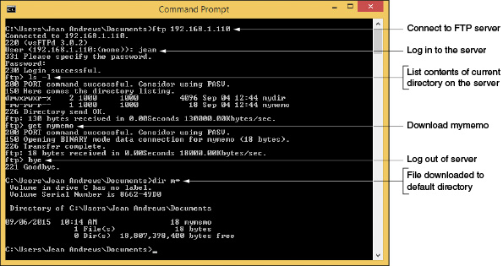
- Next use the ls -l command to see a list of directories and files. You should see the file mymemo that you created in your /home/username directory earlier.
- If you want to transfer files with FTP commands, use the get and put commands. To download the mymemo file, use the command get mymemo. To transfer a file from your Windows computer to your Ubuntu server, use the put command.
- Type bye to disconnect from the FTP server. At the Windows command prompt, you can use the dir m* command, as shown in Figure 18-52, to verify that the file was received on the Windows computer.
- Return to Ubuntu Server and examine the FTP log file, /var/log/vsftpd.log. Because the file is short, you can use the cat command to display the entire log. The sudo command is required because /var files belong to root:
- After much activity, log files can get quite long. The grep command can help you find a specific action, user, IP address, file name, or directory name. For example, to display lines in the log file that contain the text “LOGIN,” use this grep command:
The results of the cat and grep commands are shown in Figure 18-53.
Figure 18-53
The grep command can be used to search for specific text in log files
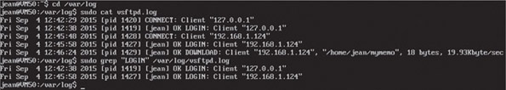
Source: Canonical Ltd.

Update Linux from the Shell Prompt
In general, Linux updates don’t come as often as Windows or macOS updates. The creator of your Linux distribution publishes updates to packages in the current release of a distribution and publishes new releases of a distribution. When you first log in to the system, Linux reports the package updates that are available (refer back to Figure 18-47).
Use these commands to update the packages previously installed in your system:
- To refresh the list of all available updates:
- To update only the installed packages:
A new release of a distribution contains all updates since the last release. As a Linux administrator, you need to stay aware of the latest release of the distribution you are using and decide when or if it’s appropriate to upgrade to that release. Before you upgrade to a new release, be sure you have backups of your data and a disk image (called a clone) of the entire Linux partition.
Here’s how to upgrade to a new release for Ubuntu Server:
- Follow the previous steps to update all packages installed in the system.
- To make sure the latest update manager program is installed:
- To install the latest release of Ubuntu Server:
If a new release is available, the last command reports it and you can follow directions to install it.
Notes
Ubuntu Server does not have an easy-to-use backup service. Normally, the system administrator installs third-party software, such as Bacula, to perform backups. Another option is to write your own shell scripts, which are similar to batch files, that include tar commands to create an archive of many files and copy it to other media or network storage. How to set up a backup process for Linux is not covered in this chapter.

Assign Permissions and Ownership of Files or Directories
A file or directory can have read, write, and/or execute permissions assigned to it. Permissions can be assigned to (a) the owner, (b) other users in the same group as the owner, and (c) all users. The chmod command is used to manage permissions for files and directories. To see current permissions, examine the 10 characters in the left column that display when you use the ls -l command. For example, suppose the output for the ls -l command on the /home/jean directory is that shown in Figure 18-54.
Figure 18-54
Information about the jean directory displayed by ls-l
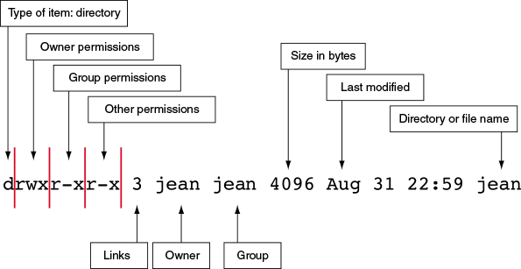
Here is the explanation of these characters:
- The first character identifies the type of item (d is a directory; - is a regular file).
- Characters 2–4 show the permissions assigned to the user or owner (for example, rwx means the user has read, write, and execute permissions).
- Characters 5–7 show the permissions assigned to the group (for example, r-x means the group has read and execute permissions, but not write permission).
- Characters 8–10 show the permissions for others (for example, r-x means other users have read and execute permissions, but not write permission. By contrast, --- would mean others don’t have read, write, or execute permission).
The chmod command changes these permissions. For example, in Figure 18-54, if the user jean wants to give read, write, and execute permissions to everyone (group and other), she can use this command:
The g assigns permission to the group and the o assigns permissions to others. (The u can assign permissions to the owner.) For a folder, you must move out of the folder before you change its permissions. Also, the command has no space before or after a comma.
Let’s look at an example of when you might need to change the ownership of a directory or file. Suppose you are setting up an FTP server so that users who have accounts on the server can use FTP to upload files to their home directories. Table 18-6 lists commands that might be useful to set up the user directories.
Table 18-6

Commands to Set Up User Directories with Appropriate Write Permissions
Command | Description
sudo adduser carlos | Creates the user account and its home directory
sudo mkdir /home/carlos/files | Creates a directory for carlos to store his files when using FTP; the sudo command is required to create the directory in another user’s account, and this new directory belongs to root
sudo chown carlos:carlos /home/carlos/files | Makes carlos the owner of the files directory; the carlos group is also assigned to the files directory
sudo chmod g-w,o-w /home/carlos/files | Removes write permissions for the files directory for all but the carlos user (the g-w parameter removes write permissions and g+w adds write permissions)
Go to pg.
help

Main content

18-2cTelnet and SSH for Remote Access
A+ Core 2
- 4.9
Given a scenario, use remote access technologies.
Recall that Windows uses Remote Desktop and macOS uses Screen Sharing to remotely access a computer with screen and file sharing. In Linux, the primary utilities for remote access at a shell prompt are Telnet and SSH (Secure Shell). Telnet does not encrypt transmissions, but SSH encrypts all transmissions. Therefore, SSH is more secure than Telnet and is the most common method to remotely access a Linux system. Use the commands in Table 18-7 to install Telnet and SSH in Linux.
Table 18-7

Install and Run Telnet and SSH in Linux
Command | Description
sudo apt-add-repository universe | Add the universe repository to the list of places Ubuntu can find apps. This is an official repository of apps, but it is not supported by Ubuntu. (Note that when you attempt to add the repository and it is already available, a message appears saying the component is already enabled.)
sudo apt-get update | Download and update all apps available to Ubuntu, including the ones in the universe repository.
sudo apt-get install openssh-server | Install and run the SSH server in Linux.
sudo apt install telnetd | Install and run the Telnet server.
In Windows, SSH is enabled by default and Telnet Client can be turned on using the Windows Features window, which is available in the Programs and Features window. Here are the steps to remotely access a Linux system from a Windows or Linux computer:
- For Windows, turn on Telnet Client in the Windows Features window.
- At a Windows command prompt or Linux shell prompt, use the following command to open a Telnet session, substituting the IP address for the Linux system you want to remote in to:
- The Linux login prompt appears. Enter your user name and password. To close the session, use the logout command.
- To use SSH to remote in, enter the following command, substituting your user name and IP address for the remote Linux system:
- Enter your password to log in to Linux. To close the session, use the logout command.
Go to pg.
help
Application Opened
Main content

18-2dComparing Windows, macOS, and Linux
A+ Core 2
- 1.1
Compare and contrast common operating system types and their purposes.
Now that you have learned how to use and support Windows, macOS, and Linux, let’s take a step back and compare these three types of operating systems. As an IT technician, most likely you’ll be called on to help a customer decide which type of OS to use in a given situation. Here are some tips to help you decide between Windows, macOS, and Linux:
- User desktops and laptops. Windows and macOS are well-suited for user desktops and laptops because each OS has a plethora of applications designed for it. Most often when deciding between the two, it comes down to what a company or individual prefers and knows how to use and support. Linux with a windows manager, on the other hand, comes up short in the number of desktop applications designed for it.
- Server applications. Linux is popular as a server OS for supporting many types of server applications, such as web servers, email servers, and DNS servers. However, Windows Server with Active Directory is more popular when it comes to controlling and securing access to a network in a corporate environment. Many IT departments use a combination of Windows Server to manage the Windows domain and Linux servers to manage server applications.
- End-of-life vendor limitation. In practice, computers and their operating systems might stay in service long after manufacturer support for the OS has ended. However, it’s important that you know when an OS will no longer be supported by its manufacturer. Here is the rundown:
  - Windows. In the past, Microsoft released a new version of Windows about every three years, but with Windows 10, it seems to be heading in the direction of Windows as a service. Microsoft has unofficially said that Windows 10 is its last version of Windows, meaning that it will continue to provide ongoing feature updates (about every six months) and minor updates weekly. Eventually, we expect to think of just Windows, not a particular version, which is the direction that Apple has taken.
  - macOS. Over the past 20 years, Apple has released versions of Mac OS X about once a year; it was renamed macOS in 2016. The version a Mac can support depends on the age of the Mac. For example, a MacBook made in 2009 or later should support High Sierra, a current macOS release, and a MacBook made in 2012 or later should support Mojave, the latest macOS release.
  - Linux. How long a Linux distribution will be supported depends on the developer. For example, Canonical (canonical.com), which makes Ubuntu Desktop and Ubuntu Server, releases a new distribution of Ubuntu about every two years and provides support of that release for about five years.
- Compatibility between OSs. When selecting an OS, consider how compatible it is with other OSs in the organization. Because macOS and Linux are both built on UNIX, they are more compatible with each other than with Windows. The FAT32 file system can be read and written by Linux, macOS, and Windows, and is therefore the file system of choice when you are concerned with compatibility. Linux can read and write to NTFS file systems used on Windows systems, but macOS cannot.
Now let’s turn our attention to the last topic of the chapter, scripting.
Go to pg.
help
Application Opened
Main content

18-3Scripting Software and Techniques
A+ Core 2
- 4.8
Identify the basics of scripting.
In this text you’ve learned to use commands in a Windows command prompt window, cmdlets in a PowerShell window, and Linux commands in macOS and Linux terminals. When a technician finds himself repetitively entering the same group of commands, he might decide to store them in a text file and execute them as a batch. The text file containing the list of commands is called a script; using scripts can save time and assures consistency (fewer errors). In this part of the chapter, you learn about the various script file types and then explore the basics of reading and writing scripts, which will help get you started using scripts written by others or writing your own scripts.
Go to pg.
help
Application Opened
Main content

18-3aScript File Types
A+ Core 2
- 4.8
Identify the basics of scripting.
In Chapter 13, you learned to create a batch file that contains Windows commands. This and other script file types are listed in Table 18-8 with a description of the software that can read and interpret each command in a script file and execute these commands in a run-time environment.
Table 18-8

Types of Script Files and Scripting Software
Script File Extension | Description
.bat | A batch file contains a list of Windows commands that can be executed in a command prompt window.
.ps1 | A PowerShell script contains cmdlets executed in Windows PowerShell. The script is written using dynamic type checking, which means each cmdlet is checked by the PowerShell interpreter as it is typed to verify that the command can be executed as it is added to the script file. Many scripting and programming applications support dynamic type checking.
.vbs | A .vbs script is written with VBScript, which is modeled after the more complex Visual Basic, a full-fledged programming language.
.sh | A UNIX or Linux script, also called a shell script, contains Linux commands and is executed in a UNIX or Linux shell.
.py | A Python script is a group of Python commands interpreted by Python. Python can also compile the commands into an executable program.
.js | A .js script written in JavaScript is a text file that contains commands normally used with webpages. These scripts can be embedded in an HTML file, which is downloaded from a web server to a browser and used to build an interactive webpage in the browser.
Scripts are simpler to write and use than programs. The difference between a script and a program is:
- A script is interpreted. A script is read, interpreted, and executed command by command directly from the script file by software called an interpreter. For example, a technician types commands into a script file, and the commands are verified to work by PowerShell or VBScript. When a technician executes the script, PowerShell or VBScript reads, interprets, and executes each command in the file.
- A program is compiled. A program is first written using a programming language such as Visual Basic or Python, which interprets the code to verify that it can be executed. Then the coding file is compiled by the Visual Basic or Python complier into a binary executable file that has an .exe file extension. The executable file can then be run or executed by an operating system.
Go to pg.
help
Application Opened
Main content

18-3bBasics of Scripting
A+ Core 2
- 4.8
Identify the basics of scripting.
Ready to learn a little scripting? Let’s get started with some key terms:
- An environmental variable (sometimes called a system variable) is information the OS makes available to a script. For example, the Windows and Linux PATH variable lists the paths (drives, directories, and subdirectories) the script can use. Another example is the TEMP variable, which tells a script where it can store its temporary files. To view and edit environmental variables in Windows, open the System window and click Advanced system settings. On the Advanced tab of the System Properties box, click Environmental Variables. See Figure 18-55.
Figure 18-55
View, create, edit, and delete environmental variables
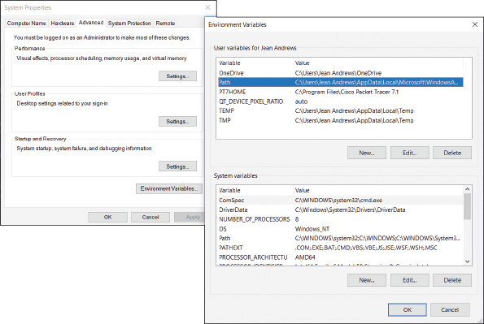
- Comments are text you put in a script to document the script. They can include your name, the date, the purpose of the script, and documentation that might help someone understand command lines in the script. Comment syntax refers to how you tag the text as a comment so that it is not interpreted as a command. For example, in PowerShell, a line in the script file can hold a comment if you begin the line with a #.
- A basic loop executes the same commands multiple times until some condition is met.
- A variable is the name of an unknown data item and can be assigned a value, which is called initializing the variable. In PowerShell, a variable name is preceded by $. You can assign a value to a variable using the equal symbol (=).
- A data type determines what type of value a variable can be assigned. Two common data types are integers (whole numbers) and strings (text).
It’s a commonly known fact in the world of scripting and programming that the very first script or program a person writes does nothing more than say “Hello World.” This proves you know how to create, save, and execute a script. Let’s create one in a shell script:
- At an Ubuntu shell prompt, make sure the current directory is your home directory. Then enter this command, saving the .sh file in your home directory:
- To assign execute permission to the file, use this command:
- To execute a shell script, type ./ before the script file name. Enter this command (see Figure 18-56):
Figure 18-56
A simple shell script is created and executed
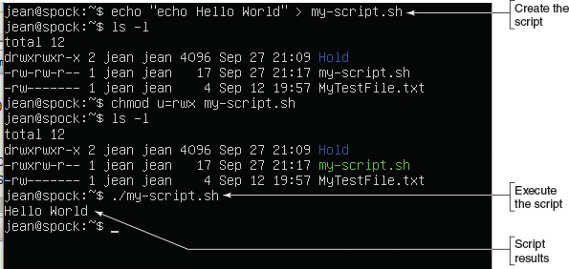
Now let’s create a PowerShell script with a loop using Windows 10 PowerShell ISE, the PowerShell Integrated Scripting Environment, where scripts are created and tested:
- In the Windows 10 search box, type powershell and then click PowerShell ISE. The PowerShell ISE window opens.
- PowerShell ISE does dynamic type checking. As the command is interpreted, color coding is added to indicate the purpose of what you type. Type the following lines in the script pane (see Table 18-9):
Table 18-9

Commands in a Script with a Basic Loop
Command | Purpose
$i = 0 | Defines an integer variable i that is assigned the value 0
While ($i -lt 3) | Continues looping as long as the variable is less than 3
{ | Defines the beginning of the loop
Write-output “Hello World” | Displays “Hello World”
$i++ | Adds one to the i variable
} | Defines the end of the loop
- To execute the script, click the Run Script button or click File and then click Run. The script is executed in the lower pane. See Figure 18-57.
Figure 18-57
A PowerShell script with a basic loop is executed
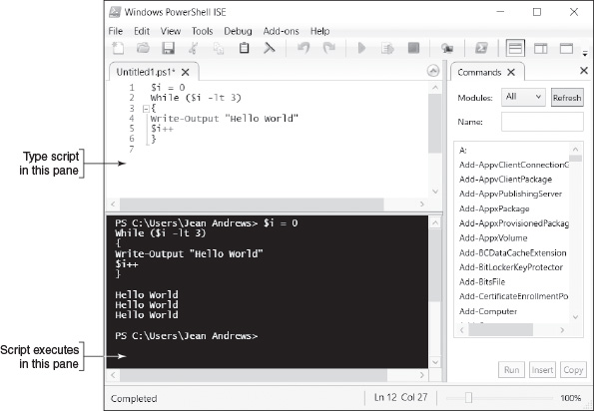
- To save your script, click File, click Save, and save the script to your desktop. Name the script MyLoopScript. By default, the .ps1 file extension is assigned to the file.
- Close the PowerShell ISE window and open a standard PowerShell window.
- By default, running PowerShell scripts is disabled. To set the execution policy so that scripts will run except those downloaded from the Internet without a valid digital signature, enter this cmdlet:
- Use this alias cmdlet to go to your Windows desktop folder:
- Use the dir alias cmdlet to list the contents of your desktop folder. You should see the script file listed.
- To execute a PowerShell script, begin with ./. Use this cmdlet to execute your script:
So that’s the basics of scripting. I hope you love it and write many more scripts in your IT career.
Go to pg.
help
Application Opened
Main content

Chapter Review

18-4aChapter Summary

macOS for Macintosh Computers
- macOS is used only for Macintosh computers by Apple Inc. Like Linux, macOS is built on a UNIX foundation.
- The dock appears at the bottom of the desktop. The icons in the dock that represent open applications have a small, black circle underneath them.
- Important macOS tools used to manage and support a Mac include Finder, Launchpad, the Apple menu, System Preferences, Spotlight, Mission Control, Keychain, Screen Sharing, Remote Disc, Terminal, and gestures on a trackpad.
- For IT technicians, the most important tools in System Preferences are accessed through Time Machine, Users & Groups, and Sharing. Screen Sharing, one of the Sharing tools, works like Remote Desktop in Windows.
- macOS updates often address zero-day vulnerabilities, which makes these updates important to maintaining a healthy system.
- Time Machine is a built-in backup utility that automatically backs up user-created data, applications, and system files to an external hard drive that’s attached either directly to the computer or through the local network.
- First Aid in Disk Utility can scan and repair file system errors on a hard drive.
- Tools to fix macOS startup problems include Safe Mode, macOS Recovery, Startup Manager, and NetBoot.
- Boot Camp is a macOS utility that allows you to install Windows on a Mac computer in a dual boot with macOS.

Linux Operating System
- Distributions of Linux provide a shell prompt in the Linux terminal and might also provide a desktop with a GUI. The default command-line shell for Linux is the Bash shell.
- Ubuntu Desktop with its windows manager offers Ubuntu software to install apps and update Ubuntu.
- The root account in Linux has access to all features of the OS. When logged in to the root account, the user is called the superuser.
- Important Linux commands include adduser, apt-get, cat, cd, chmod, chown, clear, cp, dd, deluser, df, echo, exit, grep, ifconfig, iwconfig, kill, ls, man, mkdir, mv, passwd, ping, ps, pwd, rm, rmdir, shutdown, su, sudo, touch, and vi.
- An app is normally configured in Linux by editing a text file in the /etc directory.
- Telnet and SSH can be used to remotely access a Linux computer. Telnet transmissions are not secured, but all SSH transmissions are encrypted.
- Windows and macOS are popular OSs for desktops and laptops, and Linux is popular as an application server OS. For compatibility, the FAT32 file system can be used by Windows, macOS, and Linux.

Scripting Software and Techniques
- Scripts are executed in a run-time environment without first being compiled, as are programs.
- Script file types include batch files, PowerShell scripts, VBScript, shell scripts (for Linux and UNIX), Python scripts, and JavaScript.
Go to pg.
help
Application Opened
Main content

Chapter Review

18-4bKey Terms
For explanations of key terms, see the Glossary for this text.
- APFS (Apple File System)
- Apple menu
- apt-get
- Bash shell
- basic loop
- batch file
- Boot Camp
- chmod
- chown
- clone
- comment syntax
- dd
- DMG file
- dock
- dynamic type checking
- environmental variable
- ext3
- ext4 (fourth extended file system)
- Finder
- First Aid
- force quit
- forced kill
- gestures
- grep
- GRUB (GR and Unified Bootloader)
- HFS+ (Hierarchical File System Plus)
- ifconfig
- integers
- iwconfig
- JavaScript
- kernel panic
- Keychain
- kill
- Launchpad
- Linux
- Live CD
- Live USB
- login items
- macOS
- Mac OS Extended
- Mission Control
- multiple desktops
- NetBoot
- package
- passwd
- PowerShell ISE
- PowerShell script
- Python script
- Remote Disc
- root account
- run-time environment
- Screen Sharing
- script
- secondary-click
- shell prompt
- shell script
- snapshots
- Space
- Spotlight
- SSH (Secure Shell)
- startup disk
- startup items
- strings
- su (substitute user or switch user)
- sudo
- superuser
- swapfile
- swap partition
- System Preferences
- Telnet
- terminal
- Terminal
- Time Machine
- variable
- VBScript
- vi editor
- Windows as a service
Go to pg.
help
Application Opened
Main content

Chapter Review

18-4cThinking Critically
These questions are designed to prepare you for the critical thinking required for the A+ exams and may use content from other chapters and the web.
- Why is the scrollbar typically hidden from view in macOS?
- Which app manages multiple desktop screens in macOS?
- Which app provides tools for customizing the macOS interface?
- A scanner connected to your Mac is giving problems and you suspect corrupted device drivers. What should you do first? Second?
  - Download and install drivers from the scanner manufacturer.
  - Back up the macOS startup disk using Time Machine.
  - Update macOS.
  - Uninstall the scanner and install it again.
- How often does Time Machine create new backups, and how long are these backups kept?
- Your macOS installation is corrupted and you want to boot from an external Thunderbolt hard drive to repair the installation. Which key(s) do you hold down at startup to boot from the external hard drive?
  - d key
  - command+r keys
  - shift key
  - option key
- You are helping your friend troubleshoot a problem with his Linux server. You enter a common Linux command and discover it doesn’t work exactly as you expected. What might be the problem and what do you do next?
  - The Linux installation is corrupted; restore the system from backup.
  - The Linux shell is not the one you expected; use the echo $SHELL command.
  - You probably don’t know how to use the Linux command; search the web for information about the command.
  - The Linux shell is not the one you expected; use the echo $0 command.
- What is the full path to the home directory of the user account lucio in Linux?
- You are running a web server app in Ubuntu Server. Users complain that their browsers are loading webpages with errors. Where are you likely to find the log file where the web server reports its errors?
  - /app/log
  - /bin
  - /var/log
  - /root
- In Linux, when logged in as a normal user with root privileges, which command must precede the apt-get command in the command line in order to install a program?
  - sudo
  - sudo user
  - su
  - root
- Which file system does Linux currently use for the volume on which Linux is installed?
- You have set up an FTP server in Ubuntu Server. Jason, a user, calls to say he gets an error when trying to put a file in his /home/jason/files directory. You look at the directory structure and see that you forgot to give the user ownership of the directory. Which command can fix the problem?
  - chown jason:jason /home/jason/files
  - sudo chmod u=rwx /home/jason/files
  - sudo chown jason:jason /home/jason/files
  - chmod u-rwx /home/jason/files
- What is the Linux vi editor command to save your changes and exit the editor?
- You are managing an FTP server installed in Ubuntu Server. The server has created a very large log file, vsftpd.log. Which command is appropriate to search the log file for activity of the user charlie?
  - sudo cat /var/log/vsftpd.log
  - grep “charlie” /var/log/vsftpd.log
  - sudo grep “charlie” /var/log/vsftpd.log
  - cat /var/log/vsftpd.log
- Explain why most Linux commands work about the same on a Mac computer as they do on a Linux system.
- You work at an IT help desk and have been asked to set up 25 new user accounts in Active Directory. Your boss tells you to save time by using a PowerShell script that’s available on a network share. You look at several script files named CreateNewUsers that are stored on the drive. Which one is likely to be the one you want?
  - The file with a .js file extension
  - The file with a .bat file extension
  - The file that is the largest
  - The file with a .ps1 file extension
Go to pg.
help

Main content

