Application Opened
Main content
Chapter
2

All About Motherboards
- Chapter Introduction
- 2-1Motherboard Types and Features
  - 2-1aMotherboard Form Factors
  - 2-1bIntel and AMD Chipsets and Processor Sockets
  - 2-1cBuses and Expansion Slots
  - 2-1dOnboard Ports and Connectors
- 2-2Using BIOS/UEFI Setup to Configure a Motherboard
  - 2-2aAccessing the BIOS/UEFI Setup Program
  - 2-2bViewing and Monitoring Information
  - 2-2cChanging Boot Options
  - 2-2dConfiguring Onboard Devices
  - 2-2eConfiguring Security Features
  - 2-2fBIOS Support for Virtualization
  - 2-2gExiting the BIOS/UEFI Setup Menus
- 2-3Updating Motherboard Drivers and BIOS/UEFI
  - 2-3aInstalling or Updating Motherboard Drivers
  - 2-3bUpdating Firmware
  - 2-3cUsing Jumpers to Clear BIOS/UEFI Settings
  - 2-3dReplacing the CMOS Battery
- 2-4Installing or Replacing a Motherboard
  - 2-4aHow to Select a Desktop Motherboard
  - 2-4bHow to Install or Replace a Motherboard
  - 2-4cReplacing a Laptop System Board
- 2-5Chapter Review
  - 2-5aChapter Summary
  - 2-5bKey Terms
  - 2-5cThinking Critically
  - 2-5dHands-On Projects
  - 2-5eReal Problems, Real Solutions
  - 2-5fExam Tips
Go to pg.
help
Application Opened
Main content

Chapter Introduction
After completing this chapter, you will be able to:
- Describe and contrast various types and features of motherboards
- Configure a motherboard using BIOS/UEFI firmware
- Maintain a motherboard by updating drivers and firmware, using jumpers to clear BIOS/UEFI settings, and replacing the CMOS battery
- Select, install, and replace a desktop motherboard or laptop system board
In Chapter 1, you learned how to work inside a desktop or laptop computer and began the process of learning about each major component or subsystem in a computer case. In this chapter, you build on all that knowledge to learn about motherboards, which techies sometimes call the mobo. You’ll learn about motherboard sizes (called form factors), connectors, expansion slots, sockets, onboard ports, and chipsets. Then you’ll learn how to support a motherboard, which includes configuring, maintaining, installing, and replacing it. A motherboard is considered a field replaceable unit, so it’s important to know how to replace one, but the good news is you don’t need to know how to repair one that is broken. Troubleshooting a motherboard works hand in hand with troubleshooting the processor and other components that must work to boot up a computer, so we’ll leave troubleshooting the motherboard until later chapters.
Go to pg.
help
Application Opened
Main content

2-1Motherboard Types and Features
A+ Core 1
- 1.1
Given a scenario, install and configure laptop hardware and components.
- 3.5
Given a scenario, install and configure motherboards, CPUs, and add-on cards.
A motherboard is the most complicated component in a computer. When you put together a computer from parts, generally you start by deciding which processor and motherboard you will use. Everything else follows these two decisions. Take a look at the details of Figure 2-1, which shows an ATX motherboard, the Asus Prime Z370-P, that can hold various Intel Core i7, Core i5, Core i3, or Pentium processors in the LGA1151 8th generation processor socket. When selecting a motherboard, generally you need to pay attention to the form factor, processor socket, chipset, expansion slots, and other connectors, slots, and ports. In this part of the chapter, we’ll look at the details of each of these features so that you can read a technical motherboard ad with the knowledge of a pro and know how to select the right motherboard when replacing an existing one or building a new system.
Figure 2-1
The Asus Prime Z370-P gaming motherboard uses the ATX form factor and LGA1151 8th generation process socket
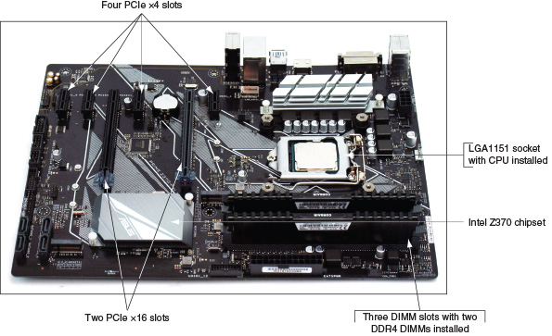
Go to pg.
help
Application Opened
Main content

2-1aMotherboard Form Factors
A+ Core 1
- 3.5
Given a scenario, install and configure motherboards, CPUs, and add-on cards.
The motherboard form factor determines the size of the board and its features that make it compatible with power supplies and cases. The most popular motherboard form factors are ATX, microATX (a smaller version of ATX, sometimes called the mATX), and Mini-ITX, also called mITX (a smaller version of microATX). You saw an ATX motherboard in Figure 2-1. Figure 2-2 shows an mATX board, and a Mini-ITX board is shown in Figure 2-3. The Mini-ITX board is also commonly referred to as an ITX board.
Figure 2-2
The Intel desktop motherboard DH676D uses the mATX form factor and has the processor, cooler, and memory modules installed
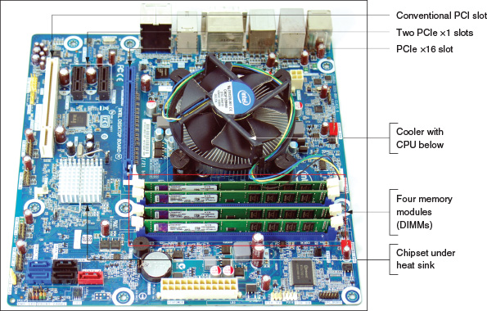
Figure 2-3
A Mini-ITX motherboard
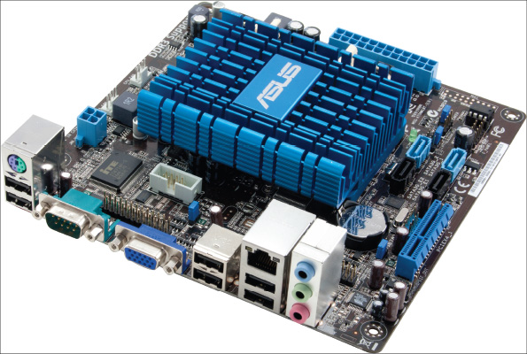
Source: Courtesy of ASUSTeK Computer, Inc.
Table 2-1 lists form factor sizes and descriptions, and Figure 2-4 shows a comparison of the sizes and hole positions of the boards. Each of these three boards can fit into an ATX computer case and use an ATX power supply.
Table 2-1

Three Motherboard Form Factors
Form Factor | Motherboard Size | Description
ATX, full size | Up to 12" × 9.6" (305mm × 244mm) | A popular form factor that has had many revisions and variations.
microATX (aka mATX) | Up to 9.6" × 9.6" (244mm × 244mm) | A smaller version of ATX.
Mini-ITX (aka mITX and ITX) | Up to 6.7" × 6.7" (170mm × 170mm) | A small form factor (SFF) board used in low-end computers and home theater systems. The boards are often used with an Intel Celeron or Atom processor and are sometimes purchased as a motherboard-processor combo unit.
Figure 2-4
Sizes and hole positions for the ATX, microATX, and Mini-ITX motherboards
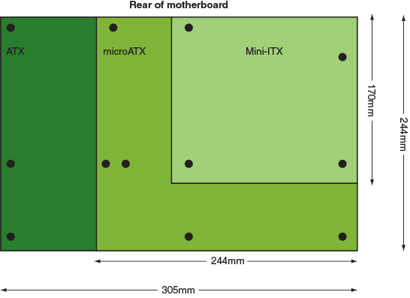
A+ Exam Tip
The A+ Core 1 exam expects you to know how to match up an ATX, mATX, ITX, or mITX motherboard with the appropriate case and power supply that support the same form factor.
Go to pg.
help
Application Opened
Main content

2-1bIntel and AMD Chipsets and Processor Sockets
A+ Core 1
- 3.5
Given a scenario, install and configure motherboards, CPUs, and add-on cards.
A chipset is a set of chips on the motherboard that works closely with the processor to collectively control the memory, buses on the motherboard, and some peripherals. The chipset must be compatible with the processor it serves. A socket is rectangular with pins or pads to connect the processor to the motherboard and a mechanism to hold the processor in place. This chipset and socket determine which processors a board can support.
The two major chipset and processor manufacturers are Intel (intel.com) and AMD (amd.com). Intel dominates the chipset market for several reasons: It knows more about its own Intel processors than other manufacturers do, and it produces the chipsets most compatible with the Intel family of processors.

Intel Chipsets
Intel makes desktop, mobile, and server chipsets and processors. To see a complete comparison chart of all Intel chipsets and processors, start at the Intel link ark.intel.com. Intel groups its chipsets and processors in generations, and each generation has a code name. Here is the list of generations from the past five years or so:
- Coffee Lake. The latest generation of chipsets and processors is the 8th generation, also called Coffee Lake, which began shipping at the end of 2017. The desktop processors use a revised version of the older LGA1151 socket and the new 300 Series chipset—for example, the Z370 chipset. The Coffee Lake LGA1151 socket is not backward compatible with 7th or 6th generation processors that use the first version of LGA1151. (The number of pins is the same, but how the pins are used is different; the newer socket also provides more wattage for processors.) The Coffee Lake 300 Series chipset uses only DDR4 memory, currently the fastest type of memory for personal computers. The 8th generation mobile processors fall into two groups: the Coffee Lake H-series processors and the Kaby Lake Refresh processors. Look back at Figure 2-1 where the Z370 chipset and LGA1151 8th generation socket and processor are labeled. A close-up of this open socket is shown in Figure 2-5.
Figure 2-5
The 8th generation LGA1151 socket with the cover removed and load plate lifted, ready to receive the processor
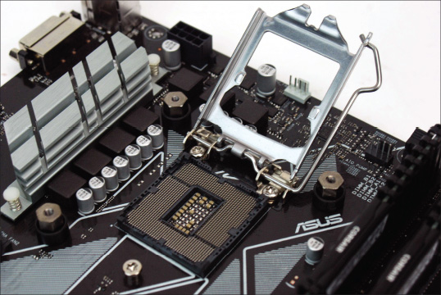
- Kaby Lake. The 7th generation desktop processors and chipsets, also called Kaby Lake, began shipping in 2016 and mobile processors were launched in 2017. Desktop processors use the first version of the LGA1151 socket.
- Skylake. The 6th generation processors and chipsets, also called Skylake, was launched in 2015. The processors were the first to use the LGA1151 socket. Other improvements over previous generations include faster and more efficient chipsets and use of faster DDR4 memory. Skylake chipsets are able to use the older and slower DDR3 memory only if it is low-voltage DDR3.
- Broadwell and Haswell. The 5th generation (Broadwell) and the 4th generation (Haswell) processors work with the older LGA1150 and LGA2011 processor sockets.
Notes
The 9th generation, or Cannon Lake processors and chipsets, is expected to be released by the time this text is published.
Since the release of the 2nd generation Intel Core family of processors, you can know which generation a processor fits in by the four digits in the model number. The first of the four digits is the generation. For example, the Core i5-6200U processor is a 6th generation processor, and the Core i5-7500 processor is a 7th generation processor.

Sockets for Intel Processors
The Intel name for a socket includes the number of pins the socket has. Intel uses a land grid array (LGA) for all its current sockets. These sockets have blunt pins that project up to connect with lands on the bottom of the processor. You can see these lands when you look closely at Figure 2-5.
Here are the current Intel sockets for desktop computers:
- The LGA1151 socket was first released in 2015. The first release of the socket works with Intel’s 7th and 6th generation processors and chipsets and is shown in Figure 2-6. The second release works with Intel 8th generation processors and chipsets.
Figure 2-6
The 7th and 6th generation LGA1151 open socket and the bottom of an Intel processor
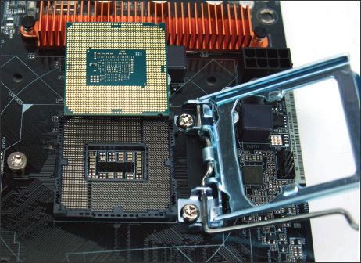
- The LGA1150 socket, shown in Figure 2-7, works with the 5th and 4th generation of chipsets and processors.
Figure 2-7
The LGA1150 socket with the protective cover installed
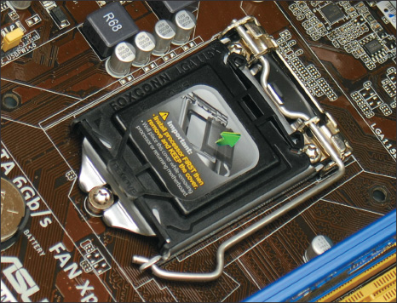
- The LGA1155 socket is used for 3rd and 2nd generation chipsets and processors.
Here are the Intel sockets used in servers and high-performance workstations:
- The LGA2066 socket is used with 8th through 6th generation processors and chipsets. It was introduced with Skylake-X high-end 6th generation processors in 2017.
- LGA2011 is used with 5th through 2nd generation processors and chipsets and has several variations for different generations, including LGA2011-0, LGA2011-1, and LGA2011-v3.
- LGA1366 is used with 4th through 1st generation processors and chipsets; it was discontinued in 2012 and introduced in 2008. The LGA1366 socket is shown in Figure 2-8.
Figure 2-8
The LGA1366 socket with the socket cover removed and the load plate lifted ready to receive a processor
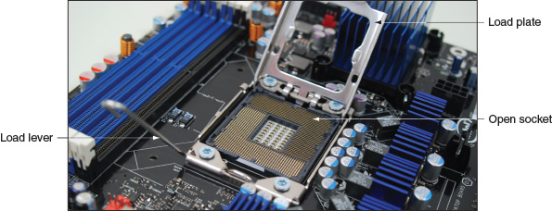
Caution
When a processor is installed in a socket, extreme care must be taken to protect the socket and the processor against ESD and from damage caused by bending the pins or scratching the processor pads during the installation. Take care not to touch the bottom of the processor or the pins of the socket, which can leave finger oil on the gold plating of the contact surfaces. This oil can later cause tarnishing and lead to a poor contact.
So that even force is applied when inserting the processor in the socket, sockets have one or two levers on the sides. These sockets are called zero insertion force (ZIF) sockets, and the levers are used to lift the processor up and out of the socket. When you push the levers down, the processor moves into its pin connectors with equal force over the entire housing. Because the socket and processor are delicate, processors generally should not be removed or replaced repeatedly.

AMD Chipsets and Sockets
Currently, AMD has four chipset and socket categories for personal computers:
- The TR4 (Threadripper 4) socket is a land grid array (LGA) socket that supports Threadripper processors and uses the AMD X399 chipset. The Threadripper processors are part of the AMD Ryzen series of high-end processors.
- The AM4 chipset family and AM4 socket is used with AMD Ryzen and Athlon processors. AMD chipsets in the AM4 family include A300, B300, and X300. The processors and chipsets support mainstream desktop systems. The socket has 1331 pins in a pin grid array (PGA), which means the socket has 1331 holes and the AMD processor has 1331 pins that fit into the socket holes.
- The AM3+ and AM3 are PGA sockets used with AMD Piledriver and Bulldozer processors and the 9-series chipsets, including 970, 980G, and 990X. The processors and chipsets are used in high-end gaming systems. AM3+ and AM3 processors can fit in either socket. Figure 2-9 shows the AM3+ socket and the bottom of the AMD FX processor.
Figure 2-9
The AMD AM3+ open socket; notice the holes in the socket and pins on the bottom of the processor
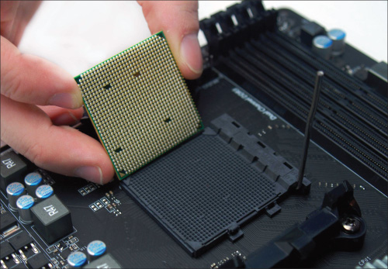
- The FM2+ is an older PGA socket used with AMD Athlon, Steamroller, and Excavator processors and A-series chipsets such as the A58 and A68H.

Match a Processor to the Socket and Motherboard
For both Intel and AMD, the processor families (for example, Intel Core i3, Intel Core i5, AMD Athlon, or AMD Ryzen) are used with various chipset generations and sockets. Therefore, you must pay close attention to the actual model number of the processor to know which socket it requires and which motherboards can support it. If you install a processor on a motherboard that can fit the socket but has the wrong chipset for the processor, you can damage both the motherboard and the processor. Sometimes, you can install a newer processor on an older motherboard by first updating the firmware on the motherboard, which you learn to do later in this chapter. To match a processor to a motherboard and socket:
- Look at the motherboard manufacturer’s website or user guide for a list of processors the motherboard supports. If a motherboard requires a firmware update to use a newer processor, the motherboard manufacturer’s website will alert you and provide the downloaded firmware update. How to update chipset firmware is covered later in this chapter. If an update is required, you must update the firmware before you install the new processor.
- You can also search the Intel (ark.intel.com) or AMD (amd.com) website for the exact processor to make sure the socket it uses is the same as the socket on the motherboard. You can also use the website to find other information about the processor.
A+ Exam Tip
The A+ Core 1 exam does not expect you to be familiar with the processor sockets used by laptop computers. It is generally more cost effective to replace a laptop that has a damaged processor than to replace the processor. If you are called on to replace a laptop processor, however, always use a processor the laptop manufacturer recommends for the particular laptop model and system board CPU socket.
Go to pg.
help
Application Opened
Main content

2-1cBuses and Expansion Slots
When you look carefully at a motherboard, you may see many fine lines on both the top and the bottom of the board’s surface (see Figure 2-10). These lines, sometimes called traces, are circuits or paths that enable data, instructions, timing signals, and power to move from component to component on the board. This system of pathways used for communication and the protocol and methods used for transmission are collectively called a bus. (A protocol is a set of rules and standards that any two entities use for communication.)
Figure 2-10
On the bottom of the motherboard, you can see bus lines terminating at the processor socket
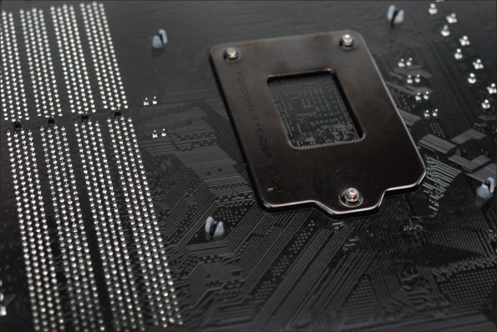
The specifications of a motherboard always include the expansion slots on the board. Take a look at a motherboard ad that shows detailed specifications and identify the types of expansion slots on the board. Table 2-2 lists the various expansion slots found on today’s motherboards.
Table 2-2

Expansion Slots and Internal Connectors Listed by Throughput
Expansion Slot or Internal Connector | Performance | Year Introduced
Each revision of PCI Express basically doubles the throughput of the previous revision.
PCI Express Version 5.0 | Up to 63 GB/sec for 16 lanes | Expected in 2019
PCI Express Version 4.0 | Up to 32 GB/sec for 16 lanes | 2017
PCI Express Version 3.0 | Up to 16 GB/sec for 16 lanes | 2010
PCI Express Version 2.0 | Up to 8 GB/sec for 16 lanes | 2007
Conventional PCI (Peripheral Component Interconnect) slots transfer data at about 500 MB/sec and have gone through several variations, but only the latest variation is seen on today’s motherboards. A notch in the slot prevents the wrong type of PCI card from installing. The standard has been replaced by PCI Express.
SATA (Serial Advanced Technology Attachment or Serial ATA) connectors on a motherboard are mostly used by storage devices, such as hard drives or optical drives.
SATA3 (Revisions 3.2 and 3.3) aka SATA 6.0 (for speed) | 6 Gb/sec or 600 MB/sec | 2008
SATA2 (Revision 2) aka SATA 3.0 (for speed) | 3 Gb/sec or 300 MB/sec | 2004
USB (Universal Serial Bus) might have internal connectors and external ports, which are used by a variety of USB devices.
USB 3.2, 3.1, and 3.0 | Up to 5 Gb/sec | 2011–2017
USB 2.0 | 480 Mb/sec | 2001
A+ Exam Tip
The A+ Core 1 exam expects you to know about the various PCI, PCIe, and SATA slots and how to select add-on cards to use them. You also need to know how to install external USB devices and how to use the internal USB headers on a motherboard.
Now let’s look at the details of the PCI and PCIe expansion slots used in desktops.

PCI Express
PCI Express (PCIe) currently comes in four different slot sizes called PCI Express ×1 (pronounced “by one”), ×4, ×8, and ×16. Figure 2-11 shows three of these slots. Notice in the figure the notch in the slot, which prevents a card from being inserted in the wrong direction or in the wrong slot.
Figure 2-11
Three types of expansion slots: PCIe ×1, PCIe ×16, and conventional PCI
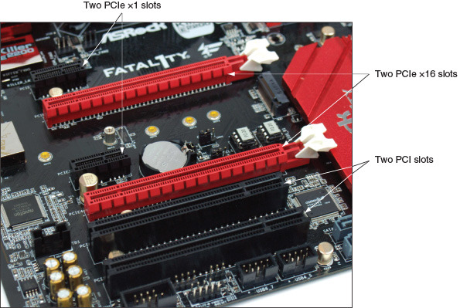
A PCIe ×1 slot contains a single lane for data. PCIe ×4 has 4 lanes, PCIe ×8 has 8 lanes, and PCIe ×16 has 16. The more lanes an add-on card uses, the more data is transmitted in a given time. Data is transferred over 1, 4, 8, or 16 lanes, which means that a 16-lane slot is faster than a shorter slot when the add-on card in the slot is using all 16 lanes. If you install a short card in a long slot, the card uses only the lanes it connects to. PCIe is used by a variety of add-on cards. The PCIe ×16 slot is used by graphics cards that require large throughput.
Less expensive motherboards may not have a full PCIe ×16 bus and yet provide PCIe ×16 slots. The longer cards can fit in the ×16 slot but only use 4 lanes for data transfers. The version of PCIe also matters; the latest currently available is Version 4, which is the fastest. (Version 5 is expected to be released in 2019.) Learn to read motherboard ads carefully. For example, look at the ad snippet shown in Figure 2-12. One of the longer PCIe ×16 slots operates in ×4 mode, only using 4 lanes, and uses the PCIe Version 2 standard. If you were to install a graphics card in one of these two PCIe ×16 slots, you would want to be sure you install it in the faster of the two ×16 slots.
Figure 2-12
PCIe documentation for one motherboard
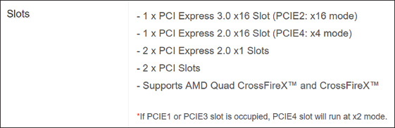
A graphics card that uses a PCIe ×16 slot may require as much as 450 watts. A typical PCIe ×16 slot provides 75 watts to a card installed in it. To provide the extra wattage for the card, a motherboard may have power connectors near the ×16 slot, and the graphics card may have one, two, or even three connectors to connect the card to the extra power (see Figure 2-13). Possibilities for these connectors are a 6-pin PCIe (which provides 75 watts) and/or an 8-pin PCIe connector (which provides 150 watts), a 4-pin Molex connector, or a SATA-style connector. Connect power cords from the power supply to the power connector type you find on the graphics card. Alternately, some motherboards provide Molex or SATA power connectors on the board to power PCIe graphics cards. See Figure 2-14. When installing a graphics card, always follow the manufacturer’s directions for connecting auxiliary power for the card. If the card requires extra wattage, the package will include power cords you need for the installation.
Figure 2-13
The graphics card has a PCIe 8-pin power connector on top
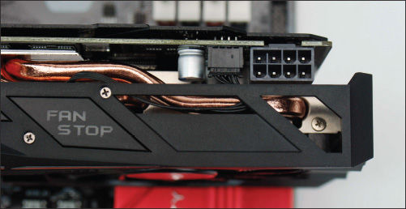
Figure 2-14
Auxiliary power connectors to support PCIe
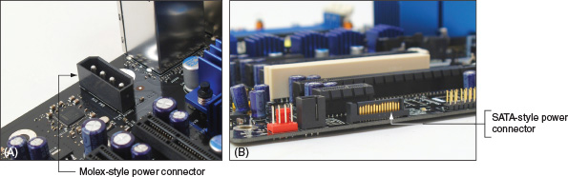

PCI
Conventional PCI slots and buses are slower than those of PCI Express. The slots are slightly taller than PCIe slots (look carefully at the two PCI slots labeled in Figure 2-11); they are positioned slightly closer to the rear of the computer case, and the notch in the slot is near the front of the slot. The PCI bus transports 32 data bits in parallel and operates at about 500 Mbps. The PCI slots are used for all types of add-on cards, such as Ethernet network cards, wireless cards, and sound cards. Although most graphics cards use PCIe, you can buy PCI video cards to use if your PCIe slots are not working.

Riser Cards Used to Extend the Slots
Suppose you are installing a Mini-ITX or microATX motherboard into a low-profile or slimline case that does not give you enough room to install an expansion card standing up in a slot. In this situation, a riser card can solve the problem. The riser card installs in the slot and provides another slot at a right angle (see Figure 2-15). When you install an expansion card in this riser card slot, the card sits parallel to the motherboard, taking up less space. These riser cards come for all types of PCI and PCIe slots.
Figure 2-15
The PCI riser card provides a slot for an expansion card installed parallel to the motherboard
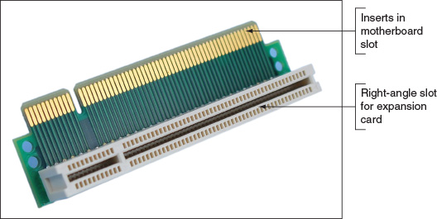
Notes
Be careful that cards installed in slots on a riser card are properly supported. It’s not a good idea to install a heavy and expensive graphics card in an improperly supported riser card slot.
Go to pg.
help
Application Opened
Main content

2-1dOnboard Ports and Connectors
In addition to expansion slots, a motherboard might also have several ports and internal connectors. Ports coming directly off the motherboard are called onboard ports or integrated components. For external ports, the motherboard provides an I/O panel of ports that stick out the rear of the case. These ports may include multiple USB ports, PS/2 mouse and keyboard ports, video ports (HDMI, DVI-D, DVI-I, or DisplayPort), sound ports, a LAN RJ-45 port (to connect to the network), and an eSATA port (for external SATA drives). Figure 2-16 shows ports on an entry-level desktop motherboard.
Figure 2-16
A motherboard provides ports for common I/O devices
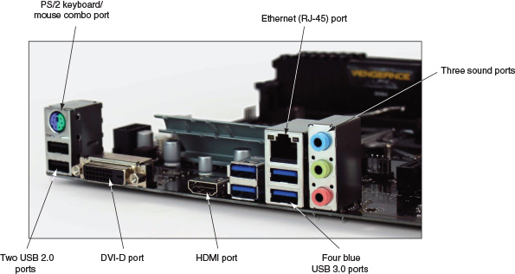
When you purchase a motherboard, the package includes an I/O shield, which is the plate you install in the computer case that provides holes for the I/O ports. The I/O shield is the size designed for the case’s form factor, and the holes in the shield are positioned for the motherboard ports (see Figure 2-17).
Figure 2-17
The I/O shield fits the motherboard ports to the computer case
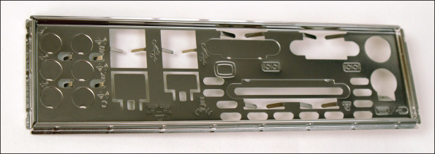
A motherboard might have several internal connectors, including USB, M.2, SATA, and IDE connectors. When you purchase a motherboard, look in the package for the motherboard manual, which is either printed or on DVD; you can also find the manual online at the manufacturer’s website. The manual will show a diagram of the board with a description of each connector. For example, the connectors for the motherboard in Figure 2-18 are labeled as the manual describes them. If a connector is a group of pins sticking up on the board, the connector is called a header. You will learn to use most of these connectors in later chapters.
Figure 2-18
Internal connectors on a motherboard for front panel ports
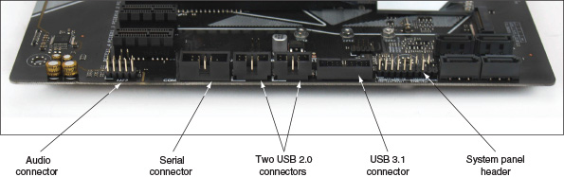
Next is a rundown of the internal connectors you need to know about.

SATA
SATA (Serial Advanced Technology Attachment or Serial ATA), pronounced “say-ta,” is an interface standard used mostly by storage devices. To attach a SATA drive to a motherboard, you need a data connection to the motherboard and a power connection to the power supply. Figure 2-19 shows a motherboard with seven SATA connectors. Six use the SATA3 standard and one is a shorter SATA Express connector.
Figure 2-19
Seven SATA connectors on a motherboard
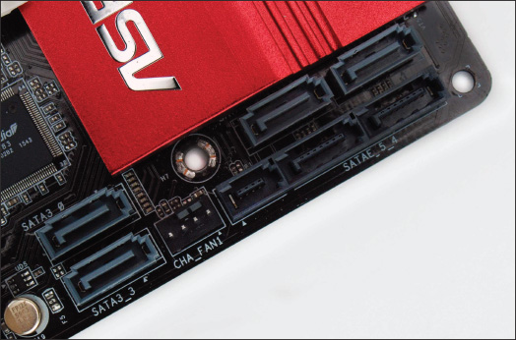
The following are currently used versions of SATA:
- SATA Express (SATAe) combines SATA and PCIe to provide a faster bus than SATA3, although the standard is seldom used.
- SATA3 (generation 3) is commonly known by its throughput as SATA 6Gb/s.
- SATA2 (generation 2) is commonly known by its throughput as SATA 3Gb/s.

M.2
The M.2 connector, formally known as the Next Generation Form Factor (NGFF), uses the PCIe, USB, or SATA interface to connect a mini add-on card. The card fits flat against the motherboard and is secured with a single screw. Figure 2-20 shows the slot and three screws for M.2 cards. The three screws allow for the installation of cards of three different lengths.
Figure 2-20
An M.2 slot and three possible screw positions to secure a card to the motherboard
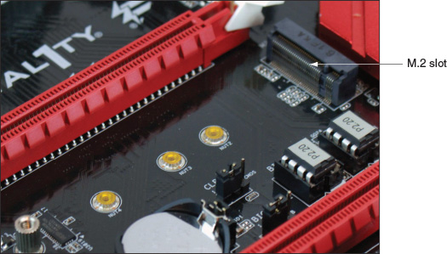
The M.2 connector or slot was first used on laptops and is now common on desktop motherboards. It is commonly used by wireless cards and solid-state drives (SSDs). When the PCIe interface is used, the slot is faster than all the SATA standards normally used by hard drives; therefore, the M.2 slot is often the choice to support the SSD that will hold the Windows installation. However, before you plan to install Windows on an M.2 drive, make sure the motherboard BIOS/UEFI firmware will boot from an M.2 device. (Look for the option in the boot priority order in BIOS/UEFI setup, which is discussed later in this chapter.)
Be aware there are multiple M.2 standards and M.2 slots. An M.2 slot is keyed for certain M.2 cards by matching keys on the slot with notches on the card. Figure 2-21 shows three popular options, although other options exist. Before purchasing an M.2 card, make sure the card matches the M.2 slot and uses an interface standard the slot supports. For example, for one motherboard, the M.2 slot uses either the PCIe or SATA interface. When a card that uses the SATA interface is installed in the slot, the motherboard uses SATA for the M.2 interface and disables one of the SATA connectors. When a PCIe M.2 card is installed, the motherboard uses the PCIe interface for the slot.
Figure 2-21
An M.2 slot is keyed with a notch to hold an M.2 card with a B key or M key edge connector
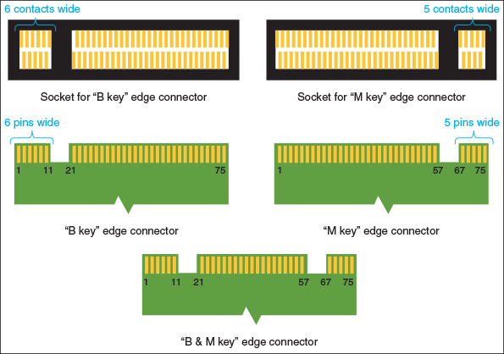

IDE
Years ago the IDE (Integrated Drive Electronics) standard was used to interface storage devices with the motherboard. An IDE connector has 40 pins and uses a wide ribbon with a 40-pin connector in the middle of the cable and another connector at the other end of the cable to connect two storage devices (hard drives or optical drives). Figure 2-22 shows an IDE connector on a motherboard and an IDE cable. These older storage devices received their power from the power supply by way of a Molex power cord.
Figure 2-22
An IDE connector and cable
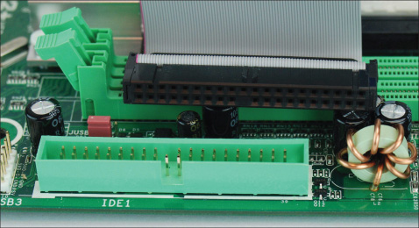
A+ Exam Tip
The A+ Core 1 exam expects you to be able to recognize SATA, IDE, M.2, and USB internal motherboard connectors and decide which connector to use in a given scenario.

USB
A motherboard may have USB headers or USB connectors. (Recall that a header is a connector with pins sticking up.) The USB header is used to connect a cable from the motherboard to USB ports on the front of the computer case (see Figure 2-23).
Figure 2-23
Two USB headers are used to connect the motherboard to USB ports on the front of the computer case
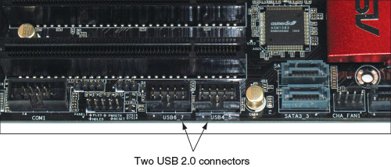
Applying Concepts

Finding the Motherboard Documentation
The motherboard manual or user guide is essential to identifying components on a board and knowing how to support the board. This guide can be a PDF file stored on the CD or DVD that came bundled with the motherboard. If you don’t have the CD, you can download the user guide from the motherboard manufacturer’s website.
To find the correct user guide online, you need to know the board manufacturer and model. If a motherboard is already installed in a computer, you can use BIOS/UEFI setup or the Windows System Information utility (msinfo32.exe) to report the brand and model of the board. To access System Information for Windows 10 or Windows 7, enter msinfo32.exe in the search box. (For Windows 8 or 8.1, right-click Start, click Run, and enter msinfo32.exe in the Run box.) In the System Information window, click System Summary. In the System Summary information in the right pane, look for the motherboard information labeled as the System Manufacturer and System Model (see Figure 2-24).
Figure 2-24
Use the system information window to identify the motherboard brand and model
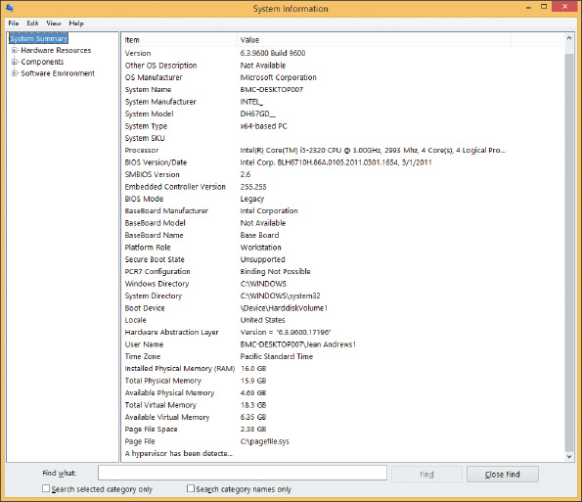
Source: Microsoft
If the motherboard is not installed or the system is not working, look for the brand and model imprinted somewhere on the motherboard (see Figure 2-25). Next, go to the website of the motherboard manufacturer and download the user guide. Websites for several motherboard manufacturers are listed in Table 2-3. The diagrams, pictures, charts, and explanations of settings and components in the user guide will be invaluable to you when supporting this board.
Figure 2-25
The motherboard brand and model are imprinted somewhere on the board
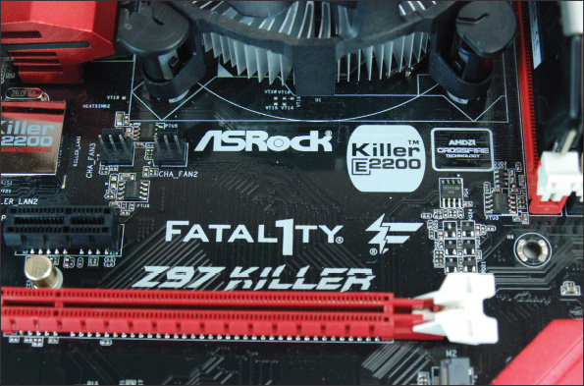
Table 2-3

Major Manufacturers of Motherboards
Manufacturer | Web Address
ASRock | asrock.com
ASUS | asus.com
BIOSTAR | biostar-usa.com
EVGA | evga.com
Gigabyte Technology Co., Ltd. | gigabyte.com
Intel Corporation | intel.com
Micro-Star International (MSI) | us.msi.com
Now that you know what to expect when examining or selecting a motherboard, let’s see how to configure a board.
Go to pg.
help
Application Opened
Main content

2-2Using BIOS/UEFI Setup to Configure a Motherboard
A+ Core 1
- 3.5
Given a scenario, install and configure motherboards, CPUs, and add-on cards.
Firmware on the motherboard is used to enable or disable a connector, port, or component; control the frequency and other features of the CPU; manage security features; control what happens when the computer first boots; and monitor and log various activities of the board.
Motherboards made after 2012 use BIOS/UEFI firmware; prior to 2012, all motherboards used BIOS firmware. UEFI (Unified Extensible Firmware Interface) improves on BIOS but includes BIOS for backward compatibility with older devices. UEFI is managed by several manufacturers and developers under the UEFI Forum (see uefi.org).
Facts you need to know about UEFI include:
- Microsoft requires UEFI in order for a system to be certified for Windows 10/8.
- UEFI is required for hard drives larger than 2 TB. (One terabyte or TB equals 1000 gigabytes or GB.) A hard drive uses one of two methods for partitioning the drive: The Master Boot Record (MBR) method is older, allows for four partitions, and is limited to 2-TB drives. The GUID Partition Table (GPT) method is newer, allows for any size of hard drive, and, for Windows, can have up to 128 partitions on the drive. GPT is required for drives larger than 2 TB or for systems that boot using UEFI firmware.
- UEFI offers Secure boot, which prevents a system from booting up with drivers or an OS that is not digitally signed and trusted by the motherboard or computer manufacturer. For Secure boot to work, the OS must support UEFI.
- For backward compatibility, UEFI can boot from an MBR hard drive and provide a BIOS boot through its Compatibility Support Module (CSM) feature. CSM is backward compatible with devices and drivers that use BIOS.
The motherboard settings don’t normally need to be changed except, for example, when you are first setting up the system, when there is a problem with hardware or the OS, or a power-saving feature or security feature (such as a power-on password) needs to be disabled or enabled.
A+ Exam Tip
The A+ Core 1 exam expects you to know about BIOS/UEFI settings for boot options, firmware updates, security settings, and interface configurations. Security settings include passwords, drive encryption, the TPM chip, LoJack, and Secure boot. All these settings and features are covered in this part of the chapter. In a given scenario, you need to know which BIOS/UEFI setting to use to solve a problem, install a new component or feature, or secure a system.
Go to pg.
help
Application Opened
Main content

2-2aAccessing the BIOS/UEFI Setup Program
You access the BIOS/UEFI setup program by pressing a key or combination of keys during the boot process; for some laptops, you press a button on the side of the laptop. For most motherboards, you press F12, F2, or Del during the boot. Sometimes, a message such as Press F12 or Del to enter UEFI BIOS Setup appears near the beginning of the boot, or a boot menu with the option to access BIOS setup appears after you have pressed a special button. See the motherboard documentation to know for sure which key or button to press.
When you press the appropriate key or button, a setup screen appears with menus and Help features that are often very user-friendly. Although the exact menus depend on the BIOS/UEFI maker, the sample screens that follow will help you become familiar with the general contents of BIOS/UEFI setup screens.
Notes
BIOS firmware uses only the keyboard for input, while UEFI firmware can use the keyboard and mouse. Some manufacturers use BIOS firmware with integrated UEFI functionality, and the setup screens are controlled only by the keyboard.
Go to pg.
help
Application Opened
Main content

2-2bViewing and Monitoring Information
The first screen you see in the firmware utility usually gives you information about the system, including the BIOS/UEFI version and information about the CPU, memory, hard drive, optical drive, date, and time. BIOS/UEFI menus and screens differ, so you might need to browse through the screens to find what you’re looking for. For example, Figure 2-26 shows information on the Configuration screen about installed hard drives and optical drives. This system has five internal SATA and eSATA ports and one external eSATA port. As you can see, a 120-GB hard drive is installed on SATA port 0, and another 1000-GB hard drive is installed on SATA port 1. Both ports are internal SATA connectors on the motherboard. Notice the optical drive is installed on SATA port 3, which is also an internal connector on the motherboard.
Figure 2-26
A BIOS/UEFI setup screen showing a list of drives installed on the system
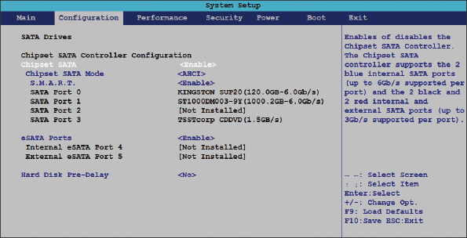
Source: Intel
Figure 2-27 shows the BIOS/UEFI screen for another system with a graphical BIOS/UEFI interface. Notice information about the BIOS version, CPU type, total memory installed, current temperature and voltage of the CPU, how the two memory slots on the motherboard are used (one is populated and one is empty), and RPMs of CPU fans.
Figure 2-27
Information about the system is reported when you first access BIOS/UEFI setup
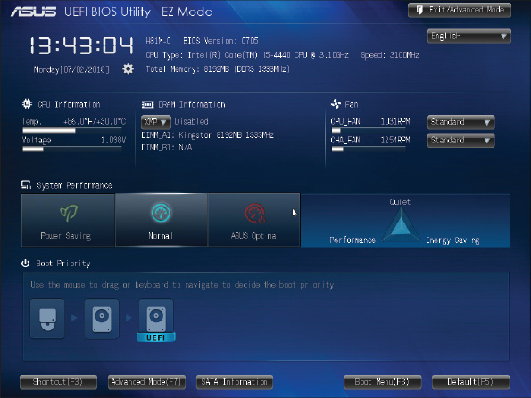
Source: American Megatrends, Inc.
When you click Advanced Mode, you see the SATA configuration. For example, Figure 2-28 shows a 1000-GB hard drive using the first SATA6G yellow port and a DVD device using the second SATA3G brown port. The other SATA ports are disabled. Also notice in the figure that S.M.A.R.T is enabled. S.M.A.R.T. (Self-Monitoring Analysis and Reporting Technology) monitors statistics reported by a hard drive and can predict when the drive is likely to fail. It displays a warning when it suspects a failure is about to happen.
Figure 2-28
SATA configuration displayed by the Asus BIOS/UEFI utility shows the status of four SATA connectors on the motherboard
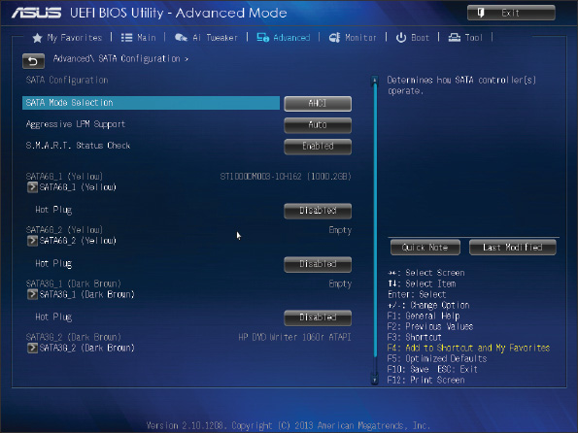
Source: American Megatrends, Inc.
Go to pg.
help
Application Opened
Main content

2-2cChanging Boot Options
Figure 2-29 shows an example of a boot menu in BIOS/UEFI setup. Here, you can set the order in which the system tries to boot from certain devices (called the boot priority order or boot sequence).
Figure 2-29
Set the boot priority order in BIOS setup
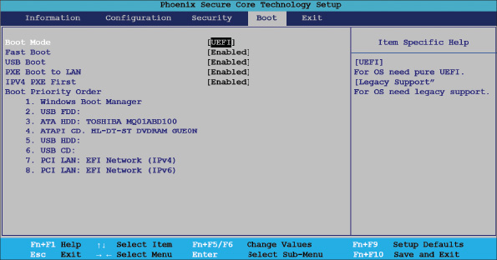
Source: Intel

Boot Priority Order
Here are some examples where you might want to change the boot priority order:
- Some distributions of the Linux operating system (OS) can be installed on a USB flash drive; you can boot the OS from this drive when you put the USB device first in the boot priority order.
Caution
Booting the system directly from a USB flash drive causes the system to ignore any OS that might be installed on the hard drive, which can be a security issue because data stored on the hard drive might be vulnerable. To help close this security hole, set the boot priority order to first boot from the hard drive and password-protect access to BIOS/UEFI setup so that others cannot change the boot order. Other ways to protect the OS and data on the hard drive are addressed later in this text.
- When you first install an OS on the hard drive, you might want BIOS/UEFI to first boot from a DVD so that you can install Windows from the Windows setup DVD.
- If you are installing the OS from a server on the network, put the PCI LAN: EFI Network option at the top of the boot priority order and enable PXE Boot to LAN. This causes the computer to boot to the firmware program called the Preboot eXecution Environment or Pre-Execution Environment (PXE), which then searches the network for an OS it receives from a deployment server. Notice in Figure 2-29 that when booting to access a deployment server on the network, you must choose whether your network is using IPv4 or IPv6 for IP addressing. You learn more about these concepts later in the text.
- When Windows is installed on the hard drive but refuses to start, you can boot from the Windows setup DVD to troubleshoot and repair the installation.
After the OS is installed, you can prevent accidental or malicious boots from a DVD or other removable media by changing the boot priority order to boot first from the hard drive. Also, BIOS/UEFI screens might give you options regarding built-in diagnostics that occur at the boot. You can configure some motherboards to perform a fast boot and bypass the extensive POST. When troubleshooting a boot problem, be sure to set BIOS/UEFI to perform the full POST.

Manage Secure Boot
You also need to know how to manage Secure boot, which was invented to help prevent malware from launching before the OS and anti-malware software are launched. Secure boot works only when the boot mode is UEFI (and not CSM) and the OS supports it. Windows 10/8 and several distributions of Linux (for example, Ubuntu and Red Hat) support Secure boot to assure that programs loaded by firmware during the boot are trustworthy.
Secure boot holds digital signatures, encryption keys, and drivers in databases stored in flash memory on the motherboard and/or on the hard drive. Initially, the motherboard manufacturer stores the data on the motherboard before it is shipped. This date is provided by OS and hardware manufacturers.
After the OS is installed, UEFI databases are stored in a system partition named efi on the hard drive. Database names are db (approved digital signatures), dbx (blacklist of signatures), and KEK (signatures maintained by the OS manufacturer). After an OS is installed on the hard drive, updates to the OS include updates to the KEK. The Platform Key (PK) is a digital signature that belongs to the motherboard or computer manufacturer. The PK authorizes turning Secure boot on or off and updating the KEK database.
When Secure boot is enabled, it checks each driver, the OS, and applications before UEFI launches these programs during the early stages of the boot to verify it is signed and identified in the Secure boot databases. After the OS is launched, it can load additional drivers and applications that UEFI Secure boot does not verify.
For normal operation, you would not be required to change Secure boot settings unless you want to install hardware or an OS (for example, Kali Linux) that is not certified by the computer manufacturer. In this situation, you could disable Secure boot. Before you make any changes to the Secure boot screen, be sure to use the option to save Secure boot keys, if that option is available. Doing so saves all the databases to a USB flash drive so that you can backtrack your changes later if need be.
Take a look at Figure 2-30, which shows the Security screen for one laptop where Secure boot can be enabled or disabled. Also notice the option highlighted to Restore Factory Keys. This option may be helpful if BIOS/UEFI refuses to allow a fresh installation of an OS or hardware device. On this system, before you can enable Secure boot, you must go to the Boot screen and select UEFI as the Boot Mode.
Figure 2-30
Manage Secure boot on the Security screen of BIOS/UEFI setup
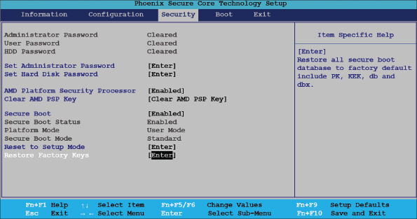
Source: Intel
Notes
On laptops and other computers that have the Windows 8 logo imprinted on them, the computer manufacturer is required to configure Secure boot so that it cannot be disabled, which assures that only certified OSs and drivers can be loaded by UEFI.

Manage CSM and UEFI Boot
The Boot screen allows you to select UEFI mode or CSM (also called Legacy Support) mode. UEFI mode is required for Secure boot to be enabled. For example, in Figure 2-31, you first must disable Fast Boot and then you can select either CSM (Compatibility Support Module) or Secure boot. When you select Secure boot, UEFI mode is enabled. Use CSM for backward compatibility with older BIOS devices and drivers and MBR hard drives.
Figure 2-31
Use CSM to boot a legacy BIOS system or disable it to implement UEFI Secure boot
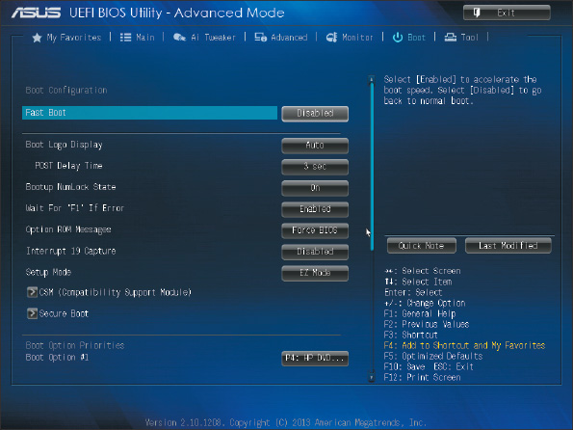
Source: American Megatrends, Inc.
Go to pg.
help
Application Opened
Main content

2-2dConfiguring Onboard Devices
You can enable or disable some onboard devices (for example, a wireless LAN, a network port, USB ports, or video ports) using BIOS/UEFI setup. For one system, the Configuration screen shown in Figure 2-32 does the job. On this screen, you can enable or disable a port or group of ports; you can configure the Front Panel Audio ports for Auto, High Definition audio, and Legacy audio; or you can disable these audio ports. What you can configure on your system depends on the onboard devices the motherboard offers.
Figure 2-32
Enable and disable onboard devices
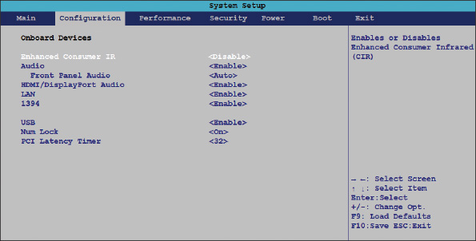
Source: Intel
Notes
You don’t have to replace an entire motherboard if one port fails. For example, if the network port fails, use BIOS/UEFI setup to disable the port. Then use an expansion card for the port instead.

Processor and Clock Speeds
Overclocking is running a processor, memory, motherboard, or video card at a higher speed than the manufacturer recommends. Some motherboards and processors allow overclocking, but it is not a recommended best practice. If you decide to overclock a system, pay careful attention to the temperature of the processor so it does not overheat; overheating can damage the processor.
Go to pg.
help
Application Opened
Main content

2-2eConfiguring Security Features
Other security features besides Secure boot are power-on passwords, LoJack, drive password protection, the TPM chip, and drive encryption. All are discussed next.

Power-on Passwords
Power-on passwords are assigned in BIOS/UEFI setup to prevent unauthorized access to the computer and/or the BIOS/UEFI setup utility. For one motherboard, this security screen looks like the one shown in Figure 2-33, where you can set a supervisor password and a user password. In addition, you can configure how the user password works.
Figure 2-33
Set supervisor and user passwords in BIOS/UEFI setup to help lock down a computer
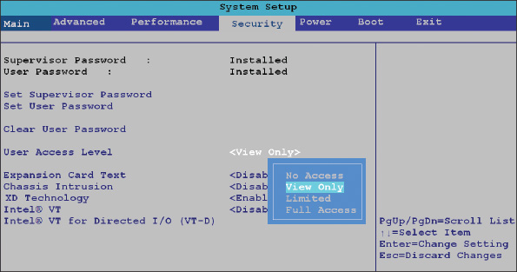
Source: Intel
The choices under User Access Level are No Access (the user cannot access the BIOS/UEFI setup utility), View Only (the user can access BIOS/UEFI setup, but cannot make changes), Limited (the user can access BIOS/UEFI setup and make a few changes such as date and time), and Full Access (the user can access the BIOS/UEFI setup utility and make any changes). When supervisor and user passwords are both set and you boot the system, a box to enter a password is displayed. The access you have depends on which password you enter. Also, if both passwords are set, you must enter a valid password to boot the system. By setting both passwords, you can totally lock down the computer from unauthorized access.
A+ Exam Tip
The A+ Core 1 exam expects you to know how to use BIOS/UEFI setup to secure a workstation from unauthorized use.
Caution
In the event that passwords are forgotten, know that supervisor and user passwords to the computer can be reset by setting a jumper (group of pins) on the motherboard to clear all BIOS/UEFI customized settings and return BIOS/UEFI setup to its default settings. To keep someone from using this technique to access the computer, you can use a computer case with a lockable side panel and install a lock on the case. Using jumpers is covered later in this chapter.
Also, the BIOS/UEFI utility might have an intrusion detection alert feature that requires a cable to be connected to a switch on the case. When the case is opened, the action is logged in BIOS/UEFI and a message appears at the beginning of the boot that an intrusion has been detected. This security feature is easily bypassed by hackers and is therefore not considered a best practice.

LoJack for Laptops Technology
LoJack and Computrace Agent technology are embedded in the firmware of many laptops to protect a system against theft. When you subscribe to the LoJack for Laptops service by Absolute (absolute.com) and later report a theft to Absolute, the company can locate your laptop whenever it connects to the Internet. Absolute reports its location to the police, and even before it is recovered, you can give commands through the Internet to lock the laptop or delete all data on it.

Drive Password Protection
Some laptop BIOS/UEFI utilities offer the option to set a hard drive password. For example, look back at Figure 2-30 and the option Set Hard Disk Password. Using this option, you can set Master and User passwords for all hard drives installed in the system. When you first turn on the computer, you must enter a power-on password to boot the computer and a hard drive password to access the hard drive.
Using a hard drive password does not encrypt all the data on the drive but encrypts only a few organizational sectors. Therefore, a hacker can move the drive to another computer and use software that can read sectors where data is kept without having to read the organizational sectors. Password-protected drives are therefore not as secure as drive encryption, which is discussed next.

The TPM Chip and Hard Drive Encryption
Many motherboards contain a chip called the TPM (Trusted Platform Module) chip. The BitLocker Encryption tool in Windows 10/8/7 is designed to work with this chip; the chip holds the BitLocker encryption key (also called the startup key). The TPM chip can also be used with encryption software other than BitLocker that may be installed on the hard drive. If the hard drive is stolen from the computer and installed in another computer, the data will be safe because BitLocker has encrypted all contents on the drive and will not allow access without the startup key stored on the TPM chip. Therefore, this method assures that the drive cannot be used in another computer. However, if the motherboard fails and is replaced, you’ll need a backup copy of the startup key to access data on the hard drive.
A+ Exam Tip
The A+ Core 1 exam expects you to know about drive encryption, the TPM chip, and how to use both to secure a workstation or laptop.
When you use Windows to install BitLocker Encryption, the initialization process also initializes the TPM chip. Initializing the TPM chip configures it and turns it on. After BitLocker is installed, you can temporarily turn it off, which also turns off the TPM chip. For example, you might want to turn off BitLocker to test the BitLocker recovery process. Normally, BitLocker will manage the TPM chip for you, and there is no need for you to manually change TPM chip settings. However, if you are having problems installing BitLocker, one thing you can do is clear the TPM chip. Be careful! If the TPM chip is being used to hold an encryption key to protect data on the hard drive and you clear the chip, the encryption key will be lost. That means all the data will be lost, too. Therefore, don’t clear the TPM chip unless you are certain it is not being used to encrypt data.
Notes
Drive encryption might be too secure at times. I know of a situation where an encrypted hard drive became corrupted. Normally, you might be able to move the drive to another computer and recover some data. However, this drive asked for the encryption password but then could not confirm it. Therefore, the entire drive, including all the data, was inaccessible.
Go to pg.
help
Application Opened
Main content

2-2fBIOS Support for Virtualization
Virtualization in computing is when one physical computer uses software to create multiple virtual computers and each virtual computer or virtual machine (VM) simulates the hardware of a physical computer. Each VM running on a computer works like a physical computer and is assigned virtual devices such as a virtual motherboard and virtual hard drive. Examples of VM software are Microsoft Hyper-V and Oracle VirtualBox. For most VM software to work, virtualization must be enabled in BIOS/UEFI setup. Looking back at Figure 2-33, you can see the option to enable Intel VT, the name Intel gives to its virtualization technology.
Go to pg.
help
Application Opened
Main content

2-2gExiting the BIOS/UEFI Setup Menus
When you finish with BIOS/UEFI setup, an exit screen such as the one shown in Figure 2-34 gives you various options, such as saving your changes and exiting or discarding your changes and exiting. Notice in the figure that you also have the option to Load Optimized Defaults. This option can sometimes solve a problem when a user has made several inappropriate changes to the BIOS/UEFI settings or you are attempting to recover from an error created while updating the firmware.
Figure 2-34
The BIOS/UEFI Utility Exit screen
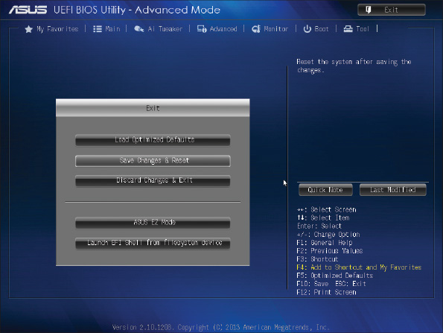
Source: American Megatrends, Inc.
Applying Concepts

Managing the TPM Chip
To manage the TPM chip, follow these steps:
- In BIOS/UEFI, verify that the TPM chip is enabled.
- Sign in to Windows using an administrator account.
- In the Windows 10/8/7 search box, enter the tpm.msc command. If necessary, respond to the UAC box. The TPM Management console opens.
- If no TPM chip is present or it’s not enabled in BIOS/UEFI setup, the console reports that. If your system has a TPM chip that is not yet initialized, the Status pane in the console reports TPM is not ready for use (see Figure 2-35). To initialize the TPM, click Prepare the TPM in the Actions pane. After Windows initializes the TPM and you close the dialog box, the console will report that the TPM is ready for use (also shown in Figure 2-35).
Figure 2-35
Use the TPM Management console to manage the TPM chip in Windows
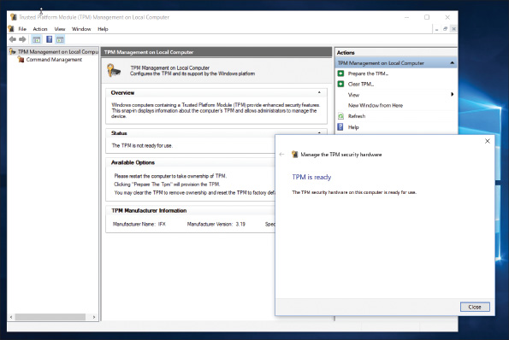
Source: Microsoft
- Using the console, you can change the TPM owner password, turn TPM on or off in Windows, reset the TPM when it has locked access to the hard drive, and clear the TPM, which resets it to factory defaults. After you have made changes to the TPM chip, you will most likely be asked to restart the computer for the changes to take effect.
Go to pg.
help
Application Opened
Main content

2-3Updating Motherboard Drivers and BIOS/UEFI
When a motherboard is causing problems or you want to use a new OS or hardware device, you might need to update the motherboard drivers or update the BIOS/UEFI firmware. Both skills are covered in this part of the chapter.
A+ Exam Tip
The A+ Core 1 exam expects you to know how to update drivers and firmware and replace the CMOS battery. Given the symptom of a problem, you must decide if the source of the problem is a device, motherboard firmware, or the CMOS battery and decide what to do to resolve the problem.
Go to pg.
help
Application Opened
Main content

2-3aInstalling or Updating Motherboard Drivers
Device drivers are small programs stored on the hard drive that an operating system such as Windows or Linux uses to communicate with a specific hardware device—for example, a printer, network port on the motherboard, or video card. The CD or DVD that comes bundled with the motherboard contains a user guide and drivers for its onboard components (for example, chipset, graphics, audio, network, and USB drivers), and these drivers need to be installed in the OS. After installing a motherboard, you can install the drivers from CD or DVD and later update them by downloading updates from the motherboard manufacturer’s website. Updates to motherboard drivers are sometimes included in updates to Windows.
Notes
The motherboard CD or DVD or the manufacturer’s website might contain useful utilities—for example, a utility to monitor the CPU temperature and alert you if overheating occurs, or a diagnostics utility for troubleshooting. You might also find a utility that works in Windows or Linux to update the BIOS/UEFI firmware.
If you don’t have the CD or DVD that came with the motherboard or you want to update the drivers already installed on the system, go to the motherboard manufacturer website to find the downloads you need. Figure 2-36 shows the download page for the Asus Prime Z370-P motherboard shown earlier in Figure 2-1. On this page, you can download manuals, drivers, utility tools, and BIOS/UEFI updates for the board. You can also access a list of CPUs and memory modules the board can use. Be sure to get the correct drivers for the OS edition and type (for example, Windows 10 64-bit) you are using with the board.
Figure 2-36
Download drivers, utilities, BIOS/UEFI updates, documentation, and other help software from the motherboard manufacturer’s website
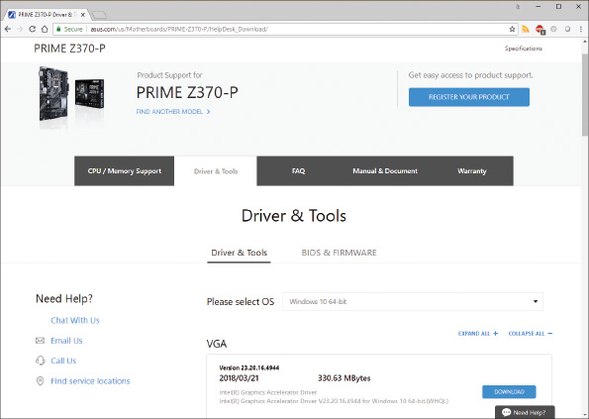
Source: ASUSTeK Computer, Inc.
Notes
To know what edition and type of Windows you are using, use the System Information utility (msinfo32.exe).
Go to pg.
help
Application Opened
Main content

2-3bUpdating Firmware
The process of upgrading or refreshing the programming and data stored on the firmware chip is called updating firmware, flashing BIOS/UEFI, or flashing BIOS. Here are some good reasons to flash the BIOS/UEFI:
- The system hangs at odd times or during the boot.
- Some motherboard functions have stopped working or are causing problems. For example, the onboard video port is not working.
- You get errors when trying to install a new OS or hardware device.
- You want to incorporate some new features or a new component on the board. For example, a BIOS upgrade might be required before you upgrade the processor.
Caution
It’s extremely important that you use the correct motherboard brand and model when selecting the BIOS/UEFI update on the manufacturer’s website. Trying to use the wrong update can cause problems. Also, get your updates directly from the manufacturer website rather than other third-party sites.
To flash BIOS/UEFI, always follow the directions that you can find in the user guide for your motherboard. Motherboards can use one or more of these methods:
- Download and update from within BIOS/UEFI setup. Some motherboards allow you to enter BIOS/UEFI setup and select the option for BIOS/UEFI to connect to the Internet, check for updates, download the update, and apply it.
- Update from a USB flash drive using BIOS/UEFI setup. Download the latest firmware update file for your BIOS/UEFI version from the manufacturer website and store it on a USB flash drive that is formatted using the FAT32 file system (not the NTFS file system). Then restart the system and launch BIOS/UEFI setup. Select the option to flash BIOS/UEFI and point to the USB drive for the update. Alternately, you might press a key at startup to launch the update rather than launch BIOS/UEFI setup. (For some motherboard brands, you press F7.) The update is applied and the system restarts.
- Run an express BIOS/UEFI update. An express BIOS/UEFI update is done from within Windows. You use Windows application software available on the motherboard manufacturer website to check for, download, and install firmware updates. Alternately, you might be instructed to download the firmware update and double-click it to start the update. Because too many things can go wrong using Windows to update BIOS/UEFI, it is not a recommended best practice.
Be aware of these cautions when updating BIOS/UEFI firmware:
- Don’t update firmware without a good reason. Makers of BIOS/UEFI are likely to provide updates frequently because putting the upgrade on the Internet is so easy for them. Generally, however, follow the principle that “if it’s not broke, don’t fix it.” Update your firmware only if you’re having a problem with your motherboard or there’s a new BIOS/UEFI feature you want to use.
- Back up first. Before attempting to update the firmware, back up the firmware to a USB flash drive, if possible. See the motherboard user manual to find out how.
- Select the correct update file. Always use an update version that is more recent than the BIOS/UEFI version already installed and carefully follow manufacturer directions. Upgrading with the wrong file could make your BIOS/UEFI useless. If you’re not sure that you’re using the correct upgrade, don’t guess. Check with the technical support for your BIOS/UEFI before moving forward. Before you call technical support, have the information available that identifies your BIOS/UEFI and motherboard.
- Don’t interrupt the update. Be sure not to turn off your computer while the update is in progress. For laptops, make sure the AC adapter is plugged in and powering the system.
Notes
To identify the BIOS/UEFI version installed, look for the BIOS version number displayed on the main menu of BIOS/UEFI setup. Alternately, you can use the System Information utility (msinfo32.exe) in Windows to display the BIOS version.
If the BIOS update is interrupted or the update creates errors, you are in an unfortunate situation. Search the motherboard manufacturer website for help. Here are some options:
- Back flash. You might be able to revert to the earlier version, which is called a back flash. To do this, generally you download the recovery file from the website and copy the file to a USB flash drive. Then set the jumper on the motherboard to recover from a failed BIOS update. When you reboot the system, the BIOS automatically reads from the device and performs the recovery. Then reset the jumper to the normal setting and boot the system.
- Bootable media and restore defaults. You might be instructed to make a bootable CD or DVD using support tools from the motherboard manufacturer. Boot the system from the CD or DVD and enter commands to attempt the update again from the file stored on the USB flash drive. Then enter BIOS/UEFI setup and restore defaults.
Notes
If a BIOS/UEFI update fails to complete, BIOS/UEFI may reboot and try again up to three times. After the third attempt, the update will be discarded and the firmware will roll back a partial update.
Go to pg.
help
Application Opened
Main content

2-3cUsing Jumpers to Clear BIOS/UEFI Settings
A motherboard may have jumpers that you can use to clear BIOS/UEFI settings, which returns the BIOS/UEFI setup to factory default settings. You might want to clear settings if flashing BIOS/UEFI didn’t work or failed to complete correctly, or if a power-on password is forgotten and you cannot boot the system.
A jumper is two small posts or metal pins that stick up on the motherboard; it’s used to hold configuration information. An open jumper has no cover, and a closed jumper has a cover on the two pins (see Figure 2-37). Look at the jumper cover in Figure 2-37(B) that is “parked,” meaning it is hanging on a single pin for safekeeping, but is not being used to turn on a jumper setting.
Figure 2-37
A 6-pin jumper group on a circuit board: (A) has no jumpers set to on, (B) has a cover parked on one pin, and (C) is configured with one jumper setting turned on
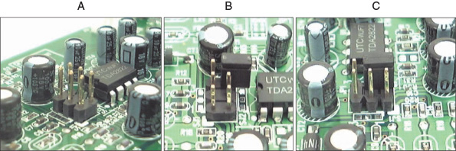
Figure 2-38 shows one example of a group of three jumpers. (The tan jumper cap is positioned on the first two jumper pins on the left side of the group.) Figure 2-39 shows the motherboard documentation for how to use these jumpers. When jumpers 1 and 2 are closed, which they are in the figure, normal booting happens. When jumpers 2 and 3 are closed, passwords to BIOS/UEFI setup can be cleared on the next boot. When no jumpers are closed, the BIOS/UEFI will recover itself on the next boot from a failed update. Once set for normal booting, the jumpers should be changed only if you are trying to recover when a power-up password is lost or flashing BIOS/UEFI has failed. To learn how to set jumpers, see the motherboard documentation.
Figure 2-38
This group of three jumpers controls the BIOS configuration
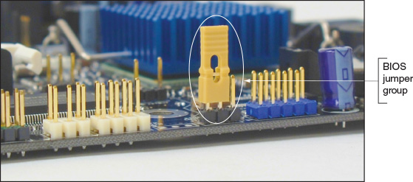
Figure 2-39
BIOS configuration jumper settings
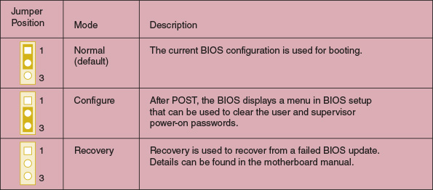
Go to pg.
help
Application Opened
Main content

2-3dReplacing the CMOS Battery
A motherboard stores its data in flash memory in the firmware or in CMOS RAM. CMOS (complementary metal-oxide semiconductor) is a method of manufacturing microchips, and CMOS RAM is a small amount of memory stored on the motherboard that retains data even when the computer is turned off because it is charged by a nearby lithium coin-cell battery (see Figure 2-40). If the CMOS battery is disconnected or fails, setup information is lost. An indication that the battery is getting weak is that the system date and time are incorrect after power has been disconnected to the computer. A message about a low battery can also appear at startup.
A+ Exam Tip
The A+ Core 1 exam expects you to recognize the symptoms that require the CMOS battery to be replaced.
Figure 2-40
The coin-cell battery powers CMOS RAM when the system is turned off and unplugged
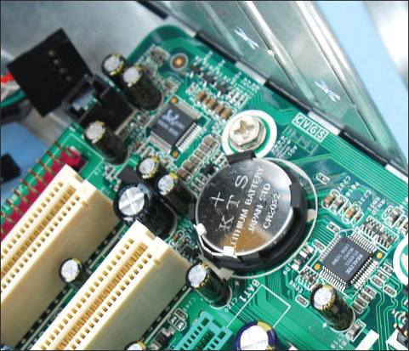
The CMOS battery on the motherboard is considered a field replaceable unit. The battery is designed to last for years and recharges when the motherboard has power. However, on rare occasions, you might need to replace one if the system loses BIOS/UEFI settings when it is unplugged. Make sure the replacement battery is an exact match to the original or is one the motherboard manufacturer recommends for the board. Power down the system, unplug it, press the power button to drain the power, and remove the case cover. Use your ESD strap to protect the system against ESD. The old battery can be removed with a little prying using a flathead screwdriver. The new battery pops into place. For more specific directions, see the motherboard documentation.
Now let’s see what other tasks you might need to do when you are installing or replacing a motherboard.
Go to pg.
help
Application Opened
Main content

2-4Installing or Replacing a Motherboard
A+ Core 1
- 3.5
Given a scenario, install and configure motherboards, CPUs, and add-on cards.
A motherboard is considered a field replaceable unit, so you need to know how to replace one when it goes bad. In this part of the chapter, you learn how to select a motherboard and then how to install or replace one in a desktop or laptop computer.
Go to pg.
help
Application Opened
Main content

2-4aHow to Select a Desktop Motherboard
Because the motherboard determines so many of your computer’s features, selecting the motherboard is often your most important decision when you purchase a desktop computer or assemble one from parts. Depending on which applications and peripheral devices you plan to use with the computer, you can take one of three approaches to selecting a motherboard. The first approach is to select the board that provides the most room for expansion, so you can upgrade and exchange components and add devices easily. A second approach is to select the board that best suits the needs of the computer’s current configuration, knowing that when you need to upgrade, you will likely switch to new technology and a new motherboard. The third approach is to select a motherboard that meets your present needs with moderate room for expansion.
Ask the following questions when selecting a motherboard:
- How is the motherboard to be used? (For example, it might be used for light business and personal use, as a gaming system, for a server, or for a high-powered workstation.)
Knowing how the board will be used helps you decide about the most important features and overall power of the board. For example, a motherboard to be used in a server might need support for RAID (an array of multiple hard drives to improve performance and fault tolerance). In another example, a motherboard used in a gaming system will not need RAID support, but might need a chipset that supports two high-end graphics adapters.
- What form factor does the motherboard use?
- Which brand (Intel or AMD) and model processors does the board support? Which chipset does it use? Which processors does it support?
Most motherboard manufacturers offer a motherboard model in two versions: one version with an Intel chipset and a second version with an AMD chipset. Here are the criteria to decide which brand of chipset to use:
  - If price is a concern, boards with AMD chipsets generally cost less than comparable boards with Intel chipsets.
  - AMD is popular in the hobbyist and gaming market, and many of its chipsets and processors are designed with high-end graphics in mind. AMD puts graphics first and processing power second. For the hobbyist, many AMD processors can be overclocked.
  - Intel offers the most options in processor models and chipset and processor features. Intel typically targets the consumer, business, and server markets, and generally is strong in power conservation, processing power, and graphics.
  - Intel dominates the laptop, pre-built desktop, consumer, and server markets.
- Which type and speed of memory does the board support?
- What are the embedded expansion slots, internal and external connectors, and devices on the board? (For example, the board might provide multiple PCIe ×16 v4 slots, SATA3 connectors, a network port, a wireless component, multiple USB ports, an M.2 slot, HDMI port, DVI-D port, and so forth.)
- Does the board fit the case you plan to use?
- What are the price and the warranty on the board? Does the board get good reviews?
- How extensive and user friendly is the documentation and how helpful is the manufacturer website?
- What warranty and how much support does the manufacturer supply for the board?
Sometimes a motherboard contains an onboard component more commonly offered as a separate device. One example is support for video. The video port might be on the motherboard or might require a video card. A motherboard with embedded video is less expensive than a motherboard and a graphics card you plan to install in a PCIe ×16 slot, but the latter plan gives higher-quality video.
Notes
If you have an embedded component, make sure you can disable it so you can use another external component if needed. Components are disabled in BIOS/UEFI setup.
Table 2-3, shown earlier in the chapter, lists some manufacturers of motherboards and their web addresses. For motherboard reviews, do a general search of the web.
Notes
Get really familiar with the manufacturer’s website of the motherboard you plan to purchase. It tells you which processors and memory modules the board can support. Make sure the processor and memory you plan to use with the board are on these lists.
Go to pg.
help
Application Opened
Main content

2-4bHow to Install or Replace a Motherboard
When you purchase a motherboard, the package comes with the board, I/O shield, documentation, drivers, and various screws, cables, and connectors. When you replace a motherboard, you pretty much have to disassemble an entire computer, install the new motherboard, and reassemble the system, which you learned to do in Chapter 1. The following steps are meant to be a general overview of the process and are not meant to include the details of all possible installation scenarios, which can vary according to the components and case you are using. The best place to go for detailed installation instructions is the motherboard user guide.
Caution
As with any installation, remember the importance of using an ESD strap to ground yourself when working inside a computer case to protect components against ESD. Other precautions to protect the hardware and you are covered in Appendix A.
The general process for replacing a motherboard is as follows:
- Verify that you have selected the right motherboard to install in the system. The new motherboard should have the same form factor as the case, support the RAM modules and processor you want to install on it, and have other internal and external connectors you need for your system.
- Get familiar with the motherboard documentation, features, and settings. Especially important are any connectors and jumpers on the motherboard. It’s a great idea to read the motherboard user guide from cover to cover. At the least, get familiar with what it has to offer and study the diagrams in it that label all the components on the board. Learn how each connector and jumper is used. You can also check the manufacturer’s website for answers to any questions you might have.
- Remove components so you can reach the old motherboard. Use an ESD strap. Turn off the system and disconnect all cables and cords. Press the power button to dissipate the power. Open the case cover and remove all expansion cards. Disconnect all internal cables and cords connected to the old motherboard. To safely remove the old motherboard, you might have to remove drives. If the processor cooler is heavy and bulky, you might remove it from the old motherboard before you remove the motherboard from the case.
- Install the I/O shield. The I/O shield is a metal plate that comes with the motherboard and fits over the ports to create a well-fitting enclosure for them. A case might come with a standard I/O shield already in place. Hold the motherboard up to the shield and make sure the ports on the board will fit the holes in the shield (see Figure 2-41). If the holes in the shield don’t match up with the ports on the board, punch out the shield and replace it with the one that came bundled with the motherboard.
Figure 2-41
Make sure the holes in the I/O shield match up with the ports on the motherboard
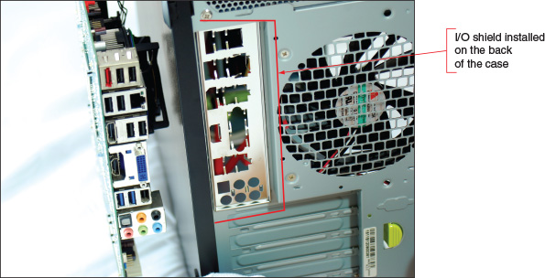
- Install the motherboard. Place the motherboard into the case and, using spacers or screws, securely fasten the board to the case. Because coolers are heavy, most processor instructions say to install the motherboard before installing the processor and cooler to better protect the board or processor from being damaged. On the other hand, some motherboard manufacturers say to install the processor and cooler and then install the motherboard. Follow the order given in the motherboard user guide. The easiest approach is to install the processor, cooler, and memory modules on the board and then place the board in the case (see Figure 2-42).
Figure 2-42
A motherboard with processor, cooler, and memory modules installed is ready to go in the case
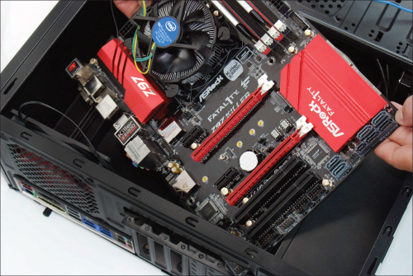
- Install the processor and processor cooler. The processor comes already installed on some motherboards, in which case you just need to install the cooler. The steps for installing a processor and cooler are covered in Chapter 3.
- Install RAM into the appropriate slots on the motherboard. You learn how to install RAM in Chapter 3.
- Attach the wires and cables. Attach the wire leads from the front panel to the front panel connector or header on the motherboard, as you learned to do in Chapter 1. You’ll also need to attach the P1 power connector, fan connectors, processor auxiliary power connector, and SATA cables to the internal drives. If the case has ports on the front, such as USB or sound ports, connect cables from the ports to the appropriate headers on the motherboard. Position and tie cables neatly together to make sure they don’t obstruct the fans and the airflow.
- Install the video card on the motherboard. If the motherboard does not have onboard video, install the video card now. It should go into the primary PCI Express ×16 slot. If the motherboard has onboard video, use the video port and check out how the system functions until you know everything else is working. Then go back and install an optional video card. If you plan to install two video cards, verify that one is working before installing the second one.
- Plug the computer into a power source, and attach the monitor, keyboard, and mouse. Initially install only the devices you absolutely need.
- Boot the system and enter BIOS/UEFI setup. Make sure the settings are set to the defaults. If the motherboard comes new from the manufacturer, it will already be at default settings. If you are salvaging a motherboard from another system, you might need to reset settings to the defaults. You will need to do the following while you are in BIOS/UEFI setup:
  - Check the time and date.
  - Make sure fast boot (also called abbreviated POST) is disabled. While you’re installing a motherboard, you generally want it to do as many diagnostic tests as possible. After you know the system is working, you can choose fast boot.
  - Set the boot order to the hard drive, and then the optical drive, if you will be booting the OS from the hard drive.
  - Leave everything else at their defaults unless you know that particular settings should be otherwise.
  - Save and exit.
- Observe POST and verify that no errors occur.
- Verify that Windows starts with no errors. If Windows is already installed on the hard drive, boot to the Windows desktop. Use Device Manager to verify that the OS recognizes all devices and that no conflicts are reported.
- Install the motherboard drivers. If your motherboard comes with a CD or DVD that contains some motherboard drivers, install them now. You will probably need Internet access so that the setup process can download the latest drivers from the motherboard manufacturer’s website. Reboot the system one more time, checking for errors.
- Install any other expansion cards and drivers. Install each device and its drivers, one device at a time, rebooting and checking for conflicts after each installation.
- Verify that everything is operating properly and make any final OS and BIOS/UEFI adjustments, such as setting power-on passwords.
Notes
Whenever you install or uninstall software or hardware, keep a notebook with details about the components you are working on, configuration settings, manufacturer specifications, and other relevant information. This helps if you need to backtrack later and can also help you document and troubleshoot your computer system. Keep all hardware documentation for this system together with the notebook in an envelope in a safe place.
Go to pg.
help
Application Opened
Main content

2-4cReplacing a Laptop System Board
A+ Core 1
- 1.1
Given a scenario, install and configure laptop hardware and components.
Replacing the system board (motherboard) on a laptop probably means you’ll need to fully disassemble the entire laptop except the LCD assembly in the lid. Therefore, before you tackle the job, consider alternatives. If available, use diagnostic software from the laptop manufacturer to verify that the problem is a failed system board. If a port or component on the system board has failed, consider installing an external device rather than replacing the entire board. Make sure the laptop is not still under a warranty that might be voided if you crack the case. Replacing the system board is a big deal, so consider that the cost of repair, including parts and labor, might be more than the laptop is worth. A new laptop might be your best solution.
Notes
You will need the teardown instructions to disassemble the laptop. Also, check for videos online about the teardown. For example, go to youtube.com and search on “disassemble lenovo ideapad 310.”
If you do decide to replace the system board, use a replacement purchased from the laptop manufacturer. Most likely, the board comes with teardown instructions to install it. As our example, we use the Lenovo Ideapad 310, which has a system board with an embedded processor. Here is the general procedure for replacing the board and processor:
- Update Windows and device drivers and make sure Windows is working properly before you shut down the system.
- This laptop has a built-in battery. Disconnect the AC adapter. Press Fn + S + V to set the battery in Ship Mode so it does not supply power to the system. To verify Ship Mode is set, press the power button; the system should not power up.
- As you learned to do in Chapter 1, remove the hard drive slot compartment cover and the hard drive. Next, remove the slot compartment cover that gives access to the memory and Mini PCIe card, and then remove these two components. Remove the optical drive. Figure 2-43 shows the bottom of the laptop with all these components removed.
Figure 2-43
The bottom of a laptop with the hard drive, memory, Mini PCI Express card, and optical drive removed
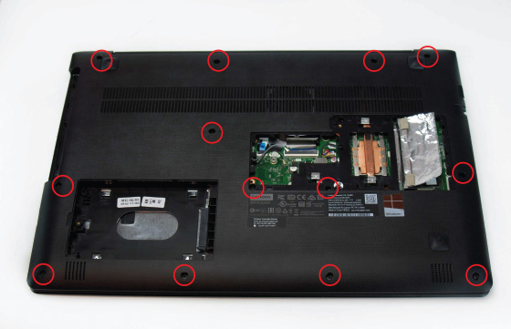
- To remove the keyboard bezel, first remove the 13 screws, which are circled in Figure 2-43. Next, detach the touch pad and keyboard ribbon cables from the two FPC (flexible printed circuit) connectors. You can now turn the laptop over, crack the case, and lift off the keyboard bezel. Figure 2-44 shows the system board now exposed.
Figure 2-44
Remove the keyboard bezel to expose the system board
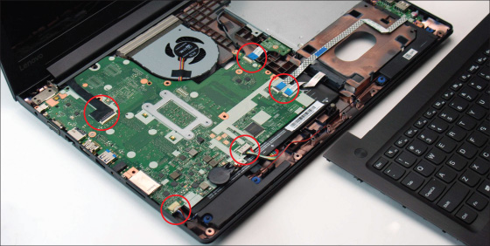
- To detach the system board, first remove the 5 screws holding it in place and then remove the 6 ribbon cables (circled in red in Figure 2-44) connecting the speakers, hard drive, optical drive, USB ports, battery, camera, and LCD panel. You can then remove the system board by pushing it to the right to dislodge it from the jacks on the side of the laptop (see Figure 2-45) and then lifting the board up and out of the case. See Figure 2-46. Handle the board carefully, making sure you don’t bend it as you work.
Figure 2-45
Detach the system board from jacks on the left side of the case and then lift the system board up and out of the case
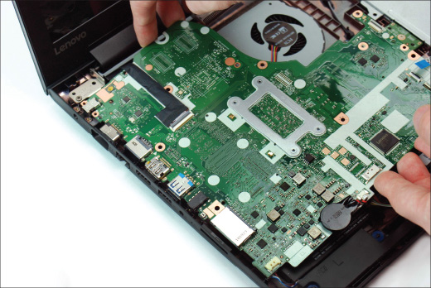
Figure 2-46
Disconnect the fan cable and screws holding the fan assembly to the system board
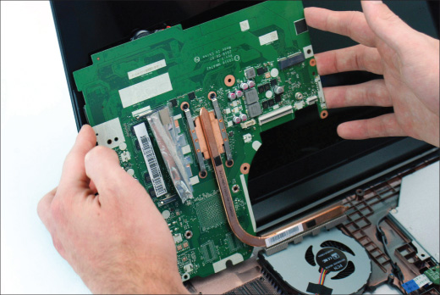
- Follow directions in reverse order to reassemble the system. Be careful to delicately, yet firmly, push the system board into the jacks on the left side of the case without damaging these jack connections. Also, double-check to make certain each ribbon cable is securely attached to its connector. After the system is assembled, attach the AC adapter, which switches the battery out of Ship Mode. Power up the system. After you have verified that Windows comes up with no errors, be sure to update BIOS/UEFI on the new board.
Go to pg.
help
Application Opened
Main content

Chapter Review

2-5aChapter Summary

Motherboard Types and Features
- The motherboard is the most complicated of all components inside the computer. It contains the processor socket and accompanying chipset, firmware holding the BIOS/UEFI, memory slots, expansion slots, jumpers, ports, and power supply connections. Sometimes, the processor is embedded on the board. The motherboard you select determines both the capabilities and limitations of your system.
- The most popular motherboard form factors are ATX, microATX, and Mini-ITX. The form factor determines the size of the board and the case and power supply the board can use.
- The chipset embedded on the motherboard determines what kind of processor and memory the board can support.
- Typically, a motherboard will have one or more Intel sockets for an Intel processor or one or more AMD sockets for an AMD processor.
- Major advancements in past Intel chipsets and processors are labeled as generations and include Coffee Lake (8th gen), Kaby Lake (7th gen), Skylake (6th gen), Broadwell (5th gen), and Haswell (4th gen).
- Current Intel desktop processors use the LGA1151, LGA1150, or LGA1155 socket. Server processors use the LGA2066, LGA2011, or LGA1366 socket.
- Current AMD processors use the TR4, AM4, AM3+, AM3, or FM2+ socket. These sockets are used to identify the current AMD generations of chipsets and processors.
- When matching a motherboard to a processor, use only processors the motherboard manufacturer recommends for the board. Even though a processor might fit the processor socket on a board, using a match not recommended by the manufacturer can damage both the board and the processor.
- Current buses and expansion slots used on motherboards include PCI Express ×1, ×4, ×8, and ×16, Versions 2, 3, 4, and 5, conventional PCI, SATAe, SATA3, SATA2, M.2, and USB.
- Components that are built into the motherboard are called onboard components. Other components can be attached to the system in some other way, such as on an expansion card, internal connector, or external port.
- A 40-pin IDE connector on a motherboard was designed to use older IDE storage devices and is seldom seen on modern motherboards.

Using BIOS/UEFI Setup to Configure a Motherboard
- The firmware that controls current motherboards is a combination of the older BIOS and the newer UEFI. Microsoft requires UEFI firmware in order for a system to be certified for Windows 10/8.
- UEFI supports the GPT partitioning system for hard drives, which supports hard drives larger than 2 TB. The older MBR partitioning system is limited to drives smaller than 2 TB.
- Booting using UEFI mode is required to use Windows Secure boot, which protects a system against malware launching before Windows or anti-malware software is started. For legacy hardware and operating systems, a UEFI system can be booted in CSM or legacy mode, which is a BIOS boot.
- Motherboard settings that can be configured using BIOS/UEFI setup include changing the boot priority order, managing Secure boot options, selecting UEFI mode or CSM mode, enabling or disabling onboard devices, overclocking the CPU, and managing power-on passwords, LoJack for Laptops, the TPM chip, and support for virtualization. You can also view information about the installed processor, memory, storage devices, CPU and chassis temperatures, fan speeds, and voltages.
- Secure boot uses databases to verify that hardware drivers are digitally signed by their manufacturers. These databases are stored in firmware on the motherboard before the board ships and later on the Windows hard drive. Updating firmware can update databases in firmware, and you can restore these databases to their factory state. In addition, Microsoft can include updates to its Secure boot databases kept on the hard drive in normal Windows updates.

Updating Motherboard Drivers and BIOS/UEFI
- Device drivers for motherboard components are installed in the operating system when you first install a motherboard. These drivers might need updating to fix a problem with a board component or to use a new feature provided by the motherboard manufacturer. Drivers come bundled on CD or DVD with the motherboard and can be downloaded from the motherboard manufacturer website.
- Update motherboard firmware when a component on the board is causing problems or you want to incorporate a new feature or component on the board.
- To update BIOS/UEFI, you can use BIOS/UEFI setup to check online for updates and apply them, or you can apply updates previously downloaded to a USB flash drive. Alternately, you might be able to install an app in Windows that can check for BIOS/UEFI updates and apply them. This last option is not recommended.
- When flashing BIOS/UEFI, don’t update firmware without a good reason, back up the firmware before you update it, be certain to select the correct update file, and make sure the update process is not interrupted.
- Jumpers on the motherboard may be used to clear BIOS/UEFI settings, restoring them to factory defaults. The CMOS battery that powers CMOS RAM might need replacing.

Installing or Replacing a Motherboard
- When selecting a motherboard, pay attention to the form factor, chipset, expansion slots and memory slots used, and the processors supported. Also notice the internal and external connectors and ports the board provides.
- When installing a motherboard, first study the motherboard and its manual, and set jumpers on the board. Sometimes it is best to install the processor and cooler before installing the motherboard in the case. When the cooling assembly is heavy and bulky, you should install it after the motherboard is securely seated in the case.
- For laptops, it’s usually more cost effective to replace the laptop than to replace a failed system board.
Go to pg.
help
Application Opened
Main content

Chapter Review

2-5bKey Terms
For explanations of key terms, see the Glossary for this text.
- AM3+
- AM4
- ATX
- back flash
- BitLocker Encryption
- bus
- chipset
- CMOS (complementary metal-oxide semiconductor)
- CMOS battery
- CMOS RAM
- Compatibility Support Module (CSM)
- device drivers
- flashing BIOS
- flashing BIOS/UEFI
- FPC (flexible printed circuit) connectors
- GUID Partition Table (GPT)
- header
- IDE (Integrated Drive Electronics)
- I/O shield
- ITX
- jumper
- land grid array (LGA)
- LGA1150
- LGA1151
- LoJack
- M.2 connector
- Master Boot Record (MBR)
- mATX
- microATX
- Mini-ITX
- mITX
- Molex connector
- onboard ports
- overclocking
- PCI (Peripheral Component Interconnect)
- PCI Express (PCIe)
- pin grid array (PGA)
- Platform Key (PK)
- Preboot eXecution Environment or Pre-Execution Environment (PXE)
- protocol
- riser card
- SATA (Serial Advanced Technology Attachment or Serial ATA)
- Secure boot
- small form factor (SFF)
- S.M.A.R.T. (Self-Monitoring Analysis and Reporting Technology)
- socket
- TPM (Trusted Platform Module) chip
- TR4 (Threadripper 4)
- traces
- UEFI (Unified Extensible Firmware Interface)
- USB (Universal Serial Bus)
- virtualization
- virtual machine (VM)
- zero insertion force (ZIF) sockets
Go to pg.
help
Application Opened
Main content

Chapter Review

2-5cThinking Critically
These questions are designed to prepare you for the critical thinking required for the A+ Core 1 exam and may use information from other chapters or the web.
- After trying multiple times, a coworker is not able to fit a motherboard in a computer case, and is having difficulty aligning screw holes in the motherboard to standoffs on the bottom of the case. Which is most likely the source of the problem?
  - The coworker is trying to use too many screws to secure the board; only four screws are required.
  - The form factors of the case and motherboard don’t match.
  - The form factors of the motherboard and power supply don’t match.
  - The board is not oriented correctly in the case. Rotate the board.
- Which type of boot authentication is more secure?
  - Power-on password or supervisor password
  - Drive password
  - Full disk encryption
  - Windows password
- You are replacing a processor on an older motherboard and see that the board has the LGA1155 socket. You have three processors on hand: Intel Core i3-2100, Intel Core i5-8400, and Intel Core i5-6500. Which of these three processors will most likely fit the board? Why?
- You are looking at a motherboard that contains B370 in the motherboard model name, and the socket appears to be an Intel LGA socket. Which socket is this board most likely using?
  - LGA1150
  - LGA1151, 7th generation
  - LGA1151, 8th generation
  - LGA1151, all generations
- Windows is displaying an error about incompatible hardware. You enter BIOS/UEFI setup to change the boot priority order so that you can boot from the Windows setup DVD to troubleshoot the system. However, when you get to the Boot screen, you find that the options to change the boot priority order are grayed out and not available. What is most likely the problem?
  - You signed in to BIOS/UEFI with the user power-on password rather than the supervisor power-on password.
  - A corrupted Windows installation does not allow you to make changes in BIOS/UEFI setup.
  - Motherboard components are malfunctioning and will not allow you to change BIOS/UEFI options.
  - The keyboard and mouse are not working.
- Your supervisor has asked you to set up a RAID hard drive array in a tower system, which has a motherboard that uses the B360 chipset. You have installed the required three matching hard drives to hold the array. When you enter BIOS/UEFI to configure the RAID, you cannot find the menus for the RAID configuration. What is most likely the problem?
  - A RAID array requires at least four matching hard drives.
  - RAID arrays are not configured in BIOS/UEFI.
  - Your supervisor did not give you the necessary access to BIOS/UEFI to configure RAID.
  - The B360 chipset does not support RAID.
- A customer asks you over the phone how much it will cost to upgrade memory on her desktop system to 16 GB. She is a capable Windows user and able to access BIOS/UEFI setup using the user power-on password you set up for her. Which actions can you ask the customer to perform as you direct her over the phone to get the information you need and develop an estimate of the upgrade’s cost?
  - Use BIOS/UEFI to view how much memory is installed and how much memory the system can hold.
  - Enter info32.exe to determine how much memory is currently installed.
  - Use BIOS/UEFI to show which memory slots are used and how much memory is installed in each slot.
  - View the System Information window to determine how much memory is currently installed.
- The GeForce GTX 1060 graphics card requires 120 W of power. You plan to install it in a PCIe 3.0 ×16 slot. Will you need to also install extra power to the card? If so, how can you do that?
  - Yes. The PCIe 3.0 ×16 slot provides 75 W, and you need to connect the card using a PCIe 8-pin connector to gain additional power.
  - No. The PCIe 3.0 ×16 slot provides all the necessary power and no extra power connection is required.
  - Yes. The PCIe 3.0 ×16 slot provides 75 W, and you need to connect the card using a PCIe 6-pin connector to gain additional power.
  - Yes. The PCIe 3.0 ×16 slot provides 100 W, and you need to connect the card using a Molex connector to gain an additional 20 W.
- While building a high-end gaming system, you are attempting to install the EVGA GeForce GTX 1080 graphics card and discover there is not enough clearance above the motherboard for the card. What is your best solution?
  - Use a different case that allows for the height of the expansion card.
  - Use a riser card to install the card parallel to the motherboard.
  - Use an onboard component rather than the graphics card.
  - Use a conventional PCI graphics card that fits the motherboard and case.
- Your boss has purchased a new laptop for business use and has asked you to make sure the data he plans to store on the laptop is secure. Which of the following security measures is the most important to implement to keep the data secure? Second in importance?
  - Use BitLocker Encryption with the TPM chip.
  - Enable Secure boot.
  - Set a supervisor password to BIOS/UEFI.
  - Disable booting from the optical drive.
- Which of the following might cause you to flash BIOS/UEFI? Select all that apply.
  - Windows displays error messages on the screen at startup and refuses to start.
  - You are installing an upgraded processor.
  - You are installing a new graphics card to replace onboard video.
  - Windows continually shows the wrong date and time.
- Which of the following must be done before you can install the Intel Core i7-7700 processor on the Gigabyte GA-H110M-S2 motherboard? Select all that apply.
  - Flash BIOS/UEFI.
  - Install motherboard drivers.
  - Clear CMOS RAM.
  - Exchange the LGA1151 socket for one that can hold the new processor.
- Does Windows 7 support Secure boot in UEFI? Windows 8? Linux Ubuntu version 14?
- Which partitioning method must be used for partitioning a 4-TB hard drive?
- If a USB port on the motherboard is failing, what can you do that might fix the problem?
- What is the purpose of installing standoffs or spacers between the motherboard and the case?
- When installing a motherboard, suppose you forget to connect the wires from the case to the front panel header. Will you be able to power up the system? Why or why not?
- When you turn off the power to a computer and unplug it at night, it loses the date, and you must reenter it each morning. What is the problem and how do you solve it?
- When troubleshooting a desktop motherboard, you discover the network port no longer works. What is the best and least expensive solution to this problem? If this solution does not work, which solution should you try next?
  - Replace the motherboard.
  - Disable the network port and install a network card in an expansion slot.
  - Use a wireless network device in a USB port to connect to a wireless network.
  - Return the motherboard to the factory for repair.
  - Update the motherboard drivers.
- A computer freezes at odd times. At first you suspected the power supply or overheating, but you have eliminated overheating and replaced the power supply without solving the problem. What do you do next?
  - Replace the processor.
  - Replace the motherboard.
  - Reinstall Windows.
  - Replace the memory modules.
  - Flash BIOS/UEFI.
Go to pg.
help

