Application Opened
Main content
Chapter
3

Supporting Processors and Upgrading Memory
- Chapter Introduction
- 3-1Types and Characteristics of Processors
  - 3-1aIntel Processors
  - 3-1bAMD Processors
- 3-2Selecting and Installing a Processor
  - 3-2aSelecting a Processor to Match System Needs
  - 3-2bInstalling a Processor and Cooler Assembly
  - 3-2cReplacing the Processor in a Laptop
- 3-3Memory Technologies
  - 3-3aDIMM and SO-DIMM Technologies
- 3-4How to Upgrade Memory
  - 3-4aHow Much Memory Do I Need and How Much Is Currently Installed?
  - 3-4bWhat Type of Memory Is Already Installed?
  - 3-4cHow Many and What Kind of Modules Can Fit on My Motherboard?
  - 3-4dHow Do I Select and Purchase the Right Memory Modules?
  - 3-4eHow Do I Install the New Modules?
  - 3-4fHow to Upgrade Memory on a Laptop
- 3-5Chapter Review
  - 3-5aChapter Summary
  - 3-5bKey Terms
  - 3-5cThinking Critically
  - 3-5dHands-On Projects
  - 3-5eReal Problems, Real Solutions
  - 3-5fExam Tips
Go to pg.
help
Application Opened
Main content

Chapter Introduction
After completing this chapter, you will be able to:
- Compare characteristics and features of Intel and AMD processors used for personal computers
- Select, install, and upgrade a processor
- Compare the different kinds of physical memory and how they work
- Upgrade memory
Previously, you learned about motherboards. In this chapter, you learn about the two most important components on the motherboard, which are the processor and memory. You learn how a processor works, about the many different types and brands of processors, and how to match a processor to the motherboard.
Memory technologies have evolved over the years. When you support an assortment of desktop and laptop computers, you’ll be amazed at all the variations of memory modules used not only in newer computers, but also in older computers still in use. A simple problem of replacing a bad memory module can become a complex research project if you don’t have a good grasp of current and past memory technologies.
The processor and memory modules are considered field replaceable units (FRUs), so you’ll learn how to install and upgrade a processor and memory modules. Upgrading the processor or adding more memory to a system can sometimes greatly improve performance. You will learn how to troubleshoot problems with the processor or memory in Chapter 4.
Go to pg.
help
Application Opened
Main content

3-1Types and Characteristics of Processors
A+ Core 1
- 1.1
Given a scenario, install and configure laptop hardware and components.
- 3.5
Given a scenario, install and configure motherboards, CPUs, and add-on cards.
The processor installed on a motherboard is the primary component that determines the computing power of the system (see Figure 3-1). Recall that the two major manufacturers of processors are Intel (intel.com) and AMD (amd.com).
Figure 3-1
An AMD FX processor installed in an AM3+ socket with the cooler not yet installed
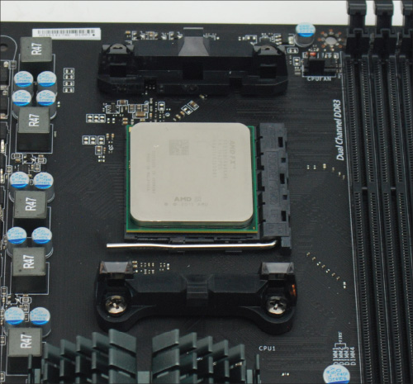
Here are the features of a processor that affect performance and compatibility with motherboards:
- Feature 1: Processor speed. The processor frequency is the speed at which the processor operates internally and is measured in gigahertz, such as 3.3 GHz. Current Intel and AMD processors run from about 2.0 GHz up to more than 4.4 GHz.
- Feature 2: Lithography. The lithography is the average space between transistors printed on the surface of the silicon chip. The measurement is in nanometers (nm); 1 nm is 1 billionth of a meter. Current processor lithography ranges from 14 nm to 35 nm. The lower the measurement, the better and faster the processor performs.
- Feature 3: Socket and chipset the processor can use. Recall that current Intel sockets for desktop and server systems are LGA1151, LGA1150, LGA1155, LGA1156, LGA2066, LGA2011, and LGA1366. AMD’s current desktop sockets are TR4, AM4, AM3+, AM3, AM2+, and FM2+.
- Feature 4: Multiprocessing abilities. The ability of a system to do more than one task at a time is accomplished by several means:
  - Multiprocessing. Using two processing units (called arithmetic logic units or ALUs) installed within a single processor is called multiprocessing. With multiprocessing, the processor, also called the core, can execute two instructions at the same time.
  - Multithreading. Each processor or core processes two threads at the same time. When Windows hands off a task to the CPU, it is called a thread and might involve several instructions. To handle two threads, the processor requires extra registers, or holding areas, within the processor housing that it uses to switch between threads. In effect, you have two logical processors for each physical processor or core. Intel calls this technology Hyper-Threading and AMD calls it HyperTransport. The feature must be enabled in BIOS/UEFI setup and the operating system (OS) must support the technology.
- Multicore processing. A single processor in the processor package is called single-core processing and using multiple processors installed in the same processor housing is called multicore processing. Multicore processing might contain up to eight cores (dual-core, triple-core, quad-core, and so forth). In Figure 3-2, the quad-core processor contains four cores or CPUs. Using multithreading, each core can handle two threads. Therefore, the processor appears to have up to eight logical processors, as it can handle eight threads from the operating system.
Figure 3-2
This quad-core processor has four cores and each core can handle two threads
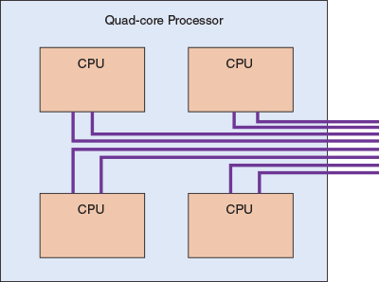
- Dual processors. A server motherboard might have two processor sockets, called dual processors or a multiprocessor platform (see Figure 3-3). A processor (for example, the Xeon processor for servers) must support this feature.
Figure 3-3
This Intel Server Board S2600ST has two Xeon processor sockets and 16 slots for DDR4 memory
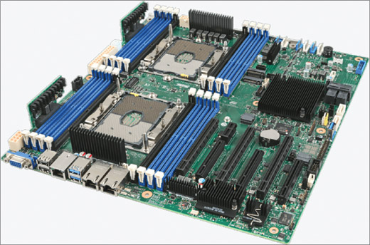
Source: intel.com/content/www/us/en/motherboards/server-motherboards/server-board-s2600st-brief.html
- Feature 5: Memory cache, which is the amount of memory included within the processor package. Today’s processors all have some memory on the processor chip (called a die). Memory on the processor die is called Level 1 cache (L1 cache). Today’s processors might have 4 MB to 12 MB of L1 cache. In addition to L1 cache, a processor may have some Level 2 cache (L2 cache), which is memory in the processor package but not on the processor die. Some processors use a third cache farther from the processor’s core, but still in the processor package, which is called Level 3 cache (L3 cache).
Notes
Memory used in a memory cache is static RAM (SRAM; pronounced “S-Ram”). Memory used on the motherboard loses data rapidly and must be refreshed often. It is therefore called dynamic RAM (DRAM; pronounced “D-Ram”). SRAM is faster than DRAM because it doesn’t need refreshing. Both SRAM and DRAM are called volatile memory because they can only hold data as long as power is available.
- Feature 6: The memory features on the motherboard that the processor can support. DRAM memory modules used on a motherboard that a processor might support include DDR2, DDR3, or DDR4. Besides the type of memory, a processor can support certain amounts of memory, memory speeds, and a number of memory channels (single, dual, triple, or quad channels). All these characteristics of memory are discussed later in the chapter.
- Feature 7: Support for virtualization. A computer can use software to create and manage multiple virtual machines and their virtual devices. Most processors sold today support virtualization. The feature must be enabled in BIOS/UEFI setup.
- Feature 8: Integrated graphics. A processor might include an integrated GPU. A graphics processing unit (GPU) is a processor that manipulates graphic data to form the images on a monitor screen. The GPU might be on a video card, on the motherboard, or embedded in the CPU package. When inside the CPU package, it is called integrated graphics. Many AMD processors and all Intel second-generation and higher processors have integrated graphics.
- Feature 9: Overclocking. Some processors are designed to allow for overclocking, which is to run the processor at a higher frequency than recommended by the processor manufacturer. As you learned in Chapter 2, if a CPU and motherboard support overclocking, it is managed in BIOS/UEFI.
A+ Exam Tip
The A+ Core 1 exam expects you to be able to select a processor for a given motherboard, considering these processor features: Hyper-Threading, number of cores, virtualization, integrated GPU, overclocking, and the motherboard CPU socket.
Older processors could process 32 bits at a time and were known as x86 processors because Intel used the number 86 in their model number. Today’s processor architectures fall into two categories:
- Hybrid processors can process 32 bits or 64 bits. All of today’s processors for desktop systems can process either 32 bits or 64 bits. These hybrid processors are known as x86-64 bit processors. An operating system such as Windows or Linux is installed as a 32-bit OS or a 64-bit OS. For most situations, when the OS installation gives you the option, you should choose to install it as a 64-bit OS to get the best performance. Applications are created as 32-bit apps or 64-bit apps, and both can be installed in a 64-bit OS. However, you cannot install a 64-bit app in a 32-bit installation of an OS.
- 64-bit processors. Intel makes several 64-bit processors for workstations or servers that use fully implemented 64-bit processing, including the Itanium and Xeon processors. Intel calls the technology IA64, but they are also called x64 processors. They require a 64-bit operating system and can handle 32-bit applications only by simulating 32-bit processing.
Notes
To know which type of operating system is installed (32-bit or 64-bit) and other information about the Windows installation, open the System window. For Windows 10, enter Control Panel in the search box. With Control Panel in icon view, click System. For Windows 8, right-click Start and click System. For Windows 7, click Start, right-click Computer, and click Properties. Figure 3-4 shows the System window for a Windows 10 system.
Figure 3-4
The System window displays the type of operating system installed
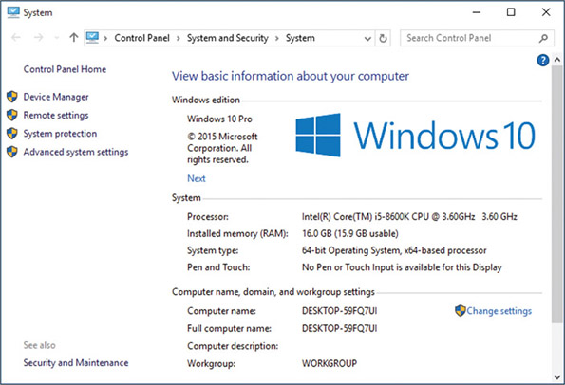
Go to pg.
help
Application Opened
Main content

3-1aIntel Processors
A+ Core 1
- 3.5
Given a scenario, install and configure motherboards, CPUs, and add-on cards.
As you learned in Chapter 2, Intel groups its processors in generations. (Recall that the 8th generation, also called Coffee Lake, was released in 2017, and the 9th generation, Cannon Lake, is expected to be released in 2019.) Intel also groups its processors in families that can span several generations. To find details about any Intel processor, search the Intel ARK database at ark.intel.com. Current families of processors for desktops and laptops include the following.
- The Intel Core processors, first introduced in the 2nd generation, target the mid- to high-end consumer market and are currently Intel’s most popular processor family:
  - Core i9 and Core i7 are made for high-end desktops and laptops. The latest Core i9 processor has 18 cores, 4.2 GHz, and a 24.75-MB cache.
  - Core i5 is well suited for mainstream desktops and laptops (see Figure 3-5).
Figure 3-5
The Intel Core i5-8600K 14-nm, 3.60-GHz, 9-MB cache processor installs in the 8th generation LGA1151 socket
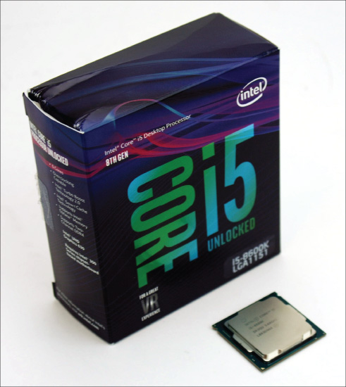
  - Core i3 is an entry-level processor for desktops and laptops.
- Pentium processors are designed for entry-level desktops and laptops.
- Atom is made for low-end desktops, netbooks, and laptops, and the Celeron is made for low-end netbooks and laptops.
Notes
Notice the processor in Figure 3-5 is advertised as unlocked, which means it can be overclocked.
Some Intel mobile processors are packaged in the Centrino processor technology. Using the Centrino technology, the Intel processor, chipset, and wireless network adapter are all interconnected as a unit, which improves laptop performance. Several Intel mobile processors have been packaged as a Centrino processor.
Intel dominates the processor and chipset market for servers with highly stable and powerful processors. Models of the Core i9, Core i7, Core i5, and Core i3 processors are designed for server use, and some of the Atom processors target energy-efficient servers. For high-end servers, Intel offers the Xeon, Xeon Phi, and Itanium. Processors designed for servers are more expensive because they are more stable and error-free than comparable desktop processors.
Go to pg.
help
Application Opened
Main content

3-1bAMD Processors
A+ Core 1
- 3.5
Given a scenario, install and configure motherboards, CPUs, and add-on cards.
Processors by Advanced Micro Devices, Inc., or AMD (amd.com), are popular in the game and hobbyist markets, and are generally less expensive than comparable Intel processors. Recall that AMD processors use different sockets than Intel processors, so the motherboard must be designed for one manufacturer’s processor or the other, but not both. Many motherboard manufacturers offer two comparable motherboards—one for an Intel processor and one for an AMD processor.
The current AMD processor families include:
- For desktops, the Ryzen, Ryzen Pro, Ryzen Threadripper, A-Series, A-Series Pro, and FX. The Threadripper can have up to 16 cores. Figure 3-6 shows an FX processor by AMD.
Figure 3-6
The AMD FX processor installs in the AMD AM3+ socket and has eight cores
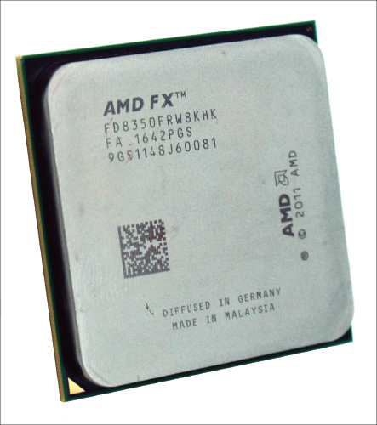
- For laptops, the Ryzen, Ryzen Pro, A-Series, and A-Series Pro.
- For servers, the EPYC and Opteron. The EPYC can have up to 32 cores.
In the next part of the chapter, you learn the detailed steps to select and install a processor in several of the popular Intel and AMD sockets used by desktop and laptop computers.
Go to pg.
help
Application Opened
Main content

3-2Selecting and Installing a Processor
A+ Core 1
- 1.1
Given a scenario, install and configure laptop hardware and components.
- 3.5
Given a scenario, install and configure motherboards, CPUs, and add-on cards.
A hardware technician is sometimes called on to assemble a desktop computer from parts, exchange a processor that is faulty, add a second processor to a dual-processor system, or upgrade an existing processor to improve performance. In each situation, it is necessary to know how to match a processor for the system in which it is installed. Next, you need to know how to install the processor on the motherboard for each of the current Intel and AMD sockets used for desktop and laptop systems.
Go to pg.
help
Application Opened
Main content

3-2aSelecting a Processor to Match System Needs
A+ Core 1
- 3.5
Given a scenario, install and configure motherboards, CPUs, and add-on cards.
When selecting the motherboard and processor, recall you must choose between the AMD and Intel chipset and processor. How to make this decision between the two brands was covered earlier in the text. When selecting a processor to match a motherboard you already have, the first requirement is to select one that the motherboard is designed to support. Among the processors the board supports, you need to select the one that best meets the general requirements of the system and the user’s needs. Here are some processor features to consider:
- To get the best performance, use the highest-performing processor the board supports. Performance can be measured by clock speed, the number of tasks a CPU can run per clock cycle, and the size of the processor cache.
- Understand the processor’s ability to multitask, considering the number of cores and multithreading abilities. Know, however, that applications must be able to take advantage of multiple cores. If not, some cores can sit idly while others do all the work. If the system will only be used for browsing the web, a single-core processor will do the job. However, Adobe Premier, AutoCAD, Star Wars Battlefront, and Excel are examples of applications that take full advantage of multiple CPU cores.
- Balance the performance and power of the CPU with that of the entire system. For example, if the system has a high-performing graphics adapter, don’t install a low-performing processor or hard drive to save on cost. One bottleneck can slow down the entire system.
- Be sure to read reviews of the processors you are considering and look for reviews that include comparison benchmarks of several processors. Also, you sometimes need to sacrifice performance and power for cost.
Applying Concepts

Selecting a Processor
A+ Core 1
- 3.5
Given a scenario, install and configure motherboards, CPUs, and add-on cards.
Your friend, Alice, is working toward her A+ certification. She has decided that the best way to get the experience she needs before she sits for the exam is to build a system from scratch. She has purchased an Asus motherboard and asked you for some help selecting the right processor. She tells you that the system will later be used for light business needs and she wants to install a processor that is moderately priced to fit her budget. She says she doesn’t want to install the most expensive processor the motherboard can support, but neither does she want to sacrifice too much performance or power.
The documentation on the Asus website (support.asus.com) for the ASUS Prime Z370-A motherboard provides this information:
- The ATX board contains the Z370 chipset and 8th generation LGA1151 socket and uses up to 64 GB of DDR4 memory.
- CPUs supported include a long list of 8th generation, 14-nm CPU Core i3, Core i5, Core i7, and Pentium processors. Here are five processors found in this list:
  - Intel Core i7-8086K, 4.0 GHz, 95 W, 12-MB L3 cache, 6 cores
  - Intel Core i5-8400T, 1.7 GHz, 35 W, 9-MB L3 cache, 6 cores
  - Intel Core i3-8300, 3.7 GHz, 62 W, 8-MB L3 cache, 4 cores
  - Intel Core i3-8100, 3.6 GHz, 65 W, 6-MB L3 cache, 4 cores
  - Intel Pentium G5400T, 3.1 35W, 4-MB L3 cache, 2 cores
Based on what Alice has said, you decide to eliminate the most expensive processors (the Core i7 and i5) and the least-performing processor (the Pentium). That decision narrows your choices down to a Core i3. Before you select one of these processors, you need to check the list on the Asus site to make sure the specific Core i3 processor is included. Look for the exact processor number—for example, the Core i3-8300.
You will also need a cooler assembly. If your processor doesn’t come boxed with a cooler, select a cooler that fits the processor socket and gets good reviews. You’ll also need some thermal compound if it is not included with the cooler.
The cooler is bracketed to the motherboard using a wire or plastic clip. A creamlike thermal compound is placed between the bottom of the cooler heat sink and the top of the processor. This compound eliminates air pockets, helping to draw heat off the processor. The thermal compound transmits heat better than air and makes an airtight connection between the fan and the processor. When processors and coolers are boxed together, the cooler heat sink might have thermal compound already applied to the bottom (see Figure 3-7).
Figure 3-7
Thermal compound is already applied to the bottom of this cooler that was purchased boxed with the processor
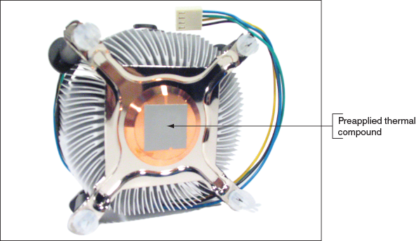
Go to pg.
help
Application Opened
Main content

3-2bInstalling a Processor and Cooler Assembly
A+ Core 1
- 3.5
Given a scenario, install and configure motherboards, CPUs, and add-on cards.
Now let’s look at the details of installing Intel and AMD processors and the cooler assembly.
A+ Exam Tip
The A+ Core 1 exam expects you to know how to install Intel and AMD processors.

Install an Intel Processor
If you are building a new system and the motherboard is not already installed in the case, follow the directions of the motherboard manufacturer to install the motherboard and then the processor, or follow the directions to install the processor and then the motherboard. The order of installation varies among manufacturers. Also, a cooler assembly might have nuts, bolts, screws, and plates that must be installed on the motherboard before you install the motherboard in the case. Here is the general procedure for installations, but always read and follow the specific directions for your motherboard and cooler assembly during your installation:
- Use an ESD strap or antistatic gloves to protect the processor, motherboard, and other components against ESD.
- When replacing a processor in an existing system, power down the system, unplug the power cord, press the power button to drain the system of power, and open the case.
- For a new motherboard, look for a protective cover over the processor socket (see Figure 3-8). Remove this socket cover and keep it in a safe place. If you ever remove the processor, put the cover back on the socket to protect it.
Figure 3-8
The Intel LGA1151 socket with a protective cover in place
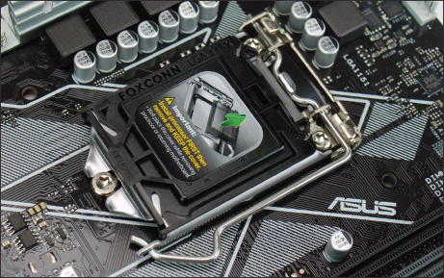
- While the socket is exposed, as in Figure 3-9, be very careful not to touch the pins in the socket. Open the socket by pushing down on the socket lever and gently pushing it away from the socket to lift the lever.
Figure 3-9
The exposed socket is extremely delicate
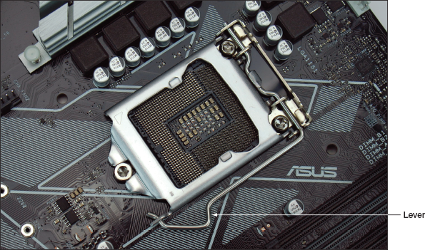
- As you lift the lever, the socket load plate is raised, as shown in Figure 3-10. Notice the two posts on either side of the socket next to the hinge. These posts help orient the processor in the socket.
Figure 3-10
Lift the socket load plate to expose the processor socket
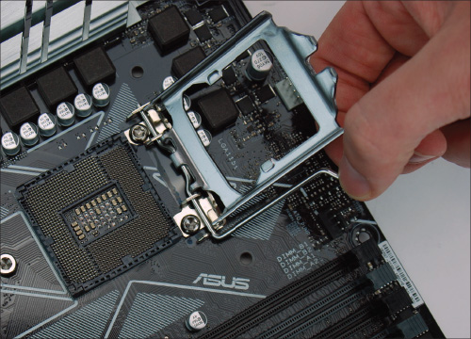
- Open the clear plastic protective cover around the processor and locate the two notches and one gold triangle that help you orient the processor in the socket. Figure 3-11 shows the posts on the socket that are used with the notches on the processor to orient the processor in the socket. You can then carefully remove the plastic cover. While the processor contacts are exposed, take extreme care not to touch the bottom of the processor. Hold it only at its edges. (It’s best to use antistatic gloves as you work, but the gloves make it difficult to handle the processor.) Put the processor cover in a safe place and use it to protect the processor if you ever remove the processor from the socket.
Figure 3-11
Two posts near the socket hinges help you orient the processor in the socket
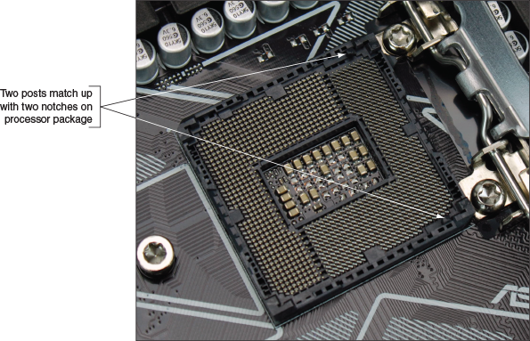
- Hold the processor with your index finger and thumb and orient the processor so that the two notches on its edge line up with the posts embedded on the socket. Gently lower the processor straight down into the socket. See Figure 3-12. Don’t allow the processor to tilt, slide, or shift as you put it in the socket. To protect the pads, the processor needs to go straight down into the socket.
Figure 3-12
Align the processor in the socket using the gold triangle and the right-angle mark
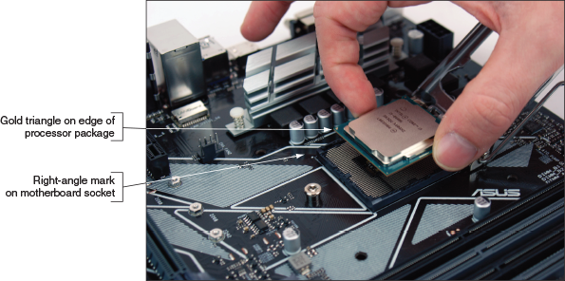
- Check carefully to make sure the processor is aligned correctly in the socket. Closing the socket without the processor fully seated can destroy the socket. Figure 3-13 shows the processor fully seated in the socket. Close the socket load plate so that it catches under the screw head at the front of the socket.
Figure 3-13
Verify that the processor is seated in the socket with notches aligned to socket posts
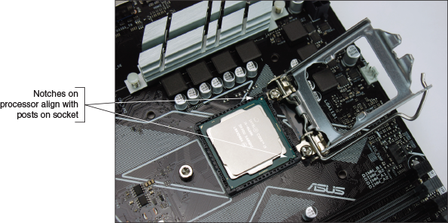
- Push down on the lever and gently return it to its locked position.

Install the Cooler Assembly
You are now ready to install the cooler. Some coolers are lightweight with heat sinks and a fan on top. Some are heavier with heat sinks, fins, and a fan on the side, and they require a plate installed on the bottom of the motherboard to strengthen the board for the heavy cooler (see Figure 3-14).
Figure 3-14
A heavy-duty cooler may have a strengthening plate, heat sink, fins, a fan, and several screws, nuts, and bolts
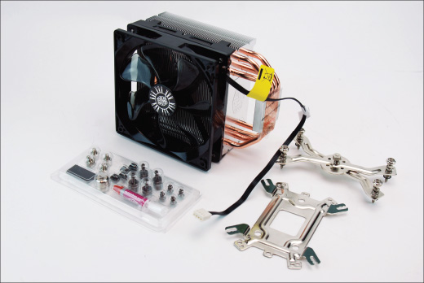
Before installing a cooler, read the directions carefully and make sure you understand them. The cooler may be designed for either an Intel or AMD socket and may have to be installed differently depending on the socket type, so be sure you’re following the correct directions.
Notes
For complicated cooler assemblies such as the Cooler Master Hyper 212 EVO shown in Figure 3-14, look for helpful YouTube videos that show how to install the assembly.
Here are the general steps for installing a cooler assembly:
- Motherboards with Intel sockets have four holes to anchor the cooler (for example, see Figure 3-15). Examine the cooler posts that fit over these holes and the clips, nuts, bolts, screws, or plates that will hold the cooler firmly in place. Make sure you understand how this mechanism works because it may be difficult to install.
Figure 3-15
If the cooler does not have preapplied thermal compound, apply it on top of the processor
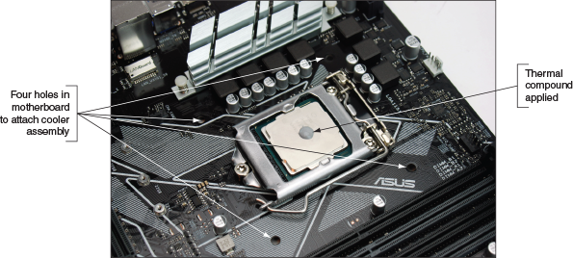
- If the cooler has thermal compound preapplied, remove the plastic from the compound. If the cooler does not have thermal compound applied, put a small dot of compound (about the size of a small pea) in the center of the processor, as shown in Figure 3-15. When the cooler is attached and the processor is running, the compound spreads over the surface. Don’t use too much—apply just enough to later create a thin layer. If you use too much compound, it can slide off the housing and damage the processor or circuits on the motherboard. To get just the right amount, you can buy individual packets that each contain a single application of thermal compound.
Notes
When removing and reinstalling a processor, use a soft, dry cloth to carefully remove all the old thermal compound from both the processor and the cooler. Don’t try to reuse the compound.
- Some heavy coolers provide a plate that fits underneath the motherboard, with nuts, bolts, and screws to secure it to the board. The plate strengthens the board to help protect it from bending when the heavy cooler is installed. Install the plate, such as the one shown in Figure 3-16. The bolts on top of the board are now ready to receive the cooler.
Figure 3-16
A cooler assembly plate on the bottom of the motherboard prevents a heavy cooler from bending the board
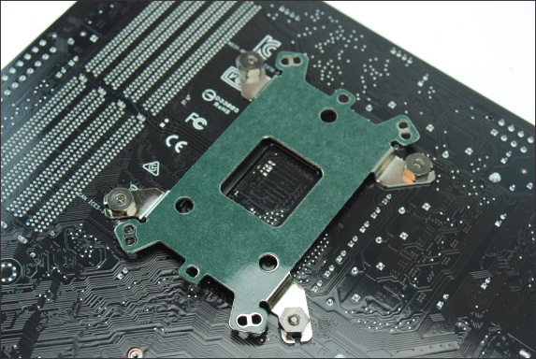
- After the plate is installed, install the cooler on top of the processor. Be very careful to place the cooler straight down on the processor without shifting it so you don’t smear the thermal compound off the top of the processor. Work very slowly and deliberately. To help keep the cooler balanced and in position, partly secure screws in two opposite bolts and then into the other two bolts. Rotate among the screws to partially tighten each one several times and keep the cooler in balance. See Figure 3-17. You can then clip the fan to the side of the cooler fins.
Figure 3-17
To keep the cooler balanced, rotate among the four screws as you partially tighten each screw in turn
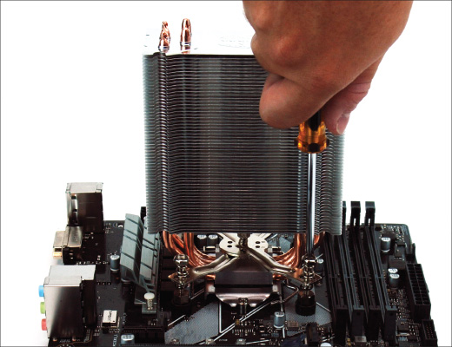
- For lighter coolers with locking pins, verify that the locking pins are turned as far as they will go in a counterclockwise direction. (Make sure the pins don’t protrude into the hollow plastic posts that go down into the motherboard holes.) Align the cooler over the processor so that all four posts fit into the four holes on the motherboard and the fan power cord can reach the fan header on the motherboard. Then push down on each locking pin until you hear it pop into the hole. To help keep the cooler balanced and in position, push down two opposite pins and then push the remaining two pins in place. Using a flathead screwdriver, turn each locking pin clockwise to secure it. Figure 3-18 shows a cooler with locking pins secured. (Later, if you need to remove the cooler, turn each locking pin counterclockwise to release it from the hole.)
Figure 3-18
The pins are turned clockwise to secure the cooler to the motherboard
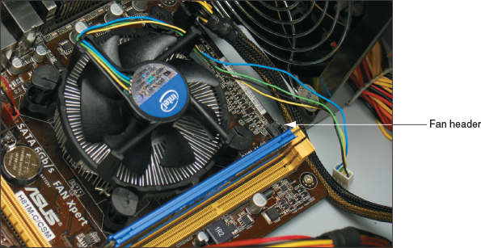
Notes
If you later notice the CPU fan is running far too often, you might need to tighten the connection between the cooler and the processor.
- The fan on a cooler receives its power from a 4-pin CPU fan header on the motherboard. Connect the power cord from the cooler fan to this 4-pin header, which you should find on the board near the processor (see Figure 3-19).
Figure 3-19
Connect the cooler fan power cord to the motherboard 4-pin CPU fan header
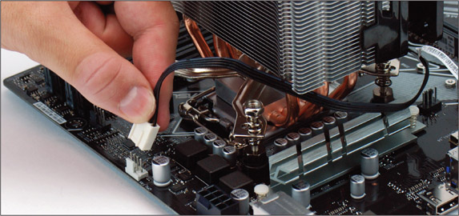
After the processor and cooler are installed and the motherboard is installed in the case, make sure cables and cords don’t obstruct fans or airflow, especially airflow around the processor and video card. Use cable ties to tie cords and cables up and out of the way.
Make one last check to verify that all power connectors are in place and that other cords and cables are connected to the motherboard correctly. You are now ready to plug the system back in, turn it on, and verify all is working. If the power comes on (you hear the fan spinning and see lights) but the system fails to work, most likely the processor is not seated solidly in the socket or some power cord has not yet been connected or is not solidly connected. Turn everything off, unplug the power cord, press the power button to drain power, open the case, and recheck your installation.
If the system comes up and begins the boot process but suddenly turns off before the boot is complete, most likely the processor is overheating because the cooler is not installed correctly. Turn everything off, unplug the power cord, press the power button to drain power, open the case, and verify that the cooler is securely seated and connected.
After the system is up and running, you can check BIOS/UEFI setup to verify that the system recognized the processor correctly. The setup screen for one processor is shown in Figure 3-20. Also, check the CPU and motherboard temperatures in BIOS/UEFI setup to verify that the CPU is not overheating. In the BIOS/UEFI utility shown in Figure 3-20, you can see the temperatures and fan RPMs.
Figure 3-20
Verify that the CPU is recognized correctly by BIOS/UEFI and that CPU and motherboard temperatures are within acceptable range
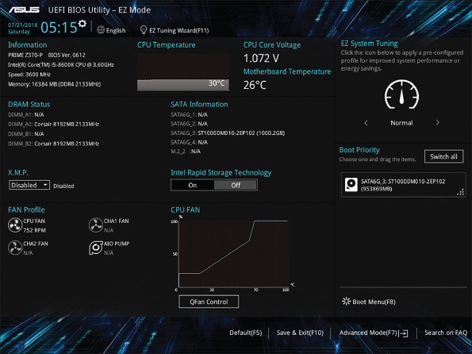
Source: American Megatrends, Inc.
The maximum processor temperature varies by processor; to know the maximum, download the datasheet specifications for the processor from the Intel website (ark.intel.com). For example, the Intel Core i5-8600K 6-core processor shown earlier in this chapter will stop execution if the temperature rises above 100 degrees. If you see the temperature rising this high, open the case cover and verify that the processor fan is running. Perhaps a wire is in the way and preventing the fan from turning or the fan power wire is not connected. Other troubleshooting tips for processors are covered in Chapter 4.

Install an AMD Processor and Cooler Assembly
When installing an AMD processor, do the following:
- Open the socket lever. If there’s a protective cover over the socket, remove it.
- Holding the processor very carefully so you don’t touch the bottom, orient the four empty pin positions on the bottom with the four filled hole positions in the socket (see Figure 3-21). For some AMD sockets, a gold triangle on one corner of the processor matches up with a small triangle on a corner of the socket. Carefully lower the processor straight down into the socket. Don’t allow it to tilt or slide as it goes into the socket. The pins on the bottom of the processor are very delicate, so take care as you work.
Figure 3-21
Orient the four alignment positions on the bottom of the processor with those in the socket
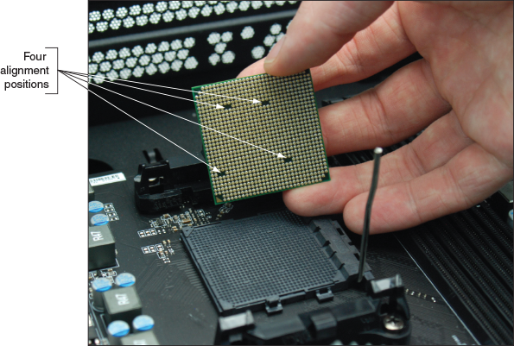
- Check carefully to make sure the pins in the processor are sitting slightly in the holes. Make sure the pins are not offset from the holes. If you try to use the lever to put pressure on these pins and they are not aligned correctly, you can destroy the processor. You can actually feel the pins settle into place when you’re lowering the processor into the socket correctly.
- Press the lever down and gently into position (see Figure 3-22).
Figure 3-22
Lower the lever into place, which puts pressure on the processor
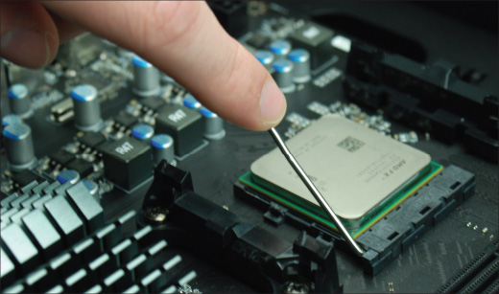
- You are now ready to apply the thermal compound and install the cooler assembly. For most AMD sockets, the black retention mechanism for the cooler is already installed on the motherboard (see Figure 3-23). Set the cooler on top of the processor, aligning it inside the retention mechanism.
Figure 3-23
Align the cooler over the retention mechanism
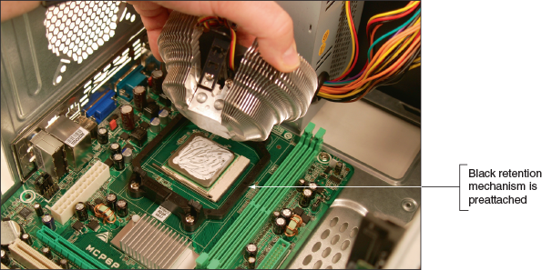
- Next, clip the clipping mechanism into place on one side of the cooler. Then push down firmly on the clip on the opposite side of the cooler assembly; the clip will snap into place. Figure 3-24 shows the clip on one side in place for a system that has a yellow retention mechanism and a black cooler clip. Later, if you need to remove the cooler, use a Phillips screwdriver to remove the screws holding the retention mechanism in place. Then remove the retention mechanism along with the entire cooler assembly.
Figure 3-24
The clips on the cooler attach the cooler to the retention mechanism on the motherboard
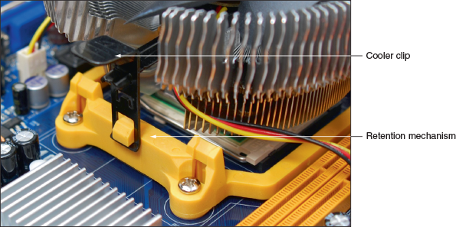
- Connect the power cord from the fan to the 4-pin CPU fan header on the motherboard next to the processor.
Notes
You will learn how to troubleshoot problems with the processor, motherboard, and RAM in Chapter 4.
Go to pg.
help
Application Opened
Main content

3-2cReplacing the Processor in a Laptop
A+ Core 1
- 1.1
Given a scenario, install and configure laptop hardware and components.
Before replacing the processor in a laptop, consider that the laptop might still be under warranty. Also consider that it might be more cost effective to replace the laptop rather than replacing the processor, when you include the cost of parts and labor. If you decide to replace a processor in a laptop, be sure to select a processor supported by the manufacturer of the particular laptop model. The range of processors supported by a laptop does not usually include as many options as those supported by a desktop motherboard.
Follow the directions in the service manual to remove the old processor. For some laptops, removing the cover on the bottom exposes the processor fan and heat sink assembly. When you remove this assembly, you can then open the socket and remove the processor. For example, looking at the laptop shown in Figure 3-25, you can see the processor heat sink and fan assembly exposed. To remove the assembly, remove the seven screws and the fan power connector (see Figure 3-26). Then lift the assembly straight up, being careful not to damage the processor underneath.
Figure 3-25
The cover is removed from the bottom of a laptop, exposing several internal components
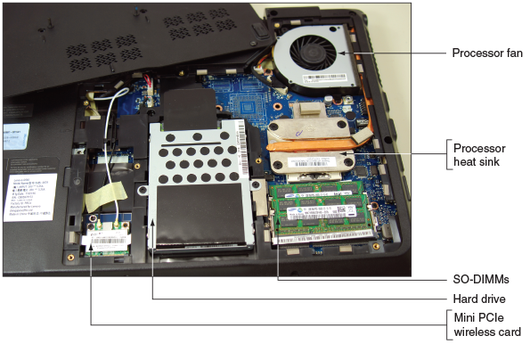
Figure 3-26
Seven screws hold the processor heat sink and fan assembly in place
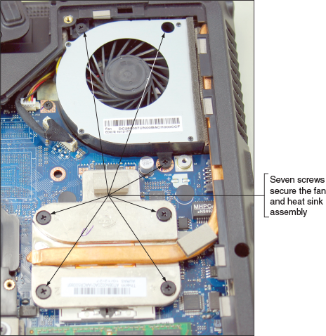
In the laptop shown in Figure 3-27, the heat sink and fan assembly are also exposed when you remove the cover on the bottom of the laptop. Notice that the heat sink on this laptop extends to the processor and chipset. You remove several screws and then lift the entire assembly out as a unit. For the laptop shown in Figures 3-25 and 3-26, the heat sink fits on top of the processor and the fan sits to the side of the processor. This design is typical of many laptops. However, some laptops require you to remove the keyboard and the keyboard bezel to reach the fan assembly and processor under the bezel.
Figure 3-27
Remove the cover from the bottom of the laptop to expose the heat sink and fan assembly and to reach the processor
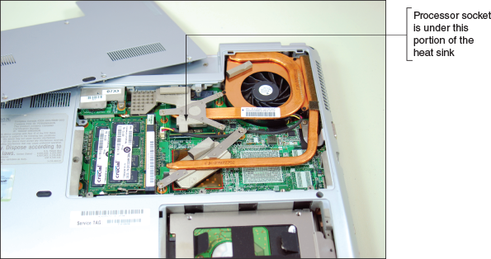
Figure 3-28 shows the heat sink and fan assembly removed in a laptop, exposing the processor. Notice the thermal compound on the processor. To remove the processor, turn the CPU socket screw 90 degrees to open the socket, as shown in the figure. Most Intel and AMD sockets have this socket screw on the side of the socket, as shown in Figure 3-28, although other sockets have the screw on the corner.
Figure 3-28
Open the CPU socket
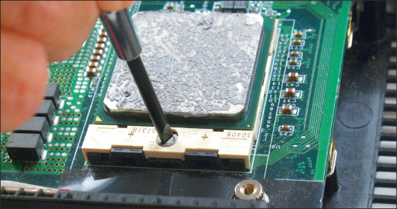
Lift the CPU from the socket. Be careful to lift straight up without bending the CPU pins. Figure 3-29 shows the processor out of the socket. If you look carefully, you can see the missing pins on one corner of the processor and socket. This corner is used to correctly orient the processor in the socket.
Figure 3-29
The processor removed from the socket
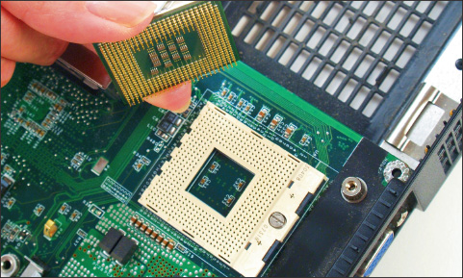
Before you place the new processor into the socket, be sure the socket screw is in the open position. Then delicately place the processor into its socket. If it does not drop in completely, consider that the screw might not be in the full open position. Be sure to use new thermal compound on top of the processor. Intel recommends 0.2 grams of compound, which is about the size of a small pea. To make sure you use just the right amount of compound, consider buying it in individual packets that are measured for a single application.
Now let’s turn our attention to the various memory technologies used in personal computers and learn how to upgrade memory.
Go to pg.
help
Application Opened
Main content

3-3Memory Technologies
A+ Core 1
- 1.1
Given a scenario, install and configure laptop hardware and components.
- 3.3
Given a scenario, install RAM types.
Recall that random access memory (RAM) temporarily holds data and instructions as the CPU processes them and that the memory modules used on a motherboard are made of dynamic RAM or DRAM. DRAM loses its data rapidly, and the memory controller must refresh it several thousand times a second. RAM is stored on memory modules, which are installed in memory slots on the motherboard (see Figure 3-30).
Figure 3-30
RAM on motherboards today is stored in DIMMs
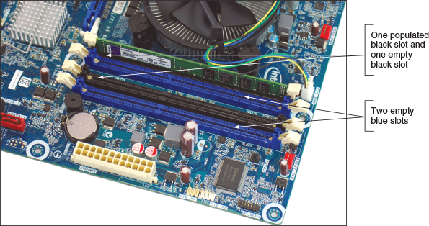
A+ Exam Tip
The A+ Core 1 exam expects you to know the purposes and characteristics of DDR2, DDR3, DDR4, and SO-DIMM memory technologies and how to match memory for an upgrade to memory already installed in a system.
Several variations of DRAM have evolved over the years. Here are the two major categories of memory modules:
- All current motherboards for desktops use a type of memory module called a DIMM (dual inline memory module).
- Laptops use a smaller version of a DIMM called a SO-DIMM (small outline DIMM, pronounced “sew-dim”). MicroDIMMs are used on subnotebook computers and are smaller than SO-DIMMs.
DIMMs have seen several evolutions and you need to know about the last three, which are shown in Table 3-1. Notice the notches on the edge connector of each module, which prevent the wrong type of module from being inserted into a memory slot on the motherboard.
Table 3-1

Types of Memory Modules
Description of Module | Example
A 288-pin DDR4 DIMM is currently the fastest memory with lower voltage requirements. It can support quad or dual channels or function as single DIMMs. It has one notch near the center of the edge connector. | 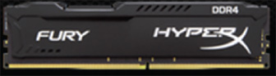  Source: kingston.com
A 240-pin DDR3 DIMM can support quad, triple, or dual channels or function as single DIMMs. It has an offset notch farther from the center than a DDR2 DIMM. | 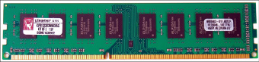
A 240-pin DDR2 DIMM can support dual channels or function as single DIMMs. It has one notch near the center of the edge connector. | 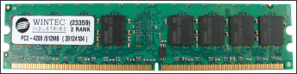
Many DIMM technologies exist because they have evolved to improve capacity, speed, and performance without greatly increasing the cost. A quick Google search for buying RAM turns up details such as those shown in Figure 3-31. In this part of the chapter, you learn about these technologies so that you can make the best selections of memory for a particular motherboard and customer needs.
Figure 3-31
Evolving memory technologies result in many details and options
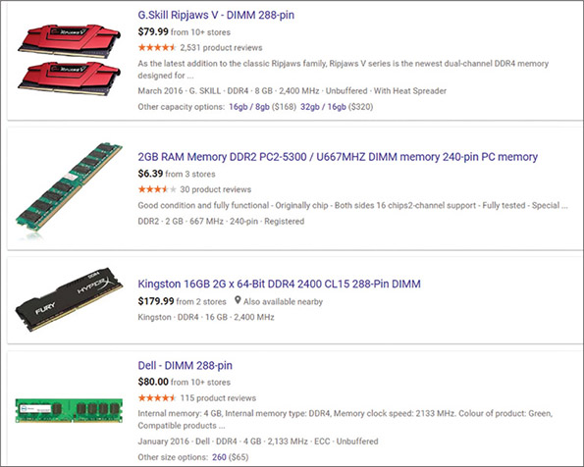
Notes
JEDEC (jedec.org) is the organization responsible for standards used by solid-state devices, including RAM technologies.
We’ll now look at each of the types of DIMM and SO-DIMM modules and the technologies they use.
Go to pg.
help
Application Opened
Main content

3-3aDIMM and SO-DIMM Technologies
A+ Core 1
- 3.3
Given a scenario, install RAM types.
To understand the details of a memory ad, let’s start with a few important acronyms:
- The “D” in DIMM stands for “dual,” named for the independent pins on both sides of the module’s edge connector. All DIMMs have a 64-bit data path.
- A SIMM (single inline memory module) is an older technology that has pins on only one side of the module edge connector. You hardly ever see them used today.
- A DDR (Double Data Rate) DIMM gets its name from the fact that it ran twice as fast as earlier DIMMs when it was invented. It was able to double the effective data rate because a DDR DIMM processes data at the rise and fall of the motherboard clock beat, rather than at each clock beat.
- DDR2 is faster and uses less power than DDR.
- DDR3 is faster and uses less power than DDR2. Both DDR2 and DDR3 DIMMs use 240 pins. They are not compatible because their notches are not in the same position.
- DDR4 is faster and uses less power than DDR3. A DDR4 module uses 288 pins and has a single notch in the edge connector.
Factors that affect the capacity, features, and performance of DIMMs include the number of channels they use, how much RAM is on one DIMM, the speed, error-checking abilities, and buffering. All these factors are discussed next.

Single, Dual, Triple, and Quad Channels
Early DIMMs only used a single channel, which means the memory controller can access only one DIMM at a time. To improve overall memory performance, dual channels allow the memory controller to communicate with two DIMMs at the same time, effectively doubling the speed of memory access. A motherboard that supports triple channels can access three DIMMs at the same time, and a quad channel motherboard can access four DIMMs at the same time. DDR2, DDR3, and DDR4 DIMMs can use dual channels. DDR3 DIMMs can also use triple channels. DDR3 and DDR4 DIMMs can use quad channels. For dual, triple, or quad channels to work, the motherboard and the DIMM must support the technology.
Motherboard manufacturers typically color-code DIMM slots to show you how to configure dual, triple, or quad channeling. For example, Figure 3-32 shows how dual channeling works on a board with two black DIMM slots and two gray slots. The board has two memory channels, channel 1 and channel 2. With dual channeling, two DIMMs installed in the two gray slots are each using a different channel, and therefore can be addressed at the same time. If two more DIMMs are installed in the two black slots, they can be accessed at the same time.
Figure 3-32
Using dual channels, the memory controller can read from two DIMMs at the same time
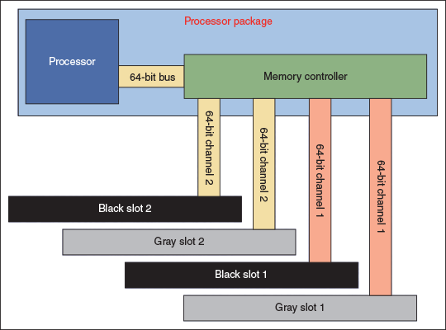
When setting up dual channeling, know that the pair of DIMMs to be addressed at the same time must be equally matched in size, speed, and features, and it is recommended they come from the same manufacturer. (Two matching DIMMs are often sold as a DIMM kit.) A motherboard that supports dual channels was shown in Figure 3-30. To use dual channeling, this motherboard requires matching DIMMs to be installed in the black slots and another matching pair in the blue slots, as shown in Figure 3-33. Know that the second pair of DIMMs does not have to match the first pair of DIMMs because the blue slots run independently of the black slots. If the two DIMM slots of the same color are not populated with matching pairs of DIMMs, the motherboard will revert to single channeling.
Figure 3-33
Matching pairs of DIMMs installed in four DIMM slots that support dual channeling
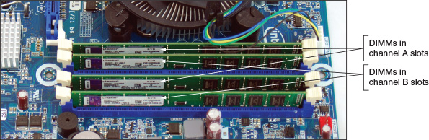
A+ Exam Tip
The A+ Core 1 exam expects you to be able to distinguish among single-channel, dual-channel, and triple-channel memory installations and to configure these installations for best performance.
For a triple-channel installation, three DIMM slots must be populated with three matching DDR3 DIMMs (see Figure 3-34). The three DIMMs are installed in the three blue slots on the board. The motherboard in the figure has a fourth black DIMM slot. You can barely see this black slot behind the three populated slots in the photo. If the fourth slot is used, then triple channeling is disabled, which can slow down performance. If a matching pair of DIMMs is installed in the first two slots and another matching pair of DIMMs is installed in the third and fourth slots, then the memory controller will use dual channels. Dual channels are not as fast as triple channels, but they are certainly better than single channels.
Figure 3-34
Three identical DDR3 DIMMs installed in a triple-channel configuration
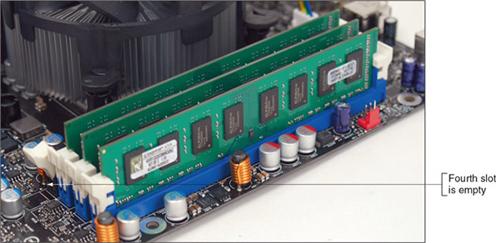
Expect a motherboard that uses quad channeling to have eight memory slots. For example, the Gigabyte AMD X399 Gaming motherboard has four DIMM slots on each side of the AMD TR4 processor socket (see Figure 3-35). The eight DIMM slots support four channels; each channel has two slots. The processor can address four slots or four channels at the same time. To know which of the eight slots to populate for optimum performance, see the motherboard user manual; in the figure, the manufacturer did not color-code the slots.
Figure 3-35
The Gigabyte AMD X399 Gaming motherboard has eight DIMM DDR4 slots and supports quad channeling
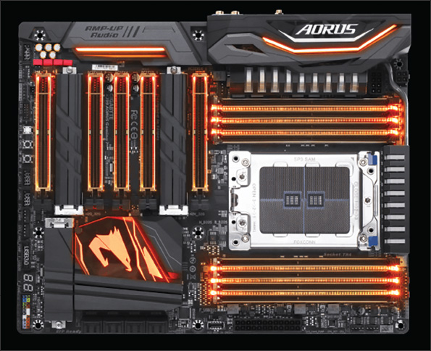
Source: gigabyte.com/us/Motherboard/X399-AORUS-Gaming-7-rev-10#kf

DIMM Speeds
DIMM speeds are measured either in MHz (such as 3,000 MHz or 1,600 MHz) or PC rating (such as PC4 24000 or PC3 12800). A PC rating is a measure of the total bandwidth (in MB/second) of data moving between the module and the CPU. To calculate the PC rating for a DDR4 DIMM, multiply the speed by 8 bytes because a DIMM has an 8-byte or 64-bit data path. For example, a DDR4 DIMM that runs at 3,000 MHz has a bandwidth or transfer rate of 3,000 × 8 or 24,000 MB/second, which is expressed as a PC rating of PC4 24000. (A DDR4 PC rating is labeled PC4.)
A second example calculates the PC rating for a DDR3 DIMM running at 1,600 MHz:
‍‍‍‍‍‍‍, which is written as PC3 12800.
A+ Exam Tip
The A+ Core 1 exam expects you to be able to calculate PC ratings, given the transfers per second. To get the PC rating, multiply the transfers per second by eight. To get the speed, divide the PC rating by eight.

Error Checking and Parity
Because DIMMs intended to be used in servers must be extremely reliable, error-checking technology called ECC (error-correcting code) is sometimes used. Figure 3-36 shows two modules with ECC designed for server use.
Figure 3-36
Server memory uses ECC for fault tolerance
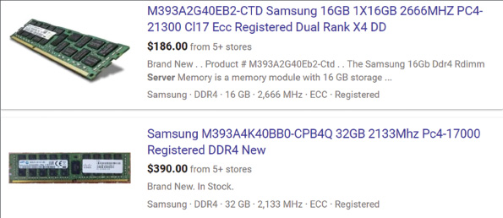
Some DDR2, DDR3, and DDR4 memory modules support ECC. A DIMM that supports ECC will have an extra chip, the ECC chip. ECC compares bits written to the module to what is later read from the module, and it can detect and correct an error in a single bit of the byte. If there are errors in 2 bits of a byte, ECC can detect the error but cannot correct it. The data path width for DIMMs is normally 64 bits, but with ECC, the data path is 72 bits. The extra 8 bits are used for error checking. ECC memory costs more than non-ECC memory, but it is more reliable. For ECC to work, the motherboard and all installed modules must support it. Also, it’s important to know that you cannot install a mix of ECC and non-ECC memory on the motherboard—the resulting system will not work.
As with most other memory technologies discussed in this chapter, when adding memory to a motherboard, match the type of memory to the type the board supports. To see if your motherboard supports ECC memory, look for the ability to enable or disable the feature in BIOS/UEFI setup, or check the motherboard documentation.
Older SIMMs and DIMMs used an error-checking technology called parity. Using parity checking, a ninth bit is stored with every 8 bits in a byte. If memory is using odd parity, it makes the ninth or parity bit either a 1 or a 0 so that the number of 1s in the 9 bits is odd. If memory uses even parity, it makes the parity bit a 1 or a 0 to make the number of 1s in the 9 bits even.
A+ Exam Tip
The A+ Core 1 exam expects you to know that parity memory uses 9 bits (8 bits for data and 1 bit for parity). You also need to be familiar with ECC and non-ECC memory technologies and to know when each technology is recommended or required in a given scenario.
Later, when the byte is read back, the memory controller checks the odd or even state. If the number of bits is not an odd number for odd parity or an even number for even parity, a parity error occurs. A parity error always causes the system to halt. On the screen, you see the error message “Parity Error 1” or “Parity Error 2” or a similar error message about parity. Parity Error 1 is a parity error on the motherboard; Parity Error 2 is a parity error on an expansion card.
Figure 3-37 shows a DIMM and SO-DIMM for sale. The DIMM is advertised as parity memory and the SO-DIMM is non-parity. Expect parity memory to be more expensive and more reliable than non-parity memory.
Figure 3-37
Parity and ECC memory is more reliable than non-parity and non-ECC memory
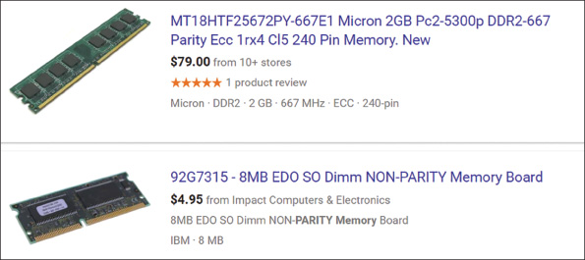
Notes
RAM chips on DIMMs can cause errors if they become undependable and cannot hold data reliably. Sometimes this happens when chips overheat or power falters.

Buffered and Registered DIMMs
Buffers and registers hold data and amplify a signal just before the data is written to the module, and they can increase memory performance in servers. (Buffers are an older technology than registers.) Some DIMMs use buffers, some use registers, and some use neither. If a DIMM doesn’t support registers or buffers, it’s referred to as an unbuffered DIMM or UDIMM. Looking back at the ad in Figure 3-31, you can see two modules listed as Unbuffered, one listed as Registered, and another that’s not identified, so we can assume it is unbuffered. You might see registered memory written as RDIMM.

CAS Latency
Another memory feature is CAS Latency (CAS stands for “column access strobe”), which is a way of measuring access timing. The feature refers to the number of clock cycles it takes to write or read a column of data off a memory module. Lower values are better than higher ones. For example, CL8 is a little faster than CL9.
Notes
In memory ads, CAS Latency is sometimes written as CL.
Ads for memory modules might give the CAS Latency value within a series of timing numbers, such as 5-5-5-15. The first value is CAS Latency, which means the module is CL5. Looking back at Figure 3-37, you can see the CL rating for the first module is CL5.
Notes
When selecting memory, use the memory type that the motherboard manufacturer recommends.

Types of Memory Used in Laptops
Today’s laptops use DDR4, DDR3L, DDR3, or DDR2 SO-DIMM memory. Table 3-2 lists current SO-DIMMs. All these memory modules are smaller than regular DIMMs and use the same technologies as DIMMs.
A+ Exam Tip
The A+ Core 1 exam expects you to know that DDR3, DDR2, and DDR memory can be found on SO-DIMMs and to know when to use each type of memory in a given scenario.
Table 3-2

Memory Modules Used in Laptop Computers
Memory Module Description | Sample Memory Module
A 2.74" 260-pin SO-DIMM contains DDR4 memory. The one notch on the module is offset from the center of the module. | 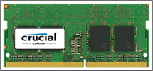  Source: crucial.com
A 2.66" 204-pin SO-DIMM contains DDR3 memory. The one notch on the module is offset from the center of the module. A DDR3L SO-DIMM uses less power than a regular DDR3 SO-DIMM. | 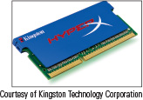  Courtesy of Kingston Technology Corporation
A 2.66" 200-pin SO-DIMM contains DDR2 SDRAM. One notch is near the side of the module. | 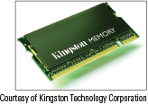  Courtesy of Kingston Technology Corporation
As with memory modules used in desktop computers, you can only use the type of memory the laptop is designed to support. The number of pins and the position of the notches on a SO-DIMM keep you from inserting the wrong module in a memory slot.
Go to pg.
help
Application Opened
Main content

3-4How to Upgrade Memory
A+ Core 1
- 1.1
Given a scenario, install and configure laptop hardware and components.
- 3.3
Given a scenario, install RAM types.
To upgrade memory means to add more RAM to a computer. Adding more RAM might solve a problem with slow performance, applications refusing to load, or an unstable system. When Windows does not have adequate memory to perform an operation, it displays an “Insufficient memory” error or it slows down to a painful crawl.
When first purchased, many computers have empty slots on the motherboard, allowing you to add DIMMs or SO-DIMMs to increase the amount of RAM. Sometimes a memory module goes bad and must be replaced.
When you add more memory to your computer, you need answers to these questions:
- How much RAM do I need and how much is currently installed?
- What type of memory is currently installed?
- How many and what kind of modules can I fit on my motherboard?
- How do I select and purchase the right modules for my upgrade?
- How do I physically install the new modules?
All these questions are answered in the following sections.
Go to pg.
help
Application Opened
Main content

3-4aHow Much Memory Do I Need and How Much Is Currently Installed?
A+ Core 1
- 3.3
Given a scenario, install RAM types.
With the demands today’s software places on memory, the answer is probably, “All you can get.” When deciding how much memory the system can support, consider the limitations of the motherboard, processor, and operating system. For the motherboard, research the motherboard user manual or manufacturer website. For the processor, see the Intel or AMD website. Here are the limitations when considering the operating system:
- Windows 10/8/7 requires a minimum of 1 GB for a 32-bit installation and 2 GB for a 64-bit installation, but more is better.
- For 64-bit installations, Windows 10 Pro can support up to 2 TB of memory, Windows 8 Pro can support up to 512 GB, and Windows 7 Pro can support up to 192 GB, although no motherboard can support that much memory.
- A 32-bit Windows 10/8/7 installation can support no more than 4 GB of memory.
Applying Concepts

How Much and What Kind of Memory Is Currently Installed?
A+ Core 1
- 3.3
Given a scenario, install RAM types.
When you execute msinfo32.exe in Windows, the System Information window shown in Figure 3-38 reports the amount of installed physical memory. Notice in the window that 16 GB is installed.
Figure 3-38
The System Information window reports installed physical memory
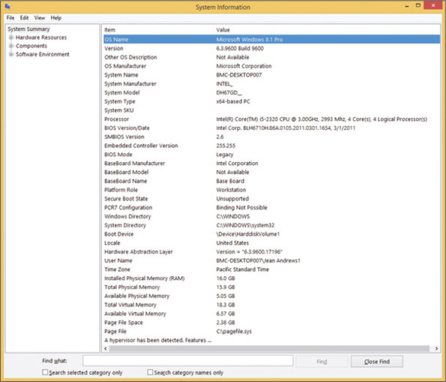
The BIOS/UEFI setup screen shows more information about installed memory than Windows does. Reboot the computer and access BIOS/UEFI setup, as you learned in Chapter 2. The BIOS/UEFI setup main menu for one system is shown in Figure 3-39. This screen shows that there are four memory slots and that each contains a 4-GB DIMM. You can also see that the memory speed is 1,333 MHz and the board supports dual channeling.
Figure 3-39
BIOS/UEFI setup reports the memory configuration and amount
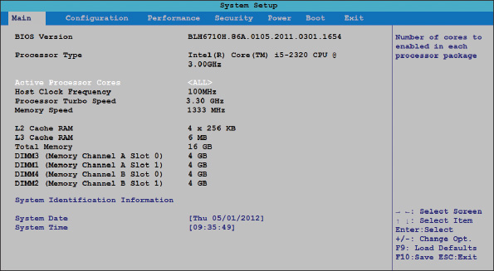
Source: Intel
Because all the slots are populated, you know you must replace existing 4-GB DIMMs with larger-capacity DIMMs, which will increase the price of the upgrade.
On other BIOS/UEFI screens, you should be able to identify the motherboard brand and model. For the BIOS/UEFI in Figure 3-39, select System Identification Information; you see that the motherboard is the Intel DH67GD.
Go to pg.
help
Application Opened
Main content

3-4bWhat Type of Memory Is Already Installed?
A+ Core 1
- 3.3
Given a scenario, install RAM types.
If the board already has memory installed, you want to do your best to match the new modules with the existing modules. To learn what type of memory modules are already installed, do the following:
- Open the case and look at the memory slots. How many slots do you have? How many are filled? Remove each module from its slot and examine it for the imprinted type, size, and speed. In Figure 3-40, the module is 4 GB PC4-17000 CL 15-15-15-36 and the brand of RAM is GEIL.
Figure 3-40
Use the label on this DIMM to identify its features
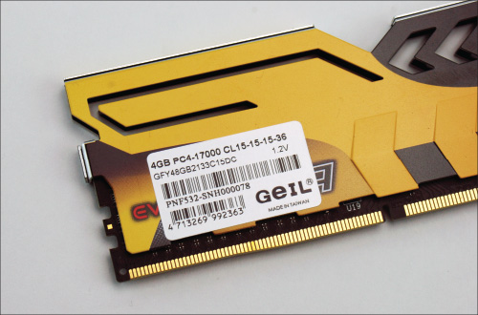
- If you have not already identified the motherboard, examine it for the imprinted manufacturer and model (see Figure 3-41).
Figure 3-41
Look for the manufacturer and model of a motherboard imprinted somewhere on the board
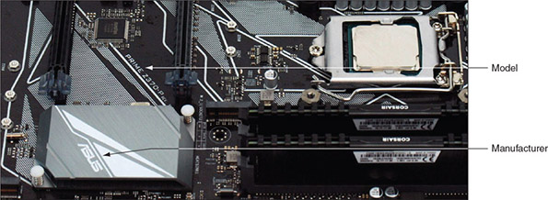
- Find the motherboard documentation online and read it to find the type of memory the board supports. Look in the documentation to see if the board supports dual channels, triple channels, or quad channels. If the board supports multiple channels and modules are already installed, verify that matching DIMMs are installed in each channel, as recommended in the documentation.
- If you still have not identified the module type, you can take the motherboard and the old memory modules to a good computer store and they should be able to match it for you.
Go to pg.
help
Application Opened
Main content

3-4cHow Many and What Kind of Modules Can Fit on My Motherboard?
A+ Core 1
- 3.3
Given a scenario, install RAM types.
Now that you know what memory modules are already installed, you’re ready to decide how much memory and what kind of modules you can add to the board. Keep in mind that if all memory slots are full, you can sometimes take out small-capacity modules and replace them with larger-capacity modules, but you can only use the type, size, and speed of modules that the board can support. Also, if you must discard existing modules, the price of the upgrade increases.
To know how much memory your motherboard can physically hold, read the documentation that comes with the board. You can always install DIMMs as single modules, but you might not get the best performance by doing so. For best performance, install matching DIMMs in each channel (two, three, or four slots). Now let’s look at two examples, one using dual channels and another using triple channels.

Motherboard Using DDR4 Dual-Channel DIMMs
The Asus Prime Z370-P motherboard has four 288-pin DDR4 DIMM slots and is shown earlier in Figure 3-41. It supports 2-GB, 4-GB, 8-GB, and 16-GB unbuffered, non-ECC DDR4 DIMMs with dual channeling. DIMM voltage cannot exceed 1.35 V and DIMMs with the same CAS Latency must be installed. The user manual recommends installing memory from the same manufacturer and same product line. It also says the maximum speed of the DIMMs supported varies by the processor. The processor shown in Figure 3-41 is the Intel Core i5-8600K; a quick check at ark.intel.com tells us that the maximum memory speed supported by this processor is 2,666 MHz. The information imprinted on the two DIMMs currently installed (see Figure 3-42) is DDR4 3,000 MHz 15-17-17-35 1.35 V Vengeance by Corsair.
Figure 3-42
Look for imprinted information about a DIMM
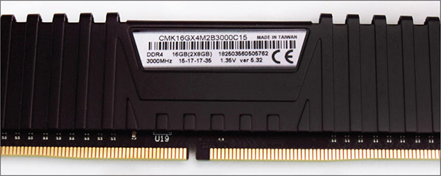
You want to upgrade memory from the current 16 GB to 32 GB. To get the full benefit of dual channeling, based on your research, you need to purchase two matching DIMMs using these specifications:
- Corsair Vengeance DDR4 DIMM
- CAS Latency 15, unbuffered, non-ECC
- Minimum speed of 2,666 MHz
To support dual channeling, the two existing DIMMs are installed in the two gray slots on the board; you plan to install the two new DIMMs in the two black slots.

Motherboard Using DDR3 Triple-Channel DIMMs
The Intel motherboard shown earlier in Figure 3-34 has four DDR3 memory slots that can be configured for single, dual, or triple channeling. The four empty slots are shown in Figure 3-43. If triple channeling is used, three matching DIMMs are used in the three blue slots. If the fourth slot is populated, the board reverts to single channeling. For dual channeling, install two matching DIMMs in the two blue slots farthest from the processor and leave the other two slots empty. If only one DIMM is installed, it goes in the blue slot in the farthest position from the processor.
Figure 3-43
Four DDR3 slots on a motherboard
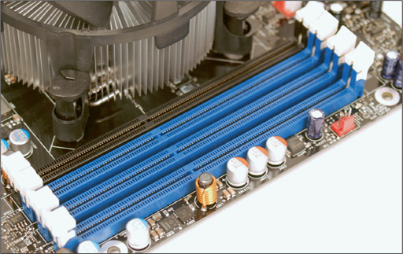
The motherboard documentation says that these types of DIMMs can be used:
- DIMM voltage rating no higher than 1.6 V
- Non-ECC DDR3 memory
- Serial Presence Detect (SPD) memory only
- Gold-plated contacts (some modules use tin-plated contacts)
- 1333 MHz, 1066 MHz, or 800 MHz (best to match the system bus speed)
- Unbuffered, nonregistered single- or double-sided DIMMs
- Up to 16 GB total installed RAM
The third item in the list needs an explanation. SPD is a DIMM technology that declares the module’s size, speed, voltage, and data path width to system BIOS/UEFI at startup. If the DIMM does not support SPD, the system might not boot or boot with errors. Today’s memory always supports SPD.
Go to pg.
help
Application Opened
Main content

3-4dHow Do I Select and Purchase the Right Memory Modules?
A+ Core 1
- 3.3
Given a scenario, install RAM types.
You’re now ready to make a purchase. As you select your memory, it might be difficult to find an exact match to DIMMs already installed on the board. Compromises might be necessary, but understand that there are some you can make and some you cannot:
- Mixing unbuffered memory with buffered or registered memory won’t work.
- When matching memory, you should also match the module manufacturer for best results. But, in a pinch, you can try using memory from two different manufacturers.
- If you mix memory speeds, know that all modules will perform at the slowest speed.
Now let’s look at how to use a website or computer ad to search for the right memory.

Use a Website to Research Your Purchase
When purchasing memory from a website such as Crucial Technology’s site (crucial.com) or Kingston Technology’s site (kingston.com), look for a search utility that will match memory modules to your motherboard. These utilities are easy to use and help you confirm you have made the right decisions about type, size, and speed to buy. They can also help if motherboard documentation is inadequate and you’re not exactly sure what memory to buy.
Let’s look at one example on the Crucial site, where we are looking to install memory in the Asus Prime Z370-P motherboard discussed earlier in the chapter. After selecting the manufacturer, product, and model (see Figure 3-44), click find upgrade.
Figure 3-44
Use the Crucial upgrade utility to find the correct memory for an upgrade
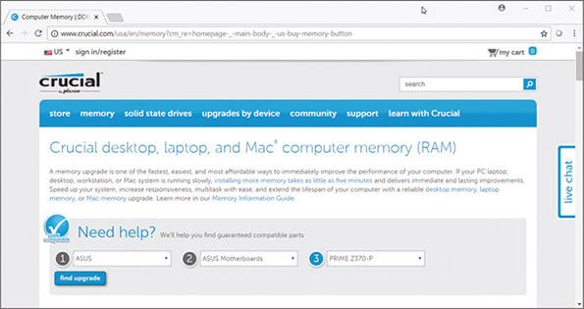
Source: crucial.com
The search results include the DIMMs shown in Figure 3-45. You can see all our criteria are met (unbuffered, CAS Latency 15, Non-ECC, 3,000 MHz, and 1.35 V) except the brand. These criteria validate what we have already determined based on our research, and we can now search for the matching brand on other memory sites. If we can’t find the matching brand, this hit will certainly work for our upgrade.
Figure 3-45
Selecting memory off the Crucial website
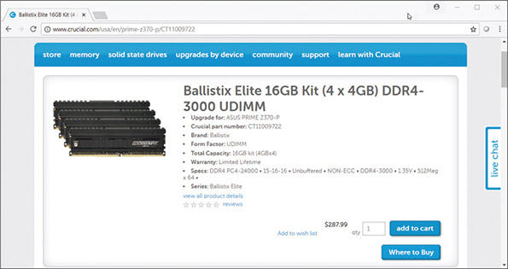
Source: crucial.com
Notes
RAM modules may have heat spreaders, which are fins or heat sinks on the side of the module to keep it from overheating. Some modules have cool lights for visual appeal in see-through cases.
Go to pg.
help
Application Opened
Main content

3-4eHow Do I Install the New Modules?
A+ Core 1
- 3.3
Given a scenario, install RAM types.
When installing RAM modules, be careful to protect the chips against static electricity, as you learned in Chapters 1 and 2. Follow these precautions:
- Always use an ESD strap as you work.
- Turn off the power, unplug the power cord, press the power button, and remove the case cover.
- Handle memory modules with care.
- Don’t touch the edge connectors on the memory module or on the memory slot.
- Don’t stack cards or modules because you can loosen a chip.
- Usually modules pop into place easily and are secured by spring catches on both ends. Make sure that you look for the notches on one side or in the middle of the module; these notches orient the module in the slot.
Let’s now look at the details of installing a DIMM.

Install DIMMs
For DIMM modules, small clips latch into place on each side of the slot to hold the module in the slot, as shown in Figure 3-46. Some motherboards have only one latch on the slot. To install a DIMM, first pull the supporting arms on the sides of the slot outward. Look on the DIMM edge connector for the notches, which help you orient the DIMM correctly over the slot, and insert the DIMM straight down into the slot. When the DIMM is fully inserted, the supporting clips should pop back into place. Figure 3-47 shows a DIMM being inserted into a slot on a motherboard. Apply pressure on both ends of the DIMM at the same time, being careful not to rock the module from side to side or backward and forward.
Figure 3-46
Clips on each side of a slot hold a DIMM in place
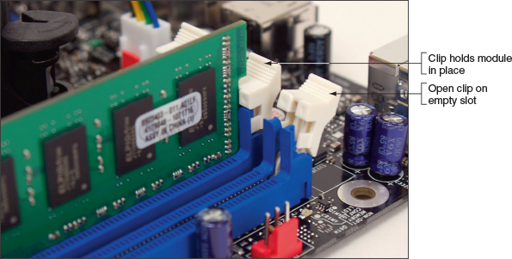
Figure 3-47
Insert the DIMM into the slot by pressing down until the support clips lock into position
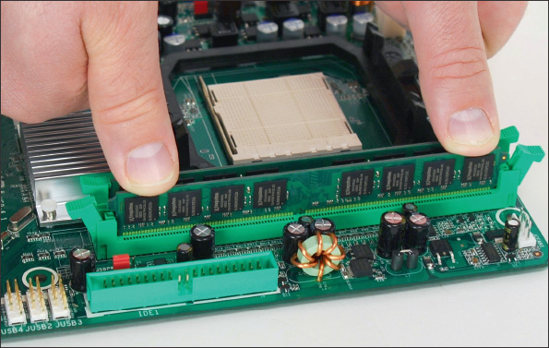
When the computer powers up, it counts the memory present without any further instruction and senses the features that the modules support, such as ECC or buffering. During the boot you can enter BIOS/UEFI to verify that the memory is recognized or allow Windows to start and use the System Information window to verify the expected amount of installed memory. If the new memory is not recognized, power down the system and reseat the module. Most likely it’s not installed solidly in the slot.
Go to pg.
help
Application Opened
Main content

3-4fHow to Upgrade Memory on a Laptop
A+ Core 1
- 1.1
Given a scenario, install and configure laptop hardware and components.
Before upgrading memory, make sure you are not voiding the laptop’s warranty. Search for the best buy, but make sure you use memory modules made by or authorized by your laptop’s manufacturer and designed for the exact model of your laptop. Installing generic memory might save money but might also void the laptop’s warranty.
Upgrading memory on a laptop works about the same way as upgrading memory on a desktop: Decide how much memory you can upgrade and what type of memory you need, purchase the memory, and install it. As with a desktop computer, be sure to match the type of memory to the type the laptop supports.
Applying Concepts

Upgrading Memory on a Laptop
A+ Core 1
- 1.1
Given a scenario, install and configure laptop hardware and components.
Most laptops are designed to allow easy access to memory. Follow these steps to exchange or upgrade memory for a typical laptop:
- Back up data and shut down the system. Remove peripherals, including the AC adapter. Remove the battery. Be sure to use an ESD strap as you work.
- Many laptops have a RAM door on the bottom. For some laptops, this door is in the battery cavity. Turn the laptop over and loosen the screws on the RAM door. (It is not necessary to remove the screws.)
- Raise the door (see Figure 3-48) and remove it from its hinges. The two memory slots are exposed.
Figure 3-48
Raise the DIMM door on the bottom of the notebook
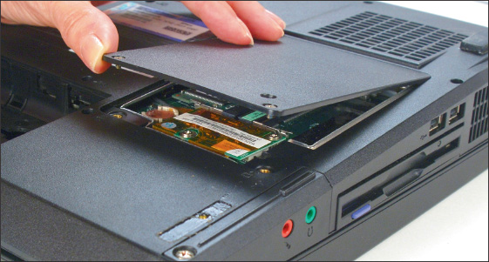
Notes
Some laptops have SO-DIMM slots stacked on top of each other. When you remove one SO-DIMM from these laptops, you can see the slot under it that holds a second SO-DIMM.
- Notice in Figure 3-49 that one slot is filled and one is available for a memory upgrade. Also notice in the figure that when you remove the RAM door, the CMOS battery is exposed. This easy access to the battery makes exchanging it very easy. To remove a SO-DIMM, pull the clips on the side of the memory slot apart slightly (see Figure 3-49). The SO-DIMM will pop up and out of the slot and can then be removed. If it does not pop up, you can hold the clips apart as you pull the module up and out of the slot.
Figure 3-49
Pull apart the clips on the memory slot to release the SO-DIMM
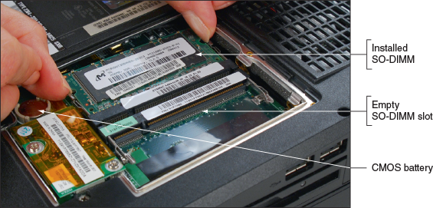
- To install a new SO-DIMM, insert the module at an angle into the slot (see Figure 3-50) and gently push it down until it snaps into the clips (see Figure 3-51). Replace the RAM door.
Figure 3-50
Insert a new SO-DIMM into a memory slot
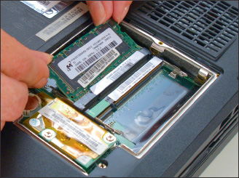
Figure 3-51
Push down on the SO-DIMM until it pops into the clips
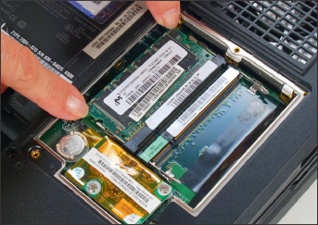
- Replace the battery, plug in the power adapter, and power up the laptop.
Go to pg.
help
Application Opened
Main content

Chapter Review

3-5aChapter Summary

Types and Characteristics of Processors
- The most important component on the motherboard is the processor, or central processing unit. The two major manufacturers of processors are Intel and AMD.
- Processors are rated by their processor speed, lithography, the socket and chipset they can use, multiprocessing features (multithreading, multicore rating, and dual processors), memory cache, memory features supported, virtualization, integrated graphics, overclocking, and processor architecture (32-bit or 64-bit).
- A processor’s memory cache inside the processor housing can be an L1 cache (contained on the processor die), L2 cache (off the die), and L3 cache (farther from the core than L2 cache).
- The core of a processor has two arithmetic logic units (ALUs). Multicore processors have two, three, or more cores (called dual core, triple core, quad core, and so forth). Each core can process two threads at once if the feature is enabled in BIOS/UEFI setup.
- The current families of Intel processors for desktops include Core, Pentium, Atom, and Celeron. Several different processors and generations are within each family.
- The current AMD desktop and laptop processor families are Ryzen, Ryzen Pro, Ryzen Threadripper, A-Series, A-Series Pro, and FX. In addition, the Ryzen Threadripper is the latest processor for desktops. Several processors exist within each family.

Selecting and Installing a Processor
- Select a processor that the motherboard supports. A board is likely to support several processors that vary in performance and price.
- When installing a processor, always follow the directions in the motherboard user guide and be careful to protect the board and processor against ESD. Current Intel sockets use a socket lever and socket load plate. When opening these sockets, lift the socket lever and then the socket load plate, install the processor, and then close the socket. Many AMD sockets have a socket lever but not a socket load plate.
- Always apply thermal compound between the processor and cooler assembly to help draw heat from the processor.

Memory Technologies
- DRAM is stored on DIMMs for desktop computers and SO-DIMMs for laptops.
- Types of current DIMMs are DDR4, which have 288 pins, and DDR3 and DDR2 DIMMs, which have 240 pins.
- Matching DIMMs can work together in dual channels, triple channels, and quad channels so that the memory controller can access more than one DIMM at a time to improve performance. In a channel, all DIMMs must match in size, speed, and features. DDR3 DIMMs can use dual, triple, or quad channeling, but DDR2 DIMMs can only use dual channels. DDR4 DIMMs can use dual or quad channels.
- DIMM speeds are measured in MHz (for example, 3,000 MHz) or PC rating (for example, PC4 24000).
- The memory controller can check memory for errors and possibly correct them using ECC (error-correcting code). Using parity, an older technology, the controller could recognize that an error had occurred, but could not correct it.
- Buffers and registers are used to hold data and amplify a data signal. A DIMM is rated as a buffered, registered (RDIMM), or unbuffered DIMM (UDIMM).
- CAS Latency (CL) measures access time to memory. The lower values are faster than the higher values.
- Today’s laptops use DDR4, DDR3L, DDR3, or DDR2 SO-DIMMs.

How to Upgrade Memory
- When upgrading memory, use the type, size, and speed the motherboard supports and match new modules to those already installed. Features to match include DDR4, DDR3, DDR2, size in MB or GB, speed (MHz or PC rating), buffered, registered, unbuffered, CL rating, tin or gold connectors, support for dual, triple, or quad channeling, ECC, and non-ECC. Using memory made by the same manufacturer is recommended.
- When upgrading components on a laptop, including memory, use components that are the same brand as the laptop, or use only components recommended by the laptop’s manufacturer.
Go to pg.
help
Application Opened
Main content

Chapter Review

3-5bKey Terms
For explanations of key terms, see the Glossary for this text.
- CAS Latency
- Centrino
- DDR (Double Data Rate)
- DDR2
- DDR3
- DDR3L
- DDR4
- DIMM (dual inline memory module)
- dual channels
- dual processors
- dynamic RAM (DRAM)
- ECC (error-correcting code)
- graphics processing unit (GPU)
- Hyper-Threading
- HyperTransport
- Level 1 cache (L1 cache)
- Level 2 cache (L2 cache)
- Level 3 cache (L3 cache)
- multicore processing
- multiprocessing
- multiprocessor platform
- parity
- parity error
- processor frequency
- quad channel
- SIMM (single inline memory module)
- single channel
- single-core processing
- SO-DIMM (small outline DIMM)
- static RAM (SRAM)
- thermal compound
- thread
- triple channels
- x86 processors
- x86-64 bit processors
Go to pg.
help
Application Opened
Main content

Chapter Review

3-5cThinking Critically
These questions are designed to prepare you for the critical thinking required for the A+ Core 1 exam and may use information from other chapters or the web. As always, remember Google is your friend!
- An experienced user has installed Oracle VM VirtualBox on her workstation and is attempting to use it to create a virtual machine (VM). The software is causing error messages while attempting to create the VM. What is the most likely problem?
  - The user does not know how to use the software.
  - Virtualization is not enabled in BIOS/UEFI.
  - The version of Windows she is using is not rated for installations of Oracle software.
  - The processor is not rated to support VirtualBox and VMs.
- A friend has asked you to help him find out if his computer is capable of overclocking. How can you direct him? Select all that apply.
  - Show him how to find System Summary data in the System Information utility in Windows and then do online research.
  - Show him how to access BIOS/UEFI setup and browse through the screens.
  - Explain to your friend that overclocking is not a recommended best practice.
  - Show him how to open the computer case, read the brand and model of his motherboard, and then do online research.
- A customer has a system with a Gigabyte B450 Aorus Pro motherboard. He wants to upgrade the processor from the AMD Athlon X4 950 to the AMD Ryzen 7 2700X. Which of the following accurately describes this upgrade?
  - The upgrade is possible and will yield a significant increase in performance.
  - The upgrade is not possible because the new processor is not supported by this motherboard.
  - The upgrade is possible, but will not yield a significant increase in performance.
  - The upgrade is not possible because this motherboard has an embedded processor that cannot be exchanged.
- What new parts will you need to replace a failing processor? Select all that apply.
  - Power cable
  - Processor
  - Cooling assembly
  - Thermal compound
- How many threads can a quad-core processor handle at once?
- A motherboard has four DIMM slots; three slots are gray and the fourth is black. What type of memory is this board designed to use?
  - DDR4
  - DDR3
  - DDR2
  - All of the above
- What prevents a DDR3 DIMM from being installed in a DDR2 DIMM slot on a motherboard?
- In memory ads for DIMMs, you notice DDR 2400 CL15 in one ad and PC4 21300 CL9 in another. Which ad is advertising the faster memory?
- When planning a memory upgrade, you discover that Windows 8 reports 4 GB of memory installed. In BIOS/UEFI, you see that two of four slots are populated. You install two 2-GB DIMMs in the two empty DIMM slots. When you boot the system, Windows 8 still reports 4 GB of memory. Order the four steps you should take to troubleshoot the problem of missing memory.
  - Open the case and verify that the DIMM modules are securely seated.
  - Go into BIOS/UEFI and verify that it recognized 8 GB of installed memory.
  - Open the System Information window to verify the edition or version of Windows 8 installed.
  - Inspect the DIMMs you installed to verify that they match the existing DIMMs and those the motherboard can support.
- If 2 bits of a byte are in error when the byte is read from ECC memory, can ECC detect the error? Can it fix the error?
- A DIMM memory ad displays 5-5-5-15. What is the CAS Latency value of this DIMM?
- What is the speed in MHz of a DIMM rated at PC4 24000?
- A motherboard uses dual channeling, but you have four DIMMs available that differ in size. The motherboard supports all four sizes. Can you install these DIMMs on the board? Will dual channeling be enabled?
- Which is faster, CL3 memory or CL5 memory?
- If your motherboard supports ECC DDR3 memory, can you substitute non-ECC DDR3 memory?
- You have just upgraded memory on a computer from 4 GB to 8 GB by adding one DIMM. When you first turn on the PC, the memory count shows only 4 GB. Which of the following is most likely the source of the problem? What can you do to fix it?
  - Windows is displaying an error because it likely became corrupted while the computer was disassembled.
  - The new DIMM you installed is faulty.
  - The new DIMM is not properly seated.
  - The DIMM is installed in the wrong slot.
- Your motherboard supports dual channeling and you currently have two slots populated with DIMMs; each module holds 2 GB. You want to install an additional 4 GB of RAM. Will your system run faster if you install two 2-GB DIMMs or one 4-GB DIMM? Explain your answer.
Go to pg.
help

