Application Opened
Main content
Chapter
4

Supporting the Power System and Troubleshooting Computers
- Chapter Introduction
- 4-1Cooling Methods and Devices
  - 4-1aProcessor Coolers, Fans, and Heat Sinks
  - 4-1bCase Fans, Other Fans, and Heat Sinks
  - 4-1cLiquid Cooling Systems
- 4-2Selecting a Power Supply
  - 4-2aTypes and Characteristics of Power Supplies
  - 4-2bHow to Calculate Wattage Capacity
- 4-3Strategies to Troubleshoot Any Computer Problem
  - 4-3aStep 1: Interviewing the User and Backing up Data
  - 4-3bStep 2: Examining the System and Making Your Best Guess
  - 4-3cStep 3: Testing Your theory
  - 4-3dStep 4: Planning Your Solution and Then Fixing the Problem
  - 4-3eStep 5: Verifying the Fix and Taking Preventive Action
  - 4-3fStep 6: Documenting What Happened
- 4-4Troubleshooting the Electrical System
  - 4-4aProblems That Come and Go
  - 4-4bPower Problems with the Motherboard
  - 4-4cProblems with Overheating
  - 4-4dProblems with Laptop Power Systems
- 4-5Troubleshooting the Motherboard, Processor, and RAM
  - 4-5aWindows Startup Repair
- 4-6Chapter Review
  - 4-6aChapter Summary
  - 4-6bKey Terms
  - 4-6cThinking Critically
  - 4-6dHands-On Projects
  - 4-6eReal Problems, Real Solutions
  - 4-6fExam Tips
Go to pg.
help
Application Opened
Main content

Chapter Introduction
After completing this chapter, you will be able to:
- Describe the methods and devices for keeping a system cool
- Select a power supply to meet the power needs of a system
- Demonstrate an organized approach to solving any computer problem, especially hardware problems occurring during the boot
- Troubleshoot problems with the electrical system
- Troubleshoot problems with the motherboard, processor, and RAM
In the first chapters of this text, you learned about the motherboard, processor, and RAM. This chapter focuses on how to keep these heat-producing components cool by using fans, heat sinks, and other cooling devices and methods. You also learn about one more essential component of a computer system, the power supply, including how to select a power supply to meet the wattage needs of a system.
Then we focus on troubleshooting these various hardware subsystems and components. You study the troubleshooting techniques and procedures to get the full picture of what it’s like to have the tools and knowledge in hand to solve any computer-related problem. Then you learn to practically apply these skills to troubleshooting the electrical system, motherboard, processor, and memory. By the end of this chapter, you should feel confident that you can face a problem with hardware and understand how to zero in on the source of the problem and its solution.
Go to pg.
help
Application Opened
Main content

4-1Cooling Methods and Devices
A+ Core 1
- 3.5
Given a scenario, install and configure motherboards, CPUs, and add-on cards.
The processor, motherboard, memory modules, expansion cards, and other components in the case produce heat. If they get overheated, the system can become unstable and components can fail or be damaged. As a hardware technician, you need to know how to keep a system cool. Devices that are used to keep a system cool include CPU fans, case fans, coolers, heat sinks, and liquid cooling systems.
In this part of the chapter, you learn about several methods to keep the system cool, beginning with these general rules to cool the inside of a computer case:
- Keeping the case closed. This may seem counterintuitive as you might think an open case allows for better airflow, but consider the dust that will clog your fans and how fans are designed to draw hot air out of a closed case. If airflow is disrupted, an open case is a temporary fix to an overheating computer and should not be used long term.
- Cleaning the inside of the computer. Dust and debris clog your computer. Dirt and dust cake on the equipment and essentially insulate the heat-sensitive components. Use a can of compressed air to blow clean the inside of the case and its components.
- Moving the computer. If the computer is in a fairly dusty or warm space, the computer might overheat. If overheating is a problem, try moving the computer to a new area that is cleaner and cooler.
Go to pg.
help
Application Opened
Main content

4-1aProcessor Coolers, Fans, and Heat Sinks
A+ Core 1
- 3.5
Given a scenario, install and configure motherboards, CPUs, and add-on cards.
Because a processor generates so much heat, computer systems use a cooling assembly designed for a specific processor to keep temperatures below the processor maximum temperature. If a processor reaches its maximum temperature, it automatically shuts down. Good processor coolers maintain a temperature of 90–110 degrees F (32–43 degrees C). The cooler (see Figure 4-1) sits on top of the processor and consists of a fan and a heat sink. A heat sink is made of metal that draws the heat away from the processor into the fins. The fan can then blow the heat away. You learned to install a cooler in Chapter 3.
Figure 4-1
A cooler sits on top of a processor to help keep it cool
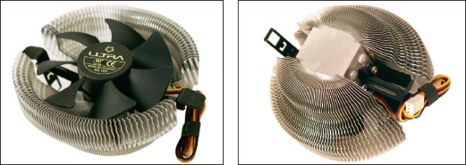
A cooler is made of aluminum, copper, or a combination of both. Copper is more expensive, but does a better job of conducting heat. For example, the Thermaltake (thermaltake.com) multisocket cooler shown in Figure 4-2 is made of copper and has an adjustable fan control.
Figure 4-2
The Thermaltake V1 copper cooler is a multisocket cooler that fits several Intel and AMD sockets
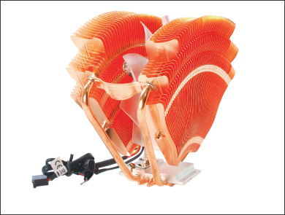
Recall that the cooler is bracketed to the motherboard using a wire or plastic clip and thermal compound is placed between the bottom of the cooler heat sink and the top of the processor. To get its power, the cooler fan power cord connects to a 4-pin fan header on the motherboard (see Figure 4-3). The fan connector will have three or four holes. A three-hole connector can fit onto a 4-pin header; just ignore the last pin. A 4-pin header on the motherboard supports pulse width modulation (PWM) that controls fan speed in order to reduce the overall noise in a system. If you use a cooler fan power cord with three pins, know that the fan will always operate at the same speed.
Figure 4-3
A cooler fan gets its power from a 4-pin PWM header on the motherboard
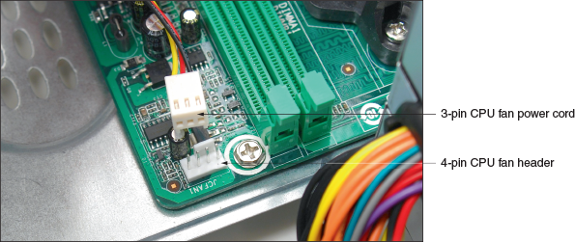
Go to pg.
help
Application Opened
Main content

4-1bCase Fans, Other Fans, and Heat Sinks
A+ Core 1
- 3.5
Given a scenario, install and configure motherboards, CPUs, and add-on cards.
To prevent overheating, you can also install additional case fans. Most cases have one or more positions to hold a case fan to help draw air out of the case. Figure 4-4 shows holes on the rear of a case designed to hold a case fan.
Figure 4-4
Install a case fan on the rear of this case to help keep the system cool
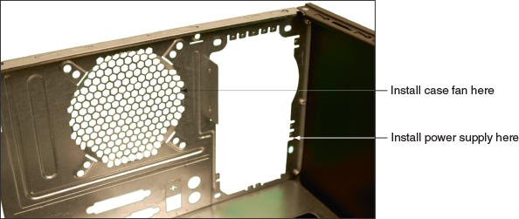
A computer case might need as many as seven or eight fans mounted inside the case; however, the trend is to use fewer and larger fans. Generally, large fans tend to perform better and run quieter than small fans.
Processors and video cards, also called graphics cards, are the two greatest heat producers in a system. Some graphics cards come with a fan on the side of the card. You can also purchase heat sinks and fans to mount on an expansion card to keep it cool. Another solution is to use a fan card mounted next to the graphics card. Figure 4-5 shows a PCI fan card. Be sure you select the fan card that fits the expansion slot you plan to use, and make sure there’s enough clearance beside the graphics card for the fan card to fit and for airflow.
Figure 4-5
A PCI fan card by Vantec can be used next to a high-end graphics card to help keep it cool
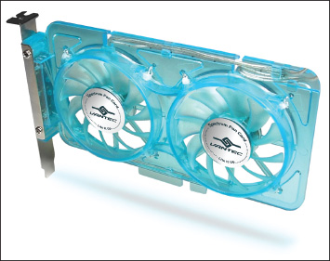
Source: Courtesy of Vantec Thermal Technologies
For additional cooling, consider a RAM cooler such as the one shown in Figure 4-6. It clips over a DIMM. A fan might be powered by a SATA power connector or 4-pin Molex power connector. The fan shown in Figure 4-6 uses a Molex connector. If you need a different or extra power connector that isn’t available on a power supply, you can use an adapter to change an unused SATA or Molex connector into the connector you need.
Figure 4-6
A RAM cooler keeps memory modules cool
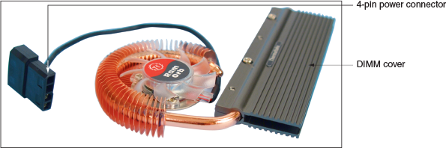
When selecting any fan or cooler, take into consideration the added noise level and the ease of installation. Some coolers and fans can use a temperature sensor that controls the fan. Also consider the guarantee made by the cooler or fan manufacturer.
Go to pg.
help
Application Opened
Main content

4-1cLiquid Cooling Systems
A+ Core 1
- 3.5
Given a scenario, install and configure motherboards, CPUs, and add-on cards.
In addition to using fans, heat sinks, and thermal compound to keep a processor cool, a liquid cooling system can be used. For the most part, they are used by hobbyists attempting to overclock to the max a processor in a gaming computer because these high-powered systems tend to run hot. Liquid cooling systems tend to run quieter than other cooling methods. They might include a PCIe card that has a power supply, temperature sensor, and processor to control the cooler.
Using liquid cooling, a small pump sits inside the computer case, and tubes move liquid around components and then away from them to a place where fans can cool the liquid, similar to how a car radiator works. Figure 4-7 shows one liquid cooling system where the liquid is cooled by fans sitting inside a large case. Sometimes, however, the liquid is pumped outside the case, where it is cooled.
Figure 4-7
A liquid cooling system pumps liquid outside and away from components where fans can then cool the liquid
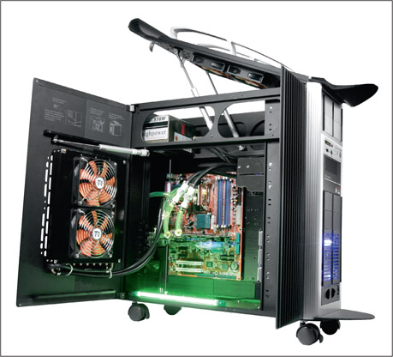
Source: Courtesy of Thermaltake (USA) Inc.
Now let’s turn our attention to the power supply.
Go to pg.
help
Application Opened
Main content

4-2Selecting a Power Supply
A+ Core 1
- 3.7
Summarize power supply types and features.
In Chapter 1, you learned how to uninstall and install a power supply unit (PSU). You might need to replace a power supply when it fails or if the power supply in an existing system is not adequate. When building a new system, you can purchase a computer case with the power supply already installed (see Figure 4-8), or you can purchase a power supply separate from the case.
Figure 4-8
This case comes with a power supply, power cord, and bag of screws
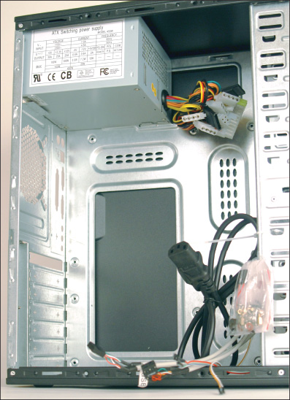
Go to pg.
help
Application Opened
Main content

4-2aTypes and Characteristics of Power Supplies
A+ Core 1
- 3.7
Summarize power supply types and features.
As you select the right power supply for a system, you need to be aware of the following power supply features:
- ATX or microATX form factor. The form factor of a power supply determines the dimensions of the power supply and the placement of screw holes and slots used to anchor the power supply to the case.
- Wattage ratings. A power supply has a wattage rating for total output maximum load (for example, 500 W, 850 W, or 1000 W) and individual wattage ratings for each of the voltage output circuits. These wattage capacities are listed in the documentation and on the side of a power supply, as shown in Figure 4-9.
Figure 4-9
Consider the number and type of power connectors and the wattage ratings of a power supply
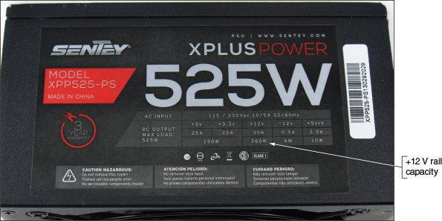
When selecting a power supply, pay particular attention to the capacity for the +12 V rail. (A rail is the term used to describe each circuit provided by the power supply.) The +12 V rail is the one most used, especially in high-end gaming systems. Notice in Figure 4-9 that the +12 V rail gets 360 W of the maximum 525-W load. Sometimes you need to use a power supply with a higher-than-needed overall wattage to get enough wattage on this one rail.
Notes
To calculate wattage, know that the power in watts (W) is equal to the current in amps (A) times the voltage in volts (V):
- Number and type of connectors. Consider the number and type of power cables and connectors the unit provides. Connector types are shown in Table 1-2 in Chapter 1. Table 4-1 lists some common connectors and the voltages they supply. Some power supplies include detached power cables, sometimes called modular cable systems, that you can plug into connectors on the side of the unit. By using only the power cables you need, extra power cables don’t get in the way of airflow inside the computer case.
Table 4-1

Power Supply Connectors and Voltages
Connector | Voltages | Description
SATA | +3.3 V, +5 V, +12 V | Power to SATA drives, 15 pin
Molex | +5 V, +12 V | Power to older IDE drives and used with some older SATA drives, 4 pin
24-pin P1 | +3.3 V, +5 V, ±12 V | Newer main power connector to motherboard
A+ Exam Tip
The A+ Core 1 exam expects you to know the voltage output of the power connectors listed in Table 4-1. Consider memorizing the table.
Notes
If a power supply doesn’t have the connector you need, it is likely you can buy an adapter to convert one connector to another. For example, Figure 4-10 shows an adapter that converts two Molex cables to one 12-V 6-pin PCIe connector.
Figure 4-10
This adapter converts two Molex cables to a single 12-V 6-pin PCIe connector
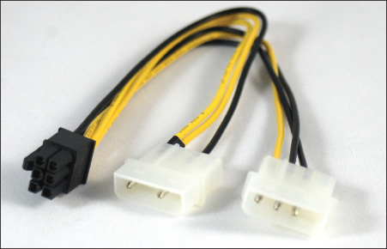
- Fans inside the PSU. Every power supply has a fan inside its case; some have two fans. The fan may be mounted on the back or top of the PSU. Fans range in size from 80 mm to 150 mm wide. The larger the fan, the better job it does and the quieter it runs. Some PSUs can automatically adjust the fan speed based on the internal temperature of the system.
Notes
Some power supplies are designed without fans so that they can be used in home theater systems or other areas where quiet operation is a requirement.
- Dual voltage options. Expect a power supply to have a dual-voltage selector switch on the back where you can switch input voltage to 115 V for the United States or 220 V for other countries.
- Extra features. Consider the warranty of the power supply and the overall quality. Some power supplies are designed to support two video cards used in a gaming computer. Two technologies used for multiple video cards are SLI by NVIDIA and Crossfire by AMD. If you plan to use multiple video cards, use a PSU that supports SLI or Crossfire. Know that more expensive power supplies are quieter, last longer, and don’t put off as much heat as less expensive ones. Also, expect a good power supply to protect the system against overvoltage. A power supply rated with Active PFC (power factor correction) runs more efficiently and uses less electricity than other power supplies.
Go to pg.
help
Application Opened
Main content

4-2bHow to Calculate Wattage Capacity
A+ Core 1
- 3.7
Summarize power supply types and features.
When deciding what wattage capacity you need for the power supply, consider the total wattage requirements of all components inside the case as well as USB devices that get their power from ports connected to the motherboard.
A+ Exam Tip
The A+ Core 1 exam expects you to know how to select and install a power supply. You need to know how to decide on the wattage, connectors, and form factor of the power supply.
Keep these two points in mind when selecting the correct wattage capacity for a power supply:
- Video cards draw the most power. Video cards draw the most power in a system, and they draw from the +12 V output. If your system has a video card, pay particular attention to the +12 V rating. The current trend is for the motherboard to provide the video components and video port, thus reducing the overall wattage needs for a system. Video cards are primarily used in gaming computers or other systems that require high-quality graphics.
- The power supply should be rated about 30 percent higher than expected needs. Power supplies that run at less than peak performance last longer and don’t overheat. In addition, a power supply loses some of its capacity over time. Also, don’t worry about a higher-rated power supply using too much electricity. Components only draw what they need. For example, a power supply rated at 1000 W and running at a 500-W draw will last longer and give off less heat than a power supply rated at 750 W and running at a 500-W draw.
To know what size of power supply you need, add up the wattage requirements of all components and then add 30 percent. Technical documentation for these components should give you the information you need. Table 4-2 lists appropriate wattage ratings for common devices. Alternately, you can use a wattage calculator provided on the website of many manufacturers and vendors. Using the calculator, you enter the components in your system and then the calculator will recommend the wattage you need for your power supply.
Table 4-2

To Calculate the Power Supply Rating You Need, Add Up Total Wattage
Devices | Approximate Wattage
Motherboard, processor, memory, keyboard, and mouse | 200–300 W
Fan | 5 W
SATA hard drive | 15–30 W
BD/DVD/CD drive | 20–30 W
PCI video card | 50 W
PCI card (network card or other PCI card) | 20 W
PCIe ×16 video card | 150–300 W
PCIe ×16 card other than a video card | 100 W
Caution
Some older Dell motherboards and power supplies do not use the standard P1 pinouts for ATX, although the power connectors look the same. For this reason, never use a Dell power supply with a non-Dell motherboard, or a Dell motherboard with a non-Dell power supply, without first verifying that the power connector pinouts match; otherwise, you might destroy the power supply, the motherboard, or both.
Table 4-3 lists a few case and power supply manufacturers.
Table 4-3

Manufacturers of Cases and Power Supplies for Personal Computers
Manufacturer | Website
Antec | antec.com
Cooler Master | coolermaster.com
Corsair | corsair.com
EVGA | evga.com
FirePower Technology | firepower-technology.com
Rosewill | rosewill.com
Seasonic | seasonic.com
Sentey | sentey.com
Silverstone | silverstonetek.com
Thermaltake | thermaltakeusa.com
Zalman | zalman.com
So far in the text, you have learned about motherboards, processors, RAM, and the electrical system, which are the principal hardware components of a computer. With this hardware foundation in place, you’re ready to learn about computer troubleshooting. Let’s start with an overview of how to approach any hardware problem, and then we’ll turn our attention to the details of troubleshooting the electrical system, motherboard, RAM, and CPU.
Go to pg.
help
Application Opened
Main content

4-3Strategies to Troubleshoot Any Computer Problem
A+ Core 1
- 5.1
Given a scenario, use the best practice methodology to resolve problems.
When a computer doesn’t work and you’re responsible for fixing it, you should generally approach the problem first as an investigator and discoverer, always being careful not to compound the problem through your actions. If the problem seems difficult, see it as an opportunity to learn something new. Ask questions until you understand the source of the problem. Once you understand it, you’re almost done because most likely the solution will be evident. If you take the attitude that you can understand the problem and solve it, no matter how deeply you have to dig, you probably will solve it.
One systematic method used by most expert troubleshooters to solve a problem is the six steps diagrammed in Figure 4-11, which can apply to both software and hardware problems. As an IT technician, expect that you will build your own style and steps for troubleshooting based on your own experiences over time.
Figure 4-11
A general approach to problem solving
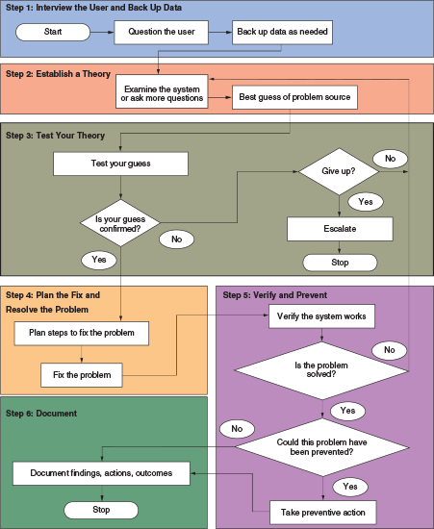
A+ Exam Tip
The A+ Core 1 exam expects you to know about all the aspects of troubleshooting theory and strategy and how to apply the troubleshooting procedures and techniques described in this section. Read A+ Core 1 Objective 5.1 and compare it with Figure 4-11. You’ll find the objectives with this text.
Here are the steps:
- Interview the user and back up data before you make any changes to the system.
- Examine the system, analyze the problem, and make an initial determination of the source of the problem.
- Test your theory. If the theory is not confirmed, form another theory or escalate the problem to someone higher in your organization with more experience or resources.
- After you know the source of the problem, plan what to do to fix the problem and then fix it.
- Verify that the problem is fixed and that the system works. Take any preventive measures to make sure the problem doesn’t happen again.
- Document activities, outcomes, and what you learned.
Over time, a good IT support technician builds a strong network of resources he or she can count on when solving computer problems. Here are some resources to help you get started with your own list of reliable and time-tested sources of help:
- The web. Do a web search on an error message, a short description of the problem, or the model and manufacturer of a device to get help. Check out the website of the product manufacturer or search a support forum. It’s likely that other technicians have encountered the same problem and posted the question and answer. If you search and cannot find your answer, you can post a new question. Youtube.com videos might help. Many technicians enjoy sharing online what they know, but be careful—not all technical advice is correct or well intentioned.
- Chat, forums, or email technical support. Support from hardware and software manufacturers can help you interpret an error message or provide general support in diagnosing a problem. Most technical support is available during working hours by way of an online chat session. Support from the manufacturer is considered the highest authority for the correct fix to a problem.
- Manufacturer’s diagnostic software. Many hardware device manufacturers provide diagnostic software, which is available for download from their websites. For example, you can download Toolkit (to back up data), SeaTools for Windows (must be installed in Windows), or SeaTools for USB (to create a bootable USB drive) and use the software to diagnose and fix problems with Seagate drives. See Figure 4-12. Search the support section of a manufacturer’s website to find diagnostic software and guidelines for using it.
Figure 4-12
Download diagnostic software tools from a manufacturer’s website
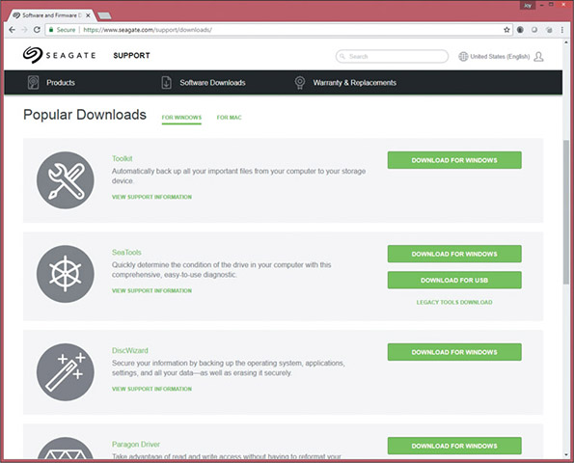
Source: seagate.com
Notes
Always check compatibility between utility software and the operating system (OS) you plan to use.
- User manuals. Refer to your user manuals, which often list error messages and their meanings. They also might contain a troubleshooting section and list any diagnostic tools available.
- Technical associates in your organization. Be sure to ask for advice when you’re stuck. Also, after making a reasonable and diligent effort to resolve a problem, getting the problem fixed could become more important than resolving it yourself. There comes a time when you might need to turn the problem over to a technician who is more experienced or has access to more resources. (In an organization, this process is called escalating the problem.)
Now let’s examine the process step by step. As you learn about these six steps, you’ll also learn about 13 rules useful when troubleshooting. Here’s the first rule.
Rule 1: Approach the Problem Systematically
When trying to solve the problem, start at the beginning and walk through the situation in a thorough, careful way. This rule is invaluable. Remember it and apply it every time. If you don’t find the explanation to the problem after one systematic walk-through, then repeat the entire process. Check and double-check to find the step you overlooked the first time. Most problems with computers are simple, such as a loose cable or incorrect Windows setting. Computers are logical through and through. Whatever the problem is, it’s also very logical. Also, if you are faced with more than one problem on the same computer, work on only one problem at a time. Trying to solve multiple problems at the same time can get too confusing.
Go to pg.
help
Application Opened
Main content

4-3aStep 1: Interviewing the User and Backing up Data
A+ Core 1
- 5.1
Given a scenario, use the best practice methodology to resolve problems.
Every troubleshooting situation begins with interviewing the user if he or she is available. If you have the opportunity to speak with the user, ask questions to help you identify the problem, how to reproduce it, and possible sources of the problem. Also ask about any data on the hard drive that is not backed up.
A+ Exam Tip
The A+ Core 1 exam expects you to know how to interact with a user and know what questions to ask in a troubleshooting scenario without accusing or dishonoring the user.
Here are some questions that can help you learn as much as you can about the problem and its root cause:
- Please describe the problem. What error messages, unusual displays, or failures did you see? (Possible answer: I see this blue screen with a funny-looking message on it that makes no sense to me.)
- When did the problem start? Does the computer have a history of similar problems? (Possible answer: When I first booted after loading this neat little screen saver I downloaded from the web.)
- What was the situation when the problem occurred? (Possible answers: I was trying to start up my laptop. I was opening a document in Microsoft Word. I was using the web to research a project.)
- What programs or software were you using? (Possible answer: I was using Internet Explorer.)
- What changes have recently been made to the system? For example, did you recently install new hardware or software or move your computer system? (Possible answer: Well, yes. Yesterday I moved the computer case across the room.)
- Has there been a recent thunderstorm or electrical problem? (Possible answer: Yes, last night. Then when I tried to turn on my computer this morning, nothing happened.)
- Have you made any hardware, software, or configuration changes? Have there been any infrastructure changes? (Possible answer: No, but I think my sister might have.)
- Has someone else used your computer recently? (Possible answer: Sure, my son uses it all the time.)
- Is there some valuable data on your system that is not backed up that I should know about before I start working on the problem? (Possible answer: Yes! Yes! My term paper! It’s not backed up! You gotta save that!)
- Can you show me how to reproduce the problem? (Possible answer: Yes, let me show you what to do.)
Based on the answers you receive, ask more penetrating questions until you feel the user has given you all the information he or she knows that can help you solve the problem. As you talk with the user, keep in mind rules 2, 3, and 4.
Rule 2: Establish Your Priorities
This rule can help make for a satisfied customer. Decide what your first priority is. For example, it might be to recover lost data or to get the computer back up and running as soon as possible. When practical, ask the user or customer for help deciding on priorities. For most users, data is the first priority unless they have a recent backup.
Rule 3: Beware of User Error
Remember that many problems stem from user error. If you suspect this is the case, ask the user to show you the problem and carefully watch what the user is doing. Be careful to handle a user error delicately because some people don’t like to hear that they made a mistake.
Rule 4: Keep Your Cool and Don’t Rush
In some situations, you might be tempted to act too quickly and to be drawn into the user’s sense of emergency. But keep your cool and don’t rush. For example, if a computer stops working and unsaved data is still in memory or if data on the hard drive has not been backed up, look and think carefully before you leap! A wrong move can be costly. The best advice is not to hurry. Carefully plan your moves. Research the problem using documentation or the web if you’re not sure what to do, and don’t hesitate to ask for help. Don’t simply try something, hoping it will work, unless you’ve run out of more intelligent alternatives!
After you have talked with the user, be sure to back up any important data that is not currently backed up before you begin work on the computer. Here are three options:
- Use File Explorer to copy the data to another system. If the computer is working well enough to boot to the Windows desktop, you can use Windows 10/8 File Explorer or Windows 7 Windows Explorer to copy data to a flash drive, another computer on the network, or other storage media.
- Move the hard drive to another system. If the computer is not healthy enough to use Explorer, don’t do anything to jeopardize the data. If you must take a risk with the data, let it be the user’s decision to do so, not yours. When a system won’t boot from the hard drive, consider removing the drive and installing it as a second drive in a working system. If the file system on the problem drive is intact, you might be able to copy data from the drive to the primary drive in the working system.
To move the hard drive to a working computer, you don’t need to physically install the drive in the drive bay. Open the computer case. Carefully lay the drive on the case and connect a power cord and data cable (see Figure 4-13). Then turn on the computer. While you have the computer turned on, be very careful not to touch the drive or touch inside the case. Also, while a tower case is lying on its side like the one in Figure 4-13, don’t use the optical drive.
Figure 4-13
Move a hard drive to a working computer to recover data on the drive
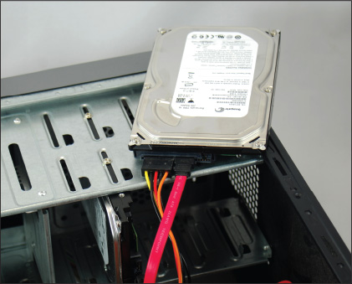
Start the computer and sign in to Windows using an Administrator account. (If you don’t sign in with an Administrator account, you must provide the password to an Administrator account before you can access the files on the newly connected hard drive.) When Windows finds the new drive, it assigns a drive letter. Use Explorer in Windows 10/8/7 or third-party software to copy files from this drive to the primary hard drive in this system or to other storage media. Then return the drive to the original system and turn your attention to solving the original problem.
Notes
An easier way to temporarily install a hard drive in a system is to use a USB port. Figure 4-14 shows a USB-to-SATA converter kit. The SATA connector can be used for desktop or laptop hard drives because a SATA connector is the same for both. A USB-to-SATA converter is really handy when recovering data and troubleshooting problems with hard drives that refuse to boot.
Figure 4-14
Use a USB-to-SATA converter to recover data from a drive that has a SATA connector
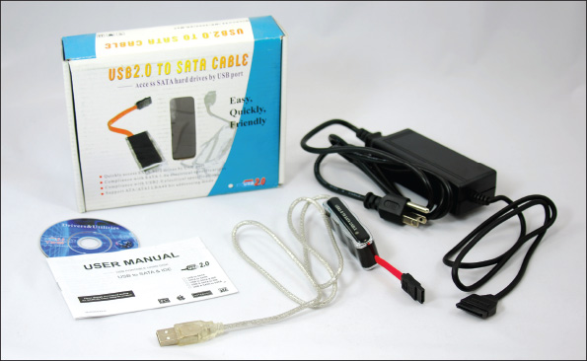
- Hire a professional file recovery service. If your data is extremely valuable and other methods have failed, you might want to consider a professional data recovery service. They’re expensive, but getting the data back might be worth it. To find a service, do a web search on “data recovery.” Before selecting a service, be sure to read reviews, understand the warranty and guarantees, and perhaps get a recommendation from a satisfied customer.
A+ Exam Tip
The A+ Core 1 exam expects you to know the importance of making backups before you make changes to a system.
If possible, have the user verify that all important data is safely backed up before you continue to the next troubleshooting step.
Caution
Don’t take chances with a user’s important data. If the user tells you the data has already been backed up, ask him to verify that he can recover the data from the backup website or media before you assume the data is really backed up.
If you’re new to troubleshooting and don’t want the user looking over your shoulder while you work, you might want to let him or her know you’d prefer to work alone. You can say something like, “Okay, I think I have everything I need to get started. I’ll let you know if I have another question.”
Go to pg.
help
Application Opened
Main content

4-3bStep 2: Examining the System and Making Your Best Guess
A+ Core 1
- 5.1
Given a scenario, use the best practice methodology to resolve problems.
You’re now ready to start solving the problem. Rules 5 and 6 can help.
Rule 5: Make No Assumptions
This rule is the hardest to follow because there is a tendency to trust anything in writing and assume that people are telling you exactly what happened. But documentation is sometimes wrong, and people don’t always describe events as they occurred, so do your own investigating. For example, if the user tells you that the system boots up with no error messages but that the software still doesn’t work, boot for yourself. You never know what the user might have overlooked.
Rule 6: Try the Simple Things First
The solutions to most problems are so simple and obvious that we overlook them because we expect the problem to be difficult. Don’t let the complexity of computers fool you. Most problems are easy to fix. Really, they are! To save time, check the simple things first, such as whether a power switch is not turned on or a cable is loose. Generally, it’s easy to check for a hardware problem before you check for a software problem. For example, if a USB drive is not working, verify that the drive works on another port or another computer before verifying the drivers are installed correctly.
Follow this process to form your best guess (best theory) and test it:
- Reproduce the problem and observe for yourself what the user has described. For example, if the user tells you the system is totally dead, find out for yourself. Plug in the power and turn on the system. Listen for fans and look for lights and error messages. Suppose the user tells you that Internet Explorer will not open. Try opening it yourself to see what error messages might appear. As you investigate the system, refrain from making changes until you’ve come up with your theory for the source of the problem. Can you duplicate the problem? Intermittent problems are generally more difficult to solve than problems that occur consistently.
- Decide if the problem is hardware- or software-related. Sometimes you might not be sure, but make your best guess. For example, if the system fails before Windows starts to load, chances are the problem is a hardware problem. If the user tells you the system has not worked since the lightning storm the night before, chances are the problem is electrical. If the problem is that Explorer will not open even though the Windows desktop loads, you can assume the problem is software-related. In another example, suppose a user complains that his Word documents are getting corrupted. Possible sources of the problem might be that the user does not know how to save documents properly, the application or the OS might be corrupted, the computer might have a virus, or the hard drive might be intermittently failing. Investigate for yourself, and then decide if the problem is caused by software, hardware, or the user.
- Make your best guess as to the source of the problem, and don’t forget to question the obvious. Here are some practical examples of questioning the obvious and checking the simple things first:
  - The video doesn’t work. Your best guess is the monitor cables are loose or the monitor is not turned on.
  - Excel worksheets are getting corrupted. Your best guess is the user is not saving the workbook files correctly.
  - The DVD drive is not reading a DVD. Your best guess is the DVD is scratched.
  - The system refuses to boot and displays the error that the hard drive is not found. Your best guess is internal cables to the drive are loose.
Rule 7: Become a Researcher
Following this rule is the most fun. When a computer problem arises that you can’t easily solve, be as tenacious as a bulldog. Search the web, ask questions, read more, make some phone calls, and ask more questions. Take advantage of every available resource, including online help, documentation, technical support, and books such as this one. Learn to perform advanced searches using a good search engine on the web, such as google.com. What you learn will be yours to take to the next problem. This is the real joy of computer troubleshooting. If you’re good at it, you’re always learning something new.
If you’re having trouble deciding what might be the source of the problem, keep rule 7 in mind and try searching these resources for ideas and tips:
- The specific application, operating system, or hardware you support must be available to you to test, observe, and study and to use to re-create a customer’s problem whenever possible.
- Verify any system or application changes by referring to the system or application event logs. Windows keeps comprehensive logs about the system, hardware, applications, and user activities; these logs can be viewed using Windows Event Viewer. Many applications keep logs of events or changes to the system or application. Some applications might pop up error messages, such as a low disk space error. Open the application log to evaluate the error more closely and to see if any more details are provided in the log.
- In a corporate setting, hardware and software products generally have technical documentation available. If you don’t find it on hand, know that you are likely to find user manuals and technical support manuals as .pdf files that can be downloaded from the product manufacturers’ websites. These sites might offer troubleshooting and support pages, help forums, chat sessions, email support, and links to submit a troubleshooting ticket to the manufacturer (see Figure 4-15). For Windows problems, the best websites to search are technet.microsoft.com and support.microsoft.com.
Figure 4-15
Search manufacturer websites for help with a hardware or software product
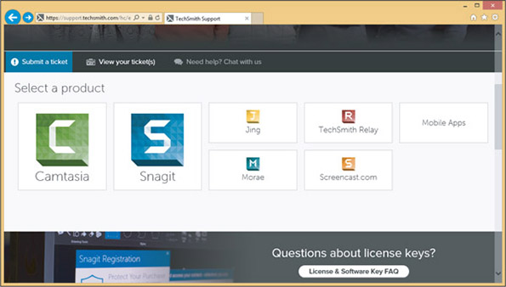
Source: Techsmith Corporation
- Use a search engine to search the web for help. In your search string, include an error message, symptom, hardware device, or description of the problem. The chances are always good that someone has had exactly the same problem, presented the problem online, and someone else has presented a step-by-step solution. All you have to do is find it! As you practice this type of web research, you’ll get better and better at knowing how to form a search string and knowing which websites are trustworthy and present the best information. If your first five minutes of searching doesn’t turn up a solution, please don’t give up! It might take patience and searching for 20 minutes or more to find the solution you need. As you search, most likely you’ll learn more and more about the problem, and you’ll slowly zero in on a solution.
- Some companies offer an expert system for troubleshooting. An expert system is software that is designed and written to help solve problems. It uses databases of known facts and rules to simulate human experts’ reasoning and decision making. Expert systems for IT technicians work by posing questions about a problem to be answered by the technician or the customer. The response to each question triggers another question from the software until the expert system arrives at a possible solution or solutions. Many expert systems are “intelligent,” meaning the system will record your input and use it in subsequent sessions to select more questions to ask and approaches to try. Therefore, future troubleshooting sessions on the same type of problem tend to zero in more quickly toward a solution.
Notes
To limit your search to a particular site when using google.com, use the site: parameter in the search box. For example, to search only the Microsoft site for information about the defrag command, enter this search string: defrag site:microsoft.com
Go to pg.
help
Application Opened
Main content

4-3cStep 3: Testing Your theory
A+ Core 1
- 5.1
Given a scenario, use the best practice methodology to resolve problems.
As you test your theories, keep in mind rules 8, 9, 10, and 11.
Rule 8: Divide and Conquer
This rule is the most powerful. Isolate the problem. In the overall system, remove one hardware or software component after another until the problem is isolated to a small part of the whole system. As you divide a large problem into smaller components, you can analyze each component separately. You can use one or more of the following to help you divide and conquer:
- In Windows, perform a clean boot to eliminate all nonessential startup programs and services as a possible source of the problem.
- Boot from a bootable DVD or flash drive to eliminate the Windows installation and the hard drive as the problem.
- Remove any unnecessary hardware devices, such as a second video card, optical drive, or even the hard drive. You don’t need to physically remove the optical drive or hard drive from the bays inside the case. Simply disconnect the data cable and the power cable.
Rule 9: Write Things Down
Keep good notes as you’re working. They’ll help you think more clearly. Draw diagrams. Make lists. Clearly and precisely write down what you’re learning. If you need to leave the problem and return to it later, it’s difficult to remember what you have observed and already tried. When the problem gets cold like this, your notes will be invaluable.
Rule 10: Don’t Assume the Worst
When it’s an emergency and your only copy of data is on a hard drive that is not working, don’t assume that the data is lost. Much can be done to recover data. If you want to recover lost data on a hard drive, don’t write anything to the drive; you might write on top of lost data, eliminating chances of recovery.
Rule 11: Reboot and Start Over
This is an important rule. Fresh starts are good, and they uncover events or steps that might have been overlooked. Take a break! Get away from the problem. Begin again.
Most computer problems are simple and can be simply solved, but you do need a game plan. That’s how Figure 4-16 can help. The flowchart focuses on problems that affect the boot. As you work your way through it, you’re eliminating one major computer subsystem after another until you zero in on the problem. After you’ve discovered the problem, many times the solution is obvious.
Figure 4-16
Use this flowchart when first facing a computer problem
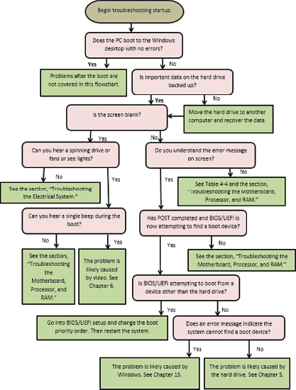
As Figure 4-16 indicates, troubleshooting a computer problem is divided into problems that occur during the boot and those that occur after the Windows Start screen or desktop has successfully loaded. Problems that occur during the boot might happen before Windows starts to load or during Windows startup. Read the flowchart in Figure 4-16 very carefully to get an idea of the symptoms that would cause you to suspect each subsystem.
Also, Table 4-4 can help as a general guideline for the primary symptoms and what are likely to be the sources of a problem.
A+ Exam Tip
The A+ Core 1 exam might give you a symptom and expect you to select a probable source of a problem from a list of sources. These examples of what can go wrong can help you connect problem sources to symptoms.
Table 4-4

Symptoms or Error Messages Caused by Hardware Problems and What to Do about Them
Symptom or Error Message | What to Do About the Problem
System shuts down unexpectedly | Try to find out what was happening at the time of the shutdowns to pinpoint an application or device causing the problem. Possible sources of the problem are overheating, faulty RAM, the motherboard, or the processor.
System shuts down unexpectedly and starts back up | Begin by checking the system for overheating. Is the processor cooler fan working? Go to BIOS/UEFI setup and check the temperature of the processor. When the processor overheats and the system restarts, the problem is called a processor thermal trip error.
System locks up with an error message on a blue screen, called a blue screen of death (BSOD) | Figure 4-17 shows an example of a BSOD error. These Windows errors are caused by problems with devices, device drivers, or a corrupted Windows installation. Begin troubleshooting by searching the Microsoft website for the error message and a description of the problem.
System locks up with an error message on a black screen | These error messages on a black background, such as the one shown in Figure 4-18, are most likely caused by an error at POST. Begin by troubleshooting the device mentioned in the error message.
System freezes or locks up without an error message | If the system locks up without an error screen and while still displaying the Windows Start screen or desktop, the problem is most likely caused by an application not responding. Sometimes you’ll see the Windows pinwheel indicating the system is waiting for a response from a program or device. Open the Windows Task Manager utility and end any application that is not responding. If that doesn’t work, restart Windows.
POST code beeps | One or no beep indicates that all is well after POST. However, startup BIOS/UEFI communicates POST errors as a series of beeps before it tests video. Search the website of the motherboard or BIOS/UEFI manufacturer to know how to interpret a series of beep codes. You might need to restart the system more than once so you can carefully count the beeps. Table 4-5 lists some common beep codes.
No power | If you see no lights on the computer case and hear no spinning fans, make sure the surge protector or wall outlet has power. Is the switch on the rear of the case on? Is the dual-voltage selector switch set correctly? Are power supply connectors securely connected? Is the power supply bad?
Blank screen when you first power up the computer, and no noise or indicator lights | Is power getting to the system? If power is getting to the computer, address the problem as electrical. Make sure the power supply is good and power supply connectors are securely connected.
Blank screen when you first power up the computer, and you can hear the fans spinning and see indicator lights | Troubleshoot the video subsystem. Is the monitor turned on? Is the monitor data cable securely connected at both ends? Is the indicator light on the front of the monitor on?
BIOS/UEFI loses its time and date settings  “CMOS battery low” error message appears during the boot | The CMOS battery is failing. Replace the battery.
System reports less memory than you know is installed | A memory module is not seated correctly or has failed. Begin troubleshooting memory.
System attempts to boot to the wrong boot device | Go into BIOS/UEFI setup and change the boot device priority order.
Fans spin, but no power to other devices | Begin by checking the power supply. Are connectors securely connected? Use a power supply tester to check for correct voltage outputs.
Smoke or burning smell | Consider this a serious electrical problem. Immediately unplug the computer.
Loud whining noise | Most likely the noise is made by the power supply or a failing hard drive. There might be a short. The power supply might be going bad or is underrated for the system.
Clicking noise | A clicking noise likely indicates the magnetic hard drive is failing. Replace the drive as soon as possible.
Intermittent device failures | Failures that come and go might be caused by overheating or failing RAM, the motherboard, the processor, or the hard drive. Begin by checking the processor temperature for overheating. Then check RAM for errors and run diagnostics on the hard drive.
Distended capacitors | Failed capacitors on the motherboard or other circuit board are sometimes distended and discolored on the top of the capacitor. Replace the motherboard.
Error appears during boot: Intruder detection error | An intrusion detection device installed on the motherboard has detected that the computer case was opened. Suspect a security breach.
Error appears during boot: Overclocking failed. Please enter setup to reconfigure your system | Overclocking should be discontinued. However, this error might not be related to overclocking; it can occur when the power supply is failing.
Possible error messages:  No boot device available  Hard drive not found  Fixed disk error  Invalid boot disk  Inaccessible boot device or drive  Invalid drive specification | Startup BIOS/UEFI did not find a device to use to load the operating system. Make sure the boot device priority order is correct in BIOS/UEFI setup. Try booting from a bootable USB flash drive or DVD. If this works, begin troubleshooting the hard drive, which is covered in Chapter 5.
Possible error messages:  Missing operating system  Error loading operating system | Windows startup programs are missing or corrupted. How to troubleshoot Windows startup is covered in Chapter 15.
Continuous reboots | See the explanation later in this chapter.
Figure 4-17
Search the Microsoft website for information about a BSOD error
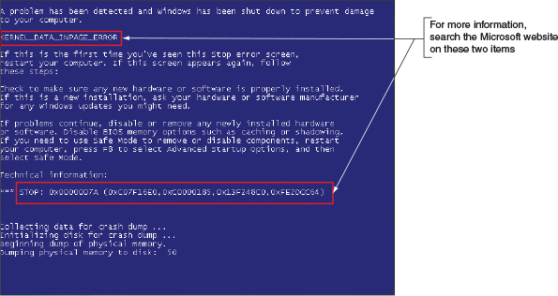
Figure 4-18
A POST error message on a black screen shown early in the boot
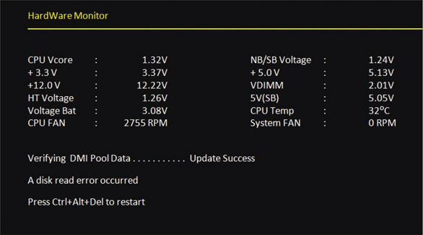
Source: Intel
Table 4-5

Common Beep Codes and Their Meanings for Intel and Award BIOS
Beeps During POST | Description
1 short beep or no beep | The computer passed all POST tests
1 long and 2 short beeps | Award BIOS: A video problem, no video card, bad video memory  Intel BIOS: A video problem
Continuous short beeps | Award BIOS: A memory error  Intel BIOS: A loose card or short
1 long and 1 short beep | Intel BIOS: Motherboard problem
1 long and 3 short beeps | Intel BIOS: A video problem
3 long beeps | Intel BIOS: A keyboard controller problem
Continuous 2 short beeps and then a pause | Intel BIOS: A video card problem
Continuous 3 short beeps and then a pause | Intel BIOS: A memory error
8 beeps followed by a system shutdown | Intel BIOS: The system has overheated
Continuous high and low beeps | Intel BIOS: CPU problem
By the time you have finished Step 3, the problem might already be solved or you will know the source of the problem and will be ready to plan a solution.
Go to pg.
help
Application Opened
Main content

4-3dStep 4: Planning Your Solution and Then Fixing the Problem
A+ Core 1
- 5.1
Given a scenario, use the best practice methodology to resolve problems.
Some solutions, such as replacing a hard drive or a motherboard, are expensive and time consuming. You need to carefully consider what you will do and the order in which you will do it. When planning and implementing your solution, keep rules 12 and 13 in mind.
Rule 12: Use the Least Invasive Solution First
As you solve computer problems, always keep in mind that you don’t want to make things worse, so you should use the least invasive solution. You want to fix the problem in such a way that the system is returned to normal working condition with the least amount of effort and fewest changes. For example, don’t format the hard drive until you’ve first tried to fix the problem without having to erase everything on the drive. As another example, don’t reinstall Microsoft Office until you have tried applying patches to the existing installation.
Rule 13: Know Your Starting Point
Find out what works and doesn’t work before you take anything apart or try a possible fix. Suppose you decide to install a new anti-malware program. After the installation, you discover Microsoft Office gives errors and you cannot print to the network printer. You don’t know if the anti-malware program is causing problems or the problems existed before you began work. As much as possible, find out what works or what doesn’t work before you attempt a fix.
Do the following to plan your solution and fix the problem:
- Consider different solutions and select the least invasive one. When appropriate, talk with the user or owner about the best solution.
- Before applying your solution, do your best to determine what works and doesn’t work in the system so you know your starting point.
- Fix the problem. This might be as simple as plugging up a new monitor, or it might be as difficult as reinstalling Windows and applications software and restoring data from backups.
Go to pg.
help
Application Opened
Main content

4-3eStep 5: Verifying the Fix and Taking Preventive Action
A+ Core 1
- 5.1
Given a scenario, use the best practice methodology to resolve problems.
After you have fixed the problem, reboot the system and verify that all is well. Can you reach the Internet, use the printer, or use Microsoft Office? If possible, have the user check everything and verify that the job is done satisfactorily. If either of you finds a problem, return to Step 2 in the troubleshooting process to examine the system and form a new theory as to the cause of the problem.
After you and the user have verified all is working, ask yourself the question, “Could this problem have been prevented?” If so, go the extra mile to instruct the user, set Windows to automatically install updates, or do whatever else is appropriate to prevent future problems.
Go to pg.
help
Application Opened
Main content

4-3fStep 6: Documenting What Happened
A+ Core 1
- 5.1
Given a scenario, use the best practice methodology to resolve problems.
Good documentation helps you take what you learned into the next troubleshooting situation, train others, develop effective preventive maintenance plans, and satisfy any audits or customer or employer queries about your work. Most companies use call-tracking software for this purpose. Be sure to include initial symptoms, the source of the problem, your troubleshooting steps, and what you did to ultimately fix it. Make the notes detailed enough so that you can use them later when solving similar problems.
For on-site support, a customer expects documentation about your services. Include in the documentation sufficient details broken down by cost of individual parts, hours worked, and cost per hour. Give the documentation to the customer at the end of the service and keep a copy for yourself. For phone support, the documentation stays in-house.
Applying Concepts

Taking Good Notes
Daniel had not been a good note taker in school, and this lack of skill was affecting his work. His manager, Jonathan, had been watching Daniel’s notes in the ticketing system at the help desk and was not happy with what he saw. Jonathan had pointed out to Daniel more than once that his cryptic, incomplete notes with sketchy information would one day cause major problems. On Monday morning, calls were hammering the help desk because a server had gone down over the weekend and many internal customers were not able to get to their data. Daniel escalated one call from a customer named Matt to a tier-two help desk. Later that day, Sandra, a tier-two technician, received the escalated ticket, and to her dismay the phone number of the customer was missing. She called Daniel. “How am I to call this customer? You only have his first name, and these notes about the problem don’t even make sense!” Daniel apologized to Sandra, but the damage was done.
Two days later, an angry Matt calls the manager of the help desk to complain that his problem is still not solved. Jonathan listens to Matt vent and apologizes for the problem his help desk has caused. It’s a little embarrassing to Jonathan to have to ask Matt for his call-back information and to repeat the details of the problem. He gives the information to Sandra and the problem gets a quick resolution.
Discuss this situation in a small group and answer the following questions:
- If you were Daniel, what could you do to improve note taking in the ticketing system?
- After Sandra called, do you think Daniel should have told Jonathan about the problem? Why or why not?
- If you were Jonathan, how would you handle the situation with Daniel?
Two students play the roles of Daniel and Jonathan when Jonathan calls Daniel into his office to discuss the call he just received from Matt. The other students in the group can watch and make suggestions as to how to improve the conversation.
Now you’re ready to look at how to troubleshoot each subsystem that is critical to booting up the computer. We begin with the electrical system.
Go to pg.
help
Application Opened
Main content

4-4Troubleshooting the Electrical System
Applying Concepts

Exploring a Computer Problem
Your friend Sharon calls to ask for your help with a computer problem. Her system has been working fine for over a year, but now strange things are happening. Sometimes the system powers down for no apparent reason while she is working, and sometimes Windows locks up. As you read this section, look for clues as to what the problem might be. Also, think of questions to ask your friend that will help you diagnose the problem.
A+ Core 1
- 5.2
Given a scenario, troubleshoot problems related to motherboards, RAM, CPUs, and power.
- 5.5
Given a scenario, troubleshoot common mobile device issues while adhering to the appropriate procedures.
Electrical problems can occur before or after the boot and can be consistent or intermittent. Repair technicians often don’t recognize the cause of a problem to be electrical because of the intermittent nature of some electrical problems. In these situations, the hard drive, memory, the OS, or even user error might be suspected as the source of the problem and then systematically eliminated before the electrical system is suspected. This section will help you to be aware of symptoms of electrical problems so that you can zero in on the source of an electrical problem as quickly as possible.
Possible symptoms of a problem with the electrical system are:
- The computer appears “dead”—no indicator lights and no spinning drive or fan.
- The computer sometimes locks up during booting. After several tries, it boots successfully.
- Error codes or beeps occur during booting, but they come and go.
- You smell burnt parts or odors. (Definitely not a good sign!)
- The computer powers down at unexpected times.
- The computer appears dead, but you hear a whine coming from the power supply.
Without opening the computer case, the following list contains some questions you can ask and things you can do to solve a problem with the electrical system. The rule of thumb is “Try the simple things first.” Most computer problems have simple solutions.
- If you smell any burnt parts or odors, don’t try to turn the system on. Identify the component that is fried and replace it.
- When you first plug up power to a system and hear a whine coming from the power supply, the power supply might be inadequate for the system or there might be a short. Don’t press the power button to start up the system. Unplug the power cord so that the power supply will not be damaged. The next step is to open the case and search for a short. If you don’t find a short, consider upgrading the power supply.
- Is the power cord plugged in? If it is plugged into a power strip or surge suppressor, is the device turned on and plugged in?
- Is the power outlet controlled by a wall switch? If so, is the switch turned on?
- Are any cable connections loose?
- Is the circuit breaker blown? Is the house circuit overloaded?
- Are all switches on the system turned on? Computer? Monitor? Surge suppressor or UPS (uninterruptible power supply)?
- Is there a possibility the system has overheated? If so, wait a while and try turning on the computer again. If the system comes on but later turns itself off, you might need additional cooling fans inside the unit. How to solve problems with overheating is covered later in this chapter.
- Older computers might be affected by electromagnetic interference (EMI). Check for sources of electrical or magnetic interference such as fluorescent lighting or an electric fan or copier sitting near the computer case.
Caution
Before opening the case of a brand-name computer, such as an HP or Dell, consider the warranty. If the system is still under warranty, sometimes the warranty is voided if the case is opened. If the warranty prevents you from opening the case, you might need to return the system to a manufacturer’s service center for repairs.
If the problem is still not solved, it’s time to look inside the case. First, turn off the computer, unplug it, press the power button to drain residual power, and then open the case. Next, do the following:
- Check all power connections from the power supply to the motherboard and drives. Also, some cases require the front panel to be in place before the power-on button will work. Are all cards securely seated?
- If you smell burnt parts, carefully search for shorts and for frayed and burnt wires. Disassemble the parts until you find the one that is damaged.
- If you suspect the power supply is bad, test it with a power supply tester.
Go to pg.
help
Application Opened
Main content

4-4aProblems That Come and Go
A+ Core 1
- 5.2
Given a scenario, troubleshoot problems related to motherboards, RAM, CPUs, and power.
If a system boots successfully to the Windows Start screen or desktop, you still might have a power system problem. Some problems are intermittent; that is, they come and go. Generally, intermittent problems are more difficult to solve than a dead system. There can be many causes of intermittent problems, such as an inadequate power supply, overheating, and devices and components damaged by ESD. Here are some symptoms that might indicate an intermittent problem with the electrical system after the boot:
- The computer stops or hangs for no reason. Sometimes it might even reboot itself.
- Memory errors appear intermittently.
- Data is written incorrectly to the hard drive or files are corrupted.
- The keyboard stops working at odd times.
- The motherboard fails or is damaged.
- The power supply overheats and becomes hot to the touch.
- The power supply fan whines and becomes very noisy or stops.
Here is what to do to eliminate the electrical system as the source of an intermittent problem:
- Consider the power supply is inadequate. If the power supply is grossly inadequate, it will whine when you first plug up the power. If you have just installed new devices that are drawing additional power, verify that the wattage rating of the power supply is adequate for the system.
You can also test the system to make sure you don’t have power problems by making all the devices in your system work at the same time. For instance, you can make two hard drives and the DVD drive work at the same time by copying files from one hard drive to the other while playing a movie on the DVD. If the drives and the other devices each work independently, but data errors occur when all work at the same time, suspect a shortage of electrical power.
- Suspect the power supply is faulty. You can test it using either a power supply tester (the easier method) or a multimeter (the more tedious method). However, know that a power supply that gives correct voltages when you measure it might still be the source of problems because power problems can be intermittent. Also be aware that an ATX power supply monitors the range of voltages provided to the motherboard and halts the motherboard if voltages are inadequate. Therefore, if the power supply appears “dead,” your best action is to replace it.
- The power supply fan might not work. Don’t operate the computer if the fan does not work because computers without cooling fans can quickly overheat. Usually just before a fan stops working, it hums or whines, especially when the computer is first turned on. If this has just happened, replace the power supply. If the new fan does not work after you replace the power supply, you have to dig deeper to find the source of the problem. You can now assume the problem wasn’t the original fan. A short drawing too much power somewhere else in the system might cause the problem. To troubleshoot a nonfunctional fan, which might be a symptom of another problem and not of the fan itself, follow these steps:
  - Turn off the power and remove all power cord connections to all components except the motherboard. Turn the power back on. If the fan works, the problem is with one of the systems you disconnected, not with the power supply, the fan, or the motherboard.
  - Turn off the power and reconnect one card or drive at a time until you identify the device with the short.
  - If the fan does not work when all devices except the motherboard are disconnected, the problem is the motherboard or the power supply. Because you have already replaced the power supply, you can assume that the motherboard needs to be replaced.
Go to pg.
help
Application Opened
Main content

4-4bPower Problems with the Motherboard
A+ Core 1
- 5.2
Given a scenario, troubleshoot problems related to motherboards, RAM, CPUs, and power.
A short might occur if some component on the motherboard makes improper contact with the chassis. This short can seriously damage the motherboard. For some cases, check for missing standoffs (small plastic or metal spacers that hold the motherboard a short distance away from the bottom of the case). A missing standoff most often causes these improper connections. Also check for loose standoffs or screws under the board that might be touching a wire on the bottom of the board and causing a short. Shake the case gently and listen for loose screws.
Shorts in the circuits on the motherboard might also cause problems. Look for damage on the bottom of the motherboard. These circuits are coated with plastic, and quite often damage is difficult to spot. Also look for burned-out capacitors that are spotted brown or corroded. You’ll see examples of burned-out capacitors later in the chapter.
Caution
Never replace a damaged motherboard with a good one without first testing or replacing the power supply. You don’t want to subject another good board to possible damage.
Applying Concepts

Investigating a Computer Problem
Back to Sharon’s computer problem. Here are some questions that will help you identify the source of the problem:
- Have you added new devices to your system? (These new devices might be drawing too much power from an overworked power supply.)
- Have you moved your computer recently? (It might be sitting beside a heat vent or electrical equipment.)
- Does the system power down or hang after you have been working for some time? (This symptom might have more than one cause, such as overheating or a power supply, processor, memory, or motherboard about to fail.)
- Has the computer case been opened recently? (Someone working inside the case might not have used a ground bracelet, and components are now failing because of ESD damage.)
- Are case vents free so that air can flow? (The case might be close to a curtain covering the vents.)
Intermittent problems like the one Sharon described are often heat-related. If the system only hangs but does not power off, the problem might be caused by faulty memory or bad software, but because it actually powers down, you can assume the problem is related to power or heat.
If Sharon tells you that the system powers down after she’s been working for several hours, you can probably assume overheating. Check that first. If that’s not the problem, the next thing to do is replace the power supply.
Go to pg.
help
Application Opened
Main content

4-4cProblems with Overheating
A+ Core 1
- 5.2
Given a scenario, troubleshoot problems related to motherboards, RAM, CPUs, and power.
As a repair technician, you’re sure to eventually face problems with computers overheating. Overheating can happen as soon as you turn on the computer or after it has been working a while. Overheating can cause intermittent errors, the system to hang, or components to fail or not last as long as they normally would. (Overheating can significantly shorten the life span of the CPU and memory.) Overheating happens for many reasons, including improper installation of the CPU cooler or fans, overclocking, poor airflow inside the case, an underrated power supply, a component going bad, or the computer’s environment (for example, heat or dust).
Here are some symptoms that a system is overheating:
- The system hangs or freezes at odd times or freezes just a few moments after the boot starts.
- A Windows BSOD error occurs during the boot.
- You cannot hear a fan running or the fan makes a whining sound.
- You cannot feel air being pulled into or out of the case.
If you suspect overheating, go into BIOS/UEFI setup and view the temperature monitors for the system. To protect the expensive processor and other components, you can also purchase a temperature sensor. The sensor plugs into a power connection coming from the power supply and mounts on the side of the case or in a drive bay. The sensor sounds an alarm when the inside of the case becomes too hot. To decide which temperature sensor to buy, use one recommended by the case manufacturer. You can also install utility software that can monitor system temperatures. For example, SpeedFan by Alfredo Comparetti is freeware that can monitor fan speeds and temperatures (see Figure 4-19). A good website to download the freeware is filehippo.com/download_speedfan. Be careful not to download other freeware available on the site.
Figure 4-19
SpeedFan monitors fan speeds and system temperatures
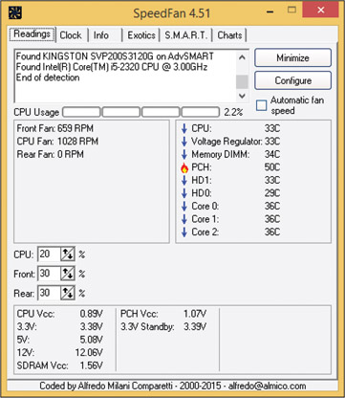
Source: SpeedFan by Alfredo Milani Comparetti
Here are some simple things you can do to solve an overheating problem:
- If the system refuses to boot or hangs after a period of activity, suspect overheating. Immediately after the system hangs, go into BIOS/UEFI setup and find the screen that reports the CPU temperature. The temperature should not exceed that recommended by the CPU manufacturer.
- Excessive dust insulates components and causes them to overheat. Use compressed air, a blower, or an antistatic vacuum to remove dust from the power supply, the vents over the entire computer, and the processor cooler fan (see Figure 4-20). To protect the fan, don’t allow it to spin as you blow air into it. Overspinning might damage a fan.
Figure 4-20
Dust in this cooler fan can cause the fan to fail and the processor to overheat
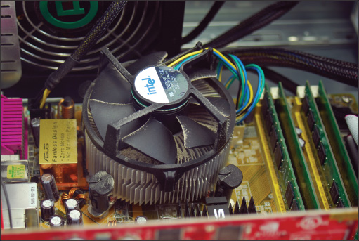
Notes
When working in a customer’s office or home, be sure you clean up any mess you create from blowing dust out of a computer case.
- Check airflow inside the case. Are all fans running? You might need to replace a fan. Is there an empty fan slot on the rear of the case? If so, install a case fan in the slot (see Figure 4-21). Orient the fan so that it blows air out of the case. The power cord to the fan can connect to a fan header on the motherboard or to a power connector coming directly from the power supply.
Figure 4-21
Install one exhaust fan on the rear of the case to help pull air through the case
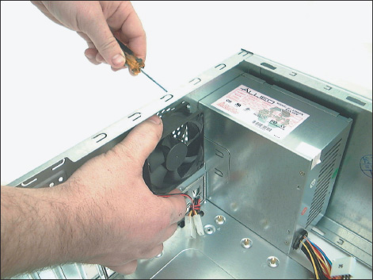
- If there are other fan slots on the side or front of the case, you can also install fans in these slots. However, don’t install more fans than the case is designed to use.
- Can the side of the case hold a chassis air guide that guides outside air to the processor? If it has a slot for the guide and the guide is missing, install one. However, don’t install a guide that obstructs the CPU cooler. How to install an air guide is covered later in this section.
- A case is generally designed for optimal airflow when slot openings on the front and rear of the case are covered and when the case cover is securely in place. To improve airflow, replace missing faceplates over empty drive bays and replace missing slot covers over empty expansion slots. See Figure 4-22.
Figure 4-22
For optimum airflow, don’t leave empty expansion slots and bays uncovered
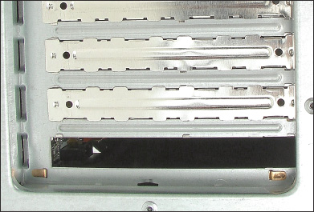
- Are cables in the way of airflow? Use tie wraps to secure cables and cords so that they don’t block airflow across the processor or get in the way of fans turning. Figure 4-23 shows the inside of a case where cables are tied up and neatly out of the way of airflow from the front to the rear of the case.
Figure 4-23
Use cable ties to hold cables out of the way of fans and airflow
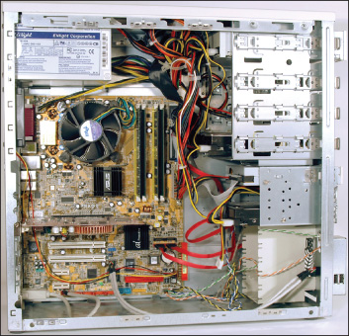
- A case needs some room to breathe. Place it so there are at least a few inches of space on both sides and the top of the case. If the case is sitting on carpet, put it on a computer stand so that air can circulate under the case and to reduce carpet dust inside the case. Many cases have a vent on the bottom front, and carpet can obstruct airflow into this vent (see Figure 4-24). Make sure drapes are not hanging too close to fan openings.
Figure 4-24
Keep a tower case off carpet to allow air to flow into the bottom air vent
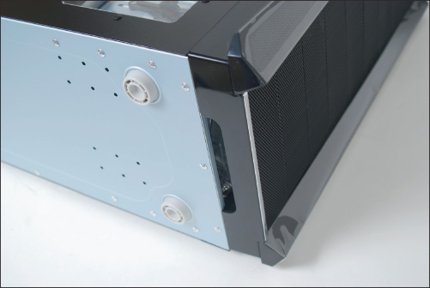
- Verify that the cooler is connected properly to the processor. If it doesn’t fit well, the system might not boot and the processor will overheat. If the cooler is not tightly connected to the motherboard and processor or the cooler fan is not working, the processor will quickly overheat as soon as the computer is turned on. Has thermal compound been installed between the cooler and processor?
- After you close the case, leave your system off for at least 30 minutes. When you power up the computer again, let it run for 10 minutes, go into BIOS/UEFI setup, check the temperature readings, and reboot. Next, let your system run until it shuts down. Power it up again and check the temperature in BIOS/UEFI setup again. A significant difference in this reading and the first one you took after running the computer for 10 minutes indicates an overheating problem.
- Check BIOS/UEFI setup to see if the processor is being overclocked. Overclocking can cause a system to overheat. Try restoring the processor and system bus frequencies to default values.
- Have too many peripherals been installed inside the case? Is the case too small for all these peripherals? Larger tower cases are better designed for good airflow than smaller slimline cases. Also, when installing expansion cards, try to leave an empty slot between each card for better airflow. The same goes for drives. Try not to install a group of drives in adjacent drive bays. For better airflow, leave empty bays between drives. Take a close look at Figure 4-23, where you can see space between each drive installed in the system.
- Flash BIOS/UEFI to update the firmware on the motherboard. How to flash BIOS/UEFI is covered in Chapter 2.
- Thermal compound should last for years, but eventually it will harden and need replacing. If the system is several years old, replace the thermal compound.
A+ Exam Tip
The A+ Core 1 exam expects you to recognize that a given symptom is possibly power- or heat-related.
If you try the preceding list of things to do and still have an overheating problem, it’s time to move on to more drastic solutions. Consider whether the case design allows for good airflow; the problem might be caused by poor air circulation inside the case. The power supply fan in ATX cases blows air out of the case, pulling outside air from the vents in the front of the case across the processor to help keep it cool. Another exhaust fan is usually installed on the back of the case to help the power supply fan pull air through the case. In addition, most processors require a cooler with a fan installed on top of the processor. Figure 4-25 shows a good arrangement of vents and fans for proper airflow and a poor arrangement.
Figure 4-25
Vents and fans need to be arranged for best airflow
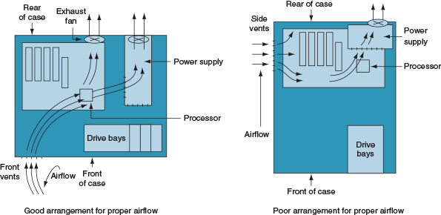
For better ventilation, use a power supply that has vents on the bottom and front, as shown in Figure 4-26. Compare that with the power supply in Figure 4-21, which has vents only on the front and not on the bottom.
Figure 4-26
This power supply has vents on the bottom to provide better airflow inside the case
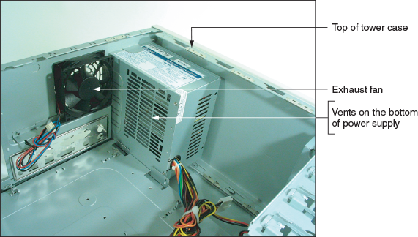
An intake fan on the front of the case might help pull air into the case. Intel recommends you use a front intake fan for high-end systems, but AMD says a front fan for ATX systems is not necessary. Check with the processor and case manufacturers for specific instructions as to the placement of fans and what type of fan and heat sink to use.
Intel and AMD both recommend a chassis air guide (CAG) as part of the case design. This air guide is a round air duct that helps to pull and direct fresh air from outside the case to the cooler and processor (see Figure 4-27). The guide should reach inside the case very close to the cooler, but not touch it. Intel recommends the clearance be no greater than 20 mm and no less than 12 mm. If the guide obstructs the cooler, you can remove the guide, but optimum airflow will not be achieved.
Figure 4-27
Use a chassis air guide to direct outside air over the cooler
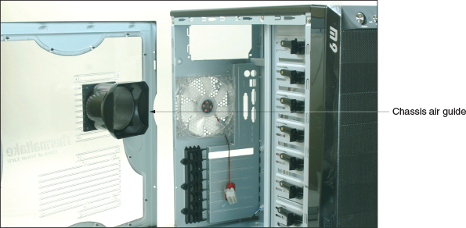
Be careful when trying to solve an overheating problem. Excessive heat can damage the CPU and the motherboard. Never operate a system if the case fan, power-supply fan, or cooler fan is not working.
Go to pg.
help
Application Opened
Main content

4-4dProblems with Laptop Power Systems
A+ Core 1
- 5.2
Given a scenario, troubleshoot problems related to motherboards, RAM, CPUs, and power.
- 5.5
Given a scenario, troubleshoot common mobile device issues while adhering to the appropriate procedures.
A laptop can be powered by an AC adapter (which uses regular house current to power the laptop) or an installed battery pack. Battery packs today use lithium ion technology. Most AC adapters today are capable of auto-switching from 110 V to 220 V AC power. Figure 4-28 shows an AC adapter that has a green light indicating the adapter is receiving power.
Figure 4-28
This AC adapter for a laptop uses a green light to indicate power
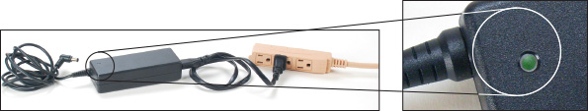
Some mobile users like to keep an extra battery on hand in case the first one uses up its charge. When the laptop signals that power is low, shut down the system, remove the old battery, and replace it with a charged one. To remove a battery, you usually must release a latch first.
Notes
If you’re using the AC adapter to power your laptop when the power goes out, the installed battery serves as a built-in UPS. The battery immediately takes over as your uninterruptible power supply (UPS). Also, a laptop has an internal surge protector. However, for extra protection, you might want to use a power strip that provides surge protection.
Here are some problems you might encounter with laptop power systems and their solutions:
- If power is not getting to the system or the battery indicator light is lit when the AC adapter should be supplying power, verify that the AC adapter is plugged into a live electrical outlet. Is the light on the AC adapter lit? Check if the AC adapter’s plug is secure in the electrical outlet. Check the connections on both sides of the AC adapter transformer. Check the connection at the DC jack on the laptop. Try exchanging the AC adapter for one you know is good. The DC jack might need replacing. Most laptops allow you to replace the DC jack without replacing the entire system board. Check the service manual for the laptop to see how labor-intensive the repair is before you decide to proceed.
- If the battery is not charging when the AC adapter is plugged in, the problem might be with the battery or the motherboard. A hot battery might not charge until it cools down. If the battery is hot, remove it from the computer and allow it to cool to room temperature. Check the battery for physical damage. If the battery is swollen or warped, replace it. If it shows no physical signs of damage, try to recharge it. If it does not recharge, replace the battery pack. If a known good battery does not recharge, you have three options:
  - Replace the system board,
  - replace the laptop, or
  - use the laptop only when it’s connected to power using the AC adapter.
Applying Concepts

Testing an AC Adapter
If the system fails only when the AC adapter is connected, it might be defective. Try a new AC adapter, or, if you have a multimeter, use it to verify the voltage output of the adapter. Do the following for an adapter with a single center-pin connector:
- Unplug the AC adapter from the computer, but leave it plugged into the electrical outlet.
- Most laptops run on 19 V DC, but a few run on 45 V DC. To be on the safe side, set the multimeter to measure voltage in the range of 1-200 V DC. Place the red probe of the multimeter in the center of the DC connector that would normally plug into the DC outlet on the laptop. Place the black probe on the outside cylinder of the DC connector (see Figure 4-29).
Figure 4-29
To use a multimeter to test this AC adapter, place the red probe in the center of the connector and the black probe on the outside
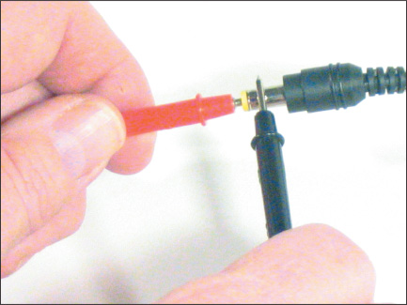
- The voltage range should be plus or minus 5 percent of the accepted voltage. For example, if a laptop is designed to use 16 V, the voltage should measure somewhere between 15.2 and 16.8 V DC.
Go to pg.
help
Application Opened
Main content

4-5Troubleshooting the Motherboard, Processor, and RAM
A+ Core 1
- 5.2
Given a scenario, troubleshoot problems related to motherboards, RAM, CPUs, and power.
The field replaceable units (FRUs) on a motherboard are the processor, the processor cooler assembly, RAM, and the CMOS battery. Also, the motherboard itself is an FRU. As you troubleshoot the motherboard and discover that some component is not working, such as a network port, you might be able to disable that component in BIOS/UEFI setup and install a card to take its place.
A+ Exam Tip
The A+ Core 1 exam expects you to know how to troubleshoot problems with motherboards, processors, and RAM.
When you suspect a bad component, a good troubleshooting technique is to substitute a known good component for the one you suspect is bad. Be cautious here. A friend once had a computer that wouldn’t boot. He replaced the hard drive, with no change. He replaced the motherboard next. The computer booted up with no problem; he was delighted, until it failed again. Later he discovered that a faulty power supply had damaged his original motherboard. When he traded the bad one for a good one, the new motherboard also got zapped! If you suspect problems with the power supply, check the voltage coming from the power supply before putting in a new motherboard.
The following symptoms can indicate that a motherboard, processor, or memory module is failing:
- The system begins to boot but then powers down.
- An error message is displayed during the boot. Investigate this message.
- The system reports less memory than you know is installed.
- The system becomes unstable, hangs, or freezes at odd times. (This symptom can have multiple causes, including a failing power supply, RAM, hard drive, motherboard, or processor, Windows errors, and overheating.)
- Intermittent Windows or hard drive errors occur.
- Components on the motherboard or devices connected to it don’t work.
Remember the troubleshooting principle to check the simple things first. The motherboard and processor are expensive and time consuming to replace. Unless you’re certain the problem is one of these two components, don’t replace either until you first eliminate other components as the source of the problem.
If you can boot the system, follow these steps to eliminate Windows, software, RAM, BIOS/UEFI settings, and other software and hardware components as the source of the problem:
- If an error message appears, Google the error message. Pay particular attention to hits on the motherboard or processor manufacturer or Microsoft websites. Search forums for information about the error.
- The problem might be a virus. If you can boot the system, run a current version of antivirus software to check for viruses.
- A memory module might be failing. In Windows 10/8/7, use the Memory Diagnostics tool to test memory. Even if Windows is not installed, you can still run the tool by booting the system from the Windows setup DVD. How to use the Memory Diagnostics tool is coming up later in this chapter.
Notes
Besides the Windows Memory Diagnostics tool, you can use the Memtest86 utility to test installed memory modules. Check the site memtest86.com to download this program.
- Suspect the problem is caused by an application or by Windows. In Windows, Device Manager is the best tool to check for potential hardware problems.
- In Windows, check Event Viewer logs for a record about a hardware or application problem. You learn to use Event Viewer in a project at the end of this chapter.
- In Windows, download and install any Windows updates or patches. These updates might solve a hardware or application problem.
- Ask yourself what has changed since the problem began. If the problem began immediately after installing a new device or application, uninstall it.
- A system that does not have enough RAM can sometimes appear to be unstable. Using the System window, find out how much RAM is installed, and compare that with the recommended amounts. Consider upgrading RAM.
- The BIOS/UEFI might be corrupted or have wrong settings. Check BIOS/UEFI setup. Have settings been tampered with? Is the CPU speed set incorrectly or is it overclocked? Reset BIOS/UEFI setup to restore default settings.
- Disable any quick booting features in BIOS/UEFI so that you get a thorough report of POST. Then look for errors reported on the screen during the boot.
- Flash BIOS/UEFI to update the firmware on the board.
- Check the motherboard manufacturer’s website for diagnostic software that might identify a problem with the motherboard.
- Update all drivers of motherboard components that are not working. For example, if the USB ports are not working, try updating the USB drivers with those downloaded from the motherboard manufacturer’s website. This process can also update the chipset drivers.
- If an onboard port or device isn’t working, but the motherboard is stable, follow these steps:
  - Verify that the problem is not with the device using the port. Try moving the device to another port on the same computer or move the device to another computer. If it works there, return it to this port. The problem might have been a bad connection.
  - Go into BIOS/UEFI setup and verify that the port is enabled.
  - Check Device Manager and verify that Windows recognizes the device or port with no errors. For example, Device Manager shown in Figure 4-30 reports the onboard Bluetooth device is disabled. Try to enable the device.
Figure 4-30
Device Manager reports a problem with an onboard device
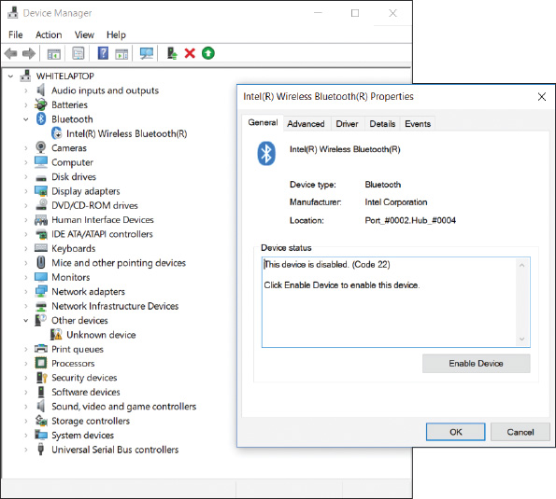
  - Next try updating the motherboard drivers for this device from the motherboard manufacturer’s website.
  - If you have a loopback plug, use it to test the port.
  - If the problem is still not solved, disable the port in BIOS/UEFI setup and install an expansion card to provide the same type of port or connector.
- Suspect the problem is caused by a failing hard drive. How to troubleshoot a failing drive is covered in Chapter 5.
- Suspect the problem is caused by overheating. How to check for overheating is covered earlier in this chapter.
- Verify that the installed processor is supported by the motherboard. Perhaps someone has installed the wrong processor.
Applying Concepts

Using Windows Memory Diagnostics
Errors with memory are often difficult to diagnose because they can appear intermittently and might be mistaken as application errors, user errors, or other hardware component errors. Sometimes these errors cause the system to hang, a blue screen error might occur, or the system continues to function with applications giving errors or data getting corrupted. You can quickly identify a problem with memory or eliminate memory as the source of a problem by using the Windows 10/8/7 Memory Diagnostics tool. Use one of these two methods to start the utility:
- Use the mdsched.exe command in Windows. To open a command prompt window from the Windows 10/8/7 desktop, enter the cmd command in the Windows start or run box. In the command prompt window, enter mdsched.exe and press Enter. A dialog box appears (see Figure 4-31) and asks if you want to run the test now or on the next restart.
Figure 4-31
Use the mdsched.exe command to test memory
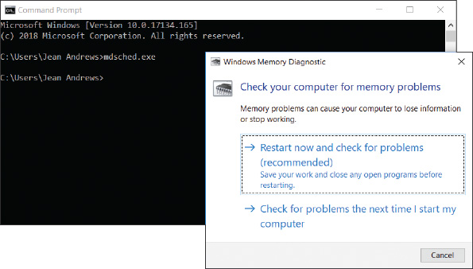
- Boot from the Windows setup DVD. If Windows is not the installed operating system or you cannot boot from the hard drive, boot the computer from the Windows setup USB drive or DVD to test memory for errors. Follow these steps:
  - If necessary, change the boot priority order in BIOS/UEFI setup to boot first from the optical drive or USB drive. Boot from the Windows setup DVD or USB drive.
  - On the opening screen for Windows 10/8, select your language and click Next. On the next screen (see Figure 4-32), click Repair your computer. Next choose Troubleshoot. For Windows 10, the Advanced options screen appears; for Windows 8, you must click Advanced options to see this screen.
Figure 4-32
The opening menu when you boot from Windows 10 setup media
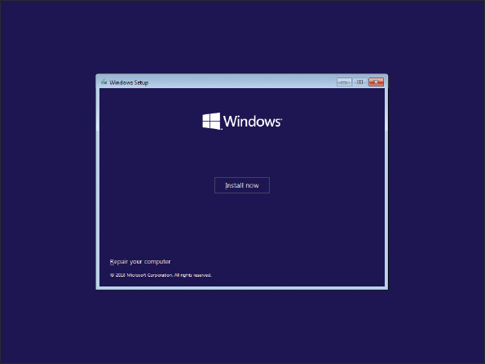
  - On the Advanced options screen (see Figure 4-33), choose Command Prompt. In the command prompt window, enter the mdsched.exe command.
Figure 4-33
The Windows 10 Advanced options screen launched from Windows 10 setup media
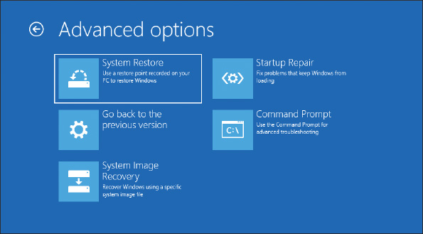
OS Differences
For Windows 7, after booting from the Windows 7 setup DVD, select the Windows installation to repair. On the System Recovery Options screen (see Figure 4-34), click Windows Memory Diagnostic. For Windows 7, it is not necessary to open a command prompt window to test memory.
Figure 4-34
Test memory using the Windows 7 System Recovery Options menu
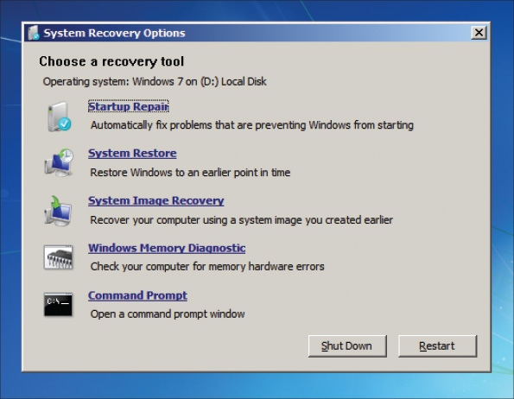
If the tool reports memory errors, replace all memory modules installed on the motherboard.
Applying Concepts

Using Device Manager to Delete the Driver Store
One thing you can do to solve a problem with a device is to uninstall and reinstall the device. When you first install a device, Windows stores a copy of the driver package in a driver store. When you uninstall the device, you can also tell Windows to delete the driver store. If you don’t delete the driver store, Windows uses it when you install the device again. That’s why the second time you install the same device, Windows does not ask you for the location of the drivers. Windows might also use the driver store to automatically install the device on the next reboot without your involvement.
All this is convenient unless there is a problem with the driver store. To get a true fresh start with an installation, you need to delete the driver store. First sign in to Windows using an account with administrative privileges and then follow these steps:
- To open Device Manager from the Windows 10/8 desktop, right-click Start and click Device Manager. (In Windows 7, click Start and click Control Panel. In Control Panel Classic icon view, click Device Manager.) Device Manager opens.
A+ Exam Tip
The A+ Core 1 exam expects you to be familiar with Control Panel in Classic icon view. If Control Panel is showing Category view, click Category, and then click Large icons or Small icons. Also, you are expected to know commands for various Windows tools. For example, to start Device Manager, you can enter the devmgmt.msc command in a command line window.
- Right-click the device and click Properties in the shortcut menu. Click the Driver tab and click Uninstall Device. In the Uninstall Device box, check Delete the driver software for this device, and click Uninstall. See Figure 4-35. The installed drivers and the driver store are both deleted. When you reinstall the device, you’ll need the drivers on CD or downloaded from the web.
Figure 4-35
Use Device Manager to uninstall the drivers and delete the driver store for a device
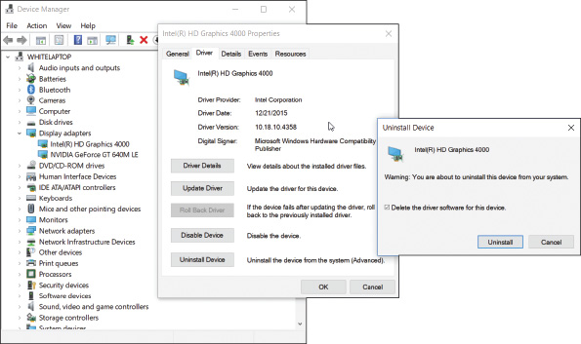
Also know that if the check box is missing on the Confirm Device Uninstall box, the drivers are embedded in Windows and you cannot delete the driver store for these devices. Examples of these devices are the optical drive, hard drive, and generic keyboard, which all have embedded Windows drivers.
We’re working our way through what to do when the system locks up, gives errors, or generally appears unstable. Another problem that can occur at the boot is continuous reboots, which can be caused by overheating, a failing processor, motherboard, or RAM, or a corrupted Windows installation.
Go to pg.
help
Application Opened
Main content

4-5aWindows Startup Repair
A+ Core 1
- 5.2
Given a scenario, troubleshoot problems related to motherboards, RAM, CPUs, and power.
For Windows 10/8/7, many continuous restart errors can be solved by performing a Startup Repair process. The Startup Repair utility restores many of the Windows files needed for a successful boot. After several restarts, Windows 10 will try to automatically run the Startup Repair process. If Startup Repair does not automatically start or does not fix the problem, try running it from Windows setup media.
Follow these steps to run Startup Repair from the Windows 10/8 setup DVD or USB drive:
- If necessary, change the boot priority order in BIOS/UEFI setup to boot first from the optical drive or USB drive. Boot from the Windows setup DVD or USB drive.
- On the opening screen, select your language and click Next. On the next screen, click Repair your computer. Next, choose Troubleshoot. For Windows 10, the Advanced options screen appears (refer back to Figure 4-33); for Windows 8, you must click Advanced options to see this screen. On the Advanced options screen, choose Startup Repair, and select your operating system. Windows will attempt to repair the system and restart to the Windows desktop.
OS Differences
For Windows 7, error messages disappear before they can be read as the system reboots. To disable these automatic restarts, press F8 as Windows starts up. The Advanced Boot Options menu appears (see Figure 4-36). Select Disable automatic restart on system failure. When you restart Windows, the error message stays on screen long enough for you to read it. Search the Microsoft websites (support.microsoft.com and technet.microsoft.com) for information about the hardware component causing the problem and what to do about it. BSOD errors might apply to the motherboard, video card, RAM, processor, hard drive, or some other device for which Windows is trying to load device drivers. From the Advanced Boot Options menu, you can click Repair Your Computer, which launches the Windows 7 version of Startup Repair.
Figure 4-36
Press F8 during the boot to see the Windows 7 Advanced Boot Options menu
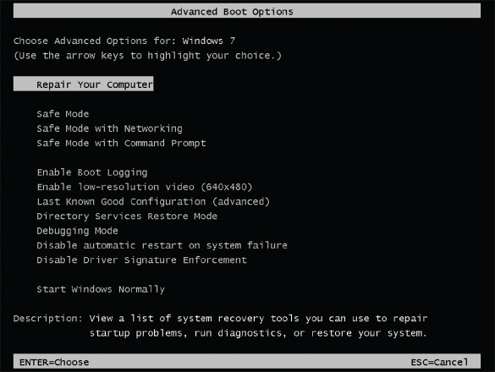
If you have tried to repair Windows, checked BIOS/UEFI settings, searched the web for help, and still have not identified the source of the problem, it’s time to open the case and check inside. Be sure to use an ESD strap and follow other procedures to protect the system against ESD. With the case open, follow these steps:
- Check that all the system power and data cables are securely connected. Try reseating all expansion cards and DIMM modules.
- Look for physical damage on the motherboard. Look for frayed traces on the bottom of the board or discolored, distended, or bulging capacitors on the board.
- Reduce the system to essentials. Remove any unnecessary hardware, such as expansion cards, and then watch to see if the problem goes away. If it does, replace one component at a time until the problem returns and you have identified the component causing the trouble.
- Try using a POST diagnostic card. It might offer you a clue as to which component is giving a problem.
- Suspect the problem is caused by a failing power supply. It’s less expensive and easier to replace than the motherboard or processor, so eliminate it as a cause before you move on to the motherboard or processor.
- Exchange the processor.
- Exchange the motherboard, but before you do, measure the voltage output of the power supply or simply replace it, in case it is producing too much power and has damaged the board.
Applying Concepts

Discolored Capacitors
Jessica complained to Wally, her IT support technician, that Windows was occasionally giving errors, data would get corrupted, or an application would not work as it should. At first, Wally suspected Jessica might need a little more training on how to open and close an application or save a file, but he discovered user error was not the problem. He tried reinstalling the application software Jessica most often used, and even reinstalled Windows, but the problems persisted.
Notes
Catastrophic errors (errors that cause the system not to boot or a device not to work) are much easier to resolve than intermittent errors (errors that come and go).
Wally began to suspect a hardware problem. Carefully examining the motherboard revealed the source of the problem: failing capacitors. Look carefully at Figure 4-37 and you can see five bad discolored capacitors with bulging heads. (Know that sometimes a leaking capacitor can also show crusty corrosion at its base.) When Wally replaced the motherboard, the problems went away.
Figure 4-37
These five bad capacitors have bulging and discolored heads
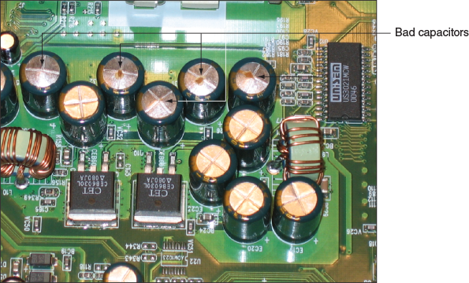
Applying Concepts

Lessons Learned
Sophia is putting together a computer from parts for the first time. She has decided to keep costs low and is installing an AMD processor on a microATX motherboard, using all low-cost parts. She installed the hard drive, optical drive, and power supply in the computer case. Then she installed the motherboard in the case, followed by the processor, cooler, and memory. Before powering up the system, she checked all connections to make sure they were solid and read through the motherboard documentation to make sure she did not forget anything important. Next, she plugs in the monitor to the onboard video port and then plugs in the keyboard and power cord. She takes a deep breath and turns on the power switch on the back of the computer. Immediately, she hears a faint whine, but she’s not sure what is making the noise. When she presses the power button on the front of the case, nothing happens. No fans, no lights. Here are the steps Sophia takes to troubleshoot the problem:
- She turns off the power switch and unplugs the power cord. She remembers to put on her ground bracelet and carefully checks all power connections. Everything looks okay.
- She plugs in the system and presses the power button again. Still all she hears is the faint whine.
- She presses the power button a second and third time. Suddenly a loud pop followed by smoke comes from the power supply, and the strong smell of electronics fills the room! Sophia jumps back in dismay.
- She removes a known good power supply from another computer, disconnects the blown power supply, and connects the good one to the computer. When she turns on the power switch, she hears that same faint whine. Quickly she turns off the switch and unplugs the power cord. She does not want to lose another power supply!
- Next, Sophia calls technical support of the company that sold her the computer parts. A very helpful technician listens carefully to the details and tells Sophia that the problem sounds like a short in the system. He explains that a power supply might whine if too much power is being drawn. As Sophia hangs up the phone, she begins to think that the problem might be with the motherboard installation.
- She removes the motherboard from the case, and the source of the problem is evident: She forgot to install spacers between the board and the case. The board was sitting directly on the bottom of the case, which had caused the short.
- Sophia installs the spacers and reinstalls the motherboard. Using the good power supply, she turns on the system. The whine is gone, but the system is dead.
- Sophia purchases a new power supply and motherboard, and this time carefully uses spacers in every hole used by the motherboard screws. Figure 4-38 shows one installed spacer and one ready to be installed. The system comes up without a problem.
Figure 4-38
Spacers installed in case holes keep the motherboard from causing a short
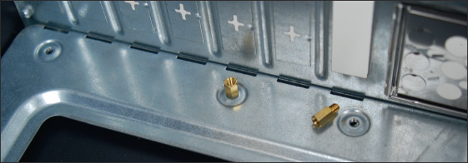
In evaluating her experience with her first computer build, Sophia declares the project a success. She was grateful she had decided to use low-cost parts for her first build. She learned much from the experience and will never, ever forget to use spacers. She told a friend, “I made a serious mistake, but I learned from it. I feel confident I know how to put a system together now, and I’m ready to tackle another build. When you make mistakes and get past them, your confidence level actually grows because you learn you can face a serious problem and solve it.”
Go to pg.
help
Application Opened
Main content

Chapter Review

4-6aChapter Summary

Cooling Methods and Devices
- Devices that are used to keep a processor and system cool include CPU coolers and fans, thermal compound, case fans, heat sinks, and liquid cooling.
- Liquid cooling systems use liquids pumped through the system to keep it cool and are sometimes used by hobbyists when overclocking a system.

Selecting a Power Supply
- Important features of a power supply to consider before purchase are its form factor, wattage capacity, number and type of connectors it provides, and warranty.
- To decide on the wattage capacity of a power supply, add up the wattage requirements for all components in a system and then increase that total by about 30 percent. The wattage provided by the +12 V rail is also important.

Strategies to Troubleshoot Any Computer Problem
- The six steps in the troubleshooting process are
  - interview the user and back up data,
  - examine the system and form a theory of probable cause (your best guess),
  - test your theory,
  - plan a solution and implement it,
  - verify that everything works and take appropriate preventive measures, and
  - document what you did and the final outcome.
- If possible, always begin troubleshooting a computer problem by interviewing the user. Find out when the problem started and what happened about the time it started. You also need to know if important data on the computer is not backed up. When troubleshooting, set your priorities based on user needs.
- Sources that can help with hardware troubleshooting are the web, online technical support and forums, diagnostic software, user manuals, and your network of technical associates.
- When troubleshooting, check the simple things first. For example, you can scan for viruses, test RAM, and run diagnostic software before you begin the process of replacing expensive components.
- Decide if a computer problem occurs before or after a successful boot and if it is caused by hardware or software. After you have fixed the problem, verify the fix and document the outcome.
- When troubleshooting laptops, consider the warranty and that replacing a component might cost more than replacing the device. If possible, substitute an external component for an internal one.

Troubleshooting the Electrical System
- To determine if a system is getting power, listen for spinning fans or drives and look for indicator lights.
- Use a power supply tester to test the power supply.
- Intermittent problems that come and go are the most difficult to solve and can be caused by hardware or software. The power supply, motherboard, RAM, processor, hard drive, and overheating can cause intermittent problems.
- Removing dust from a system, providing for proper ventilation, and installing extra fans can help to keep a system from overheating.
- The battery and the DC jack in a laptop are considered field replaceable units that pertain to the power system.
- Use a multimeter to check the voltage output of an AC adapter.

Troubleshooting the Motherboard, Processor, and RAM
- BIOS/UEFI gives beep codes when a POST error occurs during the boot before it tests video.
- Error messages on a black screen during the boot are usually put there by startup BIOS/UEFI during POST.
- Error messages on a blue screen during or after the boot are put there by Windows and are called the blue screen of death (BSOD).
- The motherboard, processor, RAM, processor cooler assembly, and CMOS battery are field replaceable units.
- An unstable system that freezes or hangs at odd times can be caused by a faulty power supply, RAM, hard drive, motherboard, or processor, a Windows error, or overheating.
- A POST diagnostic card can troubleshoot problems with the motherboard.
Go to pg.
help
Application Opened
Main content

Chapter Review

4-6bKey Terms
For explanations of key terms, see the Glossary for this text.
- AC adapter
- auto-switching
- blue screen of death (BSOD)
- case fan
- chassis air guide (CAG)
- cooler
- discolored capacitors
- driver store
- Event Viewer
- expert system
- heat sink
- lithium ion
- Memory Diagnostics
- processor thermal trip error
- Startup Repair
- technical documentation
Go to pg.
help
Application Opened
Main content

Chapter Review

4-6cThinking Critically
These questions are designed to prepare you for the critical thinking required for the A+ Core 1 exam and may use information from other chapters or the web.
- How much power is consumed by a load drawing 5 A with 120 V across it?
- What is a reasonable wattage capacity for a power supply to be used with a system that contains a DVD drive, three hard drives, and a high-end video card?
  - 250 W
  - 1000 W
  - 700 W
  - 150 W
- You upgrade a faulty PCIe video card to a recently released higher-performing card. Now the user complains that Windows 10 hangs a lot and gives errors. Which is the most likely source of the problem? Which is the least likely source?
  - A component of the computer is overheating.
  - Windows does not support the new card.
  - The drivers for the card need updating.
  - Memory is faulty.
- What should you immediately do if you turn on a computer and smell smoke or a burning odor?
  - Unplug the computer.
  - Dial 911.
  - Find a fire extinguisher.
  - Press a key on the keyboard to enter BIOS setup.
- When you boot up a computer and hear a single beep, but the screen is blank, what can you assume is the source of the problem?
  - The video card or onboard video
  - The monitor or monitor cable
  - Windows startup
  - The processor
- You suspect that a power supply is faulty, but you use a power supply tester to measure its voltage output and find it to be acceptable. Why is it still possible that the power supply may be faulty?
- Someone asks you for help with a computer that hangs at odd times. You turn it on and work for about 15 minutes, and then the computer freezes and powers down. What do you do first?
  - Replace the surge protector.
  - Replace the power supply.
  - Wait about 30 minutes for the system to cool down and try again.
  - Install an additional fan.
- You own a small computer repair company and a customer comes to you with a laptop that will not boot. After investigating, you discover the hard drive has crashed. What should you do first?
  - Install a hard drive that’s the same size and speed as the original.
  - Ask the customer’s advice about the size of the drive to install, but select a drive that’s the same speed as the original drive.
  - Ask the customer’s advice about the size and speed of the new drive to install.
  - If the customer looks like he can afford it, install the largest and fastest drive the system can support.
- You have repaired a broken LCD panel in a laptop computer. However, when you disassembled the laptop, you bent the hinge on the lid so that it now does not latch solidly. When the customer receives the laptop, he notices the bent hinge and begins shouting at you. What do you do first? Second?
  - Explain to the customer you are sorry but you did the best you could.
  - Listen carefully to the customer and don’t get defensive.
  - Apologize and offer to replace the bent hinge.
  - Tell the customer he is not allowed to speak to you like that.
- As a help-desk technician, list four good detective questions to ask if a user calls to say, “My computer won’t boot.”
- If the power connector from the CPU fan has only three pins, it can still connect to the 4-pin header, but what functionality is lost?
- How do you determine the wattage capacity needed by a power supply?
- You’ve decided to build a new gaming computer and are researching which power supply to buy. Which component in a high-end gaming computer is likely to draw the most power? What factor in a power supply do you need to consider to make sure this component has enough wattage?
- Your friend Suzy calls to ask for help with her computer. She says when she first turns on the computer, she doesn’t hear a spinning drive or fan or see indicator lights, and the monitor is blank. Is the problem hardware- or software-related?
- Which two components in a system might make a loud whining noise when there is a problem? Why?
- Your boss assigns you a trouble ticket that says a computer is randomly shutting off after about 15 minutes of use. You have a theory that the computer is overheating. What utility program can you use to read system temperatures?
- What are two reasons to tie cables up and out of the way inside a computer case?
- You suspect a component in a computer is fried. You remove any unnecessary hardware devices one by one to narrow down where the problem exists. Which step in the troubleshooting process is this?
Go to pg.
help
Application Opened
Main content

Chapter Review

4-6eReal Problems, Real Solutions
Real Problem 4-1

Replacing a Power Supply
Suppose you turn on a system and everything is dead—no lights, nothing on the monitor screen, and no spinning fan or hard drive. You verify that the power to the system works, all power connections and power cords are securely connected, and all pertinent switches are turned on. You can assume the power supply has gone bad. It’s time to replace it. To prepare for this situation in a real work environment, exchange power supplies with another student in your lab who is using a computer that has a power supply rated at about the same wattage as yours. Then verify that your system starts up and works.
Real Problem 4-2

Using Event Viewer to Troubleshoot a Hardware Problem
Just about anything that happens in Windows is recorded in Event Viewer (Eventvwr.msc). You can find events such as a hardware or network failure, OS error messages, or a device that has failed to start. When you first encounter a Windows, hardware, application, or security problem, get in the habit of checking Event Viewer as one of your first steps toward investigating the problem. To save time, first check the Administrative Events log because it filters out all events except Warning and Error events, which are the most useful for troubleshooting. Do the following to practice using Event Viewer:
- For Windows 10/8/7, enter eventvwr.msc in the Windows 10/7 search box, in the Windows 8 run box, or in a command prompt window. Event Viewer opens. Drill down into the Custom Views list in the left pane and click Administrative Events. Scroll through the list of Error or Warning events and list any that indicate a possible hardware problem. Make note of the first event in the list.
- Disconnect the network cable.
- In the Event Viewer menu bar, click Action and Refresh to refresh the list of events. How many new events do you see? Click each new event to see its details below the list of events until you find the event that tells you the network cable was unplugged. Figure 4-39 shows Event Viewer for Windows 10. Describe the details of the event about the network cable.
Figure 4-39
Use Event Viewer to find logs that can help you troubleshoot hardware problems
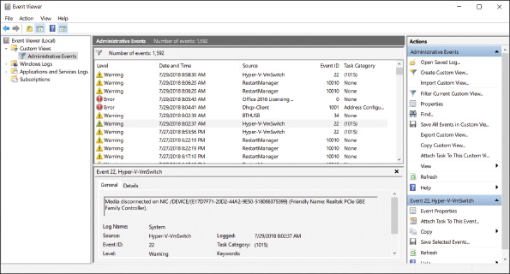
- Tinker around with other hardware on your computer. What actions did you take that triggered a Warning or Error event in Event Viewer?
Real Problem 4-3

Troubleshooting a Hung System
A user complains to you that her system hangs for no known reason. After asking her a few questions, you identify these symptoms:
- The system hangs after about 15–20 minutes of operation.
- When the system hangs, it doesn’t matter what application is open or how many applications are open.
- When the system hangs, it appears as though power is turned off: There are no lights, spinning drives, or other evidence of power.
You suspect overheating might be the problem. To test your theory, you decide to do the following:
- You want to verify that the user has not overclocked the system. How do you do that?
- You decide to check for overheating by examining the temperature of the system immediately after the system is powered up and then again immediately after the system hangs. Describe the steps you take to do this.
- After doing the first two steps, you decide overheating is the cause of the problem. What are four things you can do to fix the problem?
Go to pg.
help

