Application Opened
Main content
Chapter
5

Supporting Hard Drives and Other Storage Devices
- Chapter Introduction
- 5-1Hard Drive Technologies and Interface Standards
  - 5-1aTechnologies and Form Factors of Hard Drives
  - 5-1bInterface Standards Used by Hard Drives
- 5-2How to Select and Install Hard Drives
  - 5-2aSelecting a Hard Drive
  - 5-2bSteps to Install a SATA Drive
  - 5-2cInstalling a Drive in a Removable Bay
  - 5-2dInstalling a Small Drive in a Wide Bay
  - 5-2eInstalling an M.2 SSD Card
  - 5-2fInstalling a Hard Drive in a Laptop
  - 5-2gSetting up Hardware RAID
  - 5-2hNAS Devices and External Storage
- 5-3Supporting Other Types of Storage Devices
  - 5-3aFile Systems Used by Storage Devices
  - 5-3bStandards Used by Optical Discs and Drives
  - 5-3cInstalling an Optical Drive
  - 5-3dReplacing an Optical Drive on a Laptop
  - 5-3eSolid-State Storage
- 5-4Troubleshooting Hard Drives
  - 5-4aSlow Performance
  - 5-4bHard Drive Problems during the Boot
- 5-5Chapter Review
  - 5-5aChapter Summary
  - 5-5bKey Terms
  - 5-5cThinking Critically
  - 5-5dHands-On Projects
  - 5-5eReal Problems, Real Solutions
  - 5-5fExam Tips
Go to pg.
help
Application Opened
Main content

Chapter Introduction
After completing this chapter, you will be able to:
- Describe and contrast technologies used inside a hard drive and how a computer communicates with a hard drive
- Select, install, and support a hard drive
- Support optical drives, solid-state storage, and flash memory devices
- Troubleshoot hard drives
The hard drive is the most important permanent storage device in a computer, and supporting hard drives is one of the more important tasks of a computer support technician. This chapter introduces the different kinds of hard drive technologies and the ways a computer interfaces with a hard drive. You learn how to select and install the different types of hard drives and how to troubleshoot hard drive problems. You also learn how to select and install optical drives in desktops and laptops. This chapter also covers solid-state storage, including flash memory cards and which type of card to buy for a particular need.
Go to pg.
help
Application Opened
Main content

5-1Hard Drive Technologies and Interface Standards
A+ Core 1
- 1.1
Given a scenario, install and configure laptop hardware and components.
- 3.1
Explain basic cable types, features, and their purposes.
- 3.2
Identify common connector types.
- 3.4
Given a scenario, select, install and configure storage devices.
- 3.5
Given a scenario, install and configure motherboards, CPUs, and add-on cards.
A hard disk drive (HDD) , most often called a hard drive , is rated by its physical size, capacity, speed, technologies used inside the drive, and interface standards. First, we look at the features of a hard drive and then turn to how the drive interfaces with the computer.
Notes
In technical documentation, you might see a hard drive abbreviated as HDD (hard disk drive). However, this chapter uses the term hard drive.
Go to pg.
help
Application Opened
Main content

5-1aTechnologies and Form Factors of Hard Drives
A+ Core 1
- 1.1
Given a scenario, install and configure laptop hardware and components.
- 3.1
Explain basic cable types, features, and their purposes.
- 3.4
Given a scenario, select, install and configure storage devices.
The two types of hardware technologies used inside the drive are magnetic and solid-state. In addition, some hybrid drives use a combination of both technologies. Each hard drive technology uses several form factors, all discussed in this part of the chapter.

Magnetic Hard Drives
A magnetic hard drive has one, two, or more platters, or disks, that stack together and spin in unison inside a sealed metal housing that contains firmware to control reading and writing data to the drive and to communicate with the motherboard. The top and bottom of each disk have a read/write head that moves across the disk surface as all the disks rotate on a spindle (see Figure 5-1). All the read/write heads are controlled by an actuator, which moves the read/write heads across the disk surfaces in unison. The disk surfaces are covered with a magnetic medium that can hold data as magnetized spots. The spindle rotates at 5400, 7200, 10,000, or 15,000 RPM (revolutions per minute). The faster the spindle, the better the drive performs. Most consumer hard drives are rated at 5400 or 7200 RPM.
Figure 5-1
Inside a magnetic hard drive
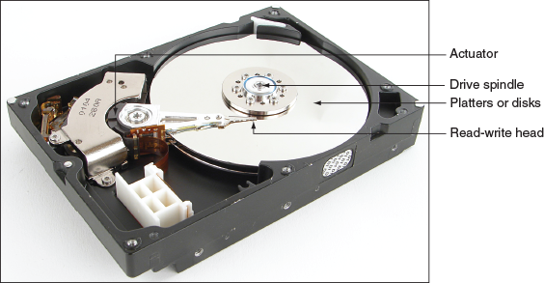
Data is organized on a magnetic hard drive in concentric circles called tracks (see Figure 5-2). Each track is divided into segments called sectors (also called records). Older hard drives used sectors that contained 512 bytes. Most current hard drives use 4096-byte sectors.
Figure 5-2
A hard drive is divided into tracks and sectors
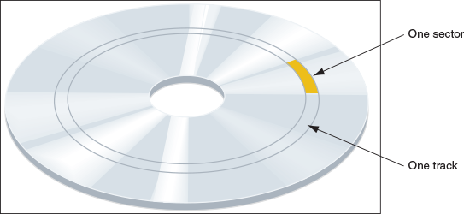
Form factors for internal magnetic hard drives are 3.5” for desktops and 2.5” for laptop computers. See Figure 5-3. In addition, a smaller 1.8” hard drive (about the size of a credit card) is used in some low-end laptops and other equipment such as MP3 players.
Figure 5-3
A magnetic hard drive for a desktop is larger than that used in laptops
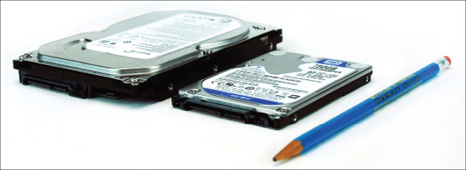

Solid-State Drives
A solid-state drive (SSD), also called a solid-state device, is so named because it has no moving parts. The drives are built using nonvolatile memory, which is similar to that used for USB flash drives and smart cards. Recall that this type of memory does not lose its data even after the power is turned off.
In an SSD, flash memory is stored on chips on a circuit board inside the drive housing (see Figure 5-4). The chips contain grids of rows and columns with two transistors at each intersection that hold a 0 or 1 bit. One of these transistors is called a floating gate and accepts the 0 or 1 state according to a logic test called NAND (stands for “Not AND”). Therefore, the memory in an SSD is called NAND flash memory.
Figure 5-4
A circuit board with NAND memory inside an SSD
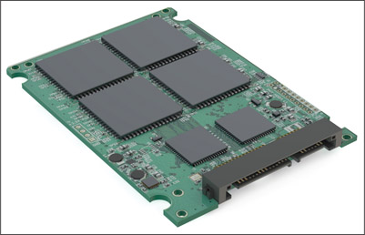
Source: istock.com/AlexLMX
Transistors are limited to the number of times they can be reprogrammed. Therefore, the life span of an SSD is based on the number of write operations to the drive, and can be expressed as TBW (TeraBytes Written) or DWPD (Drive Writes Per Day) over its expected life. (The number of read operations does not affect the life span.) For example, one SSD manufacturer guarantees its SSDs for 70 TBW, which means 70 TB or 70,000 GB write operations for the duration of the drive. Another manufacturer might rate the drive as DWPD—for example, 70 GB write operations per day for five years. For normal use, a drive would not be used that much and would last much longer. However, the drive warranty is only for five years.
Because flash memory is expensive, solid-state drives are much more expensive than magnetic hard drives of the same capacity, but they are faster, more reliable, last longer, and use less power than magnetic drives.
You need to be aware of three popular form factors used by SSDs:
- 2.5” SSD. The 2.5” SSD (see the left side of Figure 5-5) is used in desktops and laptops and can mount in the same bays and use the same cable connectors as those used by 2.5” magnetic drives. (Occasionally, you might see a 1.8” SSD for netbooks and other mobile devices, but they are rare.)
Figure 5-5
Solid-state drives in two form factors: 2.5” SSD and two lengths of M.2 SSD cards
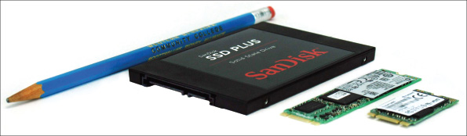
- M.2 SSD card. The M.2 SSD form factor (see the right side of Figure 5-5) is a small M.2 card that uses the motherboard M.2 slot you learned about in Chapter 2.
- PCI Express SSD expansion card. An SSD can be embedded on a PCIe expansion card (see Figure 5-6). These drives generally have a faster interface with the CPU than 2.5” SSDs and may also be faster than an M.2 SSD, depending on how the M.2 slot interfaces with the CPU. A PCIe SSD uses the NVMe interface discussed later in the chapter.
Figure 5-6
This SSD by Plextor is embedded on a PCIe ×4 version 3.0 expansion card and uses the NVMe interface standard
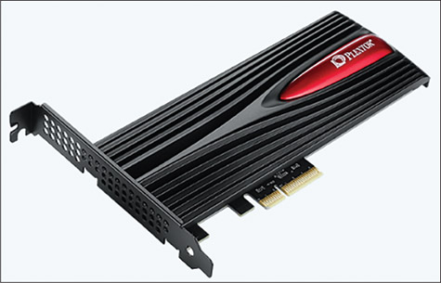
Source: www.goplextor.com/Product/Detail/M9Pe(Y)#/Features

Hybrid Hard Drives
A hybrid hard drive (H-HDD), sometimes called a solid-state hybrid drive (SSHD), contains both magnetic and SSD technologies. The magnetic drive in the drive housing permanently holds data while the flash component serves as a buffer to improve drive performance. Some hybrid drives perform just as well as an SSD. For a hybrid drive to function, the operating system must support it.

Logical Block Addressing and Capacity
Before a magnetic drive leaves the factory, sector markings are written to it in a process called low-level formatting. (This formatting is different from the high-level formatting that Windows does after a drive is installed in a computer.) The hard drive firmware, BIOS/UEFI on the motherboard, and the OS use a simple sequential numbering system called logical block addressing (LBA) to address all the sectors on the drive. SSDs are marked into blocks, which are communicated to the motherboard and OS; they read/write to the drive in blocks, just as with magnetic drives. SSDs are also low-level formatted before they leave the factory.
The size of each block and the total number of blocks on the drive determine the drive capacity. Today’s drive capacities are usually measured in GB (gigabytes) or TB (terabytes, each of which is 1024 gigabytes). Magnetic drives are generally much larger in capacity than SSDs.
Notes
Many solid-state drive manufacturers reserve blocks on the drive that are used when other blocks begin to prove they are no longer reliable. Also, a technique called wear leveling assures that the logical block addressing does not always address the same physical blocks in order to distribute write operations more evenly across the device.

S.M.A.R.T.
You need to be aware of one more technology supported by both SSD and magnetic hard drives: S.M.A.R.T. (Self-Monitoring Analysis and Reporting Technology) , which is used to predict when a drive is likely to fail. System BIOS/UEFI uses S.M.A.R.T. to monitor drive performance, temperature, and other factors. For magnetic drives, it monitors disk spin-up time, distance between the head and the disk, and other mechanical activities of the drive. Many SSDs report to the BIOS/UEFI the number of write operations, which is the best measurement of when the drive might fail. If S.M.A.R.T. suspects a drive failure is about to happen, it displays a warning message. S.M.A.R.T. can be enabled and disabled in BIOS/UEFI setup.
Notes
Malware has been known to give false S.M.A.R.T. alerts.
Now let’s look at how the drive’s firmware or controller communicates with the motherboard and processor.
Go to pg.
help
Application Opened
Main content

5-1bInterface Standards Used by Hard Drives
A+ Core 1
- 3.1
Explain basic cable types, features, and their purposes.
- 3.2
Identify common connector types.
- 3.4
Given a scenario, select, install and configure storage devices.
- 3.5
Given a scenario, install and configure motherboards, CPUs, and add-on cards.
Four interface standards used by hard drives include IDE (outdated), SCSI (also outdated), SATA (the most popular current standard), and NVMe (the latest and fastest standard.)
A+ Exam Tip
The A+ Core 1 exam expects you to recognize the cables and connectors for the IDE, SCSI, SATA, and NVMe interfaces. Given a scenario, you may be expected to decide which interface to use (SATA or NVMe) and be able to install and configure devices that use these interfaces.

IDE
Years ago, hard drives used the Parallel ATA (PATA) standards, also called the IDE (Integrated Drive Electronics) standards, to connect to a motherboard. PATA allowed for one or two IDE connectors on a motherboard, each using a 40-pin data cable. Two drives could connect to one cable (see Figure 5-7).
Figure 5-7
A computer’s hard drive subsystem using an IDE interface to the motherboard
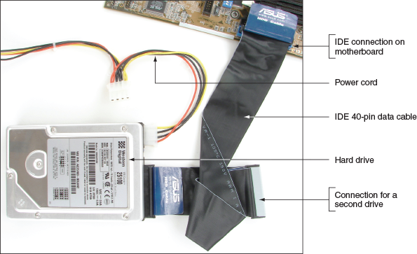
Two types of IDE cables are the older cable with a 40-pin connector and 40 wires and a newer cable with the same 40-pin connector and 80 thinner wires (see Figure 5-8). The additional 40 wires reduce crosstalk (interference that can lead to corrupted communication) on the cable. The later IDE standards required the 80-wire cable. The maximum recommended length of an IDE cable is 18”. The IDE standard is seldom used today.
Figure 5-8
In comparing the 80-conductor cable with the 40-conductor cable, note they are about the same width, but the 80-conductor cable has twice as many fine wires
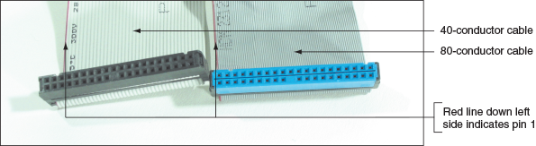

SCSI
In the distant past, a few personal computer hard drives designed for high-end workstations used the SCSI (Small Computer System Interface) interface standard. SCSI (pronounced “scuzzy”) can support up to 7 or 15 SCSI-compliant devices in a system. Most often, a SCSI expansion card (see Figure 5-9), called the SCSI host adapter, used a PCIe slot and provided one external connector for an external SCSI device, such as a SCSI printer, and one internal connector for internal SCSI devices, such as hard drives and optical drives. Figure 5-10 shows a long SCSI cable. One end of the cable connects to the host adapter and the other connectors are used for internal SCSI devices. SCSI evolved over the years with various connector types and cables but is no longer used in personal computers.
Figure 5-9
This Adaptec SCSI card uses a PCIe ×1 slot and supports up to 15 devices in a SCSI chain
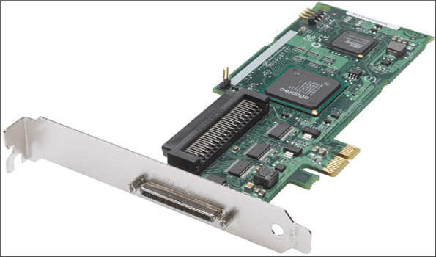
Source: Courtesy of PMC-Sierra, Inc.
Figure 5-10
This 68-pin internal SCSI ribbon cable can connect several SCSI devices
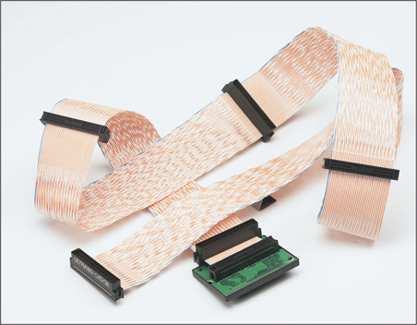
Source: Courtesy of PMC-Sierra, Inc.

SATA
Most hard drives in today’s personal computers use the SATA interface standards to connect to the motherboard. The serial ATA or SATA (pronounced “say-ta”) standard uses a serial data path, and a SATA data cable can accommodate a single SATA drive (see Figure 5-11). The three SATA standards are:
- SATA3 or SATA III, rated at 6 Gb/sec, is sometimes called SATA 6 Gb/s.
- SATA2 or SATA II, rated at 3 Gb/sec, is sometimes called SATA 3 Gb/s.
- SATA1 or SATA I, rated at 1.5 Gb/sec, is seldom seen today.
Figure 5-11
A SATA cable connects a single SATA drive to a motherboard SATA connector
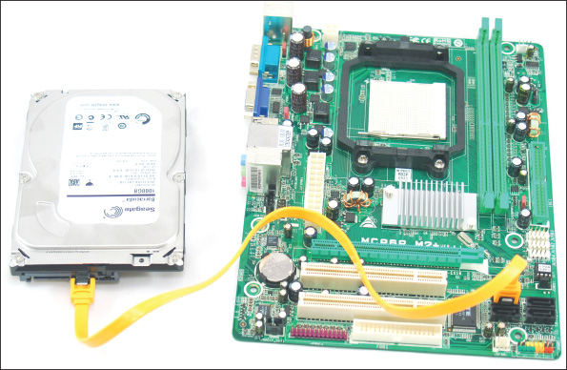
Notes
Interface standards for drives define data speeds and transfer methods between the drive controller, the BIOS/UEFI, the chipset on the motherboard, and the OS. The standards also define the type of cables and connectors used by the drive and the motherboard or expansion cards. SATA cables work for all three SATA standards.
SATA interfaces are used by all types of drives, including hard drives, CD, DVD, and Blu-ray. SATA supports hot-swapping, also called hot-plugging. With hot-swapping, you can connect and disconnect a drive while the system is running. Hard drives that can be hot-swapped cost significantly more than regular hard drives and are generally used in servers or other network storage devices.
A SATA drive connects to one internal SATA connector on the motherboard by way of a 7-pin SATA data cable and uses a 15-pin SATA power connector (see Figure 5-12). An internal SATA data cable can be up to 1 meter in length. A motherboard might have two or more SATA connectors; use the connectors in the order recommended in the motherboard user guide. For example, for the four connectors shown in Figure 5-13, you are told to use the red ones before the black ones.
Figure 5-12
A SATA data cable and SATA power cable
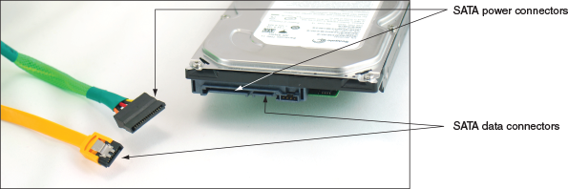
Figure 5-13
This motherboard has two black and two red SATA II ports
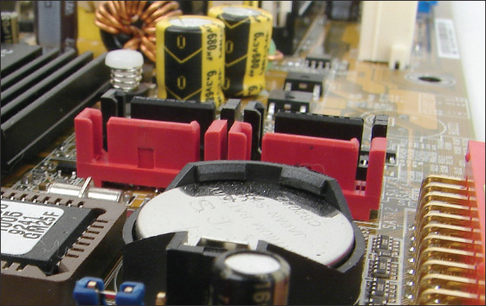
The SATA 3.2 revision allows for PCIe and SATA to work together in a technology called SATA Express, which uses a new SATA connector. The speed of SATA Express is about three times that of SATA 3.0. However, because SATA Express is not as fast as NVMe, hard drive manufacturers have been slow to invest in SATA Express drives, and only a few motherboards have SATA Express slots. Figure 5-14 shows a board with seven SATA ports. When the one SATA Express port is used, the two normal SATA ports grouped with it are disabled.
Figure 5-14
One SATA Express port is grouped with two normal SATA ports
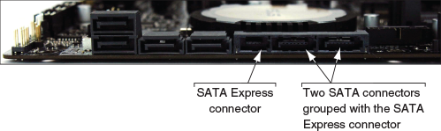
In addition to internal SATA connectors, the motherboard or an expansion card can provide external SATA (eSATA) ports for external drives (see Figure 5-15). External SATA drives use a special external shielded SATA cable up to 2 meters long. Seven-pin eSATA ports run at the same speed as the internal ports using SATA I, II, or III standards. The eSATA port is shaped differently from an internal SATA connector so as to prevent people from using the unshielded internal SATA data cables with the eSATA port.
Figure 5-15
Two eSATA ports on a motherboard
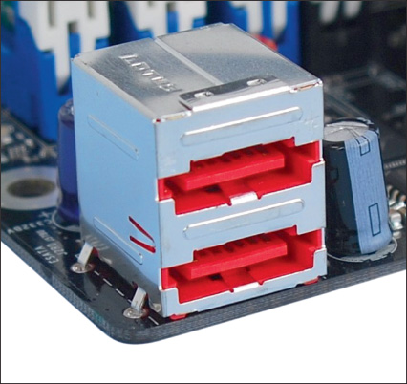
Notes
External hard drives can connect to a computer by way of external SATA (eSATA) or USB. Be sure the port provided by the computer uses the same standard that the external drive uses—for example, SuperSpeed USB 3.0 or eSATA III. If the port is not fast enough, you can install an expansion card to provide faster ports.
When purchasing a SATA hard drive, keep in mind that the SATA standards for the drive and the motherboard need to match. If either the drive or the motherboard uses a slower SATA standard than the other device, the system will run at the slower speed.

NVMe
Whereas the SATA interface is used by both magnetic and solid-state drives, the newer NVMe (Non-Volatile Memory Express or NVM Express) interface standard is used only by SSDs. Magnetic hard drives are slow enough that a SATA interface is adequate, but SSDs are so fast that the SATA interface becomes a performance bottleneck. NVMe uses the faster PCI Express ×4 interface to communicate with the processor. Here are the comparisons:
- The most common SATA standard, SATA3, transfers data at 6 Gb/sec.
- NVMe uses the most common PCIe standard, PCIe 3.0, which transfers data at 1 GB/sec per lane. Converted from Gigabyte to Gigabit, PCIe 3.0 transfers data at 8 Gb/sec per lane. NVMe uses four lanes (PCIe ×4), yielding a transfer rate of ‍‍ . Therefore, the NVMe transfer rate of 32 Gb/sec is more than five times faster than SATA3’s transfer rate of 6 Gb/sec.
The PCIe NVMe interface might be used in three ways:
- PCIe expansion card. The NVMe interface is used by SSDs embedded on PCIe expansion cards. Refer back to Figure 5-6.
- U.2 slot. A 2.5” SSD can support the NVMe interface using a U.2 connector on the drive and a U.2 port on the motherboard. See Figure 5-16. These drives might be advertised as a PCIe drive, U.2 drive, or NVMe solid-state drive.
Figure 5-16
A U.2 2.5” SSD uses the NVMe and PCIe interface standards and connects to a U.2 port on the motherboard
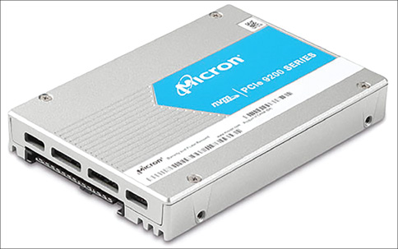
- M.2 port. An M.2 SSD card might use the NVMe or SATA standard. Recall that an M.2 slot on a motherboard might interface with the processor using the USB, SATA, or PCIe bus. If the slot uses the PCIe bus and the M.2 SSD card uses the NVMe interface, the 32-Gb/sec transfer rate can be attained. If your motherboard does not have an M.2 port, you can use a PCIe adapter card (also called a carrier card) to provide M.2 ports for M.2 SSDs (see Figure 5-17).
Figure 5-17
A PCIe ×4 adapter card provides one M.2 slot for an M.2 SSD
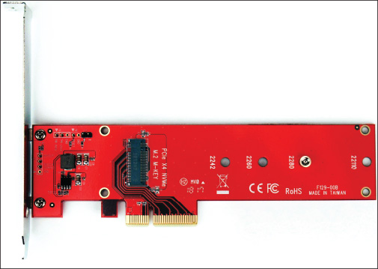
Most motherboards today have PCIe expansion slots, and M.2 slots are more common on motherboards than U.2 ports. For M.2 slots, check the motherboard documentation to find out which bus the M.2 slot uses and whether you can boot the system from the SSD card installed in the slot. Some motherboards, such as the Asus Prime Z370P, provide two M.2 slots, which can be configured in a RAID array. For this board, you can purchase the Asus Hyper M.2 ×16 card (see Figure 5-18) to install in the first PCIe ×16 slot and install up to four M.2 SSDs on the card. These four drives can be configured in a RAID array and you can use BIOS/UEFI to enable the card so that you can boot the system from this RAID array of SSDs. You learn more about RAID later in this chapter.
Figure 5-18
Install up to four M.2 SSDs in a bootable RAID array on this adapter card by Asus
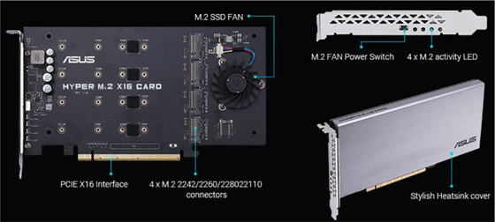
Source: https://www.asus.com/us/Motherboard-Accessory/HYPER-M-2-X16-CARD/overview/
Now that you know about the various hard drive technologies and interfaces, let’s see how to select and install a hard drive.
Go to pg.
help
Application Opened
Main content

5-2How to Select and Install Hard Drives
A+ Core 1
- 1.1
Given a scenario, install and configure laptop hardware and components.
- 3.4
Given a scenario, select, install and configure storage devices.
- 3.8
Given a scenario, select and configure appropriate components for a custom PC configuration to meet customer specifications or needs.
In this part of the chapter, you learn how to select a hard drive for your system. Then, you learn the details of installing a SATA drive. Next, you learn how to deal with using removable bays, the problem of installing a hard drive in a bay that is too wide for it, and special considerations to install a hard drive in a laptop. You also learn how to set up a RAID system.
Go to pg.
help
Application Opened
Main content

5-2aSelecting a Hard Drive
A+ Core 1
- 3.4
Given a scenario, select, install and configure storage devices.
When selecting a hard drive, keep in mind that to get the best performance from the system, the motherboard and drive must support the same interface standard. If they don’t support the same standard, they revert to the slower standard that both can use, or the drive will not work at all. There’s no point in buying an expensive hard drive with features that your system cannot support.
Therefore, when making purchasing decisions, you need to know the standards for the motherboard slot or port and perhaps for the expansion card that might provide the drive interface. Find out by reading the motherboard manual. Here are some options for compatibility:
- SATA ports on a motherboard are usually color-coded to indicate which SATA standard the port supports. A motherboard typically has a mix of SATA3 and SATA2 ports. A SATA drive is rated for one SATA standard but can run at the slower speed of the SATA port.
- M.2 slots might support PCIe 3.0, PCIe 2.0, SATA2, SATA3, or USB 3.0. M.2 ports might be keyed to one notch or two and can accommodate up to three sizes of cards. Match the card to the slot and its fastest standard.
- When an M.2 port with a card installed is using the SATA bus, one of the SATA ports might be disabled. Be sure to know which one so you don’t attempt to use it for another device.
- NVMe expansion cards most likely use a PCIe ×4 version 3.0 slot. A motherboard might have multiple PCIe ×4 slots; use one that supports PCIe version 3.0.
Besides compatibility, consider the features already discussed in this chapter when purchasing a hard drive:
- Technology (SSD is faster and lasts longer than a hybrid drive, which is faster than a magnetic drive)
- Form factor (3.5” or 2.5” for magnetic drives or 2.5”, M.2, U.2, or PCIe card for SSDs)
- Capacity (in GB or TB)
- Data transfer rate as determined by the drive interface (SATA 6.0 Gb/s, SATA 3.0 Gb/s, PCIe ×4 32 Gb/s, and so forth)
- For magnetic drives, the spindle speed (5400, 7200, 10,000, or 15,000 RPM), which affects performance
- For hybrid drives, the cache or buffer size, which affects performance (A magnetic drive with a cache is a hybrid drive.)
Some hard drive manufacturers are listed in Table 5-1. Most manufacturers of memory also make solid-state drives.
Table 5-1

Hard Drive Manufacturers
Manufacturer | Website
Kingston Technology (SSD only) | kingston. com
Samsung (SSD only) | samsung. com
Seagate Technology (magnetic and SSD) | seagate. com
Western Digital (magnetic and SSD) | wdc. com
Toshiba (magnetic and SSD) | toshiba. com
Now let’s turn our attention to the step-by-step process of installing a SATA drive.
Go to pg.
help
Application Opened
Main content

5-2bSteps to Install a SATA Drive
A+ Core 1
- 3.4
Given a scenario, select, install and configure storage devices.
In Figure 5-19, you can see the back of a SATA hard drive. A SATA drive might have jumpers used to set features such as the ability to power up from standby mode. Most likely, if jumpers are present on a SATA drive, the factory has set them as they should be and advises you not to change them.
Figure 5-19
The rear of a SATA drive
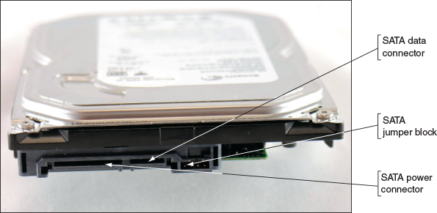
A+ Exam Tip
The A+ Core 1 exam expects you to know how to configure SATA devices in a system. What you learn in this chapter about installing a SATA hard drive in a system also applies to installing a SATA optical drive. Hard drives and optical drives use a SATA data connector and a power connector.
Some SATA drives have two power connectors, as does the one in Figure 5-20. Choose between the SATA power connector (which is preferred) or the legacy 4-pin Molex connector, but never install two power cords to the drive at the same time because it could damage the drive.
Figure 5-20
The rear of a SATA drive with two power connectors
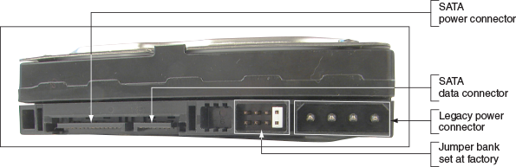

Step 1: As Best You Can, Protect the User’s Data
Recall from Chapter 4 that before you work on solving any computer problem, you need to establish your priorities. Your first priority might be the user’s data. If the user tells you there is important data on the current hard drive and you can boot from it, back up the data to other media and verify that you can access the data on that media. If the current hard drive will not boot, recall you can move it to another computer and transfer data to other media. Make every effort possible to protect the user’s data before you move on to the next step.

Step 2: Know Your Starting Point
As with replacing or installing any other devices, make sure you know your starting point before you begin installing a hard drive. Answer these questions: How is your system configured? Is everything working properly? Verify which of your system’s devices are working before installing a new one. Later, if a device does not work, the information will help you isolate the problem. Keeping notes is a good idea whenever you install new hardware or software or make any other changes to your computer system. Write down what you know about the system that might be important later.
Notes
When installing hardware and software, don’t install too many things at once. If something goes wrong, you won’t know what’s causing the problem. Install one device, start the system, and confirm that the new device is working before installing another.

Step 3: Read the Documentation and Prepare Your Work Area
Before you take anything apart, carefully read all the documentation for the drive and controller card, as well as the part of your motherboard documentation that covers hard drive installation. Make sure that you can visualize all the steps in the installation. If you have any questions, keep researching until you locate the answer. You can do a Google search, have a chat session with technical support, or ask a knowledgeable friend for help. As you get your questions answered, you might discover that what you are installing will not work on your computer, but that is better than coping with hours of frustration and a disabled computer. You cannot always anticipate every problem, but at least you can know that you made your best effort to understand everything in advance. What you learn with thorough preparation pays off every time!
You’re now ready to set out your tools, documentation, new hardware, and notebook. Remember the basic rules concerning static electricity. Be sure to protect against electrostatic discharge (ESD) by wearing an ESD strap during the installation. You also need to avoid working on carpet in the winter when there’s a lot of static electricity.
Some added precautions for working with a hard drive are as follows:
- Handle the drive carefully.
- Do not touch any exposed circuitry or chips.
- Prevent other people from touching exposed microchips on the drive.
- When you first take the drive out of the static-protective package, touch the package containing the drive to a screw holding an expansion card or cover, or to a metal part of the computer case, for at least two seconds. This drains the static electricity from the package and from your body.
- If you must set down the drive outside the static-protective package, place it component-side-up on a flat surface.
- Do not place the drive on the computer case cover or on a metal table.
If you’re assembling a new system, it’s usually best to install drives before you install the motherboard so that you will not accidentally bump sensitive motherboard components with the drives.

Step 4: Install the Drive
Now you’re ready to get started. Follow these steps to install the drive in the case:
- Shut down the computer, unplug it, and press the power button to drain residual power. Remove the computer case cover. Check that you have an available power cord from the power supply for the drive.
Notes
If there are not enough power cords from a power supply, you can purchase a Y connector that can add another power cord.
- For 2.5” or 3.5” drives, decide which bay will hold the drive by examining the locations of the drive bays and the length of the data cables and power cords. Bays designed for hard drives do not have access to the outside of the case, unlike bays for optical drives and other drives in which discs are inserted. Also, some bays are wider than others to accommodate wide drives such as a DVD drive. Will the data cable reach the drives and the motherboard connector? If not, rearrange your plan for locating the drive in a bay, or purchase a custom-length data cable. Some bays are stationary, meaning the drive is installed inside the bay because it stays in the case. Other bays are removable; you remove the bay, install the drive in it, and then return the bay to the case.
- For a stationary bay, slide the drive in the bay and then use a screwdriver to secure one side of the drive with one or two short screws (see Figure 5-21). It’s best to use two screws so the drive will not move in the bay, but sometimes a bay only provides a place for a single screw on each side. Some drive bays provide one or two tabs that you pull out before you slide the drive in the bay and then push in to secure the drive. Another option is a sliding tab (see Figure 5-22) that is used to secure the drive. Pull the tab back, slide in the drive, and push the tab forward to secure the drive.
Figure 5-21
Secure one side of the drive with one or two screws
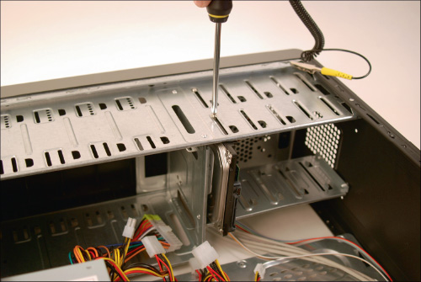
Caution
Be sure the screws are not too long. If they are, you can screw too far into the drive housing, which will damage the drive itself.
Figure 5-22
This drive bay uses tabs to secure the drive
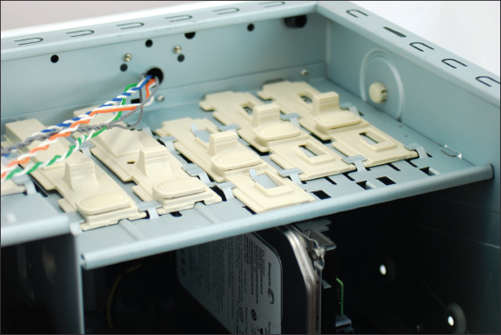
- When using screws to secure the drive, carefully turn the case over without disturbing the drive and put one or two screws on the other side of the drive (see Figure 5-23). To best secure the drive in the case, use two screws on each side of the drive.
Figure 5-23
Secure the other side of the drive with one or two screws
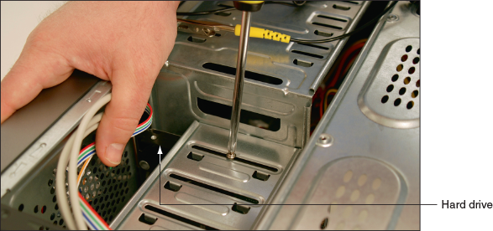
Notes
Do not allow torque to stress the drive. In other words, don’t force a drive into a space that is too small for it. Also, placing two screws in diagonal positions across the drive can place pressure diagonally on the drive.
- Check the motherboard documentation to find out which SATA connectors on the board to use first. For example, five SATA connectors are shown in Figure 5-24. The documentation says the two blue SATA connectors support 6.0 Gb/s and slower speeds, and the two black and one red SATA connectors support 3.0 Gb/s and slower speeds. On this board, be sure to connect your fastest hard drive to a blue connector. For some boards, the hard drive that has the bootable OS installed must be connected to the first SATA connector, which is usually labeled SATA 0. For both the drive and the motherboard, you can only plug the cable into the connector in one direction. A SATA cable might provide a clip on the connector to secure it (see Figure 5-25).
Figure 5-24
Five SATA connectors support different SATA standards
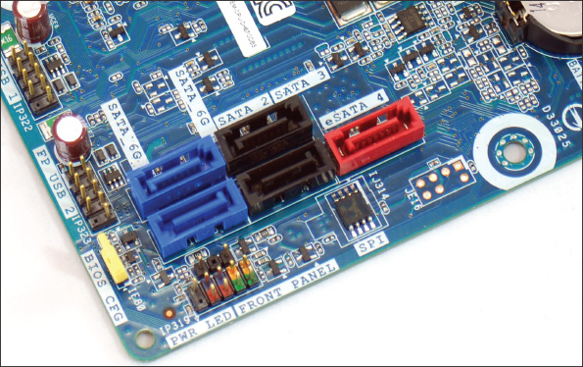
Figure 5-25
A clip on a SATA connector secures the connection
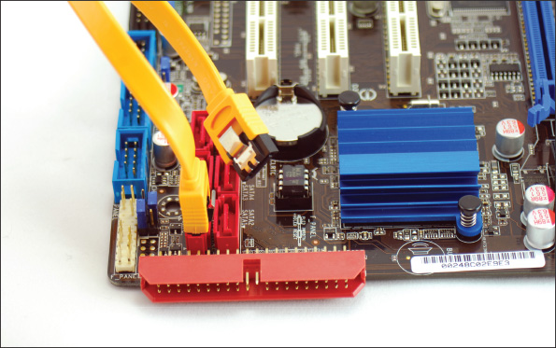
- Connect a 15-pin SATA power connector or 4-pin Molex power connector from the power supply to the drive (see Figure 5-26).
Figure 5-26
Connect the SATA power cord to the drive
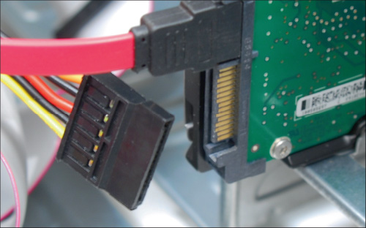
- Check all your connections and power up the system.
- To verify that the drive was recognized correctly, enter BIOS/UEFI setup and look for the drive. Figure 5-27 shows a BIOS/UEFI setup screen on one system that has four SATA connectors. A hard drive is installed on one of the faster yellow SATA connectors and a DVD drive is installed on one of the slower brown SATA connectors.
Notes
If the drive light on the front panel of the computer case does not work after you install a new drive, try reversing the LED wire on the front panel header on the motherboard.
Figure 5-27
A BIOS/UEFI setup screen showing a SATA hard drive and DVD drive installed
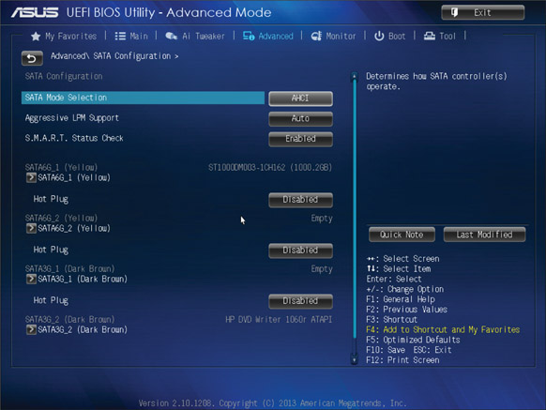
Source: American Megatrends, Inc.
You are now ready to prepare the hard drive for first use. If you are installing a new hard drive in a system that will be used for a new Windows installation, boot from the Windows setup DVD or USB drive and follow the directions on the screen to install Windows on the new drive. If you are installing a second hard drive in a system that already has Windows installed on the first hard drive, use the Disk Management utility in Windows to prepare the drive for first use (called partitioning and formatting the drive).
Go to pg.
help
Application Opened
Main content

5-2cInstalling a Drive in a Removable Bay
A+ Core 1
- 3.4
Given a scenario, select, install and configure storage devices.
Now let’s see how a drive installation goes when you are dealing with a removable bay. Figure 5-28 shows a computer case with a removable bay that has a fan at the front of the bay to help keep the drives cool. (The case manufacturer calls the bay a fan cage.) The bay is anchored to the case with three black locking pins. The third locking pin from the bottom of the case is disconnected in the photo.
Figure 5-28
The removable bay has a fan in front and is anchored to the case with locking pins
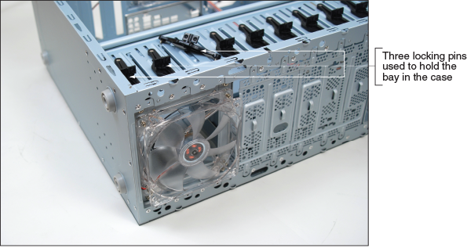
Unplug the cage fan from its power source. Turn the handle on each locking pin counterclockwise to remove it. Then slide the bay to the front and out of the case. Insert the hard drive in the bay and use two screws on each side to anchor the drive in the bay (see Figure 5-29). Slide the bay back into the case and reinstall the locking pins. Plug in the cage fan power cord.
Figure 5-29
Install the hard drive in the bay using two screws on each side of the drive
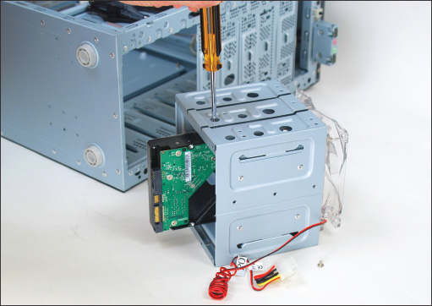
Go to pg.
help
Application Opened
Main content

5-2dInstalling a Small Drive in a Wide Bay
A+ Core 1
- 3.4
Given a scenario, select, install and configure storage devices.
Because 2.5” drives are smaller than the bays designed for 3.5” drives, you’ll need a universal bay kit to fit these drives into most desktop computer cases. These inexpensive kits should create a tailor-made fit. In Figure 5-30, you can see how the universal bay kit adapter works. The adapter spans the distance between the sides of the drive and the bay. Figure 5-31 shows a SATA SSD with the brackets connected.
Figure 5-30
Use the universal bay kit to make the drive fit the bay
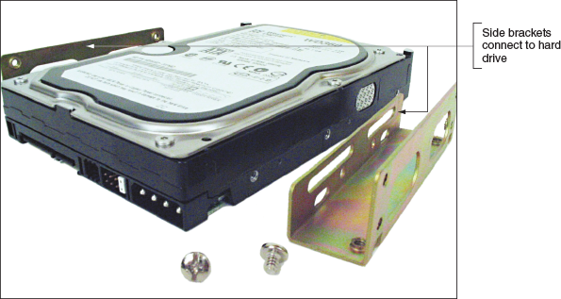
Figure 5-31
An SSD with a bay kit connected
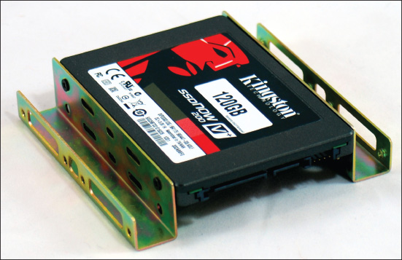
Go to pg.
help
Application Opened
Main content

5-2eInstalling an M.2 SSD Card
As always, read the motherboard manual to find out the types of M.2 cards the board supports. For SSD cards, the manual or motherboard website is likely to list specific SSD brands and models the board can use. Also be aware that if the M.2 slot is used and the SSD card uses the SATA interface standard, it might disable a SATA Express or SATA connector on the board. Do the following to install the card:
- Measure the length of the card and decide which screw hole for the M.2 slot the card requires. Install a standoff in the hole.
- Slide the card straight into the slot, but not from an upward angle because you might bend open the slot and prevent a good connection. Make sure the card is installed securely in the slot. In Figure 5-32, you can see the card has two notches and can be used in either a B-key M.2 slot (the key on the left of the slot) or an M-key M.2 slot (the key on the right of the slot). This motherboard has an M-key slot. Also notice in the figure that the standoff is installed, ready to secure the card to the board.
Figure 5-32
Slide an SSD card straight into an M.2 slot
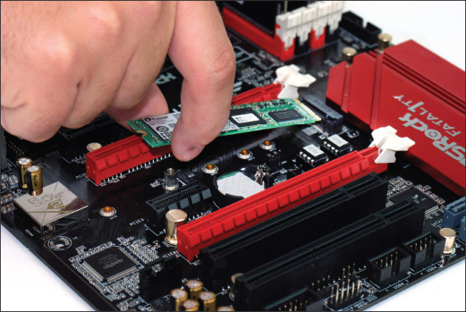
- Install the one screw in the standoff to secure the card to the motherboard. Don’t overtighten the screw because you might damage the card.
- Start the system, go into BIOS/UEFI setup, and make sure the M.2 card is recognized by the system. If it will be the boot device, make the appropriate changes in BIOS/UEFI.
Go to pg.
help
Application Opened
Main content

5-2fInstalling a Hard Drive in a Laptop
A+ Core 1
- 1.1
Given a scenario, install and configure laptop hardware and components.
When purchasing and installing an internal hard drive or optical drive in a laptop, see the laptop manufacturer’s documentation about specific capacities, form factors, and connectors that will fit the laptop. Before deciding to replace a hard drive, consider these issues:
- Be aware of voiding a warranty if you don’t follow the laptop manufacturer’s directions.
- If the old drive has crashed, you’ll need the recovery media to reinstall Windows and the drivers. Make sure you have the recovery media before you start.
- If you are upgrading from a low-capacity drive to a higher-capacity drive, you need to consider how you will transfer data from the old drive to the new one. One way is to use a USB-to-SATA converter. Using this converter, both drives can be up and working on the laptop at the same time, so you can copy files.
Here is what you need to know when shopping for a laptop hard drive:
- Purchase a hard drive recommended by the laptop manufacturer. The drive might be magnetic or SSD, and you’ll need a 2.5” or 1.8” drive. Some high-end laptops use an M.2 SSD.
- For a 2.5” drive, expect it to use the SATA interface. SATA data and power connectors on a laptop hard drive look the same as those in a desktop installation.
To replace a hard drive, older laptop computers required that you disassemble the laptop. With newer laptops, you should be able to easily replace a drive. For the laptop shown in Figure 5-33, first power down the system, remove peripherals, including the AC adapter, and remove the battery pack. Then remove a screw that holds the drive in place (see Figure 5-33).
Caution
To protect sensitive components, never open a laptop case without first unplugging the AC adapter and removing the battery pack.
Figure 5-33
This one screw holds the hard drive in position
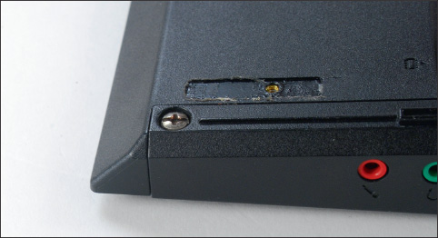
Open the lid of the laptop slightly so that the lid doesn’t obstruct your removing the drive. Turn the laptop on its side and push the drive out of its bay (see Figure 5-34). Then remove the plastic cover from the drive. Move the cover to the new drive, and insert the new drive in the bay. Next, replace the screw and power up the system.
Figure 5-34
Push the drive out of its bay
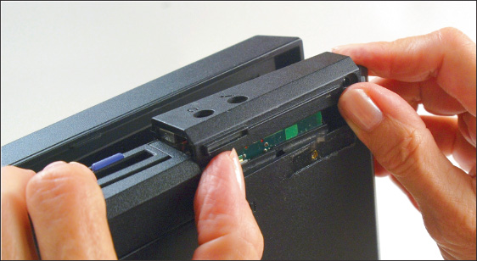
When the system boots up, BIOS/UEFI should recognize the new drive and search for an operating system. If the drive is new, boot from the Windows setup or recovery DVD or USB flash drive and install the OS.
Notes
It is possible to give general directions on desktop computer repair that apply to all kinds of brands, models, and systems. Not so with laptops. Learning to repair laptops involves learning unique ways to assemble, disassemble, and repair components for specific brands and models of laptops.
For some laptops, such as the one shown in Figure 5-35, you remove a cover on the bottom of the computer to expose the hard drive. You then remove one screw that anchors the drive. You can then remove the drive.
Figure 5-35
Remove a cover on the bottom of the laptop to exchange the hard drive, which is attached to a proprietary bracket
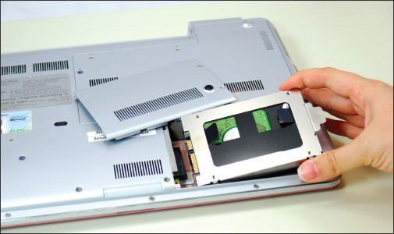
Go to pg.
help
Application Opened
Main content

5-2gSetting up Hardware RAID
A+ Core 1
- 3.4
Given a scenario, select, install and configure storage devices.
For most personal computers, a single hard drive works independently of any other installed drives. A technology that configures two or more hard drives to work together as an array of drives is called RAID (redundant array of inexpensive disks or redundant array of independent disks) . Two reasons you might consider using RAID are:
- To improve performance by writing data to two or more hard drives so that a single drive is not excessively used.
- To improve fault tolerance, which is a computer’s ability to respond to a fault or catastrophe, such as a hardware failure or power outage, so that data is not lost. If data is important enough to justify the cost, you can protect the data by continuously writing two copies of it, each to a different hard drive. This method is most often used on high-end, expensive file servers, but it is occasionally appropriate for a single-user workstation.

Types of RAID
Several types of RAID exist; the four most commonly used are RAID 0, RAID 1, RAID 5, and RAID 10. Following is a brief description of each, including another method of two disks working together called spanning. The first four methods are diagrammed in Figure 5-36:
Figure 5-36
Ways that hard drives can work together
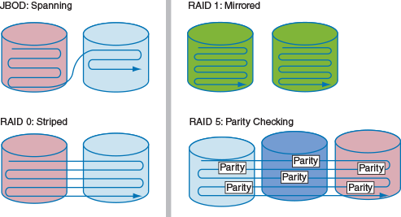
- Spanning, sometimes called JBOD (just a bunch of disks), uses two hard drives to hold a single Windows volume, such as drive E:. Data is written to the first drive, and when it is full, the data continues to be written to the second. The purpose of spanning is to increase the disk space available for a single volume.
- RAID 0 also uses two or more physical disks to increase the disk space available for a single volume. RAID 0 writes to the physical disks evenly across both disks so that neither receives all the activity; this improves performance. Windows calls RAID 0 a striped volume. To understand that term, think of data striped—or written across—several hard drives. RAID 0 is preferred to spanning.
Notes
A Windows volume is a logical hard drive that is assigned a drive letter like C: or E:. The volume can be part or all of a physical hard drive or can span multiple physical hard drives. Earlier in the chapter you learned about the Asus Prime Z370-P motherboard, which has two M.2 slots. When you install matching M.2 SSD cards in these slots, you can use BIOS/UEFI setup to configure these two cards in a RAID-0 array, which creates a superfast single logical hard drive or Windows volume.
- RAID 1 is a type of mirroring that duplicates data on one drive to another drive and is used for fault tolerance. Each drive has its own volume, and the two volumes are called mirrors. If one drive fails, the other continues to operate and data is not lost. Hot-swapping is allowed in RAID 1. Windows calls RAID 1 a mirrored volume.
- RAID 5 stripes data and parity information across three or more drives and uses parity checking, so that if one drive fails, the other drives can re-create the data stored on the failed drive by using the parity information. Data is not duplicated, and therefore RAID 5 makes better use of volume capacity. RAID-5 drives increase performance and provide fault tolerance. Hot-swapping is allowed in RAID 5. Windows calls these drives RAID-5 volumes.
- RAID 10, also called RAID 1+0 and pronounced “RAID one zero” (not “RAID ten”), is a combination of RAID 1 and RAID 0. It takes at least four disks for RAID 10. Data is mirrored across pairs of disks, as shown at the top of Figure 5-37. In addition, the two pairs of disks are striped, as shown at the bottom of Figure 5-37. To help you better understand RAID 10, notice the data labeled as A, A, B, B across the first stripe. RAID 10 is the most expensive solution that provides the best redundancy and performance and allows for hot-swapping.
Figure 5-37
RAID 1 and RAID 10
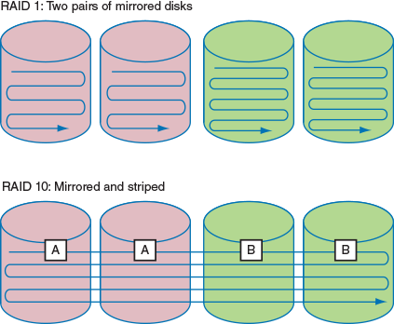
A+ Exam Tip
The A+ Core 1 exam may give you a scenario and expect you to select the appropriate RAID-0, RAID-1, RAID-5, or RAID-10 configuration. You are also expected to be able to install and configure a RAID system.
All RAID configurations can be accomplished at the hardware level (called hardware RAID) or at the operating system level (called software RAID). In Windows 10/8/7, you can use the Disk Management utility to group hard drives in a RAID array. Windows 10/8 also offers the Storage Spaces utility to implement software RAID. However, software RAID is considered an unstable solution and is not recommended by Microsoft. Configuring RAID at the hardware level is considered best practice because if Windows gets corrupted, the hardware might still be able to protect the data. Also, hardware RAID is generally faster than software RAID.

How to Implement Hardware RAID
Hardware RAID can be set up by using a RAID-enabled motherboard that is managed in BIOS/UEFI setup or by using a RAID controller card. When using a RAID controller card, run the software that comes with the card to set up your RAID array.
For best performance in any RAID system, all hard drives in an array should be identical in brand, size, speed, and other features. Also, if Windows will be installed on a hard drive that is part of a RAID array, RAID must be implemented before Windows is installed because all data on the drives will be lost when you configure RAID. As with installing any hardware, first read the documentation that comes with the motherboard or RAID controller and follow those specific directions rather than the general guidelines given here. Make sure you understand which RAID configurations the board or card supports.
A+ Exam Tip
The A+ Core 1 exam expects you to be able to set up hardware RAID and, given a scenario, know when it is appropriate to require hot-swappable drives for the array.
For one motherboard that has six SATA connectors that support RAID 0, 1, 5, and 10, here are the general directions to install three matching hard drives in a RAID-5 array:
- Install the three SATA drives in the computer case and connect each drive to a SATA connector on the motherboard (see Figure 5-38). To help keep the drives cool, install them with an empty bay between each drive.
Figure 5-38
Install three matching hard drives in a system
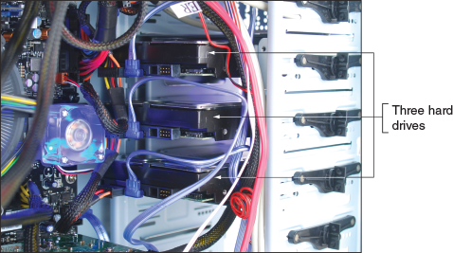
- Boot the system and enter BIOS/UEFI setup. On the Advanced setup screen, verify that the three drives are recognized. Select the option to configure SATA and then select RAID from the menu (see Figure 5-39).
Figure 5-39
Configure SATA ports on the motherboard to enable RAID
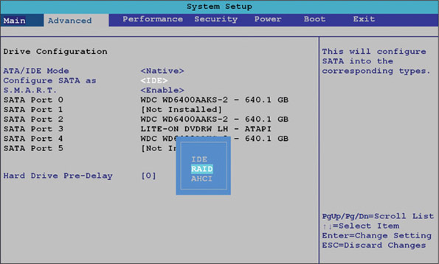
Source: Intel
- Reboot the system. A message is displayed on screen: “Press <Ctrl+I> to enter the RAID Configuration Utility.” Press Ctrl and I to enter the utility (see Figure 5-40). Notice in the information area that the three drives are recognized and their current status is Non-RAID Disk.
Figure 5-40
Use a BIOS/UEFI utility to configure a RAID array
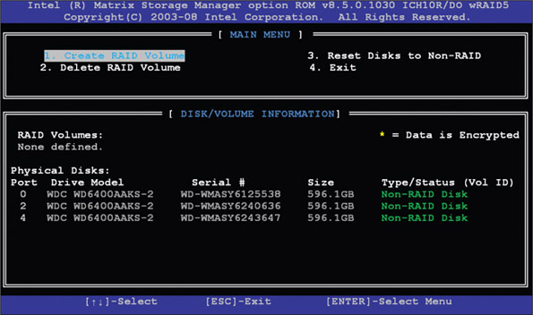
Source: Intel
- Select option 1 to Create RAID Volume. On the next screen shown in Figure 5-41, enter a volume name (FileServer in our example).
Figure 5-41
Make your choices for the RAID array
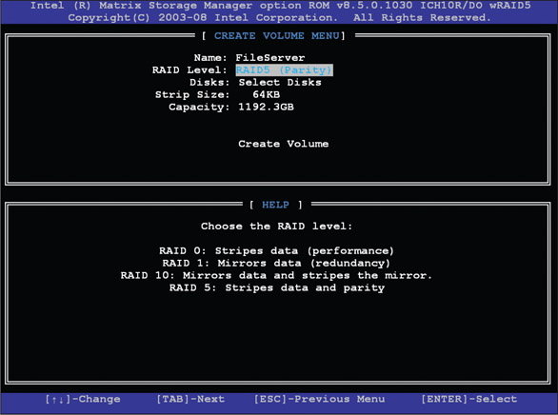
Source: Intel
- Under RAID Level, select RAID5 (Parity). Because we are using RAID 5, which requires three hard drives, the option to select the disks for the array is not available. All three disks will be used in the array.
- Select the value for the Strip Size. (This is the amount of space devoted to one strip across the striped array. Choices are 32 KB, 64 KB, or 128 KB.)
- Enter the size of the volume. The available size is shown in Figure 5-41 as 1192 GB, but you don’t have to use all the available space. The space you don’t use can later be configured as another array. (In this example, I entered 500 GB.)
- Select Create Volume to complete the RAID configuration. A message warns that if you proceed, all data on all three hard drives will be lost. Type Y to continue. The array is created and the system reboots.
You are now ready to install Windows. Windows 10/8/7 has built-in hardware RAID drivers and therefore automatically “sees” the RAID array as a single 500-GB hard drive. After Windows is installed on this one logical drive, Windows will call it volume C:.
Applying Concepts

Troubleshooting Hard Drive Installations
A+ Core 1
- 5.3
Given a scenario, troubleshoot hard drives and RAID arrays.
Sometimes, trouble crops up during an installation. Keeping a cool head, thinking things through carefully several times, and using all available resources will most likely get you out of any mess.
Installing a hard drive is not difficult unless you have an unusually complex situation. For example, your first hard drive installation should not involve the extra complexity of installing a RAID array. If a complicated installation is necessary and you have never installed a hard drive, ask for expert help.
The following list describes errors that cropped up during a few hard drive installations; the list also includes the causes of the errors and what was done about them. Everyone learns something new when making mistakes, and you probably will, too. You can then add your own experiences to this list:
- When first turning on a previously working computer, Susan received the following error message: “Hard drive not found.” She turned off the machine, checked all cables, and discovered that the data cable from the motherboard to the drive was loose. She reseated the cable and rebooted. POST found the drive.
- Lucia physically installed a new hard drive, replaced the cover on the computer case, and booted the computer with a Windows setup DVD in the drive. POST beeped three times and stopped. Recall that diagnostics during POST are often communicated by beeps if the tests take place before POST has checked video and made it available to display the messages. Three beeps on some computers signal a memory error. Lucia turned off the computer and checked the memory modules on the motherboard. A module positioned at the edge of the motherboard next to the cover had been bumped as she replaced the cover. She reseated the module and booted again, this time with the cover still off. The error disappeared.
- Jason physically installed a new hard drive and turned on the computer. He received the following error: “No boot device available.” He had forgotten to insert a Windows setup DVD. He put the disc in the drive and rebooted the machine successfully.
- The hard drive did not physically fit into the bay. The screw holes did not line up. Juan got a bay kit, but it just didn’t seem to work. He took a break, went to lunch, and came back to make a fresh start. Juan asked others to help him view the brackets, holes, and screws from a fresh perspective. It didn’t take long to discover that he had overlooked the correct position for the brackets in the bay.
Caution
When things are not going well, you can tense up and make mistakes more easily. Be certain to turn off the machine before doing anything inside! Not doing so can be a costly error. For example, a friend had been trying and retrying to boot for some time and got frustrated and careless. She plugged the power cord into the drive without turning the computer off. The machine began to smoke and everything went dead. The next thing she learned was how to replace a power supply!
Go to pg.
help
Application Opened
Main content

5-2hNAS Devices and External Storage
A+ Core 1
- 3.8
Given a scenario, select and configure appropriate components for a custom PC configuration to meet customer specifications or needs.
Hard drives are sometimes installed in external enclosures, such as the one shown in Figure 5-42. These enclosures make it easy to expand the storage capacity of a single computer or to make hard drive storage available to an entire network. For network attached storage (NAS), the enclosure connects to the network using an Ethernet port. When the storage is used by a single computer, the connection is made using a USB or eSATA port. Regardless of how the enclosure connects to a computer or network, the hard drives inside the enclosure might use a SATA connection.
Figure 5-42
The NAS ShareCenter Pro 1100 by D-Link can hold four hot-swappable SATA hard drives totaling 12 TB of storage, has a dual-core processor and 512 MB of RAM, and supports RAID
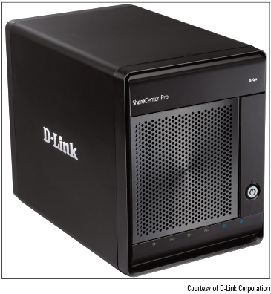
Courtesy of D-Link Corporation
Here is what you need to know about supporting these external enclosures:
- An enclosure might contain firmware that supports RAID. For example, a switch on the rear of one enclosure for two hard drives can be set for RAID 0, RAID 1, or stand-alone drives. Read the documentation for the enclosure to find out how to manage the RAID volumes.
- To replace a hard drive in an enclosure, see the documentation for the enclosure to find out how to open it and replace the drive.
- If a computer case is overheating, one way to solve the problem is to remove the hard drives from the case and install them in an external enclosure. However, it’s better to leave the hard drive that contains the Windows installation in the case.
- You can purchase a SATA controller card that provides external eSATA connectors to be used when
  - the motherboard eSATA port is not functioning, or
  - the motherboard does not support a fast SATA standard that your hard drives use.
Figure 5-43 shows a PCIe storage controller card that offers two internal SATA III connections and two eSATA III ports.
Figure 5-43
This PCIe x2 eSATA card by Ableconn has two eSATA ports and supports the SATA3 6-Gb/sec standard
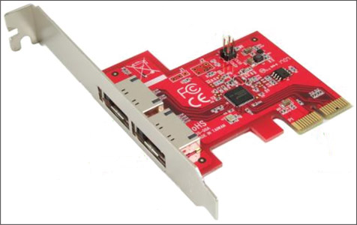
Source: Ableconn at ableconn.com
Now let’s move on to other types of storage devices, including optical drives and flash cards.
Go to pg.
help
Application Opened
Main content

5-3Supporting Other Types of Storage Devices
A+ Core 1
- 1.1
Given a scenario, install and configure laptop hardware and components.
- 3.4
Given a scenario, select, install and configure storage devices.
- 3.6
Explain the purposes and uses of various peripheral types.
Before we explore the details of several other types of storage devices, including optical discs, USB flash drives, and memory cards, let’s start with the file systems they might use.
Go to pg.
help
Application Opened
Main content

5-3aFile Systems Used by Storage Devices
A+ Core 1
- 3.4
Given a scenario, select, install and configure storage devices.
A storage device, such as a hard drive, CD, DVD, USB flash drive, or memory card, uses a file system to manage the data stored on the device. A file system is the overall structure the operating system uses to name, store, and organize files on a drive. In Windows, each storage device or group of devices, such as a RAID array, is treated as a single logical drive. When Windows first recognizes a new logical drive in the system, it determines which file system the drive is using, assigns it a drive letter (for example, C: or D:), and calls it a volume. Use File Explorer in Windows 10/8 or Windows Explorer in Windows 7 to see volumes and devices in Windows (see Figure 5-44). To see information about the volume or device, right-click it and select Properties from the shortcut menu. The device or volume Properties box appears, which shows its file system and storage capacity (see the right side of Figure 5-44).
Figure 5-44
This 16-GB USB flash drive is using the FAT32 file system
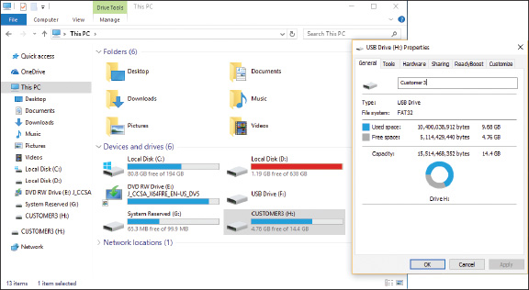
Using Windows to install a new file system on a device or logical drive is called formatting, a process that erases all data on the device or drive. One way to format a device is to right-click it and select Format from the shortcut menu. In the box that appears, you can select the file system that works for this device (see Figure 5-45). If you have problems with a device, make sure it’s using a file system appropriate for your situation:
- NTFS (New Technology file system) is primarily used by hard drives.
- The exFAT file system is used by large-capacity removable storage devices, including some USB flash drives, memory cards, and external hard drives.
- FAT32 and FAT file systems are used by smaller-capacity devices.
- CDFS (Compact Disc File System) or the UDF (Universal Disk Format) file system is used by CDs.
- A newer version of the UDF file system is used by DVDs and BDs (Blu-ray discs).
Figure 5-45
A storage device can be formatted using File Explorer
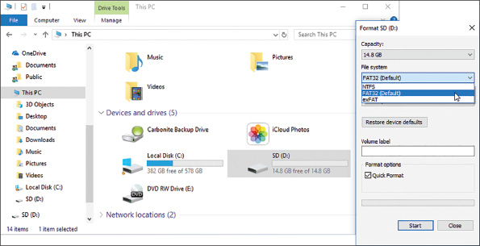
Now let’s look at the types of optical drives you might be called on to support.
Go to pg.
help
Application Opened
Main content

5-3bStandards Used by Optical Discs and Drives
A+ Core 1
- 3.6
Explain the purposes and uses of various peripheral types.
CDs (compact discs), DVDs (digital versatile discs or digital video discs) , and BDs (Blu-ray discs) use similar laser technologies. Tiny lands and pits on the surface of a disc represent bits, which a laser beam can read. This is why they are called optical storage technologies.

Optical Discs
Data is written to only one side of a CD, but it can be written to one or both sides of a DVD or Blu-ray disc. Also, a DVD or Blu-ray disc can hold data in two or more layers on each side. For example, a dual-layer, double-side DVD can hold a total of four layers on one disc (see Figure 5-46).
Figure 5-46
A DVD can hold data in double layers on both the top and bottom of the disc, yielding a maximum capacity of 17 GB
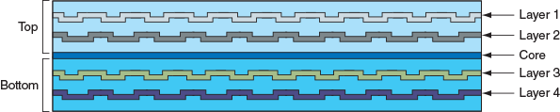
The breakdown of how much data can be held on CDs, DVDs, and BDs is shown in Figure 5-47. The capacities for DVDs and BDs depend on the number of sides and layers used to hold the data.
Figure 5-47
Storage capacities for CDs, DVDs, and BDs
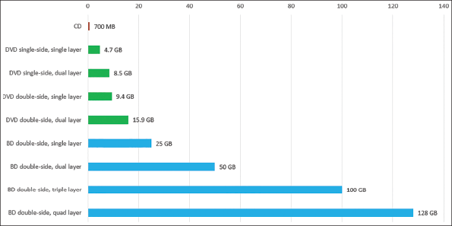
Notes
The discrepancy in the computer industry between 1 billion bytes (1,000,000,000 bytes) and 1 GB (1,073,741,824 bytes) exists because 1 KB equals 1024 bytes. Even though documentation might say that a DVD holds 17 GB, it actually holds 17 billion bytes, which is only 15.90 GB.

Optical Drives and Burners
Blu-ray drives are backward compatible with DVD and CD technologies, and DVD drives are backward compatible with CD technologies. Depending on the drive features, an optical drive might be able to read and write to BDs, DVDs, and CDs. A drive that can write to discs is commonly called a burner. Today’s internal optical drives interface with the motherboard by way of a SATA connection. An external drive might use an eSATA or USB port. Figure 5-48 shows an internal DVD drive, and Figure 5-49 shows an external DVD drive.
Figure 5-48
This internal DVD drive uses a SATA connection
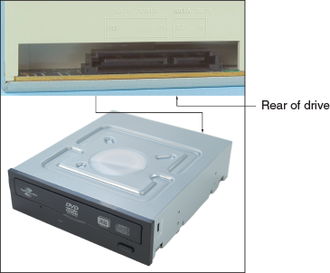
Figure 5-49
The PX-610U external DVD±RW drive by Plextor uses a USB 2.0 port
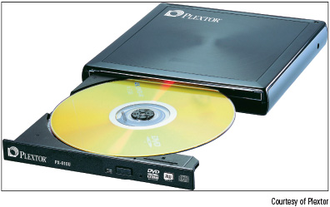
Courtesy of Plextor
When shopping for an optical drive or burner, suppose you see a couple of ads like those shown in Figure 5-50. To sort out the mix of disc standards, Table 5-2 can help. The table lists the popular CD, DVD, and Blu-ray disc and drive standards.
Figure 5-50
Ads for two internal DVD and Blu-ray burners offer many options
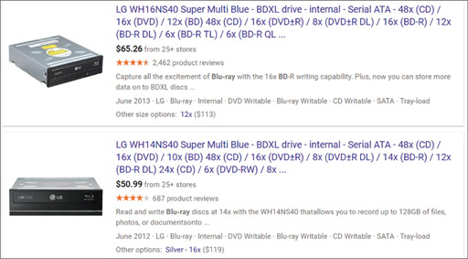
Source: google.com
Table 5-2

Optical Disc and Drive Standards
Standard | Description
CD-ROM disc or drive | CD read-only memory. A CD-ROM disc burned at the factory can hold music, software, or other data. The bottom of a CD-ROM disc is silver. A CD-ROM drive can read CDs.
CD-R disc | CD recordable. A CD-R disc is a write-once CD.
CD-RW disc or drive | CD rewriteable. A CD-RW disc can be written to many times. A CD-RW drive can write to a CD-RW or CD-R disc and overwrite a CD-RW disc.
DVD-ROM drive | DVD read-only memory. A DVD-ROM drive can also read CDs or DVDs.
DVD-R disc | DVD recordable, single layer. A DVD-R disc can hold up to 4.7 GB of data and is a write-once disc.
DVD-R DL disc | DVD recordable in dual layers. Doubles storage to 8.5 GB of data on two layers.
DVD-RW disc or drive | DVD rewriteable. A DVD-RW disc is also known as an erasable, recordable disc or a write-many disc. The speeds in an ad for an optical drive indicate the maximum speed supported when burning this type of disc—for example, DVD-RW 6X.
DVD-RW DL disc or drive, aka. DL DVD drive | DVD rewriteable, dual layers. A DVD-RW DL disc has a storage capacity of 8.5 GB.
DVD+R disc or drive | DVD recordable. Similar to DVD-R but faster. Discs hold about 4.7 GB of data.
DVD+R DL disc or drive | DVD recordable, dual layers. A DVD+R DL disc has 8.5 GB of storage.
DVD+RW disc or drive | DVD rewriteable. Faster than DVD-RW.
DVD-RAM disc or drive | DVD random access memory. Rewriteable and erasable. You can erase or rewrite certain sections of a DVD-RAM disc without disturbing other sections of the disc, and the discs can handle many times the number of rewrites (around 100,000) over the thousand rewrites expected for most DVD-RW and DVD+RW discs. DVD-RAM discs are popular media used in camcorders and set-top boxes.
BD-ROM drive | BD or Blu-ray disc read-only memory. A BD-ROM drive can also read DVDs, and some can read CDs.
BD-R disc or drive | BD recordable. The drive reads/writes only one layer of data, for a capacity of 25 GB. A BD-R disc handles one-time recording and is designed for large HD video and audio files.
BD-R DL disc or drive | BD recordable dual-layer. A BD-R DL drive or disc handles dual layers, yielding a 50-GB capacity. The discs support one-time recording.
BD-RE disc or drive | BD rewriteable. A BD-RE drive may read/write single layers, yielding a 25-GB capacity. A BD-RE disc can handle rewriting to the disc up to 1,000 times.
BD-RE DL disc or drive | BD rewriteable dual-layer. A BD-RE DL disc with a capacity of 50 GB can handle rewriting up to 1,000 times and is designed to hold backups of video and music libraries.
BD-R TL disc or drive  BD-R XL TL disc or drive | BD recordable triple-layer. A BD-R TL disc uses three layers, yielding 100-GB capacity, and supports one-time recording.
BD-R QL disc or drive  BD-R XL QL disc or drive | BD recordable quad-layer. BD-R QL discs have four layers, yielding 128-GB capacity. These discs are primarily used in data centers and cloud computing.
A+ Exam Tip
The A+ Core 1 exam expects you to know about combo optical drives and burners, including CD-ROM, CD-RW, DVD-ROM, DVD-RW, DVD-RW DL, Blu-ray, BD-R, and BD-RE combo drives. To prepare for the exam, study the details of Table 5-2. You need to know how to select the appropriate type of disc, given a scenario.
Notes
CDs, DVDs, and BDs are expected to hold their data for many years; however, you can prolong the life of a disc by protecting it from exposure to light.
Go to pg.
help
Application Opened
Main content

5-3cInstalling an Optical Drive
A+ Core 1
- 3.4
Given a scenario, select, install and configure storage devices.
Internal optical drives on today’s computers use a SATA interface. Figure 5-51 shows the rear of a SATA optical drive. An optical drive is usually installed in the drive bay at the top of a desktop case (see Figure 5-52). After the drive is installed in the bay, connect the data and power cables.
Figure 5-51
The rear of a SATA optical drive
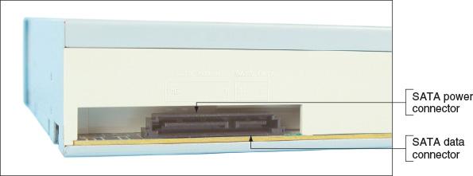
Figure 5-52
Slide the drive into the bay flush with the front panel
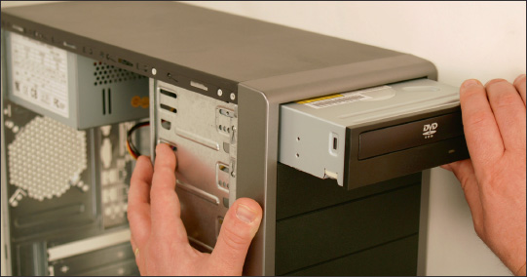
A+ Exam Tip
The A+ Core 1 exam expects you to know how to select and install a CD, DVD, or Blu-ray drive.
Windows 10/8/7 supports optical drives using its own embedded drivers without add-on drivers. Therefore, when Windows first starts up after the drive is installed, it recognizes the drive and installs drivers. Use Device Manager to verify that the drive installed with no errors and is ready to use.
Go to pg.
help
Application Opened
Main content

5-3dReplacing an Optical Drive on a Laptop
A+ Core 1
- 1.1
Given a scenario, install and configure laptop hardware and components.
Because the need to have an optical drive on a computer is decreasing, some newer laptops don’t include it, which saves on size and weight of the laptop. If you find you need an optical drive with a laptop, use an external model that connects by way of a USB port. If an internal optical drive goes bad on a laptop, it is likely cheaper to replace the optical drive than the laptop. For some systems, you’ll need to first remove the keyboard to expose an optical drive. Follow along as we remove the DVD drive from one laptop system:
- Very important: Shut down the system, unplug the AC adapter, and remove the battery pack.
- To remove the keyboard from this laptop, you first remove one screw on the bottom of the case and then turn the case over and pry up the keyboard. You can then move the keyboard to one side. You can leave the ribbon cable from the motherboard to the keyboard connected. When you move the keyboard out of the way, the DVD drive is exposed, as shown in Figure 5-53.
Figure 5-53
Remove the keyboard to expose the optical drive
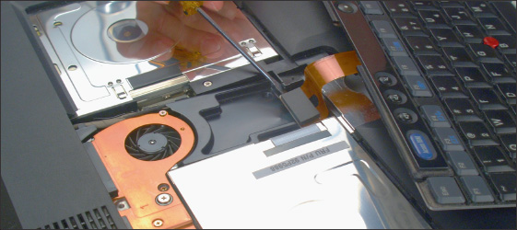
- Remove the screw that holds the DVD drive to the laptop (see Figure 5-54).
Figure 5-54
Remove the screw that holds the DVD drive
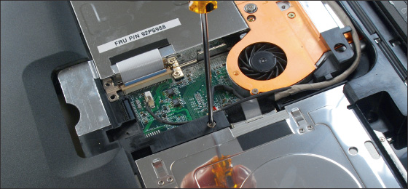
- Slide the drive out of the bay (see Figure 5-55).
Figure 5-55
Slide the drive out of the bay
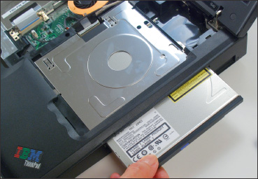
- When you slide the new drive into the bay, make sure you push it far enough into the bay so that it solidly connects with the drive connector at the back of the bay. Replace the screw.
For other systems, the optical drive can be removed by first removing a cover from the bottom of the laptop. Then you remove one screw that secures the drive. Next, push the optical drive out of the case (see Figure 5-56).
Figure 5-56
Push the optical drive out the side of the case
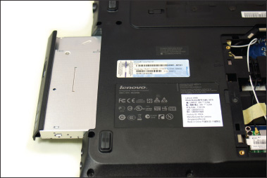
Go to pg.
help
Application Opened
Main content

5-3eSolid-State Storage
A+ Core 1
- 3.4
Given a scenario, select, install and configure storage devices.
- 3.6
Explain the purposes and uses of various peripheral types.
Types of solid-state storage include SSDs, USB flash drives, and memory cards. Current USB flash drives range in size from 256 MB to 2 TB and go by many names, including a flash pen drive, jump drive, thumb drive, and key drive. Several USB flash drives are shown in Figure 5-57. Flash drives might work at USB 2.0 or USB 3.0 speed and use the FAT (for small-capacity drives) or exFAT file system (for large-capacity drives). Windows 10/8/7 has embedded drivers to support flash drives. To use one, simply insert the device in a USB port. It then appears in Windows 10/8 File Explorer or Windows 7 Windows Explorer as a drive with an assigned letter.
Figure 5-57
USB flash drives come in a variety of styles and sizes
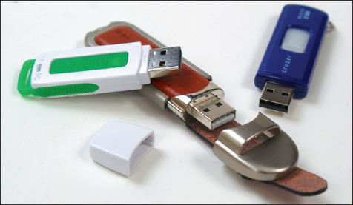
Notes
To make sure that data written to a flash drive is properly saved, right-click the drive in File Explorer or Windows Explorer and select Eject from the shortcut menu. It is then safe to remove the drive.
Memory cards might be used in digital cameras, tablets, smartphones, MP3 players, digital camcorders, and other portable devices, and most laptops have memory card slots provided by a built-in smart card reader. If there is not a memory card slot in the device, you can add an external smart card reader/writer that uses a USB connection. For a desktop, you can install a universal smart card reader/writer in a drive bay. For example, the device shown in Figure 5-58 reads and writes to several types of smart cards. It installs in a desktop drive bay and connects to the motherboard by way of a 9-pin USB cable. Plug the cable into an empty 9-pin USB 2.0 header on the motherboard.
Figure 5-58
This 7-slot USB 2.0 Internal Memory Card Reader and Writer by Sabrent supports multiple types of smart cards
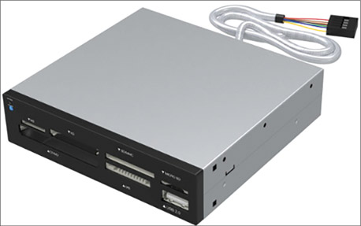
Source: https://www.sabrent.com/product/CRW-UINB/7-slot-usb-2-0-internal-memory-card-reader-writer/
The most popular memory cards are Secure Digital (SD) cards, which follow the standards of the SD Association ( sdcard. org ) and are listed in Table 5-3. The three standards for capacity used by SD cards are 1.x (regular SD), 2.x (SD High Capacity or SDHC), and 3.x (SD eXtended Capacity or SDXC). Besides capacity, SD cards come in three physical sizes (full-size, MiniSD, and MicroSD) and are rated for speed in classes.
Table 5-3

Flash Memory Cards That Follow the SD Association Standards
 | Full-size SD | MiniSD | MicroSD
SD  SD 1.x  Holds up to 2 GB | SD card  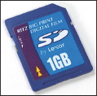 | MiniSD card  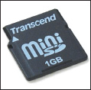 | MicroSD card  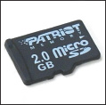
SD High Capacity  SD 2.x  Holds 1 GB to 32 GB | SDHC card  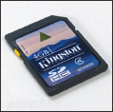 | MiniSDHC card  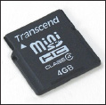 | MicroSDHC card  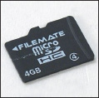
SD eXtended Capacity  SD 3.x  Holds 32 GB to 2 TB | SDXC card  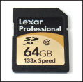 | N/A | MicroSDXC card  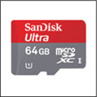  Source: Courtesy of SanDisk
Popular classes for rating speeds, from slowest to fastest, are class 2, 4, 6, 10, Ultra High Speed class 1 (UHS class 1), and UHS class 3. For digital cameras, class 4 or 6 should be fast enough. For high-resolution video recording, use class 10 or higher. To know the class rating, look for a symbol (see Figure 5-59) on the card. Generally, the higher the speed, the more expensive the card becomes. For SD cards rated in UHS classes, the device must also be rated for UHS to get the higher speeds.
Figure 5-59
Look for one of these symbols on an SD card to indicate class rating speed

Source: https://www.howtogeek.com/189897/how-to-buy-an-sd-card-speed-classes-sizes-and-capacities-explained/
SDHC and SDXC slots are backward compatible with earlier standards for SD cards. However, you cannot use an SDHC card in an SD slot, and you cannot use an SDXC card in an SDHC slot or SD slot. Only use SDXC cards in SDXC slots.
SD and SDHC cards use the FAT file system, and SDXC cards use the exFAT file system. Windows 10/8/7 supports both file systems, so you should be able to install an SD, SDHC, or SDXC card in an SD slot on a Windows laptop with no problems (assuming the slot supports the SDHC or SDXC card you are using).
Memory cards other than SD cards are shown in Table 5-4. Some of the cards in the table are seldom used today.
A+ Exam Tip
The A+ Core 1 exam expects you to know about SD, MicroSD, MiniSD, CompactFlash, and xD memory cards. Given a scenario, you need to know which type of flash storage device is appropriate for the situation.
Table 5-4

Flash Memory Cards
Flash Memory Device | Example
The Sony Memory Stick PRO Duo is about half the size of the Memory Stick PRO but is faster and has a greater storage capacity (up to 2 GB). You can use an adapter to insert the Memory Stick PRO Duo in a regular Memory Stick slot. | 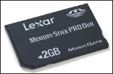
CompactFlash (CF) cards come in two types, Type I (CFI) and Type II (CFII). Type II cards are slightly thicker. CFI cards will fit a Type II slot, but CFII cards will not fit a Type I slot. The CF standard allows for sizes up to 137 GB, although current sizes range up to 64 GB. UDMA CompactFlash cards are faster than other CompactFlash cards. UDMA (Ultra Direct Memory Access) transfers data from the device to memory without involving the CPU. | 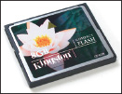
MultiMediaCard (MMC) looks like an SD card, but the technology is different and they are not interchangeable. Generally, SD cards are faster than MMC cards. | 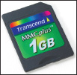
The xD-Picture Card has a compact design (about the size of a postage stamp), and currently holds up to 2 GB of data. You can use an adapter to insert this card into a PC Card slot on a laptop computer or a CF slot on a digital camera. | 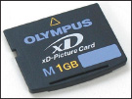
Figure 5-60 shows several flash memory cards together so you can get an idea of their relative sizes. Sometimes a memory card is bundled with one or more adapters so that a smaller card will fit a larger card slot.
Figure 5-60
Flash memory cards
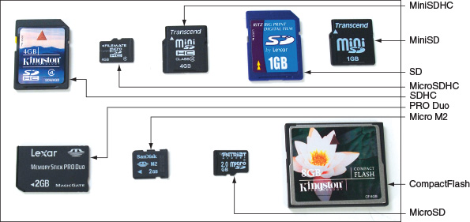
Go to pg.
help
Application Opened
Main content

5-4Troubleshooting Hard Drives
A+ Core 1
- 5.3
Given a scenario, troubleshoot hard drives and RAID arrays.
In this part of the chapter, you learn how to troubleshoot problems with hard drives. Hard drive problems during the boot can be caused by the hard drive subsystem, the file system on the drive, or files required by Windows when it begins to load. When trying to solve a problem with the boot, you need to decide if the problem is caused by hardware or software. All the problems discussed in this section are caused by hardware.
Go to pg.
help
Application Opened
Main content

5-4aSlow Performance
A+ Core 1
- 5.3
Given a scenario, troubleshoot hard drives and RAID arrays.
One of the most common complaints about a computer is that it is running slowly. In general, the overall performance of a system depends on the individual performances of the processor, motherboard, memory, and hard drive; often, the hard drive (for example, a 5400-RPM magnetic drive) or the hard drive interface (SATA2, for example) is the bottleneck.
If not managed well, hard drives can run slower over time, and full hard drives run slower than others. For best performance, don’t allow an SSD to exceed 70% capacity and a magnetic drive to exceed 80% capacity.
You can use Windows tools or tools provided by the hard drive manufacturer to optimize a drive.

Windows Automatically Optimizes a Drive
First, let’s understand why performance might slow down for magnetic drives and SSDs:
- Magnetic drives. When a magnetic drive is new, files are physically written in contiguous sectors (one following another without a break). Over time, as more files are written and deleted, files are stored in disconnected fragments on the drive and slow performance can result. To improve performance, every week Windows automatically defragments a magnetic drive, rearranging fragments or parts of files in contiguous clusters.
- SSDs. For SSDs, data is organized in blocks and each block contains many pages. A file can spread over several pages in various blocks. Each time a new page is written to the drive, the entire block to which it belongs must be read into a buffer, erased, and then rewritten with the new page included. When a file is deleted, information about the file is deleted, but the actual data in the file is not erased. This can slow down SSD performance because the unused data must still be read and rewritten in its block. To improve performance, Windows sends the trim command to an SSD to erase a block that no longer contains useful data so that a write operation does not have to manage the data. Once a week, Windows 10/8 also sends a retrim command to the SSD to erase all blocks that are filled with unused data. (Windows 7 does not retrim to optimize SSDs.)
You can use the Windows Defrag and Optimization tool (dfrgui.exe) to verify that Windows is defragmenting a magnetic drive and trimming an SSD. When you run the dfrgui command in Windows, the Optimize Drives window appears and reports the status of each drive installed in the system (see Figure 5-61 for Windows 8). To verify the settings, click Change settings. If a drive has not been recently optimized, click Optimize.
Figure 5-61
Windows reports volume C: is trimmed and volume D: is not fragmented
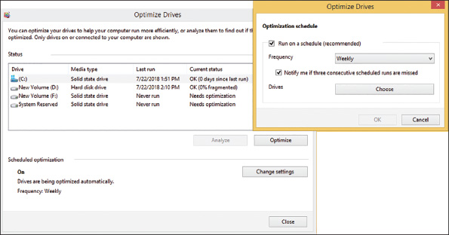
Notes
To run a command in Windows, enter the command (for example, dfrgui) in the Windows 10 or Windows 7 search box or in the Windows 8 run box.

Drive Manufacturer Utilities
Most magnetic drive and SSD manufacturers offer free utilities you can download and use to update drive firmware and optimize and troubleshoot a drive. For example, Intel offers Solid State Drive Toolbox for its SSDs, Seagate has SeaTools for its magnetic drives and SSDs, and Kingston offers SSD Toolbox for its drives. Search the manufacturer website to find and download the tools and get other hard drive support.
Go to pg.
help
Application Opened
Main content

5-4bHard Drive Problems during the Boot
A+ Core 1
- 5.3
Given a scenario, troubleshoot hard drives and RAID arrays.
Hardware problems usually show up at POST, unless there is physical damage to an area of the hard drive that is not accessed during POST. Hardware problems often make the hard drive totally inaccessible. If BIOS/UEFI cannot find a hard drive at POST, it displays an error message similar to one of the following. Most likely, the error message is in white text on a black background.
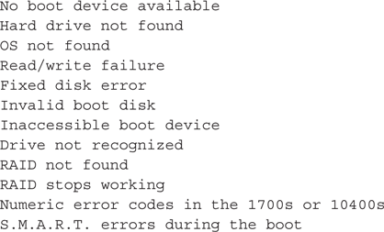
If BIOS/UEFI cannot access the drive, the cause might be the drive, the data cable, the electrical system, the motherboard, or a loose connection. Here is a list of things to do and check before you open the case:
- If BIOS/UEFI displays numeric error codes or cryptic messages during POST, check the website of the motherboard manufacturer for explanations of these codes or messages, or do a general Google search.
- Check BIOS/UEFI setup for errors in the hard drive configuration. If you suspect an error, set BIOS/UEFI to default settings, make sure autodetection is turned on, and reboot the system.
- Try booting from other bootable media such as the Windows setup DVD or a USB flash drive or CD with the Linux OS and diagnostics software installed. You learn more about this in a project at the end of this chapter. If you can boot using other media, you have proven that the problem is isolated to the hard drive subsystem. You can also use the bootable media to access the hard drive, run diagnostics on the drive, and possibly recover its data.
- For a RAID array, use the firmware utility to check the status of each disk in the array and to check for errors. Press a key at startup to access the RAID BIOS/UEFI utility. This utility lists each disk in the array and its status. You can search the website of the motherboard or RAID controller manufacturer for an interpretation of the messages on this screen and what to do about them. If one of the disks in the array has gone bad, it might take some time (as long as two days for large-capacity drives) for the array to rebuild using data on the other disks. In this situation, the status for the array is likely to show as Caution.
After the array has rebuilt, your data should be available. However, if one of the hard drives in the array has gone bad, you need to replace the hard drive. After you have replaced the failed drive, you must add it back to the RAID array. This process is called rebuilding a RAID volume. How to do this depends on the RAID hardware you are using. For some motherboards or RAID controller cards, you use the RAID firmware. For others, you use the RAID management software that came bundled with the motherboard or controller. You install this software in Windows and use the software to rebuild the RAID volume using the new hard drive.
If the problem is still not solved, open the case and check the following things. Be sure to protect the system against ESD as you work:
- Remove and reattach all drive cables.
- If you’re using a RAID or SATA controller card, remove and reseat it or place it in a different slot. Check the documentation for the card, looking for directions for troubleshooting.
- Inspect the drive for damage, such as bent pins on the cable or drive connection.
- Determine if a magnetic hard drive is spinning by listening to it or lightly touching the metal drive (with the power on).
- Check the cable for frayed edges or other damage.
- Check the installation manual for things you might have overlooked. Look for a section about system setup and carefully follow all directions that apply.
- S.M.A.R.T. errors that display during the boot result from BIOS/UEFI reporting that the drive has met a threshold point of failure. Back up the data and replace the drive as soon as possible.
- When Windows is installed on a hard drive but cannot launch, it might present a blue screen with error messages, called a BSOD (blue screen of death), or it might hang and display a never-ending, spinning Windows pinwheel or wait icon. Windows includes several tools for checking a hard drive for errors and repairing a corrupted Windows installation, as you will learn in Chapter 15. Without getting into the details of supporting Windows, here are a few simple things you can try:
  - Use Windows 10/8/7 Startup Repair. In Chapter 4, you learned that the Startup Repair utility restores many of the Windows files needed for a successful boot. Following directions given in that chapter, boot from the Windows 10/8/7 setup DVD or flash drive, select the option to Repair your computer, and perform a Startup Repair.
  - Use the chkdsk command. To make sure the hard drive does not have bad sectors that can corrupt the file system, you can use the chkdsk command. The command works from Windows, but if you cannot start Windows from the hard drive, you can use the command after booting the system from Windows setup media and selecting the option to Repair your computer. Then, for Windows 10/8, go to the Advanced options screen (see Figure 5-62); for Windows 7, go to the System Recovery Options screen. Next select Command Prompt. At the command prompt that appears, use this chkdsk command to search for bad sectors on drive C: and recover data:
Figure 5-62
Select Command Prompt, where you can execute the chkdsk command
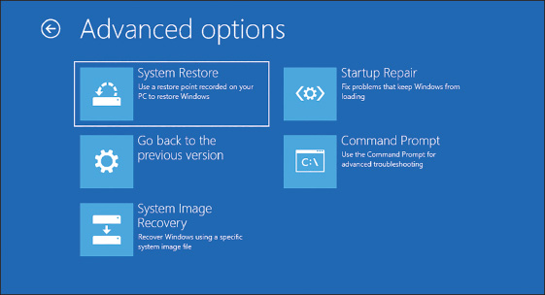
Notes
Early in the boot, BIOS/UEFI error messages usually display in white text on a black screen. Windows BSOD boot error messages display on a blue screen. As an IT help-desk technician, you might find yourself talking on the phone with a customer about his boot problem. To help you decide if the problem is happening during POST or as Windows is loading, ask the customer to tell you the color of the screen that shows the error message.
- Before Windows can format and install a file system on a drive, it first separates the drive into one or more partitions using the older MBR (Master Boot Record) or newer GPT (Global Partition Table) partitioning system. Here are steps you can take to repair an MBR hard drive:
  - Repair the BCD. The BCD (Boot Configuration Data) is a small database that holds parameters Windows needs for a successful boot. At a command prompt, use this bootrec command to rebuild the BCD:
  - Repair the boot sector. The first sector of a hard drive is called the boot sector and holds the MBR partition table, which maps the locations of partitions on the drive. To repair a corrupted boot sector, use this command:
  - Repair the MBR. The bootrec command can be used to fix problems with the MBR program in the boot sector that is needed to start Windows. Use this command:
- Check the drive manufacturer’s website for diagnostic software such as SeaTools, which is used to diagnose problems with Seagate drives. Sometimes these types of software, including SeaTools, can be run from a bootable USB flash drive or CD. Run the software to test the drive for errors.
- If it is not convenient to create a bootable USB flash drive or CD with hard drive diagnostic software installed, you can move the drive to a working computer and install it as a second drive in the system. Then you can use the diagnostic software installed on the primary hard drive to test the problem drive. While you have the drive installed in a working computer, be sure to find out if you can copy data from it to the good drive, so that you can recover any data not backed up. Remember that you set the drive on the open computer case (see Figure 5-63) or use a SATA-to-USB converter to connect the drive to a USB port. If you have the case open with the computer turned on, be very careful not to touch the drive or touch inside the case.
Figure 5-63
Temporarily connect a faulty hard drive to another system to diagnose the problem and try to recover data
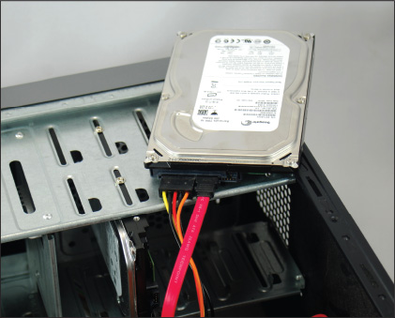
- After you have tried to recover the file system and data on the drive and before you decide to replace the hard drive, try these things to clean the drive and get a fresh start:
  - Format a hard drive volume. If you decide the hard drive volume is corrupted and you want to start over, boot the system from Windows setup media and open a Windows command prompt. Then use the format command to erase everything on the volume. In this example, D: is the drive letter for the volume:
  - Use diskpart to start over with a fresh file system. If formatting the volume doesn’t work, you can erase the hard drive partitions using the diskpart command. When you enter diskpart at a command prompt, the DISKPART> prompt appears. Then use the following commands to wipe everything off the hard drive. In the example, you are erasing partition 1 on disk 0.
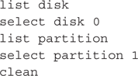
Use the exit command to exit the diskpart utility. You can then reinstall Windows, which partitions the hard drive again. If Windows cannot recognize the drive, it’s probably time to replace hardware in the hard drive subsystem.
- If the drive still does not boot, exchange the three field replaceable units—the data cable, the storage card (if the drive is connected to one), and the hard drive itself—for a hard drive subsystem. Do the following, in order, and test the hard drive after each step:
  - Try connecting the drive data cable to a different SATA connector on the motherboard. A SATA connector might be disabled when the system is using an M.2 slot.
  - Reconnect or swap the drive data cable.
  - Reseat or exchange the drive controller card, if one is present.
  - Exchange the hard drive for a known good drive.
- Sometimes older drives refuse to spin at POST or a failing drive can make a loud clicking noise. Drives that have trouble spinning often whine at startup for several months before they finally refuse to spin altogether. If your drive whines loudly when you first turn on the computer, do not turn off the computer, and replace the drive as soon as possible. One of the worst things you can do for a drive that has difficulty starting is to leave the computer turned off for an extended period of time. Some drives, like old cars, refuse to start if they are unused for a long time. A drive making a loud clicking noise most likely is not accessible and must be replaced.
- A bad power supply or a bad motherboard also might cause a disk boot failure.
If the problem is solved by exchanging the hard drive, take the extra time to reinstall the old hard drive and verify that the problem was not caused by a bad connection.
Go to pg.
help
Application Opened
Main content

Chapter Review

5-5aChapter Summary

Hard Drive Technologies and Interface Standards
- A hard disk drive (HDD) can be a magnetic drive, a solid-state drive, or a hybrid drive. A magnetic drive comes in three sizes: 3.5” for desktop computers and 2.5” and 1.8” for laptops.
- A solid-state drive contains NAND flash memory and is more expensive, faster, more reliable, and uses less power than a magnetic drive. Form factors used by SSDs include 2.5”, M.2, and PCIe cards.
- A hybrid hard drive (H-HDD) is a magnetic drive with an SSD buffer that improves performance.
- S.M.A.R.T. is a self-monitoring technology whereby the BIOS/UEFI monitors the health of the hard drive and warns of an impending failure.
- Interface standards used by hard drives and optical drives include the outdated IDE and SCSI standards, SATA (the most popular standard), and NVMe (applies only to SSDs and the fastest standard).
- Three SATA standards provide data transfer rates of 1.5 Gb/sec (using SATA I), 3 Gb/sec (using SATA II), and 16 Gb/sec (using SATA III).
- The NVMe standard can be used by SSDs embedded on PCIe expansion cards, SSDs using a U.2 connector, and SSD M.2 cards using an M.2 slot.

How to Select and Install Hard Drives
- When selecting a hard drive, consider the interface standards, storage capacity, technology (solid-state or magnetic), spindle speed (for magnetic drives), interface standard, and buffer size (for hybrid drives).
- SATA drives require no configuration and are installed using a power cord and a single SATA data cable.
- Laptop hard drives plug directly into a SATA connection on the system board.
- RAID technology uses an array of hard drives to provide fault tolerance and/or improved performance. Choices for RAID are RAID 0 (striping using two drives and improves performance), RAID 1 (mirroring using two drives and provides fault tolerance), RAID 5 (parity checking using three drives, provides fault tolerance, and improves performance), and RAID 10 (striping and mirroring combined using four drives, and provides optimum fault tolerance and performance).
- Hardware RAID is implemented using the motherboard BIOS/UEFI or a RAID controller card. Software RAID is implemented in Windows. The best practice is to use hardware RAID rather than software RAID.
- Multiple hard drives can be installed in a single external enclosure to expand the storage capacity of a single computer or to make hard drive storage available on a network as network attached storage (NAS).

Supporting Other Types of Storage Devices
- File systems a storage device might use in Windows include NTFS, exFAT, FAT32, FAT, CDFS (used by CDs), and UDF (used by CDs, DVDs, and BDs).
- CDs, DVDs, and BDs are optical discs with data physically embedded into the surface of the disc. Laser beams are used to read data off the disc by measuring light reflection.
- Optical discs can be recordable (such as a CD-R disc) or rewriteable (such as a DVD-RW disc). A BD QL (Blu-ray disc quad-layer) can hold 128 GB.
- Flash memory cards are a type of solid-state storage. Types of flash memory card standards by the SD Association include SD, MiniSD, MicroSD, SDHC, MiniSDHC, MicroSDHC, SDXC, and MicroSDXC. Other memory cards include Memory Stick PRO Duo, CompactFlash I and II, MMC, and xD-Picture Card.

Troubleshooting Hard Drives
- Defragmenting a magnetic hard drive can sometimes improve slow performance of the drive. Trimming an SSD improves performance.
- Hard drive problems during the boot can be caused by the hard drive subsystem, the file system on the drive, or files required by Windows when it begins to load. After the boot, bad sectors on a drive can cause problems with corrupted files.
- To determine if the hard drive is the problem when booting, try to boot from other media, such as the Windows setup DVD or a bootable USB flash drive.
- For problems with a RAID volume, use the RAID controller firmware (on the motherboard or on the RAID controller card) or RAID management software installed in Windows to report the status of the array and to rebuild the RAID volume.
- To determine if a drive has bad sectors, use the chkdsk command. You can run the command after booting the system using Windows setup media.
- Use the format command to erase everything on a Windows volume.
- Use commands within the diskpart utility to completely erase a partition on a hard drive.
- Field replaceable units in the hard drive subsystem are the data cable, optional storage card, and hard drive.
Go to pg.
help
Application Opened
Main content

Chapter Review

5-5bKey Terms
For explanations of key terms, see the Glossary for this text.
- BCD (Boot Configuration Data)
- BD (Blu-ray disc)
- bootrec
- BSOD (blue screen of death)
- CD (compact disc)
- CDFS (Compact Disc File System)
- chkdsk
- CompactFlash (CF) card
- Defrag and Optimization tool (dfrgui.exe)
- diskpart
- DVD (digital versatile disc or digital video disc)
- eSATA (external SATA)
- external enclosures
- fault tolerance
- file system
- formatting
- hard disk drive (HDD)
- hard drive
- hot-swapping
- hybrid hard drive (H-HDD)
- IDE (Integrated Drive Electronics)
- low-level formatting
- magnetic hard drive
- MBR (Master Boot Record)
- mirrored volume
- NAND flash memory
- NAS (network attached storage)
- NVMe (Non-Volatile Memory Express or NVM Express)
- RAID (redundant array of inexpensive disks or redundant array of independent disks)
- RAID 0
- RAID 1
- RAID 5
- RAID-5 volume
- RAID 10 or RAID 1+0
- read/write head
- SATA Express
- SCSI (Small Computer System Interface)
- SD (Secure Digital) card
- serial ATA or SATA
- S.M.A.R.T. (Self-Monitoring Analysis and Reporting Technology)
- smart card reader
- solid-state hybrid drive (SSHD)
- spanning
- SSD (solid-state drive or solid-state device)
- striped volume
- UDF (Universal Disk Format)
- volume
- wear leveling
- xD-Picture card
Go to pg.
help
Application Opened
Main content

Chapter Review

5-5cThinking Critically
These questions are designed to prepare you for the critical thinking required for the A+ exams and may use content from other chapters and the web.
- Your friend has a Lenovo IdeaPad N580 laptop, and the hard drive has failed. Her uncle has offered to give her a working hard drive he no longer needs, the Toshiba MK8009GAH 80-GB 4200-RPM drive. Will this drive fit this laptop? Why or why not?
  - Yes, the drive form factor and interface connectors match.
  - No, the drive form factor matches but the interface does not match.
  - Yes, the drive form factor, spindle speed, and interface all match.
  - No, the drive form factor and interface do not match.
- You have four 2.5” hard drives on hand and need a replacement drive for a desktop system. The documentation for the motherboard installed in the system says the board has six SATA 3 Gb/s connectors and one IDE connector. Which of the four hard drives will work in the system and yield the best performance?
  - Ultralock IDE ATA 4500-RPM 3.5” HDD
  - WD 3.5” 7200-RPM SATA 3.0 HDD
  - Seagate IDE ATA 4500-RPM 3.5” HDD
  - WD 2.5” 4500-RPM SATA 6 Gb/s HDD
- You are setting up a RAID system in a server designed for optimum fault tolerance, accuracy, and minimal downtime. Which HDD is best for this system, assuming the motherboard supports it?
  - Hot-swap 2.5” SATA 2.0 SSD
  - Hot-swap 3.5” SATA 3.0 10,000-RPM drive
  - 3.5” SATA 3.0 15,000-RPM drive
  - 2.5” SATA 6 Gb/s SSD
- You have two matching HDDs in a system, which you plan to configure as a RAID array to improve performance. Which RAID configuration should you use?
  - RAID 0
  - RAID 1
  - RAID 5
  - RAID 10
- Which RAID level stripes data across multiple drives to improve performance and provides fault tolerance?
- Which of the following situations allows for data not to be lost in a RAID array?
  - RAID 0 and one hard drive fails
  - RAID 1 and one hard drive fails
  - RAID 5 and two hard drives fail
  - RAID 10 and three hard drives fail
- A laptop has an SD card slot that no longer reads cards inserted in the slot. Which is the first and best solution to try? The second?
  - Download and install the latest drivers from the laptop manufacturer for the card slot.
  - Purchase a USB memory card adapter to replace the SD card slot.
  - Replace the card reader on the system board, being careful to only use parts sold or recommended by the laptop manufacturer.
  - Update Windows on the laptop.
  - Reinstall Windows on the laptop.
- Explain how a DVD manufacturer can advertise that a DVD can hold 4.7 GB, but Explorer reports the DVD capacity as 4,706,074,624 bytes or 4.38 GB.
  - Manufacturers are allowed to overadvertise their products.
  - The manufacturer measures capacity in decimal and the OS measures capacity in binary.
  - The actual capacity is 4.7 GB, but the OS requires overhead to manage the DVD and the overhead is not included in the reported DVD capacity.
  - The DVD was formatted to have a capacity of 4.38 GB, but it could have been formatted to have a capacity of 4.7 GB.
- You discover Event Viewer has been reporting hard drive errors for about one month. What is the first solution you should try to fix the problem?
  - Use the chkdsk command to repair the drive.
  - Use Explorer to reformat the drive.
  - Replace the drive with a known good one.
  - Download and install firmware updates to the drive from the hard drive manufacturer.
- You install a SATA hard drive and then turn on the computer for the first time. You access BIOS/UEFI setup and see that the drive is not recognized. Which of the following do you do next?
  - Turn off the computer, open the case, and verify that memory modules on the motherboard have not become loose.
  - Turn off the computer, open the case, and verify that the data cable and power cable are connected correctly.
  - Update BIOS/UEFI firmware to make sure it can recognize the new drive.
  - Reboot the computer and enter BIOS/UEFI setup again to see if it now recognizes the drive.
- You want to install an SSD in your desktop computer, but the drive is far too narrow to fit snugly into the bays of your computer case. Which of the following do you do?
  - Install the SSD in a laptop computer.
  - Buy a bay adapter that will allow you to install the narrow drive in a desktop case bay.
  - This SSD is designed for a laptop. Flash BIOS/UEFI so that your system will support a laptop hard drive.
  - Use a special SATA controller card that will support the narrow hard drive.
- Mark each statement as true or false:
  - PATA hard drives are older and slower than SATA hard drives.
  - SATA1 is about 10 times faster than SATA3.
  - RAID 0 can be implemented using only a single hard drive.
  - RAID 5 requires five hard drives working together at the same speed and capacity.
  - You can use an internal SATA data cable with an eSATA port.
  - A SATA internal data cable has seven pins.
- Why do hard drives tend to slow down over time?
  - Drives can reach full capacity, which hinders where data can be written to the drive.
  - SSDs must erase a block before a block can be written.
  - Magnetic drives take longer when having to read data from noncontiguous locations on the drive.
  - All of the above
- Of the following hard drives, which one is fastest?
  - SATA 6 Gb/s SSD
  - SATA 6 Gb/s 10,000-RPM drive
  - M.2 SSD using a SATA3 interface
  - PCIe NVMe SSD card
- You install an M.2 SSD card in an M.2 slot on a motherboard. When you boot up the system, you discover the DVD drive no longer works. What are likely causes of this problem? Select two.
  - The DVD drive SATA connector is disabled.
  - The DVD drive cable is loose or disconnected.
  - The installation corrupted the DVD drivers.
  - The DVD drive has failed and must be replaced.
Go to pg.
help
Application Opened
Main content

Chapter Review

5-5dHands-On Projects
Hands-On Project 5-1

Examining BIOS/UEFI Settings for a Hard Drive
Following the directions given in Chapter 2, view the BIOS/UEFI setup information on your computer and write down all the BIOS/UEFI settings that apply to your hard drive. Explain each setting that you can. The web and motherboard documentation can help. What is the size of the installed drive? Does your system support S.M.A.R.T.? If so, is it enabled?
Hands-On Project 5-2

Selecting a Replacement Hard Drive
Suppose one of the 640-GB Western Digital hard drives installed in the RAID array shown in Figure 5-38 has failed. Search the Internet and find a replacement drive as close to this drive as possible. Save or print three webpages showing the sizes, features, and prices of three possible replacements. Which drive would you recommend as the replacement drive and why?
Hands-On Project 5-3

Preparing for Hard Drive Hardware Problems
- Boot your computer and make certain that it works properly. Turn off your computer, remove the computer case, and disconnect the data cable to your hard drive. Turn on the computer again. Write down the message that appears.
- Turn off the computer and reconnect the data cable. Reboot and make sure the system is working again.
- Turn off the computer and disconnect the power supply cord to the hard drive. Turn on the computer. Write down the error message that appears.
- Turn off the computer, reconnect the power supply, and reboot the system. Verify that the system is working again.
Hands-On Project 5-4

Installing a Hard Drive
In a lab that has one hard drive per computer, you can practice installing a hard drive by removing it from one computer and installing it as a second drive in another computer. When you boot up the computer with two drives, verify that both drives are accessible in File Explorer (or Windows Explorer in Windows 7). Then remove the second hard drive and return it to its original computer. Verify that both computers and drives are working.
Hands-On Project 5-5

Shopping for Storage Media
Shop online and print or save webpages showing the following devices. One way to shop online is to do a general Google search and then click Shopping. Select ads to answer these questions.
- DVD+R DL discs are usually sold in packs. What is the storage capacity of each disc? How many discs are in the pack? What is the price per disc?
- DVD+RW discs are usually sold as singles or in packs. What is the price per disc? How many more times expensive is a DVD+RW disc than a DVD+R disc?
- BD-R 100-GB discs are sold as singles or in packs. What is the price per disc?
- What is the largest-capacity USB flash drive you can find? What is its capacity and price?
- The eight types of SD memory cards are listed in Table 5-3. What is the storage capacity and price of each card? Which type of SD card gives you the most storage per dollar?
Hands-On Project 5-6

Using Speccy to Inspect Your System
In a project at the end of Chapter 3, you downloaded and installed Speccy at ccleaner.com/speccy/download/standard. If Speccy is not still installed, install it now. Run it to inspect your system and answer the following questions:
- What is the manufacturer and product family of your primary hard drive? What is the capacity of the drive? Is the drive magnetic or SSD?
- Looking at the S.M.A.R.T. data reported by Speccy, how many read errors has S.M.A.R.T. reported? Of the many drive attributes that S.M.A.R.T. monitors, has it reported a status other than good? If so, which attributes have led to problems?
- Which SATA type is your hard drive using?
- For your optical drive, which read capabilities does the drive support? Which write capabilities does the drive support?
- List three ways Speccy might be able to help you when troubleshooting hard drive problems.
Go to pg.
help
Application Opened
Main content

Chapter Review

5-5eReal Problems, Real Solutions
Real Problem 5-1

Recovering Data
Your friend has a Windows 10 desktop system that contains important data. He frantically calls you to say that when he turns on the computer, the lights on the front panel light up, he can hear the fan spin for a moment, and then all goes dead. His most urgent problem is the data on his hard drive, which is not backed up. The data is located in several folders on the drive. What is the quickest and easiest way to solve the most urgent problem, recovering the data? List the major steps in that process.
Real Problem 5-2

Using Hardware RAID
You work as an IT support technician for a boss who believes you are really bright and can solve just about any problem he throws at you. Folks in the company have complained one time too many that the file server downtime is just killing them, so he asks you to solve this problem. He wants you to figure out what hardware is needed to implement hardware RAID for fault tolerance.
You check the file server’s configuration and discover it has a single hard drive using a SATA connection with Windows Server 2016 installed. There are four empty bays in the computer case and four extra SATA power cords. You also discover an empty PCIe ×4 slot on the motherboard. BIOS/UEFI setup does not offer the option to configure RAID, but you think the slot might accommodate a RAID controller.
Complete the investigation and do the following:
- Decide what hardware you must purchase and save or print webpages showing the products and their cost.
- What levels of RAID does the RAID controller card support? Which RAID level is best to use? Cite any important information in the RAID controller documentation that supports your decisions.
- What is the total hardware cost of implementing RAID? Estimate how much time you think it will take for you to install the devices and test the setup.
Real Problem 5-3

Creating a Live Ubuntu Bootable USB Drive with Persistent Storage
Every IT technician who works on personal computers needs a bootable USB flash drive, CD, or DVD in his toolkit to use when he cannot boot from the hard drive. If you can boot from other media, you have proven the problem is not the motherboard, processor, or memory and can turn your attention to the hard drive subsystem and Windows. In this project, you create an Ubuntu bootable USB flash drive, called a Live USB, with persistent storage. (A live Ubuntu flash drive or disc is one that can boot and launch Ubuntu from the drive without changing anything on the hard drive. The term “persistent storage” means that you can write files to the Ubuntu flash drive and the files will still be there next time you launch Ubuntu from the drive.) You’ll need at least 2 GB of free space (4 GB of free space is recommended) on a USB flash drive that has been formatted with the FAT32 file system. Follow these steps to create and test the drive:
- 1
Go to ubuntu.com/download/desktop and download the latest Ubuntu desktop OS to your computer.
- 2
Go to linuxliveusb.com/en/home and download the LinuxLive USB Creator app.
- 3
Install and launch the Creator app. In the app window, make these five selections:
  - For Step 1, Choose a USB key, select your USB drive.
  - For Step 2, Choose a source, click ISO/IMG/ZIP and point to the ISO file you downloaded.
  - For Step 3, Persistence, move the slider all the way to the right to select the maximum amount for persistent storage.
  - For Step 4, Options, no changes are needed.
  - For Step 5, Create, click to start the process to create the Live USB drive. The process can take 5 to 15 minutes.
- 4
You can use the flash drive on this or another computer to launch Ubuntu from the drive. First make sure the BIOS/UEFI boot priority is set to boot first from the USB drive. Then shut down the system and restart it. Ubuntu Desktop loads. Save your Live USB drive for another project you’ll do in Chapter 18.
- 5
Some systems don’t give the option to boot to a USB drive. For these systems, you’ll need a bootable CD or DVD. Search the web for directions to create a live Ubuntu bootable CD. Ubuntu calls this CD a Live CD. Which site gives the best directions?
Go to pg.
help

