Application Opened
Main content
Chapter
6

Supporting I/O Devices
- Chapter Introduction
- 6-1Basic Principles for Supporting Devices
  - 6-1aWired and Wireless Connection Standards Used by Peripheral Devices
  - 6-1bConnectors and Ports Used by Peripheral Devices
- 6-2Identifying and Installing I/O Peripheral Devices
  - 6-2aMouse or Keyboard
  - 6-2bBarcode Readers
  - 6-2cPay Devices
  - 6-2dSignature Pads
  - 6-2eBiometric Devices
  - 6-2fWebcams
  - 6-2gGraphics Tablets
  - 6-2hTouch Screens
  - 6-2iVirtual Reality Headsets
  - 6-2jKVM Switches
- 6-3Installing and Configuring Adapter Cards
  - 6-3aSound Cards and Onboard Sound
  - 6-3bReplacing Expansion Cards in a Laptop
- 6-4Supporting the Video Subsystem
  - 6-4aMonitor Technologies and Features
  - 6-4bChanging Monitor Settings
- 6-5Troubleshooting I/O Devices
  - 6-5aNumLock Indicator Light
  - 6-5bDevice Manager
  - 6-5cTroubleshooting Video, Monitors, and Projectors
  - 6-5dVideo System in a Laptop
- 6-6Customizing Computer Systems
  - 6-6aGraphics or CAD/CAM Design Workstation
  - 6-6bAudio and Video Editing Workstation
  - 6-6cGaming PC
  - 6-6dNAS (Network Attached Storage) Device
- 6-7Chapter Review
  - 6-7aChapter Summary
  - 6-7bKey Terms
  - 6-7cThinking Critically
  - 6-7dHands-On Projects
  - 6-7eReal Problems, Real Solutions
  - 6-7fExam Tips
Go to pg.
help
Application Opened
Main content

Chapter Introduction
After completing this chapter, you will be able to:
- Describe the general approach technicians use to install and support I/O devices
- Install and configure several I/O devices, such as barcode readers, biometric devices, pay devices, webcams, graphics tablets, signature pads, and touch screens
- Install and configure adapter cards
- Support the video subsystem, including selecting a monitor and video card and supporting dual monitors
- Troubleshoot common problems with I/O devices
- Customize a computer system to meet customer needs
This chapter is packed full of details about the many I/O (input/output) devices an IT support technician must be familiar with and must know how to install and support. Most of us learn about new technologies when we need to use a device or when a client or customer requests our help with purchasing decisions or solving a problem with a device. Good technicians soon develop the skills of searching the web for explanations, reviews, and ads about a device and can quickly turn to support websites for how to install, configure, or troubleshoot a device. This chapter can serve as your jump start for learning about many computer parts and devices used to enhance a system. It contains enough information to get you started toward becoming an expert with computer devices.
We begin with the basic skills common to supporting any device, including how to use Device Manager and how to select the right port for a new peripheral device. Then you learn to install I/O devices and adapter cards and to support the video subsystem. Next, you learn how to troubleshoot problems with I/O devices. Finally, we wrap up the chapter with a discussion of how to select appropriate parts for a customized computer system to satisfy your customer’s specifications.
Go to pg.
help
Application Opened
Main content

6-1Basic Principles for Supporting Devices
A+ Core 1
- 3.1
Explain basic cable types, features, and their purposes.
- 3.2
Identify common connector types.
An I/O or storage device can be either internal (installed inside the computer case) or external (installed outside the case and called a peripheral device). These basic principles apply to supporting both internal and external devices:
- Every device is controlled by software. When you install a new device, such as a barcode reader or scanner, you must install both the device and the device drivers to control it. These device drivers must be written for the OS (operating system) you are using. Recall from earlier chapters that the exceptions to this principle are some simple devices, such as the keyboard, which are controlled by the system BIOS/UEFI. Also, Windows has embedded device drivers for many devices. For example, when you install a video card, Windows can use its embedded drivers to communicate with the card, but to use all the features of the card, you can install the drivers that came bundled with it.
- When it comes to installing or supporting a device, the manufacturer knows best. In this chapter, you learn a lot of principles and procedures for installing and supporting a device, but when you’re on the job installing a device or fixing a broken one, read the manufacturer’s documentation and follow those guidelines first. For example, for most installations, you install the device before you install the device driver. However, for some devices, such as a wireless keyboard, you might need to install the device driver first. Check the device documentation to know which to do first.
- Some devices need application software to use the device. For example, after you install a scanner and its device drivers, you might also need to install Adobe Photoshop to use the scanner.
- A device is no faster than the port or slot it is designed to use. When buying a new external device, pay attention to the type of port for which it is rated. For example, an external hard drive designed to use a USB 2.0 port will work using a USB 3.0 port, but it will work at the USB 2.0 speed even when it’s connected to the faster USB 3.0 port. For another example, a video card in a PCI slot will not work as fast as a video card in a PCI Express slot because of the different speeds of the slots.
- Use an administrator account in Windows. When installing hardware devices under Windows, you need to be signed in to the system with a user account that has the highest level of privileges to change the system. This type of account is called an administrator account.
- Problems with a device can sometimes be solved by updating the device drivers. Device manufacturers often release updates to device drivers. Update the drivers to solve problems with the device or to add new features. You can use Device Manager in Windows to manage devices and their drivers.
- Install only one device at a time. If you have several devices to install, install one and restart the system. Make sure that device is working and all is well with the system before you move on to install another device.
Recall that Device Manager (its program file is named devmgmt.msc) is your primary Windows tool for managing hardware. It lists almost all installed hardware devices and the drivers they use. (Printers and many USB devices are not listed in Device Manager.) Using Device Manager, you can disable or enable a device, update its drivers, uninstall a device, and undo a driver update (called a driver rollback).
Before we move on to installing devices, you need to be familiar with the ports on a computer. When selecting a new device, you can get the best performance by selecting one that uses the fastest wired or wireless connection standard available on your computer.
Go to pg.
help
Application Opened
Main content

6-1aWired and Wireless Connection Standards Used by Peripheral Devices
A+ Core 1
- 3.1
Explain basic cable types, features, and their purposes.
- 3.2
Identify common connector types.
When deciding which connection standard to use for a new device, the speed of the transmission standard is often a tiebreaker. Table 6-1 shows the speeds of various wired and wireless standards, from fastest to slowest. This table can help you decide whether speed should affect your purchasing decisions—for example, when you are deciding between a USB 2.0 printer connection and a Bluetooth wireless connection. Standards for video transmissions are not included in this table.
Table 6-1

Data Transmission Speeds for Various Wired and Wireless Connections
Port or Wireless Type | Maximum Speed | Maximum Cable Length or Wireless Range
Thunderbolt 3 | 40 Gbps | Copper cables up to 2 meters; requires USB-C connector
Thunderbolt 2 | 20 Gbps | Copper cables up to 100 meters
SuperSpeed+ USB (USB 3.2) | 20 Gbps | For maximum speed, cable length up to 1 meter; requires USB-C connector
SuperSpeed+ USB (USB 3.1) | 10 Gbps | Cable lengths up to 3 meters
eSATA Version 3 (eSATA-600) | 6.0 Gbps | Cable lengths up to 2 meters
SuperSpeed USB (USB 3.0) | 5.0 Gbps | Cable lengths up to 3 meters
eSATA Version 2 (eSATA-300) | 3.0 Gbps | Cable lengths up to 2 meters
eSATA Version 1 (eSATA-150) | 1.5 Gbps or 1500 Mbps (megabits per second) | Cable lengths up to 2 meters
Wi-Fi 802.11ac  RF (radio frequency) of 5.0 GHz | 1.3 Gbps or 1300 Mbps | Range up to 70 meters
Wi-Fi 802.11n  RF of 2.4 GHz or 5.0 GHz | Up to 600 Mbps | Range up to 70 meters
Lightning | 480 Mbps | Cable lengths up to 2 meters
Hi-Speed USB (USB 2.0) | 480 Mbps | Cable lengths up to 5 meters
Original USB (USB 1.1) | 12 Mbps or 1.2 Mbps | Cable lengths up to 3 meters
Wi-Fi 802.11g  RF of 2.4 GHz | Up to 54 Mbps | Range up to 100 meters
Wi-Fi 802.11a  RF of 5.0 GHz | Up to 54 Mbps | Range up to 50 meters
Wi-Fi 802.11b  RF of 2.4 GHz | Up to 11 Mbps | Range up to 100 meters
Bluetooth wireless  RF of 2.45 GHz | Up to 3 Mbps | Range up to 10 meters
Near Field Communication (NFC)  RF of 13.56 MHz | Up to 424 kbps | Range up to 4 centimeters
A+ Exam Tip
The A+ Core 1 exam expects you to be able to decide the best connection type given a scenario. Some of the facts you need to know are found in Table 6-1.
Go to pg.
help
Application OpenedApplication Opened
Main content

6-2Identifying and Installing I/O Peripheral Devices
A+ Core 1
- 1.1
Given a scenario, install and configure laptop hardware and components.
- 1.2
Given a scenario, install components within the display of a laptop.
- 3.6
Explain the purposes and uses of various peripheral types.
- 3.9
Given a scenario, install and configure common devices.
Installing peripheral or external devices is easy and usually goes without a hitch. All devices need device drivers or BIOS/UEFI to control them and to interface with the OS. Simple input devices, such as the mouse and keyboard, can be controlled by the BIOS/UEFI or have embedded device drivers built into the OS. For these devices, you usually don’t have to install additional device drivers.
Peripheral devices you might be called on to install include a keyboard, mouse, touch pad, barcode reader, biometric device (for example, a fingerprint reader), touch screen, motion controller, scanner, microphone, game pad, joystick, digitizer, smart card reader, webcam, MIDI-enabled devices, speakers, and display devices. These installations are similar, so learning to do one will help you do another. Here are the general procedures to install any peripheral device:
- Read the manufacturer’s directions. I know you don’t want to hear that again, but when you follow these directions, the installation goes smoother. If you later have a problem with the installation and you ask the manufacturer for help, being able to say you followed the directions exactly as stated goes a long way toward getting more enthusiastic help and cooperation.
- Make sure the drivers provided with the device are written for the OS you are using. Recall that 64-bit drivers are required for a 64-bit OS, and 32-bit drivers are required for a 32-bit OS. You can sometimes use drivers written for older Windows versions in newer Windows versions, but for best results, use drivers written for the OS installed. You can download the drivers you need from the manufacturer’s website.
- Make sure the motherboard port you are using is enabled. Most likely it is enabled, but if the device is not recognized when you plug it in, go into BIOS/UEFI setup and make sure the port is enabled. In addition, BIOS/UEFI setup might offer the option to configure a USB port to use SuperSpeed+ (USB 3.2 or 3.1), SuperSpeed (USB 3.0), Hi-Speed USB (USB 2.0), or original USB (USB 1.1). Refer back to Figure 6-6, which shows the BIOS setup screen for one system where you can enable or disable onboard devices. In addition, if you are having problems with a motherboard port, don’t forget to update the motherboard drivers that control the port.
- Install drivers or plug in the device. Some devices, such as a USB printer, require that you plug in the device before installing the drivers, and some devices require you to install the drivers before plugging in the device. For some devices, it doesn’t matter which is installed first. Carefully read and follow the device documentation. For example, the documentation for one scanner says that if you install the camera before installing the driver, the drivers will not install properly.
If you plug in the device first, Device Setup launches and steps you through the installation of drivers (see Figure 6-15). As Device Setup works, an icon appears in the taskbar. To see the Device Setup box, as shown in the figure, click the icon.
Figure 6-15
Device Setup begins installing a new device
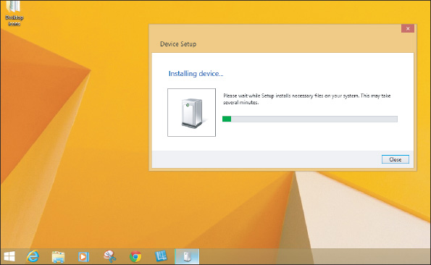
If you need to install the drivers first, run the setup program on CD or DVD. If you downloaded drivers from the web, double-click the driver file and follow the directions on screen. It might be necessary to restart the system after the installation. After the drivers are installed, plug the device into the port. The device should immediately be recognized by Windows. If you have problems using the device, turn to Device Manager for help.
- Install the application software to use the device. For example, a USB camcorder is likely to come bundled with video-editing software. Run the software to use the device.
Now let’s look at some key features and any specific installation concerns for several peripheral devices.
Go to pg.
help
Application Opened
Main content

6-2aMouse or Keyboard
A+ Core 1
- 1.1
Given a scenario, install and configure laptop hardware and components.
- 3.6
Explain the purposes and uses of various peripheral types.
When you plug a mouse or keyboard into a USB port, Windows should immediately recognize it and install generic drivers. (Older computers used PS/2 ports for the mouse and keyboard. Because these ports were not hot-pluggable, you had to restart Windows after plugging in a mouse or keyboard.) For keyboards with special features such as the one shown in Figure 6-16, you need to install the drivers that came with the keyboard before you can use these features.
Figure 6-16
The mouse and keyboard require drivers to use the extra buttons and zoom bar
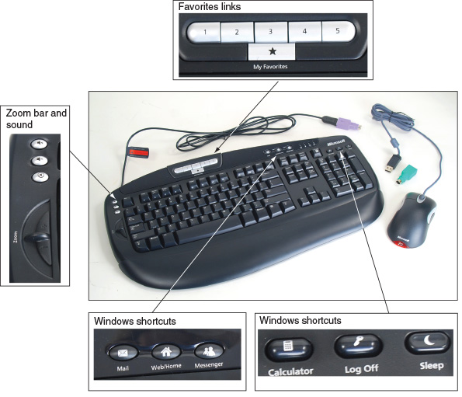
You can later use Device Manager to uninstall, disable, or enable most devices. However, USB devices are managed differently. To uninstall a USB device such as the USB keyboard shown in Figure 6-16, use the Programs and Features window. To open the window in Windows 10, press Win+X, click Apps and Features, and then click Programs and Features. In the Programs and Features window, select the device and click Uninstall. Follow the directions on screen to uninstall the device.
OS Differences
To open the Programs and Features window in Windows 8, press Win+X and click Programs and Features. See Figure 6-17. For Windows 7, click Start, click Control Panel, and click Programs and Features.
Figure 6-17
USB devices are listed as installed programs
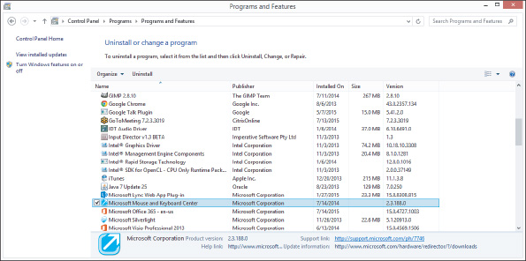
Notes
The A+ Core 1 exam expects you to use Control Panel in Classic view, which presents a list of individual items. If Control Panel is in Category view, which presents items in groups, you can get Classic view by clicking Category and then clicking Small icons or Large icons.

Replace the Keyboard and Touch Pad in a Laptop
Replacing the keyboard is pretty easy. Before you begin any disassembly of a laptop, refer to the manufacturer documentation. Here are typical steps that are similar for many models of laptops:
- Power down the laptop and remove the AC adapter and the battery pack.
- Remove two or more screws on the bottom of the laptop, as shown in Figure 6-18. (Only the manufacturer documentation can tell you which ones because there are probably several used to hold various components in place.)
Figure 6-18
Remove screws on the bottom of the laptop
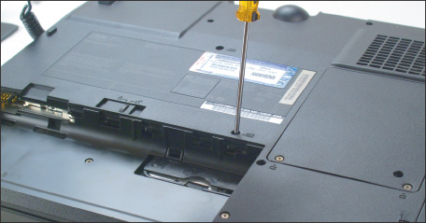
- Turn the laptop over and open the lid. Gently push the keyboard toward the lid hinges while pulling it up to release it from the case (see Figure 6-19).
Figure 6-19
Pry up and lift the keyboard out of the laptop case
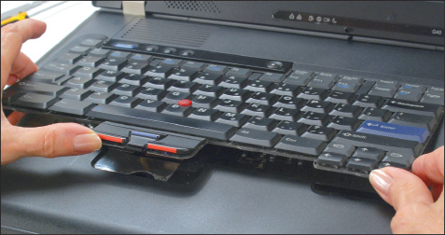
- Bring the keyboard out of the case and forward to expose the keyboard ribbon cable attached underneath the board. Use a spudger or tweezers to lift the cable connector up and out of its socket (see Figure 6-20).
Figure 6-20
Disconnect the keyboard cable from the motherboard
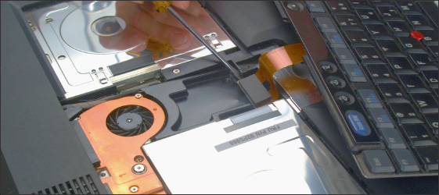
- Replace the keyboard following the steps in reverse order.
Sometimes the touch pad and keyboard are one complete field replaceable unit (FRU). If the touch pad is a separate component, it might be part of the keyboard bezel, also called the palm rest. This bezel is the flat cover that surrounds the keyboard. Most likely you have to remove the keyboard before you can remove the keyboard bezel.
Go to pg.
help
Application Opened
Main content

6-2bBarcode Readers
A+ Core 1
- 3.6
Explain the purposes and uses of various peripheral types.
A barcode reader is used to scan barcodes on products at the point of sale (POS) or when taking inventory. The reader might use a wireless connection, a serial port, a USB port, or a keyboard port. If the reader uses a keyboard port, most likely it contains a splitter (called a keyboard wedge) for the keyboard to use, and data read by the barcode reader is input into the system as though it were typed using the keyboard. Figure 6-21 shows a barcode reader by Intermec that is a laser scanner and uses Bluetooth to connect wirelessly to the computer.
Figure 6-21
A handheld or hands-free barcode scanner by Intermec Technologies
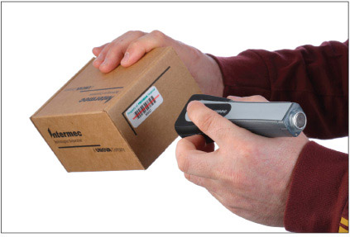
Source: Courtesy of Intermec Technologies
Go to pg.
help
Application Opened
Main content

6-2cPay Devices
A+ Core 1
- 3.6
Explain the purposes and uses of various peripheral types.
A magnetic stripe reader and chip reader can read from the stripe or chip to pull information from a card or license (see Figure 6-22). A card reader sends information to the computer through a serial connection, USB connection, Lightning connection, 3.5-mm headphone jack, or a stripe reader wedge mounted on a keyboard. A wireless card reader uses Bluetooth.
Figure 6-22
A card reader makes financial transactions faster
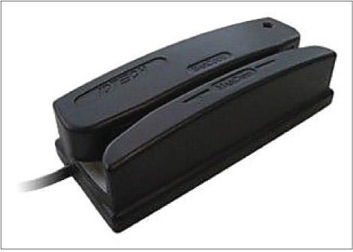
Source: https://www.staples.com/ID-TECH-Omni-WCR32-Magnetic-Stripe-Reader/product_IM1VS3392
A tap pay device connects wirelessly or by cable to a computer or mobile device to turn it into a point-of-sale system. For example, the PayPal tap pay device shown in Figure 6-23 is a magnetic chip and card reader and a tap pay device all in one; it can connect via a USB cable or Bluetooth wireless connection to a vendor’s smartphone or tablet. When a customer taps the device with her smartphone, as shown in the figure, an encrypted NFC connection sends the payment to the PayPal tap pay device. The payment is then sent by encrypted Bluetooth to the vendor’s PayPal Here mobile app installed on the vendor’s device, which passes it on to the vendor’s PayPal account.
Figure 6-23
A tap pay device receives a transaction from a customer smartphone via NFC communication
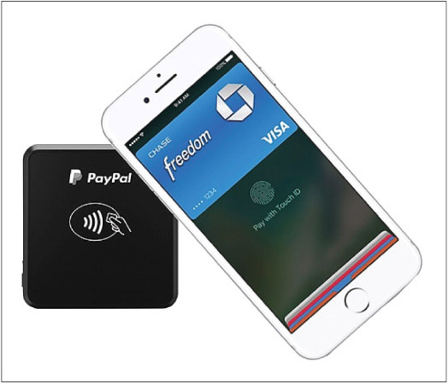
Source: https://www.staples.com/paypal-chip-and-tap-credit-card-reader/product_2774174
Go to pg.
help
Application Opened
Main content

6-2dSignature Pads
A+ Core 1
- 3.6
Explain the purposes and uses of various peripheral types.
A signature pad uses a sensitive touch screen to capture a handwritten signature made using a stylus or finger for a receipt, contract, or ID card (see Figure 6-24). The signature pad LCD panel displays electronic ink. Signature pads typically use a serial or USB connection to a computer and include software installed on the computer to process the signature. In addition to a signature pad peripheral device, an app can be installed on a smartphone or tablet to allow the mobile device touch screen to receive signatures.
Figure 6-24
The LCD panel on a signature pad captures a signature
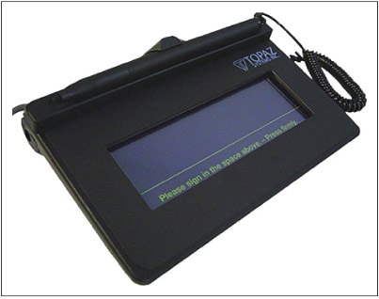
Source: https://www.staples.com/Topaz-SigLite-1x5-T-S460-BSB-R-Virtual-Serial-via-USB-Electronic-Signature-Pad/product_IM1VL7673
Go to pg.
help
Application Opened
Main content

6-2eBiometric Devices
A+ Core 1
- 3.6
Explain the purposes and uses of various peripheral types.
A biometric device inputs biological data about a person to identify the person’s fingerprint, handprint, face, voice, eye, or handwritten signature. For example, you can use a fingerprint reader to sign in to Windows or to access a smartphone using Touch ID technology. These fingerprint readers should not be considered the only authentication to control access to sensitive data: for that, use a strong password—one that is as long as you can remember or can be stored securely.
Fingerprint readers can look like a mouse and use a wireless or USB connection, such as the one shown in Figure 6-25, or they can be embedded on a keyboard, flash drive, or laptop case. For mobile devices, the fingerprint reader can be activated by pressing a button or touch screen. Most fingerprint readers that are not embedded in other devices use a USB connection. As with other USB devices, read the documentation to know if you should install the drivers first or the device first.
Figure 6-25
Fingerprint readers can (A) look like a mouse, but smaller, or (B) be embedded on a keyboard
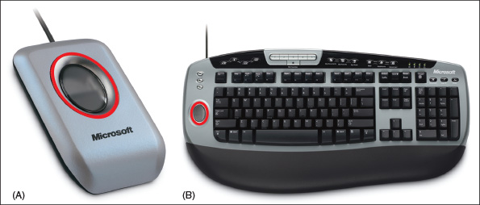
Go to pg.
help
Application Opened
Main content

6-2fWebcams
A+ Core 1
- 3.6
Explain the purposes and uses of various peripheral types.
A webcam (web camera) is embedded in most laptops and can also be installed as a peripheral device using a USB port or some other port. For example, the webcam shown in Figure 6-26 works well for personal chat sessions and videoconferencing and has a built-in microphone. First, use the setup CD to install the software and then plug in the webcam to a USB port.
Figure 6-26
This personal web camera clips to the top of your laptop and has a built-in microphone
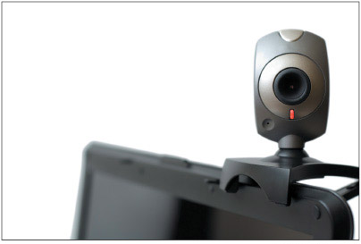
Source: iStock.com/blyjak
A webcam comes with a built-in microphone. You can use this microphone or use the microphone port on the computer. Most software allows you to select these input devices. For example, Figure 6-27 shows the Tools Options box for Camtasia Recorder by TechSmith (techsmith.com).
Figure 6-27
The Camtasia Recorder application allows you to change the input devices used for video and sound
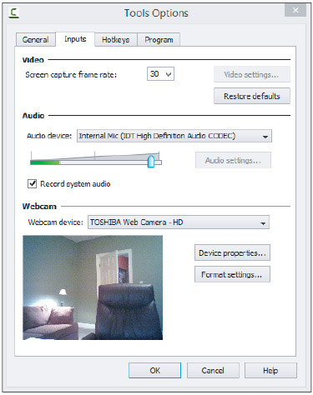
Source: Camtasia Recorder by TechSmith
Go to pg.
help
Application Opened
Main content

6-2gGraphics Tablets
A+ Core 1
- 3.6
Explain the purposes and uses of various peripheral types.
Another input device is a graphics tablet, also called a digitizing tablet or digitizer, that is used to hand draw and is likely to connect using a USB port (see Figure 6-28). It comes with a stylus that works like a pencil on the tablet and controls the pointer on the screen. The graphics tablet and stylus can be a replacement for a mouse or touch pad on a laptop, and some graphics tablets come with a mouse. Graphics tablets are popular with graphic artists and others who use desktop publishing applications.
Figure 6-28
A graphics tablet and stylus are used to digitize a hand drawing
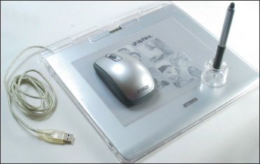
Install the graphics tablet the same way you do other USB devices. Additional software might be bundled with the device to enhance its functions, such as inputting handwritten signatures into Microsoft Word documents.
Go to pg.
help
Application Opened
Main content

6-2hTouch Screens
A+ Core 1
- 1.2
Given a scenario, install components within the display of a laptop.
- 3.6
Explain the purposes and uses of various peripheral types.
A touch screen is an input device that uses a monitor or LCD panel as the backdrop for input options. In other words, the touch screen is a grid that senses taps, finger pinches, and slides and sends these events to the computer by way of a USB port or other type of connection. Some laptops have built-in touch screens, and you can also install a touch screen on top of a monitor screen as an add-on device. As an add-on device, the touch screen has its own AC adapter to power it. Some monitors for desktop systems have built-in touch screen capability.
For add-on desktop monitors, clamp the touch screen over the monitor. For most installations, you install the drivers before you connect the touch screen to the computer by way of a USB port. After you install the drivers and the touch screen, you must use management software that came bundled with the device to decide how much of the monitor screen is taken up by the touch screen and to calibrate the touch screen. Later, if the monitor resolution is changed, the touch screen must be recalibrated.
Go to pg.
help
Application Opened
Main content

6-2iVirtual Reality Headsets
A+ Core 1
- 3.6
Explain the purposes and uses of various peripheral types.
A VR (virtual reality) headset is a device worn on the head that creates a visual and audible virtual experience for the user using a lens display, speakers, microphone, and head-tracking sensors for interaction (see Figure 6-29). VR headsets are often used for extreme gaming experiences but are also used in medical and military training. VR headsets can be programmed independently of a computer or the headset can be connected to a computer using USB for more programming input or recording the experience. Some VR headsets include a dock for a smartphone to create the visual and audible experience and use motion sensors for interaction.
Figure 6-29
A VR headset creates a visual and audible virtual experience
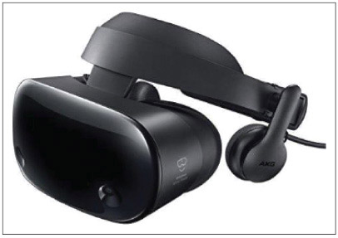
Source: https://www.newegg.com/Product/Product.aspx?Item=9SIAG797579575
Go to pg.
help
Application Opened
Main content

6-2jKVM Switches
A+ Core 1
- 3.6
Explain the purposes and uses of various peripheral types.
A KVM (Keyboard, Video, and Mouse) switch allows you to use one keyboard, monitor, and mouse for multiple computers. A KVM switch can be useful in a server room or testing lab where you use more than one computer and want to keep desk space clear of multiple keyboards, mice, and monitors; or, you may simply want to lower the cost of peripherals. Figure 6-30 shows a KVM switch that can connect a keyboard, monitor, mouse, microphone, and speakers to two computers. The device uses USB ports for the keyboard and mouse.
Figure 6-30
This KVM switch connects two computers to a keyboard, mouse, monitor, microphone, and speakers and uses USB for the keyboard and mouse
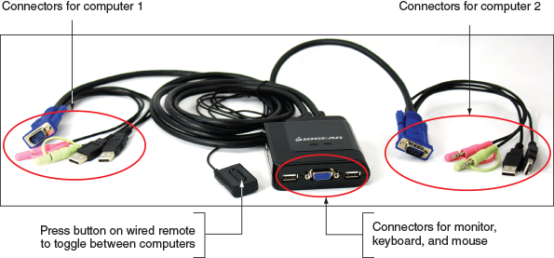
A KVM switch does not require that you install device drivers to use it. Just plug in the cables from each computer to the device. Also plug in one set of a monitor, mouse, keyboard, and possibly a microphone and speakers to the device. Switch between computers by using a hot key on the keyboard, buttons on the top of the KVM switch, or a wired remote such as the one shown in Figure 6-30.
Go to pg.
help
Application Opened
Main content

6-3Installing and Configuring Adapter Cards
A+ Core 1
- 1.1
Given a scenario, install and configure laptop hardware and components.
- 3.5
Given a scenario, install and configure motherboards, CPUs, and add-on cards.
In this part of the chapter, you learn to install and configure adapter cards. These cards include a video card, sound card, network interface card (NIC), and USB expansion card. The purpose of adding an adapter card to a system is to add external ports or internal connectors the card provides.
Regardless of the type of card you are installing, be sure to verify and do the following when preparing to install one:
- Verify that the card fits an empty expansion slot. Recall that there are several PCI and PCI Express standards; therefore, make sure the card will fit the slot. To help with airflow, try to leave an empty slot between cards. Especially try to leave an empty slot beside the video card, which puts off a lot of heat. PCIe slots on a motherboard might support different PCIe standards. The motherboard manual tells you which slot is rated for which PCIe standard.
- Verify that the device drivers for your OS are available. Check the card documentation and make sure you have the drivers for your OS. For example, you need to install 64-bit Windows 10 device drivers in a 64-bit installation of Windows 10. It might be possible to download drivers for your OS from the website of the card manufacturer.
- Back up important data that is not already backed up. Before you open the computer case, be sure to back up important data on the hard drive.
- Know your starting point. Know what works and doesn’t work on the system. Can you connect to the network and the Internet, print, and use other installed adapter cards without errors? After installing a new card, verify your starting point again before installing another card.
Here are the general directions to install an adapter card. They apply to any type of card.
- Read the documentation that came with the card. For most cards, you install the card first and then the drivers, but some installations might not work this way.
- If you are installing a card to replace an onboard port, access BIOS/UEFI setup and disable the port.
- Wear an ESD strap as you work to protect the card and the system against ESD. Shut down the system, unplug power cords and cables, and press the power button to drain the power. Remove the computer case cover.
- Locate the slot you plan to use and remove the faceplate cover from the slot if one is installed. Sometimes a faceplate punches or snaps out, and sometimes you have to remove a faceplate screw to remove the faceplate. Remove the screw in the top of the expansion slot or raise the clip on the top of the slot. Save the screw; you’ll need it later.
- Remove the card from its antistatic bag and insert it into the expansion slot. Be careful to push the card straight down into the slot without rocking the card from side to side. Rocking the card can widen the expansion slot, making it difficult to keep a good contact. If you have a problem getting the card into the slot, resist the temptation to push the front or rear of the card into the slot first. You should feel a slight snap as the card drops into the slot.
Recall that PCIe ×16 slots use a retention mechanism in the slot to help stabilize a heavy card (see Figure 6-31). For these slots, you might have to use one finger to push the stabilizer to the side as you push the card into the slot. Alternately, the card might snap into the slot and then the retention mechanism snaps into position. Figure 6-32 shows a PCIe video card installed in a PCIe ×16 slot.
Figure 6-31
A white retention mechanism on a PCIe ×16 slot pops into place to help stabilize a heavy video card
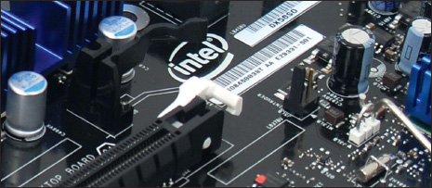
Figure 6-32
A PCIe video card installed in a PCIe ×16 slot
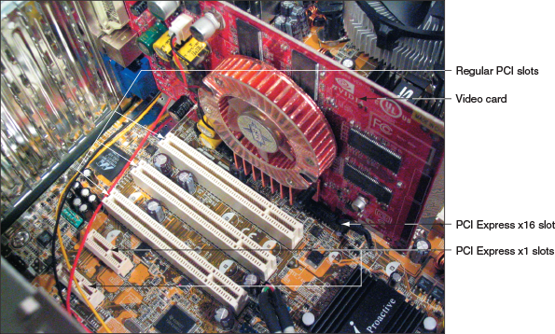
- Insert the screw that anchors the card to the top of the slot (see Figure 6-33). Be sure to use this screw. If it’s not present, the card can creep out of the slot over time, causing a loose connection.
Figure 6-33
Secure the card to the case with a single screw
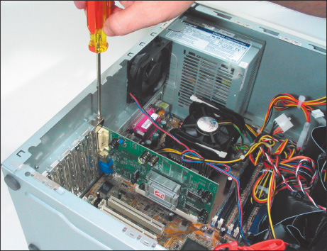
- Connect any power cords or data cables the card might use. For example, a video card might have a 6-pin or 8-pin PCIe power connector for a power cord from the power supply to the card, as shown in Figure 6-34. (If the power supply does not have the right connector, you can buy an inexpensive adapter to convert a 4-pin Molex connector to a PCIe connector.)
Figure 6-34
Connect a power cord to the PCIe power connector on the card
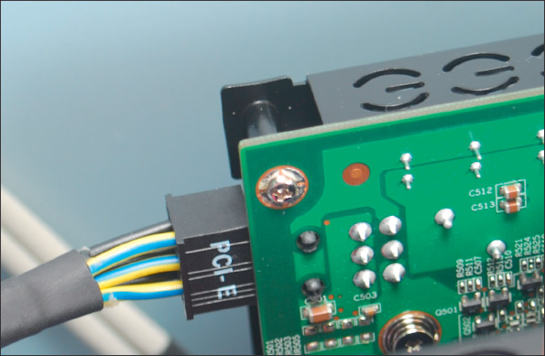
- Make a quick check of all connections and cables, and then replace the case cover. (If you want, you can leave the case cover off until you’ve tested the card, in case it doesn’t work and you need to reseat it.) Plug up the external power cable and essential peripherals.
- Start the system. When Windows starts, it should detect that a new hardware device is present and attempt to automatically install the drivers. As the drivers are installed, a message might appear above the taskbar. When you click the message, the Device Setup box appears (refer back to Figure 6-15). You can cancel the wizard and manually install the drivers.
- Insert the CD that came bundled with the card and launch the setup program on the CD. The card documentation will tell you the name of the program (examples are Setup.exe and Autorun.exe). Figure 6-35 shows the opening menu for one setup program for a video card. Click Install Video Drivers and follow the on-screen instructions to install the drivers. If you are using downloaded driver files, double-click the file to begin the installation and follow the directions on screen.
Figure 6-35
An opening menu to install video drivers
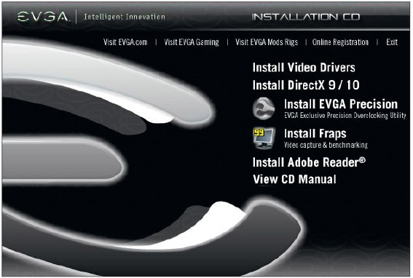
Source: EVGA
Notes
All 64-bit drivers must be certified by Microsoft to work in Windows. However, some 32-bit drivers might not be. During the driver installation, if you see a message that 32-bit drivers have not been certified, go ahead and give permission to install the drivers if you obtained them from the manufacturer or another reliable source.
- After the drivers are installed, you might be asked to restart the system. Then you can configure the card or use it with application software. If you have problems with the installation, turn to Device Manager and look for errors reported about the device. The card might not be properly seated in the slot.
Now let’s turn our attention to sound cards you might be called on to install. As with any adapter card you install, be sure to become familiar with the user guide before you start the installation so that you know the card’s hardware and software requirements and what peripheral devices it supports.
Go to pg.
help
Application Opened
Main content

6-3aSound Cards and Onboard Sound
A+ Core 1
- 3.5
Given a scenario, install and configure motherboards, CPUs, and add-on cards.
A sound card (an expansion card with sound ports) or onboard sound (sound ports embedded on a motherboard) can play and record sound and save it in a file. Figure 6-36 shows a sound card by Creative (creative.com). This Sound Blaster card uses a PCIe ×1 slot and supports up to eight surround sound version 7.1 speakers. The color-coded speaker ports are for these speakers: front left and right, front center, rear left and right, subwoofer, and two additional rear speakers. The two SPDIF (Sony-Philips Digital InterFace) ports are used to connect to external sound equipment such as a CD or DVD player.
Figure 6-36
The Sound Blaster X-Fi Titanium sound card by Creative uses a PCIe ×1 slot
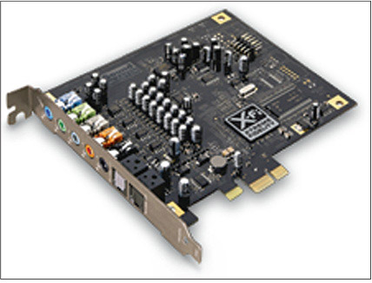
Source: Courtesy of Creative Technology Ltd.
Notes
If you are using a single speaker or two speakers with a single sound cable, connect the cable to the lime-green sound port on the motherboard, which is usually the middle port.
Go to pg.
help
Application Opened
Main content

6-3bReplacing Expansion Cards in a Laptop
A+ Core 1
- 1.1
Given a scenario, install and configure laptop hardware and components.
A laptop does not contain the normal PCI Express or PCI slots found in desktop systems. Newer laptops are likely to use the Mini PCI Express slots (also called Mini PCIe slots) that use the PCI Express standards applied to laptops. Mini PCI Express slots use 52 pins on the edge connector. These slots can be used by many kinds of Mini PCIe cards. These cards are often used to enhance communications options for a laptop, including Wi-Fi wireless, cellular WAN, video, and Bluetooth Mini PCIe cards. Figure 6-37 shows a Mini PCI Express card by Sierra Wireless that provides mobile broadband Internet.
Figure 6-37
The MC8775 Mini PCI Express card by Sierra Wireless used for voice and data transmissions on cellular networks
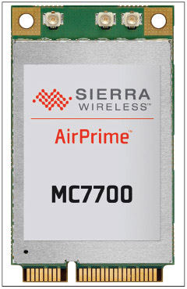
Source: Sierra Wireless
For many laptops, you can remove a cover on the bottom to expose expansion cards so that you can exchange them without an extensive disassembly. For example, to remove the cover on the bottom of one Lenovo laptop, first remove several screws and then lift the laptop cover up and out. Several internal components are exposed, as shown in Figure 6-38.
Figure 6-38
Removing the cover from the bottom of a laptop exposes several internal components
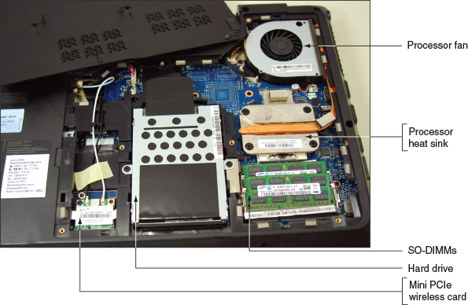
The half-size Mini PCIe wireless Wi-Fi card shown in Figure 6-39 has two antennas. To remove the card, first remove the one screw shown in the photo and disconnect the two black and white antenna wires. Note the black and white triangles labeled with a 1 and a 2 on the label of the card so you know which wire goes on which connector when replacing the card. Then slide the card forward and out of the slot. You can then install a new card.
Figure 6-39
This half-size Mini PCIe wireless card is anchored in the expansion slot with one screw
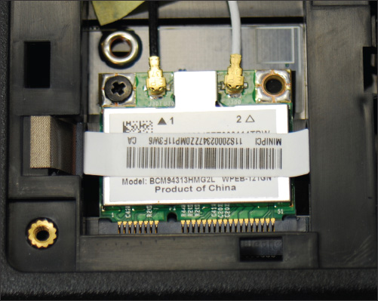
Figure 6-40 shows a full-size Mini PCIe card installed in a laptop. First remove the one screw at the top of the card and disconnect the two antenna wires, and then pull the card forward and out of the slot.
Figure 6-40
How to remove a Mini PCI Express card
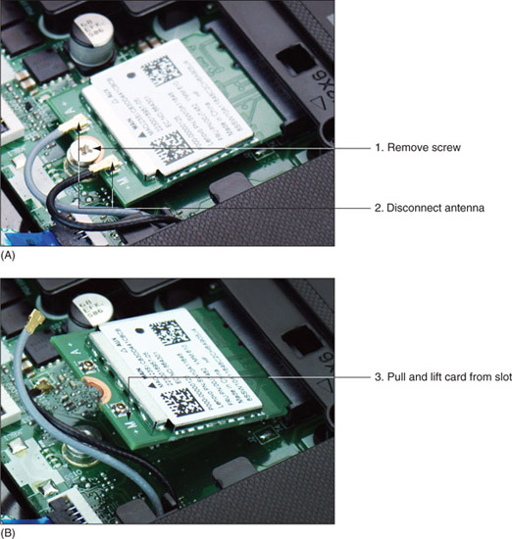
A+ Exam Tip
The A+ Core 1 exam expects you to be able to determine when you would need to replace a Mini PCIe card in a laptop given a scenario.
After you have installed a Mini PCIe card that is a Bluetooth, cellular WAN, or other wireless adapter, try to connect the laptop to the wireless network. If you have problems making a connection, verify that Device Manager reports the device is working properly and that Event Viewer has not reported error events about the device.
Go to pg.
help
Application Opened
Main content

6-4Supporting the Video Subsystem
A+ Core 1
- 1.1
Given a scenario, install and configure laptop hardware and components.
- 1.2
Given a scenario, install components within the display of a laptop.
- 3.1
Explain basic cable types, features, and their purposes.
- 3.5
Given a scenario, install and configure motherboards, CPUs, and add-on cards.
- 3.6
Explain the purposes and uses of various peripheral types.
The primary output device of a computer is the monitor. The two necessary components for video output are the monitor and the video card (also called the video adapter and graphics adapter) or a video port on the motherboard. In this part of the chapter, you learn about monitors and how to support the video subsystem.
Go to pg.
help
Application Opened
Main content

6-4aMonitor Technologies and Features
A+ Core 1
- 1.2
Given a scenario, install components within the display of a laptop.
- 3.6
Explain the purposes and uses of various peripheral types.
The most popular type of monitor for laptop and desktop systems is an LCD flat-screen monitor (see Figure 6-41), but you have other choices as well. Here is a list and description of each type of monitor:
Figure 6-41
An LCD monitor
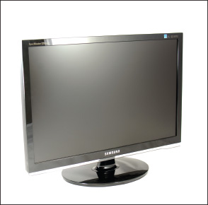
- LCD monitor. The LCD (liquid crystal display) monitor, also called a flat-panel monitor, was first used in laptops. The monitor produces an image using a liquid crystal material made of large, easily polarized molecules. Figure 6-42 shows the layers of the LCD panel that together create the image. At the center of the layers is the liquid crystal material. Next to it is the layer responsible for providing color to the image. These two layers are sandwiched between two grids of electrodes forming columns and rows. Each intersection of a row electrode and a column electrode forms one pixel on the LCD panel. Software can address each pixel to create an image.
Figure 6-42
Layers of an LCD panel
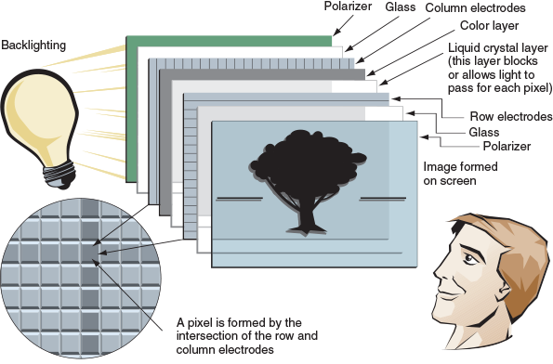
- OLED monitor. An OLED (organic light-emitting diode) monitor uses a thin LED (light-emitting diode) layer or film between two grids of electrodes and does not use backlighting. It does not emit as much light as an LCD monitor, and therefore can produce deeper blacks, provide better contrast, work in darker rooms, and use less power than an LCD monitor. On the other hand, LCD monitors give less glare than OLED monitors. OLED screens are used by mobile devices and other portable electronic devices. OLED monitors are just now appearing for desktop systems.
- Projector. A digital projector (see Figure 6-43) shines a light that projects a transparent image onto a large screen and is often used in classrooms or with other large groups. Several types of technologies are used by projectors, including LCD. A projector is often installed as a dual monitor on a computer, which you learn how to do later in the chapter.
Figure 6-43
A portable XGA projector by Panasonic
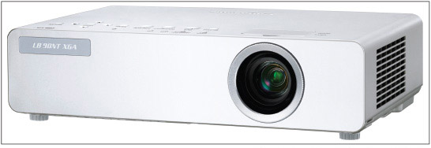
Source: Courtesy of Panasonic Corporation of North America
A+ Exam Tip
The A+ Core 1 exam expects you to compare LCD and OLED monitor types so that you can choose which one is the best fit for a given scenario.
A laptop display almost always uses LCD technology, although laptops that use an OLED display are available. Some laptop LCD panels use LED backlighting to improve display quality and conserve power. For desktops, LCD is by far the most popular monitor type. Figure 6-44 shows an ad for one best-selling LCD monitor. Table 6-3 explains the features mentioned in the ad.
A+ Exam Tip
The A+ Core 1 exam expects you to know about the components within the display of a laptop, including the components used in LCD, LED, and OLED displays. You also need to know about backlighting, the function of an inverter, and how to replace one.
Figure 6-44
An ad for a monitor lists monitor features
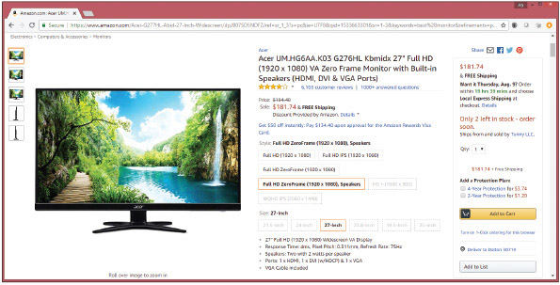
Source: amazon.com
Table 6-3

Important Features of a Monitor
Monitor Characteristic | Description
Screen size | The screen size is the diagonal length of the screen surface in inches.
Refresh rate | The refresh rate is the number of times a monitor screen is built or refreshed in 1 second, measured in Hz (cycles per second). The ad in Figure 6-44 shows the monitor refresh rate as 75 Hz (75 frames per second)—the higher, the better. Related to refresh rate, the response time is the time it takes to build one frame, measured in ms (milliseconds)—the lower, the better. The ad in Figure 6-44 shows a response time of 4 ms.
Pixel pitch | A pixel is a spot or dot on the screen that can be addressed by software. The pixel pitch is the distance between adjacent pixels on the screen—the smaller the number, the better. For example, Figure 6-44 shows a pixel pitch of 0.311 mm.
Resolution | The resolution is the number of spots or pixels on a screen that can be addressed by software. Values can range from 640 × 480 up to 4096 × 2160 for high-end monitors. Popular resolutions are 1920 × 1080 and 1366 × 768.
Contrast ratio | Contrast ratio is the contrast between true black and true white on the screen—the higher the contrast ratio, the better. 1000:1 is better than 700:1.  An advertised dynamic contrast ratio is much higher than the contrast ratio, but is not a true measurement of contrast. Dynamic contrast adjusts the backlighting to give the effect of an overall brighter or darker image. For example, if the contrast ratio is 1000:1, the dynamic ratio is 20,000,000:1. When comparing quality of monitors, pay more attention to the contrast ratio than the dynamic ratio.
Viewing angle | The viewing angle is the angle at which a monitor becomes difficult to see from the side. A viewing angle of 170 degrees is better than 140 degrees.
Backlighting or brightness | Brightness is measured in (candela per square meter), which is the same as (lumens per square meter).  In addition, the best LED backlighting for viewing photography is class IPS (in-plane switching), which provides the most accurate color.
Connectors | Popular options for connectors are VGA, DVI-I, DVI-D, HDMI, DisplayPort, and Apple’s Thunderbolt. Some monitors offer more than one connector (see Figure 6-45).
Other features | LCD monitors can also provide a privacy or antiglare surface, tilt screens, microphone input, speakers, USB ports, adjustable stands, and perhaps even an input for your smartphone. Some monitors are also touch screens, so they can be used with a stylus or finger touch.
A+ Exam Tip
The A+ Core 1 exam expects you to know about monitor features such as refresh rate, resolution, brightness in lumens, and connectors used, and why these features affect which monitor you would choose given a scenario.
Caution
If you spend many hours in front of a computer, you may strain your eyes. To protect your eyes from strain, look away from the monitor into the distance every few minutes. Use a good monitor with a high refresh rate or low response time. The lower refresh rates that cause monitor flicker can tire and damage your eyes. When you first install a monitor, set the refresh rate at the highest value the monitor can support.
Figure 6-45
The rear of this LCD monitor shows digital and analog video ports to accommodate a video cable with either a 15-pin analog VGA connector or a digital DVI connector
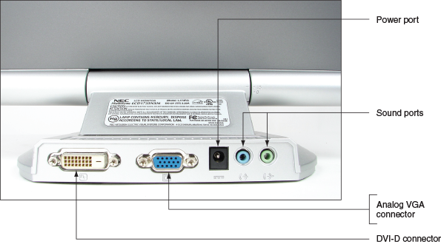
Now let’s see how to configure a monitor or dual monitors connected to a Windows computer.
Go to pg.
help
Application Opened
Main content

6-4bChanging Monitor Settings
A+ Core 1
- 3.6
Explain the purposes and uses of various peripheral types.
- 5.4
Given a scenario, troubleshoot video, projector, and display issues.
Settings that apply to the monitor can be managed by using the monitor buttons, function keys on a keyboard, and Windows utilities. Using the monitor buttons, you can adjust the horizontal and vertical position of the screen on the monitor surface and change the brightness and contrast settings. Adjust these settings to correct a distorted image. For laptops, the brightness and contrast settings can be changed using function keys on the laptop.
Applying Concepts

Installing Dual Monitors
To increase the size of your Windows desktop, you can install more than one monitor for a single computer. To install dual monitors, you need two video ports on your system, which can come from motherboard video ports, a video card that provides two video ports, or two video cards.
To install a second monitor in a dual-monitor setup using two video cards, follow these steps:
- Verify that the original video card works properly and decide whether it will be the primary monitor.
- Boot the computer and enter BIOS/UEFI setup. If BIOS/UEFI setup has the option to select the order in which video cards are initialized, verify that the currently installed card is configured to initialize first. For example, for the BIOS/UEFI system in Figure 6-46, the video adapter in the PCIe slot initializes first before other video adapters. If it does not initialize first and you install the second card, video might not work at all when you first boot with two cards.
Figure 6-46
In BIOS/UEFI setup, verify that the currently installed video adapter is set to initialize first
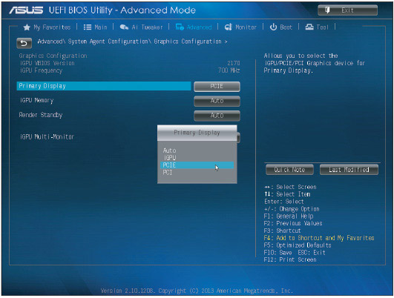
Source: American Megatrends, Inc.
- Install a second video card in an empty slot. A computer might have a second PCIe slot or an unused PCI slot you can use. Attach the second monitor.
- Boot the system. Windows recognizes the new hardware and launches Device Setup. You can use the utility to install the video card drivers or cancel the utility and install them manually, as you learned to do earlier in the chapter.
Here are the steps to configure dual monitors:
- Connect two monitors to your system. In Windows 10, open the Settings app and click the System group. The display settings appear, as shown in Figure 6-47.
Figure 6-47
Configure each monitor in a dual-monitor configuration
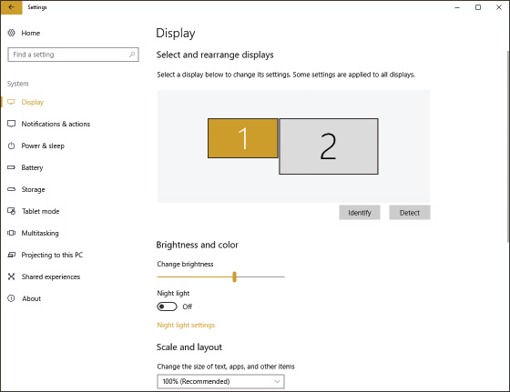
OS Differences
In Windows 8/7, open Control Panel in Classic view, click Display, and then click Adjust resolution. The Screen Resolution window appears.
- Notice the two numbered boxes that represent your two monitors. When you click one of these boxes, the settings then apply to the selected monitor, and the screen resolution and orientation (Landscape, Portrait, Landscape flipped, or Portrait flipped) follow the selected monitor. This lets you customize the settings for each monitor separately. If necessary, use drag-and-drop to arrange the boxes so that they represent the physical arrangement of your monitors.
Notes
If you see both numbered displays in the same box, the Multiple displays setting is set to Duplicate these displays. To separate the displays, change the Multiple displays setting to Extend these displays. Then click Keep changes.
Notes
In Figure 6-47, if you arrange the two boxes side by side, your extended desktop will extend left or right. If you arrange the two boxes one on top of the other, your extended desktop will extend up and down.
- Adjust the screen resolution according to your preferences. Most often the highest resolution is the best resolution for the monitor.
- The Multiple displays setting allows you to select how to handle multiple displays. You can extend your desktop onto the second monitor, duplicate displays, or disable the display on either monitor. To save the settings, click Keep changes. The second monitor should initialize and show the extended or duplicated desktop.
- Close the Settings app. For an extended desktop, open an application and verify that you can use the second monitor by dragging the application window over to the second monitor’s desktop.
After you add a second monitor to your system, you can move from one monitor to another simply by moving your mouse over the extended desktop. Switching from one monitor to the other does not require any special keystroke or menu option.
Most laptop computers are designed to be used with projectors and provide a VGA, DisplayPort, or HDMI port for this purpose. To use a projector, plug it in to the extra port and then turn it on. For a laptop computer, use a function key to activate the video port and toggle between extending the desktop to the projector, using only the projector, duplicating the screen on the projector, or not using the projector. When giving a presentation, most people prefer to see it duplicated on the LCD screen and the projector.
Notes
For group presentations that require a projector, the most common software used is Microsoft PowerPoint. If you configure your projector as a dual monitor, you can use PowerPoint to display a presentation to your audience on the projector at the same time you are using your LCD display to manage your PowerPoint slides. To do so, select the Slide Show tab in PowerPoint. In the Set Up group, click Set Up Slide Show. In the Set Up Show box under Multiple monitors, check Show Presenter View or Use Presenter View and click OK.
Go to pg.
help
Application Opened
Main content

6-5Troubleshooting I/O Devices
A+ Core 1
- 5.4
Given a scenario, troubleshoot video, projector, and display issues.
- 5.5
Given a scenario, troubleshoot common mobile device issues while adhering to the appropriate procedures.
A computer usually has so many types of peripheral devices that you’ll probably troubleshoot at least one of each at some point in your technical career. When this happens, always try the least invasive and least expensive solutions first. For example, try updating drivers of a graphics tablet before replacing it. Now let’s learn how to handle some of the errors or problems you might encounter.
Go to pg.
help
Application Opened
Main content

6-5aNumLock Indicator Light
A+ Core 1
- 5.5
Given a scenario, troubleshoot common mobile device issues while adhering to the appropriate procedures.
If a user complains she cannot sign in to Windows even when she’s certain she is entering the correct password, ask her to make sure the NumLock key is set correctly. Laptops use this key to toggle between the keys interpreted as letters and numbers. Most laptops have a NumLock indicator light near the keyboard.
Go to pg.
help
Application Opened
Main content

6-5bDevice Manager
A+ Core 1
- 5.4
Given a scenario, troubleshoot video, projector, and display issues.
- 5.5
Given a scenario, troubleshoot common mobile device issues while adhering to the appropriate procedures.
Device Manager is usually a good place to start troubleshooting. A Device Manager window is shown on the left side of Figure 6-48. Click a white arrow to expand the view of an item and click a black arrow to collapse the view. Notice the yellow triangle beside the SM Bus Controller, which indicates a problem with this motherboard component. To see a device’s properties box, right-click the device and click Properties.
Figure 6-48
Use Device Manager to solve problems with hardware devices
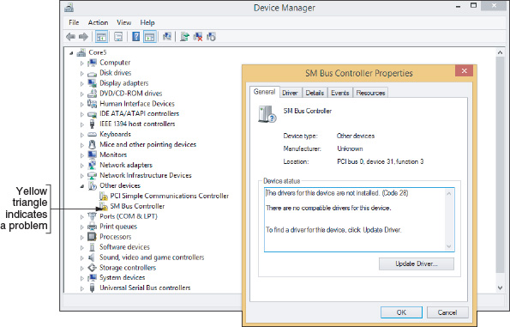
First try updating the drivers. Click Update Driver on the General tab or the Driver tab. If a driver update creates a problem, you can roll back (undo) the update if the previous drivers were working. (Windows does not save drivers that were not working before the driver update.) If you are still having a problem with a device, try uninstalling it and installing it again. To uninstall the device, click Uninstall on the Driver tab. Then reboot and reinstall the device, looking for problems during the installation that point to the source of the problem. Sometimes reinstalling a device is all that’s needed to solve the problem.
If Windows is not able to locate new drivers for a device, locate and download the latest driver files from the manufacturer’s website to your hard drive. Be sure to use 64-bit drivers for a 64-bit OS and 32-bit drivers for a 32-bit OS. If possible, use Windows 10 drivers for Windows 10, Windows 8 drivers for Windows 8, and Windows 7 drivers for Windows 7. You can double-click the downloaded driver files to launch the installation.

Update Port or Slot Drivers on a Laptop
If you ever have a problem with a port or slot on a laptop, first turn to Device Manager to see if errors are reported and to update the drivers for the port or slot. The laptop manufacturer has probably stored backups of the drivers on the hard drive under support tools and on the recovery media if available. You can also download the latest drivers from the manufacturer’s website. If the problem is still not solved after updating the drivers, try using Device Manager to uninstall the port or slot drivers and then use the support tools to reinstall the drivers.
Notes
If a port or slot on a desktop or laptop fails even after updating the drivers, you can install an external device to replace the port or slot. For example, if the network port fails, you can purchase a USB to Ethernet adapter dongle to connect an Ethernet cable to the system using a USB port.
Go to pg.
help
Application Opened
Main content

6-5cTroubleshooting Video, Monitors, and Projectors
A+ Core 1
- 5.4
Given a scenario, troubleshoot video, projector, and display issues.
- 5.5
Given a scenario, troubleshoot common mobile device issues while adhering to the appropriate procedures.
For monitor and video problems, as with other devices, try doing the easy things first. For instance, try to make simple hardware and software adjustments. Many monitor problems are caused by poor cable connections or bad contrast/brightness adjustments. Typical monitor and video problems and how to troubleshoot them are described next, and then you learn how to troubleshoot video problems on laptop computers.
Notes
A user very much appreciates a support technician who takes a little extra time to clean a system being serviced. When servicing a monitor, take the time to clean the screen with a soft, dry cloth or monitor wipe.

Problems with Video Card Installations
When you install a video card, here is a list of things that can go wrong and what to do about them:
- When you first power up the system, you hear a whining sound. This is caused by the card not getting enough power. Make sure a 6-pin or 8-pin power cord is connected to the card if it has this connector. The power supply might be inadequate.
- When you first start up the system, you see nothing but a black screen. Most likely this is caused by the onboard video port not being disabled in BIOS/UEFI setup. Disable the port.
- When you first start up the system, you hear a series of beeps. BIOS/UEFI cannot detect a video card. Make sure the card is securely seated. The video slot or video card might be bad.
- Error messages about video appear when Windows starts. This can be caused by a conflict between onboard video and the video card. Try disabling onboard video in Device Manager.
- Games crash or lock up. Try updating drivers for the motherboard, the video card, and the sound card. Also install the latest version of DirectX. Then try uninstalling the game and installing it again. Then download all patches for the game.

Monitor Indicator Light Is Not on; No Image on Screen
If you hear one or no beep during the boot and you see a blank screen, then BIOS/UEFI has successfully completed POST, which includes a test of the video card or onboard video. You can then assume the problem must be with the monitor or the monitor cable. Ask these questions and try these things:
- Is the monitor power cable plugged in?
- Is the monitor turned on? Try pushing the power button on the front of the monitor. An indicator light on the front of the monitor should turn on, indicating it has power.
- Is the monitor cable plugged into the video port at the back of the computer and the connector on the rear of the monitor?
- Try a different monitor and a different monitor cable that you know are working.
Notes
When you turn on your computer, the first thing you see on the screen is the firmware on the video card identifying itself. You can use this information to search the web, especially the manufacturer’s website, for troubleshooting information about the card.

Monitor Indicator Light Is on; No Image on Screen
For this problem, try the following:
- Make sure the video cable is securely connected at the computer and the monitor. Most likely the problem is a bad cable connection.
- If the monitor displays POST but goes blank when Windows starts to load, the problem is Windows and not the monitor or video. Boot from the Windows setup DVD and perform a Startup Repair, which you learned to do in Chapter 4. If this works, change the driver and resolution. Other tools for troubleshooting Windows are covered later in the text.
- The monitor might have a switch on the back for choosing between 110 volts and 220 volts. Check that the switch is in the correct position.
- The problem might be with the video card. If you have just installed the card and the motherboard has onboard video, go into BIOS/UEFI setup and disable the video port on the motherboard.
- Verify that the video cable is connected to the video port on the video card and not to a disabled onboard video port.
- Using buttons on the front of the monitor, check the contrast adjustment. If there’s no change, leave it at a middle setting.
- Check the brightness or backlight adjustment. If there’s no change, leave it at a middle setting.
- If the monitor-to-computer cable detaches from the monitor, exchange it for a cable you know is good or check the cable for continuity. If this solves the problem, reattach the old cable to verify that the problem was not simply a bad connection.
- As a test, use a monitor you know is good on the computer you suspect to be bad. If you think the monitor is bad, make sure that it also fails to work on a good computer.
- Open the computer case and reseat the video card. If possible, move the card to a different expansion slot. Clean the card’s edge connectors using a contact cleaner purchased from a computer supply store.
- If there are socketed chips on the video card, remove the card from the expansion slot and then use a screwdriver to press down firmly on each corner of each socketed chip on the card. Chips sometimes loosen because of temperature changes; this condition is called chip creep.
- Trade a good video card for the video card you suspect is bad. Test the video card you think is bad on a computer that works. Test a video card you know is good on the computer that you suspect is bad. Whenever possible, do both.
- Test the RAM on the motherboard with memory diagnostic software.
- For a motherboard that is using a PCI Express video card, try using a PCI video card in a PCI slot or a PCIe ×1 video card in a PCIe ×1 slot. A good repair technician keeps an extra PCI video card around for this purpose.
- Trade the motherboard for one you know is good. Sometimes, though rarely, a peripheral chip on the motherboard can cause the problem.

Screen Goes Blank 30 Seconds or One Minute after the Keyboard Is Left Untouched
A Green motherboard (one that follows energy-saving standards) used with an Energy Saver monitor can be configured to go into standby or sleep mode after a period of inactivity. Using this feature can also help prevent burn-in. Burn-in is when a static image stays on a monitor for many hours, leaving a permanent impression of that image on the monitor. An alternate method to avoid burn-in is to use a screen saver that has a moving image or a rotation of varying images. To wake up the computer, press any key on the keyboard or press the power button. Use the Power Options applet in Control Panel to configure the sleep settings on a computer.
Notes
Problems might occur if the motherboard power-saving features or the Windows screen saver is turning off the monitor. If the system hangs when you try to get the monitor going again, try disabling one or the other. If this doesn’t work, disable both.

Poor Display
In general, you can solve problems with poor display by using controls on the monitor and using Windows settings. Do the following:
- LCD monitor controls. Use buttons on the front of an LCD monitor to adjust color, brightness, contrast, focus, and horizontal and vertical positions.
- Windows display settings. Use Windows settings to adjust font size, refresh rate, screen resolution, brightness, color, and ClearType text. To adjust display settings in Windows 10, right-click the desktop and click Display settings. Here are a few settings:
  - Resolution. The resolution is the number of horizontal and vertical pixels used to build one screen. In the Resolution drop-down menu, select the highest resolution. If the monitor shows distorted geometry where images are stretched inappropriately, make sure the resolution is set to its highest value. Also, a low resolution can cause oversized images or icons.
  - Refresh rate. The refresh rate is the number of times the monitor refreshes the screen in 1 second. To adjust the refresh rate, click Display adapter properties. On the Monitor tab, select the highest refresh rate available (see Figure 6-49).
Figure 6-49
Use the highest refresh rate the system supports
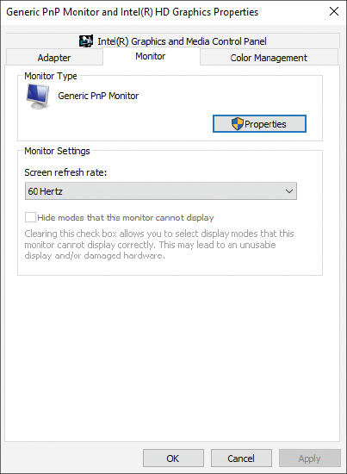
OS Differences
To open the video properties box in Windows 8/7, use Control Panel to open the Screen Resolution window. Click Advanced settings. The video properties box appears.
  - ClearType. In Windows 10, open the Settings app and open the System group to find display settings. To open the ClearType Text Tuner, search on ClearType in the search box of the Settings app, select Adjust ClearType text, and check Turn on ClearType (see Figure 6-50). Then follow the steps in the wizard to improve the quality of text displayed on the screen.
Figure 6-50
ClearType in Windows improves the display of text on the screen
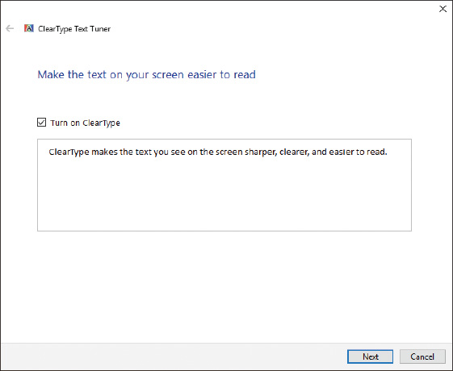
OS Differences
To change the ClearType setting in Windows 8/7, open Control Panel in Classic view, click Display, and click Adjust ClearType text.
  - Color calibration. To calibrate colors in Windows 10, open the Settings app, search on calibrate display color, and follow the directions on screen. As you do so, color patterns appear (see Figure 6-51). Use these screens to adjust the gamma settings, which define the relationships among red, green, and blue, as well as other settings that affect the display.
Figure 6-51
Two screens in the Windows 10 color calibration wizard
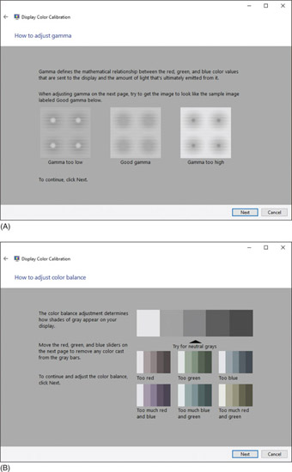
OS Differences
To change the color calibration in Windows 8/7, open Control Panel in Classic view, click Display, and then click Calibrate color.
- Update the video drivers. The latest video drivers can solve various problems with the video subsystem, including poor display.
Notes
If adjusting the resolution doesn’t correct distorted geometry or oversized images or icons, try updating the video drivers.
Here are a few other display problems and their solutions:
- Dead pixels. An LCD monitor might have pixels that are not working. These dead pixels can appear as small white, black, or colored spots on your screen. A black or white pixel is likely to be a broken transistor, which cannot be fixed. Having a few dead pixels on an LCD monitor screen is considered acceptable and usually is not covered under the manufacturer’s warranty.
Notes
A pixel might not be a dead pixel (a hardware problem), but only a stuck pixel (a software problem). You might be able to use software to fix stuck pixels. For example, run the online software at flexcode.org/lcd2.html to fix stuck pixels. The software works by rapidly changing all the pixels on the screen. (Be aware the screen flashes rapidly during the fix.)
- Dim image. A laptop computer dims the LCD screen when the computer is running on battery power to conserve the charge. You can brighten the screen using the Windows display settings. In Windows 10, open the Settings app, click System, and then adjust the brightness slide bar (see Figure 6-47). To check whether settings to conserve power are affecting screen brightness, open Control Panel in Classic view and click Power Options. Note the power plan that is selected. Click Change plan settings for this power plan. On the next screen, you can adjust when or if the screen will dim (see Figure 6-52). If the problem is still not resolved, it might be a hardware problem. How to troubleshoot hardware in laptops is covered later in this chapter.
Figure 6-52
Change power plan options to affect how or if the screen dims
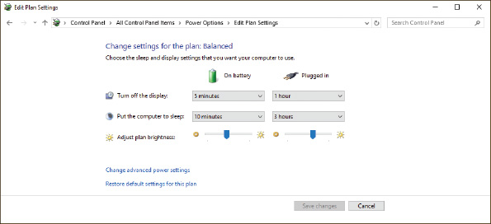
OS Differences
To adjust the brightness in Windows 8/7, open Control Panel in Classic view, click Display, and then click Adjust brightness.
A dim image in a desktop monitor might be caused by a faulty video card or a faulty monitor. To find out which is the problem, connect a different monitor. If the LCD monitor is the problem, most likely the backlighting is faulty and the monitor needs replacing.
- Artifacts. Horizontally torn images on screen are called artifacts (see Figure 6-53), and happen when the video feed from the video controller gets out of sync with the refresh of the monitor screen. The problem can be caused by hardware or software. A common cause is when the GPU on the video card overheats. You can test that possibility by downloading and running freeware to monitor the temperature of the CPU and the GPU while you’re playing a video game. If you notice the problem occurs when the GPU temperature is high, install extra fans around the video card to keep it cool. Two freeware programs to monitor temperatures are CPU-Z by CPUID (cpuid.com/softwares/cpu-z.html) and GPU-Z by TechPowerUp (techpowerup.com/gpuz). See Figure 6-54.
Figure 6-53
A simulation of horizontal tears on an image, called artifacts

Figure 6-54
GPU-Z monitors the GPU temperature
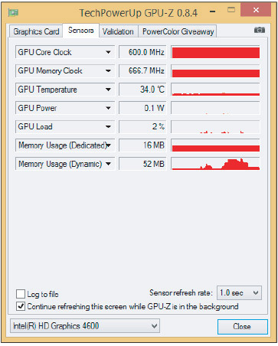
Source: GPU-Z by TechPowerUp
Notes
In this text, we’ve given several options for various freeware utilities. It’s a good idea to know about your options for several reasons: Each freeware utility has different options, owners of freeware might not update their utilities in a timely manner, and websites might decide to include adware with their downloads.
Try updating the video drivers. However, if you see artifacts on the screen before Windows loads, then you know the problem is not caused by the drivers. The problem might be caused by the monitor. Try using a different monitor to see if the problem goes away. If it doesn’t, replace the monitor.
Overclocking can cause artifacts. Other causes of artifacts are the motherboard or video card going bad, which can happen if the system has been overheating or video RAM on the card is faulty. Try replacing the video card. The power supply also might be the problem.
In general, you can improve video quality by upgrading the video card and/or monitor. Poor display might be caused by inadequate video RAM. Your video card might allow you to install additional video RAM. See the card’s documentation.

Cannot Connect to External Monitor or Projector
If the connection to the external monitor or projector fails when you’re setting up dual monitors for a desktop, using a projector for a presentation, or connecting a monitor to a laptop to troubleshoot video problems with the laptop, try the following solutions:
- Make sure the monitor or projector is getting power. Is the power cord securely connected? Is the electrical outlet working?
- Check the connection at both ends of the video cable.
- Is the monitor or projector turned on? For some projectors, a remote control is used to turn on the projector or wake it from sleep mode. The remote control batteries might be dead and need replacing.
- Use the Function keys on a laptop to toggle between the laptop display and the external monitor or projector. (Alternately, you can press Win+P to toggle between displays.)
- Try using a different video cable.
- Try using a different video connection if the laptop and monitor have another option available.
- If the projector shuts off unexpectedly, it might have entered sleep mode because of inactivity. Press the power button to wake the projector. If you can’t wake it, the problem might be overheat shutdown. Allow the projector lamp to cool down. Make sure the air vents are not obstructed and the room temperature is not too hot. The air filters inside the projector might be clogged with dust and need replacing.
Applying Concepts

Correcting Windows Display Settings When the Screen Is Unreadable
When the display settings don’t work, you can easily return to standard VGA settings called VGA mode, which includes a resolution of 640 × 480 or 800 × 600 for some systems.
To use VGA mode when Windows 10/8 is able to boot and you can use at least one monitor, do the following:
- Press Win+X and click Run. In the Run box, type msconfig.exe and press Enter. The System Configuration box appears. Click the Boot tab (see Figure 6-55).
- On the Boot tab, check Base video and click OK. In the box that appears, click Restart. The system will restart in VGA mode. You can now adjust display settings or reinstall video drivers.
- After you fix any problems with video, open the System Configuration box and click Normal startup on the General tab. Then restart Windows.
Figure 6-55
Control how Windows boots
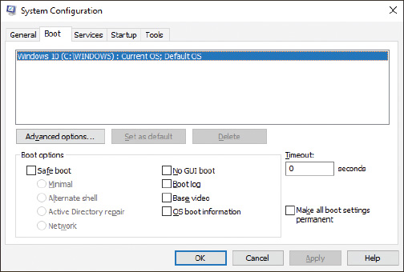
OS Differences
To use VGA mode in Windows 7, reboot the system and press the F8 key after the first beep. The Advanced Boot Options menu appears. Select Safe Mode to boot up with minimal configurations of Windows, which includes standard VGA mode. Alternately, to boot Windows normally and use VGA mode, select Enable low-resolution video (640 × 480). Change the display settings and then restart Windows.
Go to pg.
help
Application Opened
Main content

6-5dVideo System in a Laptop
A+ Core 1
- 5.5
Given a scenario, troubleshoot common mobile device issues while adhering to the appropriate procedures.
If the LCD panel in a laptop shows a black screen but the power light indicates that power is getting to the system, the video subsystem might be the source of the problem. Do the following:
- Look for an LCD cutoff switch or button on the laptop (see Figure 6-56). The switch must be on for the LCD panel to work.
- Try to use an onboard video port to connect an external monitor. After you connect the monitor, use a function key to toggle between the LCD panel, the external monitor, and both the panel and monitor. If the external monitor works but the LCD panel does not, try these things using the external monitor:
  - Check Device Manager for warnings about the video controller and to update the video drivers.
  - Check Event Viewer for reported problems or multiple failed jobs in the logs with the video subsystem. You learned about Event Viewer in Chapter 4.
- If you still can’t get the LCD panel to work but the external monitor does work, you have proven the problem is with the LCD panel assembly. In a laptop, a dim screen or no display can be caused by a bad inverter. If replacing the inverter does not help, the next task is to replace the LCD panel. Be aware that the replacement components might cost more than the laptop is worth. Steps to replace the LCD panel in a laptop are covered later in the chapter.
Figure 6-56
The LCD cutoff button on a laptop
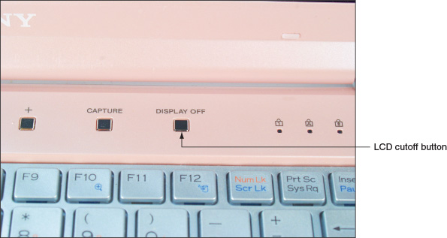

Flickering, Dim, or Otherwise Poor Video
Use these tips to solve problems with bad video:
- Verify Windows display settings. Try using the highest resolution for the LCD panel. This resolution will be the best available unless the wrong video drivers are installed.
- Try adjusting the brightness, which is a function of the backlight component of the LCD panel.
- Try updating the video drivers. Download the latest drivers from the laptop manufacturer’s website. Bad drivers can cause an occasional ghost cursor on screen. A ghost cursor is a trail left behind when you move the mouse.
- If the cursor drifts on the screen when the mouse or touch pad isn’t being used, try using a different port on the computer or replacing the batteries in the mouse.
- A flickering screen can be caused by bad video drivers, a low refresh rate, a bad inverter, or loose connections inside the laptop. After setting the refresh rate to its highest setting, updating the video drivers, and checking for loose connections, try replacing the inverter.

Replace the LCD Panel in a Laptop
Because the LCD panel is so fragile, it is one component that is likely to be broken when a laptop is not handled properly. If the LCD display is entirely black, most likely you’ll have to replace the entire LCD assembly. However, for a laptop that uses fluorescent backlighting, the problem might be the inverter if the screen is dim but you can make out that some display is present. The inverter board converts DC to the AC used to power the backlighting of the LCD panel (see Figure 6-57). Check with the laptop manufacturer to confirm that it makes sense to first try replacing the relatively inexpensive inverter board before you replace the entire LCD panel assembly. If the entire assembly needs replacing, the cost of the assembly might exceed the value of the laptop.
Figure 6-57
A ThinkPad inverter board
A laptop LCD panel, including the entire cover and hinges, is sometimes considered a single field replaceable unit, and sometimes components within the LCD assembly are considered FRUs. For example, the field replaceable units for the display panel in Figure 6-58 are the LCD front bezel, the hinges, the LCD panel, the inverter board, the LCD interface cables, the LCD USB cover, and the rear cover. Also know that an LCD assembly might include a microphone, webcam, and speakers that are embedded in the laptop lid. For other laptops, the microphone and speakers are inside the case. The speakers are considered a field replaceable unit. In addition, a Wi-Fi antenna might be in the lid of the laptop, which is why you should raise the lid if you need a better Wi-Fi signal. When you disassemble the lid, you must disconnect the antenna from the bottom part of the laptop.
Figure 6-58
Components in an LCD assembly
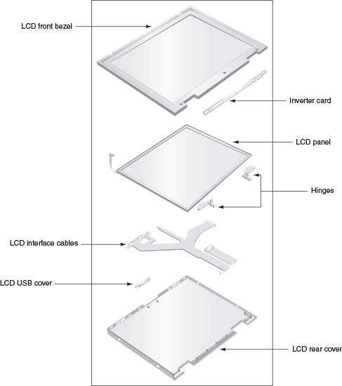
Some high-end laptops contain a video card that has embedded video memory. This video card might also need replacing. In most cases, you would replace only the LCD panel and perhaps the inverter board.
Before you begin any disassembly of a laptop, refer to the manufacturer documentation. The following are some general directions to replace an LCD panel:
- Remove the AC adapter and the battery pack.
- Remove the upper keyboard bezel, which is the band around the keyboard that holds it in place. You might also need to remove the keyboard.
- Remove the screws holding the hinge in place and remove the hinge cover. Figure 6-59 shows a laptop with a metal hinge cover, but some laptops use plastic covers that easily break as you remove them. Be careful with the plastic ones.
Figure 6-59
Remove the hinge cover from the laptop hinge
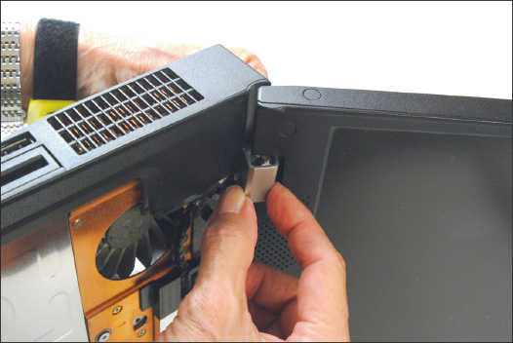
- Remove the screws holding the LCD panel to the laptop.
- You’re now ready to remove the LCD panel from the laptop. Be aware there might be wires running through the hinge assembly, cables, or a pin connector. Cables might be connected to the motherboard using ZIF connectors. As you remove the LCD top cover, be careful to notice how the panel is connected. Don’t pull on wires or cables as you remove the cover, but first carefully disconnect them.
- Next, remove screws that hold the top cover and LCD panel together. Sometimes, these screws are covered with plastic or rubber circles or pads that match the color of the case. First use a dental pick or small screwdriver to pick off these covers. You should then be able to remove the front bezel and separate the rear cover from the LCD panel. For one LCD panel, you can see the inverter board when you separate the LCD assembly from the lid cover. Figure 6-60 shows the inverter being compared with the new one to make sure they match. The match is not identical but should work.
Figure 6-60
The inverter is exposed and is compared with the new one
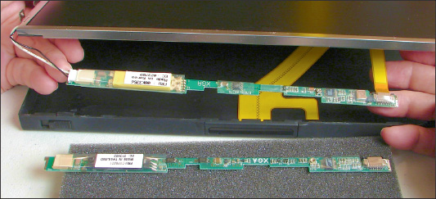
- Disconnect the old inverter and install the new one. When disconnecting the ribbon cable from the old inverter, notice you must first lift up on the lock holding the ZIF connector in place, as shown in Figure 6-61.
Figure 6-61
Lift up on the ZIF connector locking mechanism before removing the ribbon cable
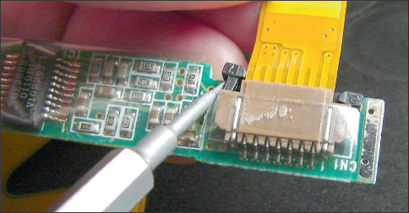
- Install the new inverter. Reassemble the LCD panel assembly. Make sure the assembly is put together with a tight fit so that all screws line up well.
- Reattach the LCD panel assembly to the laptop.
Go to pg.
help
Application Opened
Main content

6-6Customizing Computer Systems
A+ Core 1
- 3.8
Given a scenario, select and configure appropriate components for a custom PC configuration to meet customer specifications or needs.
Many computer vendors and manufacturers offer to build customized systems to meet specific needs of their customers. As a technical retail associate, you need to know how to recommend computer components that meet your customers’ needs. You also might be called on to select and purchase components for a customized system, and perhaps even build this system from parts. In this part of the chapter, we focus on several types of customized systems you might be expected to know how to configure and what parts to consider when configuring these systems.
Here are important principles to keep in mind when customizing a system to meet customer needs:
- Meet applications requirements. Consider the applications the customer will use and make sure the hardware meets or exceeds the recommended requirements for these applications. Consider any special hardware the applications might require, such as a game controller for gaming or a digital tablet for graphics applications.
- Balance functionality and budget. When working with a customer’s budget, put the most money on the hardware components that are most needed for the primary intended purposes of the system. For example, if you are building a customized gaming PC, a RAID hard drive configuration is not nearly as important as the quality of the video subsystem.
- Consider hardware compatibility. When selecting hardware, start with the motherboard and processor. Then select other components that are compatible with this motherboard.
Now let’s look at the components you need to consider when building the following four types of customized systems: a graphics or CAD/CAM design workstation, an audio and video editing workstation, a gaming PC, and a network attached storage device.
A+ Exam Tip
The A+ Core 1 exam might give you a scenario that requires you to customize any of seven types of computers: a graphics or CAD/CAM design workstation, an audio and video editing workstation, a virtualization workstation, a gaming PC, a network attached storage device, a thick client, and a thin client. Four of these types are covered in this chapter, and the other three types are covered in Chapter 10.
Go to pg.
help
Application Opened
Main content

6-6aGraphics or CAD/CAM Design Workstation
A+ Core 1
- 3.8
Given a scenario, select and configure appropriate components for a custom PC configuration to meet customer specifications or needs.
You might be called on to configure a workstation used for graphics or CAD/CAM (computer-aided design/computer-aided manufacturing). People who use these systems might be an engineer working with CAD software to design bridges, an architect who designs skyscrapers, a graphics designer who creates artistic pages for children’s books, or a landscape designer who creates lawn and garden plans. Examples of the applications these professionals might use include AutoCAD by Autodesk (autodesk.com) and Adobe Illustrator by Adobe Systems (adobe.com).
Graphics-intensive, advanced applications perform complex calculations, use large and complex files, and can benefit from the most powerful of workstations. Because rendering 3D graphics is a requirement, a high-end or ultra-high-end video card is needed. Figure 6-62 shows a high-end, customized CAD workstation from Orbital Computers (orbitalcomputers.com).
Figure 6-62
A high-end CAD workstation customized for maximum performance
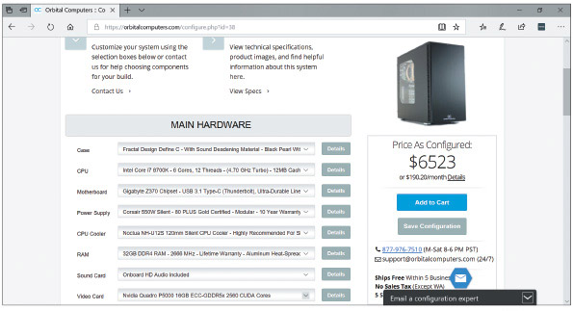
Source: orbitalcomputers.com
Here is a breakdown of the requirements for these high-end workstations:
- Motherboard that provides at least dual channels for memory and plenty of memory slots, and a generous amount of RAM. In the ad shown in Figure 6-62, the system has 32 GB of installed DDR4 RAM. For best performance, you can install the maximum amount of RAM the board supports.
- Powerful multicore processor with a large CPU cache. In the ad shown in Figure 6-62, the Intel 8th generation Core i7 processor, which is rated for high-end workstations and low-end servers, has six cores and a 12-MB cache. This processor can handle the high demands of complex calculations performed by advanced software.
- Fast hard drives with plenty of capacity. Although you can’t see them listed in Figure 6-62, the system has two solid-state drives (SSDs) with a total capacity of 2 TB to accommodate large amounts of data. Also consider the speed of the drive interface—recall from Chapter 5 that the fastest current SSD interface for desktop systems is NVMe using PCIe 3.0. (For magnetic hard drives, the fastest standard is SATA3.)
- High-end video card. To provide the best 3D graphics experience, use a high-end video card that is built more for precision than fast loading. Whereas gaming systems emphasize speed and smooth transitions, CAD/CAM workstations require high-precision graphics for complex 3D images. Two high-end manufacturers for CAD/CAM video cards are NVIDIA (nvidia.com) and AMD (amd.com). The ad in Figure 6-62 mentions the NVIDIA Quadro P5000 (see Figure 6-63). It uses a PCIe ×16 slot and has 16 GB of GDDR5x video memory using a 256-bit video bus. The card has four HDMI ports and one DVI port. The card alone costs about $1,800 and accounts for a major portion of the total system cost, which is over $6,500.
Figure 6-63
This high-end precision video card by NVIDIA costs about $1,800
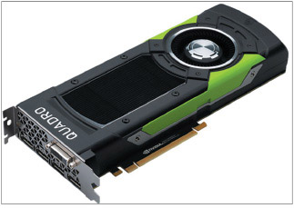
Source: NVIDIA Corporation
Wouldn’t it be fun to build this system? However, not all graphics workstations need to be this powerful or this expensive. You can still get adequate performance in a system for less than half the cost if you drop the RAM down to 16 GB and use an NVIDIA Quadro P2000 video card, along with only one 1-TB SSD while relying on network storage or cloud storage for backups and long-term file storage.
Go to pg.
help
Application Opened
Main content

6-6bAudio and Video Editing Workstation
A+ Core 1
- 3.8
Given a scenario, select and configure appropriate components for a custom PC configuration to meet customer specifications or needs.
Examples of professional applications software used to edit music, audio, video, and movies include Camtasia by TechSmith (techsmith.com), Adobe Premiere Pro by Adobe Systems (adobe.com), Media Composer by Avid (avid.com), and Final Cut Pro by Apple Computers (apple.com). Final Cut Pro only works on Mac computers, which are popular in the video-editing industry.
Audio- and video-editing applications are not usually as power-hungry as CAD/CAM and graphics applications, primarily because most audio and video editing jobs do not require rendering 3D graphics, so you can get by with a less expensive graphics card and processor. However, customers might need a Blu-ray drive and at least two monitors. The best LCD monitors that provide the most accurate color are LED monitors with a class IPS (in-plane switching) rating. Figure 6-64 shows the specs for one customized video-editing workstation designed by Logical Increments (logicalincrements.com).
Figure 6-64
This mid-range video-editing workstation uses a Core i7 processor and GTX graphics processor
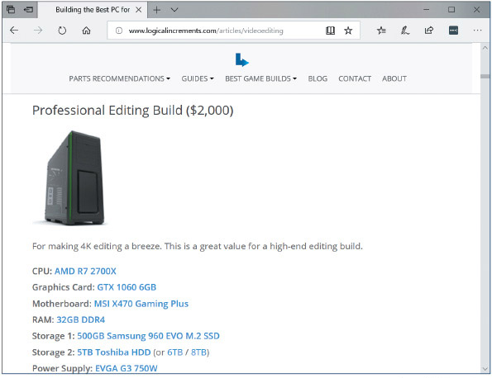
Source: LogicalIncrements.com
Here is what you need for a mid-range to high-end audio/video editing workstation:
- Core i7-equivalent or higher processor. Both Intel and AMD make high-quality CPUs.
- High-end motherboard. Choose a motherboard that supports at least dual-channel memory running at 1600-MHz RAM speed or higher.
- At least 16 GB of RAM. More is better, and make sure the RAM cards are well-matched and slotted correctly on the motherboard.
- Video card with a GeForce GTX graphics processor or better. GeForce is a family of graphics processors designed by NVIDIA that is not as high-end as the Quadro graphics processors but still yields good video performance. Note that AMD also offers impressive graphics card options. Most users will require dual or triple monitors, so you might need to consider dual video cards for optimum video performance or for more than two simultaneous-use video ports.
- Audio card for higher-quality sound output. One example is the Creative Sound Blaster Zx (us.creative.com), which requires a PCIe slot. Before you purchase, research reviews online for highly rated options.
- Maximum storage space. Use one or more large and fast hard drives running at least 7200 RPM with the SATA3 interface, or even better, use SSDs using M.2 slots and the NVMe interface.
- Double-sided, dual-layer DVD burner and possibly a Blu-ray burner. Recall from Chapter 5 that Blu-ray discs come in various standards and can have capacities of 25, 50, 100, or 128 GB. Make sure the Blu-ray burner is rated for the capacity the customer requires.
Go to pg.
help
Application Opened
Main content

6-6cGaming PC
A+ Core 1
- 3.8
Given a scenario, select and configure appropriate components for a custom PC configuration to meet customer specifications or needs.
Gaming computers benefit from a powerful multicore processor designed for gaming, a high-end video card, and a high-definition sound card. Gamers who are also computer hobbyists might want to overclock their CPUs or use dual video cards for extra video performance. Take extra care to make sure the cooling methods are adequate. Because of the heat generated by multiple video cards and overclocking, high-end cooling methods such as liquid cooling are often preferred. Most gaming computers use onboard surround sound, or you can use a sound card to improve sound. A lighted case with a clear plastic side makes for a great look.
Figure 6-65 shows some gaming PCs built by iBUYPOWER (ibuypower.com). On this website, you can adjust the sliders for CPU, GPU, and memory preferences. At the settings shown in Figure 6-65, all the systems use at least 16 GB of RAM and the powerful Intel 8th generation Core i7-8700K processor, which is designed with the gamer in mind. The “K” in the processor model number indicates that the processor can be overclocked. The video cards use a GeForce GTX graphics processor, and another popular option on the website is an AMD Radeon RX graphics processor. The Radeon graphics processors by AMD are comparable to the NVIDIA GeForce graphics processors.
Figure 6-65
A group of Intel Core i7 gaming PCs
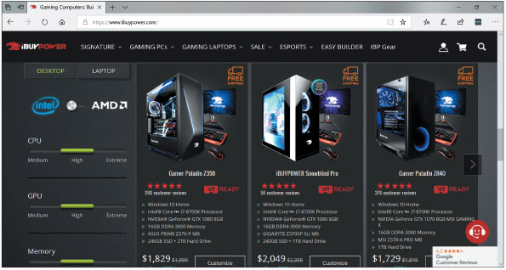
Source: ibuypower.com
Go to pg.
help
Application Opened
Main content

6-6dNAS (Network Attached Storage) Device
A+ Core 1
- 3.8
Given a scenario, select and configure appropriate components for a custom PC configuration to meet customer specifications or needs.
Recall from Chapter 5 that an NAS (network attached storage) device contains a collection of hard drives providing storage services to a network. This is useful when you have several computers on a small business or home network and want to share files among them or access these files from the Internet. You can use the NAS device to serve up these files and to stream media files and movies to client computers, or you can stream media files to the NAS device for storage, such as a video feed from a security camera. On the small end, My Cloud by WD (wdc.com) sells for just over $150 and includes a single 2-, 3-, or 4-TB disk that can be backed up to an external hard drive. A much more capable—and expensive—option is the DiskStation DS1817 by Synology (synology.com) shown in Figure 6-66. This NAS device includes eight bays that can each hold a maximum 12-TB drive with many backup and load-balancing configuration options. It also has 8 GB of RAM with the option to add another 8 GB on the dual-channeled motherboard, and the option to add a 10-Gigabit Ethernet network card or dual M.2 SSD adapter cards.
Figure 6-66
An eight-bay NAS device
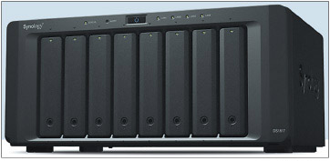
Source: Synology.com
Here are the features and hardware you need to consider when customizing an NAS device:
- Processor with moderate power. A moderate amount of RAM is sufficient—for example, 6 to 8 GB.
- RAID array. Make sure the motherboard supports hardware RAID and implement RAID on the motherboard to provide fault tolerance and high performance. Use fast hard drives (at least 7200 RPM) or, better yet, SSDs with plenty of storage capacity, accounting for the extra space needed for the RAID implementation you intend to use. Know that some storage drives are designed for energy efficiency by shutting down when not in use; this feature does not work well in RAID systems. Check the NAS device manufacturer’s website for a list of compatible storage drives.
- Appropriately sized chassis. Make sure the case has plenty of room for all the storage drives a customer might require.
- Gigabit NIC. Network transfers need to be fast, especially for streaming videos and movies. Make sure the network port is rated for Gigabit Ethernet (1000 Mbps) or, if the network will support it, 10 Gigabit Ethernet. All devices and computers on the LAN should use the same speed.
- Media streaming capability. If you plan to stream media from the NAS device, make sure it supports UPnP/DLNA standards. UPnP is a feature included in many residential and small business routers that helps computers on the network discover and communicate with services provided by other computers. DLNA is a derivative of UPnP that is specific to media streaming services.
Go to pg.
help
Application Opened
Main content

Chapter Review

6-7aChapter Summary

Basic Principles for Supporting Devices
- Adding new devices to a computer requires installing hardware and software. Even if you generally know how to install an I/O device, always follow the specific instructions of the product manufacturer.
- Use Device Manager in Windows to manage hardware devices and to solve problems with them.
- Wired data transmission types include USB, eSATA, Thunderbolt, and Lightning. Wireless data transmission types include Wi-Fi, Bluetooth, and NFC.
- USB connectors include the A-Male, Micro-A, B-Male, Mini-B, Micro-B, and USB-C.
- Popular I/O ports on a desktop or laptop motherboard include eSATA and USB. Older computers sometimes used serial RS-232 ports.
- Video ports that a video card or motherboard might provide are VGA, DVI-I, DVI-D, DisplayPort, HDMI, HDMI mini, and multipurpose Thunderbolt ports.
- Other peripheral connectors and ports include eSATA, Lightning, BNC, RG-6, RG-59, and RS-232.

Identifying and Installing I/O Peripheral Devices
- When installing devices, use 32-bit drivers for a 32-bit OS and 64-bit drivers for a 64-bit OS.
- A touch screen is likely to use a USB port. Software is installed to calibrate the touch screen to the monitor screen and receive data input.
- Biometric input devices, such as a fingerprint reader, collect biological data and compare it with that recorded about a person to authenticate the person’s access to a system.
- A KVM switch lets you use one keyboard, monitor, and mouse with multiple computers.

Installing and Configuring Adapter Cards
- Generally, when an adapter card is physically installed in a system and Windows starts up, it detects the card and then you install the drivers using the Windows wizard. However, always follow specific instructions from the device manufacturer when installing an adapter card because the order of installing the card and drivers might be different.
- A sound card allows you to input audio and use multispeaker systems.

Supporting the Video Subsystem
- Types of monitors include LCD and OLED.
- Technologies and features of LCD monitors include screen size, refresh rate, pixel pitch, resolution, contrast ratio, viewing angle, backlighting, and connectors that a monitor uses.
- Use the Windows 10 Settings app or the Windows 8/7 Screen Resolution window to configure monitor resolution and configure dual monitors.

Troubleshooting I/O Devices
- Use Device Manager to update drivers on I/O devices giving trouble.
- Video problems can be caused by the monitor, video cable, video card, onboard video, video drivers, or Windows display settings.
- To bypass Windows display settings, boot the system to the Advanced Boot Options menu and select Safe Mode or Enable low-resolution video (640 × 480) to enable VGA mode.
- A few dead pixels on an LCD monitor screen are considered acceptable by the manufacturer.
- Artifacts on the monitor screen can be caused by hardware, software, overheating, or overclocking. Try updating video drivers and checking for high temperatures.

Customizing Computer Systems
- As a technician, you might be called on to customize a system for a customer, including a graphics or CAD/CAM workstation, an audio- and video-editing workstation, a gaming PC, and an NAS device.
- A high-end video card is a requirement in a graphics, CAD/CAM, or video-editing workstation, or for a gaming PC. These systems also need powerful processors and ample RAM.
Go to pg.
help
Application Opened
Main content

Chapter Review

6-7bKey Terms
For explanations of key terms, see the Glossary for this text.
- artifact
- barcode reader
- biometric device
- BNC connector
- burn-in
- chip reader
- coaxial cable
- DB-9
- DB-15
- dead pixel
- Device Manager
- digitizer
- digitizing tablet
- DisplayPort
- distorted geometry
- DVI-D
- DVI-I
- flat-panel monitor
- ghost cursor
- graphics tablet
- HDMI connector
- HDMI mini connector
- hot-swappable
- KVM (Keyboard, Video, and Mouse) switch
- LCD (liquid crystal display) monitor
- Lightning
- magnetic stripe reader
- micro USB
- Mini DisplayPort
- mini-HDMI connector
- Mini PCIe
- Mini PCI Express
- mini USB
- OLED (organic light-emitting diode)
- overheat shutdown
- pixel
- projector
- RG-6 coaxial cable
- RG-59 coaxial cable
- RS-232
- signature pad
- sound card
- stylus
- tap pay device
- Thunderbolt
- touch screen
- USB 2.0
- USB 3.0
- USB-C
- VGA mode
- VR (virtual reality) headset
Go to pg.
help
Application Opened
Main content

Chapter Review

6-7cThinking Critically
These questions are designed to prepare you for the critical thinking required for the A+ exams and may use content from other chapters and the web.
- You want to connect an external hard drive for backups. Which is the fastest connection used by current external hard drives? What is the speed?
- You’re working on a server in a server room and need to connect a keyboard. The port available is a 9-pin serial port. What type of port is this?
- You have a contactless magnetic stripe and chip reader by Square. What type of wireless transmission does the device use to receive encrypted data?
- Your boss bought a new printer with a USB 3.0 port, and it came with a USB 3.0 cable. Your boss asks you: Will the printer work when I connect the printer’s USB cable into a USB 2.0 port on my computer?
  - No, the printer can only use a USB 3.0 port.
  - Yes, but at the USB 2.0 speed.
  - Yes, it will work at the USB 3.0 speed.
  - Yes, but at the UBS 1.1 speed.
- What is the easiest way to tell if a USB port on a laptop computer is using the USB 3.0 standard?
- Your friend Amy calls you asking for help with her new LCD monitor. She says the monitor isn’t showing the whole picture. What is the resolution you should recommend for her to use?
- Your boss has asked you what type of monitor he should use in his new office, which has a wall of windows. He is concerned there will be considerable glare. Which gives less glare, an LED monitor or an OLED monitor?
- Which Windows utility is most likely the best one to use when uninstalling an expansion card?
- Would you expect all the devices listed in BIOS/UEFI setup to also be listed in Device Manager? Would you expect all devices listed in Device Manager to also be listed in BIOS/UEFI setup?
- Why is it best to leave a slot empty between two expansion cards?
- You’re connecting a single speaker to your computer. Which speaker port should you use?
- What can you do if a port on the motherboard is faulty and a device requires this type of port?
- What are two screen resolutions that might be used by VGA mode?
- Which type of drivers must always be certified in order to be installed in Windows?
- Your desktop computer has DVI and HDMI video ports. If a DVI monitor does not work on your system and yet you know the monitor is good, what is the best solution?
  - Use a DVI to HDMI adapter to use the current DVI monitor and cable.
  - Buy a new HDMI monitor to use with the HDMI port.
  - Install a video card in your computer with a DVI port.
  - Replace the motherboard with another motherboard that has a DVI port.
- You plug a new scanner into a USB port on your Windows system. When you first turn on the scanner, what should you expect to see?
  - A message displayed by the scanner software telling you to reboot your system.
  - Windows Device Setup launches to install drivers.
  - Your system automatically reboots.
  - An error message from the USB controller.
- You turn on your Windows computer and see the system display POST messages. Then the screen goes blank with no text. Which of the following items could be the source of the problem?
  - The video card
  - The monitor
  - Windows
  - Microsoft Word software installed on the system
- You have just installed a new sound card in your system, and Windows says the card installed with no errors. When you plug up the speakers and try to play a music CD, you hear no sound. What is the first thing you should do? The second thing?
  - Check Device Manager to see if the sound card is recognized and has no errors.
  - Reinstall Windows.
  - Use Device Manager to uninstall the sound card.
  - Identify your sound card by opening the case and looking on the card for the manufacturer and model.
  - Check the volume controls on the speaker amplifier and in Windows.
  - Use Device Manager to update the sound card drivers.
- You have just installed a new DVD drive and its drivers in Windows 10. The drive will read a CD but not a DVD. You decide to reinstall the device drivers. What is the first thing you do?
  - Open the Settings app and click the System group.
  - Open Device Manager and choose Update Driver.
  - Remove the data cable from the DVD drive so Windows will no longer recognize the drive and allow you to reinstall the drivers.
  - Open Device Manager and uninstall the drive.
- Match the following ports to the diagrams in Figure 6-67: Dual Link DVI-I, USB Type A, USB Type B, VGA, DisplayPort, Mini DisplayPort, HDMI, and serial RS-232. (Note that some port diagrams are not used.)
Figure 6-67
Identify ports
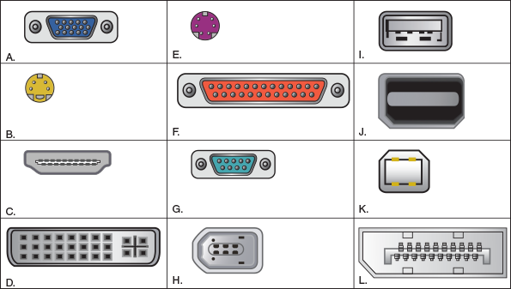
- Three hardware priorities for a CAD workstation are a multicore processor, maximum RAM, and a high-end video card. How do each of these components meet the specific demands of this type of computer system?
- You just received a shipment of two customized computer systems and need to figure out which workstation is the CAD computer and which is the video-editing workstation. While examining the specifications for each, what telltale differences will help you to identify them correctly?
- Your customer, Mykel, is ordering a custom-built computer for his home office and isn’t sure which components should be the highest priority to meet his needs. He’s a software developer and runs multiple VMs to test his applications. He also designs some of his own graphics, and he plays online games when he’s not working. Which of the following priorities would be most important for Mykel’s computer?
  - High-end graphics card, RAID array, and lots of RAM
  - High-end CPU, lots of RAM, and high-end graphics card
  - Multiple hard drives, lots of RAM, and high-end CPU
  - High-end graphics card, expansion audio card, and lots of RAM
- Your customer, Maggie, wants to buy a gaming PC, and she specifically mentions that she wants an Intel CPU and intends to overclock the CPU. How can you identify which Intel CPUs are capable of overclocking? What are two other components that must be selected with overclocking in mind?
Go to pg.
help

Main content

6-1bConnectors and Ports Used by Peripheral Devices
Take a look at the back of a computer and you’re likely to see a group of ports, several of which you saw in Table 1-1 in Chapter 1. In this part of the chapter, we survey ports used by a variety of I/O devices and ports used for video, TV, and other specific uses. We begin our survey with USB.

USB Connections and Ports
Here is a summary of important facts you need to know about USB connections:
- The USB Implementers Forum, Inc. (usb.org), the organization responsible for developing USB, uses the symbols shown in Figure 6-1 to indicate SuperSpeed+ USB (USB 3.2 and USB 3.1), SuperSpeed USB (USB 3.0), Hi-Speed USB (USB 2.0), or Original USB (USB 1.1).
Figure 6-1
SuperSpeed+, SuperSpeed, Hi-Speed, and Original USB logos appear on products certified by the USB Forum

Source: USB Forum
- As many as 127 USB devices can be daisy-chained together using USB cables. In a daisy chain, one device provides a USB port for the next device.
- USB uses serial transmissions, and USB devices are hot-swappable, meaning that you can plug in or unplug one without first powering down the system.
- A USB cable has four wires, two for power and two for communication. The two power wires (one is hot and the other is ground) allow the host controller to provide power to a device. Three general categories of USB ports and connectors are regular USB, micro USB, and mini USB. Mini USB connectors are smaller and more durable than micro USB, which are smaller than regular USB connectors. Table 6-2 shows the different USB connectors on USB cables.
Table 6-2

USB Connectors
Cable and Connectors | Description
A-Male to B-Male cable  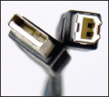 | The A-Male connector on the left is flat and wide and connects to an A-Male USB port on a computer or USB hub.  The B-Male connector on the right is square and connects to a USB 1.x or 2.0 device such as a printer.
Mini-B to A-Male cable  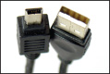 | The Mini-B connector has five pins and is often used to connect small electronic devices to a computer.
A-Male to Micro-B cable  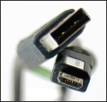 | The Micro-B connector has five pins and has a smaller height than the Mini-B connector. It’s used on tablets, cell phones, and other small electronic devices.
A-Male to Micro-A cable  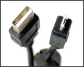 | The Micro-A connector has five pins and is smaller than the Mini-B connector. It’s used on cell phones and other small electronic devices.
USB 3.0 A-Male to USB 3.0 B-Male cable  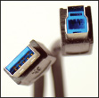 | This USB 3.0 B-Male connector is used by SuperSpeed USB 3.0 devices such as printers or scanners. Devices that have this connection can also use regular B-Male connectors, but this USB 3.0 B-Male connector will not fit the connection on a USB 1.1 or 2.0 device. USB 3.0 A-Male and B-Male connectors and ports are blue.
USB 3.0 A-Male to USB 3.0 Micro-B cable  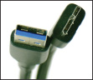 | The USB 3.0 Micro-B connector is used by SuperSpeed USB 3.0 devices. The connectors are not compatible with regular Micro-B connectors.
USB 3.1 A-Male to USB-C 3.1 cable  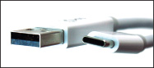 | The USB-C connector (also called the USB Type-C connector) on the right is flat with rounded sides and connects to a USB-C port on a computer or device, such as the latest smartphones or a graphics tablet. USB-C connectors do not have a specific orientation and are backward compatible with USB 2.0 and USB 3.0. The connector is required to attain maximum speeds with USB 3.2 devices.
Notes
Sometimes a mouse that uses USB 2.0 gives problems when plugged into a USB 3.0 port. If a mouse refuses to work or is unstable, try moving it to a USB 2.0 port.
Notes
A USB 3.0 A-Male connector or port has additional pins compared with USB 1.1 or 2.0 ports and connectors but still is backward compatible with USB 1.1 and 2.0 devices. A USB 3.0 A-Male or B-Male connector or port is usually blue. Take a close look at the blue and black USB ports shown in Figure 1-14 in Chapter 1.

Video Connectors and Ports
Video ports are provided by a video card or the motherboard. Video cards (see Figure 6-2) are sometimes called graphics adapters, graphics cards, or display cards. Most motherboards sold today have one or more video ports integrated into the motherboard and are called onboard ports. If you are buying a motherboard with a video port, make sure that you can disable the video port on the motherboard if it gives you trouble. You can then install a video card and use its video port rather than the port on the motherboard. Recall that a video card can use a PCI or PCI Express slot on the motherboard. The fastest slot to use is a PCIe ×16 slot.
Figure 6-2
The PCX 5750 graphics card by MSI Computer Corporation uses the PCI Express ×16 local bus
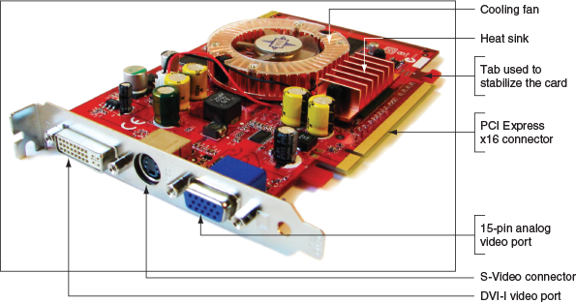
Recall that types of video ports include VGA, DVI, DisplayPort, and HDMI connectors. In addition to these ports, you also need to know about mini-HDMI, DVI-I, and DVI-D ports. These ports are described here:
- VGA. The 15-pin VGA port is the standard analog video port and transmits three signals of red, green, and blue (RGB). A VGA port is sometimes called a DB-15 port.
- DVI ports. DVI ports were designed to replace VGA, and variations of DVI can transmit analog and/or digital data. The DVI standards specify the maximum length for DVI cables as 5 meters, although some video cards produce a strong enough signal to allow for longer DVI cables.
Here are the variations of DVI:
  - DVI-D. The DVI-D port only transmits digital data. Using an adapter to convert a VGA cable to the port won’t work. You can see a DVI-D port in Figure 6-3A.
Figure 6-3
Two types of DVI ports: (A) DVI-D, (B) DVI-I
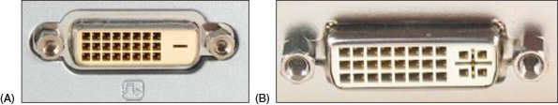
  - DVI-I. The DVI-I port (see Figure 6-3B) supports both analog and digital signals. Analog data is transmitted using the extra four holes on the right side of the connector. If a computer has this type of port, you can use a digital-to-analog adapter to connect an older analog monitor to the port using a VGA cable (see Figure 6-4). If a video card has a DVI port, most likely it will be the DVI-I port (the one with the four extra holes) so that you can use an adapter to convert the port to a VGA port.
Figure 6-4
A digital-to-analog video port converter using a DVI-I connector with four extra pins
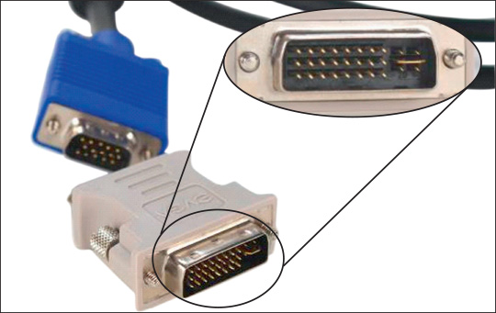
- DisplayPort. DisplayPort was designed to replace DVI and can transmit digital video and audio data. It uses data packet transmissions similar to those of Ethernet, USB, and PCI Express, and is expected to ultimately replace VGA, DVI, and HDMI on desktop and laptop computers. Besides the regular DisplayPort used on video cards and desktop computers, laptops might use the smaller Mini DisplayPort. Figure 6-5 shows a DisplayPort to Mini DisplayPort cable. The maximum length for DisplayPort cables is 15 meters.
Figure 6-5
A DisplayPort to Mini DisplayPort cable
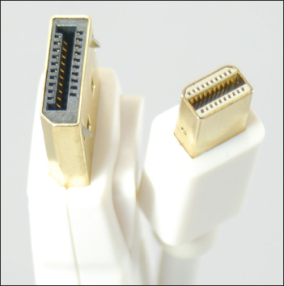
BIOS/UEFI setup can be used to manage onboard DisplayPort and HDMI ports. For example, Figure 6-6 shows the BIOS screen where you can enable or disable the audio transmissions of DisplayPort and HDMI ports and still use these ports for video.
Figure 6-6
Use BIOS/UEFI setup to enable or disable onboard ports
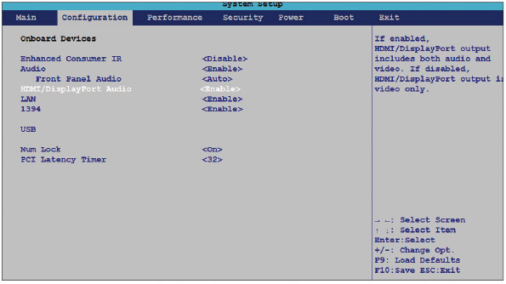
Source: Intel
- HDMI and HDMI mini connectors. HDMI transmits both digital video and audio, and was designed to be used by home theater equipment. The HDMI standards allow for several types of HDMI connectors. The best known, which is used on most computers and televisions, is the Type A 19-pin HDMI connector. Small mobile devices can use the smaller Type C 19-pin HDMI mini connector, also called the mini-HDMI connector. Figure 6-7 shows a cable with both connectors that is useful when connecting devices like a smartphone to a computer. Figure 6-8 shows an HDMI to DVI-D cable. An HDMI connector works only on DVI-D and DVI-I ports. The maximum length of an HDMI cable depends on the quality of the cable; no maximum length has been specified.
Figure 6-7
An HDMI to mini-HDMI cable
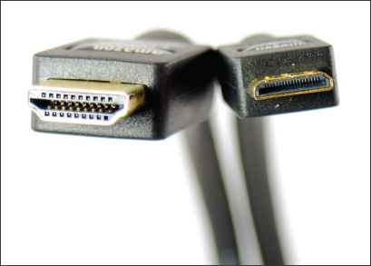
Figure 6-8
An HDMI to DVI cable can be used to connect a computer that has a DVI port to home theater equipment that uses an HDMI port
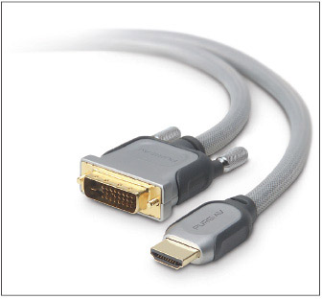
Source: Courtesy of Belkin Corporation
A+ Exam Tip
The A+ Core 1 exam expects you to know about these video connector types: VGA (DB-15), HDMI, mini-HDMI, DisplayPort, DVI-D, and DVI-I. You must also be able to choose which connector type is the right solution given a scenario.

Additional Connectors and Ports
Besides USB and video, here are a few other ports and connectors you need to know about:
- Thunderbolt. Thunderbolt is a multipurpose connector used for high-end displays, external storage devices, and to charge power for smartphones and laptops (see Figure 6-9). Earlier versions of Thunderbolt were limited to Apple products and used the DisplayPort base connection. The latest Thunderbolt 3 uses the USB-C connection (marked with a lightning bolt symbol), which opens the compatibility of Thunderbolt connections to non-Apple products. The USB-C Thunderbolt 3 port can support data transfer rates up to 40 Gbps.
Figure 6-9
The Thunderbolt 3 cable uses the USB-C connector
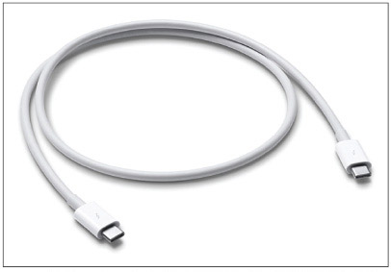
Source: https://www.apple.com/shop/product/MQ4H2AM/A/thunderbolt-3-usb%E2%80%91c-cable-08-m
- eSATA. The eSATA port is used for connecting external storage devices to a computer (see Figure 6-10).
Figure 6-10
An eSATA connection is used to connect external storage devices to a computer
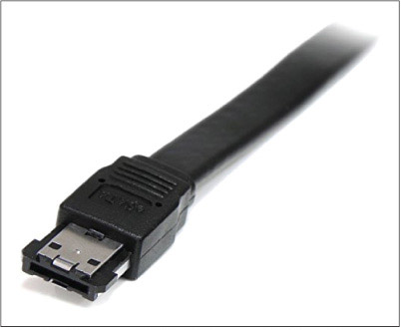
Source: https://www.amazon.com/StarTech-3-Feet-Shielded-External-ESATA3/dp/B000ENUCR4/ref=sr_1_5?ie=UTF8&qid=1534146766&sr=8-5&keywords=esata+cable
- Lightning. The Lightning connector is an Apple-specific connector for its mobile devices (see Figure 6-11). It is used to charge mobile devices, for data transfer, and to connect peripheral devices, such as a credit card payment device or headphone jack, to the Apple mobile device. The connector is reversible.
Figure 6-11
This Lightning-to-USB-C cable connects an Apple mobile device to a USB-C port
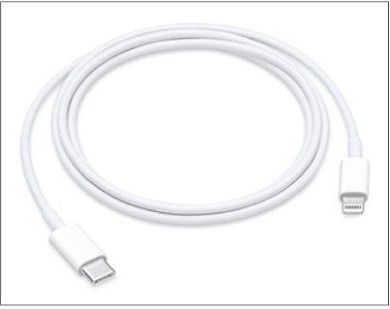
Source: https://www.apple.com/shop/product/MQGJ2AM/A/usb-c-to-lightning-cable-1-m?fnode=91
These connectors and ports are mostly outdated, although you might still see them in use:
- BNC, RG-6, and RG-59. Coaxial cable has a single copper wire down the middle and a braided shield around it (see Figure 6-12). The cable is stiff and difficult to manage, and is no longer used for networking. RG-6 coaxial cable is used for cable TV, having replaced the older and thinner RG-59 coaxial cable once used for cable TV. Coaxial cable uses a twist-on connector called a BNC connector. One type of BNC connector, called the F connector, is shown in Figure 6-13.
Figure 6-12
A coaxial cable uses a twist-on BNC connector
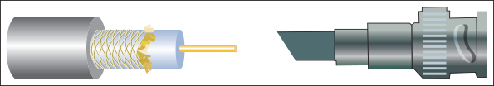
Figure 6-13
An RG-6 coaxial cable with an F connector used for connections to TV has a single copper wire
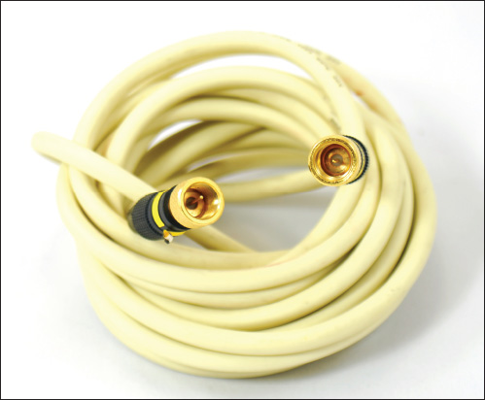
- RS-232. USB or other connectors have replaced the serial RS-232 connectors once used with mice, keyboards, dial-up modems, and peripheral connections. However, you might see a serial RS-232 connector on a rack server to set up a terminal to access the server. An earlier version of RS-232 had a 25-pin connector, but all RS-232 connectors today use 9 pins and are often called DB-9 connectors (see Figure 6-14).
Figure 6-14
The DB-9 connector may be used to connect a terminal to a server installed in a rack
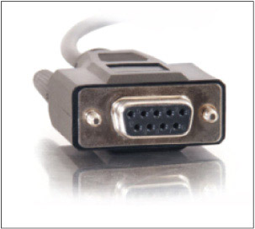
Source: https://www.cablestogo.com/product/52035/6ft-db9-f-f-serial-rs232-cable-black
Now that you know about the connection standards, ports, and connectors for external devices, let’s see how to install them.
Go to pg.
help

