1. Data Sources (next to toolbox). If you cannot find it click “View”
-> “Other Windows” -> “Data sources”. Should be on the left near the toolbox.

2.Add new
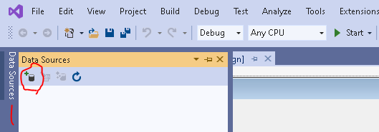

3. Database ->Data set
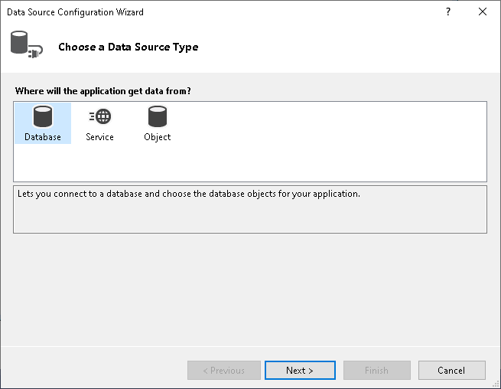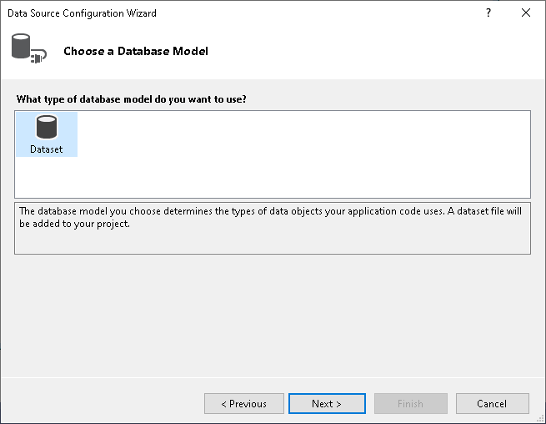

4. New Connection...
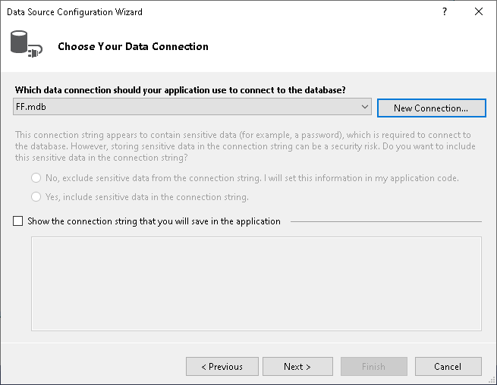

5.Click Browse
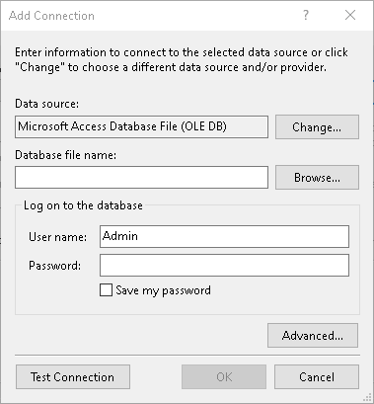

6. Select Database
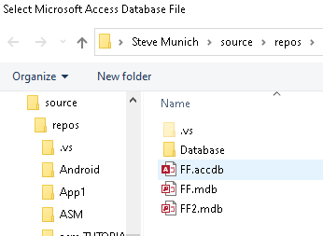

7. Click Test Connection
---------------You may get an error here------------------------
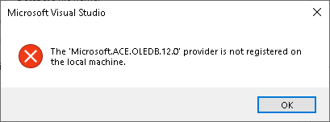
-----------------------------------------------------------------
To Fix
NOTE: This may not even be necessary, I did it. Skip to #8 if things don’t work then come back here
(You may or may not need to install the Driver at Download Microsoft Access Database Engine 2016 Redistributable from Official Microsoft Download Center
https://www.microsoft.com/en-us/download/details.aspx?id=549207.
Install the 64 bit.

8. Click Advanced


9. Click “Provider”
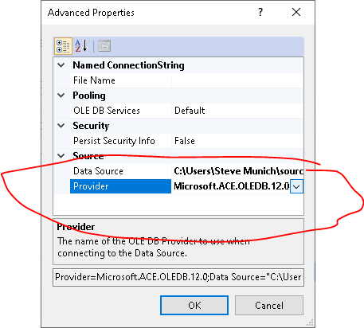

10. Change Provider to “Microsoft.Jet.OLEDB.4.0”
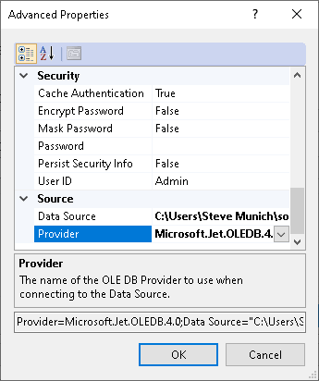
Select OK

11. Test Connection
---------------You may get an error here------------------
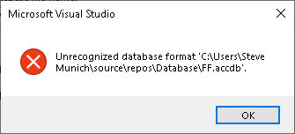
-----------------------------------------------------------------
To Fix
11. Open Access, Save Database Access file as .mdb format

12. Test Connection
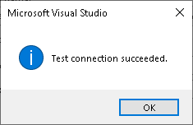

13. If connection is successful, click OK
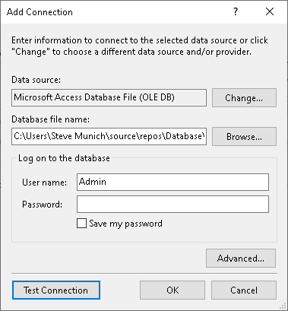

14. Click Next
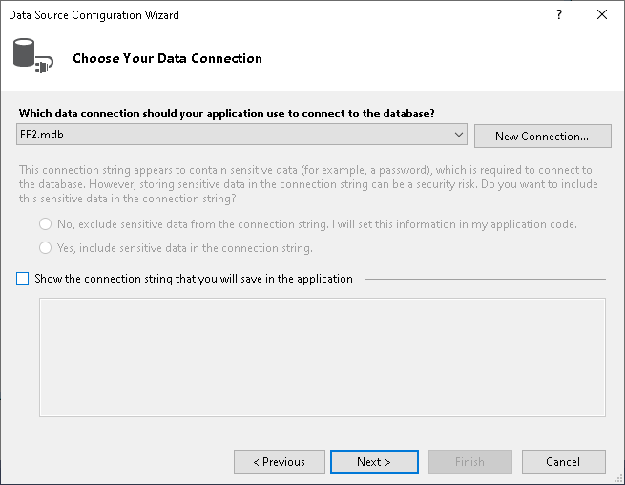.

15. Yes & No prompt
-yes if you want to copy the database into your project
-no if you want to edit the database file(I chose this option)
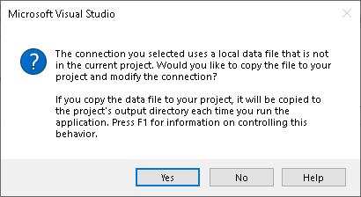

16. "Do you want to save connection string to application configuration file?"
Yes for checkbox, save the connection string
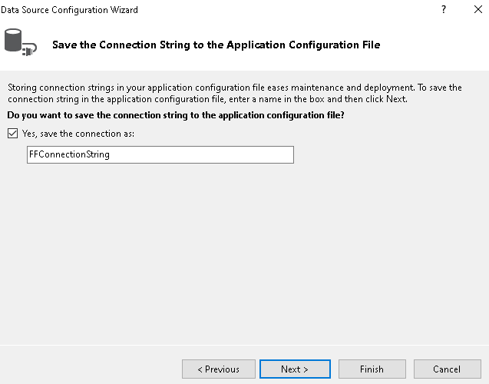
Click Next

17. choose tables & click Finish
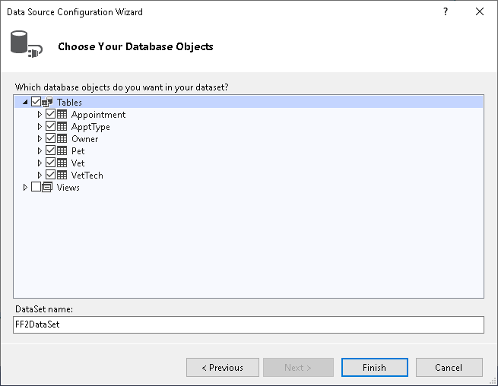

-------------------Connection Finished----------------------

Now for Code:

1. click Data Sources (next to toolbox)
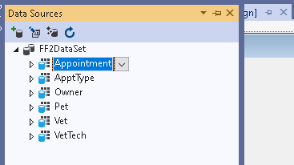

2. drag and drop table, in this example “Appointments” Table, to Windows Form(grid view, details view, doesn't matter. I chose gridview).
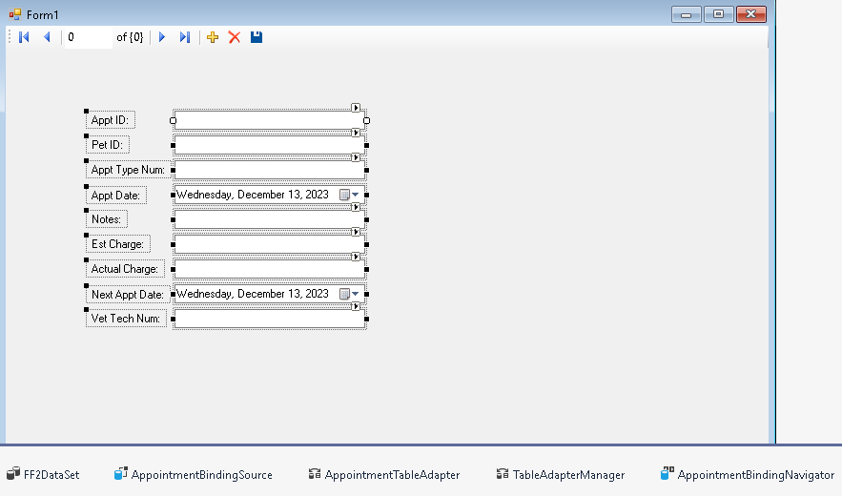
Your Form should look like this with added objects at the bottom.

3. Toolbox -> DataGridView. Drag-and-Drop onto windows form.
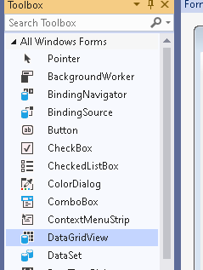
4. Click the arrow at top right of grid.
5. Choose DataGrid source, in this example "Appointment Binding Source"
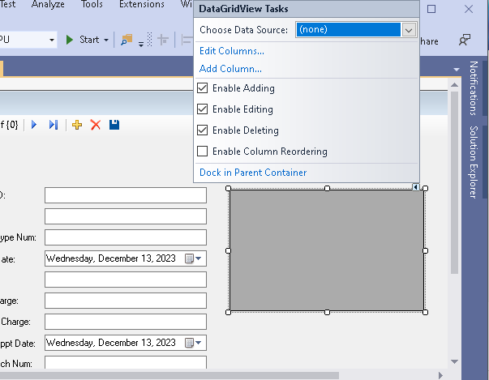
Note: I checked “Enable Column Reordering” from the tutorial.

6. run the program
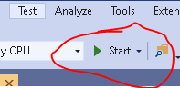
7. click add
fill in all fields, or required fields.

If not you may get an error. When you click “Save”
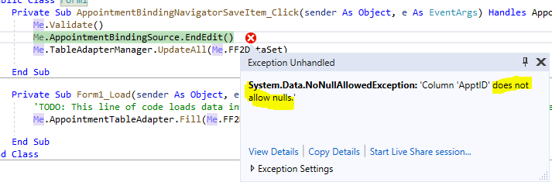
7.2 Try Again FILL ALL FIELDS. Then check the database file.

