Resume
Steven Munich
Senior at Eastern Florida State College
Software Engineering, Network+ & Cyber Security
www.stevenmunich.com

Steven  Munich | 1505 N. Highway A1A #402  Indialantic, FL 32903  (407)-717-5673  StevenMunich777@gmail.com  https://www.stevenmunich.com
ㅡ  Skills | Real Estate License, Computers experience; including software engineering(Object oriented).  2 years driving experience, I love to drive.  Years of programming experience and has been a hobby for 20 years since the age of 12.  I'm down to earth and like to make people smile and happy and understand if someone is rude that it could be something else in their life. No matter what I always try to provide the best service I can.
ㅡ  Employment | Remax alternative/ Licensed Assistant  In process of moving. (321)-777-4111,  2017-2022  Assist Sales Agents: Free up time for Veteran Realtor, learn. Can show properties, have clients sign contracts, go to closings. The Role was mostly IT Manamagement.  Assistance included: scanning offers/contracts. Show property. Research property from property’s history, including tax records. Have knowledge of comparable properties sold & listed(CMA). Advertise current listings and try to get new ones  Allows us to project how much to list for and what buyers will negotiate, which goes without saying in Standard Real Estate transactions,  Prospect for new clients (mail-outs, cold calls, advertising existing listings). Reverse Prospecting: Matches your listing with other realtors’ contacts whose criteria includes our listing. Then email 20-30 agents with those clients. When you have a listing other agents are working for you.  Organizing and filing sales, listings, and rentals. Paperwork & computer (for the database).  Send mail to sale by owners, and expired listings.  Papa John's/ Deliver driver  1/16/2016 to 6/30/2016  WASH HANDS ALWAYS, be careful with others food. Keep food hot in bag. Drive VERY SAFE, hand food to customer. Receive cash and dispense change  While Not on delivery: Wait in-line with other drivers.  In meantime:  Take phone calls when customers & take order  Fold boxes, sticky printed labels to correct sized boxes for those boxing the pizzas when ready. Slice and box them. Then deliver.  Uber-Partner/ Driver  5/20/2016 to 8/30/2017 Melbourne, FL  Pick up passenger(s)  Keep them safe in my vehicle.  Handle Intoxicated passengers  Drop them off at location.
ㅡ  Education | Brevard community college/ A.A  5/30/2008-5/30/2012  Network+ Certified  Real Estate License.  Was going into nursing, got prerequisites. Learned about anatomy, math, etc.  Thought about computer programming, did so as a hobby since age 12(2005), at 17 and was able to make complicated code. Was able to alter how code ran in videogames (third party programming) and could easily create malware for educational purposes. Decided to get license in Real Estate and worked with Father at age of 20

References
Susan Jennings (321)544 4351 Adult and Child Counseling
Jane Brady (321)777-4111 Re/Max
Misty Morrison – (321) 574- 8119 Re/Max



Steven Munich, Network+ Certified, A.A,
Senior in bachelors program for software development at Eastern Florida State College.
Basic Office work: MS Office
Cybersecurity
Configurations of routers and firewalls..
Computer repair/maintenance
Database Management
Hardware – Memory, CPU, NICs, Drives, etc.
Hosting websites on internet & intranet.
Reverse Engineering, mostly Software.
Software Development:
IDE/Code Editors:
Visual studio for C++ C# & Visual Basic
Android Studio, Eclipse, IntelliJ for Java
PyCharm for Python
Visual Studio Code for Web development & Python
Microsoft Access & SQL workbench
Notepad++ for web development and scripting(vbs, batch files, etc)

Tools I use:
Auto Clicker – personal tool
Disassemblers – IDA
Kali Linux – 500 tools preinstalled on the Operating System.
Memory Scanner – Cheat Engine
Packet Sniffer/Protocol Analyzer - WireShark
Port Scanner - Nmap

Network+ Knowledge
OSI Model
Layer 2 Addressing(Sometimes referred to a ‘MAC Address” Media Access Control)
IPv4
Ipv6
Network Address Translation(NAT)
Port Address Translation(PAT)
Transport mediums(coaxial, twinaxial, fiber optic)
MultiPlexing
Transceivers
Network Security Concepts
Access Control List
Firewalls
Honeypots
Intrusion Prevention & Detection Systems
Defense in depth
Principle of Least Privilege
Separation of duties
Inside Threats: Role Based Access control and network WIH acl coujave oii
Layer 2 Tunneling Protocol and other VPN Services
Encryption in transit

IT Business & Security
In-house vs Outsourcing

Security Concepts
Supply Chain Threats
New Emerging threats

Programming
Languages: C/C++, C#, Java, Javascript, Python, Visual Basic.NET
Concepts: Big-O, Data-Structures, Flow Control, Memory Management, Multithreading, Networking, Search/Sort Algorithms, UI/UX(User Interface/User Experience)
C++
1. keyloggers
-GetAsyncKeyState() for events on key press
-Append String until certain length then save locally or email using SMTP
-SMTP for automatic emails(can be used for other programs/business functions).
2. Third party applications
-ReadProcessMemory – reads a memory address in process
-WriteProcessMemory – Writes a value to that memory address.
-used to modify other people’s software, process injection.
3. Old games like snake, pacman,
C #
-Keyloggers (same as c++)
-Networking applications, Instant messengers, Remote Access Tool
-Xamarin in the past for mobile phone app development.

Java
1. Mobile App: Preventyl – Stopwatch + SMS
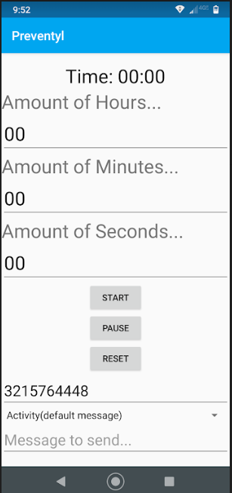
Default Message: The user of this number has not responded in 0 Hours, 01 Minutes, and 07 seconds while hiking . You may want to contact them.
Activity(default message) can be changed to Custom message:
Hey buddy I'm still sleeping can you wake me up?

Misuse case: Set seconds to 3. Sending a text message every 3 seconds.
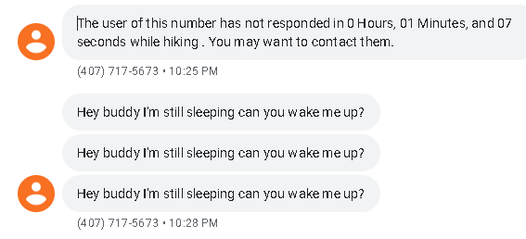
The ethical business question is “why fix this if more people download it for its misuse case?”
Google has done this with one of their services making it possible to perform denial of service attacks on land-line telephones. The first DOS attacks on land-line telephones occurred in the early 2000s using a website that was intended for deaf people to make phone calls. The hacker would use a bot to instruct the operator to call, then hang up, and call again. This would make the telephone ring non-stop.
2. Networking Aspect – Chatroom with multiple clients and one server to handle communication with all clients.

Javascript
– Apache & Node.Js to convert websites into mobile apps.
– My website www.StevenMunich.com
– Converts String into Binary stevenmunich.github.io/binary/

Python
– Beautiful Soup Library for web scraping.
– Scapy Library for packet crafting
Visual Basic was my first language(Visual Basic 2005 Express Edition) at 13 years of age.
1.Basic education programs(for kids) 2+2 = ___
2.Keyloggers
3.Third party apps(Game Hacks) using read & write process memory
4. Variety of Chat spammers using SendKeys()
1. AFK spammers
2. Basic ASCII ART
+--^----------,--------,-----,--------^-,
| ||||||||| `--------' | O
`+---------------------------^----------|

`\_,---------,---------,--------------'
/ XXXXXX /'| /'
/ XXXXXX / `\ /'
/ XXXXXX /`-------'
/ XXXXXX /
/ XXXXXX /
(________(

Advanced ASCII art

5. Auto Clicker/Typer to automate repetitive tasks.
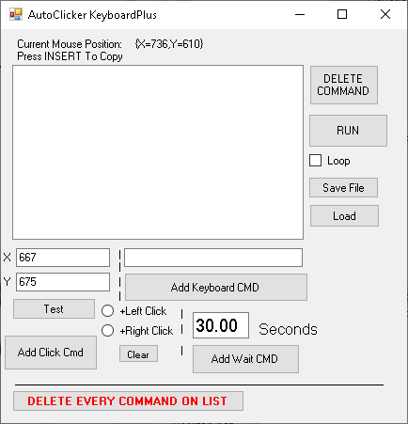
What are the 2 things people do on a computer? They click a mouse and type on the keyboard. This program allows users to simulate both, with an extra wait command between the two actions. The X & Y coordinates change as you move your mouse. So the user can move the mouse to the position they want and press ‘insert’ to copy the coordinates into the program

The 5 commands:
M – moves the mouse
R – Right Click
L – Left Click
T – Type from keyboard
W – Wait(seconds)
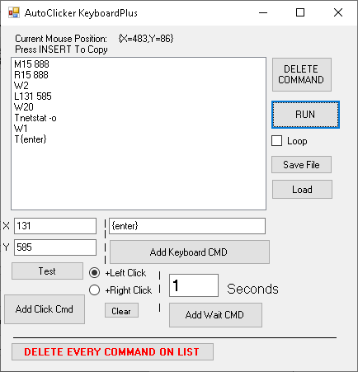
Interprets to:
Move Mouse to 15,888
Right click at 15,888, the windows start icon
Waits 2 seconds
Left click at 131, 585, opens PowerShell
Waits 20 seconds
Types in command “netstat -o”
Waits 1 second
Types the enter key
The Loop checkbox under the “RUN” button allows the script to be repeated..
Future Improvements:
– make it so simple even my grandma can use it.
– eventually added to the next version of windows OS
I’ve used this program to scrape my college e-books. Publishers only give students limited time access and do not allow direct download.
My Weak Area – Connecting software to database.
Experience with Microsoft Access, MySql, & XAMPP
Understand :
CRUD(Create, Read, Update, Delete)
SQL language
Queries and Query Strings
Data granularity and quality
Data Democratization

Ethical Hacking Hobbyist
18 years ago, was when I went down my first rabbit hole, Starcraft. Hackers could do what normal players could not and I thought it was so cool. People told me you download a program, join this channel, people would talk about it. Even the websites that let you download these programs(hacks) had a chat channel with specialized icons and what not. So, I downloaded these programs, and it modified the game.
I thought it was so cool I wanted to learn how to make these programs(hacks) and that was when I first became interested in programming.
At 13 years of age in 2005 I Looked up C++ and eventually got to Microsoft’s website.
They had 3 programming languages color-coded
C++ was yellow
C# was green
Visual Basic (VB)
Each one had a series of tutorial videos; this was before YouTube. They also had the words “Express edition” after them and you had to install them separately unlike Visual studio 2022.
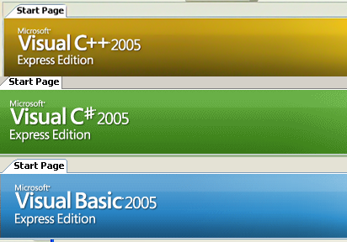
Since then I have made keyloggers, spammers, game hacks, auto clickers, all kinds of programs. That game, Starcraft, adopted some of the features in those game hacks to make their software better (UI/UX)
I have never used Key Loggers for illegal activity or to steal personal data, even when I could.
I know how malware works, If I have to buy something online, I never enter my CC# online in order.
The key logger will see what I typed sequentially, the numbers received is not in order.
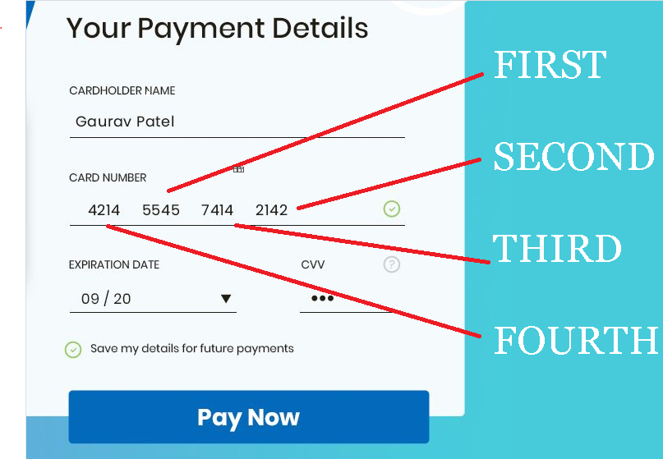
The hacker will receive “5545214274144214” from his KeyLogger
Now what if you use this technique all the time and your credit card never gets stolen and the one time you don’t do it, your data gets stolen. What does that tell you? That the device is compromised.

