Demonstration of reconnaissance

________________________________________________________________________________

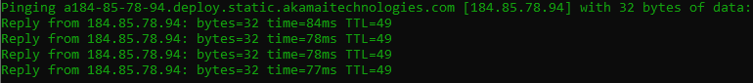

Some web surfing on akamaitechnologies

<https://answers.microsoft.com/en-us/windows/forum/all/what-is-this-akamai-technologies-stuff/b6e62fc0-83db-4daf-989e-e667e938fa72>

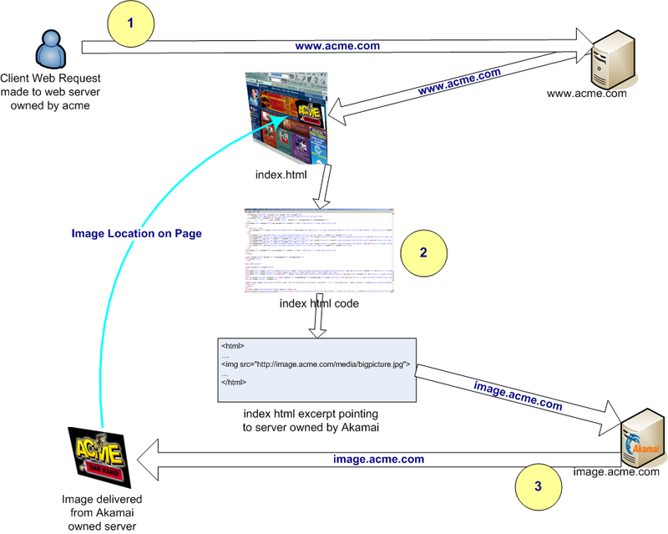

Source not to be trusted: https://en.wikipedia.org/wiki/Akamai_Technologies

Summery: ports 80 and 443 open

OS: probably Linux

Very nice, not bad.

Next Target - www.ukraineoversight.gov

Time spent: ~ 8 mins

____________________________________________________________________________________

Starting Nmap 7.95 ( https://nmap.org ) at 2024-12-20 02:59 Pacific Standard Time

NSE: Loaded 157 scripts for scanning.

NSE: Script Pre-scanning.

Initiating NSE at 02:59

Completed NSE at 02:59, 0.00s elapsed

Initiating NSE at 02:59

Completed NSE at 02:59, 0.00s elapsed

Initiating NSE at 02:59

Completed NSE at 02:59, 0.00s elapsed

Initiating Ping Scan at 02:59

Scanning 184.85.78.94 [4 ports]

Completed Ping Scan at 02:59, 0.12s elapsed (1 total hosts)

Initiating Parallel DNS resolution of 1 host. at 02:59

Completed Parallel DNS resolution of 1 host. at 02:59, 0.05s elapsed

Initiating SYN Stealth Scan at 02:59

Scanning a184-85-78-94.deploy.static.akamaitechnologies.com (184.85.78.94) [1000 ports]

Discovered open port 443/tcp on 184.85.78.94

Discovered open port 80/tcp on 184.85.78.94

Completed SYN Stealth Scan at 02:59, 7.73s elapsed (1000 total ports)

Initiating Service scan at 02:59

Scanning 2 services on a184-85-78-94.deploy.static.akamaitechnologies.com (184.85.78.94)

Completed Service scan at 02:59, 12.43s elapsed (2 services on 1 host)

Initiating OS detection (try #1) against a184-85-78-94.deploy.static.akamaitechnologies.com (184.85.78.94)

Retrying OS detection (try #2) against a184-85-78-94.deploy.static.akamaitechnologies.com (184.85.78.94)

Initiating Traceroute at 02:59

Completed Traceroute at 02:59, 3.09s elapsed

Initiating Parallel DNS resolution of 13 hosts. at 02:59

Completed Parallel DNS resolution of 13 hosts. at 02:59, 0.09s elapsed

NSE: Script scanning 184.85.78.94.

Initiating NSE at 02:59

Completed NSE at 02:59, 5.18s elapsed

Initiating NSE at 02:59

Completed NSE at 02:59, 1.70s elapsed

Initiating NSE at 02:59

Completed NSE at 02:59, 0.00s elapsed

Nmap scan report for a184-85-78-94.deploy.static.akamaitechnologies.com (184.85.78.94)

Host is up (0.077s latency).

Not shown: 998 filtered tcp ports (no-response)

PORT STATE SERVICE VERSION

80/tcp open http AkamaiGHost (Akamai's HTTP Acceleration/Mirror service)

|_http-title: Invalid URL

443/tcp open ssl/http AkamaiGHost (Akamai's HTTP Acceleration/Mirror service)

| ssl-cert: Subject: commonName=www.defense.gov

| Subject Alternative Name: DNS:2017dodtransition.defense.gov, DNS:2025dodtransition.defense.gov, DNS:actuary.defense.gov, DNS:afd.defense.gov, DNS:armedforcessports.defense.gov, DNS:atsdio.defense.gov, DNS:basicresearch.defense.gov, DNS:blueroof.gov, DNS:business.defense.gov, DNS:cmsmedia.defense.gov, DNS:comptroller.defense.gov, DNS:ctip.defense.gov, DNS:cyberwork.defense.gov, DNS:dacowits.defense.gov, DNS:dam.defense.gov, DNS:data.defense.gov, DNS:dbb.defense.gov, DNS:dcips.defense.gov, DNS:dcmo.defense.gov, DNS:diversity.defense.gov, DNS:dod.defense.gov, DNS:dodcertpmo.defense.gov, DNS:dodcio.defense.gov, DNS:dodmwrandresalepolicy.defense.gov, DNS:dodsioo.defense.gov, DNS:dpac.defense.gov, DNS:dpcld.defense.gov, DNS:dpclo.defense.gov, DNS:energy.defense.gov, DNS:execsec.defense.gov, DNS:frcsw.navair.navy.mil, DNS:history.defense.gov, DNS:innovation.defense.gov, DNS:irt.defense.gov, DNS:jamrs.defense.gov, DNS:jifco.defense.gov, DNS:jnlwp.defense.gov, DNS:jsc.defense.gov, DNS:kb.defense.gov, DNS:la.defense.gov, DNS:m.nsa.gov, DNS:militarypay.defense.gov, DNS:minerva.defense.gov, DNS:nmio.ise.gov, DNS:nsa.gov, DNS:ogc.osd.mil, DNS:oig.nsa.gov, DNS:open.defense.gov, DNS:ousdi.defense.gov, DNS:policy.defense.gov, DNS:prhome.defense.gov, DNS:ra.defense.gov, DNS:rfpb.defense.gov, DNS:servicedesk.defense.gov, DNS:valor.defense.gov, DNS:vwac.defense.gov, DNS:www.alssa.mil, DNS:www.blueroof.gov, DNS:www.business.defense.gov, DNS:www.dantes.mil, DNS:www.dc3.mil, DNS:www.defense.gov, DNS:www.deomi.mil, DNS:www.dod.defense.gov, DNS:www.dodnafaccounting.defense.gov, DNS:www.dsca.mil, DNS:www.nsa.gov, DNS:www.ukraineoversight.gov, DNS:www.whs.mil

| Issuer: commonName=R10/organizationName=Let's Encrypt/countryName=US

| Public Key type: rsa

| Public Key bits: 2048

| Signature Algorithm: sha256WithRSAEncryption

| Not valid before: 2024-12-10T15:18:57

| Not valid after: 2025-03-10T15:18:56

| MD5: 5a87:95f6:00af:f467:e090:deeb:8a1d:b8a6

|_SHA-1: b3e6:3867:f203:2580:be91:b832:f74a:4fcb:f7be:9e0d

|_ssl-date: TLS randomness does not represent time

|_http-title: Invalid URL

Warning: OSScan results may be unreliable because we could not find at least 1 open and 1 closed port

Device type: general purpose

Running (JUST GUESSING): Linux 4.X|5.X (89%)

OS CPE: cpe:/o:linux:linux_kernel:4 cpe:/o:linux:linux_kernel:5

Aggressive OS guesses: Linux 4.19 - 5.15 (89%), Linux 4.15 - 5.19 (85%)

No exact OS matches for host (test conditions non-ideal).

Uptime guess: 0.000 days (since Fri Dec 20 02:59:47 2024)

Network Distance: 17 hops

TCP Sequence Prediction: Difficulty=250 (Good luck!)

IP ID Sequence Generation: All zeros

TRACEROUTE (using port 443/tcp)

HOP RTT ADDRESS

1 2.00 ms SAC2V1A.lan (192.168.1.1)

2 13.00 ms syn-072-031-137-033.inf.spectrum.com (72.31.137.33)

3 12.00 ms int-0-5-1-5.orld29-ser2.netops.charter.com (97.69.193.250)

4 23.00 ms lag-29.orld31-car2.netops.charter.com (72.31.194.144)

5 26.00 ms lag-12.orld71-car2.netops.charter.com (72.31.220.138)

6 26.00 ms lag-14.tamp20-car1.netops.charter.com (71.44.1.214)

7 27.00 ms lag-415-10.tamsflde20w-bcr00.netops.charter.com (66.109.9.114)

8 99.00 ms lag-401.hstqtx0209w-bcr00.netops.charter.com (66.109.9.140)

9 78.00 ms lag-22.dllstx976iw-bcr00.netops.charter.com (107.14.19.49)

10 79.00 ms lag-12.tustca4200w-bcr00.netops.charter.com (66.109.6.0)

11 73.00 ms lag-1.pr2.lax10.netops.charter.com (66.109.5.241)

12 80.00 ms syn-024-027-236-019.inf.spectrum.com (24.27.236.19)

13 80.00 ms ae34.r04.border101.lax02.fab.netarch.akamai.com (23.203.155.89)

14 ... 16

17 76.00 ms a184-85-78-94.deploy.static.akamaitechnologies.com (184.85.78.94)

NSE: Script Post-scanning.

Initiating NSE at 02:59

Completed NSE at 02:59, 0.00s elapsed

Initiating NSE at 02:59

Completed NSE at 02:59, 0.00s elapsed

Initiating NSE at 02:59

Completed NSE at 02:59, 0.00s elapsed

Read data files from: C:\Program Files (x86)\Nmap

OS and Service detection performed. Please report any incorrect results at https://nmap.org/submit/ .

Nmap done: 1 IP address (1 host up) scanned in 39.15 seconds

Raw packets sent: 2107 (96.392KB) | Rcvd: 93 (5.776KB)

What a Joke

<https://prhome.defense.gov/>

