Eastern Florida State College

Guides & Scripts for Business Software Installation

Steven Munich

Intro to Info Tech Management ISM-3011

**Instructor: Dan Mondshein**

**12/01/2023**

Businesses require software to perform many functions. Supply Chain Management (SCM), Enterprise Resource Planning (ERP), Customer relationship management (CRM), and other Management Information Systems (MIS) are all necessary to keep a business operational. All these systems consist of hardware, software, and software stacks. Installing and configuring these systems can be time consuming without a guide. Complex systems can take hundreds of hours to install, configure, and become operational. Documenting the steps can reduce the time to12 hours next time that system needs to be implemented.

Two different events made me realize that this is the most efficient way to solve this problem. The first was when I was looking into Industrial computers. Programmable Logic Controllers (PLC) are used in manufacturing everyday products customers buy in the markets, the most obvious being food and beverages. To program PLC systems you need software that lets you do it. In my case it was a software stack, I had to install multiple programs and configure them with commands. It was time consuming, so I documented every step-in case I needed to install it again. This comes to the second point on the business side of it. If the business is growing and decides to open a branch office a guide to getting those systems up and running is very valuable.

Documentation is notoriously known as an IT professional’s kryptonite. However, it is very important and underestimated. It is crucial to keep things organized for security reasons as well. Installation guides can also be automated with PowerShell or Bash scripts. In the case of open-source systems, a guide will help others use that system, making the consumer more likely to contribute.

Provision packages are usually used by System Administrators to install software packages without a windows image file. Creating a script for installation of software is a similar concept. The biggest factor with installation cost is going to be software licensing. The second biggest will be time if an employee or third party is hired to install the software manually.  
The graph below shows the cost of installation for an employee paid $20.00 installing a software stack manually, which takes 100 hours, compared to an installation script that reduces the time to 12 hours.

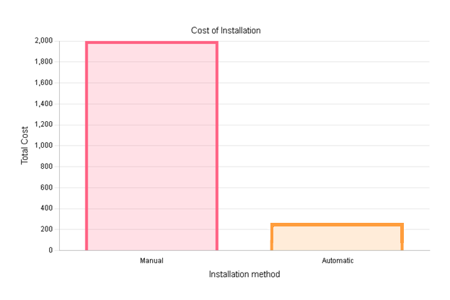

With the many different systems in a corporate environment (ERP, CRM, SCM, etc.) installation guides and scripts will make it possible for someone inside the company to get these systems up-and-running. This also eliminates the need for a third-party contractor to install and configure the systems. When dealing with third party vendor’s security must also be considered because of the increase in supply-chain attacks.

Now to play devil’s advocate, because business processes rapidly change with technology, this change in the business environment must also be considered.  
What if one system loses its business value and needs to be scrapped?   
What if there is a new system that has greater business value?  
These two scenarios may require the installation guides and scripts to be modified. Like with version control in software development, old records and scripts should be kept for future reference.

This decision will be determined by whether or not the business needs the systems.