of

|  |  |
| --- | --- |
| Affordable 3D Printed PCB’s | |
|  |  |
| Creation Date: | 12/08/24 |
| Revision #: | 00 |
| Revision Date: | N/A |
| Document Status: | Final |
| File Name: | Affordable3DPrintedPcbs.docx |
| Project: | Affordable 3D printed PCB’s |
|  |  |

TABLE OF CONTENTS

Top of File 1

TABLE OF CONTENTS 2

LIST OF FIGURES 3

1 Abbreviations – Definitions 4

2 Introduction 4

2.1 Problem statement 4

2.2 Objective Statement 4

2.3 Statement of Work 5

2.4 Research Report 6

2.5 Proposed Solution 12

2.6 Development Plan 13

3 Requirements 14

4 Assumptions, Risks, Unknowns 15

4.1 Assumptions 15

4.2 Risks 15

4.3 Unknowns 15

5 Summary 15

6 References 16

# Abbreviations – Definitions

**Acronym** **Definition**

PCB Printed Circuit Board – electronic connectivity between components

FDM Fuel Deposition Modeling – The type of 3D printer

PLA Polylactic Acid – The most common filament used in 3D printing.

CAD Computer-Aided Design - A type of software used to design.

SOT Small outline transistor – Surface Mounted Component

# Introduction

This document outlines the objectives and development process for creating 3D-printed circuit boards (PCBs) using accessible fused deposition modeling (FDM) printers. Traditional PCB fabrication is often time-consuming and expensive, typically requiring multiple third-party services. These challenges create significant barriers to rapid prototyping and product development.

The original goal of this project was to streamline a new method of PCB prototyping by designing, testing, and fabricating 3D-printed PCBs using conductive materials. The use of alternative materials, such as conductive PLA, in place of traditional copper traces aims to enable multilayer PCB printing with dual-extrusion printers.

As the project evolved, an additional objective was introduced: to develop software that bridges PCB design tools with the unique requirements of 3D-printed PCB manufacturing.

This report outlines the problem statement, proposed solutions, and a comprehensive development plan to achieve the project’s objectives.

## Problem statement

Prototyping with traditional PCB fabrication is slowed by lengthy printing and shipping times, making iteration costly and inefficient. Additionally, standard processes often limit design flexibility, restricting unique form factors. These challenges hinder innovation, especially for small-scale projects.

## Objective Statement

This project aims to design and implement a 3D printing solution for PCBs that reduces prototyping time, lowers costs for small-scale production, and supports unique form factors to enhance design flexibility and innovation. Additionally, the project evaluates various conductive plastic materials to identify optimal solutions for efficient and reliable PCB manufacturing.

## Statement of Work

**Student Names:**

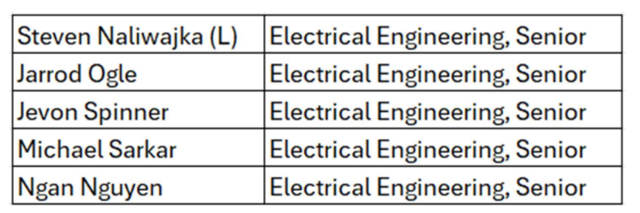

**Project Supervisor:** Dr. Theodore Grosch

**Semester:** Fall 2024

**Concentration:** Electrical Engineering

**Project Title:** Design Build and Test Affordable 3D PCB Printing for Prototyping

**Objective:**

The objective of the project is to lower the barrier of entry for prototyping dynamic PDBs for research and manufacturing by researching techniques to print PCBs on entry level 3D printers.

**Project Sequence of Goals:**

1. Collect materials/develop printing process

2. Circuit Design

3. 3D model design

4. Print PCB

5. Test PCB

6. Observations/Analysis/Deductions

7. Improvement

8. Final Presentation/Report Preparation



## Research Report

3D-printed PCBs represent a transformative advancement in electronics manufacturing. This approach integrates additive manufacturing techniques to create innovative PCB designs, reduce costs, and address supply chain challenges. This report synthesizes findings from multiple sources to provide a comprehensive understanding of the state-of-the-art in 3D-printed PCB fabrication.

Several studies showcase the advantages of using 3D printing for PCB manufacturing:

* **Reduced Costs and Faster Production**: Articles such as "3D Print PCBs – All You Need to Know" [1] and "Prototyping Complex PCBs for Advanced R&D" [8] emphasize the financial and time efficiency of 3D-printed PCBs compared to traditional methods.
* **Design Flexibility**: The ability to integrate complex geometries and custom materials is highlighted in sources like "3D Printed Circuit Boards: What They Are & How Fast They’re Made" [4].
* **Prototyping and Customization**: The articles "Simple DIY PCB with a 3D Printer" [5] and "Printing Custom Circuit Boards With a 3D Printer" [21] illustrate how 3D printing enables rapid prototyping and the production of highly tailored designs.

Despite its promise, 3D-printed PCBs face significant challenges:

* **Material Limitations**: Achieving high conductivity and thermal stability is a persistent issue, as discussed in "Fabrication of Highly Electrically Conductive Composite Filaments for 3D-Printing Circuits" [19].
* **Reliability and Precision**: Sources like "Make Your Own PCBs with a 3D Printer" [14] and "3D Printer PCB Etching" [6] note difficulties with material compatibility, etching techniques, and ensuring long-term reliability.
* **Cost of Advanced Equipment**: Dual extrusion printers and other advanced technologies, as described in "Dual Extruder (3D Printing): All You Need to Know" [25], while cheaper than fabrication of traditional circuit boards, could be too costly for some users.

The literature reveals various approaches to fabricating 3D-printed PCBs:

* **Layering vs. Channel Filling**: Articles such as "3D Printed Circuit Boards: What They Are & How Fast They’re Made" [4] detail these techniques for creating conductive paths.
* **Etching and Plotting Methods**: "3D Printer PCB Etching" [6] and "Printing Custom Circuit Boards With a 3D Printer" [21] provide insights into using conductive ink and etching processes to produce functional PCBs.
* **Material Advancements**: The development of conductive PLA and other materials, as described in "Protopasta Electrically Conductive PLA 3D" [30], demonstrates the ongoing evolution of 3D printing materials.

3D-printed PCBs find applications across various domains:

* **Research and Development**: "Prototyping Complex PCBs for Advanced R&D" [8] explores how 3D printing supports cutting-edge research by allowing fast design and print turnaround time.
* **DIY Projects and Prototyping**: Articles like "Simple DIY PCB with a 3D Printer" [5] show how hobbyists and small businesses can leverage 3D printing for rapid prototyping.
* **Advanced Multilayer Designs**: Innovative approaches to multilayer circuits, as detailed in "Enabling 3D Multilayer Electronics Through Hybrid Additive Manufacturing" [28], showcase the potential for creating complex and compact designs.

Based on the reviewed literature, the following recommendations are proposed for advancing 3D-printed PCB technology:

* **Improved Conductive Materials**: Development of materials with higher conductivity and thermal stability is critical.
* **Standardized Processes**: Establishing universal standards for 3D-printed PCB design and manufacturing will enhance reliability and scalability.
* **Expanded Research**: Further exploration of hybrid techniques, such as combining additive manufacturing with traditional processes, will open new possibilities, as highlighted in [28].

3D-printed PCBs are poised to revolutionize the electronics industry by offering cost-effective, flexible, and innovative solutions. However, significant challenges remain, particularly in material science and process standardization. By addressing these issues, 3D-printed PCBs can unlock new opportunities in prototyping, customization, and advanced research.

## Proposed Solution

### 3D Printed PCBS

PCB manufacturing can be broken down into two major groups. Additive and Subtractive manufacturing.

Copper & Silicon traditional PCBS are considered subtractive due to the nature of layering and removal of copper to form traces.

Any existing work on additive manufacturing can be broken down into two groups. The first is inkjet printing, and the second is 3D printing. While the research visited and touched on inkjet printing, it is limited in scope due to the fact it will only ever work on single layer board printing. 3D printing of PCBs came off as the most promising option out there. So far, existing work on 3D printing PCBs has been limited to the same use case as Inkjet printing. All researched prints that have been on display are single layer boards with minimal complexity.

Dual extrusion printing is 3D printing on steroids. It prints two types of filaments at once. while there exist single nozzle dual extrusion printers, the project was best suited for a dual nozzle 3D printer. The explanation on why will be explained later.

The scope of this project attempts to take on the steps of integrating dual extrusion printing into the existing process to use both conductive and non-conductive filament. Doing this will allow for 3D printed PCBS to have non-conductive material to give it shape and mass. This opens the possibility of having multi-layered PCBS.

In traditional PCBs adding layers increases the scope and steps required. Increased layer count is a non-issue in 3D printed PCBS. Print time in a wider vs taller board does not change much.

### Electricaly Mounting Components

Traditional mounting of components to a traditional silicon & copper board comes in the form of solder. This is not a usable solution when considering plastic PCBs. The best solution found in the research was to physically mount components with super glue or hot glue if rubber. Mounted components are metal, the surface of the board is conductive plastic. Conductive plastic has a very high surface resistance. This can be removed almost entirely by a colloidal silver paste to mount components electrically.

It should be noted that source [28] used electroless plating to deposit conductive material onto their printed board to allow for surface mount components to be electrically connected. The reason why this design flow was not followed was due to the reason that it would not work effectively with components mounted inside of a through hole via on the board.

## Development Plan

The primary objective of this project is to design, build, and test a multi-layered PCB using 3D printing technology. The development process includes evaluating the resistivity of available conductive filaments suitable for 3D printers. A dual extrusion 3D printer will be employed, where one nozzle prints conductive material and the other prints non-conductive material. After testing the conductive materials, the project will focus on optimizing trace dimensions to determine the most efficient method for scaling conductive traces comparable to traditional copper traces.

Figure 1: Design Development Phases and Schedule

# Requirements

1. The research will show how closely 3D printed material can be printed together without bridging.
2. The research will experiment with different conductive materials and determine what materials and techniques are the most effective.
3. The research will show area sizing of conductive material to combat voltage drop and be used effectively in digital logic circuit boards.
4. The research will provide graphs and charts on the techniques and methods that were tested.
5. Testing will be conducted on the effectiveness of ‘colloidal silver paste’ and ‘conductive filament’ on being used as conductive material for 3D printing.
6. The 3D printed lines must be conductive and allow a continuous current flow.
7. The research will evaluate how viable it is to print 3D multilayer PCB’s as well as document the design process.
8. 3D printed PCBs are tested to replicate a simple logic circuit.
9. If print time on a dual extruder 3D printer is not acquired, techniques to print multi-layered circuits on a single nozzle 3D printer will be developed.

# Hardware

## Materials used

This project tested and used three different materials. Two were found on amazon, “Youso” conductive filament, “Amolen” conductive filament. The third was found on a separate website “Electrify” Multi-3D Conductive filament. It should be noted that due to the price ($200~), after asking for a sample of the Electrify filament. The owner graciously sent half a roll for testing.

The colloidal silver paste was found from Electron Microscopy Sciences as “12640 colloidal silver paste”.

A standard PLA was used as the ‘non-conductive’ filament.

## Dual Extrusion Printer

The printer used was the Snapmaker J1S dual extrusion 3D printer.

# Resistivity testing

Resistivity was tested by printing three different trace lengths of each filament.

Table 2: Resistivity tests on conductive material

Figure 2: Resistivity Formula

Silver Paste # 12640 added .05 ohms resistance when applied to one side of the trace.

Looking at the resistivity tests, Multi3D filament had the best electrical properties of the group. Its average resistivity was 247~ times better than Amolen and 4904~ times better than Youso filament. Due to this, Multi3D filament was chosen to be the filament used in the board testing.

# Conductive Trace Characteristics

## Overview

The resistivity of copper is 1.68x10^-6 ohm/cm. The tested resistivity of Multi3D conductive filament is 1.41x10^-1 ohm/cm. This means that Multi3D conductive filament is 83,928 times worse at conducting electricity than copper. While this number may seem insurmountable, it can be overcome by printing large enough traces to lower the resistance. The required trace resistance can be further lowered by selecting a type of circuit to print that is not sensitive or does not use high voltage. This eliminates power circuits, and analog circuits and leaves digital logic circuits on the board. Digital logic circuits read in 0-1, Boolean values, at high speeds to transfer information. The voltage range depends on the type of digital logic circuit.

## Theoretical Minimum Trace Sizing Process

Typical modern Digital logic circuits fall under these categories:

Table 3: Resistivity tests on conductive material

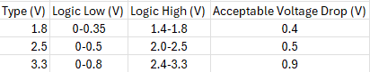

Taking a conservative estimate of 1mA of current being used in digital logic circuits. Ohms law can then be used to calculate the maximum resistance required to generate the ‘acceptable voltage drop’ of each type:

* 1.8V can handle 400 ohms
* 2.5V can handle 2500 ohms
* 3.3V can handle 3300 ohms

The smallest theoretical trace area that can be printed on the available 3D printer is 0.2mm width x .04mm height. This results in an area of .008mm squared. Using the resistivity of Multi3D filament and the calculated maximum resistance this means:

* 1.8V can be 2.27mm long.
* 2.5V can be 14.8mm long.
* 3.3V can be 18.71mm long.

## Real World Minimum Trace Sizing Process

One thing that was revealed during testing of Multi3D filament was that it trades off print quality for its resistivity. When printing with a nozzle size of .2mm or .3mm, the material jammed constantly. The smallest size that resulted in quality feeding was a .4mm nozzle. All future testing was done with this size.

If the max trace length is re-calculated with a .4mm width and a .08mm height in mind:

* 1.8V can be 9.07mm long.
* 2.5V can be 56.72mm long.
* 3.3V can be 74.88mm long.

Another factor that should be considered is that so far, calculations only consider straight lines. Traces curve and bend. The best way to maintain conductivity at the bends is to only bend slightly with a 135° outer angle. Even so a single line of a nozzle is not enough to ensure conductivity. After extensive testing, to grantee that zero breaks occur in the corners a 4-pass trace size was chosen, so 1.2mm was the final minimum width.

## Trace Density

The biggest issue here is the print quality of the conductive filament, testing suffered heavily from the physical properties of Multi-3D conducive filament. It prints as a paste unlike most 3D printer filament and bridges between traces because of dragging very easily. After extensive testing to guarantee that zero overlaps and bridges occurred a minimum trace spacing of 1.2mm was determined.

This means that with a 1.2mm trace minimum and a 1.2mm trace gap minimum, 2.4mm is required per trace.

Given a 1in x 1in example board, 10~ traces can be present.

# Design & Printing of a Prototype

The chosen board to replicate was the Sparkfun “digital temperature sensor” using the TMP102 SOT chip. While the theoretical resistivity numbers of the Multi-3D filament would allow for a trace size of .2mm and for the mounting of the SOT package chip directly onto the 3D printed PCB board. The physical properties of the Multi-3D filament required a breakout board to fit the chip. Re-designing of the base circuit allowed for the board to fit better.

Figure 3: Schematic of the Replicated Circuit

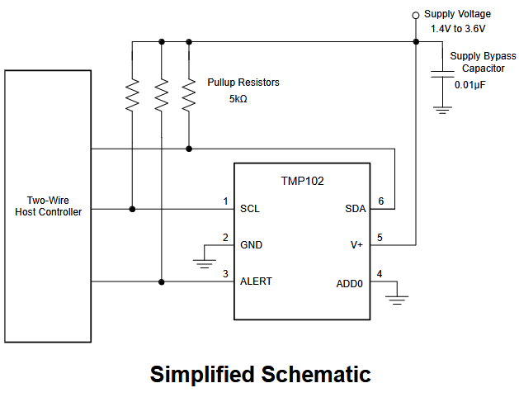

Figure 4: Designed PCB in Tinkercad

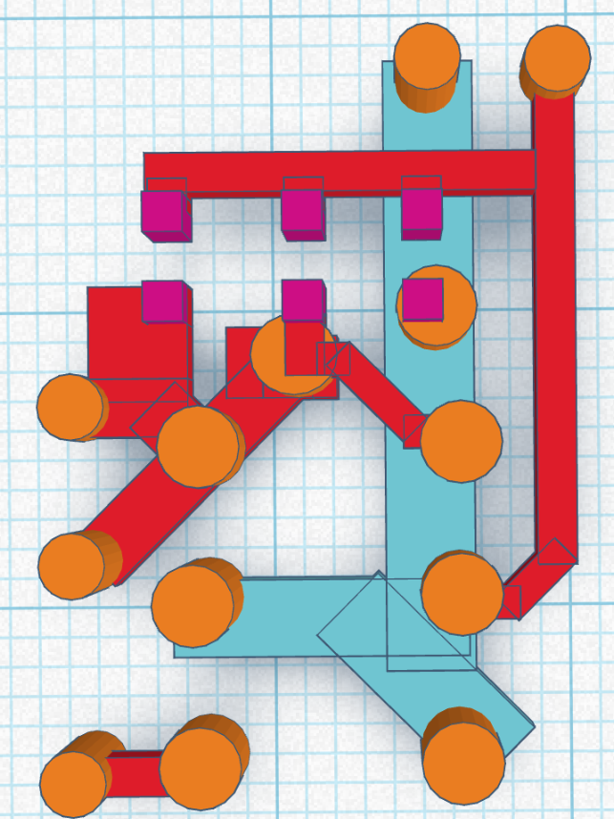

Figure 5: Final Printed Board

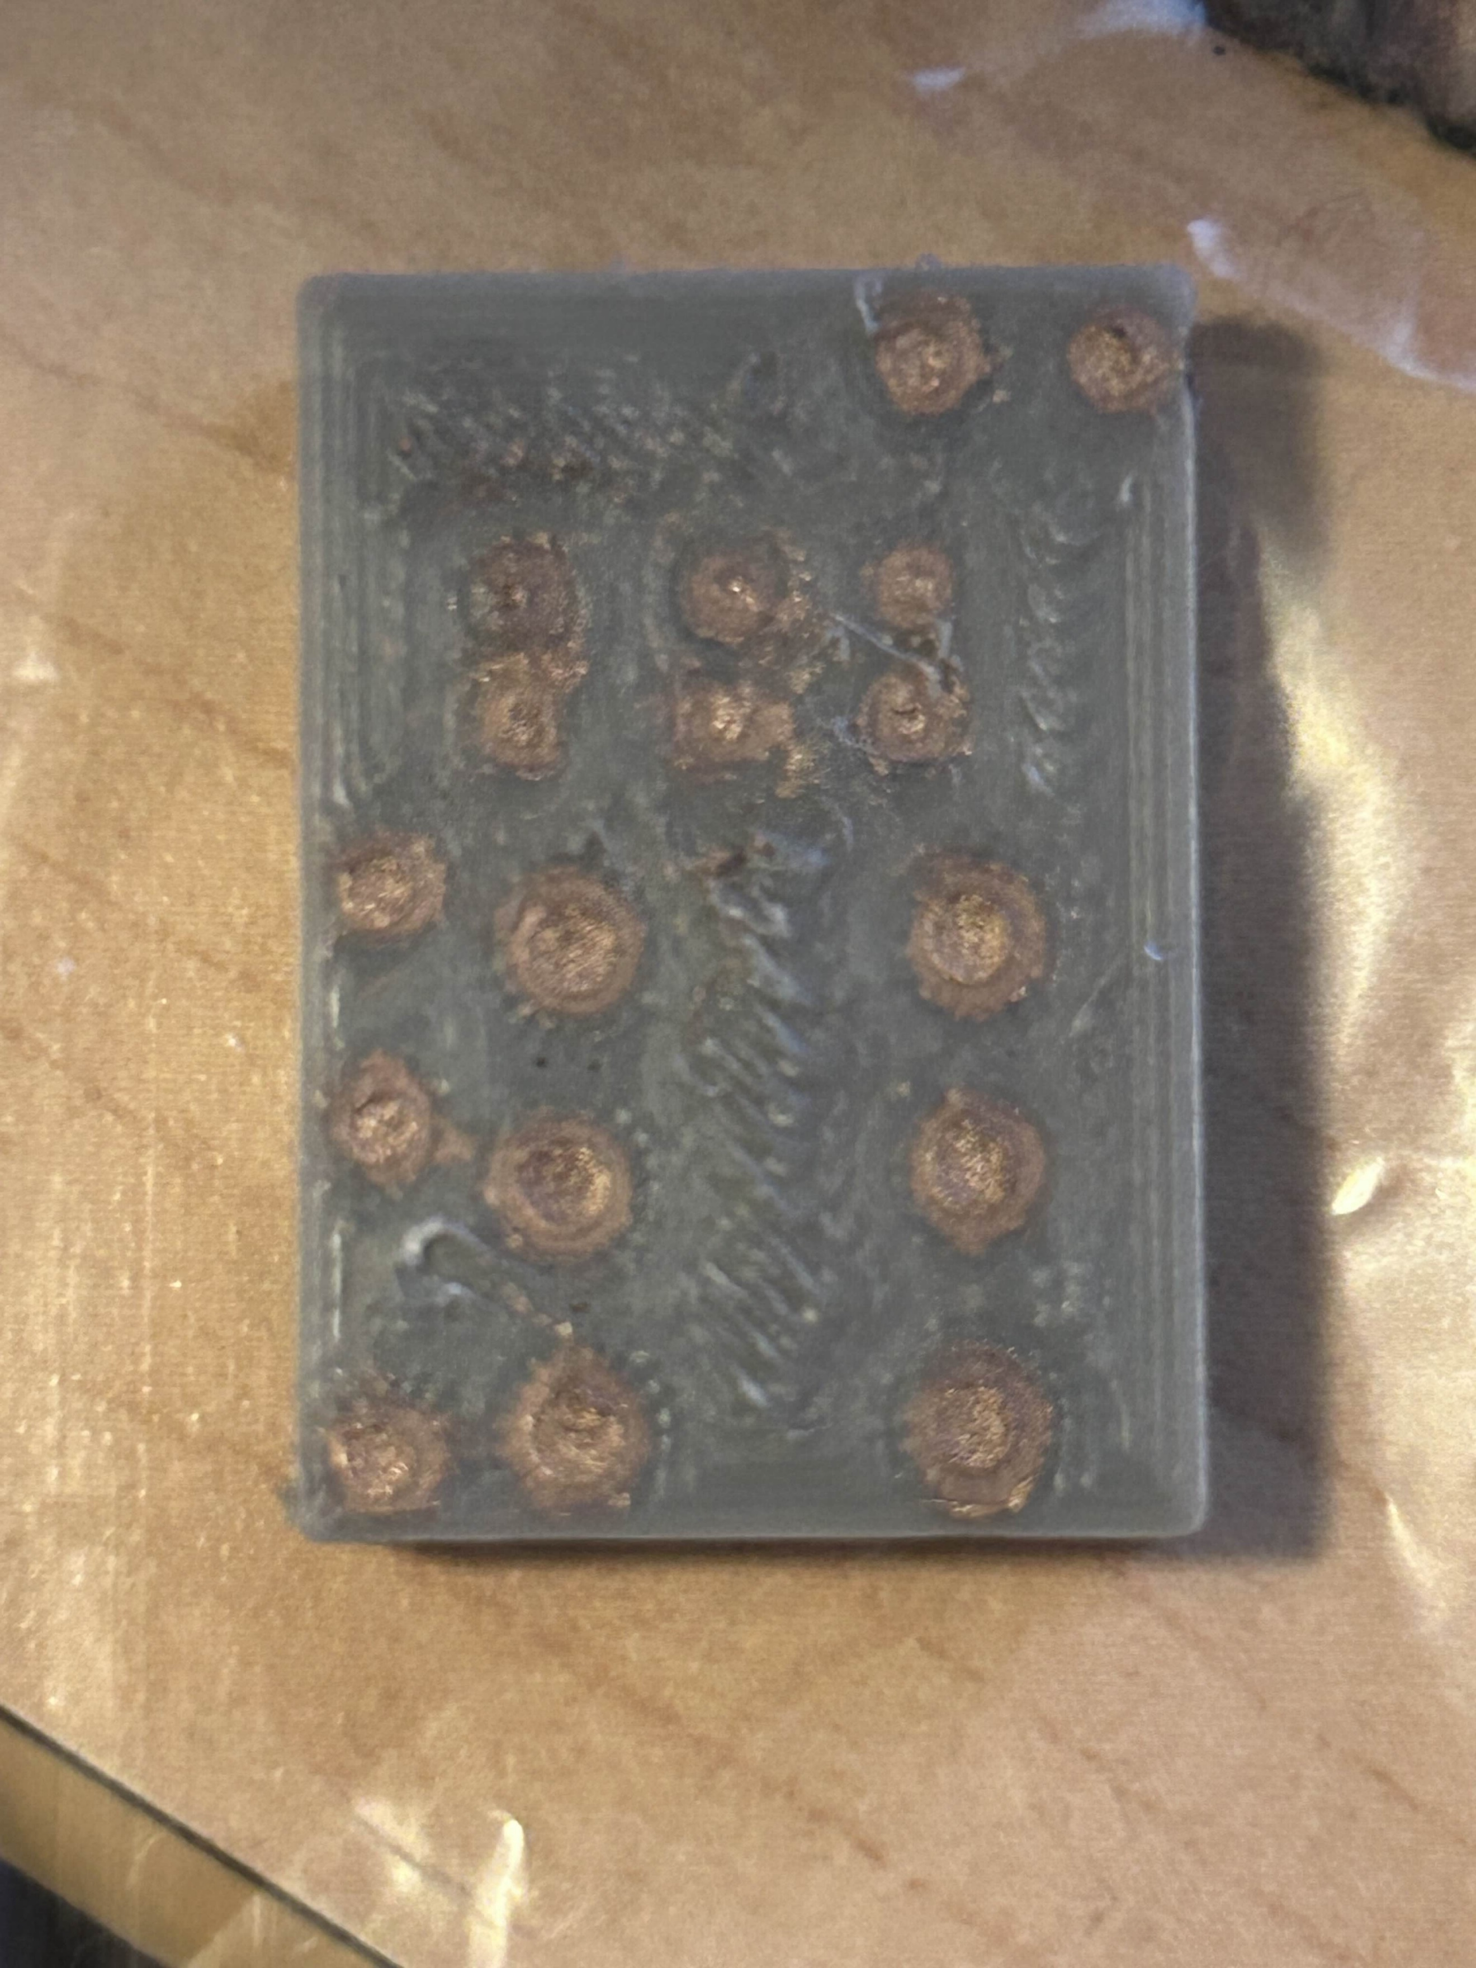

Mounting the SOT chip onto the breakout board used solder and had to be assembled under a microscope.

Figure 6: Mounting the SOT chip onto the Breakout Board

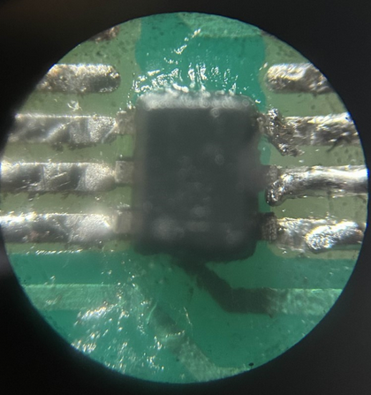

After printing the PCB components were mounted with super glue and conductive paste. For holding wires to the board, hot glue was used.

Figure 7: Final Assembled Board

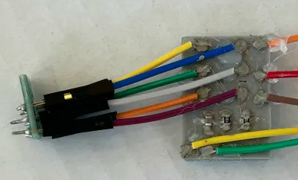

The traces on the board were carefully designed to match the breakout board's specifications. However, wires were chosen for connectivity instead of directly mounting the SOT chip onto the breakout board. This decision was made to facilitate easy removal and adjustments, considering the prototype nature of the design and the potential for revisions.

The printed PCB was a success, components were mounted correctly, measured resistance values matched calculations.

# Economic Results

After designing and printing a board, cost analysis on printed PCBs vs traditional PCBs can be conducted.

Using the following data:

* 200g MULTI-3D conductive filament: $200
* 1kg Regular PLA: $13
* Silver paste # 12640 from Electron Microscopy Sciences: $90/vial

The following calculations can be made for a 4 layer (1” x 1” board)

* Cond. Filament: $1 per 1in. x 1in.board
* Silver Paste: $1.80 per 1in. x 1in. board
* Reg. Filament: $0.06 per 1in. x 1in. board
* 3D printer cost allocation: (Assume 10,000 boards made for lifetime use): $846/10,000 = $0.08/board

The resulting price per 4-layer 3D printed 1"x1" board = $2.94, including the cost of a mid range Dual extrusion 3D printer.

Table 4: Comparison of Ordering traditional PCB vs in-house 3D printed PCB

Looking at a popular circuit fabrication website “Oshpark”, the cheapest traditional board is 15$ for 3sq inches and a 2-layer max. This is 1.7~ times more expensive than the cost of a 3D printed circuit board with the cost of the printer factored in. Additionally, 14-17 days of lead time must be considered. For the quickest 4-layer board. It's going to be $116.67 per board which is 13.2~ times the cost of a 3D printed circuit board with printer cost factored in. Even with the most expensive choice selected, a user is still going to have to wait 6 days at a minimum to receive their board.

3D printed PCBs, while currently their trace sizes will have to be bigger than traditional PCBs, they can be designed, printed and assembled in one day. Even factoring in the cost of printer, they are cheaper to print than the cheapest option available on Oshpark.

# Lessons learned

* Time and Cost Efficiency: 3D printing can significantly reduce the time and cost associated with PCB prototyping compared to traditional methods, especially for small-scale applications.
* Material and Process Challenges:
  + Developing and using conductive filament presented challenges in achieving low resistivity and consistent electrical conductivity.
  + Silver paste application and the design of 3D-printed traces required optimization to improve electrical performance.
* Design Limitations:
  + The accuracy and capability of 3D printers were limited by the resolution, depth of printed traces, and manual assembly requirements.
  + Current 3D printing technology has constraints that make it less viable for mass production but beneficial for rapid prototyping.
* Innovation Opportunities:
  + There is significant potential to improve automated workflows, like generating G-code for specific PCB layouts.
  + Design optimization for smaller, more efficient, and customizable PCBs remains an area for further research.
* Economic Feasibility: The project demonstrated that low-cost solutions for prototyping are achievable, but scalability remains an issue due to available materials.
* Need for Further Development: While successful for prototyping, further work is needed to refine resistivity, streamline processes, and integrate automation to make the solution practical for broader applications.

# Future Work

## Improved conductive material

Currently, modern conductive material Multi3D has the resistivity to allow much smaller trace sizes. It prints poorly which requires a much larger trace size. An improved conductive material will maintain the resistivity of Multi3D filament but also maintain the print quality of standard PLA.

## Software bridge to allow for PCB design software to be used

While attempting to create and print the prototype board, it was revealed that currently PCB design software is unable to be used to create and print multi-layer PCBs.

Traditional PCB manufacturing instructions are in a subtractive format. This is different than 3D printer instructions which are in additive format. The main difference between the two is that subtractive manufacturing instructions allow overlaps between prior traces on a layer.

To the extent of the research conducted, no multi-layered additive to subtractive file converter exists. That takes multiple additive files and merges into one final 3D printer file.

Phase 2 of this project was conceived halfway through the semester to attempt to remedy this problem. "FabFormat" is name of the software used to automatically convert the outputs provided by traditional PCB design software (Gerber, Excellon-Drill) into a format that can be used by a dual extrusion 3D printer (GCode).

This file converter is 80% of the way done currently with about 5,500~ lines of code. It can be found on GitHub [HERE](https://github.com/StevenNaliwajka/FabFormat), or under the name “FabFormat” and under the user “StevenNaliwajka”.

Extreme thanks go out to Professor Theodore Grosch for providing a demo sample of a single layer Gerber to G-Code converter that he adapted from Neil Gershenfeld.

The figure below depicts the example source code working.

Figure 8: Raw .brd File viewed in Autocad Eagle

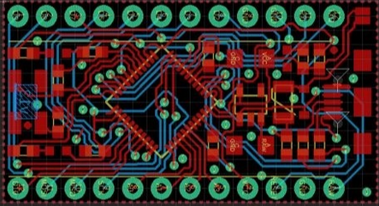

Figure 9: Gerber converted to Gcode using a modified sample of Prof. Grosch’s code

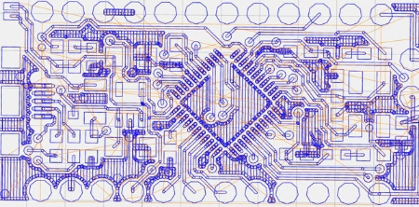

While the provided source code was a great starting point. It has some limitations.

* It is limited in scope; it can't integrate multiple files.
* Its conversion handler of Gerber is limited to simple commands.
* A lack of object orientation results in 2000-lines of code in a single file.

By this point in the semester, the work has been done to rewrite every piece of code that was existing from the original source. By starting from scratch an extreme change can be made instead of converting directly from an input to an output. The program converts an input to a “common form” (CF) then to an output. This allows modularity and scalability in the future. If in the future new inputs are wanted to be added it would be as easy as writing the input file to common form. This is faster than the alternative of writing a conversion from every input to every output. The new block diagram is shown below.

Figure 10: New Software Block Diagram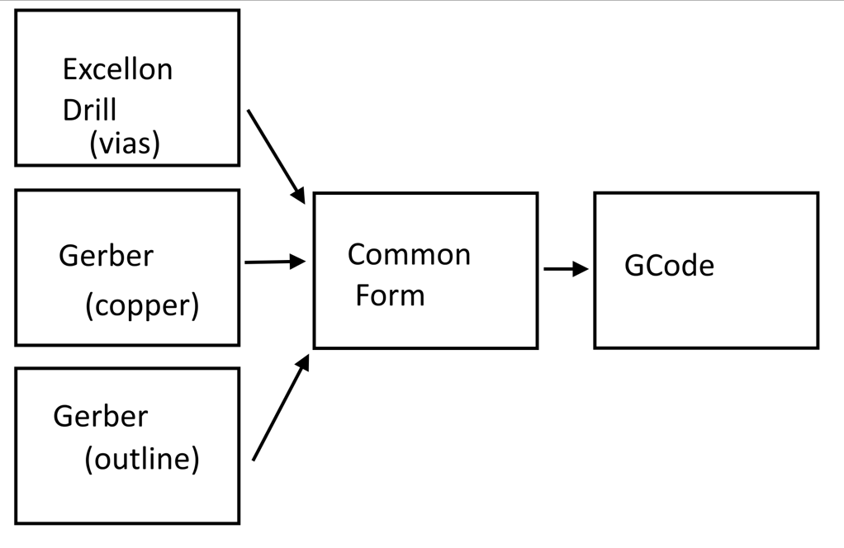

The scope of the new file converter is large. Full handling of Excellon Drill to CF is supported currently. The full scope of Gerber to CF is almost complete except for handling complex curves. While the semester and initial project is over. Work on Fabformat will continue.

# Summary

This project seeks to overcome the limitations of traditional PCB manufacturing by utilizing FDM 3D printers and conductive filaments to create functional PCBs. Mounting of components is done physically with super glue and electrically with colloidal silver paste. Research into the optimal sizing of traces has been conducted. After designing, printing and testing a prototype board that models a real-world example the group can confidently say that there is significant economic benefit to be realized by future research into the subject. While 3D printed boards are not going to show up overnight, they are possible and currently require trace sizes 3-4 times bigger than their copper counterparts. Future work into better conductive filament is being discussed. Partial work into, “FabFormat”, a solution to allow PCB design software to be used in development of 3D printed PCBs is also discussed. Every goal that was laid out was realized and more. The outcome is a scalable, low-cost method for rapid PCB prototyping, significantly reducing the time and expense typically associated with PCB production.

# References

[1] "3D Print PCBs (3D Printed Circuit Boards) – All You Need to Know“ Ile Kauppila, Jan 25, 2024

[2] "Printed Circuit Board Rapid Prototyping with Three-Dimensional Printer" A. Toprak and A. R. Boynuegri, Oct 22, 2020

[3] "3D Printed Circuit Boards" Lulz Bot, June 2022

[4] “3D Printed Circuit Boards: What They Are & How Fast They’re Made” P. Adams, Feb. 21, 2023

[5] "Simple DIY PCB with a 3D Printer" Tech2C, Sep. 02, 2018

[6] "3D Printer PCB Etching" MakinThings, 2017

[7] "Converting an Inkjet Printer to Print PCBs" pourcirm, 2012

[8] “Prototyping Complex PCBs for Advanced R&D" Botfactory, 2022

[9] “Advanced DIY PCB with a modified 3D Printer,” Tech2C, Mar. 24, 2019.

[10] “Take Your PCBs From Good To Great: Toner Transfer” Elliot Williams, Sep. 12, 2016

[11] "Overview of PCB Soldering Techniques" pcb-repair, 2024

[12] "Reducing PCB Prototype Failure Using DRC | Guide For Beginners" Syed Saad Hasan, Sep. 13, 2023

[13] "Importance of PCBs and PCB Design" Rush PCB, 2024

[14] “Make your own PCBs with a 3D printer” Stavros, Feb 14, 2020

[15] “A New Way To Produce PCBs With Your 3D Printer” Tom Nardi, July 26, 2022

[16] “PCB Layout: A Comprehensive Guide” A. Ayodele, 2022

[17] “PCB Design Basics for New Designers,” Altium, Dec. 29, 2021

[18] "What is a Pad in PCB Design and Development" Protoexpress, March 16, 2021

[19] “Fabrication of highly electrical conductive composite filaments for 3D-printing circuits” Z. L20 et al., Jul. 2018

[20] “3D printed electronics with high performance, multi-layered electrical interconnect” chiyen Kim and E. all, 2023

[21] "Printing Custom Circuit Boards With a 3D Printer" KdogGboii, 2019

[22] "3D Printed PCB" Matlek, 2022

[23] "9 Free and Open Source Circuit Design Software" EFY Bureau, 2023

[24] "Printed Circuit Board Basics: From Design to Final Artwork" Cadence PCB Solutions, 2022

[25] "Dual Extruder (3D Printing): All You Need to Know" D. DeNeve and K. Hart, Oct 15, 2023

[26] "Printing with Multiple Extruders" Simplify3D, 2024

[27] “The Best DIY 3D Printer Designs of 2020,” D. Florian, 2020

[28] "Enabling 3D multilayer electronics through the hybrid of vat photopolymerization and laser-activated selective metallization," P. Wang, J. Li, J. Yang, G. Wang, L. He, and H. Zhang, 2023

[29] "LTspice® Tutorial for Beginners" Analog, 2023

[30] "Protopasta Electrically Conductive PLA 3D" Proto-Pasta, 2024

END OF DOCUMENT