ROI Project

Steven On

CPT 307: Data Structures & Algorithms

Professor Joshua Reichard

October 17, 2019

ROI Project

I’m glad we finished this class with an ROI program mainly because ROI is a widely known metric for all businesses. According to Chen (2019), “Return on Investment (ROI) is a performance measure used to evaluate the efficiency of an investment or compare the efficiency of a number of different investments.” (para. 1). An ROI represents the benefit of a purchased service or asset. Our final project is based on this calculation for network equipment and the final output of my project is demonstrated in the screenshot below: 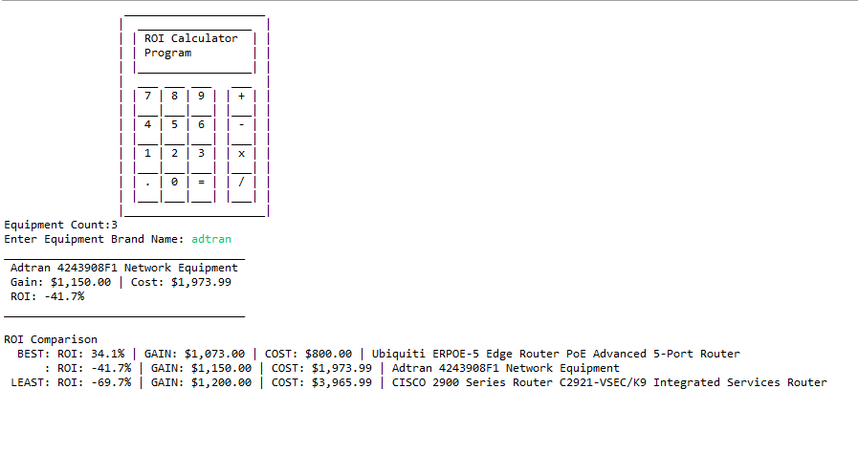

As you can see in the Green text, this is where the user can enter a brand name to retrieve a specific equipment’s name, gain, cost, and ROI calculation. The object for this program is the equipment which is demonstrated in the following screenshot below:

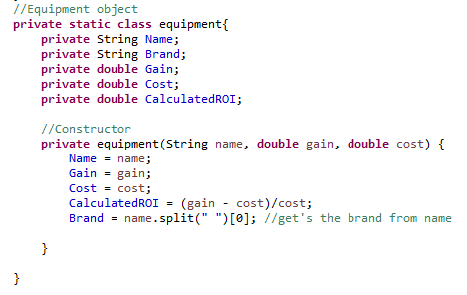

To build this object, I referenced my data points from the following CSV file that’s located on the relative path as the Java project.

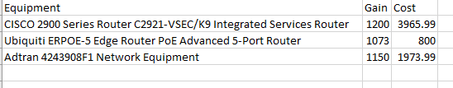

I found out how to use a relative path from stackoverflow user Abin Manathoor Devasia (2013). The call looks like this:



I mainly used this to retrieve the full path of this file. Once I receive the file path, I parse the CSV using a custom method “getEqupmentList”.

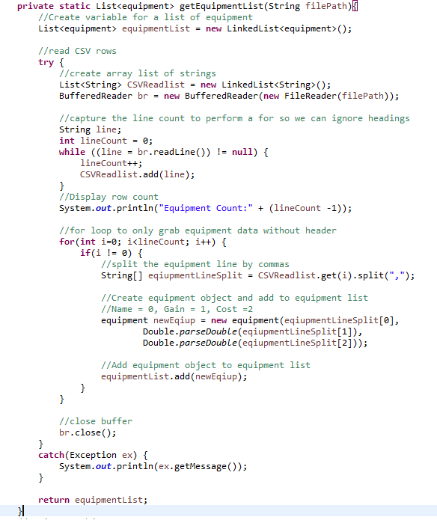

This list function will read the file using Java’s BufferReader Library. It will read each line of the CSV and it’s up to me to parse the lines using the “String”, “Split” method to delimit by comma characters. By doing this, I can reach the index per comma to extract the data per comma. I instantiate a new equipment object and add the equipment’s name, gain, and cost. The constructor in the object will automatically calculate the ROI and parse the brand name.

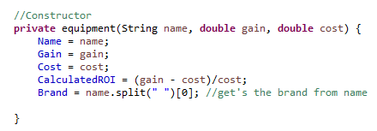

Each “equipment” object is then added to a Linked List containing “equipment” objects. Now that I have my list, I can start using search and sorting algorithms to present the data to the user. The following loop represents both selection sorting and selection search algorithms in a single loop.

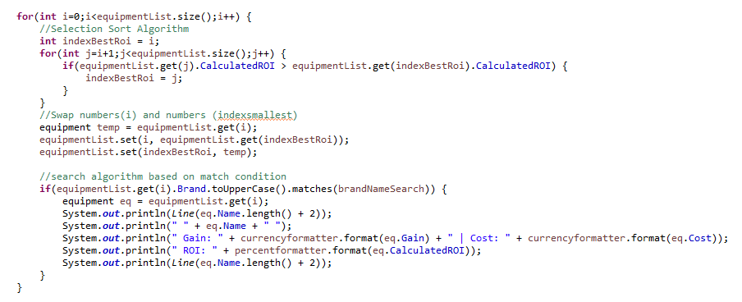

To sort by the best ROI, the condition reads if next iteration’s calculated ROI value is greater than the current iteration’s calculated ROI value then store the current index in a variable called “indexBestROI”. Using what I’ve learned from Lysecky, S., Vahid, Lysecky, R., and Givargis (2015), you can change the current “LinkedList” by first storing the current iteration into a temporary variable, setting the current iteration to the variable “indexBestROI”, and then setting the temporary variable to the “indexBestROI” index value. If the temporary variable isn’t set, then you would have duplicate values in your list. Additionally, after this algorithm runs, I have a condition to check whether the current iteration’s “Brand”, “String” property, matches the user’s “String” input. If there’s a match I output the results for the user.

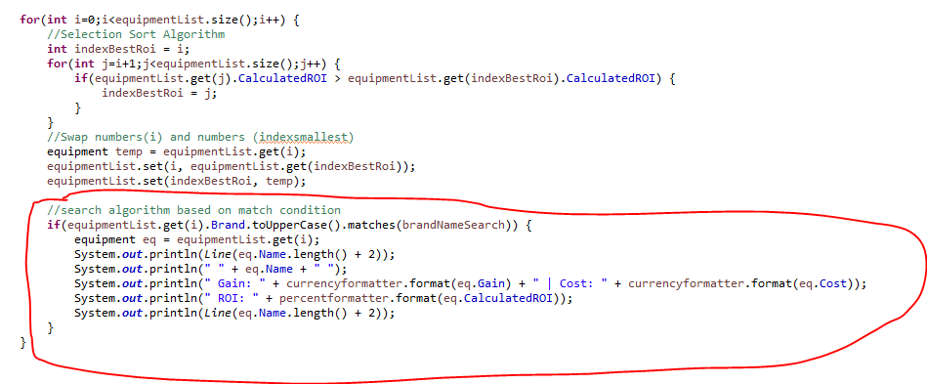

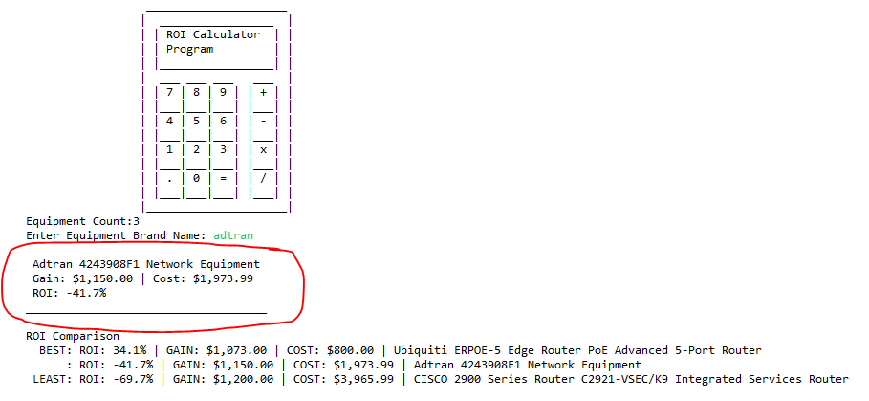

Since the list is now sorted by “BEST” ROI, I create another loop to print the results of the sort to the user.

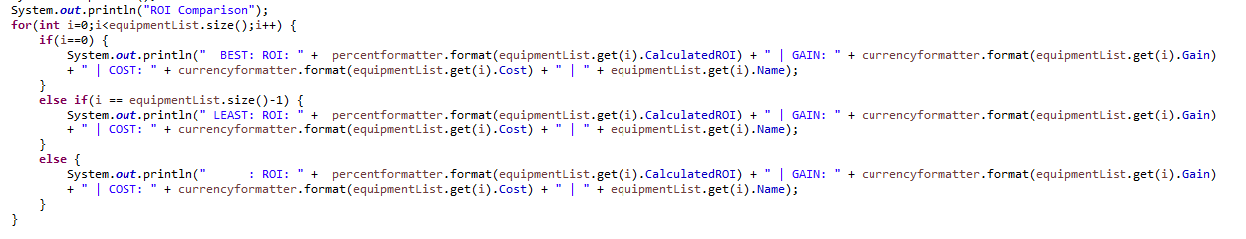

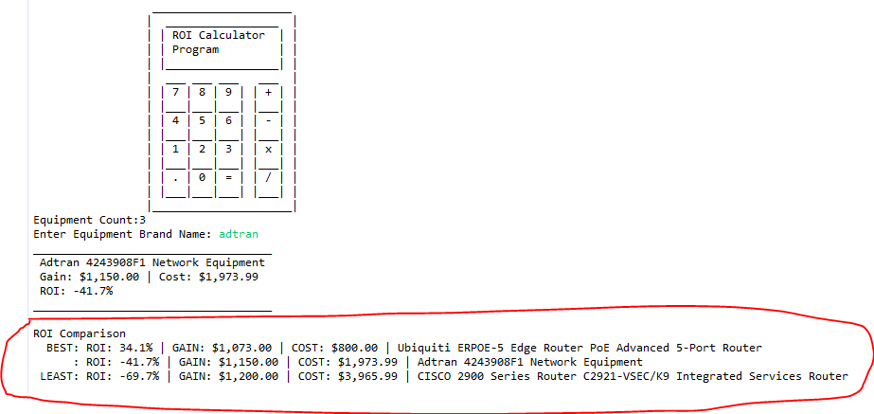

To complete the program, I’ve informed the user that the program has completed processing.

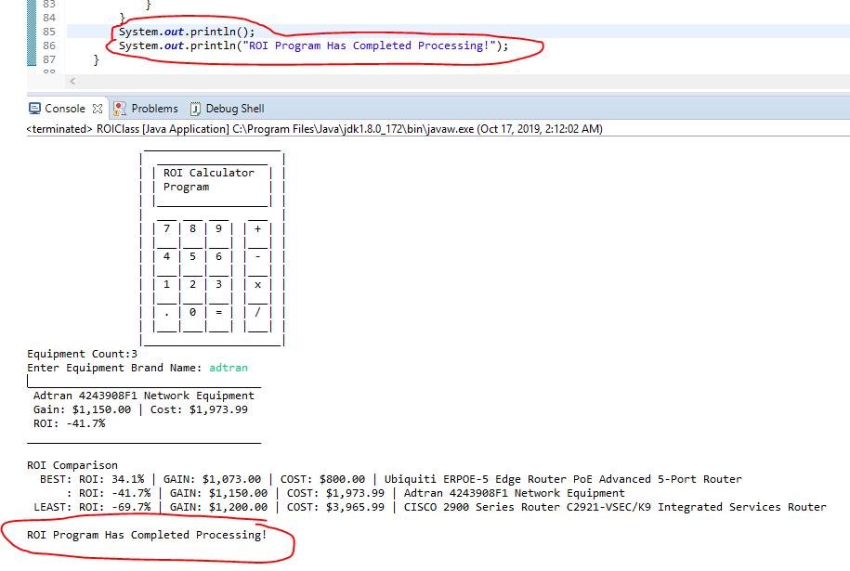

This class is amazing, and all developers must understand these principles in order to succeed in software development. I learned a lot over the course of these five weeks and will continue my education and mastery of data structures and algorithms for my career advancements on future endeavors. Thank you!

References

Abin Manathoor Devasia [Screen Name] (2013**,** Jan. 8). [How to define a relative path in java](https://stackoverflow.com/questions/14209085/how-to-define-a-relative-path-in-java).*stackoverflow*. Retrieved from <https://stackoverflow.com/questions/14209085/how-to-define-a-relative-path-in-java>

Chen, J. (2019, Oct. 13). Return on Investment (ROI). *Investopedia.* Retrieved from <https://www.investopedia.com/terms/r/returnoninvestment.asp>

duffymo [Screen Name] (2010, Mar. 4). [Java](https://stackoverflow.com/questions/14209085/how-to-define-a-relative-path-in-java) Currency Number format. stackoverflow. Retrieved from <https://stackoverflow.com/questions/2379221/java-currency-number-format>

Eriksson, D. (n.d.). How do I use NumberFormat to format a percent? *AVAJAVA Web Tutorials.* Retrieved from <https://www.avajava.com/tutorials/lessons/how-do-i-use-numberformat-to-format-a-percent.html>

Lysecky, R., Vahid, F., Lysecky, S., & Givargis, T. (2015). Data structures essentials. Retrieved from <https://learn.zybooks.com/zybook/ASHFORDCPT307HollandAcademicYear2019/chapter/1/section/7>

Olson, J.J. (n.d.) Calculators. *ASCII Art Archive*. Retrieved from <https://www.asciiart.eu/electronics/calculators>

W3schools.com. (n.d.) Java User Input (Scanner). *W3schools.com.* Retrieved from <https://www.w3schools.com/java/java_user_input.asp>