**Employee Portal Website – Final Design**

Steven On

The University of Arizona Global Campus

CST310: Software Development

Professor Joseph Issa

January 24, 2021

**Employee Portal Website – Final Design**

In course CST310: Software Development, the fifth web development task is to develop the Logout mechanism to successfully log the user out of the system. The following video demonstrates the log out functionality: <https://screencast-o-matic.com/watch/c3VOfkVDlDc>

In the video, I also present the various functionality within the employee portal website such as the login and profile page functionality to authenticate against the database, the registration page to insert a new employee in the database, the picture file upload mechanism, and the logout feature. The following screenshots below depict each functionality for the website.

**Figure 1**

*Login / Profile functionality*

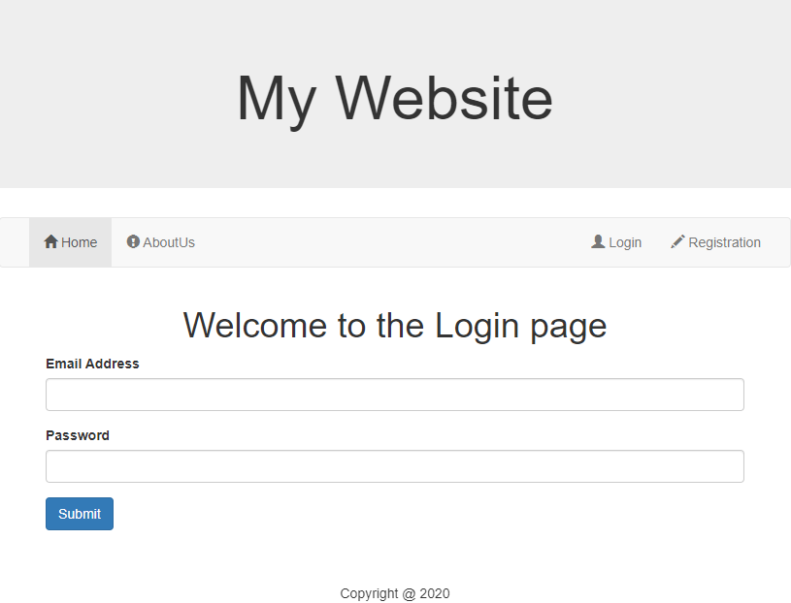

Figure 1 demonstrates the layout view of the login page. When a user attempts to input an email address or password the request is sent to the database to see if that user exists. If the user doesn’t not exists, an error message appears asking for the user to register.

**Figure 2**

*Registration*

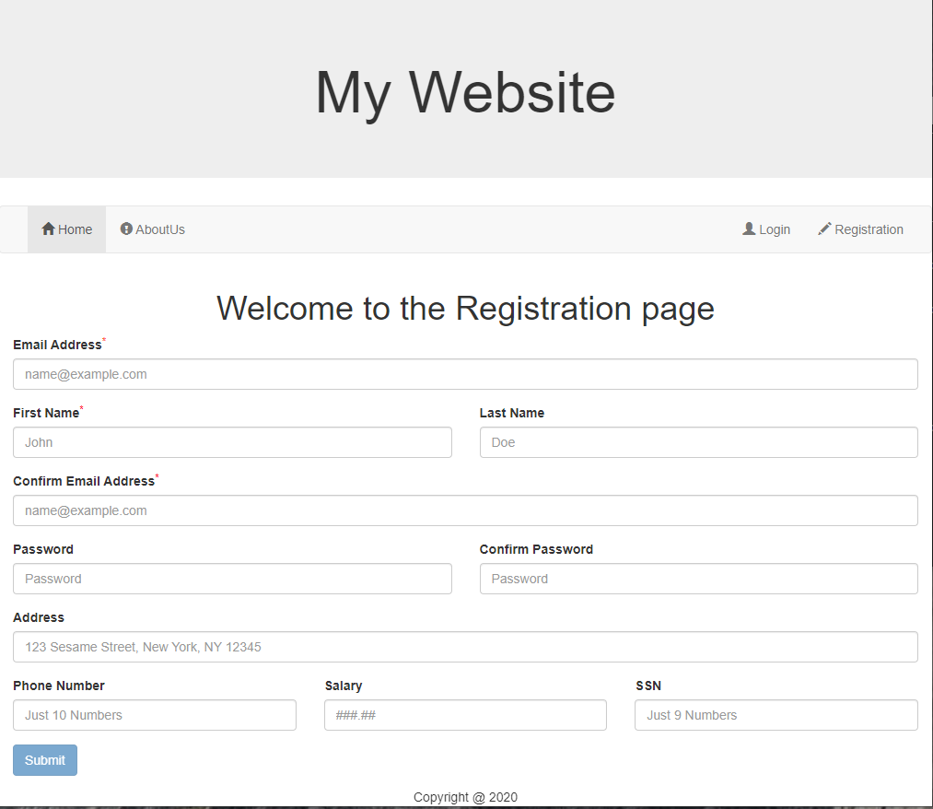

The registration page in Figure 2 allows the user to input the employee’s information into the database for authentication. This input form has multiple data validators to ensure data accuracy within the system, if the values are appropriate then the data is sent to the database for the attempt to insert a record into the user table. By default, all registrations are employees for security purposes and system maintenance.

**Figure 3**

*Profile login / Picture file upload*

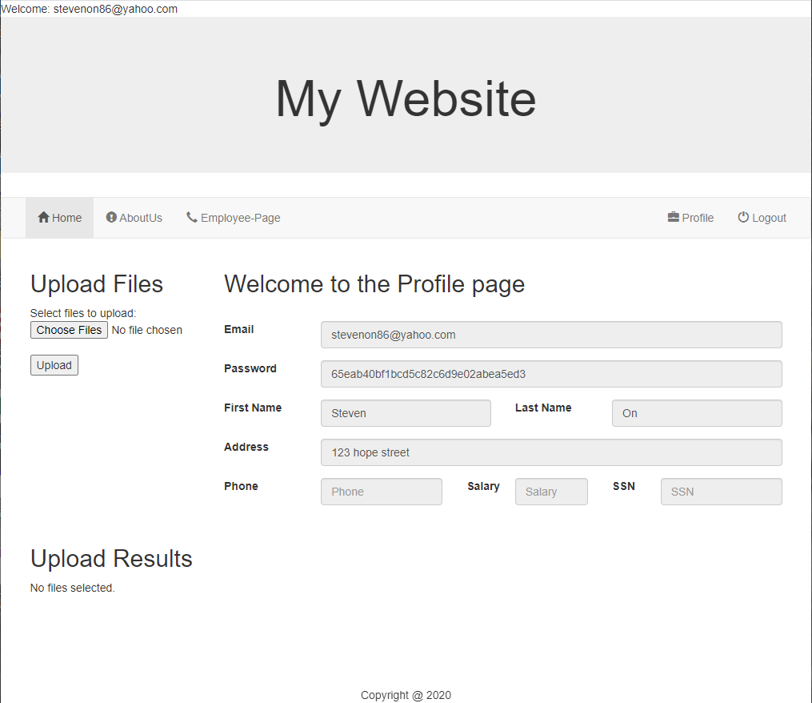

After the user of role, “employee” authenticates, the user will be sent to the profile page displayed in Figure 3. The user is authenticated in the system and their credentials are cached on the session’s browser. The user can upload files on the server or go to the Employee-Page that is only accessible to “Employee” roles.

**Figure 4**

*Logout Functionality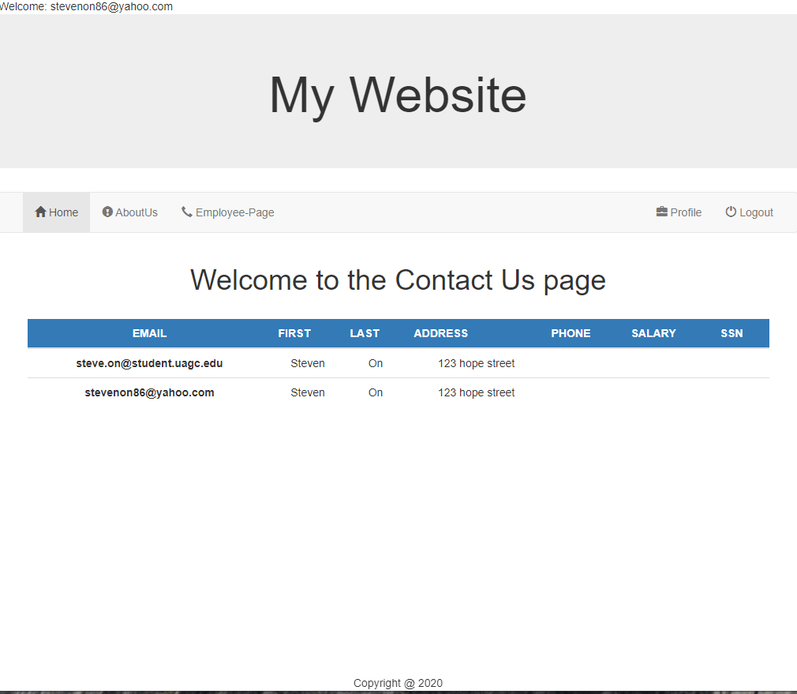*

Figure 4 demonstrates the Employee-Page where on load, all employees in the user table is displayed in an HTML table for the logged in employee. The only other option the user has is to Logout of the system which will revert the user back to Figure 1.

The following outlined steps are the steps I’ve taken to combine all the functions into one single application.

1. Create the website page layout in php.
2. Build the database user table structure
3. Connect to the database via PHP by passing text to the database integration.
4. Create input forms and pass the values to the database.
5. Create login input form.
6. Pass login values to the database for database authentication.
7. Cache the session username on master.php navbar.
8. Use the cached session username to extract profile data on the profile page.
9. Develop upload files mechanism
10. Develop check for “employee” role to allow the display of the employee-page.
11. Create the global connection to the database and display all employees in the user table on the employee-page.
12. Develop log out functionality to log the user out of the website.

The purpose of the employee portal website is to provide a company an internal intranet. This template is a solid foundation for authenticating against a database to display any data within a server. The power of server-side code shows fast and responsive websites that doesn’t bog down the client, however both client and server-side code are used for best performance such as using client-side code for form validation which is demonstrated in the registration page. With this database and PHP template, any organization can develop a robust website for managing employee content, information, and have this website be the main channel to send organizational-wide messages throughout the company.

**References**

Connolly, R., & Hoar, R. (2018). *Fundamentals of web development* (2nd ed.). Pearson. <https://ashford.instructure.com/courses/95113/modules/items/4819667>