Ashkenazi Population Structure Reassessed: Reference-Panel Sensitivity and the Europe-Levant Cline
Steven Parker
Contact: stevenparker@ashkenaziresearch.org

Abstract
Population-genetic placement is conditional on the reference populations supplied to an analysis. This study tests whether the familiar description of Ashkenazi Jews as intermediate between Europe and the Levant is stable when Italian Jewish, Southern Italian, Sicilian, Maltese, and Aegean comparators are included directly. A literature audit first identifies a recurring reference-panel pattern across foundational Y-chromosomal studies and the landmark autosomal studies synthesized by Ostrer and Skorecki (2013): Northern Italians, Tuscans, Sardinians, and Northern or Central Europeans were repeatedly available, whereas non-Jewish Southern Italians and Sicilians were generally absent. The original quantitative analysis is a linked suite of fifteen Global25 coordinate-space experiments comprising full competition panels, matched source omissions, reciprocal Italian Jewish targets, ten regional Ashkenazi targets, prehistoric controls, ancient Levant positive controls, and a full twenty-five-dimensional vector diagnostic. In the expanded modern panel, the source labeled Italki is the largest individual fitted source, and the strict Italian Jewish and central Mediterranean block totals 54.6 at distance 0.00819655. Removing only Italki worsens distance by 12.49 percent and reallocates most of the missing coefficient to related Italian and central Mediterranean sources. Removing Italki together with Southern Italian, Sicilian, Maltese, and Aegean comparators worsens distance by 47.18 percent, raises the Lombardy proxy from
9.8 to 38.0, and raises the Levantine-continuity block from 22.8 to 52.0. Reciprocal Italki models, regional replication, and ancient Levant positive controls reproduce the predicted directional behavior. For the German regional target, Levantine-continuity and Northern/Eastern European blocks produce strongly opposing, nearly equal weighted displacements around a reconstruction centered in central Mediterranean coordinate space. Global25 coefficients are descriptive, panel-dependent similarity weights and are not treated as literal ancestry percentages. The results show that a comparator architecture repeated across influential literature can create or exaggerate an apparent Europe-Levant cline when the central Mediterranean population space is not represented directly. Within the stated limitations, the most stable finding is a large Italian Jewish and central Mediterranean-associated fitted affinity, with smaller proxy coefficients requiring geometric and panel-sensitive interpretation.
Keywords: Ashkenazi Jews; population genetics; reference-panel sensitivity; comparator omission; central Mediterranean; Southern Italy; Italian Jews; Global25; coordinate-space modeling

Introduction
Genome-wide studies consistently identify Ashkenazi Jews as a genetically distinctive, endogamous population with ancestry related to both Europe and the eastern Mediterranean. Principal-component analyses, model-based clustering, identity-by-descent analyses, and ancient-DNA studies have repeatedly placed Ashkenazi samples near Southern European and Mediterranean populations while also detecting affinities with Levantine or other eastern Mediterranean groups (Atzmon et al., 2010; Behar et al., 2010; Bray et al., 2010; Ostrer and Skorecki, 2013; Xue et al., 2017; Waldman et al., 2022). The central interpretive disagreement is not whether multiple ancestry-related signals exist, but how their geographic scale should be described and how much of the apparent Europe-Levant pattern depends on the reference populations selected for analysis.
The expression Europe-Levant intermediate is often treated as though it were an intrinsic property of the target population. In practice, intermediate placement is defined relative to a declared coordinate system and a chosen reference panel. A target can appear to lie between two poles when a more directly relevant population space is absent. This is particularly important in the Mediterranean, where Northern Italians, Tuscans, Sardinians, Southern Italians, Sicilians, Maltese, Aegean Greeks, and Italian Jews are related but non-interchangeable comparators. If central Mediterranean variation is omitted, north-shifted

Italian and Levantine references may become the nearest remaining directions and can bracket the missing space.

Foundational Y-chromosomal studies and the Southern Italian comparator gap
The comparator problem is visible at the beginning of modern Ashkenazi population genetics. Hammer et al. (2000) and Nebel et al. (2001) were foundational papers in the field and were widely interpreted as evidence for substantial shared paternal ancestry between Jewish and Middle Eastern populations. Behar et al. (2004), Shen et al. (2004), and Hammer et al. (2009) extended the Y-chromosomal literature with larger or more highly resolved datasets. Yet, with the important exception of Semino et al. (2004), these studies did not place Ashkenazi Jews beside non-Jewish Southern Italian regional samples capable of testing whether broadly Mediterranean E and J lineages were geographically specific to the Levant.
The limitation is consequential because haplogroups J1, J2, E-M78, and E-M123 are distributed across the eastern and central Mediterranean. Broad labels such as J or E-M35 cannot by themselves distinguish Levantine-specific ancestry from Southern Italian, Aegean, Anatolian, or wider Mediterranean structure. The problem is intensified by small Ashkenazi samples in Nebel et al. (2001) and Shen et al. (2004), coarse haplogroup resolution in Behar et al. (2004), and the pooling of Ashkenazi and non-Ashkenazi Jewish samples in important summaries reported by Hammer et al. (2009).
Semino et al. (2004) is the critical exception because it included Ashkenazi Jews together with regional samples from Apulia, Calabria, and Sicily at greater downstream resolution. In those data, Ashkenazi J2 and E-M123 frequencies fall within the ranges reported for Southern Italian populations, while J1 remains secondary to J2. The overlap does not establish a unique Southern Italian paternal origin. It does establish that these lineages cannot be assigned a uniquely Levantine meaning by default when Southern European comparators are absent. The detailed frequency comparison is returned to the main text in Section 4.5 rather than being relegated to supplementary material.

Foundational autosomal studies and the inherited reference scaffold
The same comparator architecture recurred when the field moved from uniparental markers to genome-wide autosomal data. Ostrer and Skorecki (2013), one of the most influential syntheses of Jewish population genetics, explicitly drew on Atzmon et al. (2010), Behar et al. (2010), Kopelman et al. (2009), Bray et al. (2010), Listman et al. (2010), and Campbell et al. (2012). These papers used different marker systems, sample sizes, and analytical methods, but the European side of the shared interpretive scaffold was repeatedly represented by Northern Italians, Tuscans, Sardinians, Basques, French, Russians, or other Northern and Central European populations. Non-Jewish Southern Italians and Sicilians were not represented in the synthesis as direct competing comparators.
That omission matters because Northern Italians, Tuscans, Sardinians, Southern Italians, Sicilians, Maltese, Aegean Greeks, and Italian Jews are not interchangeable labels for a single Italian or European pole. Northern Italian samples shift the Italian reference northward. Sardinians are informative but carry island-specific drift and a distinctive demographic history. Italian Jewish samples do not substitute for non-Jewish Southern Italians when the question is whether Ashkenazi Jews fall within a broader central Mediterranean continuum. A panel that includes only the first set cannot determine where the target would fall relative to the missing southern populations.
The neighbor-joining tree reproduced below is therefore not merely an illustration of a settled geographic conclusion. It is also a visual record of the reference populations available to the calculation. The tree includes Northern Italians, Sardinians, Basques, French, Russians, and Jewish and Levantine populations, but it does not include non-Jewish Southern Italians or Sicilians. Ashkenazi placement between a north-shifted European branch and Levantine populations may reflect genuine demographic history, but the topology cannot determine how much of that placement would persist if the omitted central Mediterranean space were represented directly.
The same caution applies to apparent agreement across the underlying studies. Similar outcomes are not fully independent geographic tests when analyses reuse a comparable north-shifted European scaffold and repeat the same Southern Italian and Sicilian omission. Repetition under a shared design can reproduce a shared cline. This does not invalidate the genotypes or the statistical methods used in those studies. It

limits the geographic interpretation that can be assigned to their common topology until a matched sensitivity analysis restores the omitted comparators.
Bray et al. (2010) illustrates the interpretive consequence. The study observed Ashkenazi proximity to Italian samples but proposed that admixture with Central and Eastern European host populations could shift Ashkenazi Jews toward Italians on principal-component axes relative to Middle Eastern populations. That explanation was advanced without a direct test of Southern Italian and Sicilian sources in the same framework. The present study addresses precisely that unresolved alternative by adding Italian Jewish and central Mediterranean comparators, removing them under matched settings, and measuring the resulting redistribution and deterioration in fit.
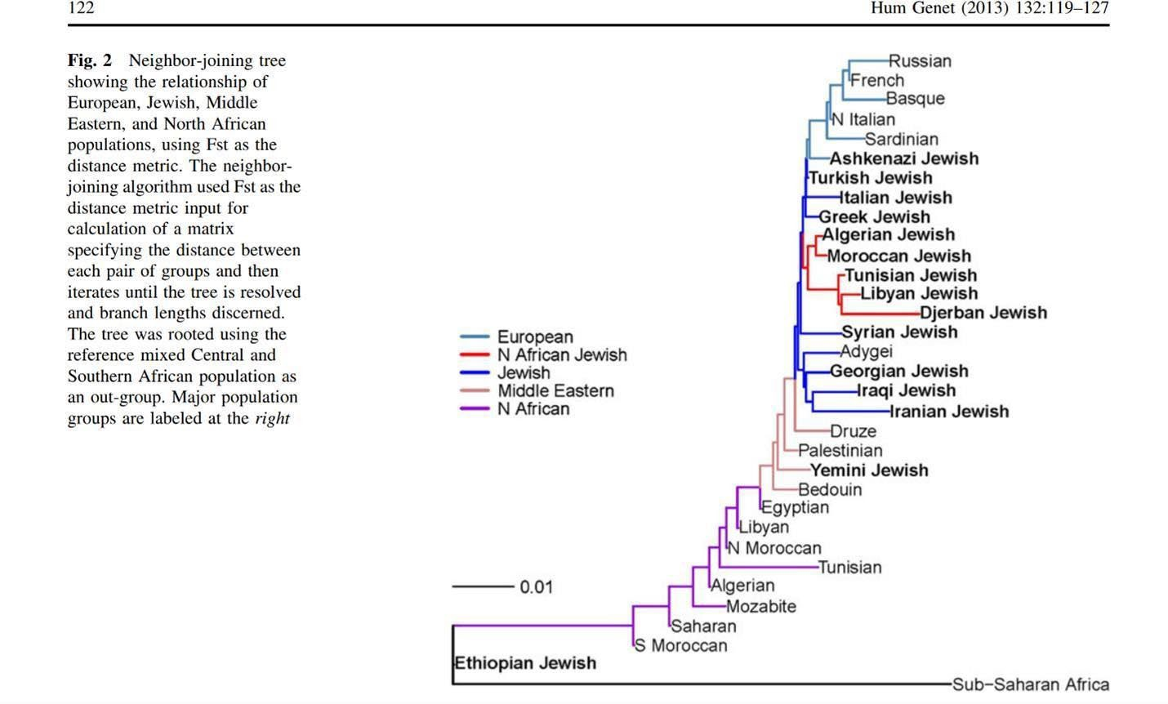
Figure 1. Neighbor-joining tree reproduced from Ostrer and Skorecki (2013). The European references shown include Northern Italians, Sardinians, Basques, French, and Russians. Non-Jewish Southern Italian and Sicilian populations are absent, so the topology cannot test Ashkenazi placement within that missing central Mediterranean space. Reproduced under the Creative Commons Attribution 2.0 International License (https://creativecommons.org/licenses/by/2.0/); resized, with no substantive alteration.

Literature stage | Named studies | Reference-panel pattern | Interpretive consequence
Early Y-chromosomal foundation | Hammer et al. (2000); Nebel et al. (2001); Behar et al. (2004); Shen et al. (2004); Hammer et al. (2009) | Southern Italian regional comparators generally absent; Semino et al. (2004) is the principal exception | Broad Mediterranean E and J lineages can be interpreted as Levantine by default when the Southern European comparison is unavailable.
Foundational autosomal studies | Kopelman et al. (2009); Atzmon et al. (2010); Behar et al. (2010); Bray et al. (2010); Listman et al. (2010); Campbell  et al. (2012) | European panels commonly include Northern Italians, Tuscans, Sardinians, Basques, French, Russians, or related groups; non-Jewish Southern Italians and Sicilians are absent from the shared synthesis | The European pole is shifted northward and the central Mediterranean continuum is incompletely represented.
Landmark synthesis | Ostrer and Skorecki (2013) | Neighbor-joining topology inherits the population coverage of the contributing studies | Apparent Europe-Levant intermediacy cannot be treated as reference-free geographic placement.
Later ancient-DNA modeling | Waldman et al. (2022); Brace et al. (2022) | Southern Italian or Sicilian proxies are finally modeled directly, although alternative proxy configurations remain possible | Large central Mediterranean-associated components become feasible when the relevant source space is represented.
Summary Table. Recurring reference-panel design across foundational Ashkenazi population-genetic studies. The pattern spans field-defining Y-chromosomal papers, landmark autosomal studies, and the synthesis that consolidated their interpretation.
This is not an isolated limitation in a handful of peripheral papers. It is a recurring design pattern across field-defining studies that established the modern genetic account of Ashkenazi population history. The early Y-chromosomal literature includes Hammer et al. (2000), Nebel et al. (2001), Behar et al. (2004), Shen et al. (2004), Semino et al. (2004), and Hammer et al. (2009). The foundational autosomal literature later

synthesized by Ostrer and Skorecki (2013) includes Kopelman et al. (2009), Atzmon et al. (2010), Behar et al. (2010), Bray et al. (2010), Listman et al. (2010), and Campbell et al. (2012). Because these studies shaped later reviews, figures, and public summaries, a repeated comparator omission became part of the field's inherited interpretive framework rather than remaining a minor limitation of one dataset.

Independent evidence, research question, and directional predictions
Published results provide reasons to perform that sensitivity analysis. Mediterranean-inclusive autosomal studies often place Ashkenazi Jews near Italians, Greeks, Sicilians, and other Southern European populations. Tian et al. (2009) reported lower autosomal FST values between Ashkenazi Jews and Italians or Greeks than between Ashkenazi Jews and Palestinians. Zoossmann-Diskin (2010) reported the same ordering in an independent distance framework. Xue et al. (2017) used identity-by-descent segment lengths to distinguish older shared structure from more recent gene flow, thereby constraining simple interpretations based solely on geometric proximity. Ancient-DNA studies further show that major Ashkenazi-associated ancestry components and founder effects were already present in medieval communities (Brace et al., 2022; Waldman et al., 2022).
Recent modeling also repeatedly assigns a large Italian or central Mediterranean-associated component. The Orchestra local-ancestry framework reported a broad Italian category as the largest assignment in modern Ashkenazi genomes (Lerga-Jaso et al., 2025). Waldman et al. (2022) reported plausible medieval Erfurt models with a large South Italian proxy component, while Brace et al. (2022) presented a model in which a Sicilian proxy accounted for the largest component in medieval individuals from Norwich. These point estimates are model-dependent and should not be treated as a single ancestry census. Their value is the recurring regional ordering across methods and datasets.
Italian Jewish populations offer a particularly useful reciprocal comparison. Long-established Jewish communities existed in Southern Italy and Sicily before the documented emergence of Ashkenazi communities north of the Alps. If Ashkenazi proximity to Italian populations were created primarily by later Central or Eastern European host admixture, an Italian Jewish target should not require the same central Mediterranean direction when Ashkenazi sources are excluded and Northern/Eastern European sources are allowed to compete. A reciprocal model therefore tests the narrow proxy claim without presuming that any present-day population is a literal ancestor.
PCA, qpAdm, clustering, and coordinate-based mixture methods answer different questions and are all sensitive to source choice. PCA describes covariance relative to included samples; qpAdm evaluates specified source and outgroup configurations; and constrained coordinate fitting represents a target using the source directions made available. None is reference-free. Global25 is used here only as a descriptive coordinate system for controlled source-panel perturbations. Its displayed coefficients have no formal confidence intervals and are not treated as historical ancestry percentages. The evidentiary focus is the response to matched panel changes: redistribution of fitted weights, deterioration of distance, reciprocal behavior, regional replication, full-dimensional geometry, and recovery of expected structure in positive controls.
The study tests one primary hypothesis: the apparent Ashkenazi Europe-Levant cline is sensitive to omission of central Mediterranean comparators. The directional predictions are specified before interpreting the results. Restoring Italian Jewish and central Mediterranean sources should improve fit and absorb signal otherwise assigned to north-shifted Italian and Levantine proxies. Removing only Italki should transfer much of its weight to genetically related Mediterranean sources with a moderate fit penalty. Removing the wider central Mediterranean source space should produce a larger fit penalty and inflate both Lombardy and Levantine-continuity proxies. Reciprocal Italki models should retain central Mediterranean sources without requiring Northern/Eastern European sources. The pattern should persist across regional Ashkenazi targets, while ancient Levantine positive controls should recover strong local Levantine continuity.

Test | Panel change or control | Directional prediction
Full modern competition | Italian Jewish, Southern Italian, Sicilian, Maltese, Aegean, Lombardy, Levantine, and Northern/Eastern European sources compete | The largest fitted direction should fall within the Italian Jewish and central Mediterranean block if that space is directly relevant.

Test | Panel change or control | Directional prediction
Italki omission | Remove only the Italki source while retaining related Mediterranean sources | Most displaced weight should transfer to related Mediterranean sources, with a moderate increase in distance.
Wider omission | Remove Italki, Southern Italian, Sicilian, Maltese, and Aegean sources | Lombardy and Levantine proxies should absorb omitted signal, and distance should worsen more strongly.
Reciprocal comparator | Model Italki as the target while excluding Ashkenazi sources | Central Mediterranean sources should remain sufficient without later Northern/Eastern European host sources.
Regional replication | Repeat the expanded panel for ten regional Ashkenazi averages | The category-level pattern should persist despite subgroup and sample-size differences.
Positive controls | Model ancient Levantine targets with appropriate earlier Levantine sources | The framework should recover strong local Levantine continuity rather than forcing central Mediterranean sources into every target.
Table 1. Pre-specified tests and directional predictions for the reference-panel sensitivity analysis.

Materials and Methods

Study design
The study is a secondary analysis of previously published or publicly distributed population-average coordinates and reported population-genetic results. It introduces no new participant recruitment, biological sampling, genotyping, or sequencing. The original quantitative contribution is a linked set of fifteen controlled Global25 experiments designed to test reference-panel sensitivity rather than to estimate a final demographic model.
The experiments were organized as connected controls. Experiments 1 and 8 used fixed prehistoric panels. Experiments 2 and 10 used broad modern competition panels. Experiments 3, 5, 11, and 12 removed declared source categories. Experiments 4, 6, and 13 provided direct-distance and reciprocal Italki comparisons. Experiments 7 and 14 evaluated ten regional Ashkenazi population averages. Experiments 9 and 15 tested ancient Levantine targets. Prehistoric and modern sources were not mixed indiscriminately within a single interpretive panel.

Experiments | Role in the linked suite
1 and 8 | Fixed prehistoric controls used to test the interpretive behavior of deep ancestral components.
2 and 10 | Full modern competition panels.
3, 5, 11, and 12 | Matched omission tests and proxy-inflation diagnostics.
4, 6, and 13 | Direct-distance and reciprocal Italki comparator tests.
7 and 14 | Regional replication across ten Ashkenazi population averages.
9 and 15 | Ancient Levant positive controls.
Table 2. Organization of the fifteen-experiment sensitivity and validation suite.

Data sources, provenance, quality control, and linkage disequilibrium considerations
All Global25 experiments used scaled population-average coordinates distributed through the declared source files documented in the accompanying Version 1 data package. The coordinate rows were used as distributed. This study did not generate or alter the upstream genotype calls, did not impute missing genotypes, and did not have access to individual-level genotype files for the populations represented by the coordinates.
Marker-level quality filtering, sample exclusion rules, phasing, linkage-disequilibrium treatment, and the construction of the underlying principal-component space were therefore inherited from the upstream datasets and coordinate-generation workflow. They cannot be independently reconstructed from twenty-five-dimensional population averages. This limitation is stated explicitly and is one reason the analysis is framed as a coordinate-space sensitivity study rather than as a raw-genotype demographic reconstruction.
Linkage-disequilibrium pruning cannot be applied at the downstream Global25 fitting stage because the inputs are twenty-five summary coordinates rather than individual SNPs. The relevant robustness checks at this stage are therefore panel-level rather than marker-level: fixed input rows, exact source labels, separation of targets and sources, matched source omissions, unchanged calculator settings, reciprocal targets, regional replication, prehistoric controls, ancient positive controls, full-dimensional distance

calculations, independent scripts, and file checksums. These controls test whether the reported directional response is reproducible within the declared coordinate system; they do not substitute for future raw-genotype replication.
A small set of pairwise FST outputs obtained through the IllustrativeDNA Admix Lab web interface using Human Origins v62.0 is retained only in Supplementary Tables S1 and S2 as a descriptive comparison. The underlying genotype files and complete web-platform filtering pipeline were not available for independent audit. Those outputs are not treated as primary evidence, are not described as a command-line replication, and are not used to establish formal significance, demographic parameters, or admixture proportions. The author-generated qpAdm analysis present in an earlier manuscript version has been removed entirely from the present evidentiary framework.

Coordinate-space experimental settings
Runs were recorded from Thierry Kerneur's ExploreYourDNA Atlantic Bronze Age calculator with cycles set to 0.25X, distance column off, printed zeroes off, fast mode off, and aggregate mode on. The repository retains source and target labels, raw outputs, grouped summaries, screenshots, comparison files, methods notes, validation scripts, and SHA-256 checksums.
Displayed coefficients are nonnegative, constrained, source-panel-dependent similarity weights. Correlated sources can substitute for one another, and an unprinted or zero coefficient does not demonstrate historical absence. A modern proxy label is geographic shorthand for sampled coordinate variation and is not evidence that the named present-day population was a literal ancestral source. Regional averages with n=2, ancient averages with n=3 or n=4, and the Italki average with n=9 require additional caution.
For matched omission experiments, fit deterioration was calculated as 100 x (d_reduced - d_full) / d_full, where d is the displayed residual distance. The primary comparison is therefore not any one coefficient in isolation but the joint pattern of coefficient redistribution and distance change under a controlled alteration of the source panel.

Full-dimensional vector diagnostic
For the Ashkenazi Germany target in Experiment 14, sources retained in the displayed solution were grouped as strict central Mediterranean (Reggio Calabria, Italki, and Maltese), Levantine continuity (Lebanese Arab Christian and Palestinian Arab Christian), and Northern/Eastern European (German and Polish). Within each block, a coefficient-weighted centroid was calculated after normalizing retained source weights to the block total.
Vectors were drawn from the strict central Mediterranean centroid to the Levantine-continuity and Northern/Eastern European centroids in all twenty-five Global25 dimensions. Directional opposition was summarized by cosine similarity. Each vector norm was multiplied by its displayed block coefficient to describe its contribution to the reconstructed displacement. A two-dimensional PCA was used only as an illustration of the same geometry; the full-dimensional calculation is the primary diagnostic, and PCA-axis signs have no historical meaning.

Literature synthesis and interpretive scope
Published PCA, genetic-distance, identity-by-descent, local-ancestry, ancient-DNA, uniparental, and historical studies were reviewed as external constraints. Genome-wide autosomal evidence was given greater interpretive weight than Y-chromosomal or single-locus observations because uniparental markers and founder-associated alleles represent limited portions of the genome and can be strongly affected by drift and endogamy.
The fifteen Global25 experiments form one linked sensitivity suite, not fifteen independent hypothesis tests. No p-values, confidence intervals, admixture dates, or multiple-testing claims are derived from the calculator outputs. The strongest inference is the repeated directional response to pre-specified panel changes, particularly Experiments 10-12, supported by reciprocal, regional, geometric, and positive controls.

Results

Full modern competition and matched omissions
Experiment 10 provides the main full-panel comparison. At distance 0.00819655, the source labeled Italki is the largest individual fitted source at 40.8. The strict Italian Jewish and central Mediterranean block totals 54.6, with Lombardy at 9.8, Levantine continuity at 22.8, and Northern/Eastern Europe at 12.8. These values establish the baseline response when all declared source categories are allowed to compete; they are not treated as ancestry percentages.
Experiment 11 removes only Italki. Distance increases to 0.00922012, a deterioration of 12.49 percent. The strict central Mediterranean block remains 43.6 because related Mediterranean sources absorb much of the displaced coefficient. Lombardy rises to 14.4, Levantine continuity rises to 32.6, and Northern/Eastern Europe declines to 9.4. The result is consistent with source substitution among correlated Mediterranean populations rather than with a unique, literal contribution from one modern group.
Experiment 12 removes Italki together with Southern Italian, Sicilian, Maltese, and Aegean sources. Distance rises to 0.01206331, a deterioration of 47.18 percent relative to the full panel. The strict central Mediterranean block is no longer available; Lombardy rises from 9.8 to 38.0 and Levantine continuity rises from 22.8 to 52.0. The more pronounced Northern Italian-Levantine solution therefore appears only after the nearer central Mediterranean source space has been removed, and it explains the target substantially less well within the declared coordinate system.
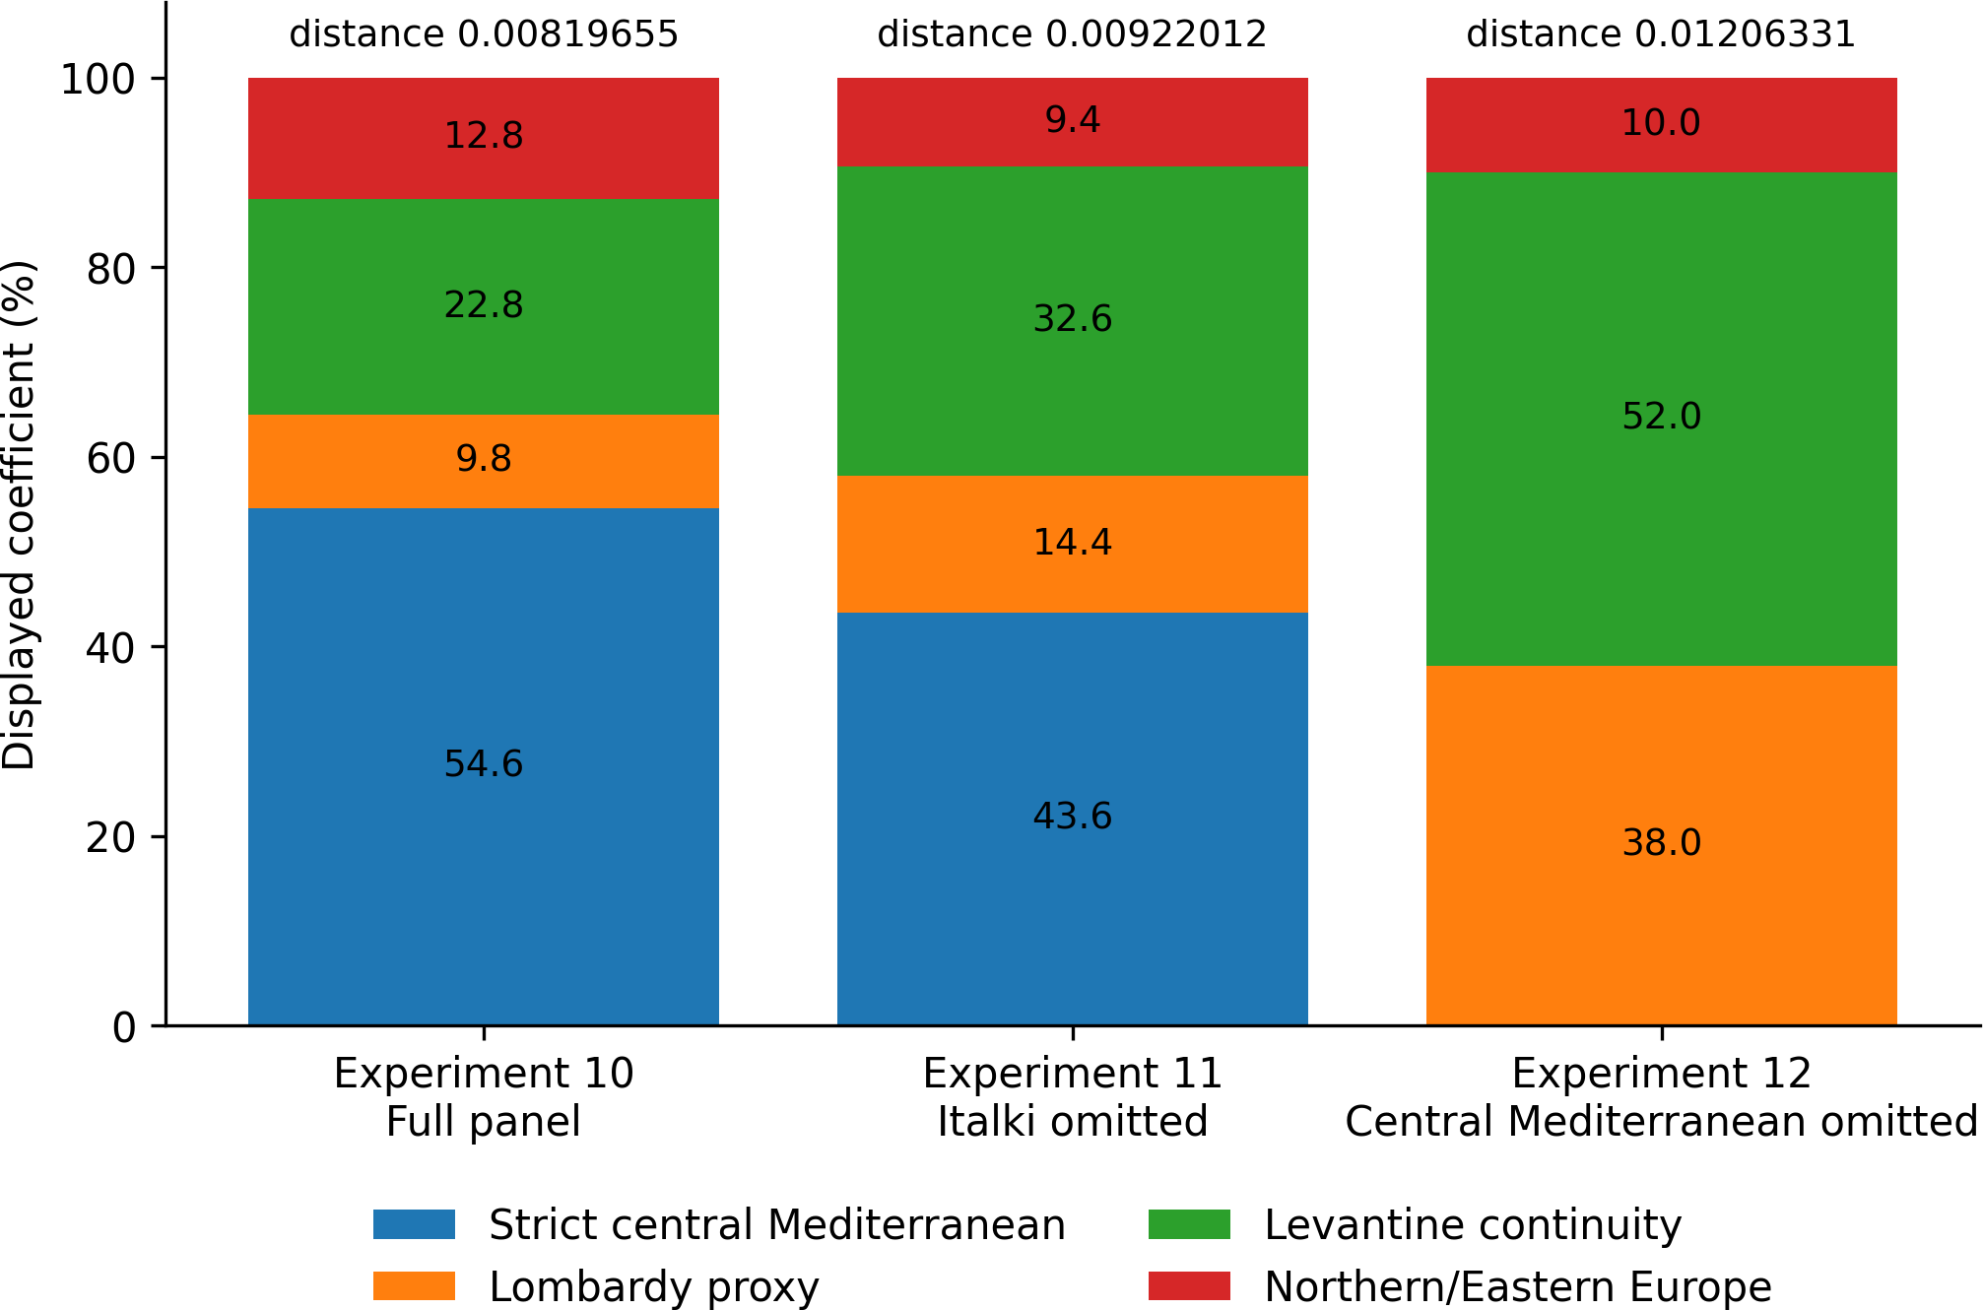

Figure 2. Matched source-panel comparison for Experiments 10-12. Removing only Italki transfers much of the fitted weight to related Mediterranean sources and moderately worsens distance. Removing the wider central Mediterranean source space produces larger Lombardy and Levantine-continuity weights together with a 47.18 percent deterioration in distance. Values are descriptive panel allocations, not literal ancestry percentages.

Reciprocal Italian Jewish comparator tests
Experiment 6 reverses the target and models Italki without using Ashkenazi Jews as a source. At distance 0.01732664, the displayed solution resolves through Maltese, Rhodian Greek, eastern Sicilian, and Reggio Calabria sources. No Northern Italian, Tuscan, German, Polish, or Russian source is retained. The

result shows that the central Mediterranean direction is present in an Italian Jewish target independently of later Ashkenazi residence north of the Alps.
Experiment 13 expands the reciprocal panel by adding modern Levantine-continuity controls while continuing to exclude Ashkenazi sources. At distance 0.00984550, the displayed Italki solution contains
70.6 strict central Mediterranean, 4.2 Lombardy, and 25.2 Levantine continuity, with no Northern/Eastern European coefficient retained. A zero displayed coefficient does not prove historical absence, but it does show that later northern host populations were available to the model and were not required to reconstruct the target under this panel.
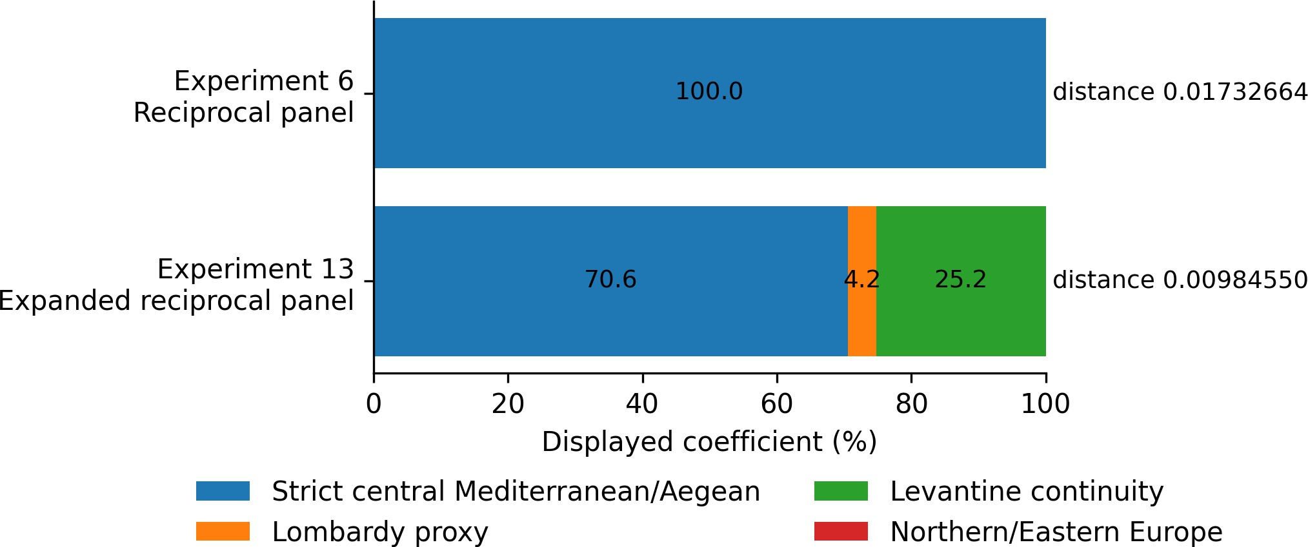
Figure 3. Reciprocal Italki models in Experiments 6 and 13. The original panel resolves entirely through central Mediterranean and Aegean sources. The expanded panel retains a large strict central Mediterranean block, a small Lombardy proxy, and a Levantine-continuity block, while Northern/Eastern European sources remain unretained.

Regional stability and full-dimensional geometry
Experiments 7 and 14 apply the modern panel to ten named regional Ashkenazi population averages. In Experiment 14, the strict central Mediterranean block exceeds 50 in every region and ranges from 50.8 in Latvia to 76.4 in France, with an unweighted average of 58.6. Adding Lombardy produces a broader Italian and central Mediterranean average of 62.5. Levantine continuity averages 23.5 and Northern/Eastern Europe averages 14.0. Some regional targets have small sample sizes, but the category-level ordering also appears in the larger Polish, Ukrainian, Belarusian, Lithuanian, German, and Russian averages.
The regional distributions constrain a simple host-population explanation. Ashkenazi Poland retains a large Italki component while Polish is small or absent in the displayed solution; comparable behavior occurs for Ukrainian, Russian, and German targets. Exact source coefficients fluctuate because correlated Mediterranean sources substitute for one another. The stable result is the category-level majority of the strict central Mediterranean block, not the identity of one source row.
For the German target, the displayed solution is 75.4 strict central Mediterranean, 16.6 Levantine continuity, and 8.0 Northern/Eastern Europe. The Levantine and northern displacement vectors from the central Mediterranean centroid have cosine similarity -0.786 and therefore point in strongly opposing directions. Their coefficient-weighted magnitudes are 0.01024 and 0.01098, respectively. Combining them leaves a displacement of 0.00697 from the central Mediterranean centroid. The smaller northern coefficient produces a similar displacement because its centroid is farther from the central Mediterranean centroid.
Direct distances provide an additional constraint. Ashkenazi Germany is 0.01470 from Reggio Calabria, 0.01588 from Italki, 0.01801 from Maltese, and 0.01978 from western Sicily. It is 0.05331 from Druze, 0.05875 from Lebanese Arab Christians, 0.06385 from Palestinian Arab Christians, and 0.07521 from Samaritans. Distances do not identify a unique ancestral source, but they show that the target position is much closer to the retained central Mediterranean references than to the retained Levantine-continuity references.

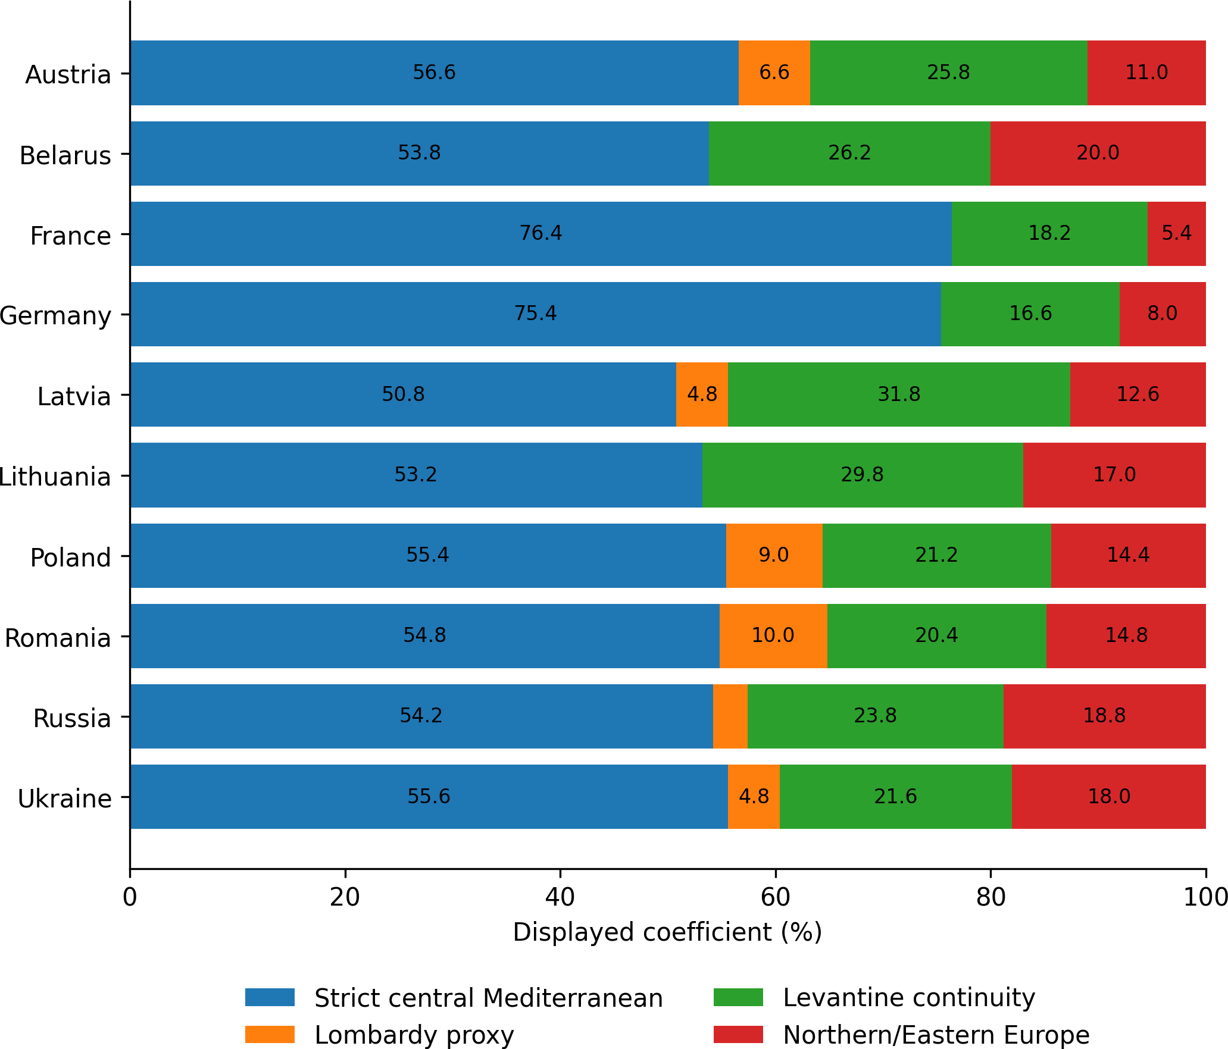

Figure 4. Experiment 14 regional stability. The strict central Mediterranean block is the largest category in all ten regional targets. Lombardy is shown separately rather than being classified as Southern Italian. Regional averages differ in sample size, and the coefficients are descriptive panel allocations.
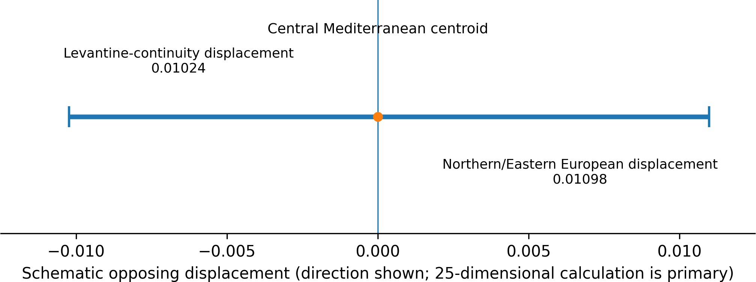
Figure 5. Schematic of the opposing weighted displacements in the German regional model. The primary calculation uses all twenty-five Global25 dimensions; the horizontal display shows only the opposing direction and similar weighted magnitude of the two proxy blocks.

Ancient Levant positive controls
Experiment 9 models ancient Levantine targets against modern Levantine and central Mediterranean controls. Peki'in, Ain Ghazal, and Middle Bronze Age Megiddo are represented as 100.0 Samaritan in the declared competition, while later Bronze and Iron Age targets remain majority Levantine. Central Mediterranean coefficients are nearly absent in most targets. The method therefore does not automatically assign central Mediterranean sources to every eastern Mediterranean target.
Experiment 15 provides a temporal continuity control by modeling three Iron Age coastal southern-Levantine averages against pre-Iron-Age Levantine site-period averages plus Mycenaean and Anatolian Early Bronze Age composites. Philistine Ashkelon is allocated 100.0 to earlier southern-Levantine sources, Achziv 95.4, and Beirut 74.0. The unweighted target average is 89.8 pre-Iron-Age southern Levant, 7.3 Mycenaean composite, and 2.9 Anatolian composite at average distance 0.01805080. The result does not

exclude all external ancestry; it demonstrates that the framework recovers strong local continuity when appropriate earlier Levantine references are supplied.
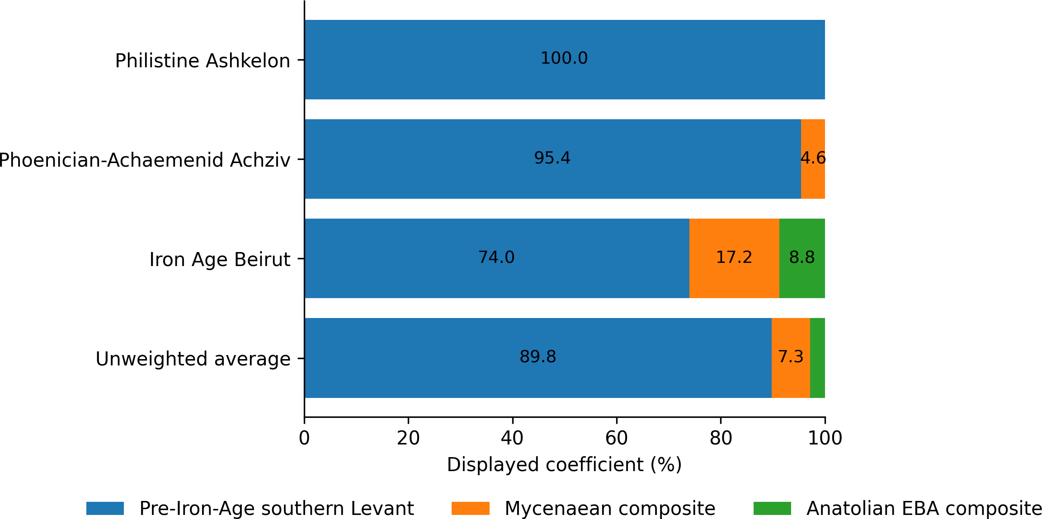

Figure 6. Experiment 15 ancient Levant positive control. Earlier southern-Levantine sources account for the large majority of every target. Values are constrained similarity weights among archaeological population averages, not literal genealogical percentages.

Convergence with independent published evidence
The panel-sensitivity results are consistent with the recurring regional ordering in independent studies. This convergence is not statistical independence in a strict sense because studies may share samples or broad reference populations, but it provides external context for the original experiments.
Published genetic-distance analyses place Ashkenazi Jews closer to Italian and Greek populations than to sampled Levantine populations. Identity-by-descent analyses distinguish substantial older shared structure from much lower levels of long recent sharing with Levantine populations. Recent local-ancestry and ancient-DNA models assign the largest modeled component to broad Italian, South Italian, or Sicilian proxies. Exact estimates vary because methods partition correlated Mediterranean structure differently.

Study | Method and data | Reported regional ordering or model | Interpretive constraint
Tian et al. (2009) | Autosomal SNP FST | Italians 0.0040; Greeks 0.0042;  Palestinians 0.0093 | Italian and Greek comparators are closer in the sampled panel; FST alone does not identify historical sources.
Zoossmann-Diskin (2010) | Autosomal distance matrix | Ashkenazi-Italian 44; Ashkenazi-Palestinian 277, scaled as reported | Independent distance framework recovers the same ordering.
Xue et al. (2017) | IBD segment-length analysis | Older and more recent shared ancestry separated by segment length | Constrains models that equate projection-based proximity with substantial recent source contribution.
Lerga-Jaso et al. (2025) | Orchestra local-ancestry inference | Approximately 68 percent broad Italian; smaller Levantine and other categories | Italian category is broad and  model-dependent, but is the largest reported assignment.
Waldman et al. (2022) | Ancient DNA and published qpAdm models for medieval Erfurt | Plausible South Italian models average approximately 65 percent South Italian, 19 percent Middle Eastern, and 16 percent Eastern European | Source identities and estimates vary among plausible models; major ancestry components pre-date the fourteenth century.
Brace et al. (2022) | Medieval Norwich ancient DNA and a proxy model | Approximately 67 percent Sicilian proxy and 33 percent Turkish Jewish proxy in one model | Small sample and proxy-sensitive result; supports a substantial central/eastern Mediterranean-associated component before the twelfth century.
Table 3. Independent published results that provide external context for the coordinate-space sensitivity analysis. Reported values are reproduced as model- or panel-dependent estimates, not combined into a meta-analytic ancestry proportion.

Discussion

Reference panels change the apparent cline
The central result is methodological: the apparent Northern Italian-Levantine cline is not stable to the restoration of Italian Jewish and central Mediterranean comparators. In the full panel, the largest fitted direction is the strict central Mediterranean block. Removing only Italki transfers most of its fitted weight to related Mediterranean sources and modestly worsens distance. Removing the wider central Mediterranean space produces a much stronger Lombardy-Levantine combination but also a 47.18 percent deterioration in distance. The reduced model looks more clinal precisely because the source space nearest the target has been removed.
This behavior follows the geometry of constrained modeling. A target can be represented only by directions included in the panel. When the relevant central Mediterranean region is absent, a north-shifted Italian proxy and a Levantine proxy can bracket the missing space. The resulting coefficients may be visually persuasive while encoding a poorer approximation. Panel sensitivity should therefore be reported before proxy coefficients or intermediate placement are translated into historical narratives.

Proxy coefficients are not independent historical layers
The German vector diagnostic illustrates why a nonzero Levantine-continuity coefficient need not equal a discrete Levantine ancestry layer of the same percentage. The Levantine-continuity and Northern/Eastern European blocks point in strongly opposing directions and have nearly equal coefficient-weighted magnitudes around a reconstruction centered in central Mediterranean coordinate space. Their joint effect is much smaller than either displacement considered separately.
This does not establish the absence of Levant-related ancestry. It constrains the historical interpretation of the displayed coefficient. A proxy weight may combine genuine shared ancestry, source substitution, correction for drift, and compensation for the positions of other panel members. The most defensible statements concern comparative fit, redistribution under controlled omissions, and the target's location relative to the declared sources.

Italian Jews as a reciprocal comparator
Italian Jews provide a test of the narrow claim that the Italian-associated Ashkenazi component is primarily Northern Italian or is generated by later Northern/Eastern European host admixture. In reciprocal models, the Italki target retains a large central Mediterranean direction even when Ashkenazi sources are excluded and German, Polish, and Russian sources are permitted to compete. The shared placement therefore cannot be attributed solely to later Ashkenazi residence in the Rhineland or Eastern Europe.
The reciprocal result is not proof of one exclusive origin scenario and does not identify a single historical community. It is more limited and more useful: models that assign the Italian-associated component mainly to Northern Italy must explain why Italian Jewish and Ashkenazi targets repeatedly share the same central Mediterranean direction, why Northern/Eastern European sources are unnecessary in the reciprocal target, and why broader comparator omission inflates both Lombardy and Levantine coefficients while worsening fit.

Historical context and the Southern Italian formation hypothesis
Jewish communities are documented in Southern Italy and Sicily from antiquity through the medieval period, including communities in Apulia, Calabria, Campania, Lucania, Syracuse, Palermo, Catania, Agrigento, and other centers (Roth, 1946; Rutgers, 1995). These communities participated in Greek- and Latin-speaking Mediterranean networks connected with the Aegean and Asia Minor (Feldman, 1993; Gruen, 2002). Historical scholarship also identifies Italy as a major staging area in the development of Jewish communities that later appear in northern France and the Rhineland (Chazan, 1987; Grossman, 1995). The historical hypothesis evaluated here is therefore more specific than unspecified Italian admixture: a substantial Ashkenazi core may have formed among long-established Italian Jewish communities within the Southern Italian and central Mediterranean population environment before migration north of the Alps. History establishes plausibility and route; it does not assign a numerical genetic percentage.

The reciprocal Italki experiments connect this historical hypothesis to the genetic sensitivity test. Italian Jewish targets retain a large central Mediterranean direction even when Ashkenazi sources are excluded and German, Polish, and Russian sources are allowed to compete. This does not prove descent from one named modern population, but it is not well explained by a model in which Ashkenazi Italian affinity was created mainly by later Northern or Eastern European host admixture. The Y-chromosomal literature provides an additional, secondary consistency check and is therefore restored to the main manuscript below.

Foundational Y-chromosomal evidence in Southern Italian context
The early Y-chromosomal literature was frequently interpreted as evidence for predominantly Levantine Ashkenazi paternal ancestry because haplogroups J1, J2, and E were labeled Near Eastern. That geographic assignment requires caution. Broad haplogroups span multiple Mediterranean regions, their frequencies can be strongly altered by founder effects and endogamy, and low phylogenetic resolution can make widely distributed lineages appear more geographically diagnostic than the data support.
Hammer et al. (2000), Nebel et al. (2001), Behar et al. (2004), Shen et al. (2004), and Hammer et al. (2009) are not incidental citations; they are foundational studies repeatedly used to characterize Jewish paternal origins. Yet the relevant Ashkenazi analyses generally lacked Southern Italian regional comparators. Behar et al. (2004) and Nebel et al. (2001) reported broad haplogroup frequencies without Southern European populations capable of testing a central Mediterranean alternative. Shen et al. (2004) used a very small Ashkenazi sample. Hammer et al. (2009) pooled Ashkenazi and non-Ashkenazi Jewish samples for several summaries and did not provide a complete Ashkenazi-specific frequency table. Those limitations matter because they constrain geographic interpretation, not merely statistical precision.
Semino et al. (2004) is uniquely informative in this early literature because it places Ashkenazi Jews beside multiple Southern Italian regional samples at greater subclade resolution. Ashkenazi E-M123 is 11.7 percent, closely matching Apulia at 11.6 percent and the Cosenza Albanian community at 13.2 percent. Ashkenazi J2-M172 is 23.2 percent, compared with 29.1 percent in Apulia, 22.8 percent in Calabria 1, 20.0 percent in the Cosenza sample, and 16.7 percent in Sicily. Southern Italy itself is heterogeneous: Calabria 1 has high E-M78 and low E-M123, whereas Apulia and the Cosenza sample show the inverse pattern. Neither subclade is therefore geographically diagnostic of the Levant.
The relative ordering of the J lineages is also important. In the Semino et al. comparison, J2 exceeds J1 in Ashkenazi Jews and in every listed Southern Italian sample. Several sampled Levantine populations in the early literature instead show a J1-dominant paternal structure. This contrast does not identify a unique ancestral population and does not eliminate eastern Mediterranean ancestry. It does show that the Ashkenazi frequency profile is not well described as a simple copy of a J1-dominant Levantine paternal pool.
The correct inference is limited but consequential. When Southern Italian comparators are included, the apparent Levantine specificity of the Ashkenazi Y-chromosomal signal is substantially reduced. The observed E-M123 and J2 frequencies are compatible with a broader Southern Italian, Aegean, and central Mediterranean distribution shaped by founder effects and long-term endogamy. Because Y-DNA represents only one paternal lineage, it remains subordinate to the genome-wide autosomal sensitivity analysis; it functions here as a consistency check on geographic claims, not as a population-wide ancestry estimate.

Study | Reported Ashkenazi sample | Southern Italian comparator coverage | Main interpretive limitation
Hammer et al. (2000) | Population sample reported in the foundational study | Absent | Broad Jewish-Middle Eastern comparison could not test Southern Italian overlap directly.
Nebel et al. (2001) | Approximately 79 | Absent | Small Ashkenazi sample and no Southern European regional comparison.
Behar et al. (2004) | Approximately 442 | Absent | Larger sample but coarse haplogroup bins and no Southern Italian regional panel.
Shen et al. (2004) | Approximately 20 | Absent | Very small Ashkenazi sample and limited power for geographic inference.
Semino et al. (2004) | 77 | Present: Apulia, Calabria, Cosenza Albanian community, and Sicily | The principal early study capable of testing Southern Italian subclade overlap directly.
Hammer et al. (2009) | 1,575 Jewish men across diaspora groups | Absent from the relevant Ashkenazi comparison | Ashkenazi and non-Ashkenazi samples pooled in important summaries; complete subgroup frequencies not reported.
Table 4. Foundational Y-chromosomal studies and Southern Italian comparator coverage. Sample descriptions follow the cited studies and the earlier manuscript audit; approximate values are identified as such.

Population | Sample size | E-M78 | E-M123 | J1-M267 | J2-M172
Ashkenazi Jews | 77 | 5.2 | 11.7 | 14.6 | 23.2
Italian, Apulia | 86 | 0.0 | 11.6 | 2.3 | 29.1
Italian, Calabria 1 | 80 | 16.3 | 2.5 | 1.8 | 22.8
Italian, Calabria 2, Albanian community, Cosenza | 68 | 5.9 | 13.2 | 0.0 | 20.0
Italian, Sicily | 55 | 12.7 | 3.6 | 7.1 | 16.7
Table 5. Semino et al. (2004) Y-chromosomal frequencies for Ashkenazi Jews and Southern Italian regional samples. Frequencies are percentages. Regional overlap and heterogeneity do not prove a unique source population, but they prevent broadly Mediterranean lineages from being assigned to the Levant by default.

Implications for future population-genetic studies
Studies of Ashkenazi origins should include Southern Italian, Sicilian, Maltese, Aegean, and Italian Jewish comparators directly rather than treating Northern Italian, Tuscan, or Sardinian populations as interchangeable representatives of Italy. Analyses should report matched source-panel perturbations, source counts, sample sizes, coordinate or genotype provenance, and the change in fit when relevant comparators are removed.
The present results motivate raw-genotype replication rather than replacing it. A future analysis should use individual-level data with documented SNP and sample quality control, explicit linkage-disequilibrium treatment, alternative outgroup configurations where appropriate, jackknife or bootstrap uncertainty, and ancient genomes from Mediterranean Jewish communities. Such work can test whether the directional panel effects observed here persist in formal genotype-based models.

Limitations
Global25 is a compressed coordinate representation. The study cannot audit or repeat the upstream marker-level quality-control and linkage-disequilibrium procedures from the coordinates alone.
The calculator outputs constrained similarity weights without formal confidence intervals. Correlated sources can substitute for one another, and individual coefficients are not literal historical ancestry percentages.
Several population averages have small or unequal sample sizes, including regional targets with n=2 and the Italki average with n=9. Stability is therefore interpreted at the category level rather than as precision for any single regional coefficient.
Modern populations are imperfect proxies for historical populations. Geographic labels identify sampled variation and do not establish direct descent from the named group.
The experiment suite is one connected sensitivity analysis rather than a set of independent hypothesis tests. Repetition across experiments is a robustness pattern, not a basis for multiplying statistical significance.
The descriptive web-platform FST outputs in the Supplementary Appendix lack an independently auditable marker-level pipeline and are not primary evidence.
Historical and Y-chromosomal evidence provide context but cannot independently quantify genome-wide ancestry or identify a unique formation event.

Conclusions
The familiar Ashkenazi Europe-Levant cline is not stable under matched changes to the reference panel. This result addresses a recurring comparator architecture present across foundational Y-chromosomal papers, landmark autosomal studies, and the influential synthesis of Ostrer and Skorecki (2013), rather than a minor defect in a few peripheral analyses. With Italki, Southern Italian, Sicilian, Maltese, and Aegean sources present, they form the largest fitted direction. When those sources are removed, north-shifted Italian and Levantine proxies absorb the missing signal, and the fit becomes substantially worse.

The results do not erase eastern Mediterranean or Levant-related continuity. They change the geographic scale and certainty that can be assigned to proxy coefficients. Repeated conclusions across the literature are not fully independent geographic confirmations when the same central Mediterranean comparator gap is inherited across studies. Within the declared coordinate system, the most stable finding is a large Italian Jewish and central Mediterranean-associated fitted affinity. Smaller Levantine-continuity and Northern/Eastern European weights remain panel-dependent and, in at least one regional model, partly function as opposing correction vectors rather than independent additive ancestry fractions.
Reference-panel sensitivity should therefore be a standard requirement before clinal placement or proxy coefficients are converted into historical ancestry claims. The next decisive test is a raw-genotype analysis with transparent quality control, linkage-disequilibrium handling, dense Southern Italian and Italian Jewish sampling, and relevant ancient Mediterranean Jewish genomes.

Data Availability and Reproducibility
The accompanying Version 1 data package contains the manuscript, supplementary appendix, metadata, integrity records, and a commit-specific record identifying the Global25 Experiments 1-15 archive used for the analysis. The linked analysis archive contains declared source and target rows, raw and grouped outputs, comparison tables, figures, screenshots, scripts, methods documentation, provenance records, and file-integrity records.

Ethics Statement
This study reports secondary analyses of previously published or publicly distributed population-level data and introduces no new participant recruitment, biological sampling, genotyping, or sequencing.

Funding Statement
The author received no financial support for the research, authorship, or publication of this study.

Conflict of Interest Disclosure
The author of this preprint declares that they have no financial conflict of interest with the content of this article and no non-financial conflict of interest to disclose.

References
Atzmon, G., Hao, L., Pe'er, I., Velez, C., Pearlman, A., Palamara, P. F., et al. (2010). Abraham's children in the genome era: major Jewish diaspora populations comprise distinct genetic clusters with shared Middle Eastern ancestry. American Journal of Human Genetics, 86, 850-859. https://doi.org/10.1016/j.ajhg.2010.04.015
Behar, D. M., Garrigan, D., Kaplan, M. E., Mobasher, Z., Rosengarten, D., Karafet, T. M., et al. (2004). Contrasting patterns of Y chromosome variation in Ashkenazi Jewish and host non-Jewish European populations. Human Genetics, 114, 354-365. https://doi.org/10.1007/s00439-003-1073-7
Behar, D. M., Yunusbayev, B., Metspalu, M., Metspalu, E., Rosset, S., Parik, J., et al. (2010). The genome-wide structure of the Jewish people. Nature, 466, 238-242. https://doi.org/10.1038/nature09103
Brace, S., Diekmann, Y., Booth, T., Macleod, R., Timpson, A., Stephen, W., et al. (2022). Genomes from a medieval mass burial show Ashkenazi-associated hereditary diseases pre-date the 12th century. Current Biology, 32, 4350-4359.e6. https://doi.org/10.1016/j.cub.2022.08.036
Bray, S. M., Mulle, J. G., Dodd, A. F., Pulver, A. E., Wooding, S., and Warren, S. T. (2010). Signatures of founder effects, admixture, and selection in the Ashkenazi Jewish population. Proceedings of the National Academy of Sciences USA, 107, 16222-16227. https://doi.org/10.1073/pnas.1004381107
Campbell, C. L., Palamara, P. F., Dubrovsky, M., Botigue, L. R., Fellous, M., Atzmon, G., et al. (2012). North African Jewish and non-Jewish populations form distinctive, orthogonal clusters. Proceedings of the National Academy of Sciences USA, 109, 13865-13870. https://doi.org/10.1073/pnas.1204840109
Chazan, R. (1987). European Jewry and the First Crusade. University of California Press.
Drineas, P., Tsetsos, F., Plantinga, A., Lazaridis, I., Yannaki, E., Razou, A., et al. (2019). Genetic history of the population of Crete. Annals of Human Genetics, 83, 373-388. https://doi.org/10.1111/ahg.12328
Feldman, L. H. (1993). Jew and Gentile in the Ancient World. Princeton University Press.
Grossman, A. (1995). The Early Sages of Ashkenaz. Magnes Press.
Gruen, E. S. (2002). Diaspora: Jews Amidst Greeks and Romans. Harvard University Press.
Hammer, M. F., Redd, A. J., Wood, E. T., Bonner, M. R., Jarjanazi, H., Karafet, T., et al. (2000). Jewish and Middle Eastern non-Jewish populations share a common pool of Y-chromosome biallelic haplotypes. Proceedings of the National Academy of Sciences USA, 97, 6769-6774. https://doi.org/10.1073/pnas.100115997
Hammer, M. F., Behar, D. M., Karafet, T. M., Mendez, F. L., Hallmark, B., Erez, T., et al. (2009). Extended Y chromosome haplotypes resolve multiple and unique lineages of the Jewish priesthood. Human Genetics, 126, 707-717. https://doi.org/10.1007/s00439-009-0727-5
Kopelman, N. M., Stone, L., Wang, C., Gefel, D., Feldman, M. W., Hillel, J., and Rosenberg, N. A. (2009). Genomic microsatellites identify shared Jewish ancestry intermediate between Middle Eastern and European populations. BMC Genetics, 10, 80. https://doi.org/10.1186/1471-2156-10-80
Lawson, D. J., van Dorp, L., and Falush, D. (2018). A tutorial on how not to over-interpret STRUCTURE and ADMIXTURE bar plots. Nature Communications, 9, 3258. https://doi.org/10.1038/s41467-018-05257-7
Lerga-Jaso, J., Novkovic, B., Unnikrishnan, D., Bamunusinghe, V., Hatorangan, M. R., Manson, C., et al. (2025). Tracing human genetic histories and natural selection with precise local ancestry inference. Nature Communications, 16, 4576. https://doi.org/10.1038/s41467-025-59936-3
Listman, J. B., Hasin, D., Kranzler, H. R., Malison, R. T., Mutirangura, A., Sughondhabirom, A., et al. (2010). Identification of population substructure among Jews using STR markers and dependence on reference populations included. BMC Genetics, 11, 48. https://doi.org/10.1186/1471-2156-11-48
Nebel, A., Filon, D., Brinkmann, B., Majumder, P. P., Faerman, M., and Oppenheim, A. (2001). The Y chromosome pool of Jews as part of the genetic landscape of the Middle East. American Journal of Human Genetics, 69, 1095-1112. https://doi.org/10.1086/324070
Ostrer, H., and Skorecki, K. (2013). The population genetics of the Jewish people. Human Genetics, 132, 119-127. https://doi.org/10.1007/s00439-012-1235-6
Roth, C. (1946). History of the Jews in Italy. Jewish Publication Society.
Rutgers, L. V. (1995). The Jews in Late Ancient Rome. Brill.
Schuenemann, V. J., Peltzer, A., Welte, B., van Pelt, W. P., Molak, M., Wang, C. C., et al. (2017). Ancient Egyptian mummy genomes suggest an increase of Sub-Saharan African ancestry in post-Roman periods. Nature Communications, 8, 15694. https://doi.org/10.1038/ncomms15694
Semino, O., Magri, C., Benuzzi, G., Lin, A. A., Al-Zahery, N., Battaglia, V., et al. (2004). Origin, diffusion, and differentiation of Y-chromosome haplogroups E and J: inferences on the neolithization of Europe and later migratory events in the Mediterranean area. American Journal of Human Genetics, 74, 1023-1034. https://doi.org/10.1086/386295
Shen, P., Lavi, T., Kivisild, T., Chou, V., Sengun, D., Gefel, D., et al. (2004). Reconstruction of patrilineages and matrilineages of Samaritans and other Israeli populations from Y-chromosome and mitochondrial DNA sequence variation. Human Mutation, 24, 248-260. https://doi.org/10.1002/humu.20077
Tian, C., Kosoy, R., Nassir, R., Lee, A., Villoslada, P., Klareskog, L., et al. (2009). European population genetic substructure: further definition of ancestry informative markers for distinguishing among diverse European ethnic groups. Molecular Medicine, 15, 371-383. https://doi.org/10.2119/molmed.2009.00094
Waldman, S., Backenroth, D., Harney, E., Flohr, S., Neff, N. C., Buckley, G. M., et al. (2022). Genome-wide data from medieval German Jews show that the Ashkenazi founder event pre-dated the 14th century. Cell, 185, 4703-4716.e16. https://doi.org/10.1016/j.cell.2022.11.002
Xue, J., Lencz, T., Darvasi, A., Pe'er, I., and Carmi, S. (2017). The time and place of European admixture in Ashkenazi Jewish history. PLOS Genetics, 13, e1006644. https://doi.org/10.1371/journal.pgen.1006644
Zoossmann-Diskin, A. (2010). The origin of Eastern European Jews revealed by autosomal, sex chromosomal and mtDNA polymorphisms. Biology Direct, 5, 57. https://doi.org/10.1186/1745-6150-5-57

