Program still functioning after changes.

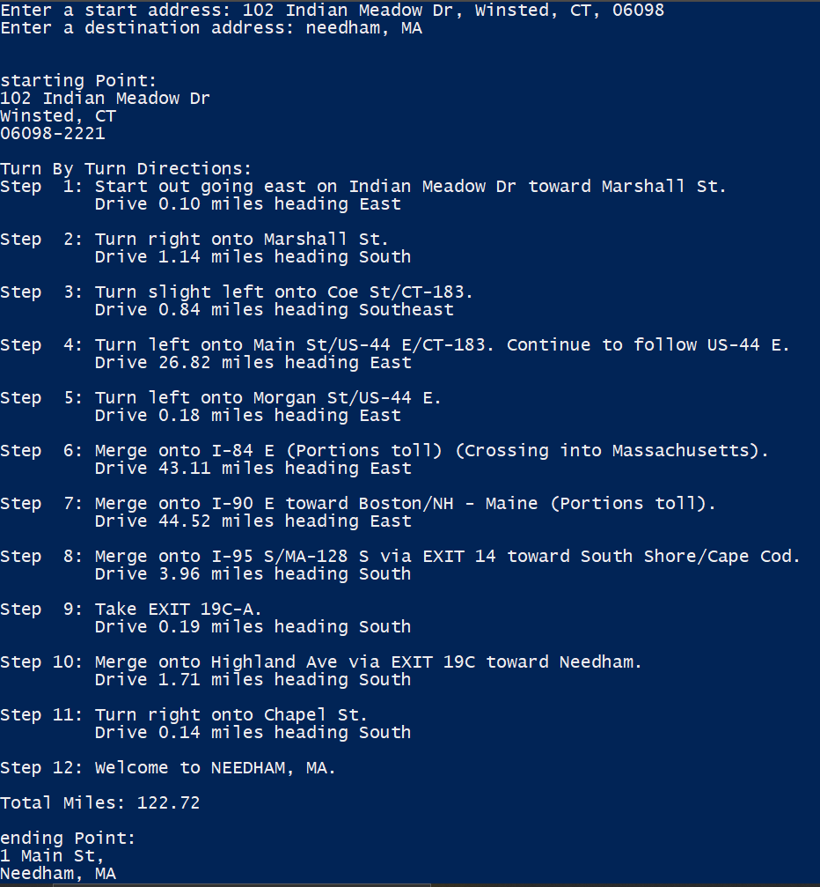

Two changes to my Directions class constructor: a connection is established using the singleton class and the extractData() method is called by the Directions class rather than the client.

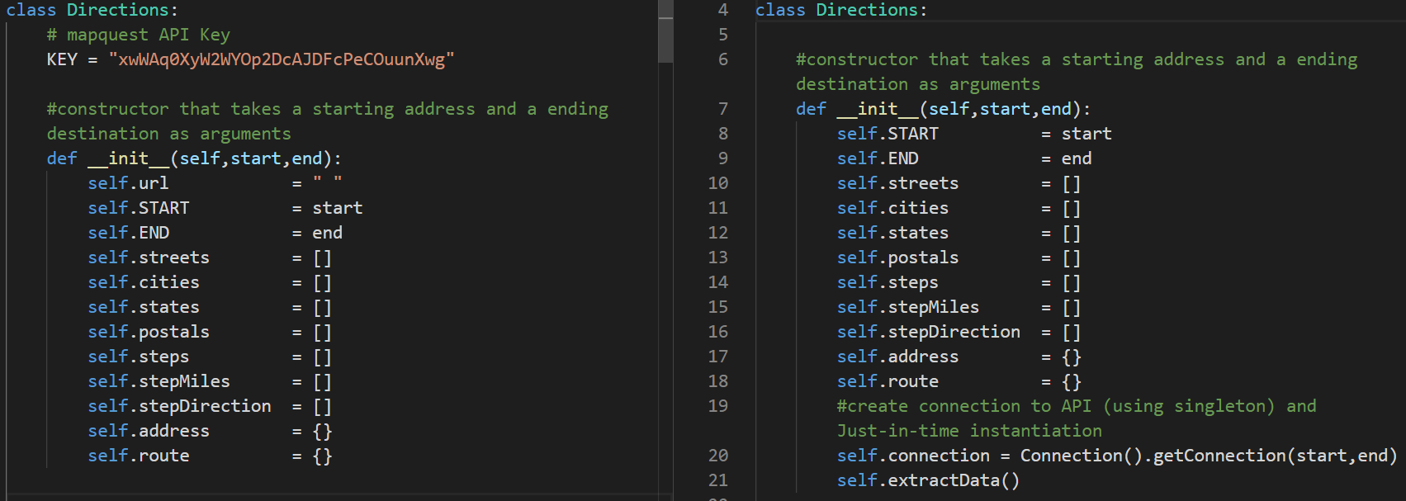

The requestData() method has been eliminated and the code has been moved the the connection class.

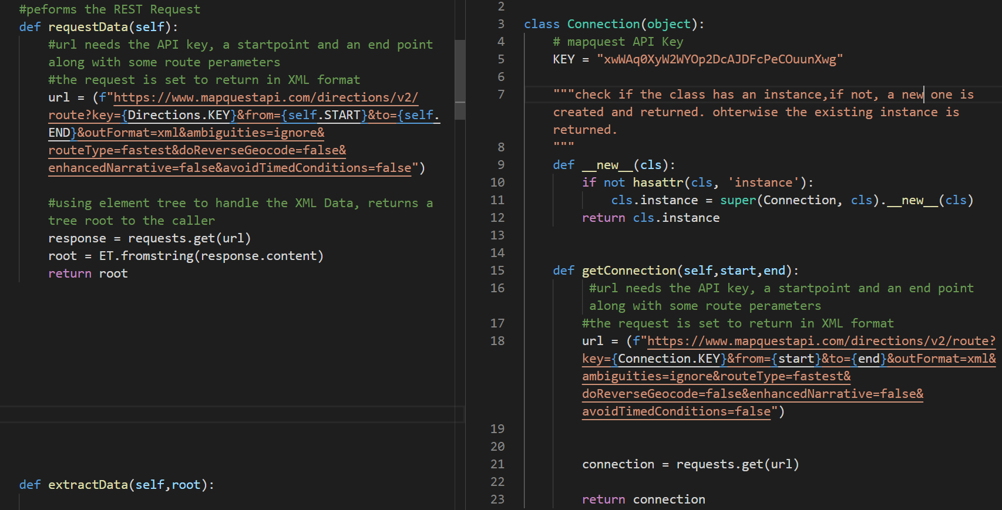

The extractData() method handles the instantiation of the element tree root using the new connection object. The client no longer calls this method

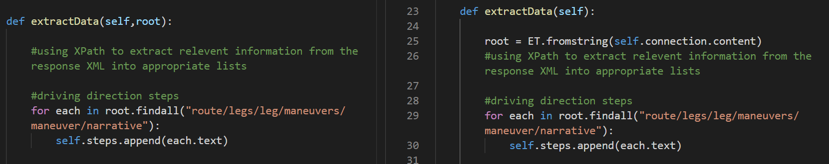

The client now only instantiates the Directions object and the class handles the other method calls.

