Screenshots

Monday, February 10, 2020

7:29 PM

Command Prompt 
licrosoft Windows [Version 18.8.18363.592] 
2819 microsoft Corporation. All rights reserved . 
- : \Users\sbish>cd desktop 
- : \Users\sbish\Desktop>cd xml parsing 
- : \Users\sbish\Desktop\xm1 parsing>dir 
Volume in drive C is OS 
Volume Serial Number is 3ADB-4ED3 
Di rectory 
)2/18/2828 
n 118/ 2828 
n 118/ 2828 
)2/89/2828 
of C: \Users\sbish\Desktop\xm1 parsing 
87 : 44 pm 
87: 44 pm 
87: 44 pm 
pm 
2 File(s) 
2 Dir(s) 
7,943 plant _ catalog.xml 
3,486 xmlparse.py 
11,429 bytes 
bytes free 
- : \Users\sbish\Desktop\xm1 parsing> 

Directory before running program

Command Prompt 
: parsing> python xmlparse.py plant 
Record to be updated 
N : Anemone 
BOTANICAL : Anemone blanda 
ZONE 
LIGHT : mostly Shady 
catalog.xml Anemone 28 
PRICE 
. 8.86 
VAILABILITY 
. 122698 
PRICE 
. From 8.86 To 18.63 
hanges Committed 
: \Users\sbish\Desktop\xm1 parsing> dir 
Volume in drive C is OS 
Volume Serial Number is 3ADB-4ED3 
Di rectory 
2/18/ 2828 
2/18/2828 
2/18/2828 
2/18/2828 
2/89/2828 
of C: \Users\sbish\Desktop\xm1 
parsing 
87:48 pm 
87:48 pm 
87: 44 pm 
87:48 pm 
: 49 pm 
3 File(s) 
2 Dir(s) 
7,943 plant _ catalog. bak 
7,944 plant _ catalog.xml 
3,486 xmlparse.py 
19,373 bytes 
bytes free 
: \Users\sbish\Desktop\xm1 parsing> 

View after running, Directory now has new backup file. With plant\_catalog.xml Updated and a new price

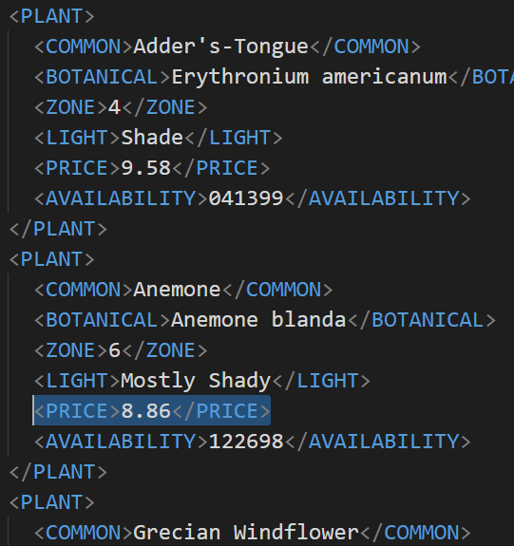

XML File before Modification

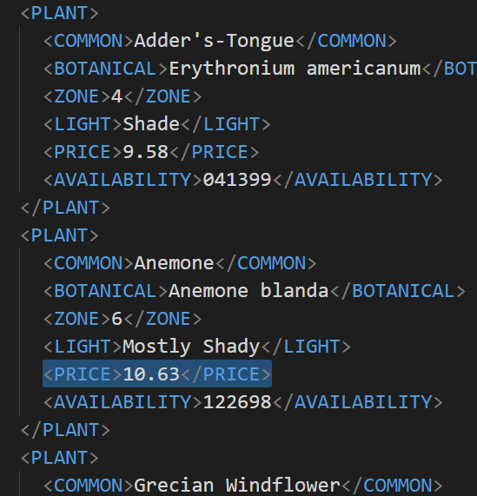

 XML File After Modification

: \Users\sbish\Desktop\xm1 parsing>python 
Record to be updated 
Cowslip 
BOTANICAL : Caltha palustris 
ZONE : 4 
LIGHT : mostly Shady 
xmlparse. py 
plant 
catalog. xml 
Cowslip 
-28 
PRICE 
. 9.98 
VAILABILITY 
838699 
PRICE 
. From 9.98 To 7.92 
hanges Committed 
: \Users\sbish\Desktop\xm1 parsing> 

2nd successful run on another plant.

## Error Handling

: parsing>python xmlparse.py plant 
matching Record Found! 
: \Users\sbish\Desktop\xm1 parsing> 
catalog.xml daisies 
28 

: \Users\sbish\Desktop\xm1 parsing>python xmlparse.py plant _ catalog.xmll Anemone 28s 
Given file cannot be found! plant _ catalog.xmll 
: \Users\sbish\Desktop\xm1 parsing> 

: : \Users\sbish\Desktop\xm1 parsing>python xmlparse.py plant _ catalog.xml Anemone 
Expecting 3 arguments: 2 given 
: : \Users\sbish\Desktop\xm1 parsing> 

2 Dlr(s) 
es free 
: \Users\sbish\Desktop\xm1 parsing>python xmlparse.py plant _ catalog.xml Anemone 181 
Percent value is out of range! 181 
: \Users\sbish\Desktop\xm1 parsing> : \Users\sbish\Desktop\xm1 parsing>python xmlparse.py plant _ catalog.xml Anemone -95 
Percent value is out of range! -95 
: \Users\sbish\Desktop\xm1 parsing> : \Users\sbish\Desktop\xm1 parsing>python xmlparse.py plant _ catalog.xml Anemone 28s 
Percent given is an improper value! 28s 
: \Users\sbish\Desktop\xm1 parsing> 