**PENYEWAAN HOSTING WEBSITE PT SIC**

Rincian Hosting Website di RumahWeb.com

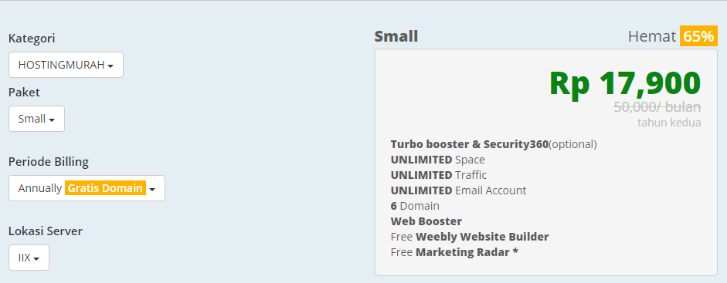

Free SSL



Biaya Hosting + Domain **sarbisertifikasi.com** per 1 tahun.

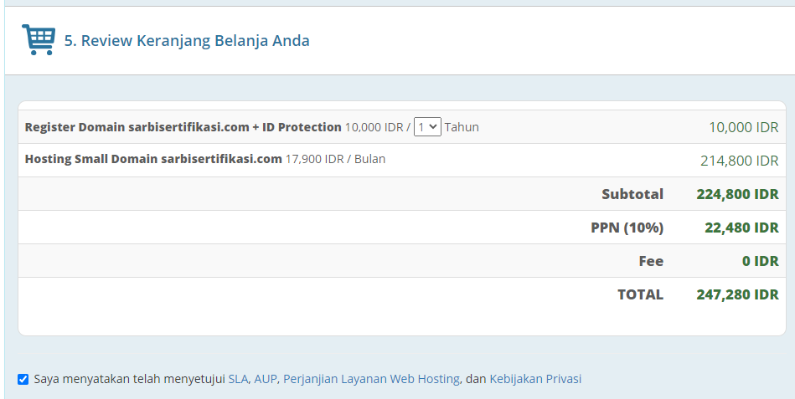

Template Premium via Themeforest senilai **$29 USD** atau

<https://themeforest.net/item/inzofin-finance-tax-wordpress-theme/31902943>

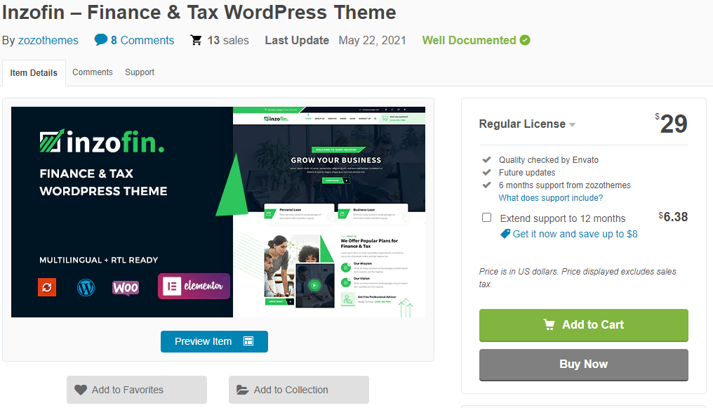

|  |  |
| --- | --- |
| INVOICE | |
| Hosting + Domain (sarbisertifikasi.com) | Rp. 247.280 |
| Tema Website Premium (Inzofin.)($29 USD) | Rp. 413.361 |
| Total Biaya | Rp. 660.641 |