Steven Tran

EECE 5570

Final Project

# Run MQTT traffic

Questions:

1. Check attached pcapng files.
2. Describe the messages that are exchanged between devices and broker for the different levels of QoS (0, 1 and 2).
   1. QoS 0
      1. Connect Command → Publisher initiates connection with broker.
      2. Connect Ack → Broker acknowledges the connection.
      3. Publish Message [temperature] → Publisher sends message to broker(QoS 0).
      4. Publish Message [temperature] → Broker sends message to subscribers (QoS 0).
      5. Disconnect Req → Publisher disconnects.
   2. QoS 1
      1. Connect Command → Publisher initiates connection with broker.
      2. Connect Ack → Broker acknowledges the connection.
      3. Publish Message [temperature] → Publisher sends message to broker (QoS 1).
      4. Publish Message [temperature] → Broker sends message subscribers (QoS 0).
      5. Publish Ack → Broker acknowledges publish message
      6. Publish Ack → Subscriber acknowledges publish message
      7. Disconnect Req → Publisher disconnects.
   3. QoS 2
      1. Connect Command → Publisher initiates connection with broker.
      2. Connect Ack → Broker acknowledges the connection.
      3. Publish Message [temperature] → Publisher sends message to broker (QoS 2).
      4. Publish Received → Broker has received the message
      5. Publish Release → Publisher then sends a packet telling the broker to proceed with delivering to subscribers.
      6. Publish Message [temperature] → Broker sends message to subscribers (QoS 0).
      7. Publish Complete → Broker sends message to publisher it has completed message delivery.
      8. Publish Received → Subscriber has received the message
      9. Publish Release → Broker instructs subscriber to finalize delivery.
      10. Publish Complete → Subscriber confirms that it has completed delivery process.
      11. Disconnect Req → Publisher disconnects.
3. How does quality affect latency? Why?  
   The higher the QoS level, the more mechanisms are in place to ensure reliable delivery. Additional network communication and processing time, directly contributes to increased latency.

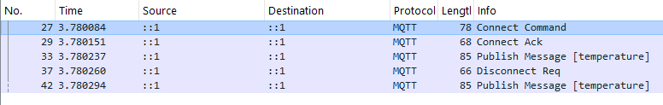

Image 1: QoS 0 Wireshark Trace

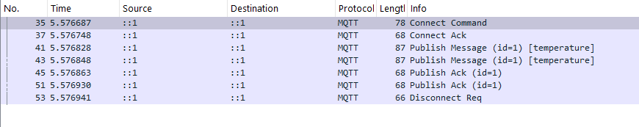

Image 2: QoS 1 Wireshark Trace

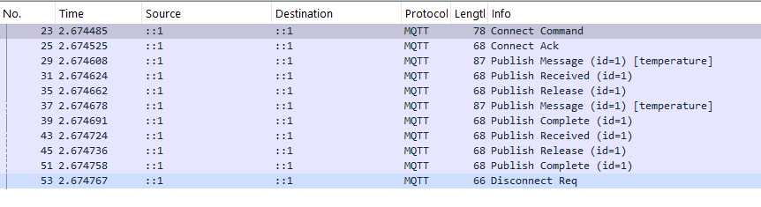

Image 3: QoS 2 Wireshark Trace

# Run CoAP traffic

Questions:

1. Check attached pcapng files.
2. Describe the messages that are exchanged between client and server for each case (what are the flows?)
   1. Confirmable
      1. Client ─────── CON GET (MID:3508) ───────▶ Server
      2. Client ◀───── ACK 2.05 Content (MID:3508) ─────── Server
   2. Non-Confirmable
      1. Client ─────── NON GET (MID:10441) ──────▶ Server
      2. Client ◀───── NON 2.05 Content (MID:10441) ────── Server
3. How does CoAP compare against MQTT for same network conditions?  
   CoAP is a lightweight, UDP-based protocol. MQTT, on the other hand, is TCP-based. Under the same network conditions, CoAP would generally have lower latency and overhead due to its use of UDP, making it faster and more efficient for simple communication between devices. While MQTT ensures that messages are delivered, it may experience more delays compared to CoAP

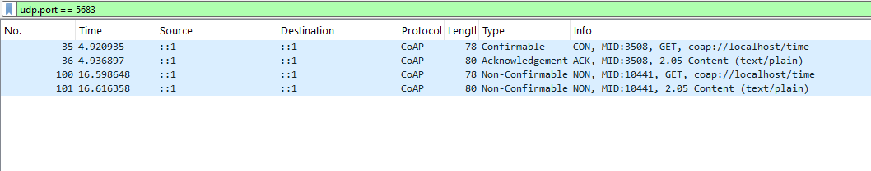

Image 4: CoAP Confirmable and Non-confirmable CoAP requests and server response.