Student Name: Steven Tran
Student ID number: 01698762
Lab # 2
Date of completion: March 23, 2025
Github: https://github.com/StevenTran11/UML-EECE/tree/main/GenAI/Lab2

- Lab Focus and Outcomes
  - Main Topics covered in this Lab
    - Part 1
The focus of part 1 of the lab was to practice fine-tuning a pretrained language model using Low-Rank Adaptation (LoRA), evaluate its performance using ROUGE metrics.
    - Part 2
In part 2 of the lab, the focus as fine-tuning a language model to summarize dialogues while minimizing toxic language by setting up a reward model to detect toxicity, and utilizing Proximal Policy Optimization (PPO) to fine-tune the model to generate less-toxic summaries.
  - Software Design
    - Part 1
The software design involved loading the Gemma-2-2B-IT model and setting up a tokenizer. The dataset was processed using a custom function that formatted it. The fine-tuning process was implemented using the SFTTrainer configured with a LoRA setup. The evaluation phase involved calculating and comparing ROUGE scores before and after fine-tuning the model.
    - Part 2
The software design outlined in the lab focuses on fine-tuning a language model to generate less-toxic summaries. The knkarthick/dialogsum dataset is loaded for training the model. The dataset is filtered based on the length of the dialogues and tokenized. The Flan-T5 model is chosen as the base model. The LoRA configuration is set up to fine-tune specific layers of the model. Using SFTTrainer, the model is fine-tuned on the processed dataset. PPO is used to fine-tune the model by optimizing a reward model that penalizes toxic outputs. A toxicity detection model is used to evaluate generated text and provide rewards based on how non-toxic the summaries are. This model classifies text into "hate" or "not hate" categories. The toxicity of both the original and fine-tuned models are evaluated using the toxicity evaluator. The mean and standard deviation of the toxicity scores are calculated for comparison.
  - Results
    - Part 1
The results of the lab demonstrated measurable improvements in the model’s summarization. Before fine-tuning, the base model achieved a ROUGE-1 score of 0.337, a ROUGE-2 score of 0.124, a ROUGE-L score of 0.192, and a ROUGE-Lsum score of 0.214. After fine-tuning, the model’s scores changed to a ROUGE-1 score of 0.355, a ROUGE-2 score of 0.145, a ROUGE-L score of 0.200, and a ROUGE-Lsum score of 0.2060. ROUGE-1, ROUCE-2, and ROUGE-L score increased while ROUGE-Lsum score decreased. This suggests that while the model's content accuracy improved, the overall structure and flow of the summary became slightly less aligned with the reference summary after fine-tuning.
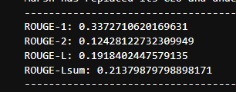
Figure 1: ROUGE scores before fine-tuning
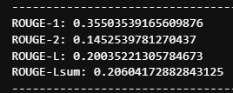
Figure 2: ROUGE scores after fine-tuning
    - Part 2
In the evaluation of the model's toxicity, we observed a significant reduction in both the mean toxicity and the variability of toxicity in the outputs after detoxification. Before detoxification, the model had a mean toxicity score of 0.0471 with a standard deviation of 0.0487. After detoxification, the mean toxicity score decreased to 0.0285, and the standard deviation dropped to 0.0429. The results suggest the detoxification process reduced the toxicity of the model’s responses and more consistent, less toxic outputs.
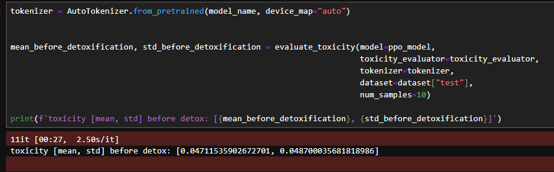
Figure 3: Mean and Standard Deviation before Detoxification
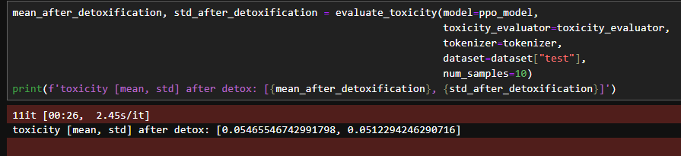
Figure 4: Mean and Standard Deviation after Detoxification
- Problems Encountered and Solved
  - Part 1
The main problems encountered during part 1 was an out-of-memory (OOM) error during the training phase. This happened because the per_device_eval_batch_size parameter was not initially specified in the training arguments. By default, the batch size was too high for the available memory. To resolve this, I adjusted the TrainingArguments to set per_device_eval_batch_size=2, which reduced the memory load and allowed the training process to complete successfully.
  - Part 2
In Part 2, I encountered an issue with setting up the PPOTrainer, as it reported that the inputs were not all on XPU. After discussing with the TA, it was confirmed that this was not expected behavior. To resolve the issue, I removed all the packages installed for Python 3.10 and reinstalled them, which successfully addressed the problem.
- Lessons Learnt
In both Part 1 and Part 2, the importance of ensuring compatibility between the environment, dependencies, and hardware, such as XPU, was emphasized for smooth model fine-tuning. Additionally, evaluating models using metrics like ROUGE provided valuable insights into performance. These lessons displayed the significance of a well-organized set-up and methodical evaluation in the fine-tuning process.

