Optimistic scenario: A lot of samples (n=76), uncorrelated features / samples, a lot of significant features (sig_p = 10) and a large effect size (d = 1.81).

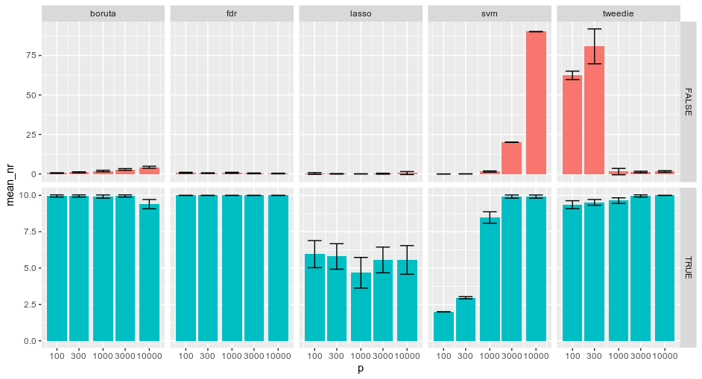
In general the mean number of true detections is high and the mean number of false detections is low as was to be expected in this very optimistic scenario.

Results are somewhat different for the lasso and SVM in terms of true detections compared to the other methods. For the Lasso, the mean number of true detections is lower throughout the entire range of the number of features (p) than for Boruta, FDR and Tweedie. Lasso also yields a lower mean number of true detections than SVM-RFE for p = 1e3-1e4.

SVM-RFE suffers from its top 1 percent procedure for lower values of p in this optimistic scenario. For the values 100 and 300 for p at most 2 and 3 features are selected respectively, resulting in a severe underdetection. This issue is resolved for larger values of p. However, another problem then arises: the mean number of false detections grows proportionally with p. Because of the same top one percent rule, at least 20 and 90 detections are false for p = 3000 and p = 10000 respectively.

Tweedie has a large number of false detections for lower values for p (p = 100 and 300). The fact that this method leans on estimation of the density function of the test statistic and the fact that this estimation is done using the p number of test statistics can explain why we a large amount of false detections when the number of test statistics is low. That is, for lower values for p this estimation suffers more from finite sample bias.

All in all. T-tests with FDR control deliver the best results as the mean number of true detections is consistently 10 (with no variation) while the mean number of false detections stays in control.

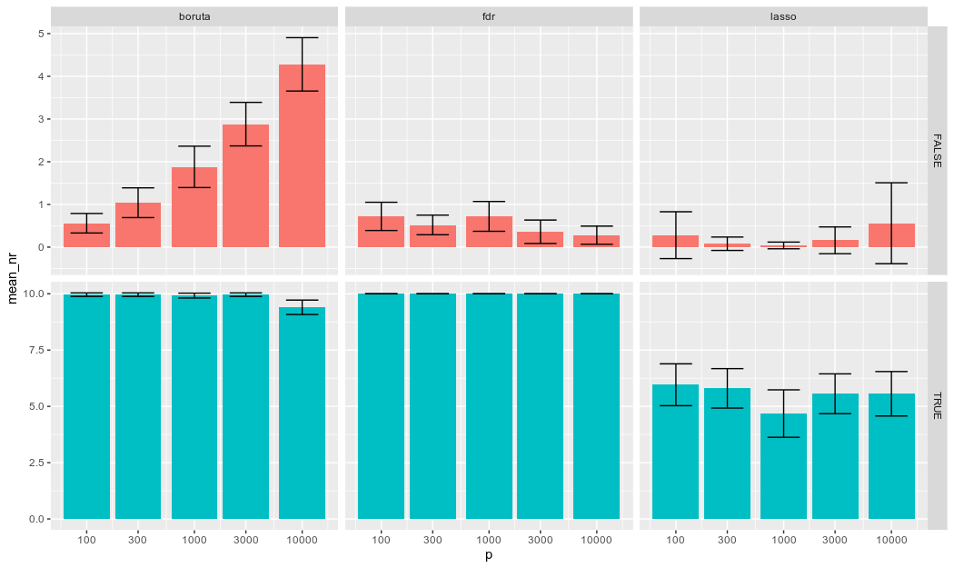
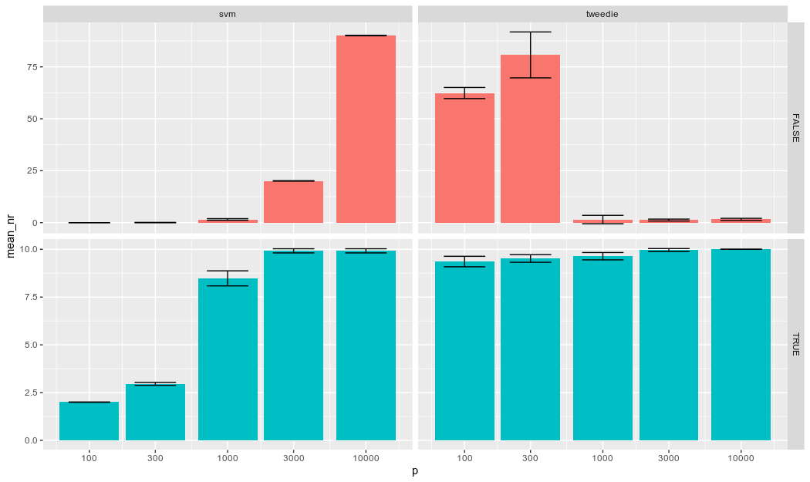
D = 1.1
now we leave the unrealistic scenario and dial back the effect size to more modest values.
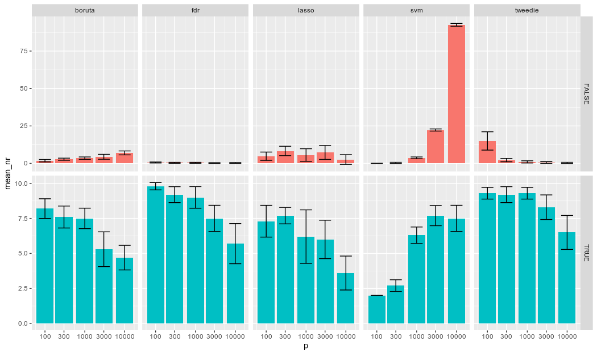
In terms of false detections there are virtually no differences for Boruta, FDR, and SVM. Tweedie has far less false detections than in the d = 1.81 condition which is food for thought. Maybe the density function of the test statistics has an irregular form when d = 1.81. One could argue that the more irregularities a function has the more difficult it is to estimate it with a constant and finite number of data points.
The lasso seems to detect more false discoveries than in the d = 1.81 condition

In terms of true detections we can see that the lasso is performing slightly better than in the d = 1.81 condition, this is again food for thought.
All methods except SVM perform worse with growing p. We know that because of the top 1 percent rule the SVM will perform artificially low for p = 100 and p = 300. Apart from that we can see no decline in performance between p = 1000 and p = 10000.
Where Tweedie, FDR, and Boruta all performed well (with FDR the best) in the d= 1.81 condition, they perform differently in the d = 1.1 condition. FDR delivers the best results for p = 100. Tweedie, however, also performs at a similar level and keeps that performance up to and including p = 1000 and then starts to decline in performance level.
Boruta seems to be outperformed by FDR, Tweedie and SVM (that is, only for larger p).

question: Would be interesting to see if SVM results are indicative of something. What would even lower effect size do? What would higher p do?
D = 0.9
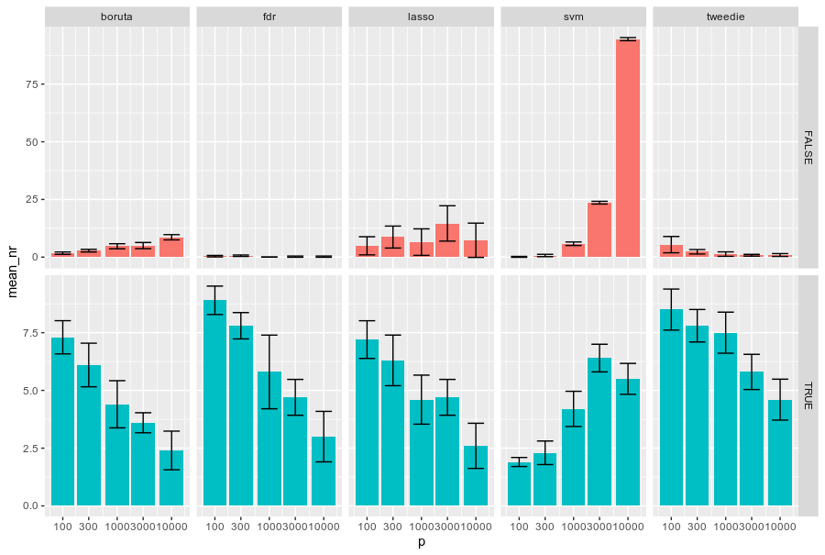
False:
Again virtually no differences for Boruta, FDR and SVM compared to d = 1.81 and 1.1. The results for Lasso are similar to these for d = 1.1. Tweedie’s results are even better now, in that it makes less false discoveries for p = 100 than in the d =1.1 scenario.

True:
Overall decline in performance throughout all methods and values for p as can be expected. Again SVM is the only method with better performance as the value for p goes up. Though, the results for p = 10000 are now less than those for p = 3000. Maximum performance is around 8 for FDR and p = 100 whereas the maximum performance was around 10 (for the same method and p) for d = 1.1. Drop in performance from d = 1.1 to 0.9 seems larger in high p settings.

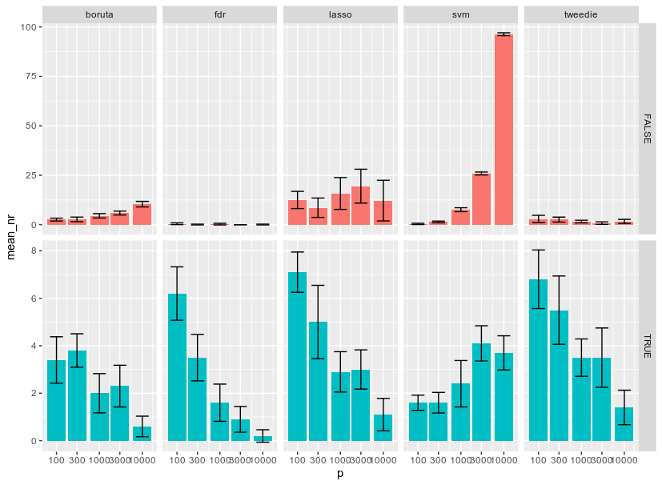
D = 0.7
False:
Again overall similar pattern but slightly worse than in d = 0.9. FDR holds up very well over the different values for p. Interestingly Tweedie is getting even better.

True:
Again further decline in performance throughout all methods. FDR performs worst among the methods in the p = 10000 setting. SVM keeps performing better at higher values for p.

In this setting, Tweedie outperforms FDR on all values for p wrt true detections. In biomarker discovery better performance in true detections is valued more even when it comes with higher chance of having false detections.

D = 0.5
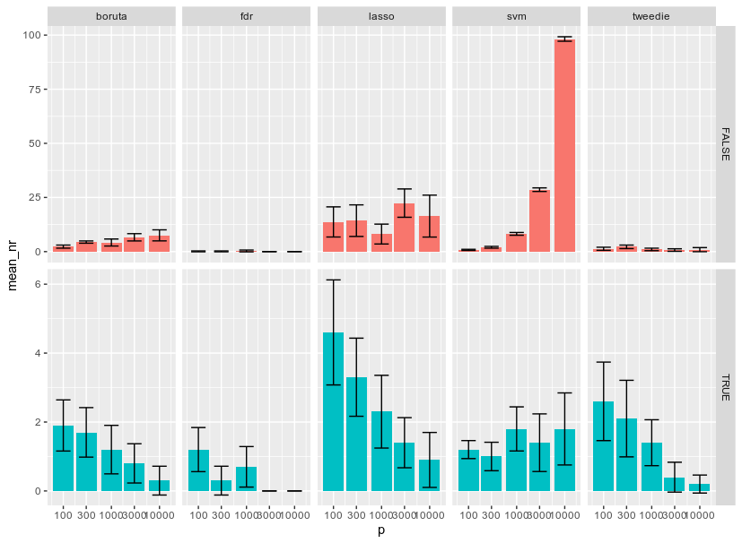
False:
Boruta performs slightly better than in d = 0.7. FDR still performs best with almost no false detections in for all values for p. Again slight decline in performance for Lasso as well as for SVM (large values for p). Tweedie seems to deliver yet better results than in d = 0.7.

True:
Decline in performance for all methods. FDR starts to fail at p =3000 and above. Lasso performs best for p = 3000 and less. That being said, SVM delivers similar performance for p = 3000 and yields best performance at p = 10000. Tweedie performs better than FDR for all values for p.

D = 0.3
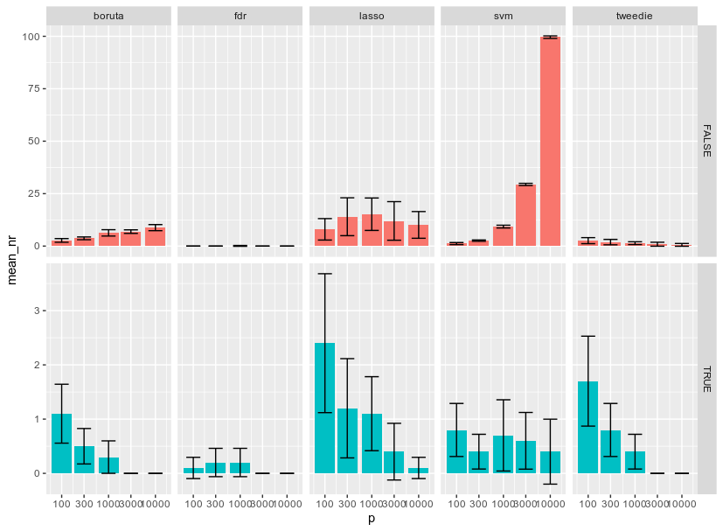
False
Boruta slightly worse than d = 0.5. FDR almost perfect across all values for p. Lasso slightly better than in d = 0.5. SVM virtually the same. Tweedie virtually the same.

True
Again overall drop in performance. Here Boruta, FDR, and Tweedie kind of ‘break’ because they fail in p > 1000 settings, whereas in d = 0.5, only FDR was ‘broken’. Lasso gives better results in low p settings, whereas SVM gives the best results for the larger values for p allbeit with large margin of error, so it could well be that both methods perform equally well or equally poor.

D = 0.1
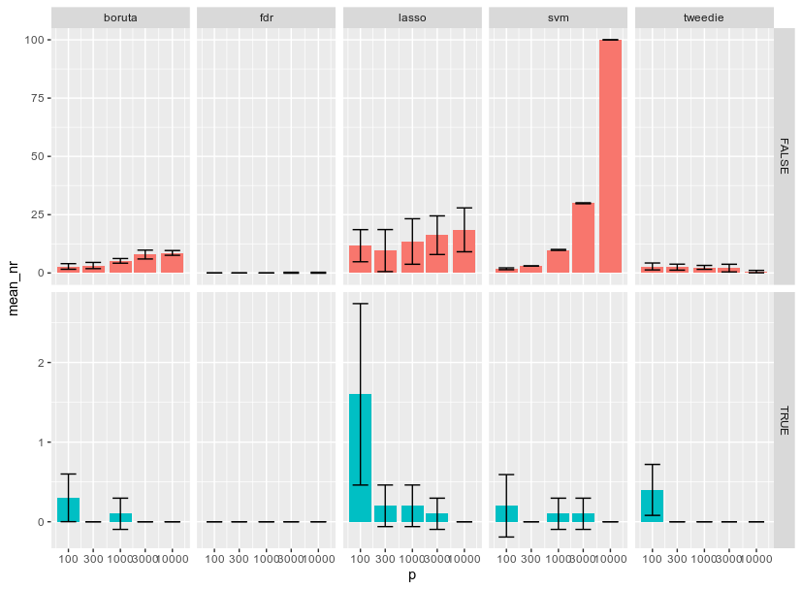
False
More or less the same patterns as in d = 0.3. Boruta, Lasso, and SVM get progressively worse with growing number of features. However difficult to tell, it seems that FDR also gets worse with growing p. Tweedie on the other hand gives the same results or better with growing p. Best performing method is FDR and after that Tweedie. Best model based method is Boruta.

True
Almost all methods fail at this point with most results 0 or not significantly different from 0. Exceptions being Lasso and Tweedie in the p = 100 case, which is not helpful in the context of extreme high dimensional data analysis.

Chance of a detection
d = 1.81
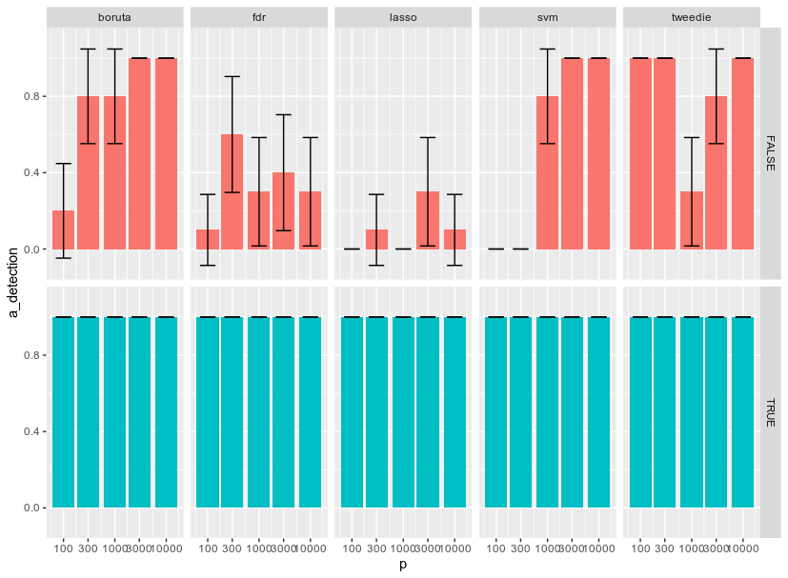
d = 1.1
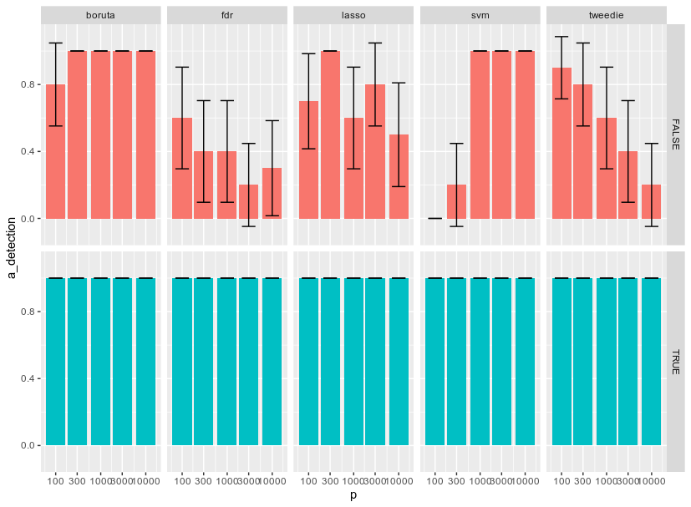
d = 0.9
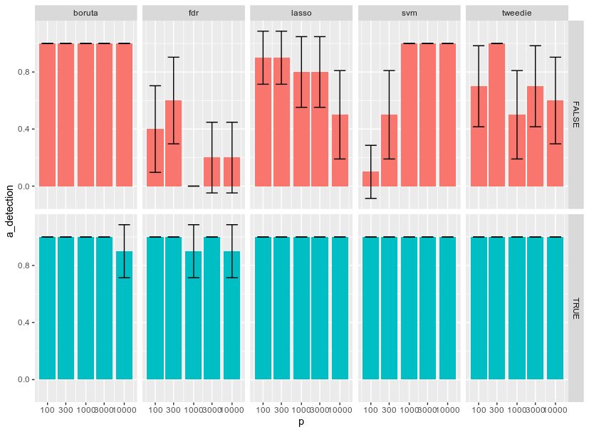
d = 0.7
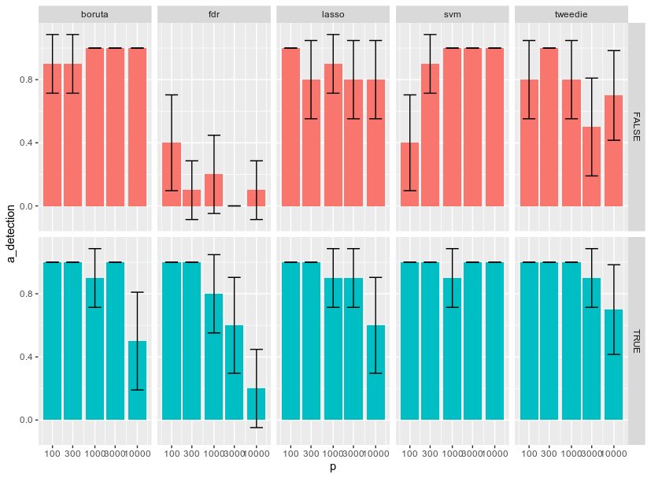
d = 0.5
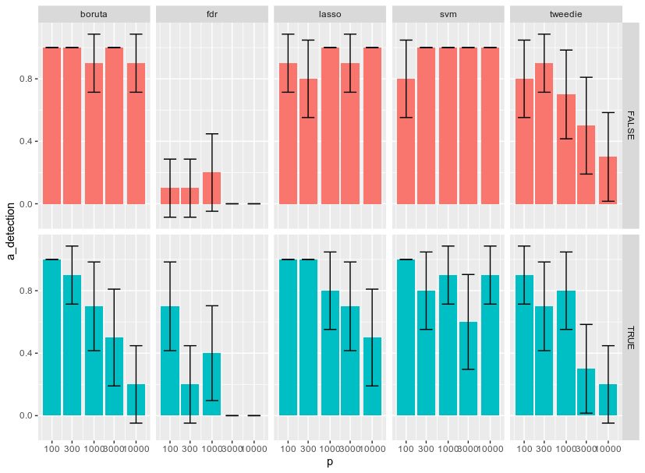
d = 0.3
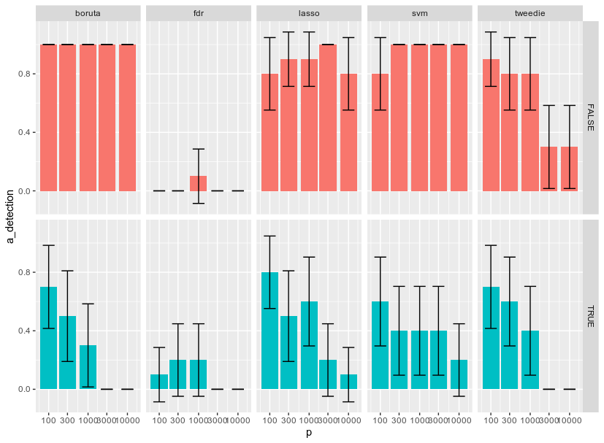
d = 0.1
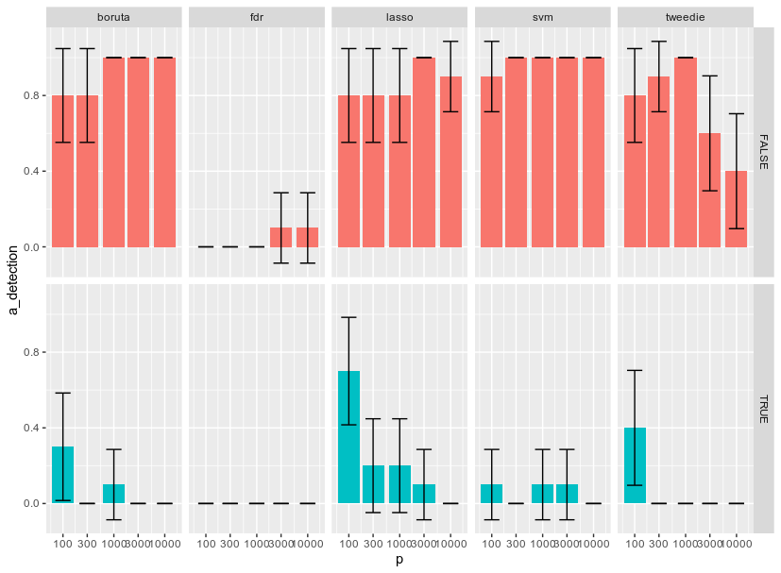
Pessimistic scenario
d = 0.36, sig_p = 1, n = 10

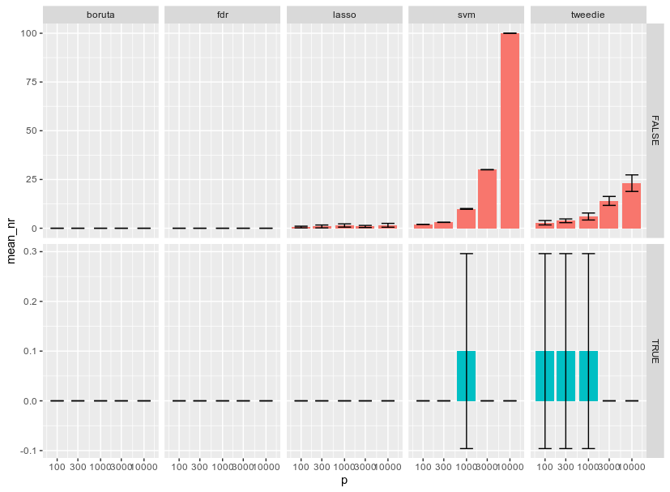
d = 0.5
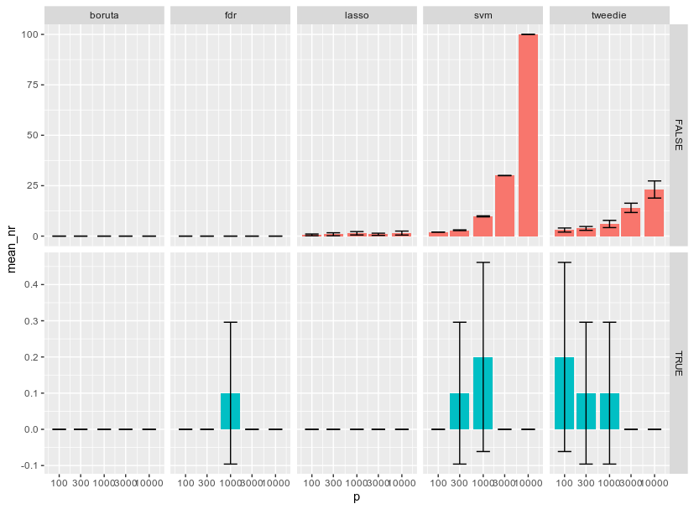

d = 0.7
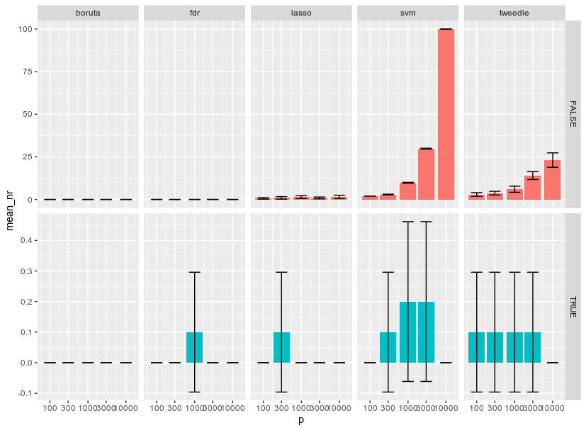
d = 0.9
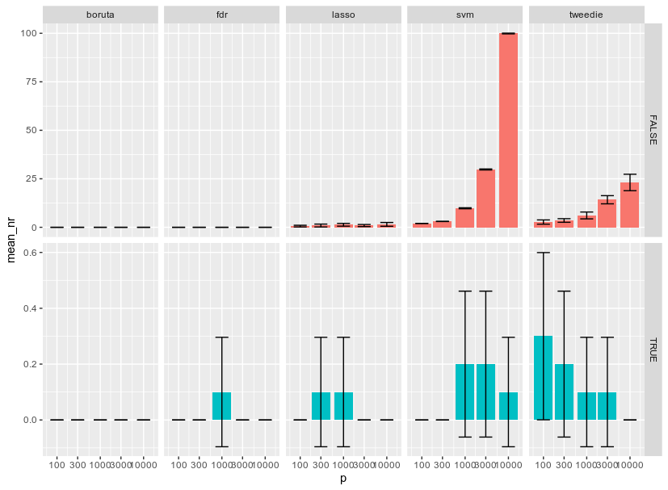
d = 1.1
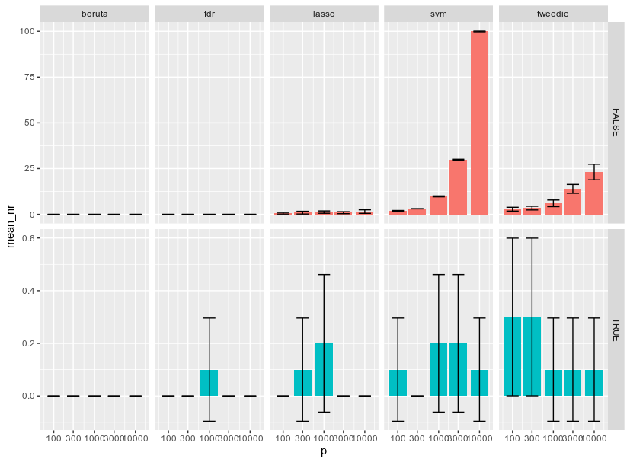
d = 1.3
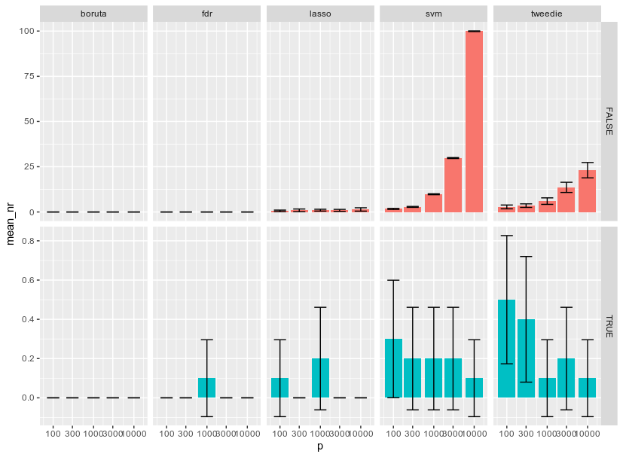
d = 1.5
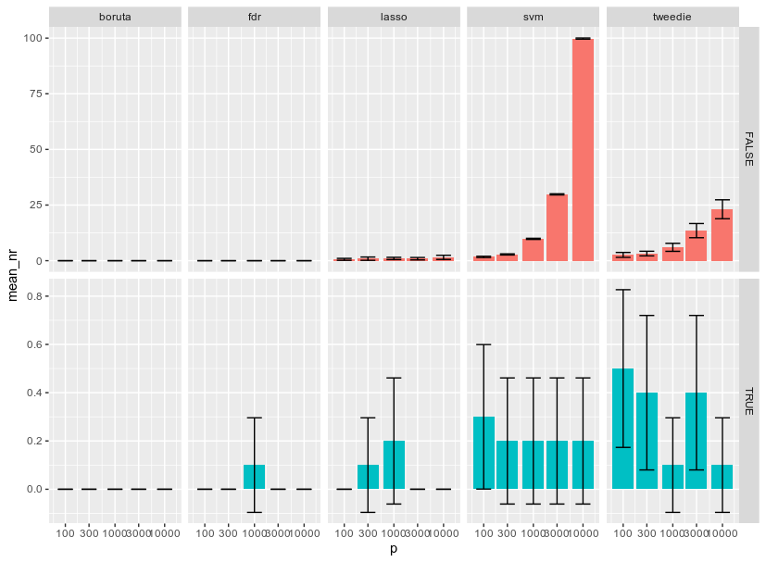
d = 1.7
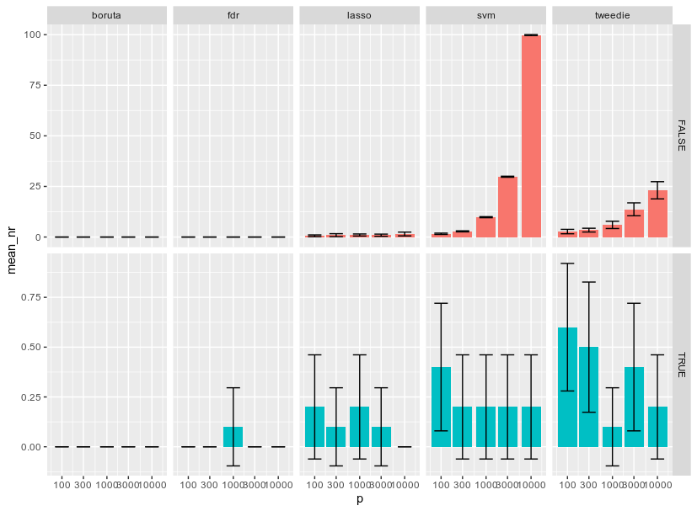
d = 1.81
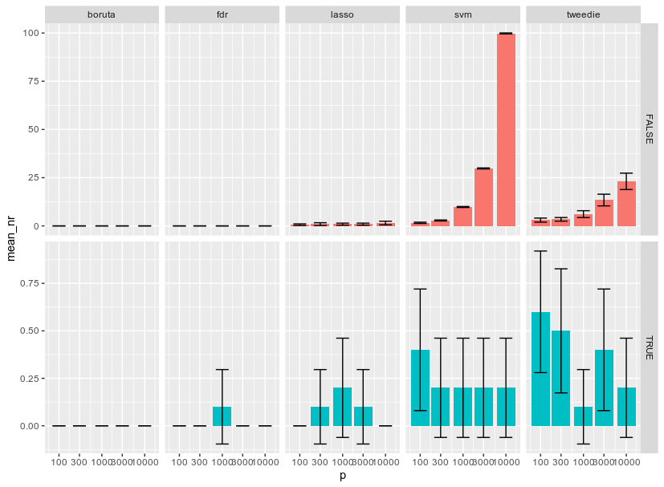

In between d = 0.95, sig_p = 3, n = 30
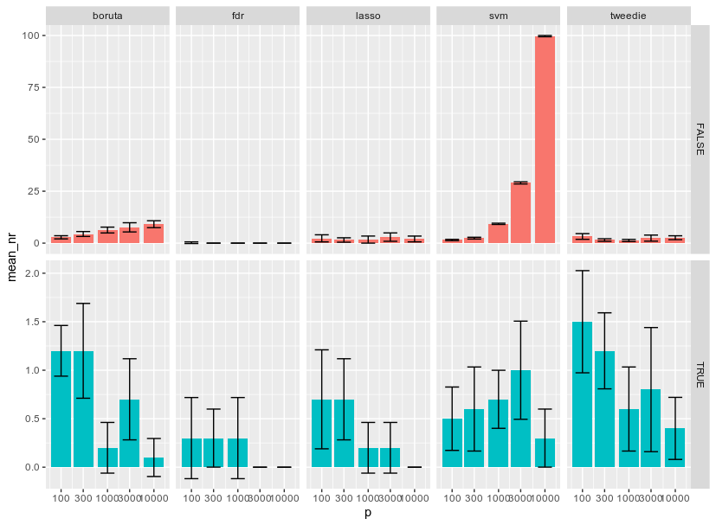
d = 0.7
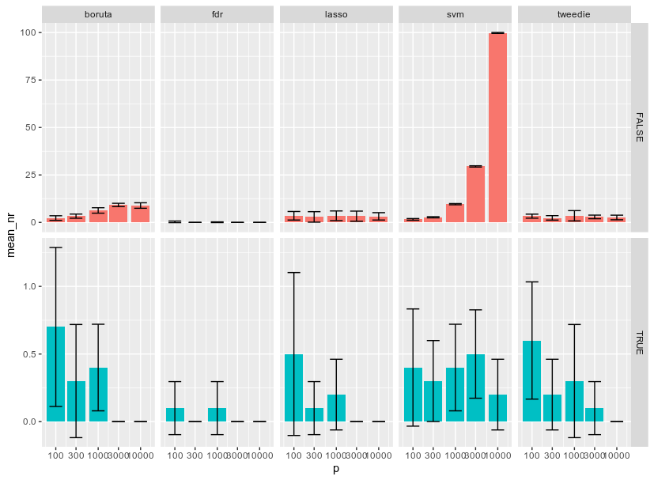

d = 0.5
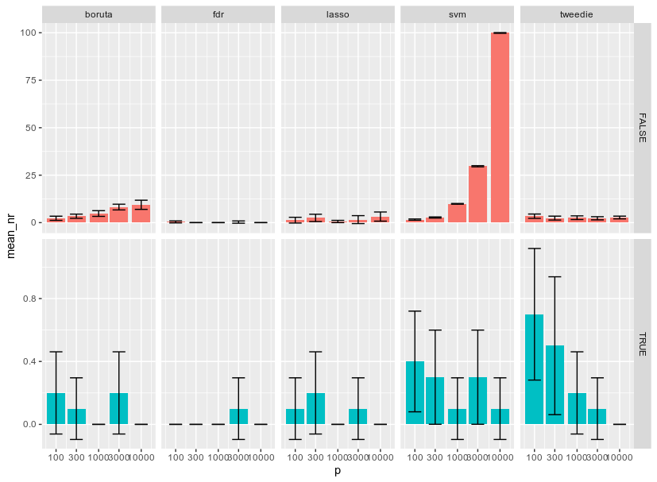
d = 0.3
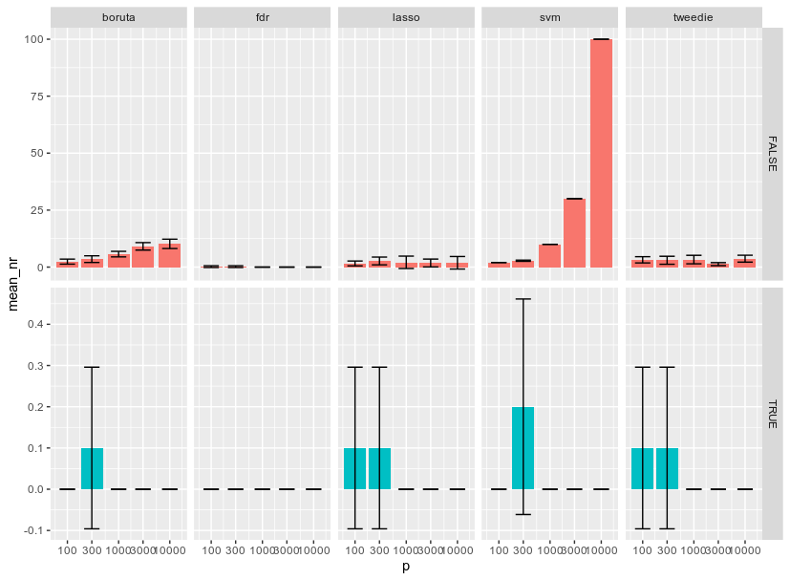
d = 1.1
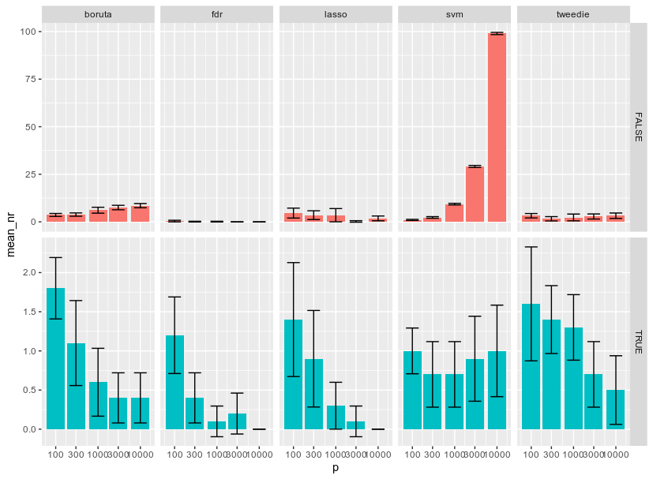
d = 1.3
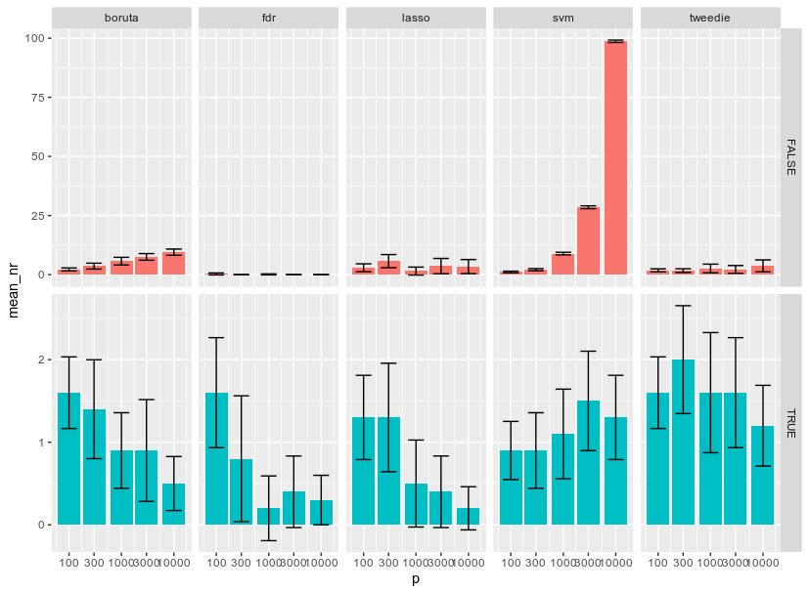
d = 1.5
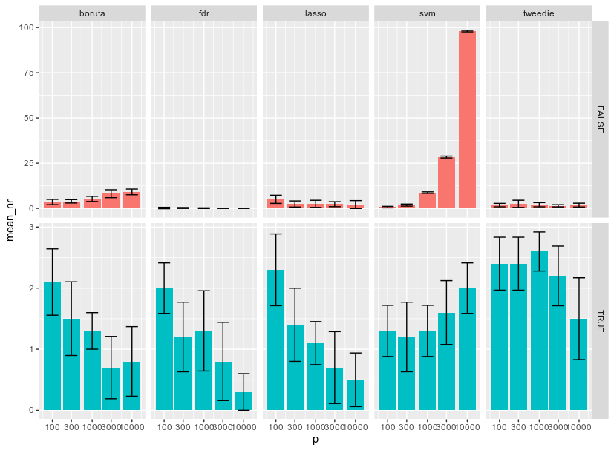
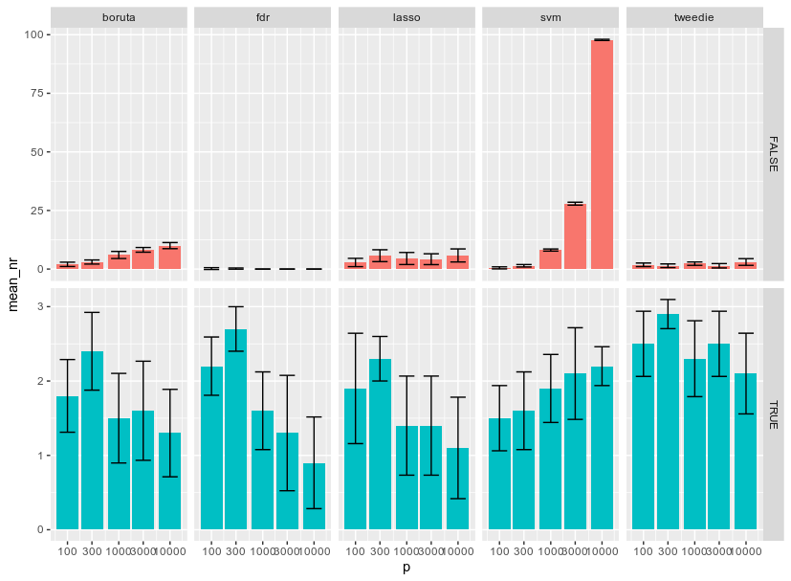
d = 1.7
d = 1.81
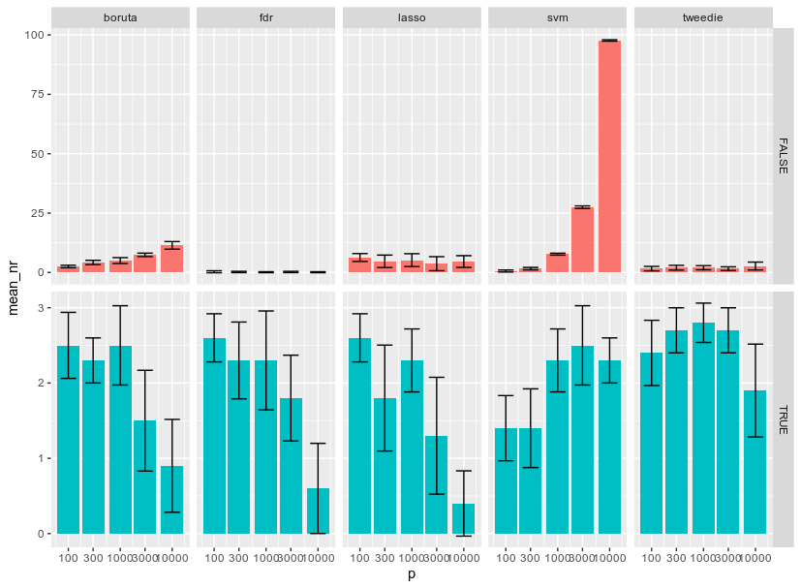
d = 2
