
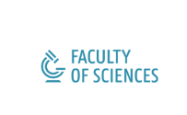

Feature Discovery In Small-Sized Experiments In Early Drug Development

Steven Wallaert

Master dissertation submitted to
obtain the degree of
Master of Statistical Data Analysis

Promoter: Prof. Dr. Ir. Olivier Thas

Department of Applied Mathematics,
Computer Science and Statistics

Academic year 2020-2021

Feature Discovery In Small-Sized Experiments In Early Drug Development

Steven Wallaert

Master dissertation submitted to
obtain the degree of
Master of Statistical Data Analysis

Promoter: Prof. Dr. Ir. Olivier Thas

Department of Applied Mathematics,
Computer Science and Statistics

Academic year 2020-2021
The author and the promoter give permission to consult this master dissertation
and to copy it or parts of it for personal use. Each other use falls under the
restrictions of the copyright, in particular concerning the obligation to mention
explicitly the source when using results of this master dissertation.

