Project ABEONA Crew Capsule Service Module:
Propulsion CAD Model and Performance Verification
[Your Name]
October 2026

Introduction
This report documents the Onshape CAD model of the Project ABEONA Crew Capsule service-module propulsion system and an independent check of the main-engine performance. The model contains the 25 kN NTO/MMH main engine, the two propellant tanks, four helium pressurant bottles, the propellant feed and helium pressurization lines, and reference shells for the service module, the capsule and the launch escape system (LES).
The engine geometry and the layout were generated by the main-engine design analysis [1] and were not changed, except where noted in Sec. 3. The tank size, envelope and LES shape follow the Preliminary Design Review (PDR) crew-capsule drawing [2,3]. The vehicle numbers come from the Crew Capsule tab of Mission_Breakdown.xlsx [4]. The ideal performance was re-computed with RocketCEA [5], which wraps NASA CEA [6], and compared with the in-house equilibrium solver used in [1] (Sec. 8).

Model Construction
The whole model is one parametric Onshape feature, ABEONA engine and tanks. It is written in FeatureScript and generated by a Python script from the analysis outputs engine_profile.csv and layout.json [1]. The model can therefore be rebuilt from the analysis files at any time. Units are millimetres. The origin is at the service-module (SM) base on the vehicle axis, with +Z up. Figures 1 and 2 show the full model.
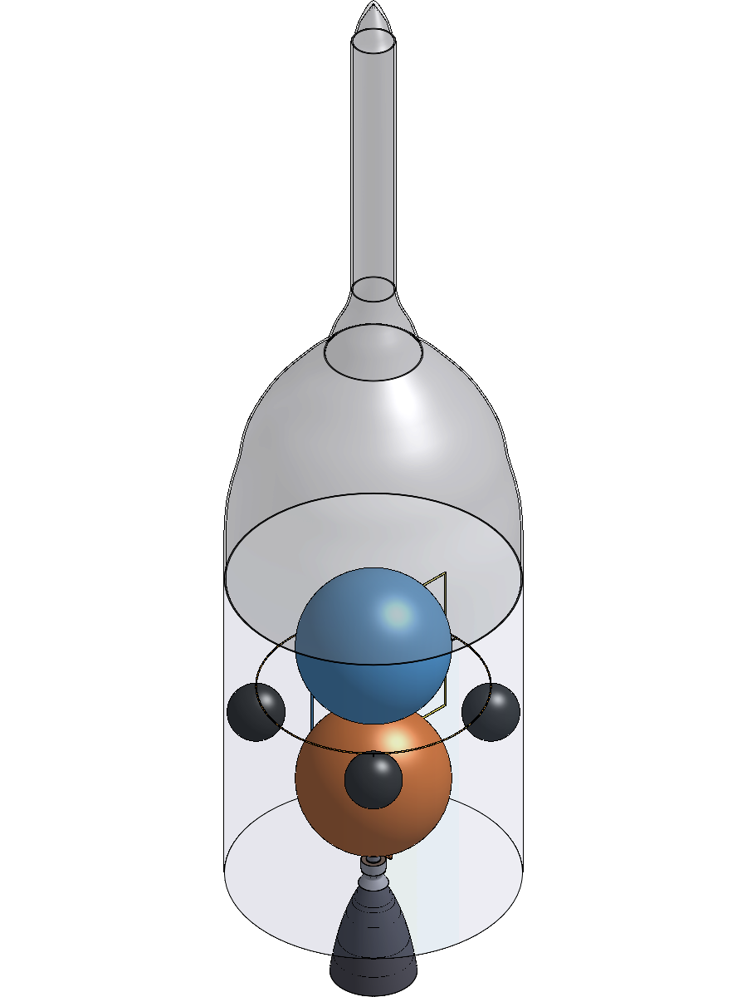
Full model, isometric view.
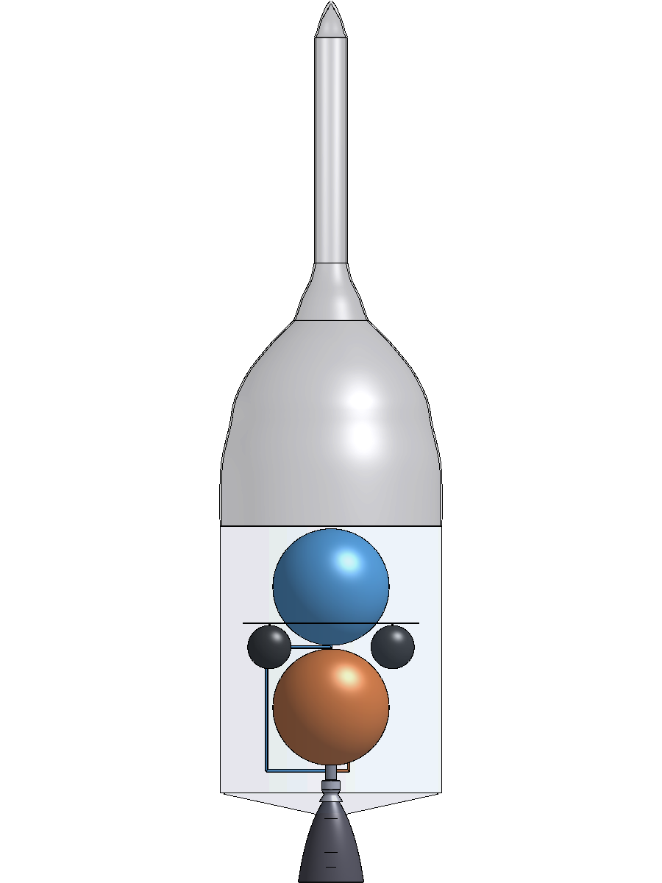
Full model, front view.

Engine
The ablative liner, the titanium case and the C-103 nozzle extension are each revolved 360° about the vehicle axis from the analysis contour. Each is a single smooth body: the gas-side and outer contours are fitted splines through the contour stations. The cylindrical chamber section is a straight line. The extension is the gas-side spline surface thickened outward by a constant 0.6 mm. It is trimmed where it meets the liner end face at area ratio 6. The liner, case and extension stay separate parts because they are different materials.
The injector is a 20 mm 304L plate at chamber diameter with twelve quarter-wave acoustic cavities, each 59.4 mm deep [1]. The analysis gives only the number and depth of the cavities, so they are modelled as axial Ø16 mm bores on a 100 mm pitch radius. The valve, gimbal and head stack is a cylinder 350 mm long, from the injector face to the gimbal plane. Its density is set so that the cylinder carries the 44 kg budgeted in [1] for valves, gimbal actuators and miscellaneous items.

Tanks, pressurant and envelope
The NTO and MMH tanks are Ti-6Al-4V spherical shells. The helium bottles are spherical shells with a 20 mm wall and a density chosen to carry the composite overwrapped pressure vessel (COPV) mass of [1]. The SM envelope (4.98 m diameter, 6 m long, 0.5 m aft cone) is a transparent reference body. The capsule and LES outer shape is a 20 mm reference shell with no mass. It was traced from the PDR drawing [3], scaled to the 4.98 m SM diameter and the 11.8 m height from the SM top to the LES tip. The drawing’s 0.41 m dimension lands on the LES nose. The tower, as drawn, is about 0.74 m in diameter, and the model follows the drawing.

Cut view
The feature has a Cut view checkbox that removes the −Y half of every body. This exposes the engine section, the hollow tanks and bottles, and the feed lines, which lie in the cut plane (Figs. 3–5). Mass properties must be read with the cut view off. Onshape’s own section-view tool gives the same picture without changing the model.
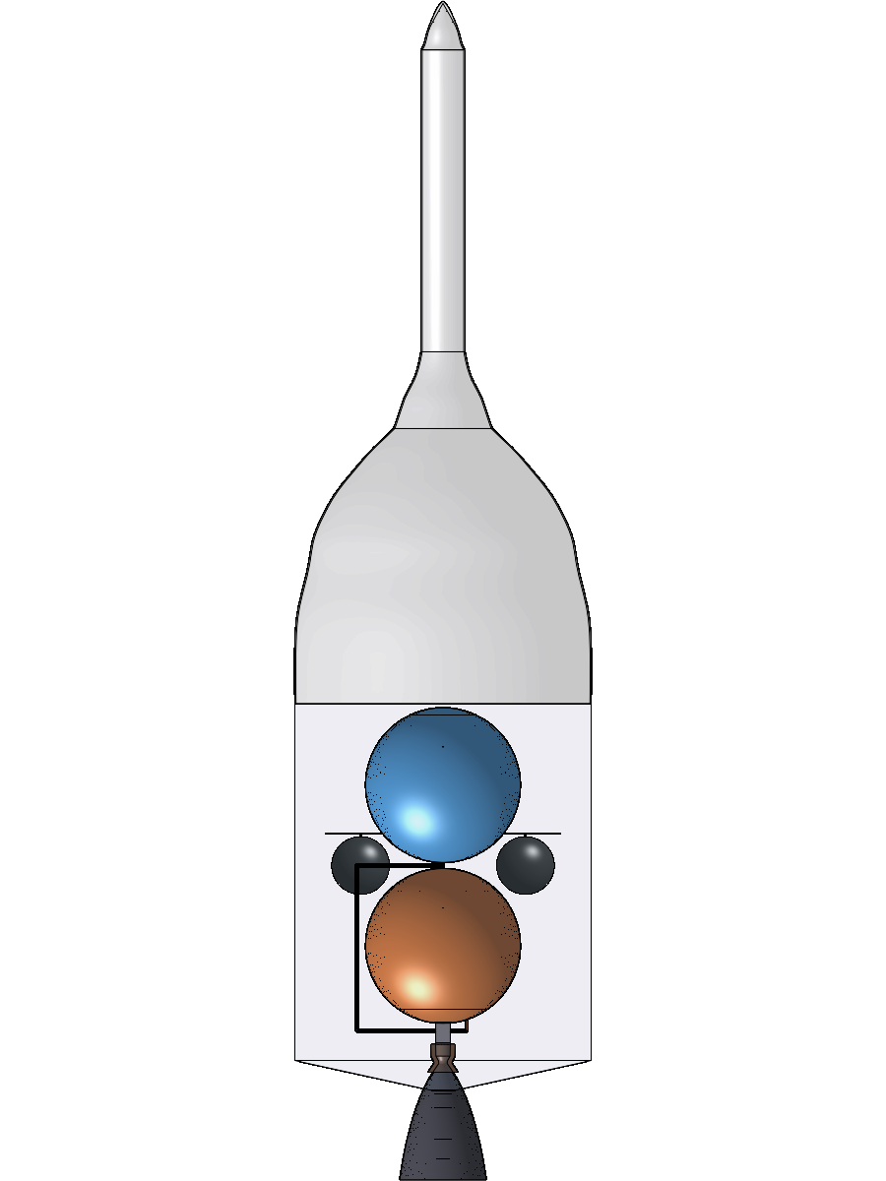
Cut view, front.
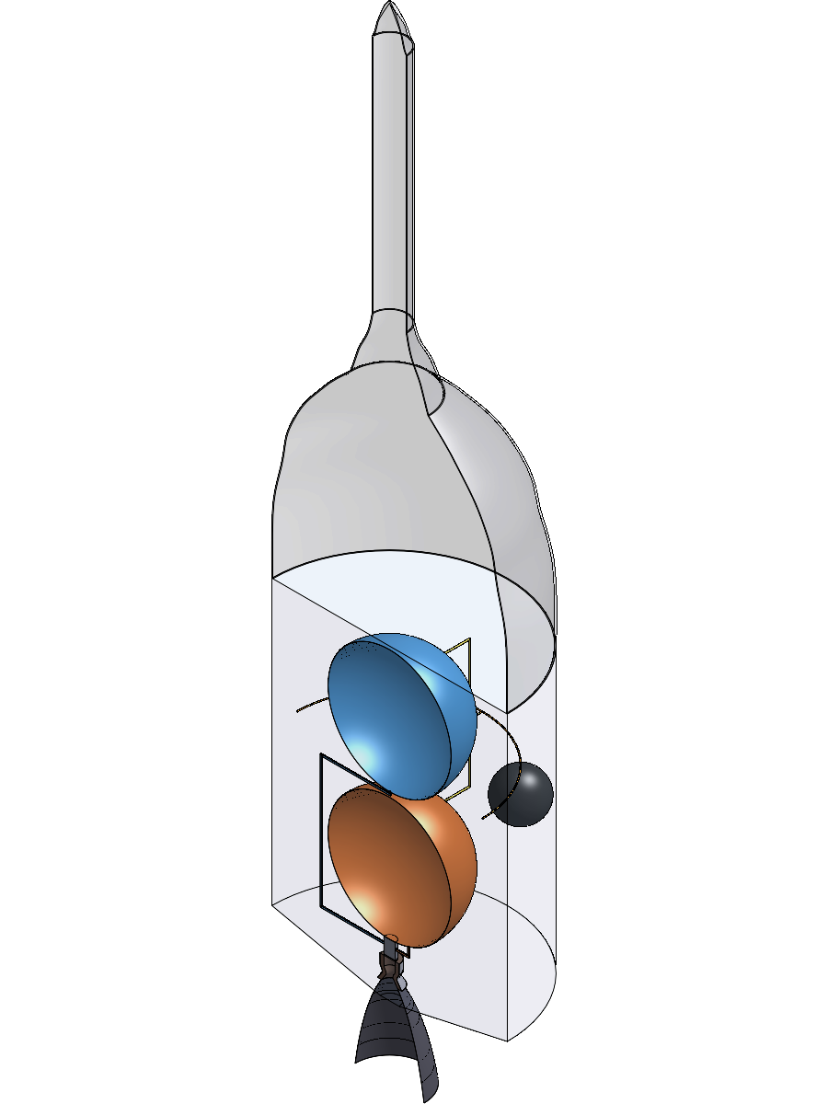
Cut view, isometric.
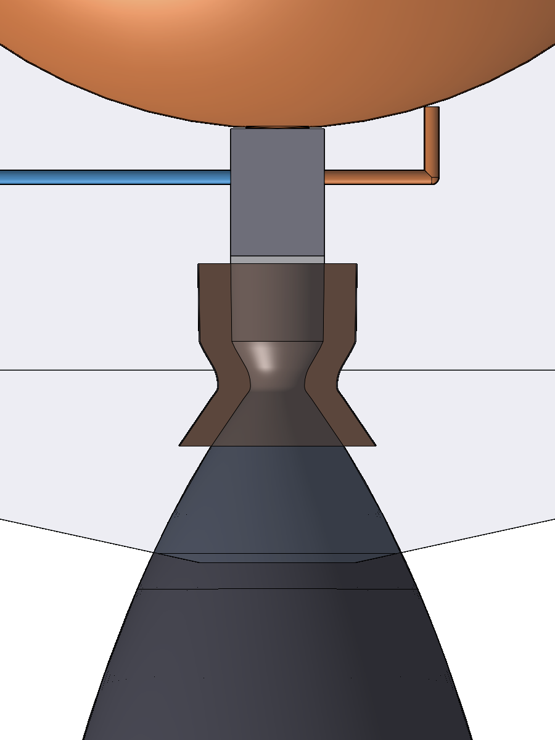
Cut view of the engine: head stack, injector, silica-phenolic liner and Ti case, throat, and the start of the C-103 extension, with the NTO (right) and MMH (left) feed lines entering the valve stack.

Changes from the Analysis Layout
- Tank size. The tanks follow the PDR drawing [3]: 2.6 m inner diameter, 9.203 m³ each. The wall is scaled from [1] to 2.14 mm, which keeps the same maximum operating pressure and allowable stress. The two tanks are the same size by design. At O/F 1.65, the NTO (1,440 kg/m³) and MMH (875 kg/m³) loads occupy 9.08 and 9.06 m³ (PDR requirements 1.2.2-01/02 [2]). The analysis in [1] enlarged the tanks to 2.63 m for 5 % ullage. With 2.6 m tanks, the free volume is only 1.3 % (NTO) and 1.6 % (MMH), which is below the usual 3–5 %. This is an open item: either return to 2.63 m or offload about 3 % of the propellant.
- Tank stacking. The analysis placed the NTO tank from its inner diameter, so its 2.16 mm wall overlapped the head stack by 19.4 cm³. Both tanks now sit on their outer surfaces. The NTO centre is at z = 1,928 mm and the MMH centre at z = 4,632 mm, with a 100 mm gap between the tanks and 65 mm clearance to the SM top. The helium bottles keep the same rules as before: 50 mm above the NTO tank and 50 mm from the SM wall.
- Lines added. The analysis sized the feed lines but did not lay them out. The routing and the helium line sizes are new (Sec. 4).
A two-bottle helium layout (2 × 1.206 m COPVs, same total volume) was also checked. It fitted with 376 mm tank clearance, but the four-bottle baseline was retained.

Feed and Pressurization Lines
The system is pressure-fed with regulated helium. Four 31 MPa COPVs supply a regulator that holds both tank ullages at 1.33 MPa, and the tank pressure drives the propellants to the engine [1]. All lines are 321 stainless steel (Table 1). The propellant line size is taken from the feed analysis in [1]. The helium lines were sized for this model:
- High-pressure line. The governing load is the 31 MPa bottle pressure. A 3/8 in × 0.065 in tube then sees a 90 MPa hoop stress, a factor of 5.7 on ultimate.
- Low-pressure lines. These are sized by the helium flow that replaces the outflowing propellant, 3.4 L/s per tank. A 3/4 in × 0.049 in tube keeps the helium velocity near 16 m/s.
The regulator and check-valve panel is a lumped 10 kg block. Valves, filters, the flexible sections each feed line needs where it crosses the gimbal, the propellant management devices and the line supports are not modelled.
Feed and pressurization lines.
Line | OD × wall | Basis | Route
NTO feed | 1.5 in × 0.065 in | 4.95 kg/s at 3.6 m/s; 64 kPa line loss [1] | NTO lower dome (r = 400 mm), down, into the +X side of the valve stack at z = 500 mm
MMH feed | 1.5 in × 0.065 in | 3.00 kg/s at 3.6 m/s; 50 kPa line loss [1] | MMH bottom pole, through the tank gap, down at x = −1,450 mm outside the NTO tank, into the −X side of the valve stack
He high pressure | 0.375 in × 0.065 in | 31 MPa; hoop stress 90 MPa (factor 5.7 on ultimate) | COPV top outlets to a ring manifold (r = 1,961 mm, z = 3,819 mm), then to the regulator
He low pressure | 0.75 in × 0.049 in | 1.33 MPa; about 16 m/s at 3.4 L/s per tank | Regulator (+Y, r = 1,700 mm) to each tank’s upper dome, 60° from the top pole

Nozzle Extension Wall
The C-103 extension wall is 0.6 mm thick. Internal pressure does not size it. The gas pressure is 19.9 kPa at the attach station (area ratio 6, Mach 3.0) and 0.44 kPa at the exit. With σ = pr/t, the hoop stress is 5.7 MPa at the attach station and 0.5 MPa at the exit, which is far below the strength of C-103 at its 1,389 K peak temperature (1,600 K limit) [1].
Thickness also does not affect the wall temperature. A radiation-cooled skirt runs at radiation equilibrium, so a thicker wall only adds mass. The real sizing loads are stiffness against vibration, gimbal and handling loads, and the attach flange. The mass budget covers these with a 25 % allowance for stiffening rings, the flange and the coating (40.7 kg against 32.5 kg for the bare wall) [1]. The CAD shows the bare wall. A taper from about 1.0 mm at the flange to 0.6 mm at the exit, with two or three hat-section stiffening rings, would represent the hardware more fully without changing the thermal design.

Mass Properties
Onshape nominal mass properties, with the cut view off, are compared with the analysis mass build-up [1] in Table 2. The densities used are silica phenolic 1,750, Ti-6Al-4V 4,430, C-103 8,860, 304L 7,900 and 321 stainless 8,030 kg/m³. Items marked “lumped” have a density chosen to match the budget. The modelled masses are bare geometry. The analysis values also include flanges, rings, manifolds and tank fittings that are not drawn.
CAD mass properties against the analysis mass build-up.
Part | Material | CAD, kg | Analysis, kg | Note
Ablative liner | silica phenolic | 66.13 | 66.38
Chamber case | Ti-6Al-4V | 6.47 | 10.03 | analysis adds 3 kg of flanges
Nozzle extension | C-103 | 33.23 | 40.65 | analysis: 32.5 kg bare × 1.25
Injector plate | 304L | 6.94 | 10.00 | analysis includes a 2.6 kg manifold
Head, valve and gimbal stack | lumped | 44.00 | 44.00 | valves, actuators, miscellaneous
NTO tank (bare shell) | Ti-6Al-4V | 201.28 | 271.92 | 2.6 m ID; analysis value includes more than the shell
MMH tank (bare shell) | Ti-6Al-4V | 201.28 | 271.22 | as above
Helium COPVs (×4) | lumped | 379.94 | 379.94
Feed lines (NTO / MMH) | 321 SS | 0.70 / 8.50
He lines (high / low pressure) | 321 SS | 4.17 / 2.01
Lines total |  | 15.38 | 12.93 | the MMH line is 5.6 m long because it routes around the NTO tank
Regulator panel | lumped | 10.00 | – | part of the 40 kg components budget

Interference Check
Every pair of the 17 hardware bodies (136 pairs) was intersected on copies in Onshape. There is no interference. The largest overlap of any pair is 4 × 10⁻⁵ mm³, which is numerical noise at tangent contacts. Connected parts meet with gaps of 0–0.12 mm. The 0.12 mm gap is at the MMH outlet, where the flat tube end meets the curved dome. Selected clearances:
- NTO to MMH tank: 95.7 mm.
- Bottles to the SM wall: 50 mm.
- Bottles to the propellant tanks: 601 mm.
Against the SM envelope, only the C-103 extension lies outside (3.27 L). This is expected, because the nozzle exit is 2.01 m below the SM base and the aft cone is only 0.5 m deep.

Performance Verification with RocketCEA
The ideal design point of [1] was re-run with RocketCEA 1.2.3 [5]: N₂O₄/MMH, P_{c} = 0.862 MPa, O/F 1.65, area ratio 108, infinite-area combustor, with frozen flow frozen at the chamber.
RocketCEA’s built-in propellant cards use different heats of formation from the NASA database used in [1]. For example, N₂O₄(l) is −19.56 kJ/mol in RocketCEA against −17.55 kJ/mol in the database. The comparison therefore uses custom cards with the database values and the 293.15 K propellant temperature of [1]. The default cards are shown for reference (Table 3).
Ideal vacuum performance: analysis solver [1] against RocketCEA.
Quantity | Analysis [1] | RocketCEA, same basis | Difference | RocketCEA, default cards | Difference
T_{c}, K | 3,042.3 | 3,045.7 | +0.11 % | 3,044.6 | +0.08 %
M_{c}, g/mol | 20.42 | 20.41 | −0.03 % | 20.41 | −0.02 %
c*, shifting, m/s | 1,737.9 | 1,739.4 | +0.08 % | 1,738.9 | +0.06 %
C_{F,vac}, shifting | 1.9276 | 1.9281 | +0.03 % | 1.9280 | +0.02 %
I_{sp,vac}, shifting, s | 341.50 | 341.99 | +0.14 % | 341.87 | +0.11 %
Exit pressure, shifting, Pa | 429.9 | 430.3 | +0.09 % | 430.2 | +0.06 %
c*, frozen, m/s | 1,698.6 | 1,699.8 | +0.07 % | 1,699.4 | +0.05 %
C_{F,vac}, frozen | 1.8753 | 1.8753 | 0.00 % | 1.8753 | 0.00 %
I_{sp,vac}, frozen, s | 324.71 | 325.04 | +0.10 % | 324.97 | +0.08 %
Every quantity agrees within 0.3 %, exit temperature included. This confirms the ideal performance on which the delivered 320.8 s specific impulse in [1] is built.

Conclusions
The service-module propulsion system is modelled as one parametric Onshape feature built directly from the analysis outputs. It includes the engine, the PDR-size tanks, four helium bottles, sized feed and pressurization lines, and reference shells for the SM, the capsule and the LES. The model has no interferences, and its masses agree with the analysis budget once the undrawn flanges, rings and fittings are accounted for. The 0.6 mm C-103 extension wall is adequate for pressure and temperature; its sizing loads are stiffness and handling, which are covered by the ring allowance. RocketCEA reproduces the analysis performance within 0.3 %. Two items remain open: the 1.3–1.6 % ullage of the 2.6 m PDR tanks, and the flex sections the feed lines need across the gimbal.

References
[1] [Your Name], “Project ABEONA Crew Capsule Main Engine: Thrust Chamber, Feed System, and Pressurization Design,” design report, October 2026.
[2] Kempf, A., Bratt, E., LeRoy, M., Bernal, R., Wiser, S., and Rouland, S., “Project ABEONA Preliminary Design Report,” unpublished class report, 2026.
[3] Kempf, A., Bratt, E., LeRoy, M., Bernal, R., Wiser, S., and Rouland, S., “Preliminary Design Review, Project ABEONA,” unpublished class presentation, slide 7 (Crew Capsule), 2026.
[4] Project ABEONA, Mission_Breakdown.xlsx, Crew Capsule tab, 2026.
[5] Taylor, C., “RocketCEA,” Python wrapper for NASA CEA, version 1.2.3, https://rocketcea.readthedocs.io.
[6] Gordon, S. and McBride, B. J., “Computer Program for Calculation of Complex Chemical Equilibrium Compositions and Applications,” NASA RP-1311, 1994.

