**Steven**

Default:

Activation function : tanh

Number of hidden layer: 1

Units of each hidden layer: 2

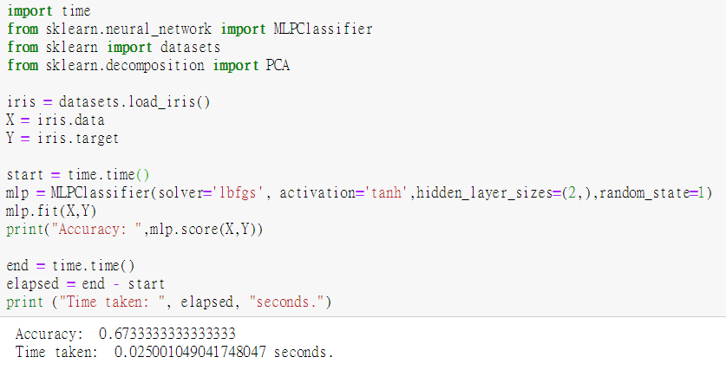

相同neural數，不同層數:

Activation function : tanh

Number of hidden layer: 3

Units of each hidden layer: 2

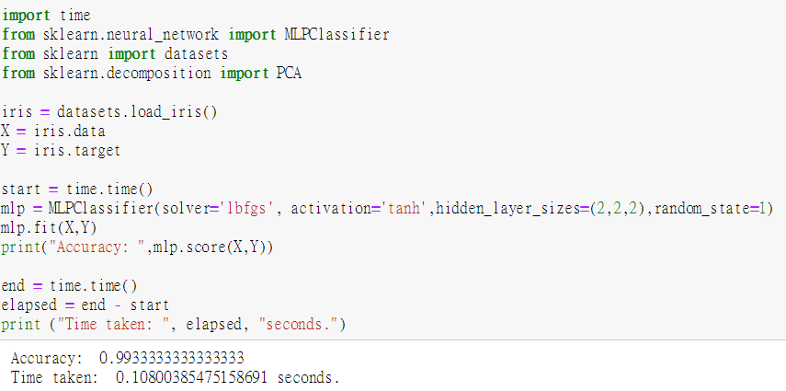

不同neural數，相同層數:

Activation function : tanh

Number of hidden layer: 1

Units of each hidden layer: 5

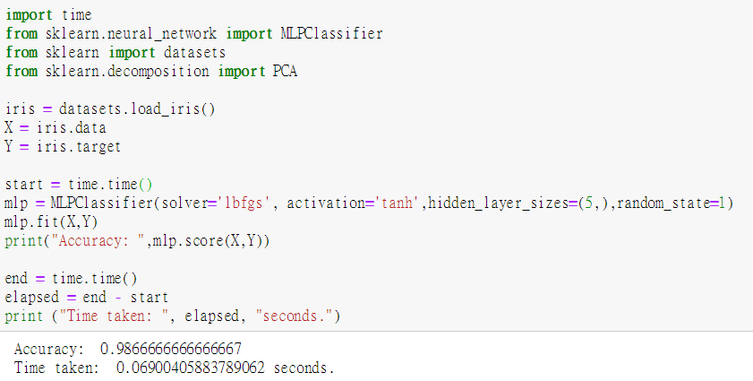

不同activation function:

Activation function : relu

Number of hidden layer: 1

Units of each hidden layer: 2

