**Gaussian Mixture Model Based Motion Detection and Tracking Using Optic Flow**

**Dingjingmu(Steven) Yang**

**1720116**

**Abstract --Tracking multiple targets is a complex task, but it can be simplified by applying motion detection ahead. The motion detection method classifies the foreground (moving object) and background, in this way, a trivial tracking algorithm can be used to track the featured foregrounds. In this project, a Gaussian Mixture Model (GMM) based motion detection technique is implemented.**

**Keywords --Motion Dectection, Gaussian Mixture Model, Tracking, Machine learning**

1. Introduction

Given a video recorded by traffic closed-circuit television (CCTV) during a light traffic period, the video shows the background, mainly the roads and trees, most of the time. Therefore, for each pixel, the frequency of occurrence of the background is much higher than the occurrence of the foreground. In this way, recording the frequency of each pixel intensity helps identify if an intensity is a background intensity or a foreground intensity[4]. The GMM based motion detection method uses this fact to classify background/foreground intensity by plotting a histogram and fitting a GMM on it for every pixel.

This project combines GMM based motion detection and optic flow based tracking to track the vehicles from a video recorded at the overpass at Southgate LRT station.

2. Theory

The input video used in this project is a 1280x720 resolution with 30 fps RGB video. This video is first grey-scaled and rescaled to 160x120 resolution to reduce the number of GMM and the amount of computation, then converted to 5000 frames. The first 1000 frames are used as training sets for the GMMs. Even though more training data means a better model, only the first 1000 frames are selected as the training data. This is because the GMM fits on a normalized distribution, and doubling the amount of data does not change the overall distribution much but will double the computation when fitting a GMM.

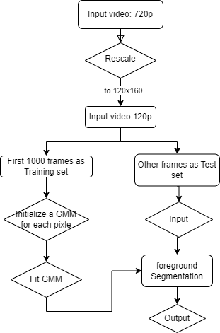

Figure 1. Flow chart of GMM based motion detection

Once a GMM is fitted for all pixel, for each frame in testing set, classify each pixel if it is foreground or background. A new intensity value is matched to a single Gaussian in GMM by closest mean value. For the matched Gaussian distribution, if it has a large weight and low standard deviation, then this intensity is classified as background and plot it in black[2], and vice versa. In this project, the value of the weight divided by the standard deviation(w/std) is checked by a threshold instead of checking both weight and standard deviation with 2 two threshold seperatly. A pixel is a background if the w/std value of the correstponding Gaussian is less than a threshold value (w/std < threshold) [1].

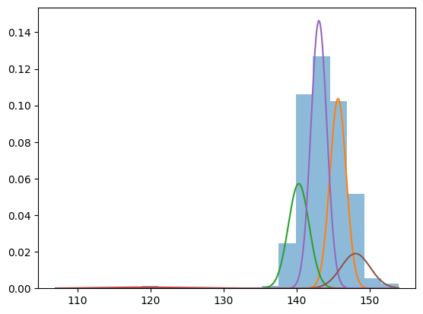

Figure 2. Normalized distruibution and fitted GMM.

y-axis is the frequency, and x-axis is the value of intensity

Figure 2 above shows a histogram and GMM of a pixel. Note that there are five Gaussian in the GMM, and the pixels in the range 145 to 160 occur in high frequency. In this way, the pixels under the green, light purple, and orange Gaussian are background pixels, and the pixels under the red and dark purple Gaussian are foreground pixels.

Next, a simple tracker is applied to the foreground segmentation frames. In the foreground segmentation frames, the foregrounds, which are the moving objects, are plotted in white, and the background is plotted in black. The simple tracker will plot a tracking box on each foreground object, and use motion vectors from the optic flow algorithm to update the tracking box to a better position. In this way, the optic flow method is used to improve the tracking performance.

In the end, the combination of GMM based motion detection and optic flow based tracking will output a video that includes foreground segmentation and tracking boxes on moving objects.

3. Experimental results.

The result of GMM based motion detection are not always accurat

*A. Factors of Inaccuracies*

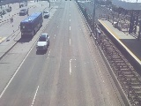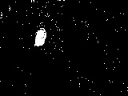

Figure 3. Input frame and corresponding GMM motion detection result

In figure 3, although the GMM successfully detects the moving vehicle in the frame, so many background pixels are classified as foreground. Many factors are causing this kind of inaccuracy, such as incorrect threshold value, bad hyperparameter, and inaccuracy of GMM itself.

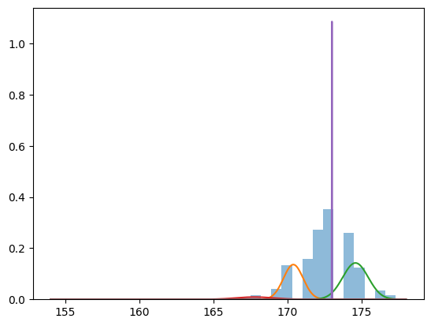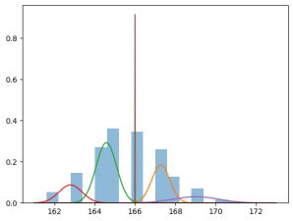

Figure 4. Histogram and GMM from 2 randomly selected pixel that gives incorrect result in Figure 3

Figure 4 indicates that GMM does not always fit the histogram well. Therefore, some inaccuracies in the GMM based motion detection method are difficult to avoid.

*B. Solution to reduce the error*

A filter method can be applied to fill the holes in foreground objects and reduce the noise in background[3]. Foreground objects here refer to every individual integration of interconnected foreground pixels in foreground segmentation frames.

The foreground objects are considered noise if they are too small as they do not match the size of a vehicle. In this filter method, the size of all the foreground objects is shrunk by setting the border pixels to the background. After shrinking twice, the whole foreground object will be set to the background if they are too small. Followed by two times of enlargement, by setting the pixels to foreground if one of their neighbours is foreground. In this way, the large foreground objects remain their size while the small foreground objects are demoted to the background. In addition, the holes in Foreground objects will also be filled during enlargement.

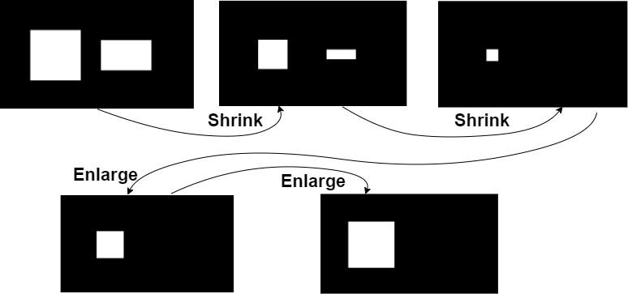

Figure 5. Illustration of how the small foreground object is set to background



Figure 6. The frame without filter (left), and the frame with filter (right)

*C. Tracking*

Tracking is the easiest part of this project. There are two steps, firstly, find all the foreground objects in a frame, and get the abstract size and position for each object. Secondly, compute the motion vector using the previous frame and update the position of the tracking box. Overall, the performance of tracking is excellent as expected.

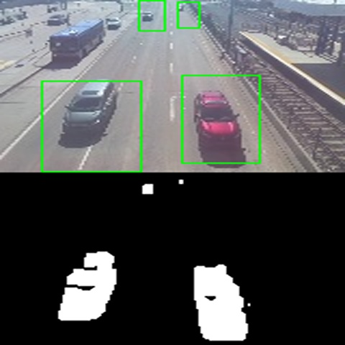

Figure 7. An example of the result of tracking on foreground segmentation frame.

4. Conclusions

*A. Summary*

This project is conducted using data of a traffic video and a combination of Gaussian Mixture Model based motion detection and optic flow tracking. The GMM overall detects all the moving objects and the noise can be reduced by applying a filter. The performance of optic flow tracking is fine, and all the moving objects are tracked accurately.

*B. Strengths and Weaknesses*

The GMM based motion detection is robust in complex and dynamic environments such as rainy days and snowy days. But it is not working properly when there are too many foreground objects.



Figure 8. The result of GMM based motion detection appling to busy traffic.

The traffic in Figure 8 is much busier than in Figure 7. The GMM performs badly because the busy traffic violates the assumption that the background intensity occurs much more frequence than the foreground intensity. As a result, the GMM can not classify foreground based on the distribution of frequency.

Furthermore, because GMM based motion detection is a machine learning approach, it takes a long time to run the algorithm and a good hardware is required for real-time tracking.

*C. Future work*

When the video is grey-scaled, different colours will be converted to the same intensity in grey, this causes inaccuracy in classification. For example, a tree with colour [0,100,2], and a car with colour [197,0,6] are both 60 intensity in grey. Therefore, changing the colour of the input video from grey-scaled to RGB can improve the accuracy of the GMM motion detection.

However, using RGB means a much more complex Gaussian Mixture Model. Therefore, a different classification method should be applied and there will be more parameters to tune. Due to a lack of time and effort, this improvement was not conducted in this project.

REFERENCES

[1] V. Anand, D. Pushp, R. Raj and K. Das, "Gaussian Mixture Model (GMM) Based Dynamic Object Detection and Tracking," 2019 International Conference on Unmanned Aircraft Systems (ICUAS), Atlanta, GA, USA, 2019, pp. 1365-1371, doi: 10.1109/ICUAS.2019.8797927.

[2] S. Rakesh, Nagaratna P. Hegde, M. Venu Gopalachari, D. Jayaram, Bhukya Madhu, Mohd Abdul Hameed, Ramdas Vankdothu, L.K. Suresh Kumar, Moving object detection using modified GMM based background subtraction, Measurement: Sensors, Volume 30, 2023, 100898, ISSN 2665-9174,

[3] Indrabayu, R. Y. Bakti, I. S. Areni and A. A. Prayogi, "Vehicle detection and tracking using Gaussian Mixture Model and Kalman Filter," 2016 International Conference on Computational Intelligence and Cybernetics, Makassar, Indonesia, 2016, pp. 115-119, doi: 10.1109/CyberneticsCom.2016.7892577.

[4] Y. Song, N. Fu, X. Li and Q. Liu, "Fast moving object detection using improved Gaussian mixture models," 2014 International Conference on Audio, Language and Image Processing, Shanghai, China, 2014, pp. 501-505, doi: 10.1109/ICALIP.2014.7009844