Attached Graphs

**Question 3**

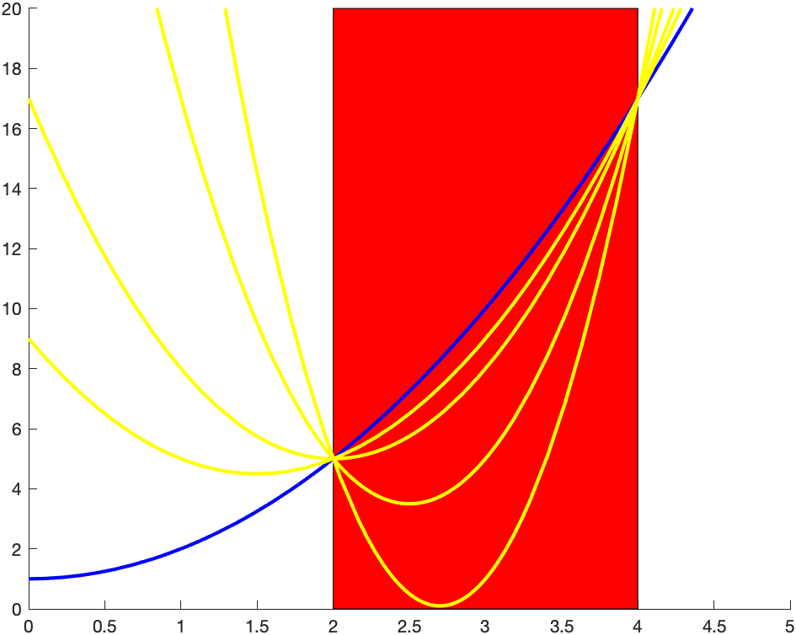

Plot the Lagrangian L(x, λ) versus x for a few positive values of λ

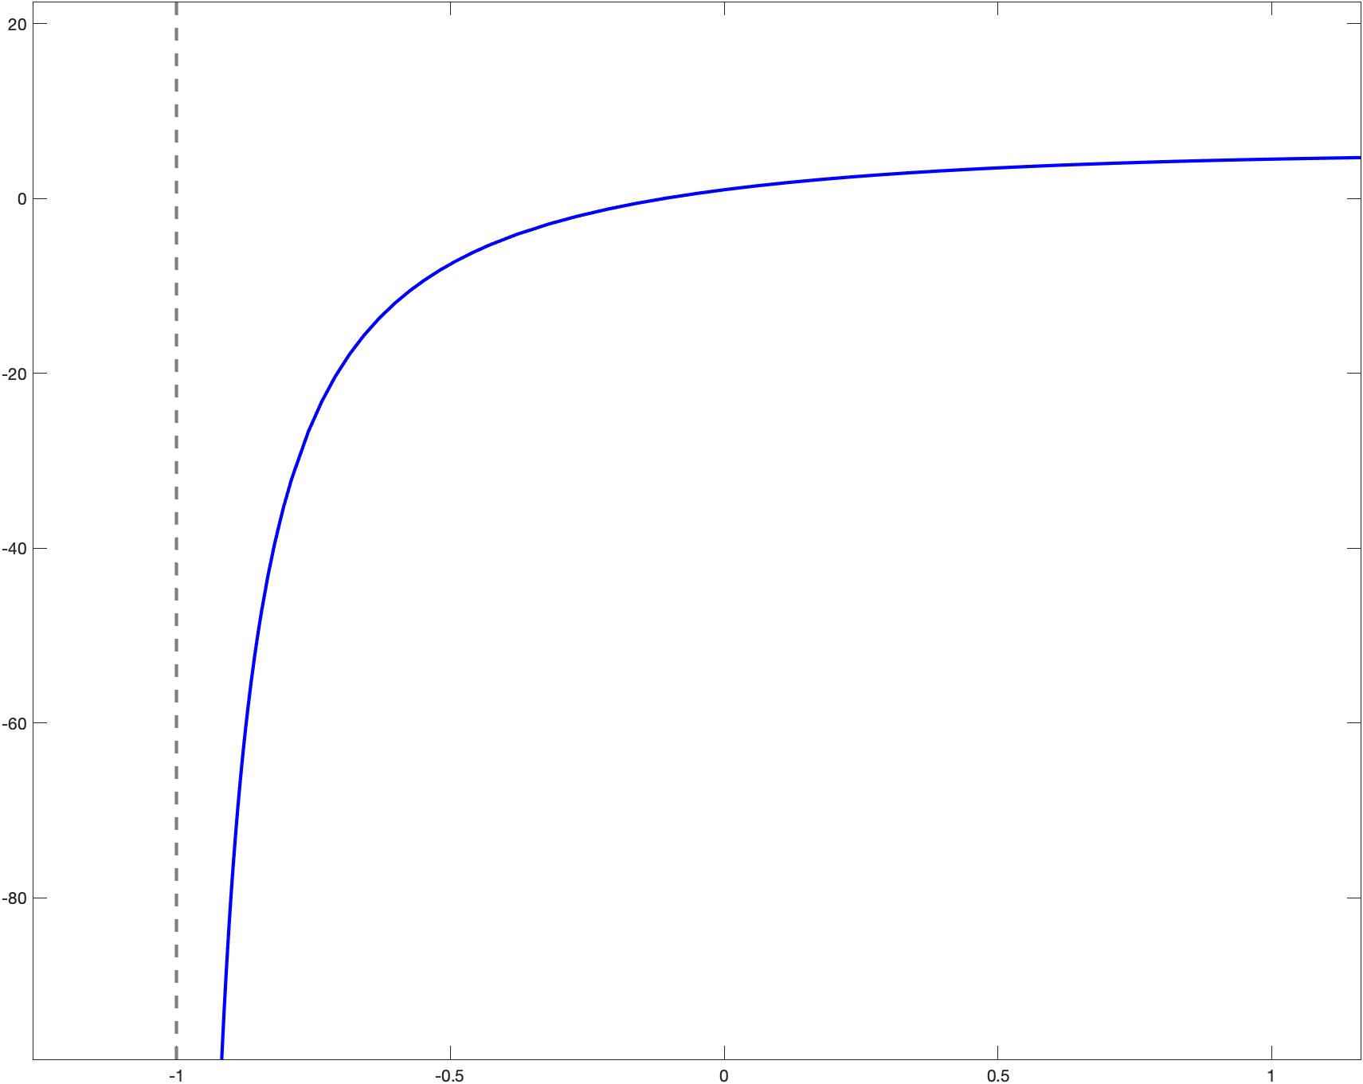

Lagrange dual function g