Creating questions:
Each question must be in a separate PNG file. The START of each filename must be the solution.
Everything afterwards is ignored, so that each of
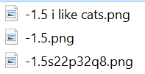
will be recognized as a question with answer -1.5
Evaluation:
For integers the students must provide the exact answer (with no decimals).
For decimals, their answer must be exactly the same as the solution either before or after rounding their answer to 3 significant figures (the computer will do the rounding for them, so -1.4999999 = -1.5).
Creating a map:
If you want to create your own map, send me:
- A blank map PNG file as the background. Over 1000 pixels in each dimension, roughly 11:6 ratio.
- And drawn or doodled “map” drawn over said PNG file with all the territory names, capitals, connections, team colors on it. Then I can code that into existence.

