**Minor Project Report**

**Submitted in partial fulfilment of the degree of**

**CSE**

**By**

**Najmul Haque (11900121069)**

**Second Year student of**

**Siliguri Institute of Technology**

**Under the supervision of**

Mr. Biprosom Majumder

**Sikharthy Infotech Pvt. Ltd.**

**Department of Computer Science and Engineering**

Date: 28/02/2023

I hereby forward the documentation prepared by me **Najmul Haque** under the supervision of Mr. Biprosom Majumder Sir entitled **Credit Card Fraud Detection** accepted as fulfilment of the requirement for the Degree of **Bachelor of Technology** in **Computer Science and Engineering** from **Siliguri Institute of Technology** affiliated to **Maulana Abul Kalam Azad University of Technology** (**MAKAUT**) .

|  |  |
| --- | --- |
| ______________________________    **Mr. Biprosom Majumder** | ____________________________________    **Najmul Haque**  **B. Tech (CSE)**  **Siliguri Institute of Technology** |

**Credit Card Fraud Detection**

By

**Najmul Haque (11900121069)**

UNDER THE GUIDANCE OF

**Mr. Biprosom Majumder**

**Project Guide**

**Sikharthy Infotech Pvt. Ltd.**

THEIS SUBMITTED IN FULFILLMENT OFTHE REQUIREMENTS FOR THE DEGREE OF

**B. Tech**

IN

COMPUTER SCIENCE AND ENGINEERING

**SILIGURI INSTITUTE OF TECHNOLOGY**

**AFFILIATED TO**

**Maulana Abul Kalam Azad University of Technology**

[**Address**](https://www.google.co.in/search?rlz=1C1GTPM_enIN734IN734&biw=1366&bih=613&q=future+institute+of+technology+address&stick=H4sIAAAAAAAAAOPgE-LVT9c3NEyrMC-JTzbO0JLNTrbSz8lPTizJzM-DM6wSU1KKUouLAYQ6jCEwAAAA&sa=X&ved=0ahUKEwi3htjS0_rbAhVLQY8KHTJnC-kQ6BMI1wEwEQ)**:**Hill Cart Road, Salbari, P.O Sukna, West Bengal 734009

[**Phone**](https://www.google.co.in/search?rlz=1C1GTPM_enIN734IN734&biw=1366&bih=613&q=future+institute+of+technology+phone&sa=X&ved=0ahUKEwi3htjS0_rbAhVLQY8KHTJnC-kQ6BMI6gEwEw)**:**+91-9434527272

**Email:** info@sittechno.org

**Website**: http://www.sittechno.org/

**Certificate of Approval**

The foregoing project is hereby approved as a creditable study for the B. Tech. in Computer Science and Engineering presented in a manner of satisfactory to warrant its acceptance as a prerequisite to the degree for which it has been submitted. It is understood that by this approval the undersigned do not necessarily endorsed or approved any statement made, opinion express or conclusion therein but approve this project only for the purpose for which it is submitted.

Final Examination for

Evaluation of the Project ----------------------------------------

-----------------------------------------

------------------------------------------

Signatures of Examiners

------------------------------------------------------------------------------------------------

**ABSTRACT**

The purpose of the project entitled as “Credit Card Fraud Detection” is to detect any kind of credit card fraudulent committed by criminals.

**ACKNOWLEDGEMENT**

It is a great pleasure for me to acknowledge the assistance and participation of a large number of individuals to this attempt. Our project report has been structured under the valued suggestion, support and guidance of **Mr. Biprosom Majumder**. Under his guidance we have accomplished the challenging task in a very short time.

Finally, we express our sincere thankfulness to our family members for inspiring me all throughout and always encouraging us.

**Najmul Haque**

**B. Tech(CSE)**

**TABLE OF CONTENTS**

Chapter 1: Introduction

1: Introduction

Chapter 2: What We Used

2.1: Python

2.2: VSCode

Chapter 3: Functionality of the Program

Chapter 4: Conclusion

Chapter 5: References

**INTRODUCTION**

Credit Card Fraud Detection is specifically designed to detect any fraudlent transaction.

**2.1 Python**

We have used Python 3.11 , numpy module, sklearn module and pandas module to make this project

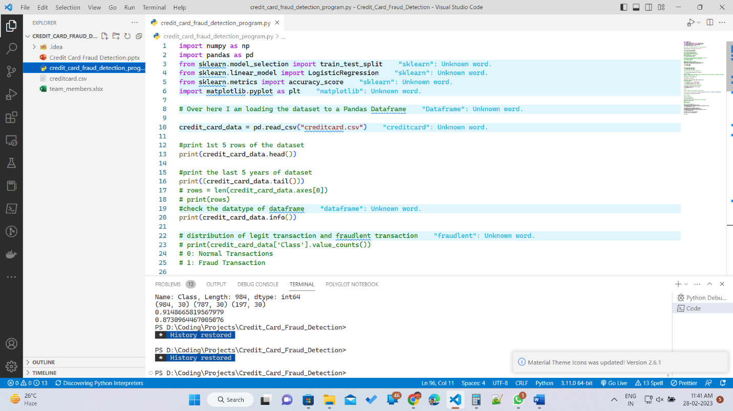

**2.2 IDE**

We used Microsoft Visual Studio Code(VS Code), in our project as IDE.

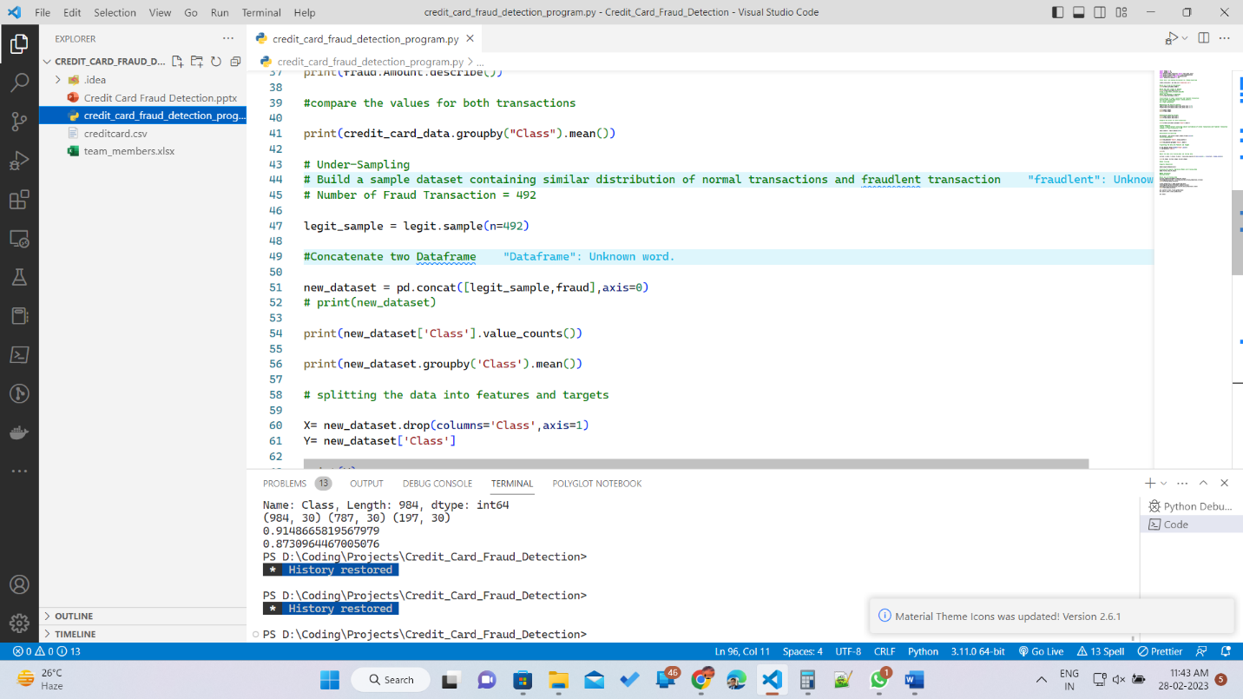

**FUNCTIONALITY OF THE PROGRAM**

So we took the help of numpy, pandas and sklearn module and from sklearn we have imported train_test_split,accuracy score to measure the accuracy of the trained model. This project is based on Logistic Regression. By matplotlib we have created a graph using pyplot.

The dataset that was used in this project was taken from Kaggle ([Link](https://www.kaggle.com/datasets/mlg-ulb/creditcardfraud?resource=download)). This dataset has 31 columns and 284807 rows with no null values. Credit card data is very sensitive data and we cannot expose this data, so the dataset provider converted the features into numerical values and we going to use these numerical values. In the class column, 0 represents normal transactions and 1 represents fraud transactions.

There are 284315 Normal transactions and 492 fraudulent transactions which make the provided dataset very unbalanced so we have stored legit transactions in the legit variable and all the fraud transactions in the fraud variable. By undersampling we have built a sample dataset containing similar distribution of normal transactions and fraud transactions. From the 284315 normal transactions we are going to take random 492 random transactions and then combine this with the fraud transactions so the dataset becomes balanced.

HARDWARE REQUIREMENTS

The minimum Hardware requirements for the application to run smoothly should have the following configuration:

|  |  |
| --- | --- |
| **Processor** | Intel Core i3 |
| **RAM** | 4GB or more |
| **HDD** | 3GB or more |

SOFTWARE SPECIFICATIONS

The minimum software requirements are as follows:

|  |  |
| --- | --- |
| **Operating System** | Windows 7,8 and upwards |
| **IDE** | VSCODE |
| **Language Used** | Python |
| **Libraries** | Numpy, Pandas, SKLearn |
| **Working IDE** | Visual Studio Code, Eclipse |

**CONCLUSION**

The project “Credit Card Fraud Detection” can be used to detect any type of fraud transactions done by criminals and the algorithm has 92% accuracy which is considered as a very good score and can be used to reduce the losses caused by these frauds.

**REFERENCES**

* [**https://www.youtube.com/watch?v=NCgjcHLFNDg**](https://www.youtube.com/watch?v=NCgjcHLFNDg)
* [**https://matplotlib.org/stable/plot_types/index**](https://matplotlib.org/stable/plot_types/index)
* **https://www.geeksforgeeks.org/**