18 September - Meeting

* Review high level objective, project plan
* [Complete team roles](https://docs.google.com/document/d/1A6HUEYMtvgPcNYS1Sy1D4sKWvF9KOSEoxyfNzmXEBiE/edit)
* Ensure everyone is set with team logistics:
  + Weekly Report
  + Drive, Todoist, Github
  + Who needs help learning Git?  Short tutorial on git after the meeting.
  + Journaling
  + Related Work
* Overview of FPGAs by Dr. Ganesan
* Walkthrough of SCCs on Matlab as a first simple algorithm

Warp algorithm??  See Ganesan’s papers

Ganesan suggests target applications

1. Database
2. Biology - Protein Groups

Jay Li - PhD student finishing his thesis and starting a job.  Busy.

Han Yu  - PhD student working on GPUs, computational biology.  May help with project.

Two reasons to use new hardware (GPU or FPGA):

1. Data set so large we need more processing capability
2. Nature of processing itself is faster on new hardware

FPGAs: good in diverse processing - not good at floating point ops

GPUs: good for data parallelism - great at floating point ops

FPGAs - each logic block has configurable lookup tables

Schematic design given by hardware manufacturer

HDL = Hardware description language - VHDL, Verilog

Use *cores* (prebuilt VHDL components) and put them together with logic to write a VHDL program.

⇒ See [**OpenCore**](http://opencores.org/projects) for examples of open source core components you can use in hardware design

Write in high level language, then use netlist and synthesizer to get the hardware code.

[Link to accumulo user guide](https://accumulo.apache.org/1.6/accumulo_user_manual.html) ([also on Drive](https://drive.google.com/file/d/0B4woLBuQwndga1NJMjdGcmx1YWM/edit?usp=sharing)) ([Accumulo examples](https://accumulo.apache.org/1.6/examples/))

[Link to Xilinx download guide](http://personal.stevens.edu/~backland/Courses/Course487_Fall_14_files/Homeworks/XilinxDnldInstructs.pdf) from Dr. Ackland for [CpE 487](http://personal.stevens.edu/~backland/Courses/Course487_Fall_14.htm).  He uses Xilinx version 13 for some reason.  I have 14.1 installed.

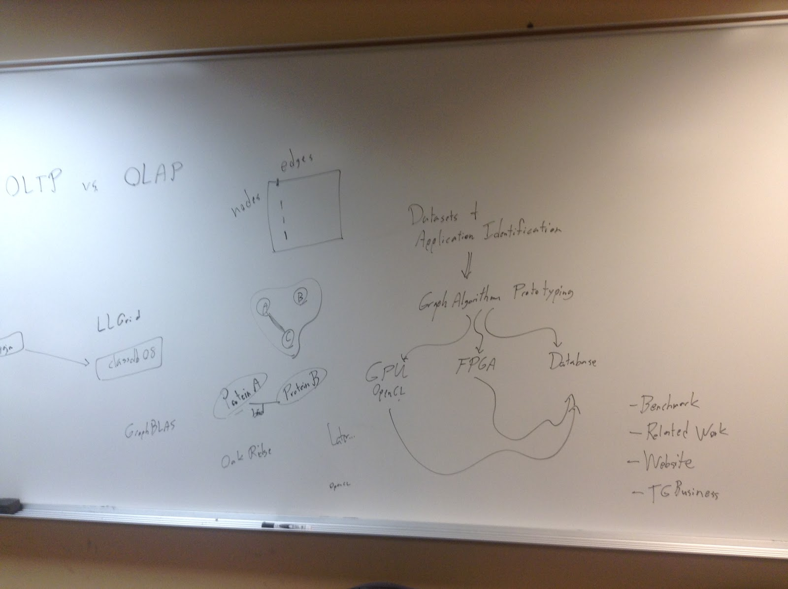

[All] Take a look at Dr. Ganesan's papers and references.

[All] Take a look at the [Graph Computing webpage](http://markorodriguez.com/2013/01/09/on-graph-computing/) I showed today and use that as an example of datasets and analytic questions we can ask about datasets that we can answer in the form of a graph algorithm.  **Next week, come with**

* **one dataset** you think is cool (you don’t have to download an actual dataset, could be as vague as “social network data”)
* **one question** you would like to ask about that dataset
* **one graph algorithm** that can answer that question
* **ideas for implementing** **it**, including whether you think a GPU, FPGA or database can help

You can write this in your journal

[All] Ensure you put your Github username inside your journal so that I can add you to the [Stevens-GraphGroup](https://github.com/Stevens-GraphGroup) organization.

[All] Check that you can see the shared [Todoist](https://en.todoist.com/) project.  If you can’t, make sure your email (that is, the email you login to Todoist with) appears correctly on this list:



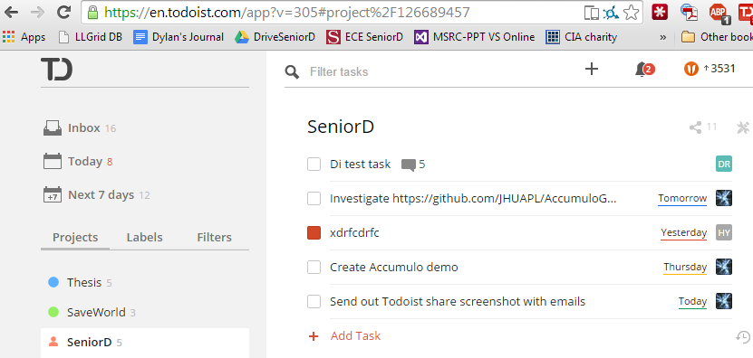

[Xin] Start website planning and development.  Decide what framework you will use for the website; if not sure list a couple options with pros and cons and ask us next week.  See if you can get an index file up on Github.

Create a repository named Stevens-GraphGroup.github.io under the organization and follow the steps here.

[Dylan] Prepare a demo of Accumulo with Twitter data for next week.  Accumulo architecture review.