Expenditures of US non-military financial assistance provided to Ukraine

Report for the US Congressmen

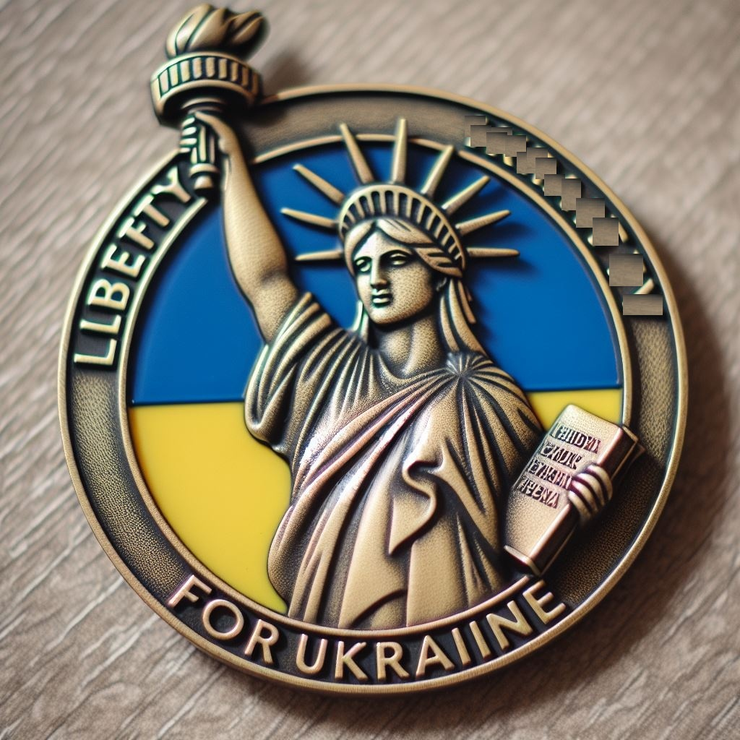

Liberty for Ukraine

[liberty4ua.org](https://liberty4ua.org/en)

February 24, 2025

Contents

Introduction 5

1. US Efforts to help Ukraine during the War 5

1.1. Claimed Purposes of Financial and Humanitarian Support 5

1.2. Humanitarian Aid Embezzlement 6

2. US Efforts to Support Free Journalism in Ukraine 7

2.1. Reasons for Supporting Media 7

2.2. Radio Free Europe - Radio Liberty 8

2.2.1. Vitaly Portnikov 8

2.2.2. Yevhen Dykyi 9

2.3. ATR TV channel 11

2.3.1. Aider Muzhdabaev 11

2.4. The Outcome of US Support of Ukrainian Media 12

3. US Efforts to help Ukraine fight corruption 13

3.1. U.S. supported anti-corruption programs 13

3.2. Ukraine’s organizations involved in fighting corruption 14

3.3. Evidence of failure of anti-corruption measures in Ukraine 15

3.3.1. Booming Ukraine Luxury Car Market 15

3.3.2. Military Food Procurement Scandal 17

3.3.3. Ukraine’s Antarctica Research 18

3.3.4. Musical Instruments and Lego Sets for Bomb Shelters 19

3.4. Ongoing Steps to Decrease Transparency 21

3.5. Results of US Involvement in Fighting Corruption in Ukraine 22

4. Human Rights and Democracy Support in Ukraine 22

4.1. Human Rights Organizations in Ukraine 22

4.2. Human Rights Abuses in Ukraine 23

4.2.1. SBU Concentration Camp “Gym” 24

4.2.2. Abuses of Power in Territorial Centers for Recruitment 25

4.3. Factual Results of US Democracy Support in Ukraine 26

5. Historical Parallels 26

6. Incentives for the USA to Help Ukraine 28

Conclusion 28

Appendix A – Information Sources 29

# Introduction

This report lays the groundwork to redirect the U.S. budget funds allocated to several civilian projects to the Ukrainian military. This report presents facts about spending the U.S. budget funds on programs in Ukraine that lead to undesirable or illegal consequences which include:

* Increases in the instances of misallocation and theft of funds obtained through the U.S. grant programs. Simply put, the U.S. budget funds are more likely to support corrupt Ukrainian bureaucracy rather than free Ukrainian society fighting for its own survival. Corruption in Ukraine increases during the period of U.S. grants but does not decrease.
* interference in U.S. elections through biased media coverage, which creates pressure both internationally and on the Ukrainian diaspora in the United States.

This document provides examples of corruption in Ukraine and its detrimental impact on the country's ability to defend itself from Russian aggression. Historical examples are used to assess the effectiveness of the Ukrainian state in comparison with another state fighting a similar war. We also argue that Ukraine’s defeat is not in the strategic interests of the United States.

Our goal is to persuade representatives in the U.S. Congress to reconsider their current position on funding projects within Ukraine for those planned for fiscal year 2025 and onwards. Stop funding the Ukrainian government, anti-corruption programs, media, and humanitarian aid, and increase support for the Ukrainian military to enhance its war-fighting capabilities. Refrain from resuming civilian support programs such as USAID or USAGM and ensure that military assistance is provided exclusively as materiel, in physical form.

# US Efforts to help Ukraine during the War

## Claimed Purposes of Financial and Humanitarian Support

Between January 24, 2022, and October 31, 2024, the U.S. government disbursed $26.90 billion in direct financial aid to the Ukrainian government and $3.68 billion in humanitarian assistance. That makes $10 billion and $1.4 billion on average annually.

Financial support is primarily delivered through the Department of State and ‘Economic Support fund for Ukraine and neighboring region’ directly to the Government of Ukraine. The main intention of direct financial aid is to provide vital economic and budgetary support for the Government of Ukraine.

Humanitarian assistance in the form first aid and essential goods is being primarily delivered through the U.S. Agency for International Development (USAID) and its multiple humanitarian programs. [44]

## Humanitarian Aid Embezzlement

In March 2022, at the beginning of the Russian-Ukrainian armed conflict, large batches of humanitarian aid were sent to Ukraine from the EU, Canada, and the United States. In particular, humanitarian relief aid worth over 100 million US dollars was sent to the Zaporizhia region.

According to information verified by the Foreign Intelligence Service of Ukraine (SVRU) [45], most of the $100 million allocated to humanitarian relief aid was stolen by a group of high-ranking officials from the Zaporizhia regional military administration (OVA) and the mayor’s office of the City of Zaporizhia (population approx. 700,000 people), an administrative center of the Zaporizhia Oblast (region).

The main role in receiving and distributing humanitarian aid belonged to Zlata Nekrasova, a deputy head of the OVA in the Zaporizhia region in 2022. In this activity, she was assisted by Victor Shcherbina who was her business partner and her significant other at the time. Victor Shcherbina is a de-facto monopolist in the funeral services business, which is likely, for very tragic reasons, a highly profitable enterprise in a front-line city during the war. He served as a key link between Zlata Nekrasova, who distributed aid, and Anatoly Kurtev, the acting mayor of Zaporizhia at the time. The entire vertically integrated system of humanitarian aid theft was supervised by the Deputy Head of the Presidential Office (OP) - Kyrylo Tymoshenko. According to available data, humanitarian aid arrived by rail, road, and sea (in sea containers).

The illegal sales scheme was organized in such a way that humanitarian aid was unloaded during the curfew to minimize witnesses. Sometimes, according to the order of the OVA - Starukha Oleksandra, the curfew was extended by two days (usually on Saturday and Sunday).

Perishable foodstuff (fruits, vegetables), alcoholic beverages, canned goods, semi-finished products, cereals, pasta - were sold through the supermarket chain "Epicenter", "ATB", "Silpo". Industrial goods were sold through "Epicenter". Pharmaceutical products were sold through an affordable pharmacy chain "ANTS" and an eye-care chain "Optika". Security and physical escort of humanitarian cargo was carried out by forces and means of the SBU in the Zaporizhzhia region (Office of the Security Service of Ukraine).

After obtaining the results of the operational search actions of the SVRU, the defendants in the criminal case ordered Colonel Viktor Zaitsev, a close connection of Viktor Shcherbina, to fabricate a criminal case against the SVU officer Colonel Olexander Kvitko. The case was fabricated on the grounds of Art. 111 of the Criminal Code of Ukraine. The case was fabricated with episodes of alleged connections with the agent network of the FSB of the Russian Federation.

As a result of the operation to suppress the activities of this organized crime group engaged in theft of humanitarian aid, it was established that the defendants committed grand larceny on a very large scale; they stole aid in quantities measured in hundreds of trucks and railway cars and in tens of sea shipping containers:

- 249 trucks;

- 22 sea containers;

- 349 railway cars.

Information about the above episodes is available on the NABU websites and on Internet resources. [45]

Gleb Rumyantsev also took part in SVRU investigation activities. A criminal case has also been opened against him. He is currently under investigation and is in the Kyiv pretrial detention center. In addition, the criminal case number 22022000000000718 as of December 27, 2022, cites both Alexander Kvitko and Gleb Rumyantsev Gleb as defendants.

We want to conclude that by USAID’s own admission, the Zaporizhia case is not unique. According to the official USAID statistics only, 182 cases of abuse of aid grants have taken place from the beginning of February 2022. [46] This shows that humanitarian aid is often misused, and the authorities try to cover up the abuses. In the case of aid theft in the Zaporizhia region discussed above, the authorities acted quickly to cover the theft and punish the investigators.

# US Efforts to Support Free Journalism in Ukraine

## Reasons for Supporting Media

The U.S. government runs several media support programs in Ukraine:

1. The United States Agency for Global Media (USAGM) is a networked global media agency created to support independent journalism in regions where the free press is threatened. The six entities that comprise the USAGM complement and reinforce one another in a shared mission vital to U.S. national interests: to inform, engage, and connect people around the world in support of freedom and democracy.
2. The Department of State (the U.S. Embassy in Ukraine), Media Development Fund (MDF) Program ($500,000 in FY24). The MDF program is striving to support efforts that are essential for sustaining independent reporting, safeguarding press freedom, and promoting accountability in governance, thereby contributing to the resilience of Ukrainian society. [3]

## Radio Free Europe - Radio Liberty

USAGM funds the Kyiv bureau of Radio Free Europe/Radio Liberty (RFE/RL). [1] The RFE/RL budget is $142.2M in 2024. [43]

## Vitaly Portnikov

Vitaly Portnikov (Ukrainian: Віталій Едуардович Портников, romanized: Vitalii Eduardovych Portnykov; born 14 May 1967) is a Ukrainian YouTube blogger, a journalist, a regular contributor to Radio Liberty programs, and a prolific author of analytical articles in Ukrainian publications on political and historical topics. [9]

Vitaly Portnikov is viewed by many as one of the most popular Ukrainian journalists. He is the editor and host of the program “Roads to Freedom” on Radio Liberty (Figure 1).

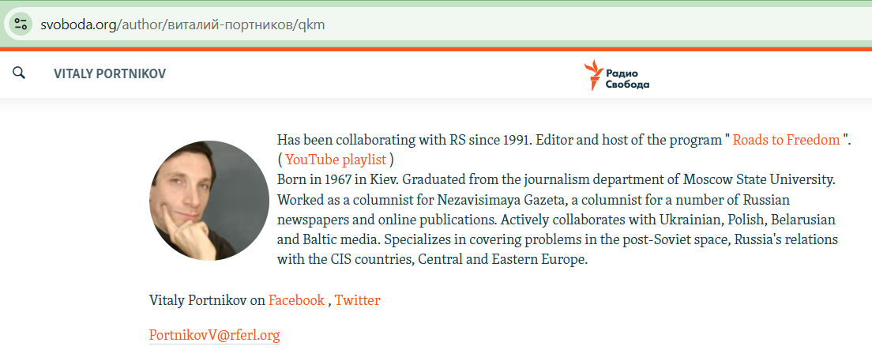

Figure – Vitaly Portnikov's page on the official Radio Liberty official website [2]

Quotes from Portnikov’s interview on July 19, 2024:

“Donald Trump will do as Donald Trump thinks, well, he is such a person. You have seen him. He is a person with an excessive ego who beats in the chest those who try to cover him in photos, literally at protocol ceremonies. He is a person with a rather unhealthy psyche, well, such is the reality, but look what charisma. Look at what. Look at what courage. A person who goes to a meeting with bullets. A person allows us to remember the same politicians of the 1930s, the centenary of Adolf Hitler, Benito Mussolini, …”

“Co-host: ‘- We often hear that there are no figures in world politics who are able to oppose Putin, there is also such an opinion.’ Portnikov: ‘- Oppose Putin? Maybe he can agree with Putin on such terms that Putin will like? Why to him, If the United States wants to leave Europe, they believe that Europe is no longer the center of influence of the United States, that Europe must ensure its own security, and Vladimir Putin claims some unfortunate people there, peripheral states in Eastern Europe. So, what is the dispute between America and Russia about, then? Well, Joseph Biden has a value dispute. He believes that international law should be respected. He believes that the people’s choice should be respected. These are classic liberal democratic values. And if Donald Trump believes that the main thing is, it is America's interests. America's interests are to expand its influence in the Asia-Pacific region, then the focus on this Ukraine in Europe only distracts the Americans from competition with China. So, what should he have a conflict with Vladimir Putin about? Where do they even have the subject of conflict?’” [4]

## Yevhen Dykyi

Yevhen Oleksandrovich Dykyi (born August 28, 1973, in Kyiv) is a Ukrainian scientist, publicist, military officer, and a public figure. He participated in the war in eastern Ukraine in 2014 serving as a deputy platoon commander and was discharged in the summer of 2014. Since February 2018, he has headed **the National Antarctic Research Center** (NARC) which has continued its operation even after the Russian invasion. [5] He is a frequent guest on Radio Liberty. (Figure 2) 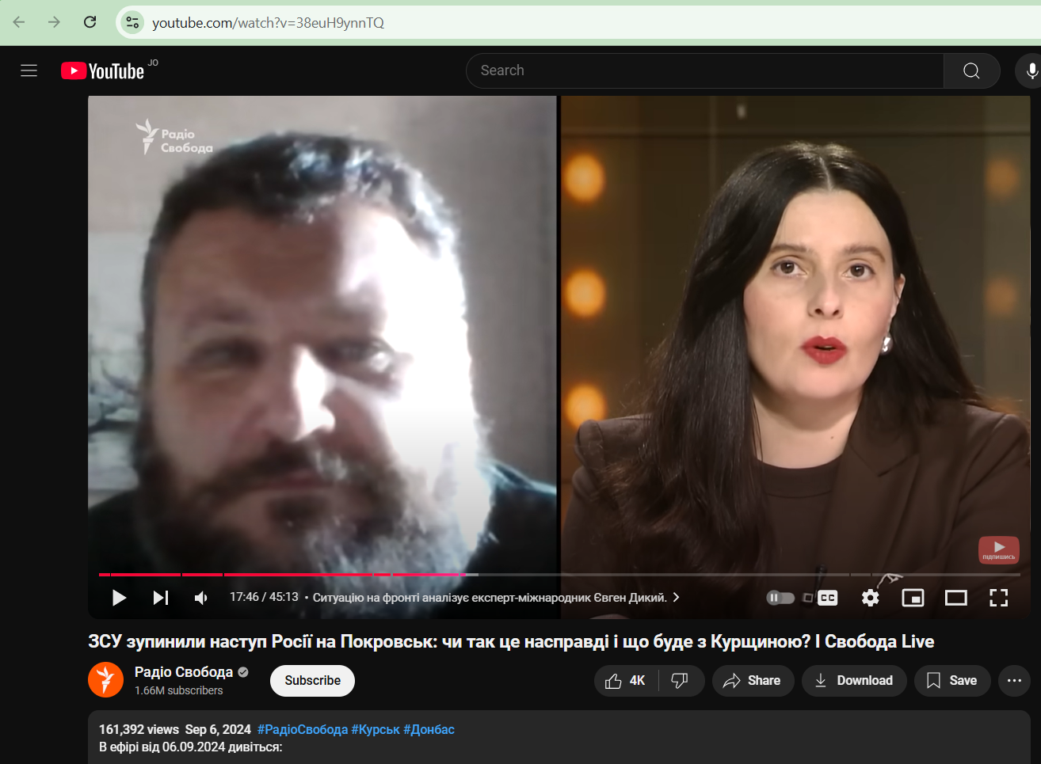

Figure – Yevhen Dykyi's appearance on Radio Liberty as a military expert, Sep 6, 2024 [6]

Below is the passage from his interview to ‘Marathon’, on Jul 14, 2024. ‘Marathon. Straight. Day’ is part of the "Єдині новини" ("United News") information marathon, a collaborative broadcasting initiative. The ‘Marathon’ is coordinated with the involvement of the Office of the President and other state bodies to maintain a unified information policy. [7]

“I'm just saying that yes, judging by everything, we really have a boy who just saw for himself what was happening, saw that it turns out that democratic institutions are not able to protect themselves, that it turns out that there is one person and his supporters, well, roughly speaking, stupid rednecks, by and large, that they can hack democracy, and no one is able to stop this victorious march by legal methods, and so he found the way out that he found for me. By the way, it's very infuriating that no one feels sorry for him. No one publicly tells him that he feels sorry for him. And everyone, on the contrary, specifically emphasizes that it's a pity for that Trumpist who was accidentally killed at this rally. Well, listen, you go to the Führer's rallies, well, be prepared for an anti-fascist to shoot you. That's normal. But the guys really feel sorry for him. The guy sacrificed himself. He tried to save the world. Unfortunately, he didn't succeed, but honor and praise be to him.” [8]

## ATR TV channel

ATR is a Ukrainian TV channel, previously one of three Crimean TV channels broadcasting in Crimean Tatar, Ukrainian, and Russian. Aider Muzhdabaev is a deputy general director there [10]

According to their official website, this project was supported by the Media Development Fund of the U.S. Embassy in Ukraine (Figure 3).

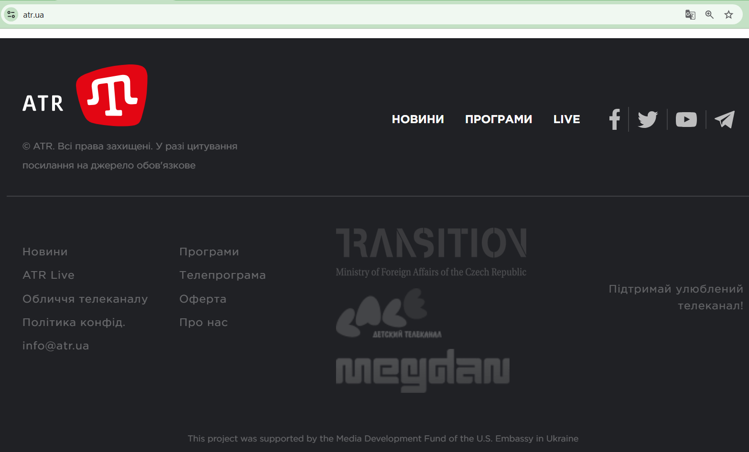

Figure – Key supporters of ATR TV channel, official website [11]

## Aider Muzhdabaev

Ayder Izzetovich Muzhdabayev (Crimean Tatar: Ayder İzzet oğlu Mujdabayev; born March 8, 1972, in Tambov, a city in Russia) is a Russian and Ukrainian journalist and media manager. He was the deputy editor-in-chief of the Moskovsky Komsomolets newspaper (2008-2015), a prominent daily newspaper in Moscow with generally liberal editorial policy during the Yeltsin era; the newspaper’s policy positions have long conformed to Putin’s government values. He was a prominent member of the Union of Crimean Tatars of Moscow, and, since 2015 has served as a Deputy Director General of the first Crimean Tatar TV channel ATR in Kyiv. [12]

Below, we provide excerpts from Muzhdabaev’s interview on October 21, 2024:

“Co-host: ‘- but you think that there is another country that can be compared to the ‘fifty-first’ state? (of USA)’ Muzhdabaev: ‘- Well, Moldova is just a state with a population of somewhere under three million 2-3 million. That’s where the participation of voters is the head of Russian propaganda and where bribery politicians, journalists, bloggers, public figures that’s where having elected in Moldova, I just recorded a video today and posted it on my site, look at it, extrapolate it on every America swing state, how they act, how they will act in America. That is, but the consequences in America can be completely different. I do not know how it is going to end up in Moldova, but the fact, that in America, Trump can raise a riot, and somehow Biden, if he miscalculated so much with the attorney general, we need to prepare for this because we must, there should be some clear answers, an algorithm of actions. I hope that they are sitting there, not counting flies, thinking about something. Because if he then called for storming the Capitol when almost all sane people were in his entourage, except him. Now, when there is not a single one sane in his entourage, I think he will go to all lengths, I think they will blockade the election commissions, they will replace the electors, they will spit on all traditions of the previous American elections. American legislation is written for honest good Christians. Here, there is no smell of good Christians, but there is a smell of fraud with Russian money, and all sorts of manipulation. They, of course, will not recognize the elections. And there are those states where he lost, for example, well, for example, in Pennsylvania or Wisconsin. If it will be of decisive importance, they will arrange such things for you that, I don’t know, Moldova will seem an easy walk.” [13]

## The Outcome of US Support of Ukrainian Media

As is clearly seen from previous chapters, instead of fair and balanced reporting, the Ukrainian media often resorts to one-sided propaganda when describing the U.S. political process:

* Representing Trump as a fascist and a criminal, and even encouraging violence against him, while expressing empathy to his assassin.
* Representing supporters of the Republican party as stupid people without a moral compass.
* Smearing, at the time, presidential candidate Trump and the Republican Party by portraying them as Putin supporters.

The facts above show that the outcome of the U.S. support of Ukrainian journalism is rather far from the goal of creating a fair and balanced media landscape with diverse viewpoints on domestic and international issues. Moreover, U.S. supported media outlets do not appear to have adopted a reasonable journalistic standard both for the content and invited guests and experts who offer their opinions and commentary. So, it is reasonable to conclude that the U.S. support of media in Ukraine is ineffective and deviates from the U.S. mission to develop and support independent unbiased journalism and preserve and increase the civil society’s access to such journalism.

Moreover, the Ukrainian state representatives are yet to condemn the calls for violence against Trump, which occurred in the state-controlled media. This fact reflects very negatively on the government of Ukraine as it appears to be unable to publicly distance itself from calls for politically motivated violence. It is yet another piece of evidence that supports our questioning the rationality of the U.S. financial non-military support of Ukrainian government and media programs.

# US Efforts to help Ukraine fight corruption

## U.S.-supported anti-corruption programs

The anti-corruption programs in Ukraine are run through the Department of State and USAID:

1. One of the State Department’s internal divisions, International Narcotics and Law (INL) Enforcement Affairs Office, is responsible for coordinating and implementing criminal justice and law enforcement reform funded by the Department of State. It implements assistance programs to combat corruption, organized crime, drug trafficking, economic and financial crimes, trafficking in persons, and other criminal activity. [14]
2. The United States Agency for International Development (USAID) is the United States government agency that leads international development and humanitarian assistance efforts to partner countries. USAID’s efforts provide humanitarian assistance, reduce poverty, enhance transparency, and strengthen democratic governance. It runs several anticorruption initiatives, including:

* Anti-Corruption Champion Institutions (SACCI) program. [15]
* USAID and UKAid Anti-Corruption Initiative. [16]
* Digital Transformation of Ukraine. [17]

Since 1992, USAID has contributed more than $3 billion in assistance to Ukraine in total. [24] The Ukraine portion of the 2025 Budget Request for USAID is $482 million. $321 million (of the $482 million requested) is for USAID fully or partially managed accounts to respond to the increased economic, development, and security needs, including bolstering energy infrastructure in the wake of systematic targeting by Russia, improving cyber security, growing the agricultural sector to generate exports, and supporting civil society including activists, journalists, and independent media. [42]

## Ukraine’s organizations involved in fighting corruption

Ukrainian society at large is very familiar with the issue of corruption, and the government was forced to respond to the political pressure to fight it. As part of the government’s response, several agencies within the government were given a mandate to tackle the problem. Many of these agencies are supported and/or work in close co-operation with the State Department’s INL office. We would like to list some of them: the Office of the President, the National Anti-corruption Bureau (NABU), the Ministry of Justice, the Office of the Prosecutor General, the Ministry of Internal Affairs (the Ukraine’s equivalent of FBI), the National Police, the State Border Guard Service, the State Customs Service, and other agencies. [14]

In addition to the government agencies, the civil society responded by creating several non-governmental organizations to tackle corruption on the level of civic engagement and government advocacy. One such organization, the Anti-Corruption Action Center (AntAC) receives a significant portion of its budget from USAID.

The AntAC’s footprint in the anti-corruption fight appears to be large. It is involved in judicial reform having advocated for the creation of the High Anti-Corruption Court which achieved over 200 anti-corruption verdicts since its inception. In addition, it advocated for adoption of laws which govern the anti-corruption law enforcement such as

* establishment of NABU, SAP, HACC, and ARMA,
* criminalization of illicit enrichment and false statements in the declarations of assets of public servants,
* opening the state register of beneficial owners of legal entities because public servants often use relatives and related third parties to register the assets obtained through corruption schemes,
* open access to the state register of property of individuals, and the launch of electronic declaration system.

Also, AntAC lobbied for laws to control procurement for state and municipal entities and prevent corruption schemes in the procurement of medicine. [23]

The Anti-Corruption Action Center (AntAC) receives significant funding from international donors, including USAID. In 2023, USAID's contribution was 19.7% ($199,404) of the total financing of $1,012,208. USAID has been supporting ANTAC since 2014, contributing a total of $4,363,627, which is 20.7% ($1,524,270) of the total financial support. [18]

## Evidence of failure of anti-corruption measures in Ukraine

Given the significant government and civil society’s resources devoted to eliminating or reducing instances of corruption, one could hope that the problem has been largely contained. Unfortunately, compelling evidence exists to the contrary.

## Booming Ukraine Luxury Car Market

In Ukraine, the Luxury Cars Market segment is defined as cars with an average footprint of around 5m2 (54 ft2), a curb weight of around 2200kg (4850 lbs), and a passenger/cargo volume larger than 3.4 m3 (120 ft3). Models in this market segment are Audi A8, BMW 7 Series, Jaguar XJ, Mercedes-Benz S-Class, and Porsche Panamera, etc. [19]

The figure below (Figure 4) highlights the key trends in the luxury car market in Ukraine from 2016 to 2024. Despite the war, the premium automotive sector has shown resilience and significant growth, especially in 2023 and 2024.

“According to Global Euronews, sales of luxury cars in Ukraine broke all sales records for the 2023 calendar year and extended the sales bonanza into 2024. The Association of Automobile Manufacturers of Ukraine noted that 5000 new cars were sold in one month between June-July 2023.” “The publication reported the increase mainly came from a surge in demand for premium models.” [20]

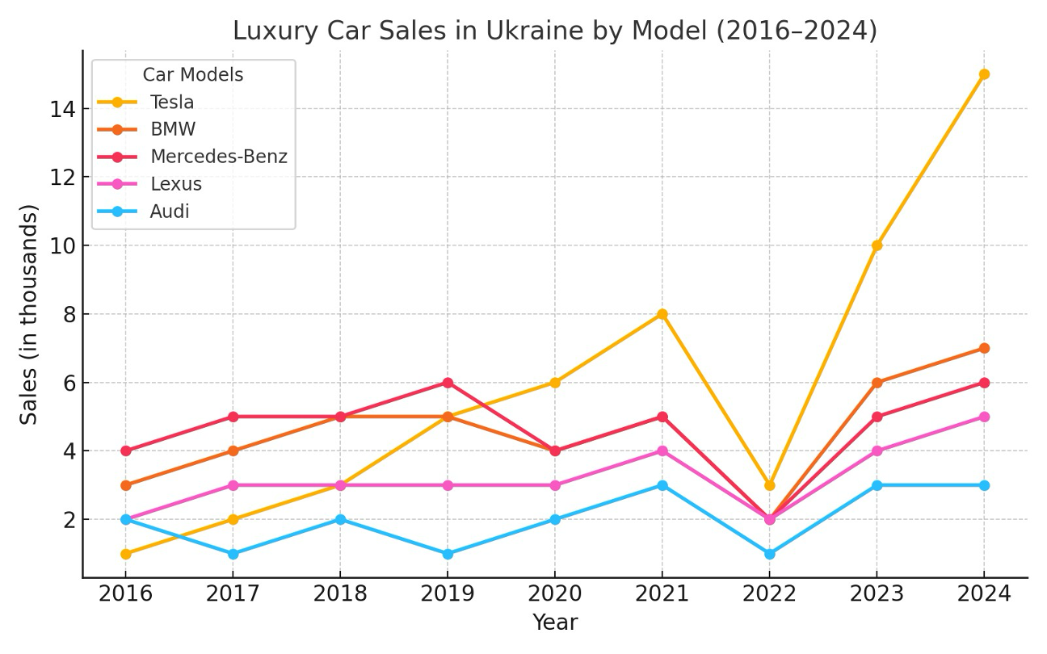

Figure – Luxury car sales in Ukraine [19]

“One of the reasons for this may be the cancellation of the obligation of officials in Ukraine to publicly disclose their assets, which was explained by the military situation and martial law in the country.” [21]

“If so, it is understandable why the president and MPs, under the pretext of war, do not want to disclose the statements of officials to citizens, who may be shocked by what they see”, – commented the portal ‘Our Groshi’.” [21]

“Journalists' investigations have repeatedly shown that it is the government officials and public servants who are one of the drivers of this market. Among them are the family of the head of the Antimonopoly Committee, judges and prosecutors, members of the parliament, and even military recruitment officers.” [22]

“This is unbelievable and provides hard evidence that some Ukrainians are doing quite well while the rest of the country turns to rubble.” “The level of corruption, which has not decreased despite the assurances of President Volodymyr Zelensky, who said at the end of 2022 that all those engaged in corruption had left the country.” [20]

## Military Food Procurement Scandal

On 23 December 2023, the Ministry of Defense concluded an agreement for catering services with LLC “Aktiv Kompani” in the amount of13.16 billion UAH (approx. $482 million) On behalf of the military, the agreement was signed by the head of the state procurement department at the Ministry of Defense Bohdan Khmelnitsky, who had been previously investigated in connection with embezzlement of ammunition supplies. Journalists obtained prices from the food procurement contracts before the war and compared them to the contract which Bohdan Khmelnytsky signed on December 23, 2022. On average, the prices of food items increased by a factor of 1.4. For some items, the prices differed by a factor of 2.4. When the procurement officials pointed out that the differences may be accounted for by delivery costs in wartime, this argument was found to be unconvincing since Ukraine’s front lines in the east are serviced by a well-developed network of roads to justify such cost increases.

In addition, it was pointed out that the catering services company in question, LLC “Aktiv Kompani”, declared about UAH1,000 of capital, a fact pointing to a corruption scheme. Moreover, in 2021, the Ukraine national tax service withdrew the license to operate from LLC “Aktiv Kompani”. In 2019, LLC "Aktiv Kompani" appeared in criminal proceedings of the National Police No. 12019100100003229. The company allegedly submitted a forged document. [25]

Another fact that circumstantially pointed to a corruption scheme was how the prices were quoted. The prices for all items were calculated on a “per kilogram” basis, even for eggs. Such obfuscation clearly makes it more difficult to compare prices between pre-war contracts and the 23 December 2022 contract.

“Speaking at a specially convened session of the parliament, Ukraine’s Minister of Defense Reznikov attempted to justify the price differences by inflation, increased delivery costs in wartime, the requirement to calculate prices on a “per kilogram” basis” “Members of parliament urged to return to transparency even during martial law, to avoid mistrust” The “deputy minister of Defense Viacheslav Shapovalov decided to resign on 24 January 2023”, which was the only outcome from this story. [26]

## Ukraine’s Antarctica Research

The National Antarctic Research Center (NARC) is Ukraine's state operator in Antarctica. It is a state research institution within the Ministry of Education and Science of Ukraine that operates the Ukrainian Antarctic Station "Akademik Vernadsky" and coordinates Antarctic research in Ukraine. Coincidently, Dykyi Yevhen Oleksandrovych, [27], who appears in this report as a key figure of the scandal covered in chapter 2.2.2, also directs NARC. NARC owns and operates at least two ships: the icebreaker "Noosphere" [28] and the ecological monitoring vessel "Boris Alexandrov". [29]

“Akademik Vernadsky” station was founded in 1947 as the British “Faraday Station”. In February 1996, it was transferred by Britain to Ukraine for free. It is financed from the government budget. In 2024, NARC received 557.6 million UAH ($13 million) of state funding to covering the costs of running the station in Antarctica [31] In 2022 and 2023, it received 283 mil UAH ($9 million) and 590 mil UAH ($16 million), respectively. [30] The British ship James Clark Ross was sold to the National Antarctic Scientific Center of Ukraine in August 2021 and became "Noosphere". [28]

On May 27, 2024, a tender under the title "Comprehensive service for logistical support of Ukrainian Antarctic expeditions using the scientific and research oceanographic vessel "Noosphere" (IMO No. 8904496)" was first noticed in the government procurement system “Prozzoro”. The tender was to cover the expedition's expenses for technical equipment, food, and the transportation of scientists.” “The tender worth was $11.6 million.” “Ukrainians on social media expressed outrage at the expenses, which include plans to purchase octopus, salmon, wine, and caviar for the expedition participants.” [32]

“On December 10, 2024, the head of NARC Yevhen Dykyi signed an agreement worth $579,357 with the Estonian company WINOT OU. According to journalistic investigations, WINOT OU is a fictitious company controlled through offshore schemes. Its activities are closely linked to Ukrainian businessmen with tainted reputation such as Andriy Chuklin, who is suspected of numerous corruption scams, and Oleksandr Moshensky, a Belarusian businessman with a questionable reputation.” [33]

The public questions about the rationality of Ukraine's having an active polar research program during wartime were deemed short-sighted, as well as questions about WINOT OU associates’ reputations. [34] There were no signs of any investigations into NARC’s activities and finances till December 19, 2024. [33]

## Musical Instruments and Lego Sets for Bomb Shelters

Department of Education of the Dniprovska District in the City of Kyiv State Administration decided to buy some items for kids to entertain themselves in bomb shelters during the air raids.

At first, on April 20, 2023, an attempt was made to buy a set of six types of drums, 51 items in each type, and 153 sets of hammers (2 pcs.). The purchase was worth 891,174 UAH ($ 24,213). [35] Then, they canceled that purchase and bought Lego (Figure 5)

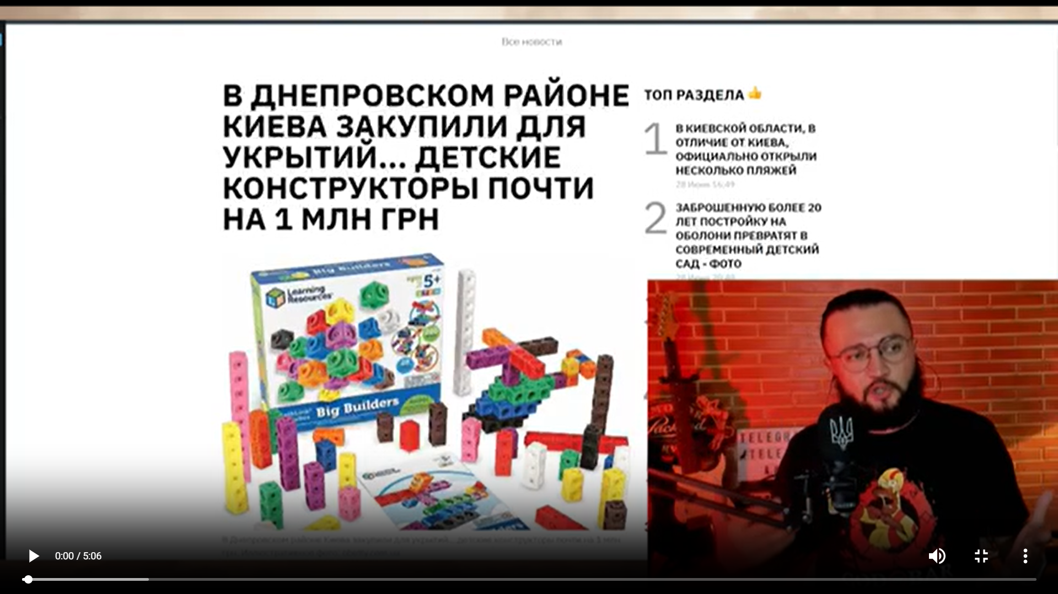

Figure –Andrey Lugansky, the independent blogger on the Lego purchase [36]

The tender contained 113 sets of ‘Wall-mounted construction set’ and 390 sets of ‘Developing mathematical constructor’. The purchase was worth 952,864 UAH ($ 25,889). The contract was finalized on May 03, 2023, but later terminated without any money and goods transferred. [37] Andrey Lugansky also mentioned that the state of most bomb shelters during the time of purchase was inadequate (Figure 6)

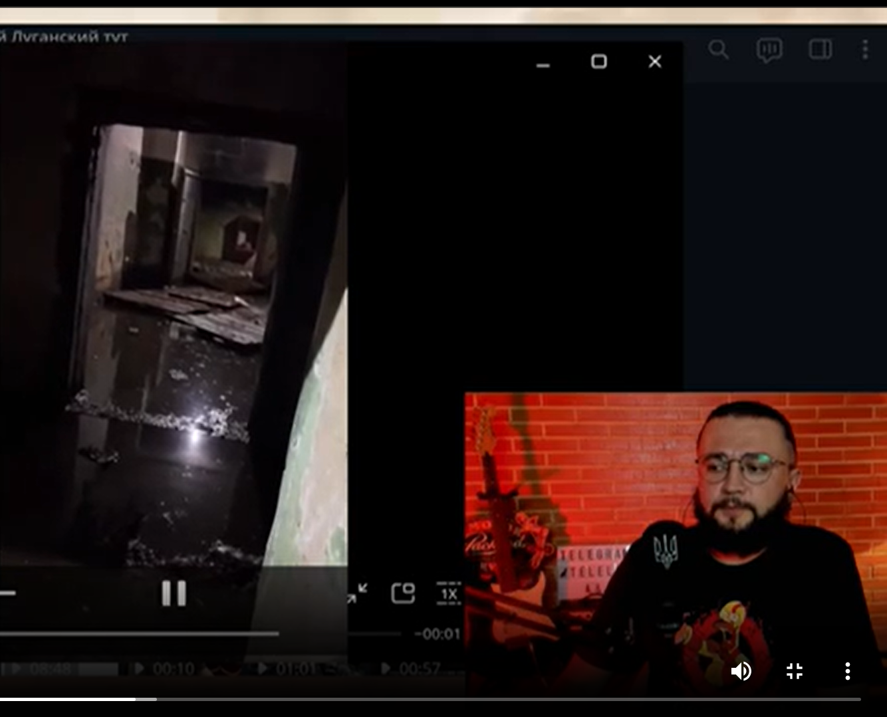

Figure –Andrey Lugansky, shelter on Patsaev Street under the children's play center "Crazy Land" [36]

Another information source confirms Lugansky’s shelter assessment: “The results of the inspections showed that out of more than 4.6 thousand shelters and storage facilities in Kyiv, 65% are suitable. The government stated that only up to 15% of the capital's shelters have no issues.” [38] No investigation was opened regarding either of those tenders.

## Ongoing Steps to Decrease Transparency

A draft of a law is currently being discussed in the national legislature under the title “the Draft Law on Amendments to the Criminal Code of Ukraine to Establish Criminal Liability for Unauthorized Interference, Sale or Distribution of Information Processed in Public Electronic Registries and Strengthening Criminal Liability During Martial Law for Criminal Offenses in the Use of Information and Communication Systems”.

This law will make life harder for journalists and independent investigators because they will soon be obliged to receive approval from authorities to publish data from electronic registers (such as Prozorro). They will face up to eight years in prison in case of violation. The officials explained it by the need to hide information from Russian spies. The law draft was adopted as the basis and went through several hearings in the Ukrainian parliament, the last one took place on December 18, 2024. [41]

While the draft of the law discussed in the paragraph above is still being considered, a different law was passed which may result in stifling criticism directed at government officials. Since January 15, 2025, the date of the law passing, the mass media have been obligated to delete negative comments about officials in the news. It is necessary to delete the comment within 3 days after the complaint. Failure to do so will result in prosecution. The law stipulates that the comments qualifying for removal may be any comments which contain accusations of corruption, violation of the law, or simply "offensive" statements. [61]

## Results of US Involvement in Fighting Corruption in Ukraine

As this report shows, there have been multiple occasions when corrupt bureaucrats got away easily. All cases covered in this chapter received wide public exposure, yet no single person was investigated for his/her acts of corruption, fired, or convicted of a crime.

These facts show the ineffectiveness of US anti-corruption programs in Ukraine. It also shows the lack of determination among Ukrainian officials to fight corruption. Some evidence even suggests that Ukrainian public servants attempt to hide acts of their corruption activities.

This fact also casts a shadow on Ukraine as it does not adhere to the principles of transparency and accountability in government and raises questions about the rationality of the US support of the Ukrainian state.

# Human Rights and Democracy Support in Ukraine

## Human Rights Organizations in Ukraine

USAID grant allocation policy purports to fight restrictive media laws, laws controlling the activity of non-governmental organizations (NGO), and harassment or persecution of civil society activists. There are many human rights organizations in Ukraine which adhere to the principles of a free civil society:

1. Ukrainian Helsinki Human Rights Union provides free legal assistance through a network of public reception centers. It is funded by USAID, the Renaissance Foundation (Soros), the Mott Foundation (Headquarters: Flint, Michigan, USA), Chemonics (Chemonics International is based in Washington, DC), the Martta Ahtisaara Peace Foundation (EU: Helsinki, Brussels), Bureau of Democracy, Human Rights and Labor (DRL) (US Department of State). [47]
2. Center for Civil Liberties has been actively working for the protection of human rights in Ukraine and the OSCE region for 15 years, and is a 2022 Nobel Peace Prize laureate. It is financed by Open Society Foundation, NED, State Department of the USA, SIDA, EUROPEAN COMMISSION, UNDP, SIGRID RAUSING TRUST, USAID, and Building Local Promise. [48]
3. Kharkiv Human Rights Group (KHRG): The mission of the KhPG is to protect human rights and fundamental freedoms from encroachments by the state, as well as to assist the state in establishing and protecting these rights and freedoms. It is funded by the European Union, DIGNITY, USAID, People in Need, Prague Civil Society Center, the US Embassy in Kyiv, and European Prison Litigation Network. [49]
4. ZMINA Human Rights Center: engages in obtaining information about human rights in Ukraine and conducting advocacy campaigns. Its mission is to promote the human rights, the rule of law and the ideas of civil society in Ukraine. It is funded by the US Department of State, UNDP, and the Renaissance Foundation (Soros). [50]
5. NGO "Media Initiative for Human Rights" advocates for changes in government policies and social practices regarding the provision and observance of human rights and freedoms. Its own proclaimed mission is “to change foreign and domestic policy for Ukraine’s integration into the free world. It is funded by the Renaissance Foundation (Soros). [51]
6. The Institute of Mass Information (IMI) is a leading Ukrainian media NGO. IMI is engaged in the preparation of analysts in the field of freedom of speech. It is in partnership with USAID, OSCE, UNESCO, N-ost, and UCBI. [52]

## Human Rights Abuses in Ukraine

As the war kept grinding on without clearly established goals and a feasible path to achieve them, the human toll of war appeared to splinter the Ukrainian society. The Ukrainian government responded to the increased need for manpower by closing the borders for men of conscription age and drafting men against their will, often by taking men into custody in the streets and transporting them to military conscription centers where they are formerly drafted into service. Having been formerly drafted, servicemen must follow the military law and procedures which includes criminal penalties for desertion.

With time, such practices became rife with abuse of power and ultimately split the Ukrainian society into those who could be drafted and those who received an exemption from military service. Soon, many with access to power and money became holders of exemption from military service which was often granted without a legitimate reason. We should note that Ukrainian law provides an exemption from the draft if one’s skills are critical to society elsewhere such as doctors, military equipment designers, repairmen, etc. This divide in society has caused numerous instances of desertion from the military and bribes to be let out of the country. The examples fitting the narrative of the paragraph are discussed in Chapter 4.2.2.

With time, the evidence of numerous occasions when people had suffered from illegal detention, torture, sexual abuse, and beatings in the Territorial Center of Recruitment and Social Support (TCR) became known to the general public. Yet, one of the most egregious instances the martial law overreach took place right at the beginning of the invasion in February of 2022. It is the instance of the so-called “gym concentration camp” organized and run by the main internal security agency of the Ukrainian government called “Security Service of Ukraine” abbreviated as SBU or SSU. We will refer to this agency as SBU in accordance with its Ukrainian acronym.

As discussed in the following chapter, SBU organized and ran an illegal detention center in one of its buildings in Kyiv at 33 Vladimirskaya street. This detention center had existed from February to November 2022, and it was closed due to the political pressure of the civil society when news of it became public.

## SBU Concentration Camp “Gym”

“OHCHR (U.N. Human Rights Office) received credible information from numerous conflict-related detainees and prisoners of war about an unofficial detention facility located in the gym and basement of the central SBU building in Kyiv, where up to 70 persons (mostly men, but also some women) were held at any one time. OHCHR documented that the unofficial detention facility operated from February 2022 until at least November 2022… They were allowed to use toilets three times a day but were given food only once or twice a day; they received water in small quantities. Several interviewees reported being blindfolded for the entire period of their detention, which lasted up to a month.

OHCHR notes that the practice of holding detainees in unofficial detention facilities, where they are not protected by law, appears to have been used to coerce detainees into confessing or making self-incriminating statements, sometimes recorded on camera. Interviewees told OHCHR that the stress and fear caused by isolation and secret detention pressured them to confess to acts they did not commit.

In May 2022, a civilian man was held for seven days in an unofficial place of detention at the local SBU office in Kryvyi Rih, where he was tortured for three days in a row. After receiving the results of a polygraph test that he was forced to take, SBU officers beat him again, hitting him in the head, ribs, and legs. After stripping him, they threatened to cut off his genitals, rape him, and send the video to his children.” [56]

“One of the victims filed a formal crime report with the State Bureau of Investigation (SBI) of Ukraine... The SBI did not initiate a criminal investigation within 24 hours as required, but only five months later, in February 2023, disregarding two prior orders from investigative judges that had required them to act promptly. Following an additional five months of pre-trial investigation, the SBI closed the investigation, asserting a lack of evidence of criminal misconduct.” [55]

One of the victims who went through “gym” was the only witness on whose testimony the charges against Dubinsky are based. Dubinsky claims that he holds evidence of corruption schemes of the Biden family connected to ‘Burisma Holdings’ business affairs in Ukraine. Thus, he interprets the charges against him as political prosecution. [57]

## Abuses of Power in Territorial Centers for Recruitment

Territorial Center for Recruitment is a local recruitment center where the draftees are formally inducted into the military. Having become military servicemen and women, conscripts lose their civilian legal status and abide by military regulations, these conscription centers are often abbreviated as TCR (TCRs).

Below we provide some first-hand accounts of how the conscription takes place at these TCRs. These accounts are translated into English very literally without editing for grammar or clarity to preserve the participants’ experiences as represented by these impressions with as little distortion as possible.

“In the process of mobilization, namely illegal detentions, torture, beatings people, including the death of detainees after such actions at the end of March in Khmelnytskyi TCR is an organization where the mobilization of people is carried out in as a result of torture, a young guy died.” [58]

“The Sambir District TCR is mocking Vadym, who is not yet mobilized, is calm the man was beaten with a pistol grip on the head and not only the trunk Vadym shot several videos, including here he is covered in blood and whispers for help, the man doubting that he could leave the premises alive, left evidence for law enforcement officers.” [59]

## Factual Results of US Democracy Support in Ukraine

Center for Countering Disinformation (CCD) in Ukraine, [54] which is a state body established in March 2021 under the National Security and Defense Council of Ukraine is used to ban political opposition journalists and bloggers, portraying them as ‘Russian propaganda’ [53]. Among those channels banned is ‘dubinskypro’ which is run by Oleksandr Dubinsky. [60]

Many human rights organizations, funded by U.S.-domiciled entities both private and affiliated with the U.S. government, often pay little attention to the totality of human and civil rights and freedoms violations which takes place in Ukraine. These violations take the form of illegal conscription of civilians into the military by taking custody of military-age men in the streets, by physical abuses, beatings, and torture at TCR locations and at the SBU. Often TCR officers are used to suppress the voice of government opposition by threatening to draft those expressing anti-corruption and anti-government views into the military service. In some sense, those with money and power, who have the exemption from the military services, use martial law and mandatory conscription duty as an enforcement mechanism to remain in power.

# Historical Parallels

The situation in Ukraine resembles Finland's situation a century ago. Finland used to be part of Russia till 1917, and Russia temporarily lost control over some of its peripheral territory in both cases. After the defeat in WWI and civil wars, Russia was in the restoration period. The same is true about the defeat in the Cold War (it can be called the first Cold War now) and the disintegration of the USSR. Russia tries to regain control over the peripheral countries after the state of its military and economy allow it to do that. Again, there were military conflicts during both those relatively calm periods.

The effectiveness of both states during conflicts can be assessed on several occasions:

1. The ability to mobilize the army during the conflict.

Finland: 320,000 troops, population: 3.7 million people, corresponding to 8,6 % of the population.

Ukraine: 1,080,000 troops, population:  28 million people (in Ukraine-controlled areas), corresponding to 3,9 % of the population.

1. The long-term defense strategy and building fortifications.

Finland: The Mannerheim Line was a defensive fortification line. During the civil war of 1918, the Finnish government and high command started to develop defense plans to protect against possible attacks from the Soviet Union. The first hundred small bunkers were built in 1920–1924. For reasons of cost, during the first phase of construction these fortifications were made of unreinforced concrete. The Karelian defensive fortifications received considerably more funds and resources from May 1938, as the European situation worsened. [39]

Ukraine: “For the first time, the construction of large-scale defense on the eastern borders was discussed in the summer and fall of 2014.” “However, almost immediately, the initiative was mired in various scandals and anti-corruption proceedings over the embezzlement of public funds.”

“What was done under The Wall project before the start of the full-scale war:

* 403.5 kilometers of 4 by 2 meters anti-tank ditches were dug (instead of the planned 1,134 kilometers)
* 158 kilometers of barbed wire fence were built (instead of 194 kilometers)
* 185 kilometers of rocky roads were built (instead of the planned 1,129 kilometers)”

“Since 2014, the military has managed to build a defense line in the Donetsk region, which, to a greater extent (except in the south), was able to cope with a full-scale invasion.” [40]

1. Territory loss: Finland: 9%, Ukraine: 18% and growing.

This comparison shows the Ukrainian government's comparatively worse performance before and during the war, mainly due to corruption and poorer resource mobilization.

# Incentives for the USA to Help Ukraine

1. A Russian-dominated scenario in Ukraine is likely to lead to Russia launching another campaign to establish its influence in the countries of the former USSR or the Warsaw Pact. This could lead to a further increase in tensions in Europe and between Europe and the United States, deteriorating the USA's position in those regions.
2. Ukraine's possible demilitarization will give Russia access to military technologies that are used by NATO, as well as the newest and battle-proven.
3. The same scenario will demonstrate the United States' weakness as a player in the global political arena. This may encourage bad players, such as China or North Korea, to try to conquer territories that they believe are of interest to them. Russia could redirect its resources to help China get Taiwan, which is a possible scenario.

# Conclusion

As the report shows, there have been numerous instances in which Ukraine’s anti-corruption efforts and U.S. programs designed to support them have been ineffective. In addition, many programs to support democracy and media freedom have ended up as partisan propaganda projects. And, to top it all off, the Ukrainian government does not take its society’s existential war against Russia seriously as evidenced by its weak anti-corruption policies and complete disregard of invasion warnings in February of 2022.

To summarize, the US budget appropriations to Ukraine were misused or even caused direct harm to the United States. Yet, the military defeat of Ukraine is not in the United States' interest. Thus, $482 million, mainly the USAID funds for 2025 FY, as well as USAGM, Department of State, should be redirected from the Ukrainian incapable state to the Ukrainian military to give Ukraine the upper hand in future peace negotiations.

# Appendix A – Information Sources

1. RadioFreeEurope - Ukrainian Service <https://about.rferl.org/service/ukrainian-service/>
2. Vitaly Portnikov - <https://www.svoboda.org/author/%D0%B2%D0%B8%D1%82%D0%B0%D0%BB%D0%B8%D0%B9-%D0%BF%D0%BE%D1%80%D1%82%D0%BD%D0%B8%D0%BA%D0%BE%D0%B2/qkm>

1. [U.S. Embassy in Ukraine](https://ua.usembassy.gov/" \o "U.S. Embassy in Ukraine) - Media Development Fund Program <https://ua.usembassy.gov/education-culture/grants-opportunities/media-development-fund-program/>
2. Trump and Third World (War) | Vitaly Portnikov @gvlua, Jul 19, 2024 (14:50-15:26; 16:04-17:13) <https://www.youtube.com/watch?v=9lmkKwtF7H8>
3. Dykyi Yevhen Oleksandrovych <https://uk.wikipedia.org/wiki/%D0%94%D0%B8%D0%BA%D0%B8%D0%B9_%D0%84%D0%B2%D0%B3%D0%B5%D0%BD_%D0%9E%D0%BB%D0%B5%D0%BA%D1%81%D0%B0%D0%BD%D0%B4%D1%80%D0%BE%D0%B2%D0%B8%D1%87>
4. The Armed Forces of Ukraine stopped the Russian offensive on Pokrovsk: is this really true and what will happen to Kurshchyna? I Svoboda Live, Sep 6, 2024 <https://www.youtube.com/watch?v=38euH9ynnTQ>
5. Television and power. How the telethon works from the inside and who oversees it <https://www.pravda.com.ua/articles/2022/06/21/7353715/>
6. 872-й день війни: ОСТАННІ НОВИНИ з фронту у марафоні
7. Vitaly Portnikov <https://en.wikipedia.org/wiki/Vitaly_Portnikov>
8. ATR (TV channel) <https://ru.wikipedia.org/wiki/ATR_(%D1%82%D0%B5%D0%BB%D0%B5%D0%BA%D0%B0%D0%BD%D0%B0%D0%BB)>
9. ATR TV channel official website <https://atr.ua/>
10. Muzhdabaev, Ayder Izzetovich <https://ru.wikipedia.org/wiki/%D0%9C%D1%83%D0%B6%D0%B4%D0%B0%D0%B1%D0%B0%D0%B5%D0%B2,_%D0%90%D0%B9%D0%B4%D0%B5%D1%80_%D0%98%D0%B7%D0%B7%D0%B5%D1%82%D0%BE%D0%B2%D0%B8%D1%87>
11. WHAT'S IN LIFE? Muzhdabaev & Rashkin | show #65, Oct 21, 2024, <https://www.youtube.com/watch?v=-GJU9evA9FI>
12. U.S. Embassy in Ukraine, International Narcotics and Law Enforcement Affairs <https://ua.usembassy.gov/embassy/kyiv/sections-offices/law-enforcement-section/>
13. Preserving Gains Against Corruption in Ukraine During Wartime <https://www.msiworldwide.com/projects/preserving-gains-against-corruption-in-ukraine-during-wartime/>
14. USAID and UKAid Anti-Corruption Initiative Launches in Ukraine <https://www.dai.com/news/usaid-and-ukaid-anti-corruption-initiative-pro-integrity-launches-in-ukraine>
15. USAID Administrator Announces Intent to Provide $650,000 in Assistance for Digital Transformation <https://www.usaid.gov/news-information/press-releases/jan-18-2023-us-supported-e-government-app-accelerated-digital-transformation-ukraine-now-ukraine-working-scale-solution-more-countries>
16. Financial reporting <https://antac.org.ua/support/#chart-section>
17. Luxury Cars – Ukraine <https://www.statista.com/outlook/mmo/passenger-cars/luxury-cars/ukraine?utm_source=chatgpt.com>
18. Ukraine is Experiencing Record Setting Luxury Car Sales <https://rvivr.com/2024/12/ukraine-is-experiencing-record-setting-luxury-car-sales/>

1. [Global Euronews](https://globaleuronews.com/) <https://globaleuronews.com/2023/08/12/premium-car-sales-soar-in-ukraine/?utm_source=chatgpt.com>
2. Elite Wheels: Why Luxury Car Sales Are Breaking Records <https://epravda.com.ua/rus/weeklycharts/2024/07/10/716457/>
3. Anti-Corruption Action Center (Ukraine) <https://ru.wikipedia.org/wiki/%D0%A6%D0%B5%D0%BD%D1%82%D1%80_%D0%BF%D1%80%D0%BE%D1%82%D0%B8%D0%B2%D0%BE%D0%B4%D0%B5%D0%B9%D1%81%D1%82%D0%B2%D0%B8%D1%8F_%D0%BA%D0%BE%D1%80%D1%80%D1%83%D0%BF%D1%86%D0%B8%D0%B8_(%D0%A3%D0%BA%D1%80%D0%B0%D0%B8%D0%BD%D0%B0)>
4. USAID <https://ua.usembassy.gov/embassy/kyiv/sections-offices/usaid/>
5. Defense's backroom rats "saw" more food <https://zn.ua/ukr/economic-security/tilovi-patsjuki-minoboroni-pid-chas-vijni-piljajut-na-kharchakh-dlja-zsu-bilshe-nizh-za-mirnoho-zhittja.html>
6. Ukrainian army food procurement scandal prompts resignation, transparency drive <https://euromaidanpress.com/2023/01/24/army-food-procurement-scandal-is-much-ado-about-nothing-but-one-thing-needs-to-be-changed/>
7. National Antarctic Science Center <https://uk.wikipedia.org/wiki/%D0%9D%D0%B0%D1%86%D1%96%D0%BE%D0%BD%D0%B0%D0%BB%D1%8C%D0%BD%D0%B8%D0%B9_%D0%B0%D0%BD%D1%82%D0%B0%D1%80%D0%BA%D1%82%D0%B8%D1%87%D0%BD%D0%B8%D0%B9_%D0%BD%D0%B0%D1%83%D0%BA%D0%BE%D0%B2%D0%B8%D0%B9_%D1%86%D0%B5%D0%BD%D1%82%D1%80>
8. Noosphere (icebreaker) <https://en.wikipedia.org/wiki/Noosfera_(icebreaker)>
9. Borys Aleksandrov (research vessel) <https://en.wikipedia.org/wiki/Borys_Aleksandrov_(research_vessel)>
10. Government Funding <https://mon.gov.ua/static-objects/mon/sites/1/budzhet/2024/11/29/zvit-pro-ohlyad-vytrat-derbyudzhetu-v-chastyni-nauk-diyalnosti-akademik-vernadskyy-29-11-2024.pdf>
11. Akademik Vernadsky Station: How much budget money is spent on Antarctic research (updated) <https://www.slovoidilo.ua/2024/05/29/infografika/nauka/stancziya-akademik-vernadskyj-skilky-byudzhetnyx-koshtiv-vytrachayetsya-doslidzhennya-antarktydy>
12. The center headed by Dyky will spend $11.6 million on studying Antarctica <https://tsn.ua/ukrayina/ocholyuvaniy-dikim-centr-vitratit-na-vivchennya-antarktidi-11-6-mln-yak-ce-komentuye-sam-veteran-2587551.html?utm_source=chatgpt.com>
13. Corruption iceberg: new scandalous tender of the National Antarctic Center for $580,000 <https://fakeoff.org/uk/corruption/koruptsiinyi-aisberh-novyi-skandalnyi-tender-natsionalnoho-antarktychnoho-tsentru-na-580-tysyach-dolariv?utm_source=chatgpt.com>
14. A billion hryvnias "for penguins and wine in Antarctica": <https://www.obozrevatel.com/ukr/ekonomika-glavnaya/analytics-and-forecasts/milyard-griven-na-pingviniv-ta-vino-na-antarktitsi-polyarniki-poyasnili-skandalnij-tender.htm?utm_source=chatgpt.com>
15. Musical instruments for psychological relief of children in shelters during air raids <https://prozorro.gov.ua/tender/UA-2023-04-20-004546-a>
16. Lugansky | UNCENSORED, July 1, 2023, They bought a million-dollar construction kit for a shelter <https://t.me/lugatut>
17. Constructors for playing and learning in shelters during air raids <https://prozorro.gov.ua/tender/UA-2023-04-24-006803-a>
18. In Kyiv, leather drums were purchased for shelters for almost 900 thousand hryvnia <https://hromadske.ua/ru/posts/v-kieve-dlya-ukrytij-zakupili-kozhanye-barabany-za-pochti-900-tysyach-griven>
19. Mannerheim Line <https://en.wikipedia.org/wiki/Mannerheim_Line>
20. Why and how is Kyiv building fortifications during third year of full-scale war? <https://global.espreso.tv/russia-ukraine-war-why-and-how-is-kyiv-building-fortifications-in-third-year-of-full-scale-war>
21. Draft Law on Amendments to the Criminal Code of Ukraine <https://itd.rada.gov.ua/billInfo/Bills/Card/43139>
22. The President's Fiscal Year (FY) 2025 Budget Request <https://www.usaid.gov/CJ>
23. About RFE/RL <https://pressroom.rferl.org/about-rfe-rl/>
24. Kiel Institute - Ukraine Support Tracker 2022-24 <https://www.ifw-kiel.de/publications/ukraine-support-tracker-data-20758/>
25. 22 sea containers, 389 railway cars and 220 trucks – such is the scale of the embezzlement of humanitarian aid <https://33kanal.com/news/191727.html>
26. Ukraine Investigations Dashboard <https://oig.usaid.gov/sites/default/files/2024-03/Ukraine%20Investigations%20Dashboard%20for%20FY2024_Q1%20508_1.pdf>
27. Donors and partners <https://www.helsinki.org.ua/donory-ta-partnery/>
28. Center for Civil Liberties <https://ccl.org.ua/about-us/#reports>
29. Human rights in Ukraine <https://khpg.org/1608811514>
30. ZMINA Human Rights Center <https://zmina.ua/>
31. Media Initiative for Human Rights <https://mipl.org.ua/>
32. Institute of Mass Information <https://imi.org.ua/upload/media/2023/07/19/64b7e9995a58c-imi-2022-report.pdf>
33. List of TikTok channels spreading hostile propaganda <https://cpd.gov.ua/announcement/spysok-tiktok-kanaliv-poshyrennya-vorozhoyi-propagandy/>
34. Center for Countering Disinformation <https://en.wikipedia.org/wiki/Center_for_Countering_Disinformation>
35. UNHR - Accountability for violations of rights of conflict-related detainees – point 84 <https://ukraine.un.org/sites/default/files/2023-12/2023-12-12%20OHCHR%2037th%20Periodic%20Report.pdf>
36. UNHR - Detention and prosecution of "collaborators" – points 116, 118, 120 <https://www.ohchr.org/sites/default/files/2023-07/2023-06-27-Ukraine-thematic-report-detention-RU_0.pdf>
37. How Trump's testimony was beaten out in Ukraine <https://www.youtube.com/watch?v=U7Xh-EovMhA&t=49s>
38. shaposhnikov news - Died in intensive care after visiting TCR. New law in Ukraine, Apr 19, 2024 (0:06-0:24) <https://www.youtube.com/watch?v=sxA1Jw6Y2ZM>
39. FIRST WESTERN - STARVED AND BEATEN: details of abuse at the TCR in the Sambir region (0:36-1:09) <https://www.youtube.com/watch?v=N94d8eGo_Sg>
40. Oleksandr Dubinsky <https://en.wikipedia.org/wiki/Oleksandr_Dubinsky>
41. Draft Law on Amendments to Certain Laws of Ukraine on Strengthening Certain Guarantees for the Activities of Media, Journalists, and Citizens on Access to Information <https://itd.rada.gov.ua/billInfo/Bills/CardByRn?regNum=11321&conv=9>