From Rubbish to Resource: Waste-Stream-Specific Scenario Narratives for the Future of Secondary Raw Material Recovery in the EU
Stewart Charles McDowall^{a*}, Carlos Felipe Blanco^{a,b}, and Stefano Cucurachiª
aInstitute of Environmental Sciences (CML), Leiden University, P.O. Box 9518, Leiden, 2300RA, South Holland, The Netherlands
bNetherlands Organisation for Applied Scientific Research (TNO), Princetonlaan 6, 3584 CB, Utrecht, The Netherlands

Abstract (307 words)
Securing the future supply of raw materials—particularly critical raw materials (CRMs)—is essential to sustaining humanity’s well-being. Effective forecasting of this supply requires consideration of secondary raw materials (2RMs) contained in diverse waste streams, alongside primary raw materials (1RMs) extracted from the environment. Given the substantial incertitude and uncertainty inherent to such fortune telling, however, it is prudent to explore a broad range of possible developments. The creation of a set of detailed future scenarios is a valuable strategy to ensure that policy formation and decision-making are well informed.
This paper presents the narrative construction phase of a scenario development process that explored future pathways for waste management and the recovery of SRMs and CRMs up to 2050.
These storylines were developed within the scope of the Horizon Europe-funded project FutuRaM, which aims to establish a methodology, reporting structure, and guidance to strengthen the raw materials knowledge base within the EU and beyond.
Three scenarios—Business as Usual (BAU), Recovery (REC), and Circularity (CIR)—were constructed to reflect divergent political, economic, and technological trajectories. Each scenario consists of an overarching narrative, complemented by detailed qualitative projections regarding the future composition and volume of specific waste categories. The six waste streams considered were Batteries (BATT), Construction and Demolition (C&D), End-of-Life Vehicles (ELV), Mining (MIN), Slags and Ashes (SLASH), and Waste Electrical and Electronic Equipment (WEEE).
The scenario development process employed a structured approach integrating forecasting and backcasting techniques, identification of key drivers and uncertainties, extensive stakeholder engagement, and the creation of coherent narrative storylines grounded in current trends, stated policy goals, and published forecasts.
These narratives provide a valuable foundation for the quantitative modelling of waste generation and material recovery potentials using methods such as life cycle assessment (LCA) and material flow analysis (MFA). In doing so, their utility for decision-making and strategic planning can be further enhanced.

Keywords
Circular Economy, Scenario Development, Storyline Narratives, Backcasting and Forecasting, Waste and Resource Management, Secondary Raw Materials, Critical Raw Materials, European Union, Sustainability, Stakeholder Engagement

Table 1. List of abbreviations
2RM Secondary Raw Material
BATT Waste Batteries (waste stream name)
BAU Business-as-usual (scenario name)
CDW Construction and Demolition Waste (waste stream name)
CE Circular Economy
CIR Circularity (scenario name)
CRM Critical Raw Material
EEE Electrical and Electronic Equipment
ELV End-of-Life Vehicles (waste stream name)
EoL End-of-Life
EoU End-of-Use
EoW End-of-Waste
EPR Extended Producer Responsibility
EU European Union
EU27+4 EU + Iceland, Norway, Switzerland and the United Kingdom
GDP Gross Domestic Product
IAM Integrated Assessment Model
LCA Life Cycle Assessment
MFA Material Flow Analysis
MIN Mining Waste (waste stream name)
R&D Research and Development
RCP Representative Concentration Pathway
REC Recovery (scenario name)
SLASH Slags and Ashes (waste stream name)
SRM Strategic Raw Material
SSPs Shared Socioeconomic Pathways
TRL Technology Readiness Level
UN United Nations
UNFC United Nations Framework Classification for Resources
WEEE Waste Electrical and Electronic Equipment (waste stream name)
WFD Waste Framework Directive

Introduction (2500 words)

Context

FutuRaM aim and scope

Scenario development

Methodology (1000 words)

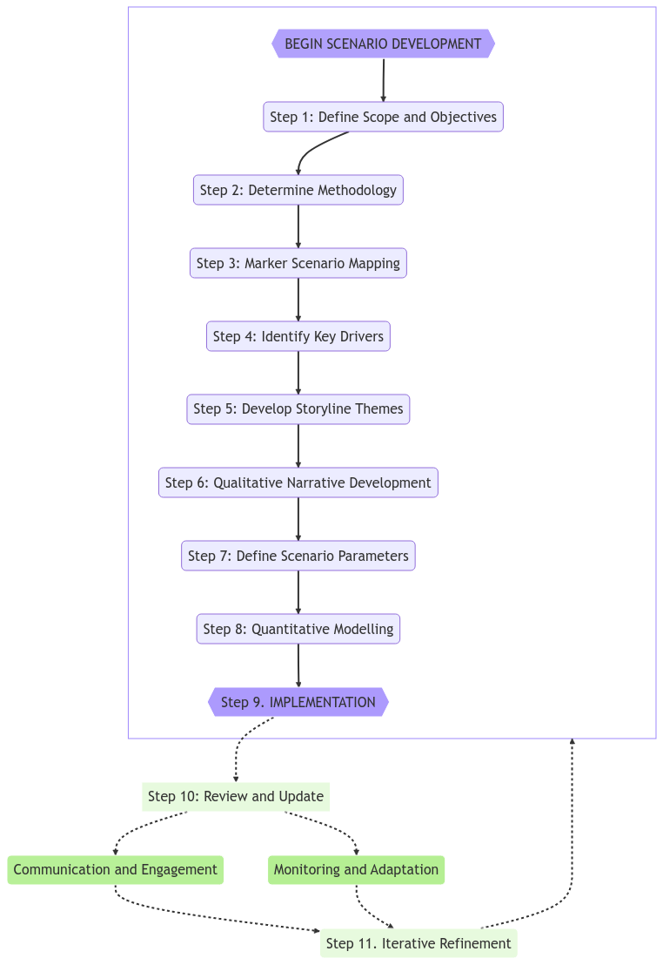
Figure 1: A flowchart representation of the methodology used for the scenario storyline development process in FutuRaM
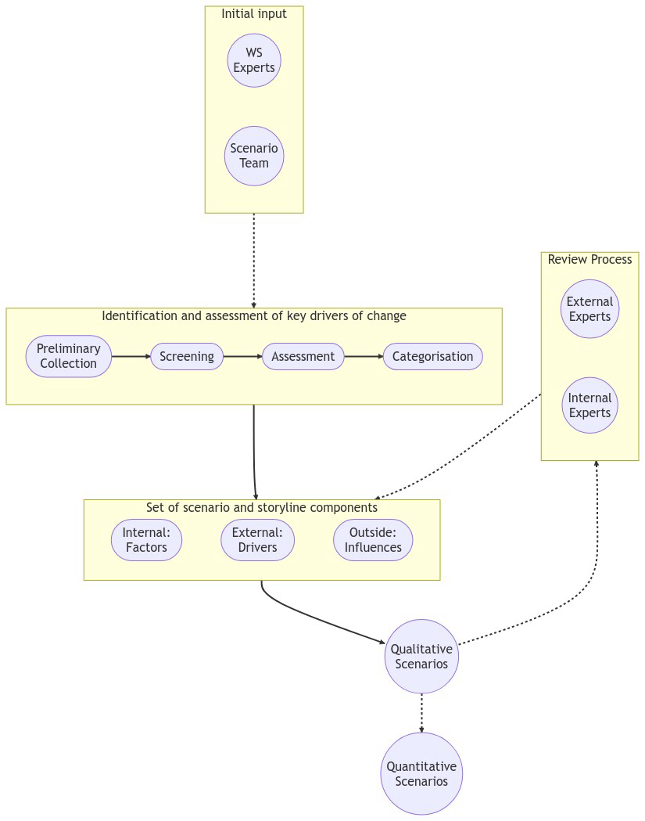
Figure 2: An illustration of the methodology used for identifing, defining, screening, and integrating the key elements of the scenarios developed in FutuRaM

Results (1500 words)
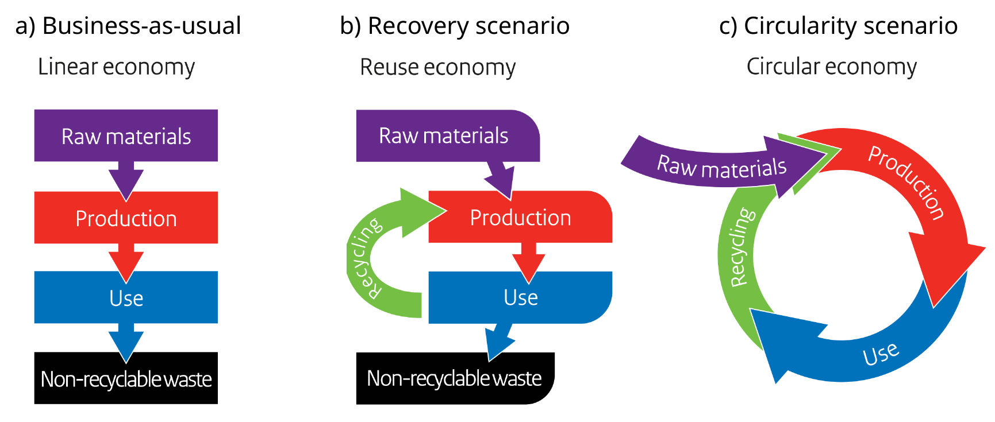
Figure 3: A schematic representation of the three discrete economic models embodied by the three scenarios developed in FutuRaM: a) Business-as-usual (BAU), b) Recovery (REC), c) Circularity (CIR). Adapted from Government of the Netherlands (2016).

Discussion (600 words)

Conclusions (200 words)

Supplementary Material
The supplementary material supplied in the appendices of this manuscript contain the following sections:
- Terminology definitions
- Scenario development methods
- Overview of relevant policy instruments
- Overview of marker scenarios
- Scenario elements identified the initial collection phase
- Drivers and factors identified in the screening phase

Data availability
All data used is publicly available online under the noted sources.

Acknowledgements
This research project was financially supported by the European Union’s Horizon 2020 research and innovation programme under the grant agreement No. 101058522 (project FutuRaM — futuram.eu). The authors would like to acknowledge the many FutuRaM consortium members and stakeholders who contributed to the development of the scenarios presented in this study. The authors would also like to thank the reviewers for their valuable comments and suggestions.

CRediT authorship contribution statement
Stewart Charles McDowall: Conceptualisation, Methodology, Investigation, Data curation, Formal analysis, Validation, Visualisation, Writing: original draft, Writing: review & editing, Visualization.
Carlos Felipe Blanco: Conceptualisation, Methodology, Validation, Writing: review & editing, Funding acquisition, Supervision.
Stefano Cucurachi: Conceptualisation, Methodology, Validation, Writing: review & editing, Funding acquisition, Supervision.
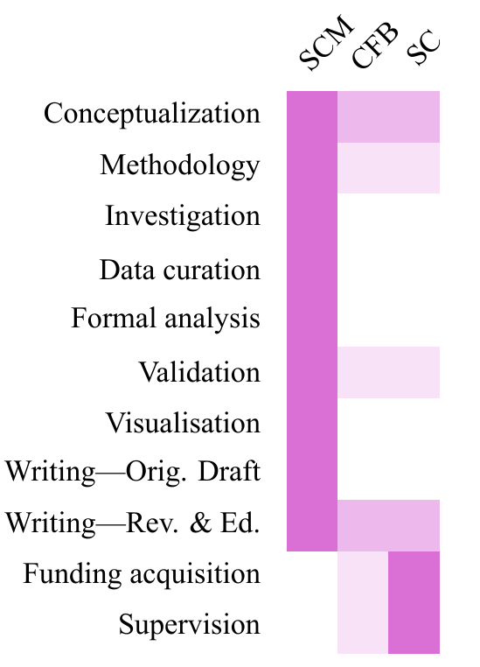
Figure 7: CRediT authorship visualisation

Declarations

Competing interests
The authors declare that they have no known competing financial interests or personal relationships that could have appeared to influence the work reported in this paper.

Open access
This article is licensed under a Creative Commons Attribution 4.0 International License, which permits use, sharing, adaptation, distribution and reproduction in any medium or format, as long as you give appropriate credit to the original author(s) and the source, provide a link to the Creative Commons licence, and indicate if changes were made. The images or other third party material in this article are included in the article’s Creative Commons licence, unless indicated otherwise in a credit line to the material. If material is not included in the article’s Creative Commons licence and your intended use is not permitted by statutory regulation or exceeds the permitted use, you will need to obtain permission directly from the copyright holder. To view a copy of this licence, visit http://creativecommons.org/licenses/by/4.0/.

Use of artificial intelligence
The authors declare that no generative artificial intelligence tools were used in the generation of the research data or results reported in this paper. Generative AI was used solely to assist in the editing and refinement of the manuscript text, with all content reviewed and approved by the authors.

References

Center for Climate Change Adaption Science at the University of Arizona. (2023). Glossary—Scenario Planning for the Institute of the Environment. https://www.adaptationscenarios.org/glossary
Government of the Netherlands. (2016). A Circular Economy in the Netherlands by 2050. https://circulareconomy.europa.eu/platform/sites/default/files/17037circulaireeconomie_en.pdf
Skea, J., van Diemen, R., Portugal-Pereira, J., & others. (2021). Outlooks, explorations and normative scenarios: Approaches to global energy futures compared. Technological Forecasting and Social Change. http://dx.doi.org/10.1016/j.techfore.2021.120736

Appendices

Terminology definitions
Table A1. To promote clarity in the scenario development process, the following set of terminology was defined for use in discussions, reports, and other stakeholder interactions. This glossary was modelled on that of Skea (2021), with additional definitions sourced from Arizona (2023).

Term | Meaning | Context level | Also called | Source
Scenario | An outline or model of an expected or supposed sequence of events. Plausible descriptions of how the future may develop based on a coherent and internally consistent set of assumptions about key driving forces. Plausible futures of a system under different conditions; “scenario’” as a “hypothetical sequence of events constructed for the purpose of focusing attention on causal processes and decision points | Highest level | Pathway, future typology | Arizona, 2023
Normative scenario | Goal-oriented scenario: identify decisions and investments that must be made to achieve desired future outcomes. Example: Constraining cumulative emissions | Scenario type | Backcasting | Skea, 2021
Exploratory scenario | Exploration of plausible alternative developments to test whether decision-making is robust against different outcomes. Generally, involving a qualitative storyline about a possible future, complemented by quantitative analysis. Example: Socio-economic scenarios | Scenario type | Plausible scenarios | Skea, 2021
Outlook | To provide a most likely estimate of future trends as a guide for decision-making | Scenario type | Forecast, projection | Skea, 2021
Scenario characteristics | A combination of the vague attributes that make up the qualitative storyline for a scenario. For example, in WEC (2019) the scenario titled Modern Jazz is described as: “A market-led, digitally disrupted world with faster-paced and more uneven economic growth. Recent signals suggest that this entrepreneurial future might accelerate clean energy access on both global and local scales, whilst presenting new systems integration, cyber security and data privacy challenges” | Scenario description | Qualitative storyline descriptors | Skea, 2021
Scenario scale | Description of the spatial extent or temporal extent of a scenario. For us, mostly EU toward 2050. | Scenario component |  | Arizona, 2023
Scenario dimensions | Uncertainties around which scenarios are constructed, represented as axes in some methods. In our case they might end up being, level of circularity, free-trade/autarky, progress in energy transition | Scenario component |  | Arizona, 2023
Scenario literature | Journal articles, grey literature, etc., from which data is sourced that can be used to justify decisions in scenario development | Scenario component |  | Skea, 2021
Scenario logics | Methods for structuring the relationships between different drivers and assumptions in scenarios | Scenario component |  | Arizona, 2023
Time horizon | End date of the scenario’s forecast | Scenario attribute |  | Skea, 2021
Snapshot | The position of scenario/s at a particular point of time | Scenario attribute |  | Skea, 2021
Storyline and simulation | Combination of qualitative narrative development and quantitative modelling | Scenario component |  | Arizona, 2023
Marker scenario | Generally, a widely accepted scenario which can be used a guide or to provide background information. E.g., SSP1-5, and the GEC models from the IEA. If applicable, these can be extended upon or combined to help build our models. | Scenario description | Basis scenario | Skea, 2021
SSP | Shared Social Pathways. They “describe plausible major global developments that together would lead in the future to different challenges for mitigation and adaptation to climate change. The SSPs are based on five narratives describing alternative socio-economic developments, including sustainable development, regional rivalry, inequality, fossil-fuelled development, and middle-of-the-road development. The long-term demographic and economic projections of the SSPs depict a wide uncertainty range consistent with the scenario literature.” | Marker scenario examples |  | (Intergovernmental Panel on Climate Change (IPCC), 2022)
Drivers | Underlying causes of system change that are external from the system of analysis. They come from higher scales and are not affected by what happens within the system. | Scenario component | Factors | Arizona, 2023
Factors | Causes of system change that are internal from the system of analysis. Can be (hopefully) quantified, or at least estimated | Scenario component (internal) |  | Skea, 2021
Factor variables | Discrete elements which are subject to change and have effects on one or more factors | Factor component |  | Skea, 2021
Factor parameters | Discrete elements which are NOT subject to change (possibly based on assumptions and simplifications) and have effects on one or more factors | Factor component |  | Skea, 2021
Trends | An inclination in a particular direction | Attribute of drivers or factors | System development | Skea, 2021
Likelihood | The likelihood of an occurrence, an outcome, or a result, where this can be estimated probabilistically | Attribute of drivers or factors | Probability | Arizona, 2023
Virtually certain | >99/% probability of occurrence | Attribute of drivers or factors | Probability | Arizona, 2023
Very likely | >90/% | Attribute of drivers or factors | Probability | Arizona, 2023
Likely | >66/% | Attribute of drivers or factors | Probability | Arizona, 2023
More likely than not | >50/% | Attribute of drivers or factors | Probability | Arizona, 2023
About as likely as not | 33–66/% | Attribute of drivers or factors | Probability | Arizona, 2023
Unlikely | <33/% | Attribute of drivers or factors | Probability | Arizona, 2023
Very unlikely | <10/% | Attribute of drivers or factors | Probability | Arizona, 2023
Exceptionally unlikely | <1/% | Attribute of drivers or factors | Probability | Arizona, 2023

Scenario development methods
Table A2. A summary of the methods and tools considered, including a brief description of each and its relevance to the specific context and objectives of the FutuRaM scenario development process.
Method | Description | Key Characteristics
Delphi | Structured expert consultation to gather and distil knowledge and judgments | Iterative rounds of surveys/questionnaires, Expert consensus building
MCA | Decision-support technique to evaluate and rank scenarios based on criteria | Consideration of multiple dimensions in quantifying qualitative factors
Forecasting | Use of historical data and statistical methods to predict future trends | Reliance on quantitative models, Time series analysis
Backcasting | Working backward from a desired future vision to identify necessary steps | Focus on desired outcomes and future targets, Identification of necessary actions
Scenario Planning | Development of multiple future scenarios to understand the range of possibilities | Identification of key drivers and uncertainties, Narrative construction for each scenario
Morphological Analysis | Exploration of different combinations of variables/factors | Matrix-based exploration of variables and combinations
Cross-Impact Analysis | Analysis of interdependencies and interactions between variables/factors | Identification of relationships and cross-impacts
Morphological Box | Systematic exploration of the potential combinations of different components | Identification of component options and combinations
Gausemeier approach | Scenario development method involving the identification of future developments, evaluation of influencing factors, and determination of desired and undesired developments | Systematic analysis of future developments and factors
Schwartz' 8-Step Scenario Model | Scenario building model consisting of eight steps: identify the focal issue, determine the key forces, construct the scenario framework, identify driving forces, assess the uncertainties, develop the scenarios, analyze the scenarios, and monitor and adjust the scenarios | Systematic progression through stages of scenario development
Schoemaker's 10-Step Scenario Model | Scenario building model consisting of ten steps: identify the focal issue, determine the scope, identify the key driving forces, develop the scenarios, define the scenario logic, assess the scenarios, refine the scenarios, examine implications, formulate actions, and communicate results | Emphasis on thorough analysis and evaluation of scenarios

Overview of relevant policy documents
Table A3. An overview of policy actions identified as relevant to the future supply of secondary raw materials (2RMs) in the EU.
Policy | Country | Year | Status | Jurisdiction
European Institute of Innovation and Technology: Raw Materials Project Call | European Union | 2023 | Announced | International
Minerals Security Partnership | European Union | 2022 | Announced | International
Resilience for the future: The UK's critical minerals strategy | United Kingdom | 2022 | In force | National
Circular Economy Action Plan | Spain | 2021 | In force | National
Horizon Europe Strategic Plan (2021 – 2024) | European Union | 2021 | In force | International
National Battery Strategy 2025 | Finland | 2021 | In force | National
National Planning Policy Framework | United Kingdom | 2021 | In force | National
EU Sustainable Batteries Regulation | European Union | 2020 | Announced | Regional
Green Deal: Circular Economy Action Plan | European Union | 2020 | In force | International
Battery fund: 3.2 billion euros for research and innovation | European Union | 2019 | In force | International
Resources for France Plan | France | 2018 | In force | National
European Battery Alliance | European Union | 2017 | In force | National
National Strategy for Energy Research | France | 2016 | In force | National
Horizon 2020: Climate action, environment resource efficiency and raw materials | European Union | 2013 | Ended | International
Resource Security Action Plan | United Kingdom | 2012 | In force | National
Supply of Mineral Resources (SoS MinErals) | United Kingdom | 2012 | In force | National
Finland’s Minerals Strategy | Finland | 2010 | In force | National
Royal Decree 975/2009 about extractive industries waste management and the protection and rehabilitation of areas affected by mining activities | Spain | 2009 | In force | National
EU Directive 2006/66/EC Battery Directive | European Union | 2006 | In force | International

Overview of marker scenarios
Table A4. An overview of marker scenarios identified as relevant to the future supply of secondary raw materials (2RMs) in the EU.

Scenario elements identified in the initial collection phase
Table A5. A list of scenario elements identified in the initial phase of driver/factor collection by FutuRaM stakeholders.

Scenario drivers and factors after the first screening phase
Table A6. A list of scenario drivers and factors that remained after the first screening phase. Reasons for omitting certain scenario elements from further development included: being ‘out of scope’, ‘not specific enough to the waste streams’, or ‘unfeasible for quantification’.

