


nnecting the world and beyond
Advanced Search
About The International Telecommunication Union (ITU)


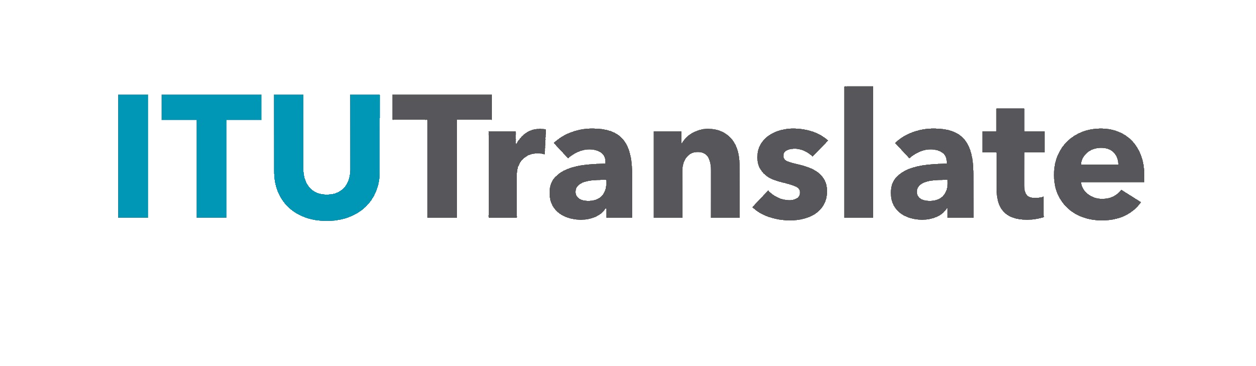
ITU is connecting the world. As the United Nations specialized agency for digital technologies, we are working towards harnessing innovation and connecting everyone to ensure a better future for all.

WHO WE ARE

ITU is the United Nations specialized agency for digital technologies (ICTs). The Organization is made up of a membership of 194 Member States and more than 1000 companies, universities and international and
regional organizations. Headquartered in Geneva, Switzerland, and with regional offices on every continent, ITU is the oldest agency in the UN family – has been connecting people for over 160 years.

WHAT WE DO

We facilitate international connectivity in communication networks. We allocate global radio spectrum and satellite orbits, develop the technical standards that ensure networks and technologies connect seamlessly, and work to improve access to digital technologies in underserved communities worldwide. ITU works to bring digital connectivity to everyone, providing a trusted,
multilateral platform to broker international agreements and standards, share knowledge, build capacity, and work with members and partners to spread access to technology around the world.

WHY WE MATTER

Technology has become the backbone of modern life. Networks and devices everywhere rely on ITU's work. Every time we use a mobile phone, send an e-mail, access the Internet, watch TV or streaming services, take a plane, consult the weather forecast, or use satellite images to navigate or explore, we are relying on ITU's work. 2.2 billion people, largely in developing countries, remain unconnected. ITU works to close this digital divide through universal connectivity and sustainable digital transformation.


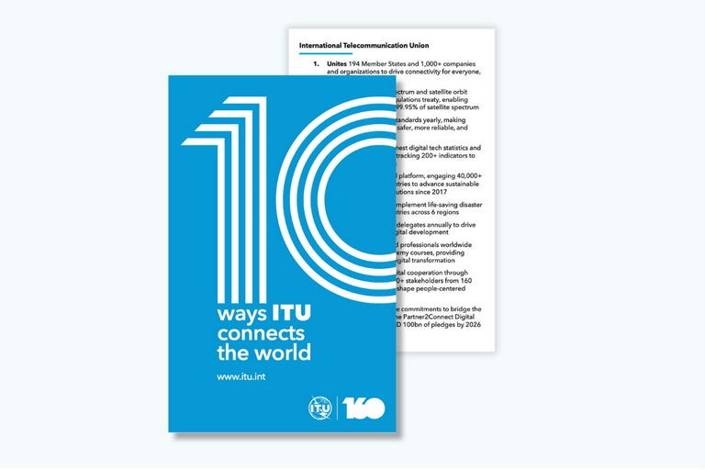


ITU Management team
ITU Member States from around the world elected the Organization's top five officials during the 21st Plenipotentiary Conference.
Meet the team

10 ways ITU connects the world
Discover how ITU drives global connectivity, innovation, and digital cooperation to build a digital future for all.
Download the card
2025 year in review
As the digital landscape evolves, ITU continues shaping the future for the good of everyone.
Check out the highlights

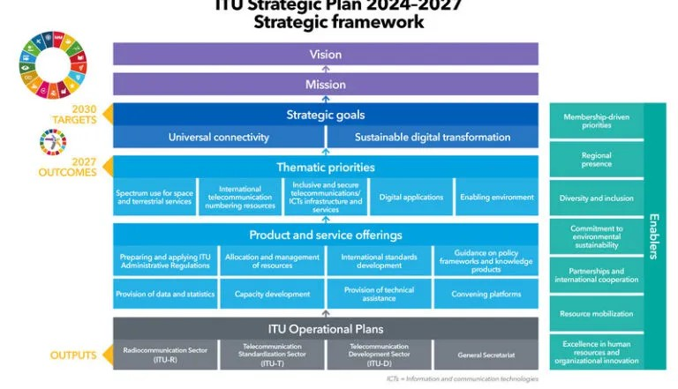

ITU Strategic Plan 2024-27
ITU Member States have set two clear strategic goals for the Union for 2024 to 2027: universal connectivity and sustainable digital transformation.
Learn more



Organizational entities

Visit by UN Secretary-General António Guterres for ITU Council 2024
ITU had the honour of welcoming UN Secretary-General António Guterres on 12 June 2024.
Learn more

General Secretariat




Radiocommunication

Standardization

Development



Not a member yet?
With 194 Member States and over 1000 Sector Members, ITU is a powerhouse in the world of technology. Join ITU as a member to have a direct voice in the decisions impacting your business, organization, or economy.

Learn more

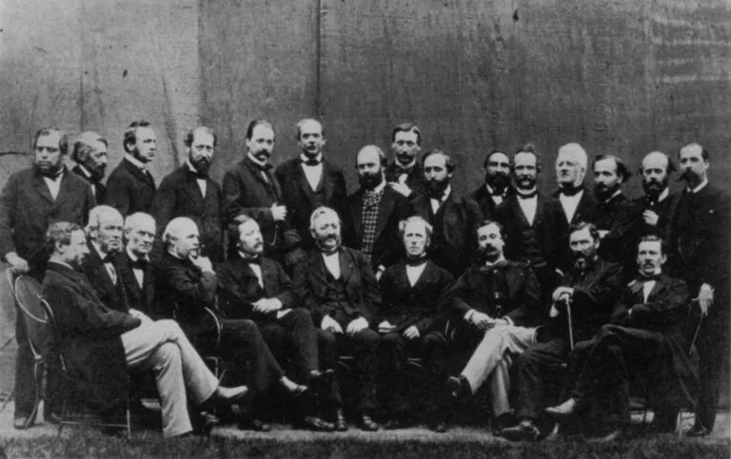
Data protection
ITU history
ITU's story is one of innovation. Established in 1865 to manage the first
international telegraph networks, ITU has worked ceaselessly since then to connect the world. Over the years, the Union's mandate has expanded to cover the invention of voice telephony, the development of radiocommunications, the launch of the first communications satellites, and most recently, artificial intelligence and metaverse.

Visit the History of ITU Portal
The protection of personal data has become increasingly crucial for intergovernmental organizations in general, the organizations of the United Nations system, and ITU in particular. Read more. ITU is committed to protecting the personal data it processes and respecting the right to privacy of individuals. ITU adopted its own Data Protection and Privacy Policy in 2023. For any questions or requests concerning the processing of your personal data by ITU, please contact here.

© ITU 2026 All Rights Reserved Back to top

