IAM Team Knowledge
UI Vocabulary and Conventions for Web Interfaces
Jack Stewart · IAM Engineer
April 25, 2026

Keywords: UX vocabulary, web UI, interface design, web development, frontend, design language, IAM Toolbox, internal applications, React, sidebar, content column, card, dropzone, table, controls.

Purpose
This document gives the IAM team a shared vocabulary for describing the visual and structural elements of web interfaces. Precise vocabulary turns vague feedback ("the thing on the left needs to be bigger") into actionable instructions ("the navigation sections in the left sidebar need wider link rows"), and is intended for use across both internal IAM tooling and any external-facing web applications the team builds or reviews. The reference is grounded in standard HTML and UX terminology, so adopting it does not require the team to invent its own language — only to converge on the language the field has already settled.

Background
The IAM team builds and maintains a growing portfolio of React and TypeScript applications, including the IAM Toolbox, the UNT Directory App, and the DSTools Azure replacement. As more frontend work moves through the team, the cost of imprecise communication compounds: a designer says "button," an engineer hears one of five things, and the implementation drifts from intent. This document was assembled while annotating a knowledge wiki that follows the same layout patterns as the IAM team's apps, then generalized so the vocabulary applies across team projects.
The terms here are drawn from established UX and HTML conventions, not invented. "Sidebar," "hero," "breadcrumb," "card" — these are the words designers and developers actually use in industry. Adopting them is less about creating new language and more about leveling-up to the language that already exists.

Content
The vocabulary moves from larger to smaller: first the page-level skeleton, then components within those regions, then individual controls, then spacing and positioning terms. Use the most specific term that fits the situation. "Field" is fine when type doesn't matter; "text input" is the right word when it does.

Page-level anatomy
Every page in a typical web application is built from the same handful of regions. The screenshot below shows the landing page of an internal knowledge wiki with the major regions identified. The same vocabulary applies to nearly any page in the IAM Toolbox, the Directory App, or comparable internal tools.
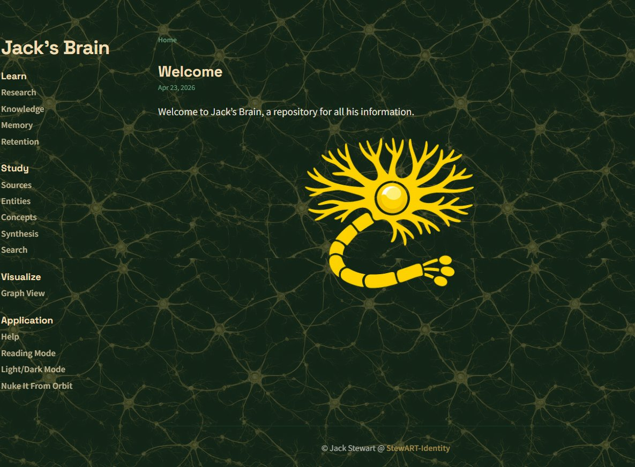
Landing page anatomy: sidebar (left column, including masthead and nav sections), content column (right side, including breadcrumb, page title, metadata, and body), and footer (the small line at the bottom).
Layout regions — the page-level skeleton:
Viewport — The browser window itself. "The whole viewport" means everything visible on screen.
Sidebar — A vertical column of navigation, typically on the left. A page can have one, two, or no sidebars.
Content column — The central area where the main article or page content lives. Also called the main area or primary content.
Footer — The bottom strip of the page, typically containing copyright, attribution, or supplementary navigation.
Gutter — Empty space between columns, or outer margins. Useful when discussing whitespace specifically.
Hero — A large visual at the top of a page intended to set tone or identity. "Hero image" is the most common form.

Sidebar parts
The sidebar in the screenshot above is composed of several parts. From top to bottom: the masthead ("Jack's Brain"), four nav sections (Learn, Study, Visualize, Application), each containing individual nav links.
Masthead — The top area of the sidebar with branding (e.g., the application name or logo). Functions as the application's "name tag."
Nav section — A grouped set of links under a header. Each section heading ("Learn", "Study", etc.) starts a new nav section.
Section heading — The bold label at the top of each nav section.
Nav link — A single clickable row inside a section.
Section divider — The horizontal line between nav sections, visually separating groups.

Content column parts
The content column has its own internal structure: a breadcrumb, a page title, optional metadata (date, tags, reading time), and the body where prose, tables, images, and embedded interactive elements appear.
Breadcrumb — The trail at the top showing hierarchical position (e.g., "Home › Learn › Research"). Also called a breadcrumb trail.
Page title — The main page heading. Technically an "H1" in HTML terms.
Metadata — The small descriptive line beneath the page title (date, tags, reading time). Also called a "byline" or "post meta."
Body — Everything inside the content column below the title — prose, tables, images, embedded interactive elements.

Components and composite UI
Beyond the basic regions, most applications assemble simpler controls into named composite elements. The Knowledge page below is a clear example: four cards stacked vertically, each containing different input modalities (file upload with a dropzone, paste-text with a textarea, paste-URL with an input row, and paste-YouTube-URL with the same pattern as Paste URL).
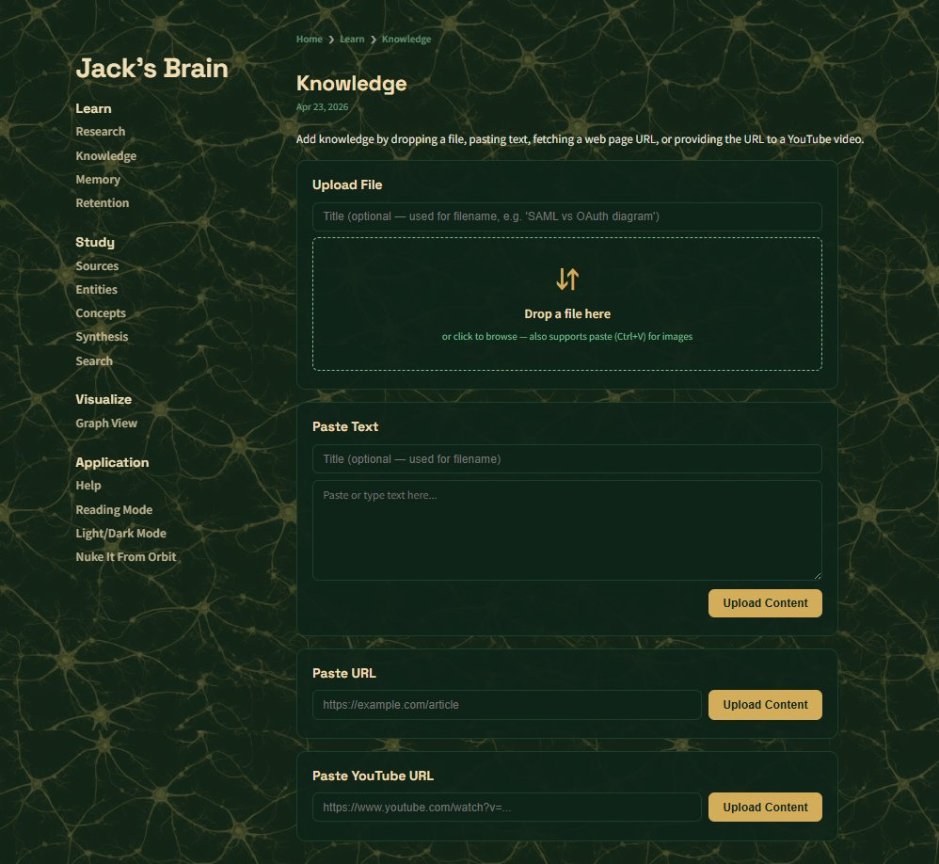
Knowledge page: four cards stacked vertically. Each card has a card heading, one or more text inputs, and a primary button. Card 1 also includes a dropzone (the dashed-border drop target).
Card — A bordered, rounded container that groups related content or controls. The IAM Toolbox uses cards for many of its forms (e.g., "Upload File," "Paste Text").
Card heading — The H3 at the top of each card (e.g., "Upload File"). Sometimes called a section label.
Dropzone — A dashed-border drop target that accepts file drops, paste events, and click-to-browse. Distinct from a text input.
Input row — A horizontal arrangement of an input and a button, typically with the input flexing to fill space and the button fixed-width.

Form controls
Use the specific term when the type matters. "Field" is acceptable casual shorthand when it does not. The Research page below shows four distinct controls in a single card: a textarea (for the question), a number input (for the result count), a checkbox (for the rank-with-Claude toggle), and a primary button (the green Search button).
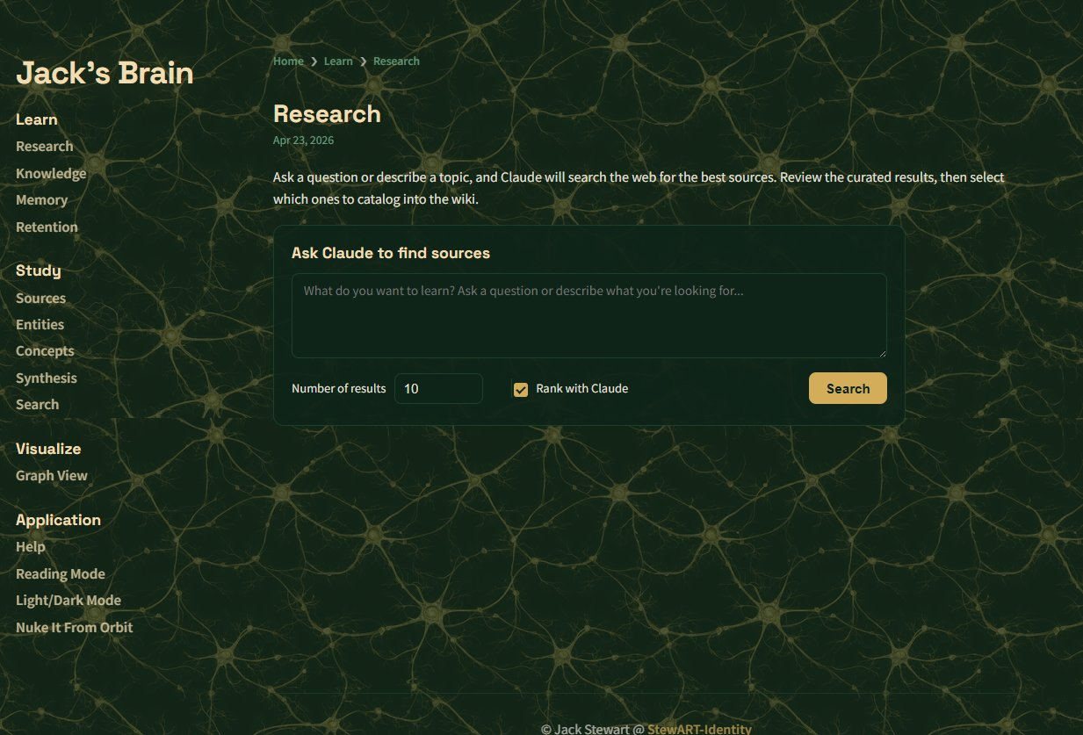
Research page: four controls demonstrate the form-control vocabulary. The large multi-line area is a textarea. The narrow numeric box is a number input (sometimes called a spinner). The square checkbox accepts a boolean value. The amber Search button is the card's primary button.
Text input — A single-line text-entry control. Used for names, titles, URLs.
Textarea — A multi-line text-entry control. Used for paragraphs, code blocks, longer prose.
Number input — A numeric-entry control with up/down spinner buttons. Sometimes called a spinner or stepper. Appropriate only for narrow bounded ranges where the user is likely to adjust by one or two steps from the default.
Dropdown / select — A clickable control revealing a list of mutually-exclusive options.
Checkbox — A square toggle for boolean values (checked or unchecked).
Toggle switch — A pill-shaped slider control for boolean values. Distinct from a checkbox in styling and animation; both express the same data.
Radio button — A circular selector that is one of a mutually-exclusive group. Choose at most one.
Label — Text describing the purpose of an input. Should sit visually adjacent to the input it labels.

Buttons, badges, and tables
Buttons come in several flavors of prominence; tables structure data; badges convey status. The Retention page is a small but vocabulary-rich example: it has an icon button (the refresh ↻ in the upper right), a three-column data table, and a status badge ("CATALOGED") in the rightmost column.
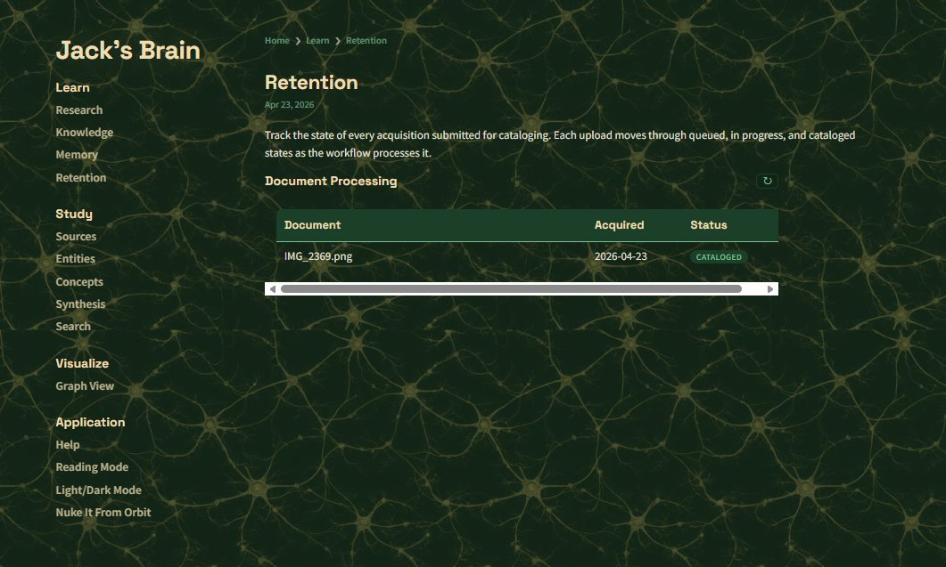
Retention page: an icon button (refresh ↻) sits to the right of the section heading. The table below shows a header row with three columns and one body row, ending in a status badge.
Primary button — A filled, high-prominence button reserved for the main action of a card or form (e.g., "Submit," "Search," "Upload Content").
Secondary button — A less-prominent button (often outlined or text-only) for supporting actions like "Cancel" or "Reset."
Icon button — A small, square button containing only an icon (e.g., a refresh ↻ button). Lower visual prominence; suited to auxiliary actions.
Badge — A small rounded tag that conveys status (e.g., "CATALOGED," "IN PROGRESS"). Sometimes called a pill when purely decorative.
Callout — A boxed aside that visually stands out from the surrounding flow, used to draw attention to important context (warnings, tips, notes).
Table — A standard tabular layout with a header row and body rows. The header row uses <th> cells; body rows use <tr> with <td> cells.

Spacing and positioning
When discussing layout adjustments, these terms help differentiate between space inside a container, space between siblings, and the constraints that govern overall sizing.
Max-width — The maximum allowed width of a content container on large screens. Establishes "comfortable reading width" — too narrow feels cramped, too wide reduces readability.
Breakpoint — A screen width at which the layout changes (e.g., a sidebar collapses to a hamburger menu below 800px).
Padding — Space inside a container, between its border and its content.
Margin — Space outside a container, between it and its neighbors.
Gap — Spacing between siblings inside a flex or grid layout (e.g., spacing between cards stacked vertically).

Practical application
Vague feedback creates rework. Precise feedback enables direct fixes. Compare:
Vague: "The thing with the file stuff feels too tight."
Precise: "The textarea inside the Paste Text card needs more vertical padding, and the dropzone above it could be shorter to give the page better rhythm."
When reviewing a UI or filing a bug ticket, the discipline is the same as in technical writing elsewhere: identify the smallest unit at fault, name it correctly, and describe what should change about it. The vocabulary above gives the team a shared starting point for that discipline.

Underlying principle
Most communication problems in interface design are not about taste or judgment — they are about not having a shared word for what is in front of both people. Adopting standard vocabulary closes that gap. The team does not need to invent its own terms when the field has already settled them.

