Instructions
- Log in to dsnr-idpr-app01
- Open Designer as an Administrator.
- For each of the HSCAD, UNTAD, and UNTADSTU drivers:
- Delete the driver from the Designer project.
- Import the driver from I:\changes\drivers\CHG0038717\DRIVER.xml
- Accept all defaults.
- When the import process is complete, select OK.
- Right click the driver, then click Live, Compare.
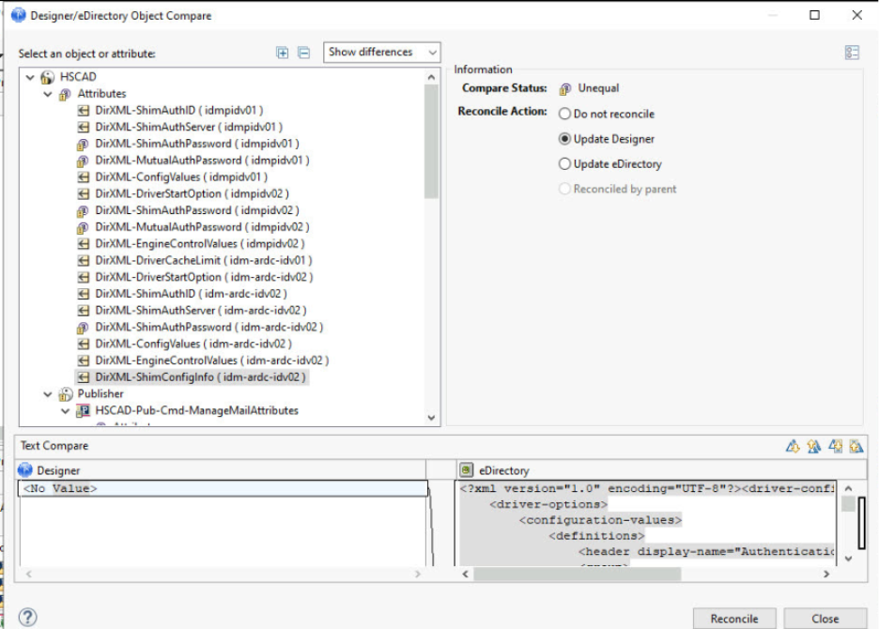
- Under Attributes, select the left-most icon for each item except for the for any attribute containing the word Password.
- Select Reconcile.
- Right click the driver, then click Live, Deploy.
- Select the Deploy button.
- When the deploy process is complete, select OK.

