
ALMA v2
Account Lifecycle Management Application
Technical Reference
Jack Stewart
IAM Architect/Engineer
March 16, 2026
UNT System · IAM

Introduction
ALMA (Account Lifecycle Management Application) v2 is a Python-based system that automates the deactivation and reactivation of user accounts across the UNT System identity infrastructure. It manages accounts for 72,000+ users across eDirectory (IDTREE), three Active Directory domains (HSC, STUDENTS, UNT), and Cisco Duo MFA.
ALMA operates on iam-script-gab and orchestrates all directory and service operations through the iam-apis FastAPI service on iam-app-gab over HTTPS (port 8443). ALMA never writes directly to Active Directory or Duo; all operations are mediated through the API.
System architecture
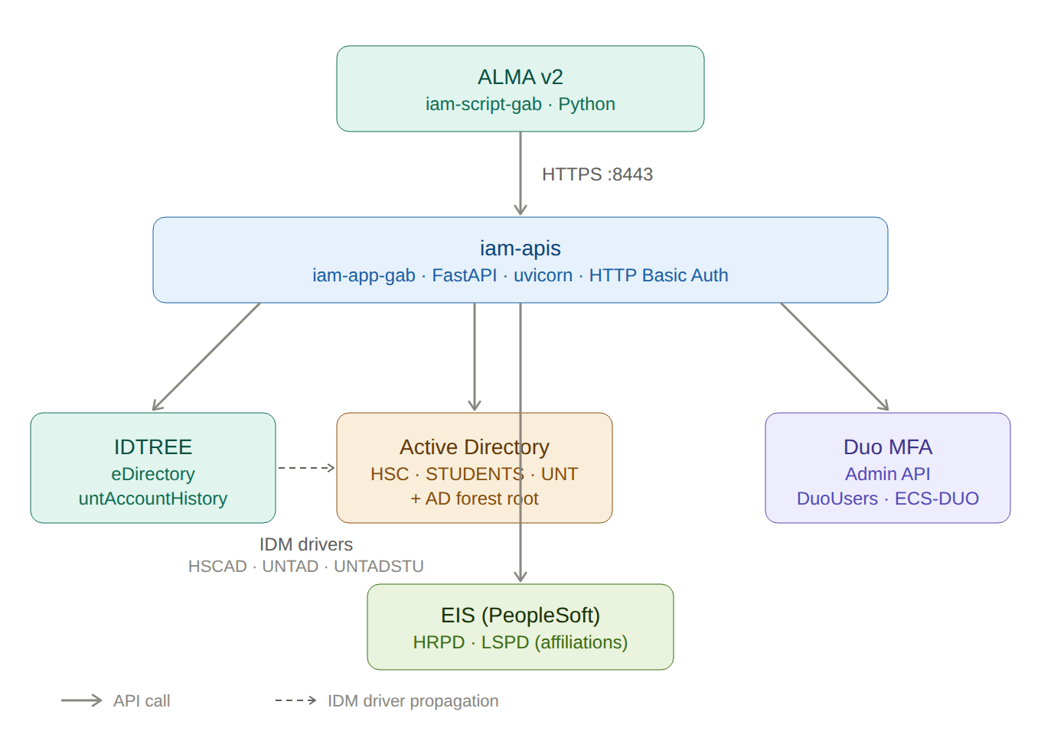
Figure 1 — System landscape. Dashed arrow indicates IDM driver propagation.
The iam-apis service provides HTTP Basic Authentication against eDirectory and exposes discrete endpoints for each phase of the lifecycle workflows. EIS (PeopleSoft) databases are queried for affiliation checks during eligibility determination.
OpenText Identity Manager drivers
Three IDM drivers (HSCAD, UNTAD, UNTADSTU) synchronize identity state from eDirectory to Active Directory. When untAccountDisabled is set to Y in IDTREE, the change event fires on each driver’s subscriber channel. The DeactivateAccounts output transformation strips the event down to dirxml-uACAccountDisable=true and description, preventing extraneous attributes from leaking into AD.
The VetoADNoSyncEvents event transformation reads the untAccountADNoSync attribute. If the user’s domain appears in that CSV list, the event is vetoed — blocking all subsequent synchronization. This prevents unintended account recreation in AD.
Planned driver cleanup
A one-time modification will remove Login Disabled and untAccountEnabled from the driver filter and output transformation policies. This localizes loginDisabled to IDTREE (where it governs eDirectory authentication) and makes untAccountDisabled the sole signal that flows through the drivers to Active Directory.

API endpoints
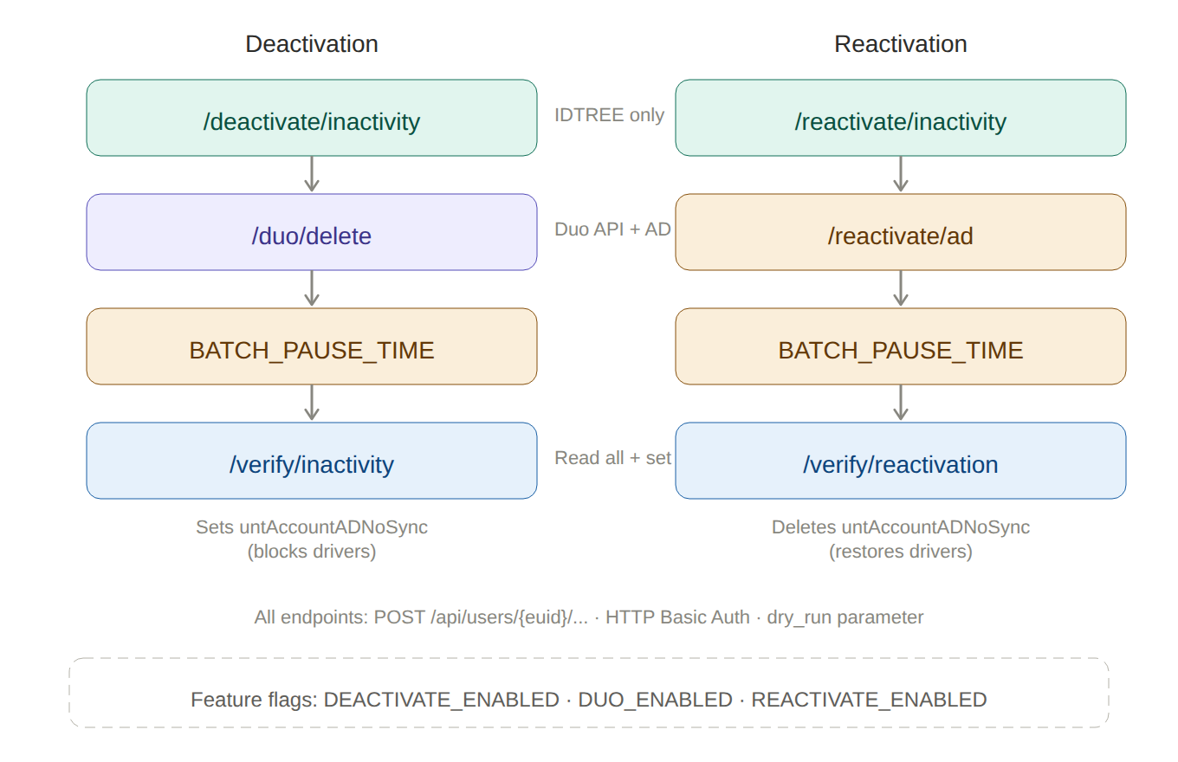
Figure 2 — Endpoint map showing deactivation and reactivation flows side by side.
All endpoints follow the pattern POST /api/users/{euid}/... and accept a dry_run query parameter.
Deactivation endpoints
- /deactivate/inactivity — Sets IDTREE disable attributes, appends to untAccountHistory
- /duo/delete — Deletes Duo account, removes from DuoUsers (UNT) and ECS-DUO-Users (AD root)
- /verify/inactivity — Reads all systems; if verified, sets untAccountADNoSync=HSC,STUDENTS,UNT
Reactivation endpoints
- /reactivate/inactivity — Deletes IDTREE disable attributes, sets untAccountDisabled=N, appends history
- /reactivate/ad — Clears uAC bit 2, sets description to “givenName sn” in HSC/STUDENTS/UNT
- /verify/reactivation — Reads all systems; if verified, deletes untAccountADNoSync

Deactivation workflow
The deactivation process follows a “trust but verify” model. IDTREE attributes are set first, the IDM drivers are given time to propagate, and only after verification succeeds is synchronization locked down.
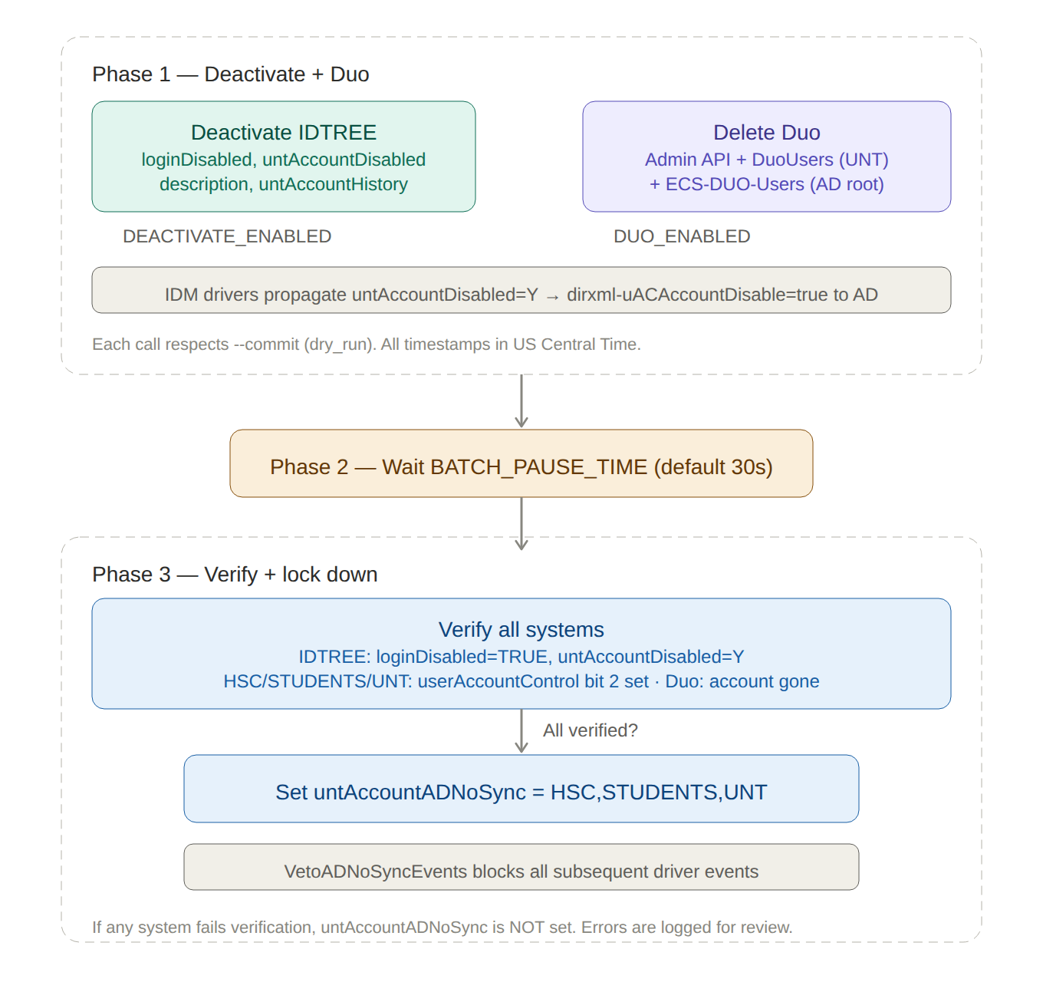
Figure 3 — Three-phase deactivation workflow.
Phase 1 — Deactivate + Duo
For each user, ALMA makes up to two API calls, each gated by a feature flag:
- IDTREE deactivation (if DEACTIVATE_ENABLED): Sets loginDisabled=TRUE, untAccountDisabled=Y, untAccountDisabledDate, and description. The description field contains the same text as the untAccountHistory entry (e.g., “ALMA: Deactivated 2026-03-16 09:15:22 (742 days inactive)”).
- Duo deletion (if DUO_ENABLED): Deletes the user from the Duo Admin API, removes from DuoUsers in the UNT domain and ECS-DUO-Users in the AD forest root.
Phase 2 — Wait
ALMA pauses for BATCH_PAUSE_TIME seconds (default: 30) to allow the IDM drivers to propagate the deactivation to AD. This is separate from BATCH_WAIT_SECONDS, which controls inter-batch pacing within Phase 1.
Phase 3 — Verify and lock down
ALMA calls the verification endpoint, which:
- Reads IDTREE to confirm loginDisabled=TRUE and untAccountDisabled=Y
- Reads HSC, STUDENTS, and UNT to confirm userAccountControl bit 2 is set
- Checks Duo to confirm the account no longer exists
Only if all five systems are confirmed deactivated does the endpoint set untAccountADNoSync=HSC,STUDENTS,UNT. The VetoADNoSyncEvents policy then blocks all subsequent events from reaching AD.

Reactivation workflow
Reactivation mirrors deactivation with one key asymmetry: because untAccountADNoSync is still set (blocking the IDM drivers), AD accounts must be re-enabled directly. The nosync flag is deleted only after verification confirms all systems are active.
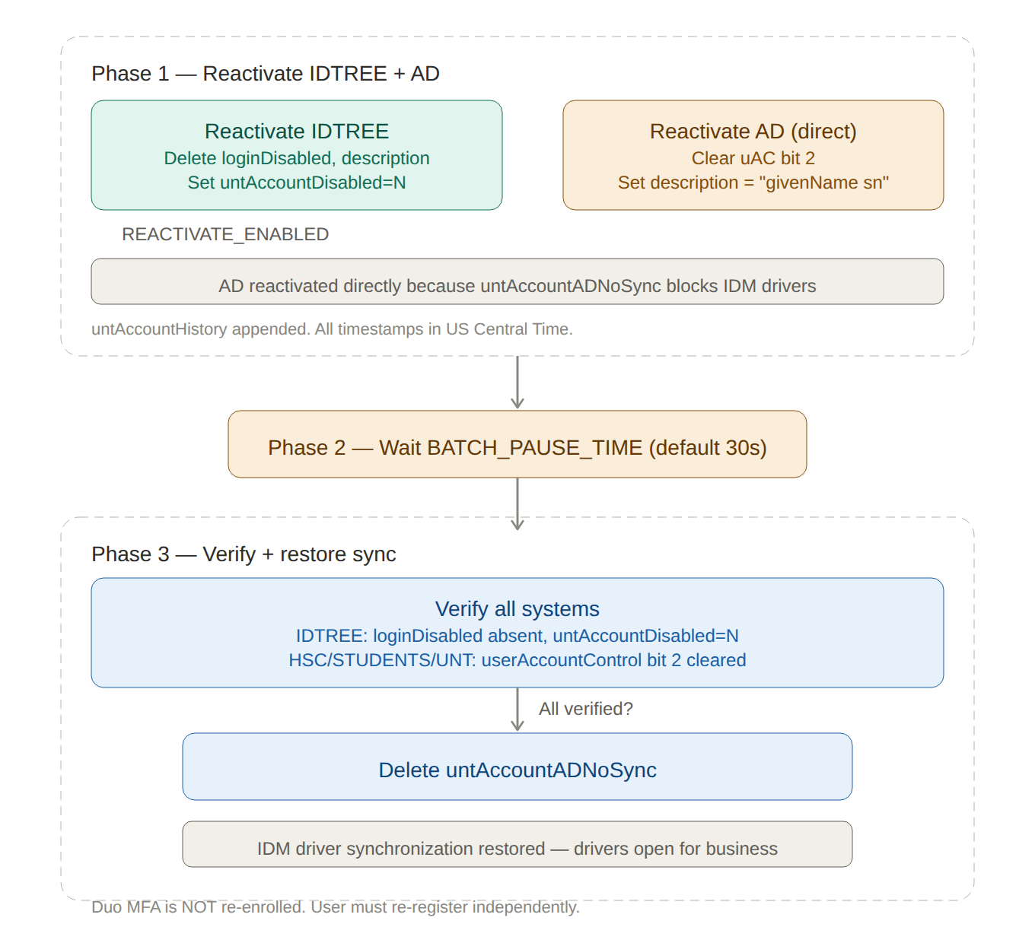
Figure 4 — Three-phase reactivation workflow.
Phase 1 — Reactivate IDTREE + AD
- IDTREE reactivation: Deletes loginDisabled, description, untAccountDisabledDate, untAccountEnabled. Sets untAccountDisabled=N (set, not deleted — IDM needs the change event). Appends to untAccountHistory.
- AD reactivation (direct): For HSC, STUDENTS, and UNT, clears userAccountControl bit 2 and sets the description to “givenName sn” (e.g., “Jack Stewart”), read from IDTREE.
Phase 2 — Wait
ALMA pauses for BATCH_PAUSE_TIME seconds to allow systems to settle.
Phase 3 — Verify and restore sync
ALMA calls the reactivation verification endpoint, which:
- Reads IDTREE to confirm loginDisabled is absent and untAccountDisabled=N
- Reads HSC, STUDENTS, and UNT to confirm userAccountControl bit 2 is cleared
If all systems verify, the endpoint deletes untAccountADNoSync, restoring normal IDM driver synchronization. Duo MFA is not re-enrolled; the user must re-register.

Account history (untAccountHistory)
Every deactivation and reactivation event appends a timestamped entry to the multi-valued untAccountHistory attribute in eDirectory. All timestamps are in US Central Time (CDT/CST). The same text is written to the description field during deactivation.
Entry formats
- ALMA: Deactivated 2026-03-16 09:15:22 (742 days inactive)
- ALMA: Reactivated 2026-04-01 14:30:05
- ADMINISTRATIVE: Deactivated 2026-05-10 11:00:00
- ADMINISTRATIVE: Reactivated 2026-05-15 08:45:12
- EMERGENCY: Deactivated 2026-06-01 16:22:33
- EMERGENCY: Reactivated 2026-07-01 09:00:00
The type prefix identifies which tool performed the action. A user deactivated by ALMA (inactivity) might be reactivated administratively, producing a mixed history that accurately reflects the account’s lifecycle.
Feature flags and dry run
Three environment variables control which code paths execute:
- DEACTIVATE_ENABLED — gates IDTREE deactivation
- DUO_ENABLED — gates Duo account deletion and group cleanup
- REACTIVATE_ENABLED — gates reactivation
Each flag controls whether ALMA calls the corresponding endpoint at all. The --commit flag (dry_run) is orthogonal: when a code path executes, the full logic runs — lookups, logging, decision-making — but the actual LDAP modify or Duo API delete is suppressed unless --commit is specified.
Safety guards
untAccountIgnore
Users with untAccountIgnore=Y are excluded from both deactivation and reactivation processing. This is enforced at two levels: the LDAP search filter excludes them from candidate discovery, and the application-level eligibility check rejects them if they reach the processing stage by any other path.
untAccountOverride
Users with untAccountOverride=Y are exempt from inactivity deactivation even if they have no active affiliations. This is checked during eligibility determination.
Design rationale
This architecture has more moving parts than its predecessors. Three separate tools with three divergent behaviors are replaced by a single orchestrated workflow with explicit phases, observable state at every step, and a verification gate that prevents the most common class of failure (incomplete propagation).
The phase boundaries correspond to real constraints: IDM drivers are asynchronous and need time to process change events. The feature flags allow each capability to be enabled independently in a production environment serving a multi-institution university system. The orthogonal dry_run flag provides a second layer of safety.
The new system is more complex to describe but simpler to operate, debug, and trust.

